Original Research Article
Impact of Physico-Chemical Factors on Water Quality in Dehradun and Haridwar

ABSTRACT
Water quality has become a crucial concern in modern times and is assessed through various physicochemical parameters. Water is necessary for all living organisms, even though it does not supply organic micronutrients. The relationship between water and the environment is a pressing issue for both the public and policymakers. Human activities are the primary contributors to water and environmental pollution, leading to severe consequences. Water contamination has been linked to numerous health issues, including cancer, respiratory and cardiovascular diseases, and reproductive disorders. Additionally, pollution adversely affects aquatic life, potentially driving many species to endangerment or extinction within the next century. A study was conducted in the Dehradun and Haridwar districts of Uttarakhand to analyze the impact of water pollution. This region was selected due to its exposure to industrial activities, agricultural practices, wastewater discharge, human settlements, embankment erosion, and urbanization. The current state of water quality in Dehradun is inadequate and often contaminated, and it is responsible for various waterborne diseases such as diarrhea, giardiasis, dysentery, typhoid fever, and E. Coli infections, particularly in rural as well as in urban areas. This study focuses on evaluating the water quality parameters of various locations across Dehradun and Haridwar. To study the effect, water samples were collected from various locations in the Dehradun and Haridwar Districts. Results were analyzed in the environmental lab at Dev Bhoomi Uttarakhand University. Monitoring water quality and taking the right steps to prevent contamination are crucial for a safe and clean water supply. This research aims to assess the physicochemical characteristics of water in the Dehradun and Haridwar districts. From the experimental results, it can be concluded that in both districts, most of the physical and chemical parameters of the water exceed the acceptable limits for drinking water.
Keywords: Physical parameter, Chemical parameter, Harmful impacts, Water Quality

INTRODUCTION AND LITERATURE
Water serves as an exceptional solvent for a diverse range of substances, encompassing both mineral and organic compounds. Consequently, it is widely used in various industrial applications. Water also plays an important role in many sports and recreational activities, including swimming, leisure boating, boat racing, surfing, sport fishing, diving, ice skating, snowboarding, and skiing.

The populations of the Dehradun and Haridwar districts are steadily increasing. This growth leads to the establishment of factories that significantly harm water quality over time. Our main water sources are rainwater, groundwater, and surface water. It is crucial to ensure that any water meant for drinking meets the quality standards set by the Bureau of Indian Standards and the World Health Organization. Regularly testing drinking water is necessary to confirm it meets these standards. Water fails to meet the criteria established by BIS and WHO, so it becomes crucial to assess the level of contamination present in the water sample (Manish et al., 2017).
Several researchers, including Khanna et al. (2009), Singh et al. (2010), Sharma et al. (2012), Shukla et al. (2013), Parveen et al. (2013), Ishaq et al. (2013), Bhadula et al. (2014), Bharti (2014), Matta et al. (2015), Bhutiani et al. (2016), Sharma et al. (2016), Dwivedi (2017), Kumar et al. (2018), Saini et al. (2018), Bhutiani et al. (2018), Matta et al. (2019), Tyagi et al. (2020), and Pal et al. (2022) have greatly contributed to the study of physical and chemical factors in the environment. However, the changing nature of environmental conditions requires ongoing research. Rapid industrialization, urbanization, and climate change keep changing environmental factors, so we need to monitor them regularly and update our analyses. Therefore, ongoing scientific investigation is essential to address emerging environmental challenges and ensure ecological balance.
In Dehradun and Haridwar, most of the population relies on groundwater for drinking. Therefore, it is necessary to evaluate the physicochemical parameters that determine water quality. Various physicochemical parameters, such as temperature, pH, alkalinity, turbidity, hardness, total suspended solids (TSS), suspended solids (SS), and total dissolved solids (TDS), have been analysed to assess the quality of water in Dehradun and Haridwar.
STUDY AREA
The present study was primarily conducted in two districts of Uttarakhand, namely Dehradun and Haridwar. Dehradun is situated at approximately 30.3165° N latitude and 78.0322° E longitude. Dehradun is located in northern India, nestled in the Doon Valley between the Himalayan foothills and the Shivalik Hills. Dehradun is the capital of Uttarakhand, a northern state. It is also known as the "Rainy City of India" because of its relentless rainfall, especially during the monsoon season. There is a lot of temperature variation throughout the year, ranging from 1º in winter to 40º in summer. The attractive landscape and milder climate of the city provide a nice getaway for the people of the Uttarakhand capital. Dehradun has a humid subtropical climate with hot summers, mild winters, and moderate to high rainfall during the monsoon season. Due to that, soil supports agriculture, and its picturesque terrain makes it a favorite tourist destination. In the second phase, Haridwar is situated in the Indian state of Uttarakhand, at a latitude of 29.95°N and longitude 78.16°E. It is situated along the banks of the Ganges River, where the river empties into the Indo-Gangetic plains, in the foothills of the Himalayas. The city is surrounded by flat plains and low hills. Haridwar has a humid subtropical climate, featuring hot summers, cool winters, and a monsoon season that brings heavy rain. Figure 1 shows the map of India, highlighting the location
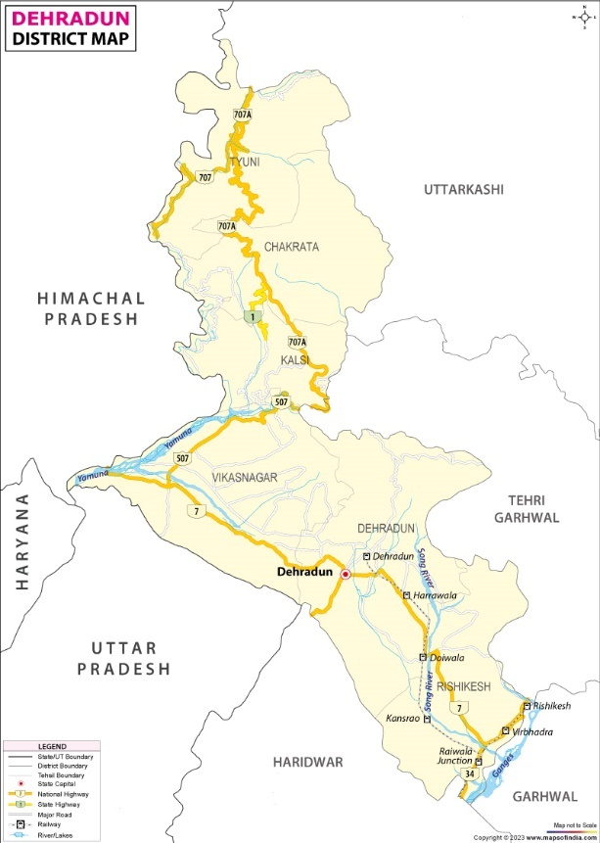
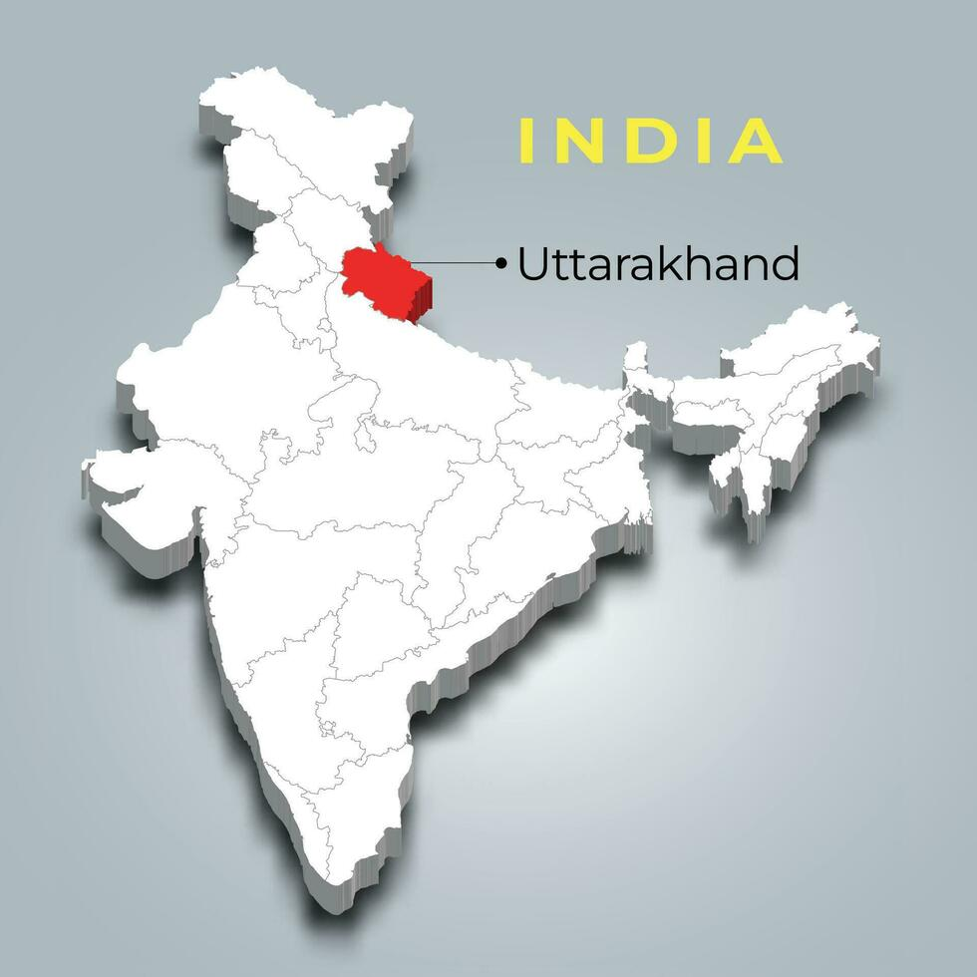
of Uttarakhand, and Figure 2 (a and b) highlights the location of Dehradun and Haridwar on the map.
Figure 1: Geographical map of India Figure: 2: (a) Topographical map of Dehradun
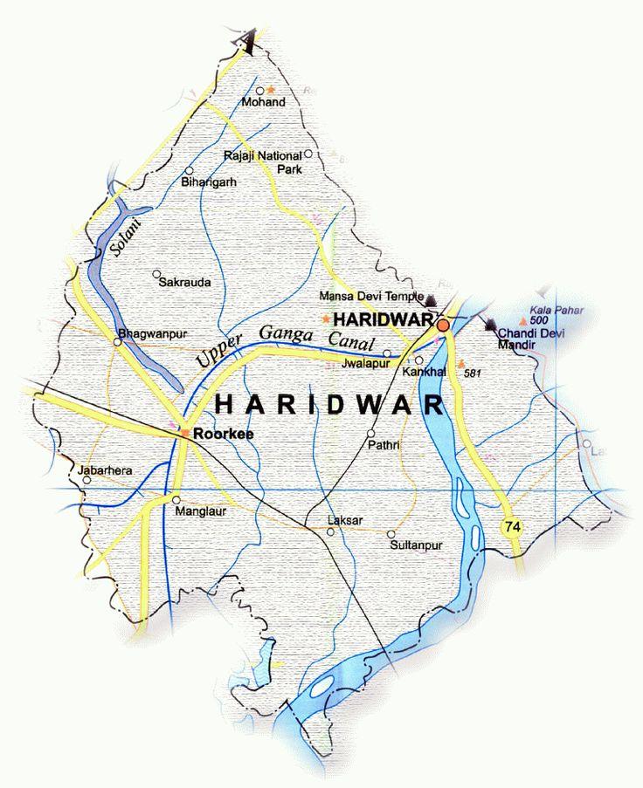
Figure 2: (b) Topographical map of Dehradun

METHODOLOGY
A study was conducted in Dehradun and Haridwar cities to select water source locations, ensuring comprehensive coverage of the entire area. All major and densely populated locations were considered in the selection process. A total of 30 locations were chosen for sample collection, followed by water quality testing from Dehradun and Haridwar. Water samples have been collected from various places in Dehradun and Haridwar to assess their quality. The study aims to analyse the availability and safety of water in different areas. Details of the sampling locations are provided below in Tables 1(a) and 1 (b).

Table 1 (a): Water Samples collected from different sites of Dehradun
S.no. | Location | site location
1 | Selaqui | - Uk Engg., (b) JB Industries, (c) Haripur (Banjara Gali)
2 | Premnagar, ISBT | - Shiv Vihar, (b) Premnagar River (c) Water, Ballupur River
3 | Doiwala | - Mdda Dalanwala, (b) Welham School, (c) Nagarjuna Pharma Office
4 | Vikasnagar | - Bhimawala, (b) Bavri, (c) Herbertpur
5 | Rajpur | - Ltc, (b) Karanpur, (c) Bahal Chowk

Table 1 (b): Water Samples collected from different sites of Haridwar

S.no. | Location | site location
1 | Haridwar | a) Song River, (b) Forest House Raiwala, (c) Pathari Forest House, (d) Sapta Sarovar, (e) Motichur river, (f) Raiwala, (g) Bhoopatwala, (h) Pratit Nagar, (i) Vivekananad Park, (j) Mayapur, (k) Jwalapur, (k) Water Department Jwalapur, (l) Ramghat, (m) Mansa Devi road, (n) Har ki Pauri (SH 86)

For this study, Water is collected from two different types of sources, i.e., underground water and river water. Because the main sources of drinking water in Dehradun and Haridwar are underground water and river water. Underground water comes from wells and tube wells. River water is taken from nearby rivers like the Ganga and Yamuna. These water sources are treated and supplied to homes for safe use. However, the growing population and pollution create challenges for keeping water quality high.

RESULTS and ANALYSIS
The present study was conducted to analyse water quality parameters through a series of laboratory tests to assess the overall water quality. Physical water quality parameters include turbidity, colour, temperature, and taste, which affect the appearance and usability of water. Chemical parameters involve pH, hardness, dissolved oxygen, and the presence of contaminants like nitrates, chlorides, and heavy metals. Both types of parameters are essential for assessing water safety and quality. In the present study, the water sample was tested only for the parameters, including pH, temperature, alkalinity, turbidity, and hardness. Additionally, Total Suspended Solids (TSS) and Total Dissolved Solids (TDS) were also analysed. The obtained results were then analysed and compared with the Indian standard to determine the quality of water and its suitability for usage. The results of the present study of the Dehradun district have been tabulated and presented in Table 2 and Figures 3 to 9.

Table 2: Results of physico-chemical study of parameters in Dehradun
S No. | Place | Site Location | Parameters
S No. | Place | Site Location | Temp.  (ºC) | PH | Alkalinity  (mg/l) | Turbidity  (NTU) | Hardness  (mg/l) | TSS  (mg/l) | SS  (mg/l) | TDS  (mg/l) | Depth  (m)
01 | SELAQUI | UK ENGG. | 27 | 7.1 | 140 | 9.5 | 100 | 0 | 0 | 250 | 149
01 | SELAQUI | JB INDUSTRIES | 27 | 6.6 | 150 | 0.7 | 90 | 0 | 0.03 | 0 | 220
01 | SELAQUI | HARIPUR (Banjara Gali) | 27 | 6.7 | 173 | 0.8 | 50 | 0 | 0.1 | 475 | 200
02 | PREMNAGAR TO ISBT | SHIV VIHAR | 21 | 9 | 35 | 1 | 450 | 0 | 0.02 | 70 | 60
02 | PREMNAGAR TO ISBT | PREMNAGAR RIVER WATER | 25 | 7 | 50 | 1.5 | 650 | 0 | 0.17 | 1 | NA
02 | PREMNAGAR TO ISBT | TONS RIVER | 18 | 8 | 35 | 1.2 | 400 | 0 | 0.04 | 0 | NA
03 | DOIWALA | MDDA DALANWALA | 27 | 7 | 105 | 0.6 | 250 | 0 | 0.05 | 350 | 250
03 | DOIWALA | WELHAM SCHOOL | 28 | 7 | 98 | 2 | 300 | 0 | 2.7 | 400 | 275
03 | DOIWALA | NAGARJUNA PHARMA OFFICE | 22 | 7 | 92 | 1.9 | 500 | 0 | 0.33 | 100 | 280
04 | VIKAS NAGAR | BHIMAWALA | 28 | 6.8 | 120 | 1.1 | 100 | 8 | 0.3 | 350 | 240
04 | VIKAS NAGAR | BAVRI | 26 | 7 | 195 | 0.4 | 75 | 0 | 0.05 | 50 | 100
04 | VIKAS NAGAR | HERBERTPUR | 28 | 7 | 180 | 1.1 | 200 | 0 | 0.029 | 65 | 200
05 | RAJPUR ROAD | ST. NURSERY SCHOOL | 23 | 7 | 118 | 1.2 | 100 | 0 | 0.4 | 300 | 240
05 | RAJPUR ROAD | KARANPUR | 23 | 6 | 106 | 1.2 | 80 | 0 | 0 | 150 | 100
05 | RAJPUR ROAD | BAHAL CHOWK | 22 | 8 | 146 | 1 | 400 | 0 | 0.05 | 65 | 230

Figure 3: Alkalinity analysis and its trends in various locations of Dehradun
The analysis of alkalinity levels at different site locations shows that all collected values are within the safe limit of 200 mg/L for drinking water, as shown in Figure 3. The highest alkalinity was found at Bavri with 195 mg/L, followed closely by Herbertpur at 180 mg/L and Haripur at 173 mg/L. These sites are close to the limit but still safe for drinking. Moderate alkalinity levels were observed at JB Industries (150 mg/L), Bahal Chowk (146 mg/L), UK ENGG. (140 mg/L), and Bhimawala (120 mg/L). Lower values were recorded at St. Nursery School (118 mg/L), Karanpur (106 mg/L), MDDA Dalanwala (105 mg/L), and Nagarjuna Pharma Office (92 mg/L). Welham School (98 mg/L) and Premnagar River Water (50 mg/L) had the lowest alkalinity levels, while the lowest readings were at Shiv Vihar and Tones River (both 35 mg/L). These findings show that all sampled water sources meet drinking water standards and are suitable for consumption.

Figure 4: Hardness analysis and its trends in various locations of Dehradun
The analysis of water hardness across various site locations indicates that several locations exceed the acceptable limit of 200 mg/L for drinking water. Premnagar River Water had the highest hardness at 650 mg/L. Nagarjuna Pharma Office followed with 500 mg/L, and Shiv Vihar had 450 mg/L. Other locations like Tones River and Bahal Chowk reported hardness levels of 400 mg/L. Welham School and MDDA Dalanwala recorded 300 mg/L and 250 mg/L, respectively. All these levels exceeded the allowable limit. In contrast, some sites, including UK ENGG., JB Industries, Bhimawala, LTC, and Herbertpur, reported hardness levels at or below the acceptable limit, ranging between 50 mg/L and 200 mg/L. The lowest hardness levels were found at Haripur (50 mg/L) and Bavri (75 mg/L), which indicates softer water, as shown in Figure 4. These results show that while some sources meet the safe drinking water standards, others, especially river water and areas near industries, have too much hardness. This situation requires treatment before the water can be consumed.

Figure 5: Suspended solids analysis and its trends in various locations of Dehradun

Figure 5 shows that the suspended solids (SS) at various site locations are all within the acceptable limit of 500 mg/L for drinking water. Most sites, including UK ENGG. and Karanpur, reported negligible suspended solids at 0 mg/L. Locations such as JB Industries (0.03 mg/L), Herbertpur (0.029 mg/L), and Shiv Vihar (0.02 mg/L) showed minimal concentrations. Higher, yet still acceptable levels were found at Premnagar River Water (0.17 mg/L), Tones River (0.04 mg/L), MDDA Dalanwala (0.05 mg/L), and Bahal Chowk (0.05 mg/L). The highest SS concentration was recorded at Welham School (2.7 mg/L), followed by LTC (0.4 mg/L), Nagarjuna Pharma Office (0.33 mg/L), and Bhimawala (0.3 mg/L). All values remain significantly below the permissible limit. These findings indicate that suspended solids in the analysed water sources are well-controlled and pose no concern regarding drinking water safety.

Figure 6: Total Dissolved Solids, its analysis, and trends in various locations of Dehradun

The analysis of Total Dissolved Solids (TDS) at different site locations shows that all recorded values are within the accepted limit of 500 mg/L for drinking water. The highest TDS concentration was at Haripur (475 mg/L), followed by Welham School (400 mg/L), MDDA Dalanwala and Bhimawala (both 350 mg/L), and LTC (300 mg/L). These levels are close to the limit but still safe for drinking. Moderate TDS levels were found at UK ENGG. (250 mg/L), Premnagar River Water (205 mg/L), and Tones River (180 mg/L). JB Industries (120 mg/L), Nagarjuna Pharma Office (100 mg/L), and Karanpur (150 mg/L) had lower values. The lowest TDS concentrations were at Bavri (50 mg/L), Herbertpur (65 mg/L), and Bahal Chowk (65 mg/L). These locations show minimal dissolved solids in their water sources, as shown in Figure 6. These results confirm that all sampled locations meet drinking water standards, making them suitable for consumption.

.
Figure 7: Turbidity analysis and its trends in various locations of Dehradun

The analysis of turbidity levels across different site locations shows that all recorded values are within the acceptable limit of 5 NTU for drinking water, ensuring safe clarity for consumption. The highest turbidity was observed at UK ENGG. (9.5 NTU), which exceeds the permissible limit and may need treatment, as shown in Figure 7. However, all other locations recorded turbidity well below the limit, with JB Industries (0.7 NTU), Haripur (0.8 NTU), and MDDA Dalanwala (0.6 NTU) having the lowest values. Moderate levels were found at Shiv Vihar (1 NTU), Bahal Chowk (1 NTU), Tons River (1.2 NTU), St. Nursery School (1.2 NTU), and Karanpur (1.2 NTU). Other sites, including Premnagar River Water (1.5 NTU), Bhimawala (1.1 NTU), Herbertpur (1.1 NTU), Nagarjuna Pharma Office (1.9 NTU), and Welham School (2 NTU), also stayed within the safe range. These findings confirm that except for UK ENGG., all sampled water sources meet the turbidity standards for drinking water, ensuring their suitability for consumption.

Figure 8: pH analysis and its trends in various locations of Dehradun
The analysis of pH levels across various site locations indicates that most recorded values fall within the acceptable range of 6.5 to 8.5 for drinking water, ensuring safe consumption. The majority of locations, including UK ENGG. (7.1), Premnagar River Water (7), MDDA Dalanwala (7), Welham School (7), Nagarjuna Pharma Office (7), Bavri (7), Herbertpur (7), and LTC (7) reported a neutral pH, which is ideal for drinking water. Tones River (8) and Bahal Chowk (8) were slightly alkaline but remained within safe limits. However, Shiv Vihar (9) exceeded the permissible range, indicating high alkalinity, which may require treatment. JB Industries (6.6), Haripur (6.7), and Bhimawala (6.8) were slightly acidic but still acceptable. Karanpur (6) was the only site below the acceptable range, indicating a need for monitoring and potential adjustment shown in Figure 8. Overall, except for Shiv Vihar and Karanpur, all locations meet the drinking water pH standards, ensuring their suitability for consumption.

Figure 9: Temperature analysis and its trends in various locations of Dehradun

The analysis of water temperature across various site locations indicates that most recorded values exceed the acceptable limit of 10–20°C for drinking water, which may impact water quality by influencing taste, dissolved oxygen levels, and microbial activity. The only site within the permissible range is Tones River (18°C), making it the most suitable in terms of temperature. Shiv Vihar (21°C), Nagarjuna Pharma Office (22°C), and Bahal Chowk (22°C) are slightly above the limit, while LTC (23°C) and Karanpur (23°C) also exceed the recommended range. All other locations, including UK ENGG., JB Industries, Haripur, MDDA Dalanwala (all at 27°C), Welham School, Bhimawala, and Herbertpur (all at 28°C), as well as Bavri (26°C) and Premnagar River Water (25°C), have significantly higher temperatures as shown in Figure 9. These findings suggest that most water sources may require cooling or treatment to meet ideal drinking water temperature standards for better quality and safety.
In the second phase, the study was carried out in the Haridwar district, and the obtained results were analysed and compared with the Indian standard to determine the quality of water and its suitability for usage. The results of the present study of the Haridwar district have been tabulated and presented in Table 3 and Figures 10 to 17.

Table 3. Different Physico-Chemical Parameters of Haridwar
S No. | Site Location | Parameters
S No. | Site Location | Temp (ºC) | PH | Alkalinity (mg/l) | Turbidity (NTU) | Hardness (mg/l) | TSS (mg/l) | SS (mg/l) | TDS (mg/l)
01 | Song River | 21 | 7 | 60 | 4 | 100 | 80.06 | 0.06 | 80
02 | Forest House Raiwala | 23 | 7.5 | 83 | 0.4 | 250 | 82.03 | 0.03 | 82
03 | Pathari Forest House | 23 | 8 | 115 | 2 | 200 | 68.09 | 0.09 | 68
04 | Sapta Sarovar | 21 | 10 | 35 | 0.8 | 150 | 175.31 | 0.31 | 175
05 | Motichur river | 21 | 7 | 35 | 0.4 | 150 | 92.03 | 0.03 | 92
06 | Raiwala | 23 | 10 | 200 | 1 | 200 | 28.04 | 0.04 | 28
07 | Bhoopatwala | 22 | 6 | 63 | 2 | 250 | 105.09 | 0.09 | 105
08 | Pratit Nagar | 21 | 7 | 95 | 3.6 | 150 | 221.02 | 0.02 | 221
09 | Vivekananad Park | 23 | 7 | 69 | 2.1 | 150 | 80.03 | 0.03 | 80
10 | Mayapur | 23 | 6.8 | 97 | 8.1 | 100 | 70.03 | 0.03 | 70
11 | Jwalapur | 24 | 6.5 | 108 | 2.2 | 200 | 60.23 | 0.23 | 60
12 | Water Department Jwalapur | 23 | 7 | 65 | 3 | 150 | 120.01 | 0.01 | 120
13 | Ramghat | 17 | 7 | 176 | 1.4 | 255 | 75.07 | 0.07 | 75
14 | Mansa Devi road | 21 | 8 | 75 | 1 | 300 | 68.15 | 0.15 | 68
15 | Har ki Pauri (SH 86) | 21 | 7.5 | 40 | 0.8 | 350 | 36.31 | 0.31 | 36

Figure 10: Alkalinity analysis and its trends in various locations of Dehradun
In Figure 10 data shows the alkalinity levels of various sites, reflecting the concentration of alkaline chemicals in water bodies or areas. Raiwala has the greatest alkalinity at 200, indicating a large mineral content, whereas Ramghat (176) and Pathari Forest House (115) have comparatively high levels. Jwalapur (108) and Mayapur (97) have somewhat high alkalinity, while Pratit Nagar (95) and Forest House Raiwala (83) follow closely. Mansa Devi Road (75) and Bhoopatwala (63) have moderate alkalinity levels. Water Department Jwalapur (65) and Vivekananda Park (69) demonstrate balanced values. Har Ki Pauri (40), Sapta Sarovar (35), and the Motichur River (35) have the lowest alkalinity levels, indicating softer water conditions.

Figure 11 Hardness analysis and its trends in various locations of Dehradun
In Figure 11, the given data shows the hardness levels (most likely in mg/L) of water at various sites, as well as the concentration of dissolved minerals like calcium and magnesium. Har Ki Pauri has the maximum hardness (350 mg/L), followed by Mansa Devi Road (300 mg/L) and Ramghat (255 mg/L), indicating the existence of large mineral resources. Bhoopatwala (250 mg/L) and Forest House Raiwala (250 mg/L) have significant hardness levels. Locations with moderately hard water include Pathari Forest House (200 mg/L), Raiwala (200 mg/L), and Jwalapur (200 mg/L). Sapta Sarovar, Motichur River, Pratit Nagar, Vivekananda Park, and Water Department Jwalapur all have hardness levels of 150 mg/L, indicating a balanced mineral concentration. The lowest hardness readings were found in the Song River (100 mg/L) and Mayapur (100 mg/L), indicating gentler water. These hardness differences can be linked to geological formations, industrial impacts, and natural water sources, all of which have an impact on water quality and use for home and industrial applications.

Figure 12: pH analysis and its trends in various locations of Dehradun
Figure 12 shows the pH values of water at various sites, indicating whether it is acidic or alkaline. pH readings range from 6 to 10, indicating that water chemistry varies among places. Sapta Sarovar (10) and Raiwala (10) have the highest pH readings, suggesting very alkaline water, potentially due to mineral deposits or less acidic impacts. Pathari Forest House (8) and Mansa Devi Road (8) have similar alkalinity levels. Forest House Raiwala (7.5) and Har Ki Pauri (7.5) have near-neutral pH levels, indicating balanced water quality. Most areas, including Song River (7), Motichur River (7), Pratit Nagar (7), Vivekananda Park (7), Water Department Jwalapur (7), and Ramghat (7), have a neutral pH, which is good for aquatic ecosystems and human consumption. However, significantly lower levels are found in Mayapur (6.8), Jwalapur (6.5), and Bhoopatwala (6), indicating moderate acidity. These changes might be caused by natural sources, human activities, or pollution levels, all of which influence overall water quality and appropriateness for drinking, irrigation, and aquatic life.

Figure 13: Suspended solids analysis and its trends in various locations of Dehradun

In Figure 13, the concentration of suspended particles (in mg/L) at various sites shows the presence of particulate matter in the water. The highest readings are seen at Sapta Sarovar (0.31 mg/L) and Har Ki Pauri (0.31 mg/L), indicating increased turbidity, which might be caused by human activity, sediment deposition, or organic matter build-up. Jwalapur (0.23 mg/L) and Mansa Devi Road (0.15 mg/L) have significant values, indicating possible urban runoff or industrial effects. Pathari Forest House (0.09 mg/L) and Bhoopatwala (0.09 mg/L) exhibit modest suspended solid levels, which might be caused by natural soil erosion or mild disturbances. Song River (0.06 mg/L) and Ramghat (0.07 mg/L) have lower values, suggesting cleaner water. The lowest values are recorded at Water Department Jwalapur (0.01 mg/L), Pratit Nagar (0.02 mg/L), Raiwala (0.04 mg/L), Forest House Raiwala (0.03 mg/L), Motichur River (0.03 mg/L), Vivekananda Park (0.03 mg/L), and Mayapur (0.03 mg/L), indicating low particulate matter levels, possibly due to natural filtration or reduced human impact. These differences in suspended particles can have an impact on water quality, including aquatic life, light penetration, and general ecosystem health.

Figure 14: Total Dissolved Solids analysis and its trends in various locations of Dehradun
Total Dissolved Solids (TDS) levels (in mg/L) at various sites, which indicate the concentration of dissolved minerals, salts, and organic materials in the water. Pratit Nagar has the highest TDS value (221 mg/L), followed by Sapta Sarovar (175 mg/L) and Water Department Jwalapur (120 mg/L), indicating a greater concentration of dissolved substances, which might be caused by natural mineral deposits, wastewater discharge, or urban runoff. TDS levels in Bhoopatwala (105 mg/L) and Motichur River (92 mg/L) are likewise high, which may have an impact on water taste and usability. Moderate TDS levels were detected in Forest House Raiwala (82 mg/L), Song River (80 mg/L), and Vivekananda Park (80 mg/L), indicating somewhat balanced water quality. Mayapur (70 mg/L), Mansa Devi Road (68 mg/L), and Pathari Forest House (68 mg/L) all had consistent readings, indicating negligible mineralization. Ramghat (75 mg/L) and Jwalapur (60 mg/L) have somewhat lower amounts, suggesting high water clarity as shown in Figure 14.
The lowest TDS readings were found at Har Ki Pauri (36 mg/L) and Raiwala (28 mg/L), indicating extremely low mineral concentration, which might be attributed to natural filtering or little external pollution. TDS levels vary, influencing water quality and its appropriateness for drinking, irrigation, and aquatic ecosystems, with higher values possibly altering flavor and hardness.

Figure 15: Temperature analysis and its trends in various locations of Dehradun

In Figure 15, the temperature data indicates that Jwalapur recorded the highest temperature at 24°C, while Ramghat had the lowest at 17°C. Most locations, including Song River, Sapta Sarovar, and Mansa Devi Road, experienced a temperature of 21°C, whereas Forest House Raiwala, Pathari Forest House, and Vivekanand Park recorded 23°C. Bhoopatwala was slightly cooler at 22°C, reflecting a moderate temperature variation across the region.

Figure 16: Total Suspended Solids analysis and its trends in various locations of Dehradun
The Total Suspended Solids (TSS) data from various places vary significantly, suggesting varying degrees of water quality. Pratit Nagar had the highest TSS of 221.02 mg/L, indicating a high amount of particle matter, followed by Sapta Sarovar (175.31 mg/L) and Water Department Jwalapur (120.01 mg/L). Bhoopatwala (105.09 mg/L) and Motichur River (92.03 mg/L) both had high readings. Raiwala (28.04 mg/L) and Har Ki Pauri (36.31 mg/L) had the lowest TSS levels, suggesting more pure water. Locations with moderate levels were Song River (80.06 mg/L), Vivekanand Park (80.03 mg/L), and Ramghat (75.07 mg/L) as shown in Figure 16. Variations in TSS might be ascribed to runoff, human activities, and natural sedimentation processes, which all influence water quality and aquatic ecosystems.

Figure 17: Turbidity analysis and its trends in various locations of Dehradun

Impact of Physical and Chemical Parameters
The comprehensive assessment of physico-chemical parameters across Dehradun and Haridwar reveals that while most sites comply with drinking water standards, some pose significant concerns that may have dangerous health and environmental effects. Elevated hardness levels, particularly in river and industrial areas, can lead to scaling in pipelines and adverse health effects like kidney stones. High turbidity at certain sites such as Mayapur and UK ENGG. can harbor pathogens, reducing disinfection effectiveness and increasing the risk of waterborne diseases. Deviations in pH at locations like Shiv Vihar and Karanpur can affect water taste and corrosion potential. Elevated temperatures observed across most Dehradun sites can lower dissolved oxygen levels, promoting microbial growth and degrading water quality. Though TDS and suspended solids are generally within limits, their high values in some areas may affect taste, clarity, and filtration systems. If left untreated, these parameters could degrade infrastructure, compromise human health, and affect aquatic life. Regular monitoring, targeted treatment, and public awareness are critical to maintaining water safety and ensuring long-term sustainability.
Conclusion
The detailed investigation of water quality indicators at several places in Dehradun and Haridwar gives crucial information about the appropriateness of these water sources for consumption. The comprehensive analysis of various physico-chemical parameters of water quality across different site locations in Dehradun and Haridwar indicates a generally acceptable standard for drinking water, with some exceptions requiring attention.
In Dehradun, alkalinity levels across all sites remain within the permissible limit of 200 mg/L, ensuring safe consumption. However, water hardness exceeds the acceptable limit (200 mg/L) in several locations, particularly in river water and industrial areas, necessitating treatment to improve portability. Suspended and total dissolved solids levels are within permissible limits across all locations, reflecting minimal contamination. Turbidity levels generally conform to standards, except UK ENGG., which exceeds the limit and may require corrective measures. pH levels are mostly within the recommended range, except for Shiv Vihar and Karanpur, which may need monitoring and adjustment. Water temperature, however, remains above the recommended limit in most locations, which may impact overall quality and microbial activity.
In Haridwar, most parameters, including alkalinity, pH, and suspended solids, fall within acceptable limits. However, some locations exhibit high hardness levels, such as Har Ki Pauri (350 mg/L) and Mansa Devi Road (300 mg/L), indicating hard water that may require treatment. TDS concentrations vary across sites, with Pratit Nagar (221 mg/L) recording the highest values, though still within safe limits. Turbidity is notably high in Mayapur (8.1 NTU), which could impact water clarity and quality.
Overall, while the water quality in both Dehradun and Haridwar largely meets drinking water standards, specific concerns such as excessive hardness, turbidity, and temperature deviations highlight the need for targeted treatment and regular monitoring to ensure long-term safety and sustainability.

References
- Khanna, D., Ashraf, J., Chauhan, B., Bhutiani, R., Matta, G., & Singh, V. (2009). Water quality analysis of river Panv-Dhoi in reference to its physico-chemical parameters and heavy metals. Environment Conservation Journal, 10(1&2), 159-169.
- Singh, M. R., Gupta, A., and Beeteswari, K. (2010). "Physico-chemical properties of water samples from Manipur River system, India." J. Appl. Struct. Equation Modeling, 14(4), 85-89.
- Kumar, V., Chopra, A. K., and Chauhan, R. K. (2012). "Effects of textile effluents disposal on water quality of sub canal of Upper Ganga Canal at Haridwar (Uttarakhand), India." J. Chem. Pharm. Res., 4(9), 4206-4211.
- Shukla, D., Bhadresha, K., Jain, N. K., and Modi, H. A. (2013). "Physicochemical analysis of water from various sources and their comparative studies." IOSR J. Environ. Sci. Toxicol. Food Technol., 5(3), 89-92.
- Praveen, A., Kumar, R., And, P., and Kumar, R. (2013). "Physio-chemical properties of the water of River Ganga at Kanpur." Int. J. Comput. Eng. Res., 3(4), 134-137.
- Ishaq, F., Khanna, D. R., & Khan, A. (2013). Physico-chemical and phytoplanktonic characteristics of river Tons at Dehradun (Uttarakhand), India. Journal of Applied and Natural Science, 5(2), 465-474.
- Bhadula, S., Sharma, V., and Joshi, B. D. (2014). "Impact of tourists activities on water quality of Sahastradhara stream, Dehradun." Int. J. Chem. Tech. Res., 6(1), 213-221.
- Bharti, P. K. (2014). "Water quality characteristics of Sahastradhara hill stream, Dehradun (Uttarakhand), India." Int. J. High. Educ. Res., 4(1), 15-27.
- Matta, G., Kumar, A., Srivastava, S., Singh, V., and Dhingra, G. K. (2015). "Impact assessment on water quality of Ganga Canal System in Himalayan Region." Int. J. Sci. Eng. Res., 6(5), 1524-1531.
- Bhutiani, R., Khanna, D. R., Ram, K., Ahmad, F., & Tyagi, V. (2016). Quality assessment of Ganga River at Haridwar with reference to various physico-chemical parameters. Biotechnology International, 9(1), 17-24.
- Sharma, B., Savera, K. K., Kausik, S., Saini, P., Bhadula, S., Sharma, V., and Singh, P. (2016). "Assessment of ground water quality of Bhagwanpur industrial area of Haridwar in Uttarakhand, India." Appl. Ecol. Environ. Sci., 4(4), 96-101.
- Dwivedi, A. P. (2017). "Study of physico-chemical characteristics of water in River Mandakini." Int. J. Adv. Res. Chem. Sci., 4(9), 1-6.
- Kumar, A., Sahay, A., Singh, R. P., & Kumar, U. (2018). Evaluation of physicochemical characteristics of Suswa River water in Dehradun, India. International Journal for Research in Applied Science & Engineering Technology, 8(7), 1997-2006.
- Saini, R., Siddiqui, N. A., Bahukhandi, K. D., & Ahuja, N. J. (2018). Study of effects of municipal solid waste on water quality of Dehradun City. Journal of Environmental Science, Computer Science and Engineering & Technology, 7(3), 409-416.
- Bhutiani, R., Khanna, D. R., Malik, R., Ahmad, F., & Tyagi, V. (2018). Physico-chemical characterization of river Ganga at Haridwar, Uttarakhand. Water Biology, 143-159.
- Matta, G., Gautam, R. K., Kumar, A., and Kumar, P. (2019). "Suitability assessment of ground water quality in rural areas of Haridwar district, Uttarakhand." Poll. Res., 39(1), 91-96.
- Tyagi, S., Dubey, R. C., Bhutiani, R., and Ahamad, F. (2020). "Multivariate statistical analysis of River Ganga water at Rishikesh and Haridwar, India." Anal. Chem. Lett., 10(2), 195-213.
- Pal, A., and Kumar, A. (2022). "Physico–chemical characteristics of water quality of district Sonbhadra." Int. J. Food Nutr. Sci., 11(9), 2629-2647.

