Critical Analysis of the Household Waste Management System in the Third District of Port-Gentil

ABSTRACT:
In Gabon, less than 20% of the population has access to waste collection services, which are primarily concentrated in planned neighborhoods. Peripheral areas, on the other hand, remain largely excluded from this system. This study is part of a research initiative led by the LANASPET laboratory at Omar Bongo University, aiming to document a persistent issue that has become central to local governance in Port-Gentil.
Conducted between 2020 and 2025 in the 3rd district of Port-Gentil, the study adopts an applied approach combining both quantitative and qualitative data. The quantitative data were drawn from the volumes of waste recorded at the Ntchengué municipal landfill, while the qualitative data were collected through a perception survey among local residents. Four field missions enabled researchers to observe local dynamics and gather the necessary information.
The methodology relies on the compound growth formula to estimate demographic changes in relation to the volumes of waste collected. A sample of 100 households was selected using a simple random sampling method, with proportional representation across two targeted neighborhoods. Geographic coordinates of illegal dumping sites and formal and informal collection points were also recorded to support a spatial analysis of the local waste management system.
The findings highlight the impact of rapid urbanization—driven largely by the oil industry—on a failing waste management system. This system is characterized by territorial inequalities, outdated infrastructure, and poorly controlled pollution. Despite substantial financial resources from oil revenues, local governance struggles to address sustainability challenges.
In response, the study proposes an innovative management model based on transparency, technical expertise, and citizen participation. It is structured around a local waste management plan supported by Geographic Information Systems (GIS), and built upon five key dimensions: technical, social, economic, political/institutional, and environmental.
Keys words: Port-Gentil, Household waste management, Collection, Urban environment.

INTRODUCTION
In several Central African countries, particularly in Gabon, urban expansion has been accelerated by oil exploitation, which is highly labor-intensive and has led to the rapid emergence of urban centers without adequate infrastructural support (Pourtier & Magrin, 2012; Adeola et al., 2022). This uncontrolled development has produced an unbalanced urban morphology, characterized by:
- the proliferation of informal housing,
- a lack of basic infrastructure, and
- the widespread presence of solid waste in public spaces (African Clean Cities Platform, 2019).
In many urban areas, slums border affluent neighborhoods, illustrating the strong socio-spatial inequalities typical of middle-income countries like Gabon (Ifri, 2024).
Household waste management has thus become a critical issue for local authorities in African urban centers. They face multiple challenges including:
- rapid demographic growth,
- unplanned urbanization,
- and persistent budgetary constraints (Climate Chance, 2023).
In Gabon, as in many Central African countries, waste management remains underdeveloped, characterized by:
- widespread illegal dumping,
- a lack of source separation, and
Addressing this issue requires a systemic approach that accounts for technical, social, economic, legal, and political factors. However, such an approach is hindered by a major obstacle: the lack of reliable, up-to-date, and accessible data, limiting the ability of researchers and decision-makers to formulate robust diagnoses and strategies (UN-Habitat, 2023; ACCP, 2019).
While household waste management has been widely studied in North African countries—where public environmental policies are relatively well-structured and documented (UN-Habitat, 2023; JICA, 2022)—the topic remains underexplored in Central Africa, especially in peer-reviewed academic literature.
This gap is particularly pronounced in Gabon, where publications on urban waste management are scarce, despite the magnitude of the issues faced in major cities like Libreville and Port-Gentil (African Clean Cities Platform, 2019).
Within this context, academic initiatives like ours aim to bridge this gap by contributing to a better understanding of local waste management dynamics. This article draws its substance from a master's thesis focused on the contribution of geomatics to household waste management in the municipality of Port-Gentil. Defended at Omar Bongo University, it forms part of a broader research initiative aimed at documenting and proposing solutions to a persistent issue that has become one of the major challenges of local governance in the city.
As the economic capital of Gabon, Port-Gentil has been deeply impacted by successive oil crises, which have led to a significant drop in public revenues and weakened the local economy (Mbadinga, 2000; Maloba, 2016/2017). This situation contrasts with the city’s ongoing demographic growth (Maganga and Maloba, 2022) and uncontrolled urban expansion, placing increased pressure on urban services—particularly in waste management. Based on the perceptions of local populations, this study takes place within the renewed context of decentralization, nearly thirty years after the 1996 laws remained unenforced. The initiative launched by the newly elected authorities aims to bring local administrations closer to citizens. The findings of this research could therefore contribute to shaping a coherent waste management policy in Port-Gentil.

1. Characterization of the Study Area, Dataset Utilization, and Analytical Methods
1.1 Port-Gentil: A Peninsula Where Overlapping Neighborhoods Across Districts Obscure the Clarity of Administrative Boundaries
Located between 0°43′09″ South latitude and 8°46′53″ East longitude, along the Atlantic Ocean on a low-lying coastline (4 m), Port-Gentil is the economic capital of Gabon and the administrative center of the Ogooué-Maritime province. Established as a municipality in 1936 during colonial administration, its urban boundaries were redefined by decree in 1995 (Obouka, 2023). Administratively, Port-Gentil is divided into four districts, stretching from Cape Lopez Bay to areas along the Atlantic shoreline (Figure 1). In 2017, the urban area of the city covered approximately 4,940 hectares, with an estimated population of nearly 150,000 residents (Maganga and Maloba, 2022), unevenly distributed across the commune’s 18 neighborhoods.
Neighborhood boundaries are not referenced in any formal administrative or legal texts. Several neighborhoods span across multiple districts, complicating administrative management (Littoral, Ocean Neighborhood, Mandji Island), and many of the boundaries are defined by natural features—primarily the hydrographic network or rainwater drainage systems.
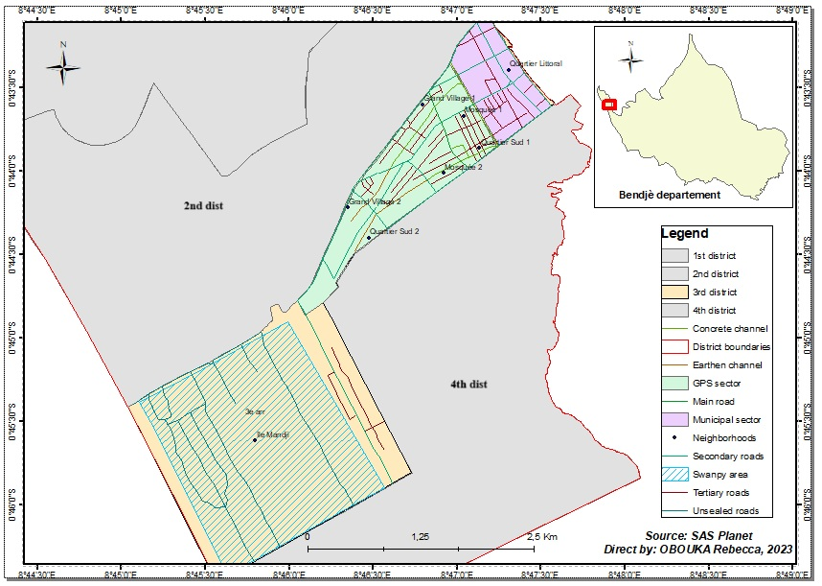
Fig. 1. Third District of Port-Gentil
The 3rd district, which constitutes the scope of our study, is the smallest of the four districts that make up the municipality of Port-Gentil. Covering an area of approximately 760 hectares, the study zone displays a heterogeneous urban structure, combining planned residential neighborhoods, mixed-housing areas, and under-integrated sectors. It includes both the city center—Port-Gentil’s administrative and commercial hub—and several peripheral neighborhoods with contrasting characteristics in terms of population density, infrastructure, and environmental vulnerabilities. The district is composed of eight neighborhoods: Île Mandji, Grand Village 1, Grand Village 2, Mosquée 1, Mosquée 2, Quartier Littoral, Quartier Sud 1, and Quartier Sud 2.
Due to its compact size and mixed urban configuration, it offers a relevant testing ground for analyzing urban management dynamics, particularly in the area of waste management (Obouka, 2023). The findings from this sector may be extrapolated to larger and potentially more complex districts, both spatially and socio-environmentally.

1.2 Data and Methods
This study adopts a mixed-methods approach, combining qualitative and quantitative techniques to provide a comprehensive analysis of waste management in Port-Gentil’s third district. By integrating field data with local stakeholders’ perceptions, the analysis is enriched through a balance of statistical rigor and contextual understanding (Denscombe, 2014).
The investigation relies on statistical data regarding household waste volumes transported to the Ntchengué landfill over a three-year period, provided by the Municipal Technical Services Department (DSTM). Given the scarcity and inconsistency of these quantitative records, a complementary approach was employed, incorporating residents’ perceptions gathered through a public-private partnership between the city council and a contracted operator.
Due to the limited resources available for this study, conducted without financial support, survey questionnaires were administered exclusively to residents of two selected neighborhoods, along with public and private entities responsible for waste management. As noted by De Landsheere (1982), sampling involves selecting a limited number of individuals, objects, or events whose observation enables conclusions applicable to the broader population from which they were drawn. Considering the demographic density of the district, our selection focused on two neighborhoods with distinct socio-spatial characteristics, including Mosquée 2, a partially urbanized area. A sample of 100 households was established, proportionally distributed between the two neighborhoods. The sample size was calculated using a simple random sampling method, following the formula below:
n = N / (1 + N × e) Where:
- n represents the sample size
- N is the total population of the two neighborhoods
- e is the margin of error (set at 10%, i.e. 0.10 for a 90% confidence level).
This approach helped ensure minimal representativeness of the populations concerned by the study, in line with the work of Yamane (1967), who used this formula to determine a representative sample size for a finite population, while accounting for an acceptable margin of error (typically between 5% and 10%) and assuming a homogeneous distribution of characteristics within the population.
In addition, the geographic coordinates of illegal dumpsites and collection points (both formal and informal) were recorded in the field. These spatial data represent key variables for accurately assessing the extent of illegal dumping in the neighborhoods studied, as well as the impacts resulting from irregular waste collection. Such dysfunctions are reflected particularly in the accumulation of refuse, including at official collection sites, thereby undermining urban sanitation and the overall efficiency of the waste management system.
2. RESULTS
2.1 Estimation of Waste Management
The primary challenge encountered in analyzing household waste management lies in the accurate quantification of our subject of study, due to the absence—or withholding—of statistical data from the two main collection operators active in the city of Port-Gentil. The three years of data made available to us allow only a general and rough estimate of the volumes of waste collected in Gabon’s second largest city. These data, aggregated at the municipal level, pertain exclusively to the waste deposited at the Ntchengué landfill site (Figure 2), operated by the company GPS, which is equipped with a weighbridge that ensures the systematic weighing of vehicles transporting waste and provides reliable traceability of the collected volumes. Within this framework, it remains impossible to extract specific volumes of waste produced in the 3rd district, and even more so in the two neighborhoods targeted by our study on citizens’ perceptions of household waste management. This methodological constraint limits the scope of spatial analyses and complicates the formulation of recommendations that are adapted to local realities.
a) | b)
Fig. 2. Monthly and annual trends in household waste flows deposited at the Ntchengué landfill (Port-Gentil), expressed in tonnes. The vertical axis represents the volume of waste (in tonnes), while the horizontal axis corresponds to the months or years depending on the chosen scale.
Figure 2 shows a significant increase in the volumes of household waste deposited at the Ntchengué landfill site between 2017 and 2021. On a monthly average, the landfill received 2.9 million tonnes in 2017, compared to 4.8 million tonnes in 2020 and 5.1 million tonnes in 2021. Although brief, this time series allows us to identify notable peaks in collection: May 2017 (4.8 t), August 2020 (5.09 t), and July 2021 (6 t). Over the course of 2021, a total of 61.4 tonnes of waste were collected—almost double the 34.8 tonnes recorded in 2017. Is this increase directly correlated with population growth?
According to data from the Ministry of Economy and Participations, Gabon's population increased from 1,811,079 inhabitants in 2013 to 2,253,716 in 2021, representing an average annual growth rate of approximately 3%. Furthermore, an estimate conducted in 2011 by the organization Toilettes du Monde, which differentiated populations by district, established a total population of 159,354 inhabitants for the entire municipality of Port-Gentil (see Table 1).
The number of inhabitants in the various districts of Port-Gentil between 2017 and 2021 can be estimated by applying an average annual growth rate of 3%, using the following formula:
Pₜ = P₀ × (1 + r)ᵗ
Where:
Pₜ = estimated population in year t ;
P₀ = initial population (in 2011);
r = growth rate (here, 0.03);
t₂₀₁₇ = number of years elapsed (here, 6 years);
t₂₀₂₁ = number of years elapsed (here, 10 years).
This approach makes it possible to estimate the population of the municipality of Port-Gentil based on a breakdown by district, as illustrated in the table below.

Table 1. Estimated population distribution by district in Port-Gentil
 | Estimated population
Districts | 2011 | 2017 | 2021
1st District | 20 035 | 23 917 | 26 933
2nd District | 68 381 | 81 667 | 91 907
3rd District | 20 634 | 24 641 | 27 733
4th District | 50 304 | 60 100 | 67 612
Total | 159 354 | 190 325 | 213 885
By applying an average annual growth rate of 3%, the population of the municipality of Port-Gentil increased from 190,325 inhabitants in 2017 to an estimated 218,885 inhabitants in 2021. Although this growth is significant, it remains below a doubling, suggesting that the increase in household waste volumes observed over the same period cannot be attributed solely to demographic growth.
Thus, the rise in waste volumes appears to be more closely linked to improvements in collection systems than to population growth alone. This raises questions about the operational equipment available to the city to manage the various phases of household waste collection. The Port-Gentil City Hall has a relatively diversified logistical fleet, designed in principle to optimize the entire waste management process, from pre-collection to transfer to the landfill.
For example, in the pre-collection phase, the city uses 26 large skips of 7 m³ and 100 bins of 1 m³, distributed across the main neighborhoods. Additionally, thanks to a historic partnership of over 60 years with the French municipality of Thouars, the city also received 120 additional bins of 2 m³, thereby strengthening its urban coverage capacity. Garbage skips play a central role in the system, facilitating and accelerating the collection process.
The collection itself is carried out using several types of specialized vehicles, including 4 garbage trucks (3 six-wheel trucks with an empty capacity of 12.140 tonnes and a loaded capacity of 19 tonnes, with a usable surface area of 21.65 m²). There is also one eight-wheel truck with an empty capacity of 13.700 tonnes and a loaded capacity of 26 tonnes, with a usable surface area of 23.05 m² (provided through the partnership with Thouars), as well as 3 multi-skip trucks (used for transporting removable skips) and 1 backhoe loader (dedicated to landfill operations, moving heavy waste, and clearing cluttered areas).
It must be acknowledged that these vehicles are frequently out of service. As a result, despite the efforts made, many neighborhoods continue to experience persistent waste accumulation. This situation has led to growing frustration among residents, as revealed by a study conducted in the 3rd district on citizen perceptions of household waste management.
2.2 Citizen Perceptions and Informal Practices in Household Waste Management
In general, residents of the 3rd district face numerous challenges related to household waste collection. The survey reveals that 97% of inhabitants express dissatisfaction with the current waste management system provided by the municipality and its contracted operator. This situation raises a fundamental question: What organizational structure has been implemented for waste collection and treatment at the local level?
According to the survey conducted in the 3rd district of Port-Gentil, men account for 60% of household heads, compared to 40% for women. Regarding waste removal, 50% is carried out by parents, 37% by children, and 13% by informal collectors (see Figure 3).
a) | b)
c) | d)
Fig. 3. Key Data on Household Waste Management
It is important to highlight the diversity of containers used for storing household waste before it is transported to designated collection sites. Approximately 36% of households use garbage bags, 11% use covered bins, and 6% rely on worn-out plastic or metal containers.
It should be noted that Port-Gentil, built on sandy soil, contains many areas that are difficult for collection vehicles to access. Residents in these sectors face major obstacles in disposing of their waste, made worse by the distance from collection points, which forces them to travel long distances. This setup poses particular challenges for children and the elderly, especially due to the physical inaccessibility of bins (which are too tall). These constraints contribute to the emergence of illegal dumping sites (see Plate 1).
According to the survey, 10% of respondents admit to discarding their waste directly into the environment. More specifically, 4% leave it by the roadside, 3% behind houses, and 3% in drainage ditches. These practices contribute to the clogging of drainage systems, increasing the risks of unsanitary conditions and flooding. Additionally, some marginal but persistent practices have been observed in underdeveloped neighborhoods, such as burying or burning waste near homes.
One of the main criticisms directed at local governance concerns the insufficient number of waste collection points and the limited availability of garbage bins in neighborhoods. In reality, the shortage of bins, frequently denounced by residents, is not merely a subjective perception.
a) A view of the only garbage bin located in the area behind the SEEG.  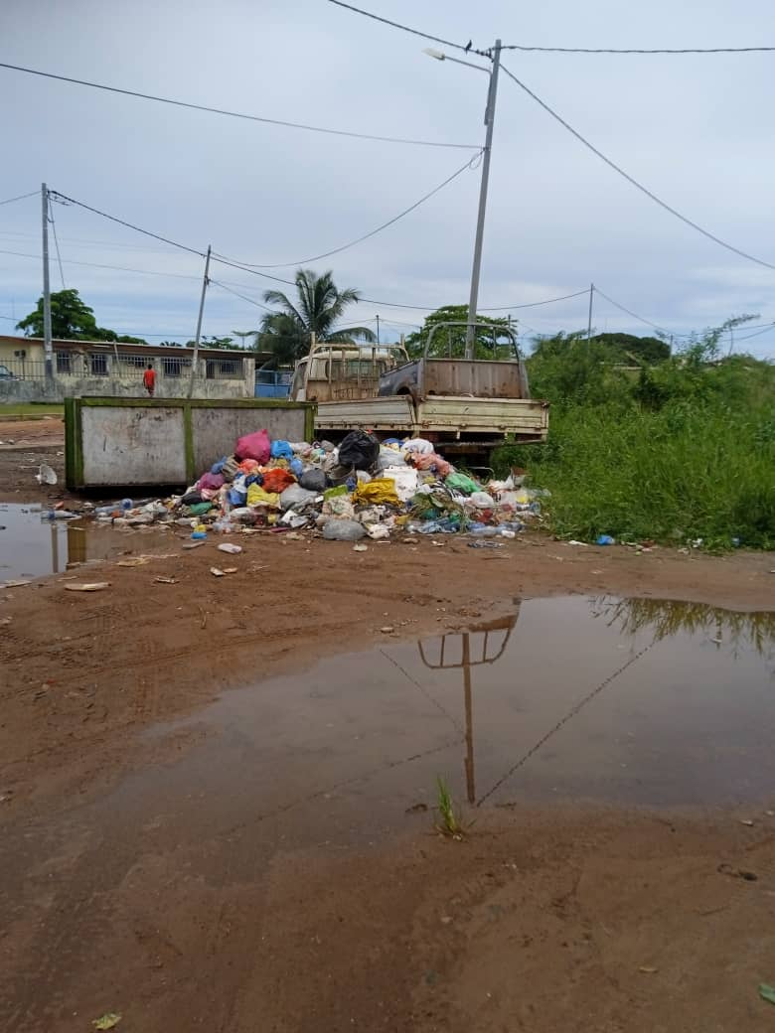 | b) Illegal dump site near a dwelling in the 3rd district  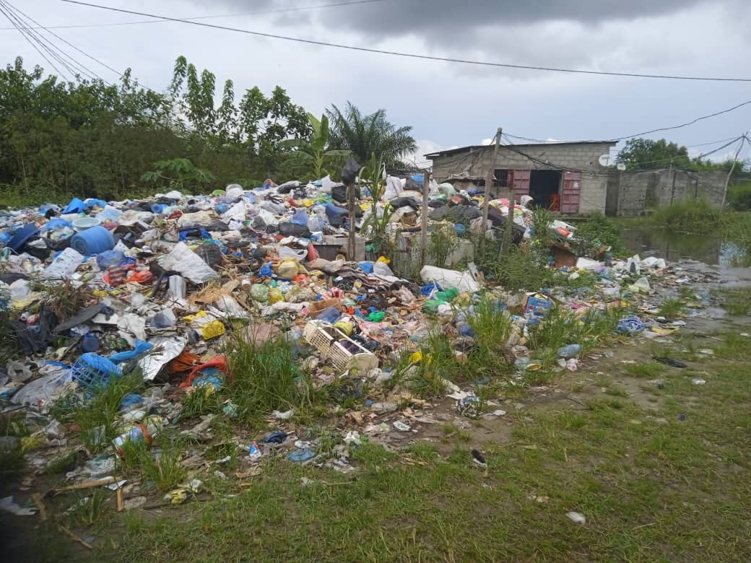
Plate 1. Illegal dumping observed next to a waste bin and a dwelling in various neighborhoods of the 3rd district of Port-Gentil
Indeed, the 3rd district of Port-Gentil has only twenty-five (25) waste bins distributed across an area of 760 hectares—equivalent to roughly one bin for every 30 hectares—a ratio that is clearly insufficient given the needs (Figures 4 and 5). These facilities are mainly installed along major roadways, near markets, shops, and drainage systems. In this context, it is particularly concerning to note that the interior of the Île Mandji neighborhood is served by only one waste bin, due to the inaccessibility of unpaved roads and the swampy nature of the terrain (Figure 5). Thus, while households located near collection points can easily access them, those situated more than 500 meters away face real challenges, undermining the effectiveness of the pre-collection system and encouraging the emergence of illegal dumping sites.
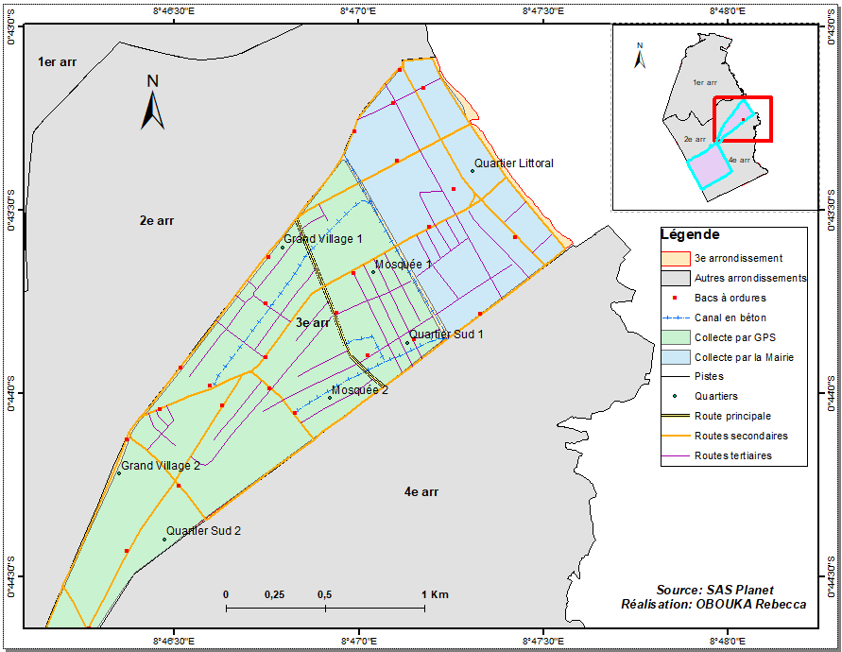
Fig. 4. Distribution of waste bins in the northern part of the 3rd district of the Municipality of Port-Gentil
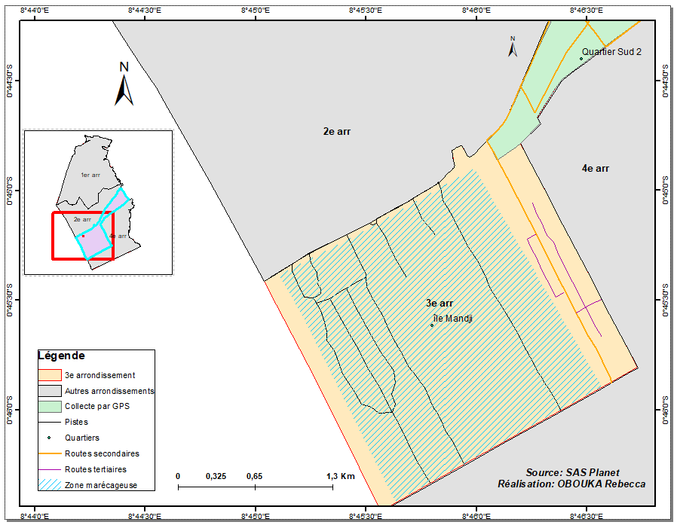
Fig. 5. Île Mandji, an example of a neighborhood located in a swampy area in the southern part of the 3rd district of the Municipality of Port-Gentil
3. DISCUSSION
It is worth recalling that a study conducted by Maganga and Maloba (2022) on land use and environmental changes in Port-Gentil between 1990 and 2017 revealed a significant increase in built-up areas (+3.26%, or 1,742.2 ha) and surface water (+2.35%, or 290 ha), while vegetation and bare soil areas experienced a marked decline (Table 2). These changes reflect growing urban pressure on natural vegetation, whose destruction has contributed to the expansion of swampy zones. Moreover, the continued population growth in Port-Gentil has generated strong demand for buildable land—demand that local authorities, particularly the Cadastre and Urban Planning services, have failed to anticipate or manage effectively. This has led to a proliferation of human settlements on non-buildable land, increasing the vulnerability of populations to flood risks.
Table 2. Quantification of the Rate of Change Between 1990 and 2017 (Maganga et Maloba, 2022)
Land Use Classes | Area (hectares) |  | t2-t1 | Tc (%)
Land Use Classes | 1990 | 2017 | t2-t1 | Tc (%)
Built-up area | 1233,8 | 2976 | 1742,2 | 3,26
Water | 326 | 616 | 290 | 2,35
Bare soil | 1042,7 | 369,8 | -672,9 | -3,83
Vegetation | 8698,5 | 7339,2 | -1359,3 | -0,62
Total | 11301 | 11301

The study reveals disorganized urban development and limited accessibility in certain neighborhoods of Port-Gentil’s 3rd district, reflecting a lack of coherent urban planning. The area's hydro-pedological configuration hinders access to isolated zones and complicates the installation of waste collection facilities. Despite the swampy nature of the southern part of the district (Plate 2), dense human settlement often precedes the development of essential infrastructure.
a) Human settlements in swampy areas  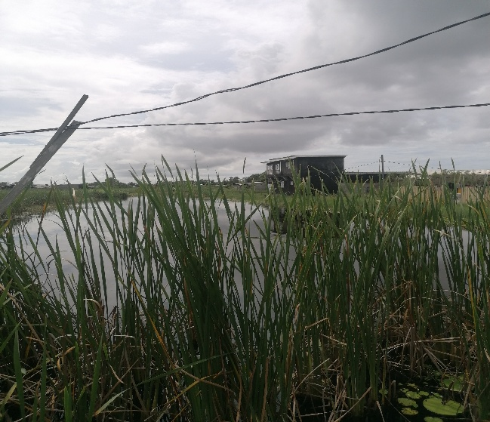 | b) Road in poor condition, located in a swampy environment with low bearing capacity  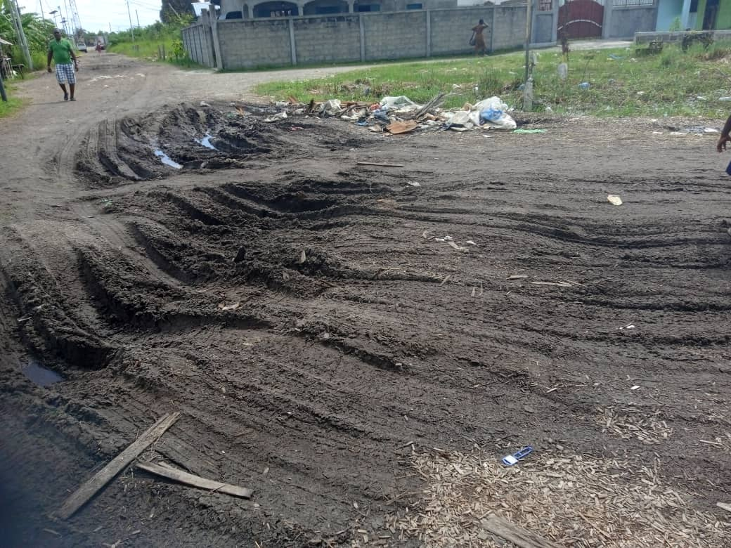
Plate 2. Human settlements (housing and roadways) built in swampy areas designated as non-buildable zones
In certain residential areas of Port-Gentil, rudimentary roads cross wetlands and are covered with wood chips that deteriorate under vehicle weight and the suction effect of rising groundwater. This reflects spontaneous, unplanned urbanization—an unsettling paradox in a petroleum city once seen as an economic Eldorado. It highlights the limits of oil exploitation’s benefits, which failed to anticipate the internal migratory flows driven by the region’s economic appeal.
A comparative analysis of Google Earth satellite images from 2003 and 2025 reveals a major transformation around the Ntchengué landfill (Plate 3). While the area showed minimal human presence in 2003, the 2025 image indicates dense informal urbanization, with over fifty buildings within 300 meters of the site. This growth contradicts planning and health standards, especially given the landfill’s poorly defined boundaries. Some homes even lie within the waste disposal zone, highlighting the lack of coherent urban planning and weak land control mechanisms.
- 2003  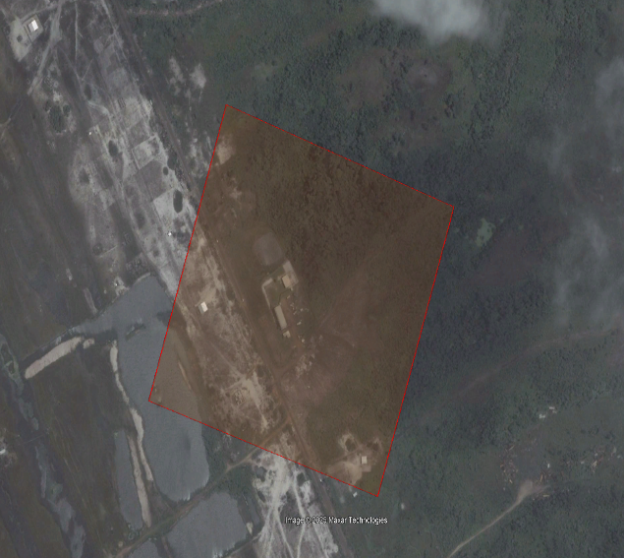 | - 2025  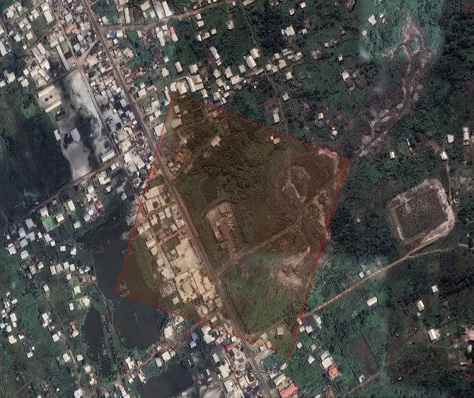
Plate 3. Gradual densification of built-up areas around and within the dumping site zone

- Overview of waste burning practices at Ntchengué, accompanied by a broader view of the surrounding urban expansion  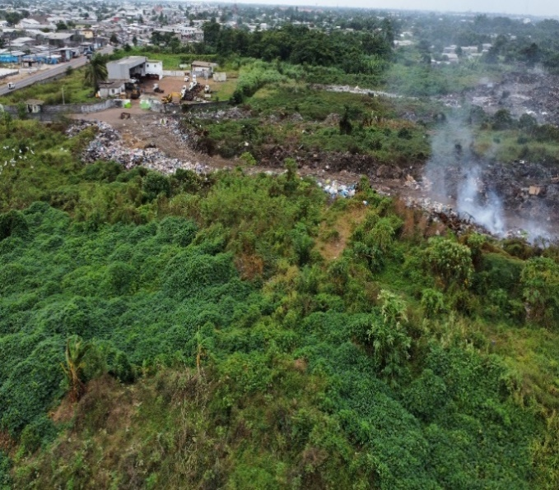 | b) Presence of vulnerable individuals scavenging for recoverable waste near a burning mound at the dumping site  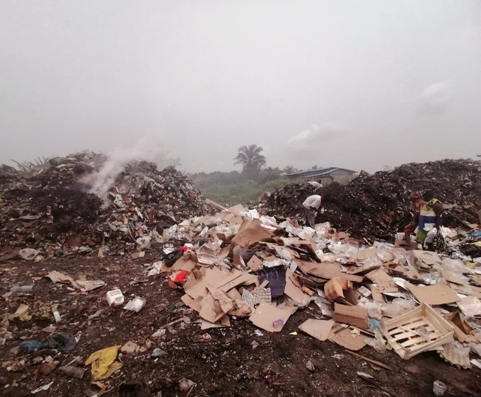
Plate 4. Waste burning and informal recovery of recyclable materials by vulnerable populations at the dumping site
Located about 7 km from downtown Port-Gentil, the Ntchengué landfill (Plate 4) has been operational since the late 1980s, although its exact date of establishment remains unknown. Waste treatment at the site relies primarily on burial and compaction, adjusted to seasonal weather conditions: during the rainy season, waste is temporarily stored at the entrance to prevent trucks from getting stuck, then moved and compacted during the dry season.
The site does not comply with any environmental standards: there is no sorting, recovery, or sealing barrier, despite the sandy soil and a shallow water table (50 to 90 cm). This configuration poses a high risk of groundwater contamination.
In addition to landfill operations, the site also uses incineration for certain types of waste. This practice is often diverted by informal waste pickers who burn electrical cables to extract copper, without supervision or protective equipment. The lack of safety measures on-site facilitates these activities, despite the associated health and environmental risks. Cable burning releases toxic substances such as dioxins and heavy metals, which pose serious health hazards (Diebold & Chollot, 2013). This practice also contributes to air pollution and soil contamination (Njewa et al., 2025; Voltz, 1997).
Although widespread, these practices raise major environmental concerns, particularly regarding leachate management and the control of gas emissions. These issues were clearly illustrated (Figure 6) and analyzed in a recent and impactful article by Njewa et al. (2025).
Fig. 6. Schematic representation of water resource pollution by landfill leachate (Njewa et al., 2025)
Waste management is part of a broader urban planning policy, which includes the organization of urban space and the development of basic infrastructure in neighborhoods. Land use plans are key strategic tools to guide these efforts (Tini, 2003; Hetcheli & Dandonougbo, 2016).
In Gabon, less than 20% of the population has access to household waste collection services, mainly concentrated in planned urban areas. Peripheral neighborhoods, often poorly developed and unsanitary, remain excluded from sanitation systems. Despite widespread issues of pollution and poor hygiene in major cities, data on solid waste management remains limited. Moreover, Maloba et al. (2022) point out that more than sixty years after independence, Gabon still lacks a comprehensive dataset to rigorously analyze the environmental changes driven by social and economic activities across the country.
It is within this context that the present study seeks to modestly contribute to the reflection on how to mitigate the negative impacts of human activities on the physical environment and the health of Port-Gentil’s population. Indeed, the shortcomings observed in waste management within the 3rd district reflect a broader reality affecting the entire city, which is largely composed of under-integrated neighborhoods.
However, this situation reveals a troubling truth: the availability of financial resources does not guarantee coherent urban planning. It highlights the limitations of local governance, which is sometimes disconnected from environmental and social challenges, and calls for a rethinking of urban planning mechanisms based on transparency, competence, and citizen participation.

Figure 7. Evolution of the Initial Budget and the Share Allocated to Household Waste Management, Expressed in Millions of CFA Francs (1996–2024)
Figure 7 shows the evolution of municipal budgets between 1996 and 2024, with approximately 15% allocated to waste management (nearly 2 billion annually). However, over 80% of the 2024 budget is absorbed by payroll costs, leaving little room for investment. This budget distribution helps explain widespread dissatisfaction with the quality of service. This situation calls for a rethinking of the current economic model, with increased investment in infrastructure and greater involvement of underrepresented communities in developing innovative and inclusive solutions.
Although Lanoix and Roy (1976) recommend hygienic waste storage in suitable containers, findings from our survey in Port-Gentil’s 3rd arrondissement indicate that this practice remains marginal. Waste is often stored in open spaces, degraded containers, or plastic bags, with only occasional use of lidded bins. These observations align with those of Tshimanga et al. (2024) in the Democratic Republic of Congo and Mougoue et al. (2021) in Cameroon, where informal storage and disposal in urban areas—such as streets, markets, open drains, waterways, and public spaces—are also widespread.
Several factors explain these practices: the distance to reach waste bins, the low frequency of collection services, and the lack or insufficiency of bins in certain neighborhoods. These constraints push residents to discard waste wherever they can. This haphazard disposal leads to health nuisances, notably the proliferation of flies, which not only produce unpleasant noise but also land on bodies and food, promoting contamination (Mougoue et al., 2021).
Regarding the transportation of waste from collection points to the Ntchengué landfill, the City Hall and the Gabon Propre service have heavy equipment dedicated to this task. However, these resources are insufficient, and most are out of service. It is worth noting that this equipment mainly comes from donations by a French municipality, raising a legitimate question: have local authorities truly committed to implementing an effective household waste management policy? This issue is not isolated. It resonates with the situation in Libreville, which recently received a substantial donation of collection vehicles from the new national authorities as part of efforts to strengthen logistical capacity.
In Port-Gentil, waste treatment methods remain generally rudimentary, relying mainly on landfill and compaction. Similarly, as with major urban dumpsites in African cities such as Lagos (Nigeria) and Nairobi (Kenya), the main sites in Port-Gentil and Libreville remain easily accessible to vulnerable populations. At their own risk, these individuals scavenge through the waste in search of materials that can be reused or repurposed, thus giving them a second life (Omokaro et al., 2024; Mouloungui Kussu et al., 2024).
It must be remembered that sustainable waste management is only one aspect of a broader policy aimed at the harmonious development of the country’s cities, whose key directions should be embedded in the new regime’s societal program. However, at the scale of Port-Gentil, and in light of the observed shortcomings in waste management, we recommend the development and implementation of a local waste management plan. This plan would aim to improve collection and storage systems while exploring avenues for household waste recovery—first in the 3rd district, and later across the entire city.
Designing a household waste management plan requires preliminary studies and precise cartographic mapping. Geographic Information Systems (GIS) offer major advantages in this area: they facilitate spatial issue visualization, enhance territorial understanding, and enable more informed decision-making. Through GIS, stakeholders can locate pre-collection operators, map collection routes, identify voluntary drop-off points, pinpoint priority zones, and target urgent interventions. This approach promotes faster, coordinated, and locally adapted action (Bapandi, 2010; Obouka, 2023).

CONCLUSION
In Gabon, rapid urbanization—largely driven by oil exploitation—has led to disorganized cities marked by deep socio-spatial inequalities and a growing accumulation of solid waste. Waste management remains marginalized, often relegated to the background due to competing budgetary priorities, persistent institutional shortcomings, and a lack of reliable data to guide public policy. In this context, less than 20% of the Gabonese population benefits from waste collection services, which are mainly concentrated in planned urban neighborhoods with basic infrastructure. In contrast, peripheral areas—often unsanitary, poorly served, and difficult to access—are largely excluded from the collection system, exacerbating sanitation and environmental challenges.
The situation is particularly concerning in Port-Gentil, where demographic growth and successive oil crises have weakened public finances and increased pressure on urban services. Despite the scale of the challenge, scientific literature on waste management in Central Africa remains limited. In Gabon, the Master’s program in Environment and Sustainable Development at Omar Bongo University seeks to fill this gap by directing research toward secondary cities, which are often overlooked in national sanitation policies.
This study, conducted in the 3rd district of Port-Gentil, reveals serious shortcomings in household waste management. Local practices are highly inconsistent: some residents use degraded containers, plastic bags, or dispose of waste directly into the environment. These behaviors—also observed in other African cities such as Kalamu (DRC) and Douala (Cameroon)—are driven by structural constraints: long distances to waste bins, low collection frequency, and lack of infrastructure. In response to the inefficiency of official services, informal collectors intervene, sometimes using carts, though their legal status remains unclear. Moreover, most households refuse to pay for waste collection, citing economic hardship, as seen in other cities like Khouribga and Kinshasa.
Waste transport to the Ntchengué landfill is handled by the City Hall and the Gabon Propre service, but the equipment is insufficient and often out of service, mostly acquired through foreign donations. This lack of logistical capacity—already observed in Libreville and Abidjan since the early 2000s—is worsened by deteriorated road conditions, compromising equipment durability. The municipal landfill in Port-Gentil relies on basic treatment methods such as burial and compaction, without prior sorting. This model, similar to that of Mindoubé in Libreville, poses serious environmental risks: leachate pollution, methane emissions, and open access to vulnerable populations who scavenge for reusable materials.
Ultimately, despite abundant oil revenues, waste management in Port-Gentil remains inadequate, revealing the limits of local governance in addressing environmental challenges. The study calls for a rethinking of the current management model, based on transparency, competence, and citizen involvement. It also recommends the development of a local waste management plan, starting in the 3rd district and expanding citywide. This plan should improve collection and storage systems while integrating waste recovery strategies. It relies on the use of Geographic Information Systems (GIS), which enable precise mapping of spatial issues and support informed decision-making. Finally, Obouka (2023) proposes that the plan incorporate five key dimensions: technical, social, economic, political and institutional, and environmental. Implemented over five years—the length of a municipal term—it would allow elected officials to present a clear and transparent report, while strengthening local governance and urban sustainability.

REFERENCES

1. POURTIER, R., & MAGRIN, G. (2012). Geopolitics of oil in Central Africa. Paris: Karthala.
2. ADEOLA, A.O., AKINGBOYE, A.S., ORE, O.T., OLUWAJANA O.A, ADEWOLE A.H., OLOWADE D.B., OGUNYELE A.C. (2022). Crude oil exploration in Africa: socio-economic implications, environmental impacts, and mitigation strategies. Environ Syst Decis 42, 26–50. https://doi.org/10.1007/s10669-021-09827-x
3. AFRICAN CLEAN CITIES PLATFORM (ACCP). (2019). Status of Solid Waste Management in Africa. Japan International Cooperation Agency (JICA). https://africancleancities.org
4. FRENCH INSTITUTE OF INTERNATIONAL RELATIONS (IFRI). (2024). Urban Governance and Spatial Justice in Africa, "Governing the Urban Transition in Africa" ​​Program, Paris: IFRI.
5. CLIMATE CHANCE. (2023). Global Climate Action Observatory - Africa Report, Africa Report. Paris: Climate Chance.
6. UN-HABITAT. (2022). World Cities Report 2022: Envisaging the Future of Cities. Nairobi: United Nations Human Settlements Programme (UN-Habitat).
7. AFRICAN CLEAN CITIES PLATFORM (ACCP). (2019). Status of Solid Waste Management in Africa. Tokyo: JICA.
8. JAPAN INTERNATIONAL COOPERATION AGENCY (JICA). (2022). Urban Development and Waste Management in Sub-Saharan Africa: Challenges and Good Practices. Tokyo: JICA.
9. MBADINGA M. (2000). Elf and Port-Gentil (Gabon). NETCOM: Networks, Communication and Territories / Networks and Communication Studies, vol. 14 no. 3-4, Built Space, New Technologies and Networks, pp. 267-282.
10. MALOBA MAKANGA Jean Damien. (2016/2017). The Problem of Climate Disasters in Gabon: The Case of the Floods in the City of Port-Gentil, IRSH Semiannual Review, no. 19, pp. 37-65.
11. MAGANGA MABIKA, S.T., MALOBA MAKANGA, J.D. (2022). Land Use and Environmental Changes in Port-Gentil from 1990 to 2017. In Geography of Socio-Economic and Environmental Issues in Gabon (pp. 65-95). Paris: Editions l’Harmattan.
12. OBOUKA KOWET, C. R. (2023). Waste Management Issues in the Municipality of Port-Gentil: Case of the 3rd Arrondissement, Master's Thesis in Territorial Planning and Governance (AGT). Libreville: Omar BONGO University.
13. DENSCOMBE, M. (2014). The Good Research Guide: For Small-Scale Social Research Projects (5th Ed.). Maidenhead: Open University Press/McGraw-Hill Education.
14. DE LANDSHEERE, G. (1982). Introduction to Educational Research. Paris: Ed. Armand Colin.
15. YAMANE, T. (1967). Statistics: An Introductory Analysis (2nd ed.). New York: Harper & Row.
16. DIEBOLD, F., CHOLLOT, A. (2013). Chemical Risks Associated with Metal Recovery and Recycling Operations (Scientific and Technical Note NS 308). Paris: National Institute for Research and Safety (INRS).
17. NJEWA, J. B., MWETA, G., SUMANI, J., BISWICK, T. T. (2025). The Impact of Dumping Sites on Air, Soil, and Water Pollution in Selected Southern African Countries: Challenges and Recommendations, Water Emerg. Contam. Nanoplastics, 4, 3. https://dx.doi.org/10.20517/wecn.2024.71
18. VOLTZ, D. (1997). A New Era in Cable Designs and Materials to Resolve Environmental Issues, IEEE Transactions on Industry Applications, Vol. 33, pp. 1321-1330, https://doi.org/10.1109/28.633813.
19. TINI, A. (2003). Household Solid Waste Management in Niamey, Niger: An Essay on a Sustainable Management Strategy, Doctoral Thesis in Civil Engineering. Lyon: National Institute of Applied Sciences (INSA).
20. HETCHELI, F., DANDONOUGBO I. (2016). Problems of Under-Equipment and Sanitation Strategies in Notsè (Togo): Stakeholders and Issues in Urban Service Management, Les Cahiers du CBRST, No. 9, pp. 78–101.
21. MALOBA MAKANGA, J. D., BIGNOUMBA, G-S., EKOMBENG BIYOGO, P. E., LEMBE, A-J. EP. BEKALE., MADEBE, D-D., MAGANGA MABIKA, S. T., et al. (2022). Geography of socio-economic and environmental issues in Gabon. Paris: Editions l’Harmattan.
22. LANOIX, J. N., ROY, M. l. (1976). Sanitary technician's manual. Geneva: World Health Organization.
23. KANKU TSHIMANGA, B., MPIANA MUKANIA, E., MUNENGE BUMBA, A., BOSHIEWA MPAMBATE, D., MABUBU PEMBE, P., MASIKINI BOMBAMU, F., BOMOI MATITA, J., MBO ILENGA, F., KINSONA BOMBILE, S., MATUZEYI KUEDI, T., KANIANGA MULOLO, MBUTU EKUENAKIA B., MBONGU MPETI, D. (2024). Waste management and its impact on the health of the populations of the municipality of Kalamu. International Journal of Progressive Sciences and Technologies (IJPSAT), Vol. 45 No. 1, pp. 591-600.
24. Mougoue, B., Agofak, C. V., Nya, E. L. (2021). Household Waste Management in the Mambanda Neighborhood (Douala, Cameroon): What Sustainable Strategies? European Scientific Journal, Vol. 17, No. 39, pp. 138-156.
25. Omokaro, G. O., Ikioukenigha, M., & Evgenievich, P. V. (2024). Assessing the Environmental and Health Implications of Waste Disposal: A Case Study of Africa's Largest Dumping Site, Journal of Geography, Environment and Earth Science International, 28(5), pp. 16–30.
26. Mouloungui Kus

