Soil Moisture Index (SMI) Estimation using Raw Landsat-8 OLI data, NDVI and Land Surface Temperature for Agricultural Drought Assessment
ABSTRACT
This study outlines the procedure for calculating Soil Moisture Index (SMI) using data from Landsat-8 OLI, along with Land Surface Temperature (LST) and Normalized Difference Vegetation Index (NDVI), both obtained from analysis of thermal imagery from Landsat-8. The satellite data are sourced through the Earth Explorer platform. NDVI and LST serve as fundamental variables in determining SMI. To estimate LST, Band-10 from Thermal Infrared Sensor (TIRS) is use, in combination with Band-4 and Band-5 from Operational Land Imager (OLI). SMI is computed by utilizing both LST and NDVI values. NDVI scores fall within a range of -1 to 1, where negative figures demonstrate absence of vegetation, and positive ones reflect healthy plant cover. The QGIS software is used to calculate LST, NDVI and SMI. LST readings are measured in degrees Celsius. SMI is classified from no drought to extreme drought. Its values span from 0 (representing extreme dry conditions) to 1 (demonstrating extreme wet conditions). Findings affirm that this technique is reliable for estimating SMI using Landsat data, providing an effective method for monitoring agricultural drought conditions.
Keywords: Soil Moisture Index (SMI), LST, Landsat-8 OLI, NDVI.

1. INTRODUCTION
Soil moisture index (SMI) is defined as the proportion of the difference between the current soil moisture and the permanent wilting point to the field capacity, as well as the residual soil moisture content [1]. Soil moisture is the main factor affecting various hydrological, ecological, and agricultural processes [2]. Remote sensing has proven to be effective method for evaluating SM across extensive spatial and temporal scales [3]. A variety of mathematical models have been created for estimating SM, utilizing data from open-access satellite optical sensors, encompassing Landsat as well as Sentinel datasets. These techniques offer practical and economical means of monitoring soil moisture on regional and national scales [3]. There are 3 primary techniques for determining soil moisture: in situ measurements, hydrological modeling, as well as remote sensing [4]. Numerous studies explore soil moisture assessment, employing two primary approaches: spaceborne remote sensing relying on the microwave portion of the electromagnetic spectrum, along with thermal infrared observations. These methods depend on the type of imagery used, microwave, thermal, visible, or infrared, along with radiometric behavior of infrared waves. They also utilize associations between surface temperature and fractional vegetation cover for estimating soil moisture [1,3].
Remote sensing techniques, particularly application of LST, offer a promising alternative for estimating soil moisture on large scales [3]. Calculating soil moisture gives the information to the farmers about water stress, crop yield predictions, drought or waterlogged conditions, and guides water management practices such as irrigation and drainage [5,6]. Soil moisture is important to know the carbon and nitrogen fluxes at the land surface.
Soil moisture is continuously assessed across large areas using remote sensing techniques. In recent years, advancements in these techniques enhance their effectiveness for assessing SMI along with related variables, encompassing LST and NDVI. LST is obtained from thermal radiation, whereas NDVI is determined using specific wavelengths from electromagnetic spectrum, primarily red and near-infrared (NIR) surface reflectance. These approaches are classified as optical and thermal infrared remote sensing methods [4]. Landsat-8 imagery is employed to estimate SMI using both LST and NDVI values. LST is calculated using data from Band 10 of TIRS on Landsat-8, in conjunction with Bands 4 and 5 from OLI [2]. LST is the most important factors in the farming decision making process during the growing seasons [10]. Generally speaking, people are familiar only with temperature and weather forecast information, which are usually obtained through electronic media and weather information provided by Meteorological Climatology and Geophysics Agencies (BMKG). However, Land Surface Temperature (LST) holds significant importance, as it is a key factor influencing global climate change [13].
In-situ soil moisture observations are conducted by collecting 40 surface soil samples to reflect moisture conditions within the study region. SMI is evaluated using thermal remote sensing data, specifically LST. This study primarily aims to determine SMI by utilizing both LST and NDVI values.

2. EXPERIMENTAL METHODS
2.1 Study Area:
This investigation is performed at Rakshasbhuwan (Tamba) village in Taluka Shirur Kasar, District Beed, in MAHARASTRA. The Beed district is situated in the centre of the Chhatrapati Sambhajinagar division of the state between 18⁰ 27̍ and 19⁰ 27̍ North latitude and 74⁰ 49̍ and 76⁰ 44̍ East longitude. From this region, Rakshasbhuwan Tamba is chosen for the current investigation. (Fig.1)
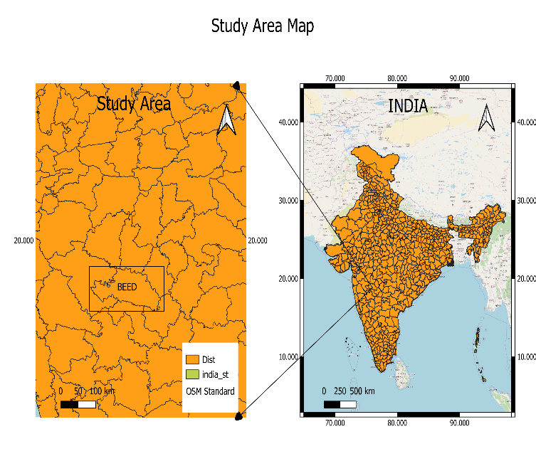Figure 1. Location map of study area in Beed District, Maharashtra State.

2.2 Remote Sensing Satellite Data Used:

Digital data from LANDSAT-8 OLI is acquired through the official website of the United States Geological Survey (USGS, a NASA platform). A NASA American Earth observation satellite called Landsat-8 ensures that the Landsat program will continue to be acquired and made available. It carries two sensor payloads, OLI and TIRS, which together capture data in nine shortwave spectral bands and two longwave thermal bands [2]. USGS Earth Explorer website is utilized to obtain Landsat-8 imagery for the current study. SMI is derived from these images, and the SMI map is generated by employing QGIS version 3.28.2 (Fig.2).
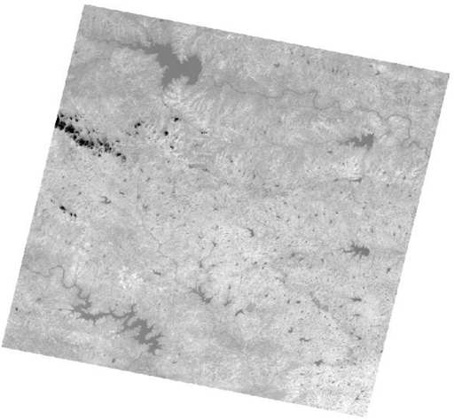
Figure 2. Landsat-8 OLI image covering study area

2.3 Soil Sample Collection:
Soil samples are obtained near-synchronously with Landsat-8 acquisition date. Test fields are covered with maize vegetation, and there is no recorded rainfall in the study area during the sampling period. A Soil samples are taken using a soil auger from a depth of 5cm and they are then safely stored in airtight polythene bags. These samples are then transported to the laboratory and transferred into glass containers. A total of 40 soil samples are obtained from pre-determined sample points within the selected study area. In the laboratory, the samples are oven-dried to ensure consistency for further analysis.
2.4 Soil Moisture Determination using Field Data:
Various techniques are established for determine soil moisture (SM) content, which are categorized into two groups: direct and indirect techniques. While indirect methods use sensors and other factors that affect soil moisture to estimate moisture content, the accuracy of these approaches varies depending on the instrument. Direct methods determine soil moisture by measuring the weight difference of a soil sample before and after drying. Among these methods, the gravimetric method is considered the best and most accurate method for determining soil moisture [2]. In the current investigation, the gravimetric method is used to determine SM content.
This method involves taking soil samples from the field and weighing them afterwards. The samples are placed in a hot-air oven and dried at 105°C for 24hrs. Once fully dried, the samples are weighed again to evaluate their dry weight. SM content is then calculated by employing the following equation (1) [2].
$Soil Moisture=\frac{M_{w}}{M_{s}}*100 \%$ ----------(1)

Here, M_{w} denotes mass of water.
M_{s} represents mass of dry soil.
M_{w} = (weight of wet soil + bowl) – (weight of oven dry soil + bowl)
M_{s} = (weight of oven dry soil + bowl)– (weight of bowl)
Average mean value of SM is calculated from all soil moisture samples.
2.5 Soil Moisture Index (SMI) Estimation:
SMI is evaluated by using LST values. Digital data from Landsat-8 OLI and TIRS is evaluated for estimate LST of study area. Estimation utilizes TIRS Band-10 data along with OLI Band-4 as well as Band-5 data. Characteristics of these bands are displayed in Table-1 [2].
Table-1. Spectral Band characteristics of LANDSAT-8
Band | Resolution(m) |  | Spectral Band | Wavelengths (µm)
4 | 30 | Red |  | 0.630-0.680
5 | 30 |  | Near Infrared | 0.845-0.885
10 | 100 |  | Longwave Infrared | 10.60-11.19

For the calculation of SMI, the steps followed in current investigation are described by (Sutariya et al., (2021) and Tajudin et al., (2021)). Steps are given below:
- Download Satellite image,
- Atmospheric correction of image,
- Digital numbers (DN) are converted to top-of-the atmosphere Spectral radiance values (TOA),
- TOA to at-sensor brightness temperature (BT) conversion,
- Evaluation of NDVI,
- Calculating Proportion of Vegetation (PV),
- By utilizing empirical relationships based on NDVI to evaluate surface emissivity,
- Evaluating LST utilizing simplified version of Plank’s law,
- Calculate SMI using LST values,
Details of major steps are mentioned in following sections:
2.5.1 Top of atmospheric Spectral radiance (TOA):
Selecting Band-10 from Landsat-8 OLI data is the first step in evaluating TOA spectral radiance:
𝐓𝐎𝐀 (𝐋) = 𝐌_{𝐋} ∗ 𝐐_{𝐜𝐚𝐥} + 𝐀_{𝐋} – 𝐐_{𝐢} ----------(2)
Where L denotes Top of Aatmospheric Spectral Radiance, M_{L} denotes the band-specific multiplicative rescaling factor from metadata, Q_{cal} represents the Band 10 image, A_{L} represents the band-specific additive rescaling factor from metadata, and Qi denotes the correction for Band 10.
2.5.2 Conversion of TOA to at-sensor brightness temperature (BT):
Brightness temperature shows the temperature of earth surface as observed from space without any atmospheric interference [14]. BT is calculated using thermal constants from landsat-8 metadata:
$BT=\frac{K_{2}}{\ln\left(\frac{K_{1}}{L}\right)+1}-273.15$ ----------(3)
Here, K₁ and K₂ are band-specific thermal conversion constant from metadata, and L is the TOA spectral radiance to obtain results in Celsius, the radiant temperature is adjusted by adding absolute zero.
2.5.3 Calculation of the Normalized Difference Vegetation Index (NDVI):
The amount of vegetation is estimated using NDVI. Drought conditions are strongly related to the NDVI, that is generated with the help of remote sensing satellite data [9]. NDVI is essential for calculating P_{V}. Surface emissivity (𝜀) must be determined, as it is influenced by P_{V}.
$NDVI=\frac{NIR-RED}{NIR+RED}$ ----------(4)
Where NDVI represents the Normalized Difference Vegetation Index, NIR indicates the near-infrared band (Band 5), and RED indicates the Red” band (Band 4)
2.5.4 Calculation of Proportion of Vegetation (P_{V}):
Proportion of vegetation (Vegetation Fraction) is defined as the percentage of vegetation occurred in the ground area in vertical projection [9]. It is closely related with NDVI values.

$P_{v}={\left[\frac{NDVI-NDVI_{min}}{NDVI_{max}-NDVI_{min}}\right]}^{2}$ ----------(5)

Where, Pv denotes the Proportion of vegetation, NDVI is the Normalized Difference Vegetation Index, NDVI_{min} represents the Minimum value of NDVI and NDVI_{max} represents the Maximum value of NDVI.
2.5.5 Estimating the surface emissivity using an empirical relationship based on the NDVI:
To estimate LST, one needs to know the surface emissivity (E), Since the emissivity (E) is a proportionality factor which scales blackbody radiance (Planck’s law) to predict emitted radiance, and it is the efficiency of transmitting thermal energy across the surface into the atmosphere [9].
The emissivity can be calculated as follows
𝐄 = 𝟎. 𝟎𝟎𝟒 ∗ 𝐏𝐯 + 𝟎. 𝟗𝟖𝟔 ----------(6)
Here, P_{v} denotes the “proportion of vegetation, 0.986 is the correction value for Landsat images.”
2.5.6 Calculating LST using the simplified Plank’s law:
LST is calculated by employing following equation:
$LST=\frac{BT}{\left[1+\left[\frac{λ*BT}{ρ}\right]*ln\left(E\right)\right]}$ ----------(7)
Where, LST denotes land surface temperature, BT represents Brightness temperature, E signifies Land surface emissivity, λ denotes wavelength of emitted radiance (10.895), ρ=1.4388*10⁻² m K
ρ =$\frac{h*c}{σ }$
where c = velocity of light = (2.998 × 10⁸ m/s),
σ = Boltzmann constant = (1.38 × 10⁻²³ J/K),
h = Planck’s constant = (6.626 × 10⁻³⁴ J s) [9].
2.5.7 Calculate Soil Moisture Index (SMI) using LST:
SMI is calculated by using LST values as follows:
$SMI=\frac{LST_{max}-LST}{LST_{max}-LST_{min}}$ ----------(8)
Here, SMI represents soil moisture index, LST_{max} and LST_{min} are maximum and minimum values of LST.
SMI was computed using raster calculator tool within QGIS version 3.28.2. resulting SMI values range from 0-1, where a value of “0” signifies extremely “dry” conditions, while value of “1” corresponds to extremely “wet” conditions.
3. RESULTS AND DISCUSSION
An algorithm is developed in QGIS for evaluating LST by employing Landsat-8 OLI and TIRS data. Band-4 (RED) and Band-5 (NIR) are used for evaluating NDVI, while Band 10 is utilized to estimate BT. Estimation of NDVI and LST depends on useful data for assessing SMI.
NDVI values lies within range of -1 to 1, with negative values demonstrating little to “no vegetation or sparse vegetative cover”, whereas positive values signify “dense and healthy vegetation”. The processed image of Landsat-8 for NDVI of selected study is as shown in fig 3.
LST values are the land surface temperature of selected study area which is measured in ֠C. LST values are varies between a minimum of 17.50 ֠C and a maximum of 35.96 ֠C as shown in fig 4.
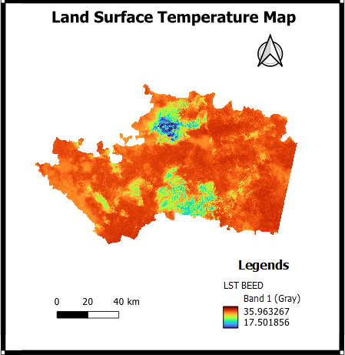
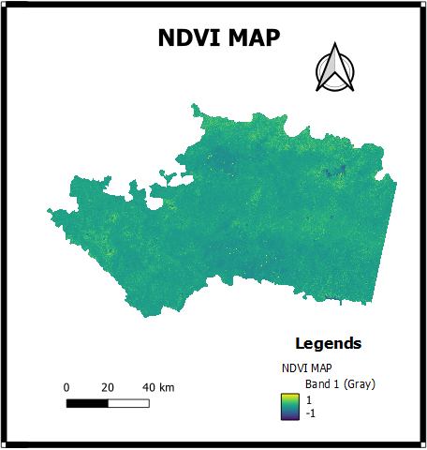
Figure 4. Land Surface Temperature Map

Figure 3. Normalized difference vegetation index (NDVI) map
SMI map is divided into 3 categories: areas with SMI<0.3 are labeled as dry, values ranging from 0.3-0.5 represent moist regions, and those >0.5 are considered wet zones. Regions appearing blue and navy blue indicate dry conditions with SMI values close to 0.3, suggesting significant water scarcity. Aqua and lawn green color denote zones with moderate moisture levels. Green lizard and maroon-colored regions, which reflect SMI values approaching 1, represent wet zones, typically including water bodies or forested lands, and possess highest moisture levels compared to other land types as shown in fig 5.
The raster histogram for Soil Moisture Index (SMI) shows the frequency distribution of pixel values across the entire raster layer values of SMI. Mostly the histogram peaks are in between 0.1 and 0.3, which means most of study area is under dry conditions, indicating possible agricultural drought shown in fig 6. Based on this study, selected area is affected by water deficit, which means it was a dry area. The range of soil moisture values calculated from gravimetric methods are between 10 to 16 vol. % for selected study area.

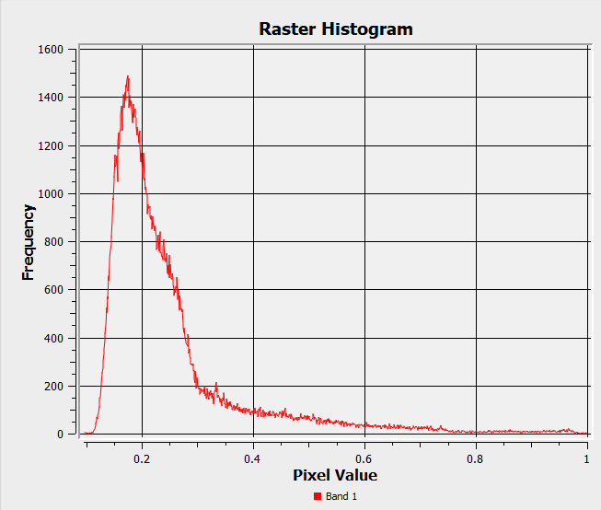
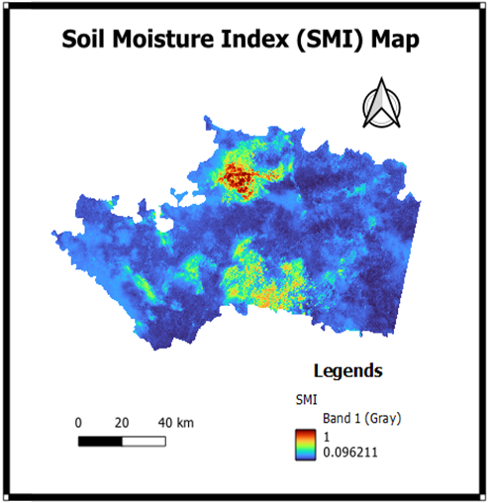
Figure 6. Graphical form of Soil Moisture Index
Figure 5. Soil Moisture Index Map

4. CONCLUSION:
The research objective was to analyse Landsat-8 OLI data for estimating soil moisture index content by employing LST and NDVI in the selected study area. Spatial variation of land surface temperature or SMI throughout research region has been successfully shown via use of remote sensing and GIS. Soil samples have been collected from designated sample points in Rakshasbhuwan (Tamba) village of Shirur kasar Taluka almost simultaneously with the satellite acquisition date. The in-situ soil moisture content was calculated by using the gravimetric method. On the other hand, the study area’s soil moisture index (SMI) shows that certain areas are flooded and others are suffering from drought. Thermal data from Landsat-8 were used to assess LST. The Thermal infrared sensor Band-10, Band-4 and Band-5 have been utilized to assess LST. The results demonstrate that this approach provides a high level of accuracy in evaluating land surface characteristics. Research outcomes of study area shows that the area experienced normal drought conditions. To enhance agricultural productivity, it was deemed necessary to focus on SM conditions.

5. REFERENCES
[1] Saha, A., Patil, M., Goyal, V. C., & Rathore, D. S. (2018, November). Assessment and impact of soil moisture index in agricultural drought estimation using remote sensing and GIS techniques. In Proceedings (Vol. 7, No. 1, p. 2). MDPI.
[2] Sutariya, S., Hirapara, A., Meherbanali, M., Tiwari, M. K., Sıngh, V., & Kalubarme, M. (2021). Soil moisture estimation using Sentinel-1 SAR data and land surface temperature in Panchmahal district, Gujarat State. International Journal of Environment and Geoinformatics, 8(1), 65-77.
[3] Acharya, U., Daigh, A. L., & Oduor, P. G. (2022). Soil moisture mapping with moisture-related indices, OPTRAM, and an integrated random forest-OPTRAM algorithm from Landsat 8 images. Remote Sensing, 14(15), 3801.
[4] Tajudin, N., Ya’acob, N., Ali, D. M., & Adnan, N. A. (2021). Soil moisture index estimation from Landsat 8 images for prediction and monitoring landslide occurrences in Ulu Kelang, Selangor, Malaysia. International Journal of Electrical and Computer Engineering, 11(3), 2101-2108.
[5] Peñuelas, J., Filella, I., Biel, C., Serrano, L., & Save, R. (1993). The reflectance at the 950–970 nm region as an indicator of plant water status. International journal of remote sensing, 14(10), 1887-1905.
[6] Tucker, C. J. (1980). Remote sensing of leaf water content in the near infrared. Remote sensing of Environment, 10(1), 23-32.
[7] Shafian, S., & Maas, S. J. (2015). Index of soil moisture using raw Landsat image digital count data in Texas high plains. Remote Sensing, 7(3), 2352-2372.
[8] Li, B., Ti, C., Zhao, Y., & Yan, X. (2016). Estimating soil moisture with Landsat data and its application in extracting the spatial distribution of winter flooded paddies. Remote Sensing, 8(1), 38.
[9] Twumasi, Y. A., Merem, E. C., Namwamba, J. B., Mwakimi, O. S., Ayala-Silva, T., Frimpong, D. B., ... & Mosby, H. J. (2021). Estimation of land surface temperature from Landsat-8 OLI thermal infrared satellite data. A comparative analysis of two cities in Ghana. Advances in Remote Sensing, 10(4), 131-149.
[10] Lin, L., Di, L., Zhang, C., & Guo, L. (2023). The global land surface temperature change in the 21st century—A satellite remote sensing based assessment. IEEE Journal of Selected Topics in Applied Earth Observations and Remote Sensing, 17, 1756-1764.
[11] Esch, S., Korres, W., Reichenau, T. G., & Schneider, K. (2018). Soil moisture index from ERS-SAR and its application to the analysis of spatial patterns in agricultural areas. Journal of Applied Remote Sensing, 12(2), 022206-022206.
[12] Sobrino, J. A., Jiménez-Muñoz, J. C., & Paolini, L. (2004). Land surface temperature retrieval from LANDSAT TM 5. Remote Sensing of environment, 90(4), 434-440.
[13] Rahmahalim, M., Ramdani, F., & Rusydi, A. N. (2020, November). Design and development of land surface temperature calculation plugin of QGIS. In Proceedings of the 5th International Conference on Sustainable Information Engineering and Technology (pp. 206-212).
[14] Kshetri, R., & Dahal, D. (2024). Estimation of Land Surface Temperature (LST) and Soil Moisture Index (SMI) using Satellite Image: A Case Study in Bharatpur Municipality, Chitwan, Nepal.
[15] Youssef, N. M., El Moustafa, A. M., Gad, M. A., & Elleithy, D. M. (2022). Soil moisture estimation using Land Surface Temperature in the Northwestern coast of Egypt. Int. Res. J. Eng. Technol, 9(12), 1560-1569.
[16] Jimenez-Munoz, J. C., Sobrino, J. A., Skoković, D., Mattar, C., & Cristobal, J. (2014). Land surface temperature retrieval methods from Landsat-8 thermal infrared sensor data. IEEE Geoscience and remote sensing letters, 11(10), 1840-1843.
[17] Jimenez-Munoz, J. C., Cristobal, J., Sobrino, J. A., Sòria, G., Ninyerola, M., & Pons, X. (2008). Revision of the single-channel algorithm for land surface temperature retrieval from Landsat thermal-infrared data. IEEE Transactions on geoscience and remote sensing, 47(1), 339-349.
[18] Amani, M., Parsian, S., MirMazloumi, S. M., & Aieneh, O. (2016). Two new soil moisture indices based on the NIR-red triangle space of Landsat-8 data. International Journal of Applied Earth Observation and Geoinformation, 50, 176-186.
[19] Zhang Feng, Z. F., Zhang LiWen, Z. L., Shi JingJing, S. J., & Huang JingFeng, H. J. (2014). Soil moisture monitoring based on land surface temperature-vegetation index space derived from MODIS data.
[20] Wagner, W., Lemoine, G., & Rott, H. (1999). A method for estimating soil moisture from ERS scatterometer and soil data. Remote sensing of environment, 70(2), 191-207.

