Heavy Metal pollution assessment in the surface water of Ameenpur Lake, Hyderabad, India by using water pollution indices approach.

Abstract

Heavy metals pose serious health hazards to aquatic organisms because of their ability for bioaccumulation and bio-magnification, that affect human health through coming in direct or indirect contact. Due to the irreversible effect of heavy metal on the aquatic ecosystems they have gained lots of attention as they damage human health (Chowdhury et al., 2016; Ali et al., 2016) as they lead to carcinogenic, teratogenic effects and multiple organ damage (Tchounwou et al., 2012). In the present study, the lake water quality in terms of heavy metal pollution was assessed using the heavy metal pollution index (HPI) during the Pre-Monsoon, Monsoon and Post-Monsoon seasons of the year 2019-20. The water quality assessment was done using Heavy metal such as Arsenic (As), Cadmium (Cd), Chromium (Cr), Copper (Cu), Lead (Pb), Mercury (Hg) and Iron (Fe). The results indicated that the concentrations of Cd, Cu, Fe and Hg are high in all three seasons. The results of the Heavy metal pollution index (HPI) of the all three seasons indicate that the HPI was high during the monsoon season. Using the ArcGIS 10.8.1 software, the spatial distribution maps have been prepared for the HPI for all the three seasons. The deteriorating quality of water may be due to the urbanization around the lake, surface and agricultural runoff and discharge of untreated sewage and industrial effluent which can directly and indirectly affect the biodiversity too. Therefore, it is important to protect and manage the Ameenpur Lake.

Keywords: Ameenpur Lake, Heavy metal, heavy metal pollution index, Biodiversity, water quality.

1.0 INTRODUCTION

Heavy metals are known to cause serious environmental problem as well as affect the human health and aquatic biodiversity (Ghosh and Vass., 1997; Das, et al., 1997). The various sources for the heavy metal pollution are mining, untreated industrial effluents containing toxic metals (Amman, et al., 2002) from various industries, like battery industries, steel plants and tannery. Other sources of heavy metal pollution are the use of fertilizers and pesticides containing these toxic metals (Lantzy and Mackenzie., 1979; Nriagu., 1979; Ross., 1994). Elements such as Fe, Ni, Cu and Mn are needed as micro-nutrients for many life processes in both micro-organisms and plants, while other heavy metals like Pb, Cr, Cd, Hg etc., are known to have no physiological activity, but are detrimental in many ways (Marschner., 1995; Bruins, et al., 2000). Due to the irreversible effect of heavy metal on the aquatic ecosystems has gained lots of attention as they damage human health (Chowdhury et al., 2016; Ali et al., 2016) as they lead to carcinogenic, teratogenic effects and multiple organ damage (Tchounwou et al., 2012). A lot of attention has been given to the assessment of heavy metals in both surface and groundwater, which brought in the need for the Heavy Metal Pollution Index (HPI) (Reddy., 1995; Mohan et al., 1996) using several water quality parameters. For the monitoring of quality of water, numerous studies have been reported mentioning the usefulness of remote sensing (Ritchie and Charles., 1996; Dekker et al., 2002 and Schalles et al., 1998a.b).

2.0 MATERIALS AND METHODOLOGY

Study Area

Ameenpur Lake is on the north western fringes of Hyderabad (17° 31.198’N, 78° 19.524’E) situated in Patancheru Mandal, Sangareddy District, Telangana State, India, covering an area of 93.15 Acres (0.38 Sq. km) (Sy.No-231- Shikam Land) and is a man-made lake that was declared as the Biodiversity Heritage Site in 2016 by the National Biodiversity Authority. It is the only urban lake to be declared as a Biodiversity Heritage Site. Even though with small size (93.15 Acres/0.38 Sq. km) and unpredictable nature, this Ameenpur Lake is known to harbour novel, rare and/or threatened fauna and their resting stages, thus acting as “local nature reserve” or “hotspot” (Srinidhi et al., 2021)

Sampling and Analysis

Collection, Stabilization, Storage of Samples and transportation to laboratory were conducted according to the recommendations of Central Pollution Control Board (CPCB, 2008). A total of thirty nine water samples were collected during the pre-monsoon, monsoon and post-monsoon seasons of the year 2019-20 and analysed for heavy metals such as Mercury (Hg), Lead (Pb), Cadmium (Cd), Chromium (Cr), Arsenic (As), Copper (Cu) and Iron (Fe). The samples were then analysed as per the Standard Methods for Examination of Water and Wastewater (APHA, 2017 23rd edition). The obtained values were then compared with BIS 2012.The details of the locations are given in Table 1 and shown in Fig 1. The heavy metal pollution index was assessed.

Calculation of Heavy Metal Pollution Index

The proposed HPI was developed by assigning a rating or weightage (Wi) for each selected parameter (El-Hamid, H. T. A et al., 2017, Prasad, B., Kumari et al., 2014, Saleh, H. N. et al., 2019, Mativenga, P. T. et al.,2018 and Tiwari, A. K et al.,2015). The rating value is between zero and one, expressing the individual quality replicating the relative importance. For each parameter, it is inversely proportional to recommended standard (Si). According to the WHO guidelines, the permissive value for drinking water (Si) and maximum desirable value (Ii) were taken. The HPI is expressed by equation (1) and (2) as follows

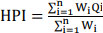
(1)

(2)
“Qi” = sub index of the ith parameter.
“Wi” is the unit weightage of ith parameter,
“n” is the number of parameters considered.
Mi = monitored value of heavy metal of ith parameter,
Ii = ideal value of ith parameter
“Si” is the standard value of the ith parameter, in mg/L.
The sign (−) indicates the numerical differences of the two values, ignoring the algebraic sign.

A modified scale given by Edet and Offiong (2002) has been used in the present study. The classes have been demarcated as low (<15), medium (15–30), and high (>30). For the drinking water purpose, this index was proposed (Singh, Gurdeep & Kamal, Rakesh Kant., 2016). Using the ArcGIS 10.8.1 software, the spatial distribution maps have been prepared for the HPI for all the three seasons.

Table 1: Details of the Sample Location points of Ameenpur Lake
S.No | Sample No. | Location | Latitude | Longitude
1 | S1 | Opp. Saibaba Temple | 17.524 | 78.3252
2 | S2 | Kattamaisamma Temple Steps | 17.5225 | 78.3258
3 | S3 | Rock Area | 17.519 | 78.3285
4 | S4 | Fisherman’s Point | 17.520 | 78.3319
5 | S5 | Mid Lake | 17.522 | 78.3319
6 | S6 | Bird Watching Point | 17.5213 | 78.335
7 | S7 | Industry Inlet | 17.5216 | 78.3422
8 | S8 | Sewage Inlet | 17.5217 | 78.3409
9 | S9 | Renuka Temple Backside | 17.5247 | 78.336
10 | S10 | Opp. to fisherman’s point | 17.5246 | 78.3308
11 | S11 | Transformers Line | 17.5258 | 78.3283
12 | S12 | Agricultural Fields | 17.525 | 78.3272
13 | S13 | Outlet | 17.52208 | 78.3255

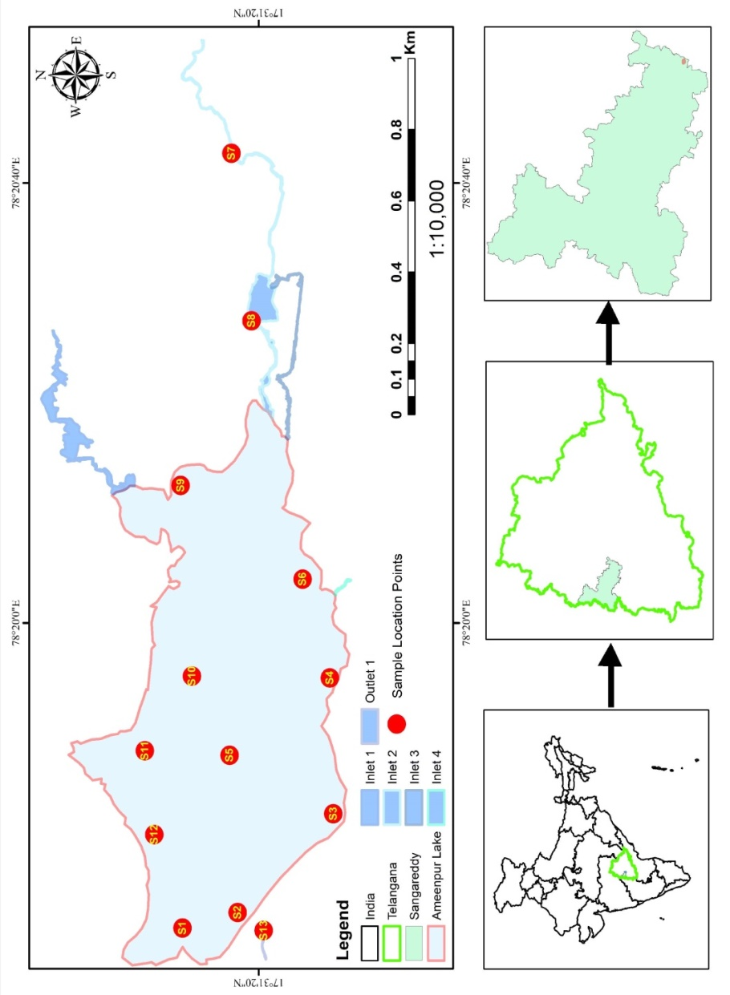

Fig 1: Map showing Sample Location points in Ameenpur Lake

3.0 RESULTS AND DISCUSSION

The results of the assessment of heavy metals are shown in Table 2. The results indicated that the concentrations of Cd, Cu, Fe and Hg are high in all three seasons.

3.1 Concentration of Arsenic (As)

The values for the PRM and POM ranged in between <0.001 to <0.01 ppm. During the MON, the values ranged in between <0.001 to 0.008 ppm. According to the BIS, 2012 the standard value for the Arsenic is 0.05 ppm. In all the three seasons, the values were found to be within the acceptable limits.

3.2 Concentration of Cadmium (Cd)

According to the BIS, 2012 the standard value for the Cadmium is 0.01 ppm. During the PRM the values ranged in between <0.01 to 0.02 ppm. Sample S7 and S8 were found to be exceeding the acceptable limits. During the MON, the values ranged in between <0.01 to 0.031 ppm. Except Sample S4, S5, S9 to S11 were found to be within the acceptable limits. All other samples were exceeding the acceptable limits. During the POM, the values ranged in between <0.01 to 0.08 ppm. Except Sample S4, S5, S9 to S11 were found to be within the acceptable limits. All other samples were exceeding the acceptable limits. Sources of Cadmium are industrial effluents like e-waste and batteries, production of zinc, pesticide fertilizer (Alluri et al., 2007), paint sludge, incinerations and fuel combustion (Rashmi Verma and Pratima Dwivedi., 2013; Uchechi et al., 2025; Meenakshi Sahu and Pallabi Dutta (2020); Boratkar et al., 2025; Ibama, et al., 2025; Uddin et al., 2025).

3.3 Concentration of Copper (Cu)

According to the BIS, 2012 the standard value for the Copper is 0.05 ppm. During the PRM the values ranged in between 0.03 to 0.1 ppm. Sample S7, S8, S9, S10 and S14 were found to be exceeding the acceptable limits. During the MON, the values ranged in between 0.03 to 0.17 ppm. Except Sample S1, S4 and S3 all other samples were found to be exceeding the prescribed limits. During the POM, the values ranged in between 0.05 to 0.21 ppm. Except Sample S1 and S4, all other samples were found to be exceeding the acceptable limits. The maximum acceptable concentration of Cu (II) in drinking water is 1.5 mg/L by WHO (Rao CS., 1992). The sources of Copper (Cu) are electroplating, mining and smelting operations (Rashmi Verma and Pratima Dwivedi., 2013; Uchechi et al., 2025; Meenakshi Sahu and Pallabi Dutta (2020); Boratkar et al., 2025; Ibama, et al., 2025; Uddin et al., 2025)

3.4 Concentration of Chromium (Cr)

According to the BIS, 2012 the standard acceptable value for the Chromium is 0.05 ppm. During the PRM the values ranged in between <0.01 to 0.03 ppm. During the MON, the values ranged in between <0.01 to 0.045 ppm. During the POM, the values ranged in between <0.01 to ppm. All the samples in all the three seasons were found to be within the acceptable limits.

3.5 Concentration of Iron (Fe)

According to the BIS, 2012 the standard acceptable value for the Iron is 0.3 ppm. During the PRM the values ranged in between 0.3 to 0.6 ppm. Except Sample S3 all the samples were found to be exceeding the acceptable limits. During the MON, the values ranged in between 0.2 to 0.5 ppm. Except Sample S1, S3 to S6, S10, S12 and S14, all other samples were found to be exceeding the prescribed limits. During the POM, the values ranged in between 0.3 to 0.63 ppm. Except Sample S3, S4, S6 and S12, all other samples were found to be exceeding the acceptable limits. The high concentration of Fe could be attributed to the run off from agricultural fields and rocks.

3.6 Concentration of Lead (Pb)

According to the BIS, 2012 the standard acceptable value for the Lead is 0.1 ppm. During the PRM, the values ranged in between <0.001 to 0.04 ppm. During the MON, the values ranged in between <0.001 to ppm. During the POM, the values ranged in between <0.001 to 0.06 ppm. All the samples in all the three seasons were found to be within the acceptable limits.

3.7 Concentration of Mercury (Hg)

According to the BIS, 2012 the standard acceptable value for the Mercury is 0.001 ppm. During the PRM the values ranged in between <0.0001 to 0.001 ppm. All the samples were found to be within the acceptable limits. During the MON, the values ranged in between <0.0001 to 0.0027 ppm. Except Sample S3, S6, S8 and S12, all other samples were found to be within the acceptable limits. During the POM, the values ranged in between <0.001 to 0.003 ppm. Except Sample S3, S6 and S8, all other samples were found to be within the acceptable limits. Sources of Mercury pollution are electrical appliances, hospital wastes and Chlor-alkali plants etc., (Rashmi Verma and Pratima Dwivedi, 2013).

The HPI of the three seasons were analysed for all the three seasons and are shown in table 2. The HPI values were classified based on the Eden and offiong (2002). The results of the HPI values indicate that 38% of the samples were in the category of Low (<15) and 62% were in the category of high (>30) during the PRM. During the MON season, 23% of the samples were found to be in the low category and the remaining 77% were found to be under the high category. In the POM, 31% of the samples were in the low category whereas the remaining 69% were in the high category. The spatial distribution of the HPI and the sample locations of all the three seasons are shown in table 2 and from Fig 2, Fig 3 and Fig 4 of PRM, MON and POM values of heavy metals respectively.

Table 2: Heavy Metal Analysis of water samples for all three seasons (All values in ppm)

S.No | Name of the Location | Season | Cd | Cr | Pb | Cu | Fe | Hg | As | HPI
BIS 2012 |  | Season | 0.01 | 0.05 | 0.1 | 0.05 | 0.3 | 0.001 | 0.05 | HPI
S1 | Opp Sai Baba Temple | Pre | <0.01 | 0.02 | <0.001 | 0.04 | 0.5 | <0.0001 | <0.001 | 0
S1 | Opp Sai Baba Temple | Mon | 0.011 | 0.032 | <0.001 | 0.05 | 0.3 | <0.0001 | <0.001 | 34
S1 | Opp Sai Baba Temple | Post | 0.013 | 0.035 | <0.001 | 0.05 | 0.4 | <0.0001 | <0.001 | 34
S2 | Kattamaisamma Temple Steps | Pre | 0.01 | <0.01 | 0.01 | 0.05 | 0.5 | <0.001 | <0.01 | 34
S2 | Kattamaisamma Temple Steps | Mon | 0.012 | <0.01 | 0.011 | 0.1 | 0.35 | <0.001 | <0.01 | 34
S2 | Kattamaisamma Temple Steps | Post | 0.03 | <0.01 | 0.016 | 0.18 | 0.41 | <0.001 | <0.01 | 34
S3 | Rock Area | Pre | 0.01 | 0.01 | 0.03 | 0.04 | 0.3 | <0.001 | <0.001 | 34
S3 | Rock Area | Mon | 0.014 | 0.029 | 0.045 | 0.07 | 0.2 | 0.0027 | <0.001 | 91
S3 | Rock Area | Post | 0.015 | 0.03 | 0.04 | 0.1 | 0.3 | 0.003 | <0.001 | 91
S4 | Fisherman's Point | Pre | <0.01 | 0.015 | 0.02 | 0.03 | 0.4 | <0.001 | <0.01 | 0
S4 | Fisherman's Point | Mon | 0.01 | 0.02 | 0.03 | 0.03 | 0.3 | <0.001 | <0.01 | 34
S4 | Fisherman's Point | Post | 0.01 | 0.03 | 0.03 | 0.05 | 0.3 | <0.001 | <0.01 | 34
S5 | Mid Lake | Pre | <0.01 | <0.01 | 0.01 | 0.05 | 0.4 | <0.001 | <0.01 | 0
S5 | Mid Lake | Mon | <0.01 | <0.01 | 0.03 | 0.06 | 0.3 | <0.001 | <0.01 | 0
S5 | Mid Lake | Post | <0.01 | <0.01 | 0.03 | 0.08 | 0.39 | <0.001 | <0.01 | 0
S6 | Bird Watch Point | Pre | 0.01 | 0.02 | 0.02 | 0.05 | 0.45 | <0.001 | <0.001 | 34
S6 | Bird Watch Point | Mon | 0.012 | 0.021 | 0.02 | 0.07 | 0.3 | 0.0014 | <0.001 | 91
S6 | Bird Watch Point | Post | 0.012 | 0.03 | 0.03 | 0.07 | 0.3 | 0.0014 | <0.001 | 91
S7 | Industry Inlet (Surya Nilayam Point) | Pre | 0.02 | 0.01 | 0.01 | 0.09 | 0.5 | <0.001 | <0.01 | 34
S7 | Industry Inlet (Surya Nilayam Point) | Mon | 0.031 | 0.029 | 0.018 | 0.17 | 0.4 | <0.001 | <0.01 | 34
S7 | Industry Inlet (Surya Nilayam Point) | Post | 0.08 | <0.01 | 0.03 | 0.21 | 0.46 | <0.001 | <0.01 | 33
S8 | Sewage Inlet (Kukka Lying Point) | Pre | 0.02 | 0.03 | 0.02 | 0.08 | 0.4 | <0.001 | <0.01 | 34
S8 | Sewage Inlet (Kukka Lying Point) | Mon | 0.027 | 0.045 | 0.027 | 0.1 | 0.4 | 0.0012 | 0.008 | 92
S8 | Sewage Inlet (Kukka Lying Point) | Post | 0.03 | 0.04 | 0.03 | 0.12 | 0.4 | 0.0014 | <0.01 | 91
S9 | Renuka Temple Backside | Pre | 0.01 | <0.01 | 0.03 | 0.09 | 0.5 | <0.001 | <0.01 | 34
S9 | Renuka Temple Backside | Mon | 0.01 | <0.01 | 0.04 | 0.1 | 0.4 | <0.001 | <0.01 | 34
S9 | Renuka Temple Backside | Post | 0.01 | <0.01 | 0.06 | 0.14 | 0.55 | <0.001 | <0.01 | 34
S10 | Opp to fisherman point | Pre | <0.01 | <0.01 | 0.04 | 0.1 | 0.4 | <0.001 | <0.01 | 0
S10 | Opp to fisherman point | Mon | <0.01 | <0.01 | 0.05 | 0.1 | 0.3 | <0.001 | <0.01 | 0
S10 | Opp to fisherman point | Post | <0.01 | <0.01 | 0.06 | 0.14 | 0.52 | <0.001 | <0.01 | 0
S11 | Transformers Line | Pre | <0.01 | <0.01 | 0.02 | 0.05 | 0.6 | <0.001 | <0.01 | 0
S11 | Transformers Line | Mon | <0.01 | <0.01 | 0.021 | 0.08 | 0.5 | <0.001 | <0.01 | 0
S11 | Transformers Line | Post | <0.01 | <0.01 | 0.025 | 0.1 | 0.63 | <0.001 | <0.01 | 0
S12 | Agricultural Fields | Pre | 0.01 | 0.02 | 0.02 | 0.05 | 0.4 | <0.0001 | <0.001 | 34
S12 | Agricultural Fields | Mon | 0.017 | 0.021 | 0.02 | 0.05 | 0.3 | 0.0014 | <0.001 | 91
S12 | Agricultural Fields | Post | 0.02 | 0.025 | 0.03 | 0.07 | 0.3 | <0.001 | <0.001 | 1
S13 | Outlet | Pre | 0.01 | <0.01 | 0.01 | 0.08 | 0.45 | <0.001 | <0.01 | 34
S13 | Outlet | Mon | 0.021 | 0.01 | 0.01 | 0.15 | 0.3 | <0.001 | <0.01 | 34
S13 | Outlet | Post | 0.03 | <0.01 | 0.016 | 0.18 | 0.41 | <0.001 | <0.01 | 34

4.0 CONCLUSION

Arsenic values in all the three seasons were found to be within the acceptable limits. Cadmium was found to be high in 15% Samples of PRM. During the MON and POM, 70% Sample were found to be within the acceptable limits. 38% samples of PRM were found to be exceeding the acceptable limits of cadmium. During the MON and POM, 23% and 84% samples respectively were found to be exceeding the acceptable limits Chromium was found to be within the acceptable limits in all the samples. Concentration of Iron was found to be exceeding the acceptable limits in 92% samples of PRM, 53% samples of MON, and 30% of POM. Lead was found to be within the acceptable limits in all the samples. Mercury was found to be within the acceptable limits during PRM. Whereas 69% samples of MON and 23% samples of POM were found to be exceeding the acceptable limits. The results of the HPI values indicate that 38% of the samples were in the category of Low (<15) and 62% were in the category of high (>30) during the PRM. During the MON season, 23% of the samples were found to be in the low category and the remaining 77% were found to be under the high category. In the POM, 31% of the samples were in the low category whereas the remaining 69% were in the high category.
The investigation generated some important baseline data on the pollution status of the Lake. These data would be helpful in planning for future policy decisions on better conservation and management of the precious biodiversity in the world heritage site of India.

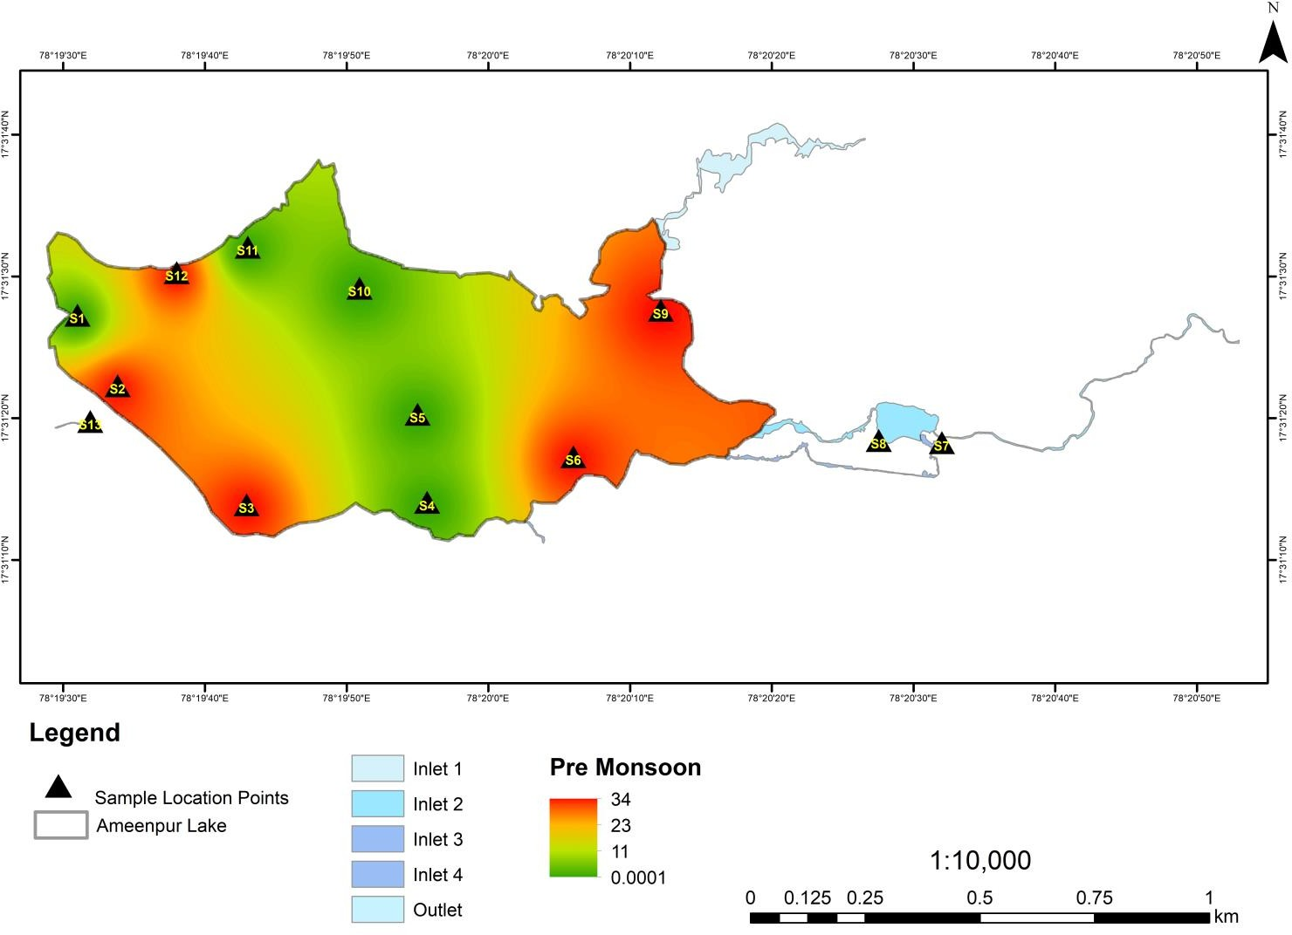
Fig 2: Heavy Metal Pollution Index of PRM Season 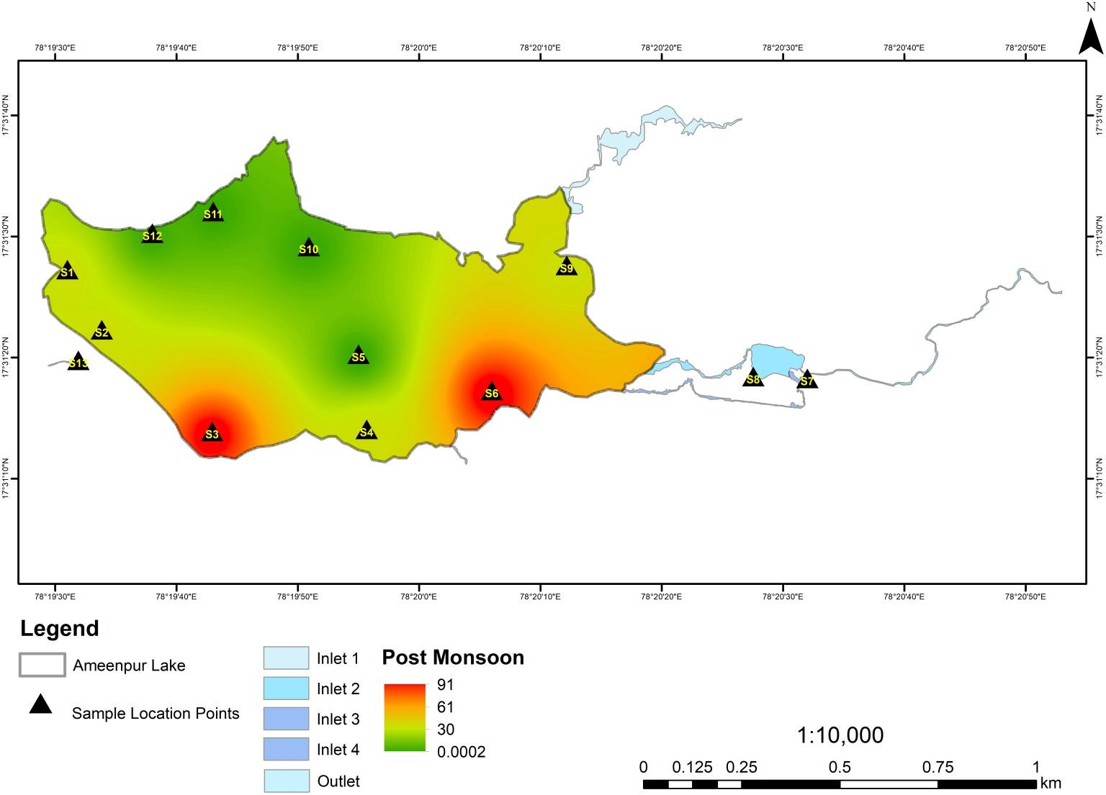

Fig 3: Heavy Metal Pollution Index of MON Season
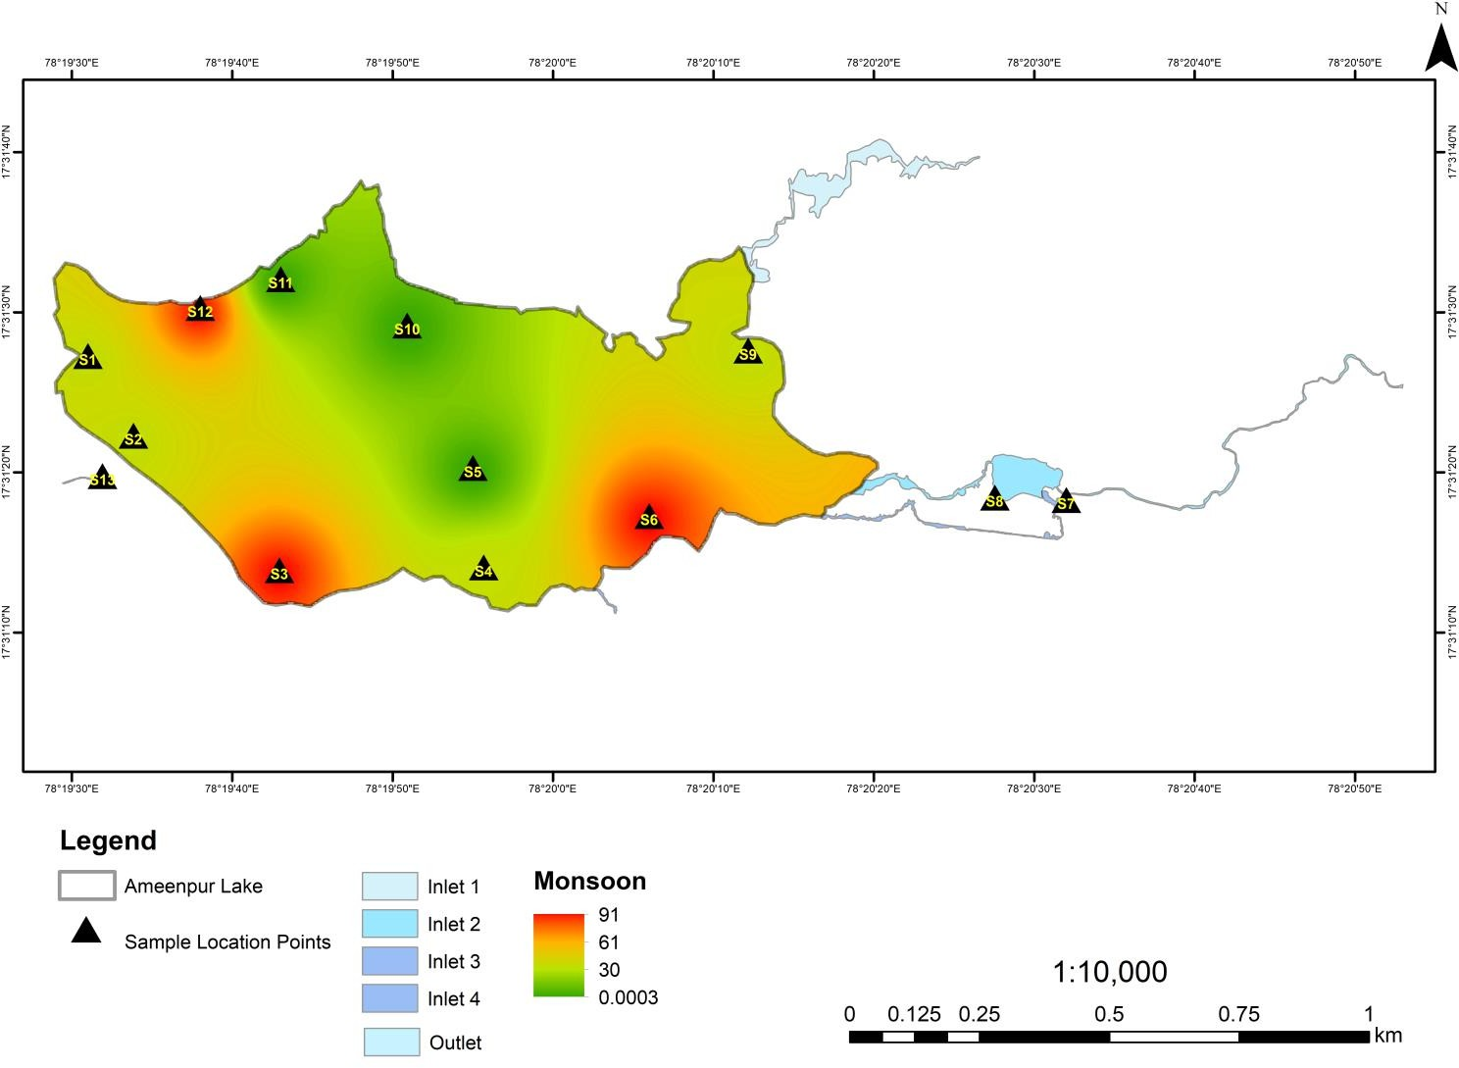

Fig 4: Heavy Metal Pollution Index of POM Season
REFERENCE

- Ali, M.M., Ali, M.L., Islam, M.S., Rahman, M.Z. Preliminary assessment of heavy metals in water and sediment of Karnaphuli River. Bangladesh. Environ. Nanotechnol. Monit. Manag 5, 27e35, 2016.
- Alluri, H.K., S.R. Ronda, V.S. Settalluri, J.S. Bondili, V. Suryanarayana and P. Venkateshwar,. Biosorption: an eco-friendly alternative for heavy metal removal. African Journal of Biotechnology, from hydrochloric acid solutions. Journal of Alloys 6(25): 2007, pp. 2924-2931.
- Amman, A. A.; Michalke, B.; Schramel, P. Speciation of heavy metals in environmental water by ion chromatography coupled to ICP-MS. Anal. Biochem., 372, 2002, pp. 448-452.
- Bruins, M. R.; Kapil, S.; Oehme, F. W. Microbial resistance to metals in the environment. Ecotox. Environ. Safe. 45, 2000, pp. 198-207.
- Chowdhury, S., Mazumder, M.A., Alattas, O., Husain, T. Heavy metals in drinking water: occurrences, implications, and future needs in developing countries. Sci Total Environ 2016, pp. 569- 570, 476e488.
- CPCB. 2008. Guideline for water quality management. Central
- Das, R. K.; Bhowmick, S.; Ghosh, S. P.; Dutta, S., Coliform and fecal coliform bacterial load in a stretch of Hooghly, in K. K Vass and M. Sinha, (Eds.), Proceedings of the National seminar on changing perspectives of inland fisheries, Inland Fisheries Society of India, Barrackpore, 1997.
- Dekker, A.G., Vos, R.J., and Peters, S.W.M. Analytical algorithms for lake water TSM estimation forretrospective analyses of TM and SPOT sensor data. Int. J. of Remote Sensing. 23, 2002, pp. 15-35.
- Edet, A.E. and Offiong, O.E., Evaluation of Water Quality Pollution Indices for Heavy Metal Contamination Monitoring. A Study Case from Akpabuyo-Odukpani Area, Lower Cross River Basin (Southeastern Nigeria). Geomicrobiology Journal, 57, 2002, pp. 295- 304.
- El-Hamid, H. T. A., & Hegazy, T. A. Evaluation of Water Quality Pollution Indices for Groundwater Resources of New Damietta, Egypt. MOJ Ecology Environmental Science. Vol. 2, No 6, 2017, p. 00045.
- Ghosh, S.; Vass, K. K., Role of sewage treatment plant in Environmental mitigation. K. K. Vass and M. Sinha (Eds.), Proceedings of the national seminar on changing perspectives of inland fisheries, Inland Fisheries Society of India, Barrackpore, 1997, pp. 36-40.
- Lantzy, R. J.; Mackenzie, F. T., (Atmospheric trace metals: global cycles and assessment of man ‘s impact, Geochim. Cosmochim. Acta., 43, 1979, pp.511- 525.
- Marschner, H., Mineral nutrition of higher plants, Academic Press, London. (1995).
- Mativenga, P. T., & Marnewick, A. Water Quality in a Mining and Water-Stressed Region. Journal of Cleaner Production. Vol. 171, 2018, pp. 446-456.
- Mohan SV, Nithila P, Reddy SJ (1996) Estimation of heavy metal in drinking water and development of heavy metal pollution index. J Environ Sci Health A 31(2):283–289
- Nriagu, J. O, Global inventory of natural and anthropogenic emissions of trace metals to the atmosphere, Nature, 279, 1979. pp.409-411.
- Prasad, B., Kumari, P., Bano, S., & Kumari, S. Ground Water Quality Evaluation near Mining Area and Development of Heavy Metal Pollution Index. Applied Water Science. Vol. 4, No 1, 2014, pp. 11-17.
- Rao CS. Remediation. Wiley Eastern; New Delhi: Elsevier Academic Press; Boston: Environmental Pollution Control Engineering. 1992.
- Reddy SJ (1995) Encyclopaedia of environmental pollution and control,vol 1. India, Environmental Media, Karlia, p. 342.
- Ritchie, J.C., and Charles, M.C. Comparison of Measured Suspended Sediment Concentration Estimatedfrom Landsat MSS data. Int J. Remote Sensing, 9(3), 1996, pp.379-387.
- Beleri, P. S. (2023). Microbial solutions to soil health: The role of biofertilizers in sustainable agriculture. Environmental Reports.
- Ross, S. M., Toxic metals in soil-plant systems, Wiley, Chichester, U. K(1994).
- Saleh, H. N., Panahande, M., Yousefi, M., Asghari, F. B., Conti, G. O., Talaee, E., & Mohammadi, A. A. Carcinogenic and Non- Carcinogenic Risk Assessment of Heavy Metals in Groundwater Wells in Neyshabur Plain, Iran. Biological Trace Element Research. Vol. 190, No 1, 2019, pp. 251-261.
- Schalles, J.F., A.A. Gitelson, Y.Z. Yacobi, and A.E. Kroenke.. Estimation of chlorophyll a from timeseries measurements of high spectral resolution reflectance in a eutrophic lake. Journal of Phycology,34, 1998b, pp.383-390.
- Singh, Gurdeep & Kamal, Rakesh Kant. (2016). Heavy metal contamination and its indexing approach for groundwater of Goa mining region, India. Applied Water Science. 7. 10.1007/s13201- 016-0430-3.
- Tchounwou, Paul B., et al. "Heavy metal toxicity and the environment." Molecular, clinical and environmental toxicology 2012: pp.133-164.
- Sen, T., Shubhalakshmi, B. S., & Reddy, H. J. (2012, June). Effect of different chemical treatment on the flexural property of sisal fibre textile composites. In Proceedings of international conference on advances in architecture and civil engineering,(AARCV 2012) (Vol. 1).
- Sagar, S. (2023). Greening the tech industry: Evaluating the environmental impact of ewaste recycling technologies. Environmental Reports.
- G. Manjulatha and E Rajanikanth (2022). Emerging Strategies in Climate Change Mitigation and Adaptation. Environmental Reports; an International Journal. DOI: https://doi.org/10.51470/ER.2022.4.2.06
- Tiwari, A. K., De Maio, M., Singh, P. K., & Mahato, M. K. Evaluation of Surface Water Quality by Using GIS and a Heavy Metal Pollution Index (HPI) Model in a Coal Mining Area, India. Bulletin of Environmental Contamination and Toxicology. Vol. 95, No 3, 2015, pp. 304-310.
- Krishnaveni, B., Shailaja, K., & Chapla, J. (2024). Water quality assessment of Bibinagar Lake by physico-chemical parameters. Environmental Reports.
- Yelikbayev, B., Correa, E. J. A., & Laith, K. Al-Ani, Neimar F. Duarte, Marcela Claudia Pagano (2024). Revitalizing Degraded Rural Landscapes: Approaches and Strategies for Ecological Restoration. Environmental Reports; an International Journal.
- Sen, T., Reddy, H. J., & Shubhalakshmi, B. S. (2012). Shear strength study of RC beams retrofitted using vinyl ester bonded GFRP and epoxy bonded GFRP. Civil Environ Res, 2(2), 23-33.
- Voruganti, C. (2023). Biochar applications in soil restoration: Enhancing soil health and carbon sequestration. Environmental Reports.
- Verma, R. and Dwivedi, P. (2013) Heavy Metal Water Pollution—A Case Study. Recent Research in Science and Technology, 5, 98-99.
- World Health Organization, Geneva, WHO. Guidelines for Drinking Water Quality.2nd Edn. Vol., 1. 1993.
- Ikenda, E. P., & Hart, L. (2025). Modelling of the Procedures of Land Titling in Port Harcourt Urban Area of Rivers State, Nigeria. Environmental Reports; an International Journal.
- Uddin, M. M., Khan, M. M. I., & Islam, M. T. (2025). Environmental Accounting and Reporting Practices in Bangladesh: Evidence from Cement, Ceramic, IT, and the Jute Industries. Environmental Reports; an International Journal.
- Bodh, A. M., & Waghmare, G. H. (2016). Study, design and improvement of pumping system efficiency of hydraulic pneumatic reciprocating pump. Int J Mech Eng Technol, 7(5), 127-132.
- Ibama, B., Tari, E., & Isaac, W. C. (2025). Rebuilding Communal Resilience in a Post Operational Social and Economic Impact Assessment of the Eastern Bulk Cement Company (Eagle Cement) in Rumuolumeni. Environmental Reports; an International Journal.
- Chawla, R., Mondal, K., & Pankaj, M. S. (2022). Mechanisms of plant stress tolerance: Drought, salinity, and temperature extremes. Plant Science Archives, 4(08). DOI: https://doi.org/10.51470/PSA.2022.7.2.04
- Boratkar, M. V., Nadaf, H., Pandey, M. K., & Gunturu, P. B. (2025). Genetic Analysis of CMS Based Rabi Sorghum (Sorghum Bicolor [L.] Moench) Single Cross Hybrids For Grain Yield and Yield Components. Environmental Reports; an International Journal.
- Meenakshi Sahu and Pallabi Dutta (2020). Air Pollution and Public Health: Linking Exposure to Disease. Environmental Reports; an International Journal. DOI: https://doi.org/10.51470/ER.2020.2.1.01
- Uchechi, A., Nwaogazie Ify, L., Onyewuchi, A., Udeh Ngozi, U., Ikebude Chiedozie, F., & Amuchi Otunyo, G. (2025). Optimization of Adsorption Parameters for Polycyclic Aromatic Hydrocarbon (PAH) Removal Using Acid-Activated Carbon Derived from Crustacean Shell Waste. Environmental Reports; an International Journal.

