Modelling Usability and Acceptance for Learning Innovations in the Post-Covid Era

Abstract
Understanding users’ acceptance is a key factor for the development and success of learning innovations (LIs). Several models have been developed and validated in different domains to help explicate the technology adoption. However, these models did not address technology adoption in learning institutions as no educational-related constructs were tested, indicating a possible gap for researchers to fill. Against this background, this study developed a generic model with a view to measuring behavioural intention to accept and use learning innovations. By doing so, future researchers could just apply the generic model to gain an understanding of a variety of problems relating to LI adoption. Educators, and practitioners can use the proposed framework towards integrating learning innovations.

Introduction
In every society, it is vital that higher education services remain viable both during and after emergencies or crises. This is supported by the fact that, more significantly, higher education is a vital component of post-emergency societal reconstruction. It also ensures the possibility of acquiring advanced skills and meaningful knowledge, as well as the flow of information in society as an emergency management strategy (Ogunji, et. al, 2022). The COVID-19 pandemic of 2019 and its devastating socio-economic effects on our society have made it necessary for stakeholders to start restructuring higher education, which is a key determinant of knowledge-based societies, in order to not only adapt to the realities of a post-Covid society but also to prevent being caught off guard by future emergencies.
While learning innovations development and deployment in Nigeria continues to increase, experiences and benefits of these innovations have largely not been widespread (Ebohon et al., 2021). Learning Innovations (LIs) are all forms of technological innovations that impact learning (Obienu and Amadin, 2021; Hariri and Roberts, 2015). This includes Microsoft Teams, Google Classroom, and Canvas. However, because they are new and not considered the norm, they tend to be confined and not used. Thus, the process of getting intended users (staff and students) to accept and use these learning innovations is equally important.
The acceptance of learning innovations is always determined by certain factors (Rahman et al., 2011). These acceptance factors have been studied by previous researchers and several theories (Venkatesh et al., 2003) have been developed to explain the intention and usage of IS, including theory of reasoned action (TRA), technology acceptance model (TAM), motivational model (MM), theory of planned behaviour (TPB) and Unified theory of Acceptance and Use of Technology (UTAUT) (Venkatesh et al., 2003).
Despite these models on technology adoption, challenges still persist.. Early attempts to define technology adoption within schools were ill-defined (Straub, 2009). Supporting this, Obienu and Amadin (2021) noted that the existing models lack the ability to propose appropriate evaluation criteria for learning institutions. They further argued that the existing models did not address technology adoption in schools as no educational-related constructs were tested, indicating a possible gap for researchers to fill. This has impelled several researchers to question the suitability of the extant model in this intricate issue in IS research.
From our review, findings revealed that there is a trend of using other constructs alongside with the existing models, to shed light and identify factors likely to influence LI adoption (Obienu and Amadin, 2021; Mohammad, 2014). Researchers in the field of LI, that adopted any of the existing models, had to modify/extend the choice model first, before adapting it in their research. Thus, the need for a generic model that could help predict technology adoption within learning institutions.

RESEARCH MODEL AND HYPOTHESIS DEVELOPMENT
Given the growing impact of new technology on many aspects of life, it is critical to comprehend how users embrace and accept these advancements. This systematic review evaluates the application of the extant models in higher education, (See Table 1). The United Theory of Acceptance and Use of Technology (UTAUT) model has been widely used to study new technological systems and has proven to be a robust theoretical framework for predicting system intentional use. Many of the UTAUT studies have focused on educational technologies like learning management systems, mobile learning, instructional devices, online collaboration tools and educational services.”

Table 1: Analysis of UTAUT Model and its Extensions (Adapted from Obienu and Amadin, 2021)
Authors | Variable Proposed | Findings | Conceptual Gap
Yang et al. (2019) | UTAUT  + CCC | Findings reveals that EE, SI and CCC all significantly impacted cloud classroom acceptance. | - Though it accounted for educational related factors, it neglected some of the contributions made by other researchers.
Chen and Hwang (2019). | UTAUT  + MC  +MT | The experimental results revealed that self-regulation in terms of metacognition and motivation directly related to performance expectancy, effort expectancy and social influence. | - Though it accounted for educational related factors, it neglected some of the contributions made by other researchers.
Lin and Lin (2019) | UTAUT  + SNA | Findings reveals that social network awareness significantly impacted Computer-supported collaborative environment acceptance. | - Need further empirical validation since most proposed construct were found insignificance.  - This model was tested for limited sample size.
Al-Adwan et al. (2018) | UTAUT  + TE  +SML  +SF | Findings reveals that TE, SML and SF all significantly impacted Mobile learning acceptance. | - Though it accounted for educational related factors, it neglected some of the contributions made by other researchers.
Bouznif (2017) | UTAUT  + SA | Findings reveals that SA significantly impacted LMS acceptance. | - Need further empirical validation since most proposed construct were found insignificance.  - This model was tested for limited sample size.
Hariri and Roberts (2015) | UTAUT  +SRE  +SL  +RE  +TR  +VI | “Findings revealed that SRE and VI are main predictors of academic staff acceptance and use learning innovations”. | - The model was based on the experience of university staff only, needs to be validated with from students’ perspective.  - Although it accounted for educational related factors, it neglected some of the contributions made by other researchers. This includes attitude towards using technology, accessibility, awareness etc.  - Need further empirical validation since most proposed construct were found insignificance.  - This model was tested for limited sample size.
“Abu-Al-Aish and Love” (2013) | “UTAUT”  +QoS  +PI | “The results indicate that PE, EE, SI, QoS, and PI were main significant factors that affect BI to adopt m-learning”. | - This model is based on the experience of students’ perspective only, needs to be validated with from university staff perspective.  - The model assumed that users are aware of the technology being provided.
Authors | Variable Proposed | Findings | Conceptual Gap
Chian-Son (2012) | UTAUT  + PI  + SL | “SI, PI, SL, PE, and PC significantly influenced e-library acceptance”. | - This model lacks the ability to propose appropriate assessment criteria for learning institutions.  - The model was developed to measure the acceptance of a single technology (e-library acceptance).
Latif, et al., (2011) | UTAUT  +IQ  +SQ | “Finding reveals that PE, EE and IQ are positively related to the BI to use digital library”. | - The model was developed to measure students’ acceptance of digital library.  - The theoretical perspective on user acceptance is very weak in providing prescriptive guidance to researchers when investigating adoption in schools.  - The model neglected the contributions made by other researchers.
Maldonado et al.,  (2011) | UTAUT  +  e-LM | “The study suggests e-LM and SI as a significant on e-portal acceptance”. | - The model is silent about several factors relating to staff/students’ acceptance.  - This model does not give the full picture whether an individual will adopt a particular technology or not.
Dulle and Minishi-Majanja (2011) | UTAUT  +TA  +ISE  +ATUT | “Amongst their findings, PE, EE, ATUT, and TA, were established as the key determinants for the researchers’ BI of open access usage”. | - No further empirical work carried out to validate the model.  - The model was developed specifically for open access usage.
Yamin and Lee (2010) | UTAUT  + VU  +AX  +SE  +ATUT | “Finding reveals that ATUT, EE, and PE are the main predictors of BI to use the stud e-mail system”. | - The model was developed to measure the acceptance and use of university e-mail system.  - The model is weak in providing directions for improvements in learning institution.
Giannakos and  Panayiotis  (2011) | UTAUT  +SCT  +TPB | “Learners who are using longer webcasts have significant higher levels of Behavioural Intention to use it. Social influence and PE are influenced by Webcast duration”. | - The model was developed mainly for the adoption and use of a single technology.  - The literature lacks further research validating and supporting the use of the model.
Pynoo, et al., (2011) | UTAUT | “PE and SI appeared to be the main predictors of DLE. EE and FC are of minor importance, UB predicted by ATUT and BI”. | - The education specific factors were not measured in the original UTAUT model, thereby rendering UTAUT inefficient within the higher-education context.
Key: ATUT - Attitudes Towards Use of Technology, BI – Behavioural Intent, CAX – Computer Anxiety, e-LM - E-learning motivation, ISE – Internet Self Efficacy, IQ - Information Quality, CSE - Computer Self Efficacy, PE - Performance Expectancy, SRE – Student Requirements and expectation. SL- Student Learning, SQ- Systems Quality, QoS – Quality of Service, PI – Personal Innovativeness, TA – Technology Awareness, IV – Innovation Visibility, VU - Voluntariness of Use.
Since its development, “the UTAUT has been used in numerous empirical studies to explore relationships between situational factors and technology use behaviour. For example, Al-Adwan et al. (2018) studied mobile learning adoption in higher education. Moreso, Bouzif (2017) examined students’ continued intentions towards the use of a learning management system using the UTAUT model. In some of these studies, the UTAUT has been used in its original form (Bervell and Umar, 2017; Liao et al., 2004; Prasad et al., 2018). In others, it has been used as a part of the primary theoretical model or has been used alongside at least one other theoretical model (termed a UTAUT ‘integration’ study by Venkatesh et al., 2016). An example of a UTAUT integration study was conducted by Chen and Hwang (2019). They examined self-regulation in terms of metacognition and motivation using the UTAUT model, to determine influences upon college students’ behavioural intentions to continue online courses. In a different context, Yang et al. (2019) examined a model that integrated UTAUT and Connected Classroom Climate (CCC) in a study in China and found that EE, SI and CCC all significantly impacted cloud classroom acceptance. Other authors that have conducted studies that represent UTAUT integration models include Radovan and Kristl (2017) and Thongsri et al. (2018). Likewise, the work of Abu-Al-Aish and Love (2013), entitled “Factors Influencing Students’ Acceptance of M-Learning: An Investigation in Higher Education”, extended the UTAUT model to understand factors likely to influence mobile learning acceptance in higher education. This modified model accounted for “Quality of Service” and “Personal innovativeness”, alongside with the UTAUT constructs. Their result reveals that influence of lecturers, performance expectancy, quality of service, effort expectancy, and personal innovativeness were all predictors that affect intention to use m-learning. Also, Al-Adwan et al. (2018) added the new factors of trust expectancy, self-management of learning and system functionality to study BI to use mobile learning.” Various studies using the UTAUT, have modified the model to incorporate additional mechanisms (See Table 1).

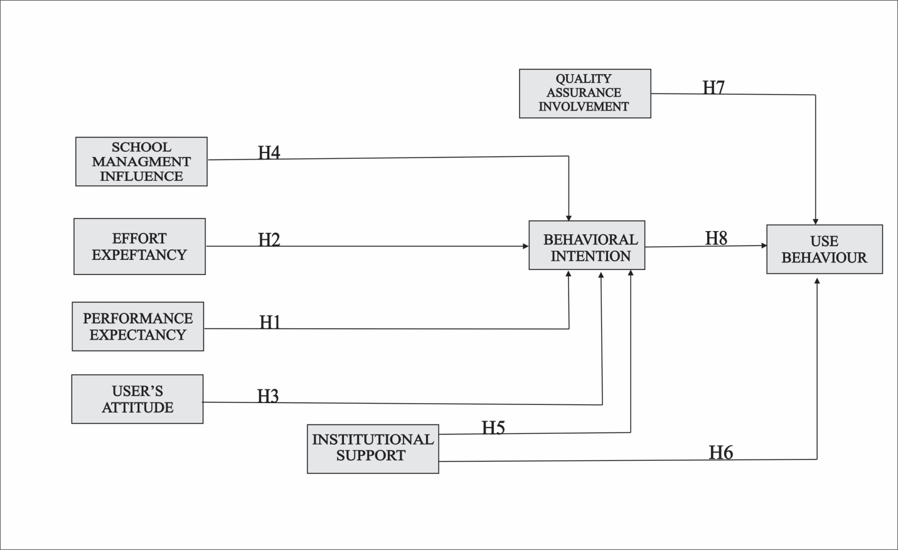
Figure 1: Research Model

As noted previously, various researchers have proposed extensions to the original UTAUT model, incorporating additional constructs within specific settings. This has been particularly apparent in research that has applied the UTAUT to study learning innovations. Here, we propose an alternative extended UTAUT to determine the factors influencing users’ adoption of learning innovations (Figure 1). Additional exogenous mechanism constructs, User Attitude , Institutional Support, Quality Assurance Involvement and School Management Influence, are proposed for incorporation within the model, as many UTAUT studies have shown that its influence has not been as consistent that of the other original constructs (Ali & Arshad, 2018; Alshehri et al., 2019; Bouznif, 2017; Chao, 2019; Kissi et al., 2018; Lakhal et al., 2013; Lin & Lin, 2019; Salloum and Shaalan, 2018; Thongsri et al., 2018; Wrycza et al., 2017). In the absence of FC, Institutional Support were added. Attitude, included an earlier TAM model, has also been re-included as a predictor of the extended UTAUT model. Figure 1 presents the research framework to be tested and analyzed using the research hypotheses presented in Table 2.
Table 2: Research hypotheses: hypothesis and literature support
SN | Research Hypothesis | Literature Support
H₁ | “Performance Expectancy will have a significant positive influence  on Behavioural Intention to use learning innovation”
H₂ | “Effort Expectancy will have a significant positive influence  on Behavioural Intention to use learning innovation”
H₃ | “Users Attitude towards technology will have a significant positive influence  on Behavioural Intention to use learning innovation”
H₄ | “School Management Influence will have a significant positive influence  on Behavioural Intention to use learning innovation” | Proposed by our study
H₅ | Institutional Supports will have a significant influence on  Behavioural Intention to use learning innovation”
H₆ | “Institutional supports will have a significant influence on  actual Use Behaviour of learning innovation”
H₇ | Quality Assurance Involvement will have a significant  positive influence on Behavioural Intention to use  learning innovation” | Proposed by our study
H₈ | Behavioural intention to use a learning innovation will have a significant positive influence on actual Use Behaviour of learning innovation” | Venkatesh et al. 2012;  Venkatesh et al. 2003.

Materials and Method
“The research framework is empirically tested with a quantitative survey. Data were aggregated and pooled across several learning innovations. With the intent of developing a generic model, such aggregation is needed in this research. Thus, any influence that may result from testing the generic model against a single learning innovation can be minimized. Furthermore, it allows for a better understanding of its suitability and helps explain its adoption across different learning innovations (Obienu and Amadin, 2021). Staff members with students from different institutions participated in the study.
The paper reviews the existing literature from which it develops a theoretical model which is then tested empirically in the post-covid era. The units of analysis in this study were south-south universities where E-learning system is employed to provide training to their students.
The overall design of the research is cross-sectional but embedded in different levels of triangulations (repeated cross-sectional studies, with different samples and aspects of the phenomenon). By cross-sectional, the study is interested in understanding the users’ adoption and use of leaning innovation at a point in time, not necessarily how those variables change over time (Obienu and Amadin, 2021). A questionnaire data collection technique were applied for this fieldwork. Each item was scored on a 5-point likert rating scale, ranging from 1= strongly disagree to 5 = strongly agree. The five-point scale was adopted to minimize a social desirability bias.”
To analyze the data, we used structural equation modelling with latent variables. Statistical tools such as SMART-PLS 3.0, was used “to verify that the research model displays an acceptable fit to the data, (Obienu and Amadin, 2021; Hariri and Roberts, 2015; Venkatesh et al. 2003). This procedure recommended refinements to the initial models (Hariri and Roberts, 2015). These modifications are made so that the model comes to represent the theoretical causal model that the researchers wants to develop.”

RESULTS AND DISCUSSION
Data and Descriptive Statistics
In line with previous studies, data were gathered from four institutions from Bayelsa State in Nigeria (Bayelsa Medical University, Federal University Otuoke, Niger Delta University, University of Africa) to“ validate our research model and add external validity of the preliminary test. The major details regarding the four participating institutions are provided in Table 3.
Out of 1451 participants contacted (250 academic staff members and 1201 students) who started the questionnaire, only 233 staff members and 1184 students completed it, making a total of 1417 respondents. Seven (7) of these responses were partial responses. As a result, they were dropped. Upon the successful collection of the research data, several statistical analyses were performed to examine the underlying relationships in the research model using 1410 useable completed responses.

Measurement Model
“By running Partial Least Square algorithm, the measurement model in Fig. 2 was created. According to Hair et al. (2017), Factor loadings should be higher than 0.7 for convergent validity. The results of CFA factor loadings are given in Table 2. From Table 3, all outer loadings (CFA) were higher than the 0.7 recommended value by (Hair et al. 2017), With regard to“composite reliability, the researchers opined that it should be higher than 0.7” (Hair et al. 2017). As seen in Table 3, all constructs exceeded the 0.7 (between 0.74 to 0.93) threshold, “confirming the achievement of reliability for the model.”Also, Average variance Extracted should be higher than 0.5. As seen in Table 3, the values obtained ranged between 0.500 to 0.564, which were all greater than the 0.5 criterion (Hair et al. 2017). The analysis of the figures for the measurement model indices as depicted in Table 3, show that internal consistency was achieved for the measurement model.”

Structural Model
In assessing the structural model, Hair et al. (2017); Dijkstra and Henseler (2015); and Vinzi et al. (2010) recommend the analysis of the paths relationships, confidence interval, and co-efficient of determination (R2)

Path Analysis
“After validating the measurement model via convergent and discriminant validity, PLS bootstrapping (BT) algorithm was run to find out the t values, to investigate the relations between latent variables. The Fig. 3 shows the path coefficients and t values over the arrows meanwhile showing the significant and non-significant relations. The criterion is to have t values greater than 1.96 (alongside with p value <0.05).”From Table 5, “we assessed the determinants of behavioural intention of staff and students towards various learning innovations use and actual use.
The results indicate that perceived system expectations (t = 6.994, p < 0.001), social influence (t = 3.395, p < 0.001) and user expectancy (t = 2.111, p < 0.01) were significant predictors of behavioural intention towards Learning innovations usage. Construct such as institutional supports was insignificant in determining behavioural intention of staff/students since its t value is less than 1.96 and p value greater than 0.05″ (Hair et al. 2017). Additionally, the significant determinants of use behaviour of Learning innovations were perceived system expectations (t = 2.792, p < 0.01), institutional supports (t = 4.557, p < 0.001) and behavioural intention (t = 6.380, p < 0.001). “Assessment of the confidence intervals for each significant path showed unidimensionality, which indicates a high confidence (up to 97.5%) in the significant paths.”

Coefficient of determination (R²)
Table 6 contains the results on the coefficient of determination for the endogenous constructs within this study. Coefficient of determination which is the variance explained by each of the predictor variable on the endogenous factor was 0.763 for overall Learning Innovation usage intention. According to the criteria by Kline (2015), coefficient values of 0.25, 0.50 and 0.70 indicate weak, moderate and high, respectively.” This means that the model explained 76.3% variance in staff/students’ intentions to use Learning innovation when enabling factors (performace expectancy, effort expectancy, institutional supports, users’ attitude, and school management influence) are modelled together. This coefficient of determination value indicates that for the endogenous variable (BI), the variance explained was relatively high as well as the variance explained by the model on actual usage (58.9%).”

Table 3: CFA Analysis
 | Factors | Factor Loading (λ) | Composite reliability | Cronbach’s Alpha (α) | Average Variance Extracted
PE | Performance Expectancy | 0.93 | 0.87 | 0.90 | 0.501
PE | Performance Expectancy | 0.88 | 0.87 | 0.90 | 0.501
PE | Performance Expectancy | 0.89 | 0.87 | 0.90 | 0.501
EE | Effort Expectancy | 0.80 | 0.77 | 0.82 | 0.532
EE | Effort Expectancy | 0.81 | 0.77 | 0.82 | 0.532
EE | Effort Expectancy | 0.87 | 0.77 | 0.82 | 0.532
IS | Institutional Support | 0.79 | 0.75 | 0.81 | 0.564
IS | Institutional Support | 0.81 | 0.75 | 0.81 | 0.564
IS | Institutional Support | 0.84 | 0.75 | 0.81 | 0.564
SMI | School Management Influence | 0.95 | 0.85 | 0.92 | 0.540
SMI | School Management Influence | 0.89 | 0.85 | 0.92 | 0.540
SMI | School Management Influence | 0.93 | 0.85 | 0.92 | 0.540
UA | Users Attitude | 0.85 | 0.74 | 0.86 | 0.513
UA | Users Attitude | 0.89 | 0.74 | 0.86 | 0.513
UA | Users Attitude | 0.88 | 0.74 | 0.86 | 0.513
QAI | Quality Assurance Involvement | 0.86 | 0.79 | 0.92 | 0.513
QAI | Quality Assurance Involvement | 0.89 | 0.79 | 0.92 | 0.513
QAI | Quality Assurance Involvement | 0.89 | 0.79 | 0.92 | 0.513
BI | Behavioural Intentions | 0.97 | 0.91 | 0.93 | 0.506
BI | Behavioural Intentions | 0.97 | 0.91 | 0.93 | 0.506
BI | Behavioural Intentions | 0.95 | 0.91 | 0.93 | 0.506
UB | Use Behaviour | 0.96 | 0.93 | 0.96 | 0.522
UB | Use Behaviour | 0.98 | 0.93 | 0.96 | 0.522
UB | Use Behaviour | 0.96 | 0.93 | 0.96 | 0.522

Table 4: Survey structure and description of statistics for dimensions
Variables | Mean | SD | PE | EE | UA | SMI | IS | QAI | BI
Performance Expectancy (PE) | 4.21 | 0.41 | 0.892
Effort Expectancy (EE) | 3.16 | 1. 07 | 0.51** | 0.834
User  Attitude (UA) | 4.41 | 1.32 | 0.48** | 0.59** | 0.912
School management Influence (SMI) | 3.56 | 0.63 | 0.71** | 0.62** | 0.64** | 0.813
INSTITUTIONAL SUPPORT (IS) | 4.17 | 1.01 | 0.41** | 0.57** | 0.67** | 0.75** | 0.769
Quality Assurance Involvement (QAI) | 4.23 | 1.12 | 0.54** | 0.61** | 0.61** | 0.74** | 0.61** | 0.917
Behabioural Intention (BI) | 3.97 | 0.92 | 0.42** | 0.55** | 0.67** | 0.71** | 0.65** | 0.61** | 0.934
NB: The bold values on the diagonal represent the square root of the AVE. Other entries represent intercorrelations of the variables.

Table 5: Path Analysis Results
 | Relationships | β- Value | t- - value | f² | p-value | Result
H₁ | PE BI | 0.158 | 3.305* | 0.029 | 0.001 | Accepted
H₂ | EE BI | 0.612 | 6.128** | 0.258 | 0.000 | Accepted
H₃ | UA BI | 0.701 | 6.514** | 0.629 | 0.000 | Accepted
H₄ | SMI BI | 0.425 | 5.323** | 0.003 | 0.005 | Accepted
H₅ | IS BI | 0.074 | 2.836** | 0.004 | 0.003 | Accepted
H₆ | IS UB | 0.249 | 4.621* | 0.003 | 0.001 | Accepted
H₇ | QAI UB | 0.615 | 0.603** | 0.294 | 0.000 | Accepted
H₈ | BI UB | 0.703 | 6.949** | 0.725 | 0.000 | Accepted
*p < 0.01; **p < 0.001

Table 6: Model Variance
Construct | R-Square | R-Square Adjusted
BI | 0.763 | 0.760
UB | 0.589 | 0.580

IMPLICATION
The results of this study showed several implications. First, the researc model makes it relevant to the present situation caused by the Covid-19 and its application in higher education to explain factors affecting online learning, most especially from the experiences of a developing economy. The results suggest that higher education institutions build a stable online portal where teachers can teach and guide students without any difficulties. Secondly, the perceived interactivity and quality of the online learning system significantly explains the students’ belief to perform better and, consequently, add to their willingness to use the system. This supports the findings that higher education students are
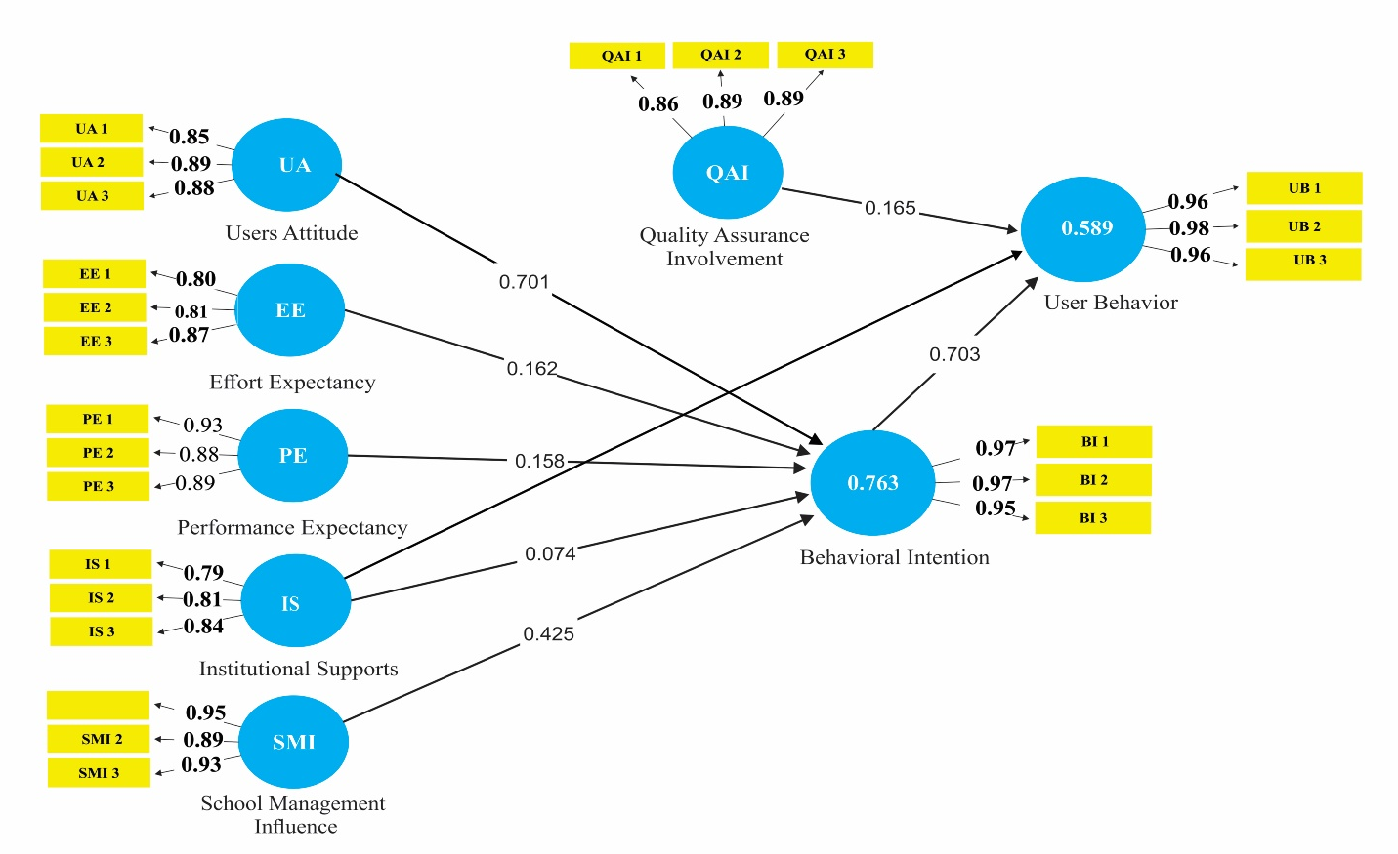
Figure 2: Path Analysis
“still abreast of digitizing their activities despite being challenged by technological infrastructure in developing economies and actively aspire to develop their technological knowledge (Gonzales and Gonzales, 2021). The clear advantage of system interactivity and quality is that it allows a consolidated variety of information combined. It permits us to store all information in one place, and students can locate them anytime, using compatible devices. It reduces administrative hassles related to maintaining learning materials in multiple areas.
Lastly, the behavioral aspects that facilitate the desire to use the online learning system significantly explain the students’ intentions. Thus, this is a reason to believe that this are facilitated with the availability of specialized instructions, awareness, and enough guidelines concerning online learning systems (Yates et al., 2021). The use of an online learning system through successful implementation is recommended to help students examine the benefits of technology. Thus, the utilization of the system is proof that it can make other educational learning activities done online.”

Conclusion
“Amidst the COVID-19 pandemic, educational institutions use online learning to meet the needs of students. The complexity of the learning environment in online learning constrains the need to investigate critical latent factors in understanding the usage behavior. The paper extended the UTAUT with enjoyment, interactivity, flexibility, and quality. It is believed that these factors differ among developing economies.
The results revealed that the model had high internal consistency and reliability, indicating that the proposed model possesses substantial explanatory power. This study shows that intention is a key factor that significantly influences students’ use behavior toward online learning. Quality Assurance Involvement played an important factor in affecting performance expectancy and effort expectancy. Finally, the positive effect of facilitating conditions on behavioral intention could be attributed to the technical and organizational infrastructure. For example, specialized instructions on online learning and the resources needed were available. Determining what motivates online learning can enrich learning quality and facilitate pedagogical and instructional uses of online learning.”
Declarations
Ethics approval and consent to participate
Approval for this study was granted by the Institutional Ethics Review Committee, Bayelsa Medical University. Consent form describing the study was sent.
Consent for publication
Not applicable.

Availability of data and materials
The datasets used and/or analyzed during the current study are available from the corresponding author on reasonable request.

References
Amadin, F. I., Obienu, A. C., and Osaseri, R. O. (2018). Main barriers and possible enablers of Google apps adoption among university staff members. Nigerian Journal of Technology, 37(2), 432–439.
Evwiekpaefe, A.E., S.C. Chiemeke, and M.Z. Haruna. (2018). “Individual and Organizational Acceptance of Technology Theories and Models: Conceptual Gap and Possible Solutions”. Pacific Journal of Science and Technology. 10(2):189-197.
Hair J. F., Hult G. T., Ringle C. M., and Sarstedt S. (2017). A Primer on Partial Least Squares Structural Equation Modeling (PLS-SEM), 2nd edn. Thousand Oaks: Sage.
Hariri, A., and Roberts, P. (2015). Adoption of Innovation within Universities: Proposing and Testing an Initial Model. Creative Education, 6, 186-203.
Krueklai, S.; Kiattisin, S. and Leelasantitham, A. (2013). Analysis of Factor Affecting in Unified Theory of Acceptance and Use of Technology (UTAUT) e-healthcare of government hospitals in Thailand,‖ in proc. of ISS & MLB, September 24-26, 2013, pp.443-451.
Lahtinen, M. (2012). “E-Invoice Adoption in Organisation”. Department of Marketing, Hanken School of Economics: Helsinki, Finland.
Obienu, A. C., and Amadin, F. I. (2021) “User acceptance of learning innovation: A structural equation modelling based on the GUAM framework”. Educ Inf Technol 26, 2091-2123. Available online @ https://doi.org/10.1007/s10639-020-10341-x
Ogunji, C. V., Onwe, J. O., Ngwa, E. S., David, E., Olaolu, M., and Cresantus, B. (2022). Higher education and the new normal: implications for sustainable post covid-19 era in Nigerian tertiary institutions. Cogent Education, 9(1). https://doi.org/10.1080/2331186X.2022.2125206
Oye, N., A.Iahad, N., and Ab.Rahim, N. Z. (2012). The Impact of UTAUT Model and ICT Theoretical Framework on University Academic Staff: Focus on Adamawa State University, Nigeria. International Journal of Computers & Technology, 2(2), 102–111.
Straub, D., Boudreau, M. C., and Gefen, D. (2004). Validation Guidelines For Positivist. Communications of the Association for Information Systems,13, 380–427.
Venkatesh, V., Morris, M. G., Davis, G. B., and Davis, F. D. (2003). Acceptance of Information Technology: Toward a Unified View. MIS Quarterly, 27(3), 425–478.

