Grid Integration of Renewable Energy for Reliable and Efficient Power Supply in Nigeria

.
ABSTRACT

This research investigates the integration of renewable energy sources such as solar and wind into Nigeria’s power grid. The main objective is to develop a simulation model that examines how renewable energy systems affect power reliability and supply efficiency under different load and generation conditions using MATLAB. The simulation setup includes solar photovoltaic arrays and wind turbines connected to the grid through inverter systems and controlled using standard power system techniques. Changes in solar radiation and wind speed are introduced during the simulation to reflect real-life variations in renewable energy generation. The results show that, despite their variable nature, solar and wind systems can support the grid effectively when combined with proper control, forecasting, and storage technologies. The study demonstrates that integrating renewable energy into the grid can reduce power shortages, improve electricity access, support a more stable and reliable power supply as well as contribute to sustainable development goals by promoting the use of renewable energy in Nigeria.

Keywords: Renewable Energy, Solar Power, Wind Energy, Grid Integration, Power Reliability, Energy Access,
Smart Grid, MATLAB/SIMULINK

1. INTRODUCTION

As the world shifts toward low-carbon energy systems, the growing demand for clean, reliable, and affordable electricity has led many countries to turn to renewable energy as a key part of their power systems. In developing countries like Nigeria, where access to reliable power supply remains a major challenge, integrating renewable energy into existing power grids has become crucial. Renewable energy is energy that comes from sources that are inexhaustible. Some examples of these sources are wind, solar, geothermal, tidal power, and hydroelectric power. The most important thing about renewable energy is that it can be used without causing pollution. Strategic solar integration reduces reliance on single sources, distributes generation, and enhances supply especially during peak daytime hours [1]. The sun is the main source of energy on earth, and this energy can be harnessed to generate electricity. This is done by using solar panels to convert sunlight into electricity through the photovoltaic principle. Solar panels are made by connecting multiple photovoltaic cells together to form a solar array which allows for a higher power output. It can be installed in solar farms or rooftops. The solar panels convert sunlight directly into electricity through a process called the photovoltaic effect. Sunlight contains energy particles called photons. When these photons hit solar panels, they excite electrons in the photovoltaic cells, thereby creating an electric current. This direct current is then converted to an alternating current by an inverter, which can be used to power homes, industries or be supplied to the grid. The authors of [2] evaluated the implementation of a grid-tied solar PV system in Nigeria, and attribute improvements in electricity access and overall supply efficiency to the integration of renewable energy. Integrating solar power into the grid helps reduce dependence on a single energy source, distributes generation across various locations, and increases supply availability during peak daytime hours. Wind energy is another valuable renewable source which is in abundance in the Northern part of Nigeria. It works by using turbines to convert the motion of the wind into mechanical power, which is then used to generate electricity. These turbines come in two main types based on the direction of the rotating blades: horizontal-axis turbines, which are more common, and vertical-axis turbines. While solar peaks during the day, wind speeds can be strong at night, enhancing overall energy supply reliability [3]. Similarly, a 10 kW wind energy conversion system model based on Ogoja, southern Nigeria, validated the potential of regionally suitable wind deployments, showing effective turbine operation across different wind speeds [4]. When connected to the grid, wind power improves energy diversity and helps maintain steady supply even when solar or hydro sources are low, enhancing the overall reliability of the electricity system. In [5], [6], the authors attribute the potential for improved electricity access in underserved communities to the integration of renewable energy into Nigeria’s existing grid infrastructure.
In this research, the integration of renewable energy such as solar and wind energy into Nigeria’s power grid is investigated through MATLAB-based simulations to evaluate their impact on power reliability and supply efficiency. The study models the incorporation of these distributed energy systems into the national grid and examines system performance under varying generation levels and load demands. The objective is to provide insights into how renewable integration can enhance energy accessibility, and reduce dependency on conventional sources in underserved regions in Nigeria. Furthermore, adopting these solutions would contribute to sustainable development goals by promoting the use of renewable energy in Nigeria.

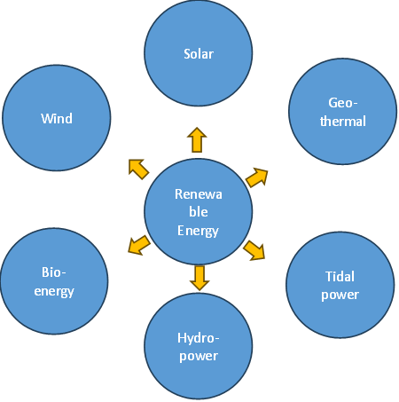
Figure 1: Types of Renewable Energy

2. material and methods

This research aims to investigate the integration of renewable energy systems, specifically solar photovoltaic and wind turbine technologies into Nigeria’s power grid to improve stability of power supply. In Nigeria today, about 40% of the population do not receive power supply from the grid. The Integration of renewable energy sources into the grid would therefore help address these challenges as it offers sustainable and increasingly cost-effective solutions. The primary objective of this research is to utilize MATLAB/Simulink to simulate the integration of renewable energy, focusing on how it affects grid performance, and its reliability under varying operational conditions.
MATLAB/Simulink was selected as the simulation environment due to its robust modeling capabilities. Its modular nature is very helpful as it allows for complex simulations and would be used for renewable energy systems, grids, and load profiles. This modularity is particularly useful for simulating hybrid systems, like solar-wind-hydro systems, where individual component models can be developed and interconnected to study system behavior [7]. The graphical interface simplifies the design and visualization of complex systems, making it easier to implement control algorithms and forecasting techniques [8].
This research employs a systematic approach, which is as follows:
- A preliminary assessment of Nigeria’s renewable resource potential,
- The development of detailed models for solar PV arrays, wind turbines, and associated power electronic devices.
- Examination of various scenarios of renewable penetration, assessing their impacts on grid stability, power quality, and overall system efficiency. To ensure the outcome is practical in Nigeria, the load profile and weather data used are region-specific.

2.2 Renewable Energy Potential in Nigeria

Nigeria has vast natural renewable energy resources which will be essential for the sustainable development of the country; however, these resources are largely under-exploited at present. High solar irradiance, ranging from 1600 to 2200 kWh/m² annually, makes northern regions like Sokoto and Kano ideal for large-scale solar PV projects [9]. Yet, the installed solar capacity remains minimal and is limited to off-grid systems and small commercial installations - indicating that there’s more that can be done to further harness the energy from the sun in these regions. The authors of [6] evaluated the integration of a 750 kW grid-tied solar PV system into Nigeria’s national power grid and attribute the potential for extended daily electricity availability from roughly 5 to 6 hours to about 11 hours and significant improvements in system efficiency and access in rural communities

Also, the potential of wind energy is significant in high topography states like Plateau (Jos) with average wind speeds up to 8 m/s at a height of 100m. Kano and Katsina have the highest wind potential with monthly wind power density of 128.47 – 778.63 Wm2 and 259.52 –832.60 Wm2, respectively. This makes these regions suitable for wind infrastructure development, with Katsina being the only state with an existing commercial scale wind energy farm in the country [10]. However, there are issues like limited investment, policy uncertainty, and inadequate wind assessments at higher altitudes, which hinder progress in this sector. In order to meet the high electricity demand and also reduce emissions, there is a strong need to explore and leverage these resources. This means ensuring enhanced policy support, targeted incentives, and comprehensive resource assessments in order to fully exploit Nigeria’s renewable energy potential and ensure long term energy security [11],[12].
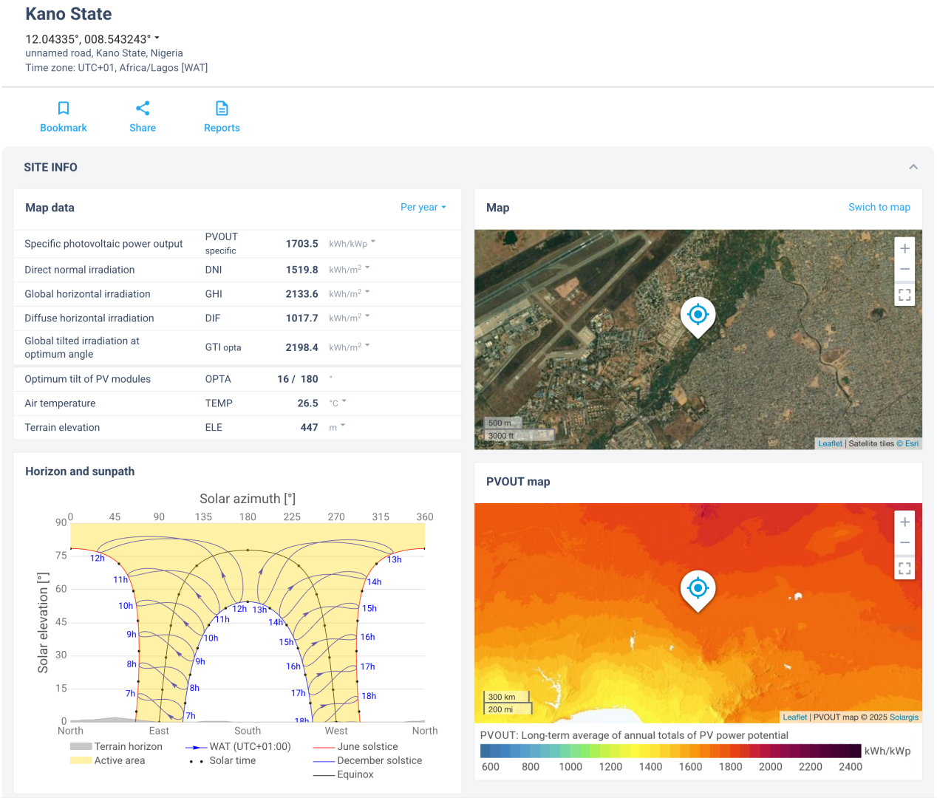

Figure 2: Showing Irradiance Map of Kano State

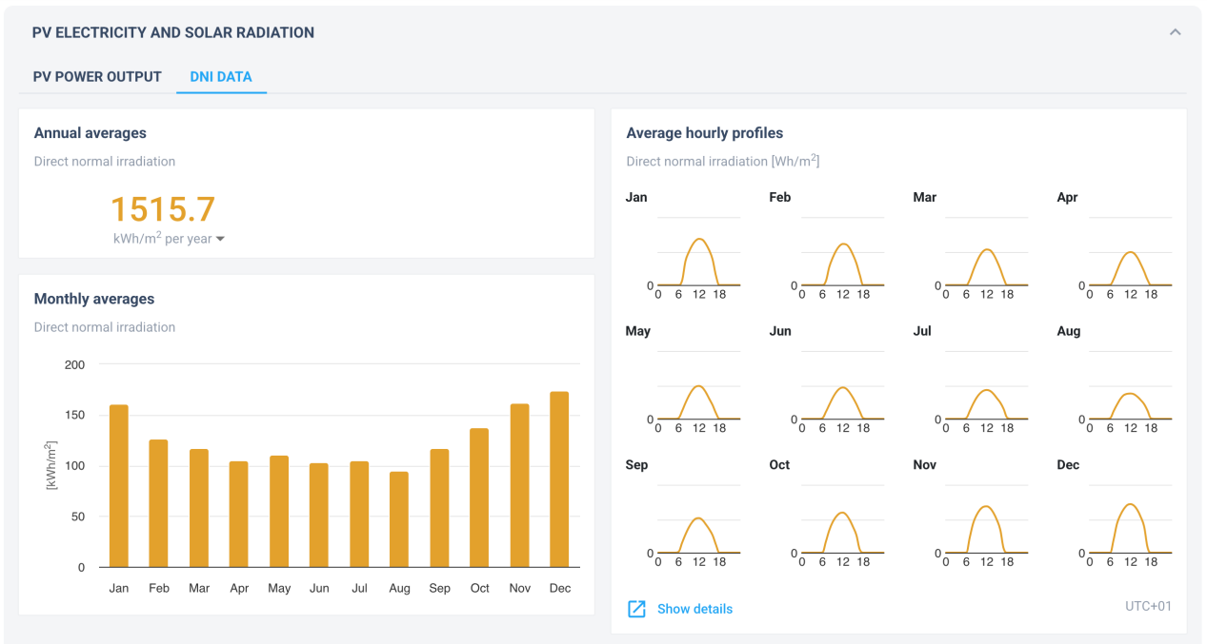
Figure 3: Showing DNI Data of 1515.7kWh/m2 per year and Specific PV out of 1703.5kWh/kWp
Source: https://globalsolaratlas.info/detail?s=12.04335,8.543243&m=site&c=11.714771,8.695679,10
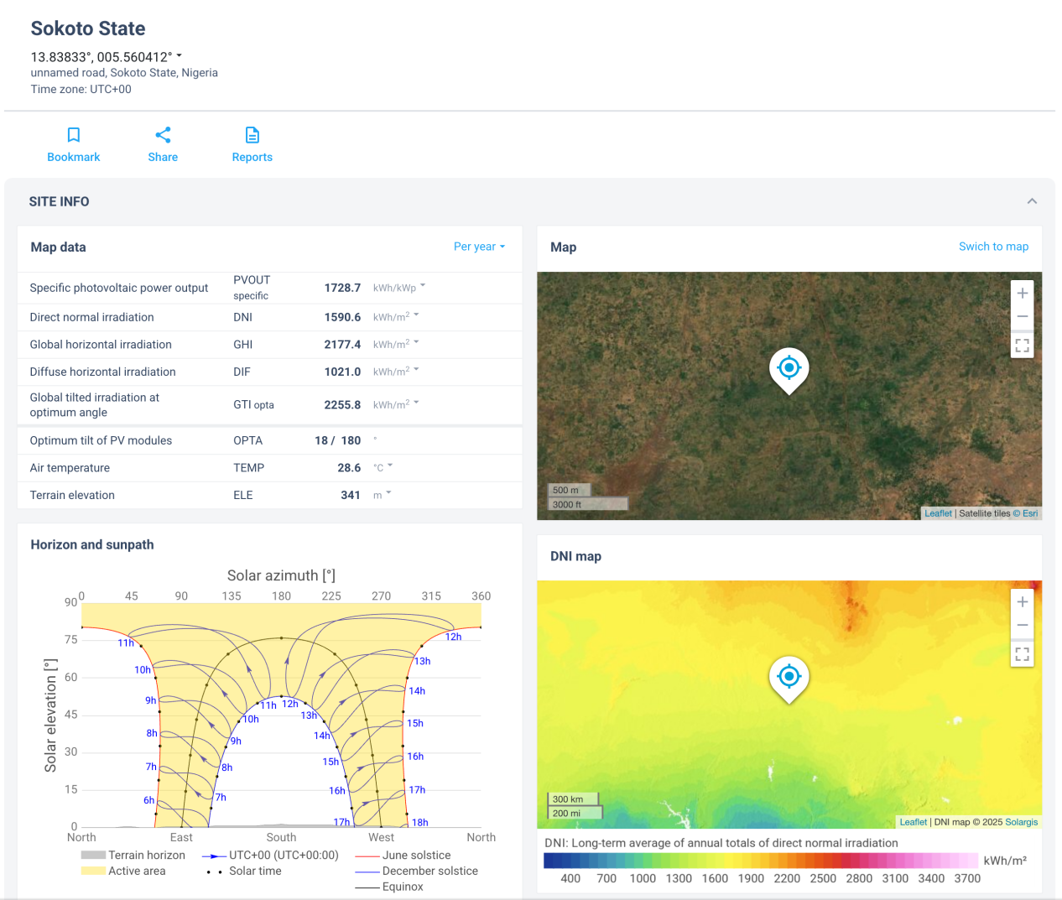
Figure 4. Showing Irradiance Map of Sokoto State
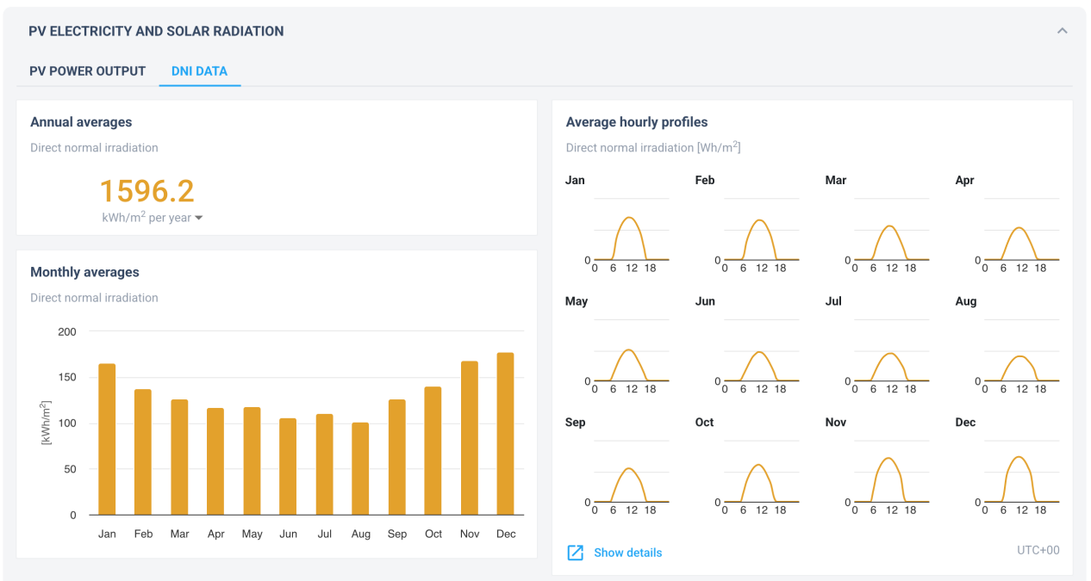
Figure 5 Showing DNI Data of 1596.2kWh/m2 per year and Specific PV out of 1728.7kWh/kWp for Sokoto state
Source: https://globalsolaratlas.info/detail?s=13.83833,5.560412&m=site&c=10.03943,9.196887,7
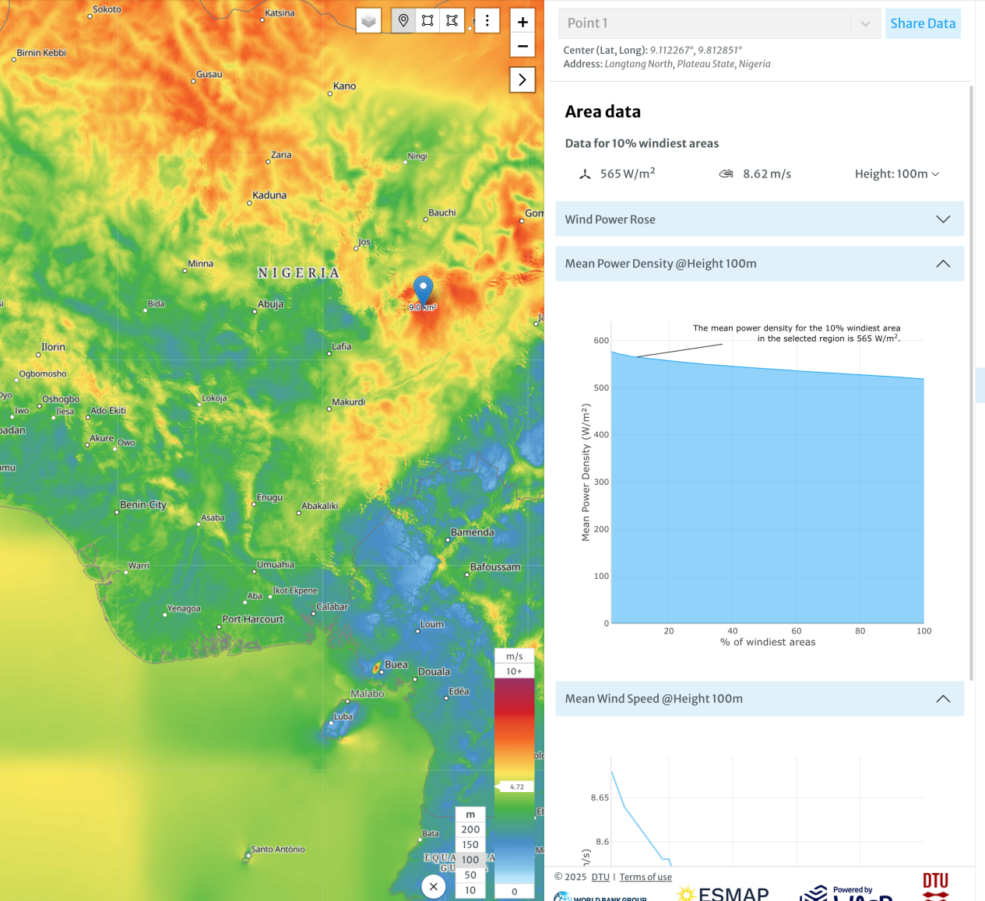
Figure 6: Showing Wind Map of Plateau State, and Mean Wind Speed of 8.62m/s at 100m above ground
Source: https://globalwindatlas.info/en/

2.3 Simulation Model and Configuration
2.3.1 Solar PV Array Model
The solar PV array model developed in this study follows a detailed mathematical representation of photovoltaic cell behavior, incorporating factors such as solar irradiance, temperature effects, and PV cell characteristics like efficiency and maximum power point tracking (MPPT). The PV module parameters are sourced from manufacturer datasheets and validated against empirical performance data from similar installations in Nigeria. The simulation accounts for daily and seasonal variations in solar irradiance, utilizing validated historical data from global solar databases such as the Global Solar Atlas.
2.3.2 Wind Turbine Model
The wind turbine model is based on established power curves provided by turbine manufacturers, representing the relationship between wind speed and power output. Turbine efficiency and performance parameters are adapted from commercially available wind turbines suitable for Nigerian wind profiles. Wind speed data used in the simulation reflects typical regional patterns observed in northern Nigeria, derived from empirical meteorological data and validated resource assessments.
2.3.3 Grid Interface and Inverter System
An essential component of the simulation is the inverter system, responsible for converting renewable power outputs into grid-compatible AC power. The inverter model incorporates harmonic filtering, synchronization mechanisms, and voltage regulation techniques compliant with international standards such as IEEE 1547-2018. Advanced inverter control algorithms ensure stable operation and minimal disturbance to the grid, addressing power quality concerns such as harmonic distortions and voltage fluctuations.

2.3.4 Load Profiles and Grid Model
The load profiles simulated include peak demand, off-peak conditions, and random fluctuations to realistically represent the variability encountered in Nigeria’s power grid. The grid model incorporates typical distribution network configurations at voltage levels of 11 kV and 33 kV, reflecting the common infrastructure utilized by Nigerian distribution companies. Load data is sourced from actual operational records provided by the Nigerian Electricity Regulatory Commission (NERC) and validated by recent grid studies.
2.4 Simulation Scenarios and Data Sources
Various scenarios are simulated, including baseline (no renewable integration), moderate integration, and high renewable penetration scenarios. Weather data, including solar irradiance and wind speed profiles, are obtained from globally recognized databases such as the Global Solar Atlas and the Global Wind Atlas, ensuring accuracy and realism in simulation outcomes.
2.5 Challenges in Grid Integration
Grid integration of renewable energy in Nigeria faces multiple challenges, including power quality issues, geographic constraints, and stability concerns.
2.5.1 Power Quality Issues
Integrating renewable energy into Nigeria’s grid poses significant power quality challenges. Power quality issue refers to any deviation in the electrical power supply that disrupts the normal functioning of electrical equipment. Renewable energy sources such as solar and wind are inherently intermittent and variable, which introduces significant disturbances into the grid. Intermittent solar and wind generation causes voltage fluctuations, disrupting electrical equipment when power output varies rapidly due to environmental factors [13]. Harmonic distortion is also a serious concern as it results from the use of power electronic inverters and converters in renewable energy systems. The process of converting DC from solar panels or variable AC from wind turbines to grid-compatible AC, introduces harmonic frequencies further degrades power quality.

2.5.2 Location Specificity
Renewable energy resources in Nigeria exhibit geographic disparities, unlike the conventional power plants which can be built close to demand centers based on strategic planning and availability of infrastructure. The presence of high solar irradiance, ideal for solar systems, concentrates in northern regions like Sokoto, while wind resources, suitable for turbines, are stronger in southern coastal areas like Apapa, Brass or northern high-altitude areas like Kano, and Katsina [10],[14]. Consequently, there’s a strong need for strategic infrastructure planning in order to harness these location-specific resources effectively.
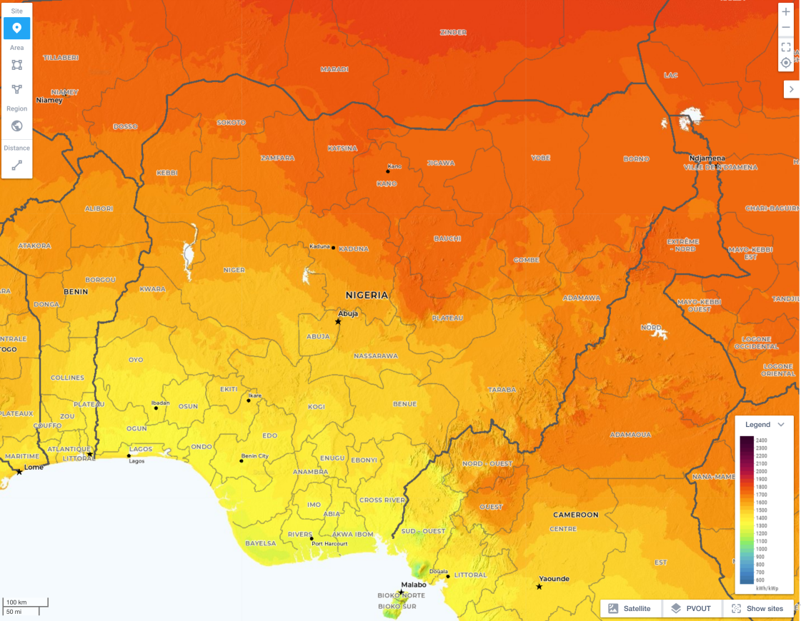
Figure 7: Map showing High Solar Irradiance up to1800 kWh/kWp in Northern Nigeria
Source: https://globalsolaratlas.info/map?c=9.215135,8.709154,7&m=site
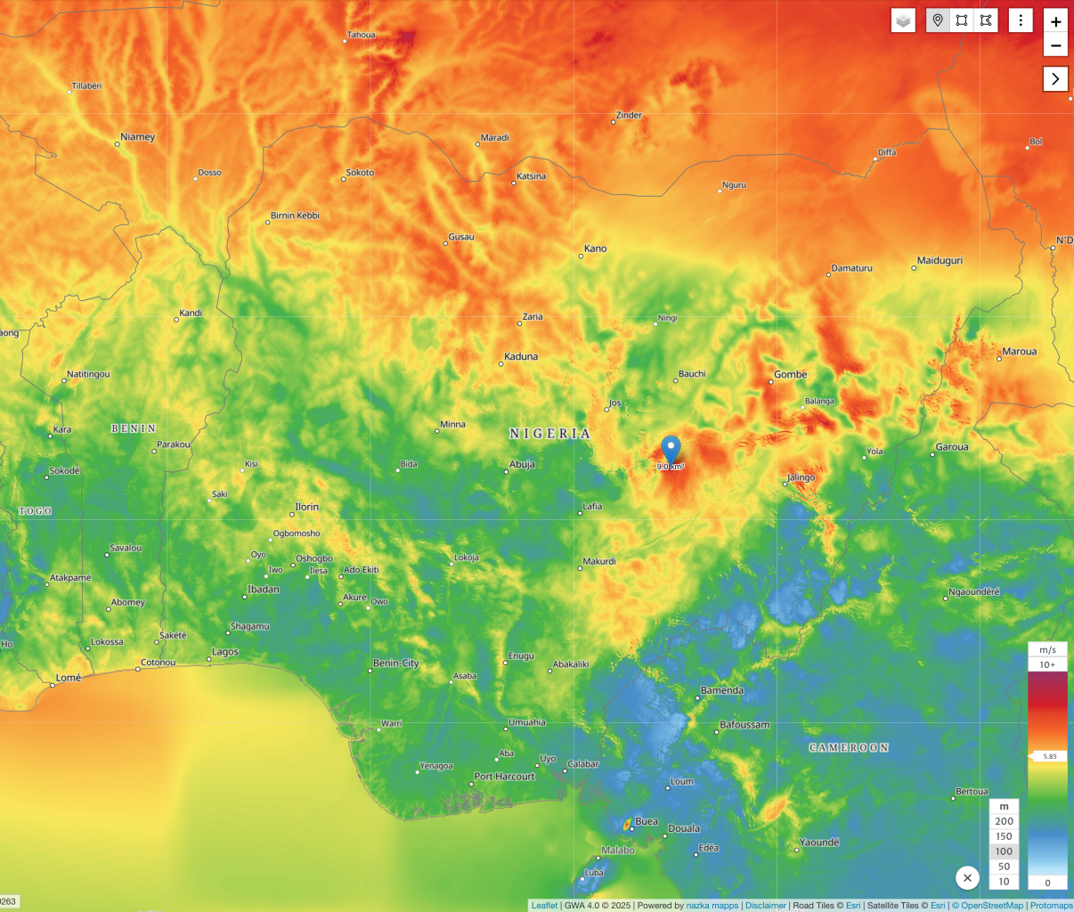
Figure 8: Showing Wind Map of Nigeria, and Mean Wind Speed up to 8.62m/s at 100m above ground in Plateau, Katsina, Kano, Gombe States
Source: https://globalwindatlas.info/en/

2.5.3 Stability Issues
Power system stability refers to the ability of various components within the power system to reach equilibrium or return to a state of operating synchrony after being subjected to a disturbance. Maintaining grid stability is critical but challenging with renewable energy integration, due to variable output from solar and wind. This disrupts load-generation balance, risking system synchrony after disturbances like faults or load changes. To ensure stable operation, techniques such as advanced forecasting and real-time control are therefore necessary.

2.6 Solutions and Technological Approaches
To address integration challenges, the study explores smart grid technologies, improved forecasting methods, and energy storage solutions. A smart grid is an advanced electricity network that uses modern communication, automation, and digital technologies to monitor, control, and manage the generation, distribution, and consumption of electricity more efficiently and reliably. Hence, smart grids provide a framework for advanced monitoring and control of the electricity grid at a very detailed or micro level, allowing operators to detect and respond to changes in real time. smart grids improve power quality by detecting issues like voltage drop or harmonic distortions early and correcting them in real-time. It also enhances grid stability through better coordination between renewable sources, storage systems, and conventional generators. Smart grids enable precise monitoring and control, significantly enhancing grid responsiveness and power quality management.

2.6.1 Improved Forecasting Techniques
Machine learning models, including regression algorithms and neural networks, have demonstrated improved accuracy in predicting renewable energy generation. These models analyze complex relationships in historical data and meteorological variables to provide reliable forecasts. An improved forecasting technique helps in addressing the variability and unpredictability of sources like solar and wind, because renewable energy depends on weather conditions, which can change rapidly, accurate forecasting helps the grid operators to plan ahead and balance supply and demand more effectively. Machine learning, involves the development of algorithms that enable systems to learn from and make predictions based on data. By incorporating artificial intelligence, and machine learning, modern forecasting techniques can predict how much solar or wind power will be available at different times of the day. By leveraging historical data and advanced computational techniques, machine learning models offer significant improvements in forecasting accuracy compared to traditional methods. This allows operators to schedule backup generation, manage storage systems, and reduce the risk of power shortages.

2.6.2 Storage Technologies
Storage technologies are essential for addressing the challenges posed by the variable and intermittent nature of renewable energy sources like solar and wind. These systems help balance supply and demand by abs orbing excess energy when production is high, and releasing it when demand is higher or generation is low, making renewable energy more reliable and valuable. This is important during periods of uncertain generation, such as cloudy or windless days. Technologies such as lithium-ion batteries, and other advanced storage systems enable energy to be stored during times of surplus and delivered when needed, reducing the degree of intermittency and enhancing the overall flexibility of the power system. As a result, storage increases the grid’s capacity to integrate more renewable energy without compromising stability or reliability.

3. results and discussion

The grid integration of renewable systems with a comprehensive battery management system has emerged as a critical advancement in the modern world. They are instrumental in ensuring power is delivered to end-users reliably, stably, and efficiently, while also playing a vital role in creating sustainable environments and mitigating pollution, especially in the context of national power grids like Nigeria.

3.1 System Architecture
The system architecture which consists of a PV power generation system, a wind energy system, and a battery energy storage system, is illustrated in Fig. 9. This architecture is specifically designed for seamless integration with the existing power grid in Nigeria, enhancing its overall reliability and efficiency.

In this configuration, the Photovoltaic system incorporates a boost converter, managed by an MPPT controller that utilizes the perturb and observe (P&O) algorithm to maximize the PV system's power output. The control pulses from the MPPT controller are fed to the boost converter, which then connects to the common DC bus. The wind energy system comprises a wind turbine mechanically coupled to a Permanent Magnet Synchronous Generator (PMSG). The variable AC power generated by the wind energy system is converted into DC power through an AC-DC converter and is linked to the DC bus. The battery storage system is connected in parallel to the DC bus through a bi-directional DC-DC boost-buck converter, which is a key component of the integrated battery management system. This allows for controlled charging and discharging of the battery, providing essential energy buffering and dispatchable power. Finally, a DC-AC converter is employed to transform the aggregated DC power from the PV, battery, and wind energy system into grid-compatible AC power. This dynamic interaction contributes significantly to the reliable and efficient power supply across Nigeria. The entire interconnected system, as represented in Fig. 9, constitutes the proposed grid-tied renewable energy system.

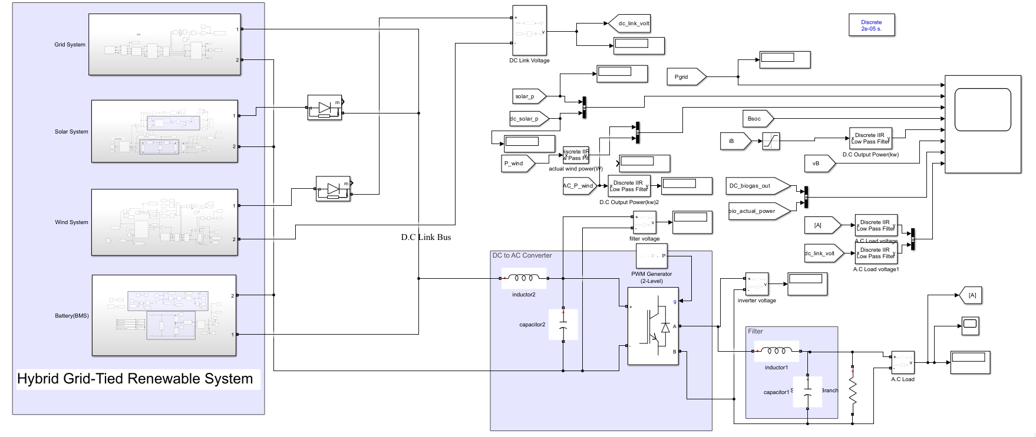
Figure 9: System Architecture

3.2 Wind Energy Conversion System:
In the wind turbine, wind dynamic energy is changed into mechanical energy and is given in equation 3.2.1 below
𝑃 = $\frac{1}{2}$ 𝜌𝜋$r^{2}C_{p}$(λ, 𝛽) 𝑉3 ---------- (3.2.1)
Where Cp is the coefficient of power (Betz),
ρ is the density of air in kg/m³,
V is the velocity of wind in m/s,
r is the length of the blade in meter.

Equation 3.2.2 gives the wind turbine aerodynamic torque.
𝑇w = $\frac{p_{w}}{w}$ --------------- (3.2.2)
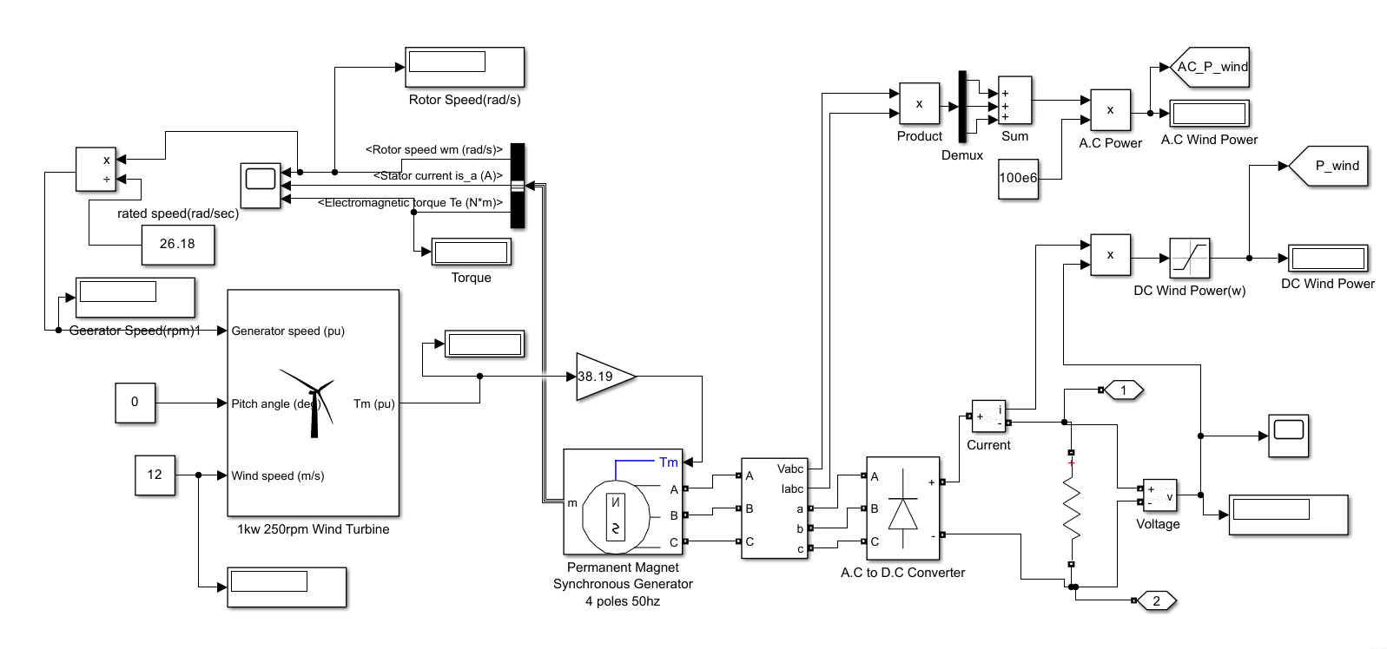
Figure 10. Configuration of Wind System with a boost converter

Where ꞷ is the rotor speed in radians per second. The generated mechanical energy is changed to electrical energy in Permanent Magnet Synchronous Generator. The diode rectifier converts the three-phase AC voltage of the PMSG into DC voltage.
Wind Energy System
S/N | Constraints | Values/Units
1 | Base rotational speed | 1.pu
2 | Maximum power at base speed | 0.73pu
3 | Nominal output power | 1kw
4 | Wind turbine rated Velocity | 12m/s
5 | Turbine radius | 1.1m
6 | Torque | 1.91
7 | Flux Linkage | 0.5
8 | Armature Resistance | 0.0025
Table 1: Wind Parameter Table

  - PV System Model

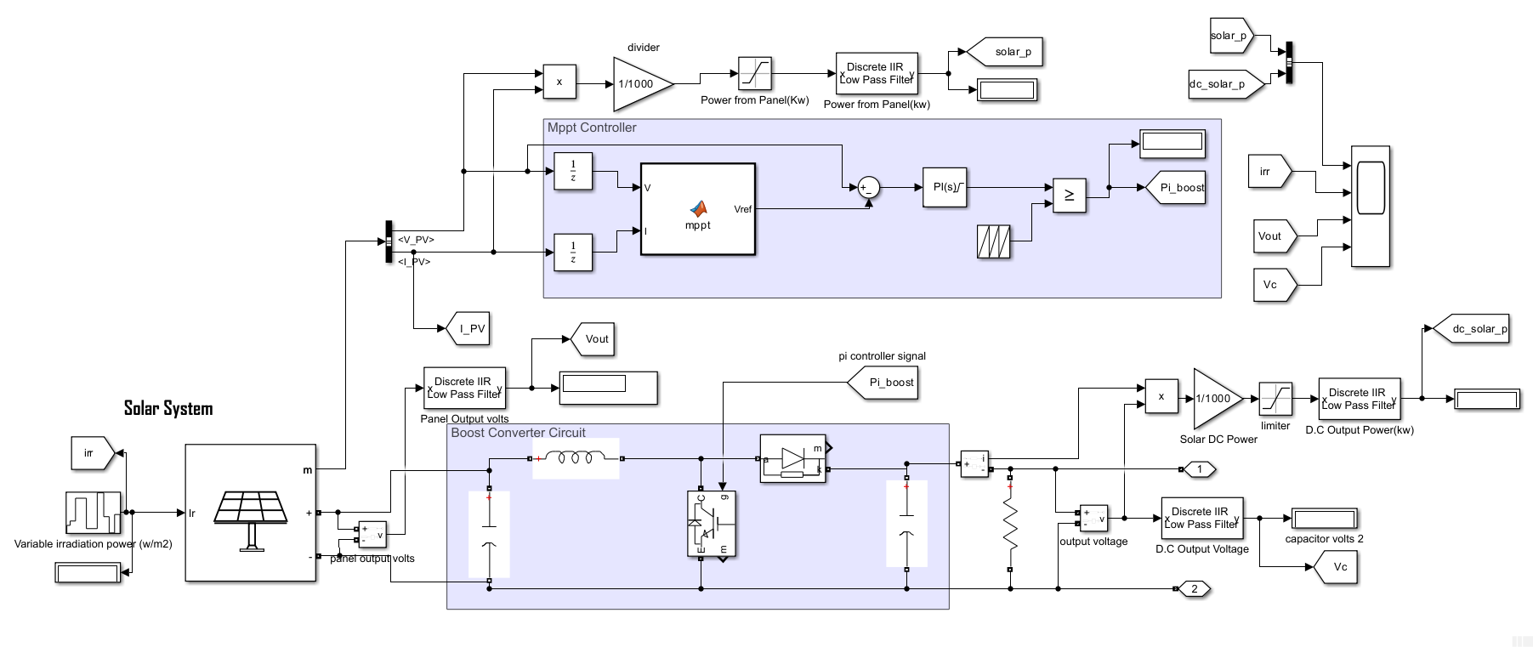
Figure 11: PV System Model

Solar Cell
S/N | Constraints (Full Solar Panel) | Values/Units
1 | Open circuit voltage Voc (V) | 36.3V
2 | Short-circuit current Isc (A) | 7.84A
3 | Voltage at maximum power point Vmp (V) | 29V
4 | Current at maximum power point Imp (A) | 7.35A
5 | Parallel strings | 47
6 | Series-connected modules per string | 10
7 | Irradiance used for measurement | 1000kw/m2
 | Constraints (Single Diode PV Circuit) | Values/Units
1 | Short circuit current | 7.34A
2 | Open circuit Voltage | 0.6V
3 | Series-connected modules per string | 10
4 | Parallel strings | 5
5 | Irradiance used for measurement | 1000w/m2
6 | Quality Factor | 1.5

Table 2: Details of PV System

The boost converter is realized with MPPT control implemented with P&O algorithm. The MPPT algorithm used is the Perturb and Observe procedure has it is simple to employ, and is used to increase the photovoltaic system.
Systems | System Requirement
Battery | Li-ion-240 V,5Ah, 20% SOC
DC-DC converter | 13.48uH, 1341uF

Table 3.: Storage and Boost Converter system requirement

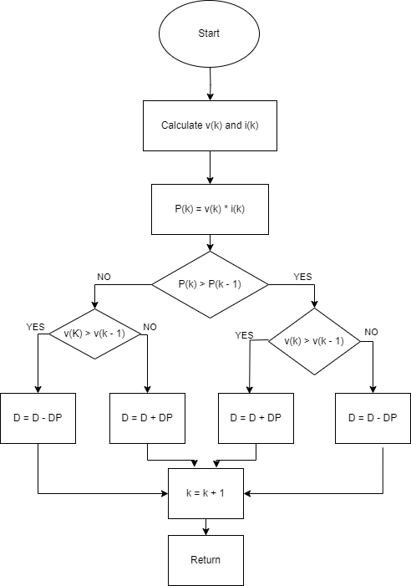

Figure 12: P&O MPPT Algorithm

power output and also to raise the system's effectiveness of the photovoltaic system. The P&O algorithm flow chart is presented in Fig.12. This algorithm is used to give pulse input to the boost converter. This algorithm disturbs the voltage, and the relative change in power is calculated and is compared with the previous power value. The operating point will be traced towards MPP if the power change is positive and away from MPP if the change in power is negative. This process will be repeated until the maximum peak is obtained.

3.4. Battery Modelling
In the grid-tied renewable system, The Li -ion battery model obtainable in MATLAB Simulink 2023 is been considered. Equivalent circuit of the Li-ion is shown in Fig.13. The Battery model represents the different variations of battery and its features. The battery is modelled as a current source with some inbuilt resistance, according to the SOC level of the battery charges and discharges.
When the battery works in charging mode, the battery voltage rises, and when it works in discharging mode, the current rises.

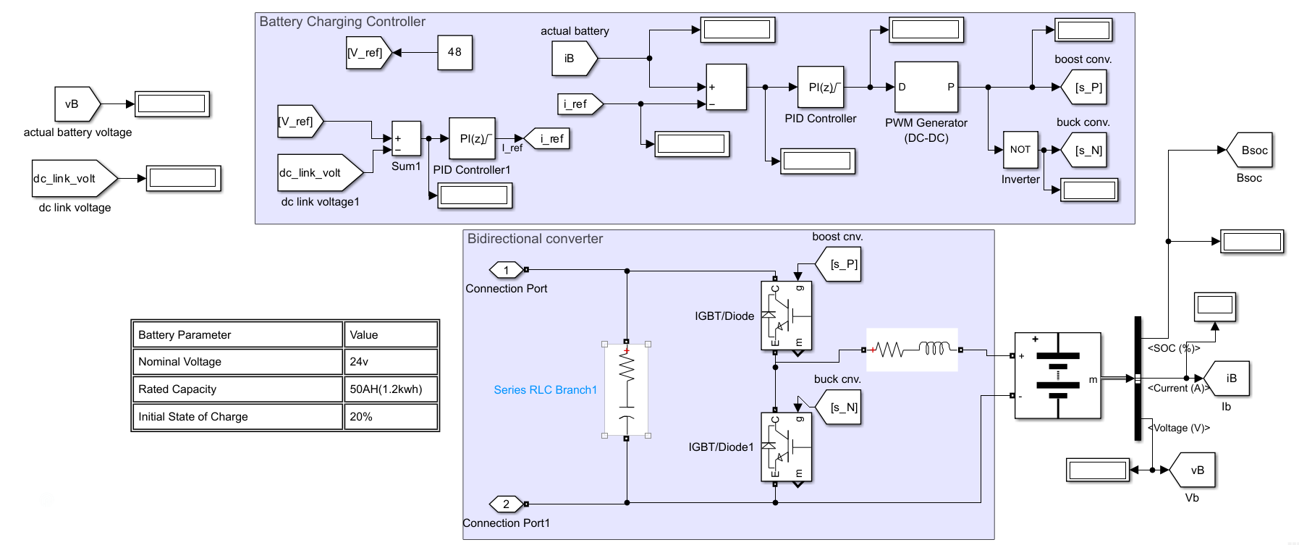

Figure.13: Battery Management System

3.5 Energy Management Algorithm
In this proposed energy management algorithm basically works on the net current required from storage devices which is obtained from the feeding difference between DC bus voltage and actual available voltage to Proportional Integral controller. PI regulator output current signal is further split into high frequency current component and average current component using filter controller. The average current component is obtained as follows

𝐼𝐵 𝑎𝑣 = 𝐹(𝐼𝑇𝑜𝑡) (3.5.1)
𝐼𝐵𝑒𝑟𝑟 =𝐼𝐵 𝑎𝑣 − 𝐼𝐵𝑎𝑡 (3.5.2)

This obtained average current component (𝐼𝐵𝑎𝑣) is compared with the available battery current 𝐼𝐵𝑎𝑡, and the error signal (𝐼𝐵𝑒𝑟𝑟) obtained as in equation (3.5) is supplied to the PI regulator to produce duty ratio. Then duty ratio is converted in to switching pulses by means of pulse width modulator (PWM), using these signals the switches SW1(IGBT/Diode) and SW2(IGBT/Diode) are operated.

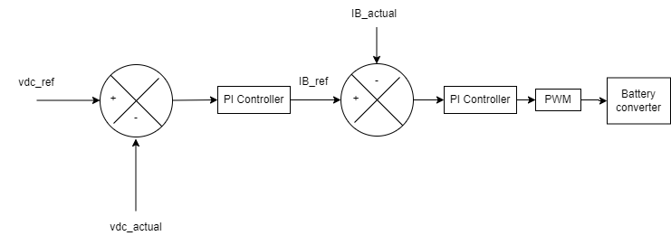
Figure 14: Energy Management Strategy of BMS

3.6 Simulation Analysis

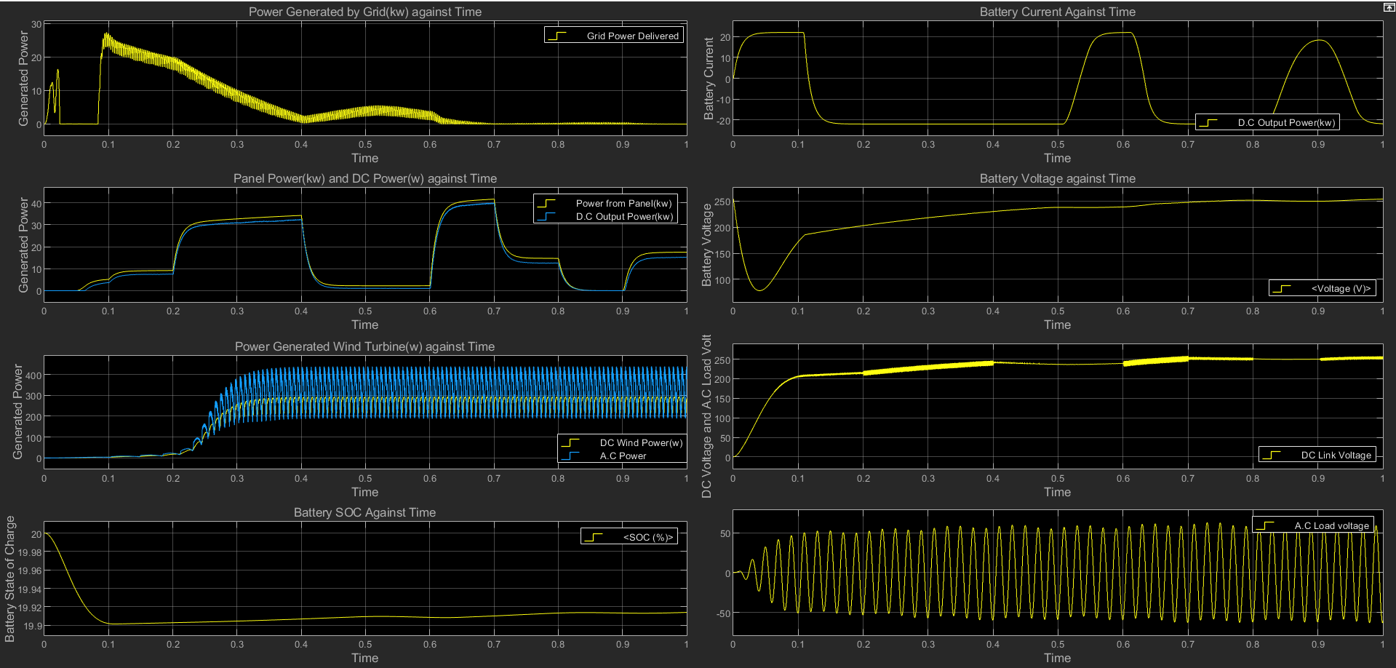
Figure 15 Overall System Analysis

This simulation provides a detailed exploration of a hybrid grid-tied system, integrating diverse distributed energy resources (DERs) alongside a main grid connection to supply local AC loads. The analysis delves into the dynamic behavior of solar photovoltaic (PV) generation, wind power, and a battery energy storage system (BESS), illustrating their coordinated interplay to manage power flow and maintain system stability.
The core of the wind energy conversion system is modeled using a 1 kW, 250 rpm wind turbine directly coupled to a Permanent Magnet Synchronous Generator (PMSG). were a constant wind speed of 12 m/s was applied, allowing for a focused examination of the system's internal power conversion and regulation. The PMSG's AC output is then rectified into DC power before being fed into the grid. During operation, the wind turbine's rotor speed reached approximately 368 rpm, exceeding its rated mechanical speed. While the wind turbine block is rated for 1 kW, the observed AC power generated was around 380.9 W, which converted to 284.7 W DC. This initial discrepancy highlighted an area for PMSG parameter optimization or improved load matching to achieve the nominal output. Within the full grid-tied context, the wind turbine's AC power was seen to stabilize around 600 W, contributing about 550 W DC after rectification, indicating improved conversion efficiency but still underperforming its nominal rating.
The solar PV system demonstrates remarkable responsiveness to varying irradiation levels, with its power output directly mirroring the assumed changes in solar input. Both the raw power from the PV panels and the processed DC output power closely tracks each other, showcasing highly efficient conversion from incident sunlight to usable electrical energy. The system effectively scaled its output to reach significant peaks of 30 kW and 50 kW, underscoring the substantial contribution of solar energy to the grid's total generation capacity. The grid's interaction reveals a clear energy management strategy. At the simulation's outset, the system relies on grid power, importing up to 25 kW to facilitate startup and meet initial load demands. However, as local renewable generation, particularly from the solar PV, rapidly increases, the reliance on grid power progressively diminishes. By approximately 0.5 seconds into the simulation, grid import falls to near zero, effectively demonstrating the system's capability to transition towards self-sufficiency and minimize external energy dependence when local generation is sufficient. The battery actively engages in dynamic charge and discharge cycles, signified by fluctuating current profiles. Conversely, during moments when generation slightly lags demand, the battery discharges to supplement the supply. This continuous buffering action is reflected in the battery's voltage, which smoothly charges from an initial 120 V to a stable 220 V. The overall State of Charge of the battery also shows a net increase throughout the simulation, affirming its role in effectively storing excess renewable energy.
The power quality within the grid-tied is also rigorously managed. A stable DC link voltage, crucial for the interconnection of DC sources and the inverter, is established at approximately 300 V, maintaining consistency with only minor ripples after an initial ramp-up. Similarly, the AC load voltages, while exhibiting some initial oscillations during the system's startup phase, quickly stabilize. By around 0.6 seconds, the AC load voltage settles into a clear sinusoidal waveform with a consistent peak amplitude of approximately 200 V, demonstrating the system's ability to deliver stable and regulated power to the end-users. this simulation clearly demonstrates the feasibility and effectiveness of a hybrid grid-tied integration system for integrating various renewable energy sources. The system effectively manages power flow, interacts dynamically with the main grid to reduce reliance, and uses battery storage to ensure a stable and continuous power supply. the overall findings strongly support the potential of such integrated grid-tied to improve energy autonomy, resilience, and contribute to sustainable energy infrastructure.

4. Conclusion

The Nigerian power sector is plagued by persistent issues of reliability, limited accessibility, and a lack of sustainable energy solutions; challenges that renewable energy can help to resolve. This research investigated the integration of solar and wind energy into Nigeria’s grid using a MATLAB/Simulink-based simulation, presenting a hybrid system architecture consisting of solar PV, wind turbines, battery storage, and grid interfacing. The simulation demonstrated that, with appropriate energy management strategies, such systems can reduce electricity shortfalls, enhance reliability, and promote sustainable development. However, the study also identified key limitations, notably in the adequacy of energy storage during low generation periods and the impact of intermittent renewable output on grid stability. These issues highlight the need for improved forecasting techniques, advanced battery management, and supportive policy frameworks. This paper presented a simple and practical simulation of hybrid renewable energy integration into Nigeria’s grid, showing how it can work, where it may fall short, and how it can help improve the country’s electricity supply especially in underserved regions.

COMPETING INTERESTS DISCLAIMER:
Authors have declared that they have no known competing financial interests OR non-financial interests OR personal relationships that could have appeared to influence the work reported in this paper.

References

[1] I. P. Okokpujie et al., “Study of the Efficiency of the Solar-Wind Hybrid Energy Generating System: Its Policy Assessment and Operations in Nigeria,” Journal of Sustainable Development Law and Policy, vol. 15, no. 3, 2024.

[2] C. Diyoke, U. Ngwaka, and K. C. Ugwu, “A comprehensive analysis on the grid-tied solar photovoltaics for clean energy mix and supply in Nigeria’s on-grid power,” Journal of Energy Systems, vol. 7, no. 1, pp. 1–17, Mar. 2023, doi: 10.30521/jes.. 988844.

[3] N. C. Ugwoke, N. S. Ugwuanyi, C. S. Ezeonye et al., “Solar-Wind Energy Integration in the Nigerian 330 kV Grid: A Technical Analysis,” Int. J. Innovative Engineering, Technology and Science, vol. 8, no. 2, Nov. 2024.

[4] G. Modukpe and D. Diei, “Modeling and Simulation of a 10 kW Wind Energy in the Coastal Area of Southern Nigeria,” IntechOpen, 2024.

[5] J. N. Okonkwo, M. S. Sule, and C. Ohikere, “Impact of Grid Interconnectivity on Solar Mini-Grid Power Generation: Case Study of FMWH Mabuchi, FCT, Abuja, Nigeria,” Academic Journal of Science, Engineering and Technology, vol. 9, no. 4, pp. 1–15, Aug. 2024, doi: 10.5281/zenodo.13331287.

[6] E. O. Nnaemeka, O. J. Chikaelo, O. C. Princewil, C. N. Ndubuisi, A. N. Onyeka, and C. N. Chidiogo, “Feasibility and Performance Analysis of Solar Energy Integration into National Grid for Improved Power Supply, Using Umuezerokam Community, Nigeria as a Case Study,” Science Journal of Energy Engineering, vol. 13, no. 2, pp. 42–61, Jun. 2025, doi: 10.11648/j.sjee.20251302.1.

[7] F. Blaabjerg and D. M. Ionel, Eds., Renewable Energy Devices and Systems with Simulations in MATLAB and ANSYS, CRC Press, 2017.

[8] D. Manivannan, “Modeling and Simulation of Renewable Hybrid Power System using MATLAB/SIMULINK Environment,” Int. J. Adv. Technol. Eng. Sci., vol. 1, no. 6, pp. 32–38, 2013. [Online]. Available: https://www.ijates.com/images/short_pdf/1396895984_P32-38.pdf. [Accessed: 1 June 2025].

[9] C. O. Okoye and B. C. Oranekwu-Okoye, “Economic Feasibility of Solar PV System for Rural Electrification in Sub-Sahara Africa,” Renew. Sustain. Energy Rev., vol. 82, pp. 2537–2547, 2018.

[10] O. Olagunju, “Assessment of the Viability of Wind Farm Projects in Northern Nigeria,” M.S. thesis, Fakultät Life Sciences, 2021. [Online]. Available: http://hdl.handle.net/20.500.12738/11190. [Accessed: 20 June 2025].

[11] International Energy Agency (IEA), “Renewables 2023.” [Online]. Available: https://www.iea.org/reports/renewables-2023. [Accessed: 26 June 2025].

[12] J. Timperley, “The Carbon Brief Profile: Nigeria,” Carbon Brief, 2017. [Online]. Available: https://www.carbonbrief.org/the-carbon-brief-profile-nigeria/. [Accessed: 2 July 2025].

[13] C. Ogbonnaya, C. Abeykoon, U. Damo, and A. Turan, “The Current and Emerging Renewable Energy Technologies for Power Generation in Nigeria: A Review,” Therm. Sci. Eng. Prog., vol. 13, Art. no. 100390, 2021. [Online]. Available: https://doi.org/10.1016/j.tsep.2019.100390. [Accessed: 7 July 2025].

[14] A. A. Attabo, O. O. Ajayi, S. O. Oyedepo, and S. A. Afolalu, “Assessment of the Wind Energy Potential and Economic Viability of Selected Sites Along Nigeria’s Coastal and Offshore Locations,” Front. Energy Res., vol. 11, Art. no. 1186095, 2023. [Online]. Available: https://doi.org/10.3389/fenrg.2023.1186095. [Accessed: 11 July 2025].

