Based on Adams, dynamic simulation and analysis of key components of the RV reducer

Abstract: The RV reducer has a series of advantages such as high transmission efficiency, small volume, light weight, large load-bearing capacity, smooth motion, low noise, and long service life, which is of great significance for studying its dynamic characteristics. Taking a certain type of RV reducer as the research object, a parametric 3D model was established in SolidWorks, and the dynamic model of the RV reducer was established using Adams. The crankshaft, as a key component of the RV reducer, is prone to failures such as pitting, cracking, and ball detachment, which can lead to the degradation of the reducer's performance and eventually failure [7] . Through simulation analysis, the stress analysis of key components such as the crankshaft was obtained. This research method has certain guiding significance for the precise design of RV reducers.

Keywords: RV, Dynamic Simulation, Force Analysis

Introduction
The RV reducer, as a high-performance transmission device, plays a crucial role in the modern industrial field. With the continuous development of industrial robots and automation technology, the requirements for key transmission components in various applications are also increasing, making in-depth research on RV reducers of great significance. The RV reducer has high precision, high reduction ratio, and a complex two-stage planetary transmission structure [8]. It has a series of advantages such as high transmission efficiency, small volume, light weight, large load-bearing capacity, smooth motion, low noise, and long service life, and is therefore widely used in industrial robots, CNC machine tools, automation equipment, aerospace, new energy, and other fields [15]. The core principle of the RV reducer is to achieve reduction by combining planetary gear transmission with cycloidal pinion transmission [12]. Its importance lies not only in its high efficiency, stability, and reliability but also in its key role in the entire transmission system [13]. Lu Chunyuan proposed to establish a rigid-flexible coupling dynamic model of the planetary gear transmission system considering the flexibility of the inner gear ring, taking into account the time-varying meshing stiffness and static transmission error excitation, and using the Runge-Kutta numerical algorithm to calculate the dynamic response characteristics of the planetary gear transmission system. By analyzing the dynamic stress and deformation distribution on the gear tooth line and tooth root, the system load and stress distribution were analyzed, and the influence of gear ring flexibility on transmission accuracy, load distribution, vibration characteristics, and other factors was studied [1] . Li Yanzhang established a rigid-flexible coupling model of the RV reducer and used the Durability module in RecurDyn software to analyze the force, calculating the fatigue life of the cycloidal pinion structure and involute gear [2] . Zhao Qiaorong used a precision reducer comprehensive testing platform to explore the influence of the driving end load and speed of the RV reducer on indicators such as no-load friction torque, no-load running-in, positioning accuracy, and mechanical efficiency during operation, monitoring the changes of key parameters in real time, and drawing and analyzing the corresponding test curves [3] . He Yilin used UG to establish and assemble the RV reducer model, and performed transient dynamic analysis on the key sun gear and planetary gear, cycloidal wheel and pinion gear of the transmission mechanism through Workbench and solved their contact stress. The analysis showed that the maximum contact stress between the sun gear and the planetary gear occurs at the meshing point, and the maximum contact stress between the cycloidal wheel and the pinion occurs at the planetary housing hole[4] . Xiang Zhao sen conducted force analysis and calculation on the cycloidal wheel and cycloidal wheel support bearing in the RV reducer, and used UG software for motion simulation to verify the accuracy of the force. The results showed the force variation curve of the shaft bearing with the crankshaft angle, and the force variation curve of the cycloidal pinion tooth, providing data support for the optimization analysis and application of RV reducer components[5]. This paper adopts a simplified 3D model to establish the dynamic model of the RV-110E reducer and obtained the dynamic response curves of key components. This research method has certain guiding significance for the development of RV reducers.

1.Transmission Principle and Characteristics of RV Reducer

1.1Transmission Principle of RV Reducer

The RV reducer is a closed differential gear system consisting of an input gear, planetary gears, and planetary carriers. The closed part is a cycloidal pinion planetary driving mechanism, composed of a crankshaft, cycloidal gear, pinion, and roller pinion housing [6,14] .
As shown in Figure 1, this is the internal structure composition of the RV reducer, including: 1- Sun gear (input shaft) 2- Input flange 3- Pinion shell 4- Main bearing (angular contact ball bearing) 5- Output flange 6- Planet gear 7- Crank shaft 8- Swing arm bearing (needle roller bearing) 9- Cycloidal gear 10- Pinion pin, the input and output flanges are fixed to form the planet carrier.
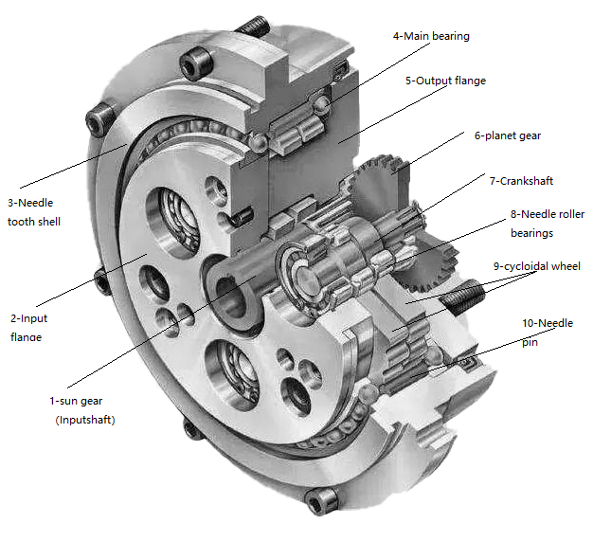
Fig.1 Structural composition diagram of RV reducer
The sun gear and planet gear transmission between the sun gear and the planet gear is the first stage of speed reduction in the RV reducer. The cycloidal gear transmission that drives the rotation of the needle gear shell through the needle pinion is the second stage of speed reduction in the RV reducer. Through two stages of transmission and speed reduction, the gear difference speed reduction of the RV reducer is achieved.
When the planet gear train is operating, the input shaft and the planet gear rotate in opposite directions. If the number of teeth on the input shaft is ZS and the number of teeth on the planet gear isZP，, then the speed ratio (planet gear output/input shaft input) is$\frac{Zs}{Zp}$。
The cycloidal pinwheel rotates, causing the crank shaft to rotate and tilt, driving the cycloidal wheel to oscillate. The crank eccentric shaft is symmetrically arranged, and the two cycloidal wheels oscillate synchronously in the symmetric direction. The oscillation process of the two cycloidal wheels has a phase difference of 180°, and the oscillation of the cycloidal wheel compresses the pin tooth pin to produce a relative rotation with the output flange.
Thus, the total speed ratio of the two-stage speed change $i=\frac{Zs}{Zp}×\frac{1}{Zr}$is obtained, which is (the output speed of the pin tooth shell / the input speed of the input shaft). Among them, the number of teeth of the pin tooth shell is Zr , the speed ratio of the pin tooth shell and the crank shaft is $i=$
, and the deflection angle θ of the pin tooth shell relative to the crank shaft is$\frac{1}{Zr}×3$60°

1.2Characteristics of RV Gearbox Transmission
Compared with other transmission forms, the transmission of the RV type gearbox has the following characteristics.
（1）The two-stage transmission composed of planetary gear and cycloidal pinwheel gear drives, which has a better transmission ratio range than harmonic gear reducers, is a large-scale reduction that is difficult to achieve with traditional ordinary gear planetary gears and worm gear reducers.
（2） The first-stage planetary gear drive has 3 sets of planetary gears, and the second-stage cycloidal pinwheel drive has hard tooth surfaces and multi-tooth pins meshing simultaneously. Compared to harmonic gear reducers, the same volume has larger tooth shapes and higher torque.
（3）The crankshaft is supported by needle roller bearings, and the pin gear shell and cycloidal wheel are driven by pin gear pins, making the reducer structure rigid and durable.
In terms of actual performance, the RV-type reducer has a larger rated output torque, higher input speed, stronger rigidity (larger elastic coefficient), higher transmission efficiency, and smaller moment of inertia than the harmonic gear reducer in the same size specification. However, there are problems such as complex structure, many parts, heavy weight, large gear clearance, and long transmission chain, mainly reflected in the slightly lower precision indicators of the RV-type reducer's transmission clearance and transmission accuracy compared to the harmonic reducer.
Therefore, the RV-type reducer is mainly applied to the deceleration and rotation parts with high inertia and high output torque in industrial robots due to its characteristics.

2.3D Modeling of RV-110E Gearbox
The RV-110E type reducer is modeled using SolidWorks software, and the 3D model is shown in Figure 2
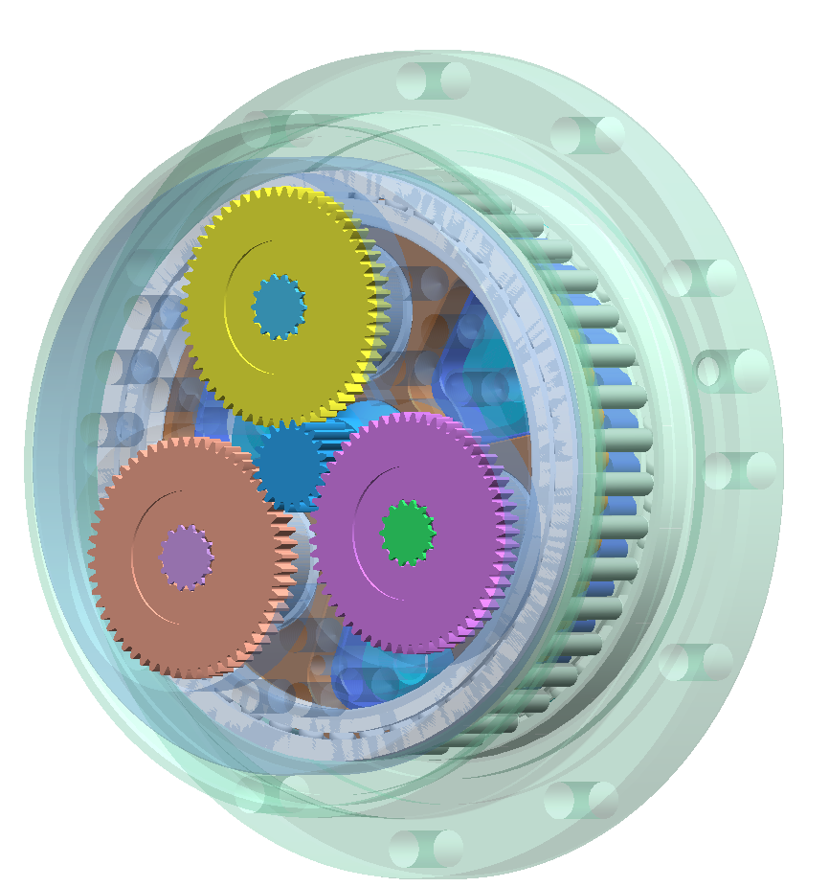

Fig.2 RV-110E Reducer 3D Model Assembly

After completing the assembly of the RV-110E type reducer model, the interference check function of SolidWorks software is used to detect whether any parts have occurred volume stacking during the assembly process. As shown in the exploded view in Figure 3, it is convenient for self-inspection while also providing a more intuitive display of the various parts of the RV-110E type reducer.

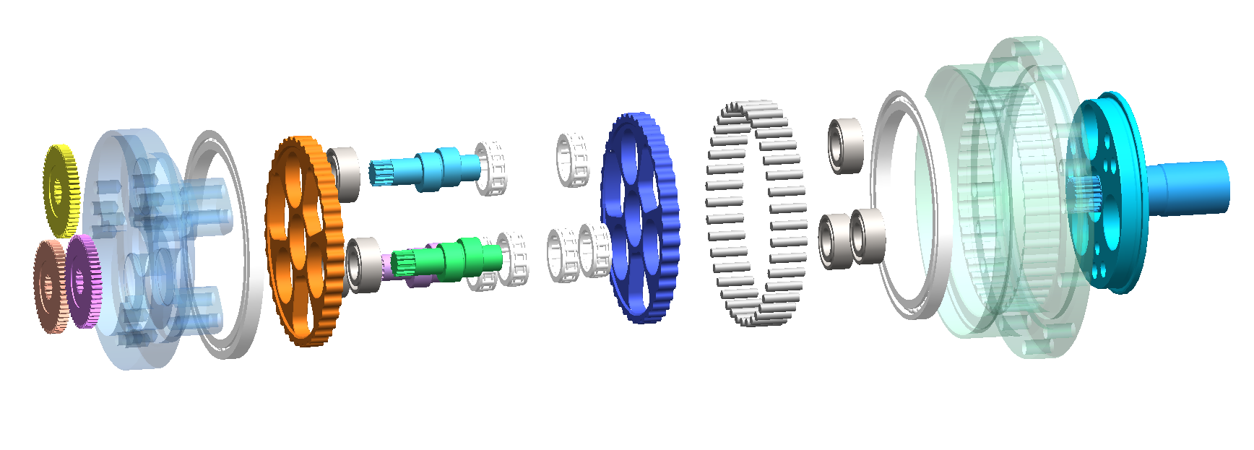
Fig.3 Exploded view of RV-110E reducer

3.Dynamics Model Simulation of RV-110E Reducer

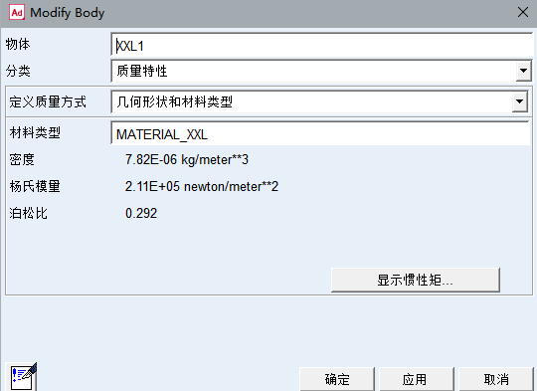
3.1Material Parameter Settings and Constraint Type Settings
Fig.4 RV-110E reducer component material and characteristic setting

Translate to English: Convert the assembly format of the completed RV-110E type reducer into a format recognizable by Adams (*.x_t) and save it. After loading the model file into the Adams multi-body mechanical system dynamics simulation module, it is necessary to first check if any parts are missing and if the part names are garbled. Then, set the model name, unit system, and gravity direction. The unit system in this paper is MMKS (millimeters, kilograms, newtons, seconds). After importing the model, define the material for each part individually. As shown in Fig. 4.
Material parameters can be learned from the RV reducer design manual and reducer specifications. The material property parameters required for all parts in the Adams dynamics simulation are shown in Table 1.
Table 1. Material Properties of 2K-V110E Reducer Components
Name | materials | Density  （kg/mm³） | Young's modulus  （N/mm ²） | Poisson's ratio（μ）
Input shaft | 20CrMo | 7.82E-06 | 2.11E+05 | 0.292
Planet gear | 20CrMo | 7.82E-06 | 2.11E+05 | 0.292
Input flange | QT450-10 | 7.0E-06 | 1.73E+05 | 0.3
Needle gear housing | QT450-10 | 7.0E-06 | 1.73E+05 | 0.3
Output flange | QT450-10 | 7.0E-06 | 1.73E+05 | 0.3
Crank shaft | 20CrMnMo | 7.87E-06 | 2.07E+05 | 0.254
Swivel arm bearing | GCr15 | 7.8E-06 | 2.19E+05 | 0.3
Cycloidal gear | 20CrMo | 7.82E-06 | 2.11E+05 | 0.292
Needle tooth pin | GCr15 | 7.8E-06 | 2.19E+05 | 0.3
By adding constraint types to the dynamic simulation of the RV-110E type reducer, the model-based simulation achieves the effect of real machine operation in the actual environment. The addition of constraint types, in essence, is the setting of the motion relationship of the reducer components. Once the constraint relationship between the components is determined, the degree of freedom of the mechanism is also determined, and the motion relationship follows. Theoretically, the more precise the constraint types added between components, the more accurate the motion relationship will be. However, this will cause a large amount of computational power waste and monotonous simulation results. To avoid the occurrence of the above problems, first, an in-depth understanding of the motion relationship of the main subject RV-110E type reducer is conducted, only setting constraint types that conform to its output logic, and relying on the physical engine of Adams software to automatically complete the contact constraint settings for other unnecessary constraints, to the maximum extent to simulate real operation.

Table 2. 2K-V110E reducer parts constraint type
Binding subject 1 | Binding subject 2 | Type of constraint | Position of action
input shaft | ground | rotating disk | input shaft axis
spur gear | input shaft | gear pair | contact surface
Input flange | Output flange | stationary sub | Input flange center of mass
Needle gear housing | ground | stationary sub | Needle gear housing center of mass
Output flange | Needle gear housing | plane sub | Output flange tangent plane
Crank shaft | spur gear | stationary sub | Crank shaft center of mass
Swivel arm bearing | Crank shaft | rotating disk | Swivel arm bearing axis
Cycloidal gear | Swivel arm bearing | rotating disk | Cycloidal gear axis
Needle tooth pin | ground | stationary sub | Needle tooth pincenter of mass

3.2Type of Contact
In the contact type settings for the dynamics simulation of the RV-110E type reducer, contact forces were used to achieve simple constraints and force transmission between components. This study adopted normal force collision to simulate the rigid body contact between components.
Through calculation, it is obtained that in the first-stage speed change, the meshing stiffness between the input shaft and the planet gear is 2.08E+05 N/mm, and the meshing damping is 2.08E-04 N·s/mm. In the second-stage speed change, the meshing stiffness between the cycloidal pinion and the needle pin is 2.13E+07 N/mm, and the meshing damping is 1.26E-05 N·s/mm.
Due to the excellent actual machine lubrication conditions, the friction force has a negligible impact on the real results, therefore, in the contact force settings of the dynamic simulation, friction is ignored, and the final contact type setting is as shown in Fig.5.

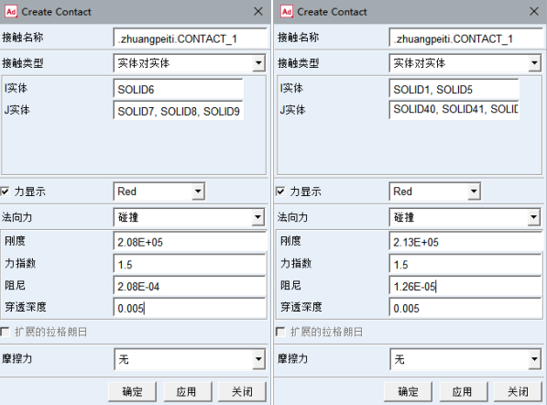
Fig.5 RV-110E reducer contact type setting

3.3Dynamic Model Drive and Load Settings
By referring to the product manual of the RV-110E type reducer, it can be known that its transmission ratio is 111, and the output speed of the output flange under the rated output condition is 15r/min, and the output torque is 1078Nm. Based on the basic operating parameters under the rated torque, the dynamic simulation model in Adams is added with drive and load and parameter settings.
Firstly, as shown in Fig. 6, a "rotary drive" is added to the input shaft pivot on the preset, and "function drive" is selected in the definition for use. The function is edited to STEP(time, 0, 0, 0.5, 9990d), and "Apply" is clicked to save. This completes the smooth acceleration of the input shaft to the rated speed within 0.5 seconds under the rated torque, and after 0.5 seconds, the input shaft runs at a stable speed of 1165r/min.

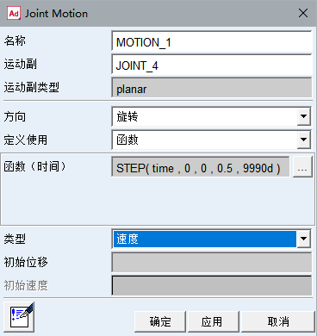
Fig.6 RV-110E reducer rated working condition drive setting
Finally, as shown in Fig. 7, a fixed torque load is applied to the output flange to simulate the output under the rated torque. The function is edited to STEP(time, 0.2, 0, 0.5, -1078000). The load is applied smoothly starting from 0.2 seconds after the simulation model starts running, and at the same time as the input acceleration is completed, the load application is completed at 0.5 seconds. Subsequently, the load will remain at 1078Nm and no longer change.
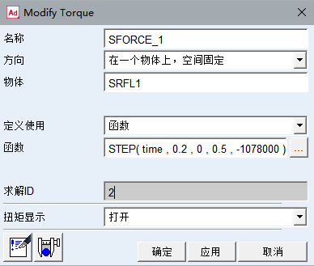
Fig.7 RV-110E reducer rated torque load setting

4.Simulation Analysis Results

4.1Verification of Simulation Results for the RV-110E Type Gearbox
To verify the correctness and rationality of the constraints added in the previous section and the model's motion, it is necessary to simulate the established model and analyze its motion form. At the rated torque of the RV-110E type reducer, the output flange speed is 15 t/min, and the input shaft speed is 1665r/min. In the first stage of reduction, the crank shaft is fixedly connected to the planet gear, and their self-rotating angular velocities are consistent at -3510 d/sec. In the second stage of reduction, the cycloidal pinion has a self-rotating angular velocity of 90 d/sec. The output flange has a circular and self-rotating angular velocity of 90 d/sec. The speeds of the input shaft and output flange are shown in Figs. 8 and 9.
It can be concluded that the dynamic simulation modeling is correct.
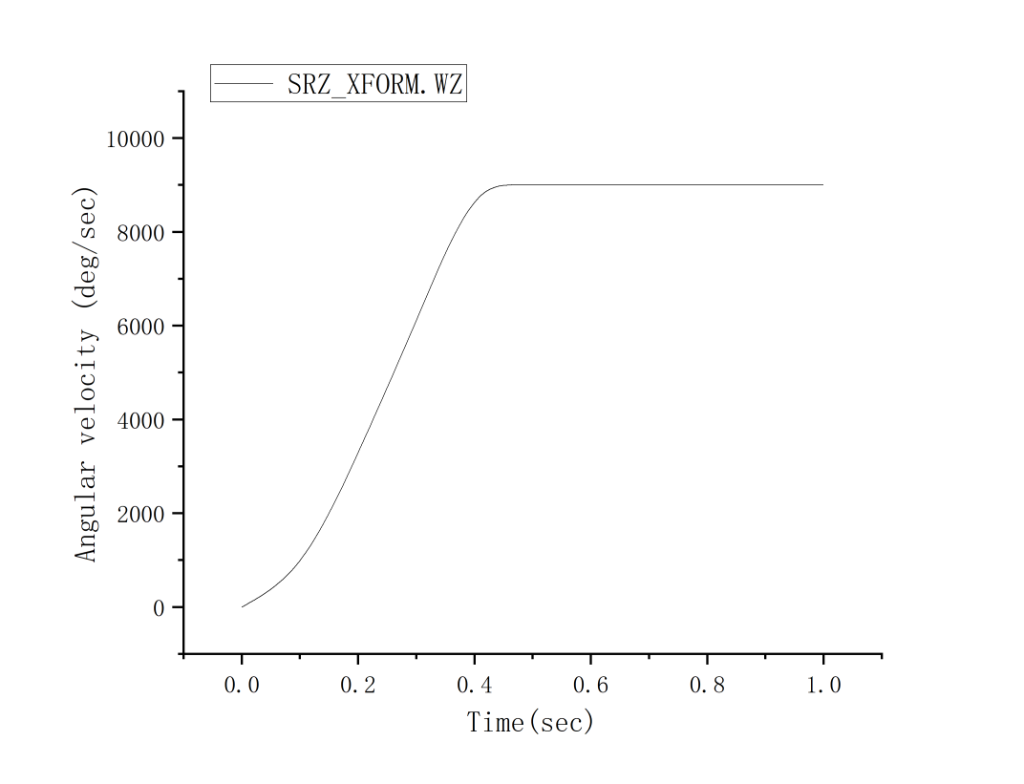
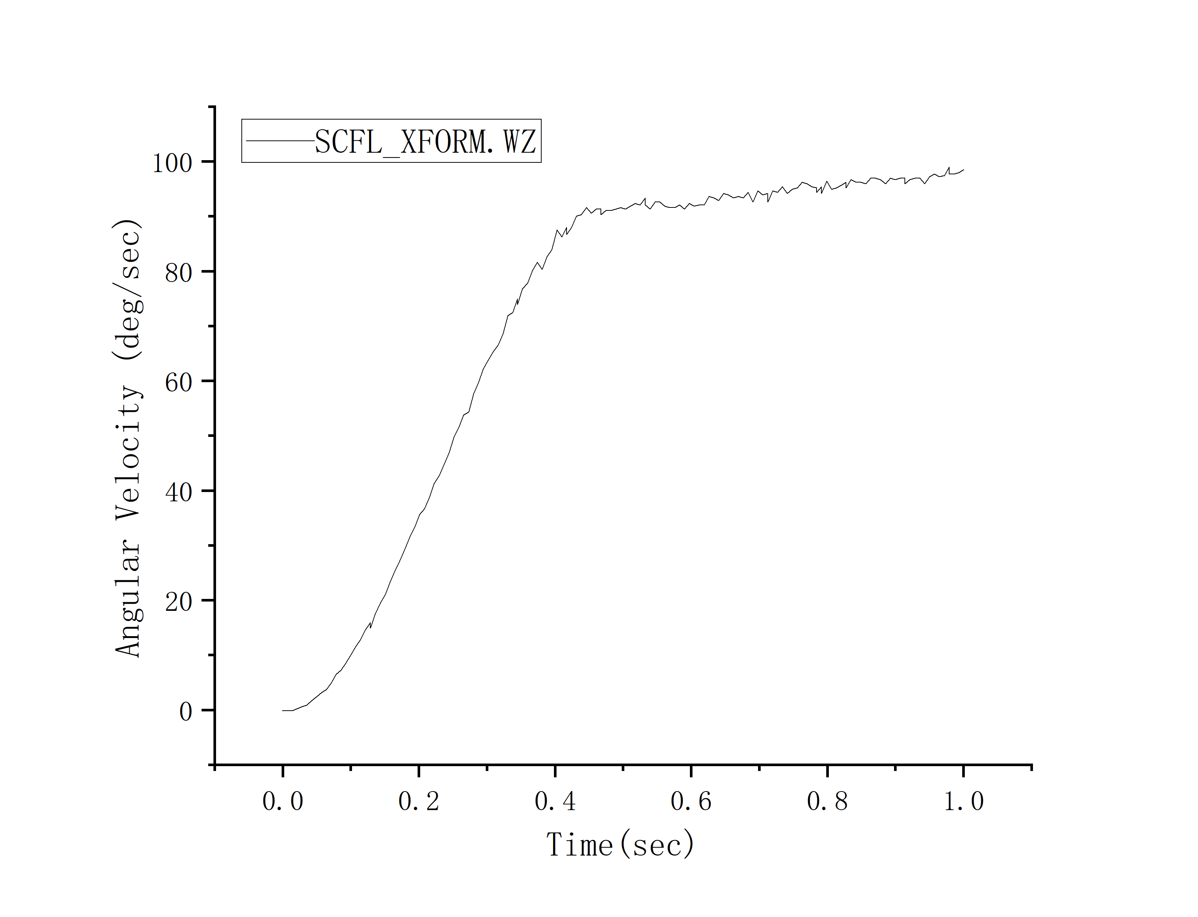
Fig.8 Angular Velocity of input shaft under rated torque

Fig.9 Angular Velocity of Output Flange under rated torque

4.2Analysis of the Crankshaft's Forces
The crankshaft, as an important non-standard force transmission component of the RV system, is subjected to a complex load environment, and its manufacturing and assembly errors will seriously affect the transmission accuracy of the RV reducer. The force on the crankshaft is crucial throughout the RV-110E reducer, serving as a connection and fixation for the planetary gears in the first stage of transmission, and as a driving and fixation for the cycloidal pinion in the second stage of transmission. It also bears the role of driving and fixing the input and output flanges. This paper mainly studies the force between the crankshaft and the input and output flanges.
Under ideal conditions, the forces acting on the crankshaft in the x and y directions at the contact positions with the input flange and output flange:
$$F_{cix}=k_{bi}(s_{bix}+s_{ix}+e_{caxi}±e_{xi})-F_{ci0}sin(θ_{c}+∅_{i})$$
$=k_{bi}[x_{pi}-x_{ca}+R_{dc}(θ_{ca}-θ_{c})sin(θ_{ca}+∅_{i})+e_{caxi}±e_{xi}]$ (4-1)
$-F_{ci0}sin(θ_{c}+∅_{i})$
$$F_{ciy}=k_{bi}(s_{bix}+s_{iy}+e_{cayi}±e_{xi})+F_{ci0}cos(θ_{c}+∅_{i})$$
$=k_{bi}[y_{pi}-y_{ca}-R_{dc}((θ_{ca}-θ_{c})cos(θ_{ca}+∅_{i})+e_{cayi}±e_{xi}]$ (4-2)
$+F_{ci0}cos(θ_{c}+∅_{i})$
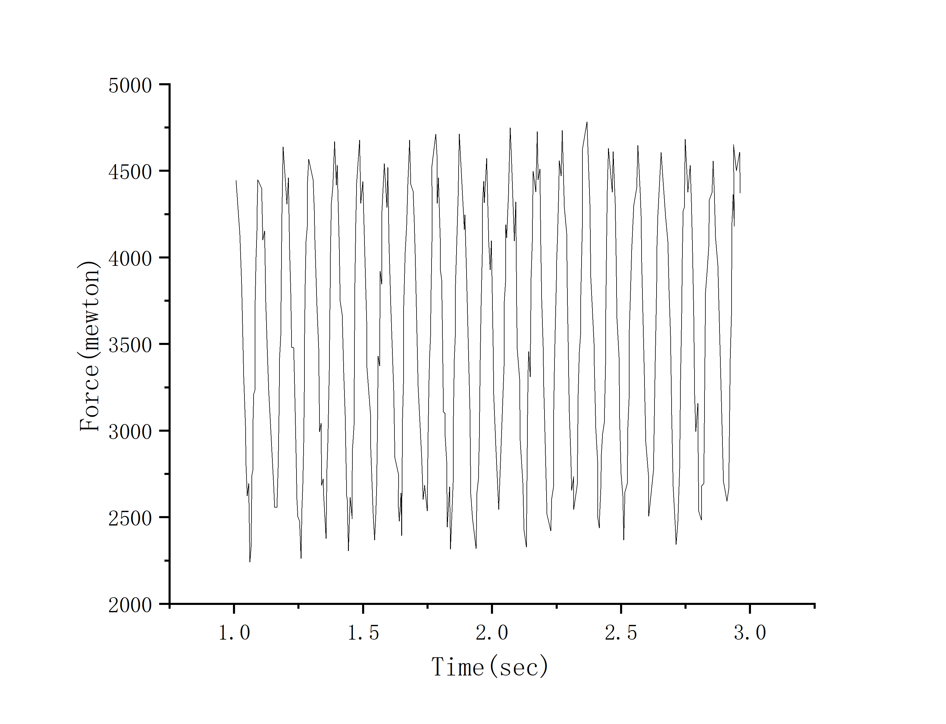

Fig.10 Plot of crankshaft force on input flange as afuncio of timt

Fig.11 Crankshaft force on input flange as afuncio of timt

By explaining the types of forces acting on the crankshaft, the dynamic simulation results of the model are analyzed, as shown in Figures 10 and 11. The force applied by the output flange is slightly higher than that of the input flange, and it is uniformly distributed below 5500N, acting on the crankshaft journals.

Conclusion
- A 3D model of the RV-110E was created using SolidWorks and its assembly interference was verified. The 3D model of the RV reducer was imported into Adams software, where material properties were added and constraints were established to build the dynamic simulation model of the reducer. This provides conditions for further research on the stress analysis of key components and life prediction.
- （2）The angular velocity of the input and output shafts is basically consistent with the theoretical value, with no significant difference. At this point, it is considered that the simulation model is set correctly, and the correctness of the dynamic simulation model is verified. The main factor affecting the fluctuation of the output shaft speed is the second-stage transmission, and the influence of the second-stage transmission on the fluctuation of the crankshaft speed is also greater than that of the first-stage transmission [9] . The types and magnitudes of forces on the key components under the rated working conditions have been obtained. The force applied by the output flange is slightly higher than that of the input flange, and it is uniformly distributed below 5500N, acting on the crankshaft journal. The simulation results all meet the requirements of the ideal model of the RV-110E type reducer.

COMPETING INTERESTS DISCLAIMER:
Authors have declared that they have no known competing financial interests OR non-financial interests OR personal relationships that could have appeared to influence the work reported in this paper.

References
- Lu Chunyuan, Jiao Hongyu. Research on the Dynamic Characteristics of Planetary Gear Transmission System under Flexible Tooth Ring[J/OL]. Mechanical Design & Manufacturing: 1-10 [2024-06-27].
- Li Yan Zhang. Fatigue Life Analysis and Optimal Design of Key Components of RV Reducer Based on Rigid-Flexible Coupling [D]. Jilin University, 2022.
- Zhao Qiaorong, Zhao Cuicui, Lei Youqiao, et al. Key Parameters Test and Analysis of RV Reducers[J]. China Testing, 2021, 47(11): 113-118.
- He Yilin, Zheng Peng. Analysis of RV Gearbox Transmission Performance[J]. Mechanical Engineer, 2021, (12): 41-43+48.
- Xiang Zhaosen, Zheng Peng. Stress Analysis of Precision RV Reducers[J]. Internal Combustion Engines and Accessories, 2021, (09): 47-49.
- HAN Linshan;SHEN Yunwen;DONG Haijun;WANG Gaofeng;LIU Jiyan;QI Houjun. THEORETICAL RESEARCH ON DYNAMIC TRANSMISSION ACCURACY FOR 2K-V-TYPE DRIVE[J]. , 2007, 43(6): 81-86.
- Nie Yu. Fault diagnosis method for crankshaft bearing of RV reducer based on time-varying signal decomposition and reconstruction [D]. Jiangxi University of Science and Technology, 2024.
- He Yilin, Zheng Peng. Analysis of Transmission Performance of RV Gearbox[J]. Mechanical Engineer, 2021, (12): 41-43+48.
- Liu Xueao. Dynamic analysis of RV reducer[D].North China University of Technology,2016.
- Zheng Yuxin, Xi Ying, Yuan Lang, et al. Force analysis of crank shaft of RV reducer and its influence on transmission accuracy[J].Mechanical Design,2017,34(08):44-50.
- Wang Chunming, Zhang Lei, Zhang Peng, et al. Dynamic Simulation Analysis of RV Reducer Based on ADAMS[J].Science and Technology Innovation and Application,2023,13(30):80-83.
- Yang, M., Zhang, D., Cheng, C., & Han, X. (2021). Reliability-based design optimization for RV reducer with experimental constraint. Structural and Multidisciplinary Optimization, 63(4), 2047-2064.
- Wang, C., & Mao, K. (2021). Design of high power density for RV reducer. Journal of the Brazilian Society of Mechanical Sciences and Engineering, 43(6), 291.
- Ahn, H. J., Choi, B. M., Lee, Y. H., & Pham, A. D. (2021). Impact analysis of tolerance and contact friction on a RV reducer using FE method. International Journal of Precision Engineering and Manufacturing, 22(7), 1285-1292.
- Han, Z., Wang, H., Li, R., Shan, W., Zhao, Y., Xu, H., ... & Du, Y. (2024). Study on nonlinear dynamic characteristics of RV reducer transmission system. Energies, 17(5), 1178.

