Method Article

Dynamic simulation analysis of wind power crane multi-body system

.
ABSTRACT

With the large-scale development of wind power, the site selection for wind farms has gradually shifted to areas with low wind speed resources. However, low wind speed areas are characterized by rough roads, construction sites mostly having weak ground pressure foundations, and small construction areas. Traditional wind power hoisting equipment cannot meet such construction conditions. Against this backdrop, the demand for developing and researching new types of wind power hoisting equipment has become increasingly urgent.
In response to the special construction environment of low wind speed wind farms and the hoisting requirements of high-tower wind power equipment, this paper focuses on the research centered on wind power cranes that are efficient, safe, non-attached, adaptable to weak ground pressure foundations, and suitable for small construction areas. It uses ADAMS and ANSYS software to conduct a combined rigid-flexible coupling dynamic simulation of trusses and steel wire ropes. Specifically, the trusses and steel wire ropes are processed as flexible structures in ANSYS software, and modal neutral files are generated. These files are then imported into ADAMS to complete the model establishment of the multi-rigid body system and the rigid-flexible coupling dynamic simulation. Finally, through the analysis of the rigid-flexible coupling model, dynamic stress and strain data graphs are obtained, the maximum dynamic load and maximum eccentric load are analyzed, and the overall stability of the boom of the non-attached tower crane during lifting operations is verified.

Keywords: wind power crane;dynamic simulation;stability checkSimulation;

Introduction
Against the backdrop of the global energy structure transitioning toward cleanliness, the wind power industry has achieved rapid development. As a core piece of equipment for wind farm construction and operation & maintenance, wind power cranes are required to perform precise operations under high-altitude and heavy-load working conditions (Jin et al., 2025). Consequently, the safety of their structural design and the stability of their dynamic performance have become key focuses of attention in the industry.A wind power crane integrates multiple systems, including hydraulic, hoisting, and drive systems. During operation, it endures complex loads such as self-weight, wind loads, and impact loads (Nie & Fu, 2020). Traditional analysis methods, which only target a single system or rigid-body structure, struggle to fully reflect the structural dynamic response under actual working conditions—easily leading to design deviations and potential safety hazards. Therefore, conducting research on the rigid-flexible coupling dynamic simulation of multi-body systems holds significant engineering significance.
However, existing studies mostly focus on static analysis or single flexible body modeling, and systematic research on the rigid-flexible coupling characteristics and multi-condition dynamic responses of key components of wind power cranes (such as booms and steel wire ropes) still needs to be improved. The development of virtual prototype technology and multi-body system dynamics theory provides an effective means to solve the above problems (He et al., 2023). Virtual prototype technology can simulate the complex movement process of equipment through software simulation, avoiding the high cost of repeated trial production of physical prototypes; multi-body system dynamics can accurately describe the coupled movement laws of rigid bodies and flexible bodies (Simeone et al., 2022). Among them, the application of theories such as dynamic stiffening and modal superposition can significantly improve the calculation accuracy of the dynamic characteristics of flexible bodies. Based on this, this paper takes the wind power crane as the research object, adopts the co-simulation technology of ADAMS and ANSYS, constructs a truss-steel wire rope rigid-flexible coupling model, focuses on analyzing the structural dynamic response under typical working conditions such as slewing, lifting, and luffing, verifies the rationality of the structural design by comparing modal frequencies, load curves, and motion parameters, and aims to provide a theoretical basis and technical support for the optimal design and safe operation of wind power cranes.
1. Research Status of Simulation Analysis on Wind Power Cranes
Wind power hoisting equipment is a complex engineering device integrating multiple disciplines, technologies, systems and fields. It consists of complex systems, including hydraulic, hoisting, cooling and drive systems. Studying and analyzing only one of these systems or structures cannot solve complex practical problems. Therefore, many scholars at home and abroad have conducted systematic simulation and analysis research on wind power crane equipment.
Many scholars at home and abroad have achieved substantial research results in the simulation and analysis of cranes. Lü Junfu [1] took a 1600 t gantry crane as the research object and proposed to use a neural network model to replace the crane model. First, a crane parameter sample table was generated based on the properties of the orthogonal array; then, the software ANSYS was used to solve the data in the parameter sample table and generate a complete overall sample set. After that, neural network models for parameters such as crane weight and frequency were established using the crane sample data to achieve rapid response. Finally, the genetic algorithm was introduced to optimize the specific parameters of the crane. Through data comparison, it was found that the crane weight was significantly reduced and the natural frequency was greatly increased, which achieved the expected goal of optimizing the model.Li Wenhua [2] et al. conducted a co-simulation of a portal crane using Adams simulation software and Matlab software. The experimental results obtained the dynamic characteristic curve of the portal crane under the luffing system at rated load, which laid a foundation for the integrated system optimization of the portal crane in the later stage.Hu Jianfeng from Xiangtan University [3] focused on a flat-top tower crane. He used the finite element software ANSYS to conduct finite element static analysis on the welding joints between the chord members and web members of the crane boom. By comparing and verifying the obtained stress results with the actual experimental data, a new research method for the static analysis of cranes was proposed. This method greatly reduces the calculation time and improves the calculation efficiency.
MILE M. Savkovic [4] conducted simulation-based optimization for single-girder overhead traveling cranes. Taking the box-section of the main girder as the research object, he set weight reduction as the objective function, and strength, stability, and stiffness as constraint functions. The firefly algorithm, bat algorithm, and cuckoo search algorithm were incorporated into the simulation optimization process. By comparing and analyzing the results, the correctness of the optimization method was verified.Ataei [5] et al. established a crane model using the finite element method and simplified it with equivalent 3D beam elements. They performed dynamic analysis under various environmental conditions and calculated the responses of the crane structure and water bridge under different working conditions. The study showed that during cooperative operations, the flexibility of the crane structure affects the relative motion between the floating rod buoy and the water turbine; the flexibility of the crane structure also has a significant impact on the rotation of the boom, and the response deviation between rigid and flexible cranes increases with the increase of excitation force.Yi Ming Lee [6] et al. studied the mechanism of a new type of multi-axis CNC machine tool and its characteristics during the development process. Basic motion commands were implemented via ADAMS, and multi-body dynamics simulation was conducted on the machine tool in a computer environment. This method is applied to the kinematic analysis of new CNC multi-axis machine tools, meeting the requirements of high-precision machine tools in the aerospace industry today.Garcia-vallejo [7] conducted further research on planar rigid-flexible multi-body systems using a hybrid approach of two methods: the natural coordinate method and the absolute nodal coordinate method.Kane [8] et al. first proposed the concept of dynamic stiffening when studying large-scale mechanical equipment, and the experimental simulation results were contrary to the traditional simulation results. Subsequently, Banerjee [9] also verified the phenomenon of dynamic stiffening in the simulation experiment of large-scale unloading equipment.In the flexible beam collision experiment, Rismantab-Sany [10] applied the momentum balance method to the flexible body system for the first time, laying a foundation for subsequent flexible body collision experiments.
2. Establishment and Process of Rigid-Flexible Coupling Model for Wind Power Cranes

2.1Division Principles of Rigid Bodies and Flexible Bodies
In the design process of wind power cranes, to ensure the overall stability and safety of the tower body, it is essential to guarantee that the tower body, boom, tower sections, and trusses have sufficiently high strength and stiffness during the design phase.For some small components, their deformation is minimal, and the deformation magnitude is negligible relative to the overall model; these components can be modeled as rigid bodies.To meet the requirements of high-altitude operation radius, wind power cranes are often designed with a relatively long boom. Additionally, to effectively transmit forces, steel wire ropes are usually used for force transmission. During the force transmission process, both the steel wire ropes and the boom are subjected to large impact loads and undergo significant deformation during the lifting operation. Therefore, the steel wire ropes should be modeled as flexible bodies.
(1) Rigid Body Modeling Method
Due to the insufficiently powerful 3D functions and incomplete features of ADAMS, the efficiency of building 3D models in the ADAMS software is low, and the accuracy cannot be guaranteed. In this paper, a 3D model of the specific structure is first established; then, the specific model is transferred via data, and the rigid body model is constructed in ADAMS (input file format: x_t).
(2) Flexible Body Modeling Methods
Common flexible body modeling methods include the discrete flexible beam connection method, automatic flexibility processing, and the modal neutral file import method.
① Discrete flexible Beam Connection Method:
The principle of the discrete flexible beam connection method is to divide the entire component into a limited number of small segments, which are flexibly connected by flexible beams. After discretization, different properties are assigned to each discrete segment, with each segment treated as an independent rigid part. However, no displacement occurs between the units, so the flexible body generated by this method is not a true flexible body. It is only suitable for simple flexibility analysis and not applicable to the analysis of crane truss structures.
② Automatic Flexibility Method:
The automatic flexibility processing is conducted in the AutoFlex module of the ADAMS software. This method can be further divided into three approaches to create flexible bodies:The first approach is flexible body creation based on the extrusion method. Typically, a path plan is set in advance; the flexible body can be generated by performing extrusion and sweeping along this predefined path.The second approach involves flexibility processing according to the geometric features of the model.The third approach is to import a neutral file into ADAMS for automatic generation of the flexible body.
③ Modal Neutral File Import Method
This method requires the use of finite element analysis software to discretize the flexible component. After conducting modal analysis on the model, the modal characteristics are extracted. Finally, the modal neutral file is imported into ADAMS to implement rigid-flexible coupling.

2.2Key Points and Generation of Flexible Body Modeling
In ADAMS, there are generally two forms of flexible bodies: one is the modal form and the other is the discrete form. For the first form, the modal characteristics of the component are usually extracted in finite element software, and a suitable mesh and mesh generation method are selected to process the component. The flexible body of this method simulates the stress-induced deformation of the component through the linear superposition of modes.
The following aspects need to be considered when extracting the Modal Neutral File (MNF) of a component in ANSYS software:
(1) Unit System
ADAMS can accept different unit settings. To ensure better recognition by ADAMS, the unit systems of the modal MNF file and the modal generated by ANSYS must be unified. Before executing the macro command, some data need to be set in advance, including the /units command and the unit systems of the component in the two simulation software, which should be set uniformly.
(2) Selection of External Nodes
Before executing the macro command, it is also necessary to select an external node of the component. This node is used for the processing of rigid regions to prevent voids at the connection of flexible bodies.
(3) Interface Points
Interface points are the points where flexible bodies connect to rigid bodies, and constraints or boundary conditions are usually applied at these points. An interface point generally has six degrees of freedom (DOFs), and each different DOF has its own constraint mode. To simplify the calculation, the number of interface points is usually set to a limited number. When applying boundary conditions to a flexible body in ADAMS, an interface point must be defined at the geometric location.
(4) Constraints
Constraints for flexible bodies are added in ADAMS software, and there is no need to add constraints during the process of generating modal information in finite element software.
(5) Modal Extraction
When importing the extracted modal information into ADAMS software, the rigid body modes need to be turned off, and the ADAMS/Flex program will automatically turn off the rigid body modes. Generally, the number of modes needs to be more than 5 orders, but not too many; otherwise, the calculation will become very complex.
This method is adopted for the flexible body of the boom in this paper. In the ANSYS finite element software, the BEAM188 element mesh is used to establish the finite element model of the boom. The local finite element model of the boom is shown in Figure 1.
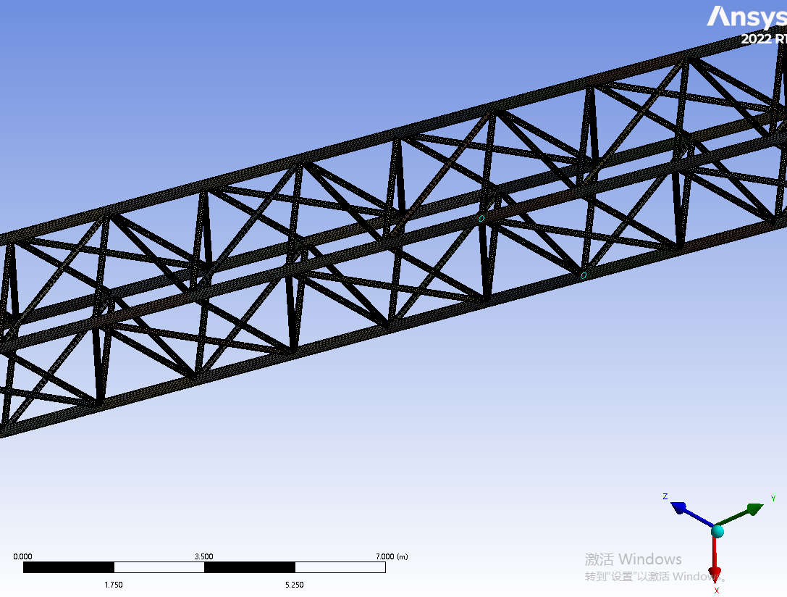

Fig. 1 Local finite element model of boom

Conduct a modal analysis on it and extract the eigenvalues. During actual operation, the frequency borne by the boom structure itself is not high. Therefore, it is sufficient to extract the low-order modal eigenvalues. The analysis shows that the first six orders of the boom are referred to as rigid body motion modes, whose natural frequencies are small and can be neglected. The calculated 7th to 11th order modes are presented in Table 1 below.
Table 1 Boom mode frequency
Order | Frequency/HZ | Vibration Mode Description
7 | 6.545 | Bending along the Y-axis
8 | 8.378 | Bending along the Z-axis
9 | 20.476 | Sinusoidal deformation along the Y-axis
10 | 45.783 | Sinusoidal deformation along the Z-axis
11 | 78.986 | Torsion along the X-axis

2.3Equivalent Modeling of Wire Ropes for Wind Power Cranes
During the operation of the unit, due to the influence of some factors, alternating loads will be generated between the wire rope and the boom, leading to unstable system movement. Therefore, it is necessary to conduct simulation research on the wire rope. There are mainly the following methods for modeling wire ropes in ADAMS software [11-12].
(1) Modal Neutral File modeling method. This method is the same as the flexible body modeling method mentioned earlier. The flexible model of the wire rope is generated into an MNF neutral file in finite element software and imported into ADAMS software through data transmission.
(2) Discrete flexible body modeling method. The principle of the discrete flexible beam connection method is to divide the entire component into a limited number of small pieces, and each small piece is flexibly connected by a flexible beam. After discretization, different attributes are assigned to each discrete part, and each part is treated as a separate rigid component. This method can directly set model parameters to generate the real actual situation of the wire rope, but it does not solve the problems of friction and contact force.
(3) Cable module modeling method. ADAMS/Cable is a module specially designed for simulating structures such as ropes and wire ropes, which can better reproduce the characteristics of wire ropes and pulleys. This method mainly divides the whole into many units and processes each unit separately. The Cable module has two main methods for establishing wire ropes: a simple model and a discrete model. The simple model mainly ignores factors such as the mass of the wire rope, only deals with the elastic deformation of the wire rope, and reflects the friction between itself and the slider by changing the magnitude and direction of the force, accurately reproducing the force situation of the pulley, and the simulation speed is greatly improved. The discrete model simulates the model through contact force, simulating the contact between the contact force and the pulley. During the calculation process, it can calculate the motion parameters and acting forces between itself and the pulley, and can also reflect the impact of vibration on the whole. However, the calculation speed is too slow, it is too affected by parameters, and the failure rate is very high.
This paper uses the first method to model the wire rope. The eigenvalue of the wire rope is extracted in finite element software, imported into ADAMS, and dynamic simulation is carried out. The first few orders of modes of the wire rope are extracted, as shown in Figure 2 below:
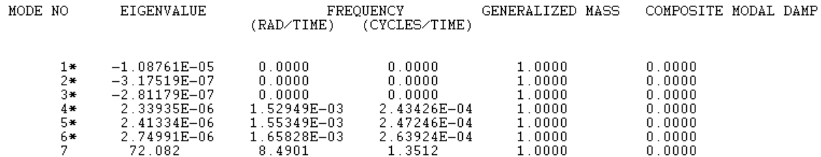
Fig. 2 The value of the first seven modes of the rope

2.4Establishment and Verification of Rigid-Flexible Coupling Model via Rigid-Flexible Replacement of the Boom
By generating the *.mnf file in the ANSYS finite element software, the specific information of this neutral file—such as natural frequency, units, and mass—can be viewed in the ADAMS/Flex toolbox to check whether the modal information is consistent. Load the AutoFlex module and replace the rigid body in ADAMS with the flexible body from the neutral file. Select the Build-Flexible Bodies-Rigid to Flex command, open the Rigid-to-Flex Replacement dialog box, select the rigid body to be replaced, and then perform the replacement. In the MNF File column, input the neutral file generated in the finite element software and its file path to complete the rigid-to-flex replacement. According to the connection method between components, adjust the centers of mass of the flexible body and the rigid body to make their centers of mass completely coincide. Use a sphere to simulate the lifted heavy object, as shown in Figures 3 and 4 below (the flexible body is colored green).
Replace the flexible body generated above and import the modal analysis neutral file established above into ADAMS through the data interface. After replacement, it should be noted that the constraints between the original model parts in ADAMS are prone to errors, leading to simulation failure. Therefore, it is necessary to redefine and reapply the constraints between parts. At the same time, attention should be paid to applying the constraints in sequence. The constraint pairs of parts should be reasonably determined according to the actual situation and appropriate movement directions to reduce the probability of errors in ADAMS. Import the flexible body of the wind power crane into ADAMS, and compare the modal frequencies in the finite element analysis with those in ADAMS, as shown in Table 2 below. It can be found that the error between the two modal frequencies is small and they are basically the same, which indicates that the rigid-flexible replacement is completed and the rigid-flexible coupling model is established.
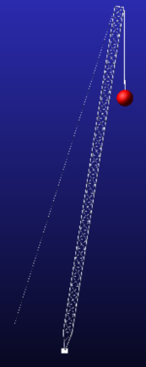
Fig. 3 Flexible body model of boom system
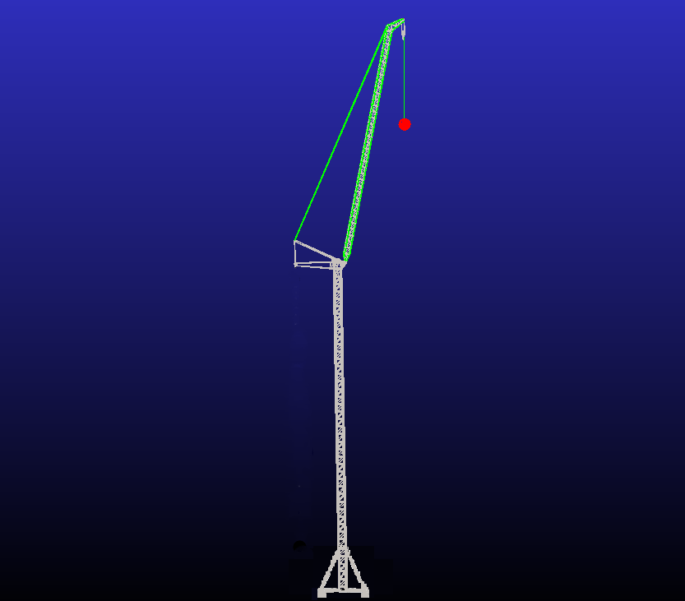
Fig. 4 Rigid-flexible coupling model of the whole system

Table 2 Natural frequency comparison between ADAMS and ANSYS
Modal Order | ANSYS（HZ） | ADAMS（HZ） | 误差
7 | 6.545 | 6.541 | 0.06%
8 | 8.378 | 8.324 | 0.64%
9 | 20.476 | 20.398 | 0.38%
10 | 45.783 | 45.771 | 0.02%
11 | 78.986 | 78.574 | 0.52%

As shown in the above table, the error range of natural frequencies between ADAMS and ANSYS is 0.02% to 0.64%. Therefore, it can be considered that the establishment of the rigid-flexible coupling model is completed.

2.5Add Constraints
After the rigid-flex coupling model is established, the components of the virtual prototype model should be connected to form a complete mechanical system. There are four common constraints in ADAMS, the first is the low second, the second is the basic second, the third is the drive, and the fourth is the high secondary. The low pair includes rotary pair, planar pair, cylindrical pair and slip pair. The main constraints added to the model are: the tower body and the earth are applied as fixed pairs; The tower body and the rotating system apply a rotating pair; Lifting arm, balance arm wire rope, herringbone frame, swing arm and main hoist wire rope are hinged with each other. Add a sliding pair between the wire rope and the small ball weight; Add a fixing pair between the drum, the hoisting system and the wire rope. When you are done adding constraints, check the degrees of freedom of the model.

2.6Add loads and drives
The size and mode of load addition can be referenced from Chapter 3 and Chapter 4. A horizontal wind load of 1.589×${10}^{4}\text{N/}{\text{m}}^{\text{2}}$ was initially added to the middle of the boom.During the no-load, hoisting, luffing, and slewing processes of the equipment, it is affected by its own load and wind load. During the luffing process, it is affected by the luffing load; during the hoisting and unloading processes, it is affected by the impact load. The self-weight load mainly depends on the influence of gravitational acceleration, and the material settings are automatically added by the system.
(1) Dynamic load when suddenly lifting a heavy object from the ground
The overall structure of a wind power crane is a vibration system with multiple degrees of freedom, and simplified models are usually used for research and calculation. The hoisting system can be simplified into a dynamic model with three masses and two degrees of freedom. When calculating vibration, the wind power equipment can be simplified as shown in Figure 5 below:
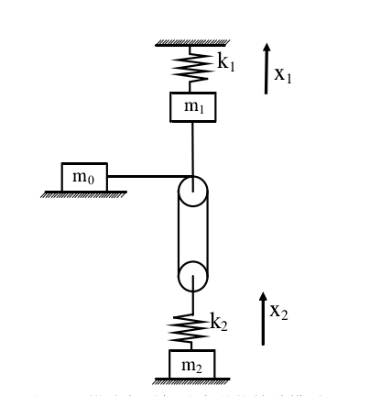
Fig. 5 Dynamic model of lifting weights off the ground

${\text{m}}_{\text{0}}$:represents the mass of the equipment's own moving parts and the mass transferred from the motor to the drum;；
${\text{m}}_{\text{1}}$:represents the mass transferred from the overall design to the boom head;；
${\text{m}}_{\text{2}}$:represents the lifting load mass;；
${\text{k}}_{\text{1}}$:represents the stiffness coefficient of the equipment equivalent to the boom head;；
${\text{k}}_{\text{2}}$:represents the stiffness coefficient of the hoisting wire rope at the heavy object suspension point;；
${\text{x}}_{\text{1}}$:represents the mass displacement;
$\text{Y}$:represents the mass displacement
Among the wind power equipment, the${ \text{m}}_{\text{0}}$ value is the largest, fixed on the turntable,${\text{m}}_{\text{1}}、{\text{m}}_{\text{2}}$, spring ${\text{k}}_{\text{1}}$、${\text{k}}_{\text{2}}$ are connected in series, and the rise speed of the wind turbine is set to ${\text{v}}_{\text{0}}$ two-degree-of-freedom system.
The differential equation is expressed as:
$$\begin{aligned}{\text{m}}_{\text{1}}{\ddot{\text{x}}}_{\text{1}}\text{+}{\text{k}}_{\text{2}}\left({\text{x}}_{\text{1}}\text{-}{\text{x}}_{\text{2}}\right)\text{=}{\text{F}}_{\text{q}}\text{=}{\text{F}}_{{\text{s}}_{\text{1}}}\text{+Q}\#（\text{1}\text{-1}）\end{aligned}$$
$\begin{aligned}{\text{m}}_{\text{2}}{\ddot{\text{x}}}_{\text{2}}\text{-}{\text{k}}_{\text{2}}\left({\text{x}}_{\text{1}}\text{-}{\text{x}}_{\text{2}}\right)\text{=Q}\#（\text{1}\text{-}\text{2}）\end{aligned}$

${\text{F}}_{\text{q}}$ :expressed as the starting circumferential force;
${\text{F}}_{{\text{s}}_{\text{1}}}$:expressed as the residual acceleration force;
$\text{Q}$:expressed as a static load of heavy objects
x=${\text{x}}_{\text{1}}$-${\text{x}}_{\text{2}}$ represents the elastic deformation of the spring, and there are the above two formulas:
$$\begin{aligned}\ddot{\text{x}}\text{+}{\text{ω}}^{\text{2}}\text{x=}\frac{{\text{F}}_{{\text{s}}_{\text{1}}}}{{\text{m}}_{\text{1}}}\text{+}\frac{{\text{m}}_{\text{1}}\text{+}{\text{m}}_{\text{2}}}{{\text{m}}_{\text{1}}{\text{m}}_{\text{2}}}\text{Q}\#（\text{1}\text{-}\text{3}）\end{aligned}$$
$$ω=\sqrt{{\text{k}}_{\text{2}}\left(\frac{{\text{m}}_{\text{1}}\text{+}{\text{m}}_{\text{2}}}{{\text{m}}_{\text{1}}{\text{m}}_{\text{2}}}\right)}$$
Solving ($\text{1}\text{-}\text{3}$) obtains:
$$\begin{aligned}\text{x=}{\text{A}}_{\text{1}}\text{sin}{\text{ωt}}\text{+}{\text{B}}_{\text{1}}\text{cos}{\text{ωt}}\text{+}\frac{{\text{m}}_{\text{2}}{\text{F}}_{{\text{s}}_{\text{1}}}}{{\text{k}}_{\text{2}}\left({\text{m}}_{\text{1}}\text{+}{\text{m}}_{\text{2}}\right)}\text{+}\frac{\text{Q}}{{\text{k}}_{\text{2}}}\#（\text{1}\text{-}\text{4}）\end{aligned}$$
$\begin{aligned}\dot{\text{x}}\text{=ω}{\text{A}}_{\text{1}}\text{cos}{\text{ωt}}\text{-}{{\text{ω}}_{\text{1}}\text{B}}_{\text{1}}\text{cos}{\text{ωt}}\#（\text{1}\text{-}\text{5}）\end{aligned}$
The initial conditions are:$x\left(\text{0}\right)\text{=}\frac{\text{Q}}{{\text{k}}_{\text{2}}}$，$\dot{\text{x}}\left(\text{0}\right)\text{=}\text{v}$，Substitutions can be obtained:
$$\begin{aligned}{\text{A}}_{\text{1}}\text{=}\frac{\text{ν}}{\text{ω}}{\text{B}}_{\text{1}}\text{=}\frac{{\text{m}}_{\text{2}}{\text{F}}_{{\text{s}}_{\text{1}}}}{{\text{k}}_{\text{2}}\left({\text{m}}_{\text{1}}\text{+}{\text{m}}_{\text{2}}\right)}\#（\text{1}\text{-}\text{6}）\end{aligned}$$
Substrain the values of $A_{1}$and$B_{1}$（$\text{1}\text{-}\text{4}$），（$\text{1}\text{-}\text{5}$）can be derived：
$$\begin{aligned}\text{x=}\frac{\text{ν}}{\text{ω}}\text{sin}{\text{ωt}}\text{+}\frac{{\text{m}}_{\text{2}}{\text{F}}_{{\text{s}}_{\text{1}}}}{{\text{k}}_{\text{2}}\left({\text{m}}_{\text{1}}\text{+}{\text{m}}_{\text{2}}\right)}\left(\text{1-}\text{cos}{\text{ωt}}\right)\text{+}\frac{\text{Q}}{{\text{k}}_{\text{2}}}\#（\text{1}\text{-}\text{7}）\end{aligned}$$
The internal force of the wire rope can be expressed as:F=${\text{k}}_{\text{2}}\text{x}$，Bringing in can yield:
$$\begin{aligned}\text{F=}{\text{k}}_{\text{2}}\text{x=}\frac{{\text{k}}_{\text{2}}\text{ν}}{\text{ω}}\text{+}\frac{{\text{m}}_{\text{2}}{\text{F}}_{{\text{s}}_{\text{1}}}}{\left({\text{m}}_{\text{1}}\text{+}{\text{m}}_{\text{2}}\right)}\left(\text{1-}\text{cos}{\text{ωt}}\right)\text{+Q}\#（\text{1}\text{-}\text{8}）\end{aligned}$$
With the above formula, it can be seen that when lifting heavy objects, the wire rope is affected by static load, inertial load and impact load.
(2) Determination of Dynamic Load When the Heavy Object Is Suspended in the Air
① During Hoisting Start-up
The initial conditions are as follows:t=0时，$x\left(\text{0}\right)\text{=}\frac{\text{Q}}{{\text{k}}_{\text{2}}}$，$\dot{\text{x}}\left(\text{0}\right)\text{=0}$
$$\begin{aligned}{\text{A}}_{\text{2}}\text{=0}{\text{B}}_{\text{2}}\text{=}\frac{{\text{m}}_{\text{2}}{\text{F}}_{{\text{s}}_{\text{1}}}}{{\text{k}}_{\text{2}}\left({\text{m}}_{\text{1}}\text{+}{\text{m}}_{\text{2}}\right)}\#（\text{1}\text{-}\text{9}）\end{aligned}$$

Substrain the values of $A_{1}$and$B_{1}$（$\text{1}\text{-}\text{4}$），（$\text{1}\text{-}\text{5}$）can be derived：
$$\begin{aligned}\text{x=}\frac{{\text{m}}_{\text{2}}{\text{F}}_{{\text{s}}_{\text{1}}}}{{\text{k}}_{\text{2}}\left({\text{m}}_{\text{1}}\text{+}{\text{m}}_{\text{2}}\right)}\left(\text{1-}\text{cos}{\text{ωt}}\right)\text{+}\frac{\text{Q}}{{\text{k}}_{\text{2}}}\#（\text{1}\text{-}\text{10}）\end{aligned}$$
Internal force on the wire rope:
$$\begin{aligned}\text{F=}{\text{k}}_{\text{2}}\text{x=}\frac{{\text{m}}_{\text{2}}{\text{F}}_{{\text{s}}_{\text{1}}}}{\left({\text{m}}_{\text{1}}\text{+}{\text{m}}_{\text{2}}\right)}\left(\text{1-}\text{cos}{\text{ωt}}\right)\text{+Q}\#（\text{1}\text{-}\text{11}）\end{aligned}$$

② Hoisting Braking
During braking, the wire rope will be affected by the braking force of the motor. The starting circumferential force${\text{F}}_{\text{q}}$ in the above formula will be replaced by the braking circumferential force ${\text{F}}_{\text{2}}$, which can be derived from the above formula:
$$\begin{aligned}\text{x=}{\text{A}}_{\text{1}}\text{sin}{\text{ωt}}\text{+}{\text{B}}_{\text{1}}\text{cos}{\text{ωt}}\text{+}\frac{\text{Q}{\text{m}}_{\text{1}}\text{-}{\text{m}}_{\text{2}}{\text{F}}_{{\text{s}}_{\text{2}}}}{{\text{k}}_{\text{2}}\left({\text{m}}_{\text{1}}\text{+}{\text{m}}_{\text{2}}\right)}\#（\text{1}\text{-}\text{12}）\end{aligned}$$
Solving:${\text{B}}_{\text{3}}$=$\frac{{\text{m}}_{\text{2}}\left({\text{F}}_{{\text{s}}_{\text{2}}}\text{+Q}\right)}{{\text{k}}_{\text{2}}\left({\text{m}}_{\text{1}}\text{+}{\text{m}}_{\text{2}}\right)}$；
$$\begin{aligned}\text{F=}{\text{k}}_{\text{2}}\text{x=}\frac{{\text{F}}_{{\text{s}}_{\text{2}}}\left({\text{m}}_{\text{2}}\text{+Q}\right)}{\left({\text{m}}_{\text{1}}\text{+}{\text{m}}_{\text{2}}\right)}\left(\text{cos}{\text{ωt-1}}\right)\text{+Q}\#（\text{1}\text{-}\text{13}）\end{aligned}$$

- Simulation results and analysis of boom systems
The jib and wire rope are analyzed as a dynamic model. Apply a rotational drive to the established model to rotate it 90° clockwise from the initial position, and record the centroid displacement curve and velocity curve of the spherical weight during this process to verify the stability of the equipment in the process of transporting the weight. As shown in Figure 6, it represents the initial position of the sphere from different perspectives. As shown in Figure 7, it represents the position of the sphere after rotating 90°.
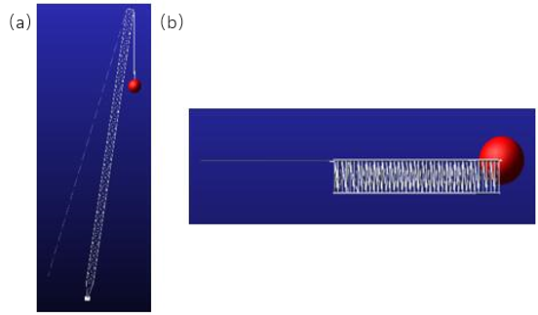
Fig. 6 Ball initial position(a) x perspective (b) z perspective

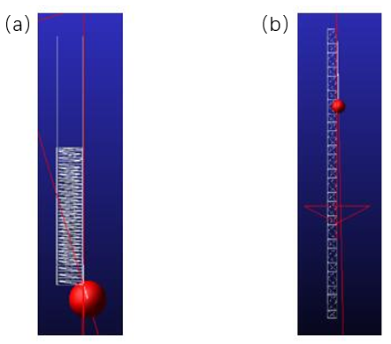
Fig. 7 The ball rotates 90° (a) x perspective (b) z perspective
According to the modeling settings of the jib system, the positive direction of the X-axis is set to the clockwise moving direction of the heavy object, the Y-axis direction is set to the vertical direction (up and down), and the Z-axis direction is set to the lateral direction (left and right). A 90° rotational drive (as shown in Figure 8) is added, and the center of mass is set at the center of the sphere. The 25-second simulation results of the heavy object during the slewing stage are obtained: the amplitude motion curve of the sphere’s center of mass is shown in Figure 9; the velocity variation curve of the center of mass along the X-axis is shown in Figure 10; the displacement characteristic curves of the center of mass are shown in Figures 11, 12, and 13; and the total displacement characteristic curve of the center of mass is shown in Figure 14.
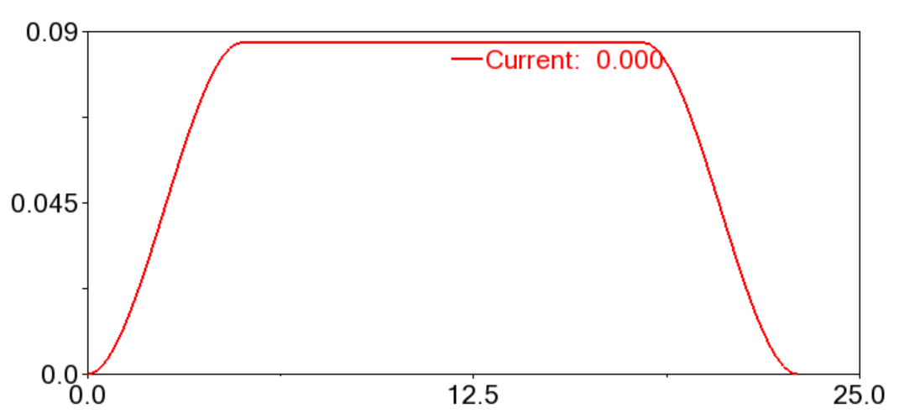
Fig. 8 Boom rotation drive curve
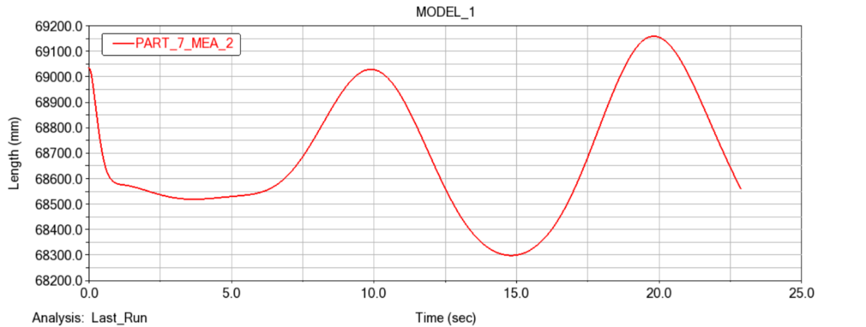
Fig. 9 Amplitude curve of ball centroid motion
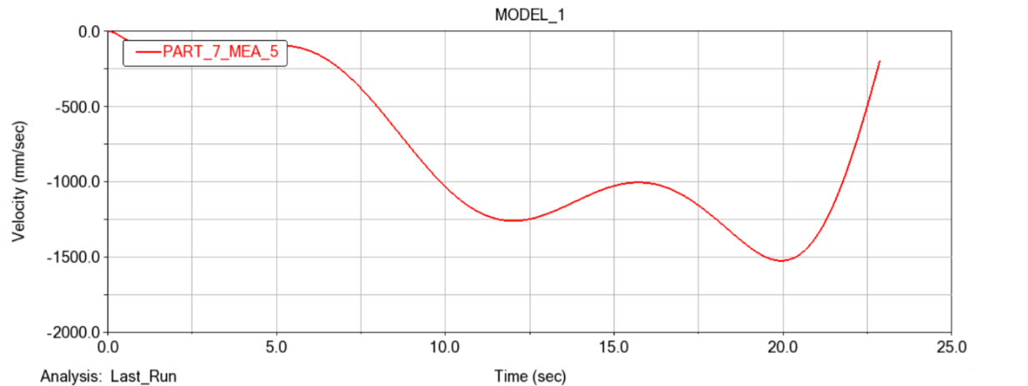
Fig. 10 Center of mass position x axis velocity curve
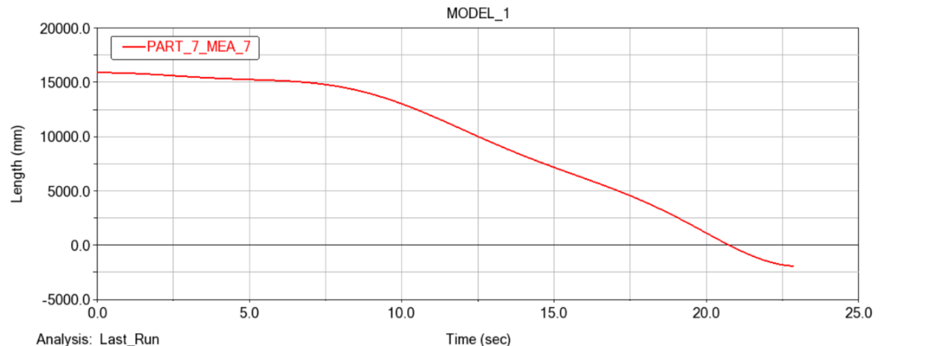
Fig. 11 Center of mass displacement curve in x axis
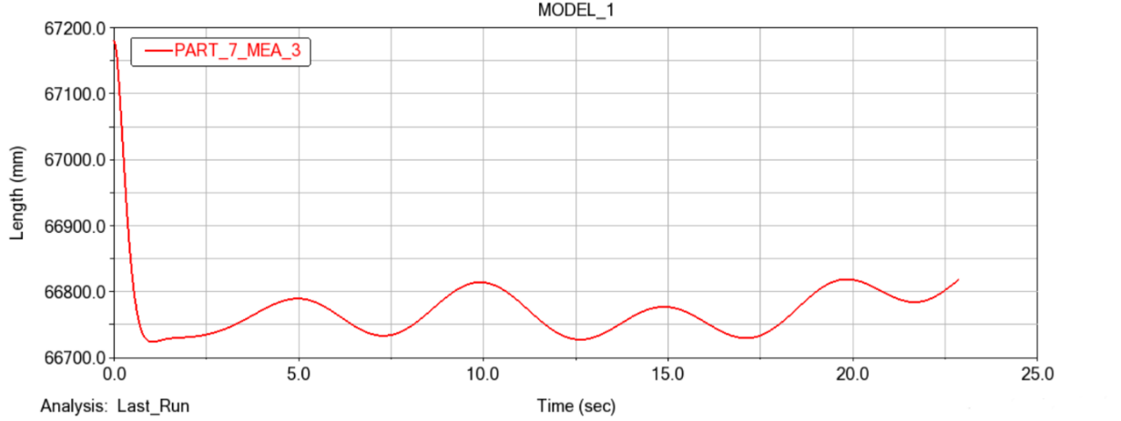
Fig. 12 Shift curve of the center of mass on the y axis
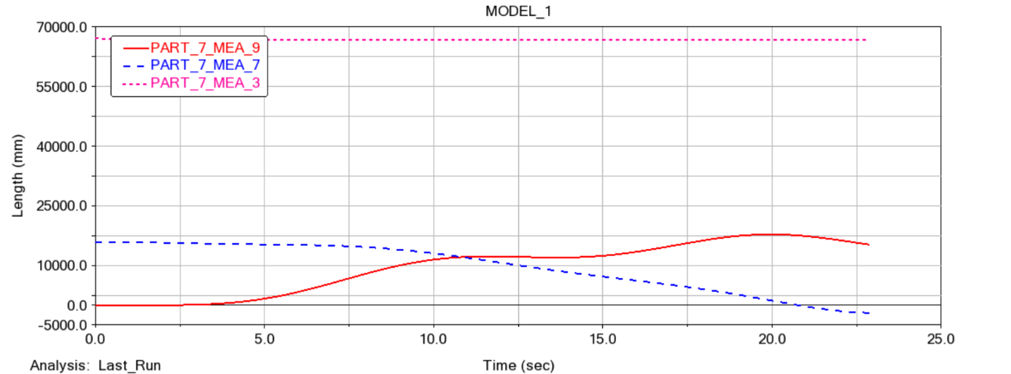
Fig. 13 Curve of displacement of the center of mass in the z axis
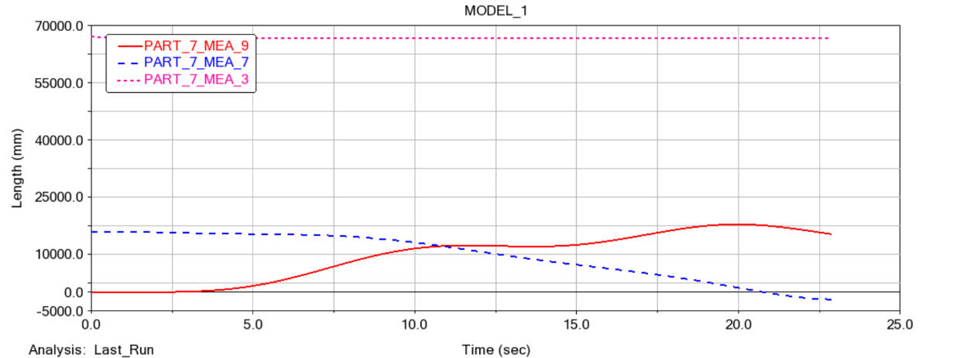
Fig. 14 Change curve of the total displacement of the center of mass position of the ball
As shown in Figure 9, the curve changes smoothly, with luffing motion occurring between 69.05 m and 68.3 m. The movement amplitude of the sphere does not exceed 1 m; considering the influence of the elastic deformation of the wire rope, the movement amplitude of the sphere is negligible. It can also be seen that during the overall slewing process of the jib system, the heavy object can maintain a stable state.
As shown in Figure 10, which presents the velocity variation curve of the sphere’s center of mass along the X-axis, it can be observed from the figure that the sphere’s velocity changes within the range of 0 to 1.5 m/s. At 20 seconds, the sphere’s velocity reaches its maximum value, and it is from this moment that the sphere begins to decelerate. The acceleration of the sphere during its movement is also within a reasonable range, and the curve changes stably. This indicates that the sphere’s velocity is controllable and its movement is stable during the slewing process.
As shown in Figures 11 to 13, which are the displacement variation curves of the sphere along the X, Y, and Z axes respectively:From the X-axis displacement variation curve, the sphere moves in the first 7 seconds with almost no change in displacement, indicating that the jib starts stably in the early stage of slewing. After 7 seconds, the sphere shows a linear movement consistent with a linear function, which means the sphere moves smoothly along the X-axis during the slewing process.From the Y-axis displacement variation curve, it can be seen that the sphere’s displacement drops sharply in the first 2 seconds. This phenomenon occurs because the jib suddenly applies the load of the heavy object, and the wire rope undergoes elastic deformation under the influence of static load. However, after 2 seconds, the displacement of the sphere along the Y-axis shows a variation trend consistent with a sine function. During this movement process, the maximum displacement is 66.5 m and the minimum displacement is 66.6 m, with a difference of no more than 10 cm. For large-tonnage wind power equipment, coupled with the elastic deformation of the wire rope, this 10 cm displacement is negligible. Overall, it can be seen that the jib can maintain the stable lifting operation of the heavy object in the vertical direction during the slewing process.From the above data curves, it can be concluded that when the jib is slewing to lift goods, it can generally maintain stable operation without unstable phenomena such as jumping or swinging, which meets the design requirements.
4. Simulation results and analysis of rigid-flex coupling dynamics of wind power cranes
The dynamic simulation of wind power cranes must be conducted by integrating its own load, luffing load, dynamic load, and other relevant loads. The material properties of the mechanism’s own load, as well as the magnitude and direction of gravitational acceleration, are automatically applied in the ADAMS software. For the inertial loads during equipment start-up and braking, a step function is input into the ADAMS/Solve solver, and the simulation process can then calculate and obtain the results [13].
In accordance with the above steps, for the established rigid-flexible coupling model of the wind power crane, rigid-flexible coupling dynamic analysis is performed on the overall model during the operation, hoisting, and luffing processes respectively. Through the Solver module in the ADAMS software, the system’s motion dynamic equations for this process are automatically generated, and results such as kinematics and dynamics are solved.
In the ADAMS software, the defined forces, expressions of kinematic pairs, functions, and other elements can be created using the function editor in the View interface. The function editor mainly exists in two forms: the first is the Expression mode, which is primarily used as a function editor for time-time relationships; the other is the Run-time mode, which is mainly used as a function editor for time-motion relationships. For this study, the hoisting mechanism mainly uses the function editor in Run-time mode to add drives.
The STEP function is often used as an operation function. In this study, the STEP function is employed during the three motion processes. When the STEP function is used as an operation function, its format is as follows:
The function format is$STEP \left(\text{x，}{\text{x}}_{\text{0}}\text{，}{\text{h}}_{\text{0}}\text{，}{\text{x}}_{\text{1}}\text{，}{\text{h}}_{\text{1}}\right)$
x – Independent variable, which can be time or any function of time;
${\text{x}}_{\text{0}}$ – Start value of the STEP function for the independent variable, which can be a constant, a function expression, or a design variable;
${\text{x}}_{\text{1}}$ – End value of the STEP function for the independent variable, which can be a constant, a function expression, or a design variable;
${\text{h}}_{0}$– Initial value of the STEP function, which can be a constant, a design variable, or another function expression;
${\text{h}}_{\text{1}}$ – Final value of the STEP function, which can be a constant, a design variable, or another function expression.

4.1Simulation of equipment operation process dynamics
The wind power crane equipment runs the motion simulation process, with a starting time of 7 s, a stable running time of 7 s, a stop time of 7 s, and a running speed of 1.5 m/s. Design a step function for this run, and run the driver step function as follows:
step（time，0，0，7，1500）+step（time，14，0，21，-1500）
The driving function curve is shown in Figure 15 below, which is shown as a speed curve, and the overall simulation is performed after adding the driver.
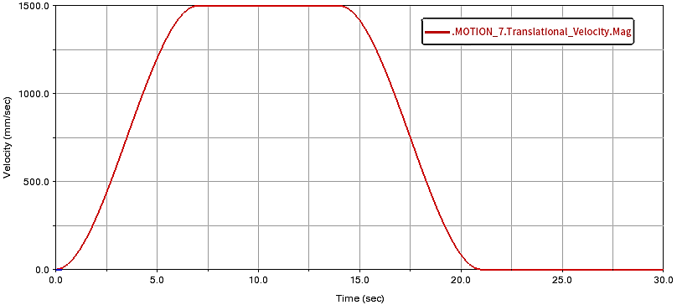
Fig. 15 Run process drive function curve
The load data in the processor is extracted to form the corresponding unit deflection load curve, as shown in Fig. 16 below.
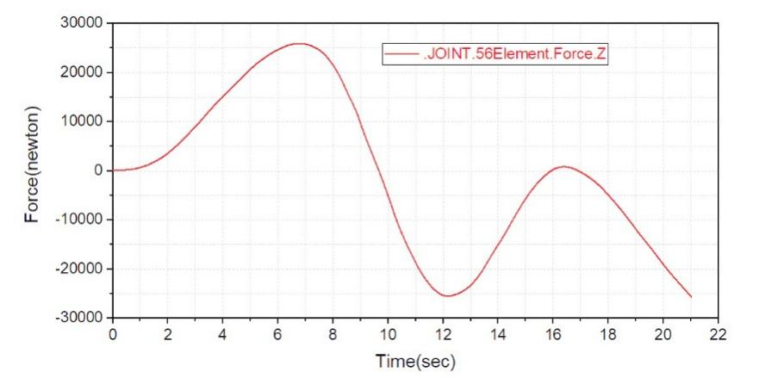
Fig. 16 Fan equipment yaw load curve
Through the analysis of the above charts, it can be seen that in the overall operation of wind power lifting equipment, the maximum offset load appears in the acceleration stage of the unit, and the maximum offset load value is P=26000 N from the post-processor data. It can be seen from the curve diagram that in the process of movement of the wind power crane boom, a deformation curve similar to the sine function occurs in the vertical direction, resulting in an increase in the maximum yaw load of the equipment.

4.2Simulation of equipment lifting process dynamics
In the simulation process of wind power crane equipment, the acceleration time is 5 s, the stable running time is 15 s, the deceleration time is 5 s, and the running speed is set to 130 mm/s. Design this runtime as a step function, and run the driver STEP function as follows:
step（time，0，0，5，130）+step（time，20，0，25，-130）
The driving function curve of the lifting process is shown in Figure 17 below, which is shown as a speed curve, and the overall simulation is carried out after adding the drive.
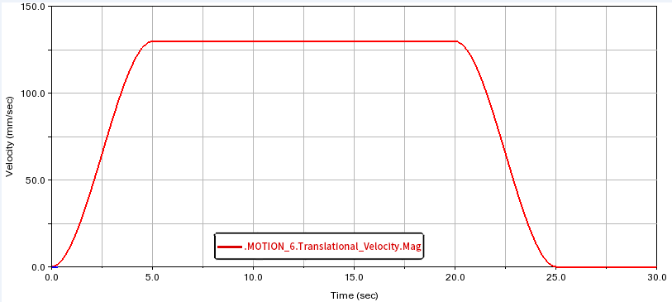
Fig. 17 Lifting process driving function curve

The dynamic load curve of the lifting motion process of the unit is formed by extracting the load data in the processor, as shown in Fig. 18 below.
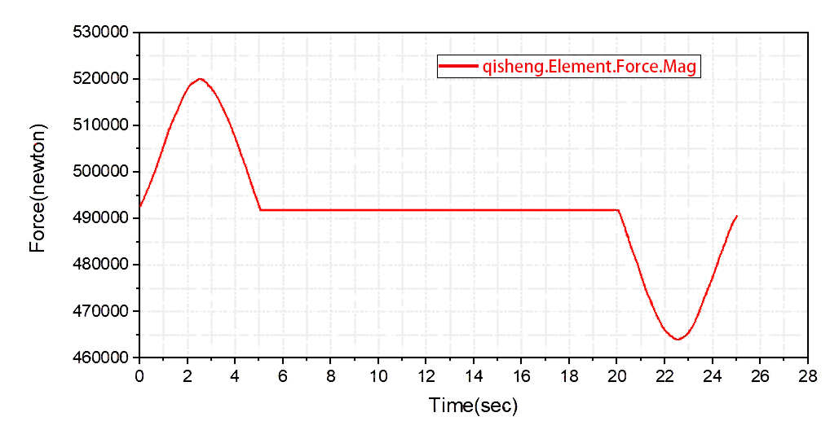
Fig. 18 Dynamic load curve during lifting

From the above curve diagram, it can be seen that the maximum dynamic load of the whole equipment is 520000 N during the lifting and acceleration process of the equipment crane. In the process of lifting wind power equipment, the boom will bend and deform in the vertical direction, and the overall equipment is accelerating, so the dynamic load of the equipment increases.

4.3Simulation of equipment luffing process dynamics
In the luffing motion simulation process of wind power crane equipment, the boom starts from 12.5 m to run the luffing action, after 15 seconds the luffing speed reaches 1.1 deg/s, maintains this speed for 65 s, then stops for 15 s, and maintains for 15 s, and drops to 12.5 m after 85 s. Design this runtime as a step function, and run the driver STEP function as follows:
step（time，0，0，15，15d）+step（time，80，0，95，-15d）+ step（time，110，0，125，15d）+step（time，210，0，225，-15d）
The driving function curve of the luffing process is shown in Figure 19 below, which is shown as the driving curve of the luffing process, and the overall simulation is carried out after adding the driver.
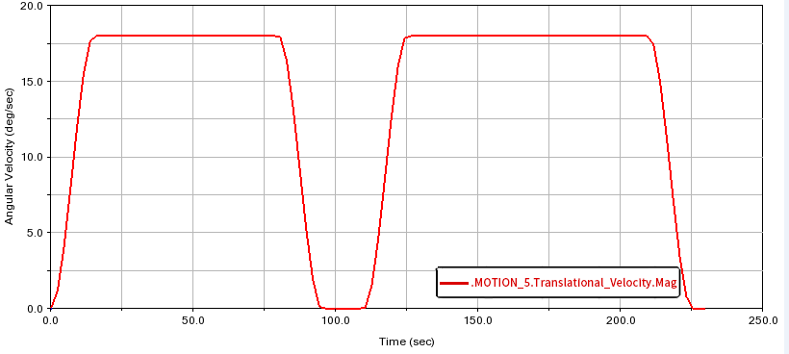
Fig. 19 Variable amplitude process driving function curve
The load data in the post-processor is extracted to form the corresponding unit luffing process deflection load curve, as shown in Fig. 20 below.
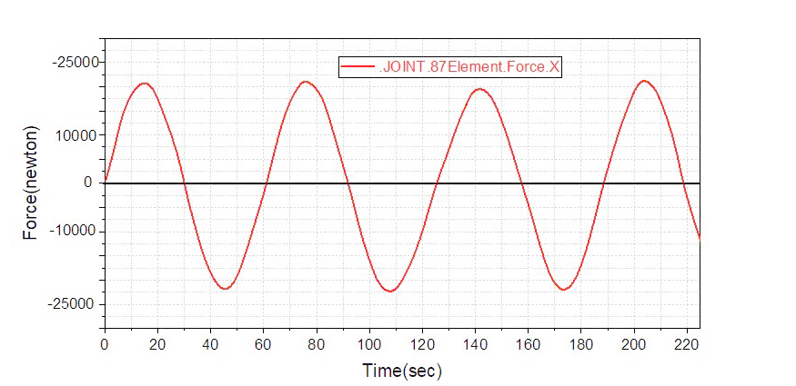
Fig. 20 Deflection load curve during amplitude variation

From the above curve diagram, it can be seen that the values of the bias load at the beginning and end of the luffing movement are different, and the maximum deflection load appears when the equipment decelerates, and it can be seen that the maximum deflection load is 21040 N. In the luffing mechanism, the vertical deformation of the boom produces a deformation similar to a sinusoidal curve.

5. epilogue
This paper mainly focuses on the performance research of the free-standing tower crane. A virtual prototype model of the tower crane was established in the ADAMS software, and a rigid-flexible coupling dynamic simulation analysis was carried out under the working condition where the equipment rotates by 90°. The displacement curve, velocity curve and acceleration curve of the heavy object were obtained. Through data analysis, it can be concluded that when the jib slews to lift goods, it can generally maintain stable operation, which meets the design requirements. To verify the rationality of the overall structural design, three motion processes of the equipment, namely operation, hoisting and luffing, were specifically selected for dynamic simulation analysis. The drive curves of the crane model, as well as the simulation curves of the yaw load and dynamic load of the jib system during the three processes, were obtained, and the times when the maximum dynamic load and maximum yaw load occur were analyzed. This provides a more efficient research method for the structural optimization design of wind power cranes in the later stage.

COMPETING INTERESTS DISCLAIMER:
Authors have declared that they have no known competing financial interests OR non-financial interests OR personal relationships that could have appeared to influence the work reported in this paper.

References

- Lü Junfu. Structural Analysis and Optimization Design of Gantry Cranes [D]. Shanghai Jiao Tong University, 2015.
- Li Wenhua, Zhou Yucai, Tang Yuxiang. Mechatronic Coupling Analysis of Luffing System for Portal Slewing Cranes [J]. Machine Tool & Hydraulics, 2018, 46 (15): 169-171
- Hu Jianfeng. Fatigue Characteristic Analysis of Jib for QTZ100 Flat-Top Tower Crane [D]. Xiangtan University, 2012.
- Mile M S, RADOVAN R B, MILOM IR M G, et al. Optimization of the box section of the main girder of the single-girder bridge crane by applying biologically inspired algorithms[J]. Engineering Structures. 2017(148): 452-465.
- Ataei B, Yuan S, Ren Z, et al. Effects of structural flexibility on the dynamic responses of low-height lifting mechanism for offshore wind turbine installation[J]. Marine Structures, 2023(89): 103399.
- LEE Y M, SHU K, SHYUE H. Using ADAMS Application on Mechanism Simulation of New Multiaxis Machines[J]. Applied Mechanics and Materials, 2014.
- Garcia-Vallejo D, Escalona J L, Mayo J, et al. Describing rigid-flexible multibody systems using absolute coordinates[J]. Nonlinear Dynamics. 2003(34): 75-94.
- A. K. Banerjee, T. R. Kane. Dynamics of a Plate in Large Overall Motion[J]. ASME Journal of Applied Mechanics. 1989, 56(4): 887-892.
- T.R. Kane, R.R. Ryan, A.K. Banerjee. Dynamics of a Cantilever Beam Attached to a Moving Base[J]. Journal of Guidance Control and Dynamics. 1987, 10(2): 139-151.
- Rismantab-Sany J, Shabana A A. On the use of momentum balance in the impact analysis of constrained elastic system[J]. Journal of Vibration and Acoustics, 1990, 112(2): 119-126.
- Zhao Xifang. Research on Flexible Body Analysis in ADAMS [J]. Electro-Mechanical Engineering, 2006 (03): 62-64.
- Li Aiping, Jiang Chaoping, Liu Xuemei. Simulation Analysis of Dynamic Tension of Wire Rope Based on ADAMS Platform [J]. Modern Manufacturing Engineering, 2010 (01): 43-46.
- Li Ruiqiang. Rigid-Flexible Coupling Dynamic Analysis of Multi-Machine Hoisting Based on ADAMS [D]. Dalian University of Technology, 2016.
- Jin, G., Wang, S., & Zhang, F. (2025). A Review of Motion Compensation Technology and Application Status of Marine Crane Payload System. Journal of Offshore Mechanics and Arctic Engineering, 147(5), 051403.
- Nie, D., & Fu, C. (2020). The Application of Closed Hydraulic System of Hoisting Mechanism in Auto Crane. Jordan Journal of Mechanical & Industrial Engineering, 14(1).
- Simeone, A. L., Cools, R., Depuydt, S., Gomes, J. M., Goris, P., Grocott, J., ... & Gerling, K. (2022, April). Immersive speculative enactments: Bringing future scenarios and technology to life using virtual reality. In Proceedings of the 2022 CHI Conference on Human Factors in Computing Systems (pp. 1-20).
- He, H., Nie, S., Ji, H., Ma, Z., Yin, F., & Zhang, Z. (2023, August). Dynamic Analysis of Integrated-Slipper Seawater Hydraulic Axial Piston Pump (ISHAPP) Based on Virtual Prototype Technology. In 2023 9th International Conference on Fluid Power and Mechatronics (FPM) (pp. 1-9). IEEE.

