Research progress and application of planar three-dimensional force sensor technology

Abstract: Plane three-dimensional force sensor, as a key sensing device that can simultaneously measure the force or moment in three orthogonal directions of X, Y and Z in three-dimensional space, has shown great application value in the fields of robotics, medical equipment, industrial automation and aerospace in recent years. In this paper, the latest research progress of planar three-dimensional force sensor is systematically reviewed, including its working principle, design type, application field and future development trend. Through the comprehensive analysis of current technology, the challenges in signal decoupling, precision improvement, flexibility and mass manufacturing are pointed out, and the future development direction of deep integration with artificial intelligence and new material technology is prospected..
Keywords: three-dimensional force sensor; Flexible sensing

1 INTRODUCTION
Three-dimensional force sensor is a kind of precise sensing device that can measure the force or torque information in three orthogonal directions of X, Y and Z in three-dimensional space at the same time. As a key interface connecting the physical world with the digital system, its core function is to provide all kinds of intelligent equipment with the perception ability similar to human touch. Because of its light weight, small volume, simple structure and strong decoupling, this sensor has become an indispensable basic component in modern intelligent manufacturing, robotics and human-computer interaction systems. By accurately capturing and analyzing multi-dimensional force information, three-dimensional force sensors enable machines to perceive and adapt to complex environments, and realize accurate grasping, precise assembly and intelligent interaction of objects, thus promoting the leap-forward development of industrial automation, medical robots and humanoid robots.
From the perspective of technical paradigm, three-dimensional force sensing technology is undergoing a fundamental change from "rigidity" to "flexibility". Traditional sensors mainly rely on rigid substrates and complex mechanical structures. With the rise of flexible electronics technology, three-dimensional force sensors have broken through the limitations of traditional rigid circuits. Based on flexible or retractable substrates, they have integrated large-scale and large-scale different materials and functional components, realizing the characteristics of deformation, light weight and reconfigurable functions. This new paradigm has greatly expanded the application field of electronics, enabling it to be seamlessly integrated into soft, movable, bendable and even stretchable surfaces, thus meeting the needs of dynamic environments such as wearable devices and soft robot.
The core value of three-dimensional force sensor is that it provides rich and accurate force information feedback for intelligent system, which is the basis of realizing accurate control and independent decision-making. Under the background of deep integration of Industry 4.0 and artificial intelligence, three-dimensional force sensors are evolving from the core components of industrial robots to the "digital tactile sense" of intelligent systems, reshaping the boundaries of human-computer interaction through real-time perception and interaction, and pushing the manufacturing industry towards flexibility and intelligence. With the continuous maturity of technology and the expansion of application scenarios, three-dimensional force sensor has become one of the important symbols to measure the high-end manufacturing level of a country, and plays an irreplaceable role in improving the intelligent level of equipment and realizing precision operation.
2 working principle and design type
The working principle of three-dimensional force sensor is mainly based on mechanical effect and resistance strain principle. The external force is converted into structural deformation through elastic elements, and then the deformation is converted into electrical signals through strain gauges for measurement. A typical planar three-dimensional force sensor adopts sandwich structure: the upper and lower electrode layers are separated by an intermediate dielectric layer. When an external force acts on the sensor, the elastic body is deformed, which causes the sensitive elements (such as strain gauges or capacitor plates) embedded in it to respond. By measuring these response changes, the force components in three directions can be calculated.
2.1 strain type three-dimensional force sensor
Strain gauge sensor is one of the earliest developed and applied three-dimensional force sensing technologies, which usually consists of four or more strain gauges, which are accurately placed at specific positions on an elastic body. Since the first appearance of metal resistance wire bonded sensor in 1938, it has been developed to adopt resistance strain gauge. The resistance strain gauge is attached to the specified position on the surface of the elastic body of the measured object, and the resistance of the resistance strain gauge changes due to the stress of the elastic body. The strain is converted into electrical signals (voltage, current, frequency, etc.) through Whiston bridge and measuring circuit, so as to measure the force value.
Chai Jixin^{[1]} and others have developed a dynamic three-component force sensor with large range strain. Multiple strain gauges are used to realize self-decoupling of the sensor through a single column and a bridge with different columns. By combining the strain gauges on each column into a bridge, each column forms a separate sensor, and four sensors are connected in parallel to reduce the coupling error and four-angle error, as shown in Figure 1. Zhang Haixia^{[2]} and others put forward a new type of three-dimensional force sensor. Using the piezoresistive effect of strain gauges, the resistance changes are converted into voltage signals through two Wheatstone bridges, as shown in Figure 2. By superposing the output voltage values of the two bridges, the corresponding force values can be obtained, so as to realize the conversion between force and electricity. Xu Zhongtian^{[3]} of Zhejiang University analyzed the types and characteristics of existing multi-dimensional force sensors, and designed a strain-gauge cross-beam three-dimensional force sensor suitable for narrow working environment. The strain gauges formed four groups of Wheatstone bridges.
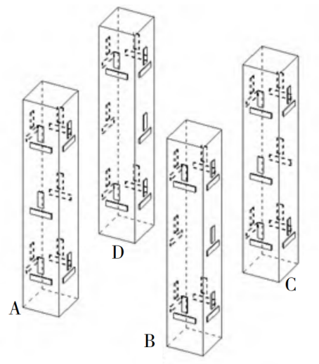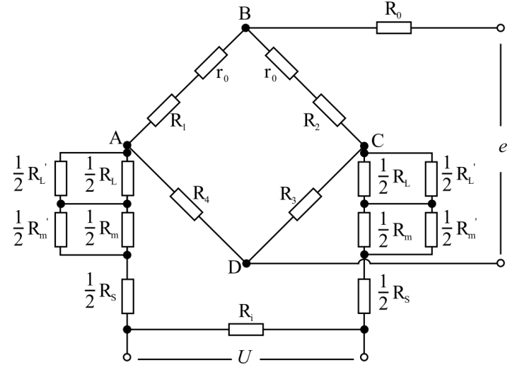
Fig. 1 Model and patch diagram of integral four-column sensor and circuit compensation circuit diagram of strain sensor.
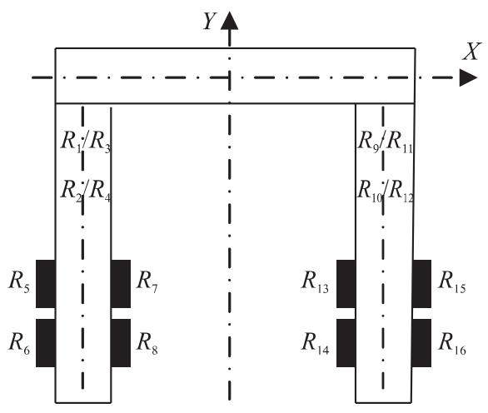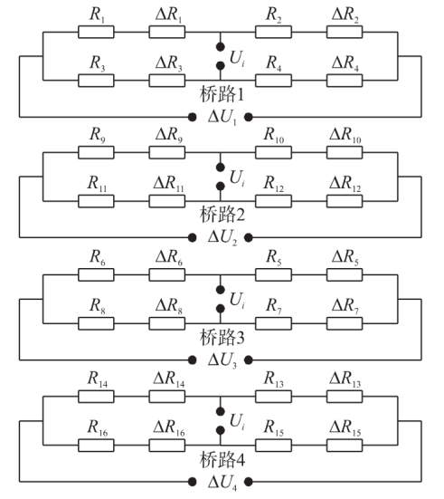
Figure 2 Position Distribution, Strain and Voltage Output Circuit of Strain Gauge
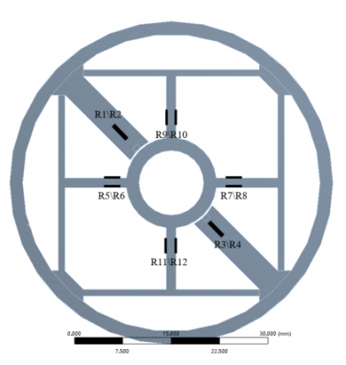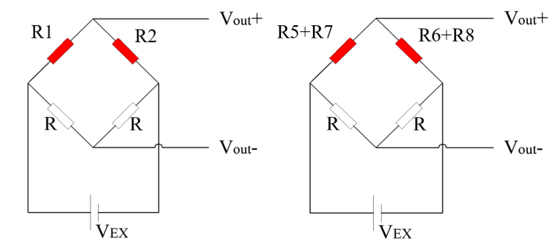
Figure 3 Schematic Diagram of Strain Gauge Layout Mode Wheatstone Bridge Diagram (Cantilever Bridge Circuit Cross Beam Bridge Circuit)

Anna Maria Lucia Lanzolla^{[4]} introduced a low-cost 3-print strain sensor. The sensor is a conductive material composed of polylactic acid (PLA) doped with carbon black nanotubes, which makes the plastic conductive. Y.D. Kim^{[5]} and others put forward a new type of three-dimensional force sensor, which uses a silicon strain gauge attached to a metal diaphragm, and has higher sensitivity than the sensor using a metal foil strain gauge.
The performance of strain-type three-dimensional force sensor mainly depends on the structural design of elastic body and the arrangement of strain gauges. Overconstrained planar parallel structure is an innovative design, which adopts six symmetrically distributed force measuring branches, and the axes of these branches are not beyond the center of the sensor, so that the sensor can measure radial load and axial torque at the same time. The strain gauge is used to measure the strain, which has high sensitivity and accuracy; The strain gauge is small in size and light in weight, which basically has no influence on the working state and stress distribution of the tested piece; The measuring range is large, which can measure both elastic deformation and plastic deformation; Can adapt to various complex environments; Convenient for multipoint measurement, etc.
2.2 Capacitive 3D Force Sensor
Capacitive three-dimensional force sensor measures external force by detecting the change of capacitance caused by the change of distance or effective area between electrodes. This kind of sensor usually adopts an array of multiple capacitance units, and through the comprehensive analysis of the capacitance changes of each unit, the force components in three directions are calculated. Sensors designed based on capacitance principle usually have the advantages of good temperature characteristics, low power consumption, strong overload capacity and strong environmental adaptability, and have been widely used in single-dimensional pressure sensors.
In order to give full play to the advantages of capacitive sensor.
Yang Shuyan^{[6]} and others designed the elastic body with cross beam structure based on the principle of variable polar distance capacitance, and measured the capacitance variation and polar distance variation. From the capacitance variation between the plates, the input force components of each dimension can be obtained, so as to realize three-dimensional force measurement, as shown in Figure 4. Zhao Zhizhong^{[7]} and Zhang Song designed a porous microstructure capacitive tactile sensor which can measure three-dimensional force. The sensor uses PDMS sponge as the sensor dielectric layer, and uses a 2×2 capacitance array to form a sensing unit, as shown in Figure 5. Based on the characteristics of parallel plate capacitance, the capacitance value is changed by changing the distance between plates, and then the changes of four capacitance output values distributed in the plane are measured to complete the detection of three-dimensional force. On the basis of low cost and low manufacturing, the sensor has high sensitivity and large range. Xu Decheng^{[8]} designed and manufactured a capacitive flexible three-dimensional force sensor which can detect normal force and tangential force. Using air as the dielectric layer between plates reduces the manufacturing cost and simplifies the sensor structure, as shown in Figure 6. The electrode part of the capacitive flexible three-dimensional force sensor can be equivalent to four capacitors, which has good stability, repeatability, hysteresis and temperature interference resistance, and can be applied to human motion detection.
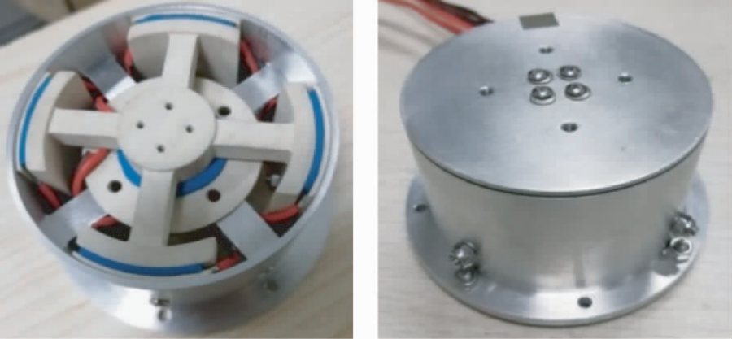
Figure 4 Physical Diagram of Sensor
Figure 5 Schematic Diagram of Sensor Unit Structure
Figure 6 Structural Diagram of Capacitive Flexible 3D Force Sensor
The capacitive three-dimensional force tactile sensor with coplanar interdigital electrode structure designed by Sun Ying et al^{[9]}. adopts coplanar interdigital electrode as the electrode structure of the sensor, and air and PDMS (polydimethylsiloxane) are used as the dielectric layer of the sensor. By using the edge effect of electric field, the output capacitance of the sensor is changed by changing the equivalent dielectric constant of the dielectric layer, and then the three-dimensional force detection is realized by changing the capacitance values of four capacitor units. Zhang Shuyan^{[10]} proposed a simple capacitive tactile sensor, which has the function of slip detection. The sensor can transform the force change into the air gap change, and then cause the capacitance change, and model the contact force as a polynomial function of the measured capacitance, so as to realize the contact force measurement. The sensor does not need to use any floating electrode, but only needs to be electrically connected with the bottom layer of the sensor, thus reducing the complexity and manufacturing cost. Yuan Haitao^{[11]}, Hefei University of Technology, based on solving the problems of flexibility, three-dimensional force detection and array compatibility of three-dimensional force tactile sensor, designed a composite multi-media capacitive flexible force tactile sensor.
Milica Kisić^{[12]} introduced a simple capacitive sensor for measuring force, which was manufactured by 3D printing technology of polylactic acid and silver conductive ink. Silicone rubber is used as the middle part of the electrode to make the sensor have better sensitivity. Achid Bekht^{[13]} has designed a compact and cost-effective triaxial capacitive force sensor. Although its structure is relatively simple, our sensor shows very high sensitivity due to the selected electronic components and special soft silica gel layer filled with ferroelectric ceramic nanoparticles. Jayer Fernandes^{[14]} studied the real-time characterization and measurement results of a new three-axis capacitive sensor array. The sensor is based on the change of differential capacitance between the central top electrode and the four bottom electrodes in the cell structure to respond to normal force or shear force. Tatsuho Nagatomo^{[15]} designed a three-dimensional microfluidic channel encapsulating liquid metal to develop a sensor small enough to be installed on an endoscope. Eight layers of polydimethylsiloxane with channel structure were assembled and filled with commercial liquid metal Galinstan to form a three-dimensional electrode. The sensor is characterized by experiments and verified to be suitable for endoscopic palpation. Jayer Fernandes^{[16]} also designed a flexible three-axis capacitive touch force sensor, which uses a patterned elastic dielectric layer and is made of copper-clad Kapton laminate, and can analyze normal pressure and track directional movement, as shown in Figure 7.
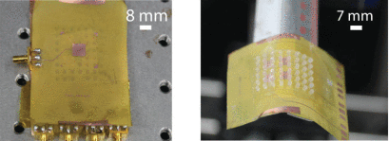
Figure 7 Manufacturing Touch Force Sensor
Kieran Morton^{[17]} studied the performance of soft triaxial capacitive force sensor in bending geometry, such as the forearm or finger position of robot arm. It consists of Ecoflex 00-30 columns forming dielectric and patterned carbon black ecoflex electrodes, which are mounted on flexible printed circuit boards for bottom connection. Sophon Somlor^{[18]} introduced a new type of three-axis capacitive force sensor. The sensor can measure the force vector, which is embedded in the 7 mm thick soft silicone skin to realize temperature sensitivity compensation and has digital output.
2.3 Piezoelectric 3D Force Sensor
Piezoelectric three-dimensional force sensor uses piezoelectric effect, when piezoelectric material is acted by external force, it will generate charge, and the amount of charge is proportional to the applied force. Piezoelectric force sensor has the characteristics of small volume, light weight, simple structure, easy installation, long life, good stability, high sensitivity and high stiffness, which has become the research focus at present.
In 2009, Xu Bin^{[19]} of Chongqing University designed a new three-dimensional force sensor based on piezoelectric effect. In 2005, Liu Jingcheng^{[20]} of Chongqing University put forward a new tactile three-dimensional force sensing head with simple structure and little interference between electrodes. The three-dimensional force sensing system designed according to the "skin effect" and bio-piezoelectric effect of human body is simple in structure, reliable in work and easy to manufacture. Based on the principle of parallel plate capacitor, the three-dimensional force sensor based on microstructure elastomer proposed by Kou Wenzhe^{[21]} of Soochow University forms four independent sensing units between the upper and lower plates by introducing patterned flexible fabric electrodes. When the sensor is subjected to external load, the sensing unit senses the external force through the change of capacitance, thus realizing the detection of three-dimensional force. In 2024, Zhang Jun^{[22]} proposed a multi-dimensional force sensor with regular octagonal wafer based on the sensor layout and the characteristics of Shi Ying wafer cutting, in order to solve the problems of limited effective test area, inconsistent output results at different test positions, and cumbersome torque acquisition ,Figure 8. The sensor has high tangential sensitivity, good linearity and repeatability in all directions, little interference between directions and good testing performance.
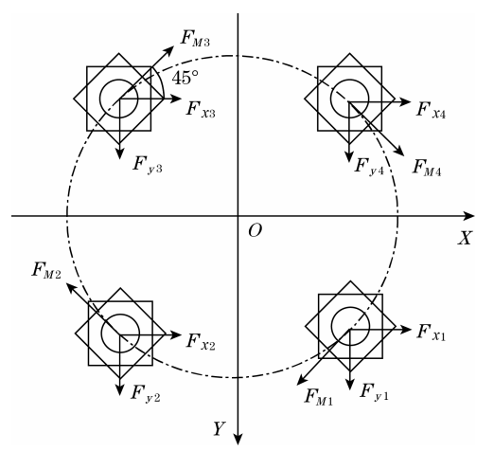
Figure 8 Three-dimensional superimposed wafer layout
Ping Yu^{[23]} proposed a new flexible piezoelectric tactile sensor array(Figure 9) based on polyvinylidene fluoride (PVDF) film, which was used to measure the dynamic contact force distribution in three axes. PVDF films of six tactile units are sandwiched between four square upper electrodes and one square lower electrode to form four piezoelectric capacitors. There is a truncated cone-shaped protrusion above the four piezoelectric capacitors to improve the force transmission. The triaxial contact force transmitted from the top of the bump will lead to different charge changes of the four piezoelectric capacitors below, from which the normal component and shear component of the force can be calculated. In order to effectively measure the three-dimensional force and improve the sensitivity of the tactile sensor, Wang Feilu^{[24]} and others proposed a new type of piezoelectric tactile sensor with "sandwich" structure. A circular truncated cone-shaped sensitive cell array made of polyvinylidene fluoride is sandwiched between two flexible substrates of polydimethylsiloxane (PDMS). Based on the piezoelectric characteristics of PVDF sensor, the finite element modeling and analysis of the sensor are carried out. The relationship between the force and voltage of the sensitive unit is obtained, and the tactile perception model is established. Wang Guicong^{[25]} and others proposed a new type of PVDF piezoelectric film three-dimensional gravity sensor(Figure 10). Luo Yunyun^{[26]} and others proposed a flexible tactile sensor to measure three-dimensional force. The sensor consists of bump structure, top and bottom electrodes, piezoelectric sensitive layer and substrate layer. The top and bottom electrodes are prepared by stripping process. When three-dimensional force is applied, the bottom four electrodes under the bump structure will collect different charge signals, which can be detected by different current changes.
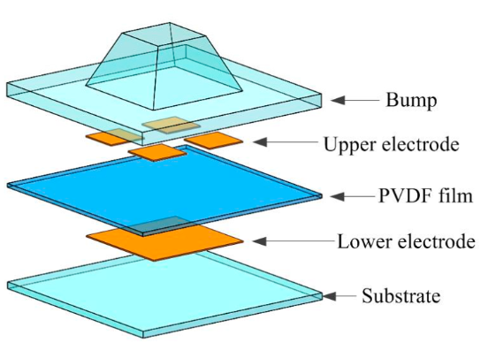
Figure 9 Exploded view of tactile unit
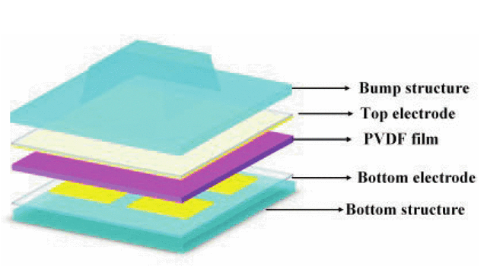
Figure 10 Schematic diagram of flexible piezoelectric triaxial tactile sensor
2.4 Fiber Bragg Grating 3D Force Sensor
Fiber Bragg Grating, FBG) three-dimensional force sensor is an important development direction in the field of sensing technology in recent years. With its advantages of high precision, anti-electromagnetic interference (EMI) and good biocompatibility, it has shown great application potential in the fields of robotics, precision manufacturing and biomedicine.
Li Meili^{[27]}, Cui Weixing, etc. proposed a 3D force sensing sensor for robot wrist based on fiber grating (FBG) technology to solve the problems of spatial 3D force sensing decision-making of cooperative robot(Figure 11). The accurate measurement of three-dimensional force components (Fx, Fy, Fz) is realized by arranging four FBG rings and one prestressed fiber grating center. Liu Yanhong^{[28]} et al. designed a segmented fiber grating three-dimensional force sensor. Four optical fibers are suspended inside the sensor to sense the stress and strain of the sensor, which are used to detect the transverse force and the axial force respectively, and can realize the three-dimensional detection of the force. Zhou Xinglin^{[29]} of Wuhan University of Science and Technology has developed a tire-pavement fiber grating three-dimensional force sensor, which can measure the three-dimensional force generated by tires. Liu Yunhui^{[30]} of Beijing University of Civil Engineering and Architecture designed a new type of fiber grating three-dimensional sensor, which is mainly applied to the three-dimensional components of building structures to monitor the structural deformation under the influence of large load conditions (such as extreme loads such as earthquake loads).
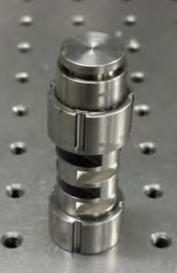
Figure 11 Physical Diagram of Sensor
Li Xiong^{[31]} adopted the classic Maltese beam and multiplexed fiber grating(Figure 12). Through ingenious design, the triaxial force can be measured only by five sensitive elements of fiber grating, and at the same time, decoupling and temperature compensation are realized. A three-dimensional force sensor based on fiber grating is designed to measure the plantar force of bionic robot. Xi Li^{[32]} Lin Jinzhao and others designed a compact three-dimensional force sensor with fewer fiber gratings, which can adapt to a smaller confined space. Sun Shizheng^{[33]} proposed a three-dimensional force sensor based on fiber Bragg grating (FBG)(Figure -13). A spatial layered elastic structure is designed, and four single-mode optical fibers are laid everywhere in the structure to realize the three-dimensional force sensing of the robot and compensate the temperature interference. It has the advantages of weak coupling and good temperature compensation effect.
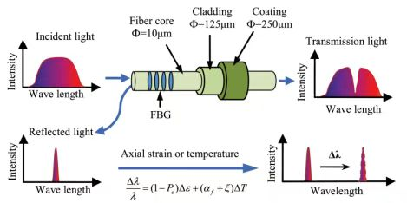
Figure 12 Working Principle Diagram
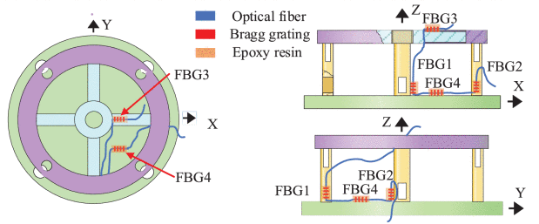
Figure 13 Distribution of Sensor Structure Sensitive Elements
Liang Qiaokang^{[34]} introduced a new fiber Bragg grating (FBG) three-dimensional force sensor, which was specially designed for the end effector of medical robot. The sensor adopts specially designed layered elastic structure, and realizes miniaturization, structural self-decoupling and high-sensitivity three-dimensional force measurement through ingenious and compact space design and reasonable layout of five fiber gratings. Cui Xiandao^{[35]} proposed a triaxial force sensor consisting of a flexible force sensing structure and three fiber gratings. We measure the triaxial force of surgical tools by monitoring the strain of FBG. Long Jianyong^{[36]} proposed a new robot wrist force sensor. Our sensor uses FBG instead of strain gauge. Fiber grating is small in size and does not need to be equipped with circuits. We propose an embedded three-spoke elastic structure to realize the ultra-thin characteristics of the sensor. Guo Yongxing^{[37]} studied a three-axis grating force sensor for robot fingers. Six fiber gratings with different wavelengths are arranged in the elastic structure, and Fx, Fy and Fz dimensionless couplings can be measured. Dong Shiyuan developed a high-precision miniature three-dimensional fiber Bragg grating (FBG) force sensor, which consists of three etched FBG fibers and an integrated elastic body. It is used to detect and locate hard masses in tissues during minimally invasive surgery (MIS) and robot-assisted MIS palpation. Li Tianliang^{[38]} proposed a three-dimensional force/torque sensor based on disposable fiber Bragg grating (FBG). The sensor is made of cheap three-dimensional printed elastomer with annular diaphragm and is sensitive to axial force Fz and torques Mx and My.
4 Application fields
Three-dimensional force sensor has been widely used in many fields because of its unique advantage of measuring force components in multiple directions at the same time. With the continuous maturity of technology and the reduction of cost, its application scope continues to expand.
In the field of industrial automation, three-dimensional force sensors are widely used in robot technology. For example, on the assembly line, the three-dimensional force sensor can help the robot grasp and place objects accurately, thus improving the production efficiency and accuracy. Specific applications include precision assembly^{[39]}, automatic grinding, contour tracking ^{[40]}, two-handed coordination and so on.
After the robot arm^{[41]} and the gripper integrate three-dimensional force sensors, accurate force control and collision detection can be realized, which greatly improves the safety and accuracy of operation. This not only improves the production efficiency, but also reduces the risk of equipment damage and product scrapping. Especially for robots working in uncertain environment, the three-dimensional force sensor provides vital force feedback information, which enables the robot to adapt to environmental changes and make corresponding adjustments.
5 Challenges and Prospects
Although the three-dimensional force sensor technology has made remarkable progress, it still faces some challenges to overcome and has broad development prospects.
At present, the main challenges faced by three-dimensional force sensor include: signal crosstalk, environmental sensitivity and complexity of manufacturing process. Mechanical crosstalk is still a technical bottleneck, and the force components in different directions interfere with each other, which affects the measurement accuracy. The output signal of the sensor is easily influenced by environmental factors such as temperature and humidity, so it needs temperature compensation and calibration.
In large-scale manufacturing, consistency (yield < 60%) and long-term stability (> 500,000 cycles) need to be solved. For flexible sensors, it is necessary to improve their durability and reliability to meet the needs of practical applications. In addition, the installation and debugging of the sensor is complicated, which requires professionals to operate and maintain, which increases the use cost and threshold.
5.2 Future development trend
Deep integration with artificial intelligence: The deep integration of bionics and AI will give birth to a new generation of adaptive tactile system. Machine learning algorithm not only plays an important role in signal decoupling, but also enables the sensor to have the ability of self-learning and self-adaptation, and automatically adjusts parameters according to different usage scenarios, thus improving the measurement accuracy and reliability.
Flexibility and extensibility: Flexible three-dimensional force sensor is an important development direction in the future, especially for electronic skin application, which requires the sensor to have good flexibility, extensibility and biocompatibility. This kind of sensor can be attached to human skin or robot surface to realize natural and seamless human-computer interaction.
Application of new materials: The application of emerging materials such as carbon nanotubes, conductive polymers, graphene and liquid metals will further improve the sensor performance. These materials have excellent electrical, mechanical and thermal properties, which can meet the higher requirements of sensors for sensitivity, stability and environmental adaptability.
Integration and miniaturization: With the development of micro-nano processing technology and 3D printing technology, 3D force sensor will develop towards smaller volume and higher integration. This will enable the sensor to be applied to space-limited scenes, such as minimally invasive surgical instruments, micro-robots, etc.
Wireless and self-powered: Combined with energy collection technology, the future 3D force sensor may realize self-powered function, and send data through wireless transmission, which greatly improves the convenience of use and the breadth of application.
6 conclusion
As a key measuring tool in modern industry, medical treatment and scientific research, the planar three-dimensional force sensor has made remarkable progress in its technical development. From the traditional strain sensor to the emerging flexible tactile sensor, from single force measurement to multi-dimensional force detection, the accuracy, sensitivity and reliability of the sensor are constantly improving.
At present, the research mainly focuses on material innovation, structural optimization and direction, and the performance of the sensor is continuously improved through new materials (such as porous elastomer and carbon nano-materials) and new structures (such as plane parallel structure and micro-nano structure). The application of three-dimensional force sensor in industrial automation, medical health, aerospace and other fields has been expanding, showing great market prospects and development potential.
However, the three-dimensional force sensor still faces challenges such as signal crosstalk, environmental sensitivity and manufacturing consistency, which need further research and solution. In the future, with the continuous development of artificial intelligence, new materials and advanced manufacturing technology, three-dimensional force sensors will evolve in the direction of higher precision, better flexibility and stronger intelligence, providing more advanced support for intelligent manufacturing, human-computer interaction and health monitoring.

COMPETING INTERESTS DISCLAIMER:
Authors have declared that they have no known competing financial interests OR non-financial interests OR personal relationships that could have appeared to influence the work reported in this paper.

REFERENCES
- Chai Jixin, Zhao Yinming, Chen Kexing, et al. Development of dynamic three-component sensor based on strain gauge principle [J]. China Testing, 2023, 49 (S1): 168-173.
- Zhang Haixia, Cui Jianwei, Chen Danfeng, et al. Research on a new type of strain gauge three-dimensional force sensor with structural decoupling [J]. Journal of Sensor Technology, 2014, 27 (02): 162-167.
- Xu Zhongtian. Research and implementation of three-dimensional dynamic excitation force testing technology for rotating shaft system [D]. Zhejiang University, 2021.
- Lanzolla, A.M.L.; Attivissimo, F.; Percoco, G.; Ragolia, M.A.; Stano, G.; Di Nisio, A. Additive Manufacturing for Sensors: Piezoresistive Strain Gauge with Temperature Compensation. Appl. Sci. 2022, 12, 8607.
- Y.D. Kim, Y. D. Kim, C. S. Lee and S. J. Kwon, "Novel 3D force sensor using ultra-thin silicon strain gauge bonded on metal membrane," TRANSDUCERS 2009 - 2009 International Solid-State Sensors, Actuators and Microsystems Conference, Denver, CO, USA, 2009, pp. 1920-1923,
- Yang Shuyan, Sun Dongjie, Li Danruo, et al. A novel capacitive three-dimensional force sensor for biomechanical measurement [J]. Acta Metrologica Sinica, 2021, 42 (04): 495-502.
- Zhao Zhizhong, Zhang Song. Capacitive three-dimensional force tactile sensor based on sponge dielectric layer [J]. Instrument Technology and Sensor, 2021, (02): 6-11.
- Xu Decheng, Wang Haonan, Feng Yanlai, et al. Design and application of capacitive three-dimensional force flexible tactile sensor [J]. Journal of Jilin Normal University (Natural Science Edition), 2024, 45 (04): 76-82.
- Sun Ying, Liu Fei, Weng Ling, et al. Design of a capacitive three-dimensional force tactile sensor with multi-finger electrode structure on the same surface [J]. Instrument Technology and Sensor, 2020, (02): 6-10.
- Zhang Shuyan, Zhang Jinhong, Zhao Lirui. Design of a simple capacitive three-dimensional force flexible tactile sensor [J]. Electronic Devices, 2018, 41 (01): 95-99.
- Yuan Haitao. Research on a capacitive flexible three-dimensional force tactile sensor with composite multi-layer dielectric layers [D]. Hefei University of Technology, 2015.
- M.Kisić, N. Blaž, L. Živanov and M. Damnjanović, "Capacitive Force Sensor Fabricated in Additive Technology," 2019 42nd International Spring Seminar on Electronics Technology (ISSE), Wroclaw, Poland, 2019, pp. 1-5,
- R. Bekhti, V. Duchaine and P. Cardou, "Miniature capacitive three-axis force sensor," 2014 IEEE/RSJ International Conference on Intelligent Robots and Systems, Chicago, IL, USA, 2014, pp. 3939-3946,
- J.Fernandes, J. Chen and H. Jiang, "Three-Axis Capacitive Sensor Arrays for Local and Global Shear Force Detection," in Journal of Microelectromechanical Systems, vol. 30, no. 5, pp. 799-813, Oct. 2021.
- Nagatomo, T. and Miki, N. (2017), Three-axis capacitive force sensor with liquid metal electrodes for endoscopic palpation. Micro Nano Lett., 12: 564-568.
- J.Fernandes and H. Jiang, "Three-Axis Capacitive Touch-Force Sensor for Clinical Breast Examination Simulators," in IEEE Sensors Journal, vol. 17, no. 22, pp. 7231-7238, 15 Nov.15, 2017.
- K.Morton, R. Ishizaki, Z. Chen, M. S. Sarwar and J. D. W. Madden, "Soft Three-Axis Capacitive Force Sensor for Robotic E-Skin on Curved Surfaces," in IEEE Sensors Letters, vol. 7, no. 10, pp. 1-4, Oct. 2023, Art no. 2503404.
- Somlor, S., Hartanto, R. S., Schmitz, A., & Sugano, S. (2015). A novel tri-axial capacitive-type skin sensor. Advanced Robotics, 29(21), 1375–1391.
- Xu Bin, Qin Lan, Liu Jun, et al. Design and characteristics of a new piezoelectric three-dimensional force sensor [J]. Foreign Electronic Measurement Technology, 2009, 28 (07): 40-44.
- Liu Jingcheng, Liu Jun, Li Min. Design of a new three-dimensional force sensor based on piezoelectric [J]. Piezoelectricity and Acousto-Optics, 2005, (06): 643-645.
- Kou Wenzhe. Research on three-dimensional force sensor based on microstructure elastic dielectric material [D]. Suzhou University, 2024.
- Zhang Jun, Zhong Yujie, Ren Zongjin, et al. Research on piezoelectric multi-dimensional force sensor [J]. Instrument Technology and Sensor, 2024, (03): 29-32+56.
- Yu, P.; Liu, W.; Gu, C.; Cheng, X.; Fu, X. Flexible Piezoelectric Tactile Sensor Array for Dynamic Three-Axis Force Measurement. Sensors 2016, 16, 819.
- Wang, Feilu, Ye, Rungen, Song, Yang, Chen, Yufeng, Jiang, Yanan, Lv, Shanna, Li, Mingkun, Modeling Analysis and 3D Force Prediction of a Novel Piezoelectric Tactile Sensor, Journal of Sensors, 2021, 3667833, 15 pages, 2021.
- Gui-cong Wang, Jun-si Zhou, Peng Xu, Ying-jun Li; Research on polyvinylidene fluoride (PVDF) piezoelectric film three-dimensional force sensor for metal material plastic cold heading forming processing. Rev. Sci. Instrum. 1 August 2025; 96 (8): 083902.
- Y.Luo et al., "A Flexible Tactile Sensor for Three-dimensional Force Detection Based on Piezoelectric Sensing," 2021 IEEE 16th International Conference on Nano/Micro Engineered and Molecular Systems (NEMS), Xiamen, China, 2021, pp. 1908-1911.
- Li Meili, Cui Weixing, Niu Liang, et al. Design of a Three-dimensional Force Sensor for Robot Wrist Based on Fiber Bragg Grating [J/OL]. Optical Communication Technology, 1-9[2025-09-01].
- Liu Yanhong, Miao Yazhou, Zhang Kuan, et al. Design of Fiber Bragg Grating Three-Dimensional Force Sensor for Pulmonary Intervention [J]. Journal of Zhengzhou University (Engineering Edition), 2025, 46 (01): 9-16.
- Zhou Xinglin, Sheng Zhonghua, Yuan Chenqi, et al. Research on Strain Transfer Characteristics of Fiber Bragg Grating Three-Dimensional Force Sensor [J]. Instrument Technology and Sensor, 2019, (05): 9-13.
- Liu Yunhui. Design of Three-Dimensional Fiber Bragg Grating Sensor and Its Application in Building Structures [D]. Beijing University of Civil Engineering and Architecture, 2017.
- L.Xiong, G. Jiang, Y. Guo and H. Liu, "A Three-Dimensional Fiber Bragg Grating Force Sensor for Robot," in IEEE Sensors Journal, vol. 18, no. 9, pp. 3632-3639, 1 May1, 2018.
- Li, X.; Lin, J.; Pang, Y.; Yang, D.; Zhong, L.; Li, Z. Three-Dimensional Force Sensor Based on Fiber Bragg Grating for Medical Puncture Robot. Photonics 2022, 9, 630.
- S.Sun, J. Yu, K. Pang and Z. He, "High-Precision FBG 3-D Force Sensor Based on Spatial Hierarchical Sensing Structure," in IEEE Sensors Journal, vol. 23, no. 5, pp. 4833-4842, 1 March1, 2023.
- Q.Liang, S. Ouyang, J. Long, L. Zhou and D. Zhang, "A Novel Fiber Bragg Grating Three-Dimensional Force Sensor for Medical Robotics," in IEEE/ASME Transactions on Mechatronics, vol. 30, no. 3, pp. 1635-1645, June 2025.
- H.Choi, Y. Lim and J. Kim, "Three-axis force sensor with fiber Bragg grating," 2017 39th Annual International Conference of the IEEE Engineering in Medicine and Biology Society (EMBC), Jeju, Korea (South), 2017, pp. 3940-3943.
- J.Long, Q. Liang, W. Sun, Y. Wang and D. Zhang, "Ultathin Three-Axis FBG Wrist Force Sensor for Collaborative Robots," in IEEE Transactions on Instrumentation and Measurement, vol. 70, pp. 1-15, 2021, Art no. 3519115.
- Yongxing Guo, Jianyi Kong, Honghai Liu, Hegen Xiong, Gongfa Li, Li Qin,A three-axis force fingertip sensor based on fiber Bragg grating,Sensors and Actuators A: Physical, Volume 249, 2016, Pages 141-148, ISSN 0924-4247
- T.Li, N. K. K. King and H. Ren, "Disposable FBG-Based Tridirectional Force/Torque Sensor for Aspiration Instruments in Neurosurgery," in IEEE Transactions on Industrial Electronics, vol. 67, no. 4, pp. 3236-3247, April 2020.
- Chen Haichu, Zhang Ruihua. Research on three-dimensional micro force sensor for microassembly [J]. Piezoelectrics & Acoustooptics, 2007, (03): 280-282.
- Y.H. Yin, Y. Xu, Z. H. Jiang and Q. R. Wang, "Tracking and Understanding Unknown Surface With High Speed ​​by Force Sensing and Control for Robot," in IEEE Sensors Journal, vol. 12, no. 9, pp. 2910-2916, Sept. 2012.
- Shams, S., Kim, D.S., Choi, Y.S. et al. A novel 3-DOF optical force sensor for wearable robotic arm. Int. J. Precis. Eng. Manuf. 12, 623–628 (2011).

