Original Research Article
Evaluation and Optimization of the Engineering Properties of LDPE Fiber-Reinforced Sandcrete Blocks Using Taguchi Method

Abstract
Sandcrete blocks are construction materials that are predominantly used in buildings in West Africa. Their constituents are similar to concrete with the exception of the coarse aggregates. Therefore, similar to the positive effect of fiber reinforcement in concrete, low-density polyethylene (LDPE) fibers are to be added to sandcrete blocks to improve their mechanical and water absorption properties. This study investigates the performance of sandcrete blocks reinforced with low-density polyethylene (LDPE) fibers obtained from wastewater sachets. While the reuse of LDPE in concrete has been explored, its application in sandcrete block production remains limited. This research addresses that gap by optimizing the effects of LDPE fiber content (0.33%, 0.67%, and 1%), fiber length (20 mm, 30 mm, and 40 mm), and water-cement ratio (w/c) (0.5,0.6, and 0.7) on key properties including density, compressive strength, flexural tensile strength, and water absorption. A Taguchi orthogonal array (L9) design was utilized to identify optimal mix combinations. Results showed that the mix with a 0.7 w/c ratio, 40 mm LDPE fiber length, and 0.33% fiber content achieved the optimum density. The highest compressive
(4.02MPa) and flexural tensile (2.06MPa) strengths were obtained from a mix containing 0.67% LDPE fibers of 20 mm length and a w/c ratio of 0.6. The mix with the least water absorption also featured 0.67% fiber content, 20 mm fiber length, and a w/c ratio of 0.6. ANOVA results indicated that the w/c ratio was the most significant, contributing over 45 % to all measured properties. The findings support the development of sustainable, cost-effective sandcrete blocks suitable for non-load bearing applications.

Keywords: Sandcrete blocks, compressive strength, flexural tensile strength, Water absorption, LDPE fiber content, LDPE fiber length, Taguchi optimization, ANOVA.

1.0 Introduction
Concrete structures are used extensively in West African construction more than steel and wood (Choplin, 2023). Concrete materials are fundamentally composed of cement, fine aggregates, coarse aggregates and water. These components characterize the various construction materials. Sandcrete blocks constructed from cement, fine aggregates, and water are used as walls in construction, mainly in West Africa (Ghana and Nigeria) (Ikeagwuani et al., 2020). In addition to the simplicity of shaping and sizing sandcrete blocks, they have low shrinkage, minimal thermal conductivity, and high compressive strength (B. Mohammed & Cheeseman, 2011).
To develop sustainable, mechanically enhanced, and cost-effective construction materials such as mortar, concrete, and sandcrete blocks, various approaches have been explored. These include the incorporation of supplementary cementitious materials, pozzolanic additives, fiber reinforcement, chemical admixtures, and improved curing methods (Lallas et al., 2023; Muralidharan et al., 2021; Qureshi et al., 2020; Toghroli et al., 2020). For instance, Awolusi et al. (2021) replaced cement with calcined clay in sandcrete block production, resulting in increased compressive strength. Furthermore, fiber addition, a sustainable method of improving the engineering properties of construction materials such as concrete, has been utilized in sandcrete blocks, as reported by Ijalana, Afoloayan and Adeleke (2015).
Fiber is important in concrete technology and cement-based materials such as sandcrete. Fibers’ excellent tensile properties significantly delay crack propagation (Plagué et al., 2017). Many research reports indicate the enhanced mechanical properties of concrete, particularly improvements in tensile and compressive strength (Altalabani et al., 2020; Ashkezari et al., 2020; T. Zhang et al., 2019). It is important to note that fibers are more effective in enhancing tensile strength due to their inherently high tensile characteristics (Hassan & Saeed, 2024).. Generally, fibers are classified as natural or artificial depending on their sources. The most commonly used natural fibers in concrete and cement based materials are bamboo, coconut, flax, hemp, jute, and palm fibers (Bheel et al., 2021; Katman et al., 2022; Mukhopadhyay & Khatana, 2015; Sridhar et al., 2022; Widiarto, 2023). Artificial fibers used for the same purpose include glass, nylon, polypropylene, polyvinyl, polyethylene, basalt, carbon and steel fibers (Gao et al., 2017; Hanif et al., 2017; Micelli et al., 2020; Pelisser et al., 2012; Sohaib et al., 2018; Yusuf et al., 2023). Research efforts have focused on improving cement-based materials, particularly sandcrete blocks. These include the addition of steel fibers in the production of hollow blocks (Musa & Abubakar, 2018), and polythene fibers to solid blocks (Ijalana et al., 2015). These studies indicate that adding various fiber types enhances compressive and flexural tensile strength to a certain extent. It is important to also note that artificial and natural fibers differ in material properties, which influence their performance when used as fiber reinforcements. Artificial fibers generally exhibit higher Young’s modulus, making them stiffer and stronger than natural fibers (Mastura et al., 2022).
Using fibers that are waste materials or by- products from industrial activities for producing construction materials also promotes environmental sustainability by reducing pollution from their disposal (Duraiswamy et al., 2024; Singh, 2024). Low density polyethylene (LDPE) from waste water sachet has been reused in concrete production (A M Ghadafi & Kankam, 2022; Abdullai M Ghadafi & Kankam, 2021; Kumi-Larbi et al., 2018; Tsala-Mbala et al., 2022) . However, research on the use of LDPE fibers in sandcrete block production remains limited. Low-density sandcrete blocks offer several advantages in construction, particularly for non-load bearing applications. These include reduced dead load on the structure, improved thermal insulation, and ease of handling and transportation, all contributing to lower construction costs and enhanced energy efficiency (Adegun & Adedeji, 2017; Falade & Ikponmwosa, 2011). Additionally, controlling water absorption in concrete materials is crucial. While excessive absorption can lead to durability issues, a moderate water absorption capacity can help regulate internal moisture , potentially reducing cracking due to shrinkage and improving the internal curing effect, which contributes to long –term strength development (Zhutovsky & Kovler, 2012).
This research uniquely addresses that gap by exploring, for the first time, the incorporation of LDPE fibers into sandcrete blocks. The novelty of this study lies in its use of waste-derived LDPE fibers to improve both the mechanical and durability performance of sandcrete, offering a dual benefit of material innovation and environmental sustainability. This research employs the Taguchi orthogonal design to determine the optimal sandcrete mix, aiming for maximum compressive and flexural tensile strength, the minimal density, and the highest moisture resistance. The sandcrete blocks' key features, such as changing percentages of fiber addition, LDPE fiber length, and water cement ratios, are addressed. Results from this research will contribute to the construction industry by providing a novel, sustainable, cost-effective, and durable materials that are well suited for non-load bearing walls, while helping to reduce environmental waste.

2.0 Materials and Experiment

2.1 Materials
A commercial supplier provided ordinary Portland cement (OPC) of grade 42.5R for use as a binder in the sandcrete mix. The composition of the OPC is shown in Table 1. Pit sand, which makes up the fine aggregates in the mix, came from Bechem in Ghana's Ahafo Region. Figure 1 depicts the particle size distribution plot for pit sand after sieving. Furthermore, Table 2 displays the physical parameters of the fine aggregates.
Low-density polyethylene (LDPE) was obtained from segregated waste, specifically disposed water sachets collected at the Faculty of Engineering waste collection point at Sunyani Technical University in the Bono Region. The physical properties of the LDPE fibers are presented in Table 3. Additionally, potable water from the Ghana Water Company was used for mixing the sandcrete blocks in this study.
Table 1: Chemical Composition of OPC
Materials | SiO₂ | Al₂O₃ | Fe₂O₃ | CaO | K₂O | MnO | MgO | SO₃ | TiO₂ | LOI
OPC | 33.58 | 7.16 | 3.16 | 46.41 | 1.19 | 0.07 | 2.6 | 2.19 | 0.32 | 3.29

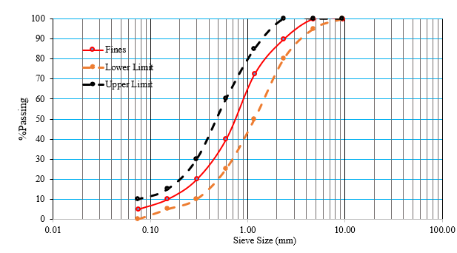
Figure 1. Particle size distribution curve for fine aggregates
Table 2: Physical Properties of Fine Aggregates
Properties | Specific Gravity | Fineness Modulus | Water Absorption (%)
Value | 2.6 | 2.41 | 1.65

Table 3: Physical Properties of LDPE Fibers
Properties | Elastic Modulus | Melt flow Index | Density
Value | 5 GPa | 7g/10 min | 0.91g/cm³

2.2 Fiber preparation
The disposed water sachets were cleaned and sun-dried for 24 hours to produce LDPE fibers. After drying, the LDPE fibers were cut into the required strips with a constant width of 5 mm and lengths of 20 mm, 30 mm and 40 mm. Figure 2 shows the fibers used in this study.
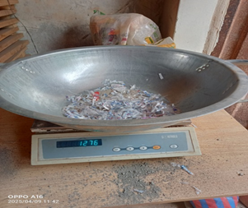
Figure 2. LDPE Fiber

2.3 Taguchi Design and Analysis of Variance (ANOVA)
The Taguchi Orthogonal array (L9) was used to optimize the sandcrete block mix design. This approach was selected to obtain an efficient and balanced experiment while minimizing the number of required runs. This study investigated the influence of three factors on the properties of sandcrete blocks, including LDPE fiber content, LDPE fiber length, and water cement ratio (W/C). All the factors were evaluated at three levels each. The selection of these levels was based on prior research demonstrating their influence on the mechanical properties of fiber-reinforced concrete and sandcrete blocks. Specifically, the W/C ratio significantly affect the compressive strength of the sandcrete blocks, while, LDPE fiber contents, along with LDPE fiber length, influence the overall strength of fiber reinforced composites. The factors and corresponding levels used in the Taguchi orthogonal array are presented in Table 4.

Table 4a: Factors and values at corresponding levels
FACTORS | LEVELS
 | 1 | 2 | 3
A. LDPE fiber content | 0.33% | 0.67% | 1%
B. LDPE fiber length | 20mm | 30mm | 40 mm
C. Water-Cement Ratio (W/C) | 0.5 | 0.6 | 0.7

Table 4b: The Taguchi orthogonal array L9
Trial | A | B | C | A (3 levels) | B (3 levels) | C (3 levels)
No. |  |  |  | LDPE Fiber Content | LDPE Fiber Length | Water/Cement
T1 | 1 | 1 | 1 | 0.33 | 20 | 0.5
T2 | 1 | 2 | 2 | 0.33 | 30 | 0.6
T3 | 1 | 3 | 3 | 0.33 | 40 | 0.7
T4 | 2 | 1 | 2 | 0.67 | 20 | 0.6
T5 | 2 | 2 | 3 | 0.67 | 30 | 0.7
T6 | 2 | 3 | 1 | 0.67 | 40 | 0.5
T7 | 3 | 1 | 3 | 1 | 20 | 0.7
T8 | 3 | 2 | 1 | 1 | 30 | 0.5
T9 | 3 | 3 | 2 | 1 | 40 | 0.6

The signal-to-noise (S/N) ratio in the Taguchi method optimizes response characteristics based on the objective. Higher-the- better is used when maximizing performance. Nominal-the-best, is applied when achieving a target value. Lower-the-better is for minimizing undesirable effects. In the current study, the higher-the-better S/N ratio equation (Equation 1) and lower-the- better S/N ratio equation (Equation 2) are used for optimization. The S/N ratio equations are given as follows:
$S/N=-{10log}_{10}{(\frac{1}{n}\sum_{i=1}^{n}{\frac{1}{{yi}^{2}})}}$ (1)
$S/N=-{10log}_{10}{(\frac{1}{n}\sum_{i=1}^{n}{{yi}^{2})}}$ (2)
Where,
yi represents the response values
n represents the number of trials
Since the objective is to maximize the compressive strength and flexural tensile strength of the sandcrete blocks, the Higher-the-better S/N ratio equation is applied to these response characteristics. Conversely, the lower-the-better S/N ratio equation is used to optimize density and water absorption, as lower values are preferred for these properties.
In the current study, Analysis of Variance (ANOVA) was used alongside Taguchi optimization to evaluate how process factors influence response variables. By analyzing variability and computing metrics such as sum of squares, F-ratio, and p-values; ANOVA identified statistically significant factors and their contributions supporting effective process optimization

2.4 Block Production
The cement-to-sand ratio used was constant at 1:6. The sandcrete blocks were prepared by dry mixing the cement, sand and the fibers according to the required proportions. Afterwards the potable mixing water was added to the dry mix and the blocks were compressed in a block making machine.

2.5 Experimental Testing
The sandcrete blocks produced measured 150 * 150 * 150 cubic mm. The blocks were cured for 7, and 28 days. For each sandcrete mix three specimens were produced. A total of 162 sandcrete blocks were produced based on the experimental design. The density of each specimen was completed in accordance with BS EN 12390-7 (British Standards Institute, 2000). The compressive strength and the flexural tensile strength were determined using the BS EN 12390-3 (British Standards Institution, 2001) and BS EN 12390-5 (British Standards Institution, 2019) standards, respectively. The experimental setup is presented in Figure 3. The water absorption which was conducted after 28 days was conducted in accordance to the BS EN 12390-8:2019.
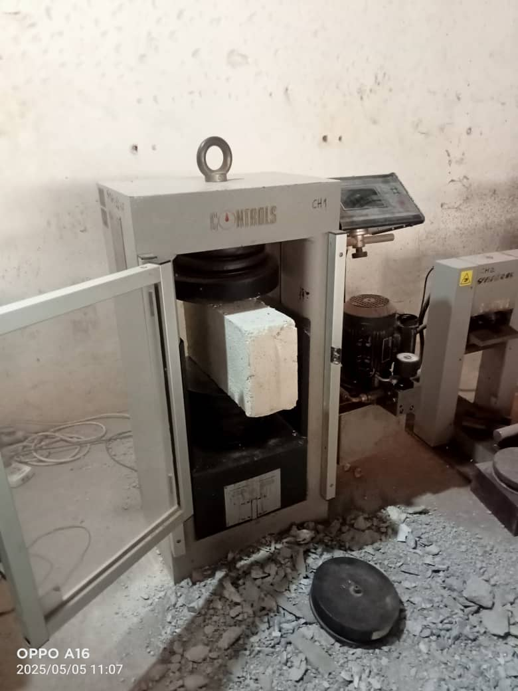
Figure 3. Experimental Setup

3 Results and Discussion

3.1 Experimental Results
The density, compressive strength, flexural tensile strength and water absorption of the sandcrete blocks after 7 and 28 days of curing is presented in Figure 4. The increase in density of the sandcrete blocks with curing time as shown in Figure 4a shows that addition of LDPE fibers positively influence the density development of the sandcrete blocks as curing progresses. This is consistent with findings in previous studies. For example, Odeyemi et al. (2024) found that adding polythene fibers to sandcrete blocks improved their density overtime, attributed to the fibers’ role in enhancing the microstructure and compaction during curing. Similarly, Ahsan et al. (2023) observed that incorporating fibers in concrete resulted in higher density, which contributed to better mechanical properties and durability. Additionally, the progressive densification resulted from the ongoing hydration process, during which cement hydration leads to the formation of calcium-silicate-hydrate (C-S-H) gel that fills the pores of the sandcrete block matrix (Akanbi et al., 2024). The maximum and minimum density values were 2000.83 kg/m³ for T1 and 1900.41 kg/m³ for T3, respectively.
With the increase in the density of the sandcrete blocks over the curing period, it can be observed from Figures 5b and 5c that both the compressive strength and flexural tensile strengths similarly increase with curing time. A denser sandcrete material offers greater resistance to loading, which explains the observed trend (Auyo et al., 2023; Ogbeide et al., 2024). Among the nine sandcrete block mixes, sandcrete mix T4 exhibited the highest compressive strength and flexural tensile strength across all curing days. Between 7 and 28 days of curing, the compressive strength increased by 48.3%, while the flexural tensile strength increased by 25.45%.
The water absorption results, as shown in Figure 4d, indicate that water absorption decreased by approximately 9.94% as the curing period increased from 7 to 28 days. This aligns with expectations as the incorporation of plastic fibers into the sandcrete matrix enhances its water resistance. Fibers contribute to this improvement by bridging microcracks, refining the pore structure, and reducing the connectivity of capillary pores, thereby limiting water ingress. As observed in similar studies , for example, Awoyera et al. (2021) demonstrated that adding plastic fibers to interlocking concrete blocks reduced water absorption and improved mechanical properties.
(a)
(c)

Figure 4. Properties of Sandcrete blocks after 7 and 28 days of curing; (a) Density ; (b) Compressive strength ; (c) Flexural Tensile strength ; (d) Water Absorption

3.2 Taguchi Results
The results were analyzed using the Minitab 20.1 software tool. According to the experimental results, the optimum curing period for all evaluated properties was determined to be 28 days. The S/N ratio for each evaluated property was calculated using Equations 1 and 2 for the 28⁻ day curing period, as presented in Table 5. The optimum sandcrete block mix was selected based on the S/N ratios, along with the factor that had the most significant influence on individual properties. Notably, the lower-the-better S/N ratio was applied for density and water absorption, while the higher-the-better S/N ratio was used for compressive strength and flexural tensile strength.
Table 5 The Experimental results after 28 days of curing and related SNR.
Trial | A | B | C | Density | SNR | Compressive | SNR | Flexural Tensile | SNR | Water | SNR
No. |  |  |  | (Kg/m^3) |  | Strength (MPa) |  | Strength (MPa) |  | Absorption (%)
T1 | 1 | 1 | 1 | 2000.83 | -66.02 | 3.26 | 10.26 | 1.2 | 1.58 | 18.50 | -25.34
T2 | 1 | 2 | 2 | 1950 | -65.80 | 3.11 | 9.86 | 1.5 | 3.52 | 17.20 | -24.71
T3 | 1 | 3 | 3 | 1900.41 | -65.58 | 2.96 | 9.43 | 1.02 | 0.17 | 19.80 | -25.93
T4 | 2 | 1 | 2 | 1980 | -65.93 | 4.02 | 12.08 | 2.04 | 6.19 | 14.47 | -23.21
T5 | 2 | 2 | 3 | 1925.5 | -65.69 | 2.81 | 8.97 | 1.3 | 2.28 | 16.30 | -24.24
T6 | 2 | 3 | 1 | 1960 | -65.85 | 3.42 | 10.68 | 1.1 | 0.83 | 18.90 | -25.53
T7 | 3 | 1 | 3 | 1955 | -65.82 | 3.11 | 9.86 | 1.4 | 2.92 | 15.60 | -23.86
T8 | 3 | 2 | 1 | 1975 | -65.91 | 2.96 | 9.43 | 1.25 | 1.94 | 20.13 | -26.08
T9 | 3 | 3 | 2 | 1930 | -65.71 | 3.87 | 11.75 | 1.6 | 4.08 | 16.80 | -24.51

Table 6 Response Index Tables for SNRs.
DENSITY
LEVEL | LDPE | LDPE | W/C
LEVEL | Fiber Content (%) | Fiber Length (mm)
LEVEL | SNR(dB) | SNR(dB) | SNR(dB)
1 | -65.8 | -65.93 | -65.93
2 | -65.82 | -65.8 | -65.82
3 | -65.82 | -65.71 | -65.7
Delta | 0.02 | 0.22 | 0.23
Rank | 3 | 2 | 1
COMPRESSIVE STRENGTH
LEVEL | LDPE | LDPE | W/C
LEVEL | Fiber Content (%) | Fiber Length (mm)
LEVEL | SNR(dB) | SNR(dB) | SNR(dB)
1 | 9.848 | 10.735 | 10.124
2 | 10.58 | 9.418 | 11.231
3 | 10.345 | 10.62 | 9.418
Delta | 0.731 | 1.316 | 1.813
Rank | 3 | 2 | 1
FLEXURAL TENSILE STRENGTH
LEVEL | LDPE | LDPE | W/C
LEVEL | Fiber Content (%) | Fiber Length (mm)
LEVEL | SNR(dB) | SNR(dB) | SNR(dB)
1 | 1.759 | 3.566 | 1.45
2 | 3.1 | 2.58 | 4.599
3 | 2.981 | 1.694 | 1.791
Delta | 1.341 | 1.872 | 3.149
Rank | 3 | 2 | 1
WATER ABSORPTION
LEVEL | LDPE | LDPE | W/C
LEVEL | Fiber Content (%) | Fiber Length (mm)
LEVEL | SNR(dB) | SNR(dB) | SNR(dB)
1 | -25.33 | -24.14 | -25.65
2 | -24.33 | -25.01 | -24.14
3 | -24.82 | -25.32 | -24.68
Delta | 1 | 1.18 | 1.51
Rank | 3 | 2 | 1

3.2.1 Density
Figure 4a identifies mix T3, which comprised 0.33% LDPE fiber content, a 40 mm fiber length and a W/C ratio of 0.7, as yielding the lowest block density identified as the optimum in this study. Both the response index analysis (Table 6) and the factor effects on the mean SNR for density plot (Figure 5) demonstrate that the W/C ratio is the dominant factor controlling density, followed in descending order by LDPE fiber length and LDPE fiber content. From Figure 5, the optimum settings for minimum density were therefore a W/C ratio of 0.7 (Level 3), LDPE fiber length of 40 mm (Level 3) and fiber content of 0.33% (Level 1). Low-density blocks are advantageous for high rise construction, where reduced dead loads are critical, and for applications requiring improved thermal insulation, since increased void volume enhances insulating performance (Briga-Sá et al., 2022; Mohamed et al., 2024; Sousa et al., 2014). The factor effects on the mean SNR for density trends show that higher W/C ratios promote capillary pore formation and thereby lower bulk density, while increased fiber length further reduces workability and introduces additional voids (Chen & Wu, 2013; Mboungou Londe et al., 2024). Analysis of variance (Table 7) confirms these findings thus, the W/C ratio accounts for 52.55% of the total variation in density (p = 0.005) and that the LDPE fiber length is also statistically significant (p = 0.005), whereas fiber content exerts a minimal effect.
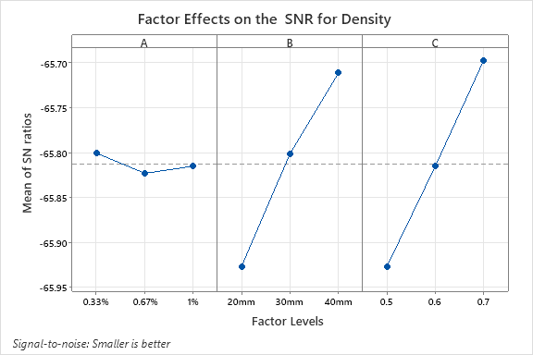
Figure 5. Factor Effect on the mean SNR for the Density

3.2.2 Compressive Strength
The average compressive strength and corresponding SNR values are presented in Table 5, while the effects of factor levels on compressive strength are detailed in Figure 6 and Table 6. Response index analysis indicated that the optimum levels for achieving the maximum compressive strength were obtained at level 2 (0.6) for W/C ratio, level 1 (20 mm) for LDPE fiber length, and level 2 (0.67%) for LDPE fiber content. The W/C ratio emerged as the most influential factor, followed by LDPE fiber length, with LDPE fiber content exhibiting the least impact. Notably, the optimal mix (T4) aligned with the response index analysis results that is W/C ratio, LDPE fiber length and LDPE fiber content.
ANOVA results shown in Table 7 confirmed the statistical significance of the W/C ratio (p=0.025. 54.96% contribution) on the compressive strength. This is consistent with previous studies (Onyia et al., 2022; Tafraoui, 2024), which emphasize that the W/C ratio is a critical factor in sandcrete blocks and concrete materials production. It governs hydration process, workability, and the development of density and porosity, microstructural characteristics that influence the resulting compressive strength.
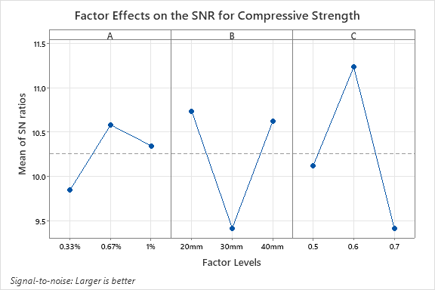
Figure 6. Factor Effect on the mean SNR for the Compressive Strength

3.2.3 Flexural tensile strength
Analysis of the SNRs as illustrated in Figure 7 highlights the relative influence of each factor on the flexural tensile strength response of the sandcrete blocks. Based on the trends in Figure 7 and the response index of the SNRs summarized in Table 6, the W/C ratio of 0.6 had the most significant impact on the flexural tensile strength, followed by the 20 mm LDPE fiber length, while the LDPE fiber content at 0.67% had the least effect. Consistent with the previously discussed compressive strength results, the W/C ratio was identified as the most significant factor influencing compressive strength, with fiber length ranking second. Regarding flexural tensile strength, the LDPE fiber length of 20 mm, representing the shortest length investigated produced the highest value. This observation corroborates findings from prior studies, which reported that shorter fibers are more effective in bridging micro cracks, delaying their propagation, and dispersing uniformly, thereby enhancing the flexural tensile strength of the sandcrete blocks (A. A. Mohammed & Mohammed, 2021; G. Q. Zhang et al., 2013).
The ANOVA results (see Table 7) indicate that the W/C ratio is the most significant factor affecting the flexural tensile strength of sandcrete blocks, accounting for 61.27% of the total variation. The associated p-value of 0.032 is below the commonly accepted significance level of 0.05, suggesting that the influence of the W/C ratio on flexural tensile strength is statistically significant and not attributable to random variation. In contrast, LDPE fiber length and LDPE fiber content contributed 28.27% and 9.54%, respectively to the variation in flexural tensile strength. However, their corresponding p-values, as presented in Table 7, exceed 0.05 threshold, indicating that their effects are not statistically significant within the tested range of values. Although statistically insignificant in this context, the contributions of LDPE fiber length and content may still be practically relevant in optimizing the performance of sandcrete block mixes.

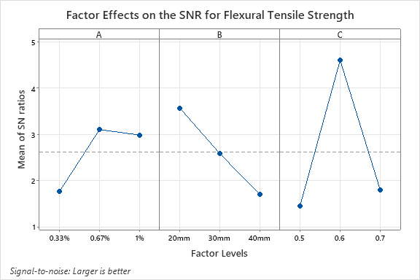
Figure 7. Factor Effect on the mean SNR for the Flexural tensile Strength

3.2.1 Water Absorption
The Figure 8 along with the data in Table 6, were used to identify the optimal process factors for minimizing water absorption. Based on the highest S/N ratio observed in Figure 8, the optimal mix was found LDPE fiber content of 0.67%, a W/C ratio of 0.6, and a LDPE fiber length of 20 mm. Among the factors investigated, the W/C ratio was the most significant. This particular combination produced the lowest water absorption values, indicating enhanced resistance to moisture penetration.
The results from ANOVA shown in Table 6 indicate that the contribution of the LDPE fiber content to the water absorption is relatively low, accounting for only 18.90%. Furthermore, the p-values for all process factors as indicated in Table 6, exceed the 0.05 limit, suggesting that none of the process factors had a statistically significant effect on the water absorption of the sandcrete blocks.
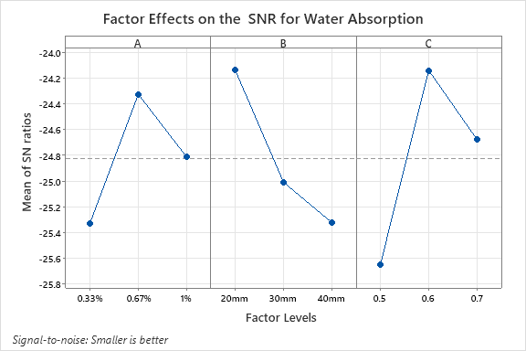
Figure 8. Factor Effect on the mean SNR for the Water Absorption

Table 7 ANOVA tables for Response Characteristics SNRs.
ANOVA for Density SNR
Factors | Degree of | Sum of Squares | Mean Squares | F-Value | P-Value | % Contribution
 | Freedom
A | 2 | 34.48 | 17.24 | 1.85 | 0.351 | 0.45
B | 2 | 3559.89 | 1779.94 | 190.73 | 0.005 | 46.76
C | 2 | 4000.62 | 2000.31 | 214.34 | 0.005 | 52.55
Error | 2 | 18.66 | 9.33 |  |  | 0.25
Total | 8 | 7613.66 |  |  |  | 100.00
ANOVA for Compressive Strength SNR
Factors | Degree of | Sum of Squares | Mean Squares | F-Value | P-Value | % Contribution
 | Freedom
A | 2 | 0.14607 | 0.07303 | 7.3 | 0.12 | 10.44
B | 2 | 0.46407 | 0.23203 | 23.2 | 0.041 | 33.17
C | 2 | 0.76907 | 0.38453 | 38.45 | 0.025 | 54.96
Error | 2 | 0.02 | 0.01 |  |  | 1.43
Total | 8 | 1.3992 |  |  |  | 100.00
ANOVA for Flexural Tensile Strength SNR
Factors | Degree of | Sum of Squares | Mean Squares | F-Value | P-Value | % Contribution
 | Freedom
A | 2 | 0.09282 | 0.046411 | 5.56 | 0.152 | 28.2718
B | 2 | 0.14482 | 0.072411 | 8.68 | 0.103 | 9.539461
C | 2 | 0.50816 | 0.254078 | 30.45 | 0.032 | 61.28555
Error | 2 | 0.01669 | 0.008344 |  |  | 0.903183
Total | 8 | 0.76249 |  |  |  | 100
ANOVA for Water Absorption SNR
Factors | Degree of | Sum of Squares | Mean Squares | F-Value | P-Value | % Contribution
 | Freedom
A | 2 | 5.665 | 2.8327 | 3.37 | 0.229 | 18.90
B | 2 | 8.569 | 4.2847 | 5.09 | 0.164 | 28.59
C | 2 | 14.056 | 7.0281 | 8.36 | 0.107 | 46.90
Error | 2 | 1.682 | 0.8411 |  |  | 5.61
Total | 8 | 29.973 |  |  |  | 100.00

4 Conclusion

This study assessed the performance of LDPE fiber – reinforced sandcrete blocks by examining the effects of LDPE fiber content, fiber length, and water-cement ratio (w/c) on key properties including density, compressive strength, flexural tensile strength, and water absorption. Using Taguchi optimization and ANOVA analysis, the following conclusions can be drawn:
- All measured properties improved with longer curing periods, with notable enhancements observed between 7 and 28 days of curing.
- The lowest and most desirable density was obtained from mix T3 that contained a w/c ratio of 0.7, LDPE fiber length of 40 mm, and LDPE fiber content of 0.33%.
- The optimal compressive strength (4.02MPa) and flexural tensile strength (2.04MPa) were achieved by mix T4, composed of a w/c ratio of 0.6, LDPE fiber length of 20 mm, LDPE fiber content of 0.67%.
- The mix with the least water absorption was T4, which included 0.67% LDPE fibers of 20 mm length and a w/c ratio of 0.6.
- ANOVA results indicated that the w/c ratio was the most significant factor influencing all properties, contributing 52.55% to density, 54.96% to compressive strength, 61.29% to flexural tensile strength, and 46.96% to water absorption.
- All measured properties, except water absorption, showed statistically significant p-values, confirming the effectiveness of the selected factors in influencing performance outcomes.

Declaration of Competing Interest
The authors declare that they have no known competing financial interests or personal relationships that could have appeared to influence the work reported in this paper.
Data Availability
The datasets generated during and/or analyzed during the current study are available from the corresponding author on request.

References
Adegun, O. ., & Adedeji, Y. M. . (2017). Suitability of Laterite-Cement Mixes for Production of Sandcrete Blocks. Construction and Building Materials, 154, 373–378.
Ahsan, M., Adil Sultan, M., Ahmad, Z., Cheema, S., Jawad, M., Kanwal, H., Asim, M., Mughal, T. L., Tahir, M., Mahmood, A., & Mughal, S. (2023). Influence of Fibers on Fresh and Mechanical Properties of (FRC) Fiber Reinforced Concrete, A Step Towards Sustainability. Journal of Applied Engineering Sciences, 13(1), 17–22. https://doi.org/10.2478/jaes-2023-0003
Akanbi, T., Habibu, A., Azare, A., & Okah, M. (2024). Evaluating the Relationship between Curing Time and Compressive Strength in Concrete: A Statistical Analysis. FUOYE Journal of Engineering and Technology, 9(2), 354–360. https://doi.org/10.4314/fuoyejet.v9i2.27
Altalabani, D., Bzeni, D. K. H., & Linsel, S. (2020). Mechanical properties and load deflection relationship of polypropylene fiber reinforced self-compacting lightweight concrete. Construction and Building Materials, 252, 119084. https://doi.org/10.1016/j.conbuildmat.2020.119084
Ashkezari, G. D., Fotouhi, F., & Razmara, M. (2020). Experimental relationships between steel fiber volume fraction and mechanical properties of ultra-high performance fiber-reinforced concrete. Journal of Building Engineering, 32(December 2019), 101613. https://doi.org/10.1016/j.jobe.2020.101613
Auyo, H., Ejeh, S., Lawan, A., & Aliyu, I. (2023). Effect of Mix Ratio and Curing on Compressive Strength of Sandcrete Hollow Blocks. Nigerian Journal of Engineering, 30(3), 43. https://doi.org/10.5455/nje.2023.30.03.07
Awolusi, T. F., Oke, L. O., Akinkurolere, O. O., Ubani, D. P., Bamisaye, R. T., & Aluko, O. G. (2021). The Application of Response Surface Methodology in Understanding the Compressive Strength and Water Absorption Capacity of Sandcrete Blocks. Silicon, 13(11), 4123–4132. https://doi.org/10.1007/s12633-020-00701-0
Awoyera, P. O., Olalusi, O. B., Ibia, S., & Prakash A., K. (2021). Water absorption, strength and microscale properties of interlocking concrete blocks made with plastic fibre and ceramic aggregates. Case Studies in Construction Materials, 15(August), e00677. https://doi.org/10.1016/j.cscm.2021.e00677
Bheel, N., Tafsirojjaman, T., Liu, Y., Awoyera, P., Kumar, A., & Keerio, M. A. (2021). Experimental study on engineering properties of cement concrete reinforced with nylon and jute fibers. Buildings, 11(10). https://doi.org/10.3390/buildings11100454
Briga-Sá, A., Gaibor, N., Magalhães, L., Pinto, T., & Leitão, D. (2022). Thermal performance characterization of cement-based lightweight blocks incorporating textile waste. Construction and Building Materials, 321, 126330. https://doi.org/https://doi.org/10.1016/j.conbuildmat.2022.126330
British Standards Institute. (2000). BS EN 12390-7:2000 Testing hardened concrete — Part 7: Density of hardened concrete. BSI Standards Publication, 3(1), 13.
British Standards Institution. (2001). BS EN 12390-3:2001 Testing hardened concrete - Part 3: Compressive strength of test specimens. In BSI Standards Publication (pp. 4–10). file:///C:/Users/hp/Downloads/dlscrib.com-pdf-bs-en-12390-3-dl_b8a9ef69ed054e431ee2df7d05824cb9.pdf
British Standards Institution. (2019). BS EN 12390-5:2009 Testing hardened concrete — Part 5: Flexural strength of test specimens. BSI Standards Publication, August, 1–22.
Chen, X., & Wu, S. (2013). Influence of water-to-cement ratio and curing period on pore structure of cement mortar. Construction and Building Materials, 38, 804–812. https://doi.org/https://doi.org/10.1016/j.conbuildmat.2012.09.058
Choplin, A. (2023). Building concrete futures: materiality and urban lives in West Africa. Africa, 93(1), 20–39. https://doi.org/10.1017/S0001972023000104
Duraiswamy, S., Neelamegam, P., Vishnupriyan, M., & Alaneme, G. U. (2024). Impact of plastic waste fiber and treated construction demolition waste on the durability and sustainability of concrete. Dental Science Reports, 14(1). https://doi.org/https://doi.org/10.1038/s41598-024-78107-w
Falade, F., & Ikponmwosa, E. (2011). Characteristic Strength of Sandcrete Blocks in Nigeria. Journal of Civil Engineering and Architecture, 5(8), 795–802.
Gao, J., Wang, Z., Zhang, T., & Zhou, L. (2017). Dispersion of carbon fibers in cement-based composites with different mixing methods. Construction and Building Materials, 134, 220–227. https://doi.org/10.1016/j.conbuildmat.2016.12.047
Ghadafi, A M, & Kankam, C. K. (2022). Toughness and Ductility Characteristics of Reinforced Concrete Beams Containing Recycled Polyethylene Fibres. Journal of Materials Science Research and Reviews, September. https://www.researchgate.net/profile/Charles-Kankam/publication/363257766_Toughness_and_Ductility_Characteristics_of_Reinforced_Concrete_Beams_Containing_Recycled_Polyethylene_Fibres/links/6313aa065eed5e4bd142b8ce/Toughness-and-Ductility-Characteristics-o
Ghadafi, Abdullai M, & Kankam, C. K. (2021). Strength Characteristics of Recycled Polyethylene Fibre Reinforced Concrete. Original Research Article Ghadafi and Kankam, JMSRR(3), 66583. http://www.sdiarticle4.com/review-history/66583
Hanif, I. M., Noor Syuhaili, M. R., Hasmori, M. F., & Shahmi, S. M. (2017). Effect of nylon fiber on mechanical properties of cement based mortar. IOP Conference Series: Materials Science and Engineering, 271(1). https://doi.org/10.1088/1757-899X/271/1/012080
Hassan, H. Z., & Saeed, N. M. (2024). Fiber reinforced concrete: a state of the art. In Discover Materials (Vol. 4, Issue 1). Springer International Publishing. https://doi.org/10.1007/s43939-024-00171-w
Ijalana, F., Afoloayan, J., & Adeleke, O. (2015). Effects of Polythene Fibres on Selected Properties of Sandcrete Blocks. Nigerian Journal of Technology, 35(1), 37. https://doi.org/10.4314/njt.v35i1.6
Ikeagwuani, C. C., Nwonu, D. C., Ugwu, C. K., & Agu, C. C. (2020). Process parameters optimization for eco-friendly high strength sandcrete block using Taguchi method. Heliyon, 6(6), e04276. https://doi.org/10.1016/j.heliyon.2020.e04276
Katman, H. Y. B., Khai, W. J., Bheel, N., Kırgız, M. S., Kumar, A., & Benjeddou, O. (2022). Fabrication and Characterization of Cement-Based Hybrid Concrete Containing Coir Fiber for Advancing Concrete Construction. Buildings, 12(9). https://doi.org/10.3390/buildings12091450
Kumi-Larbi, A., Yunana, D., Kamsouloum, P., Webster, M., Wilson, D. C., & Cheeseman, C. (2018). Recycling waste plastics in developing countries: Use of low-density polyethylene water sachets to form plastic bonded sand blocks. Waste Management, 80, 112–118. https://doi.org/10.1016/j.wasman.2018.09.003
Lallas, Z. N., Gombeda, M. J., & Mendonca, F. (2023). Review of supplementary cementitious materials with implications for age-dependent concrete properties affecting precast concrete. PCI Journal, December, 46–64. https://doi.org/10.15554/pcij68.6-01
Mastura, M. T., Nik Muhammad, M. N., Nuzaimah, M., Shaharuzaman, M. A., & Zakaria, N. H. (2022). Statistical analysis of the performance of young’s modulus of natural fiber composites and synthetic fiber composites. Jurnal Teknologi, 84(6–2), 151–162. https://doi.org/https://doi.org/10.11113/jurnalteknologi.v84.19366
Mboungou Londe, G. H., Mwero, J. N., Kanali, C., & Abuodha, S. O. (2024). Investigating the Influence of Raw and Treated Coconut Fibre Obtained from Agricultural Residue on the Strength and Durability Characteristics of High-Strength Concrete. Advances in Civil Engineering, 2024(1), 8275876. https://doi.org/https://doi.org/10.1155/2024/8275876
Micelli, F., Renni, A., Kandalaft, A. G., & Moro, S. (2020). Fiber-reinforced concrete and ultrahigh-performance fiber-reinforced concrete materials. In New Materials in Civil Engineering. INC. https://doi.org/10.1016/B978-0-12-818961-0.00007-7
Mohamed, A. M., Tayeh, B. A., Majeed, S. S., Aisheh, Y. I. A., & Salih, M. N. A. (2024). Ultra-light foamed concrete mechanical properties and thermal insulation perspective: A comprehensive review. Journal of CO2 Utilization, 83, 102827. https://doi.org/https://doi.org/10.1016/j.jcou.2024.102827
Mohammed, A. A., & Mohammed, I. I. (2021). Effect of Fiber Parameters on the Strength Properties of Concrete Reinforced with PET Waste Fibers. Iranian Journal of Science and Technology, Transactions of Civil Engineering, 45(3), 1493–1509. https://doi.org/10.1007/s40996-021-00663-2
Mohammed, B., & Cheeseman, C. R. (2011). Use of oil drill cuttings as an alternative raw material in sandcrete blocks. Waste and Biomass Valorization, 2(4), 373–380. https://doi.org/10.1007/s12649-011-9089-z
Mukhopadhyay, S., & Khatana, S. (2015). A review on the use of fibers in reinforced cementitious concrete. Journal of Industrial Textiles, 45(2), 239–264. https://doi.org/10.1177/1528083714529806
Muralidharan, R., Park, T., Yang, H. M., Lee, S. Y., Subbiah, K., & Lee, H. S. (2021). Review of the effects of supplementary cementitious materials and chemical additives on the physical, mechanical and durability properties of hydraulic concrete. Materials, 14(23). https://doi.org/10.3390/ma14237270
Musa, N. M., & Abubakar, M. (2018). Effects of tyre steel fibre reinforcement on sandcrete blocks. Nigerian Journal of Technology, 37(4), 875. https://doi.org/10.4314/njt.v37i4.3
Odeyemi, S. O., Adeniyi, A. G., Giwa, Z. T., Atoyebi, O. D., Jimoh, O. K., Abolaji, B. O., Jatto, H. O., & Abdulazeez, A. O. (2024). Effect of solvothermal-treated polyethylene on the mechanical properties of sandcrete blocks and concrete. Discover Civil Engineering, 1(1), 32. https://doi.org/10.1007/s44290-024-00038-2
Ogbeide, O; Efeakporire, O., & L; Igbinomwanhia. (2024). Modelling and Optimization of Mass Density for Strength and Durability of Sandcrete Block from Okhuare in Edo State. Nigeria. J. Appl. Sci. Environ. Manage, 28(8), 2375–2381. https://dx.doi.org/10.4314/jasem.v28i8.14
Onyia, M., Ikeagwuani, C., & Egbo, M. C. (2022). Effect of pressed palm oil fruit fibre on mechanical properties of sandcrete masonry blocks using Taguchi-grey relational analysis optimization technique. Cleaner Materials. https://doi.org/10.1016/j.clema.2022.100124
Pelisser, F., Montedo, O. R. K., Gleize, P. J. P., & Roman, H. R. (2012). Mechanical properties of recycled PET fibers in concrete. Materials Research, 15(4), 679–686. https://doi.org/10.1590/S1516-14392012005000088
Plagué, T., Desmettre, C., & Charron, J.-P. (2017). Influence of fiber type and fiber orientation on cracking and permeability of reinforced concrete under tensile loading. Cement and Concrete Research, 94, 59–70. https://doi.org/10.1016/j.cemconres.2017.01.004
Qureshi, L. A., Ali, B., & Ali, A. (2020). Combined effects of supplementary cementitious materials (silica fume, GGBS, fly ash and rice husk ash) and steel fiber on the hardened properties of recycled aggregate concrete. Construction and Building Materials, 263(2020), 120636. https://doi.org/10.1016/j.conbuildmat.2020.120636
Singh, M. (2024). Green Concrete: A step towards eco-friendly environment. World Journal of Advanced Engineering Technology and Sciences, 13(2), 549–554. https://doi.org/https://doi.org/10.30574/wjaets.2024.13.2.0626
Sohaib, N., Mamoon, R., Sana, G., & Seemab, F. (2018). Using Polypropylene Fibers in Concrete to achieve maximum strength. February, 37–42. https://doi.org/10.15224/978-1-63248-145-0-36
Sousa, L. C., Sousa, H., Castro, C. F., António, C. C., & Sousa, R. (2014). A new lightweight masonry block: Thermal and mechanical performance. Archives of Civil and Mechanical Engineering, 14(1), 160–169. https://doi.org/10.1016/j.acme.2013.08.003
Sridhar, J., Gobinath, R., & Kırgız, M. S. (2022). Comparative study for efficacy of chemically treated jute fiber and bamboo fiber on the properties of reinforced concrete beams. Journal of Natural Fibers, 19(15), 12224–12234. https://doi.org/10.1080/15440478.2022.2054894
Tafraoui, A. (2024). Impact of Water-Cement Ratio and Desert Sand Powder on the Mechanical Properties of Eco-Self-Compacting Concrete. 10, 1–9. https://doi.org/10.18540/jcecvl10iss8pp20748
Toghroli, A., Mehrabi, P., Shariati, M., Trung, N. T., Jahandari, S., & Rasekh, H. (2020). Evaluating the use of recycled concrete aggregate and pozzolanic additives in fiber-reinforced pervious concrete with industrial and recycled fibers. Construction and Building Materials, 252, 118997. https://doi.org/10.1016/j.conbuildmat.2020.118997
Tsala-Mbala, C., Hayibo, K. S., Meyer, T. K., Couao-Zotti, N., Cairns, P., & Pearce, J. M. (2022). Technical and Economic Viability of Distributed Recycling of Low-Density Polyethylene Water Sachets into Waste Composite Pavement Blocks. Journal of Composites Science, 6(10). https://doi.org/10.3390/jcs6100289
Widiarto, M. (2023). Serat Sabut Kelapa Sebagai Bahan Tambah Beton untuk Perkeras Jalan Pedesaan. Polymers Review, 15(5), 1–15. https://koran-jakarta.com/serat-sabut-kelapa-sebagai-bahan-tambah-beton-untuk-perkeras-jalan-pedesaan?page=all
Yusuf, M. S., Isak, A. B., Mohamud, G. A., Warsame, A. H., Osman, Y. I., Ibrahim, A. H., & Elmi, L. A. A. (2023). Effect of Steel Fiber on Concrete’s Compressive Strength. Open Journal of Civil Engineering, 13(01), 192–197. https://doi.org/10.4236/ojce.2023.131014
Zhang, G. Q., Suwatnodom, P., & Ju, J. W. (2013). Micromechanics of crack bridging stress-displacement and fracture energy in steel hooked-end fiber-reinforced cementitious composites. International Journal of Damage Mechanics, 22(6), 829–859. https://doi.org/10.1177/1056789512468356
Zhang, T., Yin, Y.-G., Gong, Y., & Wang, L.-J. (2019). Mechanical properties of jute fiber‐reinforced high‐strength concrete. Structural Concrete, 21, 703–712. https://doi.org/10.1002/suco.201900012
Zhutovsky, S., & Kovler, K. (2012). Internal Curing of High-Strength Concrete to Eliminate Autogenous Shrinkage Cracking. Materials and Structures, 45, 1501–1510.

