The use of artificial intelligence to optimize sustainable energy systems.

Abstract: The drive towards sustainable energy systems represents a pivotal global endeavor to address environmental concerns, optimize resource utilization, and ensure a reliable energy supply. In this context, Artificial Intelligence (AI) has emerged as a transformative catalyst, revolutionizing the energy sector's landscape. This study explores the critical role played by AI in the implementation of sustainable energy systems using artificial neural networks (ANNs) to optimize the performance of these systems. ANNs are powerful machine learning algorithms that can be used to model and predict the behavior of complex systems, including sustainable energy systems. By seamlessly integrating AI technologies with renewable energy sources and optimizing energy consumption, AI contributes significantly to enhancing energy system efficiency, reducing carbon footprints, and fostering environmental stewardship. This paper delves into the multifaceted applications of AI in energy, spanning smart grid management, demand forecasting, energy optimization, and grid stability enhancement. The result shows that the hourly predictions of solar energy in Ibadan, Nigeria, have the following errors at 24 hours: MAE (KJ/m²) = 806.35, MSE (KJ/m²) = 159767.44, RMSE (KJ/m²) = 1157.97, Max Error (KJ/m²) = 4638.76, and R-squared (%) = 94.23.

Keywords: Energy, Artificial Intelligence (AI), Artificial Neural Network (ANN), Internet of Things (IoT), (Expert’s system ES), Fuzzy Logic, Errors.

1 Introduction
Development relies on the availability of energy, and for development to be sustainable, it necessitates the presence of sustainable energy systems. In today's digital age, our daily lives are increasingly intertwined with cutting-edge digital and computer technologies. The use of artificial intelligence (AI) in the implementation of sustainable energy systems is an emerging field of research that holds great promise for the future. AI can be used to optimize the design and operation of renewable energy systems such as solar and wind power, helping to maximize efficiency and minimize environmental impact. In addition, AI can be used to monitor and control the energy system, ensuring that it operates within optimal parameters and can adapt to changing conditions. Furthermore, AI can be used to analyze large amounts of data from the energy system to identify patterns and trends and to make predictions about future energy demand and supply. These modern technologies play a crucial role in various aspects, including socio-economic improvements, environmental initiatives, sustainable practices, and climate research. They serve to elevate the productivity and efficiency of systems across different domains. Currently, one of the most cutting-edge technologies used in a wide range of businesses is artificial intelligence [1]. The recent explosion of AI technologies is being fueled by big data processing, enormous computational power, information technology, and improved machine learning (ML) and deep learning (DL) algorithms [2][3]. Google's field device management costs would not have been able to be cut by 40 percent as much without the use of deep-mind AI technologies [4]. Numerous nations, including China, the United States, the United Kingdom, and France, have incorporated AI into their development strategies. The primary motive for embracing AI is the integration of various sectors, encompassing healthcare, renewable energy and energy systems, finance, water management, education, and environmental initiatives. AI plays a pivotal role in the planning and prediction of load demand and renewable energy utilization, a role that has garnered significant recognition. These forecasts are designed to mitigate uncertainty and provide benchmarks for regulating the actual performance of power networks. A new wave of AI technology has emerged with substantial potential for enhancing forecasting techniques across a wide range of applications, including predicting product demand, workforce turnover, cash flow, distribution needs, personnel allocation, and inventory management [5][4]. Fundamentally, IoT technology operates by utilizing data provided by sensors embedded in devices [6]. It translates electrical signals generated by these sensors into tangible parameters like pressure, motion, temperature, and more. The capability to derive significance from these signals autonomously, without human intervention, is what constitutes intelligence within this context [7].
As AI becomes increasingly ubiquitous in the energy sector, it is clear that it can play a key role in accelerating the transition to renewable energy and reducing greenhouse gas emissions. This is critical for safeguarding the ozone layer and mitigating the impacts of climate change. By optimizing the design and operation of renewable energy systems, AI can help to reduce the costs and improve the efficiency of these systems. In addition, AI can be used to develop innovative solutions for energy storage and management, making it possible to use renewable energy even when the sun is not shining or the wind is not blowing [8][9]. The introduction of renewable energy sources introduces new challenges to traditional methods due to their inherent complexity. Power system analysis necessitates the processing of extensive, diverse datasets for tasks such as computation, diagnosis, and learning. Advanced technologies like computers empower the resolution of intricate issues associated with power system planning, operations, design, and diagnostics [10][11][12]. Cyberattacks have been investigated, and the number of ways to stop them is growing quickly due to the significant increase in AI deployment, IoT in the energy business, and smart grid infrastructure control [13][14]. Such attacks inflict damage on critical infrastructure, exacerbate environmental concerns (for instance, a cyber-attack on a nuclear power plant can have severe environmental consequences), and result in substantial economic losses. Can AI effectively prevent cyberattacks? AI aids in tracking potential perpetrators of attacks and identifying the additional evidence needed for automated investigative AI algorithms to draw conclusions. The incorporation and application of AI and IoT represent a significant enhancement in bolstering the security of smart grids against cyberattacks [15] [16]. References [12] [17][18] identify ways to stop cyberattacks on the infrastructure of the smart grid. The power system protection offers a number of advantages, one of which is AI's capacity for handling massive amounts of data. This is done by automating the development of security threat algorithms.
In recent years, there has been an increasing interest in the potential of AI to address challenges in healthcare, energy, and the environment. This has been driven by both technological advances in AI, such as the development of deep learning algorithms, and policy initiatives aimed at encouraging the use of AI to address these challenges. For example, the European Union has launched the AI4EU initiative, which aims to support the development and use of AI in various sectors, including energy. Similarly, the United States has introduced a number of initiatives to promote the use of AI in healthcare, such as the National Institutes of Health's AI Health Initiative. The majority of research and reviews have been focused on fault identification and diagnosis methods [19], models for energy planning and forecasting [20] power forecasts for solar and wind [21][22], regulation of building energy [23], power system improvement [24], and so on. A significant portion of global energy consumption is attributed to commercial buildings. However, energy wastage is a common issue in many of these structures, particularly when they are unoccupied. This challenge arises from the inherent complexity of commercial buildings, which cater to diverse occupants and their varying needs within expansive and intricate layouts. The integration of AI into building energy management systems is tasked with addressing a multitude of user behaviors, making it a challenge to consistently optimize energy consumption. The application of AI in energy systems has a wide range of potential uses. Some examples include: Control of power plants and power grids, including monitoring and optimizing operations for efficiency and reliability. Smart home energy systems that allow for real-time monitoring and control of energy usage. Autonomous vehicles and smart transportation systems can optimize energy consumption and reduce emissions. Smart grid technologies allow for two-way communication between energy suppliers and consumers, facilitating real-time monitoring and control.
Machine learning (ML) forecasting models have appeared in order to solve the shortcomings of conventional statistical forecasting models. Without explicit techniques, these ML models have the capacity to comprehend how input and output data relate to one another. For instance, an artificial neural network (ANN) model was used in a study by Geem and Roper (2009) to anticipate Korea's overall energy demand. Input variables for this model comprised the GDP, population projections, import and export volumes, and quantities [25]. Turkey's energy usage was forecasted using least squares support vector machines in a study by Koay et al. in 2020 [26]. By contrasting the model's performance with that of an artificial neural network (ANN) model, they assessed the model's effectiveness using metrics to acquire through receiver operating characteristic analysis, are specificity and sensitivity. The study also suggested using a genetic algorithm based on neural networks and a particle swarm optimization model based on neural networks to estimate electricity demand in a smart grid with 750 households. In 2014, Oliva et al, introduced an innovative approach that harnessed the power of the Artificial Bee Colony (ABC) algorithm to precisely identify the parameters of solar cells. The ABC algorithm draws inspiration from the intelligent foraging behavior of honey bees and stands out among evolutionary techniques for its enhanced ability to handle complex multi-modal objective functions. To showcase the effectiveness of this approach, it was rigorously compared to several established optimization methods.
The experimental results unequivocally highlighted the exceptional performance of the proposed method, underscoring its robustness and precision [27]. According to [27][28] , Grady et al (2009) introduced a generic algorithm (GA) designed to determine the optimal configuration of wind turbines, maximizing their production capacity within constraints that limit both the number of turbines installed and the land area occupied by each wind farm. Emami and Noghreh (2014) solved this issue using a fresh coding strategy and an original objective function with a generic algorithm (GA). In managing the cost, electricity, and efficiency of the wind farm, their solution fared better than earlier suggested methods. Both optimal design issues and wind active control methods could be solved by a multilevel GA. Additionally, by using ANNs and GAs, financial objectives in expanding the solar energy system were achieved [29]. They presented a generic algorithm (GA) aimed at identifying the most efficient layout for wind turbines, optimizing their production capacity while adhering to limitations on the number of turbines deployed and the land area allocated for each wind farm [30]. Next, a genetic algorithm (GA) is used to find the approximate optimal sizes of the factors that will prolong the life-cycle reserves [31]. In 2010, Araujo devised a dual-pronged approach for forecasting, incorporating clustering and axiomatic fuzzy set (AFS) classification. The innovation in this hybrid model lay in its ability to not only predict values but also effectively capture the underlying trends in time series data, all while maintaining high interpretability and accuracy [32]
This work delves into the multifaceted aspects of AI applications in power systems. Traditional methods, as they currently stand, often fall short in providing precise results that truly mirror the real conditions of power systems. Artificial Intelligence harnesses the capabilities of machines and software systems to emulate human intellectual processes, including reasoning and critical thinking. Energy system engineering encompasses a broad spectrum of tasks, including power generation, transmission, distribution, and the operation of various electrical devices. AI plays a pivotal role in effectively managing the complex and extensive data systems within this domain, delivering timely and accurate insights to facilitate informed decision-making and the enhancement of energy systems.
2. Methodology
Expert systems are computer programs that handle complicated issues and make judgments that would typically need the skill of a human being. They do this by drawing on a knowledge base of facts and rules. These systems are designed to mimic the decision-making process of human experts and to provide advice and recommendations in areas such as medicine, engineering, law, finance, and many other fields. Expert systems can help to improve efficiency and accuracy, reduce costs, and make decisions more quickly and effectively. It permits the introduction of human expertise in particular fields to address problems on a human level [1] [7]. AI is being explored as a tool that can complement or even replace human expertise in certain situations within the field of power systems and power electronics engineering [33]. As depicted in Fig. 2, the core components of expert system include a knowledge or expertise base. The two components of the knowledge base are expert knowledge and database knowledge, and they comprise the information, facts, and other claims connected to expert knowledge [34]. Consequently, the knowledge base is where you may find the program for the human knowledge interface. Additionally, it is a rule-based system with data pertaining to computational techniques linked with expert knowledge.
An expert system is a type of AI system that uses knowledge about a particular domain, such as energy, to solve problems and make decisions. An expert system can be a useful tool for implementing energy systems using AI, as it can help to automate and optimize decision-making processes. For example, an expert system could be used to optimize the operation of a power grid, balancing the supply and demand of electricity and making decisions about when to start and stop power plants based on real-time data. In addition, an expert system could be used to monitor and control renewable energy sources such as solar and wind power, ensuring that they are operating efficiently. In addition to optimizing energy systems, an expert system could also be used for predictive maintenance of energy infrastructure. For example, it could be used to analyze data from sensors and other monitoring systems to detect potential issues before they become major problems. This could help to reduce downtime and improve the reliability of energy systems. Furthermore, an expert system could be used to detect and respond to anomalies in energy usage patterns, such as spikes in demand or unusual energy usage profiles. By detecting and responding to these anomalies, an expert system could help to improve energy efficiency and reduce costs.
As illustrated in Figure 1, we presented a three-layer architecture in this research that is appropriate for integration with the smart power grid. A three-layered design of this type that complies with energy system criteria is more pertinent from an IoT application standpoint [35]. This three-layer IoT design for the smart grid is made up of the data gathering layer, the data transmission layer, and the data processing layer. Data and records detection and gathering are the responsibility of the layer that gathers data. The data communication layer is in charge of managing the transportation of the data collected at the data collecting layer. The data communication layer is the most crucial element of this design because it incorporates many forms of communication infrastructure. Prior to being given to the end user or service provider, data is processed at the data processing layer, which is the top layer. Real-time data is also stored for forecasting and other decision-making.
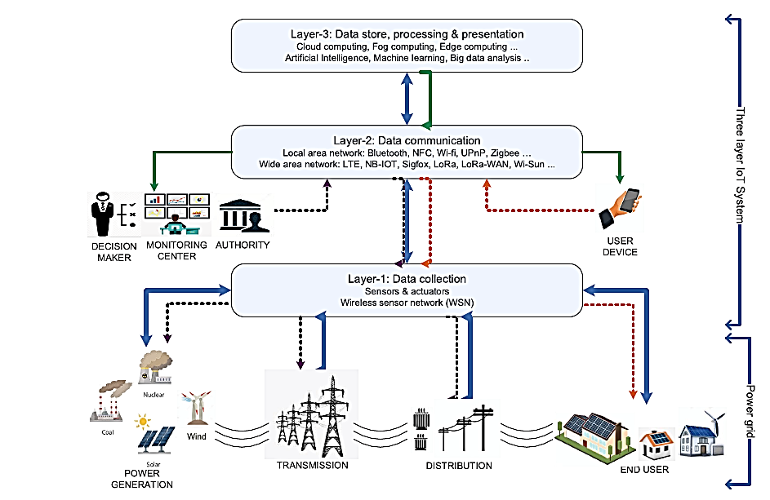
Figure 1: Artificial Intelligence IoT layers with the power grid Models in Energy System [35]

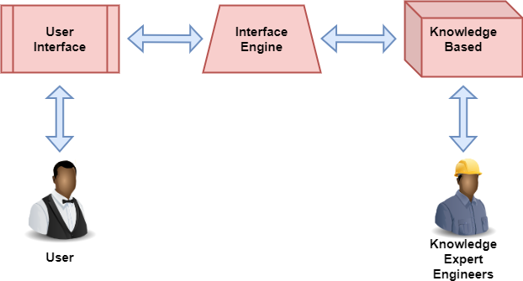
Figure 2: Element of energy expert systems
2.2 Genetic Algorithms and their application in Energy systems
Genetic algorithms (GA) are a type of AI algorithm that uses concepts from biology, such as evolution and natural selection, to optimize solutions to complex problems. GA have been successfully applied to several energy-related problems, including the optimal design of power systems, the optimal sizing of renewable energy systems, and the optimization of energy management systems. GA can be especially useful for finding optimal solutions to problems with a large search space, such as the design of energy systems, where there may be millions or even billions of possible solutions. In addition to finding optimal solutions, GA can also be used to explore the trade-offs between different design objectives, such as cost, efficiency, and reliability. This can help to find solutions that balance multiple goals and meet the needs of the system. For example, in the design of a power system, GA can be used to find a design that minimizes cost while still meeting the required level of reliability. Furthermore, GA can be used to explore the trade-offs between different renewable energy technologies, such as solar, wind, and hydroelectric power.
Genetic algorithms are based on the natural selection process, which involves three key concepts: crossover, mutation, and selection. Crossover is a process that combines the genetic material of two individuals to create new individuals, while mutation randomly changes the genetic material of an individual. Selection then determines which individuals survive and reproduce, based on their fitness (how well they meet the criteria of the problem). Over time, this process leads to the evolution of the population towards better solutions. Genetic algorithms (GA) are a type of optimization algorithm that mimics the process of natural selection to solve complex problems. In the context of energy systems, GA can be used to find the optimal solution for problems such as power system planning, energy management, and demand response. The key advantages of GA include their ability to search a large solution space, the simplicity of implementation, and the ease of incorporating problem-specific knowledge. Genetic algorithms (GA), functioning as an optimization methodology, draw inspiration from natural selection and genetics principles. Instead of focusing on encoding the variables themselves, GAs focus on encoding sets of variables. The objective function information is used to guide the application of probability transition laws as the GA evolves a population of candidate solution points in search of the optimal solution [36].
2.3 Application of Artificial Neural Networks in Energy system
An example of a machine learning technique that draws inspiration from the structure and operation of the human brain is the artificial neural network (ANN) [37]. ANNs have been used in a wide range of applications in power systems, including short-term load forecasting, fault diagnosis, security assessment, and economic dispatch. ANNs can also be used for pattern recognition, classification, and optimization. They have the advantage of being able to process large amounts of data and learn complex patterns without requiring explicit programming. One specific application of ANNs in energy systems is fault diagnosis. ANNs can be used to analyze real-time data from sensors to detect and diagnose faults such as line or equipment failures. The ANN can be trained using historical fault data, and it can then be used to detect new faults based on patterns in the sensor data. ANNs have been shown to be effective in detecting various types of faults, including phase-to-ground and phase-to-phase faults. This application can help improve the reliability and safety of power systems.
An ANN architecture typically consists of an input layer, a few hidden layers, an output layer, connection weights and biases, an activation function, and a summation node. A functional representation of the neural network is shown in Figure 3. Evolutionary learning is a subset of various learning methodologies, such as supervised, unsupervised, and reinforcement learning. Neural network training involves teaching the network to associate a specific input with a desired output. The network is modified based on the output and target comparison once the network output matches the target and the mean square error (MSE) calculation has been made [37]. The effectiveness of the network is determined by MSE. The mean of the squared errors is used to gauge the network's efficiency. When the MSE is minimized, the learning process is finished.
The ability of neurocomputer systems to model the associative memory of the human brain stems from their ability to perform mapping of nonlinear input and output, which is similar to pattern recognition. Consequently, neural network simulation (NNS) emerges as a crucial component of AI with a notable efficiency in addressing challenges pertaining to pattern recognition and image processing. Based on the direction of the signal flow, ANN is classified as either feedforward or feedback designs. Utilizing a layered perception type is quite obvious. NNSs display the three input signals in the input layer, while scaling and descaling are used to display the output signals in the output layer.
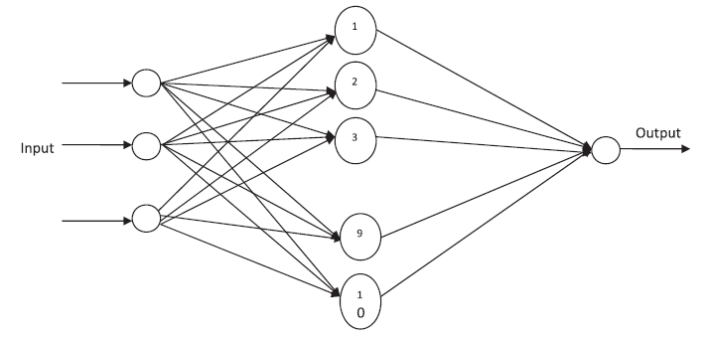
Fig. 3. Functional diagram of neural network. [37]

2.4 Application of Fuzzy Logic in Energy system
Fuzzy logic is a preferable approach for controlling a mechanical system because it is a form of AI that can make decisions based on uncertain or imprecise information. Fuzzy logic serves as a valuable tool for modeling the behavior of systems that defy precise mathematical description, a prime example being the control of power systems. Within the energy sector, fuzzy logic has found applications in tasks such as load forecasting, energy management, and the optimization of energy resources. Its distinct advantage lies in its capacity to handle imprecise and incomplete data, rendering it particularly well-suited for energy-related applications. The structure of an Adaptive Neuro-Fuzzy Inference System (ANFIS) is depicted in Fig 4. While fuzzy control may not yield significant energy-saving benefits, it possesses a robust inference engine. Leveraging an Artificial Neural Network (ANN)-based inference system, ANFIS can effectively estimate occupants' thermal comfort levels and balance energy conservation with thermal comfort considerations. In the realm of power systems, fuzzy logic contributes to enhancing the voltage profile. It facilitates the translation of voltage deviations and comparative variables into fuzzy system concepts. Fuzzy logic proves invaluable in yielding dependable, consistent, and transparent outputs, which are particularly beneficial since power system analysis often relies on approximate values and assumptions [1].
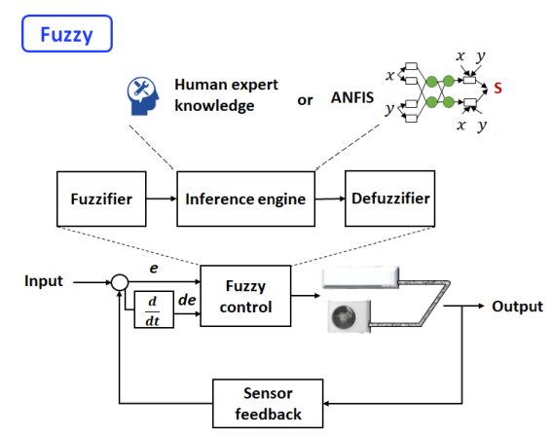
Figure 4: Fuzzy control for energy systems
2.5. Performance metrics
Performance metrics are a key aspect of machine learning, as they allow for the evaluation and comparison of different algorithms and models. The most common performance metrics in machine learning are accuracy, precision, recall, and F1 score. Accuracy is a measure of how well the model correctly predicts the output, while precision measures the proportion of correct predictions out of all the predictions made. Recall is the proportion of actual positive cases that are correctly identified as such by the model. Finally, F1 score is a measure that combines precision and recall to provide a single metric that balances both. In addition to these common metrics, there are a number of other performance metrics that can be used in machine learning. For example, the area under the receiver operating characteristic (ROC) curve is a metric that is often used to evaluate the performance of a classification model. This metric measures the ability of the model to distinguish between positive and negative cases, and it can be used to compare different models. Another metric that can be used is the root mean squared error (RMSE), which measures the difference between the predicted and actual values and is commonly used in regression problem. The difference between expected values and actual observations is typically used to assess a model's performance using various statistical techniques [21]. The accuracy of ML models for this purpose can be assessed using several metrics, including Mean Absolute Error (MAE), Mean Square Error (MSE), Root Mean Square Error (RMSE), Max Error (ME), and R-squared (R2). The formulas for these metrics are as follows:
$MAE=\frac{1}{n}\sum_{i=1}^{n}{\left|G_{i}-{GP}_{i}\right|}$ (1)
$MAE=\frac{1}{n}\sum_{i=1}^{n}{{\left(G_{i}-{GP}_{i}\right)}^{2}}$ (2)
$RSME=\sqrt{\frac{1}{n}\sum_{i=1}^{n}{{\left(G_{i}-{GP}_{i}\right)}^{2}}}$ (3)
$ME=Max \left|G_{i}-{GP}_{i}\right|$ (4)
$R_{Squared}=1- \frac{{SS}_{regression}}{{SS}_{total}}$ (5)
Different criteria are used to evaluate the values G and the estimated GP. Equation (3) computes the Root Mean Square Error (RMSE), which is employed when small errors are the only acceptable margin [34]. Conversely, Equation (4) calculates the significant errors, pinpointing the most significant disparity between actual and predicted values. We perform a statistical analysis to quantify the degree to which the independent variable explains the variation in the dependent variable. Put simply, Equation (5) quantifies the goodness of fit between the data and the regression model, with SSregression representing the sum of squares attributed to regression and SStotal denoting the overall sum of squares [34].
3. Result and Discussion
3.1 The stability of energy systems
The fuzzy logic system can diagnose the type of fault and produce an output based on that diagnosis. ANN and ES can improve the line's performance. The expert system receives input from environmental sensors and produces a result based on the parameters of the line's value. ANN can determine line parameter values within a given range using information from environmental sensors. ANN's training procedures allow it to detect any performance deviations for each hidden layer, and these deviations can be tested and analyzed. This process helps to ensure that the ANN is performing optimally and identifying the line parameters correctly [1].
Smart grids play a pivotal role in the modernization of the electrical grid, offering multiple avenues to enhance energy system stability. One such avenue involves leveraging advanced metering infrastructure, which furnishes real-time data on energy consumption and generation. This invaluable information enables the early detection and mitigation of potential stability challenges. Furthermore, the integration of distributed energy resources like wind and solar power bolsters system stability by augmenting flexibility and redundancy. The probabilistic assessment of power system stability involves three main components: modeling of input variables, use of computational methodologies, and determination of output indices. Table 3 summarizes these components. The evaluation uses a variety of procedures and models, as shown in Figure 5 and Table 1 respectively [1]. Table 3 provides a brief overview of the computational approaches used in various power system stability assessments, based on the studies we examined. The increasing complexity of power systems and growing concerns about system security are driving the trend towards using probabilistic computational analysis in energy systems. Compared to conventional deterministic methodologies, this approach can offer a more thorough and accurate assessment of system stability. In the probabilistic modeling method, the uncertainty in the energy system is quantified using probability distributions for the various input variables, such as demand, generation, transmission congestion, and component failures. This allows for the uncertainty to be taken into account in the optimization process, leading to solutions that are robust against fluctuations in the input variables. By modeling the uncertainty in the energy system, this method can provide solutions that are more robust and adaptable to the real-world environment. In addition, it can help to identify the most critical parameters that need to be monitored and controlled in order to maintain the reliability of the system. The probabilistic models of the energy system can be used to generate reliability metrics, such as loss of load probability (LOLP) and expected unserved energy (EUE). LOLP is the probability that the system will not be able to meet the demand, while EUE is the expected amount of unserved energy over a given time period. These metrics can be used to identify potential weaknesses in the system and guide the design of backup systems to ensure that the reliability requirements are met. For example, a high LOLP may indicate the need for additional generation capacity or energy storage transmission capacity or demand response programs. By using probabilistic models to generate reliability metrics, the optimal design of the energy system can be informed by the system's expected performance under real-world conditions. This can help to ensure that the system is designed to meet the reliability requirements, even under the most challenging conditions. The data generated by these models can also be used to test the sensitivity of the system to changes in key parameters, such as demand growth or fuel prices.
It has been demonstrated that ANNs are reliable in both daily forecast and real-time settings. Compared to traditional mathematical models, neural networks have been found to be more accurate and flexible, with advantages in terms of efficiency, robustness, and fault tolerance. There is a significant link between the predicted values and the observed data [38]. These results support the notion that the suggested ANN model is a solid and useful one. To optimize the model's effectiveness and accuracy while using historical data, it's also crucial to handle a lot of input data. We point out that both SVR and ANN models have been shown to be effective for learning from sizable datasets in the literature. The results of our ANN model are promising and encouraging, suggesting that it is suitable for experimentation and use in both short-term and long-term forecasting of sustainable energy systems using larger datasets.
ANN, like other deep learning models, is complex and resource-intensive, but it's still a useful tool for forecasting energy system. However, it's important to keep in mind that this complexity comes at a cost, in terms of time and computing resources. Recent advancements in computing power and storage technology, such as cloud computing, have made deep learning models, including ANN, more practical and efficient. This means that they can be used for tasks that were previously too computationally demanding. The findings demonstrate that ANN offers good and encouraging performance for both daily and real-time forecasts. While ANN is still a promising alternative for long-term predictions for sustainable energy system, even though the results of all models are less accurate for daily predictions than for real-time predictions.
The hourly forecasts of solar energy in Ibadan, Nigeria, have the following errors, as shown in Table 2.: MAE (KJ/m²) = 806.35, MSE (KJ/m²) = 159767.44, RMSE (KJ/m²) = 1157.97, Max Error (KJ/m²) = 4638.76, and R-squared (%) = 94.23. When there is a complicated and non-linear relationship between the data without any prior assumptions, ANNs and SVRs are effective instruments for prediction. An essential element that impacts a predictive effectiveness of the algorithm is the relationship between the values of its input and output [34].
As shown in Figure 6, automated design, simulation, and control tuning for a wind generation system can be performed using expert system-based software. This software platform is similar to a basic expert system, as it contains an expert system shell that supports the expert system program. It also includes an expert system knowledge base that contains 'If-Then' rules. The system makes a decision based on the user's engine interference requirements by comparing the listed rules with how the machine components are operated, as well as the optimal configuration if the simulation wing is objective. This includes checking the power circuit components of the system design and tuning the controller parameters online. It's important to note that the simulation is hybrid, meaning that it consists of both controller simulation and slow plant simulation.
To generate electricity, a photovoltaic generator relies on the sun's radiation, humidity, and ambient temperature. A Maximum Power Point Tracking (MPPT) method can be used to operate the generator at the ideal voltage and current in order to optimize the generation output. Based on ANNs, one of the most recent MPPT algorithms. Regulating the input voltage signal as closely as feasible to the ideal voltage is the primary objective of the ANN-based strategy for MPPT. Figure 7 depicts the fuzzy interface system, which employs an MLP (multi-layer perceptron) based on fuzzy logic principles. Latitude, longitude, and altitude are the input variables. However, the output includes all 12 elements that make up the monthly average clearness index.
Table 1 Probabilistic evaluation of the stability of the power system
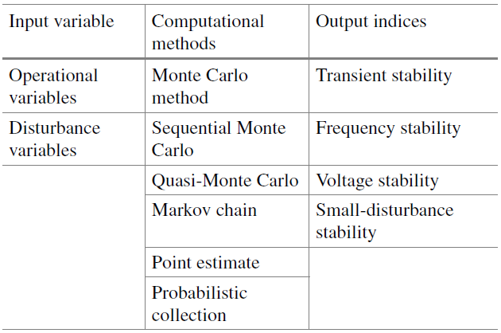

Table 2 ANN Metrics values related to hourly predictions in Ibadan, Nigeria.
Time (hrs) | MAE (KJ/m²) | MSE (KJ/m²) | RMSE (KJ/m²) | Max Error (KJ/m²) | R-squared (%)
1 | 283.95 | 148675.93 | 402.32 | 2364.83 | 89.78
4 | 313.76 | 149784.56 | 564.34 | 2464.56 | 90.56
8 | 429.45 | 151945.67 | 623.54 | 2845.56 | 91.47
12 | 495.67 | 153093.78 | 732.87 | 3103.45 | 91.98
16 | 583.23 | 155675.45 | 832.46 | 3456.78 | 92.65
20 | 673.85 | 157655.68 | 1037.11 | 4019.45 | 93.43
24 | 806.35 | 159767.44 | 1157.97 | 4638.76 | 94.23
Table. 3 Application of computational methods to stability
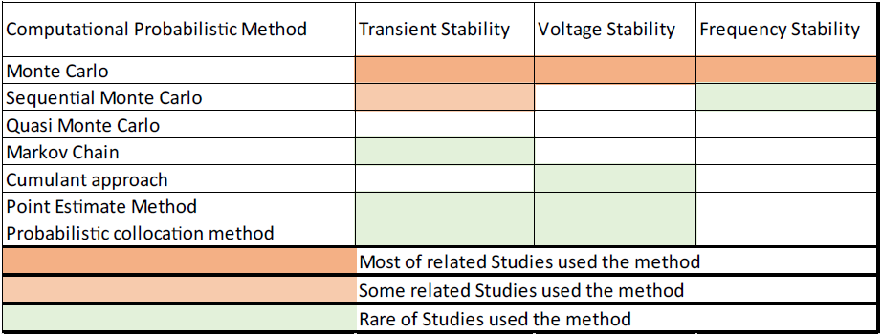

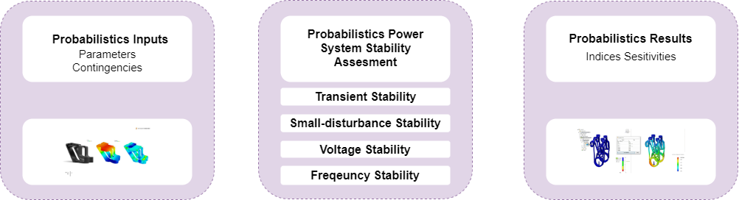
Fig. 5 Evaluating the stability of the energy system's probability

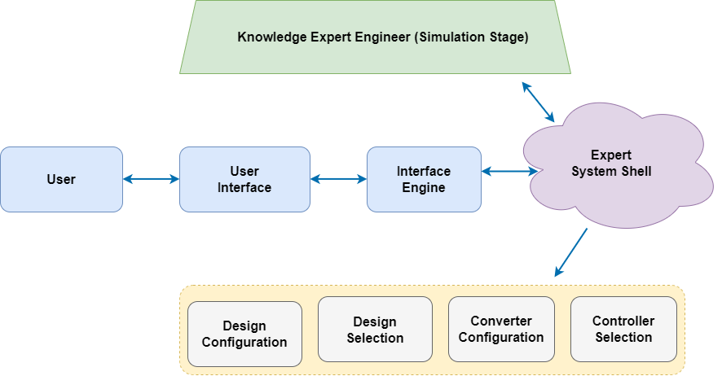
Figure 6: Automated design, simulation, and controller for an energy system.
. 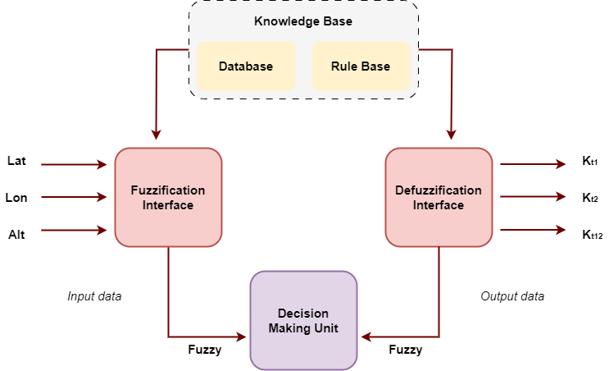
Fig. 7 Fuzzy interface system for Photovoltaic Energy
Supply
4. Conclusion
In conclusion, the probabilistic complexity of power systems is sometimes difficult to manage with traditional techniques, forcing a greater focus on the application of artificial intelligence. Research and development on integrating AI methods into power systems, including smart grids and renewable energy sources like solar and wind generators, has significantly increased in recent years. Expert systems, fuzzy logic, evolutionary algorithms, and neural networks are the main AI methodologies among them, with hybrid strategies emerging to fit certain situations. Each method is essential in resolving problems with the power system. The benefits of implementing AI in power systems are numerous and include lower maintenance and operation costs as well as improved electricity and energy market efficiency (including both conventional and renewable sources), as well as enhanced capacity for planning, controlling, monitoring, and forecasting tasks. Finding the best AI approach for particular applications in power system planning, monitoring, and control continues to be crucial.
Data Availability Statement: Data for this study will be made available on request to the corresponding author

COMPETING INTERESTS DISCLAIMER:
Authors have declared that they have no known competing financial interests OR non-financial interests OR personal relationships that could have appeared to influence the work reported in this paper.
Reference
[1] H. Yousuf, A. Y. Zainal, and M. Alshurideh, “Artificial Intelligence Models in Power System Analysis,” pp. 231–242.
[2] Temitope S. Adekunle; Morolake O. Lawrence; Oluwaseyi O. Alabi; Adenrele A. Afolorunso; Godwin N. Ebong; Matthew A. Oladipupo, “Deep Learning for Plant Disease Detection,” Comput. Sci. Inf. Technol., vol. 5, no. 1, pp. 49–56, 2023, doi: 10.11591/csit.v5i1.pp49-56.
[3] T. S. Adekunle, T. A. Adeleke, O. Sunday, and O. O. Alabi, “A Framework for Robust Attack Detection and Classification using Rap-Densenet,” Paradig. plus J. Informatics Artif. Intell., vol. 4, no. 2, pp. 1–17, 2023, doi: 10.55969/paradigmplus.v4n2a1.
[4] T. Ahmad et al., “Artificial Intelligence in Sustainable Energy Industry : Status Quo , Challenges and Opportunities”.
[5] Z. A. Elum, “Climate change mitigation and renewable energy for sustainable development in Nigeria : A discourse approach,” Renew. Sustain. Energy Rev., vol. 76, no. August 2015, pp. 72–80, 2017, doi: 10.1016/j.rser.2017.03.040.
[6] S. A. Ajagbe, M. O. Adigun, J. B. Awotunde, J. B. Oladosu, and Y. J. Oguns, “Neural Networks : Applications , Techniques , Challenges , and Prospects”.
[7] S. A. Ajagbe, S. Misra, O. Afe, and K. Okesola, “Internet of Things ( IoT ) for Secure and Sustainable Healthcare Intelligence : Analysis and Challenges Internet of Things ( IoT ) for Secure and Sustainable Healthcare Intelligence :,” no. October, 2022, doi: 10.1007/978-3-031-19647-8.
[8] O. O. Alabi, G. O. Ogunsiji, and S. A. Dada, “Performances evaluation of blended alternative refrigerant in vapour compression refrigeration system.,” Fed. Trend Sci. Technolojy Journal., vol. 8, no. 2, pp. 37–44, 2023.
[9] Adeaga, O.A. Alabi, O.O. Akintola, S.A, “EXPERIMENTAL INVESTIGATION OF THE POTENTIAL OF LIQUIFIED,” vol. 17, no. 1, pp. 1–7, 2023.
[10] S. Leo, N. M. Alsharari, and J. Abbas, From Offline to Online Learning : A Qualitative Study of Challenges and Opportunities as a Response to the COVID-19 Pandemic in the UAE Higher From Offline to Online Learning : A Qualitative Study of Challenges and Opportunities as a Response to the COVID, no. April. Springer International Publishing, 2021. doi: 10.1007/978-3-030-67151-8.
[11] M. Alshurideh, N. M. Alsharari, and B. Al Kurdi, “Supply Chain Integration and Customer Relationship Management in the Airline Logistics,” pp. 392–414, 2019, doi: 10.4236/tel.2019.92028.
[12] D. Minoli, K. Sohraby, and B. Occhiogrosso, “IoT Considerations , Requirements , and Architectures for Smart Buildings – Energy Optimization and Next Generation Building Management Systems,” vol. 4662, no. 2, 2017, doi: 10.1109/JIOT.2017.2647881.
[13] A. S. Sani, D. Yuan, J. Jin, L. Gao, S. Yu, and Z. Y. Dong, “Cyber Security Framework for Internet of Things-Based Energy Internet,” Futur. Gener. Comput. Syst., 2018, doi: 10.1016/j.future.2018.01.029.
[14] Z. Guan, X. Lu, N. Wang, J. Wu, X. Du, and M. Guizani, “Towards secure and efficient energy trading in IIoT-enabled energy internet : A blockchain approach,” Futur. Gener. Comput. Syst., no. xxxx, 2019, doi: 10.1016/j.future.2019.09.027.
[15] R. Rawat, O. A. Oki, S. Sankaran, H. Florez, and S. A. Ajagbe, “Techniques for predicting dark web events focused on the delivery of illicit products and ordered crime,” Int. J. Electr. Comput. Eng., vol. 13, no. 5, pp. 5354–5365, 2023, doi: 10.11591/ijece.v13i5.pp5354-5365.
[16] A. Lagos, E. Caicedo, G. Coria, and M. Mart, “State-of-the-Art Using Bibliometric Analysis of Wind-Speed and -Power Forecasting Methods Applied in Power Systems,” 2022.
[17] W. Yaïci, K. Krishnamurthy, E. Entchev, and M. Longo, Recent Advances in Internet of Things ( IoT ) Infrastructures for. 2021.
[18] W. Yang, J. Wang, T. Niu, and P. Du, “A hybrid forecasting system based on a dual decomposition strategy and multi-objective optimization for electricity price forecasting,” Appl. Energy, vol. 235, no. February 2018, pp. 1205–1225, 2019, doi: 10.1016/j.apenergy.2018.11.034.
[19] Y. Guo et al., “Deep learning-based fault diagnosis of variable refrigerant fl ow air- conditioning system for building energy saving,” Appl. Energy, vol. 225, pp. 732–745, 2018, doi: 10.1016/j.apenergy.2018.05.075.
[20] M. Qamar and A. Khosravi, “A review on artificial intelligence based load demand forecasting techniques for smart grid and buildings A review on arti fi cial intelligence based load demand forecasting techniques for smart grid and buildings,” Renew. Sustain. Energy Rev., vol. 50, no. December, pp. 1352–1372, 2017, doi: 10.1016/j.rser.2015.04.065.
[21] H. Hüseyin, M. Çunkaş, and K. Polat, “A new multistage short-term wind power forecast model using decomposition and artificial intelligence methods,” Physica A, vol. 534, p. 122177, 2019, doi: 10.1016/j.physa.2019.122177.
[22] M. Ahmadi and M. Khashei, “Engineering Applications of Artificial Intelligence Current status of hybrid structures in wind forecasting,” Eng. Appl. Artif. Intell., vol. 99, no. December 2020, p. 104133, 2021, doi: 10.1016/j.engappai.2020.104133.
[23] D. Lee and S. Lee, “Artificial intelligence enabled energy-efficient heating , ventilation and air conditioning system : Design , analysis and necessary hardware upgrades,” Appl. Therm. Eng., vol. 235, no. May, p. 121253, 2023, doi: 10.1016/j.applthermaleng.2023.121253.
[24] J. Duan, H. Zuocp, Y. Bai, J. Duan, and M. Chang, “Short-term wind speed forecasting using recurrent neural networks with error correction,” Energy, p. 119397, 2020, doi: 10.1016/j.energy.2020.119397.
[25] K. Nam, S. Hwangbo, and C. Yoo, “A deep learning-based forecasting model for renewable energy scenarios to guide sustainable energy policy : A case study of Korea,” Renew. Sustain. Energy Rev., vol. 122, no. December 2019, p. 109725, 2020, doi: 10.1016/j.rser.2020.109725.
[26] Y. Y. Koay, J. D. Tan, S. P. Koh, and K. H. Chong, “Optimization of wind energy conversion systems – an artificial intelligent approach,” vol. 11, no. 2, pp. 1040–1046, 2020, doi: 10.11591/ijpeds.v11.i2.pp1040-1046.
[27] S. M. Zahraee, M. K. Assadi, and R. Saidur, “Application of Arti fi cial Intelligence Methods for Hybrid Energy System Optimization,” Renew. Sustain. Energy Rev., vol. 66, pp. 617–630, 2016, doi: 10.1016/j.rser.2016.08.028.
[28] K. Murugaperumal and P. A. D. Vimal, “Feasibility design and techno-economic analysis of hybrid renewable energy system for rural electrification,” Sol. Energy, vol. 188, no. July, pp. 1068–1083, 2019, doi: 10.1016/j.solener.2019.07.008.
[29] Y. Zhao, T. Li, X. Zhang, and C. Zhang, “Arti fi cial intelligence-based fault detection and diagnosis methods for building energy systems : Advantages , challenges and the future,” Renew. Sustain. Energy Rev., vol. 109, no. April, pp. 85–101, 2019, doi: 10.1016/j.rser.2019.04.021.
[30] W. Wang, T. Pan, M. Swanteson, and T. Strand, “Experimental demonstration of a load flexible combustor for hybrid solar Brayton applications,” Energy Convers. Manag., vol. 283, no. March, p. 116904, 2023, doi: 10.1016/j.enconman.2023.116904.
[31] A. Kanasepatil, S. Technical, E. Society, H. Panchal, and S. Muthusamy, “A review of artificial intelligence-based optimization techniques for the sizing of integrated renewable energy systems in smart cities,” no. February 2021, 2020, doi: 10.1080/21622515.2020.1836035.
[32] P. Jiang and X. Ma, “A hybrid forecasting approach applied in the electrical power system based on data preprocessing , optimization and artificial intelligence algorithms,” vol. 40, pp. 10631–10649, 2016, doi: 10.1016/j.apm.2016.08.001.
[33] H. Wang, Y. Liu, B. Zhou, C. Li, G. Cao, and N. Voropai, “Taxonomy research of arti fi cial intelligence for deterministic solar power forecasting,” Energy Convers. Manag., vol. 214, no. April, p. 112909, 2020, doi: 10.1016/j.enconman.2020.112909.
[34] I. Jebli, F. Belouadha, M. Issam, and A. Tilioua, “Prediction of solar energy guided by pearson correlation using machine learning,” Energy, vol. 224, p. 120109, 2021, doi: 10.1016/j.energy.2021.120109.
[35] S. M. A. B. U. A. Abir and A. Anwar, “IoT-Enabled Smart Energy Grid : Applications and Challenges,” 2021, doi: 10.1109/ACCESS.2021.3067331.
[36] K. Jha, A. Doshi, P. Patel, and M. Shah, “Arti fi cial Intelligence in Agriculture A comprehensive review on automation in agriculture using arti fi cial intelligence,” Artif. Intell. Agric., vol. 2, pp. 1–12, 2019, doi: 10.1016/j.aiia.2019.05.004.
[37] D. V. S. K. R. K, M. Premalatha, and C. Naveen, “Analysis of di ff erent combinations of meteorological parameters in predicting the horizontal global solar radiation with ANN approach : A case study,” Renew. Sustain. Energy Rev., vol. 91, no. March, pp. 248–258, 2018, doi: 10.1016/j.rser.2018.03.096.
[38] M. S. Mirnaghi and F. Haghighat, “Fault detection and diagnosis of large-scale HVAC systems in buildings using data-driven methods: A comprehensive review,” Energy Build., p. 110492, 2020, doi: 10.1016/j.enbuild.2020.110492.

