LiDAR Technology and Its Development in Autonomous Driving

Abstract
With the continuous advancement of science and technology, LiDAR has gradually found widespread applications owing to its unique advantages, playing an increasingly pivotal role across various fields. As one of the most critical sensors in autonomous driving, this paper analyzes the evolution of autonomous driving technology and the classification of vehicle-mounted LiDAR. Furthermore, it examines and discusses the future development directions and trends, concluding that LiDAR is expected to evolve toward higher resolution, lower cost, reduced weight, and solid-state implementations.

Key words: LiDAR; Autonomous driving; solid state

Introduction
LiDAR, as a ranging technology capable of accurately acquiring three-dimensional information from both the ground and the atmosphere, has been widely applied in military, meteorological, and industrial domains. Depending on different purposes and requirements, LiDAR systems exhibit diverse types and increasingly advanced technologies ^{[19]}. Conventional sensors could only acquire single-plane spatial information of a target, requiring overlapping imaging through co-orbital or cross-orbital techniques to obtain accurate data ^{[1]}, such approaches not only suffer from low accuracy and efficiency but also involve highly cumbersome post-processing after information superposition. In contrast, LiDAR technology, owing to the high brightness, strong directionality, high monochromaticity, and strong coherence of laser beams, offers high angular, distance, and velocity resolutions, along with a wide velocity measurement range and strong anti-interference capability ^{[2]}, and it can effectively improve the aforementioned limitations.
With the continuous development of science and technology, autonomous driving has gradually entered the public’s view. In fact, as early as 1925, driverless cars appeared on the streets of New York, though they were controlled electronically via radio waves, making them more akin to remote-controlled vehicles compared with today’s technology. In 2007, the DARPA Grand Challenge demonstrated the great potential of LiDAR perception systems, as the top three teams were all equipped with multiple LiDAR sensors, with the first- and second-place teams both employing 64-line LiDAR. Furthermore, in 2009, Google, by recruiting award-winning participants from the competition, was the first to integrate LiDAR with high-definition maps, elevating autonomous driving technology to a new level. Since then, the role of LiDAR in autonomous driving perception systems has been firmly established ^{[3]}, continuously influencing subsequent research and development.
LiDAR integrates laser technology, high-speed information processing, and computer technology, enabling it to acquire precise distance and intensity information from the environment ^{[20]}. It has been widely applied in high-precision map construction and map-based localization, effectively enhancing the robustness (i.e., system survivability under abnormal or hazardous conditions) and practicality of satellite-based positioning in weak GNSS (Global Navigation Satellite System) environments ^{[4]}. As a key component of autonomous driving, conducting research and analysis on LiDAR holds significant importance. This paper provides a comprehensive review of its development and classification, its applications in the field of autonomous driving, the current limitations, and reflections on future development directions.

Classification and Application Areas of LiDAR
With the continuous advancement of science and technology and the growing needs of society, LiDAR technology has been extensively applied. It not only exhibits great diversity in terms of applications and types but also, depending on the platform on which it is deployed (e.g., satellites, vehicles, or drones), has exerted a profound impact on various aspects of human production and daily life.
In the early stages of development, LiDAR systems were generally categorized into two structural types: monostatic and bistatic. In a monostatic configuration, the laser beam transmission and reception share the same optical aperture, with switching mechanisms used to separate the two processes. In contrast, a bistatic system employs separate optical apertures for transmission and reception to improve spatial resolution. However, with the advancement of laser technology, pulse widths of emitted laser beams have reached the nanosecond and even picosecond scale, which sufficiently meets the requirements for spatial resolution. Consequently, monostatic configurations are now more commonly adopted ^{[5]}.
LiDAR systems can also be classified based on the number of beams into single-beam and multi-beam types. A single-beam LiDAR employs a high-frequency laser pulse emitter that rotates within a one-dimensional plane. Its operating principle and usage are relatively simple, yet it remains highly effective for distance measurement. Compared with the complex coordination required among multiple sensors in multi-beam systems, single-beam LiDAR offers greater precision and sensitivity in obstacle avoidance, while also being more cost-effective. However, since it only operates within a one-dimensional plane, its applications are limited, with common use in service robots such as robotic vacuum cleaners, as shown in Figure 1.
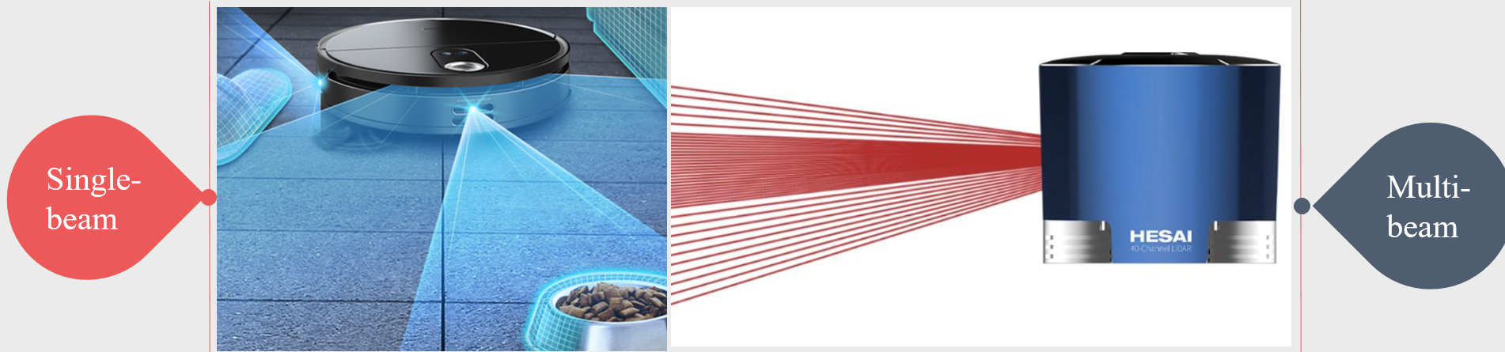
Figure 1 Single-beam and multi-beam LiDAR

In contrast, multi-beam LiDAR is not limited to a one-dimensional plane and is capable of capturing comprehensive information about the height of objects. Although it comes with higher costs and a more complex structure, the use of multiple beams greatly enhances object recognition capabilities and spatial resolution. At present, most multi-beam LiDAR systems operate in 2.5D, with a vertical field of view of less than 10°, while true 3D systems can reach up to 40°. Common configurations include 4-, 8-, 16-, 32-, and 64-beam LiDAR, with higher beam counts corresponding to significantly higher costs. These systems are primarily employed in vehicles for signal acquisition and three-dimensional imaging. Notably, Huawei has recently introduced a 96-beam LiDAR, representing a further step in advancing this technology ^{[6]}.
With the continuous advancement of science and technology and the increasing diversification of practical needs, LiDAR systems can be classified according to their platforms into spaceborne, airborne, vehicle-mounted, and ground-based types ^{[7]}. Among them, spaceborne LiDAR operates onboard satellites, as illustrated in Figure 2, which presents the development roadmap of NASA’s spaceborne LiDAR systems^{[8]}.
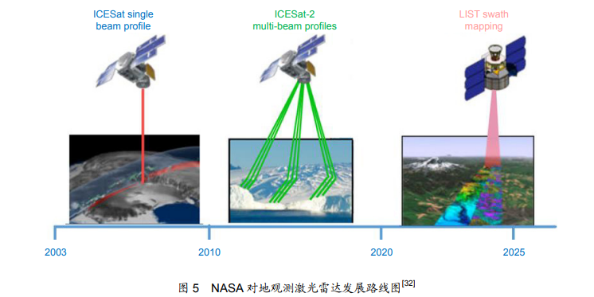
Figure 2 Roadmap for the Development of NASA Spaceborne LiDAR Systems

Secondly, airborne LiDAR is primarily carried by aircraft or unmanned aerial vehicles (UAVs). By capturing the reflections of laser pulses, it provides wide coverage and rapid data acquisition, making it suitable for high-density regions. Its applications include atmospheric detection (e.g., air pollution, water vapor, and aerosols), environmental monitoring (e.g., rivers, wind speed, cloud dynamics, wildfires, and landslides), bathymetry, and vegetation resource surveys. It has also been widely adopted in UAV-based obstacle avoidance research ^{[9]}. Ground-based LiDAR, on the other hand, is typically mounted on vehicles or stationary platforms, as shown in Figure 3. It is mainly used for surveying roads and bridges. Since it is not constrained by flight altitude or air turbulence, it achieves higher measurement accuracy. However, because it requires fixed installations to perform step-by-step scanning, its data acquisition speed is slower compared with airborne LiDAR. Vehicle-mounted LiDAR, illustrated in Figure 4, is installed on automobiles. It plays a crucial role in the development of intelligent vehicles and autonomous driving, with applications in high-definition mapping, localization and tracking, obstacle detection, environmental perception, and intelligent driving systems.
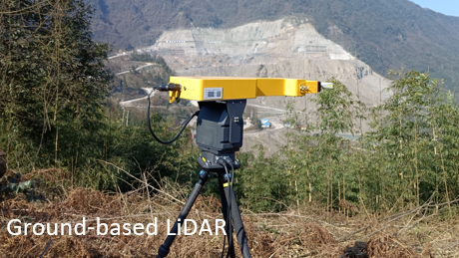
Figure 3 Ground-based LiDAR
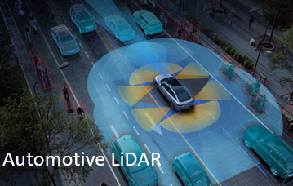
Figure 4 Automotive LiDAR
With the advancement of quantum technology, quantum LiDAR has emerged as a solution to the limitations of conventional LiDAR, particularly its low signal-to-noise ratio. Compared with traditional LiDAR systems, quantum LiDAR offers higher detection sensitivity and resolution, enabling further development in this field ^{[10]}. In addition, it demonstrates greater detection range and stronger anti-interference capability. At present, quantum LiDAR can be broadly divided into two categories: quantum pulse and quantum interferometric types. Zhang Chi ^{[11]} et al realized long-range maritime ranging based on single-photon technology, while Liu Bo ^{[12]} et al further reviewed single-photon LiDAR techniques and proposed a novel spectral filtering method to improve the daytime detection performance of quantum LiDAR.
In summary, LiDAR technology has undergone substantial development across various domains in response to societal needs, and it has gradually permeated many aspects of daily life. Although research on LiDAR in China started relatively late, its applications have already expanded into multiple fields, and the gap with Western countries is steadily narrowing. Looking ahead, research on LiDAR will continue to evolve in alignment with practical demands, fostering broader and deeper applications in the future.

The Development of LiDAR in Autonomous Driving Technology

Development History of Autonomous Driving
With the advancement of science and technology, the automotive industry has increasingly regarded autonomous driving as a strategic objective and has achieved notable progress in this field. This chapter introduces the development of LiDAR technology in the context of autonomous driving and provides an overview of its potential future directions.
The foundation of autonomous driving technology can be traced back to 1966, when several universities and automobile manufacturers abroad collaborated to integrate computer algorithms with sensor hardware (such as cameras), thereby establishing the initial technological pathway for autonomous driving. In 2004, Google took the lead by launching an autonomous driving project equipped with electronic maps and LiDAR, where LiDAR was primarily used to detect the distance between the vehicle and obstacles, while the electronic map marked obstacle information for vehicle positioning. At this stage, autonomous driving relied heavily on high-definition maps. By 2014, in response to the challenges posed by this dependence, Google pioneered the creation of high-definition maps in specific cities and directly integrated them into vehicles during production. Around this time, Google introduced autonomous vehicles equipped with cameras, LiDAR, and millimeter-wave radar, which encouraged more automobile manufacturers to engage in autonomous driving research. Since then, autonomous driving technology has been actively pursued worldwide, with substantial investments accelerating its progress.

Classification of Vehicle-Mounted LiDAR
LiDAR is a crucial component enabling the realization of autonomous driving and is often regarded as the "eyes" of the system. Vehicle-mounted LiDAR is one of the largest and most important sensors in autonomous vehicles, with its integration largely driven by the requirements of autonomous driving. At present, vehicle-mounted LiDAR is primarily pulse-based and performs distance measurements using the time-of-flight (ToF) principle ^{[13]}. Based on the scanning architecture, particularly the presence or absence of mechanical rotation components, LiDAR systems can be categorized into mechanical LiDAR, hybrid solid-state LiDAR, and solid-state LiDAR ^{[14]}.
Mechanical LiDAR requires components to control the emission angle of the laser. By employing gimbals, turntables, or similar mechanisms in combination with high-speed motors, it achieves scanning operations ^{[15]}。At present, most LiDAR systems available on the market are mechanical LiDARs, which have been more extensively studied and are more mature in terms of technological applications, as illustrated in Figure 5.
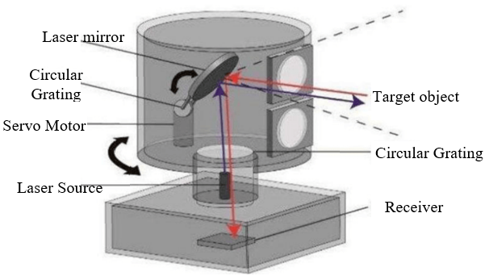
Figure 5 Mechanical LiDAR

Its two-dimensional structure consists of an emitter combined with a rotating unit, which is mainly applied to planar scanning. In contrast, three-dimensional scanning is typically achieved through a combination of multi-channel laser beams and mechanical scanning. The laser emission components are vertically arranged in a linear array, and through the use of lenses, laser beams with different orientations can be generated within the vertical plane. Driven by a stepper motor, the system continuously rotates, transforming the laser beams in the vertical plane from a “line” into a “surface.” By further rotating and scanning, multiple laser “surfaces” are formed, thereby enabling full 3D scanning of the target area.
Velodyne Lidar, Inc. (Velodyne), a leading company in the LiDAR industry in the United States, has developed the HDL-64E LiDAR, as shown in Figure 6, which adopts a 64-channel design combined with mechanical rotation scanning. This configuration enables scanning across a horizontal field of view as well as within a certain vertical field of view ^{[16]}. Furthermore, Velodyne has also released the VLS-128 LiDAR (as shown in Figure 7), which features 128 channels. Compared to the HDL-64E, the VLS-128 provides ten times higher resolution, while being more compact in size, and offering superior field of view and detection range. These advancements make it capable of meeting the requirements of Level 5 autonomous driving. However, mechanical LiDAR systems still face inherent limitations, such as a mean time to failure (MTTF) that falls short of automotive industry standards and a relatively low signal-to-noise ratio (SNR).
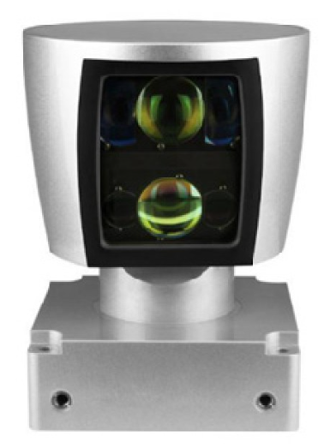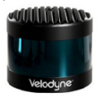
Figure 6 Velodyne’s HDL-64E(left) and VLS-128 Mechanical LiDARs（right）

Although mechanical LiDAR has been widely applied in commercial use and by several automotive companies, its limitations remain evident. As illustrated in Figure 7, which shows the LiDAR and sensor layout of Google’s autonomous vehicle, mechanical LiDAR systems are often bulky and typically mounted outside the vehicle. In addition, their research and development costs are relatively high. Consequently, the exploration of new types of vehicle-mounted LiDAR has increasingly become a key direction for technological innovation.

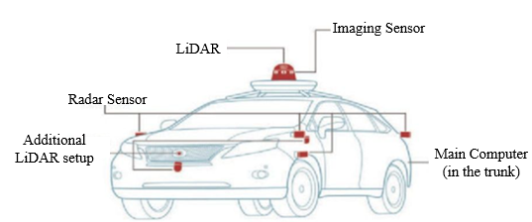
Figure 7 LiDAR and Sensor Layout of Google’s Self-Driving Car

At present, in order to reduce costs and minimize the size of LiDAR systems, hybrid vehicle-mounted LiDAR and solid-state vehicle-mounted LiDAR have also become the focus of research. Hybrid LiDAR has already been adopted by some automotive manufacturers, and well-known companies such as RoboSense, Huawei, and Innovusion in China are actively investing in both solid-state and hybrid LiDAR development. Hybrid LiDAR, also referred to as semi-solid-state LiDAR, integrates Micro-Electro-Mechanical Systems (MEMS) scanners with galvanometer technology. As shown in Figure 8, the MEMS micro-mirror technology operates by electromagnetic actuation of an integrated movable micro-mirror to achieve scanning. Compared with traditional mechanical LiDAR, hybrid LiDAR is more compact and flexible; however, its field of view is relatively narrow. To achieve 360° coverage, additional angle-expansion systems or multiple LiDAR units are required. For example, Zhou Jue ^{[17]} et al. designed a synchronous scanning system combining a brushless motor with a MEMS micromirror, which effectively expanded the micromirror’s scanning angle and achieved a scanning range of 40° × 180°.
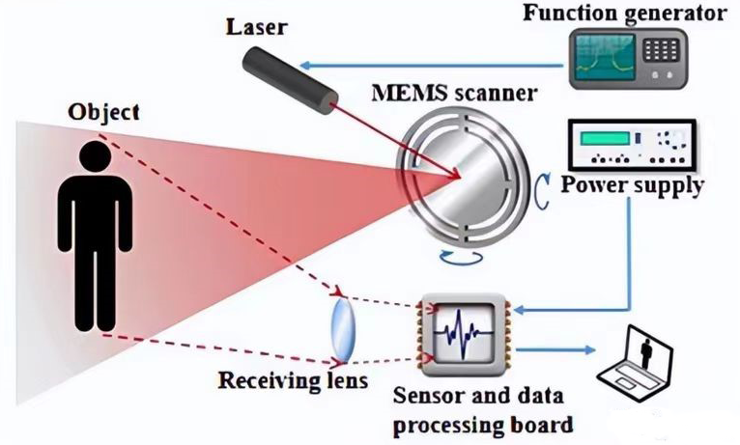
Figure 8 Principle of MEMS Micromirror Technology (Source: Auto Byte)

Finally, there is solid-state LiDAR. Solid-state LiDAR controls the emission angle of the laser through electronic components, making it a non-scanning LiDAR that does not require mechanical rotation parts. This design offers greater structural stability and higher reliability, while its production cost is significantly lower than that of mechanical LiDAR. The main types of solid-state LiDAR currently include Optical Phased Array (OPA) and Flash Automotive LiDAR.
Optical Phased Array (OPA) LiDAR is based on the principle of optical interference: when the phases are aligned, constructive interference occurs and the light waves are enhanced; when the phases are misaligned, destructive interference occurs, leading to attenuation and a distinct intensity distribution. By applying specific voltages to the optical phase control array, an optical path difference is introduced within the emission system. This enables constructive interference in designated directions, thereby generating high-intensity beams to achieve scanning.
Flash LiDAR emits a large number of laser beams within a very short period of time to cover the surrounding environment. The receiver can rapidly calculate the time-of-flight of the beams and reconstruct the spatial information based on the feedback signals, thereby enabling fast environmental mapping. However, when the detection distance increases, the number of returning photons decreases significantly, resulting in reduced accuracy. Both Flash LiDAR and Optical Phased Array (OPA) LiDAR suffer from the limitation of short detection range, which restricts their capability in long-distance sensing. At present, due to the stringent fabrication requirements of MEMS technology, most domestic systems rely on the integration of imported components. Research efforts are therefore increasingly focused on addressing the short-range limitation of solid-state LiDAR, and it is anticipated that solid-state LiDAR will play a dominant role in the future.

Levels of Autonomous Driving
With the large-scale mass production of autonomous vehicles, China’s automotive LiDAR market has shown a steady upward trend year by year. Major domestic and international LiDAR manufacturers include RoboSense, DJI Livox, Hesai Technology, Innoviz, and Valeo. At present, these companies have begun to deploy their proprietary technologies into mass production for L2 and L3 advanced driver-assistance systems (ADAS), and even for L4-level autonomous driving. Regarding the classification of autonomous driving, it is commonly divided into six levels (L0–L5). L0 refers to vehicles only equipped with warning systems, with all driving tasks entirely performed by the driver under full manual control. L1 includes limited assistance functions, such as anti-lock braking systems, but the driver remains responsible for the primary driving tasks. L2 vehicles integrate functions such as adaptive cruise control and automatic emergency braking, significantly reducing the driver’s workload. L3, also known as “conditional automation,” enables shared control between the driver and the system, where human intervention is only required in specific scenarios. L4 represents “high automation,” in which the vehicle can drive itself in most conditions without human intervention. Finally, L5 denotes “full automation,” where the vehicle is capable of completely autonomous driving under all conditions ^{[18]}, as illustrated in Figure 9.
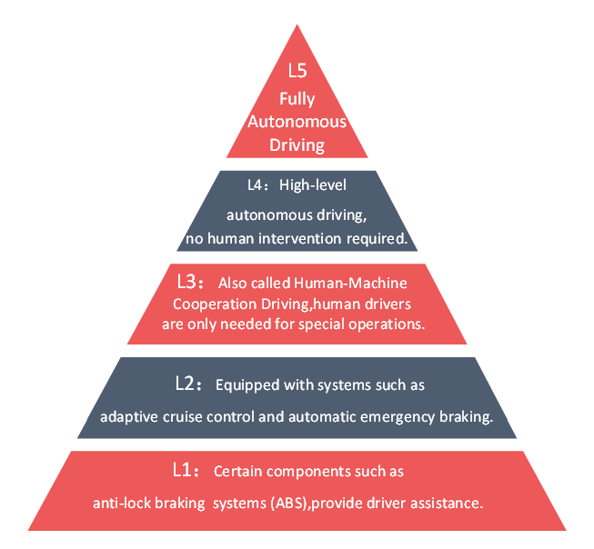
Figure 9 Levels of Autonomous Driving
Since 2011, when machine learning was first applied to autonomous driving, significant progress has been achieved in enhancing vehicle perception and decision-making. In 2021, Tesla integrated large-scale models into the perception module of its autonomous driving system, substantially improving perception capability. By 2023, Tesla further advanced this approach by employing large models to handle perception, decision-making, and control algorithms in an end-to-end manner. This breakthrough reduced the reliance on hand-crafted rule-based algorithms, cutting the codebase from approximately 300,000 lines to only about 2,000 lines, thereby realizing the world’s first end-to-end large-model autonomous driving system.
Autonomous driving technology does not rely solely on LiDAR but requires the joint operation of multiple sensors, and in some cases, even the interaction between two on-board LiDAR systems. Relying exclusively on LiDAR for panoramic scanning to generate high-resolution, long-range 3D point cloud maps and then fusing them with other sensors not only results in low efficiency but also produces a large amount of redundant or “invalid” data, which can significantly affect the system’s decision-making process. At present, a more effective approach is the fusion of LiDAR and vision-based perception systems. In this framework, vision sensors are first used for semantic segmentation and object recognition, after which LiDAR’s precise ranging capability is applied selectively to the segmented point cloud data. This strategy not only reduces the generation of invalid data but also improves the overall responsiveness of the system, thereby enhancing decision-making efficiency.
The future development of vehicle-mounted LiDAR technology will move toward multi-sensor integration. Compared with a single sensor, the use of multiple sensors to acquire complementary information enables more accurate perception, significantly reduces the probability of misclassification of the same object, and greatly enhances the signal-to-noise ratio.
At present, Tesla, following a series of incidents such as “emergency braking,” has abandoned the use of millimeter-wave radar and refused to adopt LiDAR, citing its high cost and claiming that it would slow down the commercialization of autonomous driving. However, with continuous technological innovation and the expansion of market scale, the cost of vehicle-mounted LiDAR has already dropped to the level of several thousand RMB, yet Tesla still adheres to a vision-only approach. The pure vision strategy is analogous to human binocular vision, which requires multiple cameras to work in tandem, integrating two-dimensional images into a three-dimensional scene. This approach imposes stringent requirements on camera resolution and clarity, and its performance deteriorates significantly in nighttime driving, often leading to misclassification of surrounding objects. Although LiDAR remains relatively expensive compared with other sensors and the vision-only approach offers a certain cost-performance advantage, the ongoing reduction in LiDAR cost and the inherent limitations of vision-only systems suggest that LiDAR technology will continue to attract growing attention in the future.
The trend toward intelligent vehicles has become an inevitable development, with countries around the world engaged in intense competition in the research of autonomous driving technologies. In the future, automotive LiDAR is expected to advance toward solid-state solutions. Compared with traditional mechanical LiDAR, which suffers from large size and high costs, solid-state LiDAR offers significant potential for improvement. Although mechanical LiDAR still dominates the current market, and many technical challenges in solid-state LiDAR—such as achieving wide fields of view and panoramic imaging—remain unresolved, the inherent advantages of solid-state LiDAR align with future demands for compactness, affordability, and flexibility. Looking ahead, LiDAR technology will continue to evolve toward miniaturization and integration. However, challenges remain in achieving wide scanning angles and high-resolution imaging. As such, research on intelligence, high performance, and long-range precision detection will remain the key focus areas in the development of LiDAR systems.

Conclusion
From the advent of LiDAR to the diverse forms it has developed into today, LiDAR technology has always been driven by application needs and will inevitably evolve in parallel with the advancement of other technologies. At present, LiDAR has penetrated into many aspects of daily life and plays a vital role across multiple fields. Looking ahead, LiDAR development should be demand-driven, guided by overall system-level considerations, and further refined through decomposition of performance indicators to meet specific requirements. This approach will help broaden its application scope and ensure that LiDAR systems are not only usable but also practical and efficient. Meanwhile, the increasing emphasis placed on LiDAR research worldwide will continue to expand its market, particularly in the automotive industry where autonomous driving has become a mainstream development direction. This will further accelerate technological upgrades, making LiDAR more intelligent and more practical for future applications.

COMPETING INTERESTS DISCLAIMER:
Authors have declared that they have no known competing financial interests OR non-financial interests OR personal relationships that could have appeared to influence the work reported in this paper.

References
- Chen D., Yu W., Gao Y. “LiDAR 3D Object Detection Based on Improved PointPillars,” Progress in Laser and Optoelectronics, vol. 36, no. 8, pp. 1–13, 2019.
- H. Liu, C. Y. Lin, B. W. Gong, and D. Y. Wu, “Automatic lane-level intersection map generation using low-channel roadside LiDAR,” IEEE/CAA J. Autom. Sinica, vol. 10, no. 5, pp. 1209–1222, May 2023. doi: 10.1109/JAS.2023.123183
- Huang S., Liu L., Dong J., et al. “Review of Ground Filtering Algorithms for Vehicle-Borne LiDAR Point Cloud Data,” Opto-Electronic Engineering, vol. 47, no. 12, pp. 3–14, 2020.
- Qihua M ,Qilin L ,Wenchao W , et al.LIDAR-based SLAM system for autonomous vehicles in degraded point cloud scenarios: dynamic obstacle removal[J].Industrial Robot: the international journal of robotics research and application,2024,51(4):632-639.
- Wang H., Luo P., Li X. “Design and Error Analysis of a Short-Range Dynamic LiDAR Ranging System,” Journal of Beijing University of Aeronautics and Astronautics, vol. 46, no. 2, pp. 422–429, 2020.
- “96-Line Automotive-Grade Mass-Produced Huawei LiDAR as the First High-Beam LiDAR Mounted Worldwide,” Automobile Parts, no. 1, pp. 90, 2021
- Gong W., Shi S., Chen B., et al. “Development and Prospect of Hyperspectral LiDAR for Earth Observation,” Journal of Remote Sensing, vol. 25, no. 1, pp. 501–513, 2021.
- Chen G ,Yi H,Mao Z.3D object detection based on image and LIDAR fusion for autonomous driving[J].International Journal of Vehicle Information and Communication Systems,2023,8(3):237-251.
- Pan S., Shang J., Luo Y., et al. “A Miniaturized, Long-Range, Planar Scanning LiDAR Obstacle Avoidance System,” Information Technology and Network Security, vol. 39, no. 5, pp. 46–50, 2020.
- Torromé G R ,Barzanjeh S .Advances in quantum radar and quantum LiDAR[J].Progress in Quantum Electronics,2024,93100497-.
- Zhang C., Dong G., Wu G., et al. “Implementation of Long-Range Maritime Ranging Using Single-Photon LiDAR,” Science Technology and Engineering, vol. 20, no. 14, pp. 5645–5649, 2020.
- Liu B., Jiang Y., Wang R., et al. “Progress and System Evaluation of All-Time Single-Photon LiDAR Technology,” Infrared and Laser Engineering, vol. 52, no. 1, pp. 9–23, 2023.
- Wang H ,Chen X ,Yuan Q , et al.A review of 3D object detection based on autonomous driving[J].The Visual Computer,2024,41(3):1-19.
- Yu Z .Analysis of the Autonomous Driving Technology——Lidar Versus Visual Recognition[C]//ITM Department, Illinois Institute of Technology.Proceedings of the 3rd International Conference on Signal Processing and Machine Learning（part2）.Beijing National Day School;,2023:300-303.DOI:10.26914/c.cnkihy.2023.112922.
- Pang Y., Miao R., Bai Z., et al. “Research Progress on Large Field-of-View and Panoramic Imaging Technology for Scanning LiDAR,” Laser Journal, vol. 42, no. 8, pp. 1–8, 2021.
- Zhang Y ,Feng J ,Huang M , et al.Development and Key Technologies of the Cognition system of Autonomous Driving[C]//Wuhan Zhicheng Times Cultural Development Co., Ltd..Proceedings of 2nd International Conference on Artificial Intelligence and Communication Technology (AICT 2023).Chang'an Dublin International College of Transportation,Chang'an University;,2023:686-697.DOI:10.26914/c.cnkihy.2023.058502.
- Zhou J., Wu D. “Hybrid Scanning Synchronization Design Based on MEMS Micromirror,” Application of Electronic Technique, vol. 47, no. 7, pp. 92–96, 2021.
- Yu Y. “Main Technical Branches and Development Trends of Vehicle-Borne LiDAR,” Scientific Research Informatization Technology and Application, vol. 9, no. 6, pp. 16–24, 2018.
- Sakib, S. M. (2022). LiDAR Technology-An Overview. IUP Journal of Electrical & Electronics Engineering, 15(1).
- Bogue, R. (2022). The growing importance of lidar technology. Industrial Robot: the international journal of robotics research and application, 49(6), 1025-1031.

