Research on the Optical System Design of High-Precision Stellar Simulators

Abstract：The stellar simulator is an indispensable tool in astrophysics research and a laboratory test device used for star sensor testing and calibration. Its function is to provide a controllable and realistic stellar sky. It reproduces the internal structure and evolution process of stars through numerical methods, providing theoretical support for understanding the life cycle of stars, nuclear synthesis, and the chemical evolution of the universe. However, existing simulation technologies still face challenges such as a small usable field of view and low precision of the stellar simulator. Based on the current research status of stellar simulators at home and abroad, this paper determines the core parameter performance of the stellar simulator and designs the optical system of the stellar simulator based on these parameters. The optical system is optimized and designed in a normal temperature environment through the optical design software CODE-V, and a high-precision and large-field-of-view stellar simulator is designed.
Key words: Static Star Simulator Optical system design CODE-V; Optical system design
1 Introduction
The research background and significance of the thesis
Spacecraft attitude control, as a core technology in aerospace, is particularly important for high-precision positioning of spacecraft. The attitude of a spacecraft is the spatial orientation relationship of the body coordinate system relative to a specific reference frame. To ensure the achievement of the mission goals, the spacecraft needs to precisely adjust the orientation of the observation equipment or payloads and precisely point the solar panels at the sun to guarantee energy supply. If precise attitude control is lacking, the spacecraft will experience uncontrolled rotation in orbit, leading to a "space disorder" state. It is necessary to build a high-precision attitude measurement system to achieve precise adjustment of payload orientation and meet the requirements of mission positioning accuracy^{[1]}.
The attitude determination of spacecraft can be accomplished through the vector parameter measurement carried by the sensors. Attitude solution methods based on vector observation have been widely applied in the aerospace field. Such observation tasks are usually carried out by attitude sensing devices on satellites. At present, space attitude measurement equipment includes various types such as magnetometers, Earth sensors, solar sensors and star sensors, and all kinds of sensors can achieve precise positioning. Among them, the star sensor stands out with its high-precision measurement performance, featuring both autonomous navigation capability and excellent anti-interference characteristics.
Before the star sensor is officially applied, strict calibration tests must be completed. Among them, ground tests and stellar simulations are the most reliable verification methods. Based on this demand, it is of great significance to develop star simulation equipment for ground calibration. The star simulator is precisely a device designed to meet this demand. It can complete the testing and calibration of star sensors in a laboratory environment. This device can accurately reproduce the optical characteristics of stars, provide identifiable reference targets for star sensors, and effectively simulate core parameters such as star brightness, field of view, and distance ^{[2]}。
The early developed star simulators had many technical bottlenecks, mainly reflected in the limited measurement accuracy, which made it difficult for the star sensors to complete normal tests. The main design objective of this paper is to study the static star simulator for the design of optical systems with high imaging quality. Its design is of great significance for solving technical problems in practical engineering applications.
1.2 The current research status of star simulators at home and abroad
1.2.1 Current research status abroad
The emergence of APS sensors has driven the leapfrog development of star sensors, significantly enhancing the performance indicators and simulation accuracy of such devices. As an important calibration device for star sensors, the research on star simulators has also received increasing attention and investment.
The German company Jena-optronik has been promoting the development of stellar target simulators based on the advancement of star sensors. It offers a variety of products, including the OSI series and the OSPS series. The OSI starry sky simulator can precisely simulate stars, the Sun, and the Earth, with a field of view better than 20°. The single-star simulation accuracy is better than 27 ", and it can simulate star points of magnitudes 2 to 6. The most prominent feature of the OSPS optical testing system is that it can reduce the electromagnetic shielding of the star sensor in the testing system.

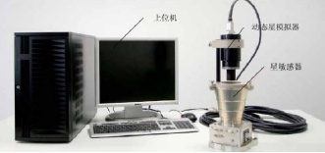
Fig 1. 1280×1024 resolution simulator developed by German company
The STOS series of stellar target simulators developed by Airbus DS is currently a product with relatively high precision and good dynamic performance. The field of view can also reach 25°, the single-star simulation accuracy is better than 20 ", the simulated magnitude range is from -1 to 6 magnitusions, the image resolution is 1280×1024, and the weight is close to 2Kg. In 2019, Stephen E. Kendrick, Christopher Robb, Dennis Ebbets and others designed a star simulator that could simulate companion planet targets with weak brightness, thereby meeting the testing requirements of high-dynamic star sensors^{[3]}。
In 2020, Victor Hugo Schulz, Gabriel Mariano Marcelino, Laio Oriel Seman and others built a verification platform based on the star tracking algorithm to verify the accuracy of the simulated star map. By using the UVM-SystemC environment paired with the OpenCV computer vision library, the star point images projected by the star simulator under different reference frames can be evaluated, and specific perturbation simulations can be enabled for the star map. The background images projected by the star simulator can be reconfigured using the measured noise. The star simulator calibrated by the platform can project star maps that are closer to the real scene, laying a solid foundation for the future testing of star sensors.
1.2.2 Current research status in China
Research on star simulators in China began in the 1970s. In the 1980s, the development of single-star simulators was initiated, and a number of fundamental studies, including stellar spectral simulation and star point imaging quality, were carried out. With the continuous progress of domestic star sensors and the rapid development of image display equipment, China has accumulated sufficient technical reserves in the field of local sky area simulation, laying a solid foundation for related research ^{[4]}。
The following are several representative examples of domestic star simulators:
The Institute of Optics and Electronics, Chinese Academy of Sciences, has developed a small dynamic star simulator that uses a high-resolution, ultra-small P13XM015 TFT-LCD liquid crystal light valve with a resolution of 1024×768 as the core component for star map display. This small dynamic star simulator operates in the spectral range of 470-750nm and a star map field of view of 6°×8°. It can simulate stars of magnitude 2 to 6.5 (Mv) with magnitude accuracy reaching ±0.3Mv. The single-star angular simulation range is 20 "to 40", and the angular distance accuracy of the stars is better than 20 ".
The Changchun Institute of Optics, Fine Mechanics and Physics, Chinese Academy of Sciences, has developed a small dynamic star simulator based on a 1024×768 resolution DMD as the core star map display device [37]. This dynamic star simulator, based on digital light processing (DLP) display technology, selects the DLP display system as the core of the star simulator system to transmit the simulation of real-time dynamic star maps for the star sensor. Under the condition of a 10.5°×7.5° star map field of view, the magnitude range of the star map simulated by this small dynamic star simulator can reach 2.0-8.0 magnitude stars. Moreover, the simulation accuracy of its single star opening Angle is better than 40 ", and the star map refresh response time is guaranteed at the millisecond level.
In order to meet the high-precision technical requirements of dynamic star simulators, Changchun University of Science and Technology has developed a dynamic star simulator based on LCOS(liquid crystal on silicon) optical splicing technology [5]. Taking LCOS with a resolution of 1920×1080 as the core component for star chart display, based on the optical splicing technology of silicon-based liquid crystal LCOS, the goal of covering the entire field of view with star chart display has been achieved under the premise of splicing error less than 10 ". Ultimately, under the star map field of view of 10.2º×10.2º, the single-star spread Angle of the star map is better than 20 ", the single-pixel equivalent spread Angle error is better than 6 ", and the star diagonal distance error is better than 25 ". And in the star map display algorithm, the celestial sphere was divided according to the principle of equal field of view, and the star map refresh rate was increased to 30Hz.
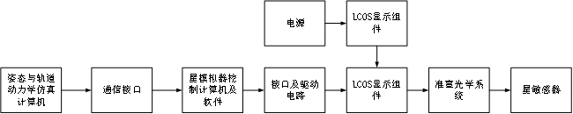
Fig 2. LCOS star simulator system
The dynamic spatial scene projector developed by the Chinese Academy of Sciences utilizes the principle of secondary imaging, truly achieving a large field of view and long exit pupil, and solving the problem of difficult phase difference correction in the system. The equipment consists of a lighting system and a large-field-of-view optical projection system. The uniformity of its lighting system has reached 94%, the exit pupil of the projection system is 60mm, the field of view is 28.6°, the distortion is 0.045%, and the geometric circle entry energy is greater than 80% within a circle with a diameter of 8μm^{[6]}。
1.3 Research content and technical approaches
This paper focuses on the technical limitations of the existing static star simulators. The existing static star simulators generally have insufficient measurement accuracy, and the shape of star points is prone to deformation in high and low temperature environments, which seriously affects the accuracy of static star simulators. Based on the optical design software Code-V, this paper designs a static star simulator with the ability to simulate star characteristics with high precision and complete normal tests in high and low temperature environments, and conducts performance analysis on it. The main research contents of this paper are as follows：
1）By investigating the parameters of the current mainstream star sensors in China, the research objective of the static star simulator designed this time was determined.
2）Based on the technical indicators of the optical system, an appropriate initial structure is selected from the lens database. After continuous optimization and calculation, an optical system solution that meets the design requirements is finally obtained: the imaging quality of the wide-field optical system.
The technical route of this article is as follows：
1）Through literature research and data analysis of the technical parameters of mainstream domestic star sensors, the design requirements of static star simulators are clarified.
2）Based on the lens database of CODE-V optical design software, the appropriate initial structure is screened according to the system F-number and half-field of view Angle. By using the Global Synthesis function module in the software and limiting key parameters such as the focal length and rear intercept of the system, the optimal design of the optical system is completed, and the image quality of the optical system is evaluated.

2 The research objective and working principle of the star simulator
2.1 Research objective
In many fields such as aerospace, which have extremely high requirements for the accuracy of celestial observation and navigation, star sensors play a crucial role. It is like a precise "eye" in space, capable of keenly capturing the light signals emitted by celestial bodies, thereby providing indispensable data support for critical tasks such as the attitude determination and orbit control of spacecraft. A star simulator is a device used to simulate stars in the sky, assisting star sensors in conducting corresponding tests and calibration work. Therefore, the technical specifications of a star simulator depend on those of a star sensor. Based on the usage requirements of star sensors, technical indicators for star simulators are proposed, covering multiple aspects such as field of view, exit pupil diameter, exit pupil distance, spectral range, single-star spread Angle, and inter-star angular distance.
At present, various types of star sensors are applied in aerospace engineering. The following table shows some technical parameters of the mainstream star sensors in China.
Table 1 Some technical specifications of domestic commonly used star sensors
Sensitive vessel model | Data update rate (Hz) | Field of view | Precision | Weight | Detectable magnitude range | Operating temperature range
NST10-G1 | 20 | 18°×18° | 5″ | 500g | 5.8Mv | 30~50°C
PST3S-H1 | 10 | 15°×18° | 3″ | 130g | 5.8Mv | /
NST5S-A1 | 10 | 15°×18° | 2″ | 380g | / | /
CMOS-APS | 1~10 | 8.8°×8.8° | 10.16″ | 990g | 5.64Mv | /
As can be seen from the above table, most of the star sensors used in China have a field of view less than 20°×20°, a detectable magnitude range of less than +6Mv, and an accuracy of less than 10 ".
Based on the technical indicators of the commonly used domestic star sensors in Table 2, the technical indicators of the star sensors applicable to the star simulator designed this time are determined as shown in Table 2.
Table 2 Technical specifications of star sensor
Indicator name | Indicator requirements
Field of view | 20°
Diameter of the entering pupil | 10mm
Spectral range | 700~800nm
Identify the magnitude range | 0~+6Mv
Working environment temperature | -30℃~60℃
2.2 Analysis of simulation parameters of the star simulator
2.2.1 Simulation of the star spectrum segment
The spectral simulation technology of the static star simulator is one of its core capabilities, aiming to reproduce the spectral distribution characteristics of real stars. The static star simulator simulates the process of a star's spectrum through LED light sources. Essentially, it is spectral synthesis, decomposing the spectrum of the target star into a linear combination of multiple LED light sources, which can provide a stable spectral output and is suitable for long-term calibration or fixed-scene testing.
The stellar spectrum can represent a function of the dimensional wavelength$（λ）$that is, the radiation intensity distribution $Starget（λ）$。The spectral characteristics of LED light sources can also be expressed as the radiation intensity distribution$S_{i}（λ）$（i=1,2,…,N，N where N represents the number of leds）。The objective of the simulator is to find a set of weight coefficients $W_{i}$，such that the synthetic spectrum $Starget（λ）$is as close as possible to the target spectrum:
 | 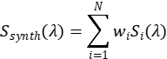 | (2-2)
In the star simulator, the simulated spectrum generates light within a specific wavelength range by selecting appropriate LED light sources and filters.
2.2.2 Simulation of the angular spread of a single star
The simulation of the angular spread of a single star by a static star simulator plays a significant role in the testing, calibration and performance verification of star sensors. It can simulate real starry sky conditions, improve the measurement accuracy and resolution ability of star sensors, support high-precision task requirements, and ensure the reliability and consistency of tests ^{[7]}。
The single-star tension Angle simulated by the star simulator is expressed by Equation (2, 3), and the schematic diagram of the single-star tension Angle of the star simulator is shown in Figure 3.
 | 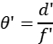 | (2-3)
Among them,$θ^{'}$ is the Angle of the simulated single star，$f^{'}$is the focal length of the star simulator, $d^{'}$is the size of the light-transmitting micro-holes on the star point plate.
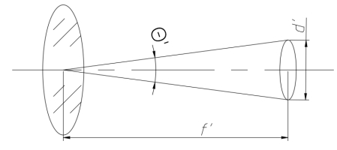
Fig 3. Schematic diagram of single star opening angle of star simulator
2.3 The working principle of the star simulator
The static star simulator, as the core equipment of the ground detection system for star sensors, is mainly used to simulate the brightness and position information of stars in the real starry sky in a laboratory environment. Its working principle is: The light beam emitted by the light source system, after passing through the filter assembly, forms light of a specific band to illuminate the star point reticulate. After being collimated by the high-precision collimating objective lens, the star points on the reticulate are converted into parallel light beams. Eventually, a high-precision simulated star map is formed on the entry pupil plane of the star sensor, thereby achieving the simulation function of the static star simulator for stars. It provides a reliable basis for simulating star maps for ground calibration, accuracy testing and other work of star sensors. The working principle diagram of the static star simulator is shown in Figure 4.
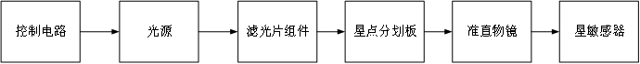
Fig 4. Schematic diagram of working principle of static star simulator
As the core component of a static star simulator, the collimating objective lens has the core function of collimating the starlight passing through the star point splitter on the focal plane into a parallel beam and projecting it onto the star sensor plane, thereby achieving the function of simulating stars in a fixed celestial region ^{[8]}。

3 Design and Analysis of Collimating Objectives
The optical design of the collimating objective lens plays a decisive role in the quality of star point imaging. It is necessary to avoid star point size exceeding the limit or image blurring, and ensure that the single-star opening Angle meets the resolution requirements of the star sensor. For the performance evaluation of the optical system of the static star simulator, the key performance parameters such as the dot plot, distortion and MTF value are analyzed emphatically.
3.1 Optimal Design and Analysis of Optical Systems
The coaxiality of the optical axis between the star simulator and the star sensor is the core requirement to ensure the efficient coupling of optical energy. According to the principle of pupil connection ^{[9]}, the pupils of the two need to achieve conjugate matching, that is, the exit pupil plane of the star simulator should be completely coincident with the entry pupil plane of the star sensor. To meet this matching condition, the star simulator adopts an external exit pupil design. This design is significantly different from traditional imaging optical systems, which usually place the exit pupil inside the optical system. The schematic diagram of pupil connection is shown in Figure 5.
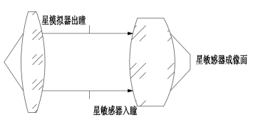
Fig 5. Schematic diagram of pupil connection
3.2.2 Optical System design
3.2.1 Selection of the initial structure of the optical system
Based on the usage requirements of the star sensor and the determination of the research objectives of this paper in Section 2.1, we can determine the main technical indicators of the optical system as shown in Table 3.
Table 3. Main design indexes of optical system
Names of the main design indicators | Indicator requirements
Collimating objective field of view | 20°
The exit pupil diameter of the collimating objective lens
The exit distance of the collimating objective lens from the pupil | 15mm
Design spectral range | 700nm～800nm
Central design wavelength | 750nm
A single star at an Angle | ≤25″±2″
Working environment temperature | -30℃~60℃
After clarifying the technical indicators of the optical system of the star simulator, it is necessary to determine the initial structure of the optical system for optimized design. There are usually two methods for determining the initial structure：
First, the analytical method. The initial structural parameters are solved through aberration calculation based on the aberration theory.
Second, the scaling method. Based on the design performance index requirements, select the structure similar to the target parameters for parameter scaling to obtain the initial design structure. Subsequently, based on the type of aberration, a global optimization algorithm is adopted to iteratively optimize the system parameters. Through multiple optimizations, the design index requirements are met.
In this paper, the scaling method is adopted to select the initial structure of the optical system. Before selecting the initial structure, the focal length of the star simulator needs to be calculated. The focal length is the distance from the principal point to the focus in an optical system, which determines the imaging characteristics of the system. The focal length of a star simulator is the angular parameter that converts the geometric dimensions of the star point scoreboard into an infinitely distant simulated star point. The focal length is determined based on the single-star opening Angle and the appropriate star point scribbling diameter of the star point scribbling plate, as shown in Equation (3-1).
(3-1)
Among them,$f^{'}$is the focal length of the star simulator,$d^{'}$ is the diameter of the star point delineation on the star point reticle, $θ^{'}$ is the Angle of the simulated single star.
From Equation (3-1)，it can be seen that the smaller the Angle $θ^{'}$ of a single star is,the smaller the corresponding value of $d^{'}$ will be, while $f^{'}$ needs to be increased. Furthermore, the smaller the $d^{'}$，the lower the energy will be accordingly. Therefore, when designing a star simulator, the choice of $d^{'}$ needs to be moderate. If a smaller single-star Angle $θ^{'}$needs to be simulated, $f^{'}$should be appropriately increased. This means that the smaller the simulated single-star opening Angle is, the greater the required focal length $f^{'}$ will be，An increase in the focal length $f^{'}$ will lead to a larger system size and heavier weight, and at the same time, the design difficulty will also increase, making the correction of aberrations more complex.When choosing the focal length $f^{'}$，it is necessary to comprehensively consider the processing difficulty and the overall size of the simulator to achieve a balance between performance and feasibility. Based on previous design experience, the focal length of the optical system of the star simulator is 60mm.
There is a rich library of optical system models in the Code V software. When designing the initial structure of the optical system of the star simulator, models similar to the design requirements can be selected from these model libraries. Usually, the screening is based on the f-number and half-field of view of the optical system, where the F-number of the optical system is the ratio of the focal length to the exit pupil diameter.
 | 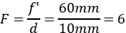 | (3-2)
Search for the optical system model with a half-field of view of 8° to 12° and an F-number of 4 to 8 in the patent lens library of Code V. The specific operation is shown in Figure 6.
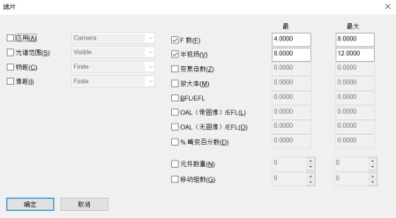
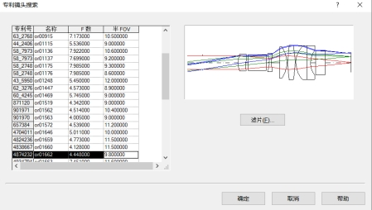
Fig 6. Initial structure selection of optical system
The design of the star simulator is generally an optical system with the exit pupil outside. Therefore, in the screening process, the optical system with the exit pupil outside is mainly selected. The initial structure diagram of the selected optical system is shown in Figure 7.
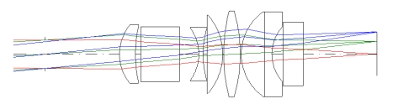
Fig 7. Optical system in lens patent Library

3.2.2 Optical system optimization design
The initial structure of the optical system was optimized based on the Code V software, and the optimization process is as follows.
Based on the parameters of the initial optical system, the basic parameters such as the spectral range, exit pupil diameter and exit pupil distance of the optical system are adjusted to the target design values.
Set the parameters of the optical glass such as the center thickness, curvature radius, lens spacing and material type as variable, and optimize and control them through special constraints (such as the total length of the optical system, field curvature, distortion and chromatic aberration, etc.) to ensure that the imaging quality meets the design requirements. Meanwhile, under general constraints, the thickness and air gap of different optical glasses are restricted to ensure the processability and assembly stability of the structure.
The Global Synthesis module in Code V software was used to carry out the optimization design work for the selected initial optical system. Through multiple iterative operations and screening and analyzing the results of each operation, the system performance is continuously optimized and adjusted. Through such repeated operations, the system performance was gradually improved until the initial design requirements were met.
During the initial optimization stage, the system defaults to using virtual glass for design, and then it needs to be replaced with real glass that is actually available for purchase. Through the glass adaptation function of Code V, specific glass models with similar performance to virtual glass are screened out from the glass libraries of mainstream manufacturers to achieve the manufacturability of the design.
After replacing with the real glass model, the optical system is further optimized based on the determined glass model to generate a new optical system. Subsequently, the image quality of the designed optical system was evaluated, and key parameters such as the dot plot, distortion, and modulation transfer function (MTF) of the system were analyzed. After multiple iterations and optimizations, the system performance fully met the design index requirements.
The optical path of the static star simulator's optical system is shown in Figures 8.
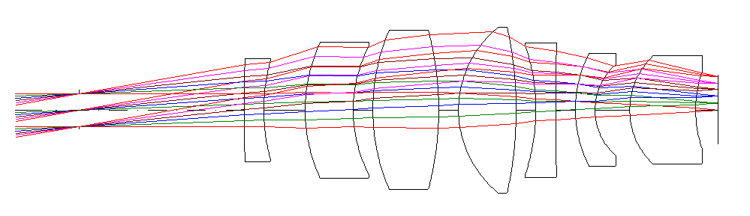
Fig 8. Schematic diagram of optical system
The system consists of 7 lenses, with a focal length of 60mm, an exit pupil distance of 50mm, The diameter of the entry pupil is ，The maximum field of view is ，The total length of the optical system is 57mm, and the maximum aperture is at the fourth lens, which is 47.6023mm. The total weight of the lenses is 300g.
3.2.3 Image quality analysis of optical systems
In the optical design process, the image quality evaluation results are the key basis for adjusting design parameters. Optical performance can be analyzed through indicators such as the system's dot plot, distortion, and modulation transfer function (MTF), providing a comprehensive and effective evaluation of the system's imaging quality。
3.2.3.1 Dot list diagram
The size and shape of the star points in the dot sequence diagram directly reflect the accuracy of the single-star spread Angle. The ideal point array diagram should present as compact and uniform star points to ensure that the star sensor can accurately identify the star points simulated by the star simulator.
A dot sequence diagram is a dispersion graph of all the light rays emitted by a point passing through an optical system on the image plane. It can approximately represent the energy distribution of the image point and thereby evaluate the imaging quality of the system.
The quality evaluation indicators of a point-list graph mainly include two characteristic parameters: the geometric maximum radius and the root mean square (RMS) radius. The geometric maximum radius is defined as the maximum deviation distance of all ray intersection points on the image plane from the principal ray intersection point. This parameter only reflects the maximum value of the system aberration and cannot characterize the concentration of the energy distribution. The root mean square radius, by calculating the root mean square deviation of the distance between each intersection point of light rays and the intersection point of the main light rays, can reflect the concentration of light energy and is more suitable for evaluating the actual imaging quality of the system ^{[10]}。
A dot plot is a geometric image spot formed when a lens captures an image of a point target. The point sequence diagrams of the light rays in each field of view of the static star simulator are shown in Figures 9.
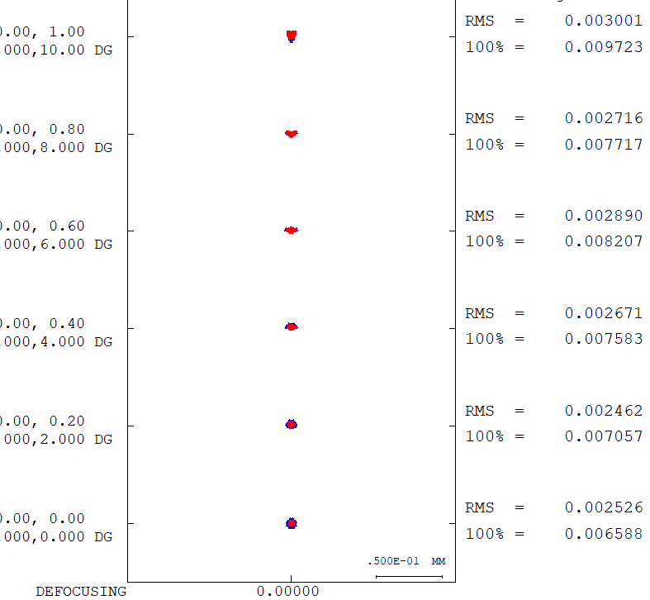
Fig 9. Point diagram of optical system
The dot plot sizes of each field of view of the optical system are obtained from Figures 3 and 5. There are six different fields of view: 0, 0.2, 0.4, 0.4, 0.8, and 1.0. The values on the right represent the dot plot sizes of different fields of view. The RMS value of the dot plot of the optical system is the largest at a 20° field of view, which is 3.001 μ m.
 | 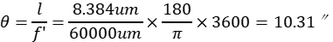 | (3-3)
$l$represents the RMS value of the dot plot, $f^{'}$ is the focal length of the optical system.
It can be obtained from Equation (3-3) that the RMS value of the point sequence diagram of the optical system at 21° field of view is 10.31 ", which meets the requirements of the research objective.
3.2.3.2 Distortion
Distortion refers to the phenomenon where the geometric similarity between an image and an object is disrupted when an optical system forms an image. Specifically, it is manifested as the shape of the image not being consistent with the actual shape of the object, which is caused by the inconsistent magnification of the optical system for different fields of view. From the perspective of optical imaging principles, it is because when light passes through an optical system, the propagation paths of the main light rays in different fields of view deviate from the ideal situation. Distortion can cause the geometric shape of the image to be distorted, which is unacceptable for the application of static star simulators.
According to the distortion definition as shown in Formula (3-4) :
 | 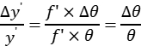 | (3-4)
According to the requirements for the position accuracy of star points in the technical indicators, the maximum relative distortion that the optical system can achieve can be calculated. The detailed calculation results are shown in Equation (3-5) :
 | 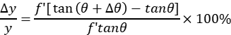 | (3-5)
The distortion magnitude of the optical system is calculated by Equation (3-5) to avoid affecting the imaging quality of the simulator.
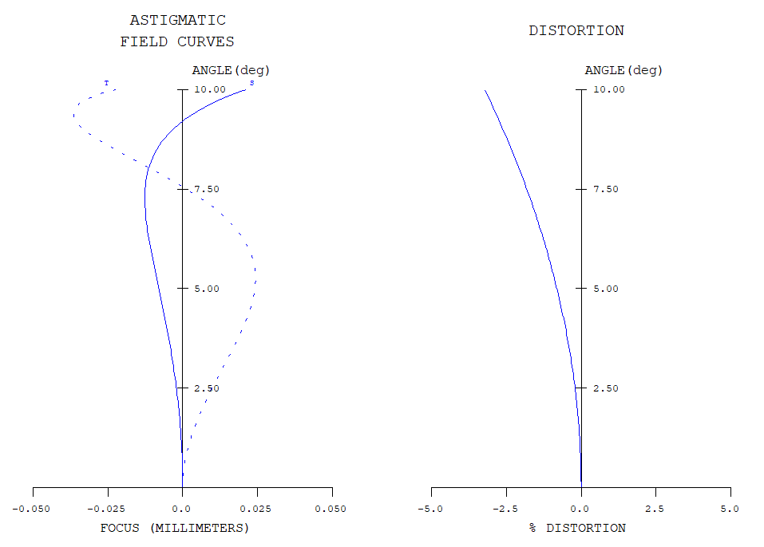
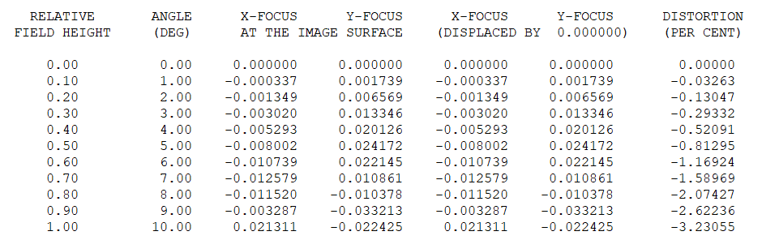
Fig 10. Optical system distortion
It can be seen from Figure 10 that the optical system has the greatest distortion at a field of view of 21°, which is -3.231%.
3.2.3.3 Modulation transfer function（MTF）
The modulation transfer function (MTF) is a function that describes the contrast transfer ability of an optical system to targets of different spatial frequencies. In a static star simulator, it represents the ability of the simulator's optical system to transfer the contrast of the input star points (which can be regarded as objects with certain spatial frequency information) to the output image plane. MTF is used to measure the transmission efficiency of optical systems for signals of different spatial frequencies. A higher MTF value indicates that the energy distribution of star points is more concentrated, which is conducive to improving the single-star spread Angle of the star simulator. When the MTF value is low, it may cause star point blurring or energy diffusion phenomena, thereby reducing the single-star spread Angle of the star simulator. Spatial frequency is usually measured in terms of the number of pairs of lines per millimeter (lp/mm), indicating the number of pairs of black and white lines per unit length.
To calculate MTF, it is necessary to perform ray tracing on the optical system to simulate the imaging conditions of sinusoidal grating-shaped objects with different spatial frequencies after passing through the optical system. In the optical design software Code V, a series of gratings with different spatial frequencies can be set as inputs. After modeling and ray tracing of the simulator optical system, the contrast variation of the output image is analyzed to calculate the MTF curve.
For an imaging system, its spatial resolution is related to the Nyquist frequency. The pixel pitch of the imaging system is d. According to the characteristics of the optical system, its Nyquist spatial frequency $f_{N}$（expressed as the number of line pairs per millimeter lp/mm） can be approximately$\frac{1}{2d}$。When the focal length is 60mm, the single-star opening Angle of 25 "is 7.272um. Therefore, the diameter of the light-transmitting micropores on the star plate engraved in this design is approximately 7.27μm. Based on this, the Nyquist frequency can be calculated. The calculation process is as shown in Equation (3-6):
 | 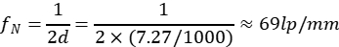 | (3-6)
The MTF curve of the optical system at 69lp/mm is shown in Figure 11.
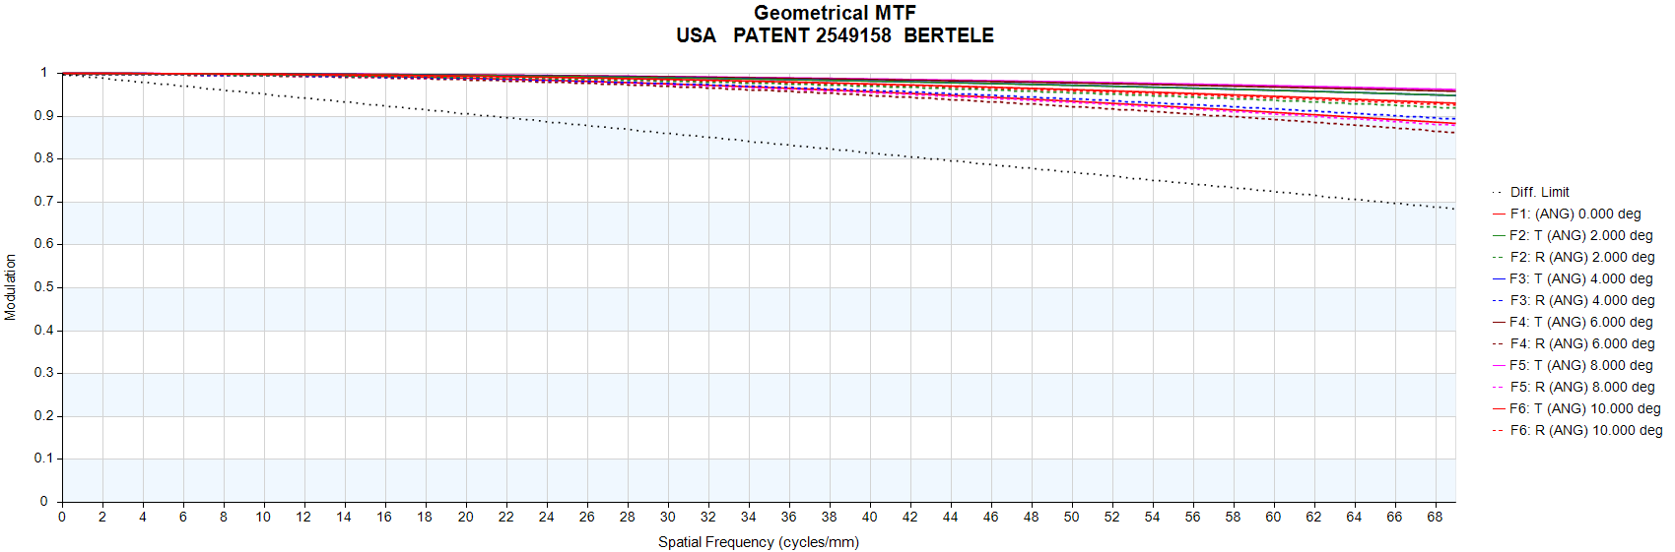
Fig 11. MTF curve
As can be seen from the above figure, the MTF value of the optical system in the full field of view at 69lp/mm is all higher than 0.85, which proves that the optical system has a good imaging effect.

4 Summary and Prospect
4.1 Summary
This paper conducts the design work of a static star simulator based on two parts: the optical system and the opto-mechanical structure. A high-precision wide-field-of-view star simulator suitable for high and low temperature environments is designed. During the research process, the following main works were carried out:
1）Through systematic literature research and in combination with the technical parameters of mainstream domestic star sensors, the key performance indicators of the star simulator were determined. On this basis, the research objective of the static star simulator was clarified. The main parameters of the star simulator were simulated and analyzed, providing a theoretical method for the subsequent design of the optical system and opto-mechanical structure of the star simulator, thereby ensuring that the star simulator can achieve the design of an optical system with high imaging quality.
2）Based on the F-number and half-field of view parameters of the optical system, a suitable optical system was screened out from the patent lens library of the Code V software as the initial structure, and the system performance was improved through iterative optimization. The RMS value of the dot plot of the optimized optical system reaches 3.001um (10.31 "), and at a spatial frequency of 69lp/mm, the MTF value of the full field of view is better than 0.85.
4.2 Outlook
The advancement of aerospace technology has driven up the demand for the accuracy of spacecraft attitude positioning, which directly prompts the continuous upgrading of the performance standards of star sensors. Against this backdrop, star simulator technology is evolving towards a wide field of view and high precision.

COMPETING INTERESTS DISCLAIMER:
Authors have declared that they have no known competing financial interests OR non-financial interests OR personal relationships that could have appeared to influence the work reported in this paper.

References
[1] Sun Bo. Research on Key Technologies of High-Precision Attitude Measurement for Spaceborne Satellite Sensors [D] Jilin University,2024.Gan J X ,Chen Y .Star Simulator Base on Multiple LEDs, Optical Fiber and Integral Sphere[J].Applied Mechanics and Materials,2014,3546(672-674):2048-2051.
[2]NEUMANN N, SAMAAN M, CONRADT M, et al. Attitude Determination for the SHEFEX-2 Mission Using a Low Cost Star Tracker[C]. 2013.
[3]NEUMANN N, SAMAAN M, CONRADT M, et al. Attitude Determination for the SHEFEX-2 Mission Using a Low Cost Star Tracker[C]. 2013.
[4]Chen Xiaoning, Sun Tao, Li Ying. Research and Design of Detection Bands for Digital Zenith Photogrammetry [J]. Surveying and Mapping Technology Equipment, 2009, 9 (001): 13-15.
[5]Zheng Ru, Zhang Guoyu, Gao Yue, et al. Optical System Design of Dynamic Star Simulator Based on LCOS splicing Technology. Journal of Scientific Instrument.2012(9) : 2145-2149
[6]Gong Yan, Hu Yining, Zhao Yang. Design of a Small Star Simulator Based on Digital Light Processing Technology. Optics and Precision Engineering.2007,15(11) : 1699-1702
[7]Gong Yan, Hu Yining, Zhao Yang. Design of a Small Star Simulator Based on Digital Light Processing Technology. Optics and Precision Engineering.2007,15(11) : 1699-1702
[8] Wang Shiran, Wang Lingyun, Zheng Ru, et al. Design of Collimation Optical System for Long Exit pupil Distance Static Star Simulator [J]. Journal of Changchun University of Science and Technology (Natural Science Edition),2023,46(03):39-45.
[9] Xu Honggang, Han Bing, Li Manli, et al. Design and Verification of High-precision Wide-Field Multi-Satellite Simulator [J]. Chinese Optics,2020,13(06):1343-1351.
[10]Chen Na, Wang Lingyun, Li Guangxi, et al. Design of Collimation Optical System for Static Star Simulator [J]. Journal of Changchun University of Science and Technology (Natural Science Edition),2019,42(05):23-26.

