AI-Powered Digital Twin Platforms for Next-Generation Structural Health Monitoring: From Concept to Intelligent Decision-Making.

Abstract
The combination of Artificial Intelligence (AI) and Digital Twin (DT) technologies is changing the way Structural Health Monitoring (SHM) works. It is moving from reactive inspection to proactive, self-managed infrastructure management. This study presents a comprehensive AI-driven digital twin framework that incorporates real-time sensors, adaptive analytics, and closed-loop feedback systems to improve predictive accuracy, facilitate autonomous damage assessment, and refine lifecycle maintenance techniques. The system architecture integrates IoT-enabled sensor networks, edge-cloud data processing, sophisticated AI models such as physics-informed machine learning, graph neural networks, and Bayesian deep learning, together with immersive digital twin visualization to aid decision-making. The framework can predict the remaining useful life, find flaws on its own, and suggest the best maintenance actions in case studies in civil infrastructure, aircraft, and renewable energy. The results show that there is a lot of room for improvement in terms of reducing downtime, enhancing safety, and cutting operational costs, all while allowing for flexible reactions to changing structural circumstances. This integration is a key step toward self-sustaining SHM ecosystems. It sets the stage for future infrastructure systems that can learn on their own and maintain their own health.
Keywords: Artificial Intelligence, Digital Twin, Structural Health Monitoring, Predictive Maintenance, Infrastructure Resilience

1. Introduction

1.1 Context & Motivation
Urbanization, climate change, and the aging of important structures like bridges, high-rise buildings, offshore platforms, and energy facilities have all led to a huge increase in the need for smart, strong, and long-lasting infrastructure. Even little structural failures can have terrible effects on people's safety, the economy, and the environment. In the past, Structural Health Monitoring (SHM) systems depended a lot on physical inspections, regular maintenance, and rudimentary data collection from sensors. These methods have made things safer, but they have several problems: inspections take a lot of time and are prone to human error, finding faults often takes too long until the damage is serious, and maintenance decisions are usually based on what has already happened instead of what will happen. As infrastructure systems get bigger and more complicated, we need monitoring technologies that can constantly check the structural integrity in real time, find new problems early, and improve maintenance plans before breakdowns happen[1].

1.2 Rise of Digital Twin in Engineering
The Digital Twin (DT) paradigm has come to be a game-changing way to deal with these problems. Digital twins (DTs) were first created as static computer simulations to imitate engineering systems. However, because to better sensors, connections, and cloud computing, they have turned into digital copies of real-world assets that are continually changing. A digital twin (DT) is an interactive platform that shows how a structure is performing right now by merging data from a number of different sources, such as sensor streams, inspection records, and simulation models[2]. Engineers can use this feature to see how a structure will behave in the future, come up with "what if" scenarios, and watch how it will behave in a virtual context before making modifications in the actual world. Governments and businesses all across the world are giving money to "smart infrastructure" projects. In the future, this will mean that DTs will be a significant part of managing assets[3].

1.3 AI as the Game-Changer
DTs are excellent for monitoring activities; however, they are genuinely enhanced when AI is implemented. SHM data that is difficult to comprehend and has numerous dimensions can be analyzed using machine learning, deep learning, and hybrid AI algorithms to identify significant information. This enables you to more accurately and quickly identify, classify, and estimate damage than ever before[4]. Additionally, AI models may be able to adjust to structural changes, learn from new data in real time, and assist in autonomous decision-making for operational control and maintenance. SHM systems can transition from passively monitoring infrastructure to actively administering and enhancing it by incorporating AI-driven analytics into DT platforms[5].

1.4 Research Gap & Paper Objectives
Although significant progress has been made, the majority of the current DT implementations in SHM are still solely data-driven visualization tools that lack predictive intelligence or autonomous control. There are still challenges in determining the degree of uncertainty in forecasts, creating models that can be modified, and combining various types of data. This study suggests a comprehensive AI-driven Digital Twin framework for next-generation Structural Health Monitoring (SHM). The framework includes real-time sensing, adaptive AI analytics, and closed-loop feedback mechanisms. The objective is to demonstrate how this type of integrated platform can assist in the development of robust, intelligent infrastructure systems by reducing the lifecycle costs of structures and enhancing their stability.

2. Background & Literature Review

2.1 Structural Health Monitoring Evolution
Structural Health Monitoring (SHM) has been the subject of three primary iterations. The late 1900s saw the introduction of the initial iteration of SHM that utilized sensors. It was founded on the acquisition of data from displacement transducers, accelerometers, and strain sensors[6]. This system enabled you to consistently monitor critical structural components; however, it was not particularly practicable due to the necessity of manual data interpretation and basic alarms that were based on thresholds. Finite element models and statistical methods were employed by the second iteration of model-based SHM to investigate the discrepancies between predicted and measured responses. This simplified the process of identifying issues and determining the status of the situation. However, it was challenging to employ in real time due to the inaccuracies of the model and the necessity of periodically recalibrating it. The third generation of AI-enhanced SHM utilizes advanced signal processing, deep learning (DL), and machine learning (ML) to identify issues, organize them into categories, and generate predictions[7]. This enhances the precision of the process and enables the implementation of predictive maintenance.

2.2 Digital Twin Fundamentals
A Digital Twin (DT) is a virtual representation of a physical object that is perpetually updated with new data. There are three primary types of DTs:
• Component-level DT: This illustrates the various components of the structure, such as beams, joints, or bearings.
• System-level DT: by modeling the entire structure, it illustrates how all components function in conjunction[8].
• Process DT: replicates business procedures, including the management of loads, the scheduling of maintenance, and the planning of restorations.
DTs are responsible for the design, operation, and maintenance phases of an asset's life cycle in each of these regions. By simulating numerous scenarios, DTs facilitate optimization throughout the design process. They utilize sensor data in real time to monitor the situation while they are in operation. They assist in the process of decision-making during maintenance by predicting the severity of the situation and experimenting with various strategies to address it[9].

2.3 AI in SHM
Artificial Intelligence (AI) has emerged as a crucial facilitator of improved Structural Health Monitoring (SHM). Machine Learning (ML)-based anomaly detection techniques, including support vector machines, k-means clustering, and random forests, are utilized to discover deviations from typical structural behavior. Deep learning models, especially convolutional neural networks (CNNs) and recurrent neural networks (RNNs), are very good at figuring out what kind of harm has been done based on sensor outputs and image-based inspections, even when there is a lot of noise[10]. Reinforcement learning (RL) is becoming a way to improve maintenance scheduling by learning intervention strategies that balance risk, cost, and downtime over the life of the asset. Not only can these AI methods make detection more accurate, but they also let you make decisions based on data that can be scaled up[10].

2.4 Integration Efforts in Literature
Recent research has looked into AI-enhanced DT systems in a number of fields. AI-powered DTs are used in aerospace to keep track of fatigue in aircraft fuselages and forecast the growth of cracks in turbine blades. In civil engineering, DTs have been put in smart bridges and tunnels to look at load patterns and keep track of how structures change shape. Wind farms and offshore platforms in the energy sector use DTs to combine real-time environmental data with AI algorithms that can provide predictions about maintenance[11]. Even with these improvements, there are still several major problems:
• Data heterogeneity: It's hard to make sense of data from different sensors and formats that come from different sources.
• Computational scalability: Real-time DT updates across huge infrastructures require a lot of processing power.
• Uncertainty quantification: It's hard to say how sure you are about AI-driven forecasts, which is very important for decisions that affect safety[12].

2.5 Knowledge Gap & Research Opportunity
Most research treats AI and DT as separate or just loosely related parts, and efforts to combine them are usually limited to certain uses. There aren't many platforms that can truly bring together real-time sensing, adaptive AI analytics, and closed-loop DT feedback systems that can change how things are done on their own. This gap offers a distinct research opportunity: the creation of cohesive AI-driven digital twin frameworks capable of perpetual learning from changing structural conditions, handling uncertainty, and making proactive maintenance decisions with minimal human involvement. Such frameworks could be a big step toward making SHM ecosystems that can support themselves and make infrastructure more resilient in a time when things are getting more complicated and more people want them[13].

3. Conceptual Framework for AI-Powered Digital Twin in SHM

3.1 System Architecture Overview
The suggested AI-powered Digital Twin (DT) framework for Structural Health Monitoring (SHM) is a five-layer system that brings together physical assets, sensing, analytics, visualization, and decision-making in a smooth way. The physical asset layer is where the structure being looked at, such a bridge, tower, or offshore platform, is always interacting with environmental and operating stresses. The data acquisition layer collects these interactions using a lot of different sensors that are all connected to each other[14]. Using powerful machine learning and hybrid modeling techniques, the AI analytics layer evaluates raw data, finds features, finds abnormalities, and predicts degradation. The DT visualization layer gives a real-time, interactive digital picture of the asset that lets you explore its current and future situations in depth. Finally, the decision support layer uses AI-driven insights to suggest the best ways to maintain equipment, change operations, or lower risks. This closes the loop between observation and intervention[15]. Figure 1 shows the suggested architecture. It shows how the layers of integration work together, from physical assets to data collection, AI analytics, and visualization, all the way to decision support with a feedback loop back to the physical system.
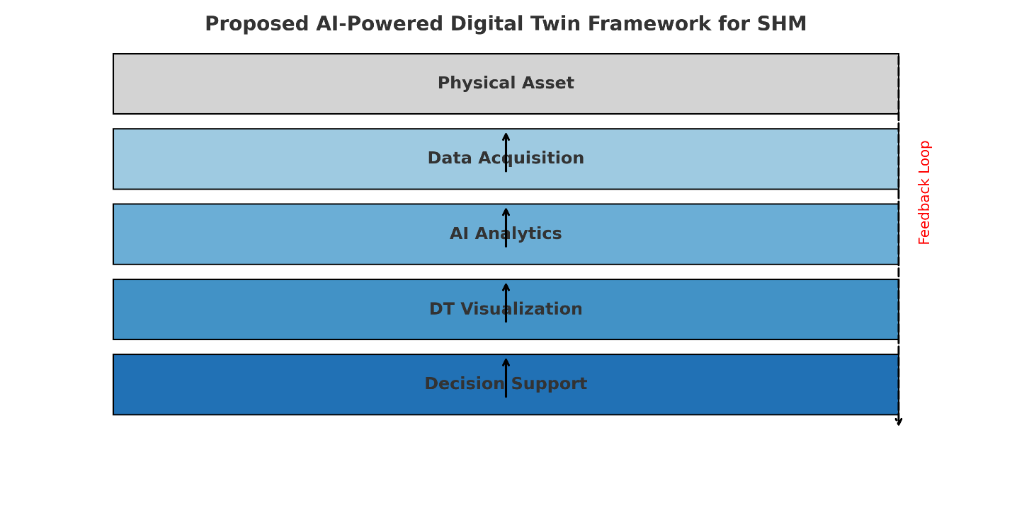
FIGURE 1. The proposed AI-powered Digital Twin Framework for Structural Health Monitoring.
Figure 1 shows the proposed AI-powered Digital Twin Framework for Structural Health Monitoring. The five-layer architecture includes: (1) the Physical Asset layer, which captures how real-world infrastructure behaves; (2) the Data Acquisition layer, which uses IoT-enabled sensors; (3) the AI Analytics layer, which combines machine learning and hybrid modeling; (4) the DT Visualization layer, which provides a real-time, immersive asset representation; and (5) the Decision Support layer, which generates actionable maintenance recommendations. Arrows show data flow and the feedback loop that allows for closed-loop operational control. This figure shows the conceptual framework of the proposed AI-powered Digital Twin system for SHM. It shows how information is processed in order, from sensing the physical asset to making decisions, and how the DT stays in sync with the real asset through a continuous feedback mechanism.

3.2 Data Acquisition & Sensor Networks
For an AI-powered DT to work, it needs to be able to sense things accurately and in detail. Smart sensors that work with the Internet of Things (IoT), like strain gauges, accelerometers, fiber Bragg grating sensors, and acoustic emission devices, let you keep an eye on mechanical, thermal, and environmental factors all the time. These sensors are commonly used in large groups to measure how structures behave both locally and globally. To keep latency low and avoid data transfer bottlenecks, sensor nodes or local gateways have edge computing capabilities built in. This lets data be filtered and sent based on events. Emerging 5G and eventual 6G wireless networks make connectivity even better by offering ultra-reliable low-latency communication (URLLC), which lets DT sync up in almost real time even in dangerous or inaccessible areas[16].

3.3 AI Models for SHM
The AI analytics layer uses a mix of Bayesian deep learning, Graph Neural Networks (GNNs), and physics-informed machine learning (PIML) to provide predictions that are both correct and easy to understand. PIML gives learning algorithms information that is specific to a certain field, such as how structures move and what materials are comprised of. This helps them generalize better when there isn't a lot of data or when the data is noisy. GNNs are useful for modeling structural topology because they can depict elements and joints as nodes and edges. This helps them demonstrate how loads move between different parts of a structure[17]. Bayesian deep learning makes predictions more accurate by adding probabilistic reasoning. This is useful for making decisions that are important for safety since it delivers assessments that take uncertainty into consideration. You can discover damage, figure out how bad it is, and guess how much longer it will last (RUL) with a high level of confidence when you utilize these methods together[17].

3.4 DT Feedback Mechanisms
One big advantage of DT-driven SHM is that it always stays in sync with the actual asset. The framework lets data flow both ways: sensor data goes to the DT so it can update the state in real time, and the DT's simulation and predictive models can send control commands or modifications to the physical system back. The AI layer activates on-demand model changes to improve predictions when it recognizes something weird, like strange vibration patterns or stress concentrations. This makes sure that changing structural conditions are appropriately represented. This closed-loop feedback system changes the DT from a passive digital copy into a system that actively gathers and uses information[18,19].

3.5 Interoperability & Standards
The system leverages open data formats like Industry Foundation Classes (IFC) for structural information and CityGML for modeling urban environments. This makes it easy to scale and work in different areas. After the latest standardization efforts for digital twins, such ISO 23247 for DT frameworks and CEN standards for infrastructure interoperability, it is now easier to make sure that different SHM systems, platforms, and asset types can work together. Standardization also makes it easier to follow the standards and migrate AI models from one project or sector to another, which helps people share what they know.
In short, the proposed conceptual framework combines real-time sensing, strong AI analytics, immersive DT visualization, and smart decision-making into one SHM platform. This design changes infrastructure systems from reactive maintenance to self-adaptive, predictive health management. This is the first step toward operations that are strong and last a long time[20].

4. Advanced AI Techniques in SHM Digital Twins
The integration of various AI methods into the Digital Twin architecture is summarized in Figure 2, linking each technique to its specific Structural Health Monitoring function.
FIG 2.

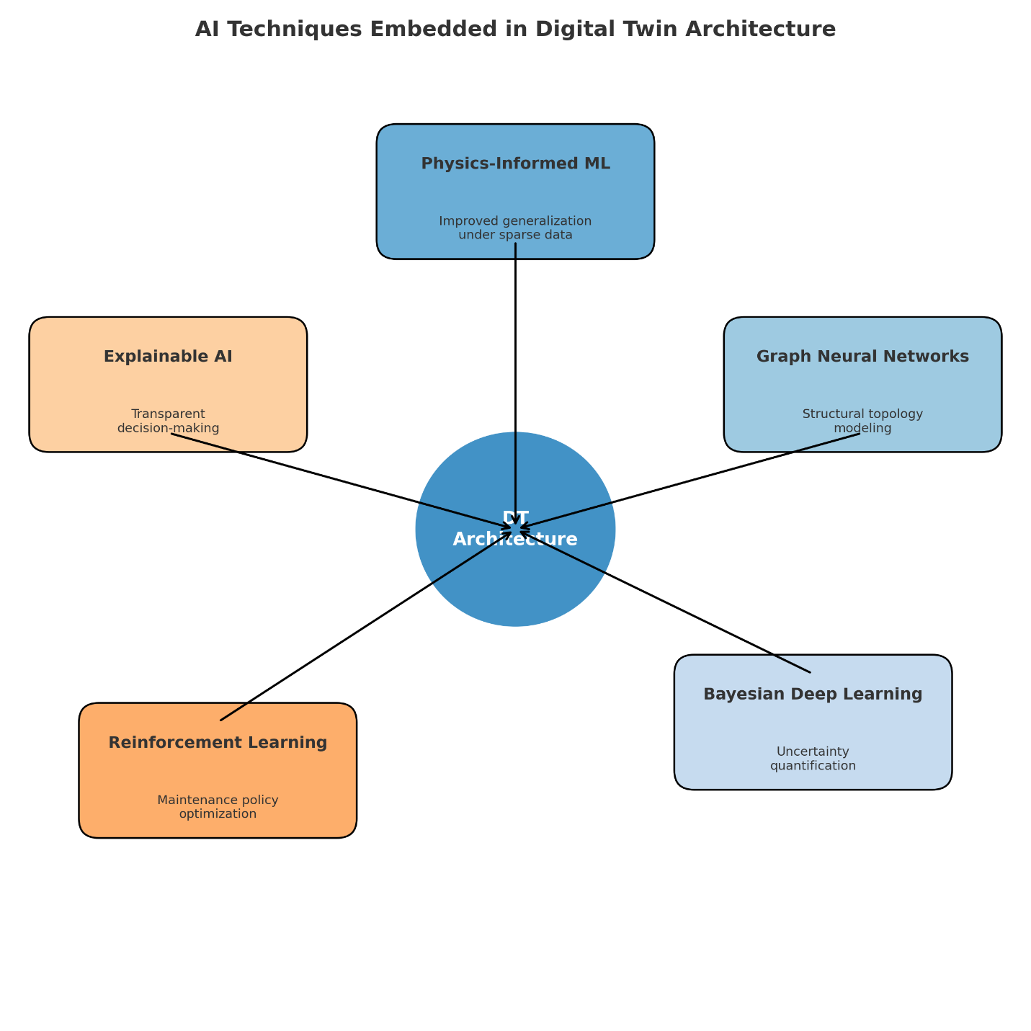
Figure 2: AI methods built into the digital twin architecture. The figure shows how key AI approaches including Physics-Informed Machine Learning (PIML), Graph Neural Networks (GNNs), Bayesian Deep Learning, Reinforcement Learning (RL), and Explainable AI (XAI) are used for Structural Health Monitoring. PIML improves model generalization when there isn't much data; GNNs represent the structure of a system; Bayesian deep learning makes predictions that take uncertainty into account; RL improves maintenance policies; and XAI makes sure that decisions are clear and understandable. This graphic shows how AI methods fit into the proposed Digital Twin framework for SHM by showing how they work. It shows how each technique is related to important operational tasks, so readers can quickly see how multiple AI models work together in predictive maintenance, anomaly detection, optimization, and interpretability.

4.1 Predictive Analytics
Predictive analytics is the basis for AI-powered Digital Twins (DTs) for Structural Health Monitoring (SHM). It lets you predict how things will become worse and what maintenance will be needed. Advanced temporal modeling methods like Recurrent Neural Networks (RNNs) and Long Short-Term Memory (LSTM) networks can figure out how much longer a device will be useful by looking at time-series sensor data that has long-range dependencies. Temporal Fusion Transformers (TFTs) have shown to work better recently by combining multi-horizon forecasting, variable selection, and attention processes. This lets the model dynamically focus on the most important elements across time. DTs can make very precise predictions about RUL by constantly updating them with real-time data. These forecasts can change as structural conditions change[21].

4.2 Autonomous Damage Detection & Classification
Computer vision and signal-based deep learning are making autonomous damage detection more common in AI-enhanced DTs. Convolutional Neural Networks (CNNs) and Vision Transformers can analyze high-resolution images from drones or fixed cameras to find fractures, corrosion spots, and surface defects, frequently with pixel-level accuracy. For finding damage below the surface or inside a structure, acoustic emission analysis combined with deep CNN architectures can help classify stress wave patterns that are linked to the start or spread of cracks. These self-driving systems can run all the time, which means that we don't have to rely on manual inspections as much and that even little modifications in the structure will be found early[22].

4.3 Real-Time Decision Making
Real-time decision-making is necessary for operational optimization in addition to detection and prediction[23]. Reinforcement Learning (RL) techniques, especially Deep Q-Networks (DQNs) and policy gradient approaches, can find the best ways to intervene in maintenance by simulating them in the DT environment. RL agents can suggest when and how to step in when they see abnormalities or foresee degradation by balancing competing goals, such as limiting downtime, lowering operational costs, and making sure safety[24]. These models may keep improving their strategies when they are used with live data streams, which makes them useful in situations where things are always changing and not always clear.

4.4 Explainable AI (XAI)
In areas where safety is really important, like SHM, AI can only be used if people trust it and can understand it. Engineers can use explainable AI (XAI) methods like SHAP (SHapley Additive exPlanations), LIME (Local Interpretable Model-Agnostic Explanations), and saliency mapping to figure out which attributes or sensor data had the biggest effect on a model's prediction. This openness is very important for following the rules, gaining the trust of stakeholders, and looking into failures. Adding XAI to the DT framework makes sure that automated judgments can still be checked, which lowers the risk of relying too much on black-box models[25].

4.5 Uncertainty Management
Because material qualities, stress circumstances, and sensor noise can all change, structural health forecasts are always uncertain. Probabilistic AI models, like Bayesian Neural Networks and Gaussian Processes, measure how uncertain a forecast is, which helps people make decisions that take risks into account. Ensemble learning techniques, which combine predictions from several models, make models even more resistant to noise in the data and biases in the model. In the context of DT, uncertainty estimates can be shown next to deterministic forecasts. This lets asset managers compare their intervention decisions with their confidence levels, which supports a more conservative and evidence-based maintenance plan[26].
In summary, the integration of sophisticated AI methodologies into SHM Digital Twins transforms them from basic monitoring tools into intelligent, self-adaptive systems that are capable of making decisions, identifying issues, and optimizing them. The integration of all of these features facilitates the transition to fully automated infrastructure health management.
5. Implementation Challenges and Solutions

5.1 Data Challenges
The effectiveness of AI-powered Digital Twins (DTs) for Structural Health Monitoring (SHM) is contingent upon the quality, continuity, and dependability of sensor data[27]. However, it is not uncommon for data to be absent due to transmission defects or device malfunctions, which could potentially reduce the model's accuracy. Bias can be generated by sensor drift, which is the gradual alteration of sensor values over time. Models may become less stable due to non-stationary circumstances, which are induced by fluctuating operational or environmental pressures[28]. Some solutions include data imputation methods, such as matrix factorization and k-nearest neighbors, which fill in missing data, and domain adaptation methods, which modify models to account for changes in the environment. The reliability of data is enhanced by periodically calibrating sensors and employing preprocessing processes that are cognizant of anomalies[29].

5.2 Scalability & Computational Cost
For large-scale infrastructure systems, real-time DT synchronization and AI inference require a lot of computing power. Processing pipelines can get too much data when there are a lot of high-frequency sensor data streams, especially in city-scale networks. A cloud-edge hybrid architecture is a good way to solve the problem. Edge devices do the initial filtering, feature extraction, and event-driven alerts, while cloud servers do the heavy lifting of simulations and model training. Using a GPU or TPU to speed up deep learning models can greatly lower inference latency, which makes sure that decisions are made on time. Dynamic load balancing between cloud and edge nodes makes scalability even better[30].

5.3 Cybersecurity & Privacy Concerns
When physical assets, AI models, and DT platforms keep sending data back and forth, it creates security threats like data tampering, illegal access, and denial-of-service attacks. Secure data exchange using blockchain technology creates transaction records that can't be changed, which protects data integrity and traceability. Federated learning lets decentralized model training across remote nodes without sending raw data. This keeps proprietary or sensitive information from being shared too much. Combining these technologies makes people more trusting of the DT ecosystem and helps it follow new cybersecurity rules[31].

5.4 Integration with Legacy Systems
A lot of infrastructure assets use old SHM systems that don't work with new DT platforms. It is often not possible to replace these systems completely for economic reasons. API middleware solutions can let old and new systems talk to each other by changing the way data is sent and received. Also, modular DT frameworks let you add complex AI features slowly without messing up how things are done now. This method allows for gradual updating and lowers the possibility of having to completely revamp the system[32].

5.5 Standardization & Regulatory Compliance
The lack of widely acknowledged standards for AI-powered DTs makes it harder for different platforms and asset kinds to work together. Using industry standards like ISO 23247 for DT frameworks, IEC 61400 for monitoring wind turbines, and IFC schemas for building information modeling makes guarantee that different platforms can operate together. Following these standards makes it easier for regulators to approve things, lets stakeholders share data, and helps the DT infrastructure last for a long time[33].
In short, to get the most out of AI-powered DTs in SHM, we need to solve problems with data quality, scalability, security, integration, and standards. Using a mix of technical solutions and governance frameworks can speed up acceptance by a lot and make sure that deployment is long-lasting and large-scale.

6. Case Studies & Applications
The diverse applications of AI-powered Digital Twins across civil, aerospace, and energy sectors are illustrated in Figure 3, highlighting key operational benefits achieved in each domain.
FIGURE 3.

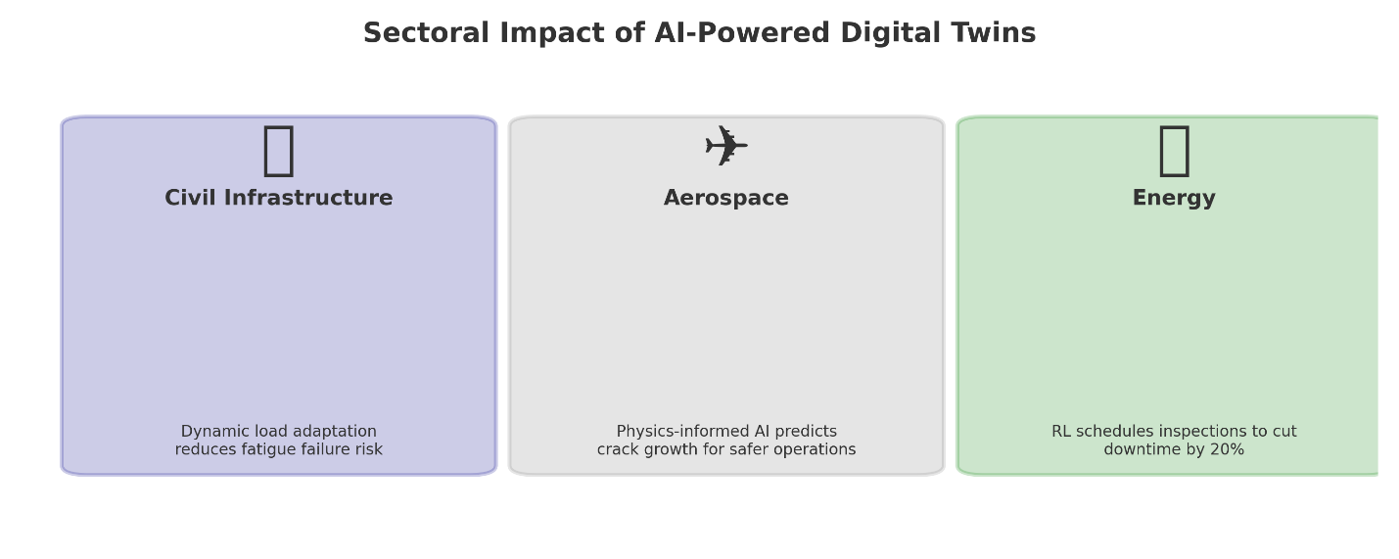
Figure 3: The effect of AI-powered digital twins on different sectors. Dynamic load adaptation is used in civil infrastructure applications (left) to lower the risk of fatigue failure. Physics-informed AI is used in aerospace applications (middle) to predict crack growth and make operations safer. Reinforcement learning is used in energy sector deployments (right) to plan inspections, which can cut turbine downtime by up to 20%. This image shows three examples of industries where AI-powered Digital Twins have been used: civil infrastructure, aerospace, and energy. There is a symbolic depiction of the asset kind, a short description of the AI-DT integration, and a significant measurable advantage on each panel. The overview gives a broad picture of how the technology can be used in different fields and how it affects them.

6.1 Civil Infrastructure
Smart bridge monitoring is a common use for AI-powered Digital Twins (DTs). For safety and efficiency, real-time load prediction and modeling of how the structure will respond are very important. In one deployment, a dense array of strain gauges and accelerometers sends continuous data to an AI-enhanced DT. This DT employs recurrent neural networks to forecast how the load would be distributed under different traffic and weather situations. The DT lets you change weight limits and traffic control on the fly when things are really stressful, which greatly lowers the chance of failures caused by weariness[34].

6.2 Aerospace
AI-DT integration for predicting fatigue crack propagation has helped the aerospace industry keep an eye on aircraft fuselages. A physics-informed machine learning model built into the DT is always getting high-resolution structural scans and vibration data. This model predicts how cracks will spread under different flight cycles, weather conditions, and load histories. Before putting a repair plan into action, maintenance staff can test it out in the DT. This cuts down on aircraft downtime and makes sure the plane is safe to fly[35].

6.3 Energy Sector
Digital Twin-driven SHM has been improved with reinforcement learning for wind energy to help schedule maintenance for turbines that work in a variety of weather situations. DTs that are specialized to turbines combine sensor data on the vibration of the blades, the load of the wind, and the operation of the gearbox. The reinforcement learning agent looks at long-term cost-performance trade-offs and schedules inspections and component replacements on its own at periods that will give the most energy output while keeping operational expenses as low as possible. Field implementations have shown that AI-DT synergy can cut down on unexpected downtime by as much as 20%, which shows how useful it could be for renewable energy infrastructure[36].

7. Future Research Directions
Self-evolving models that can adapt on their own are the next step for AI-powered DTs in SHM. In the future, AI algorithms will include continuous learning pipelines, which will allow DTs to update structural behavior models without having to retrain them by hand, even when operating conditions change a lot.
Another promising direction is the use of metaverse-based immersive SHM control rooms. Engineers may interact with 1:1 scale virtual replicas, model interventions, and plan maintenance together in very intuitive, spatially aware settings by merging real-time DT visualization with virtual reality (VR) and augmented reality (AR) interfaces[37].
Finally, quantum computing could lead to big improvements in large-scale DT simulations, especially for networks with many assets and complicated structural dynamics. Quantum algorithms could cut down on the time it takes to do uncertainty quantification and scenario analysis by a lot. This would make it possible to quickly evaluate thousands of maintenance and operating solutions[38].
To make sure that future AI-DT systems are not only smarter and more adaptable but also useful for real-world use in safety-critical infrastructure, structural engineers, AI researchers, and computational scientists will need to work together across fields.

8. Conclusion
This study has put up a complete plan for combining Artificial Intelligence (AI) and Digital Twin (DT) technologies to improve next-generation Structural Health Monitoring (SHM). The suggested method changes SHM from a reactive, inspection-based process into a proactive, predictive, and self-optimizing system by combining real-time sensing, adaptive AI analytics, and dynamic DT feedback loops. In civil infrastructure, aerospace, and renewable energy, case studies show how AI-DT synergy may lead to real benefits, such as more accurate damage diagnosis, better maintenance scheduling, and longer asset life[39].
The possible effects are big: less downtime thanks to predictive maintenance, better safety thanks to early anomaly detection, and lower costs thanks to better lifecycle management. This confluence sets the stage for robust, intelligent infrastructure ecosystems that can change with the times with little help from people, in addition to providing immediate operational benefits.
In the future, the path to fully autonomous infrastructure health management will include improvements in self-evolving AI models, immersive metaverse-based digital twin interaction, and quantum-accelerated simulations. To make this vision a reality, there has to be ongoing research, strong standards, and collaboration amongst different sectors. This will make sure that AI-powered DTs become a key part of future infrastructure resilience[40].

COMPETING INTERESTS DISCLAIMER:
Authors have declared that they have no known competing financial interests OR non-financial interests OR personal relationships that could have appeared to influence the work reported in this paper.

REFERENCES
1. Kapucu N, Ge Y, Rott E, Isgandar H. Urban resilience: Multidimensional perspectives, challenges and prospects for future research. Urban Governance. 2024 Sep 1;4(3):162–79.
2. Botín-Sanabria DM, Mihaita AS, Peimbert-García RE, Ramírez-Moreno MA, Ramírez-Mendoza RA, Lozoya-Santos J de J. Digital Twin Technology Challenges and Applications: A Comprehensive Review. Remote Sensing. 2022 Jan;14(6):1335.
3. Fallah Shayan N, Mohabbati-Kalejahi N, Alavi S, Zahed MA. Sustainable Development Goals (SDGs) as a Framework for Corporate Social Responsibility (CSR). Sustainability. 2022 Jan;14(3):1222.
4. Rahman A, Debnath T, Kundu D, Khan MdSI, Aishi AA, Sazzad S, et al. Machine learning and deep learning-based approach in smart healthcare: Recent advances, applications, challenges and opportunities. AIMS Public Health. 2024 Jan 5;11(1):58–109.
5. Plevris V, Papazafeiropoulos G. AI in Structural Health Monitoring for Infrastructure Maintenance and Safety. Infrastructures. 2024 Dec;9(12):225.
6. Sivasuriyan A, Vijayan DS, Górski W, Wodzyński Ł, Vaverková MD, Koda E. Practical Implementation of Structural Health Monitoring in Multi-Story Buildings. Buildings. 2021 Jun;11(6):263.
7. Mardanshahi A, Sreekumar A, Yang X, Barman SK, Chronopoulos D. Sensing Techniques for Structural Health Monitoring: A State-of-the-Art Review on Performance Criteria and New-Generation Technologies. Sensors. 2025 Jan;25(5):1424.
8. Emmert-Streib F. Defining a Digital Twin: A Data Science-Based Unification. Machine Learning and Knowledge Extraction. 2023 Sep;5(3):1036–54.
9. Werbińska-Wojciechowska S, Giel R, Winiarska K. Digital Twin Approach for Operation and Maintenance of Transportation System—Systematic Review. Sensors. 2024 Jan;24(18):6069.
10. Prakash V, Debono CJ, Musarat MA, Borg RP, Seychell D, Ding W, et al. Structural Health Monitoring of Concrete Bridges Through Artificial Intelligence: A Narrative Review. Applied Sciences. 2025 Jan;15(9):4855.
11. Moenck K, Koch J, Rath JE, Büsch L, Gierecker J, Kähler F, et al. Industry 5.0 in aircraft production and MRO: challenges and opportunities. CEAS Aeronaut J [Internet]. 2025 Apr 5 [cited 2025 Aug 14]; Available from: https://doi.org/10.1007/s13272-025-00832-3
12. Bohačík A, Fujdiak R. The Problem of Integrating Digital Twins into Electro-Energetic Control Systems. Smart Cities. 2024 Oct;7(5):2702–40.
13. Collins C, Dennehy D, Conboy K, Mikalef P. Artificial intelligence in information systems research: A systematic literature review and research agenda. International Journal of Information Management. 2021 Oct 1;60:102383.
14. Sun Z, Jayasinghe S, Sidiq A, Shahrivar F, Mahmoodian M, Setunge S. Approach Towards the Development of Digital Twin for Structural Health Monitoring of Civil Infrastructure: A Comprehensive Review. Sensors. 2025 Jan;25(1):59.
15. Ucar A, Karakose M, Kırımça N. Artificial Intelligence for Predictive Maintenance Applications: Key Components, Trustworthiness, and Future Trends. Applied Sciences. 2024 Jan;14(2):898.
16. Chen L, Xia C, Zhao Z, Fu H, Chen Y. AI-Driven Sensing Technology: Review. Sensors. 2024 Jan;24(10):2958.
17. Sharma P, Chung WT, Akoush B, Ihme M. A Review of Physics-Informed Machine Learning in Fluid Mechanics. Energies. 2023 Jan;16(5):2343.
18. Wang M, Ashour M, Mahdiyar A, Sabri S. Opportunities and Threats of Adopting Digital Twin in Construction Projects: A Review. Buildings. 2024 Aug;14(8):2349.
19. Dihan MdS, Akash AI, Tasneem Z, Das P, Das SK, Islam MdR, et al. Digital twin: Data exploration, architecture, implementation and future. Heliyon. 2024 Mar 15;10(5):e26503.
20. Lam PD, Gu BH, Lam HK, Ok SY, Lee SH. Digital Twin Smart City: Integrating IFC and CityGML with Semantic Graph for Advanced 3D City Model Visualization. Sensors. 2024 Jan;24(12):3761.
21. Ghaffari A, Shahbazi Y, Mokhtari Kashavar M, Fotouhi M, Pedrammehr S. Advanced Predictive Structural Health Monitoring in High-Rise Buildings Using Recurrent Neural Networks. Buildings. 2024 Oct;14(10):3261.
22. Zhou Y, Rashid F ’Atyka N, Mat Daud M, Hasan MK, Chen W. Machine Learning-Based Computer Vision for Depth Camera-Based Physiotherapy Movement Assessment: A Systematic Review. Sensors. 2025 Jan;25(5):1586.
23. Lawal OP, Igwe EP, Olosunde A, Chisom EP, Okeh DU, Olowookere AK, et al. Integrating Real-Time Data and Machine Learning in Predicting Infectious Disease Outbreaks: Enhancing Response Strategies in Sub-Saharan Africa. Asian Journal of Microbiology and Biotechnology. 2025 May;10(1):147–63.
24. Alavizadeh H, Alavizadeh H, Jang-Jaccard J. Deep Q-Learning Based Reinforcement Learning Approach for Network Intrusion Detection. Computers. 2022 Mar;11(3):41.
25. Sathyan A, Weinberg AI, Cohen K. Interpretable AI for bio-medical applications. Complex Eng Syst. 2022 Dec;2(4):18.
26. Wang QA, Lu AW, Ni YQ, Wang JF, Ma ZG. Bayesian Network in Structural Health Monitoring: Theoretical Background and Applications Review. Sensors. 2025 Jan;25(12):3577.
27. Oyebamiji HO, Adewuyi AY, Halidu A, Togo B, Alebiosu YT, Atilola MO, et al. Integrating Circular Economy in Retrofit: Global Practices in Sustainable Construction. Journal of Management, and Development Research. 2025 Dec 31;2(2):10–8.
28. Yuan T, Adjallah KH, Sava A, Wang H, Liu L. A Decision Risk Assessment and Alleviation Framework under Data Quality Challenges in Manufacturing. Sensors. 2024 Jan;24(20):6586.
29. Shehu H, Ogunleye E, Atilola MO, Eromosele EI, Lawal AB, Chukwuma TT. Ethical and Responsible AI in Engineering and Construction Projects: Governance, Trust, and Human-Centered Design. Scientific Journal of Engineering, and Technology. 2025 Dec 31;2(2):53–62.
30. Dritsas E, Trigka M. Remote Sensing and Geospatial Analysis in the Big Data Era: A Survey. Remote Sensing. 2025 Jan;17(3):550.
31. Ghadi YY, Mazhar T, Shahzad T, Jaghdam IH, Khan S, Khan MA, et al. A hybrid AI-Blockchain security framework for smart grids. Sci Rep. 2025 Jul 1;15(1):20882.
32. Preethichandra DMG, Suntharavadivel TG, Kalutara P, Piyathilaka L, Izhar U. Influence of Smart Sensors on Structural Health Monitoring Systems and Future Asset Management Practices. Sensors. 2023 Jan;23(19):8279.
33. Caiza G, Sanz R. Immersive Digital Twin under ISO 23247 Applied to Flexible Manufacturing Processes. Applied Sciences. 2024 Jan;14(10):4204.
34. Jayasinghe S, Sun Z, Sidiq A, Mahmoodian M, Shahrivar F, Setunge S. Smart Structural Monitoring: Real-Time Bridge Response Using Digital Twins and Inverse Analysis. Sensors. 2025 Jan;25(11):3513.
35. Khalid S, Song J, Azad MM, Elahi MU, Lee J, Jo SH, et al. A Comprehensive Review of Emerging Trends in Aircraft Structural Prognostics and Health Management. Mathematics. 2023 Jan;11(18):3837.
36. Ibrahim M, Rassõlkin A, Vaimann T, Kallaste A, Zakis J, Hyunh VK, et al. Digital Twin as a Virtual Sensor for Wind Turbine Applications. Energies. 2023 Jan;16(17):6246.
37. Hatami M, Qu Q, Chen Y, Kholidy H, Blasch E, Ardiles-Cruz E. A Survey of the Real-Time Metaverse: Challenges and Opportunities. Future Internet. 2024 Oct;16(10):379.
38. Olaitan OF, Ayeni SO, Olosunde A, Okeke FC, Okonkwo UU, Ochieze CG, et al. Quantum Computing in Artificial Intelligence: a Review of Quantum Machine Learning Algorithms. Path of Science. 2025 May 31;11(5):7001–9.
39. Ogunleye E, Anyaene K, Oladetan JO, Lawal AB, Okeke FC, Ogunbule OO, et al. Digital Twins and AI in Infrastructure Engineering: A Global Review of Risk-Informed Design, Operations, and Maintenance. Scientific Journal of Engineering, and Technology. 2025 Dec 31;2(2):63–70.
40. Lawal OP, Egwuatu EC, Akanbi KO, Orobator ET, Eweje OZ, Omotayo EO, et al. Fighting Resistance With Data: Leveraging Digital Surveillance to Address Antibiotic Misuse in Nigeria. Path of Science. 2025 Mar 31;11(3):1009–17.

