TECHNICAL EVALUATION OF POWER GENERATION MIX FOR RURAL ELECTRIFICATION: A CASE STUDY OF IMINI VILLAGE, OYO STATE, NIGERIA

Abstract:
This study was designed to evaluate power generation mix for rural electrification at Imini Village Oyo state, Nigeria by analyzing eleven combinations of different Sustainable Stand-Alone Power Generation Alternatives (SSPGA) comprising of Wind turbine (WT), Solar Power System (SPS), Diesel Generator (DG), Polymer Electrolyte Membrane Fuel Cell (PEMFC) in order to determine the most cost effective and environmentally friendly. The energy audit and profile were developed based on data collected from residents through in-depth and key informant interviews. A simulation and sensitivity analysis of 11 scenarios were performed using the Levelised Cost of Energy (LCOE) and Net Present Cost (NPC) to evaluate various hybrid energy configurations for electrification in order to identify the most optimal solution. The optimal solution was compared with DG system used as the base case. The results revealed that the WT, SPS, and PEMFC architecture offered a lower cost per unit of energy, compared to using DG alone. Also, this hybrid configuration yielded sufficient power generation and CO₂ emissions reduction (in kWh/yr, kg/yr, respectively) to meet the daily energy need and the AC primary load with zero CO₂ emissions.
Keywords: Power generation, Rural electrification, Levelised cost of energy, Net present cost, Hybrid power.

Introduction
Numerous studies in the past have shown that Nigeria houses abundant energy resources which include biomass, coal, crude oil, lignite, solar, hydropower, wind, geothermal, wood fuel and tidal energy. However, four of these resources (coal, crude oil, natural gas, and hydropower) are currently being actively used. Among the many resources, solar energy and wood fuel are still primarily used in their raw forms, mainly for domestic cooking as well as heating (Apata, 2009).
Out of Nigeria’s total installed electricity generation capacity of 8,000MW, only 4,000 MW is currently operational (KPMG, 2022). In terms of electricity consumption in Nigeria, per capital is 167 kWh per person, ranking among the lowest globally (Doris Dokua Sasu, 2022).

The dire energy situation has hindered the country's development for decades, contributing to rising poverty levels as majority of businesses are crippled. According to the World Bank, the nation loses approximately $28 billion annually due to frequent power outages (Tosan Olajide, 2020). In response to this, many individuals and businesses rely on generators, which emit high levels of carbon and poses serious health risks to households and workers, while increasing the cost of living and further deteriorating the overall quality of life for Nigerians.

In order to lessen the continued impact of fossil fuels on climate change, a shift to renewable and sustainable energy sources is required. Traditional fossil fuels like oil are are non-renewable and limited in supply. With the increasing of demand of energy, the widening gap between this rising demand and the finite nature of oil must be addressed by expanding the use of alternative energy sources in the near future (Nwokocha et al., 2012, Zubairu et al; 2022).

As of 2017, the CO₂ emissions per capital in developing nations including Nigeria acconted for 53% when compared to the industrialized nations, such as North America and Europe which contributed 18% and 17% respectively. However, this is expected to significantly increase as developing nations become industrialized (Our World in Data, 2017). In order to promote environmental sustainability and stable energy supply, the UN established a comprehensive energy policy to encourage the development of eco-friendlier fuels and promote renewable energy sources to reduce the carbon footprint (International Energy Agency, 2010, Zubairu et al; 2023). Previous studies on the use of alternative energy sources for power generation, for instance, Buragohain et al. (2021) carried out the technical, economic and environmental evaluation of a hybrid 3.5 kVA biogas-fueled generator and 1 kW solar photovoltaic plant (with battery backup). Their study examined energy sharing between the combined systems when the hybrid system was operated under constant load settings of between 20% to 80% of the rated power conditioning unit. Analysis using the System Advisor Model (SAM) showed a positive net present value of $306.45 and an LCOE value of $0.15/kWh for the electrical load demand of a residential community situated in a desert area.

Rehman and Al-Hadhram (2010) conducted a study on power generation in some hamlets around Rafha in Saudi Arabia, using a combination of solar PV, batteries and diesel. The solar irradiation data was collected on an hourly basis from the on-site. The PV modules were mounted on fixed platforms and four generators with different power rating, battery sizes and converters were used while diesel prices ranged from $0.2 to $1.2/L.

The results showed that the Cost of Energy (CoE) for a hybrid diesel/PV/battery system was $0.219/kWh, while a diesel-only system with 21% solar penetration had a slightly lower COE of $0.190/kWh when diesel was priced at $0.20/L. However, as the price of diesel increased to $0.6/l, the CoE of the hybrid system approached that of the diesel-only system. When the diesel prices became higher than $0.6/l, the hybrid system (diesel/PV/battery) became more cost-effective than the diesel-only power system. Most existing studies have focused more on power generation for integration into the national grid, or using DG and renewable energy as backup solutions for rural communities (Zubairu et al; 2024). In contrast, this study, was designed to assess the energy needs of Imini village, Oyo State, Nigeria, and explore the feasibility of electrification through stand-alone power generation mix.

2. Materials and Methods
2.1 Information of Study Area
The selected off-grid remote rural village for this study is Imini. Imini community has about 80 households having a mean of five individuals in a household where they all generate power using fossil fuel generator. Major occupation of Imini residents is farming. Crops grown include: cocoa, kola nut, oil palm, tobacco, cassava, maize, citrus (orange, mango, and pineapple), melon and vegetables but they end up losing most of their farm produce to pest due to lack of sufficient electricity for processing . Because of the power challenges combating Imini community, most of their youths have migrated to cities such as Lagos, Ibadan, Oyo town etc., in search of educational, business and industrial opportunities. Presently, there are three (3) primary schools (2 publics and 1 private), one (1) public secondary school, one (1) health Centre, one (1) youth information Centre and one (1) solar powered borehole (dysfunctional) (Reshearcher,2023). The entire aforementioned infrastructures are presently in a very poor and dilapidated condition. Findings reveal that residents are being confronted on daily basis with problems such as lack of electricity, especially inadequate energy source for crop processing, no electricity to pump water needed for agricultural purposes, irrigation and households and industrial uses. This study therefore analyses the energy mix options for power generation at Imini based on their technical viability in terms of power production and consumption.
2.2 Qualitative Data Analysis Reports
2.2.1 Key informant and In-depth Interviews
In this study interview was conducted with residents as individuals and groups to get data on energy needs of the Imini residents by determining the energy audit and load profile of the community households. The study went further to investigate the spatial arrangement and social networks of the community as well as the resident perception about the problems they face in their community. Individuals and groups of selected people who participated in the planned discussion were asked questions about their perception, opinion, belief and attitude toward the energy need of the community. A structured questionnaire was administered to eighty household head (HH). In-depth Interviews were conducted with 10 artisans, while Key Informant Interviews were held with four chiefs. These were processed and represented in this study statistically via excel sheet in form of load profile.
2.3 Scheduling of Electrical load
Load Profile
Having estimated the current and future (which are mainly their public utility needs) energy needs of the community based on the result of the audit conducted, energy profile was developed. As a result of the low income of the persons in the study community, the household energy demand of the village is assumed to be lower than that of the urban area. Analysis from Table 1.a indicates the proposed power consumption of basic household appliance and the number of hours used in a day per household which reflects the total kilowatt consumed at each particular hour and kilowatt-hour consumed by each electrical appliance in individual households. Result from Table 2.1b, shows the number of residential households in the community that is proposed to be connected to the power system. A total of 167.6 kWh daily energy demand is generated for the 80 households in Imini but a demand factor of 0.7 or 70% is used in ensuring that the system is properly sized and represents the characteristics of a community like Imini. The table also shows the effect of the application of the demand factor as seen in the Total Demand (kW) and Total Energy Demand (kWh) bringing the total Energy Demand for the 80 households in Imini to 117.30 kWh daily.

Table.1 The energy consumption profile of the appliances in each household in the community and their daily energy usage pattern
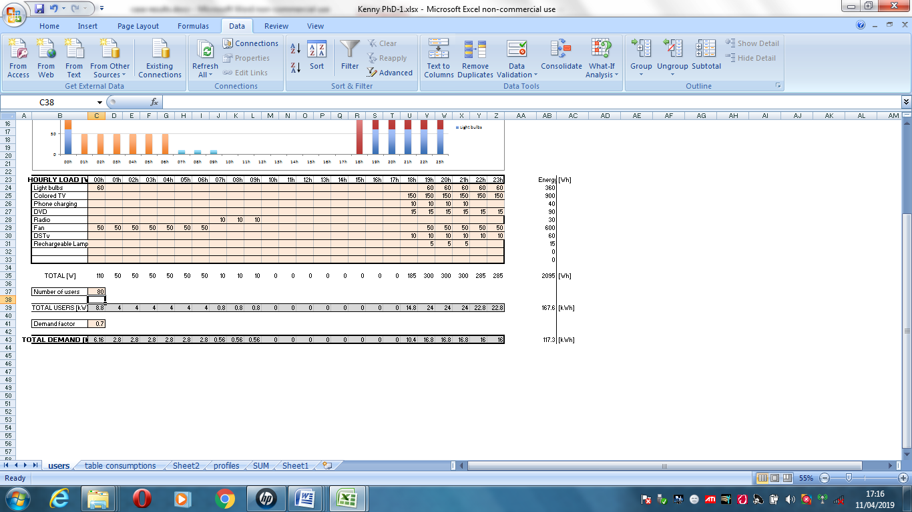

Table 2.: Number of Households and Demand Factor

Source: Researcher, (2017)

2.4. System components
A hybrid power system was designed for Imini village to generate electricity where the photovoltaic module was integrated with the wind turbine, electrolyser, hydrogen storage and fuel cell unit (figure 1). An auto-size back-up generator was also included in the configuration.
Figure 1. Hybrid Power system
Source: Researcher, (2023)

A five year solar irradiation, and wind speed result of the study area (Akilo hills) was obtained from NIMET office. The HOMER software (Hybrid Optimization for Multiple Energy Resources) simulated power generation mix for scenarios 1 up to 11. The sensitivity variable parameter for simulation included 197.7kWh/d and 165kWh/d for electric load baseline average and electric load scaled average respectively and solar scaled average of 5.14kWh/m²/day. The Solar PV module used in the design has a capacity of 300 Watts per module. The entire array considered in this design amounts to 300kW and simulated using Homer optimizer. The modules were inclined at an angle of 15 degrees with a lifespan of 20 years. The capital and replacement costs were specified at $452/kW. No maintenance and operating cost was considered since little or no maintenance was needed for the panels to operate. Wind Turbine system was also proposed for this design. The XANT M-21-ETR turbine with a capacity of 100 kW was used. The hub height of 31.80m was considered for the simulation. Clearly shown are the power curves of the wind turbine depicting how much power was generated.The cut in speed for the turbine is 3.0m/s while the rated wind speed and cut out wind speed is 11.0m/s and 20.0m/s respectively. The rotor diameter is 21.0m with 3 numbers blades. Its rotor speed is 58.0u/min and tip speed is 64m/s. The generator type for the turbine is permanent magnet produced at varying wind speeds.The capital and replacement costs of $80,000 were specified. The expected lifetime of the turbine is 20 years making it cheap and suitable for a 25 years project. Wind turbines are typically operational year-round with greater efficiency than other renewable energy sources and generate over 70% of their nominal year-round power output. It is worthy of note that according to Fadare 2010, the new generation wind turbines (like the XANT-M-21-ETR used in this study) have adequate capacity to work in light winds starting as low as 3m/s making wind a more viable and economical source of energy in most part of the north and mountains in the south. Polymer electrolyte membrane fuel cell was also proposed in the system design to compliment the wind and solar arrangement. The sensitivity analysis sizes considered in the optimization are 50 and 100kW for power generation. Electrolyser and Hydrogen tank for fuel supply has been embedded in the design as well. The lifetime hour for fuel cell operation is 40,000hours and cost per kilowatt is $3000.
The type of electrolyser employed for hydrogen production is also the polymer electrolyte membrane type. The size considered varied from 50kW to 70kW.The expected life time is 15years and operation efficiency is 85%. The cost per kilowatt is $1200.Stainless steel hydrogen tank storage was chosen for hydrogen storage. Hydrogen production was through water electrolysis using PEM electrolyser and stored for use by fuel cell to generate power for household and community use. An auto size generator of 54 kW was used as the baseline modelling datapoint. This baseline modelling data point helps to determine cost and the rating.The price of diesel considered is $0.65 equivalent. The auto size generator operates at a minimum load ratio of 25% and 15,000 lifetime hours.

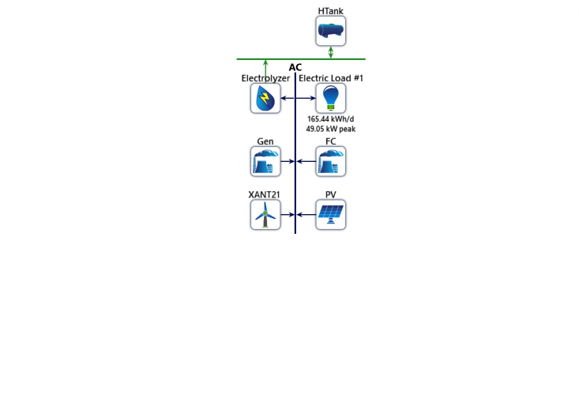
Figure 2: Equipment configuration for Imini hybrid power system
Source, Researcher, (2017)
2.5 Optimization of the System
The basis for electricity consumption and production was formed using the present and future electric load demand for the community derived from the energy profile and input parameters of the system architecture.
2.5.1. Model Assumption:
Availability of adequate renewable energy resources at Imini Village
The assumption was that the Village has access to renewable energy resources such as solar, wind and hydro that can be harnessed for power generation. The assumption is that these resources are viable and available in sufficient quantities to meet the energy demands of the rural community.
This assumption is important because HOMER Pro Software is widely used for analyzing and optimizing hybrid power systems that combine multiple renewable energy sources with conventional power sources. It helps determine the optimal mix of energy sources based on resource availability, cost, and other factors.
These assumptions would further shape the modeling and analysis conducted using HOMER Pro Software for designing an effective and sustainable power generation mix for rural electrification.

2.5.2 Mathematical Modeling for the Hybrid Power System
The modeling of the SSPGA components is given below.

Solar PV Panel
The photovoltaic current (I_{ph}) under standard test conditions (STC) given by the manufacturer (T_{ref} = 298.15 K (25 °C) and G_{ref} = 1000 W/m²) is given by (2.1):
𝐼_{𝑝ℎ}=[𝐼_{𝑠𝑐}+𝐾_{𝑖}(𝑇−𝑇_{𝑟𝑒𝑓})]×𝐺/1000 2.1
where T, G, I_{sc}, and 𝐾𝑖 are the operating temperature, solar irradiance, short-circuit current, and coefficient with temperature of the short-circuit current, respectively.
The PV panel voltage is given by (2.2):
𝑈_{𝑃𝑉}=𝑈_{𝐷𝐶}×𝑁_{𝑠} (2.2)
where U_{DC} is the cell voltage and N_{s} is the number of cells connected in series.
The power (P) generated by the PV is given by (2.3):
𝑃=𝐼_{𝑠𝑐}×𝐺×𝑈_{𝑃𝑉}×𝑁_{𝑠}/𝑘_{𝐹} (2.3)
where 𝑘_{𝐹} represents the loss factor.

Wind Turbine
The power generated by a wind turbine is given by (2.4):
𝑃_{𝑚𝑎𝑥}=16/27×𝑃₀ (2.4)
where 𝑃₀ is the power on the upstream section
𝑃₀=1/2×𝜌×𝐴𝑟×𝑣₀³ (2.5)
and 𝜌 is air density [kg/m³], 𝐴_{𝑟} is the area swept by the rotor blades [m²], and 𝑣₀ is the wind speed [m/s].
So
𝑃_{𝑚𝑎𝑥}=0.296×𝜌×𝐴_{𝑟}×𝑣₀³ (2.6)
P_{max} denotes the theoretical maximum power produced by the Wind turbine

Fuel Cell
Fuel cells (FC) are devices that use electrochemical oxidation-reduction reaction to perform the direct conversion of chemical energy into electrical energy, which occurs at the two electrodes, namely, the anode that is supplied with hydrogen (H₂) and the cathode that is supplied with oxygen (O₂) from air, and are separated by an electrolyte that allows the transfer of ions between the two electrodes. Based on the nature of electrolyte or fuel used, there are different types of cells, among which the proton exchange membrane fuel cell (PEM-FC) is widely used due to its low temperature operation and fast start-up.
The output voltage of the fuel cell is given by the following equation (2.7):
𝑉=𝐸−𝑉_{𝑎𝑐𝑡1}−𝑉_{𝑐}−𝑉_{𝑜ℎ𝑚} (2.7)
where 𝐸 is the internal voltage of the fuel cell (FC), 𝑉𝑎𝑐𝑡1 is the temperature-dependent activation voltage loss, 𝑉𝑐 is the voltage loss across the capacitor, and 𝑉𝑜ℎ𝑚 is the voltage loss across the ohmic resistance.
The voltage E across a single cell is given by the following relationship:
𝐸=𝐸₀+𝑅𝑇/2(𝑃_{𝐻2}𝑃_{𝑂2}/ 𝑃_{𝐻2𝑂})…………………………………. 2.8
where 𝐸0 =1229 V is the standard potential of the hydrogen/oxygen reaction, R is the universal gas constant, F is the Faraday’s number, 𝑃_{𝐻2} is the partial pressure of hydrogen at the anode, and 𝑃_{𝐻2𝑂} and 𝑃_{𝑂2} are the partial pressures of water and oxygen at the cathode, respectively.

2.5.3 Theory of HOMER
The theory behind HOMER involves performing a techno-economic analysis that considers the costs, performance, and availability of different energy resources and technologies. The software uses optimization algorithms to determine the optimal configuration and dispatch strategy for the hybrid power system.
The basic objective function of HOMER is to minimise the total net present cost (NPC) of the system over the analysis period, which includes the capital costs, operating costs, and replacement costs of the different system components (NREL, 2021). The NPC is calculated using the formula:
NPC = IC + OC + RC + FC + VC ……………………………………………… 2.9
Where:
IC: Initial capital costs of the system components
OC: Operating costs, including maintenance, fuel, and other expenses
RC: Replacement costs of components with a finite lifespan
FC: Financial costs, such as interest and loan payments
VC: Value costs, which account for factors like emissions and environmental impacts
HOMER takes into account various constraints and parameters, including the energy demand profile, the availability and variability of renewable energy resources, the technical specifications and efficiency of different technologies, and the desired level of reliability.
2.5.4 Calculating Levelised Cost of Energy in HOMER
The levelised cost of energy (LCOE) in HOMER (Hybrid Optimization for Multiple Energy Resources) is calculated using the following formula:
LCOE = (Total annualized costs / Total annual energy production) + (Total annualized costs * O&M costs).
LCOE = (TAC / TAEPr) + (TAC * O&MC) …………………………………….. 2.10
Where:
Total annualized costs: The sum of the annualized capital costs and the annualized O&M costs.
Total annual energy production: The total amount of energy produced in a year by the system.
O&M costs: The annual operation and maintenance costs as a percentage of the capital costs.
The annualized capital costs can be calculated as follows:
Annualized capital costs = (Capital cost * CRF) / Lifetime
ACC = (CC * CRF) / LT …………………………………………………………… 2.11
Where:
Capital cost: The initial cost of the system.
CRF: The capital recovery factor, which is calculated as (r(1+r)^n) / ((1+r)^n - 1), where "r" is the discount rate and "n" is the system lifetime.
Lifetime: The expected lifetime of the system.

2.5.5 Calculating Carbon Emission in HOMER
To estimate carbon emissions associated with electricity generation in HOMER, the following expression can be followed:

Total Carbon Emissions = (Energy Production₁ * Emissions Factor₁) + (Energy Production₂ * Emissions Factor₂) + ... + (Energy Production_{n} * Emissions Factor_{n})
EP₁ * EmF₁) + (EP₂ * EmF₂) + ... + (EP_{n} * EmF_{n}) ………………………………….. 2.12
Where:
Energy Production₁, Energy Production₂, ... Energy Production_{n} is the annual energy production for each energy source in the system.
Emissions Factor₁, Emissions Factor₂ ... Emissions Factor_{n}: is the emissions factor (expressed as CO₂ emissions per unit of energy) for each energy source.

3. Results and Discussions
3.1 Wind system only with auto size generator back up (Scenario 1)
The results show that the auto size generator contributes 6.90 percent of the entire electricity while the Wind turbine contributes about 93.1 percent of the design capacity (Table 3).The total annual production of the system is 484,362kWh/yr while the AC primary load of the community is 72,161kWh/yr this suggests that there is sufficient production to meet the energy demand of the community and excess is also generated for the purpose of scale up in the future and feeding of neighboring communities and by extension functioning as base station for feed back into national grid in the future.

Auto Size Generator
From the results the mean electrical output for auto size generator was 14kW while the maximum electrical output was 31.5kW and its average electrical efficiency was 23.7% on 2,389hrs/yr for operational hours and with operational life time of 6.28 years and rated capacity factor of 7.06% at fixed generation cost of $3.37/hr.

Wind Turbine Result
In the hybrid design of the Imini community, an AC wind turbine was used in the simulation. The XANT M-21-ETR wind turbine with rated capacity of 100 kW was selected as the wind turbine to produce the optimum or most efficient output. The mean output for the Wind turbine system is 51.5kW and maximum output is 98.1kW. This is largely due to the wind speed of Akilo hill which is approximately a yearly average of 8m/s. The total production from the wind turbine is 450,944kWh/yr with yearly hours of operation of 7817hr/yr. The LCOE for wind turbine system alone is $0. 0192kWh which makes the use of wind resources cheap and highly competitive. The Wind turbine data output chart (Figure 3) clearly shows the color representation and implies that turbine operates for 24 hours every day with significant impact of wind penetration being felt almost across the day. As explained earlier, this is largely due to the wind speed resource on Akilo hill at the Imini community.
Table 3 Power production and consumption (Scenario 1)
Power generation mix | Total Consumption(kWh/yr) | Electrical Output(kWh/yr) | Total output(kWh/yr) | System Architecture(kW)
1 | 72,161 | Gen-33,418,WT - 450,944 | 484,362 | Gen – 54, WT- 100

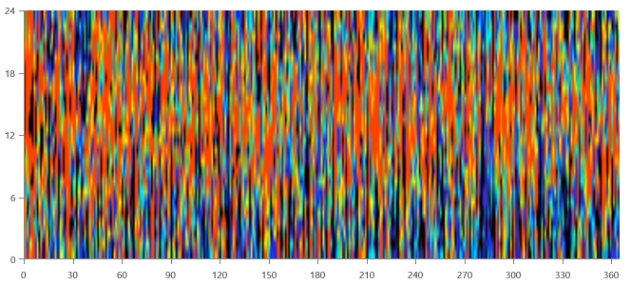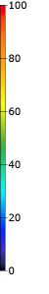Figure 3.. XANT M-21-ETR [100kW] Production (kW)

3.2 Solar PV only with Auto size generator back up (Scenario 2)
The results show that the auto size generator contributes 34.1 percent of the entire electricity while the Solar PV contributes about 65.9 percent of the design capacity.The total annual production of the system is 235,967kWh/yr (Table 4) while the AC primary load of the community is 72,161kWh/yr this suggests that there is sufficient production to meet the energy demand of the community and excess is also generated for the purpose of scale up in the future and feeding of neighboring communities and by extension functioning as base station for feed back into national grid in the future.

Auto Size Generator Result
The auto size generator scoring rate is 34.1% with mean electrical output of 15.1kW and 32.5kW maximum output for mean electrical efficiency of 24.5% at 5,320hrs/yr of operation while the specific fuel consumption for the generator is 0.414L/kWh.The operational life of the generator is projected at 2.82 years with capacity factor of 17%. The generator operates at almost zero capacity during the day but functions at 26-35kW between 6pm and 12am at fixed generation cost of $3.37/hr.

PV Result
The table 4 clearly showed the rated capacity of Nexus flat plate PV is 102kW, from the electrical result, the mean output is 17.8kW and 426kWh/d while total production of 155,619kWh/year which exceeds the AC primary load of the community thus sufficient enough to meet their energy need. The Levelized Cost of Energy (LCOE) for the solar PV is $ 0.0295/kWh and the total number of hours of operation is 4,318hr/yr with Photovoltaic Infiltration of 258 percent. The d map chart (Figure 4) shows in color variations the power output of the array in each time step of the year with production occuring between 6am and 7pm daily also from data map output chart, PV operates at 48-96kw between 6am and 6pm daily.
The cost of operation and fueling which stands at $111,415 and $279,771 respectively contributes to the rises in the LCOE for this arrangement.

Table 4 Power Production and Consumption (Scenario 2)
Power generation mix | Total Consumption(kWh/yr) | Electrical Output(kWh/yr) | Total output(kWh/yr) | System Architecture(kW)
2 | 72,161 | PV-155,619, Gen -80,348 | 235,967 | PV – 102, Gen- 54

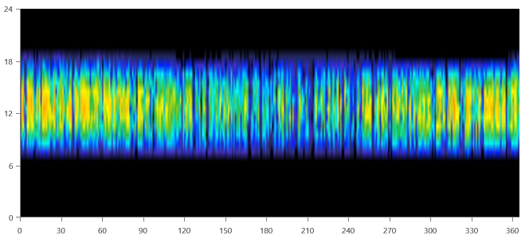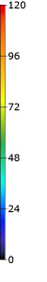
Figure 4. Nexus flat plate PV Production (kW)

3.3 Wind and Solar Photovoltaic only with Generator back up (Scenario 3)
Result from table 5 shows that the size of PV is relatively low in this hybrid arrangement and only one wind turbine is employed. Auto size generator of 54kW size acts as backup. The system architecture of 92.9% Wind turbine scoring compared to Solar PV 0.27% shows the overwhelming effect of wind system performance at the study site. Auto size generator in this arrangement is also 6.87%.

Auto Size Generator Result
The generator backs up arrangement operates up to 31.5 kW capacity. Also from the auto-size result, the auto size generator had mean electrical output of 14.0kW and mean electrical efficiency of 23.7% at 2,385hrs/yr of operation while the specific fuel consumption for the generator is 0.429L/kWh.The operational life of the generator is projected at 6.29 years with capacity factor of 17%. The generator operates at varying hours of the day functioning at between 13.5- 31.5kW to support other renewable sources available in this arrangement.

PV Result
Maximum power output for Solar PV is 0.87kW with operating hours of 4,318 yearly deplorable to meet energy demand in school during the day. Solar PV mean output is 0.150kW and 3.59kWh/d. The peak performance of between 0.60-0.80kW usually occurs between hours of 10am to 4pm daily

Wind Turbine Result
The mean output for the Wind turbine system is 51.5kW and maximum output is 98.1kW resulting from wind infiltration of 747 percent on Akilo hill. The total production from the wind turbine is 450,944kWh/yr with yearly hours of operation of 7817hr/yr. The LCOE for wind turbine system is $0. 0192kWh which is cheaper when compared to Solar PV. The Wind turbine output chart (Figure 5) clearly shows the distribution of 24 hours every day output with significant impact.
Table 5 Power Production and Consumption (Scenario 3)
Power generation mix | Total Consumption(kWh/yr) | Electrical Output(kWh/yr) | Total output(kWh/yr) | System Architecture(kW)
3 | 72,161 | PV – 1,310, Gen-33,364  WT – 450,944 | 485,618 | PV – 0.859, Gen – 54  WT - 100

Figure 5. XANT M-21-ETR [100kW] Production (kW)

3.4 Wind and Fuel cell with Auto Size Generator back up (Scenario 4)
The system architecture comprised 54kW generator, 50kW PEM Fuel cell, 100kW XANT M-21-ETR wind turbine and other components such as 50kW PEM Electrolysis device and 700kg hydrogen container. From the electrical result in table 6, the PEM fuel cell has scoring value of 2.45% and Wind turbine scoring is 97.6%. The auto size generator scoring value is 0% which implies that auto size generator does not contribute to the power generation for this scenario.

Autosize Generator Result
Result showed that the auto size generator power output showed all round black coloration which implies 0kW power output (Figure 6).
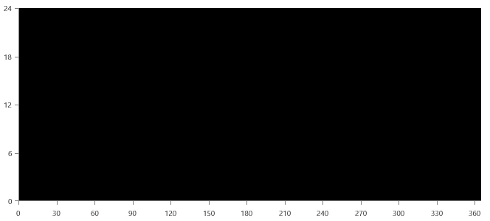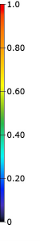
Figure 6. Autosize Genset Output (kW)

Fuel Cell Result
The simulation data showed the fuel cell result for Hybrid system in the Imini community power generation mix. The mean electrical output of fuel cell is 4.74kW with expected operational life of 16.7years and operating hours of 2,389hrs/yr.Fuel cell production is 11,317kWh/yr which is enough to take care of certain percentage of the community household demands. The fuel cell result from the fuel cell power output showed it worked to supplement the wind turbine where the village's power demand rises between 6 pm and 12 am, delivering between 20-31kW (Figure 7). Electrolyser functions as energy storage in this scenario when there is excess electricity and hydrogen from the storage is supplied to fuel cell to compliment wind turbine when there is power deficiency.
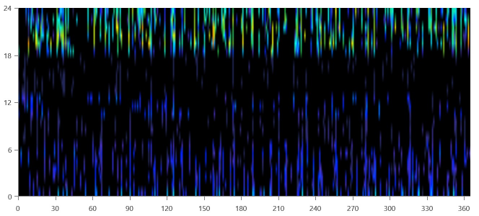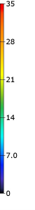
Figure 7. PEM Fuel Cell Output (kW)

Wind Turbine Result
The mean output for the Wind turbine system is 51.5kW and maximum output is 98.1kW. The total production from the wind turbine is 450,944kWh/yr with yearly hours of operation of 7817hr/yr (Table 6).The LCOE for wind turbine system is $0. 0192kWh which is cheaper when compared to Solar PV. The Wind turbine output data map (Figure 8) clearly shows the colour representation and implies that the wind turbinewas working at optimum
Table 6. Power Production and Consumption (Scenario 4)
Power generation mix | Total Consumption(kWh/yr) | Electrical Output(kWh/yr) | Total output(kWh/yr) | System Architecture(kW)
4 | 121,131 | Gen – 0, PEMFC – 11,317  WT – 450,944 | 462,261 | Gen – 54, PEMFC –50  WT -100

Figure 8. XANT M-21-ETR [100kW] Production (kW)

3.5 Solar PV and Fuel cell with Auto Size Generator back up (Scenario 5)
Result from table 7 revealed that the size of PV is 124kW and PEM fuel cell is 50kW with an auto size generator of 54kW as backup to supply power for 24 hours. PV power production is 189,536 which represent a scoring rate of 79.5% and PEM fuel cell power production is 48,990kWh/yr representing 20.5% scoring value. The use of auto size generator for this arrangement is negligible or equals to zero. Total power production from solar PV and fuel cell was 238,526kWh/yr enough to meet the primary energy demand of the community without the need for a generator back up

Fuel Cell Result
Fuel cell electrical summary revealed that the system operated at 50 percent efficiency with annual production of 48,990kWh/yr. The mean electrical output is 32.5kW and hydrogen fuel consumption value is 2,939kg with specific fuel consumption of 0.0600kg/kWh. Operational hours of fuel cell for this architecture is 5,191hrs/yr with optimum operation occurring between 6pm to 12am at power output of 14-32kW (Figure 9). Electrolyser mean output is 0.336kg/hr and total production is 2,943kg/yr (more than Fuel cell, hydrogen consumption requirement of 2,939kg). The electrolyser produces hydrogen by drawing power from Solar PV to supply fuel cell for Night use and also to make up for power supply shortfall from Solar PV.
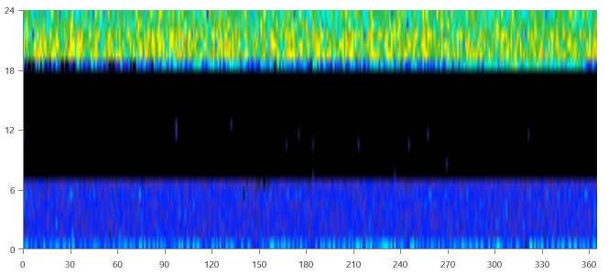
Figure 9. PEM Fuel Cell Production (kW)

PV Result
Result showed the rate capacity of Nexus flat plate PV is 124kW, from the electrical result, the mean output is 21.6kW and 519kWh/d while total production of 189,536kWh/year. The Levelized Cost of Energy (LCOE) for the solar PV is $ 0.0295/kWh and the total number of hours of operation is 4,318hr/yr with Photovoltaic Infiltration of 314 percent (Table 7). The d map chart (Figure 10) shows in color variations the power output of the array in each time step of the year with production occuring between 6am and 7pm daily also from data map output chart, PV operates at 50-126kw between 6am and 6pm daily.

Table 7 Power Production and Consumption (Scenario 5)
Power generation mix | Total Consumption(kWh/yr) | Electrical Output(kWh/yr) | Total output(kWh/yr) | System Architecture(kW)
5 | 196,965 | PV – 189,536, Gen – 0  PEMFC – 48,990 | 238,526 | PV – 124, Gen – 54  PEMFC - 50

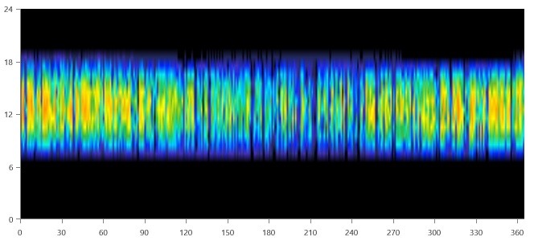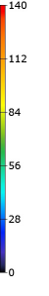Figure 10. Nexus flat plate PV Production (kW)

3.6 Fuel cell system with auto size generator back up (Scenario 6)
The size of PEM fuel cell for this arrangement (Table 8) is 100kW as well as 50kW Electrolysis device, 700kg Hydrogen container, to be backed up by 54kW auto size generator.

Auto Size Generator Result
From the auto size generator electrical result, electrical production was 126,993kWh/yr enough to meet AC electrical power demand of 72,161kWh/yr for Imini community. The mean electrical output was 14.5kW and the yearly diesel fuel consumption was 53,571/L with average electrical efficiency of 24.1 percent. The operational hour of the auto size generator is 8,760hr/yr and operational life time of 1.71 years.

Fuel Cell Result
This system was predominantly dominated by auto-size generator with zero fuel cell penetration even though the cost of fuel cell reflected in the overall cost result analysis thereby adding to the NPC and the LCOE of the system.

Table 8 Power Production and Consumption (Scenario 6)
Power generation mix | Total Consumption(kWh/yr) | Electrical Output(kWh/yr) | Total output(kWh/yr) | System Architecture(kW)
6 | 89,621 | Gen – 126,993  PEMFC- 0 | 126,993 | Gen – 54  PEMFC- 100

3.7 Wind, Solar PV and Fuel cell with Auto Size Generator (Scenario 7)
The system sizing for this architecture included 54kW Auto-size generator, 50kW PEM fuel cell, 100kW wind turbine, 0.890kW Nexus flat plate solar PV as well as 700kg hydrogen container and 50kW PEM electrolysis device. The PEM fuel cell works along with solar PV and Wind system for day and night use to compliment for intermittency in power supply hence doubling the function of fuel cell as power generator and energy storage. Result showed power production from Wind system, Solar PV and fuel cell are 450,944kWh/yr, 1,358kWh/yr and 11,182kWh/yr respectively with the Wind System contributing 97.3% of the component sizing followed by fuel cell with 2.41% (Table 9).

Auto Size Generator Result
Result showed that Auto size generator contributes zero input in this arrangement hence no diesel cost is considered.

Fuel Cell Result
Result revealed that Fuel cell system operated at 50 percent efficiency with maximum electrical production of 31.5kW and specific fuel consumption of 0.0600kg/kWh.PEM fuel cell mean output is 4.69kW with 2,385 hours of operation per year for 16.8 years. The PEM fuel cell makes up for intermittency of both the solar PV and Wind system during the day and night as the case may be and result (Figure 11) revealed that Fuel cell penetration is at optimum between 6pm to 12am at power output of 14-31.5kW. The electrolyser produces hydrogen by drawing power from Wind energy to supply fuel cell for this arrangement.
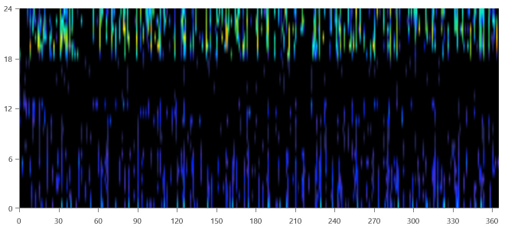Figure 11 PEM Fuel Cell Production (kW)
PV Result
Result revealed that Nexus flat plate PV has mean output of 0.155kW and 3.72kWh/d which is very low compared to the Wind system. The low percentage input of solar PV in the arrangement is characterised by lower LCOE cost for wind power as well as high wind infiltration in the system and absence of battery storage in this arrangement.

Wind Turbine Result
It could be seen that the wind turbine has mean output of 51.5kW and maximum output of 98.1kW. The levelised cost of energy for wind system is 0.0192kWh and this contributes to bringing down the value of the overall LCOE for the hybrid system. Operational hours for the wind turbine are 7,817hrs/yr). Result also indicated that the wind turbine operates for 24hours at varying output to meet the energy needs of the community.
Table 9 Power Production and Consumption (Scenario 7)
Power generation mix | Total Consumption(kWh/yr) | Electrical Output(kWh/yr) | Total output(kWh/yr) | System Architecture(kW)
7 | 120,756 | PV – 1,358, Gen – 0  PEMFC – 11,182  WT – 450,944 | 463,485 | PV – 0.809, Gen – 54  PEMFC – 50  WT – 100

3.8 Generator only (as base case and Scenario 8)
This forms the base case for this study and it includes Generator only system since the community depends on the use of generator only at the moment for their power supply.
Result from table 10 revealed electrical power production of 126,993kWh/yr sufficient to meet the AC primary load demand of the Imini community.

Auto Size Generator Result
Also, power is 126,993kWh/yr with operational hours of 8,760hrs per year. The generator is expected to function for 1.71years with capacity factor of 26.8 %.
Table 10 Power Production and Consumption (Scenario 8)
Power generation mix | Total Consumption(kWh/yr) | Electrical Output(kWh/yr) | Total output(kWh/yr) | System Architecture(kW)
8 (Base case) | 72,161 | Gen-126,993 | 126,993 | Gen- 54

3.9 Solar PV system and Fuel cell (Scenario 9)
The size of solar PV is 124kW and PEM fuel cell is 50kW with 50kW PEM electrolyser for hydrogen production and 700kg hydrogen container for storage. Nexus Solar PV produces 189,536kWh/yr while 48,990kWh/yr is the production from PEM fuel cell as shown in table 11.

Fuel Cell Result
PEM fuel cell mean output is 9.44kW and has 5,191hrs/yr of operation, operating mainly between 12am to 8am and 6pm till 12 am.

PV Result
Result revealed that the mean output for Nexus PV is 21.6kW and 519kWh/d for 4,318hrs/yr hours of operation. The LCOE for solar PV alone is $0.0295kWh which contributes to the reduction in the LCOE for the overall hybrid arrangement. Operating hours for the Solar PV from the output graph (Figure 12) is 7am to 8pm in the evening but on the peak of operation between 10am and 4pm.

Table 11. Power Production and Consumption (Scenario 9)
Power generation mix | Total Consumption(kWh/yr) | Electrical Output(kWh/yr) | Total output(kWh/yr) | System Architecture(kW)
9 | 196,965 | PV – 189,536  PEMFC – 48,990 | 238,526 | PV – 124  PEMFC – 50

Figure 12. Nexus flat plate PV Production (kW)

3.10 Wind System and Fuel Cell (Scenario 10)

The size of Wind turbine for the system is 100kW capacity and 50kW PEM fuel cell with 50kW PEM electrolyser and 700kg hydrogen container (Table 12). Energy production for wind turbine and fuel cell is 450,944 and 11,317kWh/yr respectively.

Fuel Cell Result
Fuel cell mean output from result is 4.74kW and operational hours are 2,389hr/yr and fixed generation cost is $4.38/hr.

Wind Turbine Result
The Wind turbine output data map (Figure 13) clearly shows the colour representation that implies the wind turbine was working at optimum. The wind turbine operates at 7,817hr/yr with mean output of 51.5kW.
Table 12 Power Production and Consumption (Scenario 10)
Power generation mix | Total Consumption(kWh/yr) | Electrical Output(kWh/yr) | Total output(kWh/yr) | System Architecture(kW)
10 | 121,131 | PEMFC – 11,317  WT – 450,944 | 462,261 | PEMFC – 50  WT – 100

Figure 13 XANT M-21-ETR [100kW] Production (kW)

3.11 Wind, Solar PV and Fuel Cell system (Scenario 11)
This consists of the hybrid of Wind turbine, Solar PV and PEM fuel cell which is 100% renewable technology.
The power output of Solar PV is low compared to Wind and Fuel cell because of the absence of battery storage for the Solar PV system and also because the rate of power demand during the day is low compared to power demand during the night period. Fuel cell is proposed to take of intermittency in the system. The power from the Nexus PV system will be utilised in the schools during the school hours and it will be complimented with fuel cell power while the energy demand for the other sectors of the village will be met by Wind system and Fuel cell. The low cost of Wind energy system and high-power production has made this option more economical than the use of generator only option as the case of scenario 8 which is used as the base case for this power generation mix analysis.
Result from table 13 showed that the power production from wind system, fuel cell system and solar PV were 450, 944, 11,182 and 1,358 kWh/yr respectively sufficient enough to catch up with the energy need of the community without the need for a generator back up and there is fuel cell availability to support wind and solar PV in case of intermittency which would have been the reason for compulsory use of a storage battery in the system. The energy production is sufficient enough to meet the 72,161kWh/yr AC primary load of the village. The unmet electric load is 0kWh/yr and capacity shortage is also 0kWh/yr

Table 13 Power Production and Consumption (Scenario 11)
Power generation mix | Total Consumption(kWh/yr) | Electrical Output(kWh/yr) | Total output(kWh/yr) | System Architecture(kW)
11 | 120,756 | PV – 1,358  PEMFC – 11,182  WT – 450,944 | 463,485 | PV – 0.890  PEMFC – 50  WT – 100

Fuel Cell Result
Result showed that PEM fuel cell has maximum electrical production of 31.5kW and 2385hrs/yr of operation over 16.8years lifetime, operating lightly in morning and afternoon as back up and more intensely in the evening especially between 6pm and 12am (Figure 14).

Figure 14. PEM Fuel Cell Production (kW)
PV Result
Result also revealed that the mean output for Nexus PV is 0.155kW and 3.72kWh/d for 4318 hrs/yr hours of operation. The LCOE for solar PV alone is $0.0295kWh which contributes to the reduction in the LCOE for the overall hybrid arrangement. Operating hours for the Solar PV from the output graph (Figure 15) is 7am to 6pm in the evening but on the peak of operation between 10am and 4pm.
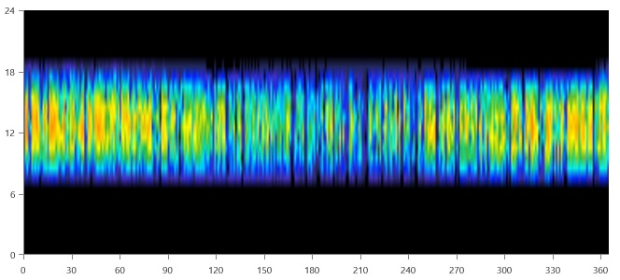
Figure 15. Nexus flat plate PV Production (kW)

Wind Turbine Result
The wind turbine has mean output of 51.5kW and maximum output of 98. 1kW from the result obtained. The levelised cost of energy for wind system is 0.0192kWh and this contributes to bringing down the value of the overall LCOE for the hybrid system. Operational hours for the wind turbine are 7,817hrs/yr. The wind turbine operates for 24hours (Figure 16) at varying output to meet the energy needs of the community.

Figure 16. XANT M-21-ETR [100kW] Production (kW)

3.12 Electrical Energy Consumption and Production Summary
Electrical consumption and production for the power generation mix is discussed in Table 14
Table 14 Electrical Consumption and Production Results
Power generation mix | Total Consumption(kWh/yr) | Electrical Output(kWh/yr) | Total output(kWh/yr) | System Architecture(kW)
1 | 72,161 | Gen-33,418,WT - 450,944 | 484,362 | Gen – 54, WT- 100
2 | 72,161 | PV-155,619, Gen -80,348 | 235,967 | PV – 102, Gen- 54
3 | 72,161 | PV – 1,310, Gen-33,364  WT – 450,944 | 485,618 | PV – 0.859, Gen – 54  WT - 100
4 | 121,131 | Gen – 0, PEMFC – 11,317  WT – 450,944 | 462,261 | Gen – 54, PEMFC –50  WT -100
5 | 196,965 | PV – 189,536, Gen – 0  PEMFC – 48,990 | 238,526 | PV – 124, Gen – 54  PEMFC - 50
6 | 89,621 | Gen – 126,993  PEMFC- 0 | 126,993 | Gen – 54  PEMFC- 100
7 | 120,756 | PV – 1,358, Gen – 0  PEMFC – 11,182  WT – 450,944 | 463,485 | PV – 0.809, Gen – 54  PEMFC – 50  WT – 100
8 (Base case) | 72,161 | Gen-126,993 | 126,993 | Gen- 54
9 | 196,965 | PV – 189,536  PEMFC – 48,990 | 238,526 | PV – 124  PEMFC – 50
10 | 121,131 | PEMFC – 11,317  WT – 450,944 | 462,261 | PEMFC – 50  WT – 100
11 | 120,756 | PV – 1,358  PEMFC – 11,182  WT – 450,944 | 463,485 | PV – 0.890  PEMFC – 50  WT – 100

3.13 Emission Results
Table 15 Emission Summary
Toxic substances | 1 | 2 | 3 | 4 | 5 | 6 | 7 | 8 | 9 | 10 | 11
Carbon (IV) Oxide (kg/yr) | 37,492 | 87,152 | 37,430 | 0 | 0 | 140,227 | 0 | 140,227 | 0 | 0 | 0
Carbon (II) Oxide (kg/yr) | 236 | 549 | 236 | 0 | 0 | 884 | 0 | 884 | 0 | 0 | 0
Unscathed Hydrocarbons (kg/yr) | 10.3 | 24.0 | 10.3 | 0 | 0 | 38.6 | 0 | 38.6 | 0 | 0 | 0
Particulate Matter (kg/yr) | 1.43 | 3.33 | 1.43 | 0 | 0 | 5.36 | 0 | 5.36 | 0 | 0 | 0
Sulfur (IV) Oxide (kg/yr) | 91.8 | 213 | 91.7 | 0 | 0 | 343 | 0 | 343 | 0 | 0 | 0
Nitrogen Oxides (kg/yr) | 222 | 516 | _ | 0 | 0 | 830 | 0 | 830 | 0 | 0 | 0

Table 16 shows the emission summary for scenarios 1 to 11 highlighting scenario 8 which is also the base case as the basis for comparison with the other scenarios. Fuel and emission result for scenario 11 showed a clean energy system with zero emission of toxic substances and no diesel consumption. This denotes that the power mix arrangement for Imini community is environmentally friendly.
3.14 NPC AND LEVELISED COST OF ELECTRICITY
Table 16 .Analysis of the economics of the power generation mix for all the scenarios in comparison with the base case .
Scenario | NPC ($) | LCOE($/kWh)
1 | $285,764.20 | $0.366
2 | $454,111.60 | $0.582
3 | $285,981.00 | $0.366
4 | $423,549.90 | $0.543
5 | $539,126.80 | $0.691
6 | $966,200.40 | $1.24
7 | $423,851.50 | $0.543
8 | $637,366.80 | $0.816
9  10 | $535,624.90  $420,048.10 | $0.686  $0.538
11 | $420,349.70 | $0.538

The result from table 16 revealed a cheaper LCOE for scenario 11 when compared with the base case (scenario 8) of fossil fuel generator use only.

3.15 Conclusion
The designed hybrid power system was able to optimise the power generation mix of Imini standalone system and it can be said to be feasible, more environmental friendly, sustainable and a good economic option. More so, renewable energy sources are reliable. And it is speculated that by year 2050 world oil reserve would be insufficient to cater for fast growing global economy hence focus now on renewable energy economy before the time (Reuters, 2021). The results gotten in HOMER demonstrates that component sizes cost summary, cash flow summary, electrical production and cost of PV-Wind-Fuel cell hybrid system has been found feasible. Considering the hybrid system comparison with the base case of diesel generator use only, it is concluded that the standalone hybrid system proposed for the Imini community is feasible and a good economic option.

COMPETING INTERESTS DISCLAIMER:
Authors have declared that they have no known competing financial interests OR non-financial interests OR personal relationships that could have appeared to influence the work reported in this paper.

References
Adeyemi, A. O. (2013). Electricity consumption and economic growth in Nigeria. Scientific Papers: Journal of Business Management and Applied Economics, 2(4). http://www.scientificpapers.org
Agbo, S. N., Unachukwu, G. O., Enibe, S. O., & Okeke, C. E. (2005). Solar water heating for resident university students. Nigerian Journal of Solar Energy, 15, 85–92.
Ajayi, O. O. (2009). Assessment of utilization of wind energy resources in Nigeria. Energy Policy, 37, 750–753. https://doi.org/10.1016/j.enpol.2008.10.040
Akpinar, E. K., & Akpinar, S. (2004). Statistical analysis of wind energy potential on the basis of the Weibull and Rayleigh distributions for Agin-Elazig, Turkey. Proceedings of the Institution of Mechanical Engineers, Part A: Journal of Power and Energy, 218(7), 557–565. https://doi.org/10.1243/0957650042794780
Al Garni, H. Z., Awasthi, A., & Ramli, M. A. (2018). Optimal design and analysis of grid-connected photovoltaic under different tracking systems using HOMER. Energy Conversion and Management, 155, 42–57. https://doi.org/10.1016/j.enconman.2017.10.078
Alliance for Rural Electrification. (2012). Hybrid power systems based on renewable energies: A suitable and cost-competitive solution for rural electrification. http://www.ruralelec.org/fileadmin/DATA/Documents/06_Publications/Position_papers/ARE-WG_Technological_Solutions_-_Brochure_Hybrid_Systems.pdf
Al-Othman, A., Tawalbeh, M., Martis, R., Dhou, S., Orhan, M., Qasim, M., & Olabi, A. G. (2022). Artificial intelligence and numerical models in hybrid renewable energy systems with fuel cells: Advances and prospects. Energy Conversion and Management, 253, 115154. https://doi.org/10.1016/j.enconman.2021.115154
Benz, J., Ortiz, B., Roth, W., et al. (2003). Fuel cells in photovoltaic hybrid systems for stand-alone power supplies. In 2nd European PV-Hybrid and Mini-Grid Conference (pp. 1–4). Kassel, Germany.
Bertuccioli, L., Chan, A., Hart, D., Lehner, F., Madden, B., & Standen, E. (2014). Study on development of water electrolysis in the EU. Fuel Cells and Hydrogen Joint Undertaking.
Buragohain, S., Mohanty, K., & Mahanta, P. (2021). Hybridization of solar photovoltaic and biogas system: Experimental, economic and environmental analysis. Sustainable Energy Technologies and Assessments, 45, 101050. https://doi.org/10.1016/j.seta.2021.101050
Carmo, M., Fritz, D., Mergel, J., & Stolten, D. (2013). A comprehensive review on PEM water electrolysis. International Journal of Hydrogen Energy, 38(12), 4901–4934. https://doi.org/10.1016/j.ijhydene.2013.01.151
Chedid, R., & Akiki, H. (1998). A decision support technique for the design of hybrid solar-wind power system. IEEE Transactions on Energy Conversion, 13(1), 154–176. https://doi.org/10.1109/60.661634
Chen, L., & Yang, Z. (2012). Design and optimizing a hybrid photocatalytic/electrolytic water-splitting system. Engineering Science Programme, National University of Singapore, Kent Ridge, Singapore.
Council for Renewable Energy, Nigeria (CREN). (2009). Nigeria electricity crunch. www.renewablenigeria.org
Dokua Sasu, D. (2022). Electricity in Nigeria - statistics and facts. Statista. https://www.statista.com/statistics/1234567/electricity-in-nigeria
KPMG. (2022). Power sector update: Edition 2022, Q2. https://home.kpmg/content/dam/kpmg/ng/pdf/power-sector-watch-edition-2022-q2.pdf
Reuters. (2021, August 12). World to reach peak oil demand before 2030. Reuters. https://www.reuters.com/business/energy/world-to-reach-peak-oil-demand-before-2030-2021-08-12/
Rehman, S., & Al-Hadhrami, L. M. (2010). Study of a solar PV-diesel-battery hybrid power system for a remotely located population near Rafha, Saudi Arabia. Energy, 35(11), 4986–4995. https://doi.org/10.1016/j.energy.2010.08.025
Olajide, T. (2020, June 25). See how much Nigeria loses annually to power outages. Financial Watch.
Zubairu, I., Falode, O. A., Diji, C. J., Awonusi, A. A., Afolalu, S. A., Akinlabi, E. T., & Ikumapayi, O. M. (2023). Evaluation of a hybrid solar power system as a potential replacement for urban residential and medical economic activity areas in southern Nigeria. AIMS Energy, 11(2), 319–336.
Zubairu, I., Falode, O. A., Diji, C. J., Awonusi, A. A., Afolalu, S. A., Akinlabi, E. T., & Ikumapayi, O. M. (2022). A global overview of renewable energy strategies. AIMS Energy, 10(4), 718–775. https://doi.org/10.3934/energy.2022034
Zubairu, I., Falode, O. A., Diji, C. J., Kazeem, R. A., Ikumapayi, O. M., Jen, T.-C., Laseinde, O. T., & Akinlabi, E. T. (2024). Analysis of a hybrid solar power system as a potential substitute in selected Southern Nigerian economic activity areas. In O. T. Laseinde & A. C. Eloka-Eboka (Eds.), Localized energy transition in the 4th industrial revolution (1st ed., pp. 105–119). CRC Press. https://doi.org/10.1201/9781032651958-6
Luo, X., Liu, Y., & Liu, X. (2021). Bi-level multi-objective optimization of design and subsidies for standalone hybrid renewable energy systems: A novel approach based on artificial neural network. Journal of Building Engineering, 41, 102744. https://doi.org/10.1016/j.jobe.2021.102744

Alternative Energy Tutorials. (n.d.). Retrieved July 17, 2025, from http://www.alternative-energy-tutorials.com
Hydrogenics. (n.d.). Hydrogen technology: Electrolysis. Retrieved July 17, 2025, from http://www.hydrogenics.com/technology-resources/hydrogen-technology/electrolysis
How Stuff Works. (n.d.). How solar cells work. Retrieved July 17, 2025, from http://science.howstuffworks.com/environmental/energy/solar-cell3.htm
Renewable Energy Sources. (n.d.). Retrieved July 17, 2025, from http://www.renewable-energysources.com/
Ecology.com. (2011, September 6). Fossil fuels and renewable energy resources. Retrieved July 17, 2025, from http://www.ecology.com/2011/09/06/fossil-fuels-renewable-energy-resources/
Tufts University. (n.d.). Renewable energy economics [PDF]. Retrieved July 17, 2025, from http://www.ase.tufts.edu/gdae/education_materials/modules/RenewableEnergyEcon.pdf
Alternative Energy Tutorials. (n.d.). Retrieved July 17, 2025, from http://www.alternative-energy-tutorials.com

