Original Research Article

Understanding Transaction Cost Drivers in European Financial Market Infrastructures: A PLS-SEM Analysis (2012–2023)

.
ABSTRACT

Aims: This study examines the impact of financial market regulations, specifically MiFIR and MiFID II, on transaction costs and competitive positioning within European financial market infrastructures. The research evaluates the extent to which regulatory interventions influence market leadership, revenue structures, and cost efficiency in stock exchange organizations.
Study Design: The study employs an empirical approach based on Partial Least Squares Structural Equation Modeling (PLS-SEM) to analyze the relationships between infrastructure transactions, market economics, infrastructure operations, and transaction costs. Transaction costs are measured as the revenues of financial market infrastructure providers, reflecting the cost implications for market participants.
Place and Duration of Study: The study focuses on European financial market infrastructures over the period 2012–2023, covering both pre- and post-implementation phases of MiFID II.
Methodology: Secondary data were collected from audited annual financial reports, trading statistics, and regulatory disclosures. The dataset consists of 120 observations, transformed using natural logarithms (LN) to facilitate statistical modeling. A PLS-SEM analysis was performed using 5,000 bootstrapped subsamples to assess model validity and path significance.
Results: The findings indicate that infrastructure operations have a strong positive effect on transaction costs (path coefficient: 0.870), whereas infrastructure transactions exert a weaker influence (path coefficient: 0.083). Market economics do not directly affect transaction costs (path coefficient: 0.027) but positively influence infrastructure operations (path coefficient: 0.311). The model exhibits strong explanatory power, with an R² of 0.909 for transaction costs and 0.682 for infrastructure operations.
Conclusion: This study provides empirical evidence on the regulatory impact on financial market infrastructures, highlighting the critical role of infrastructure operations in shaping transaction cost structures. The findings suggest that regulatory compliance, cost structures, and market dynamics collectively influence market leadership and competitive positioning. Future research could explore technological advancements and cross-border market integration as potential factors affecting regulatory cost optimization and financial market efficiency.

Keywords: Transaction Cost Economics, MiFID II, Financial Market Infrastructure, Market Leadership, Competitive Analysis, EU Capital Market Union
1. INTRODUCTION

In response to the global financial crisis, authorities across the world implemented stricter financial market regulations to improve stability, increase transparency, and safeguard investors. Within the European Union, the Markets in Financial Instruments Directive (MiFID I & II) and its accompanying Regulation (MiFIR) serve as foundational regulatory frameworks that have significantly transformed the value chain of financial market infrastructures. These regulations influence not only the operational structure of stock exchange organizations but also the fundamental economics of market participation, particularly transaction costs, infrastructure investments, and competitive positioning.

Stock exchange organizations operate within a complex environment where transaction costs play a crucial role in shaping their market leadership and competitiveness. The ability to optimize transaction costs through efficient infrastructure operations transformation to cloud computing and artificial intelligence capabilities foster strategic market positioning, and effective regulatory adaptation is critical to maintaining a competitive edge in the evolving European financial landscape.

This study empirically investigates the relationship between infrastructure transactions, market economics, infrastructure operations, and transaction costs, with a particular focus on their impact on the competitive positioning of stock exchange organizations. Utilizing a structural equation modeling approach, this research provides a data-driven assessment of how MiFIR/MiFID II has influenced financial market infrastructures, transaction cost dynamics, and the broader competitive environment.
1.1 Research objects and subjects

This research empirically validates the effects of the Markets in Financial Instruments Regulation (MiFIR) and the Markets in Financial Instruments Directive (MiFID II) on transaction costs and their implications for the market leadership and competitiveness of European financial market infrastructures. By conducting rigorous empirical tests, this study provides an independent scientific assessment of whether these regulatory frameworks effectively enhance the competitiveness of European financial markets by optimizing transaction costs within financial market infrastructures.

The focus of this research is on stock exchange organizations that operate regulated trading venues in Europe under the enforced regulatory framework. Rooted in the operational and strategic dynamics of these organizations, the study examines how financial market regulation influences market leadership and competitive advantages within the broader financial market infrastructure.
The empirical analysis specifically investigates the extent to which MiFIR/MiFID II impacts transaction cost optimization and its interplay with infrastructure operations, infrastructure transactions, and market economics. By analyzing these relationships, the study aims to provide deeper insights into how regulatory interventions shape the financial market landscape and affect the cost efficiency and competitive positioning of stock exchange organizations.

1.2 Research thesis and testable sub-hypotheses

The competitive positioning and market leadership of stock exchange organizations operating financial market infrastructures are significantly shaped by the interplay between infrastructure transactions, market economics, infrastructure operations, and transaction costs. The extent to which these factors interact determines the ability of stock exchange organizations to optimize costs, sustain market efficiency, and maintain their competitive advantage in a regulated financial environment.
For financial market participants, transaction costs are primarily influenced by infrastructure operations, infrastructure transactions, and market economics. These cost determinants, in turn, impact the competitive positioning and strategic leadership of stock exchange organizations. To empirically assess these relationships, the following hypotheses have been formulated, drawing upon transaction cost economics within the framework of market leadership and competitive analysis:

- H₁: Infrastructure transactions and transaction costs – Infrastructure transactions conducted by stock exchange organizations have a positive relationship with transaction costs for market participants, as reflected in increased revenue streams for stock exchanges.
- H₂: Infrastructure operations and transaction costs – The operational activities of stock exchange organizations contribute positively to transaction costs, as higher personnel/staff costs, operating costs, and depreciation/amortization expenses lead to revenue growth.
- H₃: Market economics and transaction costs – Market economics exert a negative impact on transaction costs, as higher market capitalization and increased listings expand liquidity pools, ultimately reducing per-unit transaction costs.
- H₄: Market economics and infrastructure operations – Market economics positively affect infrastructure operations, as an increasing number of market participants and a larger financial market drive up the operational costs of stock exchange organizations relative to market size.
- H₅: Infrastructure transactions and infrastructure operations – Infrastructure transactions positively influence infrastructure operations, as heightened trading activity necessitates increased operational capacity to handle the growing volume of trades within stock exchange systems.
This study empirically tests these hypotheses to provide deeper insights into the structural dynamics of transaction costs within financial market infrastructures. The findings will contribute to a better understanding of the regulatory impact of MiFIR/MiFID II and its implications for cost efficiency and competitive positioning in European financial markets.

2. METHoDOLOGY

For the empirical analysis, a structural equation model (SEM) was developed using SmartPLS Version 4.1.0.8, released on September 6, 2024. The model was constructed to assess the relationships between infrastructure transactions, market economics, infrastructure operations, and transaction costs within financial market infrastructures. The analysis followed a structured Partial Least Squares Structural Equation Modeling (PLS-SEM) approach to ensure statistical rigor and accuracy. The initial model applied the PLS-SEM algorithm with the Path weighting scheme, standardized result outputs, and default initial weights. To ensure data comparability and improve normality, all variables were transformed using the natural logarithm (LN). The dataset consisted of 120 observations, incorporating 31 indicators representing key financial and operational metrics.
To evaluate model robustness, a bootstrapping procedure was performed with 5,000 subsamples and parallel processing enabled. The bias-corrected and accelerated (Bca) bootstrap method was used to construct confidence intervals, ensuring the reliability of estimated parameters. A two-tailed test with a significance level of 0.05 was applied, utilizing a fixed-seed random number generator to enhance reproducibility. The structural model was assessed based on T-values, determining the significance of hypothesized relationships. The measurement model was analyzed using outer weights/loadings and P-values, ensuring indicator reliability. In addition, construct validity was examined through R² values, evaluating the explanatory power of latent variables within the model.
A second bootstrapping iteration was conducted to further examine path coefficients and P-values, using the same statistical approach. The structural model’s path coefficients were tested for significance, while the measurement model was refined through outer weight/loadings and associated P-values. By employing these methodological steps, the study ensures a rigorous empirical evaluation of MiFIR/MiFID II’s impact on transaction costs, infrastructure operations, and market dynamics within European financial market infrastructures.

2.1 Research process

The research process involved multiple key steps, beginning with a comprehensive literature review on transaction cost economics, financial market infrastructures, and stock exchange organizations. Additionally, the review covered the regulatory framework, identifying major regulatory initiatives that influence transaction costs within European financial market infrastructures.
Building on this theoretical foundation, an initial conceptual model – the Transaction Cost Economics in Financial Market Infrastructures (TCE-FMI) Model – was developed to systematically analyze the relationships between transaction costs, market structures, and regulatory interventions. In accordance with the TCE-FMI Model, audited annual financial reports, current and historical trading statistics, and factbooks were collected from leading stock exchange organizations and industry associations. The dataset includes archival records such as secondary market fact sheets, historical company data, and archived listings of regulated markets, covering the period from 2012 to 2023. These archival and secondary data sources form the empirical foundation of the study.
To ensure research integrity, generalizability, and compliance with academic ethical standards, all data were anonymized to prevent conflicts of interest. The data anonymization process included:
- Scaling and natural logarithm (LN) transformations for consistency in statistical modeling.
- Anonymized financial ratios to preserve confidentiality.
- Data masking and synthetic data generation through techniques such as permutation and bootstrapping.
Following the empirical analysis, results were interpreted to derive theoretical and practical conclusions, contributing to a deeper understanding of transaction cost optimization and market competitiveness in financial market infrastructures.

2.2 Conception of the empirical design

Building on the theoretical foundation, the empirical design is structured around secondary data sources, including annual financial reports, trading statistics, factbooks, archived historical listing data, and transparency disclosures in accordance with MiFID II from stock exchange organizations and industry associations. These data sources form the empirical basis for assessing the impact of financial market infrastructure on transaction costs and market competitiveness.
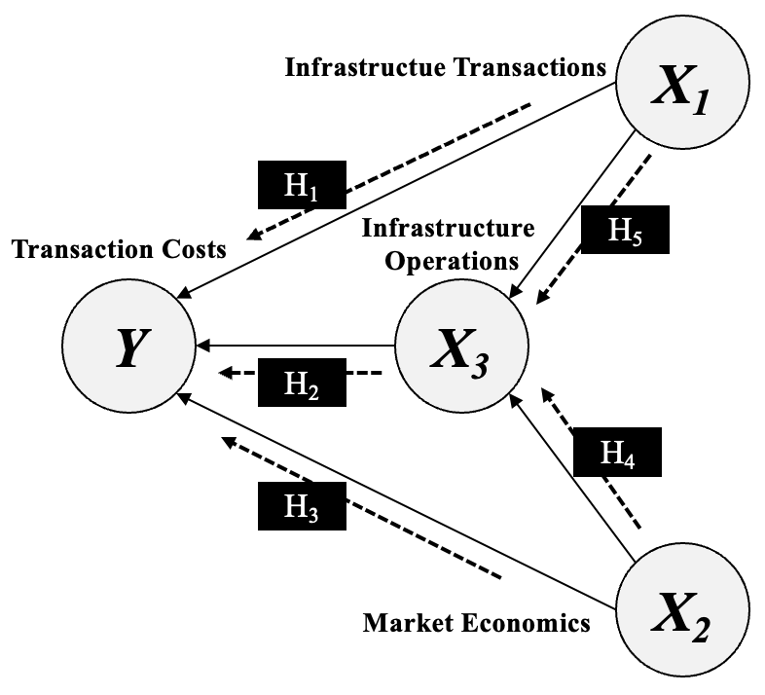

Fig .1 The Theoretical Research – TCE-FMI-Model

The dependent variable in the analysis is transaction costs for financial market participants, measured through the revenues generated by stock exchange organizations operating financial market infrastructures.
The independent variables are structured as follows:
- Infrastructure Transactions – This variable encompasses detailed trade transaction data from the electronic order book, off-electronic order book, and overall trading turnover, capturing the transactional dynamics within the financial market infrastructure.
- Market Economics – This variable includes data on listed financial instruments and market capitalization, reflecting the broader economic framework in which stock exchange organizations operate. It measures how financial instruments utilize the regulated financial market infrastructure.
- Infrastructure Operations – Defined as the third independent variable, infrastructure operations directly influence transaction costs and include operational cost structures, such as staff/personnel expenses (including headcount), other operating costs, depreciation, and amortization.
This empirical design allows for a comprehensive assessment of the key drivers of transaction costs and their relationship to the market leadership and competitive positioning of stock exchange organizations.

3. results and discussion

3.1 Explanatory power

The interpretation of the preliminary results from the structural equation modeling (PLS-SEM) can be assessed based on explanatory power, relationships between variables, and the reliability of indicators.
First, the R² value for Transaction Costs is 0.909, indicating that 90.9% of the variance in transaction costs can be explained by the variable constructs of infrastructure operations, infrastructure transactions, and market economics. This suggests a strong explanatory power, demonstrating that these factors collectively account for nearly all variations in transaction costs within financial market infrastructures.
Second, the R² value for Infrastructure Operations is 0.682, meaning that 68.2% of its variance is explained by infrastructure transactions and market economics. This reflects a moderately high explanatory power, capturing a significant portion of the variance associated with infrastructure-related operational costs.
In summary, the variance explanation for Transaction Costs is strong, while the R² value for Infrastructure Operations is sufficiently high to provide a substantial basis for analyzing the interdependencies between market economics, infrastructure transactions, and operational costs within the financial market infrastructure framework.

3.2 Relationship between variable constructs

The relationships between variable constructs are represented by path coefficients, providing insights into the strength and direction of these associations.
A path coefficient of 0.610 indicates a strong positive relationship between infrastructure transactions and infrastructure operations, suggesting that higher trading volumes and increased turnover lead to greater operational costs within financial market infrastructures.
A very strong correlation is observed between infrastructure operations and transaction costs, with a path coefficient of 0.870. This result implies that rising operational expenses in financial market infrastructures have a statistically significant impact on increasing transaction costs for market participants.
In contrast, the path coefficient of 0.027 between market economics and transaction costs is extremely weak, indicating that market capitalization and the number of listed companies do not exert a significant direct effect on the transaction costs incurred by financial market participants.
A moderate positive relationship exists between market economics and infrastructure operations, as evidenced by a path coefficient of 0.311. This suggests that a higher market capitalization and an increased number of listed companies tend to elevate the operational costs of financial market infrastructures.
Finally, the path coefficient of 0.083 between infrastructure transactions and transaction costs is relatively weak, indicating that the number of trades, turnover, and trading days per period does not substantially impact transaction costs for financial market participants. This low path coefficient suggests the presence of economies of scale, where transaction costs per trade decrease as trading volumes increase, enhancing overall market efficiency.
These findings provide empirical evidence on the interdependencies between infrastructure transactions, market economics, infrastructure operations, and transaction costs, offering valuable insights into the cost dynamics of financial market infrastructures.

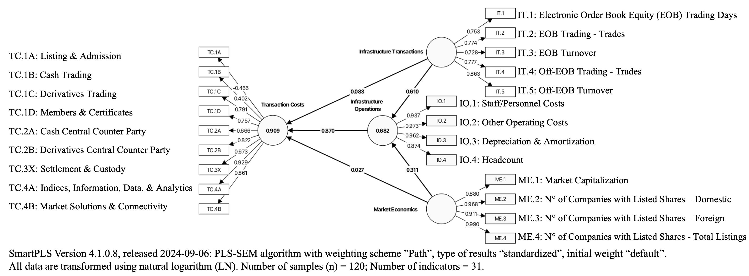
Fig .2 .Transaction Cost Analysis – PLS-SEM Algorithm

3.3 Path coefficients and P-values

The outer loadings provide insights into the reliability of the indicators used in the structural model. Most outer loadings for transaction costs are relatively high, exceeding 0.7, indicating strong indicator reliability. However, cash trading exhibits a lower outer loading of 0.402, suggesting that transaction costs associated with cash trading serve as a weaker indicator.
Notably, listing and admission shows a negative outer loading of -0.466, indicating that this indicator does not contribute effectively to the measurement of transaction costs. A dataset review identified a structural shift in annual financial reporting, reallocating financial data from listing and admission to members and certificates. This adjustment resulted in a reasonably high outer loading of 0.757, reinforcing members and certificates as a more reliable measure within the model.
For infrastructure operations, all outer loadings exceed 0.85, confirming that these indicators provide very strong measures of the latent variable construct. Similarly, infrastructure transactions exhibit strong outer loadings, ranging between 0.72 and 0.86, affirming the reliability of indicators such as trading days, trades, and turnover.
Finally, the outer loadings for market economics indicate strong reliability, with values ranging between 0.88 and 0.99, confirming their robustness as indicators of this latent variable. These findings support the overall validity and consistency of the measurement model, ensuring that key constructs are well-represented in the empirical analysis.

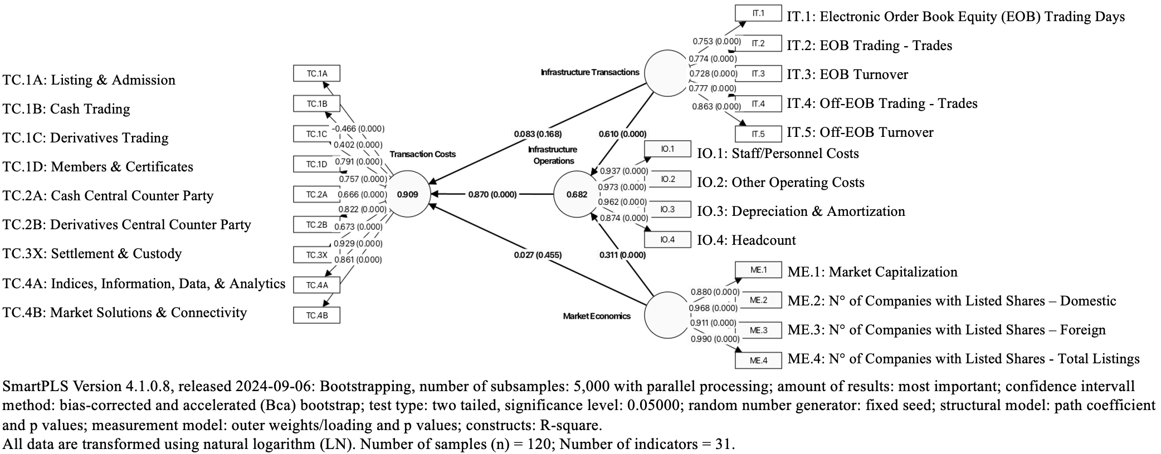
Fig.3 Bootstrapping (Path coefficients and P-values)

3.4 T-values and summary of sub-hypotheses-test conclusion

The bootstrapping results provide statistical evidence regarding the relationships between infrastructure transactions, market economics, infrastructure operations, and transaction costs.
The path coefficient between infrastructure transactions and transaction costs yields a T-value of 1.380 and a P-value of 0.168, indicating a lack of statistical significance. This result suggests that trading days, trades, and turnover volumes do not directly influence the transaction costs of stock exchange organizations for market participants. Consequently, H₁ is not supported.
Conversely, a T-value of 16.536 and a P-value of 0.000 indicate a strong positive and highly statistically significant relationship between infrastructure operations and transaction costs. The empirical test confirms that rising operating costs within financial market infrastructures lead to higher transaction costs for stock exchange organizations. As a result, H₂ is supported.
Regarding market economics and transaction costs, the findings do not support a negative influence. The corresponding T-value of 0.748 and an insignificant P-value of 0.455 suggest that market capitalization and an increased number of listings do not directly impact transaction costs. Consequently, H₃ is not supported.
In contrast, market economics exhibits a positive impact on infrastructure operations, as evidenced by a T-value of 7.049 and a highly significant P-value of 0.000. This result indicates that higher market capitalization and an increased number of listings necessitate additional operational resources, confirming that H₄ is supported.
Finally, the statistical analysis identifies a strong positive and significant relationship between infrastructure transactions and infrastructure operations, with a T-value of 16.629 and a P-value of 0.000. This finding demonstrates that increased trading volumes demand greater operational capacity and resources for financial market infrastructures, leading to the conclusion that H₅ is supported.
These empirical results provide valuable insights into the structural dynamics of financial market infrastructures, reinforcing the critical role of infrastructure operations and market economics in shaping transaction costs and competitive positioning within stock exchange organizations.
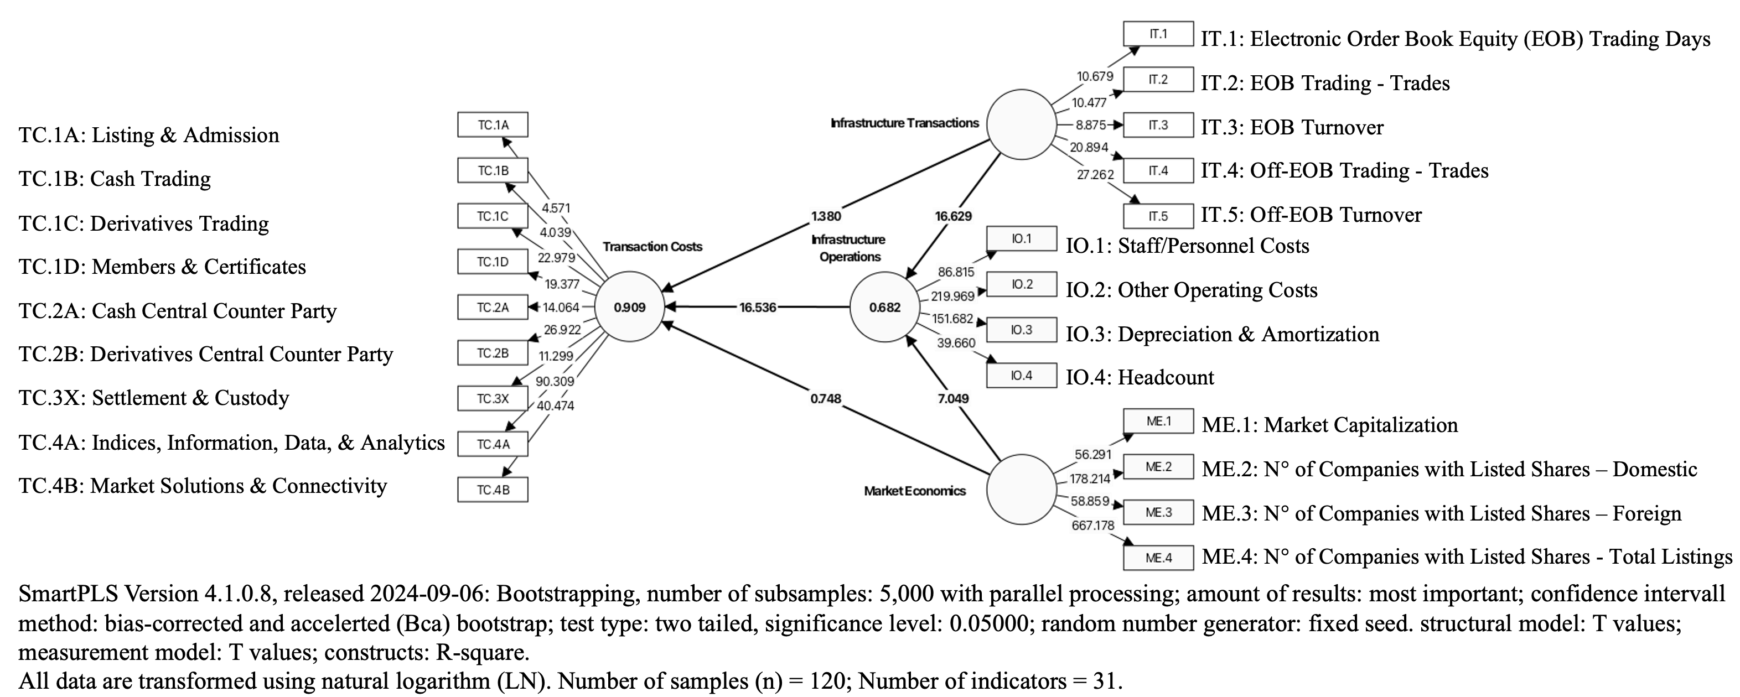
Fig .4 Transaction Cost Analysis – Bootstrapping (T-values)

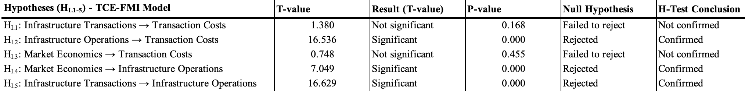
Table 1 Summary of Sub-Hypotheses-Test Conclusion

4. Conclusion

This study provides empirical evidence of the regulatory impact on European financial market infrastructures, particularly in relation to transaction cost optimization and market competitiveness. The findings indicate that infrastructure operations play a crucial role in determining transaction costs, whereas infrastructure transactions exhibit a weaker influence. Additionally, market economics impact infrastructure operations but do not have a direct effect on transaction costs.
The results suggest that regulatory frameworks should consider the balance between compliance, cost structures, and competitive positioning. Future research could explore the role of technological advancements and the integration of European financial markets in mitigating regulatory costs.
This research focuses on the empirical validation of the effects of MiFIR/MiFID II financial market regulations on market leadership and competitive positioning within European financial market infrastructures. The empirical tests contribute to an independent scientific assessment of the effectiveness of these regulations in shaping transaction cost structures and enhancing financial market efficiency.
The research objects are stock exchange organizations operating regulated trading venues in Europe, in compliance with MiFIR/MiFID II. The study empirically examines how these regulations influence transaction costs, infrastructure operations, and market economics, ultimately affecting business strategies and operational cost structures within financial market infrastructures.
The empirical results confirm a significant correlation between infrastructure operations and transaction costs, reinforcing that higher operational costs lead to increased transaction costs for market participants. Conversely, market economics do not have a direct effect on transaction costs but influence infrastructure operations, indicating that higher market capitalization and more listings drive increased operational costs for financial market infrastructures. Furthermore, infrastructure transactions exhibit a weak impact on transaction costs, supporting the presence of economies of scale, where larger trade volumes reduce per-unit transaction costs.
These findings contribute to a deeper understanding of cost dynamics within financial market infrastructures and highlight the interdependencies between trading activity, market structures, and operational expenditures. The study provides empirical evidence that MiFIR/MiFID II’s implementation has influenced transaction costs through operational efficiencies rather than direct cost reductions.
By elucidating the relationship between financial market regulation, infrastructure transactions, infrastructure operations, market economics and transaction costs, this study contributes to the body of scientific knowledge on financial market infrastructures. The findings enhance the academic understanding of regulatory effects on transaction costs and market structures, providing a foundation for further research in economic and financial market studies.

disclaimer (Artificial Intelligence)

The author hereby declares that generative AI technologies were utilized in the writing and editing of this manuscript to enhance grammar, sentence structure, and overall clarity. Specifically, ChatGPT-4 (OpenAI) was employed for linguistic refinement, sentence restructuring, and improving coherence. AI-assisted revisions were guided by targeted prompts requesting rewriting, summarization, and clarity enhancements for specific sections.

disclaimer (data usage and research intent)

The author hereby declares that the research presented in this document is based exclusively on publicly available data, including audited financial reports, trading statistics, and industry association reports. The use of this data serves solely to contribute to the academic body of knowledge and does not aim to derive any business-related insights or conclusions.
The author assumes no responsibility for the accuracy or correctness of the data, as the research relies entirely on publicly accessible information. Furthermore, the study was conducted independently by the author, without external funding, third-party validation, or the application of the four-eyes principle.
disclaimer (financial instrument projections)

Any references to theoretical profits or financial developments in this document are based solely on historical data and past performance. It is important to acknowledge that past performance does not guarantee future results. Neither the author nor any referenced financial service providers assume responsibility for future developments in financial instruments or market conditions, as these are inherently subject to change and uncertainty.

References

Benston, G. J., & Smith, C. W. (1976). A Transactions Cost Approach to the Theory of Financial Intermediation. The Journal of Finance, 31(2), 215-231. https://doi.org/10.2307/2326596
Bitz, M. (2007). Banken und Börsen/Banking and Stock Markets - KE 3: „Wertpapierbörsen: Funktionen und institutionelle Rahmenbedingungen“ (Vol. 3). FernUniversität in Hagen - Lehrstuhl für Bank- und Finanzwirtschaft. https://d-nb.info/987173774
COMMISSION-DELEGATED-REGULATION-(EU)-2017/565. (2017). COMMISSION DELEGATED REGULATION (EU) 2017/565 of 25 April 2016 supplementing Directive 2014/65/EU of the European Parliament and of the Council as regards organisational requirements and operating conditions for investment firms and defined terms for the purposes of that Directive. THE EUROPEAN PARLIAMENT AND THE COUNCIL OF THE EUROPEAN UNION. Retrieved 10. November 2023 from https://eur-lex.europa.eu/legal-content/EN/TXT/?uri=CELEX%3A32017R0565&qid=1699615896701
COMMISSION-DELEGATED-REGULATION-(EU)-2017/567. (2017). COMMISSION DELEGATED REGULATION (EU) 2017/567 of 18 May 2016 supplementing Regulation (EU) No 600/2014 of the European Parliament and of the Council with regard to definitions, transparency, portfolio compression and supervisory measures on product intervention and positions. THE EUROPEAN PARLIAMENT AND THE COUNCIL OF THE EUROPEAN UNION. Retrieved 21. September 2023 from https://eur-lex.europa.eu/legal-content/EN/TXT/PDF/?uri=CELEX:32017R0567
Commons, J. R. (1931). Institutional Economics. History of Economic Thought Articles, 21, 648-657. https://EconPapers.repec.org/RePEc:hay:hetart:commons1931
Dugger, W. M. (1983). The Transaction Cost Analysis of Oliver E. Williamson: A New Synthesis? Journal of Economic Issues, 17(1), 95-114. http://www.jstor.org.datubazes.lanet.lv/stable/4225277
Francioni, R. (2017). An Exchange and Its Value Chain. In R. Francioni & R. A. Schwartz (Eds.), Equity Markets in Transition: The Value Chain, Price Discovery, Regulation, and Beyond (pp. 15-69). Springer International Publishing. https://doi.org/10.1007/978-3-319-45848-9_2
Francioni, R., Freis, J. H., & Hachmeister, A. (2017). Financial Market Regulation. In R. Francioni & R. A. Schwartz (Eds.), Equity Markets in Transition: The Value Chain, Price Discovery, Regulation, and Beyond (pp. 239-286). Springer International Publishing. https://doi.org/10.1007/978-3-319-45848-9_9
Geranio, M. (2018). Evolution of the Exchange Industry - From Dealers’ Clubs to Multinational Companies. Springer Cham, Springer International Publishing Switzerland 2016. https://doi.org/https://doi-org.datubazes.lanet.lv/10.1007/978-3-319-21027-8
Ghosh, I., Chaudhuri, T. D., Alfaro-Cortés, E., Gámez, M., & García, N. (2022). A hybrid approach to forecasting futures prices with simultaneous consideration of optimality in ensemble feature selection and advanced artificial intelligence. Technological Forecasting and Social Change, 181, 121757. https://doi.org/https://doi.org/10.1016/j.techfore.2022.121757
Kun, E. (2024). Challenges in regulating cloud service providers in EU financial regulation: From operational to systemic risks, and examining challenges of the new oversight regime for critical cloud service providers under the Digital Operational Resilience Act. Computer Law & Security Review, 52, 105931. https://doi.org/https://doi.org/10.1016/j.clsr.2023.105931
Laudenbach, H. (2025). Digital Transformation and Transaction Cost Drivers in European Financial Market Infrastructures: A Systematic Literature Review. Journal of Economics, Management and Trade, 31(9), 66–101. https://doi.org/https://doi.org/10.9734/jemt/2025/v31i91351
North, D. C. (1992). Transaction costs, institutions, and economic performance. ICS Press San Francisco, CA. https://pdf.usaid.gov/pdf_docs/pnabm255.pdf
Schmidt, H. (1983). Marktorganisationsbestimmte Kosten und Transaktionskosten als börsenpolitische Kategorien — Grundsätzliche Überlegungen zur Weiterentwicklung des Anlegerschutzes aus ökonomischer Sicht. 16(2), 184-204. https://doi.org/10.3790/ccm.16.2.184 (Credit and Capital Markets – Kredit und Kapital)
Tchuente, D., Lonlac, J., & Kamsu-Foguem, B. (2024). A methodological and theoretical framework for implementing explainable artificial intelligence (XAI) in business applications [Article]. Computers in Industry, 155, Article 104044. https://doi.org/10.1016/j.compind.2023.104044
Williamson, O. E. (1979). Transaction-Cost Economics: The Governance of Contractual Relations. The Journal of Law & Economics, 22(2), 233-261. http://www.jstor.org.datubazes.lanet.lv/stable/725118
Williamson, O. E. (1981). The Modern Corporation: Origins, Evolution, Attributes. Journal of Economic Literature, 19(4), 1537-1568. http://www.jstor.org.datubazes.lanet.lv/stable/2724566
Williamson, O. E. (2010). Transaction Cost Economics: The Natural Progression. The American Economic Review, 100(3), 673-690. http://www.jstor.org.datubazes.lanet.lv/stable/27871227

Francioni, Freis and Hachmeister (2017), pp. 239-259
Francioni (2017), p. 11; Geranio (2018), pp. 15, 22-23, 27-28, 35-51
Kun (2024), pp. 14-15
Tchuente, Lonlac and Kamsu-Foguem (2024), p. 9; Ghosh, Chaudhuri, Alfaro-Cortés, Gámez and García (2022).
Bitz (2007), pp. 7-28; Williamson (1981), pp. 1537-1538; 1543-1551; Schmidt (1983), p. 187; Francioni (2017), pp. 15-70
COMMISSION-DELEGATED-REGULATION-(EU)-2017/567 (2017)
Williamson (1979), pp. 234-254, 259; Dugger (1983), pp. 96-99; Williamson (1981), pp. 1544-1548, 1562-1565; Francioni (2017), pp. 15-17
Commons (1931), pp. 648-657
Williamson (2010), pp. 673, 686; North (1992), pp. 7-8
Schmidt (1983), p. 187; Bitz (2007), pp. 2-4, 8-9
Laudenbach (2025)
Francioni (2017), p. 64; Benston and Smith (1976), pp. 228-229; Geranio (2018), p. 99
COMMISSION-DELEGATED-REGULATION-(EU)-2017/565 (2017), p. L 87/70; COMMISSION-DELEGATED-REGULATION-(EU)-2017/567 (2017), p. L 87/98
Authors own figure
Authors own figure
Authors own figure
Authors own figure
Authors own figure

