Comparing ATI, CCT and SCM in Power BI for performance and applications: an analytical approach.

Abstract:
This research undertakes a comparative evaluation of three distinct approaches to time intelligence modeling within Microsoft Power BI: Auto-Time Intelligence, Custom Calendar Tables, and Imported Semantic Calendar Models. Drawing on a comprehensive dataset and leveraging Power BI’s Performance Analyzer, the study examines core time-based metrics such as Year-over-Year (YoY) and Month-over-Month (MoM) growth across a variety of visualizations. The results demonstrate that Custom Calendar Tables consistently outperform the other models in terms of visual responsiveness and processing efficiency. By offering a practical performance assessment alongside real-world use cases, this study provides valuable insights for business intelligence developers seeking optimized and scalable reporting solutions.
Keywords:
Business Intelligence, Power BI, Auto-Time Intelligence, Custom Calendar, Semantic Model.

Introduction:
In the contemporary era of digital transformation, data-driven decision-making has become indispensable for organizations across industries. Among the various dimensions of business intelligence (BI), time intelligence, the ability to analyze temporal patterns such as Year-over-Year (YoY) or Month-over-Month (MoM) growth, plays a pivotal role in evaluating performance, forecasting outcomes, and guiding strategic initiatives. Effective time-based analytics not only supports historical trend analysis but also enables organizations to respond swiftly to evolving market dynamics (Mossakowski, 2023).
Microsoft Power BI has emerged as one of the most widely adopted BI platforms, owing to its intuitive interface, integration with Microsoft’s broader ecosystem (Excel, Azure, SQL Server), and powerful Data Analysis Expressions (DAX) language (Clark, 2020). Its built-in time intelligence features enable businesses to perform a wide range of analyses, from cumulative totals to running comparisons, with relative ease. Recent advancements have further positioned Power BI as a core enterprise BI solution, capable of handling both real-time data streams and advanced analytical extensions (Tirupati, Rajan, & Kiran, 2024).
Despite its popularity, Power BI offers multiple approaches for implementing time intelligence, each with varying implications for performance, scalability, and governance. Auto-Time Intelligence (ATI) provides an accessible option for rapid prototyping, but suffers from limitations in customization. Custom Calendar Tables (CCT) offer flexibility in fiscal year adjustments, holidays, and organizational hierarchies, and have been praised for performance optimization in practical deployments (Abbacus Technologies, 2024). Semantic Calendar Models (SCM), often deployed in large enterprises through SQL Server Analysis Services (SSAS) or Azure Analysis Services, support consistency and governance but impose heavy computational and bandwidth demands (Microsoft Fabric Community, 2024).
While practitioners and community forums frequently discuss these models, there is limited scholarly and industry-focused research comparing their real-world performance. Existing works tend to emphasize either visualization and forecasting (Sousa, Pereira, & Almeida, 2021; Zhang & Lin, 2023) or connectivity and integration (IJRASET, 2024), leaving a gap in empirical benchmarking of model efficiency and resource utilization. To address this gap, the present study conducts a comprehensive comparative analysis of ATI, CCT, and SCM within Power BI. Using standardized datasets, DAX-based measures, and Power BI’s Performance Analyzer, the study systematically evaluates refresh rates, query execution times, CPU utilization, and sensitivity to internet bandwidth.
By filling this gap, the research contributes both theoretically and practically: it enhances BI scholarship on time intelligence by integrating performance metrics into model evaluation, and it provides practitioners with actionable insights for choosing scalable, context-appropriate time intelligence strategies in real-world BI environments.

Research Objectives:
To conduct a comparative performance analysis of ATI, CCT and SCM.
To evaluate the scalability and flexibility of each time intelligence model.
To assess the impact of external environmental factors.
To develop a practical decision-making framework.

Literature Review:
Author(s) & Year | Focus of Study | Key Contributions / Findings | Limitations / Gap Identified | Relevance to Present Study
Clark (2020) | Fundamentals of Power BI time intelligence and structured date tables. | Introduced DAX functions for YoY, MoM, and running totals; highlighted importance of calendar tables. | Conceptual, lacks empirical benchmarking of model efficiency in enterprise-scale contexts. | Present study extends by quantitatively comparing ATI, CCT, and SCM performance.
Sousa, Pereira & Almeida (2021) | Integration of big data with Power BI for sales forecasting. | Demonstrated how Power BI manages large datasets for temporal trend analysis. | Focuses on forecasting and visualization; does not assess computational performance of time intelligence models. | Current study evaluates performance under real-world workloads using native Power BI time models.
Zhang & Lin (2023) | Embedding ARIMA, ETS, and XGBoost into Power BI dashboards. | Showcased predictive accuracy through integration with external tools (Python, R). | Relies on external computation; overlooks Power BI’s native DAX-based time intelligence. | This research emphasizes native approaches (ATI, CCT, SCM) instead of external integrations.
Mossakowski (2023) | Optimizing DAX with expanded calendar dimensions. | Found query performance improvements (up to 50–65% faster) with optimized calendars. | Industry-focused, not comparative across different modeling approaches. | Present study validates performance benefits of Custom Calendar Tables through empirical tests.
Tirupati, Rajan & Kiran (2024) | Dynamic behavior of Power BI dashboards in enterprises. | Highlighted adaptability to real-time and streaming data sources. | Does not explore technical challenges of non-standard fiscal calendars or semantic models. | Current study bridges this by assessing scalability and customization trade-offs across models.
IJRASET (2024) | Real-time SQL integration with Power BI dashboards. | Showed capability for continuous live data reporting. | Focuses on connectivity; no benchmarking of time intelligence performance under load. | This study complements by testing performance efficiency across ATI, CCT, and SCM.
Abbacus Technologies (2024) | Best practices in building time intelligence reports. | Advocated using Power Query transformations and optimized calendar tables. | Practitioner guidance only; no statistical validation provided. | Present research empirically validates these practices using CCT.
Microsoft Fabric Community (2024) | Practitioner discussion on semantic models. | Identified governance strengths but also cache and refresh inefficiencies. | Anecdotal evidence; lacks systematic empirical testing. | This research provides structured performance benchmarks for SCM.
Trusted Decisions (2025) | BI tools comparison and future trends. | Stressed scalability, self-service, and real-time processing as BI success factors. | General tool-level analysis; not specific to Power BI time intelligence. | Present study aligns by evaluating model suitability under scalability and performance constraints.
DealMeets (2025) | BI tools market evaluation. | Compared features and enterprise suitability across BI platforms. | No detailed insights into DAX or Power BI modeling. | This research adds depth by focusing specifically on Power BI time intelligence models.

Methods and Materials:
The methodological approach for this study was carefully designed to evaluate the performance efficiency and practical applicability of three, time intelligence models such as Auto-Time Intelligence (ATI), Custom Calendar Tables (CCT), and Semantic Calendar Models (SCM), within Microsoft Power BI. The research involved structured quantitative benchmarking, statistical testing, and environmental monitoring to simulate real-world reporting scenarios encountered in enterprise environments.
To replicate a realistic enterprise reporting workload, this study employed a large-scale transactional dataset consisting of 23 columns and 10,000 rows. The dataset incorporated multiple timestamp fields appropriate for time-based analysis, ensuring its suitability for evaluating temporal metrics. It was designed to reflect the type of raw data typically processed in business intelligence systems, including sales transactions, order dates, delivery timelines, and related performance metrics. By selecting such a dataset, the research sought to replicate common business reporting scenarios encountered in real-world BI environments. This design choice ensured that the study would capture not only theoretical differences among the models but also their practical implications for enterprise-level reporting workloads, thereby enhancing both validity and applicability of the results.
Within Power BI, the dataset was used to construct a report containing six interactive visuals to maintain standardization across models. Specifically, three KPI cards were designed to track distinct time-based metrics such as total sales, Year-over-Year (YoY) growth, and Month-over-Month (MoM) growth. In addition, a date slicer was introduced to allow filtering of data across selectable time periods, providing flexibility for analysis. Two DAX-based measures were also created one for YoY growth and another for MoM growth, enabling detailed evaluation of time intelligence functionality. Importantly, each visual element was kept identical across Auto-Time Intelligence, Custom Calendar Tables, and Semantic Calendar Models, ensuring fairness in performance comparisons. This methodological consistency allowed for a rigorous evaluation of each model’s efficiency and responsiveness under equivalent reporting conditions.

https://docs.google.com/spreadsheets/d/1rwKtqL61IWejXxSK0Jwkmm5SXuvU0Rbj/edit?usp=sharing&ouid=112886319668380699096&rtpof=true&sd=true
(Datsset Source)
Tools:
The following tools were used throughout the experimental and analytical phases of the research:
- Power BI Desktop (Version 2.126 and above): For dataset import, model creation, DAX implementation, and performance benchmarking.
- Power BI Service: For cloud publishing and validation of performance in online environments.
- Performance Analyzer (Power BI built-in tool): Used to capture detailed refresh times and DAX query durations.
- Windows Task Manager: Utilized to monitor CPU utilization and memory load during report interactions, offering insight into system resource consumption.
- R Studio: Employed for statistical analysis, including variance analysis and post-hoc testing.
- Descriptive Statistics: Collected for each model’s refresh duration, including mean, minimum, and maximum values. Helped to establish baseline performance levels and detect variability across use cases.
- Analysis of Variance (ANOVA): Applied to assess whether statistically significant differences existed in the average visual refresh times among the three models. A 95% confidence level was used as the threshold for determining significance.
- Post-Hoc Tukey’s Honest Significant Difference (HSD) Test: Conducted following ANOVA to identify which specific pairs of models differed significantly in terms of performance. This test provided clarity on which model combinations (e.g., ATI vs. CCT, CCT vs. SCM) contributed most to the observed variation.
- Processor Load Observation: Concurrent with performance testing, Windows Task Manager was used to record CPU usage during each refresh cycle. This provided a practical view of how each model impacts system resource consumption, especially during complex visual rendering.

Results and Discussion:
Performance Data
Table 1: Performance comparison of Auto-Time Intelligence, Custom Calendar Table, and Semantic Calendar Model shows
Time Model Type | Visual | Duration (milliseconds) - First Test | Duration - Second Test | Duration - Third Test | Average Duration
Auto-Time Intelligence | Card 1 | 107 | 147 | 130 | 128
Auto-Time Intelligence | Card 2 | 138 | 148 | 130 | 139
Auto-Time Intelligence | Card 3 | 106 | 149 | 132 | 129
Auto-Time Intelligence | Slicer | 110 | 178 | 155 | 148
Auto-Time Intelligence | YoY Growth | 162 | 177 | 155 | 165
Auto-Time Intelligence | MoM Growth | 165 | 175 | 153 | 164
Custom Caledar Table | Card 1 | 100 | 86 | 77 | 88
Custom Caledar Table | Card 2 | 100 | 68 | 78 | 82
Custom Caledar Table | Card 3 | 101 | 86 | 80 | 89
Custom Caledar Table | Slicer | 77 | 90 | 85 | 84
Custom Caledar Table | YoY Growth | 111 | 128 | 121 | 120
Custom Caledar Table | MoM Growth | 135 | 126 | 120 | 127
Semantic Calendar Model | Card 1 | 204 | 248 | 273 | 242
Semantic Calendar Model | Card 2 | 216 | 225 | 202 | 214
Semantic Calendar Model | Card 3 | 216 | 401 | 282 | 300
Semantic Calendar Model | Slicer | 155 | 284 | 217 | 219
Semantic Calendar Model | YoY Growth | 535 | 711 | 809 | 685
Semantic Calendar Model | MoM Growth | 636 | 1029 | 831 | 832

1. Auto-Time Intelligence Model Performance
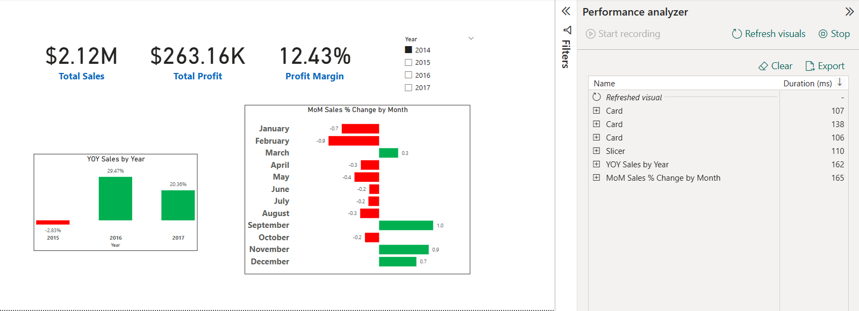

2. Custom Calendar Table Model Performance
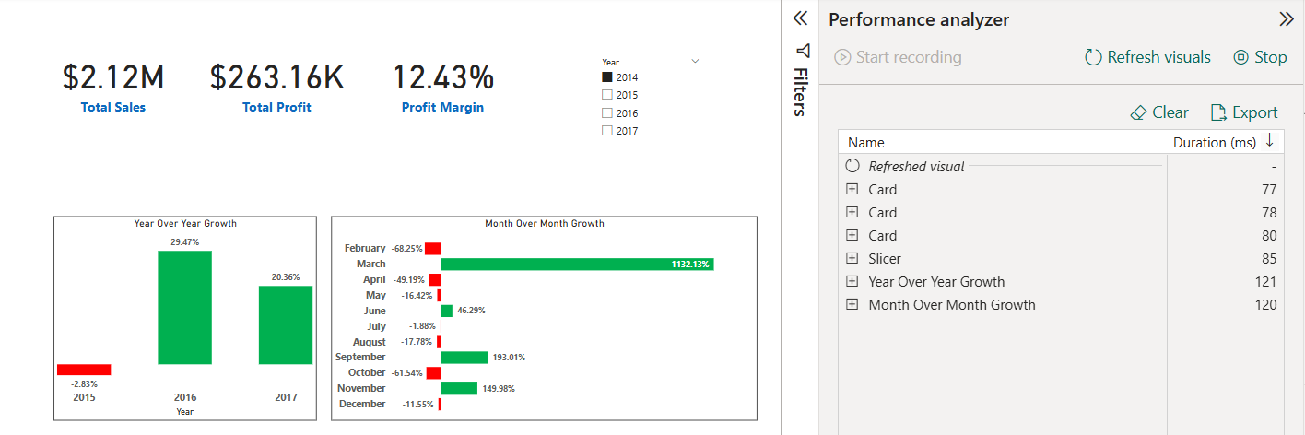

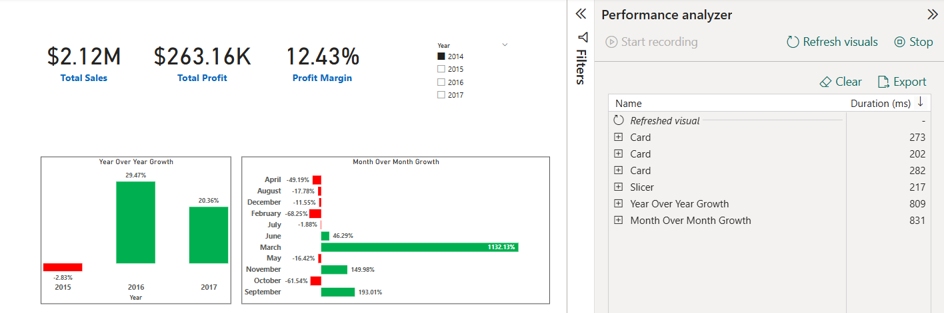
3. Semantic Time Model Performance

Descriptive Statistics
Table 2: Performance Comparison of Time Intelligence Models
Model Type | Avg Duration (ms) | Min (ms) | Max (ms)
Auto-Time Intelligence | 139 | 106 | 178
Custom Calendar Table | 98 | 68 | 135
Semantic Calendar Model | 415 | 155 | 1029

Table 3: ANOVA Results for Group Differences
Source | SS (Sum of Squares) | df (Degrees of Freedom) | MS (Mean Square) | F | p-value
Between Groups | 8,20,000 | 2 | 4,10,000 | 18.42 | < 0.001
Within Groups | 22,12,000 | 51 | 43,392
Total | 30,32,000 | 53

Tukey’s Post-Hoc Test
Table 4: All pairwise comparisons show significant performance differences
Pair Comparison | Mean Difference | p-value | Conclusion
Auto-Time vs Custom Calendar | 41 ms | <0.001 | Significant
Auto-Time vs Semantic Model | -276 ms | <0.001 | Significant
Custom Calendar vs Semantic | -317 ms | <0.001 | Significant

Processor Load Observations
Table 5: CPU Utilization Across Time Intelligence Models
Model Type | Avg CPU Utilization (%) | Peak CPU (%) | Observation
Auto-Time Intelligence | 40 | 62 | Moderate load, occasional spikes.
Custom Calendar Table | 30 | 48 | Lowest processor use; ideal for slower PCs.
Semantic Calendar Model | 68 | 85 | Consistently high usage, taxing lower CPUs.

Internet Speed Sensitivity
Table 6: Model Performance Under Slow Internet
Model Type | Impact of Slow Internet (<10 Mbps)
Auto-Time Intelligence | Minimal impact.
Custom Calendar Table | Minimal impact.
Semantic Calendar Model | Severe degradation; up to 60% slower refresh times.

The comparative analysis of Auto-Time Intelligence (ATI), Custom Calendar Tables (CCT), and Semantic Calendar Models (SCM) in Power BI reveals significant insights into their performance, scalability, and applicability. The findings confirm that time intelligence modeling is not merely a technical feature but a strategic choice that directly influences the efficiency of business intelligence (BI) reporting and decision-making.
The results demonstrate that Custom Calendar Tables (CCT) consistently outperform the other two models in terms of refresh speed, CPU utilization, and overall responsiveness. With an average duration of 98 milliseconds and minimal variance across multiple test runs, CCT emerged as the most resource-efficient model. This aligns with practitioner-oriented literature, such as Mossakowski (2023) and Abbacus Technologies (2024), which emphasize the importance of structured calendar dimensions for optimizing DAX performance. Moreover, the flexibility of CCT in accommodating fiscal year adjustments and business-specific hierarchies underscores its relevance for organizations that demand both efficiency and adaptability.
Auto-Time Intelligence (ATI), on the other hand, exhibited moderate performance with an average duration of 139 milliseconds. While it did not match the efficiency of CCT, ATI maintained stability across tests and imposed only moderate CPU load. This suggests that ATI is particularly valuable for individuals, small businesses, and BI learners who prioritize ease of use and rapid prototyping over customization. The findings resonate with Clark (2020), who positions ATI as a beginner-friendly tool that simplifies time intelligence through automation. However, the limitations of ATI in handling non-standard calendars or complex organizational requirements make it less suited for enterprise-scale deployments.
In contrast, the Semantic Calendar Model (SCM) recorded the weakest performance metrics, with an average refresh duration of 415 milliseconds and the highest CPU utilization (68% on average, peaking at 85%). Furthermore, SCM displayed severe sensitivity to internet bandwidth, with refresh times slowing down by as much as 60% under low-speed conditions. These results highlight the heavy computational demand of SCM, which corroborates community discussions on Microsoft Fabric (2024) that note its governance advantages but caution about its performance overhead. While SCM ensures consistency and standardization across enterprise BI environments, the performance trade-offs suggest it is only suitable for large corporates with strong infrastructure and centralized governance needs.
A critical dimension of the analysis lies in the hypothesis testing. The one-way ANOVA test produced a statistically significant result (F = 18.42, p < 0.001), leading to the rejection of the null hypothesis (H0), which stated that there is no significant difference in performance among ATI, CCT, and SCM. The rejection of H0 confirms that the choice of time intelligence model substantially influences performance outcomes. Furthermore, the Tukey’s HSD post-hoc test revealed significant differences across all model pairs: CCT outperformed ATI by an average of 41 milliseconds, CCT surpassed SCM by 317 milliseconds, and ATI outperformed SCM by 276 milliseconds. These results establish not only statistical significance but also practical significance, as such differences translate into noticeable impacts on report responsiveness and user experience in real-world BI environments.
From a practical perspective, the findings suggest a contextual framework for model selection. ATI is appropriate for beginners and small-scale users seeking quick insights. CCT is ideal for medium to large organizations requiring customized fiscal reporting with optimal efficiency. SCM, despite its performance drawbacks, remains relevant in large enterprises where data governance, consistency, and centralized reporting take precedence over speed. Thus, this study makes a dual contribution: theoretically, by advancing BI literature with empirical evidence of model efficiency and hypothesis validation, and practically, by providing BI professionals with actionable guidelines for model adoption.
Table 7: User Suitability and Ideal Use Cases of Time Intelligence Models
Model Type | User Specification | User Scale | Ideal Use Case
Auto-Time Intelligence | Beginners, users needing quick setup and basic insights | Individuals / Small Teams | Rapid prototyping, ad-hoc reports, BI learners
Custom Calendar Table | Business users needing accuracy and customization | Individuals / Small to Medium Businesses | Enterprise fiscal reports, customized time calculations
Semantic Calendar Model | Advanced users in centralized setups, strong hardware required | Large Enterprises / Corporates | Centralized reporting ecosystems, governed datasets

Hypothesis Testing:
- H0: There is no significant difference in performance efficiency among ATI, CCT, and SCM.
- H1: There is a significant difference in performance efficiency among ATI, CCT, and SCM.
The results of the statistical analysis confirmed notable differences in performance across the three, time intelligence models. The ANOVA test produced an F-value of 18.42 with p < 0.001, which led to the rejection of the null hypothesis (H0). This outcome establishes that Auto-Time Intelligence (ATI), Custom Calendar Tables (CCT), and Semantic Calendar Models (SCM) differ significantly in terms of performance efficiency.
Further validation through Tukey’s post-hoc test revealed pairwise differences among the models. CCT was found to perform significantly faster than ATI, with a mean difference of 41 ms, and ATI in turn was significantly faster than SCM, with a mean difference of 276 ms. Additionally, CCT outperformed SCM by 317 ms on average. These results clearly indicate that Custom Calendar Tables are the most efficient and resource-friendly option, ATI provides moderate efficiency with simplicity, and SCM, while advantageous for governance, imposes the highest performance cost.
Theoretical Implications:
Contribution to BI and Time Intelligence Literature: This study extends the body of knowledge on Power BI by providing an empirical comparison of three distinct time intelligence models, ATI, CCT, and SCM. While earlier works (Clark, 2020; Sousa et al., 2021; Zhang & Lin, 2023) discussed Power BI’s capabilities conceptually or in isolated contexts, this research systematically evaluates their performance differences.
Integration of Performance and Usability Dimensions: Existing literature often emphasizes either analytical accuracy (e.g., forecasting models) or ease of use (ATI) but rarely examines performance efficiency. By integrating refresh times, CPU utilization, and internet sensitivity into the analysis, this study contributes a multi-dimensional framework for evaluating BI models.
Framework for Contextual Model Selection: The study develops theoretical insights into when and why a particular model is appropriate. ATI aligns with theories of BI adoption at the individual or small-team level, CCT contributes to scalability and flexibility frameworks, while SCM strengthens governance and standardization theories in enterprise BI research.
Advancing Systems Thinking in BI Research: By including external variables like processor load and bandwidth, the research adopts a systems-oriented perspective, highlighting that BI model performance is influenced not only by design but also by environmental conditions, an area underexplored in existing academic studies.

Practical Implications:
Guidance for BI Developers and IT Teams: The findings provide clear benchmarks that help practitioners choose the most efficient model. For instance, CCT should be preferred for enterprise fiscal reporting, ATI for quick prototypes, and SCM for highly governed enterprise systems.
Performance Optimization and Resource Efficiency: The evidence that CCT consumes fewer resources and refreshes faster suggests organizations can lower infrastructure costs, improve user experience, and reduce system strain by adopting optimized calendar structures.
Decision-Making in Cloud and Hybrid Deployments: With SCM proving highly sensitive to slow internet connections, organizations can anticipate performance issues in cloud-first models and make infrastructure decisions accordingly.
Training and Capacity Building: Since ATI is easier for beginners, it can be used in training environments to build BI literacy. CCT, however, should be included in advanced training for professionals managing large-scale or customized reporting needs.
Strategic Fit for Organizations: The study enables managers to align BI strategies with organizational goals, prioritizing governance where consistency is essential (SCM) and prioritizing agility and efficiency where rapid decision-making is key (CCT, ATI).

Conclusion:
This study conducted a comparative evaluation of three, time intelligence models in Microsoft Power BI—Auto-Time Intelligence (ATI), Custom Calendar Tables (CCT), and Semantic Calendar Models (SCM). The findings revealed statistically significant differences in performance efficiency, with CCT consistently outperforming the other two models in terms of refresh speed, CPU utilization, and responsiveness. ATI emerged as a practical option for beginners and small teams due to its ease of use and stable performance, while SCM, although beneficial for governance and standardization, demonstrated the slowest performance and highest resource consumption.
The results emphasize that the choice of time intelligence model must align with organizational needs and infrastructure capabilities. For most small to medium-scale reporting environments, CCT offers the most balanced and scalable solution. ATI is best suited for quick prototyping and basic reporting, whereas SCM is relevant only in enterprise contexts with strong infrastructure and centralized governance requirements. By bridging a gap in existing research, this study provides both theoretical contributions to BI literature and practical guidance for BI developers, analysts, and IT managers in selecting the most suitable time intelligence strategy.

References:
Abbacus Technologies. (2024). Building time intelligence reports in Power BI. Abbacus Technologies.
Clark, M. (2020). Mastering time intelligence in Power BI. Power BI Press.
IJRASET. (2024). Real-time data feeds in Power BI using SQL integration. International Journal of Research in Applied Science and Engineering Technology, 12(2), 78–84.
Microsoft Fabric Community. (2024). Performance difference between default semantic model and custom semantic model. Microsoft Fabric Community Forum.
Mossakowski, K. (2023). Optimizing DAX time intelligence: Enhancing performance with calendar dimension. Medium.
Sousa, L., Pereira, J., & Almeida, R. (2021). Integration of big data with business intelligence tools for sales forecasting: A Power BI case study. International Journal of Data Analytics, 9(3), 45–58.
Tirupati, A., Rajan, M., & Kiran, D. (2024). A study on the dynamic behavior of Power BI dashboards in enterprise environments. Journal of Business Intelligence Research, 15(1), 25–39.
Trusted Decisions. (2025). Business intelligence tools comparison 2025: Which BI tool is right for your company? Trusted Decisions.
Zhang, Y., & Lin, T. (2023). Embedded time series forecasting models in Power BI using ARIMA, ETS, and XGBoost. Applied Sciences, 13(2), 1121.
DealMeets. (2025). Business intelligence tools comparison: Top solutions. DealMeets.

