Revolutionizing international marketing: A Comprehensive review of the digital milestone

Abstract
The rapid advancement of digital technologies has revolutionized international marketing, reshaping how businesses engage with consumers and compete in the global marketplace. This review provides a comprehensive analysis of the digital milestones that have transformed marketing practices, including e-commerce, social media, mobile marketing, artificial intelligence (AI), big data analytics, content marketing, and omni-channel strategies. These innovations have expanded global market reach, enabled precision targeting, and facilitated real-time, personalized customer engagement. The study highlights how digital tools have influenced consumer behavior by raising expectations for convenience, transparency, and personalization while simultaneously enhancing satisfaction and loyalty through data-driven insights. Despite these opportunities, the paper also identifies critical challenges, such as data privacy concerns, cybersecurity risks, ethical issues in AI-driven marketing, cultural differences across markets, and growing consumer fatigue from digital advertising. Emerging trends, including voice search, AI-powered chatbots, augmented and virtual reality, influencer marketing, programmatic advertising, and blockchain applications are further shaping the future of digital marketing. The review concludes that businesses must adopt agile, culturally adaptive, and ethically grounded strategies to leverage digital innovations effectively. Future research should explore the ethical implications of AI, the evolving role of influencers, and the integration of block chain to enhance transparency and trust in international marketing practices.

Key words: Digital marketing, E-commerce, International marketing, Consumer behavior, Artificial intelligence

- Introduction
The rapid evolution of digital technologies has fundamentally transformed the landscape of international marketing (Cham et al., 2022). Over the last few decades, businesses have witnessed a significant shift in how they engage with global markets, foster customer relationships, and deliver value (Ali & Naushad, 2023; Cham et al., 2022). Traditional marketing strategies, once dominated by print media, direct sales, and physical storefronts, are increasingly being replaced by dynamic, digital-first approaches (Figueiredo et al., 2025). The advent of the internet, coupled with the rise of social media platforms, mobile technologies, big data, and artificial intelligence, has led to the democratization of marketing (Akter et al., 2021). This transformation has made it possible for companies, regardless of size or geographical location, to connect with consumers worldwide in ways that were once unimaginable (Ferreira et al., 2023).
The global marketplace has become more interconnected, competitive, and complex, and organizations must adapt to survive (Alghizzawi et al., 2024). With the proliferation of digital technologies, consumers have become more informed, empowered, and selective in their purchasing decisions. In response, companies have been forced to rethink their marketing strategies and embrace digital innovation to meet the evolving expectations of their audiences (Ali et al., 2024). This shift has given rise to a new era of marketing characterized by precision targeting, personalized content, real-time customer engagement, and data-driven decision-making (Ali & Naushad, 2023).
Digital milestones such as the rise of e-commerce, the widespread adoption of social media, the growth of mobile marketing, and the increasing reliance on artificial intelligence have revolutionized how marketing is conceived and executed (Antczak, 2024). E-commerce platforms have opened up new avenues for international trade, enabling businesses to reach customers across borders with unprecedented ease and efficiency (Babatunde et al., 2022). Social media, once seen primarily as a tool for personal interaction, has become an integral part of marketing strategies, offering platforms for brand building, customer engagement, and targeted advertising. Mobile marketing, driven by the ubiquity of smartphones, has allowed companies to engage with consumers on the go, providing personalized and contextually relevant content that is tailored to individual preferences (Baskoro, 2024).
The growing significance of data in marketing has also contributed to this revolution (Battisti et al., 2021). Big data analytics, coupled with advancements in artificial intelligence and machine learning, has enabled marketers to gain deeper insights into consumer behavior, preferences, and purchasing patterns. This wealth of information has empowered businesses to make more informed decisions, optimize marketing campaigns, and enhance customer experiences (Cahen & Borini, 2020). Predictive analytics, for example, allows companies to anticipate consumer needs and personalize offerings, driving customer loyalty and increasing conversion rates (Cateriano-Arévalo et al., 2022).
Furthermore, digital marketing has played a pivotal role in fostering a more inclusive and diverse global marketplace (Chinnici et al., 2025). By lowering entry barriers, it has enabled small businesses and startups to compete on a level playing field with larger, established organizations. Digital platforms provide these companies with the tools and reach needed to market their products and services effectively to international audiences, without the heavy financial investment traditionally required for global expansion (Cho et al., 2023). Additionally, digital marketing has facilitated the rise of micro-marketing strategies that cater to specific segments of the population, enabling businesses to meet the unique needs of diverse customer groups across the globe (Cumming et al., 2023).
As the digital marketing landscape continues to evolve, businesses must remain agile and adaptive to keep pace with emerging trends and technologies (Dallocchio et al., 2024). The increasing reliance on artificial intelligence, virtual reality, and voice search, among other innovations, suggests that the future of international marketing will be shaped by a new set of tools and strategies that prioritize hyper-personalization, immersive experiences, and real-time engagement (Del Vecchio et al., 2022). However, with these advancements come challenges, such as data privacy concerns, cybersecurity risks, and the ethical implications of AI-driven marketing tactics (Devang et al., 2019). Businesses must navigate these complexities to build trust with consumers while maintaining a competitive edge in an ever-changing digital environment (Dillon et al., 2020).
This paper aims to provide a comprehensive review of the digital milestones that have revolutionized international marketing, examining the key technological advancements, strategies, and trends that have reshaped the field. It will explore the impact of digital tools on global marketing practices, discuss the challenges and opportunities presented by digital marketing, and offer insights into the future directions of the discipline. By analyzing the intersection of technology, consumer behavior, and marketing strategies, this review seeks to contribute to the understanding of how businesses can leverage digital innovations to gain a competitive advantage in the increasingly globalized and digitally connected marketplace. Through this, the paper will highlight the crucial role of digital marketing in driving business success and shaping the future of international commerce.

The evolution of international marketing in the digital age

A historical overview of traditional marketing practices
Before the rise of digital marketing, traditional marketing practices dominated the global landscape (Douglas & Craig, 1992). These practices primarily included television and radio advertising, print media (newspapers, magazines), direct mail, and in-person sales. Such strategies were often one-way communication channels where businesses could broadcast their message to large audiences. A key limitation of traditional marketing was its reliance on broad demographics, with little ability for businesses to target specific individuals (Du & Dzamankulov, 2023). International marketing efforts were constrained by geographical boundaries, time zones, and communication barriers, which limited the reach and precision of marketing campaigns (Fan et al., 2023).
  - Introduction of digital marketing technologies and their early adoption
The introduction of digital marketing technologies in the 1990s, with the rise of the internet, marked a pivotal shift in marketing strategies (Douglas & Craig, 1992). Websites became the cornerstone of businesses' digital presence, and email marketing was one of the first forms of digital communication to supplement traditional methods (Fan et al., 2023). The early adoption of digital marketing began with search engine marketing (SEM), the use of websites for direct sales, and the first iterations of banner advertisements. As the internet became more accessible globally, businesses began to recognize the potential of reaching a much broader audience at a fraction of the cost compared to traditional marketing channels (Ferreira et al., 2023).
Remarkable milestones in the evolution of digital marketing have significantly shaped international marketing strategies (Figueiredo et al., 2025). E-commerce, for instance, revolutionized global trade by enabling businesses to conduct transactions online (Figure 1). Early examples like Amazon and eBay (which began in the mid-1990s) showed that businesses could sell products to customers across the world without the need for physical stores (Forghani et al., 2022). As highlighted by (Francis et al., 2023), the global rise of online shopping has reshaped international retail dynamics, expanding market access for small businesses and large corporations alike (Francis et al., 2023).
Another pivotal milestone was the rise of social media marketing in the 2000s. Platforms like Facebook, Twitter, and Instagram allowed businesses to directly engage with global consumers in real time (Fu, 2023). Social media provided a two-way communication channel, fostering customer interaction and brand loyalty. For example, Starbucks successfully used social media to create personalized campaigns that increased its global footprint (Fregidou-Malama et al., 2023).
Furthermore, the adoption of mobile marketing in the 2010s took advantage of the global ubiquity of smartphones. Mobile advertising allowed businesses to target consumers based on location, time, and user behavior (Furr et al., 2022; Jaas, 2022). As mobile commerce soared, companies like Alibaba capitalized on mobile platforms to establish themselves as global leaders (Figure 1). These technological milestones have collectively transformed international marketing, offering businesses the opportunity to engage with consumers more directly and efficiently (Hewett, 2020).

Key digital milestones in international marketing
    - E-commerce: revolutionizing global trade through online platforms
E-commerce has been one of the most transformative digital milestones, drastically altering how businesses engage in international trade (Cumming et al., 2023). Online platforms such as Amazon, Alibaba, and eBay have expanded the global marketplace, offering businesses the ability to sell products across borders without the overhead costs of physical stores. According to Hidayati et al., (2024), e-commerce facilitates efficient transactions through digital platforms, enabling businesses to reach global audiences with lower operational costs. This shift has allowed small and medium enterprises (SMEs) to compete globally, democratizing access to international markets (Hosseini & Roshanfekr, 2023).

Social media marketing
The rise of social media platforms such as Facebook, Instagram, and Twitter has dramatically reshaped brand engagement in international marketing (Huang & Rust, 2021). These platforms allow businesses to create direct, real-time communication channels with consumers worldwide, enabling personalized and interactive marketing. (Huang & Rust, 2022) argue that social media marketing provides companies with an opportunity to foster relationships with consumers, improve brand loyalty, and reach new market segments. Social media campaigns also allow brands to build communities around their products and services, leveraging user-generated content and viral marketing to increase visibility and consumer engagement (Hussain et al., 2023).

Mobile marketing: the role of mobile devices in enhancing consumer engagement
Mobile marketing emerged as a key milestone with the proliferation of smartphones, which have become integral to consumers' daily lives (Indrawan et al., 2023). Mobile marketing offers businesses the ability to engage with customers in real time and in personalized contexts, whether through apps, SMS campaigns, or location-based advertising. According to (Jaas, 2022), mobile marketing allows brands to deliver tailored content based on user behavior, location, and preferences, leading to enhanced customer engagement and improved conversion rates.

Artificial intelligence and data analytics: leveraging big data, AI, and machine learning for targeted marketing
The integration of artificial intelligence (AI) and big data analytics into marketing strategies has ushered in a new era of precision targeting (Jean et al., 2021). AI algorithms and machine learning techniques analyze vast amounts of consumer data to predict behaviors, personalize marketing efforts, and optimize advertising campaigns (Jeong et al., 2023). As noted by (Katsikeas et al., 2020), AI-driven marketing tools can segment audiences more accurately, enhancing the effectiveness of campaigns and driving higher returns on investment (Figure 1). These technologies also enable marketers to implement dynamic pricing strategies and automate customer service through AI-powered chatbots (Ingriana et al., 2024).

Content marketing and influencer marketing
Content marketing and influencer marketing have become central to shaping consumer perceptions and driving brand engagement (Jaas, 2022; Jeong et al., 2023). Content marketing involves creating valuable, informative, and engaging content to attract and retain customers, while influencer marketing capitalizes on the credibility of online personalities to endorse products (Katsikeas et al., 2020). As defined by (Katsikeas et al., 2020), content marketing seeks to build trust and authority, which is crucial in the decision-making process for international consumers. Influencer marketing, on the other hand, has become a powerful tool for reaching niche markets, as influencers create authentic connections with their followers that can translate into higher conversion rates (Katsikeas, 2003).

Omni-channel marketing: the convergence of digital and physical marketing strategies
Omni-channel marketing refers to the integration of digital and physical marketing strategies to provide a seamless, cohesive customer experience across multiple touchpoints (Khaki & Khan, 2024). This approach ensures that customers can engage with a brand through various channels whether online, in-store, or via mobile apps without experiencing disruptions in service or messaging (Khaki & Khan, 2024). (Khan, 2020) emphasize that omni-channel strategies enhance customer satisfaction and loyalty by providing consistent, personalized interactions across all channels. The shift towards omni-channel marketing has allowed global brands to bridge the gap between digital and physical experiences, creating a unified customer journey that transcends geographical boundaries (Khan & Khan, 2021).

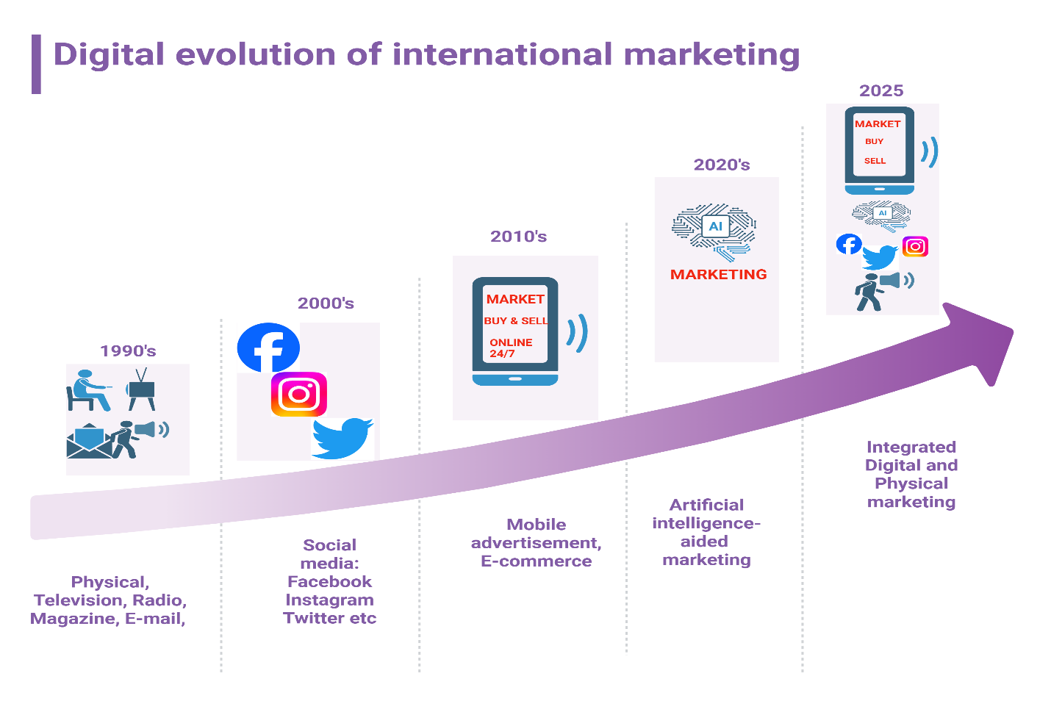
Figure 1: A schematic view of digital advancement in international marketing from 1990’s to 2025

The impact of digital marketing on global consumer behavior

Changing consumer expectations and buying patterns
Digital marketing has significantly altered consumer expectations, making them more informed, empowered, and selective (Khan et al., 2022). The internet, social media, and e-commerce platforms have provided consumers with unprecedented access to information, enabling them to compare prices (Figure 2), read reviews, and evaluate products from global sources before making a purchase decision (Knight & Fletcher, 2022). As a result, consumers now expect instant access to relevant information, tailored offers, and seamless buying experiences (Kozlenkova et al., 2021). This shift has enhanced adjustment of marketing strategies to meet heightened consumer demands for convenience, speed, and personalization (Labib, 2024).

The shift towards personalized and real-time customer engagement
Consumers now seek personalized experiences that reflect their individual needs, preferences, and behaviors (Lacka et al., 2020). Digital marketing allows companies to deliver real-time, targeted content and offers through various channels, including email, social media, and mobile apps (Lamichhane, 2022). Personalization, powered by data analytics and AI, has become a key driver of customer engagement, as brands use behavioral data to craft individualized experiences (Leonidou et al., 2017). This shift towards real-time, interactive communication fosters deeper relationships between brands and consumers, enhancing engagement and improving customer satisfaction (Li et al., 2024).

The role of data-driven insights in influencing consumer decisions
Data analytics plays a pivotal role in shaping consumer decisions by providing insights into purchasing behaviors, preferences, and patterns (Luo & Zahra, 2023). Marketers can use this data to create highly targeted campaigns that resonate with specific consumer segments, increasing the likelihood of conversion (Madan & Rosca, 2022). With advanced AI and machine learning algorithms, businesses can predict consumer needs, offering relevant products or services at optimal times (Mahbub & Ayman, 2024; Manoharan et al., 2023).

Enhancing customer satisfaction and loyalty
Through personalized content, timely communication, and a seamless multiple channel experience, digital marketing has enhanced customer satisfaction and loyalty (Makrides et al., 2022). By meeting or exceeding consumer expectations, brands can build trust and encourage repeat business. Furthermore, data-driven insights allow brands to continuously optimize their offerings, fostering long-term customer loyalty and positive brand perceptions (Meyer et al., 2023; Monaghan et al., 2020).
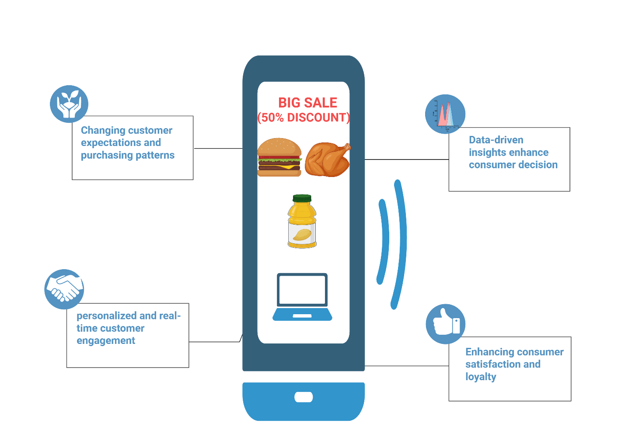
Figure 2: The impact of digital marketing on consumer beahviour

Opportunities and challenges in digital international marketing

Opportunities
    - Global market access
One of the most significant opportunities digital marketing offers is the ability to reach a global audience (Mueller & Swoboda, 2025). Traditional marketing methods often had geographical limitations, but digital platforms have broken these barriers. E-commerce, social media, and mobile marketing allow businesses to engage with consumers across borders (Figure 3), expanding their reach to new markets (Mueller & Swoboda, 2025). This enhanced market access enables even small businesses to scale globally, democratizing opportunities for international trade (Musa et al., 2023). For example, small artisanal brands can reach international consumers through platforms like Etsy or Shopify, while larger corporations use targeted ads on platforms like Facebook or Google to market products globally (Musa et al., 2023).
    - Cost-efficiency in marketing campaigns
Digital marketing offers businesses a more cost-effective way to reach large audiences compared to traditional methods such as print ads or TV commercials (Mustak et al., 2021). According to Nakata & Huang (2005), digital marketing channels, such as social media advertising, search engine optimization (SEO), and email marketing, provide a lower cost per reach and enable businesses to target specific consumer segments effectively. This cost-efficiency has made marketing campaigns more accessible for companies of all sizes, reducing the entry barriers for global marketing efforts (Nalbant & Aydin, 2025; Nambisan et al., 2019; Nazarudin & Handayani, 2024).
    - Precision in targeting and personalization
One of the key advantages of digital marketing is the ability to create highly personalized marketing campaigns (Nim et al., 2024). Through data analytics and AI, businesses can analyze consumer behavior, preferences, and purchasing patterns to deliver customized content, offers, and ads (Ojala et al., 2018). This targeted approach enhances the relevance of marketing messages and improves conversion rates (Olivieri & Testa, 2024). For example, Netflix’s personalized content recommendations are powered by sophisticated algorithms that analyze individual viewing preferences, driving user engagement (Pal & Shukla, 2020).

Challenges
    - Data privacy and cybersecurity concerns
While the ability to collect and analyze consumer data is a major advantage, it also brings significant risks related to data privacy and cybersecurity (Pegan et al., 2020). With the growing use of personal data in digital marketing, consumers are increasingly concerned about how their information is collected, stored, and used (Pfajfar et al., 2024). The European Union’s General Data Protection Regulation (GDPR) and similar regulations globally highlight the importance of safeguarding consumer privacy (Pillai et al., 2021). Violations of data privacy can lead to legal repercussions, loss of consumer trust, and reputational damage (Pfajfar et al., 2024). This challenge necessitates that businesses adopt robust cybersecurity measures and transparent data practices to mitigate risks.
    - Ethical issues surrounding AI and automated marketing
The use of artificial intelligence (AI) in digital marketing raises several ethical concerns, particularly regarding the automation of consumer interactions and decision-making (Pillai et al., 2021). AI algorithms can inadvertently reinforce biases present in the data they analyze, leading to unfair targeting practices and exclusion of certain groups (Rajawat et al., 2025). For example, automated systems might unintentionally favor particular demographic groups over others, thereby excluding marginalized communities (Pillai et al., 2021). Furthermore, there are concerns about AI-driven surveillance marketing, where consumers’ behavior is monitored and used to manipulate decisions. Businesses must, therefore, adopt ethical AI practices, ensuring fairness, transparency, and accountability in automated marketing strategies (Rajawat et al., 2025).
    - Cultural differences in digital marketing strategies
Cultural differences present a significant challenge in international digital marketing. Marketing strategies that work well in one region may not resonate in another due to differences in language, cultural norms, and consumer behaviors (Riedel et al., 2023). For example, humor, values, and social norms vary widely across cultures, and a campaign that is successful in the U.S. might fail in Asia or the Middle East if not appropriately localized (Ramadhani, 2024). Businesses must invest in understanding local cultures and tailor their content, language, and digital strategies accordingly to effectively engage international customers (Rodriguez & Romero, 2024).
    - Overcoming digital marketing fatigue among consumers
As digital marketing becomes more pervasive, consumers are experiencing digital marketing fatigue (Ruiz et al., 2025). Overexposure to ads, pop-ups, emails, and notifications can lead to ad blindness and decreased engagement. According to statistics, the average consumer is exposed to over 5,000 ads daily, leading to a growing resistance to digital marketing (Ryans et al., 2003). Businesses need to find innovative ways to keep their marketing strategies fresh and engaging, such as through interactive content, personalized experiences, and non-intrusive ad formats (Figure 3). Balancing marketing frequency and delivering value-added content is essential to overcoming consumer fatigue (Rynarzewska et al., 2024).

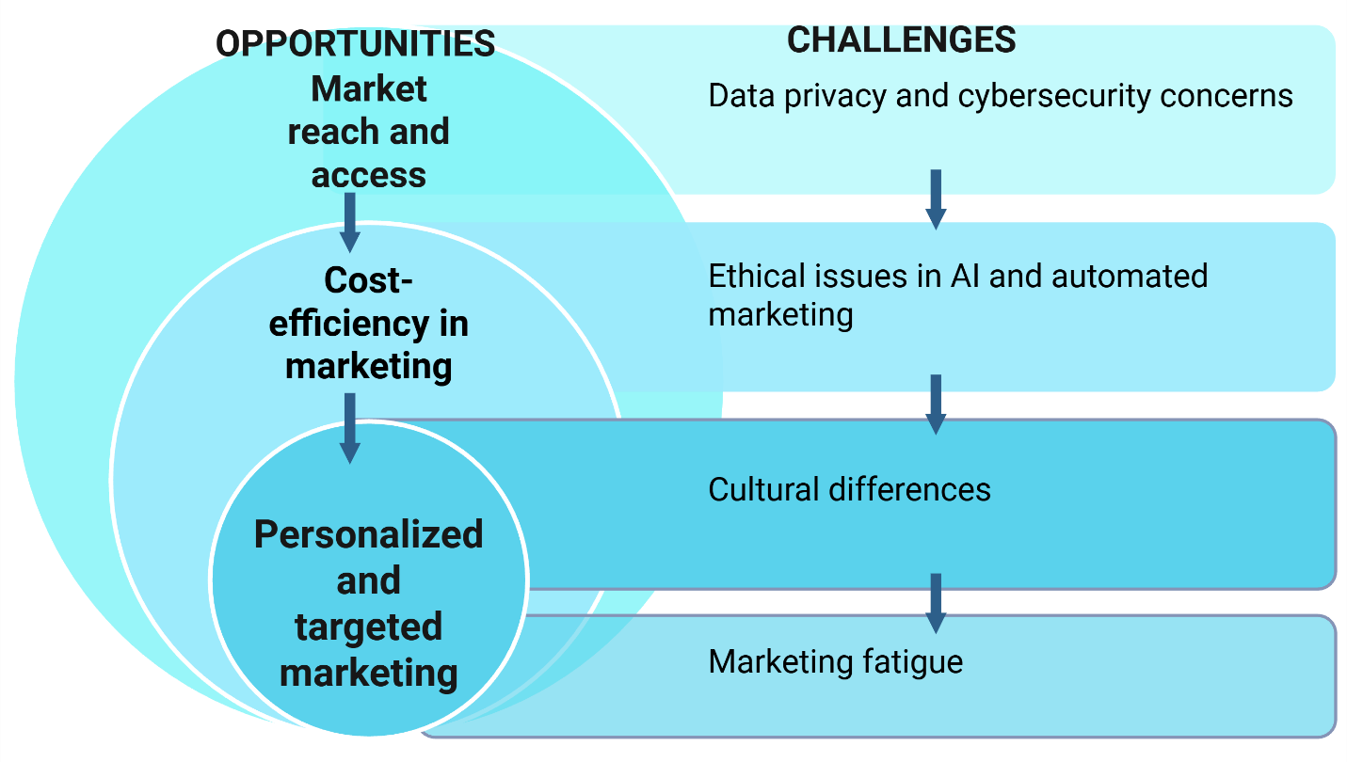

Figure 3: Challenges and opportunities for enhancing efficient marketing

Emerging trends in digital international marketing
  - The increasing role of voice search and AI-powered chatbots
Voice search is rapidly becoming a dominant feature in digital marketing, driven by the widespread use of virtual assistants like Amazon’s Alexa, Google Assistant, and Apple’s Siri (Saleh & Zeebaree, 2025). Consumers are increasingly using voice queries to find products, services, and information, prompting businesses to optimize their content for voice search (Samiee, 2020). Additionally, AI-powered chatbots are enhancing customer service by providing real-time, automated responses to customer inquiries (Samiee et al., 2021). These chatbots enable full time engagement, improving customer satisfaction and operational efficiency (Samuel Craig & Douglas, 2001; Sang, 2024; Sharabati et al., 2024).
  - Augmented reality (AR) and virtual reality (VR) in enhancing user experiences
AR and VR technologies are transforming the way consumers interact with brands (Sihare, 2022). AR allows customers to visualize products in their real-world environment before making a purchase decision, while VR creates immersive, interactive experiences (Silva et al., 2020). For example, IKEA’s AR app lets users place virtual furniture in their homes to visualize how it fits and looks, driving purchasing decisions (Silveira et al., 2025). These technologies are becoming essential tools for enhancing user experience and engagement in global marketing (Solberg & Durrieu, 2023; Strange et al., 2022; Syahnur, 2024).
  - Influencer marketing and its growing importance in niche markets
Influencer marketing continues to grow, particularly in niche markets where micro-influencers have strong, engaged followings (Srisomwongse et al., 2025). Brands are increasingly partnering with influencers to target specific consumer segments, leveraging their authenticity and credibility to build trust with audiences (Strange et al., 2022).
  - Block chain technology and its potential applications in marketing
Block chain technology has the potential to revolutionize digital marketing by offering secure, transparent transaction records and reducing fraud (Thrassou et al., 2022). It can enhance trust in advertising networks, streamline supply chains, and ensure data privacy (Trkulja et al., 2024).

Strategic approaches for leveraging digital milestones
  - Sustainable practices for integrating digital marketing strategies into global operations
In order to successfully integrate digital marketing strategies into global operations, businesses must first ensure they have a unified digital presence across all platforms (Figure 4). This includes maintaining consistent brand messaging while adapting content to fit different regional markets (Verbeke & Hutzschenreuter, 2021). A key best practice is leveraging automation tools to streamline content distribution, customer segmentation, and campaign management across multiple geographies (Verbivska et al., 2023). Additionally, brands should focus on building an agile marketing team capable of responding quickly to changing trends and emerging technologies globally (Vadana et al., 2021; Verbytska et al., 2023).
  - Merging marketing campaigns to diverse cultural and regional preferences
Adapting marketing campaigns to local cultures and preferences is crucial for international success (Verma et al., 2021). Businesses should invest in local market research to understand cultural nuances, values, language, and purchasing behaviors (Vlačić et al., 2021). Localization, rather than mere translation, is critical for adjusting visual elements, messaging tone, and promotional strategies to resonate with local consumers (Wu & Monfort, 2023). For example, McDonald's successfully adapts its menu and marketing in different regions, offering region-specific products and aligning campaigns with local festivals and cultural norms (Wu & Monfort, 2023).
  - Evaluating digital marketing ROI and budgets
Evaluating the return on investment (ROI) for digital marketing campaigns is essential to ensure cost-efficiency (Ramachandran, 2023). Marketers should utilize analytics tools to track key performance indicators (KPIs) such as customer acquisition cost (CAC), conversion rates, and customer lifetime value (CLV) (Yang et al., 2025). In a global context, optimizing marketing budgets requires strategic allocation based on market potential, customer engagement levels, and channel performance (Zaharia et al., 2024; Zahoor & Lew, 2023). Data-driven decisions allow for dynamic budget adjustments, ensuring that marketing efforts yield maximum impact across diverse markets (Zhechev, 2024).
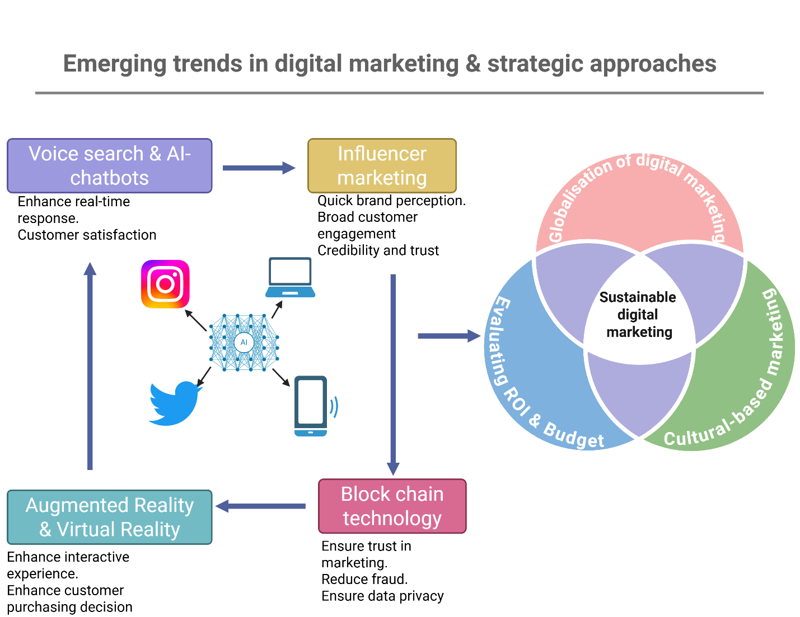
Figure 4: Strategies for effective adoption of emerging trends in digital marketing

Conclusion
This review highlights the profound impact of digital marketing on international commerce, emphasizing the transformative role of e-commerce, social media, mobile marketing, and AI-driven personalization. Major findings suggest that businesses are leveraging digital tools to expand global reach, enhance customer engagement, and optimize marketing efforts. Digital marketing’s ability to provide real-time, data-driven insights is reshaping how companies interact with consumers, offering unprecedented opportunities for personalization and market expansion. To adapt to the ongoing digital transformation, businesses must embrace agility, invest in localized marketing strategies, and prioritize data privacy and security. It is crucial for companies to remain responsive to emerging technologies such as AI, VR, and block chain, which are shaping the future of digital marketing. Future research should focus on exploring the ethical implications of AI in marketing, the long-term impact of influencer marketing in diverse regions, and the integration of block chain for enhancing transparency in global marketing strategies.
COMPETING INTERESTS
Authors have declared that no competing interests exist.

Reference
Akter, S., Hossain, M. A., Lu, Q., & Shams, S. R. (2021). Big data-driven strategic orientation in international marketing. International Marketing Review, 38(5), 927-947.
Alghizzawi, M., Ezmigna, I., Jado, K., Alzeaideen, K., & Kanan, M. (2024). Theoretical perspective of artificial intelligence in digital marketing for business organizations Business Analytical Capabilities and Artificial Intelligence-Enabled Analytics: Applications and Challenges in the Digital Era, Volume 1 (pp. 167-177): Springer.
Ali, E., Riaz, M., & Rashid, M. (2024). Ethical Considerations in Use of Artificial Intelligence in Digital Marketing. Journal of Peace, Development and Communication, 8(02).
Ali, I., & Naushad, M. (2023). Examining the influence of social media marketing on purchase intention: The mediating role of brand image. Innovative Marketing, 19(4), 145.
Antczak, B. (2024). The influence of digital marketing and social media marketing on consumer buying behavior. Journal of Modern Science, 56(2), 310-335.
Babatunde, S. O., Okeleke, P. A., & Ijomah, T. I. (2022). The Role of Digital Marketing In Shaping Modern Economies: An Analysis Of E-Commerce Growth And Consumer Behavior. International Journal of Digital Economy Research, 8(2), 112-128.
Baskoro, T. (2024). Digital Disruption: Landscape of E-Business for Competitive Advantage. Advances in Business & Industrial Marketing Research, 2(1), 1-14.
Battisti, E., Graziano, E. A., Leonidou, E., Stylianou, I., & Pereira, V. (2021). International marketing studies in banking and finance: a comprehensive review and integrative framework. International Marketing Review, 38(5), 1047-1081.
Cahen, F., & Borini, F. M. (2020). International digital competence. Journal of International Management, 26(1), 100691.
Cateriano-Arévalo, E., Alrakhayes, S., Foote, L., Hussain, T., Lai, K., & Nyundo, L. (2022). Social marketing at 50: Towards an epistemological expansion of the discipline to embrace diversity. A viewpoint. Journal of Social Marketing, 12(3), 315-336.
Cham, T.-H., Cheah, J.-H., Memon, M. A., Fam, K.-S., & László, J. (2022). Digitalization and its impact on contemporary marketing strategies and practices. Journal of Marketing Analytics, 10(2), 103-105.
Chinnici, P., Bacarella, S., Chironi, S., Naselli, V., & Ingrassia, M. (2025). How will artificial intelligence drive marketing in the beverage industry?-A bibliometric literature review. Future Foods, 100704.
Cho, H. E., Jeong, I., Kim, E., & Cho, J. (2023). Achieving superior performance in international markets: the roles of organizational agility and absorptive capacity. Journal of Business & Industrial Marketing, 38(4), 736-750.
Cumming, D., Johan, S., Khan, Z., & Meyer, M. (2023). E-commerce policy and international business. Management International Review, 63(1), 3-25.
Dallocchio, M., Lambri, M., Sironi, E., & Teti, E. (2024). The role of digitalization in cross-border e-commerce performance of Italian SMEs. Sustainability, 16(2), 508.
Del Vecchio, P., Mele, G., Siachou, E., & Schito, G. (2022). A structured literature review on Big Data for customer relationship management (CRM): toward a future agenda in international marketing. International Marketing Review, 39(5), 1069-1092.
Devang, V., Chintan, S., Gunjan, T., & Krupa, R. (2019). Applications of artificial intelligence in marketing. Annals of Dunarea de Jos University of Galati. Fascicle I. Economics and Applied Informatics, 25(1), 28-36.
Dillon, S. M., Glavas, C., & Mathews, S. (2020). Digitally immersive, international entrepreneurial experiences. International Business Review, 29(6), 101739.
Douglas, S. P., & Craig, C. S. (1992). Advances in international marketing. International Journal of Research in Marketing, 9(4), 291-318.
Du, W., & Dzamankulov, B. (2023). The value, role, and analysis of cross-border e-commerce development in china's import and export economy. International Journal of eBusiness and eGovernment Studies, 15(1), 366-393.
Fan, Z., Wang, Y., & Ying, Z. (2023). Empowerment of cross-border e-commerce platforms for small and medium-sized enterprises: evidence from China. Journal of Business-to-Business Marketing, 30(1), 33-44.
Ferreira, C., Robertson, J., Reyneke, M., & Pitt, L. (2023). Inside-out: Using the marketing classroom to mirror diversity and inclusion of the marketplace. Marketing Education Review, 33(1), 7-21.
Figueiredo, N., Ferreira, B. M., Abrantes, J. L., & Martinez, L. F. (2025). The Role of Digital Marketing in Online Shopping: A Bibliometric Analysis for Decoding Consumer Behavior. Journal of Theoretical and Applied Electronic Commerce Research, 20(1), 25.
Forghani, E., Sheikh, R., Hosseini, S. M. H., & Sana, S. S. (2022). The impact of digital marketing strategies on customer’s buying behavior in online shopping using the rough set theory. International journal of system assurance engineering and management, 13(2), 625-640.
Francis, U. O., Haque, R., Rahman, A., Al-Hunaiyyan, A., Al-Ainati, S., Lokman, F. Z. A., & Isa, M. B. M. (2023). The impact of digital marketing on consumer purchasing behaviour. International Journal of Operations and Quantitative Management, 29(2).
Fregidou-Malama, M., Chowdhury, E. H., & Hyder, A. S. (2023). International marketing strategy of emerging market firms: the case of Bangladesh. Journal of Asia Business Studies, 17(4), 804-823.
Fu, X. (2023). The Promoting Role of Business Environment Optimization on the Development of Cross-border E-commerce. Information Systems and Economics, 4(8), 128-134.
Furr, N., Ozcan, P., & Eisenhardt, K. M. (2022). What is digital transformation? Core tensions facing established companies on the global stage. Global Strategy Journal, 12(4), 595-618.
Hewett, K. (2020). Advancing international marketing thought based on the China experience (Vol. 28, pp. 1-2): SAGE Publications Sage CA: Los Angeles, CA.
Hidayati, A., Susanti, E., Jamalong, A., Ginting, D., Suwanto, W., & Arifin, A. (2024). Marketing analytics in the era of digital-based marketing strategy. Jurnal Ilmiah Ilmu Terapan Universitas Jambi, 8(1), 61-75.
Hosseini, S., & Roshanfekr, M. (2023). Emerging Trends and Innovative Methods in Global Marketing: A Review Paper. CRPASE: Transactions of Applied Sciences, 1-9.
Huang, M.-H., & Rust, R. T. (2021). A strategic framework for artificial intelligence in marketing. Journal of the academy of marketing science, 49(1), 30-50.
Huang, M.-H., & Rust, R. T. (2022). A framework for collaborative artificial intelligence in marketing. Journal of Retailing, 98(2), 209-223.
Hussain, H. N., Alabdullah, T. T. Y., Ries, E., & Jamal, K. M. (2023). Implementing technology for competitive advantage in digital marketing. International Journal of Scientific and Management Research, 6(6), 95-114.
Indrawan, D., Yorman, Y., Stiadi, M., Hendayani, N., & Al-Amin, A.-A. (2023). Revolutionizing social media marketing through AI and automation: an in-depth analysis of strategies, ethics, and future trends. International Journal of Humanities, Social Sciences and Business (INJOSS), 3(1), 22-45.
Ingriana, A., Prajitno, G. G., & Rolando, B. (2024). THE UTILIZATION OF AI AND BIG DATA TECHNOLOGY FOR OPTIMIZING DIGITAL MARKETING STRATEGIES. International Journal of Economics And Business Studies, 1(1), 21-42.
Jaas, A. (2022). E-marketing and its strategies: Digital opportunities and challenges. Open Journal of Business and Management, 10(2), 822-845.
Jean, R.-J. B., Kim, D., Zhou, K. Z., & Cavusgil, S. T. (2021). E-platform use and exporting in the context of Alibaba: A signaling theory perspective. Journal of International Business Studies, 52(8), 1501-1528.
Jeong, I., Jean, R.-J. B., Kim, D., & Samiee, S. (2023). Managing disruptive external forces in international marketing. International Marketing Review, 40(5), 936-956.
Katsikeas, C., Leonidou, L., & Zeriti, A. (2020). Revisiting international marketing strategy in a digital era: Opportunities, challenges, and research directions. International Marketing Review, 37(3), 405-424.
Katsikeas, C. S. (2003). Advances in international marketing theory and practice. International Business Review, 12(2), 135-140.
Khaki, A. A., & Khan, T. A. (2024). Social media marketing and its influence on the performance of micro, small, and medium-sized tourism enterprises: Mediation of innovation capabilities. Journal of Global Marketing, 37(1), 1-23.
Khan, H. (2020). Is marketing agility important for emerging market firms in advanced markets? International Business Review, 29(5), 101733.
Khan, H., & Khan, Z. (2021). The efficacy of marketing skills and market responsiveness in marketing performance of emerging market exporting firms in advanced markets: The moderating role of competitive intensity. International Business Review, 30(6), 101860.
Khan, S., Rana, S., & Goel, A. (2022). Presence of digital sources in international marketing: A review of literature using Leximancer. International Journal of Technology Marketing, 16(3), 246-274.
Knight, G., & Fletcher, R. (2022). Marketing communications strategy in advanced and emerging markets: an international comparison. Journal of Comparative International Management, 25(1), 125-143.
Kozlenkova, I. V., Lee, J.-Y., Xiang, D., & Palmatier, R. W. (2021). Sharing economy: International marketing strategies. Journal of International Business Studies, 52(8), 1445-1473.
Labib, E. (2024). Artificial intelligence in marketing: exploring current and future trends. Cogent Business & Management, 11(1), 2348728.
Lacka, E., Chan, H. K., & Wang, X. (2020). Technological advancements and B2B international trade: A bibliometric analysis and review of industrial marketing research. Industrial Marketing Management, 88, 1-11.
Lamichhane, B. (2022). Impact of digital marketing on consumer behavior in Pokhara. KIC International Journal of Social Science and Management, 1(1), 13-23.
Leonidou, L. C., Katsikeas, C. S., Samiee, S., & Aykol, B. (2017). International marketing research: A state-of-the-art review and the way forward. Advances in global marketing: A research anthology, 3-33.
Li, F., Silva, S. C., & Larimo, J. (2024). Understanding the influencing factors on firms’ social media marketing strategies development: a cross-country investigation. International Marketing Review, 41(6), 1487-1520.
Luo, Y., & Zahra, S. A. (2023). Industry 4.0 in international business research. Journal of International Business Studies, 54(3), 403.
Madan, A., & Rosca, M. I. (2022). Current trends in digital marketing communication. Journal of Marketing Research and Case Studies, 2022, 1-13.
Mahbub, M. B., & Ayman, A. (2024). Utilising artificial intelligence-prospects and obstacles for modern businesses. Malaysian E Commerce Journal, 8(1), 23-28.
Makrides, A., Kvasova, O., Thrassou, A., Hadjielias, E., & Ferraris, A. (2022). Consumer cosmopolitanism in international marketing research: a systematic review and future research agenda. International Marketing Review, 39(5), 1151-1181.
Manoharan, G., Durai, S., Ashtikar, S. P., & Kumari, N. (2023). Artificial intelligence in marketing applications Artificial Intelligence for Business (pp. 40-70): Productivity Press.
Meyer, K. E., Li, J., & Brouthers, K. D. (2023). International business in the digital age: Global strategies in a world of national institutions. Journal of International Business Studies, 54(4), 577.
Monaghan, S., Tippmann, E., & Coviello, N. (2020). Born digitals: Thoughts on their internationalization and a research agenda. Journal of International Business Studies, 51(1), 11-22.
Mueller, M., & Swoboda, B. (2025). Effects of International E-commerce firms’ depth versus breadth of control on foreign sales performance and the role of market size and growth as context factors. Management International Review, 65(2), 275-304.
Musa, I., Hamka, R. A., & Atifah, N. (2023). Development of trends, innovation and effective distribution strategies in international marketing. Journal Management & Economics Review (JUMPER), 1(1), 9-16.
Mustak, M., Salminen, J., Plé, L., & Wirtz, J. (2021). Artificial intelligence in marketing: Topic modeling, scientometric analysis, and research agenda. Journal of Business Research, 124, 389-404.
Nakata, C., & Huang, Y. (2005). Progress and promise: the last decade of international marketing research. Journal of Business Research, 58(5), 611-618.
Nalbant, K. G., & Aydin, S. (2025). A bibliometric approach to the evolution of artificial intelligence in digital marketing. International Marketing Review.
Nambisan, S., Zahra, S. A., & Luo, Y. (2019). Global platforms and ecosystems: Implications for international business theories. Journal of International Business Studies, 50(9), 1464-1486.
Nazarudin, M. I., & Handayani, W. (2024). Optimizing social media as a global marketing tool: Qualitative analysis of different approaches in enhancing the image and sales of exported products. Business and Investment Review, 2(1), 23-29.
Nim, N., Pedada, K., & Hewett, K. (2024). Digital marketing ecosystems and global market expansion: current state and future research agenda. International Marketing Review, 41(5), 872-885.
Ojala, A., Evers, N., & Rialp, A. (2018). Extending the international new venture phenomenon to digital platform providers: A longitudinal case study. Journal of World Business, 53(5), 725-739.
Olivieri, M., & Testa, G. (2024). Social media platforms use in startups’ international marketing strategies: a multiple case study. International Marketing Review, 41(5), 1074-1101.
Pal, A. K., & Shukla, B. (2020). Impact of digital marketing on consumer buying behaviour. Iconic research and engineering journals, 3(11), 209-220.
Pegan, G., Vianelli, D., & De Luca, P. (2020). International Marketing Strategy. Springer International Publishing, Cham, doi, 10, 978-973.
Pfajfar, G., Mitręga, M., & Shoham, A. (2024). International dynamic marketing capabilities: developments and a research agenda. International Marketing Review, 41(1), 1-41.
Pillai, R., Holla, N., & Srinivas, D. (2021). A study on Digital marketing and its impact on Consumer Behavior. PalArch's Journal of Archaeology of Egypt/Egyptology, 18(09), 78-85.
Rajawat, A. S., Prakash, V., & Chauhan, S. S. (2025). AI-powered navigation of the digital frontier: Analyzing modern trends in digital marketing and their influence on consumer purchasing patterns with special reference to pharma industry. Emerging Trends in Computer Science and Its Application, 534-541.
Ramachandran, K. (2023). Evaluating ROI in digital marketing campaigns: metrics, measurement, and insights. International Journal of Management (IJM), 14(7).
Ramadhani, R. (2024). Big Data in Digital Transformation of Corporate Marketing Strategy. Economic and Business Horizon, 3(1), 24-28.
Riedel, A. S., Beatson, A. T., & Gottlieb, U. (2023). Inclusivity and diversity: A systematic review of strategies employed in the higher education marketing discipline. Journal of Marketing Education, 45(2), 123-140.
Rodriguez, E. P., & Romero, L. d. C. E. (2024). Mapping digital marketing research in social networks: A short-term bibliometric analysis (2018-2023). Revista de ciencias sociales, 30(2), 15-31.
Ruiz, M. J. S., Calderón, C. E. J., Venecia, A. R. O., Santodomingo, A. A., & Forero, M. P. (2025). Bibliometric behavior of artificial intelligence and digital marketing sustainability. Procedia Computer Science, 257, 1047-1052.
Ryans Jr, J. K., Griffith, D. A., & Steven White, D. (2003). Standardization/adaptation of international marketing strategy: Necessary conditions for the advancement of knowledge. International Marketing Review, 20(6), 588-603.
Rynarzewska, A. I., Tanner Jr, J. F., & Edmondson, D. R. (2024). An introduction to the “The role of inclusion, diversity, equity, & access (IDEA) in today’s global marketing environment” special issue (Vol. 34, pp. 1-4): Taylor & Francis.
Saleh, R. A., & Zeebaree, S. R. (2025). Artificial Intelligence in E-commerce and Digital Marketing: A Systematic Review of Opportunities, Challenges, and Ethical Implications. Asian Journal of Research in Computer Science, 18, 395-410.
Samiee, S. (2020). International marketing and the internet: a research overview and the path forward. International Marketing Review, 37(3), 425-436.
Samiee, S., Katsikeas, C. S., & Hult, G. T. M. (2021). The overarching role of international marketing: Relevance and centrality in research and practice. Journal of International Business Studies, 52(8), 1429-1444.
Samuel Craig, C., & Douglas, S. P. (2001). Conducting international marketing research in the twenty‐first century. International Marketing Review, 18(1), 80-90.
Sang, N. M. (2024). Bibliometric insights into the evolution of digital marketing trends. Innovative Marketing, 20(2), 1-14.
Sharabati, A.-A. A., Ali, A. A. A., Allahham, M. I., Hussein, A. A., Alheet, A. F., & Mohammad, A. S. (2024). The impact of digital marketing on the performance of SMEs: An analytical study in light of modern digital transformations. Sustainability, 16(19), 8667.
Sihare, S. (2022). Future digital marketing revolutionizing e-commerce. Towards Excellence, 14(1).
Silva, S. C., Duarte, P. A. O., & Almeida, S. R. (2020). How companies evaluate the ROI of social media marketing programmes: insights from B2B and B2C. Journal of Business & Industrial Marketing, 35(12), 2097-2110.
Silveira, A., Khanna, K., & Kataria, P. (2025). A Uses and Gratifications Approach to Examining Lo-Fi Music Genre Popularity among Indian Gen Z during the COVID-19 Pandemic. Music Perception: An Interdisciplinary Journal, 42(5), 505-522.
Solberg, C. A., & Durrieu, F. (2023). Patterns of international marketing strategy. Journal of Business & Industrial Marketing, 38(7), 1532-1544.
Srisomwongse, R., Roongruangsee, R., & Patterson, P. (2025). Capabilities influencing export intensity of Thai SMEs during COVID-19: a capability-based perspective. Asia Pacific Business Review, 1-33.
Strange, R., Chen, L., & Fleury, M. T. L. (2022). Digital transformation and international strategies. Journal of International Management, 28(4), 100968.
Syahnur, H. (2024). Leveraging technology and innovation for effective e-business management. Advances in Business & Industrial Marketing Research, 2(2), 83-95.
Teece, D. J. (2025). The multinational enterprise, capabilities, and digitalization: governance and growth with world disorder. Journal of International Business Studies, 56(1), 7-22.
Thakur, S., Sandhu, S., & Yehuwalashet, F. (2024). E-Commerce and Trade: The Role of Artificial Intelligence Handbook of Artificial Intelligence Applications for Industrial Sustainability (pp. 232-248): CRC Press.
Thrassou, A., Vrontis, D., Efthymiou, L., & Uzunboylu, N. (2022). An overview of business advancement through technology: Markets and marketing in transition. Business Advancement through Technology Volume I: Markets and Marketing in Transition, 1-20.
Trkulja, Ž. M., Primorac, D., & Bilić, I. (2024). Exploring the role of socially responsible marketing in promoting diversity, equity, and inclusion in organizational settings. Administrative Sciences, 14(4), 66.
Vadana, I.-I., Kuivalainen, O., Torkkeli, L., & Saarenketo, S. (2021). The role of digitalization on the internationalization strategy of born-digital companies. Sustainability, 13(24), 14002.
Verbeke, A., & Hutzschenreuter, T. (2021). The dark side of digital globalization. Academy of Management Perspectives, 35(4), 606-621.
Verbivska, L., Zhuk, O., Ievsieieva, O., Kuchmiiova, T., & Saienko, V. (2023). The role of e-commerce in stimulating innovative business development in the conditions of European integration. Financial and credit activity-problems of theory and practice, 3(50), 330-340.
Verbytska, A., Lysenko, I., Babachenko, L., & Kraskivska, N. (2023). Inclusive social marketing: Representation and diversity in brand campaigns. Marketing and Branding Research, 10(1), 45-58.
Verma, S., Sharma, R., Deb, S., & Maitra, D. (2021). Artificial intelligence in marketing: Systematic review and future research direction. International Journal of Information Management Data Insights, 1(1), 100002.
Vlačić, B., Corbo, L., e Silva, S. C., & Dabić, M. (2021). The evolving role of artificial intelligence in marketing: A review and research agenda. Journal of Business Research, 128, 187-203.
Wu, C. W., & Monfort, A. (2023). Role of artificial intelligence in marketing strategies and performance. Psychology & Marketing, 40(3), 484-496.
Yang, B., Bai, W., Chen, Y., & Rong, K. (2025). Internationalization of digital firms: A systematic review and research agenda. Journal of Business Research, 189, 115124.
Zaharia, G.-E., Apostol, I. G., Savin, P. S., & Tanase, I. (2024). Digital Frontiers: Assessing the influence and ethical challenges of AI in online marketing. Paper presented at the Proceedings of the International Conference on Business Excellence.
Zahoor, N., & Lew, Y. K. (2023). Enhancing international marketing capability and export performance of emerging market SMEs in crises: strategic flexibility and digital technologies. International Marketing Review, 40(5), 1158-1187.
Zhechev, V. (2024). A dive into the marketing trends of 2024: insights to unlocking potential. Business & Management Compass, 68(1), 54-65.

