Original Research Article
Understanding Transaction Cost Drivers in Financial Market Infrastructures: A Systematic Literature Review

.
ABSTRACT

Aims: This study aims to systematically explore how Transaction Cost Economics (TCE) has been applied to Financial Market Infrastructures (FMI) – including clearing, settlement, and custody services. It seeks to identify theoretical gaps, assess empirical applications, and provide a structured research agenda to advance understanding of governance structures and transaction cost mechanisms in highly regulated financial markets.
Study Design: This is a Systematic Literature Review (SLR) conducted in accordance with the PRISMA guidelines, guided by the TCCM (Theory-Context-Characteristics-Methodology) framework and the READ (Read-Extract-Analyze-Distill) protocol for systematic analysis and conceptual mapping.
Place and Duration of Study: The review was conducted between November 2024 and August 2025 as part of an ongoing doctoral research project based in Germany and Latvia, with a specific focus on EU-level financial market regulation and infrastructure.
Methodology: Relevant literature from 1998 to 2023 was identified via Scopus using a transparent, replicable search strategy. The initial pool of over 52,180 records was screened through the PRISMA process, resulting in 77 peer-reviewed studies for full-text analysis. Documents were analyzed through coding grids along the TCCM and READ frameworks, identifying theoretical, contextual, and methodological patterns.
Results: The analysis shows that while TCE is frequently referenced in discussions about FMI governance, only a small subset of studies rigorously apply its foundational constructs – such as asset specificity, bounded rationality, and opportunism. Key research clusters focus on market efficiency, cost allocation mechanisms, regulatory adaptation, and data governance. However, most studies lack coherent integration of TCE principles in empirical modeling, particularly in the context of the MiFID II regulatory regime and digital infrastructure transformation.
Conclusion: This study provides the first systematic synthesis of TCE applications to FMI using a dual TCCM-READ approach. It highlights substantial fragmentation in the literature and calls for deeper interdisciplinary, theory-grounded research. The findings offer actionable insights for both academic inquiry and regulatory practice, especially as financial market infrastructures face growing pressures from digitalization, harmonization, and governance complexity in the post-MiFID II era.

Keywords: Transaction Cost Economics (TCE); Financial Market Infrastructure (FMI); MiFID II; Trading; Clearing and Settlement; Market Governance; Regulatory Efficiency.
1. INTRODUCTION

Following the global financial crisis, regulatory bodies worldwide introduced stringent financial market regulations aimed at enhancing market stability, transparency, and investor protection. The digital transformation of financial market infrastructures (FMIs), particularly in the post-trading domain, has emerged as a central theme in the ongoing evolution of global capital markets. As transaction volumes grow in complexity and regulatory frameworks such as MiFID II, EMIR, and CSDR impose increasingly granular requirements on transparency, risk mitigation, and investor protection, the interplay between technology, governance, and market efficiency becomes critical. In the European Union, the Markets in Financial Instruments Regulation (MiFIR) and the Markets in Financial Instruments Directive (MiFID I & II) represent key regulatory frameworks reshaping financial market infrastructures value chain.
In this context, post-trade processes – including clearing, settlement, custody, and collateral management – are not merely operational necessities, but key drivers of cost, risk exposure, and systemic resilience. Stock exchange organizations operate within a complex environment where transaction costs play a crucial role in shaping their market leadership and competitiveness. The ability to optimize transaction costs through efficient infrastructure operations transformation to cloud computing and artificial intelligence capabilities foster strategic market positioning, and effective regulatory adaptation is critical to maintaining a competitive edge in the evolving European financial landscape.
Despite growing interest in the digitalization of post-trade services – through distributed ledger technology (DLT), smart contracts, standardized APIs, and real-time settlement systems – the existing academic discourse remains fragmented. Many studies focus on isolated aspects of infrastructure innovation, regulatory compliance, or cost allocation, but rarely integrate these dimensions into a cohesive analytical framework. Moreover, the quantitative measurement of transaction costs in the post-trade value chain and the empirical validation of digital transformation’s efficiency gains remain underdeveloped in the literature.
To address this gap, the present systematic literature review investigates the state of academic knowledge at the intersection of digital transformation, regulatory governance, and transaction cost economics within post-trading FMIs. The review adheres to the PRISMA protocol to ensure transparency in source identification and selection, while the READ protocol (Read, Extract, Analyze, Distill) supports a reproducible and rigorous analysis. Furthermore, the review is structured using the TCCM framework (Theory–Context–Characteristics–Methodology) to map the landscape of scholarly contributions, identify conceptual overlaps, and reveal underexplored research areas.
The objective of this review is not only to consolidate fragmented findings across disciplines, but also to provide a structured agenda for future research. Specifically, it seeks to uncover how digital innovation in post-trading processes is theorized, operationalized, and empirically tested in relation to transaction costs, and how these transformations are governed by evolving regulatory paradigms. In doing so, this study contributes to a deeper understanding of how technology and regulation co-evolve in shaping efficient, secure, and resilient post-trade environments in global capital markets. This study empirically investigates the relationship between infrastructure transactions, market economics, infrastructure operations, and transaction costs, with a particular focus on their impact on the competitive positioning of stock exchange organizations.
1.1 Research objects and subjects

This research empirically validates the effects of the Markets in Financial Instruments Regulation (MiFIR) and the Markets in Financial Instruments Directive (MiFID II) on transaction costs and their implications for the market leadership and competitiveness of European financial market infrastructures. This study provides an independent scientific assessment of current available literature of whether these regulatory frameworks effectively enhance the competitiveness of European financial markets by optimizing transaction costs within financial market infrastructures.

The focus of this research is on financial market infrastructures that operate regulated trading venues in Europe under the enforced regulatory framework. Rooted in the operational and strategic dynamics of these organizations, the study examines how financial market regulation influences market leadership and competitive advantages within the broader financial market infrastructure.
This systematic literature review specifically investigates the extent to which MiFIR/MiFID II impacts transaction cost optimization and its interplay with infrastructure operations, infrastructure transactions, and market economics. By analyzing these relationships, the study aims to provide deeper theoretical insights into how regulatory interventions shape the financial market landscape and affect the cost efficiency and competitive positioning of stock exchange organizations.

1.2 Research hypotheses for systematic literature review

The competitive positioning and market leadership of stock exchange organizations operating financial market infrastructures are significantly shaped by the interplay between infrastructure transactions, market economics, infrastructure operations, and transaction costs. The extent to which these factors interact determines the ability of financial market infrastructure provider such as stock exchange organizations to optimize costs, sustain market efficiency, and maintain their competitive advantage in a regulated financial environment.
For financial market participants, transaction costs are primarily influenced by infrastructure operations, infrastructure transactions, and market economics. These cost determinants impact the competitive positioning and strategic leadership of stock exchange organizations. To empirically assess these relationships, the following overarching hypotheses have been formulated, drawing upon transaction cost economics within the framework of market leadership and competitive analysis:

- H₁: The transaction costs for financial market participants are significantly influenced by infrastructure operations, infrastructure transactions and market economics, which influences the market leadership and competitive positioning of stock exchange organizations.
- H₂: With the enforcement of MiFID II, the relationship between transaction costs, infrastructure operations, infrastructure transactions and market economics has changed significantly, leading to more competitive European financial market infrastructures.
- H₃: The impact of post-MiFID II on the transaction costs of infrastructure operations, infrastructure transactions and the market economics differs between financial market infrastructure provider due to competitive positioning and strategic transformation of the business model.

2. METHoDOLOGY

2.1 Methodological framework of the systematic literature review

Recent developments in the field of impactful systematic literature reviews encourage the consideration of a framework for structuring processes and ensuring transparency, which encompass the comparison of inclusion and exclusion criteria. The methodological approach of the "[...] Search, AppraisaL, Synthesis and Analysis (SALSA) [...]" by Grant and Booth (2009) provides an analytical framework for a transparent decision-making process and supports the reproduction of the review procedures carried out.

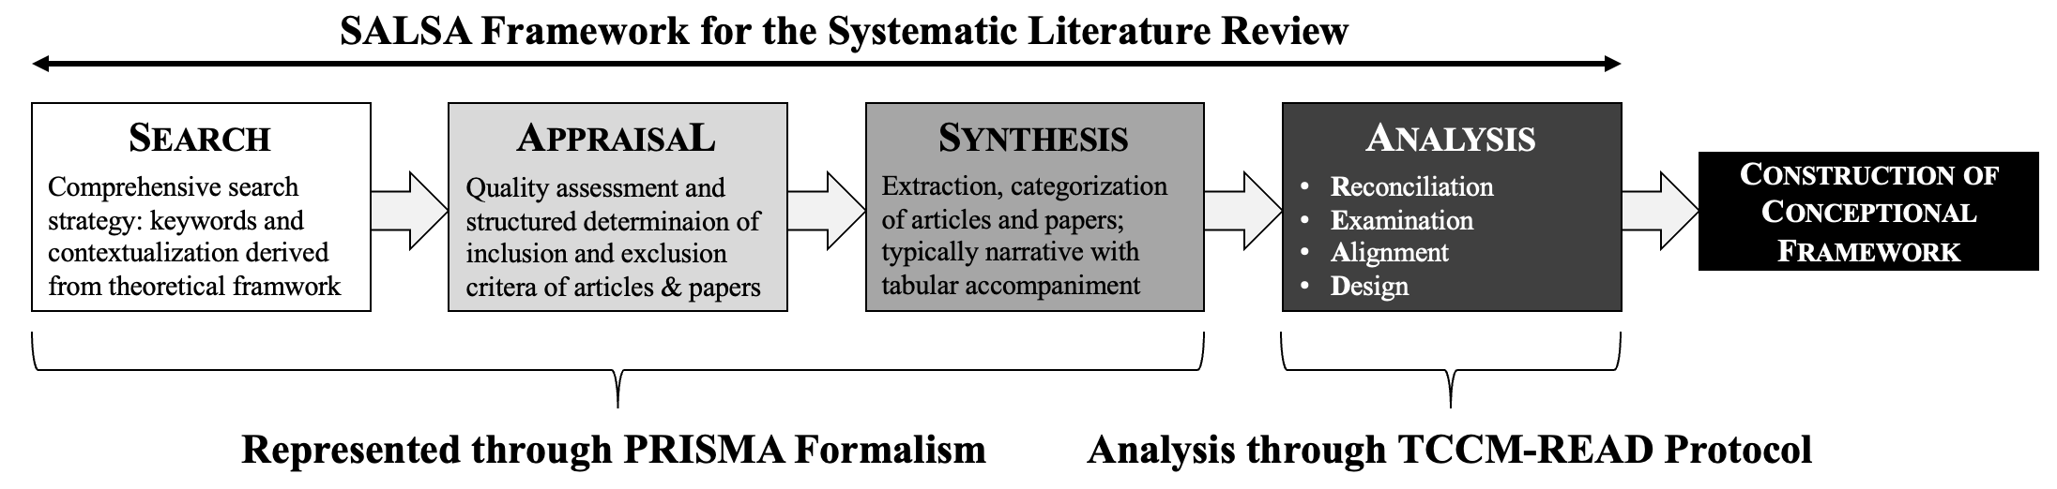
Figure 1 The Methodological Framework of the Systematic Literature Review
At its core, the SALSA framework enables scientific content review in the sense of a systematic decomposition and synopsis of research results in the sense of critical rationalism. Such a methodological approach aims at the systematic search, evaluation, synthesis, and analysis of literature to derive evidence-based principles for constructing the conceptual framework that forms the basis of empirical design and eventually empirical tests. The first three steps of the SALSA framework are carried out via the Preferred Reporting Item for Systematic Review and Meta-Analysis (PRISMA). The PRISMA formalism, as introduced and updated by M. Page in 2020, defines a formalized approach aimed at improving transparency requirements, completeness of documentation, and reproducibility guidelines when conducting rigorous systematic literature reviews (SLR). Since the fundamentals of the PRISMA statements are conceived in the context of medical science, the author has adapted the process steps that must be carried out in order to apply the PRISMA formalism principles for a systematic literature review in economics and management science. The main goal in using the SALSA framework and the PRISMA formalism is a systematic review of the currently available literature in the research context. Transaction cost economics of financial market infrastructures operated by stock exchange organizations forms the scrutiny context.

2.2 Research process Search, appraisal, synthesis through PRISMA formalism and conception of the READ protocol

After carefully reviewing a suitable database for systematic literature research, the author followed other scientists and chose Scopus because it contains the largest database available for scientific research. Especially for research in social science disciplines, Scopus is a recommended alternative to Web of Science. According to the findings of Zhao and Strotmann, the Scopus database [...] covers 60% more than the ISI databases [...] which also includes the Web of Science. Using the Scopus database, the author developed a comprehensive and evidence-based search query in line with Popper's critical rationalism. Empirical evidence for the developed search strategy was the creation of a word cloud, which also contains a word and frequency count based on a self-developed Python program.
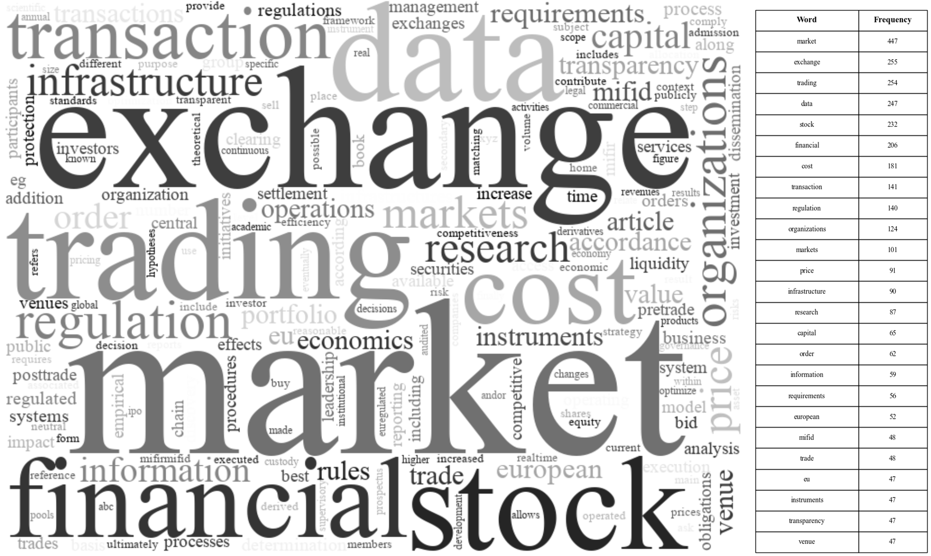
Figure 2 WordCloud and Word Frequency Counting for SLR-Search Strategy
The empirical foundation supports the reproducibility, generalization, and alignment of key concepts as outlined in the theoretical framework which formed the dataset of the word cloud generation and word frequency counting. With a focus on Europe, the European Union, capital markets, MiFID and EU regulation, the developed search string supports a contextualized scrutiny with unique systemic characteristics. Furthermore, the search term requires broad discoverability by including key terms such as trading cost, stock exchange, trading cost, exchange trading, market infrastructure, market capitalization, but also supports depth through the use of specific terms such as derivatives trading, equity trading, electronic order book, trading volume, trading transactions, trading turnover, central counter party, indices, market data, cash trading, infrastructure operation, CCP, custody, custodian, listed shares, or EOB trades and EOB turnover. The terms used in the search query align well with the theoretical foundation by including key terms along the value chain operations of financial market infrastructures operated by stock exchange organizations. Finally, the search string has been revised multiple times to achieve a balanced number of search results.
Search string executed in Scopus on November 10, 2024. resulted in 52,208 documents found:
“TITLE-ABS-KEY("transaction cost*" OR "stock exchange*" OR "trading cost*" OR "exchange trading" OR "market infrastructure" OR "listing" OR "market capitalization" OR "derivatives trading" OR "equity trading" OR "settlement" OR "clearing" OR "electronic order book" OR "trading volume" OR "trading transaction*" OR "trading turnover" OR "central counter party" OR "indices" OR "market data" OR "cash trading" OR "infrastructure operation*" OR "CCP" OR "custody" OR "custodian" OR "EOB trades" OR "EOB turnover" OR "listed Shares") AND TITLE-ABS-KEY("Europe" OR "European Union" OR "capital market*" OR "MiFID" OR "EU regulation")”

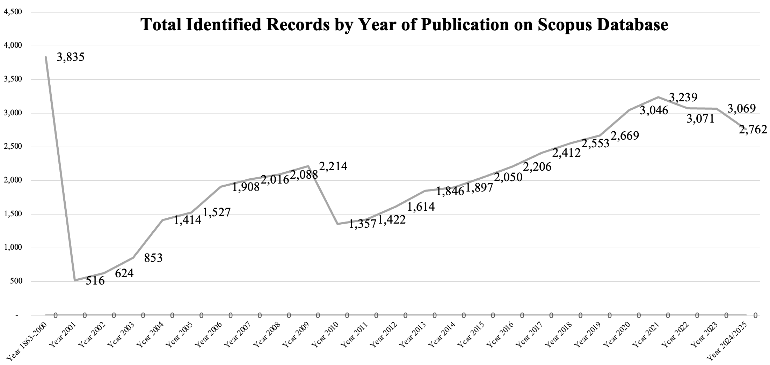
Figure 3 Total Identified Records by Year of Publication on Scopus Database
In total, the executed search term resulted in 52,208 documents found in the Scopus database. Over the years, there has been a steady growth in indexed documents until 2021. In 2010, indexed documents fell below 2014 levels but recovered steadily, ultimately rising to the all-time high of 3,239 documents in 2021. Since 2022, the number of documents on Scopus has been shrinking again, but the Compound Annual Growth Rate (CAGR) between the years 2021 and 2024 is 7.55 percent.
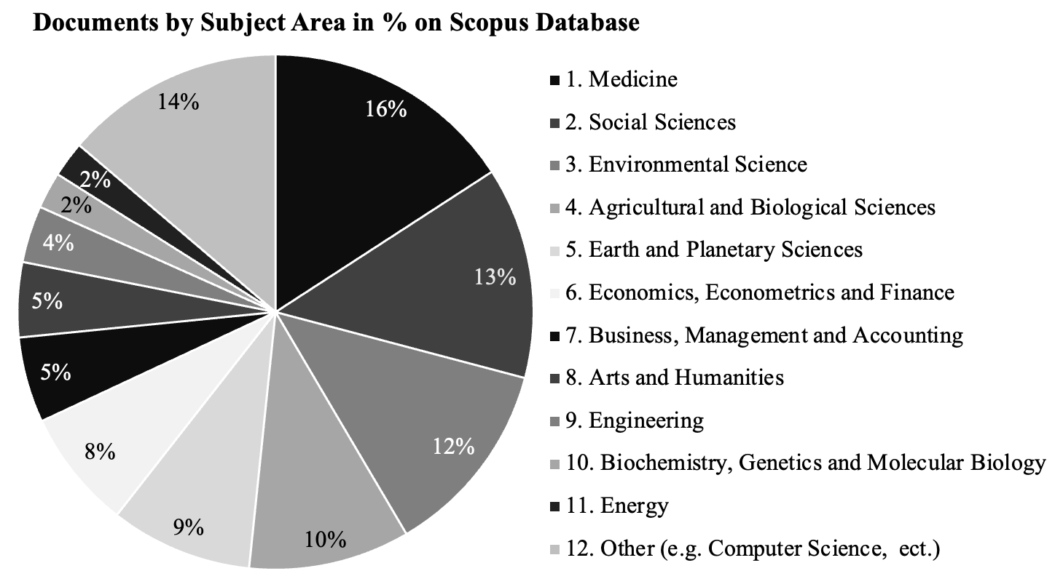
Figure 4 Documents by Subject Area in % on Scopus Database
A further examination of the overall results shows that the inclusion of the broad keywords "Europe" and "European Union" was the reason for documents relating to subject areas that are not relevant to this systematic literature review. The figure documents by topic in percentage can be read clockwise, starting with 1. "Medicine" and ending with 12. "Other", which include computer science, nursing, mathematics, decision science, and 13 other scientific fields. This means that 74 percent of the subject areas are not relevant for this systematic literature search. As outlined in the theoretical foundation, this research focuses on disciplines relevant to economics, econometrics, finance, business administration, management, accounting, and social sciences, accounting for 26 percent of the total documents indexed on Scopus when the developed search term is applied. Using the PRISMA formalism, the author has systematically narrowed down the search results to the most meaningful literature in order to derive insights, thoughts, and preliminary answers to the overarching research questions outlined.

3. results and discussion

3.1 Systematic Identification of Literature

With a focus on findings from the field of economics and social sciences, this SLR aims to derive insights for the outlined overarching hypotheses (H₁, H₂, and H₃). As part of the research on the transaction cost economics in financial market infrastructures, non-English documents were excluded from this SLR and the focus was placed on final journal articles. In order to support open science and reproducibility in the appraisal phase, all results that are not open access documents have been excluded. From a theoretical point of view, a further selection of keywords based on the Scopus database could further narrow down the results. Based on titles and abstracts, decisions were made for further exclusions that do not support the contextual relevance of the derived findings to the overarching research questions.

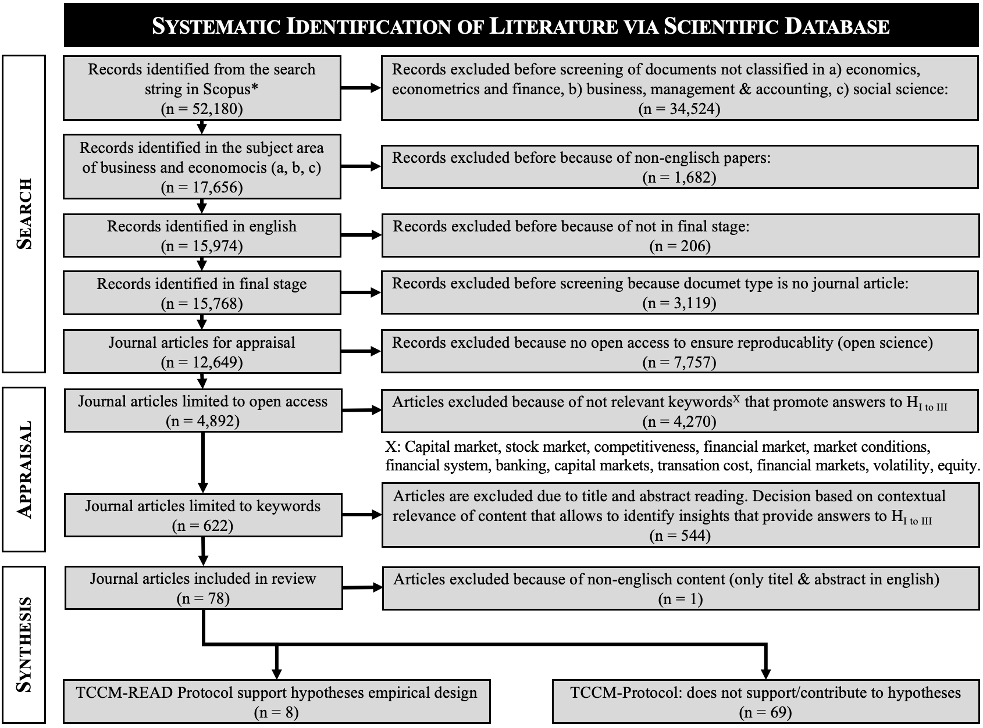
Figure 5 Search, Appraisal, Synthesis of SLR Based on PRISMA-Formalism
When analyzing the keywords of the journal articles finally considered, a WordCloud was created about the 77 remaining ones using the same bespoke developed Python algorithm that were used to discover keywords of the developed search query for the Scoups database.

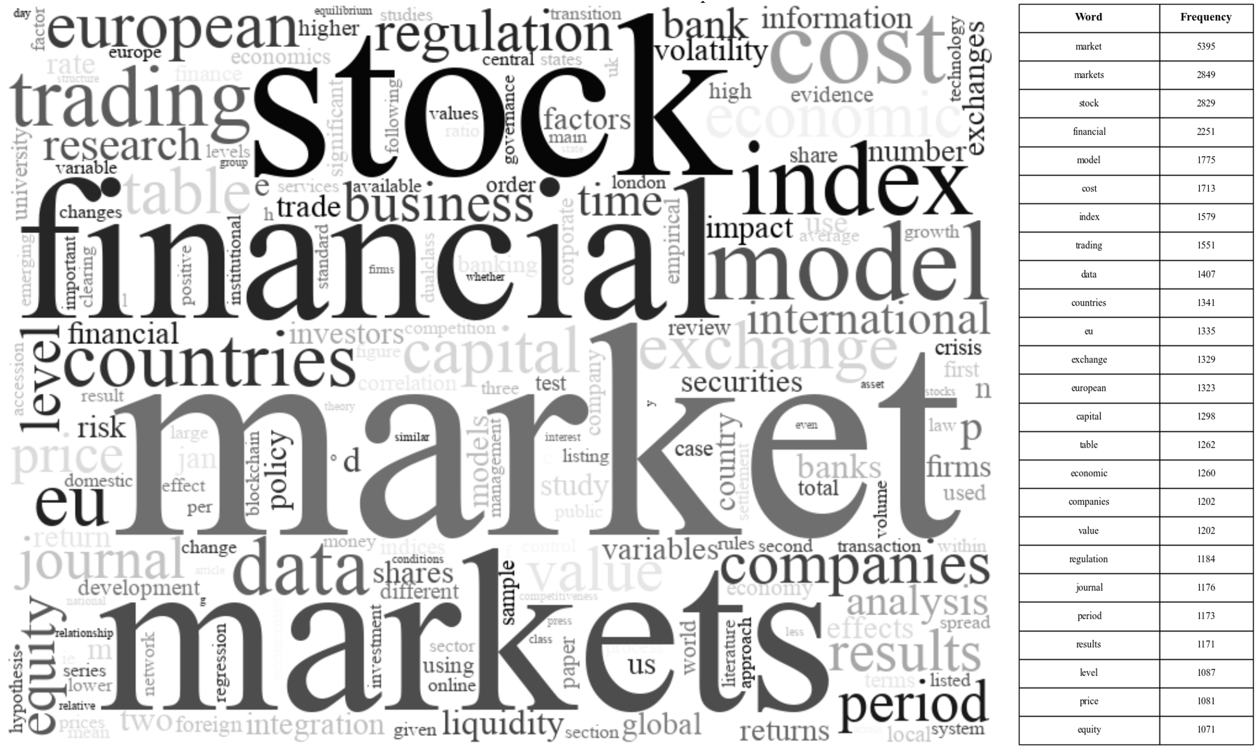
Figure 6 WordCloud and Word Frequency Counting of Journals Considered in Synthesis
As a result of the WordCloud comparison of the top 25 words of the theoretical foundations and the selected 77 journal articles of this SLR, there is an overlap of 73%. These results indicate good align-ment of the applied search strategy. In contrast, the mutual overlap between the SLR-WordCloud and the theoretical basis results in a moderate overlap of 63%. Further scrutiny is needed to determine whether additional insights from the SLR could enhance the theoretical basis and empirical design. One notable difference between the SLR-Search Strategy WordCloud (SSWC) and the SLR-Results WordCloud is the percentage weighting of words according to their ranking. Focusing on the most relevant words the comparison is further narrowed down to 15 words. For the SSWC Matching to SLR there is an overlap of 75%, while the SLR Matching for the SSWC is moderate at 71%.

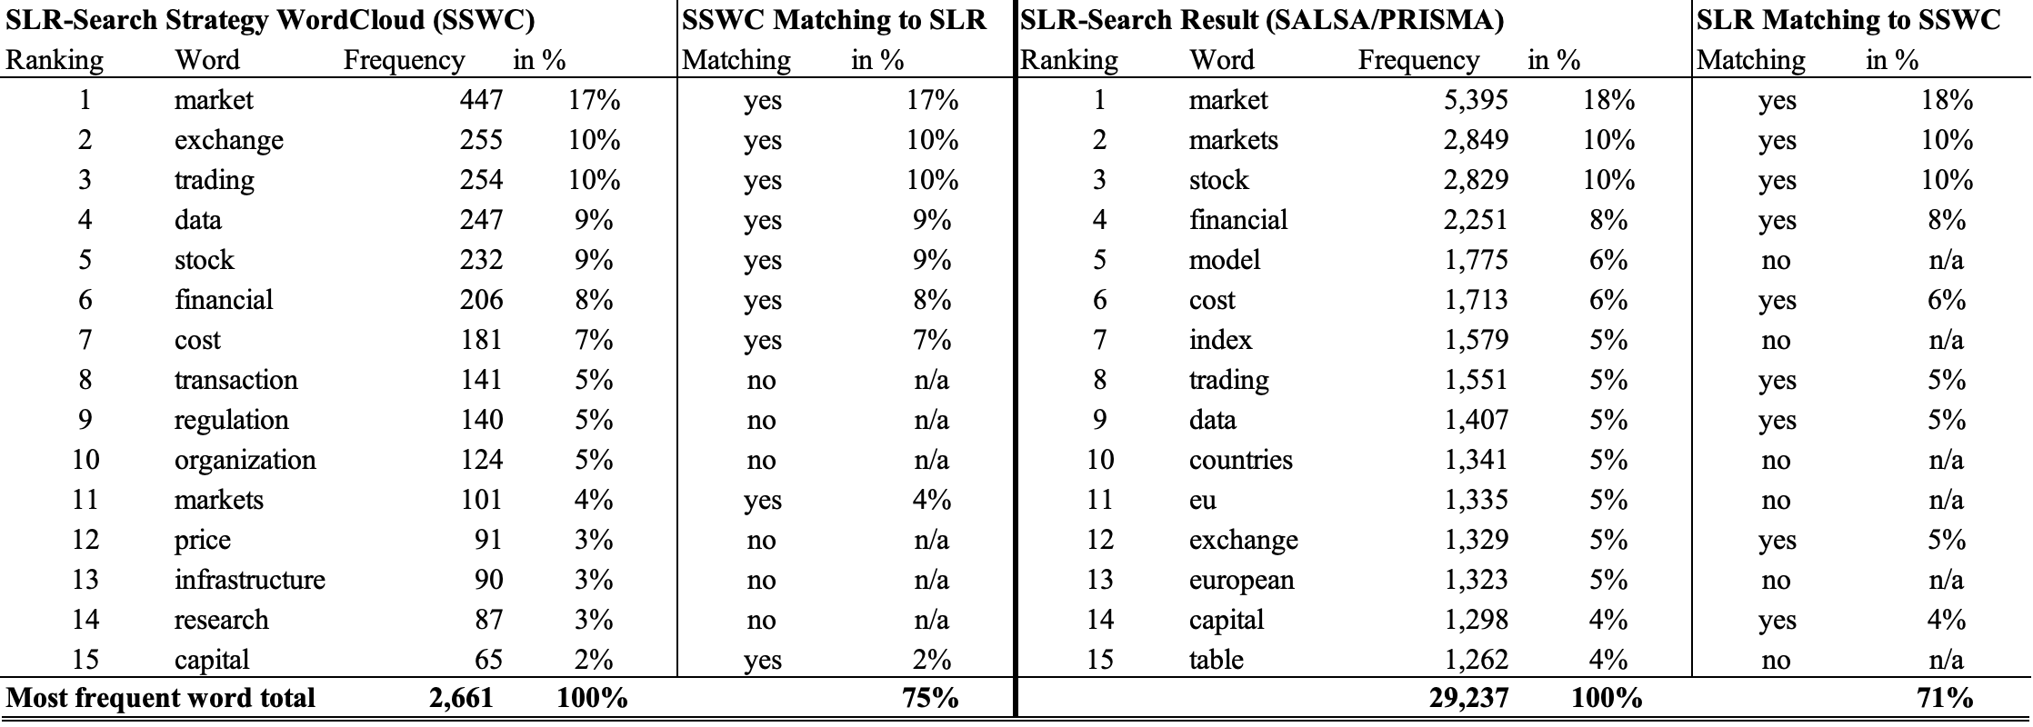
Table 1 Analysis of Search Strategy WordCloud versus SLR-SALSA/PRISMA Results
Unmatched words in the SSWC Matching to SLR's top 15-word analysis are transaction, regulation, organizations, price, infrastructure, and research. This discrepancy can be attributed to the theoretical foundations focus on transaction cost economics in financial market infrastructures. Most of the literature on the contextualized relevance of the first five words is not available via open access. To address these limitations, and to ensure reproducibility, and to promote open science, these SLRs only include open access journal articles. Conversely, the unmatched words SLR to SSWC include model, index, countries, EU, European, and table. Specifically, from a theoretical point of view and to improve the theoretical foundations, the word “index” can be seen as relevant to contribute to possible insights and answers to the hypotheses. This is due to the context and listing of the shares on the stock exchange and the dissemination of the data associated with them. Important insights from indices businesses are covered in the search string by the inclusion of the word “indices” which is a more generalized and commonly used term for stock exchange organizations operating a financial market infrastructure. Similarly, the mismatch of the word’s countries, EU and Europe contributes to the focus of this SLR and potentially strengthen the theoretical basis, as MiFID II is an EU regulation. Generalizing words such as model and table correspond to a broader research methodology and may reciprocally linked to the unmatched word “research” of the SSWC Matching SLR. This can potentially further close open accessible scientific literature gaps.

3.2 Theory, Context, Characteristics, Methodology (TCCM) Reconciliation, Examination, Alignment, Design (READ)-Protocol

Inspired by the TCCM (Theory, Context, Characteristics, Methodology) framework the author devised the Reconciliation, Examination, Alignment, Design (READ) protocol to carry out an insightful systematic literature review and to derive testable sub-hypotheses for the empirical test. Paul and Rosado-Serrano challenge researchers to compare future empirical designs with "[...] a close interaction between theoretical development and empirical reality [...]". Second, the research base needs to be contextualized so that subject-related conclusions can be defined. Third, characteristics refer to geographic patterns, such as those related to international or global expansion. Finally, the methods refer to samples, data and analytical tools and the recommendation for more diverse empirical designs "[...] such as content analysis of secondary sources such as websites, financial statements [...] structural equation modeling [...]". By adapting to the specific needs of this systematic literature review, the READ protocol enables the structuring of the results and promotes a pathway to derive insights for the conceptual framework of empirical design. The objective of the Reconciliation is to discover and determine dependent and independent variable constructs that can be operationalized across studies based on a generalization of definitions. Second, the aim of the Examination is to analyze the cause-and-effect relationship and dependencies of variable constructs. In a third step, Alignment focuses on the synthesis of measurement principles including their orchestration to ensure consistency, comparability, reproducibility and generalization for future research. Finally, along the design process, a conceptual framework will be developed to address the research objectives and close the identified gaps to contribute to a comprehensive empirical design for transaction cost economics in financial market infrastructures.

3.3 Analysis and Results of the TCCM-READ-Protocol

Table 2 : Summary of Selected Empirical Studies on Financial and Economic Theories

Paper ID: # | Theoretical | Context | Characteristics | Methods
# 1: (Coria & Jaraitė, 2019) | Transaction Cost Economics | Sweden, Energy Sector, Regulatory Impact; 2012 | Regulations, Environmental Policy Instruments, Monitoring, Reporting, and Verification (MRV) costs for CO taxation versus EU ETS. Distentanlment of costs related to regulations | Non-parametric tests, log-linear models, OLS regression, robust regression, and MS-estimator
# 2: (Krkošková, 2020) | Time Series Econometrics, Cointegration Analysis | Slovakia, Hungary, Czech Republic, and Poland; Analysis of the GDP development; 2005 to 2018 | Long-term and short-term analysis of economic growth GDP and the relationships between trading transaction volume and index performance | Vector Error Correction Models (VECMs), Granger causality tests, and block exogeneity tests
# 3: (Tamás, 2013) | Myers-Majluf theory, aligns with the Basel III framework | Cross-country research including emerging and developed countries of the EU; 2008 to 2010 | Analysis of the Basel III banking regulation on liquidity, leverage and profitability | Linear regression analysis to test the relationship between liquidity, leverage ratios, and profitability
# 4: (Li & Liang, 2022) | Market Segmentation Theory, Liquidity Theory, Investor Perception Theory, and Investor Protection Theory | Domestic and foreign listing and financing of Chinese companies on Shenzen, Shanghai, and Bejing stock market | Examinitaion on the impact of market information efficencies in the context to domestic and foreign listing and financing; Analysis of pandemic shors, state shareholeings and Bejiing Stock Exchange listing and finanancing behaviour | Regression model, data selection, industry-dimension data analysis
#5: (Gelos & Sahay, 2001) | Transition Econommics | European transition economies of Czech Republic, Hungary, Poland, Russia, Estonia, and the Slovak Republic; 1993 to 1998 | Spillover effects of economies in transation, especially during financial market shocks or crisis. The investigation includes a comparission with Asia and Latin America and the determination of systematic patterns | Vector Autoregression (VAR) analysis, Granger causality tests
#6: (Roscoe & Willman, 2021) | Economic Theory of Financial Markets, Efficient Market Hypothesis | London Alternative Investment Market (AIM) | Formation of London's AIM focusing on market effeciency, social releationships and organization of market governance | Interviews, personal communication, and textual sources to document the interconnected history of stock markets
#7: (Leppin & Reitz, 2016) | Credit Default Swaps spreads research on the structural approach from Merton and the reduced-form approach as outlined in Duffie and Singleton | European financial market, Credit Default Swap (CDS) spreads written on debt from EURO STOXX 50 firms | Parametic estimates related to standard CDS pricing models considering ECB systematic stress composite index, Sentix index and VSTOXX derviatives | Panel Smooth Transition Regression (PSTR), modeling of nonlinearities in pricing of risk derivatives

Paper ID: # |  | Theory |  | Context | Characteristics |  |  | Methods
# 8: (Gümüş et al., 2011) |  | Theory of Market Efficiency, Macroeconomic news on stock market volatility |  | Istanbul Stock Exchange (ISE), effects of domestic and foreign macroeconomic news on the Turkish home market; 2002 to 2010 | The analysis revealed insights that domestic macroeconomic trading relevant news significantly affects market volatility, while foreign macroeconomic news does not |  |  | Autoregressive Conditional Heteroskedasticity (ARCH), Generalized Autoregressive Conditional Heteroskedasticity (GARCH), Ordinary Least Squares (OLS) regression
# 9: (Krarup, 2019) |  | Actor-Network Theory and social studies of finance |  | European financial market integration, Germany, France, Belgium, and Denmark; 2006 to 2017 | Socio-technological research on the introduction and development of Target2 Securities (T2S); Competitiveness related examination over technology, ideology, political and economic interests |  |  | Qualitative interviews
# 10: (Kalaitzake, 2022) |  | Transaction Costs, Concept of Agglomeration peak theory that London’s financial sector is closely linked to Wall-Street |  | City of London's financial services industry after the Brexit referendum; post Brexit referendum | Findings confirm no significant impact of Brexit referendum on London’s financial services industry due to transaction cost optimization and legal protection |  |  | Systematic analysis of market trends, employment, investment, and activity on key trading markets
# 11: (Jiménez-Gómez, 2023) |  | European Union Regulation 2022/858, especially focus on market infrastructures based on distributed ledger technology |  | European Union Regulation in the context of financial market infrastructures; 2023 | Research focus on advantages, risks, and challenges which arise from distributed ledger technology in financial markets |  |  | Critical analysis of current EU Pilot Regultions with previous regulations proposal to examine legal restrictions and identification of new regulatory concepts
#12: (Fiszeder & Pietryka, 2018) |  | Direct Inflation Targeting Strategy, Effectiveness of monetary policies in stabilizing the interbank market rate |  | Eurosystem and Poland, comparision of the policy effectivenes; 2008 to 2014 | Examinitaion on the differences of EONIA and POLONIA spreads. |  |  | Average-Generalized Autoregressive Conditional Heteroskedasticity (ARFIMA-GARCH) to forecast the volatility of financial time series
#13: (Yan, 2022) |  | Corporate Governance Theory, Agency Theory in the context of investor/ shareholder protection |  | United Kindom, voting principles at general meetings of premium listings at the London Stock Exchange (LSE), conflicting standards for high-tech listings versus corporate governace standards | Analysis of conflicts in permitting dual class shares and structures to enhance investor/shareholder protection and engagement |  |  | Critical analysis based on historical srutiny of insights related to conflicts of the rise and fall of dual share structures in the UK
#14: (Hearn & Piesse, 2020) |  | Market Microstructure Neoclassical view on the impact of financial market integration on stock markets and trading system design |  | Namibia and South Africa’ regional integration of stock markets and its assocaited benefits and characteristics | Research focuses on the challenges for smaler markets to benift from the market integration, while strenghten investor protection equal to dominant markets |  |  | Literature review and theoretical discussion to contribute to a generalized understanding of challenges and benefits of market integration for smaler markets
Paper ID: # | Theory |  | Context |  |  | Characteristics | Methods
# 15: (Karkowska & Kravchuk, 2019) | Basel Committee on Banking Supervision’s indicators, Int. Monetary Fund guidance, Financial Stability Board methodologies |  | Identification of systematically important regulated markets operated by stock exchange organizations |  |  | Development of a composite ratio to identify systematically important stock exchange organizations operating regulated markets with impact on global scale | Systemically Important Financial Instruments Markets Ratio (SIFMIR) composite ratio and cluster analysis considering market size, juristicational activity, interconnetness, substitudablity, and complexity
# 16: (Sharkasi et al., 2005) | Theory of Interdependencies of prices between stock markets for co-movements and international spillover effects |  | International stock market indices in Irish, UK, Portuguese, US, Brazilian, Japanese, and Hong Kong on intra-conential relationships; 1990 to 2000 |  |  | Identified significant global co-movements between European, US and Brazil, and Japanese and Hong Kong markets indicating increased clockwise international transmission mechanism | Wavelet analysis and simple regression models
# 17: (Miloș, 2021) | Volatility on capital markets and stock price accuracy, and market efficiency |  | Capital markets stock indices in Eastern and Western Europe home markets |  |  | Examination of the impact of MiFID II on volatility for developed and emerging markets | Event study approach, econometric analysis to quantify MiFID II’s impact on stock market volatility
# 18: (Ademmer et al., 2022) | International financial integration and linkages between domestic and foreign markets; direct and indirect spillover effects, and common shocks |  | Eurozone, United States and emerging economies; highlights the linkages between advanced/developed and emerging economies; 1999 to 2007 |  |  | Analysis reveals shock patterns and quantifies their effects on regulated markets variables and the importance domestic, foreign, and common shocks of emerging economies for global financial markets | Structural model to segregate market-specific shocks from common shocks and analysis of theire relative importance, interdependencies and spillovers among global financial markets
# 19: (Serhiienko et al., 2023) | Assessment, analysis and forcasting of the dynamics of stock market indices for effective investments |  | Global and European stock markets and the level of interconnectness with Ukrain financial market; 2005 to 2021 |  |  | Development of an economic-mathematical model to assess, analyze and forecast investment in contemprorary conditions | Autoregressive Integrated Moving Average (ARIMA) model and spectral analysis
# 20: (Harrisona & Moore, 2009) | Theory of stock market co-movement and integration |  | Central and Eastern European (CEE), especifically London and Frankfurt; integration of developed and emerging CEE economies; 1994 to 2006 |  |  | Research provid insights of the source and magnitude of spillover effects | Time-varying realized correlation ratios, time-varying cointegration statistics, and a Multivariate Generalized Autoregressive Conditional Heteroscedasticity (MGARCH) model
# 21: (Casu & Girardone, 2009) | Structure-Conduct-Performance (SCP) paradigm, New Empirical Industrial Organisation (NEIO) |  | EU banking markets of. France, Germany, Italy, Spain, and the UK; assesses the degree of competition |  |  | Results indicate more concentration of EU banking market with signification country differernces | Structural approach using Herfindahl-Hirshman indices (HHI) and non-structural includes Panzar-Rosse H-statistic and the Lerner index

Paper ID: # | Theory | Context | Characteristics | Methods
# 22: (Bouresli & Abdulsalam, 2019) | Transaction Cost Economics, Market Microstructure, and Capital Markets Theory | Kuwait Stock Exchange, Research focus on the regulations and information disclosure impact on market liquidity in the context of firm size and sector; 2005 to 2017 | Examination on the enforced retulations of the Capital Market Authority on market liquidity in different market sectors | Non-parametric Mann-Whitney U test, parametric t-test, ordinary least square regression models
# 23: (Brooks & Katsaris, 2003) | Theory of speculative bubbles in financal markets to compare actual prices with fundamental data | Srutiny on divergence of quity prices at London Stock Exchange during speculative bubbles; late 1990 | Identified significant divergences between stock market prices and fundamental data | Test for speculative bubbles, variance bounds tests, non-stationarity test, cointegration tests
# 24: (Zaimović & Delalić, 2010) | Modern Portfolio Theory (MPT), Capital Asset Pricing Model (CAPM) | West Balkan capital markets, analysis of risk diversification based on correlations of indices; 2006 to 2008 | Revealed medium significant correlations between underlying indices returns and regional capital market | Markowitz's portfolio selection methodology, correlation analysis
# 25: (Edwards, 2008) | Theoretical foundation based on gravity models and general equilibrium model (GEMEE) in analyzing trading patterns | European Union (EU) especially Central and Eastern European Countries' (CEEC) research on the effects of formal barriers, mid-1990s | Research focus was on import and export related boarder effects and comparative costs | Armington formulation, Dixit–Stiglitz (D–S) formulation used for simulation model
# 26: (Bauvars, 2021) | Blockchain Applicability Framework with focus on financial markets and securities settlement | European Unioun (EU), financial market infrastructure requirements as outlined by the Central Securities Depository Regulation (CSDR) | Evaluation of a Proof-of-Authority consensus mechanism focusing on the analysis of a blockchain architecture and its impact of its nodes structure of security settlement | Literature review
# 27: (Gurrea-Martínez, 2021b) | Efficient Market Hypothesis (EMH), One-Share-One-Vote Principle, Concept of Stock Pyramids and Cross-Ownership | United States, Europe, Asia, analysis of regulatory patterns related to dual-shares | Research focus is the analysis of different regulatory approaches and the examination of local factors | Assessment of foreign studies and regulatory models based on empirical literature
# 28: (Bhattacharjee & De, 2022) | New Impact Curve to measure volatility in market shocks | United States, Europe, Asia, Australia (MSCI indices), Brazil, Russia, India, China (BRIC), volatiliy analysis in differnet economic reagions; 2020 | Results reveal assymetic response on volatily exemplified in market shocks during COVID-19 pandemic | News Impact Curve, Lagrange-multiplier (ARCH-LM) test to examine correlations between news flows and stock market volatility

Paper ID: # | Theory | Context | Characteristics | Methods
# 29: (Houpt & Cagigal, 2010) | Market Integration Theory, Market Microstructure | Spain, integration of the Bilbao Stock Exchange (BSE) with other exchanges in Madrid and Barcelony, evolution of secondary market | Historical investigation on the evolution of the BSE and the construction of indices in comparision with other regional indices | Test on market integration, cointegration, market index developent, capital market performance
# 30: (Cotter, 2004) | Extreme Value Theory (EVT) in order to measure downside risk | European equity market, ISEQ (Ireland), FTSE100 (UK), CAC40 (France), DAX100 (Germany), and IBEX35 (Spain); 1998 to 1999 | Research results indicate fat-tailed returns of European equity indices, increase of Value at Risk (VaR) quantiles | Mean Variance Analysis (portfolio theory), Value at Risk (VaR)
# 31: (Lütz, 1998) | Theory of financial internationalization and its impact on regulations and power dynamics | Germany, stock exchange sector and the collaboration between the national states on regulatory matters | Research focus on new state functions and the reorganization of domestic governance structures to respond to globalized challenges | Empirical approach, historical analysis, case studies to understand the impact of globalization and the transformation need of nation-states
# 32: (Lener, 2022) | Legal Theory, Financial Regulation Theory, Economic Theory to analyze legal and regulatory requirements for crypto-assets and crypto-currencies | European Union (EU) with focus on Italy, examiniation of new European regulation for crypto-based financial services; 2022 | Investigation reveals the implications for traditional financial intermediaries and impacts on investor protection by “encrypted” financial market services based on blockchain, smart contracts, and tokens | Critical examination approach of EU Regulators and Couts to respond to cryptoactivites in financial markets wich includes anlyses and interpretation of regulations and directives
# 33: (Apergis et al., 2022) | Theory of Optimal Currency Areas (OCA) to analyze TARGET (T2) efficiency | Eurozone countries to investigvate on TARGET2 (T2) mechanism and settlement systems | Research focus on the influencing factors on TARGET (2) mechanism efficiency exemplified by real GDP, unemployment, labor costs, international investment and industrial production | Stochastic Frontier Approach (SFA), parametric and nonparametric methods, understanding behavoir and modelling of ineffeciences and market shocks (sovereign crisis)
# 34: (Manahov, 2021) | Market Microstructure Theory | Australia, S&P/ASX 100 and S&P/ASX100 ETF focus on market quality, liquidity and volatility; 2016 | Results revealed systematic anticipatory trading activity in order to participate in arbitrage opportunities | Econometric models, transaction costs analysis of trading High-Frequency-Trading (HFT) activites, examination on the relationship between order cancellation and impact profitablity, market quality
# 35: (Aghanya et al., 2020) | Market Microstructure Theory, Lamfalussy process | European Union’ 28 contries, focus on traded stocks and the effects of MiFID; 2006 to 2008 | Findings indicate a significant impact of MiFID on the informativeness of stock prices and liquidy in stocks | Difference-in-Differences (DID), Propensity Score Matching (PSM), uses control samples from firms in the United States and Canada

Paper ID: # | Theory | Context | Characteristics | Methods
# 36: (Li & Zhao, 2018) | Theory is based on a scientific discussion of market-based (US and UK) versus bank-based (Germany, Japan) financial systems | Global reach with 146 countries and 507 cities to analyse relationships between the systems incl. creation as well as development of financial centers; 2013 to 2015 | Scrutiny includes institutional factors which are related to the development of financial centers and ascertain distinct levels such as “global” and “international”, summarizes of the Total Market Capitalization (TMC) | Methods are based on the measurement of the GDP-per-capita, percentage of employment
# 37: (Marszk & Lechman, 2021) | Theories are rooted in the information and communicaiton tech-nology (ICT) and its relation to exchange traded funds (ETF) | 10 European contries, focus on the penetration of ICT and its impact of the development of financial instruments; 2004 to 2019 | Examination on the relationship between ICT and innovative financial instruments, specifically ETFs in comparison with index derivatives | Locally Weighted Polynomial Smoother (LOWESS) for non-parametric graphical approximation, regression models, panel regressions, dynamic panel models
# 38: (Braja & Gemzik-Salwach, 2019) | Theory of Competitiveness, microeconomic analysis, macroeconomics, trade theory | 16 European Union countries, focus on high-tech sectors examining the relation between Research & Development (R&D) and export performance; 2008 to 2014 | Results of the study reveal a strong positive correlation between R&D expenditure and export performance, as well as competitiveness, and indicate that high levels of knowledge and research advances are being adopted in high-tech industries | Two-Stage Approach, first on the correlation between R&D and competitiveness, second use of Balassa index of Revealed Comparative Advantages (RCA)
# 39: (Acosta-Gonzalez et al., 2009) | Theory of time-varying variances and covariances of asset returns | United States and Spain, focus on international risk management and portfolio diversivicaiton between the NYSE and the Madrid Stock Exchange; 1991 to 2002 | Findings suggests the consideration of time-varying variances and correlations between daily returns on two equity stock market indices and its importance in risk management and portfolio diversification. | Nonparametric model, local polynomial regression, multivariate nearest neighbor predictions, Seemingly Unrelated Regression (SUR), conditional covariance matrix
# 40: (Schittenkopf et al., 2002) | Efficient Market Hypothesis (EMH), information processing theory | Germany, United Kingdom’ major stock indices DAX and the FTSE 100, focus on prediciton of trading strategies & performance | Investigation on trading performance based on different modeling approaches considering real setting scenarios, results reveal that symbolic information processing is beneficial | Different modeling paradigms, real-valued time series models, predictive models on a symbolic level
# 41: (Jabłónski & Jabłónski, 2016) | Resource-Based View, the Triple Bottom Line, Systems Theory Approach, Stakeholder Theory | Poland, focus on listed companies on Warsow Stock Exchange in different stages of their development; 2011 | Research results indicate that companies with an mature business model are sustainable | Literature analysis, quantitative research, qualitative research
# 42: (Engineer et al., 2013) | Theory of deposit insurance provision, international political economoy, regulatory competition, normative banking | European Union and its member states, focus on regutory competition between EU countries in the context of the 2008 European banking crisis | Examiniation of non-cooperative policy strateties between member states on the provision of deposit insurance and costs of funding for banks | Theoretical approach using theoretical modeling and game theory to model and analyze the competitive game in a complex regulatory context

Paper ID: # | Theory | Context | Characteristics | Methods
# 43: (Zaremba & Nikorowski, 2019) | Transaction Cost Economics, Capital Asset Pricing Model (CAPM) | Emerging Europen contries: the Czech Republic, Hungary, Poland, Russia, and Turkey; 2000 to 2015 | Analysis of 70 anomalies on stock market performance and the impact of trading costs on short-sale constrains (profitability) | Asset pricing model used for equal-weighted and capitalization-weighted stock portfolios
# 44: (Huemer et al., 2013) | Competition theory focusing on system competition’ institutional variables | European Monetary Union (EMU) Member States and some OECD countries; 1990 to 2009 | Research introduces the institutional competitiveness index (ICI) to extend traditional approaches, and to distinguish between governments effects (political dimension) and factor-price development | Methodology of composite indices to construct the ICI to capture political dimensions and its impact on competitivesss
# 45: (Tong et al., 2018) | Network theory applied in financial systems | Global connectivity of equity markets, Europe, Africa, Asia-Pacific, and America (North and South); 1992 to 2012 | Research findings indicate that financial markets become more integrated over time. U.S. and Hong Kong markets are dominating centrality while Japan and Australia provide geographical bridges to the rest of the world | Minimum Spanning Tree Networks (MSTNs) and Graph Networks (GNs) for visual representation of centrality and connectivity of global financial markets
# 46: (Pagano et al., 2001) | Theory of capital market integration, market microstructure, investor protection, accounting standards, informational cascades, and agency problems | European public companies, cross-listings of 10 European and three U.S. exchanges; 1986 to 1997 | Findings of the research reveal that European companies tend more to cross-list in larger or more liquid markets, cross-listing decision are correlated with the country’s characteristics where an exchange home market is located | Stastistical methods such as computing in difference to correlate cross listing decision with specific characteristics of exchanges
# 47: (Linzert & Schmidt, 2011) | Theoretical foundation is based on the interaction of liquidy supply and demand factors | Eurozone, mid-2004 to mid-2006 | Examination of the determinants of the European Overnight Rate (EONIA) spread and the ECB’s policy rate, impact on the interbank market equilibrium | Empirical model estimates based on EGARCH model to analyze the determinants between the explanatory variables and the EONIA spread
# 48: (Gomber et al., 2016) | Transaction Cost Economics, Market Microstructure, and Capital Markets Theory | European markets especially German markets (DAX 30) and French Securities Transaction Tax (STT); 10 days and 6 months before and after the STT event | Research focus on market quality parameters such as trading volume, price volatility, and order book depth to evaluate the liquidity demand vs. supply ath the NYSE Euronext Paris trading venue | Difference-in-Differences (DiD) regression in order to evaluate the effects of political events, liquidity demand vs. supply, volatility patterns, and the inter-market infromation transmission
# 49: (Hurnyak & Struk, 2024) | Theoretical foundation based on Fama-French approach including neural networks | Central and Eastern European (CEE) market, particularly on the stock markets of Czech, Polish, Hungarian, and Ukrainian | Results of the research emphasize the pivotal role of IT in CEE market, propoed that investment policies should orientate on software and investments in IT companies to steady competitiveness | Methods include machine learning techniques (linear regression, random forest, gradient boosting, and Lasso), economic analysis, and the utilization of Python and R packages

Paper ID: # | Theory | Context | Characteristics | Methods
# 50: (Pagano & von Thadden, 2004) | Market Microstructure Theory | Austria, France, Germany, Ireland, the Netherlands, and Spain; January 1999 to May 2002 | Examination reveal changes in issuance practice such as syndicated procedures or issuance of inflation-index bonds and constant maturity and highlight factors impacting yield differentials, liquidity, and spread | Conducting cross-sectional regressions, Cox-Ingersoll-Roll model
# 51: (Krarup, 2021) | Theoratical framework include neoliberalism, economic theory, competitive conception of the market, role of money as infrastructure | European Union, Eurozone context of financial market integration; pre-2008 to the present (2021) | Research focus on the epistemological challenge of the European financial market integration, results reveal tensions, contradictions, paradoxes, and controversies across the integration process | Qualitative interviews
# 52: (Börner & Hatfield, 2017) | Market design theory, game theory, Pareto efficiency | Pre-industrial Europe, late middle ages – 13th to 18th century | Examination on a theoretical model of decentralized multilateral clearing procedures (rescontre), historical analysis of efficiency on clearing mechanism thru the lens of market design | Historical analysis, construction of a game theoretical model to identify equilibrium outcomes and strategic behaviors
# 53: (Engelen & Grote, 2009) | Combination of New Economic Geography (NEG) and Comparative Political Economy (CPE) | Europe, especially focusing on second-tier financial centers in Amsterdam and Frankfurt; from the late 1990s to 2009 | Research focused on the decline of second-tier financial centers in Europe due to stock exchange virtualization and financialization, examination on impacts of trans- nationalization vs. regionalization | Theoretical analysis and empirical narrative
# 54: (Southall, 2008) | Theory of market integration, co-movement, market liberalizaiton and integration, and arbitrage pricing theory (APT) | Central and Eastern European (CEE), Czech Republic, Estonia, Hungary, Latvia, Lithuania, Poland, Slovak Republic, and Slovenia; 1996 to 2006 | Research results focus on the siginificance of changes related to the integration with global financial markets, influence of local vs. global macroeconomic factors, volatility on equity markets and EU’ return levels | Statistical tests, graphical analysis, and regression analyses
# 55: (Mata, 2023) | Theoretical foundation is based on organizational theoretical frameworks | Europe, European stock exchanges | Examiniation of the dynamics and changes of stock exchange organizations operations in providing services for the financial industry | Historical evidence and time window analysis
# 56: (Batrinca et al., 2020) | Market Microstructure Theory, Transaction Cost Economics | Comprehensive pan-European of almost 500 stocks, spanning 16 years; MSCI quarterly index reviews | Research results focuses on the examiniation of expiration days, Friday and month-end-closing effects on trading volume, price returnes and costs assocated with trading activites | OLS descriptive models, randomization tests, and stepwise regression predictive models

Paper ID: # | Theory | Context | Characteristics | Methods
# 57: (Haufler & Wooton, 2021) | Transaction Cost Economics, international trade theory and literature on regulation | Two-country trade model of banking sector (multinational banks) | Examination on effects related to international trading in regulated financial markets of multinational banks on risk management and banking operations | Two-country trade model, financial regulatory policy analysis
# 58: (Okolelova & Bikker, 2022) | Theory of market power and competition | Austria, France, Germany, Italy, and Spain; 2013 to 2016 | Research focuses on the effects of the Single Supervisory Mechanism (SSM) on market power and competition in the economies of the euro area | Non-structural techniques such as Lerner index and the Boone indicator
# 59: (Zema, 2023) | Theoretical foundation combines network theory, empirical economics, and financial stability | Europe (EMIR related) network structure of derivative clearing; February 14 to March 31, 2020 | Scrutiny focuses on the network structure of centrally cleared derivative markets transactions using an EMIR compliant infrastructure, analysis of liquidity dynamics, initial and variation margin networks, and potential losses | Network analysis, filtering tools, spanning trees
# 60: (Petry, 2020) | Theory based on the concept of infrastructural power derived from the field of International Political Economy (IPE) | London, Frankfurt, Hong Kong, Shanghai, and Singapore; May 2017 and September 2019 | Analysis focuses on the transformational process of stock exchange organizations from national marketplaces to global providers of infrastructures for market data, indices, trading venues, and post-trade services | Semi-structured interviews with exchanges, regulators, and market participants; analysis of exchanges' annual corporate reports, news coverage, and market databases
# 61: (Zulu et al., 2017) | The Olson model forms the theoretical basis to analyze the relevance of annual financial statements | Geographical context is not specified, study covers a sample period between 1999 to 2012 | Investigation on the relevance of interim financial statements and comprision of its market values of equity and relevance in relation to annual financial statements | Ohlson model to test the value relevance of accounting information, Ordinary Least Squares (OLS) regression
# 62: (Lo, 2013) | Transaction Cost Economics, Market Microstructure, and Capital Markets Theory | International research on the world's 45 largest stock exchanges | Examination of the attractivness of stock exchange organizations and which factors impact listing and trading competetiveness considering country specific regulatory requirements | Data Envelopment Analysis (DEA), competition matrix
# 63: (Yepes-Rios et al., 2015) | Core theories and frameworks: economic integration stages, regional integration agreements, impact of ecnomic integration | Latin American Integrated Market (MILA), Columbia; 2011 | Analyis of the internationalization and ownership of Columbian brokerage businesses and the integration of stock exchanges in the context of the introduction of the MILA framework | Descriptive research approach and a case study methodology, development of conceptual framwork which support the integration of stock exchanges

Paper ID: # | Theory | Context | Characteristics | Methods
# 64: (Kancs & Ciaian, 2010) | Factor content of trade theory, Heckscher–Ohlin–Vanek (HOV), and Transaction Cost | Central and Eastern European (CEE): Czech Republic, Estonia, Hungary, Latvia, Lithuania, Poland, Slovakia, and Slovenia; 2004 | Analysis of technological differences and relative factor abundances between CEE and developed countries considering market imperfections which are interpreted as transaction costs | Theoretical and empirical methods to consider a trade equilibrium, HOV model
# 65: (Oprea & Stoica, 2018) | Capital Market Theory, capital market integration, and economic growth | 28 European Union countries; 2004-2016 | Research focus on the integration of European capital markets and variables such as traded value, indices, market capitalization, capital mobility, immigration, and unemployment impact on economic growth | Autoregressive Distributed Lag (ARDL) model, Granger causality analysis, and cointegration analysis
# 66: (Chen, 2023) | Market Competition Theory, bonding theory, cost-benefit analysis, and the impact of securities enforcement on market valuation | US, China, and Hong Kong, global financial center competition; 2018 to 2021 | Examination of the impact of the dual-class share structure (DCSS) and the competition which arise on inter-jurisdictional markets, stock market attractiveness for issuers and regulatory framework | Hand-collected data analysis, theoretical analysis, and empirical study
# 67: (Girich et al., 2022) | Theoretical foundation is related to legal regulation of digital financial assets (DFA) | Russia, comparative analysis of legal regulation, 2022 | Scrutiny on the legal regulation related to tokenized assets (DFA) and underlying financial instruments procedures related to issuing, storing, trading, right and obligations of market particpants | Legal research, comparative analysis of regulations, and examination of the application of distributed ledger technology
# 68: (Van der Marel & Shepherd, 2013) | Theoretial foundation based on gravity model of trade form Anderson and Van Wincoop (2003) | European Union (EU), impact on regulation and regional integration; 2005 | Examiniation focuses on the impact of regulatory policy and regional integration on trade in services, shedding light on regulatory issues and cross-sectoral heterogeneity | Gravity model specification, Poisson quasi-maximum likelihood estimation, and graphical methods
# 69: (Armagan, 2023) | Efficient Market Hypothesis (EMH) theory | Turkish banking system and the Borsa Istanbul Banks Index (XBANKS); 1996 to 2023 | Analysis and discussion focus on the comparative usage of artificial intellegence (AI) deep learing versus traditional models to efficiently forecast the Borsa Istanbul Banks Index | Traditional Autoregressive Integrated Moving Average (ARIMA) model, Two AI models, namely the Facebook Prophet Model (FPM) and Convolutional Neural Networks Model (CNNM)
# 70: (Baudry et al., 2021) | Transaction Cost Economics, Coase theorem, equilibrium frameworks by Stavins and Montero, and a model developed by Singh and Weninger | European Union (EU) Emissions Trading System (EU ETS), 2008 to 2012 | Research focuses on the impact of transaction costs on emissions archetypical permit trading uncovering patterns and participants market behavior; evaluation of the presence vs. absence of trading costs | Consolidation methodology, iterative search procedure for duplicates in the accounts' information fields, calibration of model parameters for particpants/firms’ characteristics

Paper ID: # | Theory | Context | Characteristics |  | Methods
# 71: (Caporale et al., 2016) | Efficient Market Hypothesis (EMH) theory, | US and European stock indices; 1986 to 2013 | Examination focuses on long-memory properties of stock indices and theire linkages, it explores non-linear dynamics of stock prices and evidence of mean revision and co-movements |  | Fractional integration and fractional cointegration techniques
# 72: (Sehrawat et al., 2020) | Fama-French three-factor model, Capital Asset Pricing Model (CAPM), International Diversification Theory, International Asset Pricing Model (IAPM) | Indian capital market with global markets; 2003 to 2019 | Research focuses on the Fama-French vs. CAPM comparison and examining the integration of the Indian and US stock markets, providing evidence of market segmentation and suggesting a gradual integration of the Indian market with the global markets |  | Fama-French three-factor model, Johansen cointegration test, Augmented Dickey-Fuller Unit Root Test, and correlation analysis
# 73: (Bernal et al., 2014) | Market Microstructure Theory, Diamond and Verrecchia's hypothesis, and Miller's overvaluation hypothesis | European financial market (EU-27 countries); 1 of July 2008 to 30 June 2009 | Comparison of three regulatory regimes – prohibition on naked short sales/covered short sales, and disclosure requirements; examination of the impacts of those regimes on global financial market environment |  | Panel regression, comprehensive analysis of the impact of different regulatory regimes
# 74: (Tobin & Sun, 2009) | Theoretical foundation include micro-level framework on financial globalization, historical evolution of the Anglo-American system | China, benefits from international listings to improve governance and overcome institutaional constrance; 1993 to 2007 | Analysis focus on micro-level innovations of firms in developing countries (China), it reveals insights to international listings and improved governance practices, regulatory compliance, transparency, and knowledge transfer |  | Micro-level framework, case studies, and survey-type evidence
# 75: (Genge, 2017) | Theoretical foundation is based on Global Competitiveness Index (GCI) as a core framework, Latent class models and latent transition analysis | European Union (EU) countries, sustainable competitiveness analysis; 2006 to 2013 | Examiniation of competitiveness indicatiors on 12 major pillars wich includes financial market development, measurement of risks and expected return including policy discussion to sustain EU comptetitiveness |  | Latent class analysis (LCA), repeated-measures LCA (RMLCA), and latent transition analysis (LTA)
# 76: (Gurrea-Martínez, 2021a) | Theory, evidence, policy implications of dual-class share structure include the agency theory | Global debate on dual-class shares; 2021 | Research provides evidence on global debate of dual-class shares and country specific responses on policy implications |  | Qualitative research, scientific discussion
# 77: (Love & Roper, 2005) | Transaction Cost Economics | UK, Germany, and Ireland; comparision of economist perception on transaction cost; 1990 to 2000 | Examiniation on the consistency between economist’s perceptions and firm’ make-or-buy (outsourcing) decisions considering transaction costs |  | Large-scale survey
Paper ID: # | Reconciliation | Examination | Alignment | Design
# 9: (Krarup, 2019) | Due to the qualitative nature of the research no results related to variables constructs identified | Reseach focus on the debates and techno-political response of centralization and harmonisation | No information about specific patterns and measurement concepts revealed | The study suggests theory and methodologial enhancements of structural analyses to provide insights on international integration of financial market infrastructures
# 10: (Kalaitzake, 2022) | Dependend variable is the resilience of the City of London; independend variables include jobs, investments, share of key trading markets and relocation | Impact of Brexit on jobs, investments, and trading markets; cause-and-effect relationship focuses on agglomeration effects | Due to the nature and focus of the research no orchestration patterns of measurement concepts identified which contribute to reproducibility | Research gaps are identified in the lack of empirical evidence and systematic analysis for reallocation of financial market services and the City of London as indespensible hub for global financial markets; policy alignment and dependencies of infrastrucrue, and EU on UK
# 11: (Jiménez-Gómez, 2023) | No specific information on dependent and independent variable constructs identified | Relations of DLT in financial markets are multifaced and the Pilot Regulation aims for adoption in trading, and post-trading, interoperability, value transfer, and sustainability (emission) | Orchestration patterns relate to the establishment of common standards, Digital Token Identifiers (DTIs) and the development of ISO 24165-1 to ensure that different DLTs can function together | Further research is suggested on the impact of DLT on financial stability, systematic contagion risk from crypto assets, and the coordination of the Pilot Regulation incl. potential obstacles to innovation or regulatory burdens
# 31: (Lütz, 1998) | Dependent variable is the power relationship between states and markets; independent variables incl. competitiveness, interstate collaboration in financial regulation | Relationships are tied in to the theory of economic globalization which shifts the balance between private and state caused by international competition and the need for increased interstate collaboration | Due to the qualitative nature no measurement concepts identified | The research suggests to examine specific mechanism related to challenges of nation-states in the context of globalization and the sectors beyond stock exchange organizations
# 44: (Huemer et al., 2013) | Dependent variable is the ICI, independent variables include public institutions, pension system, taxation, financial market regulation, employment protection, infrastructrue, taxation of labor and capital, R&D spending, and domestic credit | Cause-and-effect relationship focueses on the impact of institutional variable constructs on competetiveness such as legal system and infrastructure which can be influenced by goverments to sustain countries competitive postion | The integration of multiple dimensions of competitiveness requires synthesis of measurement variables to create a single measure. Using composite indices lays the foundation of a genearalized single measure and provides detailed understanding of competitiveness driving factors | Research gap include the examinination to which extent factor price competitiveness is impacted by institutional competitiveness, furthermore is there a significant correlation between institutional competititveness and financial flows

Paper ID: # | Reconciliation | Examination | Alignment | Design
# 51: (Krarup, 2021) | Due to the focus on the epistemic problem the research provides no results related to variable constructs | Cause-and-effect relationships are tied to the epistemic problem in the tensions and desire to limit the state and use state power to enhance market freedom in the notion of liberal economic thinking; furthermore the relation between monetary policy and the 2008 financial market crises let to new regulations. | No information about specific patterns and measurement concepts revealed | The study suggests theory and methodologial enhancements of to explore the relationship between monetary policy (money – as commodity and liquidity) and market integration in the light of sustainable competetiveness; in addtion, the the impacts of monetary policy pre- and post-2008 financial crisis is unexplored and can contribute to theory and methodologies to better undersand the market integration process
# 55: (Mata, 2023) | No specific dependent and independent variable constructs identified | The paper does not reveal any specific cause-and-effect relationship | No information about specific patterns and measurement concepts revealed | Research gaps are identified in the field of organizational perspectives for stock exchanges considering the current global tensions, impacts of market events (i.e. shocks) on SMEs, organizational patterns of equity markets in the context of European history, legal and regulatory framework amendments to adress geopolitical changes – gloablization vs. deglobalisation
# 60: (Petry, 2020) | No specific information on dependent and independent variable constructs identified | Cause-and-effect relationship are tied in the transition and transformation of exchanges from local markets to global provider of financial market infrastructures, changes of the business model to overcome regulatory burden and keep structural power over market participants, companies, and investors through the provision of financial market infrastructure services which is caused by the reconfiguration, marketization, and digitalization | No information about specific patterns and measurement concepts revealed | Further research is suggested on the role of stock exchange organizations and their influence thru the structural power on market participants, companies, investors, and states; additional examination is required on how the actors that provide the financial market infrastructure shape the rules and regulations of the financial markets; furthermore the unexplored patterns to become more integrated into hybrid systems of public-private governance relationships requires additional scrutiny

4. Conclusion

This systematic literature review offers a structured synthesis of current research on digital transformation within financial market infrastructures, emphasizing its implications for transaction costs and regulatory adaptation. Through the application of the PRISMA protocol, 77 peer-reviewed academic sources were identified as relevant and rigorously analyzed. The READ protocol (Read, Extract, Analyze, Distill) was employed to ensure transparency, replicability, and analytical depth throughout the review process.
To frame and critically evaluate the contributions of the existing literature, the author applied the TCCM framework (Theory–Context–Characteristics–Methodology). Thematically, the review reveals that the domain is dominated by theories rooted in transaction cost economics, platform economics, and institutional theory, while practical insights often center on clearing, settlement, and custody mechanisms. Contextually, the literature reflects a strong EU and North American focus, often tied to regulatory frameworks such as MiFID II, EMIR, and CSDR. However, these are frequently explored in isolation, lacking integrative cross-jurisdictional or longitudinal perspectives.
Key findings show that while the technological dimension – especially automation, APIs, and DLT – is widely recognized as transformative, empirical studies still lag in linking these innovations to measurable reductions in transaction costs or enhanced regulatory efficiency. Furthermore, existing research tends to rely on single-method case studies or limited econometric models, with few attempts to bridge quantitative and qualitative paradigms.
This review contributes to the domain of science by consolidating dispersed scholarly efforts into a coherent research landscape and revealing clear knowledge gaps. It highlights the need for future research to (1) incorporate cross-border comparative analyses, (2) operationalize digital transformation through standardized metrics of infrastructure cost efficiency, and (3) study the co-evolution of regulation and technology using mixed-method approaches.
Ultimately, this review provides a robust platform for future empirical and theoretical inquiry, aligning digital transformation, regulatory governance, and market infrastructure into a unified research agenda. It strengthens the conceptual and methodological foundation for scholars, regulators, and practitioners seeking to understand and shape the future of post-trading financial ecosystems.

disclaimer (Artificial Intelligence)

The author hereby declares that generative AI technologies were utilized in the writing and editing of this manuscript to enhance grammar, sentence structure, and overall clarity. Specifically, ChatGPT-4 (OpenAI) was employed for linguistic refinement, sentence restructuring, and improving coherence. AI-assisted revisions were guided by targeted prompts requesting rewriting, summarization, and clarity enhancements for specific sections.

disclaimer (data usage and research intent)

The author hereby declares that the research presented in this document is based exclusively on publicly available data, including audited financial reports, trading statistics, and industry association reports. The use of this data serves solely to contribute to the academic body of knowledge and does not aim to derive any business-related insights or conclusions.
The author assumes no responsibility for the accuracy or correctness of the data, as the research relies entirely on publicly accessible information. Furthermore, the study was conducted independently by the author, without external funding, third-party validation, or the application of the four-eyes principle.
disclaimer (financial instrument projections)

Any references to theoretical profits or financial developments in this document are based solely on historical data and past performance. It is important to acknowledge that past performance does not guarantee future results. Neither the author nor any referenced financial service providers assume responsibility for future developments in financial instruments or market conditions, as these are inherently subject to change and uncertainty.

References

Acosta-Gonzalez, E., Andrada-Felix, J., & Fernandez-Rodriguez, F. (2009). Estimating time-varying variances and covariances via nearest neighbour multivariate predictions: Applications to the NYSE and the Madrid stock exchange index [Article]. Applied Economics, 41(26), 3437-3445. https://doi.org/10.1080/00036840701439371
Ademmer, M., Horn, W., & Quast, J. (2022). Stock market dynamics and the relative importance of domestic, foreign, and common shocks [Article]. International Journal of Finance and Economics, 27(4), 3911-3923. https://doi.org/10.1002/ijfe.2194
Aghanya, D., Agarwal, V., & Poshakwale, S. (2020). Market in Financial Instruments Directive (MiFID), stock price informativeness and liquidity [Article]. Journal of Banking and Finance, 113, Article 105730. https://doi.org/10.1016/j.jbankfin.2019.105730
Apergis, E., Apergis, I., & Apergis, N. (2022). A technical efficiency analysis of intra-central bank settlement mechanism in Eurozone [Article]. Applied Economics, 54(31), 3635-3653. https://doi.org/10.1080/00036846.2021.2015061
Armagan, I. U. (2023). Price prediction of the Borsa Istanbul banks index with traditional methods and artificial neural networks. Borsa Istanbul Review, 23, S30-S39. https://doi.org/https://doi.org/10.1016/j.bir.2023.10.005
Batrinca, B., Hesse, C. W., & Treleaven, P. C. (2020). Expiration day effects on European trading volumes [Article]. Empirical Economics, 58(4), 1603-1638. https://doi.org/10.1007/s00181-019-01627-2
Baudry, M., Faure, A., & Quemin, S. (2021). Emissions trading with transaction costs [Article]. Journal of Environmental Economics and Management, 108, Article 102468. https://doi.org/10.1016/j.jeem.2021.102468
Bauvars, J. (2021). Applicability of Blockchain Technology in Securities Settlement [Article]. Complex Systems Informatics and Modeling Quarterly, 2021(28), 34-58, Article 161. https://doi.org/10.7250/csimq.2021-28.03
Bernal, O., Herinckx, A., & Szafarz, A. (2014). Which short-selling regulation is the least damaging to market efficiency? Evidence from Europe [Article]. International Review of Law and Economics, 37, 244-256. https://doi.org/10.1016/j.irle.2013.12.002
Bhattacharjee, N., & De, A. (2022). Black Swan Event and the Stock Market Volatility Response to Shocks in Developed, Emerging, Frontier and the BRIC Markets: Lessons from the COVID-19 Pandemic [Article]. Brazilian Business Review, 19(5), 492-507. https://doi.org/10.15728/bbr.2022.19.5.2.en
Bitz, M. (2007). Banken und Börsen/Banking and Stock Markets - KE 3: „Wertpapierbörsen: Funktionen und institutionelle Rahmenbedingungen“ (Vol. 3). FernUniversität in Hagen - Lehrstuhl für Bank- und Finanzwirtschaft. https://d-nb.info/987173774
Börner, L., & Hatfield, J. W. (2017). The design of debt-clearing markets: Clearinghouse mechanisms in preindustrial Europe [Article]. Journal of Political Economy, 125(6), 1991-2037. https://doi.org/10.1086/694288
Bouresli, A. K., & Abdulsalam, F. A. (2019). New market reforms and stock exchange liquidity: The case of Kuwait [Article]. Investment Management and Financial Innovations, 16(1), 46-64. https://doi.org/10.21511/imfi.16(1).2019.04
Braja, M., & Gemzik-Salwach, A. (2019). Competitiveness of high-tech sectors in the European union: A comparative study [Article]. Journal of International Studies, 12(2), 213-227. https://doi.org/10.14254/2071-8330.2019/12-2/13
Brooks, C., & Katsaris, A. (2003). Rational speculative bubbles: An empirical investigation of the London Stock Exchange [Article]. Bulletin of Economic Research, 55(4), 319-346. https://doi.org/10.1111/1467-8586.00179
Caporale, G. M., Gil-Alana, L. A., & Orlando, J. C. (2016). Linkages Between the US and European Stock Markets: A Fractional Cointegration Approach [Article]. International Journal of Finance and Economics, 21(2), 143-153. https://doi.org/10.1002/ijfe.1537
Casu, B., & Girardone, C. (2009). Competition issues in European banking [Article]. Journal of Financial Regulation and Compliance, 17(2), 119-133. https://doi.org/10.1108/13581980910952568
Chen, F. (2023). Does the dual-class share structure help stock markets attract issuers? Empirical lessons from global financial centres [Article]. Legal Studies, 43(1), 159-178. https://doi.org/10.1017/lst.2022.30
Comerio, N., & Strozzi, F. (2018). Tourism and its economic impact: A literature review using bibliometric tools. Tourism Economics, 25, 135481661879376. https://doi.org/10.1177/1354816618793762
COMMISSION-DELEGATED-REGULATION-(EU)-2017/567. (2017). COMMISSION DELEGATED REGULATION (EU) 2017/567 of 18 May 2016 supplementing Regulation (EU) No 600/2014 of the European Parliament and of the Council with regard to definitions, transparency, portfolio compression and supervisory measures on product intervention and positions. THE EUROPEAN PARLIAMENT AND THE COUNCIL OF THE EUROPEAN UNION. Retrieved 21. September 2023 from https://eur-lex.europa.eu/legal-content/EN/TXT/PDF/?uri=CELEX:32017R0567
Commons, J. R. (1931). Institutional Economics. History of Economic Thought Articles, 21, 648-657. https://EconPapers.repec.org/RePEc:hay:hetart:commons1931
Coria, J., & Jaraitė, J. (2019). Transaction Costs of Upstream Versus Downstream Pricing of CO 2 Emissions [Article]. Environmental and Resource Economics, 72(4), 965-1001. https://doi.org/10.1007/s10640-018-0235-y
Cotter, J. (2004). Downside risk for European equity markets [Article]. Applied Financial Economics, 14(10), 707-716. https://doi.org/10.1080/0960310042000243547
Dugger, W. M. (1983). The Transaction Cost Analysis of Oliver E. Williamson: A New Synthesis? Journal of Economic Issues, 17(1), 95-114. http://www.jstor.org.datubazes.lanet.lv/stable/4225277
Edwards, T. H. (2008). Implicit trade costs and European single market enlargement [Article]. Applied Economics, 40(20), 2601-2613. https://doi.org/10.1080/00036840600970260
Engelen, E., & Grote, M. H. (2009). Stock exchange virtualisation and the decline of second-tier financial centres - The cases of Amsterdam and Frankfurt [Article]. Journal of Economic Geography, 9(5), 679-696. https://doi.org/10.1093/jeg/lbp027
Engineer, M. H., Schure, P., & Gillis, M. (2013). A positive analysis of deposit insurance provision: Regulatory competition among European Union Countries [Article]. Journal of Financial Stability, 9(4), 530-544. https://doi.org/10.1016/j.jfs.2013.10.001
Fiszeder, P., & Pietryka, I. (2018). Monetary policy in steering the EONIA and POLONIA rates in the Eurosystem and Poland: a comparative analysis [Article]. Empirical Economics, 55(2), 445-470. https://doi.org/10.1007/s00181-017-1285-7
Francioni, R. (2017). An Exchange and Its Value Chain. In R. Francioni & R. A. Schwartz (Eds.), Equity Markets in Transition: The Value Chain, Price Discovery, Regulation, and Beyond (pp. 15-69). Springer International Publishing. https://doi.org/10.1007/978-3-319-45848-9_2
Francioni, R., Freis, J. H., & Hachmeister, A. (2017). Financial Market Regulation. In R. Francioni & R. A. Schwartz (Eds.), Equity Markets in Transition: The Value Chain, Price Discovery, Regulation, and Beyond (pp. 239-286). Springer International Publishing. https://doi.org/10.1007/978-3-319-45848-9_9
Gelos, R. G., & Sahay, R. (2001). Financial market spillovers in transition economies [Article]. Economics of Transition, 9(1), 53-86. https://doi.org/10.1111/1468-0351.00067
Genge, E. (2017). An analysis of competitiveness of the eu countries using the dependent mixture model [Article]. Argumenta Oeconomica, 39(2), 111-128. https://doi.org/10.15611/aoe.2017.2.05
Geranio, M. (2018). Evolution of the Exchange Industry - From Dealers’ Clubs to Multinational Companies. Springer Cham, Springer International Publishing Switzerland 2016. https://doi.org/https://doi-org.datubazes.lanet.lv/10.1007/978-3-319-21027-8
Ghosh, I., Chaudhuri, T. D., Alfaro-Cortés, E., Gámez, M., & García, N. (2022). A hybrid approach to forecasting futures prices with simultaneous consideration of optimality in ensemble feature selection and advanced artificial intelligence. Technological Forecasting and Social Change, 181, 121757. https://doi.org/https://doi.org/10.1016/j.techfore.2022.121757
Girich, M., Ermokhin, I., & Levashenko, A. (2022). Comparative Analysis of the Legal Regulation of Digital Financial Assets in Russia and Other Countries [Article]. International Organisations Research Journal, 17(4), 176-192. https://doi.org/10.17323/1996-7845-2022-04-07
Gomber, P., Haferkorn, M., & Zimmermann, K. (2016). Securities Transaction Tax and Market Quality - the Case of France [Article]. European Financial Management, 22(2), 313-337. https://doi.org/10.1111/eufm.12062
Grant, M. J., & Booth, A. (2009). A typology of reviews: an analysis of 14 review types and associated methodologies. Health Information & Libraries Journal, 26(2), 91-108. https://doi.org/https://doi.org/10.1111/j.1471-1842.2009.00848.x
Gümüş, G. K., Yücel, A. T., Karaoǧlan, D., & Çelik, S. (2011). The impact of domestic and foreign macroeconomic news on stock market volatility: Istanbul stock exchange [Article]. Bogazici Journal, 25(1), 123-137. https://doi.org/10.21773/boun.25.1.5
Gurrea-Martínez, A. (2021a). Correction to: Theory, Evidence, and Policy on Dual‑Class Shares: A Country‑Specific Response to a Global Debate (European Business Organization Law Review, (2021), 22, 3, (475-515), 10.1007/s40804-021-00212-4) [Erratum]. European Business Organization Law Review, 22(3), 591. https://doi.org/10.1007/s40804-021-00214-2
Gurrea-Martínez, A. (2021b). Theory, Evidence, and Policy on Dual-Class Shares: A Country-Specific Response to a Global Debate [Article]. European Business Organization Law Review, 22(3), 475-515. https://doi.org/10.1007/s40804-021-00212-4
Harrisona, B., & Moore, W. (2009). Spillover effects from London and Frankfurt to central and Eastern European stock markets [Article]. Applied Financial Economics, 19(18), 1509-1521. https://doi.org/10.1080/09603100902902220
Haufler, A., & Wooton, I. (2021). Multinational banks in regulated markets: Is financial integration desirable? [Article]. Canadian Journal of Economics, 54(4), 1811-1841. https://doi.org/10.1111/caje.12508
Hearn, B., & Piesse, J. (2020). A reassessment of stock market integration in SADC: The case of Namibia [Article]. Development Southern Africa, 37(3), 501-518. https://doi.org/10.1080/0376835X.2020.1717928
Houpt, S., & Cagigal, J. C. R. (2010). Capital market integration in Spain? Introducing the Bilbao stock exchange, 1891-1936 [Article]. Revista de Historia Economica - Journal of Iberian and Latin American Economic History, 28(3), 535-573. https://doi.org/10.1017/S0212610910000145
Huemer, S., Scheubel, B., & Walch, F. (2013). Measuring institutional competitiveness in Europe [Article]. CESifo Economic Studies, 59(3), 576-608, Article ift002. https://doi.org/10.1093/cesifo/ift002
Hurnyak, I., & Struk, O. (2024). Prioritization of the IT Sector in the CEE Stock Markets: Investment Policies, Trends and Hidden Gems [Article]. Comparative Economic Research, 27(3), 23-45. https://doi.org/10.18778/1508-2008.27.20
Jabłónski, A., & Jabłónski, M. (2016). Research on business models in their life cycle [Article]. Sustainability (Switzerland), 8(5), Article 430. https://doi.org/10.3390/su8050430
Jiménez-Gómez, B. S. (2023). Distributed Ledger Technology in Financial Markets. The European Union Experiment [Article]. Cuadernos de Derecho Transnacional, 15(2), 665-678. https://doi.org/10.20318/cdt.2023.8073
Kalaitzake, M. (2022). Resilience in the City of London: the fate of UK financial services after Brexit [Article]. New Political Economy, 27(4), 610-628. https://doi.org/10.1080/13563467.2021.1994540
Kancs, D., & Ciaian, P. (2010). Factor content of bilateral trade: The role of firm heterogeneity and transaction costs [Article]. Agricultural Economics, 41(3-4), 305-317. https://doi.org/10.1111/j.1574-0862.2010.00444.x
Karkowska, R., & Kravchuk, I. (2019). Identification of global systemically important stock exchanges [Article]. Equilibrium. Quarterly Journal of Economics and Economic Policy, 14(1), 31-51. https://doi.org/10.24136/eq.2019.002
Krarup, T. (2019). Between competition and centralization: the new infrastructures of European finance [Article]. Economy and Society, 48(1), 107-126. https://doi.org/10.1080/03085147.2019.1578064
Krarup, T. (2021). Money and the ‘Level Playing Field’: The Epistemic Problem of European Financial Market Integration [Article]. New Political Economy, 26(1), 36-51. https://doi.org/10.1080/13563467.2019.1685959
Krkošková, R. (2020). Impact of stock markets on the economy in the V4 countries [Article]. E a M: Ekonomie a Management, 23(3), 138-154. https://doi.org/10.15240/tul/001/2020-3-009
Kun, E. (2024). Challenges in regulating cloud service providers in EU financial regulation: From operational to systemic risks, and examining challenges of the new oversight regime for critical cloud service providers under the Digital Operational Resilience Act. Computer Law & Security Review, 52, 105931. https://doi.org/https://doi.org/10.1016/j.clsr.2023.105931
Lener, R. (2022). Cryptocurrencies and crypto-assets in the Italian and EU perspective [Article]. Vestnik Sankt-Peterburgskogo Universiteta. Pravo, 13(1), 219-229. https://doi.org/10.21638/spbu14.2022.112
Leppin, J. S., & Reitz, S. (2016). The Role of a Changing Market Environment for Credit Default Swap Pricing [Article]. International Journal of Finance and Economics, 21(3), 209-223. https://doi.org/10.1002/ijfe.1543
Li, C. L. K., & Zhao, S. X. (2018). The rise of international financial centres in bank-based and market-based financial systems [Article]. Banks and Bank Systems, 13(4), 161-172. https://doi.org/10.21511/bbs.13(4).2018.15
Li, X., & Liang, W. (2022). Impact of Market Information Efficiency on Corporate Listing and Financing: Evidence from China [Article]. Sustainability (Switzerland), 14(20), Article 13594. https://doi.org/10.3390/su142013594
Linzert, T., & Schmidt, S. (2011). What explains the spread between the Euro overnight rate and the ECB's policy rate? [Article]. International Journal of Finance and Economics, 16(3), 275-289. https://doi.org/10.1002/ijfe.430
Lo, S. F. (2013). Which stock exchanges are more attractive? The competition analysis of listing and trading performance [Article]. Economic Modelling, 30(1), 501-509. https://doi.org/10.1016/j.econmod.2012.09.036
Love, J. H., & Roper, S. (2005). Economists' perceptions versus managers' decisions: An experiment in transaction-cost analysis [Article]. Cambridge Journal of Economics, 29(1), 19-36. https://doi.org/10.1093/cje/bei001
Lütz, S. (1998). The revival of the nation-state? Stock exchange regulation in an era of globalized financial markets [Article]. Journal of European Public Policy, 5(1), 153-168. https://doi.org/10.1080/13501768880000071
Manahov, V. (2021). High-frequency trading order cancellations and market quality: Is stricter regulation the answer? [Article]. International Journal of Finance and Economics, 26(4), 5385-5407. https://doi.org/10.1002/ijfe.2071
Marszk, A., & Lechman, E. (2021). Reshaping financial systems: The role of ICT in the diffusion of financial innovations – Recent evidence from European countries [Article]. Technological Forecasting and Social Change, 167, Article 120683. https://doi.org/10.1016/j.techfore.2021.120683
Mata, M. E. (2023). Organizational perspectives for Stock Exchanges in a fragile global world: Forecasts and Speculations [Article]. Journal of Evolutionary Studies in Business, 8(2), 77-105. https://doi.org/10.1344/jesb2023.8.2.38128
Miloș, M. C. (2021). Impact of MiFID II on the Market Volatility—Analysis on Some Developed and Emerging European Stock Markets [Article]. Laws, 10(3), Article 55. https://doi.org/10.3390/laws10030055
Norris, M., & Oppenheim, C. (2007). Comparing alternatives to the Web of Science for coverage of the social sciences’ literature. Journal of Informetrics, 1(2), 161-169. https://EconPapers.repec.org/RePEc:eee:infome:v:1:y:2007:i:2:p:161-169
North, D. C. (1992). Transaction costs, institutions, and economic performance. ICS Press San Francisco, CA. https://pdf.usaid.gov/pdf_docs/pnabm255.pdf
Okolelova, I., & Bikker, J. A. (2022). The single supervisory mechanism: Competitive implications for the banking sectors in the euro area [Article]. International Journal of Finance and Economics, 27(2), 1818-1835. https://doi.org/10.1002/ijfe.2244
Oprea, O. R., & Stoica, O. (2018). Capital markets integration and economic growth [Article]. Montenegrin Journal of Economics, 14(3), 23-35. https://doi.org/10.14254/1800-5845/2018.14-3.2
Pagano, M., Randl, O., Röell, A. A., & Zechner, J. (2001). What makes stock exchanges succeed? Evidence from cross-listing decisions [Article]. European Economic Review, 45(4-6), 770-782. https://doi.org/10.1016/S0014-2921(01)00132-5
Pagano, M., & von Thadden, E. L. (2004). The European bond markets under EMU [Article]. Oxford Review of Economic Policy, 20(4), 531-554. https://doi.org/10.1093/oxrep/grh031
Page, M. J., Moher, D., Bossuyt, P. M., Boutron, I., Hoffmann, T. C., Mulrow, C. D., Shamseer, L., Tetzlaff, J. M., Akl, E. A., Brennan, S. E., Chou, R., Glanville, J., Grimshaw, J. M., Hróbjartsson, A., Lalu, M. M., Li, T., Loder, E. W., Mayo-Wilson, E., McDonald, S., . . . McKenzie, J. E. (2021). PRISMA 2020 explanation and elaboration: updated guidance and exemplars for reporting systematic reviews. BMJ, 372, n160. https://doi.org/10.1136/bmj.n160
Paul, J., & Menzies, J. (2023). Developing classic systematic literature reviews to advance knowledge: Dos and don'ts. European Management Journal, 41(6), 815-820. https://doi.org/https://doi.org/10.1016/j.emj.2023.11.006
Paul, J., & Rosado-Serrano, A. (2019). Gradual Internationalization vs Born-Global/International new venture models. International Marketing Review, 36(6), 830-858. https://doi.org/10.1108/IMR-10-2018-0280
Petry, J. (2020). From National Marketplaces to Global Providers of Financial Infrastructures: Exchanges, Infrastructures and Structural Power in Global Finance [Article]. New Political Economy, 1-24. https://doi.org/10.1080/13563467.2020.1782368
Roscoe, P., & Willman, P. (2021). Flaunt the imperfections: Information, entanglements and the regulation of London’s Alternative Investment Market [Article]. Economy and Society, 50(4), 565-589. https://doi.org/10.1080/03085147.2021.1934306
Schittenkopf, C., Tiňo, P., & Dorffner, G. (2002). The benefit of information reduction for trading strategies [Article]. Applied Economics, 34(7), 917-930. https://doi.org/10.1080/00036840110061938
Schmidt, H. (1983). Marktorganisationsbestimmte Kosten und Transaktionskosten als börsenpolitische Kategorien — Grundsätzliche Überlegungen zur Weiterentwicklung des Anlegerschutzes aus ökonomischer Sicht. 16(2), 184-204. https://doi.org/10.3790/ccm.16.2.184 (Credit and Capital Markets – Kredit und Kapital)
Sehrawat, N., Kumar, A., Nigam, N. K., Singh, K., & Goyal, K. (2020). Test of capital market integration using Fama-French three-factor model: Empirical evidence from India [Article]. Investment Management and Financial Innovations, 17(2), 113-127. https://doi.org/10.21511/imfi.17(2).2020.10
Serhiienko, O., Bril, M., Baranova, V., Tatar, M., & Bilotserkivskyi, O. (2023). ANALYSIS OF THE DYNAMICS OF EUROPE STOCK MARKETS DEVELOPMENT [Article]. Financial and Credit Activity: Problems of Theory and Practice, 4(51), 175-189. https://doi.org/10.55643/fcaptp.4.51.2023.4038
Sharkasi, A., Ruskin, H. J., & Crane, M. (2005). Interrelationships among international stock market indices: Europe, Asia and the Americas [Article]. International Journal of Theoretical and Applied Finance, 8(5), 603-622. https://doi.org/10.1142/S0219024905003190
Southall, T. F. (2008). European financial markets: The effects of European Union membership on central and eastern European equity markets [Article]. Contributions to Economics, 1-189. https://doi.org/10.1007/978-3-7908-2074-4
Tamás, I. (2013). Basel III: Rethinking liquidity and leverage [Article]. Economic Research-Ekonomska Istrazivanja, 26, 415-432. https://doi.org/10.1080/1331677X.2013.11517660
Tchuente, D., Lonlac, J., & Kamsu-Foguem, B. (2024). A methodological and theoretical framework for implementing explainable artificial intelligence (XAI) in business applications [Article]. Computers in Industry, 155, Article 104044. https://doi.org/10.1016/j.compind.2023.104044
Tobin, D., & Sun, L. (2009). International Listing as a Means to Mobilize the Benefits of Financial Globalization: Micro-level Evidence from China [Article]. World Development, 37(4), 825-838. https://doi.org/10.1016/j.worlddev.2008.07.013
Tong, C., Chen, J., & Buckle, M. J. (2018). A network visualization approach and global stock market integration [Article]. International Journal of Finance and Economics, 23(3), 296-314. https://doi.org/10.1002/ijfe.1617
Van der Marel, E., & Shepherd, B. (2013). Services trade, regulation and regional integration: Evidence from sectoral data [Article]. World Economy, 36(11), 1393-1405. https://doi.org/10.1111/twec.12083
Williamson, O. E. (1979). Transaction-Cost Economics: The Governance of Contractual Relations. The Journal of Law & Economics, 22(2), 233-261. http://www.jstor.org.datubazes.lanet.lv/stable/725118
Williamson, O. E. (1981). The Modern Corporation: Origins, Evolution, Attributes. Journal of Economic Literature, 19(4), 1537-1568. http://www.jstor.org.datubazes.lanet.lv/stable/2724566
Williamson, O. E. (2010). Transaction Cost Economics: The Natural Progression. The American Economic Review, 100(3), 673-690. http://www.jstor.org.datubazes.lanet.lv/stable/27871227
Yan, M. (2022). Permitting dual class shares in the UK premium listing regime - A path to enhance rather than compromise investor protection [Article]. Legal Studies, 42(2), 335-357. https://doi.org/10.1017/lst.2021.50
Yepes-Rios, B., Gonzalez-Tapia, K., & Gonzalez-Perez, M. A. (2015). The integration of stock exchanges: The case of the Latin American Integrated Market (MILA) and its impact on ownership and internationalization status in Colombian brokerage firms [Article]. Journal of Economics, Finance and Administrative Science, 20(39), 84-93. https://doi.org/10.1016/j.jefas.2015.08.001
Zaimović, A., & Delalić, A. (2010). Possibilities of risk diversification in regional stock exchanges [Article]. Ekonomska Istrazivanja, 23(1), 30-46. https://doi.org/10.1080/1331677x.2010.11517399
Zaremba, A., & Nikorowski, J. (2019). Trading costs, short sale constraints, and the performance of stock market anomalies in Emerging Europe [Article]. Economic Research-Ekonomska Istrazivanja, 32(1), 403-422. https://doi.org/10.1080/1331677X.2018.1545593
Zema, S. M. (2023). Uncovering the network structure of non-centrally cleared derivative markets: evidence from large regulatory data [Article]. Empirical Economics, 65(4), 1799-1822. https://doi.org/10.1007/s00181-023-02396-9
Zhao, D., & Strotmann, A. (2015). Analysis and Visualization of Citation Networks (Vol. 7). https://doi.org/10.2200/S00624ED1V01Y201501ICR039
Zulu, M., de Klerk, M., & Oberholster, J. G. I. (2017). A comparison of the value relevance of interim and annual financial statements [Article]. South African Journal of Economic and Management Sciences, 20(1), Article a1498. https://doi.org/10.4102/sajems.v20i1.1498

Francioni, Freis and Hachmeister (2017), pp. 239-259
Francioni (2017), p. 11; Geranio (2018), pp. 15, 22-23, 27-28, 35-51
Kun (2024), pp. 14-15
Tchuente, Lonlac and Kamsu-Foguem (2024), p. 9; Ghosh, Chaudhuri, Alfaro-Cortés, Gámez and García (2022).
Bitz (2007), pp. 7-28; Williamson (1981), pp. 1537-1538; 1543-1551; Schmidt (1983), p. 187; Francioni (2017), pp. 15-70
COMMISSION-DELEGATED-REGULATION-(EU)-2017/567 (2017)
Williamson (1979), pp. 234-254, 259; Dugger (1983), pp. 96-99; Williamson (1981), pp. 1544-1548, 1562-1565; Francioni (2017), pp. 15-17
Commons (1931), pp. 648-657
Williamson (2010), pp. 673, 686; North (1992), pp. 7-8
Schmidt (1983), p. 187; Bitz (2007), pp. 2-4, 8-9
Paul and Menzies (2023), pp. 815-816
Grant and Booth (2009), p. 91
Grant and Booth (2009), pp. 91-95
Adjusted figure based on the thoughts of Grant and Booth (2009), p. 95; Tchuente, Lonlac and Kamsu-Foguem (2024), p. 4
Grant and Booth (2009), pp. 91-95
Page, Moher, Bossuyt, Boutron, Hoffmann, Mulrow, Shamseer, Tetzlaff, Akl, Brennan, Chou, Glanville, Grimshaw, Hróbjartsson, Lalu, Li, Loder, Mayo-Wilson, McDonald, McGuinness, Stewart, Thomas, Tricco, Welch, Whiting and McKenzie (2021), p. 1
Tchuente, Lonlac and Kamsu-Foguem (2024), p. 4; Comerio and Strozzi (2018), p. 3
Norris and Oppenheim (2007), p. 168
Zhao and Strotmann (2015), p. 78
Zhao and Strotmann (2015), p. 83
The author harnessed the power of artificial intelligence OpenAI to develop the Python program. The generated source code is in the appendix.
Authors own figure generated in PyCharm 2024.2.4 (Professional Edition), Runtime version: 21.0.4+13-b509.26 aarch64 (JCEF 122.1.9) VM: OpenJDK 64-Bit Server VM by JetBrains s.r.o.
Authors own figure based on analysis results from Scopus
Authors own figure based on analysis results data from Scopus database. Counting the total amount of all subject areas, including the undefined ones, the total result of the Scopus analysis data mart is 86,462 documents, which forms the basis for the 26% relevant indexed documents. This result differs from the drill-down functionalities of Scopus. By using the PRISMA formalism and excluding subject areas before screening documents that are not classified in a) economics, econometrics and finance, b) business administration, management and accounting, c) social sciences, 34,524 (66%) documents were removed from the Scopus database, leaving 17,656 (34%) documents for further processing of the PRISMA formalism.
Authors own figure based on Page, Moher, Bossuyt, Boutron, Hoffmann, Mulrow, Shamseer, Tetzlaff, Akl, Brennan, Chou, Glanville, Grimshaw, Hróbjartsson, Lalu, Li, Loder, Mayo-Wilson, McDonald, McGuinness, Stewart, Thomas, Tricco, Welch, Whiting and McKenzie (2021), pp. 19-30
Authors own figure generated in PyCharm 2024.2.4 (Professional Edition), Runtime version: 21.0.4+13-b509.26 aarch64 (JCEF 122.1.9) VM: OpenJDK 64-Bit Server VM by JetBrains s.r.o.
Authors own figure.
Paul and Rosado-Serrano (2019), pp. 15-17
Paul and Rosado-Serrano (2019), p. 15
Paul and Rosado-Serrano (2019), p. 17

