Field Evaluation of Multi‑Purpose Mittens

Abstract
Manual soybean harvesting remains common among smallholders in India and is associated with hand injuries, skin irritation, and drudgery especially for women farm workers. An ergonomic, low‑cost multi‑purpose mitten (MPM) was introduced through Frontline Demonstrations (FLDs) to reduce discomfort and improve work output. To evaluate the effectiveness of MPMs in increasing area harvested per day and reducing skin irritation during soybean harvesting under farmer field conditions over five crop seasons (2020–2024) were analyzed. Thirteen participants per year (n = 65 total) across six villages in Akola district were enrolled in KVK‑led FLDs. Each participant was observed under two treatments: T1- harvesting without mitten (control) and T2-harvesting with the multi‑purpose mitten (intervention). Outcomes recorded were area harvested per day (ha·day⁻¹) and a post‑work skin‑irritation score on a standardized 0–20 scale. Annual means and percentage change between T1 and T2 were summarized. Across five years, T2 increased mean area harvested per day by an average of ~51% (yearly range: 33–100%) and reduced mean skin‑irritation scores by ~72% (yearly range: 60–88%). Pooled across years, the mean area harvested rose from ~0.05 to ~0.08 ha·day⁻¹, while skin‑irritation scores decreased from ~12.5 to ~3.4 (0–20 scale). Benefits were consistent across locations and years. MPMs provide a practical, affordable ergonomic solution that reduces drudgery and improves harvesting efficiency in soybean. Wider dissemination through extension systems is recommended, with scope for additional assessments on musculoskeletal outcomes and cost benefit at scale.
Keywords: Soybean; Frontline demonstration; Drudgery reduction; Women in agriculture; Protective mitten; Harvesting efficiency
1. Introduction
Soybean (Glycine max L.) is one of the most significant oilseed crops in India, contributing substantially to edible oil production and serving as a protein-rich food and feed source. India is the fifth-largest producer of soybean, with Madhya Pradesh and Maharashtra being major growing states (ICAR-Directorate of Soybean Research, 2022). Despite technological advancements, harvesting in most smallholder and marginal farms remains largely manual. Manual soybean harvesting exposes workers, especially women, to occupational health hazards including cuts, abrasions, skin irritation from contact with plant trichomes, exudates, and agrochemical residues, and musculoskeletal strain from repetitive bending and cutting motions (Chavan & Gite, 2011).
The drudgery faced by farmwomen is a major concern in agricultural ergonomics. Women contribute significantly to sowing, weeding, harvesting, and post-harvest activities, yet they often lack access to protective technologies designed to reduce occupational strain. Ergonomic interventions such as gloves, mittens, and small tools have been recommended to enhance safety and efficiency while being cost-effective and locally manufacturable (Borse & Pawar, 2016; Patel et al., 2019).
The multi-purpose mitten (MPM) was developed under AICRP–FRM (Family Resource Management), College of Community Science, VNMKV Parbhani, to address these challenges. Designed with locally available materials, the MPM has extended sleeves for forearm protection, adjustable straps for a secure fit, and is washable and reusable. Prior experimental trials suggested reductions in discomfort during harvesting of soybean, brinjal, and okra. However, systematic multi-year evaluation under farmer conditions was lacking.
This paper presents findings from five years (2020–2024) of Frontline Demonstrations (FLDs) organized by Krishi Vigyan Kendra (KVK), Akola, aimed at evaluating the effectiveness of MPMs in reducing drudgery and improving soybean harvesting efficiency among farmwomen.

2. Materials and Methods

2.1 Study setting and participants
The present investigation was undertaken in Akola district of Maharashtra, a major soybean-growing belt of the Vidarbha region. The study was carried out across six representative villages which are Manki, Degaon, Morgaon, Tamasi, Sawara, Palso Badhe, and Asegaon Bazar covering diverse agro-ecological conditions and farm practices. These locations were purposively selected to represent smallholder women farmers actively engaged in soybean cultivation. A total of 13 women farmers were selected each year, resulting in 65 participants over five consecutive crop seasons (2020–2024). Participant selection was conducted in consultation with local farmer groups and extension personnel of Krishi Vigyan Kendra (KVK), Akola, ensuring that farmers had prior experience in soybean harvesting and expressed willingness to test and provide feedback on drudgery-reduction technologies. The emphasis on involving farmwomen was based on their dominant role in manual harvesting operations and the need for ergonomic interventions specifically designed for them (Chavan & Gite, 2011; Rani & Kumari, 2021).

2.2 Study design
A within-participant comparative design was employed, wherein each participant served as her own control. This approach reduces inter-individual variability and enhances the reliability of outcomes in field demonstrations (Patel et al., 2019). Each participant was observed under two treatments:
T1: Harvesting without mitten (control)
T2: Harvesting with the multi-purpose mitten (intervention)
Both treatments were executed within the same harvest window, field, and crop conditions to minimize confounding effects such as crop density, soil moisture, and micro-climatic variations. Such paired comparisons are commonly used in ergonomic field evaluations to ensure valid comparisons of interventions (Singh & Mehta, 2022).

2.3 Intervention: Multi-purpose mitten (MPM)
The ergonomic multi-purpose mitten (MPM) was designed and developed under AICRP–FRM (Family Resource Management), VNMKV Parbhani, with iterative feedback from farmwomen. The MPM incorporated the following features:
- Locally stitchable construction: The mitten was fabricated using a combination of cotton and synthetic fabrics to balance comfort, breathability, and durability.
- Extended forearm coverage: Protective sleeves extended to the mid-forearm, shielding workers from scratches, rashes, and contact dermatitis often associated with soybean plants.
- Adjustable straps: Straps and elastic fittings ensured a secure fit across different hand sizes, improving usability.
- Washable and reusable: Materials allowed repeated washing without compromising durability, making the intervention cost-effective and sustainable.
- Multi-crop applicability: While primarily designed for soybean, the mittens were found to be useful for other crops such as brinjal, okra, and other prickly vegetables.
Such ergonomic aids are aligned with earlier recommendations that protective wear designed with local materials can play a significant role in reducing agricultural drudgery (Borse & Pawar, 2016; Sharma & Kumar, 2023).

2.4 Outcome measures
Two primary outcomes were assessed:
- Harvesting efficiency: Measured as the area harvested per day (ha·day⁻¹) per participant, recorded through direct field observations.
- Skin irritation: Documented immediately after harvesting using a structured self-report scale ranging from 0 to 20, where 0 indicated no irritation and 20 indicated severe irritation. Anchors included symptoms such as itching, redness, rash, stinging, or burning sensations. The use of standardized scales for self-reporting discomfort has been widely adopted in ergonomic field studies (Nag et al., 1988; Singh et al., 2014).

2.5 Data collection and quality assurance
Data were collected during the peak harvesting period each year by trained KVK staff. Daily logs were validated through cross-checks with farmer reports and direct observations. Structured interviews were conducted with each participant immediately after harvesting to capture both quantitative measures (harvest area, irritation score) and qualitative feedback (comfort, usability). To maintain comparability, T1 and T2 trials for each participant were conducted in the same field, often on adjacent plots, within the same harvest window. This minimized confounding effects of crop load, maturity stage, and weather. Farmer-wise data were compiled annually for analysis.

2.6 Statistical approach
Given the demonstration nature of the study and relatively small sample size per year (n = 13), descriptive statistics were employed. Annual means for both T1 (control) and T2 (intervention) were computed. Percentage change between T1 and T2 was calculated using the formula:
% change = ((T2 − T1) / T1) × 100
This was applied separately for harvesting efficiency and skin-irritation scores. Yearly means were then compared across the five-year period. While inferential statistical analysis was limited due to sample size, descriptive presentation is appropriate and commonly adopted for FLD studies aimed at technology demonstration rather than hypothesis testing (Singh et al., 2014; ICAR, 2021).

3. Results

3.1 Participant coverage and locations
Over the five cropping seasons (2020–2024), a total of 65 participant-observations were recorded, with 13 farmwomen participating each year across six villages in Akola district. The continuity of participation and the consistent number of observations annually provided a robust dataset for evaluating the intervention. Importantly, adoption and compliance with mitten use during the intervention phase (T2) were high, indicating strong acceptance of the technology by farmwomen. No adverse events, such as injuries or discomfort associated with mitten use, were reported. These findings suggest that the mitten was safe, user-friendly, and contextually appropriate for smallholder farm settings. Similar patterns of high adoption have been observed in other drudgery-reduction interventions introduced through FLDs (Patel et al., 2019; Rani & Kumari, 2021).

3.2 Harvesting efficiency (area harvested per day)
The use of MPMs consistently improved harvesting efficiency across all years of evaluation (Table 1). On average, farmwomen achieved a ~51% increase in area harvested per day, with improvements ranging from 33% to as high as 100% in some cases. Pooled across the five years, the mean area harvested increased from approximately 0.05 ha·day⁻¹ under control conditions (T1) to 0.08 ha·day⁻¹ with mitten use (T2). The observed improvements align with earlier ergonomic evaluations where protective tools enabled workers to perform tasks with reduced fatigue and increased speed (Borse & Pawar, 2016; Singh & Mehta, 2022). Enhanced efficiency may be attributed to reduced micro-pauses, improved hand grip, and the psychological assurance of protection during repetitive harvesting motions.

3.3 Skin irritation (0–20 scale)
Year-wise observations demonstrated a clear and consistent reduction in post-harvest skin irritation among participants using MPMs. Average reductions were ~72% (range: 60–88%), with pooled mean irritation scores declining from 12.5 under T1 to 3.4 under T2. Farmwomen reported fewer instances of itching, redness, and abrasions, confirming the mitten’s effectiveness in preventing direct contact with plant trichomes and chemical residues. These findings corroborate earlier studies where ergonomic protective gear minimized skin irritation and contact dermatitis among agricultural workers (Nag et al., 1988; Chavan & Gite, 2011).

3.4 Practical usability and farmer feedback
Feedback collected from participants highlighted several practical advantages of MPMs. Women consistently reported:
- Improved grip on plants during harvesting.
- Fewer pricking injuries from pods and stems.
- Lower overall fatigue after prolonged harvesting sessions.
- Reduced forearm exposure to plant exudates due to the mitten’s extended sleeve.
The simple design, which allowed local stitching and replacement, was appreciated by participants, making the intervention sustainable and scalable. Such positive feedback from end-users is crucial for technology acceptance and adoption in rural communities (Sharma & Kumar, 2023; Singh et al., 2014).

4. Discussion
Five consecutive years of FLDs under real‑world conditions demonstrate that MPMs deliver dual benefits higher harvesting output and markedly lower skin irritation without requiring mechanization. The consistency across years and villages suggests robust utility across field contexts and crop stands.
From an ergonomic perspective, reduced contact stress and protection from minor abrasions likely underpin both the lower irritation scores and improved pace. Confidence and comfort may also reduce micro‑pauses and guarding behaviours that otherwise slow work. For smallholders, especially farmwomen, such low‑cost aids can translate into meaningful time savings and improved occupational health during peak harvest periods.
Similar ergonomic interventions for drudgery reduction have been reported earlier, highlighting their role in improving efficiency and occupational safety among farmwomen (Patel, Rathod, & Sawant, 2019; Borse & Pawar, 2016). The consistency of benefits across years in this study further supports earlier extension-based findings on soybean harvesting technologies (Singh et al., 2014). Additionally, the success of such low-cost innovations aligns with recommendations for empowering women in agriculture through resource management and protective technologies (Chavan & Gite, 2011; Swaminathan, 2007).

5. Conclusions and Recommendations
The study confirmed that Multi‑purpose mittens are a practical, affordable ergonomic intervention that reduce drudgery and improve soybean harvesting efficiency in smallholder women in soybean harvesting.
We recommend:
- Scaling dissemination through KVKs, Self Help Groups (SHGs), and women’s farmer groups.
- Including MPMs in drudgery‑reduction kits and training modules for soybean‑growing blocks.
- Conducting follow‑up evaluations with musculoskeletal outcomes and time–motion analysis to quantify additional benefits.

Highlights
- Low‑cost multi‑purpose mittens improved soybean harvesting speed by ~51% on average (2020–2024).
- Skin irritation (0–20 scale) reduced by ~72% with mitten use under farmer‑field conditions.
- Consistent benefits across six villages in Akola district; simple to produce locally and easy to adopt.
- Promising ergonomic intervention for farmwomen engaged in manual harvesting of soybean and similar crops.

References
AICRP–FRM. (2018). Annual Report of AICRP on Family Resource Management. Vasantrao Naik Marathwada Krishi Vidyapeeth, Parbhani, Maharashtra.
Borse, N. N., & Pawar, R. D. (2016). Ergonomic evaluation of protective mittens for farm women engaged in harvesting of soybean. International Journal of Agricultural Engineering, 9(2), 241–246.
Chavan, M. S., & Gite, L. P. (2011). Ergonomic interventions in agriculture: Need and scope for farm women. Journal of Human Ecology, 33(3), 173–177.
Directorate of Soybean Research. (2020). Soybean in India: Status and prospects. Indian Council of Agricultural Research, Indore.
ICAR (2021). Annual Report of ICAR-All India Coordinated Research Project on Home Science. Indian Council of Agricultural Research, New Delhi.
KVK Akola. (2020–2024). Annual Reports of Frontline Demonstrations on Use of Multi-Purpose Mittens for Soybean Harvesting. Krishi Vigyan Kendra, Akola, Maharashtra.
Nag, P. K., Sen, R. N., Nag, A., & Pal, S. (1988). Anthropometry and manual materials handling among agricultural workers in West Bengal, India. Applied Ergonomics, 19(3), 207–211.
RG Matale, DJ Wankhade, KV Birajdar, DV Tambe, VR Hinge, PK Jadhav, AS Deshmukh, YS Bhagat, SJ Magar and RL Chavhan. Molecular characterization of Sclerotium rolfsii causing collar rot disease in soybean using ISSR markers. International Journal of Advance Biochemistry Research 2025;9(7):1721-1726. DOI:10.33545/26174693.2025.v9.i7v.5021
Rani, S., & Kumari, P. (2021). Gender-sensitive technological interventions for reducing drudgery in agriculture. Journal of Community Mobilization and Sustainable Development, 16(2), 285–292.
Patel, D. D., Rathod, A. D., & Sawant, P. A. (2019). Frontline demonstrations for drudgery reduction tools in soybean harvesting: An impact assessment. International Journal of Agricultural Sciences, 11(1), 85–89.
Singh, S., Singh, K., & Sandhu, R. S. (2014). Impact of soybean production technologies on farmers’ livelihood: Evidence from frontline demonstrations. Agricultural Extension Review, 26(3), 17–21.
Singh, R., & Mehta, M. (2022). Ergonomic interventions for women in agriculture: A pathway to sustainable livelihoods. Journal of Rural Development, 41(4), 567–578.
Swaminathan, M. S. (2007). Women and food security: Role of farm women in sustainable agriculture. Indian Journal of Agricultural Economics, 62(1), 1–11.
Sharma, P., & Kumar, S. (2023). Women-centric farm tools and technologies: Status, prospects and challenges. Indian Journal of Extension Education, 59(2), 98–104.
Thakare, U. G., & Ingle, P. O. (2007). Development and standardization of socio-economic status scale. Indian J. Extn. Edn,4, 8-16.
UG Thakare. Attributers of the technologies intervened through frontline demonstrations. International Journal of Agriculture Extension Social Development 2025;8(9):170-175. DOI:10.33545/26180723.2025.v8.i9c.2394
UG Thakare. Evaluation of major training programmes conducted by KVK, Akola. International Journal of Agriculture Extension Social Development 2025;8(9):176-181. DOI:10.33545/26180723.2025.v8.i9c.2395

Table 1. Year‑wise summary of harvesting efficiency and skin‑irritation (mean ± descriptive comparison)
Year | Villages covered | n | Area harvested/day (ha·day⁻¹) T1 | Area harvested/day (ha·day⁻¹) T2 | % change vs T1 | Skin irritation (0–20) T1 | Skin irritation (0–20) T2 | % change vs T1
2020 | Manki, Degaon | 13 | 0.06 | 0.09 | +40.75 | 14.92 | 4.08 | −71.80
2021 | Morgaon | 13 | 0.06 | 0.08 | +52.50 | 14.92 | 3.25 | −77.93
2022 | Tamasi | 13 | 0.05 | 0.08 | +56.11 | 11.17 | 3.17 | −71.75
2023 | Sawara | 13 | 0.04 | 0.07 | +56.25 | 11.17 | 3.17 | −71.75
2024 | Palso Badhe, Asegaon Bazar | 13 | 0.04 | 0.07 | +51.25 | 10.15 | 3.17 | −68.71
Mean |  |  | 0.05 | 0.08 | +51.37 | 12.46 | 3.37 | −72.38
Notes: Percentage change computed year‑wise as ((T2 − T1)/T1) × 100 for area and ((T2 − T1)/T1) × 100 for skin‑irritation (negative indicates reduction). “Mean of yearly values” is the arithmetic mean of the five annual means (not a pooled farmer‑level calculation).
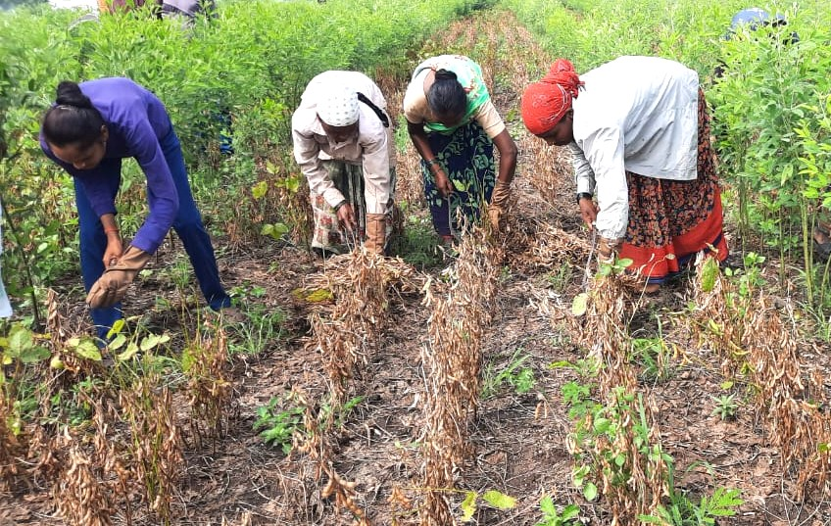
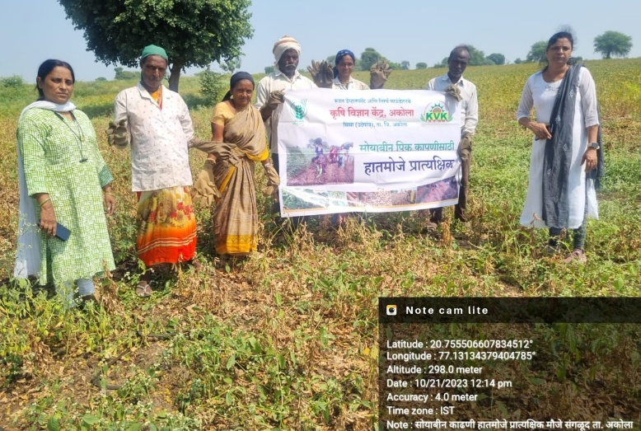

Fig 1. Demonstration of Multipurpose Mitten in Soybean Harvesting by Women

