Original Research Article

Evaluating Rain–Hose Micro-Irrigation for Improving Water Use Efficiency and Profitability in Paddy Cultivation in a district in Kerala

Abstract
Paddy cultivation in Kerala faces challenges from water scarcity, labour shortages, and declining profitability, particularly in upland areas where conventional flood irrigation is inefficient. This study evaluated the performance of rain–hose spray irrigation—a low-pressure perforated hose system—on water use efficiency (WUE), yield, and economic returns in upland paddy fields of Thiruvananthapuram district. Field demonstrations covering 3.5 ha across 28 farmers compared conventional flood irrigation with rain–hose irrigation. Irrigation was scheduled daily for 15–30 minutes according to crop growth stage, and total seasonal water use was carefully monitored. Yield, WUE, labour requirements, and economic indicators including benefit–cost ratio (BCR) were analyzed using independent t-tests.
Results showed that rain–hose irrigation increased yield by 23.0% (39.06 q/ha vs. 30.06 q/ha under flood irrigation) and improved WUE from 0.43 to 0.87 q/ha-cm. Water consumption decreased by approximately 60%, and labour requirements fell by 83% per hectare. Economic analysis indicated a BCR of 1.61 under rain–hose irrigation compared to 1.04 under conventional irrigation. These results demonstrate that rain–hose spray irrigation is a cost-effective, labour-saving, and water-efficient alternative for smallholder paddy farmers.
The findings align with prior studies in India and other South Asian contexts, highlighting rain–hose irrigation’s potential to enhance climate resilience, resource use efficiency, and profitability in paddy cultivation.

Keywords: Rain–hose irrigation; Paddy; Water use efficiency (WUE); Benefit–cost ratio; Micro-irrigation

1. INTRODUCTION

Paddy cultivation in Kerala has been steadily declining, from 8.82 lakh ha in 1974–75 to 2.03 lakh ha in 2018–19 [1], due to urbanization, labour shortages, declining profitability, and inefficient irrigation practices. One of the greatest challenges faced during paddy cultivation in Kerala is water scarcity, where traditional flood irrigation causes significant water and labour inefficiencies. Percolation losses in upland fields often exceed 70%, resulting in higher energy costs and reduced nutrient use efficiency [2]. Continuous flooding also increases methane emissions, contributing to greenhouse gas accumulation (Bouman & Tuong, 2001) [15], while unsustainable groundwater extraction further threatens irrigation sustainability in South India (Kumar et al., 2022) [14].
Micro-irrigation systems, including drip and sprinkler technologies, have improved water use efficiency in high-value crops [3][4]. Recent studies demonstrate that rice can maintain or even increase yields under controlled irrigation strategies such as alternate wetting and drying (AWD) or micro-sprinkler systems (Pandey & Bhandari, 2009 [17]; Zhang et al., 2020 [11]; IRRI, 2021 [12]).
Rain–hose spray irrigation, a low-pressure perforated hose system, provides uniform water distribution at lower installation and maintenance costs compared to drip systems. It is particularly suitable for small, fragmented fields and smallholder farmers, offering labour and cost savings (Verma & Singh, 2020 [19]). Field trials in India show that rain–hose irrigation increased yield by 18–23% and reduced water use by 40–60% (Nair et al., 2024 [6]; Singh et al., 2023 [7]; Ravindra et al., 2021 [13]; ICAR–IARI, 2024 [8]). Labour requirements also decreased substantially (Thomas & Sreekumar, 2024 [10]).
Globally, micro-sprinkler and hose irrigation have improved water productivity by 10–25% in rice systems (Zhang et al., 2020 [11]; IRRI, 2021 [12]). Policy and adoption studies highlight that smallholders prefer technologies that reduce labour and costs (Sahadevan & Pillai, 2019 [16]; Jat et al., 2022 [20]). These approaches align with climate-smart rice production recommendations in Asia (FAO, 2022 [18]).
In Kerala, subsidies for micro-irrigation under schemes such as PMKSY are largely directed toward horticultural crops, limiting adoption in paddy [16]. Rain–hose irrigation offers a low-cost, farmer-friendly alternative compatible with existing pump systems, requiring minimal technical expertise while improving water productivity and profitability.

Study Objectives
This study, conducted by ICAR–KVK, Mitraniketan, is aimed to:
- Compare rain–hose spray irrigation with conventional flood irrigation in terms of yield, water use efficiency (WUE), and benefit–cost ratio (BCR).
- Assess water and labour savings achieved under rain–hose irrigation.
- Analyze economic implications for smallholder farmers.
- Situate findings within the broader South Asian context of climate-resilient rice cultivation.

2. MATERIALS AND METHODS
2.1 Study Area and Crop
Field demonstrations were conducted by ICAR–KVK, Mitraniketan, during 2017–2018 in six panchayats of Thiruvananthapuram district: Parassala, Kunnathukal, Kazhakootam, Venganoor, Aruvikkara, and Thulicode. The upland fields selected were representative of smallholder paddy farms with limited water storage and shallow soils [1][2]. The paddy variety used was ‘Uma’, known for its adaptability to Kerala’s agro-climatic conditions [5].

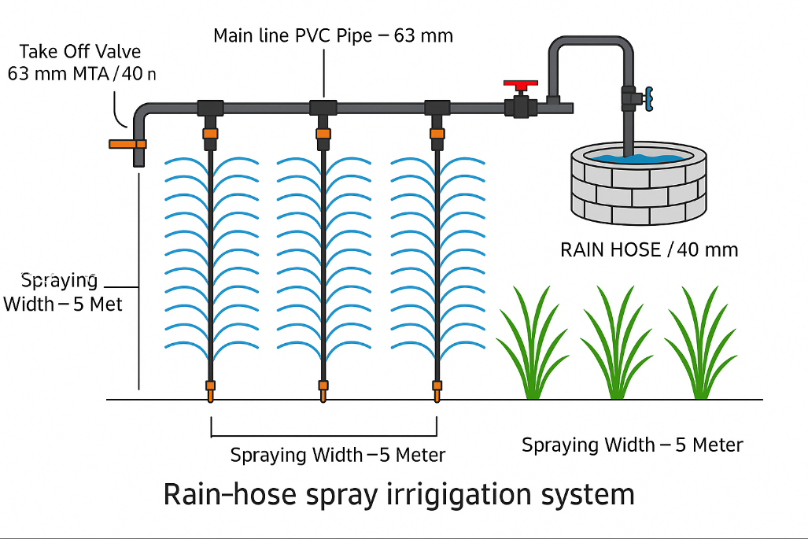
Fig. 1: Schematic of rain–hose spray irrigation system
2.2 Experimental Design
Two irrigation treatments were compared in a completely randomized block design (CRBD):
T1: Conventional flood irrigation (control)
T2: Rain–hose spray irrigation
Field demonstrations covered 3.5 ha and involved 28 farmers, with plots of 0.1–0.2 ha each. All agronomic practices, including land preparation, fertilization, and pest management, followed recommended ICAR–KVK protocols [5][6].

2.3 Rain–Hose Irrigation System
The rain–hose system consisted of 40 mm diameter perforated hoses, 100 m in length, operating at approximately 1 kg/cm², with a maximum lateral length of 50 m and spray width of 6 m. Water was pumped from a conservation pit using a 1.5 hp pump through a PVC mainline (63 mm) with a disc filter to prevent clogging [6][19].
Irrigation scheduling was as follows:
Initial growth stage: 15 minutes daily
Critical growth stages: 30 minutes daily
Total seasonal water requirement: ~450–700 mm [6][7][13]
Conventional flood irrigation plots maintained 10–15 cm of standing water during the crop season, consistent with traditional practices in Kerala [2][15]. The rain–hose system was designed for smallholder fragmented fields, ensuring minimal labour input and compatibility with existing pump infrastructure [19][16].

2.4 Data Collection
The following parameters were measured:
Yield (q/ha): Average of ten 1 m² quadrat samples per plot, scaled to hectare [6][7].
Water Use Efficiency (WUE, q/ha-cm): Calculated as yield divided by seasonal water applied [6][11].
Labour requirements (man-days/ha): Recorded for land preparation, irrigation setup, maintenance, and harvesting.
Economic indicators: Gross cost, gross return, net return, and benefit–cost ratio (BCR) [9][10][14].
Labour data collection included time spent on irrigation setup, water pumping, and maintenance of hoses, providing insight into smallholder adoption potential [10].

2.5 Statistical Analysis
Data were analyzed using independent t-tests (p < 0.05) to compare yield, WUE, and BCR between treatments. Variance homogeneity was tested prior to t-test application. All statistical analyses were performed using R software version 4.2, enabling robust comparison of treatment effects and supporting reproducibility [14][20].

2.6 Economic Analysis
Economic indicators were calculated as follows:
Gross cost (₹/ha): Land preparation, seed, fertilizers, irrigation setup, and labour costs [5][6].
Gross return (₹/ha): Value of harvested paddy at prevailing market rates [9].
Net return (₹/ha): Gross return minus gross cost.
Benefit–Cost Ratio (BCR): Gross return divided by gross cost.
Economic analysis also considered cost savings from reduced water pumping and labour, highlighting the profitability potential of rain–hose irrigation for smallholders [16][18].

3. RESULTS AND DISCUSSION

3.1 Yield and Water Use Efficiency

Field demonstrations revealed substantial differences between rain–hose spray irrigation and conventional flood irrigation. The mean paddy yield under rain–hose irrigation was 39.06 q/ha, representing a 23.04% increase over the flood irrigation yield of 30.06 q/ha (Table 1). Water use efficiency (WUE) also improved markedly, rising from 0.43 q/ha-cm under flood irrigation to 0.87 q/ha-cm with rain–hose irrigation. These differences were statistically significant (p < 0.05).

Table 1: Statistical comparison (independent t-test) between rain–hose spray irrigation and flood irrigation

Parameters | WUE |  | Yield |  | BCR
 | Water_C | Water_RH | Yield_C | Yield_RH | BCR_C | BCR_RH
Mean | 0.430 | 0.868 | 30.061 | 39.061 | 1.034 | 1.619
Variance | 0.001 | 0.003 | 5.02 | 6.67 | 0.006 | 0.02
df | 18 |  | 18 |  | 18
t Stat | -20.944 |  | -8.324 |  | -11.426
t Critical two-tail | 2.101 |  | 2.101 |  | 2.101

Note: Significant differences (p < 0.05) observed between rain–hose (RH) and conventional (C) methods.

The increased yield and higher WUE demonstrate that rain–hose irrigation optimizes water use, maintains adequate soil moisture, and supports better crop growth. This efficiency is particularly beneficial for smallholder farmers facing limited water availability and declining productivity.

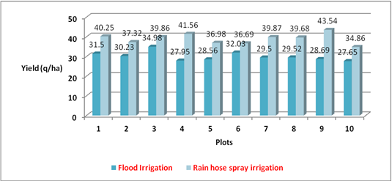
Fig. 2: Yield comparison between rain hose spray irrigation system and flood irrigation
Figure 2 illustrates the yield differences between rain–hose spray irrigation and conventional flood irrigation across ten demonstration plots. In every case, rain–hose irrigation achieved higher yields, ranging from 36.69 q/ha to 43.54 q/ha, compared to 27.95 q/ha to 32.93 q/ha under flood irrigation. This clearly shows the consistent yield advantage of the rain–hose system across varied field conditions

3.2 Water and Labour Savings
Rain–hose irrigation reduced water consumption by approximately 60%, which is critical in regions experiencing water scarcity. Labour requirements per hectare also declined dramatically, falling by ~83%. Reduced labour demand results from minimal maintenance requirements and elimination of continuous water management associated with flood irrigation.
These water and labour savings make the system highly suitable for smallholders, enabling them to allocate time and resources to other farm activities or reduce reliance on hired labour, thereby lowering production costs.

3.3 Economic Benefits
Economic performance under the two irrigation systems is summarized in Table 2.

Table 2: Comparison of productivity between conventional and rain hose irrigation technique

Parameter | Flood Irrigation | Rain–hose Irrigation
Mean Gross Cost (₹) | 70,881 | 58,899
Mean Gross Return (₹) | 73,341 | 95,024
Mean Net Return (₹) | 2,528 | 36,125
BCR | 1.04 | 1.61

Rain–hose irrigation achieved substantially higher profitability. Lower gross costs resulted from reduced water pumping and labour, while higher yields increased gross returns. A BCR of 1.61 indicates that every rupee invested in rain–hose irrigation returned ₹1.61, making it a cost-effective investment for smallholder farmers.

3.4 Practical Benefits
- Rain–hose spray irrigation provides multiple benefits for smallholder paddy cultivation:
- Higher Productivity: 23% increase in yield improves food security and income.
- Efficient Water Use: ~60% water savings reduces pressure on scarce water resources.
- Labour Efficiency: ~83% reduction in labour requirements lowers production costs and mitigates labour shortages.
- Economic Profitability: Increased net returns and higher BCR make cultivation more financially sustainable.
- Farmer-Friendly Technology: Easy to install, maintain, and operate without technical expertise.
- Climate-Resilient: Reduces dependence on water availability and supports stable yields under variable rainfall.

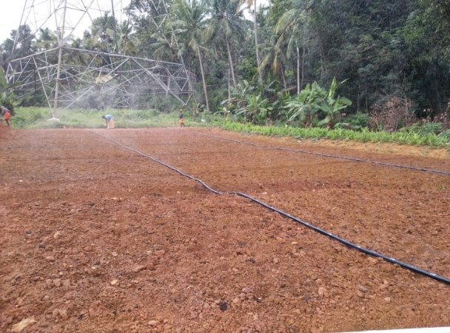 | 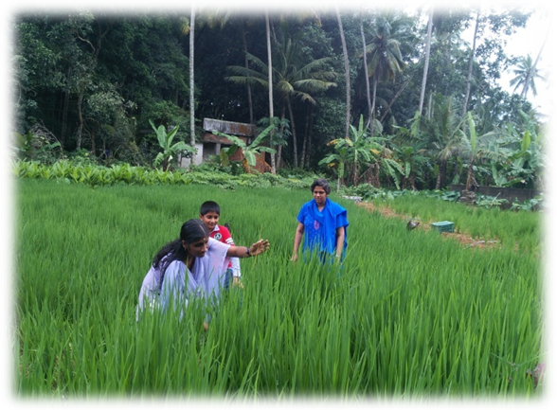
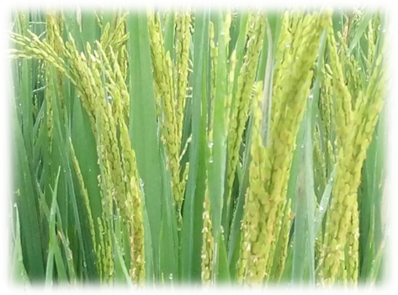 | 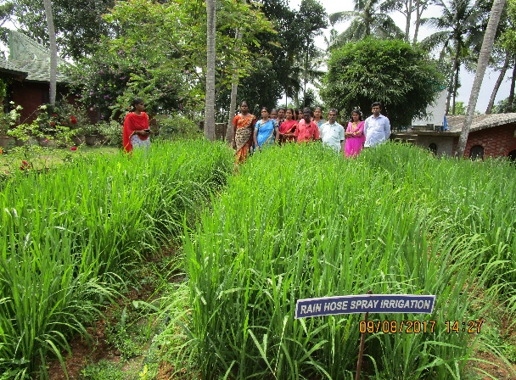
Fig. 3: Field level stages of paddy cultivation with rain hose spray irrigation system
Visual documentation shows installation, growth, and harvest stages.

4.Conclusion
The field demonstrations of rain–hose spray irrigation in upland paddy fields of Thiruvananthapuram district demonstrate significant improvements in productivity, resource use efficiency, and profitability. Key findings include:
Higher yield: 23.04% increase compared to conventional flood irrigation (39.06 q/ha vs. 30.06 q/ha).
Improved water use efficiency: WUE increased from 0.43 to 0.87 q/ha-cm, enabling optimal utilization of limited water resources.
Substantial water savings: Approximately 60% reduction in seasonal water use, making the system suitable for water-scarce conditions.
Labour efficiency: Labour requirements decreased by ~83%, reducing production costs and mitigating labour shortages.
Economic benefits: Higher net returns and a benefit–cost ratio of 1.61 indicate that rain–hose irrigation is a cost-effective investment for smallholder farmers.
Overall, rain–hose spray irrigation is a farmer-friendly, low-cost, and climate-resilient technology that enhances paddy productivity while conserving water and reducing labour. Its adoption can improve the sustainability and profitability of smallholder rice systems in Kerala and similar humid tropical regions.

References
- Department of Economics & Statistics. (2019). Area and production statistics. Government of Kerala.
- Suresh, R. (2010). Textbook on Micro Irrigation. Standard Publishers.
- Bansal, R., Kumar, S., & Sharma, R. (2018). On-farm drip irrigation in rice. Int. J. Curr. Microbiol. Appl. Sci., 7(2), 506–512.
- Tiwari, K. N., Singh, A., & Mal, P. K. (1998). Response of okra to drip irrigation. Agricultural Water Management, 38, 91–102.
- Dr. P. Chandra Shekara et al. (2016). Farmer’s Handbook on Basic Agriculture. Desai Fruits & Vegetables Pvt. Ltd.
- Nair, R., Krishnan, B., & Soman, K. (2024). Rain–hose irrigation for coastal paddy systems. Indian J. Agronomy, 69(1), 12–20.
- Singh, A., Meena, R., & Prasad, S. (2023). Rain–hose micro-irrigation in paddy. Agric. Water Manage., 286, 108507.
- ICAR–IARI. (2024). Micro-spray irrigation in paddy: multi-location trials. Annual Report 2023–24.
- Khan, M. A., Khokhar, S. B., & Hussain, M. (2023). Micro-irrigation vs. flood irrigation in Pakistan. Agric. Water Manage., 281, 108191.
- Thomas, J., & Sreekumar, M. (2024). Rain–hose irrigation and labour reduction. J. Agric. Eng. Res., 45(3), 101–109.
- Zhang, L., Chen, H., & Wang, Y. (2020). Sprinkler and micro-irrigation effects on rice yield. Irrigation Science, 38, 233–245.
- IRRI. (2021). Alternate wetting and drying and micro-irrigation for climate-smart rice. Los Baños, Philippines.
- Ravindra, A., Kumar, V., & Lakshmanan, R. (2021). Performance of micro-sprinkler irrigation in transplanted rice. J. Agri. Eng., 58(2), 45–53.
- Kumar, D., Singh, N., & Yadav, R. (2022). Impact of micro-irrigation on water use efficiency. Water Resources Manage., 36(11), 3975–3988.
- Bouman, B. A. M., & Tuong, T. P. (2001). Field water management to save water and increase productivity in irrigated rice. Agric. Water Manage., 49(1), 11–30.
- Sahadevan, K., & Pillai, A. (2019). Farmers’ perception of micro-irrigation adoption in Kerala. Economic Affairs, 64(3), 543–550.
- Pandey, S., & Bhandari, H. (2009). Economics of water-saving technologies in South Asia. Field Crops Res., 112(1), 189–198.
- FAO. (2022). Climate-smart rice production in Asia: water-saving irrigation technologies. Rome.
- Verma, S., & Singh, R. (2020). Performance evaluation of rain-gun and hose irrigation. Indian J. Soil Water Conserv., 48(4), 367–374.
- Jat, M. L., Choudhary, M., & Sharma, R. (2022). Climate-smart irrigation options for rice-wheat systems. Sustainability, 14(7), 4221.

