Original Research Article
Correlation and Path Coefficient Analysis of Yield and Its Component Traits in Groundnut (Arachis hypogaea L.)

.
ABSTRACT
Aims: To study the correlation and path coefficient analysis of yield and its contributing characters in groundnut with aim of identifying superior yield contributing attributes for crop improvement.
Study design: Augmented Block Design.
Place and Duration of Study: AICRP on Groundnut, Rajasthan Agricultural Research Institute, Durgapura, Jaipur, Rajasthan, between June 2024 to October 2024.
Methodology: We include sixty-three genotypes, including three standard checks, were assessed at the Rajasthan Agricultural Research Institute, Durgapura, Jaipur, using an augmented block design. Observations were taken for twelve characters: three phenological (days to 50% flowering, peg initiation, and maturity), seven yield-related (branches/plant, pods/plant, pod yield/plant, kernel yield/plant, shelling percentage, sound mature kernel (SMK) percentage and 100-kernel weight) and two biochemical (protein and oil content).
Results: The correlation and path analyses revealed kernel yield/plant, pods/plant, branches, and SMK as the most dependable contributors to dry pod yield/plant in groundnut. The yield of dry pods/plant demonstrated very strong positive correlations with both the number of pods/plant (rg = 0.98**) and kernel yield/plant (rg = 0.98**), as well as with the number of branches/plant (rg = 0.82**). It was also strongly correlated with the presence of sound mature kernels (rg = 0.73**). Path analysis confirmed kernel yield as the most influential trait, showing a strong direct effect (0.9767) on the yield of dry pods/plant is followed by the number of pods/plant with a moderate direct effect (0.0641) and sound mature kernels with a smaller effect (0.0215). While branches are positively correlated, they exerted a minimal negative direct effect of -0.0059, which suggests that their contributions are primarily indirect. Conversely, shelling percentage (-0.2067), 100-kernel weight (-0.0129), oil content (0.0211) and protein content (0.0137) showed weak or inconsistent direct effects, highlighting their limited role in yield improvement.
Conclusion: The traits such as kernel yield, pods/plant and SMK were identified as greater portion of dependable selection parameters aimed at enhancing dry pod yield in groundnut, with branches acting as a supportive trait through indirect effects. Conversely, shelling percentage, 100-kernel weight, protein content and oil content played minor or inconsistent roles, making them less reliable as primary selection indices.

Keywords: Correlation analysis, Path analysis, Pod yield, Groundnut
1. INTRODUCTION

Groundnut (Arachis hypogaea L.) is a vital oilseed and legume, valued for its nutritional richness, diverse uses, and economic importance in tropical and subtropical regions. Globally, groundnut covered 30.9 million hectares in 2023–24, producing 54.27 mt and average yield was 1755 kg/ha. China, India, and Nigeria ranked as the leading producers (FAO, 2024). In India, groundnut continues to dominate the oilseed sector, contributing 10.18 million tonnes from 4.7 million hectares and mean yield was 2163 kg/ha. Gujarat is the largest producer, trailed by Rajasthan, Madhya Pradesh, and Tamil Nadu, together accounting for nearly 85% of the national output (DA & FW, 2024). Despite its significance, improving pod yield remains challenging due to its complex genetic inheritance and dependence on multiple yield-related traits. Since direct selection for yield can be less efficient, it is important to recognize the relationships between yield components to identify dependable indirect selection criteria.
Correlation analysis provides valuable information on the strength and direction of associations among traits, enabling breeders to identify those positively linked with yield and suitable for simultaneous improvement (Patel et al., 2021). In contrast, correlation alone does not explain whether these relationships stem from direct effects or are channeled through other characteristics. Path coefficient analysis fills this void by breaking down correlations into direct and indirect impacts, providing a clearer insight into cause-and-effect relationships among yield attributes (Rajanna et al., 2024; Attia et al., 2022).
In groundnut, the combined application of correlation and path coefficient analysis has proven effective for highlighting key yield determinants such as kernel yield/plant, number of pods/plant, and SMK. Integrating these approaches allows breeders to focus on the most influential traits, thereby improving selection efficiency and accelerating genetic gains for enhanced productivity.

2. Methedology

2.1 Experimental Details
The investigation was performed at the AICRP on Groundnut, Rajasthan Agricultural Research Institute, Durgapura, Jaipur, situated in the Semi-Arid Eastern Plain Zone (Zone IIIA) at latitude of 26°51′N, longitude of 75°47′E, and elevation of 390 meters above sea level. For this study, sixty-three groundnut genotypes, including three standard checks (RG 638, RG 559-3, and RG 578), were assessed using an augmented block design consisting of six blocks. Data were collected on twelve characters: three phenological traits (days to 50% flowering, initiation of pegging, and maturity), seven yield-related traits (number of branches/plant, number of pods/plant, pod yield/plant, kernel yield/plant, shelling percentage, sound mature kernel percentage and 100-kernel weight), and two biochemical traits (protein and oil content). For all traits, observations were taken from five representative plants, except for phenological traits, which were recorded on a plot basis.
2.2 Statistical Analysis
To study the interrelationships among yield and its contributing characters, correlation and path analyses were performed. The calculation of genotypic and phenotypic correlation coefficient was performed using variance and covariance components based on the methodology of Singh and Chaudhary (1979). In order to further partitioned these relationships, path coefficient analysis was conducted according to the approach introduced by Wright (1921) and subsequently explained by Dewey and Lu (1959). This approach allowed the separation of total correlation into direct and indirect effects of individual traits on yield through a system of simultaneous equations.
3. results and discussion

Correlation and path analyses were conducted among sixty-three groundnut genotypes across twelve agronomic and quality traits. Understanding these interrelationships is essential for identifying effective selection criteria, as direct improvement of complex traits like dry pod yield is often difficult. In such cases, indirect selection through correlated traits provides a more efficient approach. To this end, both genotypic and phenotypic correlations were estimated to examine associations between yield and its component traits.
3.1 Correlation Analysis
3.1.1 Correlation between seed yield/plant and its contributing trait
Correlation results demonstrated several significant relationships. Dry pod yield/plant was found to be highly and positively correlated with the number of pods/plant (r_{g} = 0.98**), kernel yield/plant (r_{g} = 0.98**) and number of branches/plant (r_{g} = 0.82**). A strong positive correlation was also observed with sound mature kernel (r_{g} = 0.73**), highlighting the collective role of these traits in yield enhancement. In contrast, a weak and non-significant positive association was observed for shelling percentage, 100-kernel weight and oil content, while days to 50% flowering (r_{g} = -0.14) and protein content (r_{g} = -0.07) recorded weak, non-significant negative associations, indicating limited direct contributions to yield.

Table 1. Estimates of genotypic correlation coefficients between different characters
Character | DFF | NBP | NPP | KYP | SMK | SP | HSW | OC | PC | DPYP
DFF | 1.00 | -0.13 | -0.07 | -0.24 | 0.29* | -0.44** | -0.26* | -0.13 | 0.2 | -0.14
NBP |  | 1.00 | 0.87** | 0.77** | 0.16 | -0.07 | 0.13 | 0.10 | -0.02 | 0.82**
NPP |  |  | 1.00 | 0.95** | 0.49** | 0.08 | -0.01 | 0.08 | -0.10 | 0.98**
KYP |  |  |  | 1.00 | 0.88** | 0.32* | 0.09 | 0.01 | -0.04 | 0.98**
SMK |  |  |  |  | 1.00 | 0.84** | 0.80** | 0.04 | -0.10 | 0.73**
SP |  |  |  |  |  | 1.00 | 0.16 | -0.26* | 0.16 | 0.13
HSW |  |  |  |  |  |  | 1.00 | -0.10 | -0.08 | 0.05
OC |  |  |  |  |  |  |  | 1.00 | -0.03 | 0.08
PC |  |  |  |  |  |  |  |  | 1.00 | -0.07
DPYP |  |  |  |  |  |  |  |  |  | 1.00
*, ** Significant at 5% and 1% respectively

Fig. 1. Genotypic correlation of dry pod yield with its attributing characters
3.1.2 Relationships among the studied traits
Interestingly, days to 50% flowering presented mixed patterns: it was positively correlated with sound mature kernel (r_{g} = 0.29*) but recorded a negative association with shelling percentage (r_{g} = -0.44**) and 100-kernel weight (r_{g} = -0.26*). Its correlations with yield, number of branches, pods, and oil content were weakly negative, while the association with protein content was weakly positive and non-significant. This suggests that flowering time plays only a minor role in direct yield determination but may influence other yield-related traits. Out of the traits considered, number of branches per plant emerged as an important contributor, showing highly positive correlations with pods/plant (r_{g} = 0.87**), kernel yield/plant (r_{g} = 0.77**), and dry pod yield/plant (r_{g} = 0.82**). Its relationships with shelling percentage, protein content, and flowering were weakly negative, while weak non-significant positive correlations were recorded with sound mature kernel, 100-kernel weight and oil percentage. Similarly, the number of pods/plant showed a strong association with productivity, exhibiting significant positive association with kernel yield/plant (r_{g} = 0.95**), dry pod yield/plant (r_{g} = 0.98**) and SMK (r_{g} = 0.49**). Kernel yield was also highly correlated with pods, branches, dry pod yield, and SMK, whereas shelling percentage and 100-kernel weight were positively linked with sound mature kernels but displayed inconsistent relationships with yield. Oil content exhibited a significant negative association with shelling percentage (r_{g} = -0.26*), and protein content showed weak and inconsistent correlations with most traits. Overall, kernel yield/plant, number of pods/plant, number of branches/plant and sound mature kernel were identified as the most dependable contributors to dry pod yield, while traits such as oil content, protein content, and shelling percentage contributed minimally. These results align with earlier findings: Mitra et al. (2021) for pods and branches; Deepa et al. (2022) for kernel yield; Yadav et al. (2023) and Vaghasiya et al. (2025) for pods and kernel yield; and Rao et al. (2024) and Gupta et al. (2025) for pods, branches, kernel yield, and sound mature kernels. Similar non-significant positive association with shelling percentage, 100-kernel weight, and oil percentage were reported by Deepa et al. (2022), Reddy et al. (2023), Patil et al. (2024), and Sravanti et al. (2024).
3.2 Path Coefficient Analysis
Path coefficient analysis provided deeper insights into cause–effect relationships among yield components. Kernel yield per plant emerged as the most influential trait, exerting a very strong direct effect (0.9767) for dry pod yield/plant, further reinforced by substantial indirect effects through pods/plant and sound mature kernels. Number of pods/plant also contributed positively, with a moderate direct effect (0.0641) and strong indirect contributions via kernel yield, confirming its role as a key secondary determinant. Sound mature kernel exerted a positive but moderate direct effect (0.0215), with its overall influence largely expressed indirectly through kernel yield/plant and number of pods/plant. Number of branches/plant, though strongly correlated to yield, exhibited a negligible negative direct effect (-0.0059), suggesting its influence is mainly indirect through kernel yield and pods.
Other traits contributed weakly or inconsistently. Although shelling percentage showed a weak positive correlation with yield, it exerted a strong negative direct effect (-0.2067). Similarly, 100-kernel weight, although weakly correlated with yield, had a small negative direct effect (-0.0129), with influence largely mediated through kernel yield and sound mature kernels. Oil content exerted a weak positive direct effect (0.0211), and protein content, though negatively correlated with yield, showed a small positive direct effect (0.0137). Both traits, however, contributed little to yield improvement. These findings are consistent with previous reports by Kumari & Sridharan (2020), Mitra et al. (2021), Deepa et al. (2022), Reddy et al. (2023), Yadav et al. (2023), Rao et al. (2024), Sravanti et al. (2024), Gupta et al. (2025), and Vaghasiya et al. (2025).
Table 2. Genotypic path coefficient analysis for various traits on dry pod yield/plant
Character | DFF | NBP | NPP | KYP | SMK | SP | HSW | OC | PC
DFF | -0.0034 | 0.0007 | -0.0042 | -0.2347 | 0.0062 | 0.0899 | 0.0033 | -0.0028 | 0.0028
NBP | 0.0004 | -0.0059 | 0.0559 | 0.7511 | 0.0034 | 0.0136 | -0.0017 | 0.0022 | -0.0003
NPP | 0.0002 | -0.0052 | 0.0641 | 0.9293 | 0.0105 | -0.0157 | 0.0001 | 0.0017 | -0.0014
KYP | 0.0008 | -0.0045 | 0.0610 | 0.9767 | 0.0190 | -0.0664 | -0.0012 | 0.0004 | -0.0006
SMK | -0.0010 | -0.0009 | 0.0315 | 0.8624 | 0.0215 | -0.1736 | -0.0104 | 0.0009 | -0.0014
SP | 0.0015 | 0.0004 | 0.0049 | 0.3136 | 0.0180 | -0.2067 | -0.0021 | -0.0056 | 0.0023
HSW | 0.0009 | -0.0008 | -0.0006 | 0.0881 | 0.0172 | -0.0340 | -0.0129 | -0.0022 | -0.0011
OC | 0.0005 | -0.0006 | 0.0052 | 0.0004 | 0.0009 | 0.0546 | 0.0013 | 0.0211 | -0.0005
PC | -0.0007 | 0.0001 | -0.0067 | -0.0408 | -0.0022 | -0.0339 | 0.0010 | -0.0007 | 0.0137
Residual effect = 0.0591 *, ** Significant at 5% and 1% respectively
Overall, the study highlights kernel yield/plant, number of pods/plant and sound mature kernels as the most reliable indicators for selecting genotypes with superior dry pod yield in groundnut. Number of branches/plant, although mainly acting through indirect effects, may still serve as a supportive trait. Conversely, shelling percentage, 100-kernel weight, oil and protein content exhibited weak or inconsistent roles, making them less valuable as primary selection indices.

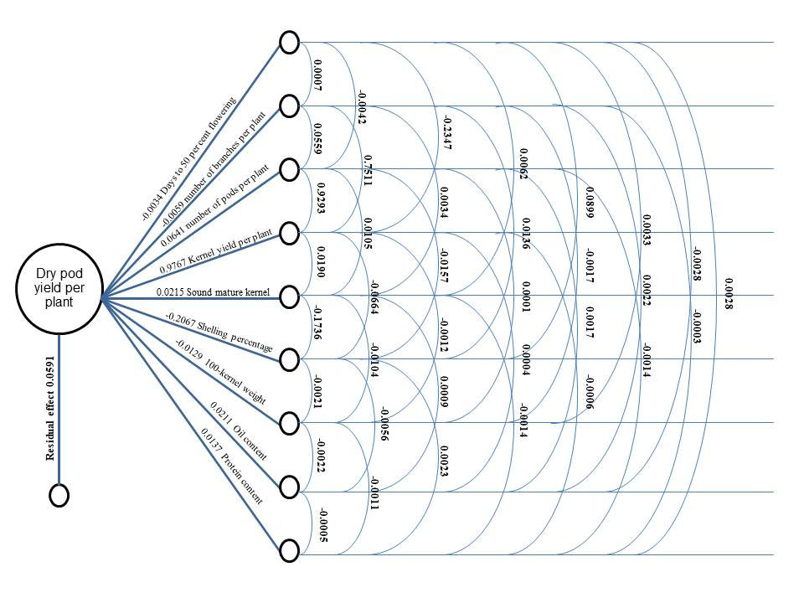
Fig. 2. Path diagram of yield components of dry pod yield/plant

4. Conclusion

Correlation and path analyses identified kernel yield/plant, number of pods/plant and SMK as the most dependable and direct contributors to dry pod yield in groundnut, establishing them as key selection criteria for yield improvement. Number of branches/plant, despite its strong association with yield, influenced productivity mainly through indirect effects, reflecting a supportive rather than causal role. Conversely, traits such as shelling percentage, 100-kernel weight, oil and protein content exhibited weak, inconsistent, or negative direct effects, indicating limited value for selection. Overall, the results underscore the significance of prioritizing kernel yield/plant, pod number and SMK in breeding programs, with branches serving as a complementary trait to enhance productivity.

Abbreviations
DFF: days to 50% Flowering; NBP: Number of Branches per Plant; NPP: Number of Pods per Plant; KYP: Kernel Yield per Plant; SMK: Sound Mature Kernel; SP: Shelling Percentage; HSW: 100-Kernel Weight; OC: Oil Content; PC: Protein Content; DPYP: Dry Pod Yield per Plant

References

Attia, M. A., Asmaa, A. A. and Heba, M. N. (2022). Genetic variation, correlation coefficient and path analysis for yield and its components in peanut (Arachis hypogaea L.). SVU-International Journal of Agricultural Sciences, 4(3), 178-186.
DA & FW (2024). Department of Agriculture and Farmers Welfare, Government of India. State-wise area, production and yield: Dashboard report.
Deepa, G. M., Laxmi, C. P., Nadini, B. and Palakshappa, G. (2022). Genetic correlation and path analysis of productive traits in confectionery groundnut (Arachis hypogaea L.) genotypes. Journal of Farm Science, 35(2), 180-184.
Dewey, O. R. and Lu, K. H. (1959). A correlation and path coefficient analysis of components of crested wheatgrass seed production. Journal of Agronomy, 51, 515-518.
FAO (2024). FAOSTAT: Crops and livestock products database. Food and Agriculture Organization of the United Nations.
Gupta, S., Singh, P. B., Sharma, H., Dubey, R. B., Jain, D. and Singh, H. (2025). Character association and path coefficient analysis of different environments for yield and yield attributes in groundnut (Arachis hypogaea L.). Ecology, Environment & Conservation, 31, 281-284.
Kumari, K. and Sasidharan, N. (2020). Studies on genetic variability, correlation and path coefficient analysis for morphological and yield traits in different Arachis spp. International Journal of Current Microbiology and Applied Sciences, 9(11), 1030-1039.
Mitra, M., Gantait, S., and Kundu, R. (2021). Genetic variability, character association and genetic divergence in groundnut (Arachis hypogaea L.) accessions. Legume Research-An International Journal, 44(2), 164-169.
Patel, D. G., Chandaragi, M. K., Hingu, J. N. and Patel, J. A. (2021). Genetic variability, correlation coefficient and path analysis for yield and its attributing characters in groundnut (Arachis hypogaea L.) genotypes. Environment and Ecology, 39(3), 537-544.
Patil, P., Singh, S., Meshram, S., Kharche, K. and Kadam, S. (2024). Study on Correlation and Path Coefficient Analysis in Groundnut (Arachis hypogaea L.). Ecology, Environment & Conservation, 30(4), 1821-1827.
Rajanna B., Divya K., Lokesh G. Y., Shivakumar K., Sreedevi S. C. (2024). Assessment of correlation and path coefficient analysis for pod yield and its attributing traits in groundnut (Arachis hypogaea L.) germplasm. International Journal of Research in Agronomy, 7(8S), 25-28. https://doi.org/10.33545/2618060X.2024.v7.i8Sa.1218.
Rao, G. V., Pandiyan, M., Manivannan, N., Chandrasekhar, C. N. and Harisudan, C. (2024). Understanding combining ability, heterosis and relationships of pod yield and yield contributing traits in groundnut (Arachis hypogaea L.). Electronic Journal of Plant Breeding, 15(2), 394-404.
Reddy, P., Sabara, P., Padhiyar, S. M., Kulkarni, G. U., Sapara, G. K. and Tomar, R. S. (2023). Correlation and path analysis among agro morphological traits in groundnut (Arachis hypogaea L.). Annals of Arid Zone, 62(3), 227-234.
Singh, R. K. and Chaudhary, B. D. (1979). Biometrical methods in quantitative genetic analysis. Kalyani Publications. Delhi and Ludhiana, India.
Sravanti, K., Reddy, V. R., Mamatha, K., Navatha, N., Shankar, M., Vanisri, S. and Reddy, M. M. (2024). Correlation and path coefficient studies of yield and its contributing traits in groundnut (Arachis hypogaea L.). Journal of Advances in Biology & Biotechnology, 27(12), 1076-1082.
Vaghasiya, D. R., Dholariya, N. D., Mungala, M. P., Chaudhary, Y. J. and Jambukiya, R. M. (2025). Correlation and path coefficient analysis in spanish bunch groundnut (Arachis hypogaea L.). Plant Archives, 25, 291-296.
Wright, S. (1921). Correlation and causation. Journal of Agricultural Research, 20, 257-287.
Yadav, G. L., Rajput, S. S., Gothwal, D. K. and Jakhar, M. L. (2023). Genetic variability, character association and path analysis for pod yield and its component characters in groundnut (Arachis hypogaea L.). Legume Research. 46(6), 678-683.

