Screening of Mungbean [Vigna radiata (L.) Wilczek] genotypes against Cercospora leaf spot disease Incited by Cercospora canescens

Abstract
Mungbean (Vigna radiata (L.) Wilczek] is an important pulse crop valued for its high protein content, short growth duration, and soil-enriching ability through nitrogen fixation. Its productivity, however, is often constrained by Cercospora leaf spot (CLS), caused by Cercospora canescens, which produces necrotic lesions on leaves leading to defoliation, reduced photosynthesis, and yield loss. To identify resistant sources, sixty mungbean genotypes were evaluated under field conditions during the Kharif seasons of 2023 and 2024. Disease intensity was recorded using a standard rating scale, and genotypes were classified as resistant, moderately resistant, susceptible, or highly susceptible. Wide variability was observed among the accessions, with a few genotypes consistently showing low disease incidence, indicating potential resistance. Conversely, susceptible lines exhibited rapid disease development and severe leaf damage. The study highlights host plant resistance as an effective and eco-friendly strategy for CLS management and emphasizes the role of resistant genotypes in breeding durable varieties. The findings of this study underline the importance of host plant resistance as a key strategy for managing CLS disease in mungbean.

Keywords: Cercospora leaf spot, Disease intensity, Eco-friendly, Genotypes, Soil-enriching.
INTRODUCTION
Mungbean (Vigna radiata L.) belongs to the family Fabaceae, is one of the important edible legume’s crops having global economic importance as a protein dietary source of the necessary food in tropical and subtropical region worldwide. Mungbean also known as greengram, maash, mudga (Sanskrit) and golden gram (Swamy, 2023). It considered as poor men’s protein (Mian, 1976) and having third in position after chickpea and pigeonpea, grown and consumed in India (Mohanty and Satyasai, 2015).
Pulses, a group of food legumes, have been cultivated for thousands of years and are vital in providing nutritionally balanced diets for the Indian population (Nene, 2006). Pulses hold a crucial position in both agriculture and human nutrition by ensuring nutritional security (Malik et al., 2021). Mungbean seeds contain high protein about of 26% protein, 62% carbohydrate, 1.4% fiber, vitamins, minerals, calcium and phosphorous (Baza et al., 2022).
These crops are short-duration, hearty, and profitable for farmers. They also support environmental and agricultural sustainability. It is a well-adapted pulse crop that can be produced for green forage, manure and seeds. It has the ability to fix the atmospheric nitrogen in the soil to improve soil fertility and have been widely grown in the semi-arid regions of India. FAO reports that the United Nations General Assembly's sixty-eighth session on December 20, 2013, announced 2016 to be the International Year of Pulses. According to the FAO, legumes are the second most important crop in the world after cereals.
The crop is infected with abundant number of diseases caused by fungi, bacteria, virus and nematode. Among the fungal diseases, most common includes are Cercospora leaf spot, leaf blight, anthracnose, powdery mildew and dry root rot. In India, the yield losses ranged between 23-93% have been recorded (Chavhan et al., 2018). In Rajasthan, the disease intensity of Cercospora leaf spot of mungbean has been recorded between ranged of 29.38 to 51.20 per cent in mostly grown areas (Kumar et al., 2021). Additionally, the crop is also significantly infected by virus i.e., Mungbean yellow vein mosaic virus. Both biotic and abiotic factors have a negative impact on the crop, and among them, diseases are estimated to be the cause of production losses ranging from 21.93 to 68.77% (Sharma et al.,2008).
Cercospora leaf spot, the disease reported prominently across the Asia regions and found is the most damaging where relative humidity ranged between 79–85 per cent with average temperatures of 22.5–23.5 °C (Batzer et al., 2022). When the pathogen is inoculated into the plant, the disease's symptoms frequently appear after one to two weeks. The pathogens can infect plants at any stage of growth (Samal et al., 2021). On the leaves of the plants, the fungus causes conspicuous brown spots that consequently turn grey or dirty grey with a short reddish-brown margin and fructifications on both the surfaces. The spot's diameter might range from 5 to 10 mm. The fungus survives on plant residues and infected seeds and humidity plays an important role in conidial germination (Kumar et al., 2011).
The disease first manifests itself about 30 to 40 days after planting, depending on the day and night relative humidity and temperature. The most important symptoms of this disease appearance angular lesion and it causes water-soaked spots with greyish edges on the leaves and favourable condition for disease development. Similar patches can also be found on branches and pods. The fungal infection produces extensive leaf spotting and defoliation during blooming and pod formation. The causal organism Cercospora is a shy sporulating pathogen and is soil and air borne in nature. The present work was undertaken with in aim to know the Screening of mungbean [Vigna radiata (L.) Wilczek] genotypes against cercospora leaf spot disease incited by Cercospora canescens. The result obtained are presented in this paper.
MATERIALS AND METHODS
Plant materials:
A field experiment was conducted to find out the source of resistance to Cercospora leaf spot of mungbean under natural field conditions at Instructional Farm and Department of Plant Pathology, CoA, Jodhpur under Agriculture University, Jodhpur. Mungbean genotypes were obtained from IIPR Kanpur, IIPR-RRC Bikaner, RARI- Durgapura (Jaipur), ARS on Arid Legumes ARS, Jodhpur (Rajasthan).
CLS disease reactions of a set of sixty genotypes were evaluated in under natural field conditions in the Instructional Farm and Department of Plant Pathology, CoA, Jodhpur, during Kharif 2023 and Kharif 2024. A total of 60 genotypes will be tested for relative resistance to the Cercospora leaf spot disease of mungbean in screening plots which will be laid out with Randomized Block Design in three replications. Each plot contains two rows of one-meter length and the seeds are sown in a spacing of 30 × 10 cm. Observations on disease incidence were recorded at 15 days interval, starting with first appearance of symptoms till the maturity of crop using 1-9 rating scale of Mayee and Datar (1986). Per cent disease incidence were calculated with the following formula given by Mayee and Datar, 1986.
Per cent disease incidence = | Number of infected plants | × 100
Per cent disease incidence = | Total number of plants | × 100

Table 1: CLS disease rating scale on mungbean.
Disease scale | Per cent leaf area coverage | Description | Reaction
0 | 0 | No Symptom on the leaf. Immune (I) | Immune  (I)
1 | <1 | Lesions small, pin head sized, covering less than 1% leaf area. | Resistant  (R)
3 | 1-10 | Lesions 1-2 mm in diameter, covering 1-10% of the leaf area. | Moderately Resistant (MR)
5 | 11-25 | Lesions enlarged but not coalescing covering 11-25% of the leaf area. | Moderately Susceptible (MS)
7 | 26-50 | Lesions coalescing covering 26-50% of leaf area. | Susceptible  (S)
9 | >50 | Above 50% leaf area covered by large coalescing lesions defoliation of leaves. | Highly Susceptible  (HS)

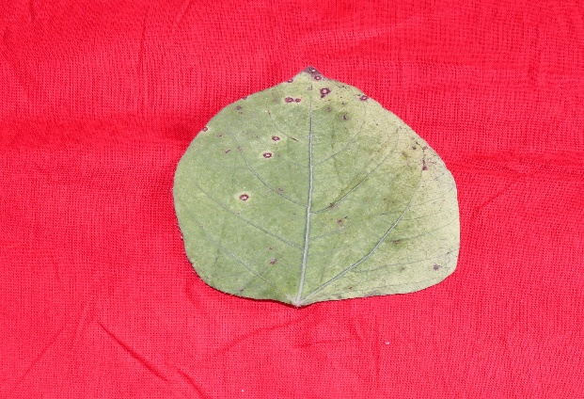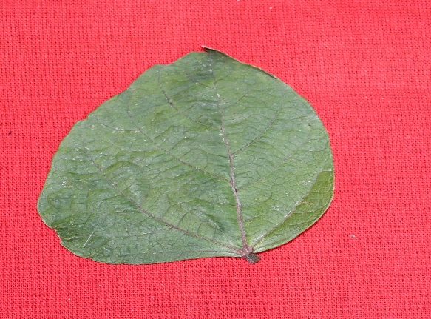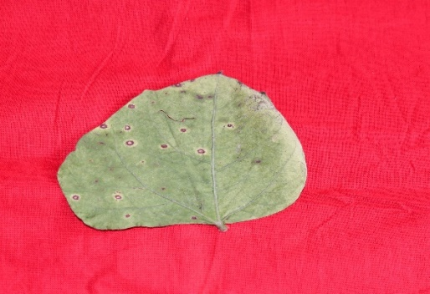
Scale 0 (No infection)
Scale 1 (<1 % leaf) Ninfection)
Scale 3 (1-10 % leaf area)
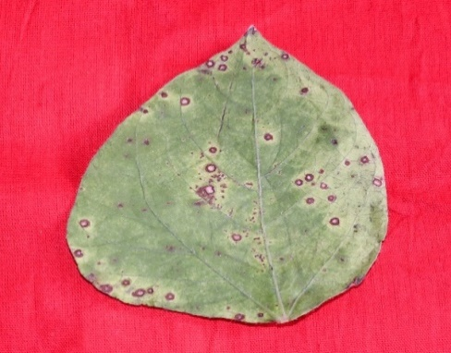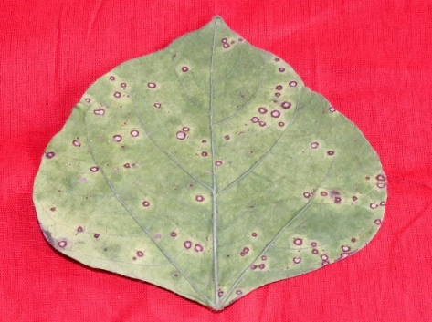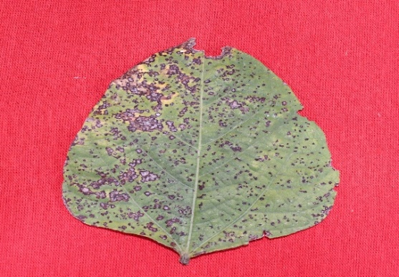
Scale 9 (> 50 % leaf area)
Scale 7 ( 26-50 % leaf area)
Scale 5 (11-25 % leaf area)
Plate 1: Rating scale for Cercospora leaf spot disease in mungbean

Result and Discussion:
Total sixty genotypes of mungbean were screened against the Cercospora leaf spot disease. Out of sixty genotypes were screened for their reaction to Cercospora canescens in the field that out of total test entries screened none genotypes of mungbean was found completely free from the disease whereas eight genotypes namely RMG- 975, IPM-99-120, IPM-409-4 (Heera), GM-7, IPM-2-15, IPM-99-125, RMG-1131 and RMG-62 were found moderately resistant (MR) with disease scale of 3 and maximum per cent disease intensity of 9.14 to 9.98 per cent. Among, genotypes, twenty- two genotypes viz., IPM-2-14, VIRAT, MH-2-15, NARENDRA MUNG-1, GM-6, IPM-302-2, MH-1142, OBGG-101, OBGG-102, BASANTI, MGG-399, TRCM171-B-B-12, SML-1901, SHWETA, KM-15-471, PM-1511, LGG-630, PM-1522, SKAU-M-365, MGG-347, VGG-17-002 and RMG-492 were found moderately susceptible (MS) with disease scale of 5 and maximum per cent disease intensity of 16.97 to 24.56 per cent. While twenty-one genotypes MSJ-118, GAM-5, IPM-02-3, BMWCD-31, SML-668, VARSHA, SML-832, ML-818, IPM-99-125, IPM-312-20, IPM-512-1, PUSA M-1872, AKM-1604, IPM-604-1, COGG-912, KM-1, KM-2, PUSA 1771, ML-2483, OGGV-59 and RMG-344 were showed susceptible (S) with disease scale of 7 and maximum per cent disease intensity of 26.66 to 42.98 per cent. Remaining nine entries viz., MH-421, SHIKHA, PDM-139, WGG-42, PL-16, LGG-460, IGKM-05-6-27, JLM 707-5 and OCU-11-5 were found highly susceptible (HS) to cercospora leaf spot disease caused by Cercosopra canescens with disease scale of 9 and maximum per cent disease intensity of 51.25 to 52.31 per cent, respectively. Ilyas et al. (2023) evaluated 11 mung bean germplasm lines for resistance against Cercospora leaf spot. Among them, two germplasm lines (NM-54 and NM-51) exhibited resistance, while three demonstrated moderate resistance. Additionally, three germplasm lines were classified as susceptible, whereas the remaining three showed a high degree of susceptibility. Notably, none of the tested germplasm exhibited complete immunity or a highly resistant reaction to the disease. Sahoo et al. (2022) tested total 90 mungbean germplasm lines to assess their resistance levels against Cercospora canescens. Of the total accessions, 32 exhibited resistances, while 35 were classified as moderately resistant. The remaining germplasm displayed varying degrees of susceptibility, ranging from susceptible to moderately susceptible and highly susceptible to Cercospora leaf spot.

Table 2: Screening of mungbean genotypes against Cercospora leaf spot in natural field conditions.
Sr. No. | Variety | Per cent disease intensity |  | Pooled | Disease Reaction
Sr. No. | Variety | 2023 | 2024 | Pooled | Disease Reaction
1 | RMG- 975 | 9.55 | 10.44 | 9.99 | MR
2 | MSJ-118 | 27.77 | 30.86 | 29.31 | S
3 | IPM-2-14 | 17.36 | 23.14 | 20.25 | MS
4 | GAM-5 | 34.72 | 36.60 | 35.66 | S
5 | IPM-02-3 | 25.55 | 30.86 | 28.20 | S
6 | IPM-99-120 | 9.45 | 10.22 | 9.83 | MR
7 | VIRAT | 21.36 | 23.14 | 22.25 | MS
8 | MH-2-15 | 19.84 | 21.36 | 20.60 | MS
9 | MH-421 | 50.68 | 52.82 | 51.75 | HS
10 | NARENDRA MUNG-1 | 15.43 | 19.84 | 17.63 | MS
11 | SML-668 | 34.72 | 39.68 | 37.20 | S
12 | GM-6 | 16.33 | 18.51 | 17.42 | MS
13 | GM-7 | 8.84 | 9.45 | 9.145 | MR
14 | IPM-302-2 | 19.84 | 23.14 | 21.49 | MS
15 | VARSHA | 30.86 | 34.72 | 32.79 | S
16 | SHIKHA | 51.75 | 52.82 | 52.28 | HS
17 | MH-1142 | 18.51 | 23.14 | 20.82 | MS
18 | SML-832 | 30.86 | 39.68 | 35.27 | S
19 | ML-818 | 33.76 | 34.72 | 34.24 | S
20 | PDM-139 | 50.68 | 51.75 | 51.21 | HS
21 | IPM-99-125 | 27.77 | 34.72 | 31.24 | S
22 | HEERA | 9.45 | 10.44 | 9.94 | MR
23 | WGG-42 | 47.25 | 55.55 | 51.40 | HS
24 | IPM-312-20 | 39.68 | 46.29 | 42.98 | S
25 | BMWCD-31 | 25.25 | 27.77 | 26.51 | S
26 | IPM-512-1 | 34.72 | 39.68 | 37.20 | S
27 | OBGG-101 | 19.84 | 25.55 | 22.69 | MS
28 | OBGG-102 | 19.84 | 23.14 | 21.49 | MS
29 | PUSA M-1872 | 33.37 | 34.72 | 34.04 | S
30 | AKM-1604 | 34.72 | 35.68 | 35.20 | S
31 | BASANTI | 17.36 | 19.84 | 18.60 | MS
32 | MGG-399 | 18.51 | 19.84 | 19.17 | MS
33 | IPM-604-1 | 30.86 | 39.68 | 35.27 | S
34 | TRCM171-B-B-12 | 21.36 | 25.55 | 23.45 | MS
35 | SML-1901 | 17.36 | 21.36 | 19.36 | MS
36 | PL-16 | 50.68 | 52.82 | 51.75 | HS
37 | SHWETA | 18.51 | 23.14 | 20.82 | MS
38 | KM-15-471 | 16.33 | 19.84 | 18.08 | MS
39 | PM-1511 | 17.36 | 23.14 | 20.25 | MS
40 | COGG-912 | 25.55 | 30.86 | 28.20 | S
41 | LGG-460 | 46.55 | 55.55 | 51.05 | HS
42 | IPM-2-15 | 9.45 | 10.22 | 9.83 | MR
43 | IGKM-05-6-27 | 50.68 | 51.75 | 51.21 | HS
44 | KM-1 | 25.55 | 27.77 | 26.66 | S
45 | IPM-99-125 | 9.55 | 10.22 | 9.88 | MR
46 | JLM 707-5 | 51.75 | 52.88 | 52.31 | HS
47 | KM-2 | 27.77 | 34.72 | 31.24 | S
48 | LGG-630 | 15.43 | 18.51 | 16.97 | MS
49 | PM-1522 | 16.33 | 21.36 | 18.84 | MS
50 | PUSA 1771 | 34.72 | 39.68 | 37.20 | S
51 | SKAU-M-365 | 17.36 | 25.55 | 21.45 | MS
52 | ML-2483 | 35.45 | 39.68 | 37.56 | S
53 | MGG-347 | 19.84 | 25.55 | 22.69 | MS
54 | OGGV-59 | 27.77 | 34.72 | 31.24 | S
55 | VGG-17-002 | 17.36 | 20.25 | 18.80 | MS
56 | OCU-11-5 | 51.75 | 52.82 | 52.28 | HS
57 | RMG-1131 | 9.45 | 10.22 | 9.83 | MR
58 | RMG-492 | 21.36 | 27.77 | 24.56 | MS
59 | RMG-62 | 8.86 | 10.44 | 9.65 | MR
60 | RMG-344 | 34.72 | 39.68 | 37.20 | S

Table 3: Genotype showed different response against CLS disease of mungbean under field during Kharif 2023 and Kharif 2024.
Disease scale | Reaction | No. of genotypes | Name of genotypes
0 | Immune (I) | 0 | Nil
1 | Resistant (R) | 0 | Nil
3 | Moderately Resistant (MR) | 8 | RMG- 975, IPM-99-120, IPM-409-4 (Heera), GM-7, IPM-2-15, IPM-99-125, RMG-1131, RMG-62
5 | Moderately Susceptible (MS) | 22 | IPM-2-14, VIRAT, MH-2-15, NARENDRA MUNG-1, GM-6, IPM-302-2, MH-1142, OBGG-101, OBGG-102, BASANTI, MGG-399, TRCM171-B-B-12, SML-1901, SHWETA, KM-15-471, PM-1511, LGG-630, PM-1522, SKAU-M-365, MGG-347, VGG-17-002, RMG-492
7 | Susceptible (S) | 21 | MSJ-118, GAM-5, IPM-02-3, SML-668, VARSHA, SML-832, ML-818, IPM-99-125, IPM-312-20, IPM-512-1, BMWCD-31, PUSA M-1872, AKM-1604, IPM-604-1, COGG-912, KM-1, KM-2, PUSA 1771, ML-2483, OGGV-59, RMG-344
9 | Highly Susceptible  (HS) | 9 | MH-421, SHIKHA, PDM-139, WGG-42, PL-16, LGG-460, IGKM-05-6-27, JLM 707-5, OCU-11-5
Conclusion
Based on the current findings, the eight moderately resistance accessions, nine highly susceptible accessions for CLS disease may be used in a breeding programme aimed at developing a high-level resistant mung bean variety against CLS. The findings of this study could also serve as a prerequisite and starting point for launching a crop improvement programme aimed at introducing CLS resistant genes or QTLs into elite mung bean cultivars.

Reference
Batzer, J.C., Singh, A., Rairdin, A., Chiteri, K. and Mueller, D.S. 2022. Mungbean: A Preview of Disease Management Challenges for an Alternative US Cash Crop. Journal of Integrated Pest Management, 13(1): 4.
Baza, M., D. Shanka and M. Bibiso, 2022. Agronomic and economic performance of mung bean (Vigna radiata L.) varieties in response to rates of blended NPS fertilizer in Kindo Koysha District, Southern Ethiopia. Open Life Science, 17: 1053-1063.
Chavhan, S.T., Darade, M.S. and Devarkar, V.D. 2018. Mycopathological studies on Vigna radiata (L.) Wilczek (Green gram) from Patur, Dist. Akola (MS), India. Plantae Scientia, 1: 55-59.
Daub, M. E. (1982). Cercosporin, a photosensitizing toxin from Cercospora species. Phytopathology, 72(4): 370-374.
Ellis, J.B. and Martin, B.M. 1882. Cercospora canescens. The American Naturalist, 1003.
Ilyas, S., Ali, S., Habib, A., and Ali, M. (2023). Unveiling the factors affecting leaf spot disease in mung bean and its management. Pakistan Journal of Agricultural Research, 36(2): 147-154.
Kumar, R., Pandey, M. and Chandra, R. 2011. Effect of relative humidity, temperature and fungicide on germination of conidia of Cercospora canescens caused the Cercospora leaf spot disease in mungbean. Archives of Phytopathology and Plant Protection, 44(16): 1635-1645.
Kumar, N., Singh, M., Prajapati, S., Lakhran, L., Maurya, S and Kumar, S. (2021). Pathogenic Variability of Cercospora Leaf Spot Disease of mung bean caused by Cercospora canescens in Surveyed areas of Rajasthan. Biological Forum – An International Journal, 13(4): 76-79.
Mayee, C.D. and Datar, V.V. 1986. Phytopathometry. Technical Bulletin-I, Marathawad Agricultural University, Parbhani, India. Pp. 146.
Malik, D. P., Bishnoi, D. K., Pawar, N. and Kumar, S. N. (2021). Additional income generation from cultivation of summer mungbean in rice-wheat system of Haryana. Legume Research- An International Journal, 44(8): 952-955.
Mian, A.L. 1976. Grow more pulse to keep your pulse well: An essay of Bangladesh Pulse, Department of Agronomy, Bangladesh Agricultural University, Mymensingh. Pp. 11-15.
Mohanty, S. and Satyasai, K. J. 2015. Feeling the pulse, Indian pulses sector. NABARD Rural pulse, 10: 1-4.
Nene, Y. L. 2006. Indian Pulses Through the Millennia. Asian Agri-History, 10(3): 179–202.
Sahoo, J.P., Samal, K.C., Lenka, D., Beura, S.K., Behera, L. and Sawant, S.S. 2022. Cercospora Leaf Spot (CLS) Disease Resistance Screening of Mungbean [Vigna radiata (L.) Wilczek] Germplasms. Biological Forum – An International Journal, 14(3): 1115-1119.
Samal, K.C., Sahoo, J.P., Behera, L. and Dash, T. 2021. Understanding the BLAST (Basic local alignment search tool) Program and a step-by-step guide for its use in life science research. Bhartiya Krishi Anusandhan Patrika, 36(1): 55-61.
Sharma, P.N., Sharma, O.P., Padder, B.A. and Kapil, R. 2008. Yield loss assessment in common bean due to anthracnose Colletotrichum lindemuthianum under sub temperate conditions of North- western in Himalayas. Indian Phytopathology, 61: 323-330.
Swamy, K. R. M. 2023. Origin, Domestication, Taxonomy, Botanical Description, Genetics and Cytogenetics, Genetic Diversity and Breeding of Mung bean (Vigna radiata (L.) R. Wilczek). International Journal of Current Research, 15(07): 25351-25375.
***

