Requirement, Availability and Consumption of Food Grains: A case study in Nagaon District of Assam

Abstract
As the population increases requirement of cereals and pulses also increases but due to imbalance of availability and requirement price, instability occurs which affects the rural farming community as well as poor population, ultimately, requirement of urgent need for policy interventions to curb the obstacles. Rice is the major crop in Assam, especially in Nagaon district covering a cultivating area of 1.98 lakh ha with the productivity of 2.55 MT per hectare out of total 2.766 lakh ha geographical area. This paper attempt to estimate availability and requirement of cereal and pulses in Nagaon district of Assam during 24-25. The study was conducted in Nagaon district of Assam to access the demand and supply of food grains gap with the help of secondary sources. Census data of male, female and children population and production of cereals and pulses were collected from Office of the Deputy Director of Economics & Statistics along with Statistical Handbook of Assam,2024. In order to estimate district requirement adult male population, female population are taken. Total food grain production in the district was taken from District Agril. Office through and published sources. Major pulses growing in Nagaon district are Green Gram, Black gram, Arahar, Pea and Lentil. From the study we can conclude that total production of cereal and total pulsed are644578 MT and 78583 MT to feed 1720818 numbers of adult male populations. Again estimated requirement was 295659.4608 MT and 20905.2144 MT for total cereal and pulse respectively, meant that availability of cereals is 644578 MT against demand for the same is 172727.10675 MT indicating surplus production of rice in Nagaon district. Whereas in case of Pulses availability is 7858 MT and demand for the same is 50247.8856 indicating deficit in the pulse in the district. The Per capita surplus of cereal is 751.327g/year and per capita deficit for pulse is 67.4892. The meet the current population total pulse productivity should be increased from .632 MT/ha to 4.40 MT/ha. Technological improvement, better management practices, high government policies like price support programmes etc will enhance the supply and productivity of pulses in India for minimizing the demand supply gap

Key Words: Availability, Requirement. Per capita consumption, Production

Introduction
World’s population grows at exponential rate it which is challenging to feed the increasing population whereas population of India were projected to 1.51 billion (reported NITI Ayog, 2020), which is one of the biggest challenges is feeding the population. Barman and Toor (2017) projected total demand of the food grain for entire India will be 252.05 million tonnes and 171.68 million tonnes for rural and urban areas respectively and further projected total demand of the food grain for entire India [1]. NITI Ayog, (2018) revealed that foodgrains demand would increase from 167 million tonnes in the base year to 189 million tonnes in 2021-22 and 215 million tonnes by 2033-34.Inclusing the indirect demand, the total demand for foodgrains that was 242 million tonnes during the base year is expected to increase to 258-260 million tonnes during the forgoing financial year (2016-17), 280-285 million tonnes by 2021-22 and 340-355 million tonnes by 2033-34 [2] Asiamah et. al Stated that by 20230, 840 number of people will face undernourished and to cope up the situation, special focus should be given on food production, processing, and consumption methods to remedy these problems (Food and Agriculture Organization, 2018 [3]. S Mittal (2008) estimated supply and demand trends of rice, wheat, total cereals, pulses, edible oil/oilseeds and sugar/sugarcane and provides the demand and supply projections for food items during 2011, 2021 and 2026 which was based on change in productivity levels, changes in price, growth of population and income growth [4] Rice is the major crop in Assam, especially in Nagaon district covering a cultivating area of 1.98 lakh ha with the productivity of 2.55 MT per hectare out of total 2.766 lakh ha geographical area. Again area under total pulse is .12439 lakh ha. Area under high-yielding varieties grown are 18.28 and 0.91818lakh ha in Assam and Nagaon district respectively during 2020-21 (Statistical Handbook, 2024). In Nagaon district rice occupies more than of the total cropped area and accounts for about 99 per cent of the acreage under cereals and the output of cereals. and practically other cereals like wheat maize, millet are grown in small quantities. Major cereal crop and pulse grown in the district are paddy, wheat, maize and Summer Green Gram, Arahar , Summer Black Gram, Pea, Lentil, Summer Mong respectively. As the population increases requirement of cereals and pulses also increases but due to imbalance of availability and requirement price instability occurs which affects the rural farming community as well as poor population, ultimately requirement of urgent need for policy interventions to curb the obstacles. This paper attempt to estimate availability and requirement of cereal and pulses in Nagaon district of Assam during 24-25.
Methodology:
The study was conducted in Nagaon district of Assam. To access the demand and supply of food grains gap with the help of secondary sources and to examine the pattern of cereal and pulses consumption, Again, census data of male, female and children population and production of cereals and pulses were collected from Statistical Handbook of Assam,2024. In order to estimate Demand District adult male population, female population and Children below 14 years are taken. Total food grain production in the district was taken from District Agril. Office through and published sources. Food grain we can take Cereal and Pulse. Consumption of food different for different category, as female less than male, So, following conversion must be done for easy calculation by converting the whole population to male adult Minimum requirement of pulses as recommended by Indian Council of Medical Research consumption of cereal (including millet) per person per day is 275g where as, average consumption of pulse is 80 g/person/day (Guideline. ICMR,2020). The whole conversion was done with the help of following formula:
- Total Demand/Requirement for food = (Total population) X Per Person Consumption Unit X 365 days
- Total Supply or Availability of food = Total production of food
Again, following Stratified Random Sampling, Raha and Khagorijaan blocks were selected as first units of sampling. In the next stage, all the villages in the above mentioned two selected blocks and villages selected randomly for the study. The villages selected for Raha block are Phuloguri and Dhemajigaon and villages selected for Khagorijaan block are Mahariati Kamarchuk and Bebejia. After- selection of the villages 25 number of households from each village are selected for the study. Thus, a sample of 100 households were taken for the study with the help of pre tested schedule sample households with interview method. tHe collected data were tabulated and analysed with proper analytical technique.

Results and discussion
Major cereal and pulses grown in Nagaon district are Rice and Green Gram, Blackgram, Arahar respectively , Pea and Lentil, It is clear from the table we can conclude that total production of cereal and total pulsed are644578 MT and 78583 MT to feed 1720818 numbers of adult male populations. Again, estimated requirement was 295659.4608 MT and 20905.2144 MT for total cereal and pulse respectively. Thus, the production of total cereals in Nagaon district is sufficient to feed the population whereas in case of total pulse is still deficit. Kumar Ganesh et. al (2012) also attempted for project of future supply and demand up to the year 2025 for rice and wheat, the two main cereals cultivated and consumed in India and also found that under reasonable scenarios on demand and supply, the country is likely to face growing surplus in rice, from 15.5–30.8 million tons in 2015 to 26.9–60.9 million tons in 2025 [5]. Goyal et. al Found in their study that food grain production in terms of wheat and rice showed increasing trend whereas the share of coarse cereals and pulses has shown a declining trend during the last four decades and found that the per capita cereal consumption showed a declining trend [6]

Table 1: Estimate of Production and Requirement of Cereal and Pulses
Sl no. | Particular | Value (Tonnes)
1. | Total Production of Cereals | 644578
2. | Total Production of Pulses | 78583
3. | Total adult male population | 1720818
4. | Total demand for Cereals | (Total population) X Per Person Consumption Unit X 365 days
4. | Total demand for Cereals | 2045520 X 275 g/day X 365 days
4. | Total demand for Cereals | 295659.4608 Tonnes
5. | Total demand for Pulses | (Total population) X Per Person Consumption Unit X 365 days
5. | Total demand for Pulses | 2045520 X 80 g/day X 365 days
5. | Total demand for Pulses | 20905.2144 Tonnes

Table2: Production and Requirement of Cereal and Pulses along with per capita consumption deficit /surplus
Sl No. | Particulars | Production/ Supply (MT) | Demand (MT) | Deficit/ Surplus (+/-) | Per capita Male population deficit/surplus (g/ year)
1 | Cereals | 644578.00 | 172727.10675 | 471850.8933Tonnes | 751.327
2 | Pulses | 7858.00 | 50247.8856 | 42389.8856Tonnes | -67.4892

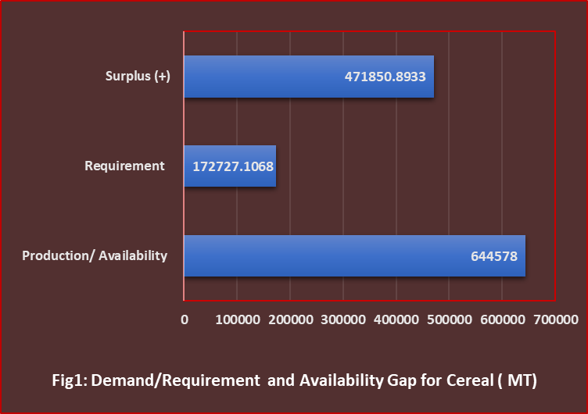
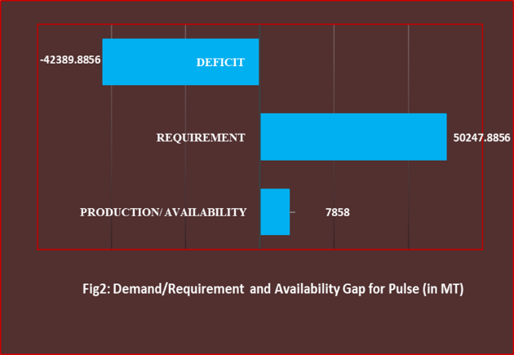
From Table 2 we can conclude that local availability of cereals is 644578 MT against deemand for the same is 172727.10675 MT indicating surplus production of rice in Nagaon district. Whereas in case of Pulses availability is 7858 MT and demand for the same is 50247.8856 indicating deficit in the pulse in the district. The Per capita surplus of cereal is 751.327g/year and per capita deficit is 67.4892. The meet the current population total pulse productivity should be increased from .632 MT/ha to 4.40 MT/ha. Under current condition food security is the biggest challenge we would be facing in the near future and the adoption of technology like high yielding varieties is only the way to meet the food demand for increasing population. Soumik and Bhattacharyya (2018) analyse demand-supply gap for pulses and found that in 2020 will be 22.92 Mt whereas the pulses supply in that year will be 19.68 Mt confirming the big gap between demand-supply gap of pulses and suggested that better technology, improved mechanism would make minimizing the demand-supply gap of pulses in India [7]. Krishi Vigyan Kendra, Nagaon plays a vital role for motivating farmers towards shifting from local varieties to High Yielding Varieties (HYV). Pradumn et .al (2009) stated that to meet the foodgrain demand in 2011-12, the yields of different commodities must be raised to a minimum of 2.37 t/ha for rice, 3.07 t/ha for wheat, and 0.68 t/ha for pulses [8]. Manickavasagan et. al conducted a study to assess the whole grain consumption, willingness to consume whole grain-based food products, whole grain knowledge and availability of whole grain-based food products in the Sultanate of Oman. Consumption of rice and bread was reported by 99 per cent in their study [9]
Table 3: Production, Marketing and Consumption of Food Grains across different farm sizes
Farm Size | Number of households | Production of food item(q) | Quantity Marketed(q) | Food items consumed in household(q/year)
Marginal (less than 1 ha) | 45 | 65.00 | 45.00 | 20.00
Small (1-2ha) | 25 | 107.50 | 88.50 | 19.00
Semi Medium (2-4ha) | 19 | 158.00 | 134.00 | 24.00
Medium (4-10 ha) | 11 | 582.00 | 511.00 | 71.00
Large (More than 10 ha) | Nil | - | - | -
Pooled | 100 | 912.5 | 778.5 | 134.00

Table 4: Consumption of food grain among different farm sizes
Farm Size | Cereals (q/year/ person ) | Pulses(q/year/person) | Cereal/day/person (g) | Pulse/day/person(g) | Deficit/ Surplus of cereal Requirement and consumption (g/day) | Deficit or Surplus of pulse Requirement and consumption (g/day)
Marginal | 1.98 | .40 | 542.47 | 109.59 | 267.47 | 29.59
Small | 2.5 | .12 | 684.93 | 32.88 | 409.93 | -47.12
Semi medium | 3.5 | .25 | 958.90 | 68.49 | 683.90 | -11.51
Medium | 2.35 | .22 | 643.84 | 60.27 | 368.84 | -19.73

From Table3 below we find that the grain Consumption, Production and marketing pattern are not similar among all sizes of farm group. Production of food grains is highest in Medium size of group with 582q followed by Semi Medium size group (158q). From the table we can conclude that production of food grains is directly proportional to production of food grains. Again, quantity Marketed and consumption was highest in case of medium size of farm with little exception in case of Marginal Size of farm food consumption is 20q per person which is more than the small size of farmers. Rakhit and Roy also conducted study on food grain consumption pattern and stated that consumption of food grain is decreased from independence and the fall is more drastic in the neo-liberal period [10]. Table 3 Showed Cereal consumption per day per person are 542.47, 684,93, 958.90 and 643.84 g for Marginal, Small, Semi medium and Medium farm sizes respectively. Whereas, In case of pulse consumption per day are 109.59, 32.88, 68.49 and 60.27 respectively for Marginal, Small, Semi Medium and Medium size of farms. The consumption of cereal and pulses per person per year along with the gap between requirement and consumption per person per day and found that consumption of cereal is higher than the requirement in all the farm sizes whereas consumption of pulse is deficit in all farm sizes except marginal farmers . In case of marginal farm size per day consumption is higher that requirement i.e. 109.59g. The per person deficit of pulse consumption of Small, Semi Medium, Medium farms are 47.12, 11.51, 19.73 g respectively.

Conclusion:
The food grains production has increased at growth rate of 6.68% per annum during the period 1950-2013 which was mainly because of productivity growth rate 4.03% per annum. The population of India has increased at growth rate of 3.8% per annum. Thus, we may conclude from this study that India has successfully achieved self-sufficiency in food grains production . Since India could not meet its growing demand with its production, it has to rely heavily on import. So we have to more concern about to this crop. Technological improvement, better management practices, high government policies like price support programmes etc will enhance the supply and productivity of pulses in India for minimizing the demand supply gap. Arundhathi (2018) stated that through research and development agricultural productivity should be increased as with growing population demand for food is expected to increase and it would become challenging for india in attaining food self-sufficiency due to climate change and low productivity [11]. Forgenie et.al (2025) analyse the factors affecting availability of food grains in a Caribbean Small Island Developing State, Trinidad and Tobago and stated that excess to credit, stabilize inflation and strategic extension works are required in order to counter the food availability deficit [12].Barman et. al (2022) recommended from their study that more research works should be done for farmers friendly technology innovation, mechanized agriculture should be popularized to enhance productivity through establishment of sufficient numbers of Custom Hiring Centre and establishment of proper functioning organized market should be developed through Govt. policies [13]. To ensure essential nutrition, under the National Food Security Act, 2013, Assam State government during Budget 2025-26 ensure to provide masur dal, sugar etc. at subsidised rates to beneficiaries and for this Rs 370 crore has been allocated. Again Central Government launched a 6-year “Mission for Aatmanirbhar in Pulses” with a special focus on Tur, Urad and Masoor where Central agencies, NAFED and NCCF will be ready to procure these 3 pulses from the registered farmers which ultimately safeguard farmers from price risk [14].

References:
- Barman and Ajay M. S. Toor (2017). Demand and Supply Projections of Food Grains in India. Journal of Agricultural Development and Policy, 2017 Volume 27, No. 1&2, 75-8
- Anonymous. Demand and Supply Projections towards 2033 Crop, Livestock, Fishery and Agricultural Inputs. The Working Group Report, NITI Ayog, February, 2018
- Asiamah JY, Mahdi SH, Tamang KR, Carson CB, Koirala P, Reed EA, Asare AT, Augustine A, Ratnaparkhe MB, Bansal KC and Valliyodan B (2025) Genome editing in grain legumes for food security. Front. Genome Ed. 7:1572292. doi: 10.3389/fgeed.2025.1572292
- Surabhi Mittal (2008) Demand-Supply Trends and Projections of Food in India. Indian Council for Research on International Economic Relations. Working Paper No. 209
- Kumar Ganesh., Mehta. R., Pullabhotla H., Prasad S. K. Ganguly K., Gulati (2012) A., Demand and Supply Cereals in India. International Food Policy Research Institute. IFRI Discussion Paper 001158
- Goyal,S. K., SINGH, J.P. Demand Versus Supply of Foodgrains In India: Implications to Food Security. 13th International IFMA Congress of Farm Management on “Feed the World- please the Consumer-Maintain the Environment” to be held at wageningen, The Netherlands, July 8-13, 2001
- Ray Soumik and Bhattacharyya Banjul (2018) Statistical investigation of Food grains Demand and Supply in India. International Journal of Agriculture Sciences, ISSN: 0975-3710 & E-ISSN: 0975-9107, Volume 10, Issue 11, pp.- 6200-6205.
- Kumar, P., Joshi, P.K., Birthal, P. S. Demand Projections for Foodgrains in India.Agricultural Economics Research Review Vol. 22 July-December 2009 pp 237-243
- Manickavasagan A, Abbas I, Ali A, Cork L, Khan MA, Claereboudt M, Al-Wardy M, Al-Rahbi S, Reicks M. Whole Grain Food Products: Knowledge, Availability and Consumption in Oman. Int J Nutr Pharmacol Neurol Dis 2020;10:128-36
- Rakshit, S., Roy,P. Consumption of Food grain and Calorie Deprivation in Rural West Bengal: A Case study of Two Villages in Birbhum District----Journal of Social Work & Social Development, Vol-1 No.-1, June-2010, ISSN-2229-6468
- Arundhathi Y., Population Income and Demand for Food Grains in India. International Journal of Innovative Science and Research Technology. Volume 3, Issue 8, August – 2018.ISSN No:-2456-2165
- Forgenie, David., Forgenie, M.M.,Caires, S. D.,Isaac W.A.P., Dhayal, K. S. (2025).Understanding the determinants of domestic food availability: Evidence from a Caribbean Small Island Developing State. Journal of Agriculture and Food Research.22(2025).102128.
- Sinki Barman, A. Deka, RN Borkakati, N, Deka and P.K. Pathak (2022). Evaluation of ICAR Schemes / Approaches- Progressive Farmers Perception on KVKs Activities. Journal of Experimental Agriculture International 44(10): 100-104, 2022; Article no. JEAI.86746 ISSN: 2457-0591
- Statistical Handbook Assam (2024). Directorate 0f Economics and Statistics Government Of Assam Guwahati-28 (des.assam.gov.in)

