Optimization of Spawning Rate for Enhanced Yield of Pleurotus pulmonarius on wheat and paddy straw

Abstract
The present study aimed to optimize the spawning rate for maximizing the yield of Pleurotus pulmonarius cultivated on wheat and paddy straw substrates. Varying spawning rates (2%, 4%, 6%, and 8%) were evaluated to determine their effect on mycelial growth, spawn run duration, pinhead initiation, yield and biological efficiency. The results revealed significant differences among the spawning rates, with higher rates generally accelerating colonization and fruiting body formation. Among the tested treatments, at 8% spawning rate exhibited the best performance in terms of biological efficiency and total yield across both substrates, while 2% offered no significant yield advantage and incurred higher spawn cost. Wheat straw supported slightly higher productivity compared to paddy straw. These findings find out the importance of optimizing spawn dosage to improve mushroom yield and cost-effectiveness in commercial cultivation of P. pulmonarius.
Keywords: Mushroom, Spawning rate, wheat straw, paddy straw
Introduction
Mushroom cultivation emerges as a promising solution, offering numerous advantages such as efficient resource utilization, land conservation and high nutritional value. By various agricultural and industrial wastes, mushrooms transform these materials into protein-rich food without requiring additional land, while also possessing valuable medicinal properties. This innovative approach not only addresses food security concerns but also presents economic opportunities, making it a viable strategy to combat malnutrition and meet the nutritional demands of India's vast population in an environmentally sustainable manner. (Manikanandan, 2011). Mushroom can also create significant health supplements, which offer numerous health advantages (Chang, 2008).
Oyster mushroom can be cultivated throughout the year but commercially, it requires specific weather conditions, temperature and relative humidity. The optimum temperature and relative humidity for maximum mycelial growth is 25-27°C and 75 to 90 per cent respectively (Gupta et al., 2016). Variations in any of the factors directly affect the primordial initiation, yield and biological efficiency. Oyster mushrooms are commonly wood and other lignocellulosic decaying fungi (Naraian et al., 2009). Mushrooms are supposed to be low calorific food (Ukwuruet et al. 2018).
Mushroom cultivation, especially of species like Pleurotus pulmonarius (commonly known as the Indian oyster mushroom), has gained prominence due to its nutritional value, low cost of production, and ability to grow on a wide range of agro-wastes. Among the various factors influencing successful cultivation, substrate preparation plays a critical role in determining both mycelial growth and fruiting body yield.
Another important factor in mushroom production is the spawning rate, or the amount of mushroom spawn introduced into the substrate. Higher spawning rates can accelerate colonization, reduce the risk of contamination, and improve yield; however, they also increase production costs. Conversely, lower spawn rates may result in delayed colonization and reduced yield, especially if the substrate is not optimally prepared.
Despite the individual importance of spawn rate, few studies have comprehensively explored their combined effect on P. pulmonarius cultivation. Understanding the interaction between these two variables is crucial for optimizing production practices, especially for small-scale and commercial growers aiming to enhance profitability and sustainability
Material and method
Effect of different spawning rates on growth and yield (g) of P. pulmonarius on wheat straw substrate
An experiment was conducted to determine the optimum inoculum level of P. pulmonarius strain (PP-21-10) on wheat, paddy straw The experiment in 2 season rainy and winter seasons to find out optimum level of spawn on growth and yield of P. pulmonarius different levels (2%, 4%, 6%, and 8% on a dry weight basis) were studied. The substrates were soaked in 75 ppm carbendazim and 500 ppm formaldehyde added water and kept for 8 hours. After soaking, the chemical mixed water was drained off on a sloppy concrete floor and substrates were air-dried in shade to achieve 65% moisture content. The treated substrates (1.0 kg dry weight per bag) were spawned by different spawning rates using the layer spawning technique. The spawned bags were incubated in cropping rooms at 22–28 °C and relative humidity (80–90%) was maintained. Observations were recorded for spawn run duration, pinhead initiation, total yield, and biological efficiency (BE%). Each treatment was replicated five times.
Result and Discussion
Effect of different spawning rates on growth and yield (g) of P. pulmonarius on wheat straw substrate.
Different spawning rates i.e. 2,4,6, and 8 % were used see to their influence on spawn run ,pin head initiation ,yield and B.E. of P. pulmonarius . The experiment was conducted 2 seasons (rainy and winter season) on wheat straw substrate and results are presented in Table 1 and Fig 1 (a), 1 (b), 1 (c), 1 (d).
Spawn run (days):
It is clear from the table that different spawning rates showed significant variation in the period required for spawn run by P. pulmonarius and it varied from (13 -17days).In rainy season spawn run period of P. pulmonarius did not differ significantly with the use of different rate of spawn all studied spawning rates and took 16 -17 days for mycelial colonization on wheat straw substrate.
In winter spawn run period significantly influence by different spawning rate of P. pulmonarius significantly earliest (13.0 days) spawn run was observed at 6% and 8 % (14.0 days) which was significantly delayed in 2 % and 4 % (16, 15 days respectively) both were statistically at par.
The average period for spawn run was significantly less (15 days) when spawning was done @6 and 8percent However, more (17 days) period required by 2%and 4% (16 days) spawning rate.
Pinhead initiation (days):
The period required for pin head initiation in rainy season did not influence much by different spawning rates and it ranged from 3 and 4 days. During winter similar trend was observed, and it varied from 4 - 5 days.
On average of 2 season clearly indicated that different spawning rates did not much influence the initiation of pin head of P.pulmonarius and required 4- 5 days when spawning was done 2,4,6 and 8%
Yield (g):
The yield of P. pulmonarius significantly influenced by the different spawning rates in both seasons of cultivation In rainy season it varied from (541.36 - 791.28 g). Significantly higher (791.28g) yield was obtained when spawning was done @8%while it was significantly lower (541.36) recorded with 2%spawning rate .the spawning rate 4% and 6% gave 582.69 and 696.47 fresh yield of P pulmonarius The experiment was repeated in winter, and it was found that the higher spawning rate produced more yield as spawning rate decrease yield was also reduced. Significantly more (762.36 g) yield was achieved at 8% and significantly lower (555.23 g) was recorded at 2% followed by 4% (575.63 g) and 6% (675.59 g).
On average of 2 seasons indicate that 8% spawning rate gave considerably more (776.82) yield of P pulmonarius whereas it was at least (548.30 g) recorded with 2% spawning rate at other concentration it was observed 579.16 g and 686.03 g at 4 % and 6 % respectively.
Biological Efficiency (%):
The biological efficiency in both studied seasons are in accordance with that of yield and it varied from 54.14 % to 79.13 percent. In both season the highest biological efficiency was noted at 8% spawning rate whereas it was least noticed at 2% spawning rate in both studied season

Table 1-Effect of different spawning rates on growth and yield (g) of P. pulmonarius on wheat straw.
Tr. No. | Spawning rate | Spawn run (days) |  |  | Pinhead initiation (days) |  |  | Yield (g) |  |  | Biological Efficiency (%)
Tr. No. | Spawning rate | rainy | winter | Average | rainy | winter | Average | rainy | winter | Average | rainy | winter | Average
T₁ | 2% | 17 | 16 | 17 | 4 | 4 | 4 | 541.36 | 555.23 | 548.30 | 54.14 | 55.52 | 54.83
T₂ | 4% | 17 | 15 | 16 | 4 | 5 | 5 | 582.69 | 575.63 | 579.16 | 58.27 | 57.56 | 57.92
T₃ | 6% | 17 | 13 | 15 | 4 | 4 | 4 | 696.47 | 675.59 | 686.03 | 69.65 | 67.56 | 68.60
T₄ | 8% | 16 | 14 | 15 | 3 | 4 | 4 | 791.28 | 762.36 | 776.82 | 79.13 | 76.24 | 77.68
 | Sem (±) | 0.22 | 0.42 | 0.32 | 0.24 | 0.27 | 0.26 | 5.50 | 0.97 | 3.24 | - | - | -
 | CD (5%) | 0.67 | 1.25 | 0.96 | 0.73 | 0.82 | 0.78 | 16.49 | 2.90 | 9.70 | - | - | -

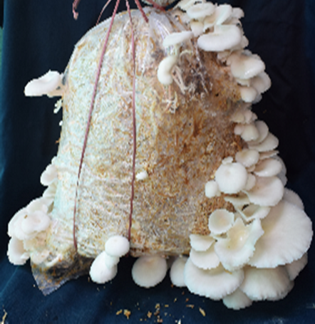 | 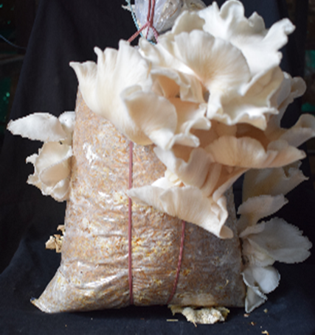
2% | 4%
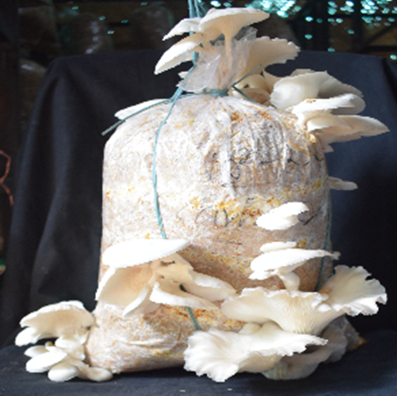 | 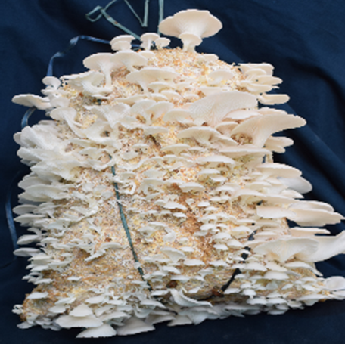
6% | 8%

Fig 1-Effect of different spawning rates on the yield of P. Pulmonarius on wheat straw substrate.

Effect of different spawning rates on growth and yield (g) of P. pulmonarius on paddy straw
The influence of different spawning rates was studied on growth and yield of P. pulmonarius. The experiment was laid down on paddy straw substrate in rainy and winter season. The results are presented in Table.
Spawn run (days):
The spawn run period of P. pulmonarius differ significantly with respect to different spawn rates and it varies from 12 -16 days. The spawn run period of P. pulmonarius was significantly earliest noticed with the use of 8% spawn while it was significantly delayed (16 days) at 2, 4, and 6 % spawning rate which at par with each other.
Similarly in winter season, the spawn run period significantly influenced by different spawning rate of P. pulmonarius and significantly quicker (14.0 days) spawn run was observed at 8%spawning rate and next was 4 % (15.0 days) which did not differ significantly with one another one. However, it was significantly delayed when spawning was done 2% and 6 % which required 18 and 17 days respectively and both were found statistically at par.
The average of 2 seasons clearly indicates higher spawning rate required significantly less (13 days) time for spawn run of P. pulmonarius on paddy straw substrate However, 2 ,4 and 6 % spawning rates took 17, 16, and 17 days for spawn run.
Pinhead initiation (days):
The period required for pin head initiation in the rainy and winter season did not significantly influence by different rates of spawning and it varied from 4 - 5 days. On average of 2 seasons clearly indicated that different spawning rate -initiated pin head formation within 4 and 5 days.
Yield (g):
The yield of P. pulmonarius significantly influenced by the different spawning rate in both seasons and it varied from 533.28 - 780.63 g. During rainy season 8% spawning rate gave significantly the highest (780.63g) fresh yield of P. pulmonarius whereas significantly lower (533.28g) found when spawning was done 2% which was followed by 4% (564.69) and 6% (611.58) which differed significantly with each other. In winter significantly more yield was achieved at 8% (799.72 g) while significantly lower was recorded at 2% (556.13g) and next were 4% (567.46 g) and 6% (580.39 g) spawning rate.
On an average of 2 season indicate that 8% spawning rate gave significantly (790.18 g) yield of P pulmonarius whereas it was at least (544.71 g) recorded with 2%. At other spawning rates yield was 566.08 g and 595.03 g at 4 % and 6 % respectively.
Biological Efficiency (%):
The biological efficiency in both studied seasons are in accordance with that of yield and it varied from 53.33 to 79.97 %. The highest BE was noticed at higher spawning rate which was 8% and lower found when spawning was done 2 percent
The growth and yield of P. pulmonarius on paddy straw were significantly influenced by the spawning rate, with variations in spawn run, pinhead initiation, yield, and biological efficiency. Higher spawning rates (e.g., 8%) provided a greater inoculum density which accelerated substrate colonization and reduced the time required for spawn run and pinhead initiation. In contrast, lower spawning rates (2% and 4%) required longer colonization periods, which delayed spawn run and pinhead initiation. These rates produced lower yields and biological efficiency due to the slower establishment of mycelial growth. Overall, the study indicates that a higher spawning rate (8%) optimizes growth, yield, and biological efficiency in P. pulmonarius cultivation on wheat and paddy straw substrate These outcomes are consistent with the findings of Banik and Nandi (2018) found higher spawning rate showed earlier spawn run ,pinhead initiation and yield of Pleurotus spp. similarly Patil et al. (2010) reported higher spawning rates (6% and 8%) significantly decreased the spawn run period and increased sporophore yield as compared to lower spawn rates of P. pulmonarius cultivation. Dahmardesh et al. (2010) demonstrate that higher concentration of spawn produced more fresh yield of P. ostreatus in comparison to lower spawning rate. Dawit and Addis (2020) conducted a trial on wheat and paddy straw and concluded that 6% spawn rate to be most efficient for promoting early sporophore formation and achieving maximum yield of P. pulmonarius. Jadhav et al. (2022) found 8% spawn rate led to the highest fresh mushroom yield and faster colonization of P. florida, Verma et al. (2024) concluded that 6% spawning enhances the yield of P. florida a spawning rate to better without contamination.

Table 2: Effect of different spawning rates on growth and yield (g) of P. pulmonarius on paddy straw.
Tr. No. | Spawning rate | Spawn run (days) |  |  | Pinhead initiation (days) |  |  | Yield (g) |  |  | Biological Efficiency (%)
Tr. No. | Spawning rate | Rainy | Winter | Average | Rainy | Winter | Average | Rainy | Winter | Average | Rainy | Winter | Average
T₁ | 2% | 16 | 18 | 17 | 4 | 4 | 4 | 533.28 | 556.13 | 544.71 | 53.33 | 55.61 | 54.47
T₂ | 4% | 16 | 15 | 16 | 5 | 5 | 5 | 564.69 | 567.46 | 566.08 | 56.47 | 56.75 | 56.61
T₃ | 6% | 16 | 17 | 17 | 5 | 4 | 5 | 611.58 | 580.39 | 595.99 | 61.16 | 58.04 | 59.60
T₄ | 8% | 12 | 14 | 13 | 4 | 4 | 4 | 780.63 | 799.72 | 790.18 | 78.06 | 79.97 | 79.02
 | Sem (±) | 0.32 | 0.42 | 0.37 | 0.33 | 0.27 | 0.30 | 1.01 | 5.36 | 3.18 | - | - | -
 | CD (5%) | 0.95 | 1.25 | 1.10 | 0.99 | 0.82 | 0.91 | 3.01 | 16.06 | 9.54 | - | - | -

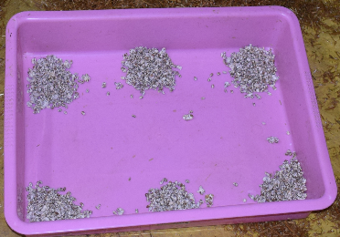 | 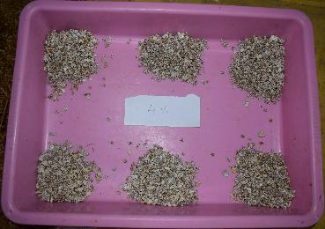
2% | 4%
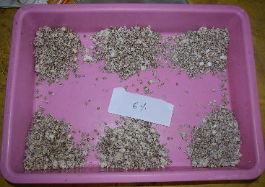 | 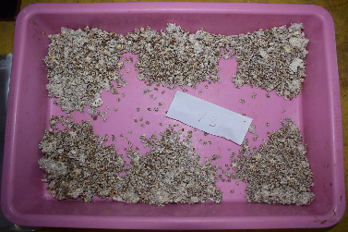
6% | 8%
Fig 2-Effect of different spawning rates on the yield of P. pulmonarius

 | 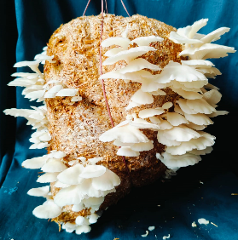
2% | 4%
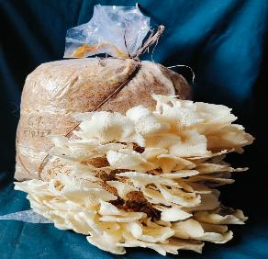 | 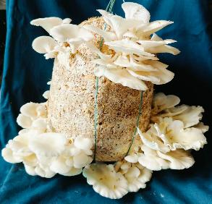
6% | 8%
Fig 3-Effect of different spawning rates on the yield of P. Pulmonarius on paddy straw
Conclusion
The study demonstrated that the spawning rate plays a critical role in determining the growth performance and yield of Pleurotus pulmonarius on wheat and paddy straw substrates. Among the tested rates, 8% spawn level proved to be the most efficient, offering optimal biological efficiency and yield without excessive spawn usage. While 2% spawn accelerated colonization slightly, it did not result in a proportionate increase in yield, making it economically less viable. Wheat straw was found to be a more suitable substrate than paddy straw, supporting higher mushroom productivity. Thus, a 8% spawning rate on wheat straw is recommended for enhanced and cost-effective cultivation of P. pulmonarius under standard conditions.
References
- Banik, S., & Nandi, R. (2018). Impact of spawning rate on yield and biological efficiency of Pleurotus spp. Journal of Mycopathological Research, 56(1), 77 80.
- Chang, S. T. (2008). Overview of mushroom cultivation and utilization as functional foods. In Mushrooms as functional foods (pp. 1–33). Wiley.
- Dahmardeh, M., Hossienabadi, R., Safarpoor, H., & Dahmardeh, M. (2010). Comparative study on cultivation and yield performance of Pleurotus ostreatus (oyster mushroom) grown on different substrates and supplemented at various levels of spawn. Journal of Food, Agriculture and Environment, 8(3–4), 996 998.
- Dawit, A., & Addis, E. (2020). Evaluation of different spawn rates on yield performance of oyster mushroom (Pleurotus spp.) on agricultural substrates. International Journal of Microbiology and Mycology, 12(2), 20–27.
- Gupta, S., Summuna, B., Gupta, M., & Mantoo, A. (2016). Mushroom cultivation: A means of nutritional security in India. World, 3, 6–50.
- Jadhav, R. S., et al. (2022). Evaluation of different substrates for cultivation of Pleurotus eryngii.. Indian Journal of Mycology, 50(2), 120 122.
- Manikanandan, K. (2011). Nutritional and health benefits of mushrooms. In Mushrooms: Production, Consumption and Marketing (Vol. 1, pp. 9–12).
- Naraian, R., Sahu, R. K., Kumar, S., Garg, S. K., Singh, C. S., & Kanaujia, R. S. (2009). Influence of different nitrogen-rich supplements during cultivation of Pleurotus florida on corn cob substrate. The Environmentalist, 29(2), 1–7.
- Patil, S. S., Ahmed, S. A., Telang, S. M., & Baig, M. M. V. (2010). The nutritional value of Pleurotus ostreatus (Jacq.: Fr.) Kumm cultivated on different lignocellulosic agro-wastes. Innovative Romanian Food Biotechnology, 7, 66 76.
- Ukwuru, M. U., Muritala, A., & Eze, L. U. (2018). Edible and non-edible wild mushrooms: Nutrition, toxicity and strategies for recognition. Journal of Clinical Nutrition and Metabolism, 2, 2.
- Verma, A., Somdutt, Chirag. G & Singh, R. (2024). Optimization of spawn rate for Oyster Mushroom cultivation. Indian Journal of Fungal Biology, 9(2), 87–94.

