Precision Medicine for Gastric Cancer: Current Status and Future Directions

Abstract
Gastric cancer remains a significant global health burden, with survival rates showing limited improvement despite advances in surgery and chemotherapy.Conventional treatments have been challenged by significant tumour heterogeneity and complex molecular mechanisms.
This review examined advances in precision medicine for gastric cancer, highlighting next-generation sequencing (NGS) and molecular profiling approaches that led to The Cancer Genome Atlas (TCGA) 2014 classification into four molecular subtypes: Epstein–Barr virus–positive (9% of cases), microsatellite instable (21.7%), chromosome instable (49.8%), and genome stable (19.7%). Key mutations (e.g., PIK3CA, TP53, CDH1, ARID1A), along with epigenetic alterations and deregulated non-coding RNAs, drive tumour progression and resistance to therapy.
This review further discussed the impact of the tumour microenvironment and mechanisms of immune evasion, providing a rationale for emerging checkpoint inhibitors and other targeted therapies. This review uniquely integrates the mutational landscape (e.g., TP53, ARID1A mutations), epigenetic modifications, transcriptomic profiles, and tumour microenvironment to outline precise targets for next-generation personalised therapies in gastric cancer. This paper highlights the importance of integrating molecular classification and biomarker-driven treatment to advance precision care in gastric cancer.
Key Words: Gastric Cancer, Precision Medicine, Molecular Profiling, Targeted Therapy, Immunotherapy

Introduction
Despite a declining trend in morbidity and mortality, gastric cancer remains the world’s fifth most common cancer (1.03 million new cases in 2018) and the third leading cause of cancer-related death (783,000 deaths in 2018) (World Health Organisation, 2018). This is mainly because most gastric cancers (GC) are diagnosed at an advanced stage due to non-specific clinical manifestations and the lack of a routine screening test. Studies of migrants from high- to low-risk areas show a marked decline in gastric cancer risk, suggesting a strong role of dietary and environmental factors in its development (Kumar, Abbas and Aster, 2015). It is a heterogeneous disease influenced by both genetic and environmental factors (Yusefi et al., 2018). In the last few decades, tremendous advances in cancer biology have improved our understanding of the molecular pathophysiology of tumorigenesis, tumour progression, immunity, metastasis, drug resistance, relapse, and signalling pathways, as well as the development of novel diagnostic techniques and agents for targeted therapy and precision medicine.
Therefore, advanced gastric cancer remains one of the most challenging malignancies for researchers and clinicians, with a poor prognosis and low five-year survival rates due to chemotherapy resistance and a high tendency for metastasis. Adding further complexity, it also shows high inter- and intratumour heterogeneity, making it more resistant to conventional chemotherapy. Researchers are therefore focusing on personalised treatment approaches based on the molecular characteristics of the tumour.
Recent advances in molecular techniques such as high-throughput next-generation sequencing (NGS), transcriptome analysis by microarray and RNA sequencing, as well as improvements in targeted and immunotherapeutic approaches, are supporting the shift towards personalised treatment.
Hallmarks of Cancer: Foundation for Precision Medicine
Cancer is a disease of genetic aberrations that disrupt cellular and tissue homeostasis. Hanahan and Weinberg’s framework of the hallmarks of cancer helps simplify this complexity by grouping key mechanisms driving tumour development. Understanding these hallmarks supports the design of precision medicine strategies that target specific molecular pathways (Hanahan and Weinberg, 2011).
Gastric carcinogenesis and its risk factor
Gastric carcinoma is a multifactorial disease influenced by both genetic and environmental factors (Karimi et al., 2014). Chronic infection with Helicobacter pylori (H. pylori) has long been marked as a group-1 carcinogen and is known to cause non-cardia gastric adenocarcinoma (Park et al., 2018). The Epstein–Barr virus is another potent carcinogenic agent responsible for GC. About 9% of all GC cases are EBV-positive, occurring preferentially in the cardiac region of the stomach (Marques-Lespier, Gonzalez-Pons and Cruz-Correa, 2016). Dietary habits such as the consumption of salted, smoked, and pickled foods, nitrites and nitrates, as well as a lack of fresh fruits and vegetables, contribute to gastric carcinogenesis. Several other risk factors have been identified, including smoking, alcohol consumption, autoimmune gastritis (pernicious anaemia), adenomatous gastric polyps, previous partial gastrectomy (>20 years), and hereditary diffuse gastric cancer families (CDH1 mutation) (Yusefi et al., 2018; Davidson, 2006).
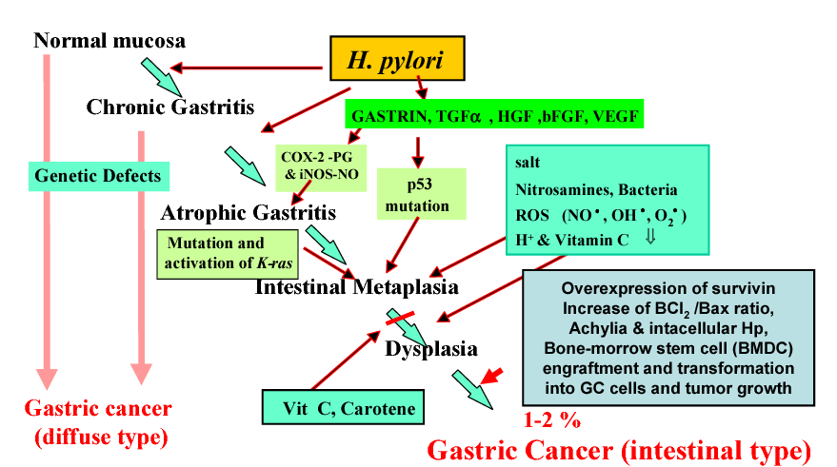
Figure 1: Correa's cascade of gastric carcinogenesis proposed in 1996 and modified by S. Konturek et al. in 2005 (Konturek, 2005).
Mutational Landscape of Gastric Cancer
Advances in next-generation sequencing (NGS) technology have made it possible to investigate the mutational profiles of tumour samples derived from patients and to identify driver mutations for designing targeted therapies (Cai et al., 2019). Over the last decade, several studies have focused on identifying cancer-driving mutations, copy number alterations (CNAs), and tumour mutation burden (TMB) in GC. Databases such as The Cancer Genome Atlas (TCGA) and Biotecan PanCancer Panoramic Detection (BTC-PCPD) have been established using NGS data from patient tumour samples.
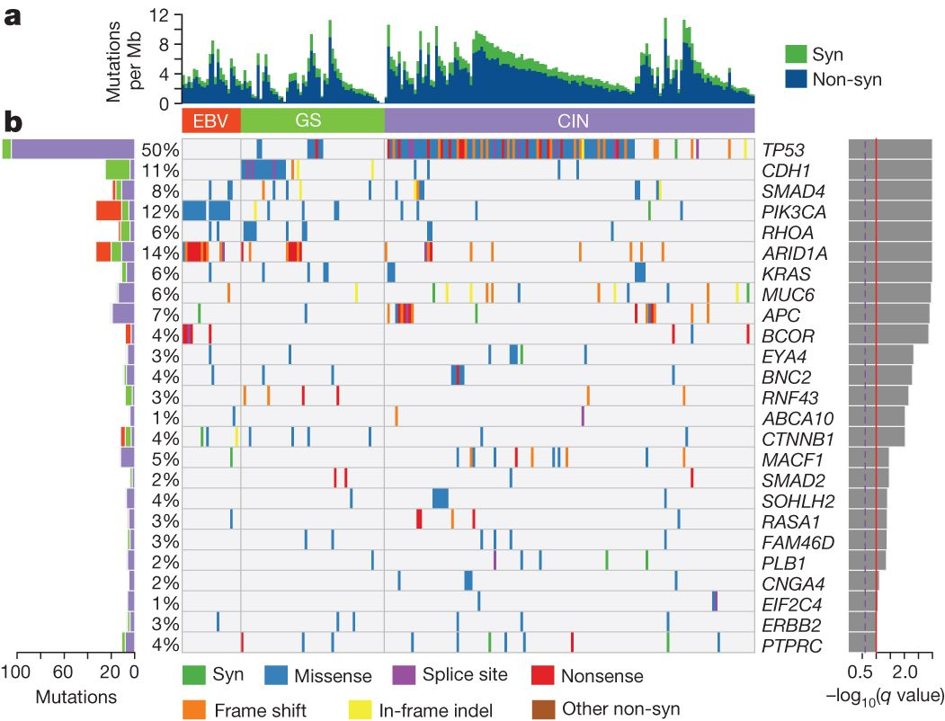
Figure 2: Somatic mutation spectrum of gastric cancer showing commonly mutated genes (Ito et al., 2011).
TCGA conducted a study on 295 patient-derived tumours in 2012 to identify commonly occurring somatic mutations, which are shown in Figure 2. They identified the 10 most common mutations as TP53 (50%), ARID1A (14%), PIK3CA (12%), CDH1 (11%), SMAD4 (8%), APC (7%), KRAS (6%), RHOA (6%), MUC6 (6%), and CTNNB1 (4%). In comparison, BTC-PCPD conducted another study on 153 samples and found the 10 most commonly mutated genes to be TP53 (59%), DRD2 (14%), CDH1 (13%), AKAP9 (15%), ATM (12%), PTEN (13%), NOTCH2 (10%), LRP2 (10%), SMAD4 (9%), and mTOR (8%). The commonly occurring mutations in the TCGA 2014 study are illustrated in Figure 2. The functional types, mutation frequencies in TCGA and BTC-PCPD, and the impact of each mutation on the hallmarks of cancer are shown in Table 1.
Gene | Functional type | Frequency of mutation |  | Relation to hallmarks of cancer
Gene | Functional type | TCGA | BTC-PCPD | Relation to hallmarks of cancer
TP53 | Tumour suppressor | 50% | 59% | 1. Evading growth suppressor.  2. Escaping programmed cell death.  3. Deregulating cellular energetics.
ARID1A | Tumour suppressor | 14% | N/A | 1. Evading growth suppressor.  2. Replicative immortality.
PIK3CA | Oncogene | 12% | N/A | 1. Sustained proliferative signalling.  2. Deregulating cellular energetics.  3. Induced angiogenesis.  4. Invasion and metastasis.
CDH1 | Adhesion molecule | 11% | 13% | 1. Invasion and metastasis.  2.Deregulating cellular energetics
SMAD4 | Transcriptional regulator | 8% | 9% | 1. Evading growth suppressor.
APC | Tumour suppressor | 7% | 7% | 1. Evading growth suppressor.  2. invasion and metastasis.  3. Genomic instability and mutation.
KRAS | Oncogene | 6% | N/A | 1. Sustained proliferative signalling.  2. Invasion and metastasis.  3. Induced angiogenesis.  4. Deregulating cellular energetics.
RHOA | Tumour suppressor | 6% | N/A | 1. Evading growth suppressor.  2. Escaping programmed cell death.  3. Invasion and metastasis.
PTEN | Tumour suppressor | N/A | 13% | 1. Evading growth suppressor.  2. Deregulating cellular energetics.
NOTCH2 | Oncogene | N/A | 10% | 1. Sustained proliferative signalling.  2. Invasion and metastasis.
Table 1: Commonly mutated genes in TCGA and BTC-PCPD database and their relation to hallmarks of cancer (Hanahan and Weinberg, 2011; Bass et al., 2014; Cai et al., 2019; Karimi et al., 2014).
Copy number alteration is another common form of mutation found in cancers. Cai et al., in their study on 153 patients with GC, identified important peaks of copy number gains at chromosomal positions such as 7p11.2 (EGFR), 8q24.21 (MYC), 10q26.23 (FGFR2, MMP21), 12p12.1 (KRAS), 17q12 (ERBB2, CDK12, GRB7), 19q12 (CCNE1), and 20q13.2 (ZNF217). These amplifications mainly involved known oncogenes such as FGFR, ERBB2, KRAS, MYC, CCNE1, JAK2, and FGFR2, while deletions were observed in genes such as ROS1, ZAN, APC, LRP2, and ATM (Cai et al., 2019).
Transcriptomics and Epigenomics of Gastric Cancer
Epigenetic alteration
Epigenetics is a relatively new frontier in GC research. The central processes in this field involve modifications of DNA, histones, and RNAs through methylation and demethylation or acetylation and deacetylation. GC shows methylation changes in various classes of genes, including tumour suppressors, DNA repair genes, HOX genes, cell cycle regulators, and genes of the WNT pathway (Padmanabhan, Ushijima and Tan, 2017).
Hypermethylation at promoter regions causes silencing of these genes. Profiling of chromatin marks on different histone proteins, such as H3K36me3, H3K4me3, H3K4me1, H3K27me3, and H3K27ac, has revealed aberrations in many promoters and enhancers associated with GC (Padmanabhan, Ushijima and Tan, 2017). Some of the epigenetic footprints of GC are shown in Figure 3.
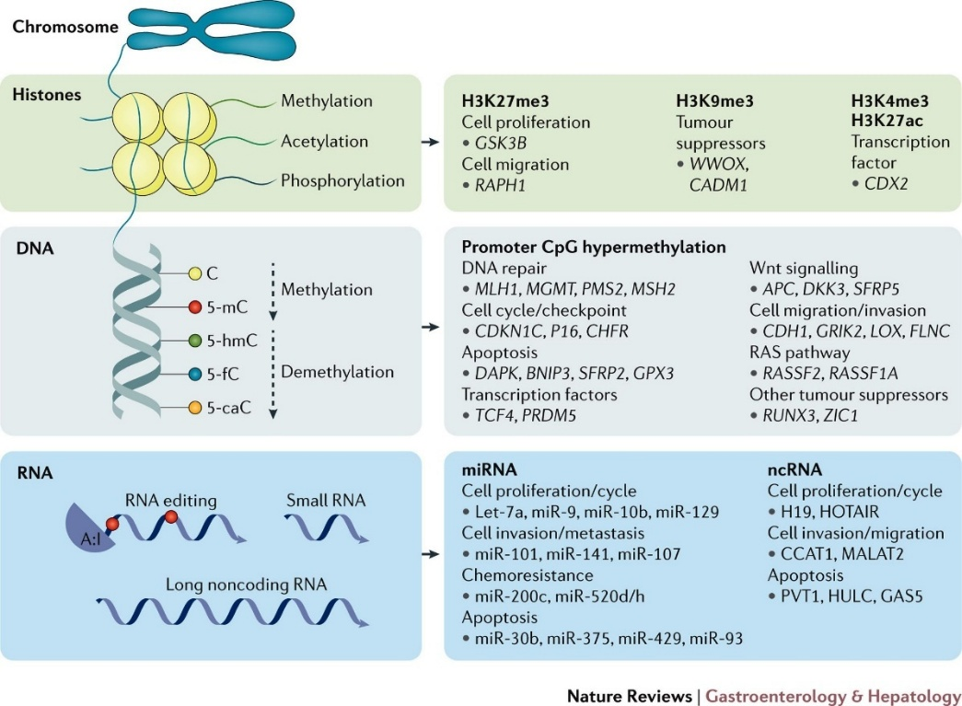
Figure 3: Epigenetic signature of gastric cancer (Fei et al., 2018).

Transcriptional landscape (DEGs)
With advances in understanding cancer biology, it is now evident that not only somatic mutations but also alterations in gene expression play an important role in tumorigenesis. Transcriptional changes in GC include differentially expressed genes (DEGs) and changes in levels of noncoding RNAs such as microRNAs (miRNAs), long noncoding RNAs (lncRNAs), and circular RNAs. Among these, DEGs and miRNAs have been studied, and their impact on GC has been explored.
Transcriptomic and Non-Coding RNA Signatures in Gastric Cancer
Analyzing the Gene Expression Omnibus (GEO) database, Fei et al. screened for DEGs by dividing the data into two groups. The first group contained 60 GC samples and 56 normal samples and identified 265 DEGs, of which 59 were upregulated and 165 were downregulated. In the second group, screening 134 samples from both normal and GC cases, they found 7 upregulated and 35 downregulated genes. By comparing both groups, they found 3 upregulated and 34 downregulated genes in common. Among these, the β and α subunits of H+/K+ ATPase (ATP4B and ATP4A, respectively), gastrokine 1 (GKN1), gastric intrinsic factor (GIF), lipase F gastric type (LIPF), and pepsinogen 4 group A (PGA4) showed the greatest changes in expression; all of these were downregulated. The three commonly upregulated genes were secreted phosphoprotein 1 (SPP1), thrombospondin 2 (THBS2), and sulfatase 1 (SULF1) (Fei et al., 2018). Gene ontology term analysis of these genes revealed that the downregulated genes are associated with processes such as digestion, aldehyde metabolism, oxidation–reduction, and K+ transport (Hunt et al., 2015). The upregulated genes were associated with a poorer prognosis (Fei et al., 2018).
Studies on miRNAs have shown that deregulation of their expression plays a potential role in tumorigenesis and tumour progression. They can also serve as novel biomarkers for early diagnosis and for monitoring the prognosis of GC. Some miRNAs, such as miR-101, miR-137, miR-520d-3p, and miR-17-5p/20a, induce cell cycle arrest by binding to the 3’ UTR of mRNAs that regulate the cell cycle and are generally downregulated in GC. Generally, miRNAs with tumour-suppressive activity are downregulated; for example, miR-449a, miR-133a, miR-224, miR-338, miR-143, and miR-874 can induce apoptosis by acting on BCL-2 and other anti-apoptotic genes. On the other hand, some miRNAs known as oncomiRs have a tumorigenic impact; miR-183, miR-645, miR-181a, and miR-942, for example, act by inhibiting apoptosis and promoting tumour growth (Yang et al., 2015). In a meta-analysis, Wang et al. reviewed 19 studies with varying sample sizes to identify the 25 most commonly upregulated and 14 most frequently downregulated genes, as illustrated in Figure 4 (Wang et al., 2015).
Figure 4:Commonly deregulated miRNAs in gastric cancer (24).
Deregulated expression of other non-coding RNA and their role in GC
Long non-coding RNAs (lncRNAs) HOTAIR, H19, AK058003, HULC, and SDMGC are upregulated, while FENDDR is downregulated in GC (Yang et al., 2015). HOTAIR promotes tumorigenesis and metastasis by downregulating PCBP1 expression and reversibly inhibiting miR-331-3p and miR-124 (Liu et al., 2014). H19 promotes metastasis by upregulating the expression of ISM1 and miR-675, which subsequently inactivates CALN1 (Li et al., 2014). HULC is directly linked with epithelial–mesenchymal transition (EMT)-mediated invasion and metastasis, whereas AK058003 promotes hypoxia-mediated metastasis by inducing overexpression of SNCG (Zhao et al., 2014; Wang et al., 2014). FENDDR inhibits invasion and metastasis by downregulating FN1 and MMP2/MM9 (Xu et al., 2014).
Network analysis and its impact on the design of targeted therapy of GC
For comprehensive molecular profiling of gastric cancer, recognising only the mutated genes, deregulated expression, or epigenetic changes may not be sufficient. Network analysis of these genes and their impact on cell signalling pathways is critical for categorising GC at the molecular level and for designing targeted therapies. As an illustration, commonly mutated genes plotted in the STRING database show a highly interconnected network (Figure 5), highlighting their functional relationships (STRING, 2019).
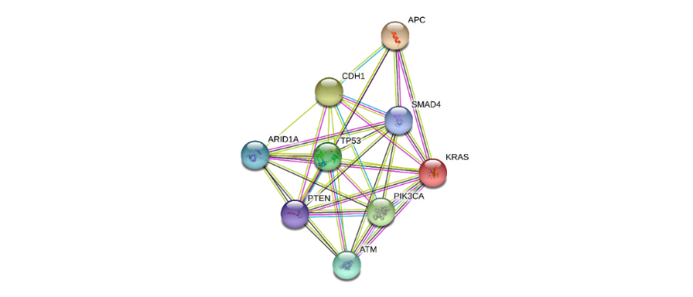
Figure 5: STRING diagram of commonly mutated genes of GC discussed in this report (Chung and Lim, 2014).
KEGG pathway analysis further demonstrates that these genes are involved in key oncogenic pathways in gastric cancer, including the TP53 signalling pathway, WNT pathway (APC), β-catenin pathway (CDH1), PI3K–AKT–mTOR pathway (PIK3CA), and Ras–Raf pathway (KRAS), as shown in Figure 6 (KEGG, 2019).
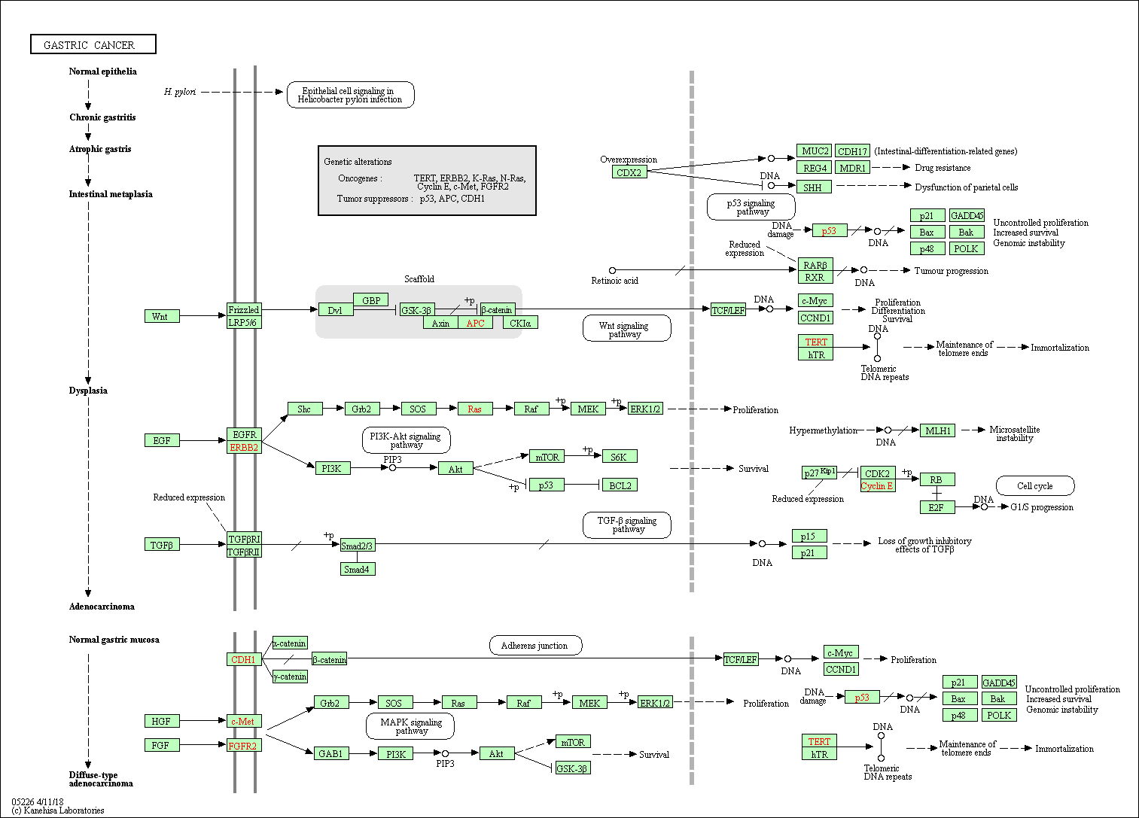
Figure 6: Kyoto Encyclopaedia of Gene and Genome (KEGG) pathway analysis of gastric cancer based on commonly mutated genes (Ishimoto et al., 2014).

Tumour microenvironment and its role in GC
Cancer cells and stromal cells induce transformation of each other by secreting soluble cytokines, growth factors, proteases, and other factors that act through autocrine and paracrine mechanisms (Ishimoto, Sawayama, Sugihara and Baba, 2014). Through its cellular and soluble components, the TME plays an important role in the homeostasis of GC, as briefly outlined below.
Cellular components of TME and their role in GC
Cancer-associated fibroblast — Fibroblasts residing near cancer cells undergo phenotypic changes, transforming from a quiescent state to an activated state with high metabolic and synthetic activity. These are known as myofibroblasts or cancer-associated fibroblasts (CAFs). CAFs secrete IL-11 to activate the Janus Kinase/Signal Transducer and Activator of Transcription 3 (JAK/STAT3) pathway and IL-6 to activate the JAK2/STAT3 pathway in gastric epithelial cells, thereby inducing gastric carcinogenesis and EMT in GC cells (Ollila et al., 2018; Wu et al., 2017). They also interact with cancer cells by paracrine signalling through the TGF-β pathway to promote EMT (Yu et al., 2014). Transgelin (TAGLN) secreted by CAF induces MMP2 expression, which helps in invasion and metastasis by remodelling the extracellular matrix (ECM) (Yu et al., 2013). CAFs also promote angiogenesis by secreting vascular endothelial growth factor (VEGF) and stromal cell-derived factor 1 (SDF-1) (Fukumura et al., 1998; Orimo et al., 2005).

Tumour-infiltrating immune cells, A variety of immune cells infiltrate the tumour from both lymphocytic and myeloid lineages. The lymphocytic lineage in the TME includes natural killer (NK) cells, cytotoxic T lymphocytes (CD8+), Th2 helper T cells (CD4+), and regulatory T cells (Tregs). The myeloid lineage includes dendritic cells (DCs), tumour-associated macrophages (TAMs), and myeloid-derived suppressor cells (MDSCs), which form the niche (Chung and Lim, 2014; Batista et al., 2019). However, their overall role in the TME is fundamentally immunosuppressive, which is discussed in detail later in this report.
Bone marrow-derived progenitor cells, Bone marrow-derived cells (BMDCs) modulate tumour growth and metastasis by regulating angiogenesis, controlling inflammation, and inhibiting the immune response (Gao and Mittal, 2009). BMDCs tend to be recruited in the H. pylori-infected gastric mucosa, promoting the development of dysplasia, metaplasia, and ultimately cancer (Houghton et al., 2004). Bone marrow-derived mesenchymal stem cells (MSCs) increase the production of VEGF, which induces angiogenesis, and they also exert an inhibitory effect on the PTEN gene by secreting miR-221, miR-214, and miR-222 through their exosomes (Batista et al., 2019).
Endothelial and perivascular cells, Endothelial cells, lymphatic endothelial cells, and pericytes all help in tumour progression and metastasis, as well as immunosuppression, by inducing VEGF secretion, MMP9 overexpression, expression of tissue inhibitor of metalloproteinase 2 (TIMP2), and upregulation of PD-L1 and indoleamine 2,3-dioxygenase (IDO), respectively (Batista et al., 2019).
Normal cells of the gastric mucosa — These surrounding tumour cells also contribute to the homeostasis of the tumour tissue.
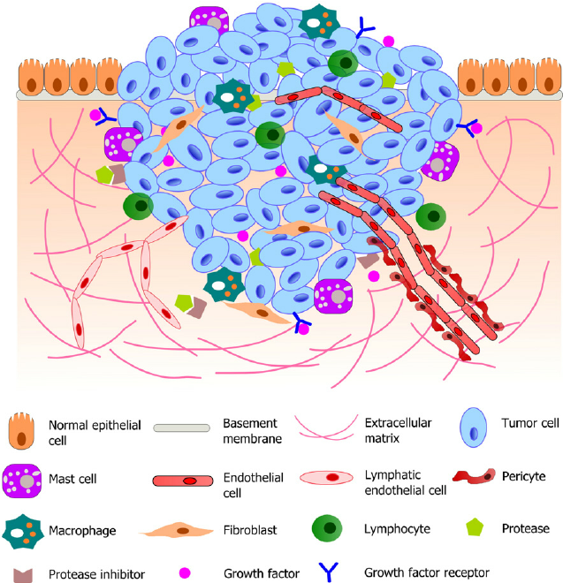
Figure 7: Microenvironment of gastric cancer (Xu, Farach-Carson and Jia, 2014).

Soluble components of TME
IL-1β is a pro-tumorigenic cytokine that inhibits gastric acid secretion and induces inflammation, dysplasia, metaplasia, and carcinoma. It also promotes activation of the NF-κB pathway and subsequent overexpression of IL-6 and TNF-α (Chung and Lim, 2014). IFN-γ is an anti-tumorigenic cytokine produced by activated T cells and NK cells that inhibits IL-1β-induced gastritis and neoplastic changes, gastric epithelial cell proliferation, and the release of proinflammatory cytokines from Th1 and Th17 cells. It also induces apoptosis of resident T cells in the gastric mucosa (Tu et al., 2011). IL-8/CXCL8 promotes tumour growth by inducing angiogenesis. It also increases the expression of EGFR, MMP-9, VEGF, and IL-8 itself. Overexpression of IL-8 in GC is associated with high aggressiveness, increased neovascularisation, invasion, and metastasis (Kitadai et al., 2000).
Stromal cell-derived factor 1 (SDF1) promotes angiogenesis and distant seeding of CXCR-positive tumour cells. It induces angiogenesis directly by binding to endothelial cells expressing CXCR4 or CXCR7 and indirectly by increasing the expression of MMPs, IL-8, and VEGF (Kucia et al., 2005). Matrix metalloproteinases MMP1, MMP7, and MMP9 cause remodelling of the ECM, thereby contributing to invasion and metastasis, and are overexpressed in GC (Chung and Lim, 2014). Some growth factors, such as epidermal growth factor (EGF), vascular endothelial growth factor (VEGF), platelet-derived growth factor (PDGF), and hepatocyte growth factor (HGF), are frequently overexpressed in the TME of GC and play a central role in tumour formation, progression, and the development of resistance to chemotherapy (Chung and Lim, 2014; Ishimoto et al., 2014; Batista et al., 2019).
Metastasis of gastric cancer
Metastasis is the seeding of cancer cells at sites distant from the primary tumour and occurs as a result of interactions between cancer cells and the surrounding stroma. Although metastasis is a very inefficient process, almost 99% of tumour cells shed from the primary tumour are destroyed on the way to colonising distant sites (Tissot et al., 2019). Most cancer-related mortalities are due to metastasis, and in the case of gastric cancer, it is almost always fatal. The median survival of GC patients diagnosed with metastasis is three months, irrespective of the N stage in TNM classification, histological type, and sex (Riihimaki et al., 2016). Gastric cancer generally metastasises to the peritoneum (32%) through direct transperitoneal seeding, and to the liver (48%), lungs (15%), and bone through the haematological route. Metastasis to distant lymph nodes (e.g., Virchow’s gland) is reported in 11% of cases, as well as to the ovary (Krukenburg tumour) (Riihimaki et al., 2016). Metastasis through the haematological route follows a sequential cascade shown in Figure 8. Different theories have been proposed to explain the tropism of metastases, the most widely accepted of which are Paget’s “seed and soil” theory and James Ewing’s anatomical/mechanical theory (Akhtar et al., 2019; Pienta et al., 2013). The seed and soil theory states that circulating tumour cells show tissue-specific tropism, whereas the anatomical theory suggests that metastases follow anatomical forces such as venous and lymphatic drainage (Riihimaki et al., 2016). However, recent studies suggest that both these theories act as complementary (Liu et al., 2017). Metastasis also plays a significant role in the development of resistance to chemotherapy by promoting resistant clonal evolution and establishing dormant metastatic sites.
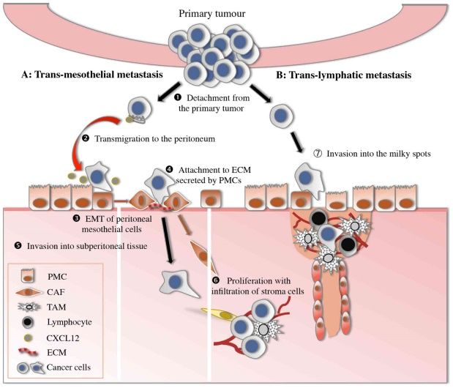
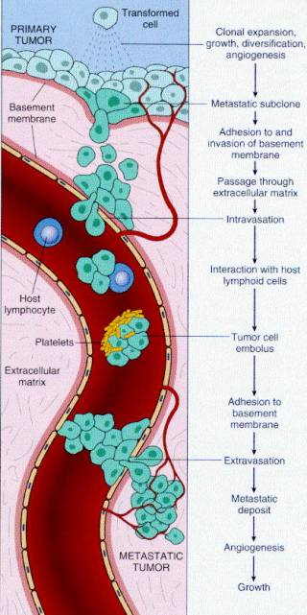
a. b.
Figure 8: Metastatic cascade of gastric cancer. a. peritoneal seeding. b. hematogenous spread.
Tumour immunology of gastric cancer
Immune cells continually circulate to detect and destroy tumour cells through a process called immune surveillance. To develop into a full-blown cancer, tumour cells must evade this surveillance and destruction process, which they achieve through immunoediting — a mechanism consisting of three sequential phases: (1) the elimination phase, where immune cells recognise and destroy rapidly proliferating tumour cells, thereby reducing tumour burden; (2) the equilibrium phase, where tumour-suppressing immune cells and proliferating tumour cells remain in dynamic equilibrium; and (3) the escape phase, where tumour cells overcome the selection pressure of immune cells (Dolcetti, De Re and Canzonieri, 2018).
Gastric cancer cells are eliminated by the effector activity of CTL and NK cells residing within the tumour microenvironment. For proper activation of CTL, convergent stimulation from three different pathways is required: 1) recognition of tumour antigen in association with class I MHC molecule by T cell receptor (TCR), 2) signalling of co-stimulatory molecules such as CD80, CD86, CD40, etc., and 3) cytokines such as IL-2. Given that, cancer cells present antigen via APCs through an MHC-II-dependent pathway to helper T cells, which is then converted to a proinflammatory and anti-tumorigenic Th1 subset that releases cytokines and chemokines that attract CTLs to the tumour site as well as provide the co-stimulatory molecules and cytokines necessary for their efficient activation (Finn, 2018). Once activated, these CD8+ T cells then proliferate, infiltrate the tumour, and directly destroy cancer cells by releasing perforins and granzymes (Dolcetti, De Re and Canzonieri, 2018). On the other hand, NK cells kill cancer cells through antibody-dependent cellular cytotoxicity (ADCC) and by releasing perforin, granzyme, Fas ligand, TNF-related apoptosis-inducing ligand (TRAIL), and IFN-γ (Marcus et al., 2014).
Immune avoidance – the escape of gastric cancer cells from immune-mediated degradation
Gastric cancers with a high abundance of T cells in the microenvironment evade immune detection by exerting suppressive actions on the immune system; GC with a high tumour mutation burden (TMB), such as EBV-positive and MSI subtypes, fall into this category. In contrast, cancers with low TMB have relatively less T cell infiltration and evade immunity through immune exclusion.
Defective antigen presentation — Expression of components of the antigen processing machinery of the MHC-I pathway, such as the proteasome subunits latent membrane protein 2 and 7 (LMP2 and LMP7), the transporter associated with antigen presentation (TAP), and tapasin, are downregulated. Thus, the sensing of tumour antigens by CD8+ T cells is impaired (Garrido et al., 1997; Johnsen et al., 1999). Additionally, inhibitory molecules such as TGF-β and IL-10 repress DC maturation, causing a low expression of co-stimulatory molecules like CD80, CD86, and CD40, and a high level of indoleamine 2,3-dioxygenase (IDO) (Vinay et al., 2015).
T cell anergy owing to a suboptimal IL-2 level and the absence of a costimulatory signal (interaction between CD28 and CD80/CD86) (Dolcetti, De Re and Canzonieri, 2018). Induction of T cell exhaustion is a state of progressive loss of capacity for proliferation, cytokine production, and cytotoxicity caused by immunosuppressive cells and inhibitory cytokines in the GC microenvironment. Exhausted T cells increasingly express inhibitory receptors such as programmed death 1 (PD-1), cytotoxic T lymphocyte antigen 4 (CTLA-4), lymphocyte activation gene 3 (LAG-3), T cell immunoglobulin and mucin domain-containing 3 (TIM-3), B and T lymphocyte attenuator (BTLA), and T cell immunoreceptor with immunoglobulin and ITIM domains (TIGIT) (Gholami et al., 2017; Wherry, 2011).
The M2 subtype of tumour-associated macrophages (TAMs), being one of the most abundant immune cells in the GC microenvironment, secretes immunosuppressive molecules such as IL-10 and TGF-β and causes functional inhibition of T cells (Ishigami et al., 2003; Mitchem et al., 2013).
MDSCs present in the tumour microenvironment of GC suppress both innate and adaptive immunity by secreting arginase 1 (Arg-1), producing an increased amount of nitric oxide (NO) through the action of iNOS, and generating reactive oxygen species (ROS) (Ben-Meir, Twaik and Baniyash, 2018). An increased number of circulating MDSCs in the blood of GC patients is shown to be a poor prognostic factor (Choi et al., 2013). They also suppress CTLs by downregulating the TCR-ζ chain. The presence of chronic inflammatory mediators inhibits apoptosis of MDSCs (Vinay et al., 2015).
An important component of the GC microenvironment is regulatory T cells (Tregs). They are transformed from helper T cells in situ under the influence of TGF-β or are recruited to the tumour site by chemokines released from cancer cells. They inhibit activation and differentiation of Th1 cells, effector CTLs, and NK cells by releasing inhibitory cytokines, including IL-10 (Dolcetti, De Re and Canzonieri, 2018).
B cells may also be converted to regulatory B cells (Bregs) in the GC microenvironment, where they release anti-inflammatory mediators (e.g., IL-10) and promote the conversion of T cells to Tregs (Sarvaria, Madrigal and Saudemont, 2017).
Gastric cancer with low TMB can result in fewer neoantigens, causing hypo-immunogenicity, and thus may evade immune surveillance, resulting in ‘immune desert’ tumours (Dolcetti, De Re and Canzonieri, 2018).
Tumour-infiltrating lymphocytes may also be absent due to intrinsic defects in T cell trafficking and the homing cascade (Dolcetti, De Re and Canzonieri, 2018).
Therapeutic application of tumour immunology
Immune checkpoint inhibitor
Immune checkpoints regulate T cell activation to maintain immune homeostasis. In gastric cancer (GC), tumour cells may induce T cell suppression by upregulating inhibitory checkpoint molecules such as CD28/CTLA-4, PD-1/PD-L1, TIM3, B7H3, VISTA, LAG3, and TIGIT (Sharma and Allison, 2015). Among these, monoclonal antibodies (mAbs) against CTLA-4, PD-1, and PD-L1 are already in clinical use, while others remain under evaluation. PD-1/PD-L1 antagonists act during the effector phase of T cell activity and perform best in tumours with abundant tumour-infiltrating lymphocytes (TILs), whereas CTLA-4 antagonists act during the priming phase of T cell activation (Dolcetti, De Re and Canzonieri, 2018). Although checkpoint inhibitors are generally well tolerated, 10–20% of GC patients develop adverse reactions such as fatigue, anaemia, and elevated liver enzymes, including alanine and aspartate aminotransferase (Dolcetti, De Re and Canzonieri, 2018). They may also cause immune-related adverse events (irAEs) affecting the rheumatic, gastrointestinal, dermatologic, pulmonary, endocrine, neurologic, hepatic, cardiac, and renal systems (Kottschade, 2018).
Engineered cell for immunotherapy – CAR-T cell therapy
Advancements in cell therapy have enabled the development of chimeric antigen receptor (CAR)-T cells, which redirect T cells to recognise tumour antigens using a B cell–derived receptor domain joined with CD3ζ signalling and co-stimulatory domains (Figure 9). CAR-T cells have shown promising results in haematological malignancies; however, in solid tumours, including GC, their effectiveness is still under evaluation. Despite the efficacy shown by CAR-T cell therapy, they are associated with some severe acute toxicities, including cytokine release syndrome (CRS), which can occasionally progress to fulminant hemophagocytic lymphohistiocytosis. CAR-T cell–related encephalopathy is also another common complication of this therapy (Dolcetti, De Re and Canzonieri, 2018).

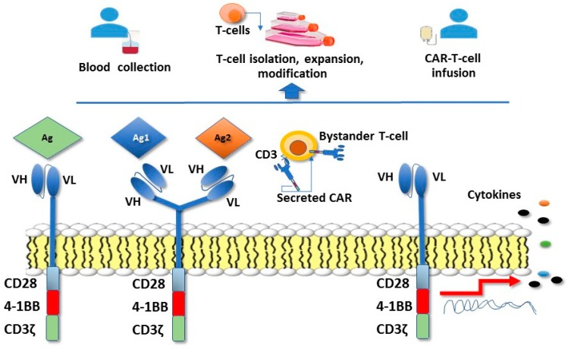
Figure 9: Mechanism of CAR-T cell therapy with different CAR constructs (Dolcetti, De Re and Canzonieri, 2018).
Adoptive cell therapy
Adoptive cell therapy involves isolating tumouricidal NK and T cells from cancer patients, enhancing their tumour antigen specificity and anti-tumour activity through genetic modification or other treatments, expanding them in vitro, and reinfusing them (Rosenberg and Restifo, 2015). In addition to autologous approaches, allogeneic NK cell therapy is being explored, as NK cells are not rejected by HLA-mediated graft-versus-host responses. Cytokine-induced killer (CIK) cells are also used in this strategy, and combination therapy of CIK cells with chemotherapy has shown improved progression-free survival (PFS) and overall survival (OS) in multiple studies (Zhang et al., 2007; Shi et al., 2012).

Agonists of co-stimulatory molecules
Molecules like OX40, 4-1BB, and ICOS act with the TCR to provide potent activation and proliferation of CTLs and Th1 cells. Agonistic antibodies targeting these receptors are being preclinically explored against cancers, including GC (Croft et al., 2013).
Cancer vaccines
Preclinical studies developing cancer vaccines are ongoing, mainly targeting dendritic cells (DCs). The advantage of developing a vaccine is that it can induce immunological memory (Dolcetti, De Re and Canzonieri, 2018).
Current diagnostic procedure of gastric cancer
Clinical feature
The clinical features of GC are classified as symptoms (patient-reported) and signs (physician-detected). Common presenting symptoms include anorexia, nausea, early satiety, weight loss, and dyspepsia (Davidson, 2006). Typical signs may include anaemia, a palpable epigastric mass, Troisier’s sign, Sister Joseph’s nodule, or Krukenberg tumour (Davidson, 2006). Imaging methods such as contrast-enhanced CT, PET-CT, MRI, and endoscopic ultrasound are used to assess tumour staging and metastasis (Davidson, 2006; Ajani et al., 2016). Endoscopy is one of the first-line diagnostic tools for detecting GC. In regions with higher incidence and prevalence, such as countries in East Asia, endoscopy is performed every three years as a screening method for stomach cancer (Lee et al., 2014).
Histopathological examination remains the gold standard for gastric cancer diagnosis. Based on morphological appearance, GC is divided into three types in the Lauren classification (Kumar, Abbas and Aster, 2015; Ajani et al., 2016).
- Intestinal – Late-onset; occurs mostly in the antrum and pylorus; shows intestinal morphology.
- Diffuse – Earlier onset; occurs in the cardia and gastro-oesophageal junction; shows diffuse infiltration.
- Mixed – Undifferentiated morphology.
On histopathological examination, staging of GC is performed to plan treatment modalities. This staging follows the TNM staging, 7th edition (Table 2).
Stage | T (tumour size) | N (lymph node involvement) | M (metastasis)
I | 1-2 | 0 | 0
IIa | 1-2 | 1-3 | 0
IIb | 3-4a | 0 | 0
III | 3-4a | 1-3 | 0
IVa | 4b | 1-3 | 0
IVb | Any | Any | M1
Table-2: clinical staging of gastric cancer (75).
Molecular
Next-generation sequencing (NGS) is used to identify the genomic profile, while microarray and RNA sequencing are used to determine the transcriptomic profile of GC. Based on these findings, TCGA provided a molecular classification of GC in 2014, dividing it into four subtypes to guide targeted therapy planning (Bass et al., 2014).
1.Epstein Barr virus-positive (EBV)
- Mostly situated in the fundus and body of the stomach; accounts for ~9% of total GC cases.
- Hypomethylation of the CDKN2A promoter region.
- PIK3CA mutated in 80% of cases.
- Amplification of JAK2, PD-L1, and PD-L2.
- ARID1A mutated in 55% and BCOR (a BCL-6 corepressor) in 23% of cases.
2. Microsatellite instable (MSI)
- Generally intestinal type.
- Diagnosed in older patients.
- Accounts for ~21.7% of total GC cases.
- Hypermethylation of DNA mismatch repair genes such as MutL homolog 1 (MLH1).
- High incidence of mutations in PIK3CA, ERBB3, RNF43, PTEN, TP53, KRAS, and ARID1A.
- Increased expression of mitotic pathway components like E2F transcription factor, aurora kinase A (AURKA), polo-like kinase 1 (PLK1), and forkhead box M1 (FOXM1).
3. Chromosome instable (CIN):
- Represents ~49.8% of total GC cases.
- Most frequently found in the cardia and gastro-oesophageal junction.
- Chromosomal deletions of CDH1, CTNNA1, and RB transcriptional co-repressor 1 (RB1).
- TP53 mutated in 71% of cases.
- Amplification of ERBB2, ERBB3, FGFR2, and MET receptors.
- Amplification of CDK6, cyclin D1, cyclin E, PD-L2, PIK3CA, and transcription factors MYC and GATA4.
4. Genome stable (GS):
- ~19.7% of total GC cases; histologically diffuse type.
- Mostly found in younger patients.
- Frequently mutated genes include ARID1A, RHOA, and CDH1. Claudin18–Rho GTPase activating protein 6 (CLDN18–ARHGAP6) is also mutated.
- RHOA modulates apoptosis and motility, while CLDN18 regulates tight junction structure, and ARHGAP6 activates Rho signalling.
Current treatments of gastric cancer
Current techniques used in treatment of GC
Surgical resection remains the gold standard treatment for GC. It includes partial gastrectomy or total gastrectomy with D1 or D2 lymph node dissection. A D1 resection involves removal of lymph nodes from stations 1–7, while D2 involves removal of lymph nodes up to station 12. Reconstruction of the digestive tract following proximal gastrectomy is performed by esophagogastrostomy, while distal gastrectomy is typically reconstructed using Billroth I or II, and total gastrectomy is followed by Roux-en-Y anastomosis (Ajani et al., 2016).
Radiotherapy involves the application of X-ray beams to the tumour to induce lethal and sublethal irreversible DNA damage in cancer cells. It can be used as neoadjuvant therapy (preoperative) to shrink the tumour or as adjuvant therapy (postoperative) to enhance tumour control. In GC, X-ray beams are delivered by:
1) Teletherapy – irradiation from a distance using a linear accelerator.
2) Brachytherapy – direct placement of the radiation source onto or into the tumour.
Additionally, intravenous injection of radioactive isotopes, such as Strontium-89, is used for treating bone metastasis (Davidson, 2006).
Chemotherapy (Davidson, 2006; Lee et al., 2014)
Chemotherapeutic agents are used non-resectable GCs or with surgery as adjuvant or neoadjuvant therapy. Common chemotherapeutic agents used to treat gastric cancer are described below
- Alkylating agents (e.g. Cisplatin, Oxaliplatin etc.) – Binds with N⁷ of two adjacent guanosine and thus causes intra-strand cross-linking of DNA double helix.
- Antimetabolite (e.g. 5- fluorouracil, Capecitabine etc.) – Inhibit thymidylate synthase thus stop production of thymidine.
- Texane (e.g. Docetaxel and Paclitaxel etc.) – Prevent depolymerization of microtubule monomers by stabilising them in GDP bound state thus, inhibiting mitotic spindle formation.
- Topoisomerase inhibitor (Irinotecan inhibit Topoisomerase-I and Epirubicine inhibit Topoisomerase-II) – Winding and unwinding of DNA strand.
- Combinations of them are used in clinical practice such as ECF (Epirubicine + Cisplatin + 5-FU), ECX (Epirubicine + Cisplatin + Capecitabine), FLOT (Docetaxel + Oxaliplatin + 5-FU + Leucovorin) and S-1 (Tegafur + 5-chloro-2,4-dihydroxypyridine + Oxonic acid).
Targeted therapy (Lee et al., 2014; Bang et al., 2010)
- Trastuzumab – Monoclonal antibody against HER2 receptor approved by US-FDA as first-line therapy for gastric cancer.
- Ramucirumab - Monoclonal antibody against VEGFR2 receptor approved by US-FDA as second-line therapy for gastric cancer.
Immunotherapy (Lee et al., 2014; Bang et al., 2010)
Pembrolizumab and Nivolumab; both of them are monoclonal antibody against PD-1 and approved by US-FDA for use in treating GC.
Future perspective of gastric cancer management: the personalised approach
All the features of the molecular profile of gastric cancer described so far have important implications for designing future personalised therapeutic approaches. Early detection of GC through genomic, epigenetic, and transcriptomic analyses has the potential to revolutionise treatment strategies and patient survival rates. Novel personalised therapies are likely to include the identification of rare targetable alterations, innovative immunotherapeutic approaches, and therapeutic modulation of the tumour microenvironment.
Novel biomarker for early detection of gastric cancer
Recent advancements in state-of-the-art technologies hold the potential to identify new molecular markers that can enable early detection, predict disease outcomes, and help design appropriate patient-specific treatment plans. Recent studies have identified several oncogenes whose upregulated expression in plasma and tissue samples is linked to GC and may be useful for early diagnosis, including xeroderma pigmentosa group G/excision repair cross-complementing group 5 (XPG/ERCC5), interferon-induced transmembrane protein 1 (IFTIM1), matrix metalloproteinase 9 (MMP-9), and pituitary tumour-transforming gene 1 (PPTG1) (Kim et al., 2016). On the other hand, detecting under-expressed tumour suppressor genes might also be useful for the same purpose. Examples include transmembrane EGF-like two follistatin-like domain 2 (TMEFF2) and gastrokine 1 (GKN1) (Eto et al., 2016; Gomes et al., 2014). Another study evaluated the gene expression profiles of GC patients and identified a four-gene panel that was able to detect GC with 95% accuracy, 92% sensitivity, and 96% specificity. The two upregulated genes were purine-rich element binding protein B (PURB) and structural maintenance of chromosomes 1A (SMC1A), while the two downregulated genes were DENN domain containing 1B (DENND1B) and programmed cell death 4 (PD-4) (Song et al., 2012).
In the case of GC, aberrant DNA methylation has been shown to be more frequent than mutations (Chan et al., 2003). For this reason, studies have been conducted to identify biomarkers based on epigenetic alterations. Six methylated genes have been identified as most specific and sensitive so far, including ADAM23, MINT25, GDNF, PRDM5, MLF1 and RORA, and among them the combination of MINT25, ADAM23 and GDNF has been able to achieve 95% sensitivity and 92% specificity (Gomes et al., 2014). Additionally, some biomarkers have also been identified to be significant in the blood or plasma of GC patients, including P16, CDH1, MGMT, RARB and RNF180 (Zhang et al., 2015).
Another potential emerging biomarker field is miRNA. Circulating miRNA-21, miRNA-196a/b, and miRNA-200c levels have shown the potential to predict GC cases with sensitivities of 88.4%, 69.5%, and 65.4% and specificities of 79.6%, 97.6%, and 100%, respectively (Tsujiura et al., 2010; Li et al., 2012; Shiotani et al., 2013). Plasma levels of circulating exosome-derived miRNA-19b and miRNA-106a have also shown greater sensitivity and specificity of around 95% and 90%, respectively (Li et al., 2014).
Novel targetable therapy
With the increasing use of molecular profiling, the development of targeted therapy is advancing gastric cancer management towards a more personalised approach. To guide this improvement, Hanahan and Weinberg (2011) proposed a framework based on the hallmarks of cancer, as illustrated in Figure 10 (Hanahan and Weinberg, 2011).
Figure 10: Development of targeted therapy based on the hallmarks of cancer.
Based on this guideline, several targeted molecules have been developed. Among them, only Trastuzumab, a HER2 receptor inhibitor, and Ramucirumab, a VEGFR2 receptor antagonist, are currently approved as first-line and second-line treatments for GC, respectively (Van Cutsem et al., 2016; Bang et al., 2010). Many other targeted agents are in clinical trials at various phases, including Everolimus, an mTOR inhibitor; Rilotumumab, an HGF inhibitor; Onartuzumab, a MET inhibitor; and Bevacizumab and Apatinib, which are both VEGF inhibitors. HDM201, a TP53/MDM2 interaction inhibitor, and Olaparib, a PARP inhibitor, have shown variable success in improving progression-free survival and overall survival rates (Van Cutsem et al., 2016). However, these targeted agents are being evaluated in clinical trials as monotherapy or in combination with different chemotherapy regimens.
Novel immunotherapy
Several immunological interventions are already in clinical use for the treatment of GC. Many more are under evaluation in ongoing clinical trials and preclinical studies. For example, Ipilimumab is a CTLA-4 inhibitor. Combined targeting of TIM3 and PD-1 is also being tested; TIM3 is a member of the TNF family and acts as a negative regulator of both helper and cytotoxic T cells. Antagonising VISTA, a transmembrane protein expressed on granulocytes, myeloid cells, and T cells that suppresses T cell activation, is another promising approach (Dolcetti, De Re and Canzonieri, 2018; Van Cutsem et al., 2016). Evaluation of CAR-T cells as a treatment for GC is still in the preclinical stage but has shown promising results. CAR-T cells targeting the HER2 oncoprotein and CAR-T constructs containing co-stimulatory molecules (e.g., 4-1BB, CD3ζ) or fusion proteins combining CEA and IL-2 have demonstrated positive results in mice. In addition, the development of cancer vaccines, adoptive cell therapy, and phytochemicals is also being actively explored (Liang et al., 2017).
Challenges of targeted therapy: cancer evolution and heterogenicity
The clonal evolution and intratumour heterogeneity often drive resistance to targeted therapeutic agents in GC. For example, GC cells can acquire resistance to trastuzumab by activating the IL-6/STAT3/Jagged-1/NOTCH loop. This occurs through increased expression of IL-6, which activates the STAT3 pathway and subsequently upregulates the NOTCH ligand Jagged-1 and downstream genes of the NOTCH pathway, such as Hey-1 and Hey-2. Combining trastuzumab with a NOTCH or STAT3 inhibitor may be a potential solution to this problem. Another major challenge for targeted therapy is inter- and intratumour heterogeneity, as described in the pioneering work of Gerlinger et al. (2012), who identified extensive intratumour heterogeneity in both primary and metastatic tumours by multiregional sequencing of renal cell carcinoma. A similar detailed evaluation of gastric cancer heterogeneity is urgently needed.
Conclusion
In summary, despite major breakthroughs in understanding cancer biology, the management of gastric cancer remains a challenge for both clinicians and researchers. To overcome this hurdle, newer technologies for profiling individual tumours at the molecular level and designing therapies accordingly should be adopted. This report shows that the era of personalised therapy has already begun: molecular profiling of gastric cancer is being advanced by analysing the genomics and transcriptomics of cancer cells using NGS technology. Newer targeted agents are already in use, although results remain unsatisfactory and are further complicated by the high cost of these techniques. However, to advance GC management towards a personalised approach, we must overcome these complexities. The wider availability and gradually decreasing costs of NGS and sequencing technologies are paving the way.
To improve outcomes in gastric cancer, more emphasis should be placed on modulating the tumour microenvironment and enhancing the safety profile of immunotherapy. More research in precision medicine should focus on using CAR-T cell therapy for gastric cancer and on modulating TAMs, as they play a key role in immunosuppression and drug resistance. While many recent reviews cover molecular profiling of gastric cancer, few integrate mutational, epigenetic, transcriptomic, and immunological aspects with clinical strategies. This review combines all levels of molecular detail to support a roadmap for truly personalised gastric cancer care.

COMPETING INTERESTS DISCLAIMER:
Authors have declared that they have no known competing financial interests OR non-financial interests OR personal relationships that could have appeared to influence the work reported in this paper.

References
World Health Organisation. (2018). Cancer. [Online]. Available at: https://www.who.int/news-room/fact-sheets/detail/cancer [Accessed 12 July 2025].
Kumar, V., Abbas, A.K. and Aster, J.C. (2015). Robbins and Cotran: Pathologic Basis of Disease. 9th ed. Philadelphia: Elsevier.
Yusefi, A.R., Bagheri Lankarani, K., Bastani, P., Radinmanesh, M. and Kavosi, Z. (2018). Risk factors for gastric cancer: a systematic review. Asian Pacific Journal of Cancer Prevention, 19(3), pp.591–603.
Hanahan, D. and Weinberg, R.A. (2011). Hallmarks of cancer: the next generation. Cell, 144(5), pp.646–674.
Karimi, P., Islami, F., Anandasabapathy, S., Freedman, N.D. and Kamangar, F. (2014). Gastric cancer: descriptive epidemiology, risk factors, screening, and prevention. Cancer Epidemiology, Biomarkers & Prevention, 23(5), pp.700–713.
Park, J.Y., Forman, D., Waskito, L.A., Yamaoka, Y. and Crabtree, J.E. (2018). Epidemiology of Helicobacter pylori and CagA-positive infections and global variations in gastric cancer. Toxins, 10(4).
Marques-Lespier, J.M., Gonzalez-Pons, M. and Cruz-Correa, M. (2016). Current perspectives on gastric cancer. Gastroenterology Clinics of North America, 45(3), pp.413–428.
Davidson, S. (2006). Davidson's Principles and Practice of Medicine. 20th ed. Edinburgh: Churchill Livingstone.
Konturek, S.J. (2005). Discovery by Andrew J. M. Munro of the H. pylori–gastric cancer link: a historical perspective. Journal of Physiology and Pharmacology, 56(Suppl 3), pp.33–41.
Cai, H., Jing, C.Q., Chang, X.S., Ding, D., Han, T. and Yang, J.C. (2019). Mutational landscape of gastric cancer and clinical application of genomic profiling based on target next-generation sequencing. Journal of Translational Medicine, 17.
Ito, S., Shen, L., Dai, Q., Wu, S.C., Collins, L.B. and Swenberg, J.A. (2011). Tet proteins can convert 5-methylcytosine to 5-formylcytosine and 5-carboxylcytosine. Science, 333(6047), pp.1300–1303.
Bass, A.J., Thorsson, V., Shmulevich, I., Reynolds, S.M., Miller, M. and Bernard, B. (2014). Comprehensive molecular characterization of gastric adenocarcinoma. Nature, 513(7517), pp.202–209.
Padmanabhan, N., Ushijima, T. and Tan, P. (2017). How to stomach an epigenetic insult: the gastric cancer epigenome. Nature Reviews Gastroenterology & Hepatology, 14(8), pp.467–478.
Fei, H.J., Chen, S.C., Zhang, J.Y., Li, S.Y., Zhang, L.L. and Chen, Y.Y. (2018). Identification of significant biomarkers and pathways associated with gastric carcinogenesis by whole genome-wide expression profiling analysis. International Journal of Oncology, 52(3), pp.955–966.
Hunt, R.H., Camilleri, M., Crowe, S.E., El-Omar, E.M., Fox, J.G. and Kuipers, E.J. (2015). The stomach in health and disease. Gut, 64(10), pp.1650–1668.
Yang, Q., Zhang, R.W., Sui, P.C., He, H.T. and Ding, L. (2015). Dysregulation of non-coding RNAs in gastric cancer. World Journal of Gastroenterology, 21(39), pp.10956–10981.
Wang, Q.X., Zhu, Y.Q., Zhang, H. and Xiao, J. (2015). Altered MiRNA expression in gastric cancer: a systematic review and meta-analysis. Cellular Physiology and Biochemistry, 35(3), pp.933–944.
Liu, X.H., Sun, M., Nie, F.Q., Ge, Y.B., Zhang, E.B. and Yin, D.D. (2014). Lnc RNA HOTAIR functions as a competing endogenous RNA to regulate HER2 expression by sponging miR-331-3p in gastric cancer. Molecular Cancer, 13.
Li, J.F., Li, H., Su, L.P., Zhu, Z.G. and Liu, B.Y. (2014). Overexpression of lncRNA H19 enhances development and metastasis of gastric cancer. Cancer Research, 74(19).
Zhao, Y., Guo, Q.H., Chen, J.J., Hu, J., Wang, S.W. and Sun, Y.M. (2014). Role of long non-coding RNA HULC in cell proliferation, apoptosis and tumor metastasis of gastric cancer: a clinical and in vitro investigation. Oncology Reports, 31(1), pp.358–364.
Wang, Y.F., Liu, X.Q., Zhang, H.B., Sun, L., Zhou, Y.A. and Jin, H.F. (2014). Hypoxia-inducible lncRNA-AK058003 promotes gastric cancer metastasis by targeting gamma-synuclein. Neoplasia, 16(12), pp.1094–1106.
Xu, T.P., Huang, M.D., Xia, R., Liu, X.X., Sun, M. and Yin, L. (2014). Decreased expression of the long non-coding RNA FENDRR is associated with poor prognosis in gastric cancer and FENDRR regulates gastric cancer cell metastasis by affecting fibronectin1 expression. Journal of Hematology & Oncology, 7.
STRING (2019). STRING Database. [Online]. Available at: https://string-db.org [Accessed 12 July 2025].
Chung, H.W. and Lim, J.B. (2014). Role of the tumor microenvironment in the pathogenesis of gastric carcinoma. World Journal of Gastroenterology, 20(7), pp.1667–1680.
KEGG (2019). KEGG Pathway - Gastric Cancer. [Online]. Available at: https://www.kegg.jp/kegg-bin/show_pathway?hsa05226 [Accessed 12 July 2025].
Ishimoto, T., Sawayama, H., Sugihara, H. and Baba, H. (2014). Interaction between gastric cancer stem cells and the tumor microenvironment. Journal of Gastroenterology, 49(7), pp.1111–1120.
Ollila, S., Domenech-Moreno, E., Laajanen, K., Wong, I.P.L., Tripathi, S. and Pentinmikko, N. (2018). Stromal Lkb1 deficiency leads to gastrointestinal tumorigenesis involving the IL-11-JAK/STAT3 pathway. Journal of Clinical Investigation, 128(1), pp.402–414.
Wu, X.Y., Tao, P., Zhou, Q., Li, J., Yu, Z.J. and Wang, X.F. (2017). IL-6 secreted by cancer-associated fibroblasts promotes epithelial-mesenchymal transition and metastasis of gastric cancer via JAK2/STAT3 signaling pathway. Oncotarget, 8(13), pp.20741–20750.
Yu, Y., Xiao, C.H., Tan, L.D., Wang, Q.S., Li, X.Q. and Feng, Y.M. (2014). Cancer-associated fibroblasts induce epithelial-mesenchymal transition of breast cancer cells through paracrine TGF-beta signalling. British Journal of Cancer, 110(3), pp.724–732.
Yu, B.Q., Chen, X.H., Li, J.F., Qu, Y., Su, L.P. and Peng, Y.B. (2013). Stromal fibroblasts in the microenvironment of gastric carcinomas promote tumor metastasis via upregulating TAGLN expression. BMC Cell Biology, 14.
Fukumura, D., Xavier, R., Sugiura, T., Chen, Y., Park, E.C. and Lu, N.F. (1998). Tumor induction of VEGF promoter activity in stromal cells. Cell, 94(6), pp.715–725.
Orimo, A., Gupta, P.B., Sgroi, D.C., Arenzana-Seisdedos, F., Delaunay, T. and Naeem, R. (2005). Stromal fibroblasts present in invasive human breast carcinomas promote tumor growth and angiogenesis through elevated SDF-1/CXCL12 secretion. Cell, 121(3), pp.335–348.
Chung, H.W. and Lim, J.B. (2014). Role of the tumor microenvironment in the pathogenesis of gastric carcinoma. World Journal of Gastroenterology, 20(7), pp.1667–1680.
Batista, S., Gregorio, A.C., Otake, A.H., Couto, N. and Costa-Silva, B. (2019). The gastrointestinal tumor microenvironment: an updated biological and clinical perspective. Journal of Oncology, 2019.
Gao, D. and Mittal, V. (2009). The role of bone-marrow-derived cells in tumor growth, metastasis initiation and progression. Trends in Molecular Medicine, 15(8), pp.333–343.
Houghton, J., Stoicov, C., Nomura, S., Rogers, A.B., Carlson, J. and Li, H.C. (2004). Gastric cancer originating from bone marrow-derived cells. Science, 306(5701), pp.1568–1572.
Xu, X., Farach-Carson, M.C. and Jia, X.Q. (2014). Three-dimensional in vitro tumor models for cancer research and drug evaluation. Biotechnology Advances, 32(7), pp.1256–1268.
Tu, S.P., Quante, M., Bhagat, G., Takaishi, S., Cui, G.L. and Yang, X.D. (2011). IFN-gamma inhibits gastric carcinogenesis by inducing epithelial cell autophagy and T-cell apoptosis. Cancer Research, 71(12), pp.4247–4259.
Kitadai, Y., Haruma, K., Mukaida, N., Ohmoto, Y., Matsutani, N. and Yasui, W. (2000). Regulation of disease-progression genes in human gastric carcinoma cells by interleukin 8. Clinical Cancer Research, 6(7), pp.2735–2740.
Kucia, M., Reca, R., Miekus, K., Wanzeck, J., Wojakowski, W. and Janowska-Wieczorek, A. (2005). Trafficking of normal stem cells and metastasis of cancer stem cells involve similar mechanisms: pivotal role of the SDF-1-CXCR4 axis. Stem Cells, 23(7), pp.879–886.
Tissot, T., Massol, F., Ujvari, B., Alix-Panabieres, C., Loeuille, N. and Thomas, F. (2019). Metastasis and the evolution of dispersal. Proceedings of the Royal Society B-Biological Sciences, 286(1916).
Riihimaki, M., Hemminki, A., Sundquist, K., Sundquist, J. and Hemminki, K. (2016). Metastatic spread in patients with gastric cancer. Oncotarget, 7(32), pp.52307–52316.
Akhtar, M., Haider, A., Rashid, S. and Al-Nabet, A. (2019). Paget's “Seed and Soil” theory of cancer metastasis: an idea whose time has come. Advances in Anatomic Pathology, 26(1), pp.69–74.
Pienta, K.J., Robertson, B.A., Coffey, D.S. and Taichman, R.S. (2013). The cancer diaspora: metastasis beyond the seed and soil hypothesis. Clinical Cancer Research, 19(21), pp.5849–5855.
Liu, Q., Zhang, H., Jiang, X., Qian, C., Liu, Z. and Luo, D. (2017). Factors involved in cancer metastasis: a better understanding to “seed and soil” hypothesis. Molecular Cancer, 16(1), p.176.
Dolcetti, R., De Re, V. and Canzonieri, V. (2018). Immunotherapy for gastric cancer: time for a personalized approach? International Journal of Molecular Sciences, 19(6).
Finn, O.J. (2018). A believer's overview of cancer immunosurveillance and immunotherapy. Journal of Immunology, 200(2), pp.385–391.
Marcus, A., Gowen, B.G., Thompson, T.W., Iannello, A., Ardolino, M. and Deng, W.W. (2014). Recognition of tumors by the innate immune system and natural killer cells. Advances in Immunology, 122, pp.91–128.
Garrido, F., Ruiz-Cabello, F., Cabrera, T., Perez-Villar, J.J., Lopez-Botet, M. and Duggan-Keen, M. (1997). Implications for immunosurveillance of altered HLA class I phenotypes in human tumours. Immunology Today, 18(2), pp.89–95.
Johnsen, A.K., Templeton, D.J., Sy, M.S. and Harding, C.V. (1999). Deficiency of transporter for antigen presentation (TAP) in tumor cells allows evasion of immune surveillance and increases tumorigenesis. Journal of Immunology, 163(8), pp.4224–4231.
Vinay, D.S., Ryan, E.P., Pawelec, G., Talib, W.H., Stagg, J. and Elkord, E. (2015). Immune evasion in cancer: mechanistic basis and therapeutic strategies. Seminars in Cancer Biology, 35, pp.S185–S198.
Gholami, M.D., Kardar, G.A., Saeedi, Y., Heydari, S., Garssen, J. and Falak, R. (2017). Exhaustion of T lymphocytes in the tumor microenvironment: significance and effective mechanisms. Cellular Immunology, 322, pp.1–14.
Wherry, E.J. (2011). T cell exhaustion. Nature Immunology, 12(6), pp.492–499.
Ishigami, S., Natsugoe, S., Tokuda, K., Nakajo, A., Okumura, H. and Matsumoto, M. (2003). Tumor-associated macrophage (TAM) infiltration in gastric cancer. Anticancer Research, 23(5A), pp.4079–4083.
Mitchem, J.B., Brennan, D.J., Knolhoff, B.L., Belt, B.A., Zhu, Y. and Sanford, D.E. (2013). Targeting tumor-infiltrating macrophages decreases tumor-initiating cells, relieves immunosuppression, and improves chemotherapeutic responses. Cancer Research, 73(3), pp.1128–1141.
Ben-Meir, K., Twaik, N. and Baniyash, M. (2018). Plasticity and biological diversity of myeloid-derived suppressor cells. Current Opinion in Immunology, 51, pp.154–161.
Choi, B.D., Gedeon, P.C., Herndon, J.E., Archer, G.E., Reap, E.A. and Sanchez-Perez, L. (2013). Human regulatory T cells kill tumor cells through granzyme-dependent cytotoxicity upon retargeting with a bispecific antibody. Cancer Immunology Research, 1(3), pp.163–167.
Sarvaria, A., Madrigal, J.A. and Saudemont, A. (2017). B cell regulation in cancer and anti-tumor immunity. Cellular & Molecular Immunology, 14(8), pp.662–674.
Sharma, P. and Allison, J.P. (2015). Immune checkpoint targeting in cancer therapy: toward combination strategies with curative potential. Cell, 161(2), pp.205–217.
Kottschade, L.A. (2018). Incidence and management of immune-related adverse events in patients undergoing treatment with immune checkpoint inhibitors. Current Oncology Reports, 20(3).
Ajani, J.A., D’Amico, T.A., Almhanna, K., Bentrem, D.J., Chao, J. and Das, P. (2016). Gastric cancer, version 3.2016, NCCN clinical practice guidelines in oncology. Journal of the National Comprehensive Cancer Network, 14(10), pp.1286–1312.
Bang, Y.J., Van Cutsem, E., Feyereislova, A., Chung, H.C., Shen, L. and Sawaki, A. (2010). Trastuzumab in combination with chemotherapy versus chemotherapy alone for treatment of HER2-positive advanced gastric or gastro-oesophageal junction cancer (ToGA): a phase 3, open-label, randomised controlled trial. The Lancet, 376(9742), pp.687–697.
Bass, A.J., Thorsson, V., Shmulevich, I., Reynolds, S.M., Miller, M. and Bernard, B. (2014). Comprehensive molecular characterization of gastric adenocarcinoma. Nature, 513(7517), pp.202–209.
Chan, A.O.O., Lam, S.K., Wong, B.C.Y., Wong, W.M., Yuen, M.F. and Yeung, Y.H. (2003). Promoter methylation of E-cadherin gene in gastric mucosa associated with Helicobacter pylori infection and in gastric cancer. Gut, 52(4), pp.502–506.
Croft, M., So, T., Duan, W. and Soroosh, P. (2013). The significance of OX40 and OX40L to T-cell biology and immune disease. Immunological Reviews, 229(1), pp.173–191.
Davidson, S. (2006). Davidson’s Principles and Practice of Medicine. 20th ed. Edinburgh: Churchill Livingstone.
Dolcetti, R., De Re, V. and Canzonieri, V. (2018). Immunotherapy for gastric cancer: time for a personalized approach? International Journal of Molecular Sciences, 19(6).
Eto, K., Nishikawa, Y., Kagawa, S., Nishio, K., Tazawa, H., Kuroda, S., Kimura, H. and Fujiwara, T. (2016). Prognostic impact of TMEFF2 in gastric cancer: correlation with DNA methylation and H. pylori infection. Gastric Cancer, 19(4), pp.958–966.
Gerlinger, M., Rowan, A.J., Horswell, S., Larkin, J., Endesfelder, D. and Gronroos, E. (2012). Intratumor heterogeneity and branched evolution revealed by multiregion sequencing. New England Journal of Medicine, 366(10), pp.883–892.
Gomes, S.C., Dinis-Ribeiro, M., Leite, M., Moreira-Dias, L. and Carneiro, F. (2014). Predictive microRNAs for lymph node metastasis in gastric cancer: a systematic review and meta-analysis. Oncotarget, 5(19), pp.9212–9224.
Kim, M.A., Lee, H.S., Lee, B.L., Yang, H.K. and Kim, W.H. (2016). Gastric carcinogenesis: evidence for a multi-step and multi-faceted process guided by genetic and epigenetic alterations. Journal of Pathology and Translational Medicine, 50(1), pp.35–44.
Kumar, V., Abbas, A.K. and Aster, J.C. (2015). Robbins and Cotran: Pathologic Basis of Disease. 9th ed. Philadelphia: Elsevier.
Lee, H.E., Park, D.J., Kim, W.H., Kim, H.H., Lee, H.S., Yang, H.K. and Lee, K.U. (2014). Clinical significance of intra-tumoral HER2 heterogeneity in gastric cancer. European Journal of Cancer, 50(18), pp.2808–2815.
Li, B.S., Zhao, Y.L., Guo, G., Li, W., Zhu, E.D., Luo, X., Zhang, Y., Jiang, D.Y., Chen, X.P., Li, Y.M. and Chen, J.S. (2012). Plasma microRNAs, miR-223, miR-21 and miR-218, as novel potential biomarkers for gastric cancer detection. PLoS ONE, 7(7).
Li, X., Wang, Y., Wang, L., Duan, W., Zhang, H., Wu, Y. and Yin, Y. (2014). A serum exosomal microRNA panel as a potential biomarker test for gastric cancer. Biochemical and Biophysical Research Communications, 493(3), pp.1322–1328.
Liang, W., Guan, X., Zeng, L., Yang, W., Qin, T., Xie, L. and Li, Z. (2017). Application of chimeric antigen receptor T cell therapy for the treatment of gastric cancer. Journal of Cancer, 8(3), pp.450–456.
Rosenberg, S.A. and Restifo, N.P. (2015). Adoptive cell transfer as personalized immunotherapy for human cancer. Science, 348(6230), pp.62–68.
Shi, L., Zhang, B., Sun, X., Zhang, X., Lv, S., Li, H., Song, J. and Zeng, Q. (2012). Efficacy of adjuvant chemotherapy combined with adoptive immunotherapy with cytokine-induced killer cells for gastric cancer after D2 gastrectomy. International Journal of Clinical and Experimental Medicine, 5(6), pp.521–529.
Song, J., Bai, Z., Han, W., Zhang, J., Meng, H., Bi, J., Ma, X. and Han, S. (2012). Identification of four-gene signature for detection of gastric cancer by DNA microarray. Oncology Reports, 27(6), pp.1527–1534.
Tsujiura, M., Ichikawa, D., Komatsu, S., Shiozaki, A., Takeshita, H., Kosuga, T., Konishi, H., Morimura, R., Deguchi, K., Okamoto, K. and Fujiwara, H. (2010). Circulating microRNAs in plasma of patients with gastric cancers. British Journal of Cancer, 102(7), pp.1174–1179.
Van Cutsem, E., Sagaert, X., Topal, B., Haustermans, K. and Prenen, H. (2016). Gastric cancer. The Lancet, 388(10060), pp.2654–2664.
Zhang, W., Li, Z., Wang, J., Wu, Y., Zhang, Y., Yuan, X. and Lin, Y. (2015). DNA methylation in the detection of gastric cancer: a systematic review and meta-analysis. Oncotarget, 7(26), pp.39495–39506.
Zhang, X., Zhang, R., Li, W., Zhao, J., Hao, J., Wang, H., Du, C., Xu, Y. and Wang, Z. (2007). Clinical efficacy of adoptive immunotherapy with cytokine-induced killer cells in patients with gastric carcinoma. Cancer Biotherapy and Radiopharmaceuticals, 22(4), pp.507–513.

