Original Research Article

Analysis of the prevalence of anxiety and depression in medical students throughout their undergraduate studies

.
ABSTRACT

Introduction: Common Mental Disorders (CMD), such as depression and anxiety, represent a pathological state of mental health, causing impairment in physical health, social relationships, beliefs, and interpersonal connections. These pathological forms are commonly found among medical students, as the routine and obligations characteristic of this phase led to psychological imbalance which, when left untreated, contributes to the prevalence and worsening of these psychiatric disorders. Research indicates that being female, the presence of comorbidities, and frequent use of stimulants are associated with a reduction in students’ quality of life.
Objectives: To assess the development of anxiety and depression disorders among medical students at different stages of their undergraduate studies. To identify the period within the course with the highest prevalence of these disorders and their triggering factors.
Methodology: A cross-sectional epidemiological study was conducted using data collected from an anonymous online questionnaire administered to medical students. The analysis was performed using Python within the Google Colab environment, employing the pandas library for data manipulation and matplotlib and seaborn for graphical visualizations. Additionally, an ANOVA test was employed to evaluate differences between various demographic groups, considering academic terms and gender.
Results: Significant differences were observed across academic terms, indicating that the impact on mental health varies throughout medical training. Long working hours (69.2%) and self-imposed pressure (75.1%) were identified as the main stressors. Regarding depressive symptoms, a 26% increase was recorded following university enrolment, while anxiety showed a 43.2% increase.
Conclusion: The need to increasingly disseminate knowledge regarding mental balance becomes evident.

Keywords: Medical Students; Generalized Anxiety Disorder (GAD); Depression; Mental Health

1. INTRODUCTION

According to the World Health Organization (WHO), mental health is a state of well-being in which the individual expresses his or her abilities, copes with the normal stressors of life, works productively and fruitfully, and contributes to his or her community (1). In contrast, Common Mental Disorders (CMD), such as depression and anxiety, characterize a pathological state of this concept of health.
Depression can be defined as a chronic psychiatric illness that generates a feeling of deep sadness, causing disenchantment and hopelessness about life (2). Anxiety, in turn, is an emotion necessary for carrying out daily activities. However, it can present itself in a pathological form, being classified as Generalized Anxiety Disorder (GAD) when the symptoms interfere with daily life, affecting the individual's personal and social sphere, by including disproportionate stress, restlessness, and inability to overcome an event (3).
It is important to highlight that the various forms of anxiety and depression are commonly found in university students, among which are the medical students reported in the present study, since the routine and obligations characteristic of this phase linked to the little experience in controlling emotions and time support an emotional imbalance that, when left untreated, culminates in the incidence or worsening of psychiatric disorders (4).
As has been well-reported in the literature (5), medical students have more symptoms of anxiety and depression than the average student in other courses, and it is necessary to understand the factors that trigger the emotional imbalances prevalent in this group. Among these factors, we can highlight the medical study environment itself, which has an intense workload of classes and internships, in addition to the need for intense individual study to ensure success in exams and to prepare for medical practice in the future. Because of this, students are more susceptible to developing pathological levels of anxiety and depression due to little attention to themselves and excessive concern with tasks, grades and staying among the best (6). In addition, it is also common for many university students not to seek the necessary professional help (7). Many students justify this situation by lack of time, stigma associated with mental health, high cost of treatment, shame or belief in their own ability to improve without help. All of this comes from a context based on discrimination regarding mental health and the denial of doctors as vulnerable human beings who are capable of being treated. It is worth highlighting that if these reasons did not affect the lives of academics, their quality of life and psychological well-being would be restored, avoiding rates of complications and treatment abandonment (8).
Therefore, many students, even if they have not faced these Common Mental Disorders during their pre-university period, begin to develop them during their undergraduate studies (10). According to a study by Costa et al. (9), students in the first two cycles of the course are even more susceptible to depression and anxiety symptoms. This occurs due to the lack of expectations in the face of the large amount of content that is often dissociated from clinical practice (10). In addition, many of these students have not yet learned to reconcile university life with extracurricular activities and their personal lives.
Another aggravating factor in this situation is the large number of medical students who come from cities other than the place where they study. Therefore, many of these students are in the process of adapting to combining academic responsibilities with the obligations of taking care of a new home, taking on commitments such as paying bills, cleaning the house and preparing meals (10).
It is also noted that medical students tend to experience increased anxiety levels throughout the semesters due to the approaching end of their medical training and the increase in responsibilities, which are different from those of the basic cycle. This is due to excessive concern about the future, fear related to facing the job market, insecurity about their own (10). knowledge, social expectations about the role of the doctor and the fear of making mistakes.
Therefore, the objective of this study is to analyze and map how the prevalence of these symptoms occurs throughout the academic semesters of medical students at a university in São Paulo, the largest capital city in Latin America.

2. material and methods

2.1 Data Collection

A cross-sectional epidemiological study was conducted with undergraduate students of the medical course at a university in the city of São Paulo, Brazil, from the first to the twelfth semesters, in the second semester of 2020. Data was collected through the application of an anonymous online questionnaire, sent by institutional email, containing sociodemographic and anxiety and depression variables. The form contains 29 questions that take on average, 5 minutes to be answered - some of which were prepared using questionnaires to assess the level of anxiety and depression as a reference. Ethical approval was obtained (approval No. 4.365.539/2020). Written informed consent was obtained from all participants prior to access the questionnaire.

The inclusion criteria for the study were: students regularly enrolled in the medical course from the first to the twelfth period at the University who answered the form and agreed to the Written Informed Consent Form (WICF). The exclusion classification for the study was: students who did not want to enroll in the WICF. The WICF was sent with the questionnaire, and participants could only access the questions after agreeing to the terms in the form.
2.2 Data Handling and Preprocessing
All data analyses and visualizations were conducted using Python (version ≥3.10) within Jupyter Notebooks. The analytical procedures included data preprocessing, descriptive statistics, inferential statistical testing, machine learning-based exploration, and data visualization. Data were imported from CSV format and processed using the pandas library. This included standardization of column labels, removal of trailing whitespace, and mapping of detailed survey responses into consolidated analytical categories (e.g., sleep quality responses grouped into “Insomnia,” “Hypersomnia,” “Sleep Improvement,” and “No change”). Categorical variables such as academic semester were converted into year-level and stage-level groupings (e.g., Pre-clinical, Clinical, Internship).
2.3 Statistical Analyses
Associations between categorical variables were assessed using chi-square (χ²) tests of independence implemented with scipy.stats.chi2_contingency. Standardized residuals (z-scores) were calculated for post hoc interpretation of cell-specific deviations from expected frequencies. Significance was defined as |z| ≥ 1.96. Associations examined included stage of medical training versus psychiatric diagnosis, sleep quality versus stimulant use, and others.

3. results

3.1 Demographic Data

The questionnaire received 169 responses. Most participants were female, accounting for 75.7% of the total, while male participants represented 24.3%. Regarding age, the highest concentration of respondents was in the 21 to 25 age group, comprising 60.4% of the sample (Table 1).

Table 1: Demographic Data of Participants
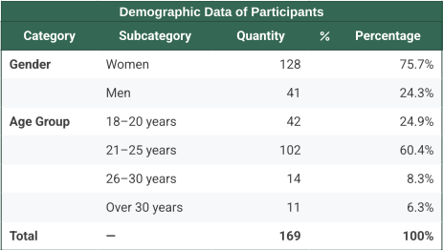
Summary table showing the distribution of participants by gender and age group. Data are presented as absolute numbers and percentages.

3.2 Diagnosis of Depression and Anxiety

A fact worth highlighting is that 61.5% of participants were not diagnosed with anxiety disorders or depression before entering college. However, after admission in medical school, the number of students not diagnosed decreased significantly (47.9%), highlighting the impact of the academic environment on mental health. During the internship period - the final two years of medical school - there was a significant increase in depression diagnoses. In contrast, no significant variation was observed in anxiety diagnoses throughout the academic years (Figure 1).

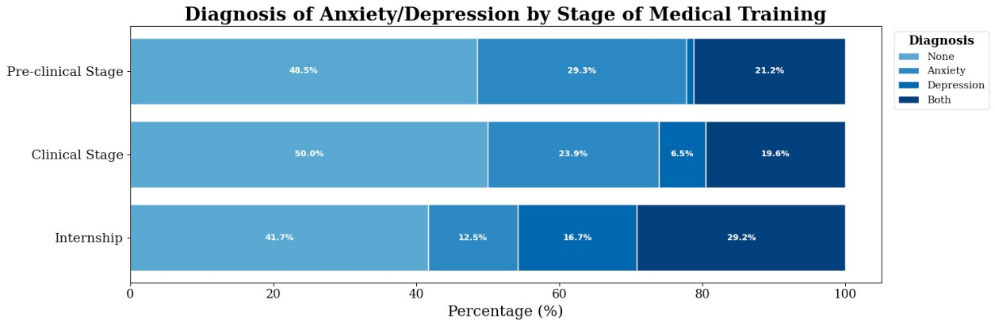Figure 1. Diagnosis of Anxiety/Depression by Stage of Medical Training
Stacked bar chart showing the percentage of medical students with diagnoses of anxiety, depression, both, or none, across pre-clinical, clinical, and internship stages. Values are presented as percentages for each group.
The data collected reveals an alarming increase not only in diagnosis, but also in levels of anxiety and depressive symptoms after entering university, with 43.2% and 26% of students rating these feelings at 4 and 5, respectively, on a scale of 1 to 5 - with 1 representing that they decreased a lot, 3 representing that there was no change and 5 representing that they increased a lot (Figure 2).
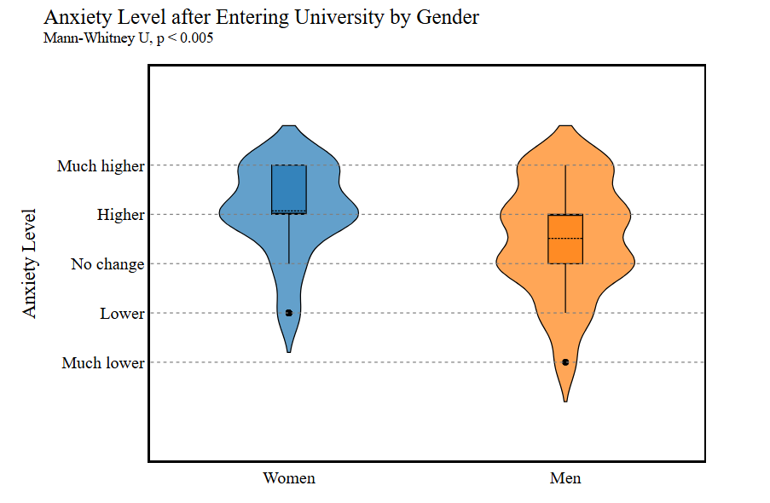
Figure 2: Anxiety Level after Entering University by Gender
Violin plots showing the distribution of self-reported changes in anxiety levels after entering university, stratified by gender (women and men).

Another notable aspect of the results is the high incidence of feelings of panic among students, with 45% reporting experiencing these feelings “from time to time.” Whether associated with a feeling of fear as if something bad was going to happen or not, 33.7% of participants described this feeling as not very strong, while 24.3% classified it as very strong.
One of the most important consequences of this whole situation was the finding of loss of pleasure in activities previously enjoyed. More than half (53.8%) reported maintaining the same level of pleasure, but a significant portion (37.9%) felt less pleasure than before. Despite this finding, throughout the semesters the students continued to do the same activities during their free time, which shows a lack of association between these factors (P < 0.005) (Figure 3).
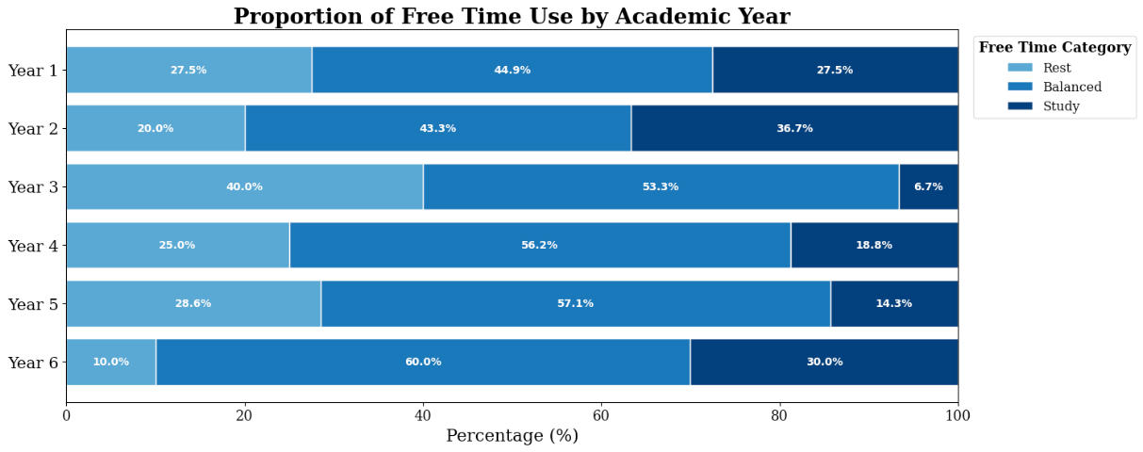
Figure 3: Proportion of Free Time Use by Academic Year
Stacked bar chart showing the percentage of students reporting their free time is dedicated mainly to rest, study, or balanced activities, across each academic year. Values are expressed as percentages for each group.
3.3 Anxiety and Depression Triggers
Self-demanding and long workloads stand out among the factors that contribute to high levels of anxiety and depression. These factors were considered the main triggers by 75.1% and 69.2% of students, respectively, among the numerous factors cited in the survey (figure 4). To deal with such self-demanding, more than half of students (58%) resort to the use of stimulant substances.
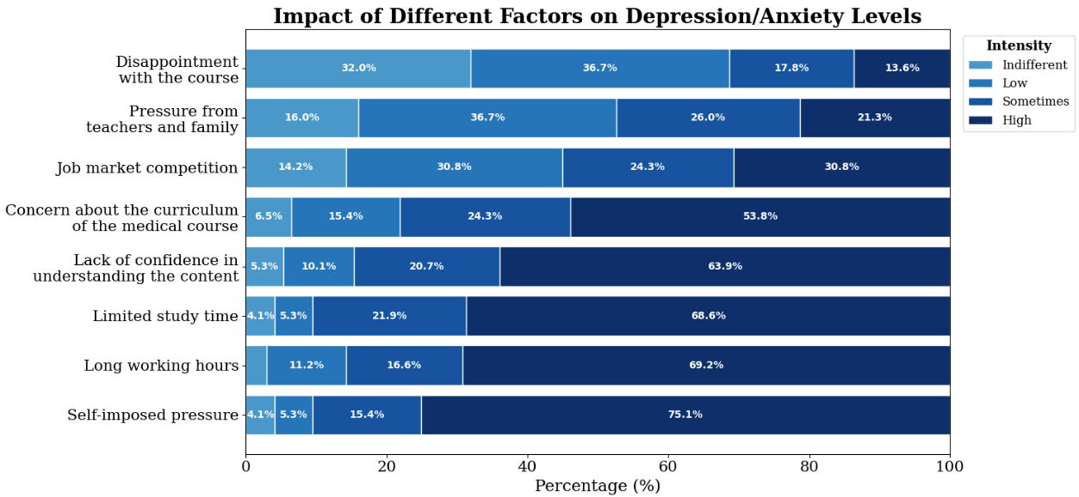Figure 4: Impact of Different Factors on Depression/Anxiety Levels
Stacked bar chart showing the self-reported intensity (indifferent, low, sometimes, or high) of various factors contributing to depression and anxiety among students. Values are shown as percentages for each factor.
3.4 Sleep
Sleep is an important pillar for development and because of mental disorders. Although students were asked about changes in their sleep after entering medical school, there was no significant difference (p > 0.05) over the years (Figure 5). However, when correlating sleep quality with the use of stimulant substances, it was possible to verify (p-value = 0.015) that individuals who do not use stimulant substances did not present changes in their sleep pattern.
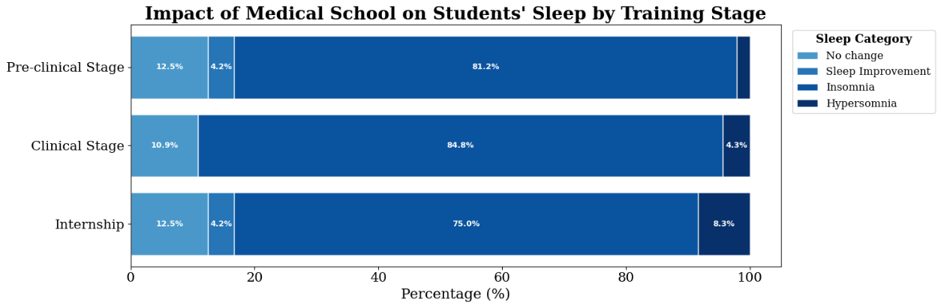
Figure 5: Impact of Medical School on Students Sleep by Training Stage
Stacked bar chart showing the percentage of students reporting no change, sleep improvement, insomnia, or hypersomnia during different stages of medical training. Values are presented as percentages for each category within each stage.
3.5 Treatment and Alternative Therapies
Many students do not seek professional help, mainly due to lack of time (20.2%) and high costs (18.5%). However, even in the face of these challenges, 77.5% of students sought alternative therapies to deal with symptoms of anxiety and depression. Physical exercise is the most common form of alternative therapy, adopted by 67.5% of students, followed by meditation (37.9%) and reading (35.5%).
3.5 Influence of Social Isolation
The data collection may exhibit some response bias due to the period in which it was conducted (2020). This parameter was also addressed in the form, where respondents were asked to rate whether social isolation influenced their answers. However, as shown in Figure 6, this parameter significantly impacted the results. (p-value = 0.000). This was particularly evident in the later semesters. where fewer responses than expected were recorded for ‘No influence' and more responses than expected for 'extreme influence' in Year 1. Conversely, for Year 5 and Year 6, there were more responses than expected for ‘No influence’.
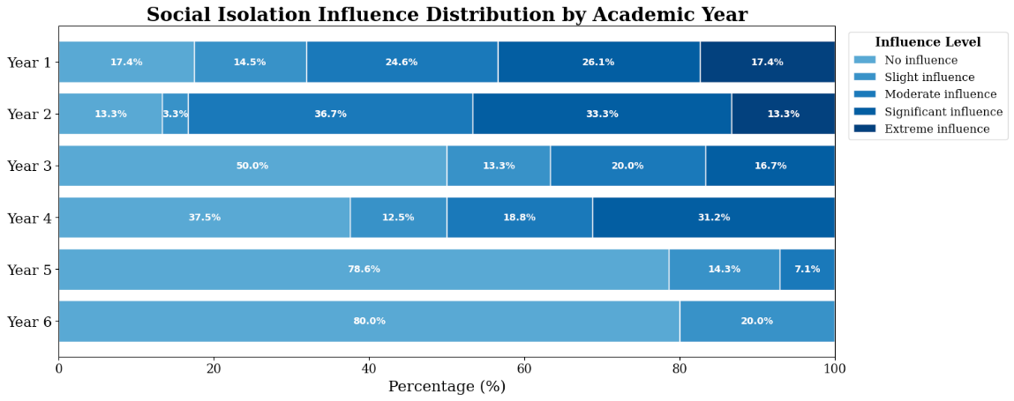
Figure 6: Self Isolation Influence Distribution by Academic Year
Stacked bar chart illustrating the percentage of students reporting different levels of social isolation influence, ranging from no influence to extreme influence, across each academic year. Values are presented as percentages for each group.

4. DISCUSSION

The life of a medical student involves an exorbitant workload and intense ties with their colleagues, professors, and everything that surrounds the lives of these individuals related to their academic course. Given this, the overworked student puts his or her personal life on the back burner, not giving due attention to taking care of his or her mental health. This process triggers anxiety disorders and depression, transforming an already exhausting routine into something pathological. Therefore, there is a clear need for a study that analyzes the possible psychological impacts that each period of graduation tends to cause in the lives of these students. Based on this study, the information gathered can direct the attention of researchers and students to take measures to care for these students and improve their quality of life and, consequently, their professional quality.
This cross-sectional epidemiological study included 169 respondents, the majority of whom were female students (75,7%) aged between 21-26 years. This range is commonly reported in other studies on anxiety and depression among medical students (11).
Within the sample, the prevalence of depression diagnoses increased significantly over the course of the medical program - particularly during the internship years - while anxiety diagnoses did not show significant variation throughout the academic timeline. A Turkish study aimed at assessing anxiety and depression levels among medical students reported a decrease in both diagnoses over the course of medical training. In the third year, 58.5% of students were diagnosed with depression, a figure that dropped to 55% by the sixth year (12). A systematic review and meta-analysis of 135 studies on the prevalence of anxiety and depression among medical students during the COVID-19 pandemic found no significant differences in the prevalence of these mental health disorders based on the academic year or phase of training (11). Similarly, a study conducted across 43 medical schools in Spain contradicts the findings of the present study. It reported no significant differences in anxiety diagnoses across different years of medical training and, in contrast, observed a protective effect among students engaged in clinical rotations (13).
Regarding the prevalence of anxiety and depressive symptoms throughout the academic semesters, a significant difference was observed over the course of medical training. Contrary to the patterns observed in formal diagnoses, anxiety symptoms (43.2%) increased more markedly than depressive symptoms (26%) as students advanced in the program. These findings are challenged by a cross-sectional quantitative study conducted at University in Northeastern Brazil, which analyzed symptoms of depression, stress, and anxiety among medical students (14). That study found a significant correlation between anxiety levels and the stage of medical training, with higher levels reported at the beginning of the program. Although other studies have assessed the severity os symptoms related to these mental health disorders, few have directly examined how symptom levels correlate with specific stages of medical education. Regarding the increase in anxiety levels by gender, the present study observed a higher prevalence of “high” anxiety levels among female participants compared to male counterparts, whose median levels ranged between “no change” and “high”. This finding is consistent with other studies in literature (13).
A noteworthy finding of the results is the high incidence of panic sensations among medical students, with 45% reporting experiencing such feelings occasionally. Specifically, 33.7¨% of participants described the sensation as mild, while 24.3% rated it as very intense. However, there is limited evidence in the literature regarding the prevalence of these symptoms among medical students.
Although a clear cause-and-effect relationship between anxiety and depressive symptoms and their triggers cannot be established, this study was able to evaluate the influence of various elements on the emergence of such conditions. The most reported contributors were self-imposed pressure (75.1%), long working hours (69.2%), limited study time (68.6%), and a lack of confidence in understanding the content (63.9%). The study by Capdevila-Gaudens et al. (2021) identified ‘health problems’ and ‘dissatisfaction with academic performance’ as the main correlates of depression among medical students. The latter aligns with several of the key issues highlighted in the present research (13). Additional variables noted in their study - but not examined in our questionnaire - included students balancing work and study, as well as those facing financial hardship, the latter of which has also been linked to mental health challenges in other investigations (15).
Changes in sleep patterns - an important indicator of both the development and consequences of mental disorders - were not found to correlate with the progression through medical school. Although most students reported experiencing insomnia, there was no significant increase or decrease in its prevalence across academic years. The number of hours slept should be more thoroughly investigated, given its direct correlation with quality of life. A cross-sectional study assessing the quality of life of 419 medical students in Brazil, using sociodemographic and lifestyle questionnaires along with the World Health Organization Quality of Life - Brief Form (WHOQOF - BREF), found that each additional hour of sleep was associated with an increase in student’s quality of life. However, although overall sleep patterns did not show significant changes in the present study, a noteworthy observation was that individuals who did not use stimulant substances maintained stable sleep behavior. This data is also confirmed by the study mentioned above where the use of stimulants decreases the quality of life of the medical students (9).
Although most students diagnosed with depression or anxiety sought professional help for treatment, those who did not cited lack of time and high costs as the main barriers. Among individuals whose symptoms became exacerbated beyond a clinical diagnosis, the vast majority (90.5%) turned to alternative treatments, with physical activity, meditation, and reading being the most reported strategies. No comparable data were available in the literature regarding the use of such non-pharmacological approaches to manage anxiety and depressive symptoms, as most studies focus primarily on the use or avoidance of psychiatric medication.
This study presents some limitations, particularly due to the small sample size, which included medical students from only a single university in São Paulo. As such, the generalization of depressive and anxiety symptoms to all medical schools in the region is not feasible. In addition to the limited sample, it is most important to note that the self-reported questionnaire was administered during the COVID-19 pandemic, a period marked by heightened emotional vulnerability, which may have introduced confounding bias. Students in the earlier years were more affected by social isolation than those in the later years, potentially influencing their responses. These findings significantly impact the interpretation of the study’s results. A meta-analysis conducted to assess the prevalence of anxiety and depression among medical students during the COVID-19 pandemic reported that between February and June 2020 the prevalence of those conditions increased over time (11). Finally, the cross-sectional design of the study limits the ability to establish casual relationships between risk factors and the presence of anxiety or depressive symptoms.

5. Conclusion

The study highlights the significant impact of medical school on students’ mental health, with self-imposed pressure and excessive workload identified as the primary contributors to anxiety and depression. Although some students seek therapeutic support, access is often limited by time constraints and high costs. Social isolation further exacerbates the issue, underscoring the urgent need for targeted attention to the mental health of this vulnerable population.

Consent

All authors declare that ‘written informed consent was obtained from the patient (or other approved parties) for publication of this case report and accompanying images. A copy of the written consent is available for review by the Editorial office/Chief Editor/Editorial Board members of this journal.

Ethical approval

All authors hereby declare that all experiments have been examined and approved by the appropriate ethics committee and have therefore been performed in accordance with the ethical standards laid down in the 1964 Declaration of Helsinki.

References

1. RIBEIRO, J. P. et al. Further validation of the 28-item Goldberg General Health Questionnaire. Psychology, Health and Disease, Portuguese Society of Health Psychology, 2015.

2. VARELLA, Dr. Drauzio. Depression. Drauzio Varella, July 26, 2019. Available at: https://drauziovarella.uol.com.br/doencas-e-sintomas/depressao/. Accessed on June 8, 2025.

3. LIMA, R. L. et al. Medical student stress and academic performance. Brazilian Journal of Medical Education, v. 40, n. 4, p. 678–684, 2016.

4. CONCEIÇÃO, L. D. et al. Mental health of Brazilian medical students: a systematic literature review. 2019.

5. RIBEIRO, C. F. et al. Prevalence of factors associated with depression and anxiety in Brazilian medical students. Brazilian Journal of Medical Education, v. 44, n. 1, 2020.

6. MORO, A. et al. Symptoms of depression in medical students at the University of the Joinville Region (SC). Brazilian Journal of Medical Education, v. 29, n. 2, 2005.

7. NEPONUCENO, H. de J. et al. Common mental disorders in medical students. Bioethics Journal, Federal Council of Medicine, Sept. 2019.

8. VASCONCELOS, T. C. et al. Prevalence of symptoms of anxiety and depression in medical students. Brazilian Journal of Medical Education, v. 39, n. 1, 2015.

9. MIRANDA, I. M. M. et al. Quality of life and graduation in medicine. Brazilian Journal of Medical Education, Brazilian Association of Medical Education, June 24, 2020.

10. COSTA, D. S. et al. Symptoms of depression, anxiety, and stress in medical students and institutional coping strategies. Brazilian Journal of Medical Education, Brazilian Association of Medical Education, March 30, 2020.
11. LIN, Yen-Ko et al. Global prevalence of anxiety and depression among medical students during the COVID-19 pandemic: a systematic review and meta-analysis. BMC Psychology, v. 12, 2024.
12. KARAGÖL, Arda. Levels of depression, anxiety, and quality of life of medical students. Psychiatria Danubina, v. 33, suppl. 4, p. 732-737, 2021.
13. MARTINS, Fernanda et al. Impact of COVID-19 on medical students' mental health. Journal of Medical Education, 2021.
14. OLIVEIRA, Lucas et al. Burnout syndrome among medical students in Brazil. Brazilian Journal of Medical Education, 2020.
15. PEREIRA, Carla et al. Mental health impact on medical students during COVID-19 pandemic. International Journal of Environmental Research and Public Health, 2020.

