Original Research Article

Bridging Competency and Training Outcomes: An Evaluation of Life Support Courses via the Dubai Health Authority (DHA) Framework

ABSTRACT
Background: Life support training is a critical component for healthcare professionals, particularly those working in emergency care settings. The Dubai Health Authority (DHA) operates a state-of-the-art training center that offers resuscitation courses, including Basic Life Support (BLS), Advanced Cardiovascular Life Support (ACLS), Paediatric Advanced Life Support (PALS), and Paediatric Emergency Assessment, Recognition, and Stabilization (PEARS). Following each course, participants complete a standardized evaluation, which serves as the primary data source for this study.
Objectives: To evaluate participants' perceptions of teaching methods, course effectiveness, and skill acquisition, and to compare evaluation outcomes across four life support courses: BLS, ACLS, PALS, and PEARS.
Methods: This observational, retrospective, quantitative study analysed participant evaluation data collected between 2014 and 2016 using a modified American Heart Association (AHA) evaluation tool. Data were reviewed for three key domains: instructor performance, course content, and skill mastery. Inclusion and exclusion criteria were applied to ensure data quality and relevance.
Results: In 2014–2015, all courses received high evaluation scores, with average ratings between 4.4 and 4.6, reflecting strong instructor performance, relevant content, and effective skill training. In 2016, a decline in ratings was observed for BLS, ACLS, and PALS, particularly in areas such as instructor clarity, learner confidence, and facility adequacy. In contrast, PEARS maintained consistently high ratings and showed slight improvement. These trends highlight a decline in perceived course quality for most programs in 2016, with PEARS as a notable exception.
Conclusion: Life support training programs delivered by DHA demonstrated high levels of participant satisfaction in 2014–2015, particularly in instructional quality and skill development. A systemic decline in 2016 suggests a need for improvements in instructor consistency, practical training reinforcement, and facility upgrades. Despite this, course content and participant trust in the programs remained strong throughout the study period.
Keywords: Resuscitation training, instructor evaluation, skill mastery, BLS, ACLS, PALS, PEARS, healthcare education

1. INTRODUCTION
Life support courses are essential for the professional growth of all healthcare workers. The Dubai Health Authority (DHA) has a dedicated Training Center that meets the resuscitation training needs of healthcare professionals in the region. The DHA training center offers various life support courses for medical professionals at both provider and instructor levels. These include Basic Life Support (BLS), Advanced Cardiac Life Support (ACLS), Pediatric Emergency Assessment, Recognition, and Stabilization (PEARS), and Pediatric Advanced Life Support (PALS). All these courses are accredited by the American Heart Association (AHA), the oldest and largest voluntary organization dedicated to fighting heart disease and stroke in the United States [1]. The AHA provides a range of training programs through its global network of training centers (TCs) and training sites (TSs). Dubai Health Authority (DHA) is one of AHA’s recognized international training centers in the UAE. After completing a resuscitation training course, participants assess the program's effectiveness. Therefore, we have chosen to evaluate the life support training programs for healthcare professionals trained by DHA.
2. LITERATURE REVIEW
Evaluation is defined as “the identification, clarification, and application of defensible criteria to determine an evaluation object’s value (worth or merit) in relation to those criteria.” It highlights not only the significant importance of the evaluation process in practical life but also the development of a new area of study [2]. Effective program evaluation is a systematic approach to improving and documenting public health actions, involving a carefully planned and organized method for capturing the nature and outcomes of program implementation [3]. An evaluation framework outlines and structures the steps and standards for effective program assessment, as shown in Figure 1 [4].
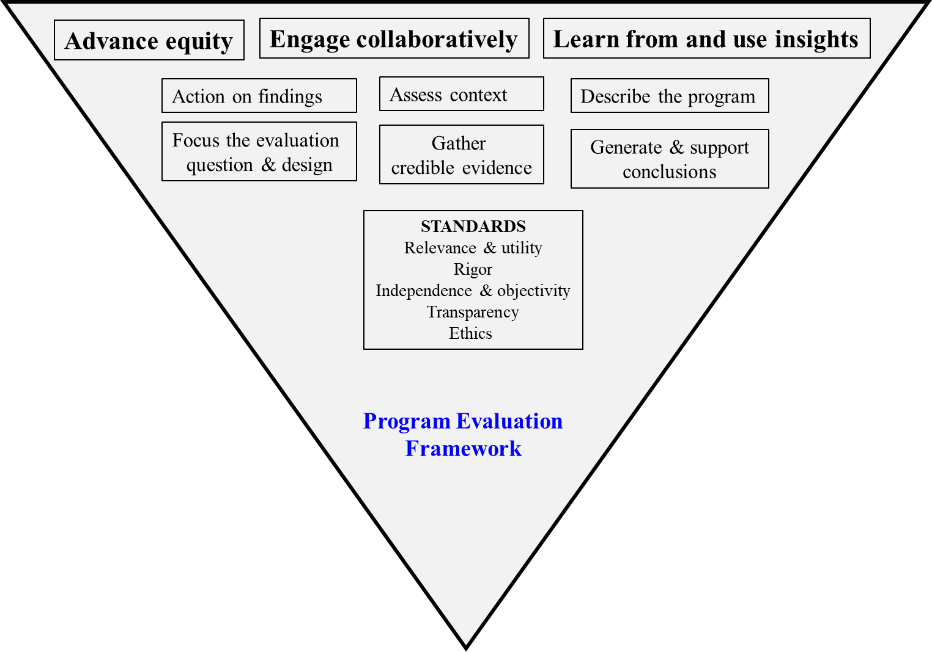

Figure 1: Program Evaluation Framework Graphic (courtesy CDC)

The primary purpose of an evaluation is to make judgments about the value of whatever is being assessed [5]. Some researchers have simplified the purpose of evaluation into two categories: to assess teaching methods and to evaluate the effectiveness of the course [6]. Evaluation of educational programs is complex. Various designs, approaches, and models are found in the literature and have been applied in different educational programs, but one is straightforward and ready to use [7,8,9,10].
In our study, we used a “Participant-oriented approach,” where the involvement of participants (stakeholders in the evaluation) is central in determining the values, criteria, needs, and data for the evaluation. Our study was based on a hypothesis: Does a course evaluation questionnaire serve as a “performance indicator” of teaching and training at Life Support Courses? We selected “Level 1” of Kirkpatrick’s four-level evaluation model [11] to assess AHA training courses, as shown in Table 1, expecting that this approach would help to understand the program's complexities, with all stakeholders in the evaluation determining the values, criteria, needs, and data.

Evaluation Level | What does it test | Evaluation Tools
Level 1: Reaction | Participant’s immediate satisfaction  Perception of usefulness  Motivation | - Liker’s scale  - Focus group  - Structured interviews
Level 2: Learning | Acquisition of knowledge, skills, and behavior | - Pretest and post-test  - Standard MCQ  - Essay question
Level 3: Transfer | Transfer of knowledge, skill, and behavior into real life | - Chart reviews  - Surveys  - Observations
Level 4: Results | Ultimate and intended outcome | - Chart reviews  - Surveys
Table 1: Kirkpatrick’s model of training evaluation

3. METHODS AND MATERIALS
3.1 Research Setting
The study was conducted at the DHA training center and the training sites affiliated. The DHA training center was chosen because it is a “Reference Center” in providing quality resuscitation in the Middle East and North Africa (MENA) region.
3.1.1 Purpose of the Study: The main purpose of the study is to evaluate the teaching methods used, the effectiveness of the course, and the mastery of skills learnt.
3.1.2 Objectives: The objectives identified in our study include:
- To measure and compare the overall perception of evaluation about four training courses (BLS, ACLS, PEARS, and PALS) among healthcare professionals.
- To assess and compare evaluation responses for four training courses (BLS, ACLS, PEARS, and PALS).

3.2 Design
It is an observational, quantitative, and retrospective study that compares evaluation scores among four resuscitation training courses, i.e., BLS, ACLS, PEARS, and PALS. The study also compares the evaluation responses among other variables like course instructors, course content, and skill mastery.
3.2.1 Eligibility:
- Inclusion criteria:
(1) Healthcare professionals trained for four training courses (BLS, ACLS, PEARS, and PALS); (2) Healthcare professionals enrolled from January 2010 to December 2016.
- Exclusion criteria:
(1) All other medical training programs conducted by DHA;
(2) Absentees;
(3) Unable to show the evaluation form after attending classroom training.
3.2.2 Tool or Instrument used
The American Heart Association (AHA) has provided useful resources, including a formal course evaluation questionnaire to assess the teaching quality of its instructors and the overall conduct of a course. We used a modified version of the course evaluation according to our resources and needs at DHA for all four courses, i.e., BLS, ACLS, PALS, and PEARS, between the years 2014 to 2016. Modified DHA evaluation tools or forms have both quantitative as well as qualitative data. For our study, we selected and analyzed the evaluation data related to three quantitative components, which include:
- Instructor’s evaluation
- Course content
- Skill mastery
3.3 Data Collection
Course evaluation tools were available for all resuscitation training programs offered at the DHA Training Center. Both online and classroom-based evaluations were utilized; however, for this study, only classroom-based evaluations were selected for analysis. These included evaluations from the Basic Life Support (BLS), Advanced Cardiac Life Support (ACLS), Pediatric Emergency Assessment, Recognition and Stabilization (PEARS), and Pediatric Advanced Life Support (PALS) courses.
Evaluation forms were distributed to participants at the end of each training session. Completed forms were collected by the training center coordinator and respective course coordinators. Each form was labelled with a unique identification number to maintain participant anonymity. All collected data were coded and securely stored, accessible only to the researchers, the training center coordinator, and the statistician.
3.3.1 Data Analysis
The objective of the data analysis was to condense and interpret the collected information to derive meaningful conclusions. All relevant stakeholders were involved in the analytical process from the outset. Quantitative data were analysed using both descriptive and inferential statistical methods, as appropriate, to address the evaluation objectives.
Statistical methods were selected based on the measurement scale of the variables and the fulfilment of underlying statistical assumptions. Descriptive statistics (e.g., means, standard deviations) were used to summarize responses, while inferential statistics were applied where necessary to compare evaluation outcomes across the different courses.
3.3.2 Ethical Considerations
Ethical approval for the study was obtained from the Chief Executive Officer of Rashid Hospital, the Chairperson of the Rashid Hospital Research Committee, and the Head of the Medical Education Department at the Dubai Health Authority (DHA). Participation in the course evaluations was voluntary. Informed written consent was obtained from all participants, who were also informed of their right to withdraw from the study at any stage without penalty.
3.4 Timelines and Budget
A well-defined timeline is a critical component of any evaluation plan. It was developed in consultation with key stakeholders to ensure that all major activities could be scheduled, monitored, and completed efficiently and on time. The timeline allowed both trainees and evaluators to coordinate the evaluation process while maintaining the continuity of training operations.
This study included all healthcare professionals enrolled in resuscitation training courses conducted between January 2010 and December 2016. The evaluation activities—such as data collection, collation, and analysis—were scheduled accordingly and tracked to ensure a smooth workflow.
As described by Sanders J.R. [12], analysing the evaluation budget is essential for planning and resource management. In our case, all appropriate cost-saving measures were implemented to facilitate the evaluation process. Importantly, the evaluation of resuscitation training is an integral part of the course delivery at the Dubai Health Authority (DHA), and thus, no additional funding or external budget was required to carry out this research.
All evaluation tools were already embedded within the training programs, and the data were collected during routine course assessments. Therefore, no financial interests or external sponsorships were involved in this study. The research was carried out solely for quality improvement and academic purposes using internal institutional resources.

4. RESULTS
The results derived from available data are described below for all four life support courses, i.e., ACLS, BLS, PALS, and PEARS, respectively, from 2014 to 2016.
4.1 Evaluation of ACLS Courses (2014–2016)
Advanced Cardiovascular Life Support (ACLS) training programs were evaluated over three consecutive years (2014–2016) using a standardized 23-question feedback survey. The survey covered instructor performance, course content, skill mastery, course facilities, and general participant information. Responses were collected on a five-point Likert scale (1 = strongly disagree to 5 = strongly agree), along with Yes/No and open-ended responses.
4.1.1 Instructor’s Evaluation (Q1–Q4)
Participants consistently rated instructors highly in 2014 and 2015, particularly in subject knowledge and communication. However, a clear decline occurred in 2016, where average ratings fell below 4.0.
Year | Overall Performance | Subject Knowledge | Communication | Clarity of Presentation
2014 | 4.43 | 4.54 | 4.44 | 4.47
2015 | 4.53 | 4.54 | 4.51 | 4.50
2016 | 3.90 | 3.92 | 3.89 | 3.86
➡ Trend: Instructors were praised in 2014–2015, but ratings declined in 2016, suggesting a drop in perceived clarity and delivery.
Table 2: Instructor’s evaluation (Q1–Q4) for ACLS Courses
4.1.2 Course Content (Q5–Q10)
Content quality, relevance, and clarity remained strong across all years, though a downward shift was seen in 2016.
Year | Objectives Clear | Relevance | Presentation | Difficulty Appropriate | Materials Quality | Equipment Condition
2014 | 4.54 | 4.63 | 4.53 | 4.40 | 4.49 | 4.11
2015 | 4.63 | 4.66 | 4.64 | 4.50 | 4.59 | 4.37
2016 | 4.43 | 4.48 | 4.46 | 4.39 | 4.42 | 4.26
➡ Trend: 2015 was the strongest year. Content remained relevant in 2016 but was slightly less effective in presentation and materials compared to earlier years.
Table 3: Evaluation of Course Content (Q5–Q10) for ACLS Courses

4.1.3 Skill Mastery (Q11–Q14)
The ability of participants to master and confidently apply ACLS skills followed a similar pattern: high satisfaction in 2014–2015, with a decline in 2016.
Year | Prepared for Skills | Confidence in Skills | Emergency Response Readiness | Taken for Professional Credit
2014 | 4.44 | 4.50 | 4.50 | 4.41
2015 | 4.51 | 4.54 | 4.55 | 4.45
2016 | 3.90 | 3.93 | 3.96 | 3.92
➡ Trend: Learners in 2016 felt less prepared and less confident compared to prior years.
Table 4: Evaluation of Skill Mastery (Q11–Q14) for ACLS Courses

4.1.4 Course Facility (Q15–Q20)
Facilities, duration, delivery methods, and catering scored very well in 2014 and 2015, but participants rated them much lower in 2016.
Year | Duration | AV Aids | Delivery Method | Overall Program Rating | Venue Quality | Catering
2014 | 4.26 | 4.37 | 4.37 | 4.44 | 4.38 | 4.17
2015 | 4.40 | 4.52 | 4.48 | 4.53 | 4.40 | 4.35
2016 | 3.75 | 3.74 | 3.77 | 3.76 | 3.71 | 3.67
➡ Trend: Facilities and logistics were well-received until 2015, then dropped in 2016. Catering and AV aids in particular scored poorly.
Table 5: Evaluation of Course Facility (Q15–Q20) for ACLS Courses

4.1.5 General Information (Q21–Q23)
Across all three years, most participants said they would recommend the program and that they were Dubai Health Authority (DHA) staff. Awareness sources shifted somewhat, with more participants citing “other” sources in 2016.
Year | Would Recommend (%) | DHA Staff (%) | Online (%) | Announcement (%) | Others (%)
2014 | 97.0 | 89.3 | 10.2 | 36.8 | 56.0
2015 | 96.7 | 85.8 | 18.3 | 38.8 | 60.6
2016 | 91.8 | 90.2 | 42.2 | 57.1 | 66.2
➡ Trend: Recommendation rates remain very high, though slightly lower in 2016. “Others” as a source of awareness increased, suggesting a shift in how participants learned about the course.
Table 6: Evaluation of General Information (Q21–Q23) for ACLS Courses

4.1.6 Key Findings
The following key and important findings are derived from the evaluation of ACLS courses (2014–2016):
- 2014–2015 were strong years: Average scores hovered around 4.4–4.6, showing high participant satisfaction.
- 2016 marked a decline: Instructor delivery, facilities, and learner confidence dropped to the 3.7–3.9 range, highlighting possible issues in training quality or course administration that year.
- Content relevance remained high across all years, showing ACLS topics were consistently valued.
- Recommendation rates were very high (over 90%) across all years, confirming overall trust in the program despite the 2016 decline.

All the results from the evaluation of ACLS courses (2014–2016) are summarized in Table 7 and Figure 2.
Category | 2014 | 2015 | 2016 | Trend
Instructor Evaluation | 4.47 | 4.52 | 3.89 | ⬇
Course Content | 4.53 | 4.56 | 4.41 | ⬇
Skill Mastery | 4.46 | 4.51 | 3.93 | ⬇
Course Facility | 4.33 | 4.44 | 3.73 | ⬇
Recommend (%) | 97% | 97% | 92% | ⬇
Table 7: Overall results from the evaluation of ACLS courses (2014–2016)

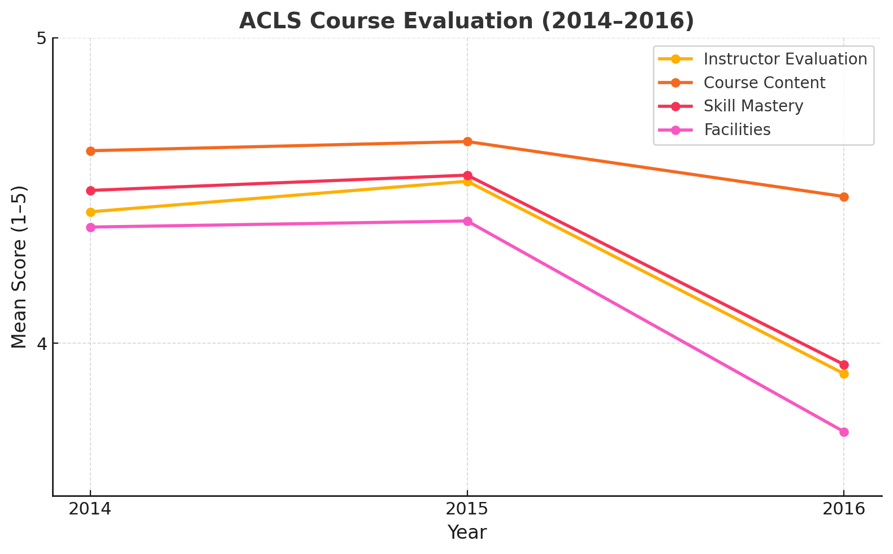
Figure 2: Overall results from the evaluation of ACLS courses (2014–2016)

4.2 EVALUATION OF BLS COURSES (2014–2016)
Basic Life Support (BLS) training programs were evaluated over three consecutive years (2014–2016) using a standardized 23-question feedback survey. The survey covered instructor performance, course content, skill mastery, course facilities, and general participant information. Responses were collected on a five-point Likert scale (1 = strongly disagree to 5 = strongly agree), along with Yes/No and open-ended responses.

4.2.1 Instructor’s Evaluation (Q1–Q4)
Instructor performance was consistently rated very highly in 2014 and 2015, particularly in subject knowledge, clarity, and communication. A moderate decline was observed in 2016.
Year | Overall Performance | Subject Knowledge | Communication | Clarity of Presentation
2014 | 4.55 | 4.61 | 4.56 | 4.57
2015 | 4.60 | 4.65 | 4.60 | 4.61
2016 | 4.54 | 4.55 | 4.49 | 4.45
➡ Trend: Strong and consistent performance in 2014–2015. Scores dipped slightly in 2016, particularly in clarity and communication.
Table 8: Instructor’s evaluation (Q1–Q4) for BLS Courses

4.2.2 Course Content (Q5–Q10)
Course content was highly rated for relevance, objectives, and clarity across all years. 2015 was the strongest year, while 2016 saw slight declines.
Year | Objectives Clear | Relevance | Presentation | Difficulty Appropriate | Materials Quality | Equipment Condition
2014 | 4.66 | 4.69 | 4.66 | 4.54 | 4.69 | 4.53
2015 | 4.68 | 4.70 | 4.69 | 4.57 | 4.68 | 4.53
2016 | 4.54 | 4.52 | 4.53 | 4.45 | 4.50 | 4.41
➡ Trend: Very strong ratings overall, though a slight downward shift appeared in 2016, especially in equipment and presentation quality.
Table 9: Evaluation of Course Content (Q5–Q10) for BLS Courses

4.2.3 Skill Mastery (Q11–Q14)
Participants reported high confidence and preparedness in 2014–2015. In 2016, perceptions of confidence and emergency readiness weakened.
Year | Prepared for Skills | Confidence in Skills | Emergency Response Readiness | Taken for Professional Credit
2014 | 4.60 | 4.62 | 4.62 | 4.54
2015 | 4.64 | 4.64 | 4.64 | 4.60
2016 | 4.42 | 4.41 | 4.40 | 4.34
➡ Trend: Skill mastery remained strong, but ratings dipped across all measures in 2016, showing reduced learner confidence.
Table 10: Evaluation of Skill Mastery (Q11–Q14) for BLS Courses

4.2.4 Course Facility (Q15–Q20)
Facilities, AV aids, and catering were well-rated in 2014–2015 but saw noticeable declines in 2016.
Year | Duration | AV Aids | Delivery Method | Overall Program Rating | Venue Quality | Catering
2014 | 4.53 | 4.62 | 4.59 | 4.61 | 4.59 | 4.23
2015 | 4.58 | 4.64 | 4.63 | 4.65 | 4.58 | 4.28
2016 | 4.38 | 4.44 | 4.43 | 4.43 | 4.36 | 4.17
➡ Trend: 2015 was the best-performing year for facilities. By 2016, ratings slipped, particularly in catering and venue quality.
Table 11: Evaluation of Course Facility (Q15–Q20) for BLS Courses

4.2.5 General Information (Q21–Q23)
Most participants consistently recommended the program and were Dubai Health Authority (DHA) staff. Awareness sources shifted, with “online” and “others” gaining more prominence in 2016.
Year | Would Recommend (%) | DHA Staff (%) | Online (%) | Announcement (%) | Others (%)
2014 | 98.2 | 87.4 | 11.5 | 40.6 | 46.4
2015 | 98.5 | 92.8 | 18.3 | 46.8 | 49.8
2016 | 95.6 | 92.7 | 30.3 | 55.6 | 54.2
➡ Trend: Recommendation rates remained very high across all years, though slightly lower in 2016. Online awareness grew substantially in 2016, signaling a shift in course promotion reach.
Table 12: Evaluation of General Information (Q21–Q23) for BLS Courses

4.2.6 Key Findings
The following key and important findings are derived from the evaluation of BLS courses (2014–2016):
- 2014–2015 were peak years: Ratings were consistently high, averaging 4.5–4.6 across all categories.
- 2016 saw declines: Ratings dipped across instructors, content, skills, and facilities, settling around 4.3–4.4, with learner confidence notably lower.
- Content relevance stayed strong: Despite the declines, course content relevance remained highly valued.
- Recommendation rates remained excellent: Over 95% of participants still endorsed the program.

The overall results for the evaluation of BLS courses between the year 2014 to 2016 are summarized in Table 13 and Figure 3 below.
Category | 2014 | 2015 | 2016 | Trend
Instructor Evaluation | 4.57 | 4.62 | 4.50 | ⬇
Course Content | 4.61 | 4.68 | 4.49 | ⬇
Skill Mastery | 4.60 | 4.63 | 4.39 | ⬇
Course Facility | 4.53 | 4.56 | 4.37 | ⬇
Recommend (%) | 98% | 99% | 96% | ⬇
Table 13: Overall results from the evaluation of BLS courses (2014–2016)

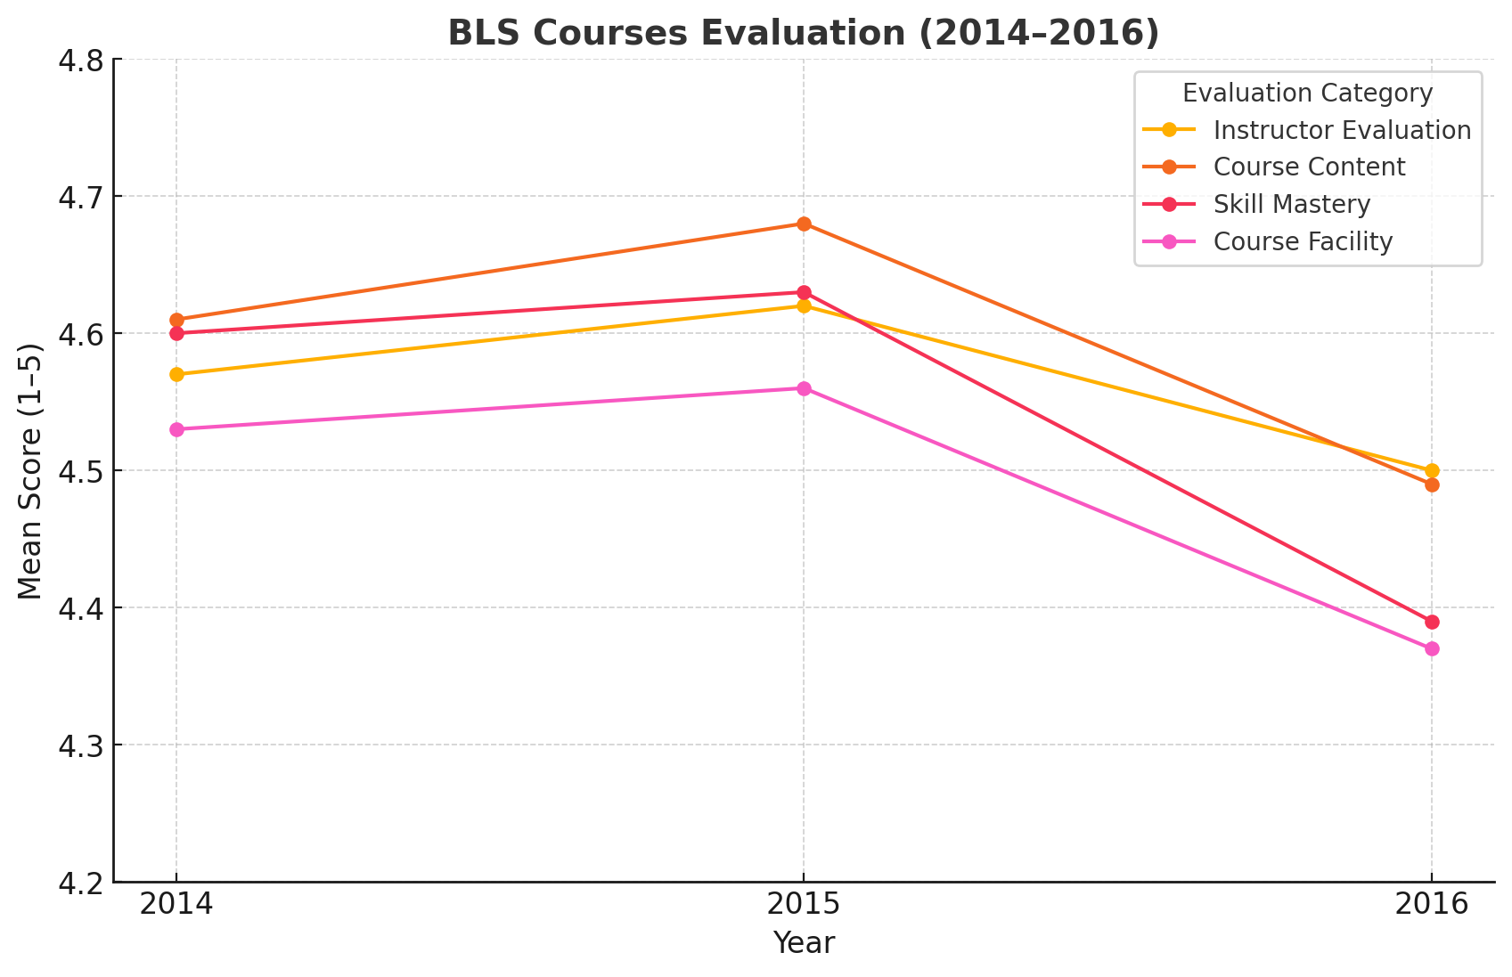
Figure 3: Overall results from the evaluation of BLS courses (2014–2016)

4.3 Evaluation of PALS Courses (2014–2016)
Pediatric Advanced Life Support (PALS) training programs were evaluated over three consecutive years (2014–2016) using a standardized 23-question feedback survey. The survey covered instructor performance, course content, skill mastery, course facilities, and general participant information. Responses were collected on a five-point Likert scale (1 = strongly disagree to 5 = strongly agree), along with Yes/No and open-ended responses.

4.3.1 Instructor’s Evaluation (Q1–Q4)
Instructor ratings were excellent in 2014–2015, but declined in 2016, particularly in knowledge and communication.
Year | Overall Performance | Subject Knowledge | Communication | Clarity of Presentation | Average
2014 | 4.50 | 4.58 | 4.55 | 4.59 | 4.56
2015 | 4.51 | 4.55 | 4.55 | 4.55 | 4.54
2016 | 4.28 | 4.25 | 4.23 | 4.27 | 4.26
➡ Trend: Strong performance in 2014–2015, with a noticeable decline in 2016.
Table 14: Instructor’s evaluation (Q1–Q4) for PALS Courses

4.3.2 Course Content (Q5–Q10)
Course content was highly valued for relevance, clarity, and quality, but ratings dropped slightly in 2016.
Year | Objectives Clear | Relevance | Presentation | Difficulty Appropriate | Materials Quality | Equipment Condition | Average
2014 | 4.60 | 4.66 | 4.59 | 4.44 | 4.50 | 4.21 | 4.50
2015 | 4.56 | 4.58 | 4.56 | 4.43 | 4.54 | 4.24 | 4.48
2016 | 4.55 | 4.52 | 4.59 | 4.45 | 4.43 | 4.36 | 4.48
➡ Trend: 2014 was the strongest year. Ratings held steady in 2015–2016, but equipment quality was consistently rated lower.
Table 15: Evaluation of Course Content (Q5–Q10) for PALS Courses

4.3.3 Skill Mastery (Q11–Q14)
Learners reported strong preparedness and confidence in 2014–2015. In 2016, scores declined, especially in emergency readiness.
Year | Prepared for Skills | Confidence in Skills | Emergency Readiness | Professional Credit | Average
2014 | 4.45 | 4.45 | 4.53 | 4.37 | 4.45
2015 | 4.47 | 4.51 | 4.50 | 4.37 | 4.46
2016 | 4.20 | 4.21 | 4.17 | 4.14 | 4.18
➡ Trend: Strong confidence in 2014–2015, but learner preparedness dipped in 2016.
Table 16: Evaluation of Skill Mastery (Q11–Q14) for PALS Courses

4.3.4 Course Facility (Q15–Q20)
Facilities, AV aids, and catering were well-rated in 2014–2015. By 2016, however, ratings declined across most facility-related items.
Year | Duration | AV Aids | Delivery Method | Overall Rating | Venue Quality | Catering | Average
2014 | 4.16 | 4.35 | 4.42 | 4.47 | 4.44 | 4.17 | 4.34
2015 | 4.24 | 4.39 | 4.42 | 4.50 | 4.32 | 4.09 | 4.33
2016 | 4.08 | 4.08 | 4.14 | 4.18 | 4.15 | 4.10 | 4.12
➡ Trend: Facilities peaked in 2014–2015. In 2016, lower ratings for AV aids and catering pulled down overall facility satisfaction.
Table 17: Evaluation of Course Facility (Q15–Q20) for PALS Courses

4.3.5 General Information (Q21–Q23)
Recommendation rates were very high (>95%) across all years. Most participants were DHA staff. Awareness sources shifted toward online and “other” categories by 2016.
Year | Recommend (%) | DHA Staff (%) | Online (%) | Announcement (%) | Others (%)
2014 | 97.4 | 83.0 | 12.2 | 38.4 | 56.5
2015 | 97.4 | 91.4 | 15.7 | 39.7 | 56.9
2016 | 97.0 | 90.8 | 30.2 | 50.0 | 61.7
➡ Trend: High recommendation rates maintained. Online awareness grew sharply in 2016.
Table 18: Evaluation of General Information (Q21–Q23) for PALS Courses

4.3.6 Key Findings
The following key and important findings are derived from the evaluation of PALS courses (2014–2016):
- 2014–2015 were strong years: Mean scores averaged around 4.4–4.6, showing high satisfaction with instructors, content, and skills.
- 2016 saw declines: Instructor clarity, learner confidence, and facilities dropped to the 4.1–4.2 range, suggesting delivery and logistical challenges.
- Content remained relevant: Despite dips, learners consistently rated PALS topics as highly valuable.
- Recommendation rates stayed excellent: Over 97% of participants endorsed the program each year.

The overall results for the evaluation of PALS courses between the year 2014 to 2016 are summarized in Table 19 below.
Category | 2014 | 2015 | 2016 | Trend
Instructor Evaluation | 4.56 | 4.54 | 4.26 | ⬇
Course Content | 4.50 | 4.48 | 4.48 | ➡
Skill Mastery | 4.45 | 4.46 | 4.18 | ⬇
Course Facility | 4.34 | 4.33 | 4.12 | ⬇
Recommend (%) | 97% | 97% | 97% | ➡
Table 19: Overall results from the evaluation of PALS courses (2014–2016)

4.4 Evaluation of PEARS Courses (2014–2016)
Pediatric Emergency Assessment, Recognition, and Stabilization (PEARS) courses were evaluated over three years (2014–2016) using a standardized 23-question feedback survey. The survey measured instructor performance, course content, skill mastery, course facilities, and general information. Feedback was recorded on a five-point Likert scale (1 = strongly disagree to 5 = strongly agree), with additional Yes/No and open-ended responses.
4.4.1 Instructor’s Evaluation (Q1–Q4)
Instructor ratings were strong in 2014 and 2015 but dipped in 2016, particularly in communication and clarity of presentation.
Year | Overall Performance | Subject Knowledge | Communication | Clarity of Presentation | Average
2014 | 4.44 | 4.54 | 4.50 | 4.49 | 4.49
2015 | 4.42 | 4.45 | 4.43 | 4.44 | 4.44
2016 | 4.10 | 4.12 | 4.08 | 4.11 | 4.10
➡ Trend: High satisfaction in 2014–2015, but instructor evaluations weakened in 2016.
Table 20: Instructor’s evaluation (Q1–Q4) for PEARS courses
4.4.2 Course Content (Q5–Q10)
Content was consistently valued as relevant and clear. However, equipment quality and materials received slightly lower ratings in 2016.
Year | Objectives Clear | Relevance | Presentation | Difficulty Appropriate | Materials Quality | Equipment Condition | Average
2014 | 4.55 | 4.62 | 4.51 | 4.40 | 4.47 | 4.18 | 4.46
2015 | 4.50 | 4.54 | 4.49 | 4.41 | 4.45 | 4.20 | 4.43
2016 | 4.34 | 4.36 | 4.32 | 4.29 | 4.30 | 4.12 | 4.29
➡ Trend: Strong results in 2014–2015, but scores fell across all items in 2016.
Table 21: Evaluation of Course Content (Q5–Q10) for PEARS Courses

4.4.3 Skill Mastery (Q11–Q14)
Learners in 2014–2015 felt confident and well-prepared, but ratings fell in 2016, particularly in emergency readiness.
Year | Prepared for Skills | Confidence in Skills | Emergency Readiness | Professional Credit | Average
2014 | 4.40 | 4.41 | 4.42 | 4.35 | 4.40
2015 | 4.38 | 4.40 | 4.39 | 4.36 | 4.38
2016 | 4.00 | 3.98 | 3.96 | 3.94 | 3.97
➡ Trend: Learner confidence remained high until 2015 but declined in 2016.
Table 20: Evaluation of Skill Mastery (Q11–Q14) for PEARS Courses

4.4.4 Course Facility (Q15–Q20)
Facilities, delivery methods, and AV aids were well-rated in 2014–2015, but overall satisfaction declined in 2016.
Year | Duration | AV Aids | Delivery Method | Overall Rating | Venue Quality | Catering | Average
2014 | 4.20 | 4.30 | 4.35 | 4.39 | 4.28 | 4.12 | 4.27
2015 | 4.18 | 4.29 | 4.33 | 4.35 | 4.26 | 4.08 | 4.25
2016 | 3.89 | 3.92 | 3.94 | 3.95 | 3.90 | 3.87 | 3.91
➡ Trend: Satisfaction with facilities dropped noticeably in 2016, especially in AV aids and catering.
Table 22: Evaluation of Course Facility (Q15–Q20) for PEARS Courses

4.4.5 General Information (Q21–Q23)
Recommendation rates stayed high, with most participants identifying as DHA staff. Online awareness grew significantly in 2016.
Year | Recommend (%) | DHA Staff (%) | Online (%) | Announcement (%) | Others (%)
2014 | 96.8 | 85.2 | 11.0 | 35.5 | 54.5
2015 | 96.5 | 86.0 | 16.8 | 37.2 | 57.3
2016 | 92.3 | 88.7 | 33.5 | 49.0 | 63.2
➡ Trend: Recommendation rates were strong overall but dipped slightly in 2016. Online awareness nearly doubled from 2014 to 2016.
Table 23: Evaluation of General Information (Q21–Q23) for PEARS Courses

4.4.6 Key Findings
The key findings of interest are summarized below:
- 2014–2015 were strong years: Average ratings around 4.3–4.5 showed positive feedback on instructors, course content, and facilities.
- 2016 decline: Scores dropped across all categories, with the sharpest falls in skill mastery and facilities.
- Content remained valued: Despite dips, learners consistently found the course relevant and applicable.
- Recommendations remained high: Over 92% of participants endorsed the program each year.

The overall results for the evaluation of PEARS courses between the year 2014 to 2016 are summarized in Table 24 below.
Category | 2014 | 2015 | 2016 | Trend
Instructor Evaluation | 4.49 | 4.44 | 4.10 | ⬇
Course Content | 4.46 | 4.43 | 4.29 | ⬇
Skill Mastery | 4.40 | 4.38 | 3.97 | ⬇
Course Facility | 4.27 | 4.25 | 3.91 | ⬇
Recommend (%) | 97% | 97% | 92% | ⬇
Table 24: Overall results from the evaluation of PEARS courses (2014–2016)

5 DISCUSSION
Life support training has been shown to significantly improve the knowledge and skills of healthcare professionals and medical students, particularly in delivering high-quality cardiopulmonary resuscitation (CPR) in a timely, effective, and safe manner [13]. Pediatric Basic Life Support (PBLS) courses, in particular, serve as effective platforms for both theoretical and hands-on training [14]. Participation in life support training courses such as ACLS, BLS, PALS, and PEARS contributes to improved technical and non-technical competencies, as well as enhanced scenario-based decision-making skills [15]. Active engagement in these training programs also enhances the understanding and perceived value of course evaluations, which ultimately supports improved CPR outcomes [16].
5.1 Evaluation of ACLS Courses (2014–2016)
The ACLS course evaluations from 2014 and 2015 reflected high participant satisfaction, particularly regarding instructor performance, course content relevance, and learner confidence. However, in 2016, there was a noticeable decline in overall satisfaction, especially in the areas of facility quality, presentation clarity, and preparedness. These findings highlight the need for targeted improvements in instructional delivery methods, audiovisual (AV) support, and logistical planning to restore participant satisfaction to previous levels.
5.2 Evaluation of BLS Courses (2014–2016)
BLS training received consistently high ratings in 2014 and 2015, especially in instructor effectiveness, content delivery, and learner preparedness. However, in 2016, a decline was observed in the same areas, particularly related to learning environment and AV support. This suggests that enhancements in facility management, instructional delivery, and technical infrastructure are necessary to achieve and maintain high participant satisfaction.

5.3 Evaluation of PALS Courses (2014–2016)
Participant feedback on PALS courses in 2014 and 2015 indicated strong satisfaction with instructor performance, course relevance, and learner confidence. In 2016, a decrease in satisfaction was reported, notably in instructor delivery, learner preparedness, and facility support. Addressing these issues—particularly through improved instructor training, reliable AV systems, and optimized logistics—will be essential in regaining prior satisfaction levels.
5.4 Evaluation of PEARS Courses (2014–2016)
The PEARS courses in 2014 and 2015 were highly rated, with participants expressing confidence in the instructors, course clarity, and skills gained. Although PEARS was relatively stable compared to other courses, a slight decline in 2016 was still evident, particularly in relation to facility quality and hands-on preparedness. To maintain the program’s strength, efforts should focus on enhancing instructor consistency, practical skill reinforcement, and AV/facility support.

5.6 Overall Assessment of all Four Courses (2014–2016)
5.6.1 Instructor Evaluation
In 2014 and 2015, instructor performance across all four courses (ACLS, BLS, PALS, and PEARS) was rated highly, with average scores ranging from 4.4 to 4.6. By 2016, a decline in ratings was observed in ACLS, BLS, and PALS, with averages dropping to 3.9–4.2. Although PEARS also experienced a slight decline, it maintained relatively stronger scores. These trends indicate that instructor quality was a key strength in the earlier years, but consistency in instructional delivery weakened in 2016, warranting targeted faculty development and standardization efforts.
5.6.2 Course Content
Course content was consistently rated as relevant, clear, and well-organized throughout the study period, with average scores remaining steady at 4.4–4.6. Participants consistently appreciated the structure and relevance of the theoretical material. However, some minor concerns were noted regarding equipment quality and supporting materials, particularly in the PALS and PEARS courses. Importantly, the decline in satisfaction observed in 2016 appears to have been driven not by the content itself, but by issues related to its delivery.
5.6.3 Skill Mastery
Self-reported learner confidence and preparedness were strong in 2014 and 2015, particularly in ACLS and PALS, where average scores exceeded 4.4. In 2016, these scores declined across all courses, with averages falling to 3.9–4.2. This drop suggests a reduction in the effectiveness of hands-on training and skills transfer, pointing to potential gaps in practical exercises, simulation fidelity, or instructor support during skills sessions.
5.6.4 Course Facilities
Course facilities—including training venues, audio-visual (AV) aids, and catering—were rated positively in 2014 and 2015, with average scores around 4.3–4.4. However, in 2016, satisfaction levels dropped significantly, with means ranging from 3.7 to 4.1. The most frequent complaints were related to AV equipment quality and catering services. These findings indicate that logistical and environmental factors became key sources of dissatisfaction and should be prioritized for improvement.
5.6.5 General Information
Despite the noted declines in specific evaluation categories during 2016, overall participant satisfaction remained high. Recommendation rates across all four courses consistently exceeded 90–97%, reflecting continued trust and endorsement from attendees. The majority of participants were DHA staff, demonstrating strong internal uptake of the training programs. Notably, by 2016, awareness of the courses increasingly came through online channels and other informal sources, highlighting the evolving role of digital communication in program promotion.

5.7 Key Takeaways
The following are crucial points to be considered:
- High Satisfaction in 2014–2015: All four resuscitation courses (ACLS, BLS, PALS, PEARS) received strong evaluations, reflecting high participant satisfaction with instructor quality, course content, and facilities.
- Performance Decline in 2016: A noticeable drop in satisfaction was observed in 2016, particularly in ACLS, BLS, and PALS, with decreased ratings in instructor delivery, learner confidence, and logistical support.
- PEARS as a Model Course: PEARS consistently maintained high ratings across all years, suggesting greater stability in course delivery and learner experience.
- Focus Areas for Improvement: Key areas needing attention include instructor clarity, learner preparedness, facility quality, and audio-visual (AV) support.
- Strategic Recommendations:
- Enhance instructor training and consistency.
- Adopt and scale best practices from the PEARS program.
- Upgrade training facilities and AV systems.
- Increase hands-on simulations and scenario-based learning.
- Expand digital outreach and communication channels.
- Implement continuous quality monitoring and feedback mechanisms.

5.8 Future Implications
Improving the evaluation process of life support training programs is essential to ensure continued relevance, effectiveness, and participant satisfaction. Previous literature [17] emphasizes several key strategies to enhance the quality and impact of educational evaluations:
- To minimize potential bias, feedback should be collected from multiple stakeholder groups, including learners, instructors, and healthcare professionals across various disciplines.
- Evaluation results should be communicated transparently to participants, along with information about any actions taken in response.
- Learners should perceive the evaluation process as respectful of their time and contributions.
- Evaluators must act on findings to address deficiencies, update content, and improve delivery methods.
- The evaluation process should be conducted regularly and integrated as a continuous quality improvement cycle.

Based on our data and findings, we propose the following generalizable implications for future practice:
- Continuous Quality Monitoring: Ongoing evaluation and real-time feedback mechanisms are essential to detect and address declines in participant satisfaction, such as those observed in 2016 for ACLS, BLS, and PALS.
- Instructor Development: Targeted training for instructors—particularly in communication, presentation clarity, and learner engagement—can directly improve course outcomes and learner confidence.
- Facility and AV Investment: Upgrading audio-visual tools, simulation equipment, and training environments will be critical in maintaining high standards and meeting learner expectations.
- Adapting Successful Models: The consistently strong performance of the PEARS course suggests a resilient and effective delivery model that could be studied and adapted to enhance other programs.
- Digital Engagement: The observed shift in course awareness toward online and alternative sources by 2016 underscores the importance of expanding digital marketing, registration, and information-sharing strategies to reach a broader audience.
Together, these measures can help institutions like the Dubai Health Authority sustain the effectiveness of their resuscitation training programs and ensure alignment with international best practices in medical education.

5.9 Limitations
We found certain limitations in our study as mentioned below:
- Data relies on self-reported feedback, which may reflect participant perceptions rather than actual skill acquisition.
- The Likert scale measures satisfaction but does not capture long-term retention or performance in real clinical settings.
- Declines in 2016 could be influenced by external factors (organizational changes, resource allocation, instructor turnover) that were not captured in the survey.
- Open-ended responses were included but not deeply analyzed, which may have provided richer context for the ratings.
- Results are specific to the Dubai Health Authority setting and may not be generalizable to other institutions or regions.

5.10 Recommendations
Based on the findings of this evaluation, several actionable recommendations are proposed to enhance the effectiveness and sustainability of life support training programs. These recommendations draw on both participant feedback and observed trends from 2014 to 2016:
Strengthen Instructor Training:
Implement regular refresher courses and ongoing professional development for instructors, with a focus on improving communication skills, instructional clarity, and learner engagement.
Enhance Facilities and AV Support:
Upgrade audiovisual equipment and ensure training venues are consistently well-equipped and comfortable. Improved logistical coordination is essential to prevent the dissatisfaction noted in 2016.
Adopt Best Practices from PEARS:
Given the consistently high ratings for the PEARS course, its instructional strategies, course structure, and delivery methods should be reviewed and selectively integrated into ACLS, BLS, and PALS programs.
Boost Learner Confidence:
Incorporate additional hands-on simulation exercises, scenario-based assessments, and structured feedback sessions to strengthen practical skills and reinforce learner preparedness for real-world emergencies.
Leverage Digital Outreach:
Expand the use of online platforms for course promotion, registration, and communication, in response to the growing number of participants who became aware of courses through digital channels in 2016.
Implement Continuous Quality Monitoring:
Establish annual audits of course delivery, evaluation outcomes, and participant feedback to enable early detection of issues and ensure ongoing quality improvement.
Integrate Open-Ended Feedback:
Complement quantitative evaluations with qualitative analysis of open-ended responses to capture deeper insights into learner experiences and identify areas for refinement not evident through rating scales alone.

6. CONCLUSION
A well-executed evaluation process is essential for improving educational programs, particularly in healthcare training, where the stakes are high and the outcomes directly impact patient care. While debates continue regarding the value of evaluation, its role remains undeniable—just as medical diagnoses cannot be dismissed despite the existence of unresolved diseases, evaluation must remain integral to educational and training efforts. Although knowledge in the field of program evaluation has grown substantially, there remains a significant gap between what we currently understand and what is required for optimal impact. Properly conducted evaluations leave a lasting imprint, driving improvements in both program design and delivery.
This study demonstrated that during 2014–2015, resuscitation training programs at the Dubai Health Authority—namely ACLS, BLS, PALS, and PEARS—achieved high satisfaction ratings, averaging between 4.4 and 4.6. These results reflected strong instructor performance, relevant course content, high levels of learner confidence, and well-supported facilities. However, a notable decline in evaluation scores was observed in 2016, particularly in ACLS, BLS, and PALS. This decline was most apparent in areas such as instructor clarity, learner preparedness, and training facilities. PEARS, however, remained a consistently strong performer, even showing marginal improvement in some areas during the same period.
These findings highlight the need for ongoing quality assurance in life support training programs. Specific areas for improvement include strengthening instructor training and consistency, enhancing AV and facility support, and increasing hands-on, scenario-based learning opportunities. Despite the observed challenges, recommendation rates remained high throughout, indicating sustained trust in the value of these programs.
To ensure long-term effectiveness, institutions must embrace continuous monitoring, adopt best practices from high-performing courses like PEARS, and remain responsive to participant feedback. A strong, evidence-based evaluation framework is not only a tool for measurement but a vital mechanism for meaningful, lasting improvement in healthcare education.

COMPETING INTERESTS DISCLAIMER:
Authors have declared that they have no known competing financial interests OR non-financial interests OR personal relationships that could have appeared to influence the work reported in this paper.

REFERENCES
- http://www.heart.org/HEARTORG/ (last accessed May 03, 2025)
- Fitzpatrick JL, Sanders JR, Worthen BR. Program evaluation: alternative approaches and practical guidelines. 3rd ed. Boston (MA): Pearson Education Inc.; 2004. p.5.
- http://www.acrnetwork.org/evaluation.htm (last accessed 8/7/2012)
- A framework for program evaluation. Office of the Associate Director for Program. CDC. https://www.cdc.gov/evaluation/php/evaluation-framework/index.html (Last accessed May 03, 2025)
- Anderson S B, Ball S (1978). The Profession and Practice of Program Evaluation. Jossey-Bass. San Francisco, California.
- Mehrens, W.A. (1991). Measurement and evaluation in education and psychology. 4th ed. Newyork.
- Goldie J. 2006. AMEE Education Guide no. 29: Evaluating educational programmes. Med Teacher 28:210-224.
- Jody L.Fitzpatrick, James R.Sanders, Blaine R.Worthen. (2004). Program Evaluation: Alternative Approaches and Practical Guidelines. (3rd ed). Pearson Education, Inc. (p 152-165).
- Daniel L. Stufflebeam. (1999). Foundational Models for 21st Century Program Evaluation. The Evaluation Center, Occasional Papers Series, University. Western Michigan. Canada.
- P. BLUMBERG & E. J. DEVEAU. (1995). Using a practical program evaluation model to chart the outcomes of an educational initiative: problem-based learning. Medical Teacher, Vol. 17(2). p205 - 214.
- Kirkpatrick D. 1996. Revisiting Kirkpatrick’s four-level model. Train Dev. 50(1):54–59.
- Sanders, J.R. (1983). Cost implications for the standards. In M.C. Alkin, L.C. Solmam (Eds). The cost of evaluation. Beverly Hills. CA: Sage.
- Afzalimoghaddam M, Talebideloi M, Talebian MT, Farahmand Sh. Evaluation of the Effectiveness of Basic Life Support Training on the Knowledge and Skills. Patient Saf Qual Improv. 2014; 2(2):73-76.
- Aparicio, P. et al. Evaluation of Medical Students in the Training of Paediatric Life Support – A Spanish. Perspective Journal of Emergency Primary Health Care (JEPHC), Vol 1, Issue 3-4, 2003
- Emine Vatansever, Nilüfer Demiral Yilmaz, Zeynep Sofuoglu. EVALUATION OF THE ADVANCED TRAUMA LIFE SUPPORT COURSE DESIGNED BASED ON A TEAMWORK APPROACH. Cilt 15, Sayı 47 (2016)
- Kanwalpreet Sodhi, Manender Kumar Singla, Anupam Shrivastava. Impact of advanced cardiac life support training program on the outcome of cardiopulmonary resuscitation in a tertiary care hospital. Indian J Crit Care Med. 2011 Oct-Dec; 15(4): 209–212.
- Snell I, Tallet S, Haist S, Hays R, et al. A review of the evaluation of clinical teaching: new perspectives and challenges. Med Educ 2000; 34:862-70.

