Case report

Uncommon clinical features of lower lip squamous cell carcinoma in an elderly woman

.
ABSTRACT

Introduction: Lip squamous cell carcinoma (LSCC) of the lower lip is the most common malignant neoplasm in the oral region, strongly associated with chronic sun exposure. Case Report: A 73-year-old woman presented with a persistent ulcer on the lower lip lasting two years. Clinical examination revealed a crusted nodule with discoloration and changes in the vermilion border. Histopathological analysis showed high-grade epithelial dysplasia, solar elastosis, and islands of neoplastic epithelial cells, findings consistent with LSCC. Following oncologic therapy referral, the patient remains in follow-up care with no recurrence and a favorable esthetic outcome. Conclusion: Early diagnosis and close monitoring of potentially malignant oral disorders are critical steps in reducing disease complications and improving quality of life, especially in elderly patients.

Keywords: Squamous Cell Carcinoma, Lower Lip, Actinic Cheilitis, Oral Cancer

1. INTRODUCTION

Lip squamous cell carcinoma (LSCC) of the lower lip is the most prevalent malignant neoplasm in the oral region, accounting for approximately 90% of oral cancers diagnosed at this site [1,2]. Its development is strongly associated with chronic ultraviolet (UV) radiation exposure, particularly among fair-skinned individuals and those with outdoor occupations [3,4].

As the population ages, it becomes increasingly important to investigate and establish care strategies for potentially malignant oral disorders (PMODs), such as leukoplakia, erythroplakia, oral lichen planus with dysplasia, and oral submucous fibrosis. Among potentially malignant disorders, actinic cheilitis is notably common in older adults. [2,5,6,12].

Actinic cheilitis results from cumulative UV-induced damage and is recognized as the primary precursor lesion for LSCC, preceding approximately 95% of cases. These lesions carry a heightened risk of malignant transformation, particularly in individuals over 60 years of age due to increased exposure to carcinogens and age-related immune changes [4,5,12].

Literature indicates that most PMODs may go unnoticed or be misdiagnosed as chronic inflammatory processes, delaying appropriate referral to specialists. In the elderly, this is exacerbated by reduced regenerative capacity and the presence of comorbidities that complicate clinical management [6,12]. While LSCC is potentially curable if diagnosed early, it can behave aggressively, with local invasion and metastatic potential in neglected or immunocompromised cases [2,5,6].

Due to its often subtle clinical presentation, early detection can be challenging, contributing to delayed diagnosis [3,9]. However, early diagnosis and complete surgical removal with clear margins are associated with excellent prognosis [7,8]. Regular screening, education on sun protection, routine dental evaluations, and timely referral to specialists are essential strategies for preventing LSCC and promoting oral health in older adults [7,11,12].

This report presents a case of lower LSCC in an elderly woman with clinical history suggestive of progression from actinic cheilitis and discusses its clinical and pathological features in the context of current literature.

2. CASE REPORT

A 73-year-old woman with a history of a two-year non-healing ulcer on her lower lip experienced nodular growth over two months. During the interview, she denied smoking and alcohol consumption but revealed sun exposure for her whole life with no sunscreen protection. We observed a painless nodule located in the lower lip nodule with approximately 1.8 × 1.5 × 0.4 cm in size, grayish in color, with a crusted surface, discoloration, and blurring of the adjacent vermillion border (Figure 1A; 1B).

Following the incisional biopsy, the histopathological examination revealed a dysplastic surface epithelium, exhibiting high-grade epithelial dysplasia. The underlying stroma displayed superficial cords or islands of malignant squamous epithelial cells (Figure 2A). In other areas a mild inflammatory infiltrate, and basophilic degeneration of collagen, known as solar elastosis was observed (Figure 2B). These findings were compatible with lip squamous cell carcinoma (LSCC). We referred the patient for total removal of the lesion and assessed regional lymph node screening, but the results were negative.

These findings confirmed the diagnosis of LSCC. The patient was referred for complete lesion excision and regional lymph node evaluation, which returned negative for metastasis. After confirming the diagnosis, the patient underwent oncologic treatment. At 12-month follow-up, she remains recurrence-free and in good general condition. (Figure 3)

3. discussion

The chronic ultraviolet radiation exposure, particularly in people with light skin phototypes, is the key risk factor for actinic cheilitis (AC), na oral potentially malignant disorder (OPMD) typically seen in middle-aged people with fair skin. Demographic factors such as age over 40 and male gender increase the risk. Lifestyle factors such as smoking and alcohol intake can also increase the risk of developing AC. Studies showed that the use of sunscreen creams and hats is not effective in reducing the development of AC. [13,14].

LSCC, a subtype of oral cancer, impacts the vermilion area of the lower lips. Approximately 95% of LSCC cases may be preceded by AC. The World Health Organization (WHO) indicates that LSCC is among the most prevalent malignant lesions in the head and neck area. Lower lip squamous cell carcinoma is significantly associated with environmental factors, especially prolonged sun exposure. AC is acknowledged as the principal precursor lesion [1,3,4]. Actinic cheilitis may be clinically underestimated, manifesting as atrophic, whitish, fissured, or crusted regions [4,10,13,14].

Biopsy is the gold standard for diagnosing persistent lesions [3,9]. The histopathological features observed in this case—high-grade dysplasia, solar elastosis, and malignant squamous cells—are classic findings in lip SCC [4,5,10].
The main treatment modalities include surgical excision, radiation, and chemotherapy. Immunotherapy and targeted molecular treatments are emerging therapeutics that show enormous promise. Early detection and treatment result in a better prognosis, whereas advanced-stage cases have poorer outcomes. [7,8,11].
The five-year survival rate exceeds 90% in early-stage cases, although local recurrence may occur, requiring long-term monitoring [6,11].

In elderly patients, such as in this case, clinical management demands extra caution. Age-related immune changes, reduced tissue repair capacity, and comorbidities may influence both disease progression and response to therapy [5,6]. Moreover, older patients may have limited risk perception or access to healthcare services, increasing the likelihood of late diagnosis. Thus, continuous clinical monitoring with periodic reassessment is essential to detect recurrence or new potentially malignant lesions [10,12].

Health education directed at the elderly population is also vital. Patients should be instructed to recognize suspicious clinical signs and understand the importance of sun protection, adequate lip hydration, and periodic evaluations of persistent lesions. Multidisciplinary care—including dental surgeons, geriatricians, and dermatologists—can enhance outcomes and improve patients' quality of life and cancer prognosis [6,7,12].

The prognosis is closely tied to early detection, underscoring the importance of awareness, education, and preventive measures focused on lip health and sun protection [7,12].

5. Conclusion

Lower lip squamous cell carcinoma is a potentially curable malignancy if diagnosed early. Its development from actinic cheilitis, an OPMD, requires vigilance regarding initial clinical signs, particularly in elderly patients with a history of sun exposure. Regular skin examinations and prompt attention to any changes in the lips or surrounding areas can significantly improve outcomes. Additionally, educating patients about sun protection and self-monitoring may help in early detection and prevention of progression. This case illustrates the importance of early diagnosis, accurate histopathological evaluation, and appropriate surgical management.

Consent

"All authors declare that ‘written informed consent was obtained from the patient (or other approved parties) for publication of this case report and accompanying images. A copy of the written consent is available for review by the Editorial office/Chief Editor/Editorial Board members of this journal."

References

1. Silva LVO et al. Demographic and Clinicopathologic Features of Actinic Cheilitis and Lip Squamous Cell Carcinoma: a Brazilian Multicentre Study. Head Neck Pathol. 2020 Dec;14(4):899–908. doi: 10.1007/s12105-020-01142-2. Epub 2020 Feb 2019.
2. Effiom OA, Adeyemo WL, Soyele OO. Oral squamous cell carcinoma: a clinicopathologic review of 233 cases in Lagos, Nigeria. World J Surg Oncol. 2018;16(1):1–8.
3. Gutiérrez-Trujillo G, Delgado Ríos MA, Segura Sampedro JJ. Squamous cell carcinoma of the lip: early diagnosis and treatment. Cir Plást IberoLatinoam. 2017;43(4):425–431.
4. Piña-Vázquez C, Martín-Pérez MA. Chronic actinic cheilitis: clinical, histological and therapeutic review. Rev Méd Clín Condes. 2020;31(2):172–179.
5. D’Souza J, Garcia J. Epidemiology and pathogenesis of cutaneous squamous cell carcinoma. Clin Dermatol. 2019;37(3):226–231.
6. Dias FL, Kligerman J, Matos CE, et al. Prognostic factors in patients with squamous cell carcinoma of the oral cavity. Head Neck. 2004;26(1):31–38.
7. Oliveira DT, et al. Prognostic factors in lip squamous cell carcinoma: a retrospective study of 108 cases. J Oral Maxillofac Surg. 2006;64(7):1130–1136.
8. Souza LLS, et al. Squamous cell carcinoma of the lower lip: case report and literature review. Braz J Dev 2019;5(9):15130–15140.
9. Silva ESA, et al. Squamous cell carcinoma of the lower lip: analysis of 100 cases. Rev Bras Otorhinolaryngol. 2010;76(5):565–570.
10. Araújo ALD, et al. Actinic queilite: literature review and clinical case report. Braz J Otorhinolaryngol. 2012;78(4):130–134.
11. Tarsitano A, Pizzigallo A, Giorgini FA, et al. Early-stage oral cancer: prognostic markers and treatment outcomes. Oral Oncol. 2020;104:104632.
12. Migliari DA, Sugaya NN. Actinic cheilitis: clinical and histopathologic features. J Oral Maxillofac Surg. 2001;59(3):273–277.
13. El-Naggar AK, Chan JKC, Takata T, Grandis JR, Slootweg PJ. The fourth edition of the head and neck World Health Organization blue book: editors’ perspectives. Human Pathology [Internet]. 2017 Jun 3;66:10–2.
14. De Oliveira Silva LV, De Arruda JAA, Abreu LG, Ferreira RC, Da Silva LP, Pelissari C, et al. Demographic and Clinicopathologic Features of Actinic Cheilitis and Lip Squamous Cell Carcinoma: a Brazilian Multicentre Study. Head and Neck Pathology [Internet]. 2020 Feb 19;14(4):899–908.
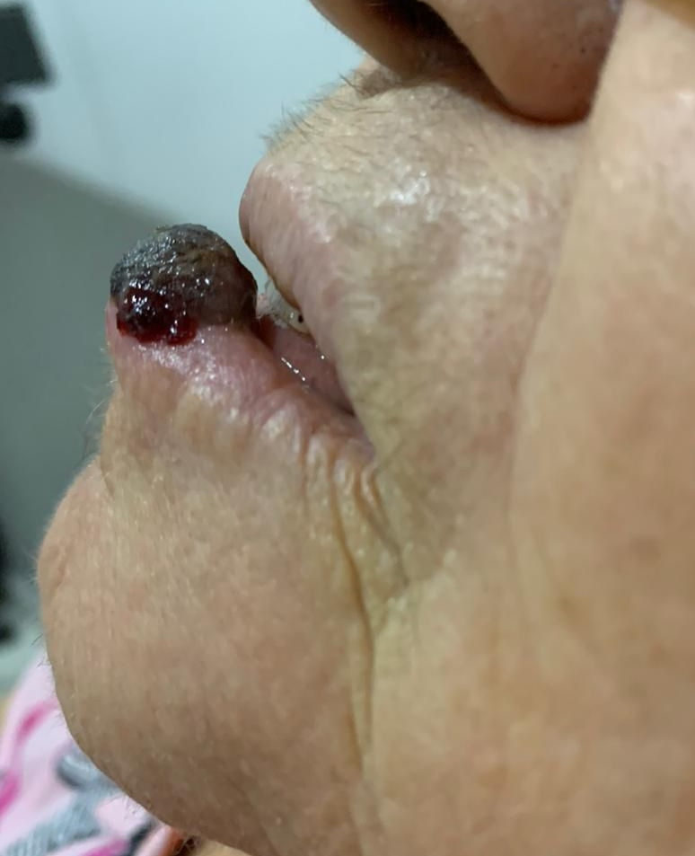

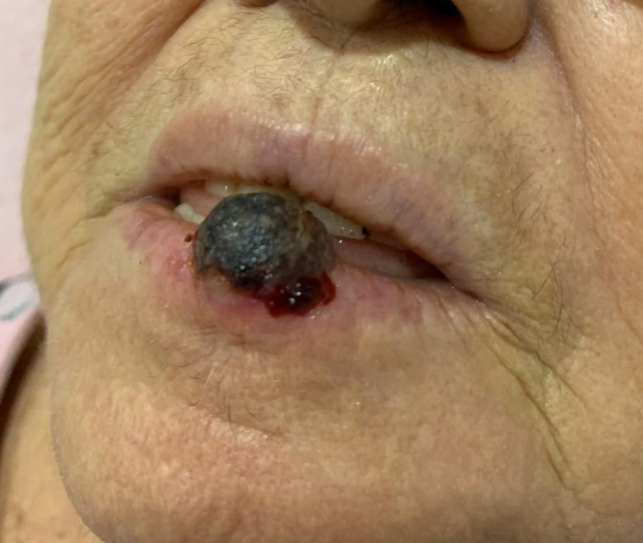
(Figure 1A: 1B)-
Figure 1- lower lip squamous cell carcinoma in an elderly woman

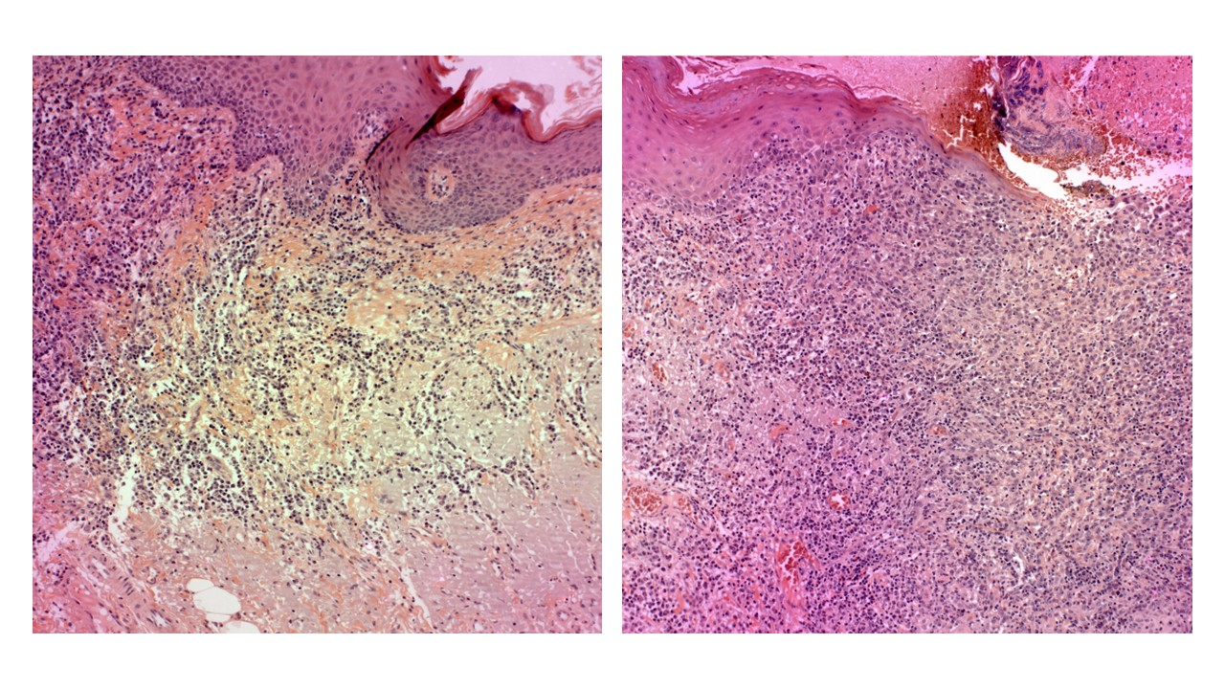(Figure 2A: 2B)
Figure 2- 2A: The underlying stroma displayed superficial cords or islands of malignant squamous epithelial cells, 2B: along with a mild inflammatory infiltrate, and basophilic degeneration of collagen, known as solar elastosis was observed
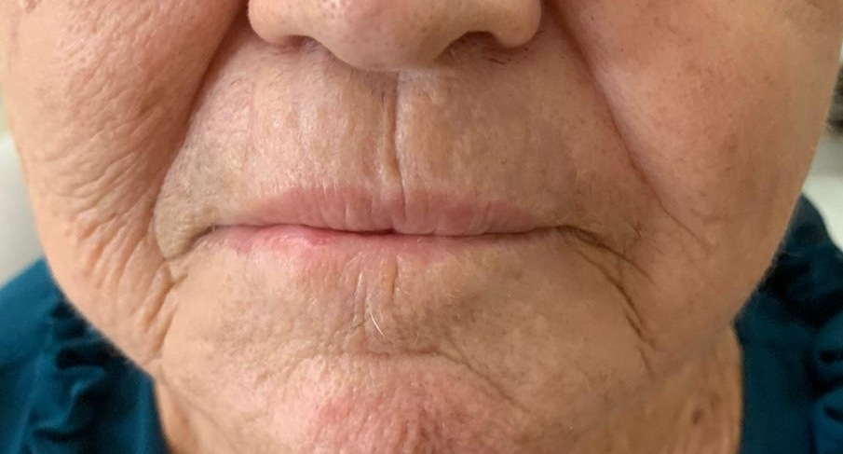
(Figure 3)- After the surgery for lower lip squamous cell carcinoma

