Original Research Article

Nephrology and palliative care: bibliometric analysis and visual mapping of the 50 most cited articles

ABSTRACT
Objective: Bibliometric analysis allows for an objective evaluation of studies in a specific research field and has become an essential tool in metascience. Based on this premise, this manuscript aims to analyze the intersection of nephrology and palliative care. Introduction: The incidence of chronic kidney disease (CKD) is increasing, particularly in countries with low socioeconomic indicators, where the consequences are more complex. Given the significant burden of symptoms, comorbidities, and mortality associated with CKD, the principles of palliative care are important in clinical practice. However, there are still challenges that need to be addressed. Methods: In April 2024, the 50 most cited articles were extracted from the SCOPUS (Elsevier) database, followed by an analysis of relevant variables to understand the scientific production in this area. Results: The ten most cited articles represent 54.08% of total citations, and ten journals contribute 92.12% of all citations. English-speaking countries, particularly the United States of America, receive the highest citation counts. Nearly all published articles and citations originate from high-income countries. Conclusion: Integration of palliative care in nephrology is still an incipient and developing field, with low-income countries being underrepresented despite a higher prevalence of comorbidities in their populations.

Keywords: nephrology; integrative palliative care; bibliometrics.

INTRODUCTION

Since the beginning of its theoretical development, renal support care has primarily focused on improving the quality of life for individuals with chronic kidney disease (CKD). Integrating palliative care principles into the management of these patients represents an important clinical challenge. It requires a careful balance of the benefits and adverse effects of renal replacement therapies, effective symptom control, and shared decision-making involving the patients and their family (1). According to the “KDIGO 2024 Clinical Practice Guideline for the Evaluation and Management of Chronic Kidney Disease”, the incidence of CKD is increasing, presenting a global health challenge, particularly in low-income countries. These regions face substantial limitations in healthcare services, which significantly impact the Disability-Adjusted Life Years (DALYs) of this population (2).

This context reinforces the significance of palliative care in the clinical follow-up of patients with CKD due to their symptom burden, severe comorbidities, and increased mortality in advanced stages of disease, although the effective implementation still encounters obstacles (3). Among these are the difficulty of comprehending the prognosis, the lack of educational training for specialists, and the reluctance of both the health team and patients to initiate discussions about palliative care (4,5). The scenario has negative consequences. For example, the standard choice of dialysis, for situations that will not necessarily be improved by the method, results in patients' regrets after the treatment begins. Additionally, the end-of-life care provided is usually incompatible with their preferences (4,6).

With the high number of scientific publications in the last decades, metascience has emerged as an essential method for comprehending different areas of research over time (7). Bibliometric analysis is a methodological tool based on quantitative data to evaluate the impact and relevance of publications across various fields of study (8). In this manuscript, we aim to describe the characteristics of the most influential articles that focus on the intersection of nephrology and palliative care.

METHODS

In April 2024, a search [(“nephrology”) AND (“palliative care”)] in the SCOPUS (Elsevier) database produced 278 results. These documents were limited to articles as the document type and English as the publication language, reducing the count to 159 documents, which were then ranked in descending order by the number of citations. Subsequent analysis of the titles and abstracts allowed the selection of the 50 most cited articles relevant to the research strategy, followed by the extraction of variables for analysis.
The data provided by the correspondent author, considered the last author of the articles in this analysis, was used to define the country of origin. If information from the corresponding author was unavailable for definitions, data from the first author was used. Impact factors of 2022 and 5-year impact factors were collected from the Incites Journal Citation Reports (JCR - Clarivate Analytics). RGXP and ADA independently analyzed the guiding theme, with the senior author (LLAN) resolving classification disagreements. Country income classifications were extracted from the World Bank (World Bank Country and Lending Groups – World Bank Data Help Desk). Bibliometric maps were created using VOSViewer software (Ness Jan van Eck and Ludo Waltman - Centre for Science and Technology Studies, Leiden University).

BIBLIOMETRIC MAPS INTERPRETATION
They are visual representations of the relationships between different items (authors, keywords, countries…), and in every map, only one type of item is displayed. Each node represents a single item, with its size indicating the item's importance in the map, while proximity between nodes shows the degree of their relationship. Links connect nodes to indicate specific relationships, and the thickness of each link reflects the intensity of the relationship. Nodes are grouped into clusters based on their relationships and highlighted with different colors (9).

RESULTS
The articles analyzed showed a mean of 70.78 ± 82.80 citations, with a minimum of 16 and a maximum of 503. The 10 most cited ones concentrated 54.08% of the total citations (N = 1914 / 3539 citations). The United States of America had the largest number of articles and citations (50%; N = 5/10 articles; 42.26%; N = 809 / 1914 citations). Fliss E. M. Murtagh stands out as the first author of 3 articles in the 10 most cited ones, contributing a total of 622 citations. The most cited article in this research area is based on primary data and was published in the Clinical Journal of the American Society of Nephrology in 2010, authored by Sara N. Davison, and received 503 citations (Table 1).

Table 1 – The 10 most cited articles
First Author | Title | Year | Journal | Country | Citations
Davison, S.N. | End-of-life care preferences and needs: Perceptions of patients with chronic kidney disease. | 2010 | Clinical Journal of the American Society of Nephrology | Canada | 503
Moss, A. H. | Utility of the surprise question to identify dialysis patients with high mortality. | 2008 | Clinical Journal of the American Society of Nephrology | USA | 279
Murtagh, F.E.M. | Symptoms in advanced renal disease: A cross-sectional survey of symptom prevalence in stage 5 chronic kidney disease managed without dialysis. | 2007 | Journal of Palliative Medicine | United  Kingdom | 220
Brown, M. A. | CKD in elderly patients managed without dialysis: survival, symptoms, and quality of life. | 2015 | Clinical Journal of the American Society of Nephrology | Australia | 178
Weisbord, S. D. | Symptom burden, quality of life, advance care planning, and the potential value of palliative care in severely ill haemodialysis patients | 2003 | Nephrology Dialysis Transplantation | USA | 173
Holley, J.L. | The need for end-of-life care training in nephrology: National survey results of nephrology fellows. | 2003 | American Journal of Kidney Diseases | USA | 154
Combs, S.A. | Update on end-of-life care training during nephrology fellowship: A cross-sectional national survey of fellows. | 2015 | American Journal of Kidney Diseases | USA | 108
Murtagh, F.E.M. | Supportive care: Comprehensive conservative care in end-stage kidney disease. | 2016 | Clinical Journal of the American Society of Nephrology | South Africa | 102
Murtagh, F.E.M. | Trajectories of illness in stage 5 chronic kidney disease: A longitudinal study of patient symptoms and concerns in the last year of life. | 2011 | Clinical Journal of the American Society of Nephrology | United Kingdom | 102
Schell, J.O. | Communication skills training for dialysis decision-making and end-of-life care in nephrology. | 2013 | Clinical Journal of the American Society of Nephrology | USA | 95
Source: created by the authors
Eighteen different journals are represented among the 50 publications, and the 10 most cited ones account for nearly the total number of articles and citations (84%; N = 42 / 50 articles; 92.12%; N = 3261 / 3539 citations). 5-year impact factors presented a mean of 4.40 ± 2.64, with a minimum of 1.7 and a maximum of 9.9. The Hong Kong Journal of Nephrology and the EDTNA-ERCA Journal were excluded from this analysis due to the lack of data in the JCR database. The most prolific journal was the Clinical Journal of the American Society of Nephrology, which published 15 articles that garnered a total of 1673 citations, and 6 of these articles are in the 10 most cited in this research field (Table 2).

Table 2 - The 10 most cited journals
Journal | Number of articles | Number of citations | Impact Factor 2022 | 5-year Impact Factor
Clinical Journal of the American Society of Nephrology | 15 | 1673 | 9.8 | 9.9
American Journal of Kidney Diseases | 9 | 651 | 13.2 | 9.9
Journal of Palliative Medicine | 6 | 329 | 2.8 | 3
Nephrology Dialysis Transplantation | 2 | 206 | 6.1 | 5.8
Renal Failure | 1 | 87 | 3 | 2.8
Nephrology | 1 | 69 | 2.5 | 2.4
Journal of Pain and Symptom Management | 2 | 68 | 4.7 | 4.8
Journal of Renal Care | 2 | 67 | 1.9 | 1.7
Palliative Medicine | 2 | 57 | 4.4 | 5.5
BMC Palliative Care | 2 | 54 | 3.1 | 3.7
Source: created by the authors.
The Shapiro-Wilk test was used to evaluate the normality of the variables: 5-year impact factor (p < 0.01), number of citations (p < 0.01), and number of articles (p < 0.01). To analyze the correlation among these variables, Spearman’s rank correlation coefficient was used. The results demonstrated a moderated positive correlation between the 5-year impact factor and the number of articles (rs = 0.5509; p = 0.0269; n = 16). However, there was no statistically significant correlation between the 5-year impact factor and the number of citations (rs = 0.3935; p = 0.1315; n = 16).

Figure 1 – Correlation between the 5-year impact factor and number of citations (A) and articles (B).

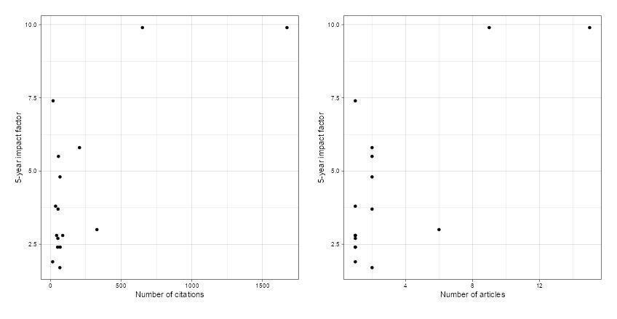
Source: created by the authors.
Ten countries across five continents are affiliated with the 50 articles. America, represented exclusively by North America, concentrates the highest number of articles (31) and citations (2352). The USA has absolute domination with 28 articles and 1749 citations that represent 56% and 49.42% of the total articles and citations, respectively. The second most cited country is Canada, with 3 articles and 603 citations (Table 3). And, although Hong Kong is not recognized as an independent entity by the World Bank, we included it in our analysis individually due to its economic influence.

High-income countries demonstrated to be the most productive, accounting for nearly the total number of articles and citations (98%; N = 49 / 50 articles; 97.11%; N = 3437 / 3539 citations). The only upper-middle-income country is South Africa, which has 102 citations. There were no articles from lower-middle-income or low-income countries.

Table 3 – Citations and number of articles by geographic distribution

Region | Number of articles (% of total) | Number of citations (% of total)
North America | 31 (62%) | 2352 (66.45%)
United States of America | 28 | 1749
Canada | 3 | 603
Europe | 12 (24%) | 720 (20.34%)
United Kingdom | 8 | 578
Switzerland | 1 | 53
Netherlands | 1 | 44
Spain | 1 | 27
Sweden | 1 | 18
Oceania | 4 (8%) | 303 (8.56%)
Australia | 4 | 303
Africa | 1 (2%) | 102 (2.88%)
South Africa | 1 | 102
Asia | 2 (4%) | 70 (1.97%)
Hong Kong | 2 | 70

Source: created by the authors.
The articles were published in 17 different years from 2000 to 2021. The mean number of articles per year of publication is 2.94 ± 1.91, with a maximum of 8 and a minimum of 1. 2016 is the year with the highest number of publications (8), followed by 2007 and 2017, each with 5 articles. The mean of citations per year is 208.17 ± 159.99, with a maximum of 530 and a minimum of 19. The year with the highest number of citations was 2010, with 530 citations, followed by 2007 with 444 and 2015 with 363 (Figure 2).

Figure 2 – Number of articles by year of publication
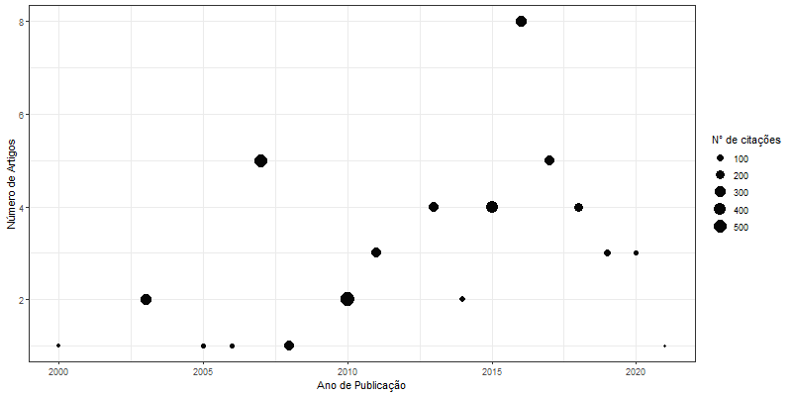
Source: created by the authors.
The articles were classified by their guiding theme, and the research about “symptom control or prevalence” and “decision-making” was found to be more common. The most frequent theme was “symptom control or prevalence” with ten articles and 864 citations, especially in patients with CKD in dialysis or conservative treatment. The articles about “decision making” discourse about initiating, maintaining, or removing substitutive renal therapy in CKD, with 15 articles and 626 citations. Together, these two themes account for 50% of articles and 42.10% of citations (Table 4).

Table 4 – Number of articles and citations by guiding theme

Guiding Theme | Number of articles | Number of citations
Symptom Control / Prevalence | 10 | 864
Decision Making | 15 | 626
Doctors / Patients Perception | 4 | 626
Outcome Analysis / Prognosis | 5 | 526
Medical Training | 3 | 360
Nursing Care | 1 | 27
Others | 12 | 510

Source: created by the authors.
Primary research was most frequent (66%; N = 33/50 articles), with observational articles in the highest number (75,75%; N = 25/33 articles), and representing the major means of citations per article (90.2). Narrative review was the only methodology of secondary research in the analysis (Table 5).

Table 5 – Classification of research methods

Methodology | Number of articles | Number of citations (average per article)
Primary research | 33 | 2757
Observational | 25 | 2255 (90.2)
Interventionist | 8 | 502 (62.75)
Secondary research | 17 | 782
Narrative Review | 17 | 782 (46)

Source: created by the authors.

Among the 226 nodes identified in the co-autorship map, most of them did not have connections with each other, which explains why only 99 nodes are represented in Figure 3. This map consists of 10 clusters, 399 links, and a total link strength of 70.5. The most prolific author is Alvin H. Moss (H-index = 42), the third most cited author, with participation in 7 documents, 26 links, a link strength of 7, and a total of 677 citations. Following him is Jane O. Schell, the seventh most cited author, with 5 documents, 14 links, a link strength of 5, and 281 citations in total.

Figure 3 - Bibliometric map of co-authorship

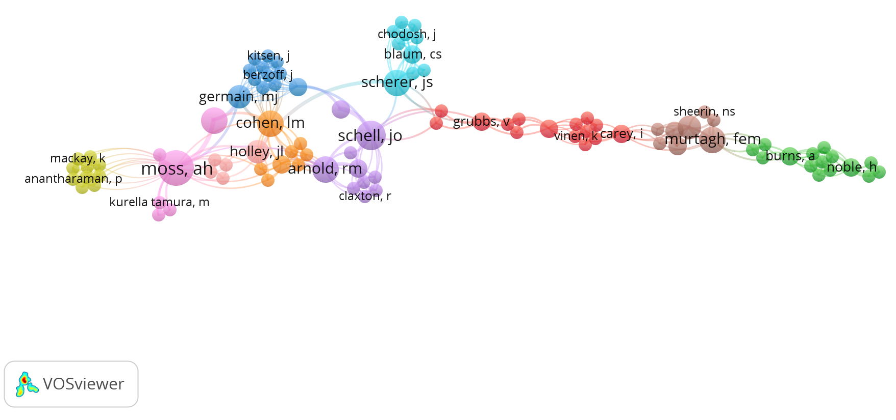
Legend: The nodes represent authors, with their size indicating their relevance in the analysis. The proximity between nodes reflects the strength of their relationship. The connecting lines represent co-authorships, with thicker lines indicating a higher number of collaborations. Colored clusters represent groups of authors who collaborate more frequently with each other.

Source: created by the authors.

The keywords bibliometric map consists of 168 nodes, 15 clusters, 1241 links, and a total link strength of 136. The most frequently occurring keyword was “palliative care” with 20 occurrences, 111 links, a link strength of 20, and 2014.85 as the average year of publication. Following this, the word “dialysis” appears with 9 occurrences, 48 links, a link strength of 9, and 2014.89 as the average year of publication. Lastly, the word “nephrology” occurs 7 times, has 32 links, a link strength of 7, and 2017.46 as the average year of publication (Figure 4).

Figure 4 – Bibliometric map of keyword co-occurrence
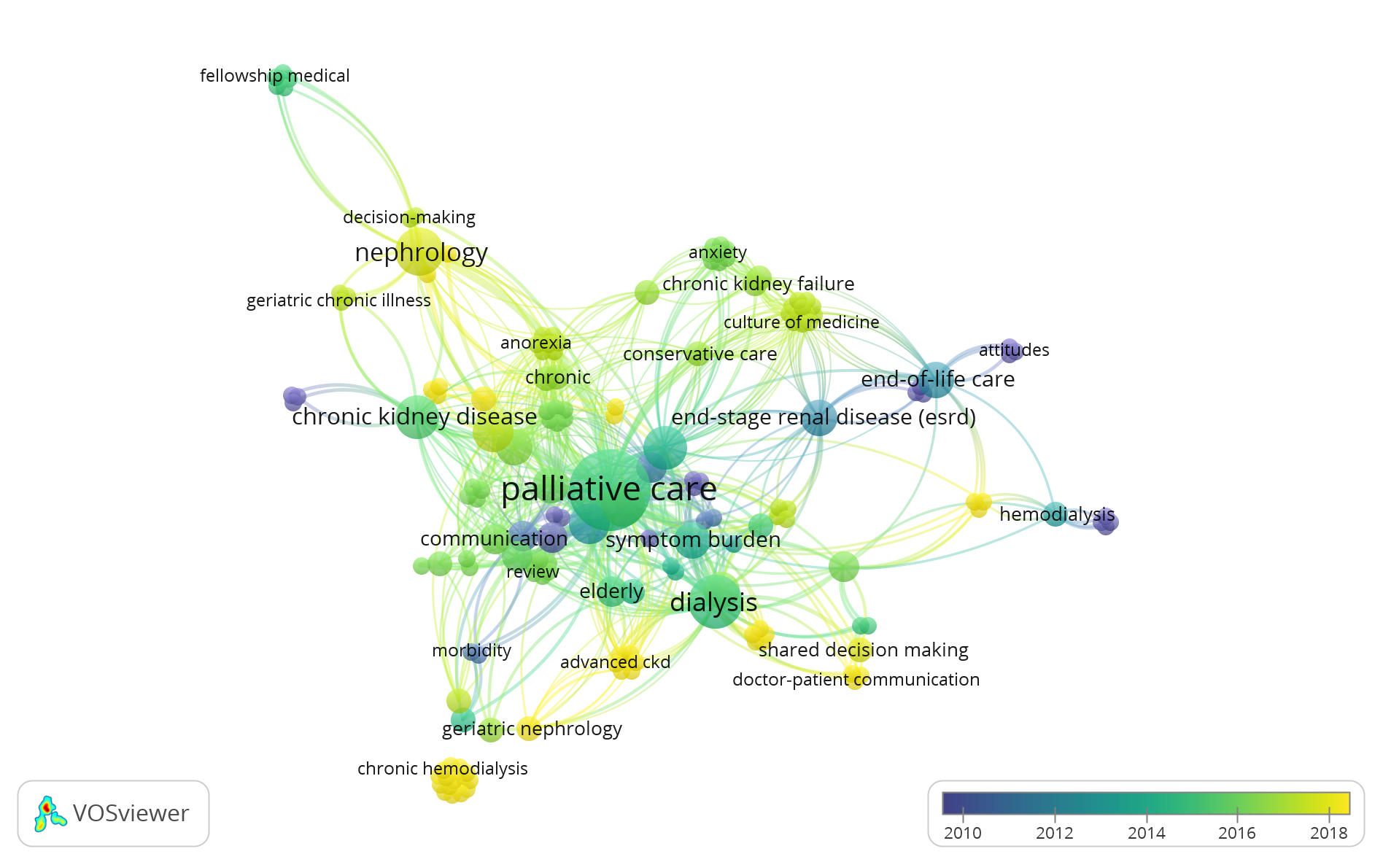
Legend: Each node represents a keyword, with its size indicating frequency and proximity reflecting the strength of its association. The lines represent co-occurrence in the articles, with thicker lines indicating a higher number of joint appearances. The color of each node represents the average publication year in which the keyword appears, highlighting temporal trends in term usage.

Source: created by the authors.

The co-citation map is structured by 20 nodes, 4 clusters, 190 links, and a total link strength of 401.97. The featured author was Alvin H. Moss with 115 citations, 2 clusters, 19 links, and a total link strength of 100.47, followed by Sara N. Davison (H-index = 42), the first most cited author with 110 citations and a total link strength of 94.12 (Figure 5).

Figure 5 – Bibliometric map of co-citation
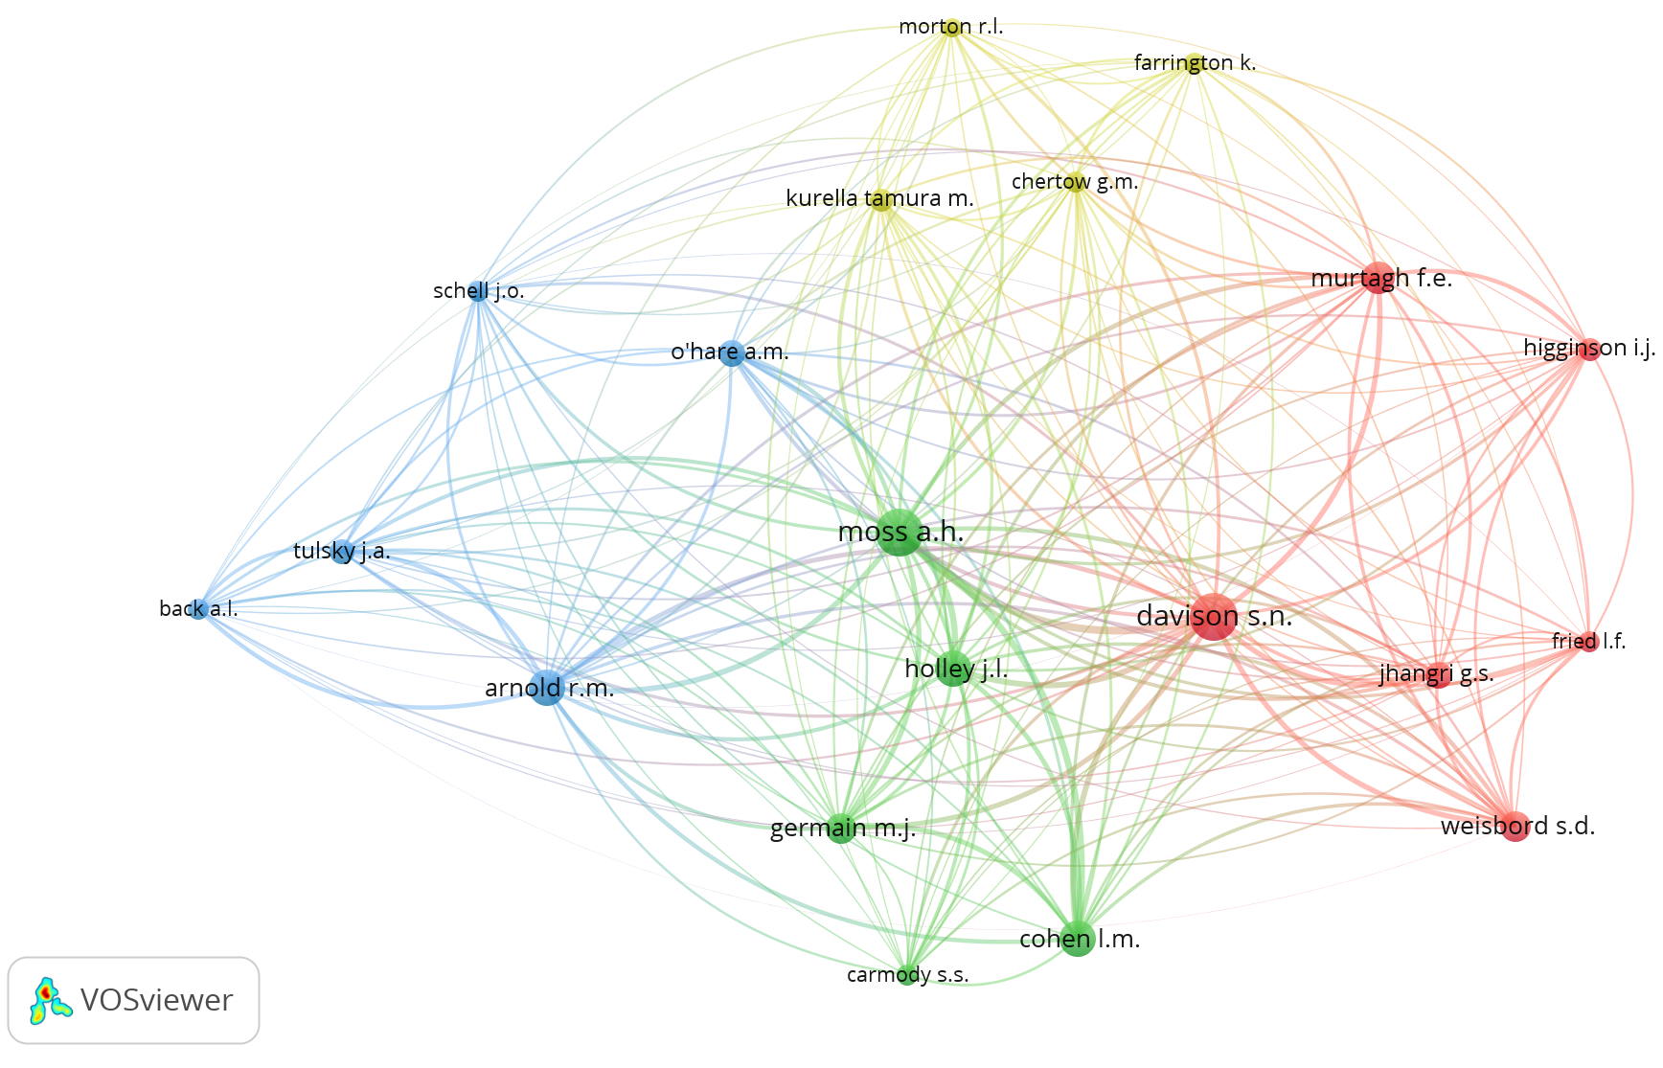

Legend: The nodes represent authors, with their size indicating the frequency of co-citation. The proximity between nodes reflects the strength of their relationship. The lines indicate co-citation links, with thicker lines representing a higher number of joint citations. Colored clusters represent themes or subfields within the research area.

Source: created by the authors.

DISCUSSION
North America has the highest number of publications and citations, with a significant contribution from the USA to research on palliative care in nephrology. This result reinforces previous bibliometric analyses in other themes within this area, which describe the USA and China alternating as leaders in productivity (10-14). Data from the Scimago Journal and Country Rank (https://www.scimagojr.com/countryrank.php), covering 1996 to 2023, indicates that the USA has consistently held the top position in scientific publications and citations in nephrology. And, this dominance extends beyond the specialty into the broader medical literature.
Despite opportunities and scenarios for research with direct population impact, low-income countries face challenges in scientific production, including insufficient training and education in medical research, limited funding, and scarce infrastructure (15). This disparity is reflected in global scientific collaboration, where high-income countries dominate academic production. According to data from the Nature Index (16), only 24 of 500.000 available articles involve collaborations from authors of low-income countries. This aligns with our finding that 98% of articles and 97.11% of citations are from high-income nations.
Moreover, resource limitations justify the need for optimization efforts in these countries, making evidence generation important for assessing strategy costs, benefits, and potential outcomes (17). However, this manuscript highlights the limited scientific production from low-income countries, harming the effectiveness of public policies in this area.
The literature of renal support care is relatively recent, with its theoretical origins dating back to the 1980s. Nonetheless, the discussion about palliative care in nephrology turned effective just after 2000 (1). Consequently, most articles in this field were published after 2000, with 3508 of 3539 citations in this period, and the most common keywords have an average publication year around 2014.
Patients with advanced CKD experience numerous symptoms, including psychological disturbances related to the disease. These include fatigue (71%), itch (55%), pain (47%), anxiety (38%), depression (27%), dyspnea (35%), and others (18). Regarding these conditions, most studies focus on symptom control or prevalence and decision-making in substitutive renal therapy.
Evaluating an author's productivity using metrics is a complex task that requires different analyses, avoiding a single criterion. The h-index, developed by Jorge E. Hirsch in 2005, is a tool with advantages compared to other bibliometric indices for combining impact and productivity. However, its values can be influenced by factors such as area of research and career duration, and researchers from life sciences generally have the highest ones (19). Among the most cited authors, two presented a h-index superior to 50: Ann M. O’Hare (h-index = 58) and Mark A. Brown (h-index = 54). The co-authorship and co-citation maps analysis demonstrated a dispersed collaboration network, with a concentration in a few influential authors. This conclusion can be justified by the research area still being in development.
The scientometric study conducted by Annalingam et al in 2014 evaluated 768 articles from biomedical science and described that the probability of a paper being cited is influenced by factors such as the methodology used and the journal impact factor. In addition, studies based on secondary research had fewer articles, but more citations (20). Comparatively, in this study, articles based on primary data predominated in the number of articles and citations, with those based on secondary data represented only by narrative reviews, a methodology that is more susceptible to biases. However, frequent in some fields of research for motives as analysis of concepts in evolution with more flexibility (21).
Bibliometric studies on various nephrologic conditions indicate that most journals have an impact factor (IF) below 10 (10, 22-24). In this analysis, only the American Journal of Kidney Diseases presented an impact factor higher than this value, and the 5-year impact factors from all the journals in this manuscript were lower than this. The impact factor is a metric to assess the quality of scientific journals, the papers published within them, and the authors associated. Journals with greater IF tend to gain more relevance in the scientific community, despite the limitations inherent to the metric (25).
This study has limitations that should be considered when interpreting the results. The most recent published articles may show a lower number of citations simply due to their shorter publication duration. Additionally, the analysis was based only on data related to the first and last authors, which may influence certain classifications by neglecting the co-authors' information. Moreover, the SCOPUS (Elsevier) database was used for the data extraction instead of others like Web of Science, PubMed, and Google Scholar. This choice was based on the superposition of titles, broader coverage of journals, rigorous publication selection, and the presence in previous bibliometric analysis (26,27). However, one isolated database may result in influential articles being excluded from the analysis and impact metrics such as citation counts.

CONCLUSION
This study mapped the scientometric data from the most influential articles in the intersection of nephrology and palliative care, which demonstrated to be a recent and developing field. The results revealed a significant dominance of the scientific production by high-income countries, which evidences a lack of biomedical research in low-income nations in the area, impacting the correct comprehension of pathologies and restricting interventions and improvements in healthcare.

REFERENCES

Tavares APS, Silva JV, Lima Neto PL, Bessa AM, Araujo SML, Lima FET, et al. Cuidados de suporte renal: uma atualização da situação atual dos cuidados paliativos em pacientes com DRC. Braz J Nephrol. 2020;43:74–87.

Kidney Disease: Improving Global Outcomes (KDIGO). KDIGO 2024 Clinical Practice Guideline for the Management of Chronic Kidney Disease [Internet]. Kidney Int Suppl. 2024 [cited 2024 Nov 23]. Available from: https://kdigo.org

Axelsson L, Benzein E, Lindberg J, Persson C. End-of-life and palliative care of patients on maintenance hemodialysis treatment: a focus group study. BMC Palliat Care. 2019;18(1):76. doi:10.1186/s12904-019-0481-y

Saeed F, Sardar MA, Davison SN, Murad H, Duberstein PR, Quill TE. Patients’ perspectives on dialysis decision-making and end-of-life care. Clin Nephrol. 2019;91(5):294–300. doi:10.5414/cn109608

Combs SA, Culp S, Matlock DD, Kutner JS, Holley JL, Moss AH. Update on end-of-life care training during nephrology fellowship: a cross-sectional national survey of fellows. Am J Kidney Dis. 2015;65(2):233–9. doi:10.1053/j.ajkd.2014.07.018

Davison SN, Levin A, Moss AH, Jha V, Brown EA, Brennan F, et al. Executive summary of the KDIGO Controversies Conference on Supportive Care in Chronic Kidney Disease: developing a roadmap to improving quality care. Kidney Int. 2015;88(3):447–59. doi:10.1038/ki.2015.110

Ioannidis JPA. Meta-research: why research on research matters. PLoS Biol. 2018;16(3):e2005468. doi:10.1371/journal.pbio.2005468

Zupic I, Čater T. Bibliometric methods in management and organization. Organ Res Methods. 2015;18(3):429–72. doi:10.1177/1094428114562629

Van Eck NJ, Waltman L. VOSviewer manual [Internet]. Leiden: Centre for Science and Technology Studies, Leiden University; 2023 [cited 2024 Nov 23]. Available from: https://www.vosviewer.com/documentation/Manual_VOSviewer_1.6.19.pdf

Qi J, Wu T, Wang J, Zhang J, Chen L, Jiang Z, et al. Research trends and frontiers in lupus nephritis: a bibliometric analysis from 2012 to 2022. Int Urol Nephrol. 2023;56(2):781–94. doi:10.1007/s11255-023-03715-w

Wang J, Wang X, Cai X, Pan D. Global trends and hotspots in IgA nephropathy: a bibliometric analysis and knowledge map visualization from 2012 to 2023. Int Urol Nephrol. 2023;55(12):3197–207. doi:10.1007/s11255-023-03598-x

Yin T, Chen Y, Tang L, Yuan H, Zeng X, Fu P. Relationship between modifiable lifestyle factors and chronic kidney disease: a bibliometric analysis of top-cited publications from 2011 to 2020. BMC Nephrol. 2022;23(1):1. doi:10.1186/s12882-022-02745-3

Wei Y, Jiang Z. The evolution and future of diabetic kidney disease research: a bibliometric analysis. BMC Nephrol. 2021;22(1):1. doi:10.1186/s12882-021-02369-z

Park S, Park BS, Lee YJ, Kim IH, Park JH, Ko J, et al. Artificial intelligence with kidney disease. Medicine (Baltimore). 2021;100(14):e25422. doi:10.1097/MD.0000000000025422

Rahman MM, Ghoshal UC, Ragunath K, Jenkins G, Rahman M, Edwards C, et al. Biomedical research in developing countries: opportunities, methods, and challenges. Indian J Gastroenterol. 2020;39(3):292–302. doi:10.1007/s12664-020-01056-5

End the glaring inequity in international science collaborations. Nature. 2023;624(7992):473. doi:10.1038/d41586-023-04022-1

McMichael C, Waters E, Volmink J. Evidence-based public health: what does it offer developing countries? J Public Health (Oxf). 2005;27(2):215–21. doi:10.1093/pubmed/fdi024

Murtagh FEM, Addington-Hall J, Higginson IJ. The prevalence of symptoms in end-stage renal disease: a systematic review. Adv Chronic Kidney Dis. 2007;14(1):82–99.

Thomaz PG, Assad RS, Moreira LFP. Uso do fator de impacto e do índice H para avaliar pesquisadores e publicações. Arq Bras Cardiol. 2011;96(2):90–3. doi:10.1590/S0066-782X2011000200001

Annalingam A, Damayanthi H, Jayawardena R, Ranasinghe P. Determinants of the citation rate of medical research publications from a developing country. Springerplus. 2014;3(1):140. doi:10.1186/2193-1801-3-140

Byrne JA. Improving the peer review of narrative literature reviews. Res Integr Peer Rev. 2016;1(1):1. doi:10.1186/s41073-016-0019-2

Zhou J, Zhu L, Yue R. Evolution and global research trends of immunity in diabetic nephropathy: a bibliometric and visual analysis from 2004 to 2023. Int Urol Nephrol. 2024;56(10):3307–21. doi:10.1007/s11255-024-04081-x

Ai S, Li Y, Zheng H, Wang Z, Liu W, Tao J, et al. Global research trends and hot spots on autophagy and kidney diseases: a bibliometric analysis from 2000 to 2022. Front Pharmacol. 2023;14:1275792. doi:10.3389/fphar.2023.1275792

Yu X, Wu R, Ji Y, Feng Z. Bibliometric and visual analysis of machine learning-based research in acute kidney injury worldwide. Front Public Health. 2023;11:1136939. doi:10.3389/fpubh.2023.1136939
Erratum in: Front Public Health. 2024;12:1430491. doi:10.3389/fpubh.2024.1430491

Miglioli S. Influência e limites do fator de impacto como métrica de avaliação na ciência. Pesqui Bras Ciênc Inf Bibliotecon. 2018;13(1):17–33. doi:10.22478/ufpb.1981-0695.2018v13n1.40041

Mongeon P, Paul-Hus A. The journal coverage of Web of Science and Scopus: a comparative analysis. Scientometrics. 2016;106(1):213–28. doi:10.1007/s11192-015-1765-5

Falagas ME, Pitsouni EI, Malietzis GA, Pappas G. Comparison of PubMed, Scopus, Web of Science, and Google Scholar: strengths and weaknesses. FASEB J. 2008;22(2):338–42. doi:10.1096/fj.07-9492LSF

