Case report

Diagnosis and Treatment of Supernumerary Teeth: Case Report

.
ABSTRACT
Aims: To address the diagnosis and treatment of supernumerary teeth through a clinical case report.
Study design: descriptive case study.
Place and Duration of Study: Radiology and Surgery Clinics of the School of Dentistry, Federal University of Alfenas (UNIFAL-MG), with a duration of seven months.
Methodology: A 13-year-old melanoderm patient presenting with five supernumerary teeth in the mandibular premolar region bilaterally, who was diagnosed and surgically treated.
Results: Cone-beam computed tomography (CBCT) of the mandible was performed to analyze the positioning of the supernumerary teeth and their relationship with the adjacent anatomical structures. Surgical treatment was selected, with access made through the lingual aspect of the respective regions, followed by the use of biomaterials for tissue regeneration in the affected areas. Five months after the surgical procedures, panoramic radiography revealed bone neoformation in the corresponding regions.
Conclusion: CBCT was essential for the diagnosis and planning of the surgical procedures, which, despite the challenges, were carried out without complications.

Keywords: tooth abnormalities; tooth, supernumerary; diagnostic imaging; oral surgical procedures.

1. INTRODUCTION

The prevalence of supernumerary teeth in the global population ranges from 0.4% to 3.8% (Aparcana-Quijandría; Huamani-Echaccaya, 2020). Few reports describe their occurrence in melanoderm individuals, suggesting the possibility of a racial tendency (Neville et al., 2016). However, studies conducted across different continents have not revealed significant discrepancies among various racial groups (Silvério et al., 2019; Hadziabdic et al.,2022; Irish, 2022; Liu et al., 2023; Kvaratsthelia, 2024).
In non-syndromic individuals with multiple supernumerary teeth, a higher prevalence is observed in the mandibular premolar region, followed by molars and anterior teeth (Assunção et al., 2024).
Treatment planning takes into account factors such as tooth location, morphology, angulation and eruption status, proximity to anatomical structures, potential for utilization, general health, age, and patient compliance (Aparcana-Quijandría; Huamani-Echaccaya, 2020; Bogdanowicz et al., 2023). In the permanent dentition, treatment may be conservative, involving either monitoring or the utilization of the supernumerary tooth in transplantation procedures (Bogdanowicz et al., 2023; Kinaia et al., 2022), as well as surgical, which is preferred when indicated (Rocha et al., 2021; Fernandes et al., 2023), with consideration given to the optimal timing of extraction to minimize potential damage (Aparcana-Quijandría; Huamani-Echaccaya, 2020).
Supernumerary teeth in the mandibular premolar region are often challenging to extract due to the high bone density of the mandible, proximity to the mental nerve, and limited direct visualization through lingual access (Marya et al., 2023).
In light of the above, the aim of this study is to describe, from diagnosis to treatment, a clinical case with particular features, involving a melanoderm patient with multiple supernumerary teeth bilaterally in the mandibular premolar region, requiring surgical access in a technically challenging area.

2. CASE REPORT

The patient is a 13-year-old melanoderm, non-syndromic individual who began orthodontic treatment in a private practice. Panoramic radiography revealed the presence of supernumerary teeth in the mandibular premolar region (Fig. 1).

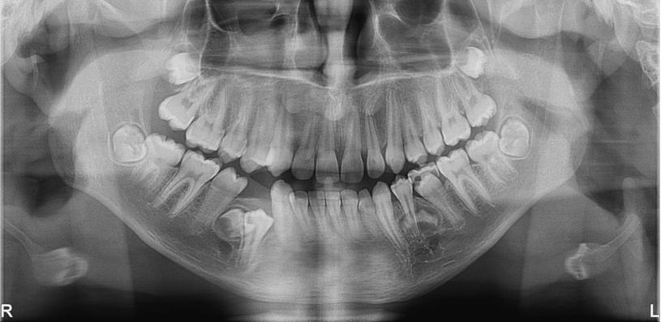
Fig. 1. Panoramic radiograph

The patient was referred to the Federal University of Alfenas (UNIFAL-MG) and underwent cone-beam computed tomography (CBCT) of the mandible for precise analysis of the positioning of these teeth, as well as to assess their relationship with adjacent anatomical structures.
CBCT analysis revealed, on the right side, two impacted supernumerary teeth with fully formed crowns, fused and with the onset of root formation, located between the roots of teeth 44 and 45, centrally on the alveolar ridge and slightly displaced lingually, extending from the cervical to apical thirds. On the left side, three supernumerary teeth with approximately two-thirds of their crowns formed, fused, were observed between the roots of teeth 33 and 34, lingual to 34, extending to the region between the roots of 34 and 35, at the middle and apical thirds. On both sides, the supernumerary teeth were positioned above the mental foramen, with closer proximity on the left side, as seen in the transverse sections. No root resorption of the mandibular premolars was identified; however, divergence of the roots was observed bilaterally, along with root bifurcation in teeth 44, 34, and 35. Additionally, the left mandibular deciduous canine was present (Fig. 2).

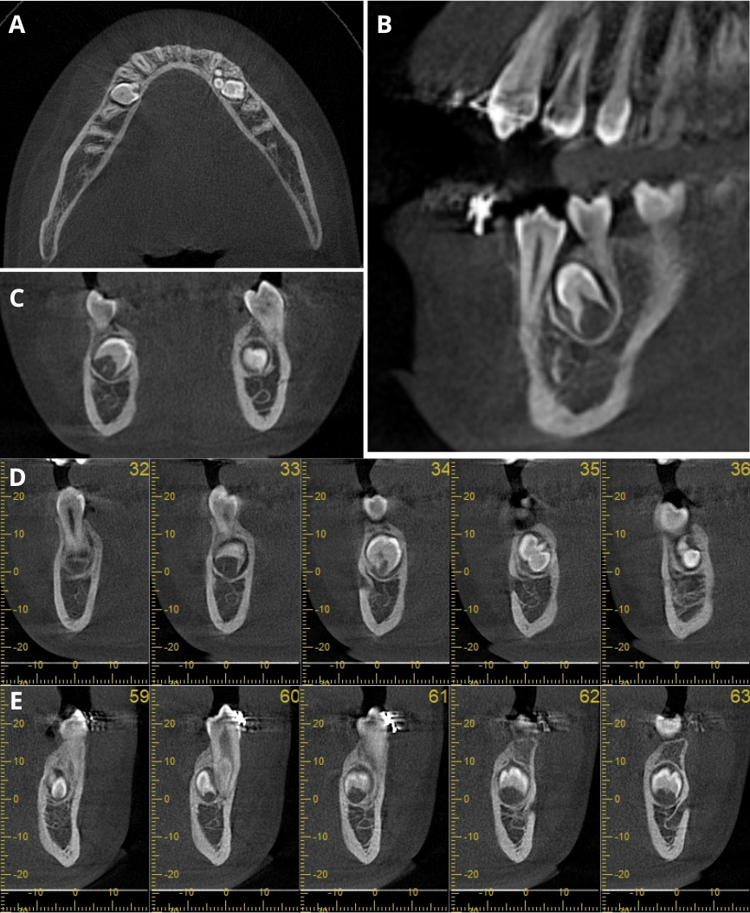
Fig. 2. Multiplanar CBCT reconstructions - a) axial; b) sagittal; c) coronal; d) transverse sections – right side; e) transverse sections – left side

The proposed treatment was the surgical removal of the supernumerary teeth, as there were no systemic contraindications. Hematological tests were reviewed and showed no abnormalities. Extractions were planned in two sessions, first on the right side, followed by the left side.
Pre- and postoperative medication was administered. Anesthesia was performed, followed by an intrasulcular incision (envelope flap) on the lingual side, with an additional relieving incision. Soft tissue dissection and ostectomy were performed to create a surgical window, followed by sectioning and removal of the dental fragments. Osteoplasty was carried out, and bovine collagen sponges were inserted into the site to fill the bony cavity on both sides, promoting optimal bone and tissue regeneration, and the procedure was concluded with suturing (Fig. 3).

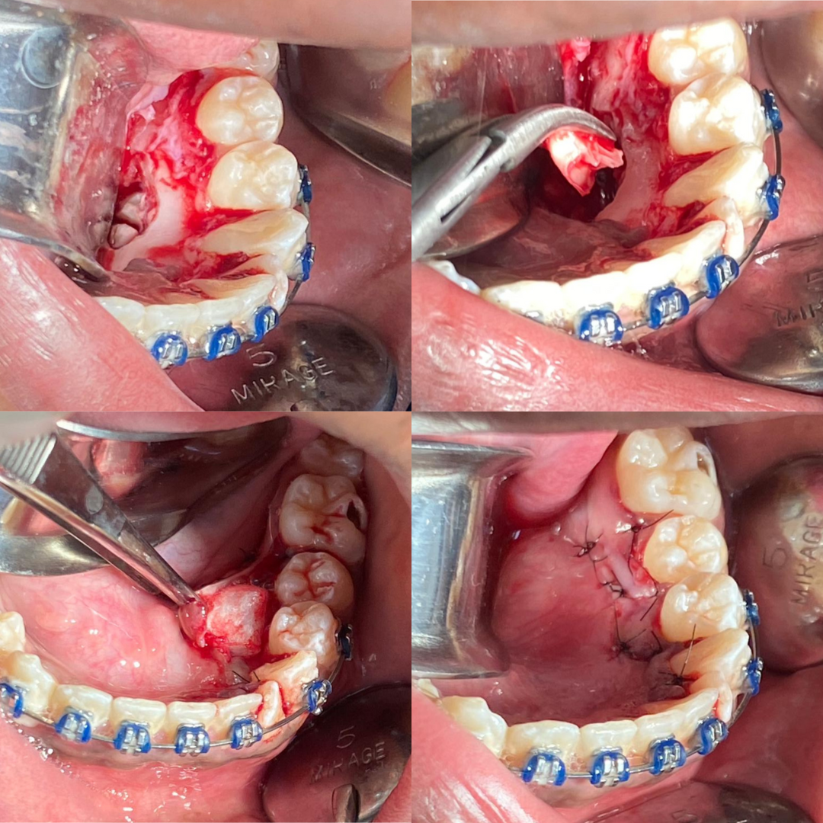
Fig. 3. Tooth sectioning; removal of dental fragment; insertion of collagen sponge; and suturing, respectively

Postoperative instructions were provided, and the patient returned for suture removal. Healing progressed favorably, with complete coaptation of the wound margins. The patient was referred for continuation of orthodontic treatment (Fig. 4).

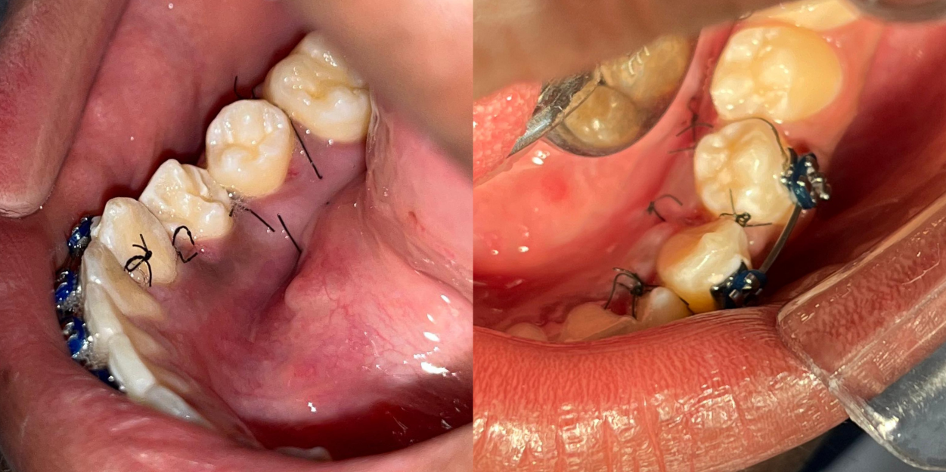
Fig. 4. Postoperative period: 8 days – right side; 7 days – left side, respectively

During patient follow-up, five months after the surgical procedures, a panoramic radiograph was taken, which revealed bone neoformation in the respective mandibular regions (Fig. 5).
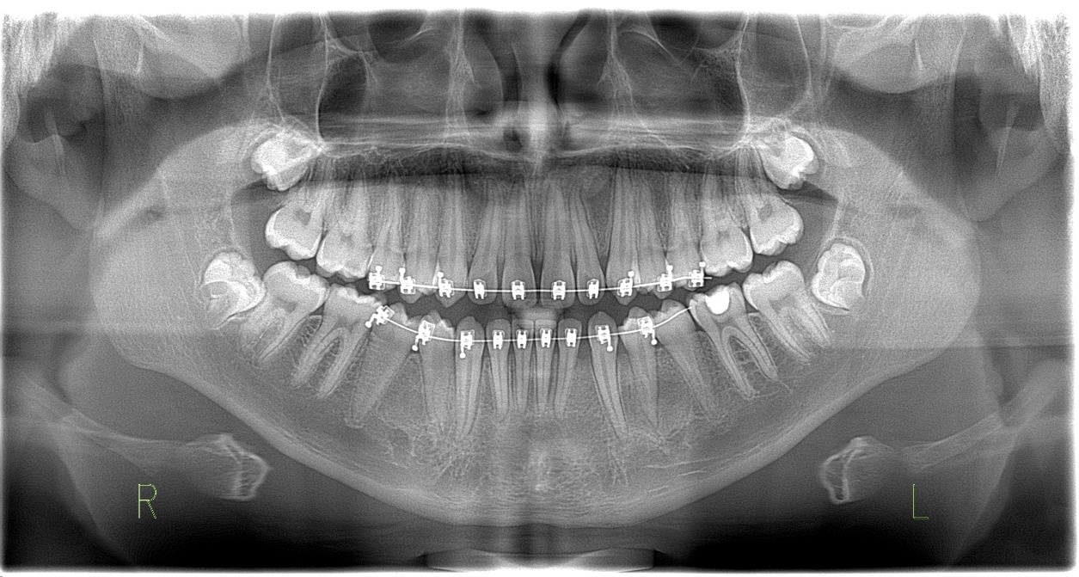
Fig. 5. Follow-up panoramic radiograph

3. discussion

According to Neville et al. (2016), multiple supernumerary teeth in non-syndromic individuals predominantly occur in the mandibular premolar region, as illustrated by the reported clinical case, which presented five supernumerary teeth, two on the right side and three on the left, with approximately two-thirds of the crown fully formed and fused on both sides.

When impacted, these teeth may cause root resorption of adjacent teeth, interfere with dental eruption, and lead to dental misalignment (Aparcana-Quijandría; Huamani-Echaccaya, 2020; Mallya; Lam, 2020), as well as pericoronitis, gingivitis, cysts, and odontogenic tumors (Neville et al., 2016). In the present case, only dental misalignment and root divergence were observed.

Treatment may be conservative or surgical (Bogdanowicz et al., 2023), with the latter preferred in the absence of contraindications, particularly in the mixed dentition, to minimize aesthetic and functional abnormalities (Fernandes et al., 2023; Neville et al., 2016).

In the reported case, the supernumerary teeth were incidentally detected on a panoramic radiograph taken for orthodontic purposes, which commonly occurs due to their asymptomatic nature, with precise anatomical localization achieved via CBCT. Surgical access was performed through the lingual aspect, requiring careful attention to avoid neural injury, particularly on the left side. Biomaterials were applied in the surgical sites, resulting in favorable bone repair and no complications.

4. Conclusion

The findings reported in the literature were confirmed in the present case report of a non-syndromic patient with bilateral supernumerary teeth in the mandibular premolar region, detected early as radiographic findings on panoramic imaging. Cone-beam computed tomography allowed precise localization of the teeth, which was essential for planning the surgical removal procedures. The surgeries presented challenges, including the need for lingual surgical access, high bone density in the regions, and the requirement for biomaterials to support tissue regeneration.

DISCLAIMER (ARTIFICIAL INTELLIGENCE)

Author(s) hereby declare that NO generative AI technologies such as Large Language Models (ChatGPT, COPILOT, etc) and text-to-image generators have been used during writing or editing of this manuscript.

Consent

All authors declare that written informed consent was obtained from the patient (or authorized representatives) for the publication of this case report and the accompanying images. A copy of the written consent is available for review by the Editorial Board, Editor-in-Chief, or members of the Editorial Board of this journal.

Ethical approval

This study was submitted to the Research Ethics Committee of the Federal University of Alfenas (UNIFAL-MG) and was approved on December 6, 2024, under protocol number CAAE 84675924.0.0000.5142.

References

1. Aparcana-Quijandría, P. M. J., & Huamani-Echaccaya, J. L. (2020). Nonsyndromic multiple supernumeraries in permanent dentition. Case report. Revista Estomatológica Herediana, 30(4), 302–307. https://doi.org/10.20453/reh.v30i4.3884

2. Neville, B., Damm, D. D., Allen, C. M., & Bouquot, J. E. (2016). Oral and maxillofacial pathology (4th ed.). Rio de Janeiro: Elsevier.

3. Silvério, P. N., Osório, S. G., Osório, A., & Queiroz, P. M. (2019). Epidemiological study of supernumerary teeth diagnosed by panoramic radiography. Revista Uningá, 56(S5), 115–121. https://doi.org/10.46311/2318-0579.56.eUJ2998

4. Hadziabdic, N., Haskic, A., Mujkic, A., Hasic-Brankovic, L., Dzankovic, A., Korac, S., & Tahmiscija, I. (2022). Epidemiological, Clinical, and Radiographic Features of Supernumerary Teeth in Nonsyndromic Bosnian and Herzegovinian Population: a Monocentric Study. Medical archives (Sarajevo, Bosnia and Herzegovina), 76(5), 348–353. https://doi.org/10.5455/medarh.2022.76.348-353

5. Irish J.D. (2022). Hyperdontia across sub-Saharan Africa: Prevalence, patterning, and implications. Archives of oral biology, 140, 105463. https://doi.org/10.1016/j.archoralbio.2022.105463

6. Liu, X., Ren, Q., Bai, J., Kang, P., Ren, G., Li, X., & Feng, X. (2023). Imaging analysis of 1 138 supernumerary teeth by using cone-beam computed tomography. Hua xi kou qiang yi xue za zhi = Huaxi kouqiang yixue zazhi = West China journal of stomatology, 41(6), 671–677. https://doi.org/10.7518/hxkq.2023.2023110

7. Kvaratsthelia, S. (2024). Prevalence of dentition, dental arches, and dental anomalies. Georgian Medical News, (347), 177–180.

8. Assunção, W. B., Lemos, A. D. do N., Silva, J. H. R. da, & Pereira, N. S. da S. (2024). Supernumerary tooth in the mandibular region: Case report. Observatory of the Latin American Economy, 22(5), e4839. https://doi.org/10.55905/oelv22n5-157

9. Bogdanowicz, A., Szwarczyńska, K., Zaleska, S. B., Kulczyk, T., & Biedziak, B. (2023). Tooth Migration in a Female Patient with Hyperdontia: 11-Year Follow-Up Case Report. Journal of clinical medicine, 12(9), 3206. https://doi.org/10.3390/jcm12093206

10. Kinaia, B. M., Hasso, D. F., Jirjis, L., Zora, J. S., Azimi, K., Akkad, L., Agarwal, K., Kaspo, G., Neely, A. L., & Al-Qawasmi, R. (2022). Supernumerary tooth autotransplantation to replace missing maxillary central incisor using three-dimensional replica: A 6-year follow-up. International orthodontics, 20(2), 100635. https://doi.org/10.1016/j.ortho.2022.100635

11. Rocha, M. de O., Almeida Junior, A. A. N., Bezerra, G. F., Santos, G. A. dos, Castro, M. W. C. de, & Souza, N. B. (2021). Removal of a supernumerary premolar: Clinical case report. Revista Ciência & Saúde, 6(2), 12–16. https://revistaeletronicafunvic.org/index.php/c14ffd10/article/view/268

12. Fernandes, D., Miranda, Y. M. S., Silva Neto, É. L. da, Andrade, M. C. de, Silva, G. F. S., Lima Filho, H. L., & Silva, L. A. B. da. (2023). Surgical removal of a supernumerary tooth associated with orthodontic treatment in a pediatric patient. Brazilian Journal of Implantology and Health Sciences, 5(4), 235–245. https://doi.org/10.36557/2674-8169.2023v5n4p235-245

13. Marya, A., Sharan, J., Mandava, P., & El-Hassanein, E. H. (2023). Complications associated with the surgical removal of non-syndromic supernumerary premolar tooth buds in the mandible. Journal of surgical case reports, 2023(5), rjad304. https://doi.org/10.1093/jscr/rjad304

14. Mallya, S. M., & Lam, E. W. N. (2020). White & Pharoah: Oral Radiology – Principles and Interpretation (8th ed.). Rio de Janeiro: GEN Guanabara Koogan.

