Case report

Single-Session Endodontic Treatment Using Photodynamic Therapy as an Adjunct to the Antisepsis Protocol in a Tooth with Chronic Periapical Abscess – A Case Report

ABSTRACT
In teeth with pulp necrosis, microorganisms form complex biofilms along the walls of the root canals and deeply colonize the dentinal tubules. This infection is essential for the development of periapical abscesses, granulomas, and cysts. Biomechanical preparation represents the cornerstone of endodontic treatment; however, the anatomical complexity of the root canal system facilitates the survival of microorganisms even after this debridement and shaping phase, regardless of the use of modern devices, instruments, antiseptics, and disinfectants. Therefore, photodynamic therapy (PDT) has been employed as an alternative to intracanal medication in order to enhance antisepsis, reduce chair time, and minimize postoperative pain. This study aimed to report a clinical case of endodontic treatment of tooth 32 with chronic periapical abscess, performed in a single session, using PDT as an adjunct to root canal antisepsis, with the purpose of contributing to current research on the use of PDT in Endodontics and to present it to the dental community as an alternative to conventional endodontic treatment. A 46-year-old female patient attended the Dental Clinic of UFVJM, complaining of gingival bleeding and swelling in the region of the lower anterior teeth. Clinical and radiographic examinations revealed the presence of a fistula associated with a radiolucent periapical lesion in tooth 32, leading to the diagnosis of a chronic periapical abscess. The proposed treatment included biomechanical preparation using the Protaper Next rotary system with alternating irrigation protocol, followed by PDT application and root canal obturation. At the six-month follow-up appointment, the patient was asymptomatic. Clinically, gingival bleeding had decreased, the fistula had resolved, and radiographically, the periapical lesion had reduced in size. It can thus be concluded that the use of PDT resulted in satisfactory periapical tissue healing and effective control of postoperative pain. However, randomized clinical trials are necessary to confirm the actual effectiveness of PDT as an adjunct to root canal disinfection protocols.

Keywords: Periapical periodontitis. Periapical abscess. Periapical granuloma. Laser therapy. Regenerative endodontics.

1. INTRODUCTION

In teeth with pulp necrosis, microorganisms form complex biofilms on the walls of root canals and deeply colonize the dentinal tubules [1]. This infection is a key factor in the development of periapical abscesses, granulomas, and cysts [2]. Given this cause-and-effect relationship, the first step in resolving these pathologies is the elimination of the infection disseminated throughout the root canal system (RCS) [3–5].
In this context, endodontic treatment aims to eliminate as many pathogens as possible from the RCS and prevent reinfection [1,6]. In the traditional treatment of teeth with pulp necrosis and associated periapical lesions, during the biomechanical preparation (BMP) phase, irrigating solutions such as sodium hypochlorite or chlorhexidine are used—often in combination with EDTA (ethylenediaminetetraacetic acid)—along with mechanical instruments and files, followed by intracanal medication with calcium hydroxide-based compounds [7,8], primarily aiming to reduce or eliminate microorganisms and their by-products from the RCS prior to obturation [9].
Although BMP represents the cornerstone of endodontic treatment [10–12], the anatomical complexity of the RCS makes it difficult to completely eliminate microorganisms, regardless of the use of advanced devices, instruments, antiseptics, and disinfectants [1,13]. From a microbiological standpoint, the persistence of these microorganisms is concerning, as they contribute to the reestablishment of a resistant bacterial colonization, potentially leading to the failure of primary endodontic treatment [2,6,14-16], and necessitating retreatment [4,17,18], which may often require periapical surgery as an adjunct [19–22].
Multiple-visit endodontic treatment is widely accepted and considered safe [8]; however, in recent years, the advent of modern techniques and equipment—such as magnification, electronic apex locators, and mechanized systems using nickel-titanium (NiTi) rotary or reciprocating files—has shortened treatment time, enabling completion in a single visit [9]. Along with other advantages, including time savings, cost-effectiveness, better patient acceptance, and reduced risk of inter-appointment contamination, single-visit treatment has become an increasingly acceptable protocol [23], and a long-debated topic within the endodontic community. For this approach to be scientifically supported, it must be based on a triad: (I) adequate shaping and debridement of the RCS, (II) omission of intracanal antiseptic medication, and (III) implementation of a short-duration but effective antiseptic protocol using photodynamic therapy (PDT) [24,25].
PDT in endodontics is a technique designed to complement BMP by employing a non-toxic aromatic dye (photosensitizer) activated by a low-power laser light source within the red spectrum [620–690 nm), which generates singlet oxygen and free radicals with high bactericidal potential [26–34]. Although still limited in the literature, PDT has shown promise, as laser light can reach areas within the dentinal tubules that conventional biomechanical preparation and irrigating solutions are unable to access [29–32].
Therefore, the aim of this study was to report a clinical case of endodontic treatment of tooth #32 with chronic periapical abscess, completed in a single session using PDT as an adjunct to root canal antisepsis. The objective was to present a simplified endodontic treatment protocol to the dental community as an alternative to conventional therapy and to evaluate, through radiographic follow-up, its efficacy in periapical healing six months after treatment, thereby contributing to ongoing research on the use of PDT in endodontics.

2. CASE DESCRIPTION

Ethical Considerations
This study was approved by the Research Ethics Committee of the Federal University of the Jequitinhonha and Mucuri Valleys under protocol number 7.616.760. The patient was informed about the study and signed the Informed Consent Form.
Anamnesis, Clinical and Radiographic Evaluation
The patient, I.C.A.M., female, 46 years old, presented to the Dental Clinic of the Federal University of Jequitinhonha and Mucuri Valleys (UFVJM) complaining of gingival bleeding and swelling in the region of the lower anterior teeth (sextant 5). During anamnesis, it was reported that the patient had a history of kidney disease (unspecified), was in a pre-diabetic condition, and was taking only vitamin D as a daily medication. In the dental clinical examination, a code 4* was observed in the area of the chief complaint, according to the Periodontal Screening and Recording (PSR) system. Teeth 31 and 41 presented with periodontal pockets, bleeding on probing, and grade 1 mobility, indicating the need for periodontal treatment. An active fistula was also observed in the vestibular sulcus near tooth 32, which showed a negative response to pulp sensitivity testing and a positive response to vertical percussion. During fistula tracing using a fine gutta-percha cone (Odous de Deus, Belo Horizonte, MG), radiographic confirmation showed that the fistula was associated with tooth 32 (Figure 1).
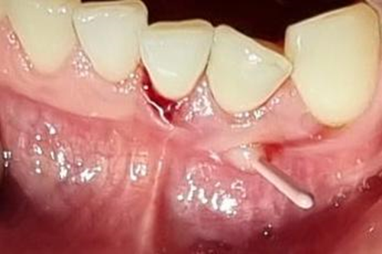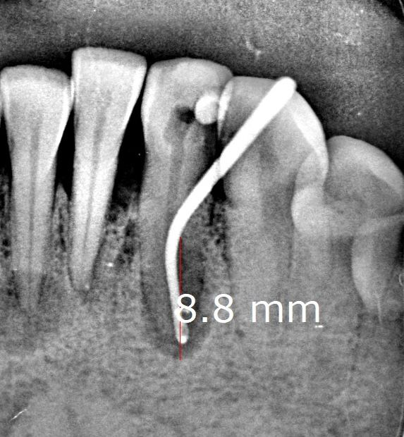
A
B
Figure 1. A) Fistula tracing with gutta-percha cone. B) Periapical radiograph to identify the tooth of origin of the fistula. A well-defined radiolucent periapical lesion can be observed in the affected tooth.
In the complementary radiographic examination for fistula tracing, a relationship between the lesion and tooth 32 was observed. The tooth presented a well-defined radiolucent periapical lesion, approximately 8.8 mm in its greatest diameter (Figure 2). Additionally, a radiolucent image was noted in the pulp chamber region, suggestive of coronal access, indicating a possible previous neutralization procedure. Based on the clinical and radiographic findings, a diagnosis of chronic periapical abscess was established, and the proposed treatment plan was simplified endodontic therapy.
Upon further analysis of the radiograph, a well-defined radiolucent lesion was also noted at the apex of tooth 41. To rule out pulp necrosis, a pulp sensitivity test was performed, which yielded a positive response. The patient was referred for stomatological evaluation.

Clinical sequence of the instituted protocol
Following mental nerve block anesthesia with 2% lidocaine and 1:100,000 epinephrine, absolute isolation was achieved, and coronal access was performed. Canal patency was established using a #10 manual file and an electronic apex locator (Finepex, Schuster) to determine the actual working length (AWL) of the tooth. After achieving patency, the canal was enlarged to a #20 manual file at the working length (WL), set 1 mm short of the AWL. Biomechanical preparation was then carried out using the Protaper Next rotary system (Dentsply Maillefer – Switzerland) with 2.5 N·cm torque and 300 rpm, up to file X3 at the established WL. After each file change, recapitulation was performed using the #10 file at the AWL. The root canal was irrigated using an alternating protocol with the following irrigating solutions: 2.5% sodium hypochlorite (NaOCl, ASFER – Brazil) and 17% EDTA (Biodinâmica – Brazil). These procedures can be observed in Figure 2.
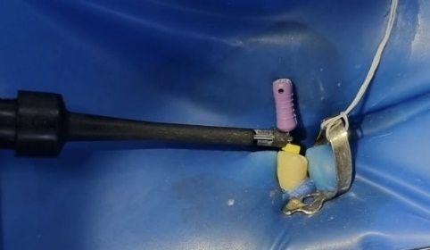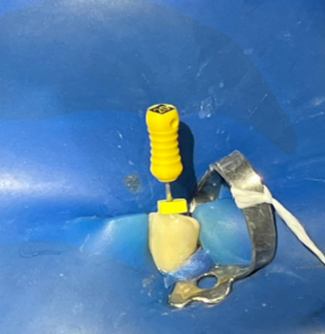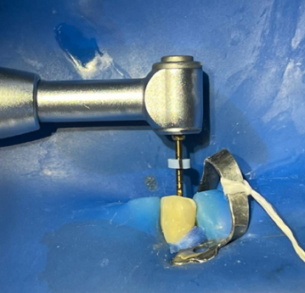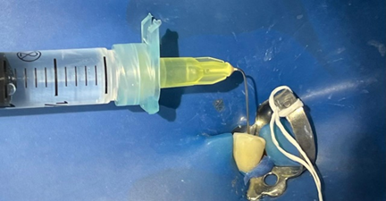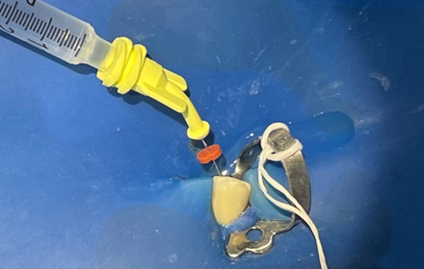
D
E
A
B
C
Figure 2. A) #10 manual file attached to the apex locator rod to determine the actual root length (ARL). B) Manual canal instrumentation with a #20 file. C) Instrumentation with the X3 file of the Protaper Next rotary system. D) Root canal irrigation with 2.5% sodium hypochlorite (NaOCl). E) Root canal irrigation with EDTA.
After completing the biomechanical preparation (BMP) and prior to root canal obturation, the photodynamic therapy (PDT) protocol was performed using the Duo Laser – MMOptics with 100 mW output power (Figure 3). Initially, the canal was dried with a sterile absorbent paper point, followed by flooding the canal with 0.01% methylene blue dye (Chimiolux 10, DMC – Brazil) (Figure 3), which remained in the root canal for 2 minutes as the pre-irradiation phase. Subsequently, with the optical fiber tip (TF Premier\Laser Duo-MMO) attached to the laser device, three cycles of 60 seconds each were applied at a wavelength of 660 nm, with apical-to-incisal and helical movements inside the root canal, totaling 18 J (Figure 4). Between laser applications, the dye was aspirated and refreshed with new pre-irradiation in each cycle. Upon completion of the laser application, the canal was irrigated again with 5 mL of sodium hypochlorite (NaOCl) to remove the dye.
After the cone fit was verified, the canal was dried again with sterile absorbent paper points and then obturated using a matched X3 file gutta-percha cone (TDK –Brazil) and Sealer 26 cement (Dentsply – Brazil). For the definitive coronal restoration, a base of Cotosol (Villevie – Brazil) was applied, followed by a sandwich restoration technique using glass ionomer cement and composite resin. The final result of the treatment can be seen in Figure 5.
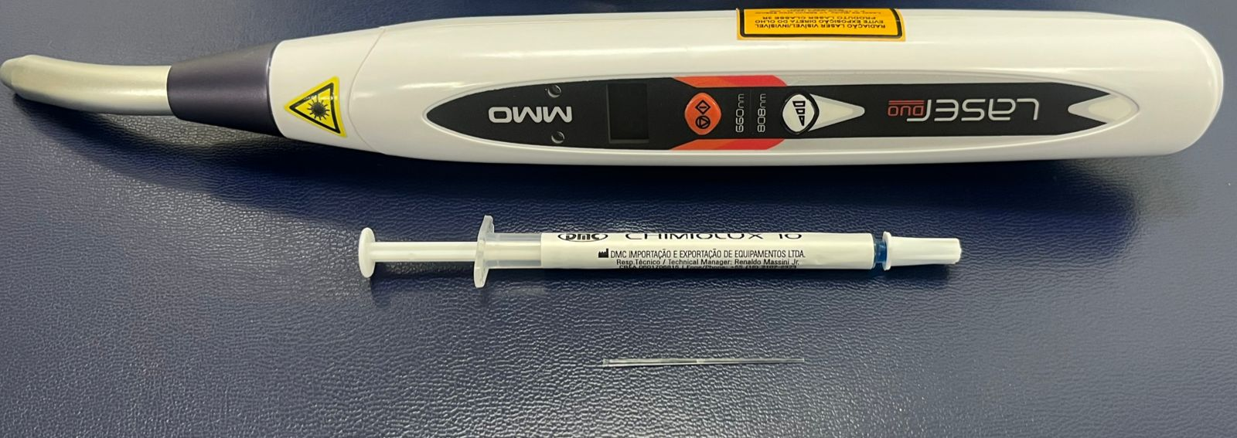
Figure 3. Duo Laser device – MMOptics, methylene blue dye (Chimiolux 10), and optical fiber tip used prior to root canal obturation. Source: Original image.

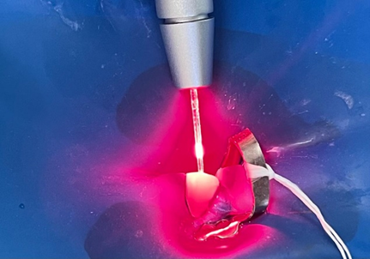
Figure 4 – Application of low-power laser in the root canal for 60 seconds. Note the use of the optical fiber tip. Source: Original image.
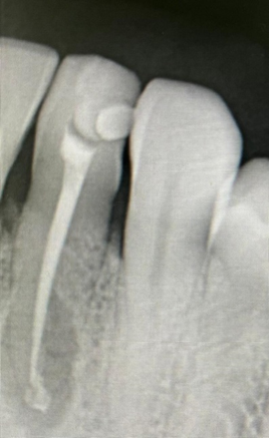
Figure 5. Final radiograph. Source: Original image.

Recall
Six months after completion of endodontic treatment, the patient returned to the UFVJM Dental Clinic for clinical and radiographic reevaluation. The percussion test was negative; however, mobility and periodontal pocketing were still present, as the patient reported not having initiated periodontal therapy. The coronal restoration was satisfactory, and the patient reported no postoperative pain. Radiographic analysis revealed a reduction of the periapical lesion from 8.8 mm to 6.9 mm, as well as periodontal ligament formation in the mesial region of tooth 32 (Figures 6).
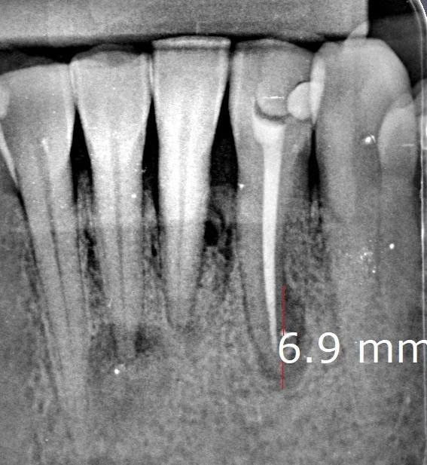
A
B
Figure 6 – A) Radiograph taken at the time of the cone fit verification, illustrating the initial lesion length of 8.8 mm at its greatest diameter. B) Radiograph taken six months after obturation. Note the periapical lesion measuring 6.9 mm at its greatest diameter.

Finally, in the radiographic follow-up evaluation, in addition to the reduction of the periapical lesion, absorption of the formed periodontal ligament space (PLS) after obturation was also observed, along with an increase in radiopacity in the region, indicating greater bone density. These findings suggest a process of bone neoformation and, consequently, successful treatment outcome.

3. DISCUSSION

The primary objective of root canal instrumentation in teeth with pulp necrosis is the removal of infected tissue, debris, and bacteria from the root canal system (RCS), thereby preparing the canal for obturation. However, the anatomical complexity of the RCS poses significant challenges in endodontic treatments due to variations such as the number of canals, their shapes, sizes, and curvatures, as well as the presence of accessory canals and isthmuses, which significantly influence the instrumentation approach [9] and its corresponding antisepsis, making sterilization of the RCS difficult and consequently favoring endodontic treatment failure [35]. As Prof. Dr. Tauby Coutinho aptly stated: "The endodontist’s greatest enemy remains bacteria in the form of biofilms, while the greatest challenge is to overcome the anatomy where these biofilms are established."
Thus, many dentists perform endodontic treatment over multiple sessions [36]. However, significant advances in techniques and technologies over the years, along with the use of modern equipment such as magnification, electronic apex locators, and mechanized devices employing NiTi files and reciprocating systems—supported by advanced imaging and irrigation methods [23]—have reduced treatment time, increasing professional interest in completing treatment in a single session [37, 23]. Accordingly, in recent decades, many institutions across various geographic areas and researchers have advocated for single-visit endodontic treatment [38]. The possibility of performing root canal treatment in a single session for cases diagnosed with irreversible pulpitis is largely uncontested [38,39]. However, in cases of pulp necrosis with or without apical periodontitis, the literature remains controversial [40].
In this context, one of the methodologies discussed in the literature that could contribute to the success of endodontic treatments, enabling single-session procedures, is the use of low-level laser therapy for RCS disinfection. This technique is known as photodynamic therapy (PDT) and is based on the use of a light-sensitive chemical agent (photosensitizer) at an extremely low and non-toxic concentration, which, when activated by light at a specific wavelength, produces toxic oxygen species [41], such as singlet oxygen and free radicals that cause bacterial death. Most photosensitizers are activated by light between 630 and 700 nm, with the most commonly reported in the literature being hematoporphyrin derivatives (620–650 nm), phenothiazines such as toluidine blue and methylene blue (620–700 nm), cyanines (600–805 nm), phytotherapeutics (550–700 nm), and hyalocyanines (660–700 nm) (42,43,44), with methylene blue being the most commonly used in clinical applications [45].
According to a study by Sin et al. (2020), [46] methylene blue concentrations between 0.001% and 0.1% appear to be the most effective in producing singlet oxygen. Moreover, the study emphasizes that photoactivated disinfection with methylene blue should be used in conjunction with sodium hypochlorite for optimal RCS disinfection. Similarly, a literature review by Cunha and Schwingel (2022) [47] concluded that although PDT has antimicrobial effects, it should be used in combination with conventional techniques and medicinal therapies, rather than as a standalone treatment. Tennert et al. (2014), [48]evaluating the antibacterial effect of photodynamic therapy on Enterococcus faecalis biofilms in experimentally infected human root canals during primary infections and endodontic retreatments, found that PDT alone was less effective compared to NaOCl irrigation and that the combination of NaOCl irrigation and PDT yielded superior results.
Garcez et al. (2010), [49] investigating the effect of PDT in in vivo endodontic retreatments, also observed that PDT as an adjunct to conventional endodontic treatment resulted in a significant additional reduction in bacterial load after irrigation with sodium hypochlorite, hydrogen peroxide, and EDTA, proving effective against multi-resistant bacteria.
Therefore, to combat resistant infections and ensure endodontic treatment success, alternative RCS disinfection methods using NaOCl and PDT have been studied. An experiment by Soares et al. (2010) [11] demonstrated the efficacy of an alternating irrigation regimen with NaOCl and EDTA in eliminating Enterococcus faecalis biofilms following root canal preparation. However, a study by Alves et al. (2023) [50] showed the persistence of moderate quantities of this bacterium within dentinal tubules, indicating that biomechanical preparation and irrigation alone are insufficient for RCS antisepsis. Consequently, Soares et al. (2018) [51] established a PDT protocol which, when combined with biomechanical preparation and alternating irrigation, surprisingly eliminated Enterococcus faecalis from root canals on a logarithmic scale, leaving only residual amounts in the pericervical dentin. This demonstrated the effectiveness of the alternating irrigation regimen using NaOCl and EDTA combined with PDT in eliminating microorganisms within dentinal tubules. Furthermore, the same study highlighted the importance of dye renewal, since successive PDT cycles expose bacterial cells to increasing amounts of photosensitizer, enabling greater bacterial eradication.
Considering the current literature, this study employed an alternating irrigation regimen using 2.5% NaOCl and 17% EDTA, followed by PDT application as an adjunct in the RCS antisepsis protocol to complete the treatment in a single session. Methylene blue at 0.01% concentration was used as the photosensitizer, and the Laser Duo MMOptics device was utilized at a wavelength of 660 nm and power of 100 mW. This is considered a low-level laser, incapable of generating sufficient heat to damage adjacent tissues, while promoting tissue repair, inflammation modulation, and pain relief [47, 52]. According to Pelozo et al. (2023) [53], low-level laser therapy decreases inflammatory mediator levels in tissues and increases neovascularization, potentially accelerating osteogenesis.
Literature also reports results using other types of low-intensity lasers, such as the randomized clinical trial by Pelozo et al. (2023) [53], which used a 980 nm diode laser as adjunctive therapy in root canal retreatments with a one-year patient follow-up. Despite not using photosensitizers, they concluded that bacterial counts were lower after laser irradiation compared to placebo, and that laser therapy facilitated periapical healing, showing 45% more cured cases than the placebo group, demonstrating the benefits of low-level laser therapy in endodontics [53].
It is important to highlight that the present clinical case has limitations, such as the short follow-up period, use of a protocol not yet consolidated in the literature, and the absence of final tomographic examination to better assess periapical repair. However, database analyses reveal a limited number of articles addressing PDT use as an adjunct to RCS antisepsis protocols in single-session treatments of teeth with chronic periapical lesions, highlighting the need for more studies with longer follow-up periods to evaluate PDT efficacy and protocol standardization.

Therefore, future clinical studies with long-term follow-up and comparisons between groups using PDT and intracanal medication for RCS disinfection in teeth with apical periodontitis are necessary.

4. CONCLUSION

In this context, considering the benefits of using PDT in Endodontics and the outcomes observed in this clinical case—such as regression of the periapical lesion and reduction of pain symptoms in the 6-month postoperative evaluation—it can be concluded that the use of PDT as an adjunct in the disinfection protocol of root canal systems is satisfactory and comparable to the results obtained with endodontic treatments using intracanal medication with calcium hydroxide. However, PDT offers advantages in terms of reduced clinical time and ease of application. Nevertheless, it is important to emphasize that further studies are needed to assess and confirm the long-term effectiveness of laser therapy.

CONSENT

Authors may use the following wordings for this section: "All authors declare that ‘written informed consent was obtained from the patient for publication of this case report and accompanying images. A copy of the written consent is available for review by the Editorial office/Chief Editor/Editorial Board members of this journal.

ETHICS APPROVAL

All authors declare that this case report was reviewed and approved by the Ethics Committee of the Federal University of the Jequitinhonha and Mucuri Valleys (approval no. 7.616.760) and was therefore conducted in accordance with the ethical standards laid down in the 1964 Declaration of Helsinki.

COMPETING INTERESTS DISCLAIMER:
Authors have declared that they have no known competing financial interests OR non-financial interests OR personal relationships that could have appeared to influence the work reported in this paper.

5. REFERENCES

[1] Soares, J. A. et al. (2006) Histomicrobiological aspects of the root canal system and periapical lesions in dogs’ teeth after rotary instrumentation and intracanal dressing with Ca(OH)₂ pastes. Journal of Applied Oral Science, 14, 355-364. https://doi.org/10.1590/S1678-77572006000500011.

[2] Stashenko, P., Yu, S. M., Wang, C. Y. (1992). Kinetics of immune cell and bone resorptive responses to endodontic infections. Journal of Endodontics, [S.l.], 18, 422-426. DOI: 10.1016/S0099-2399(06]80841-1.

[3] Sjögren, U. et al. 91997). Influence of infection at the time of root filling on the outcome of endodontic treatment of teeth with apical periodontitis. International Endodontic Journal, [S.l.], v. 30, 297-306. DOI: 10.1046/j.1365-2591.1997.00092.x.

[4] Byström, A. et al. (1987). Hling of periapical lesions of pulpless teeth after endodontic treatment with controlled asepsis. Endodontics and Dental Traumatology, [S.l.], 3(2), 58-63. DOI: https://doi.org/10.1111/j.1600-9657.1987.tb00543.x.

[5] Sundqvist, G. et al. (1998). Microbiological analysis of teeth with failed endodontic treatment and the outcome of conservative re-treatment. Oral Surgery, Oral Medicine, Oral Pathology, Oral Radiology and Endodontology, [S.l.], 85, 86-93. DOI: https://doi.org/10.1016/s1079-2104(98)90404-8.

[6] Garcez, A. S. et al. (2007). Antimicrobial photodynamic therapy combined with conventional endodontic treatment to eliminate root canal biofilm infection. Lasers in Surgery and Medicine, Hoboken, v. 39(1), 59-66. DOI: 10.1002/lsm.20415.

[7] Peters, L. B., Wesselink, P. R. (2002) Periapical healing of endodontically treated teeth in one and two visits obturated in the presence or absence of detectable microorganisms. International Endodontic Journal, [S.l.], 35, 660-667.DOI: 10.1046/j.1365-2591.2002.00541.x.

[8] Weiger, R., Rosendahl, R., Löst, C. (2000). Influence of calcium hydroxide intracanal dressings on the prognosis of teeth with endodontically induced periapical lesions. International Endodontic Journal, 33(3), 219-226. DOI:10.1046/j.1365-2591.1999.00298.x.

[9] Srivastava, S. (2024). Root canal instrumentation: current trends and future perspectives. Cureus, [S. l.], 16(4), e58045. DOI: https://doi.org/10.7759/cureus.58045.

[10] Byström, A., Sundqvist, G. (1981). Bacteriological evaluation of the efficacy of mechanical root canal instrumentation in endodontic therapy. Scandinavian Journal of Dental Research, [S.l.], 89, 321-328, DOI: 10.1111/j.1600-0722.1981.tb01689.x.

[11] Soares, J. A. et al. (2010). Effectiveness of chemomechanical preparation with alternating use of sodium hypochlorite and EDTA in eliminating intracanal Enterococcus faecalis biofilm. Journal of Endodontics, [S.l.], 36, 894-898. DOI: 10.1016/j.joen.2010.01.002.

[12] Neves, M. A. et al. (2016). Clinical antibacterial effectiveness of root canal preparation with reciprocating single-instrument or continuously rotating multi-instrument systems. Journal of Endodontics, [S.l.], 42(1)25-29. DOI: 10.1016/j.joen.2015.09.019.

[13] Gu, L. S. et al. (2009). Review of contemporary irrigant agitation techniques and devices. Journal of Endodontics, [S.l.], 35, 791-804. DOI: 10.1016/j.joen.2009.03.010.

[14] Fabricius, L. et al. (2006). Influence of residual bacteria on periapical tissue healing after chemomechanical treatment and root filling of experimentally infected monkey teeth. European Journal of Oral Sciences, [S.l.], 114, 278-285. DOI: 10.1111/j.1600-0722.2006.00380.x.

[15] Eters, L. B., Wesselink, P. R., Moorer, W. R. (1995). The fate and the role of bacteria left in root dentinal tubules. International Endodontic Journal, [S.l.], 28, 95-99. DOI: 10.1111/j.1365-2591.1995.tb00166.x.
[16] Byström, A., Sundqvist, G. (1985). The antibacterial action of sodium hypochlorite and EDTA in 60 cases of endodontic therapy. International Endodontic Journal, [S.l.], 18, 35-40. DOI: 10.1111/j.1365-2591.1985.tb00416.x.

[17] Farzaneh, M., Abitbol, S., Friedman, S. (2024) Treatment outcome in endodontics: the Toronto study. Phases I and II: Orthograde retreatment. Journal of Endodontics, [S.l.], 30(9), 627-633. DOI: 10.1097/01.don.0000129958.12388.82.

[18] Ricucci, D., Loghin, S., Siqueira, J. F. Jr. (2013). Exuberant biofilm infection in a lateral canal as the cause of short-term endodontic treatment failure: report of a case. Journal of Endodontics, [S.l.], 39(5), 712-718. DOI: 10.1016/j.joen.2012.12.008.

[19] Ricucci, D. et al. (2016). Complex apical intraradicular infection and extraradicular mineralized biofilms as the cause of wet canals and treatment failure: report of 2 cases. Journal of Endodontics, [S.l.], 42(3):509-15. DOI: 10.1016/j.joen.2015.12.014.

[20] Rodrigues, R. C. et al. (2015). Infection control in retreatment cases: in vivo antibacterial effects of 2 instrumentation systems. Journal of Endodontics, [S.l.], 41(10), 1600-1605. DOI: 10.1016/j.joen.2015.06.005.

[21] Antunes, H. S. et al. (2015). Total and specific bacterial levels in the apical root canal system of teeth with post-treatment apical periodontitis. Journal of Endodontics, [S.l.], 41(7), 1037-1042, DOI: 10.1016/j.joen.2015.03.008.

[22] Siqueira, J. F. Jr. et al. (2014). Causes and management of post-treatment apical periodontitis. British Dental Journal, [S.l.], 216(6), 305-312. DOI: 10.1038/sj.bdj.2014.200.

[23] Nakajo, K. et al. (2005). Resistance to acidic and alkaline environments in the endodontic pathogen Enterococcus faecalis. Oral Microbiology and Immunology, 21, 283–288. DOI: https://doi.org/10.1016/j.ics.2005.06.060.

[24] Sathorn, C., Parashos, P., Messer, H. (2007). Antibacterial efficacy of calcium hydroxide intracanal dressing: a systematic review and meta-analysis. International Endodontic Journal, [S.l.], 40(1), 2-10,. DOI: 10.1111/j.1365-2591.2006.01197.x.

[25] Kvist, T. et al. (2004). Microbiological evaluation of one- and two-visit endodontic treatment of teeth with apical periodontitis: a randomized, clinical trial. Journal of Endodontics, [S.l.], 30, 572-576. DOI: 10.1097/01.don.0000121607.87969.6e.

[26] Wong, A. W. et al. (2015). Incidence of post-obturation pain after single-visit versus multiple-visit non-surgical endodontic treatments. BMC Oral Health, [S.l.], 15, 96p. DOI: 10.1186/s12903-015-0082-y.

[27] Benedicenti, S. et al. (2008). Decontamination of root canals with the gallium-aluminum-arsenide laser: an in vitro study. Photomedicine and Laser Surgery, New Rochelle, 26(4), 367-370. DOI: 10.1089/pho.2008.2158.

[28] Nakamura, V. C. et al. (2013). Ex vivo evaluation of the effects of several root canal preparation techniques and irrigation regimes on a mixed microbial infection. International Endodontic Journal, [S.l.], 46, 217-224.. DOI: 10.1111/j.1365-2591.2012.02110.x.

[29] Chrepa, V. et al. (2014). The effect of photodynamic therapy in root canal disinfection: a systematic review. Journal of Endodontics, [S.l.], 40, 891-898. DOI:10.1016/j.joen.2014.03.005.

[30] Soukos, N. S. et al. (2006). Photodynamic therapy for endodontic disinfection. Journal of Endodontics, [S.l.], 32(10)979-984. DOI:10.1016/j.joen.2006.04.007.

[31] Fimple, J. L. et al. (2008). Photodynamic treatment of endodontic polymicrobial infection in vitro. Journal of Endodontics, [S.l.], 34, 728-734. DOI: 10.1016/j.joen.2008.03.011.

[32] NG, R. et al. (2011). Endodontic photodynamic therapy ex vivo. Journal of Endodontics, [S.l.], 7(2):217-22. DOI: 10.1016/j.joen.2010.10.008.

[33] Mergoni, G. et al. (2022). Single versus multiple visits for endodontic treatment of permanent teeth. Cochrane Database of Systematic Reviews, 12, Art. No.: CD005296. DOI: https://doi.org/10.1002/14651858.CD005296.pub4.

[34] Miranda, R. G., Colombo, A. P. V. (2018). Clinical and microbiological effectiveness of photodynamic therapy on primary endodontic infections: a 6-month randomized clinical trial. Clinical Oral Investigations, 22(4)1751-1761. DOI: https://doi.org/10.1007/s00784-017-2270-4.

[35] Convissar, R. A. (2011). Principles and practices of laser in dentistry. 1st ed. Rio de Janeiro: Elsevier Editora Ltda, p. 163–173.

[36] E. L. Mubarak, A. H., Abu-Bakr, N. H., Ibrahim, Y. E. (2010). Postoperative pain in multiple-visit and single-visit root canal treatment. Journal of Endodontics, 36(1)36–39. DOI: 10.1016/j.joen.2009.09.003.

[37] Endo, M. S., Santos, A. C. L., Pavan, A. J., Queiroz, A. F., Pavan, N. N. O. (2015). Endodontics in single or multiple visits: literature review. Journal of the Faculty of Dentistry of Passo Fundo, 20(3), 408-413.

[38] Eleazer, P. D., Eleazer, K. R. (1998). Flare-up rate in pulpally necrotic molars in one-visit versus two-visit endodontic treatment. Journal of Endodontics, 24(9), 614–616. DOI: https://doi.org/10.1016/S0099-2399(98)80158-4.

[39] Albashaireh, Z. S., Alnegrish, A. S. (1998). Postobturation pain after single- and multiple-visit endodontic therapy. Journal of Dentistry, 26(3), 227-232. DOI: https://doi.org/10.1016/S0300-5712(97)00024-6.

[40] Abbott, P. V., Yu, C. (2007). A clinical classification of the status of the pulp and the root canal system. Australian Dental Journal, 52(1), 17-31. DOI: https://doi.org/10.1111/j.1834-7819.2007.tb00467.x.

[41] Kishen, A. (2010). Advanced therapeutic options for endodontic biofilms. Endodontic Topics, 22(1), 99-123. DOI: https://doi.org/10.1111/j.1601-1546.2010.00241.x.

[42] Meisel, P., Kocher, T. (2005). Photodynamic therapy for periodontal diseases: state of the art. Journal of Photochemistry and Photobiology B: Biology, 79, 159-170. DOI: https://doi.org/10.1016/j.jphotobiol.2004.11.023.

[43] Pinheiro, S. L. et al. (2009). Photodynamic therapy in endodontic treatment of deciduous teeth. Lasers in Medical Science, 24, 521–526. DOI: https://doi.org/10.1007/s10103-008-0562-2.

[44] Sigusch, B. W. et al. (2005). Efficacy of photodynamic therapy on inflammatory signs and two selected periodontopathogenic species in a beagle dog model. Journal of Periodontology, 76(7), 1100–1105. DOI: https://doi.org/10.1902/jop.2005.76.7.1100.

[45] Wainwright, M., Giddens, R. M. (2003). Phenothiazinium photosensitizers: choices in synthesis and application. Dyes and Pigments, 57, 245–257. DOI:10.1016/S0143-7208(03)00021-4.

[46] Sin, J. H. M., Walsh, L. J., Figueredo, C. M., George, R. (2020). Evaluation of the effectiveness of photosensitizers used in laser endodontic disinfection: A systematic review. Translational Biophotonics, 3(1), e202000007. DOI: 10.1002/tbio.202000007.

[47] Cunha, C. R. S., Schwingel, R. A. (2022). Photodynamic therapy associated with endodontic treatment: a literature review. Revista REMATOS, 1(1), 1–10.

[48] Tennert, C. et al. (2014). Effect of photodynamic therapy (PDT) on Enterococcus faecalis biofilm in experimental primary and secondary endodontic infections. BMC Oral Health, 14, 132. DOI: https://doi.org/10.1186/1472-6831-14-132.

[49] Garcez, A. S., Nunez, S. C., Hamblim, M. R., Suzuki, H., Ribeiro, M. S. (2010). Photodynamic therapy associated with conventional endodontic treatment in patients with antibiotic-resistant microflora: a preliminary report. Journal of Endodontics, 36, 1463–1466. DOI:10.1016/j.joen.2010.06.001.

[50] Alves-Silva, E. G. et al. (2023). Effect of antimicrobial photodynamic therapy on the reduction of bacteria and virulence factors in teeth with primary endodontic infection. Photodiagnosis and Photodynamic Therapy, 41, 103292. DOI: https://doi.org/10.1016/j.pdpdt.2023.103292.

[51] Soares, J. A. et al. (2018). Exploring different photodynamic therapy parameters to optimize elimination of Enterococcus faecalis in planktonic form. Photodiagnosis and Photodynamic Therapy, 22, 127–131. DOI: 10.1016/j.pdpdt.2018.03.009.

[52] Gama, B. M. S.; Almeida, S. A. (2025). Photodynamic therapy in endodontics: a review of the literature. JNT Facit Business and Technology Journal, 1(59), 266–272.

[53] Pelozo, L. L et al. (2023). Adjuvant therapy with a 980-nm diode laser in root canal retreatment: randomized clinical trial with 1-year follow-up. Lasers Med Sci 38(1), 77. DOI: 10.1007/s10103-022-03659-0.

