Mathematical Modeling of HIV/AIDS Dynamics in Relation to Drug Abuse

Abstract - HIV/AIDS remains a major public health concern, especially in regions where drug abuse is prevalent. Drug abuse facilitates HIV transmission through behaviours such as needle sharing and unsafe sexual practices. In this study, a mathematical model was formulated to investigate the co-dynamics of HIV/AIDS and drug abuse within a population. The model consists of seven compartments: susceptible individuals, protected individuals, HIV-infected individuals, drug abusers, dual-infected individuals, those under HIV treatment, and those undergoing rehabilitation. The model incorporates protection mechanisms and rehabilitation efforts aimed at controlling both epidemics. The basic reproduction numbers R₀ were derived using the Next Generation Matrix method to assess the threshold conditions for disease spread or elimination. Analytical results showed that the disease-free equilibrium is locally asymptotically stable when R_{C} < 1, indicating that both HIV and drug abuse can be controlled under appropriate interventions. Numerical simulations using Maple software further supported the analytical findings. An increase in protection and rehabilitation rates significantly reduced the number of drug abusers, HIV-infected individuals, and co-infections. Conversely, lower intervention rates led to persistence in all three compartments. These results emphasize the critical role of enhancing protection strategies and rehabilitation programs. The study highlights the importance of integrated public health interventions to effectively mitigate the dual burden of HIV/AIDS and drug abuse.
Keywords: HIV/AIDS, Drug Abuse, Rehabilitation, protection.

INTRODUCTION
HIV/AIDS remains a major global health challenge, with millions affected across the globe and an especially heavy burden in sub-Saharan Africa. In Kenya, the HIV prevalence rate stands at approximately 4.5%, making the country one of the most severely affected in Africa [1]. While antiretroviral therapy (ART) has significantly improved the quality of life and survival of people living with HIV/AIDS, the epidemic persists, driven by complex socio-behavioral factors such as substance abuse, poverty, and stigma [2].
Drug abuse, which involves the excessive or non-medical use of substances that alter mental and physical states, has become a growing concern in Kenya. Substances commonly misused include alcohol, cannabis, heroin, cocaine, and synthetic drugs [3]. The rise in drug abuse correlates strongly with increased risk behaviors such as unprotected sex, multiple sexual partners, and sharing of contaminated needles, all of which heighten the transmission of HIV [4]. Furthermore, social stigma, limited access to treatment, and weak rehabilitation infrastructure make addressing this dual crisis particularly difficult in developing nations [5].
While numerous studies have independently investigated HIV/AIDS and drug abuse, few have analyzed the co-dynamics of both epidemics using integrated mathematical frameworks. For instance, Espitia [6] developed a comprehensive model focusing on sexual orientation and transmission networks, incorporating antiretroviral treatment as a key intervention [7]. Although insightful, the model largely ignored the impact of substance abuse on transmission dynamics, especially among populations where sexual and injection-based risks overlap.
Similarly, Muin et al [8] proposed a five-compartment model (SAHR) to examine drug abuse transitions, including light and heavy usage, treatment, and recovery. The model utilized optimal control theory to assess the effects of anti-drug campaigns and psychological interventions [9]. While effective in illustrating the pathways of substance dependency and relapse, Muin’s model did not address how drug use behaviors contribute to HIV infection risk, especially in populations engaging in high-risk practices like needle sharing.
Recognizing these gaps, this study aims to integrate both domains, HIV/AIDS transmission and drug abuse, within a unified mathematical modeling framework. In particular, it focuses on the role of protection and rehabilitation, two vital public health strategies that are often modeled independently, if at all. Protection refers to behavioral and structural interventions that reduce the risk of HIV infection and drug initiation, such as condom use, needle exchange programs, and public sensitization. Rehabilitation, on the other hand, includes structured programs that support individuals in overcoming addiction, reintegrating into society, and adopting safer lifestyles, cite de2022incorporating.
A notable effort to bridge this gap was made by Lokaran, who modeled the spread of HIV/AIDS in Turkana County, Kenya, while incorporating drug and substance abuse factors. His model introduced compartments for individuals infected with HIV, those with substance abuse problems, and those with both conditions [10]. However, it lacked mechanisms to assess the influence of preventive and rehabilitative interventions, which limit its usefulness for evaluating policy impacts.
Further emphasizing the significance of this interaction, Bloomquist and Vaidya demonstrated through a within-host biological model how chronic morphine use increases the susceptibility of immune cells to HIV infection [11]. Their work showed that substance abuse not only influences behavioral risk but also alters biological vulnerability to the virus. However, their approach remained focused on the cellular level and did not extend to population-wide implications or the mitigating role of behavioral interventions.
To address these limitations, the present study constructs a seven-compartment model that reflects both the transmission of HIV/AIDS and the behavioral dynamics of drug abuse. The model includes susceptible individuals, protected individuals, HIV-infected individuals, drug abusers, those with co-infections, individuals under HIV treatment, and individuals in rehabilitation. By incorporating both protection and rehabilitation, the model seeks to explore the indirect yet powerful effects these strategies have on breaking transmission chains and reducing high-risk behavior.
This study contributes to ongoing efforts in applied mathematical epidemiology by offering a more holistic framework that aligns with real-world complexities. In doing so, it supports the development of targeted and integrated interventions in resource-limited settings grappling with intersecting epidemics.

Model Formulation
The study develops a deterministic compartmental model to capture the dynamics of HIV/AIDS and drug abuse in a population. The population is divided into seven compartments. These compartments are Susceptible (S), Protected (P), Infected with HIV/AIDS(I_{H}), Drug Abuse population (I_{D}), dually infected with HIV/AIDS and also drug abusers (I_{HD}), Individuals under HIV/AIDS treatment (T_{H}), and finally individuals under rehabilitation for Drug abuse (R_{D}). The model applies some assumptions that are included in this chapter. Taking the population at time t, the total population is given by the expression.
N(t) = S + P + I_{H} + I_{D} + I_{HD} + T_{D} + R_{D}
The recruitment for the susceptible is at a rate π as a result of both birth and immigration. Those under treatment for HIV/AIDS (T_{H}) are assumed not to transmit the disease due to low viral load, while those under Rehabilitation for drug abuse can relapse at a rate α₂; those who recover from drug abuse do not leave the population but become susceptible at a rate σ₂. The susceptible are assumed to acquire drug abuse at the age of 15 due to peer influence at a rate β_{2,} while β₁ is the rate at which susceptibles become infected with HIV/ AIDS either by birth(children) or by sexual interaction with infected individuals. There are control measures that are put in place, such as sensitization and educational campaigns, among others. The rate of susceptibility being protected is δ, and the ineffectiveness of the measures leads to individuals becoming infected with HIV/AIDS or Drug users at ω₁ and ω_{2,} respectively. The force of infection of HIV/AIDS is
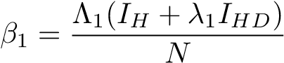
where Λ₁ is the rate of contact of HIV/AIDS and λ₁ accounts for the infectiousness of the infected individuals in the I_{HD} compartment. The individuals in I_{HD} have a higher viral load than those in I_{H}, hence higher infectious capabilities. Drug abuse increases at a rate
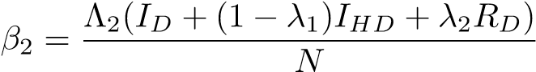
where Λ₂ is the influence of I_{D,} I_{HD,} and R_{D} on the S, while 1 − λ₁ and λ₂ are the parameters of modification I_{HD} and R_{D,} which leads to an increase in I_{D} and I_{HD}
The natural death occurs across all the compartments at a rate µ. There is induced death due to HIV/AIDS and drug abuse at γ and ρ, respectively. Those infected with HIV/AIDS can become drug abusers as a result of stigmatization, discrimination, and depression at a rate of θ_{1,} while the drug users can get infected with HIV/AIDS as a result of factors such as reckless, immoral acts, sharing of needles, among others, at a rate θ₂ and therefore move from their respective compartment to I_{HD}. In I_{HD}, death can be a result of natural factors, drug abuse, or HIV/AIDS. Individuals infected with HIV/AIDS receive ARV and transition to treatment compartments at τ. Those infected with both HIV/AIDS and who are drug abusers can either transition to HIV/AIDS treatment or Rehabilitation (in rehabilitation, there is no treatment for HIV/AIDS) at the rates η₁ and η_{2,} respectively. The drug users transition to rehabilitation at α₁. Once those who have both infection and transition to rehabilitation are rehabilitated, they can go on with HIV/AIDS treatment at T_{H} at a rate σ₁.
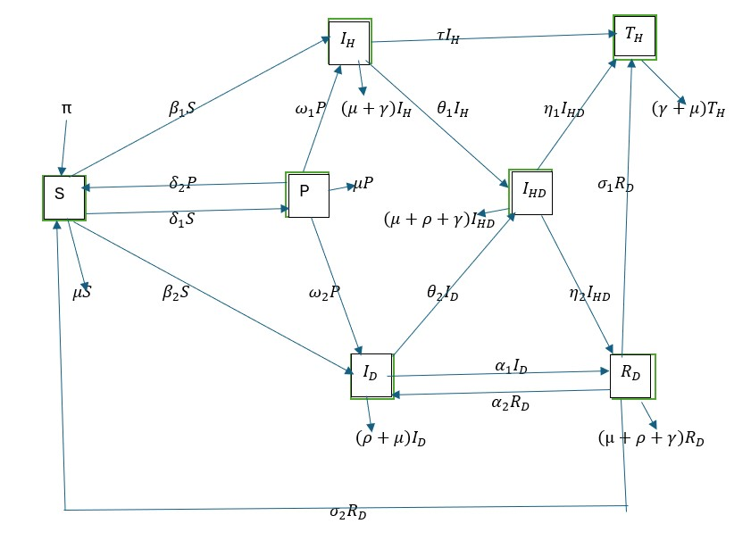
Figure 1: Flow of the model (source: Author's model)
The components used in the model are described in the table below.

VARIABLE | DESCRIPTION
S | Susceptible population
P | Protected population
I_{H} | Population infected with HIV/AIDS
I_{D} | Drug abuse population
I_{HD} | Population infected with HIV/AIDS and uses drugs
T_{H} | Population under HIV/AIDS treatment
R_{D} | Population under rehabilitation
Table 1: Description of the model Variables
The model applies the following assumptions
- The population is homogeneous.
- All individuals are susceptible to HIV/AIDS, but they become vulnerable to drug abuse from the age of 15 years due to peer influence.
- There is a possibility of being HIV/AIDS positive, but not a drug abuser or a drug abuser who is not HIV/AIDS positive.
- Those who undergo rehabilitation as a treatment method for Drug abuse can relapse.
- Since there is no permanent cure for HIV/AIDS, individuals living with HIV/AIDS may be more susceptible to drug abuse. At the same time, individuals who recover from drug abuse rehabilitation without relapse may become susceptible to HIV/AIDS transmission..
- Those who are infected by HIV/AIDS and Drug abuse and are in rehabilitation, once they recover from Drug abuse, continue with HIV/AIDS treatment.
- Death in the model is a result of a natural course that all individuals are subject to; those with drug abuse problems can suffer Drug-attributable death, such as overdose, while those with HIV/AIDS die as a result of it. Those with both can succumb to either natural or HIV/AIDS-induced death or Drug-attributed death.
- Those under treatment for HIV/AIDS are assumed to have a low viral load and therefore do not spread the HIV/AIDS infection.
- Those infected with HIV/AIDS and are drug users, but are in denial of drug addiction, do not go for rehabilitation, but rather go for HIV/AIDS treatment only.

2.0.1 Model Equations
The following equations are derived from the model and used to analyses its dynamics.
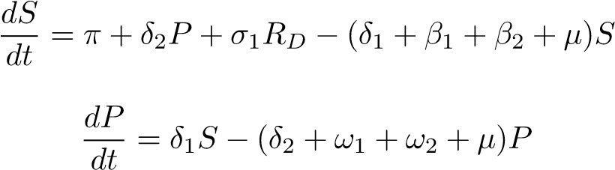
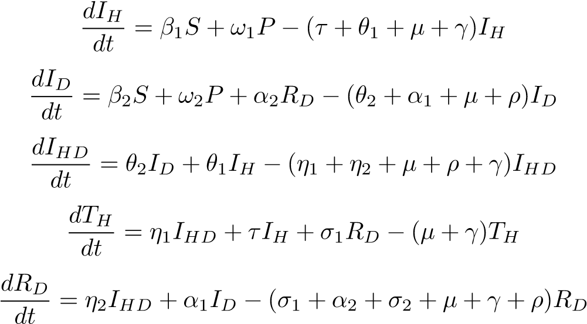

Basic properties

Invariant Region
Theorem: The model solutions are uniformly bounded for all time t > 0 if
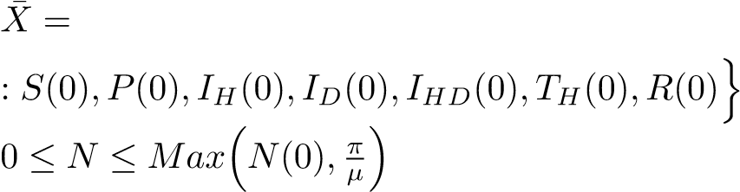
n
(S(t) + P(t) + I_{H}(t) + I_{D}(t) + I_{HD}(t) + T_{H}(t) + R_{D}(t) ∈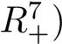
.
Proof: Taking the total population, as at time t, as
N(t) = S(t) + P(t) + I_{H}(t) + I_{D}(t) + I_{HD}(t) + T_{H}(t) + R_{D}(t)
Using the initial conditions
S(0) ≥ 0,P(0) ≥ 0,I_{H} ≥ 0,I_{D}(0) ≥ 0,I_{HD}(0) ≥ 0,T_{H}(0) ≥ 0 and R(0) ≥ 0 we Differentiate N(t) with respect to t;
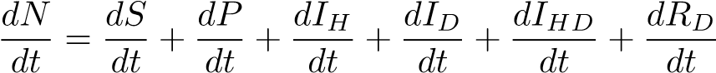 (2.1)
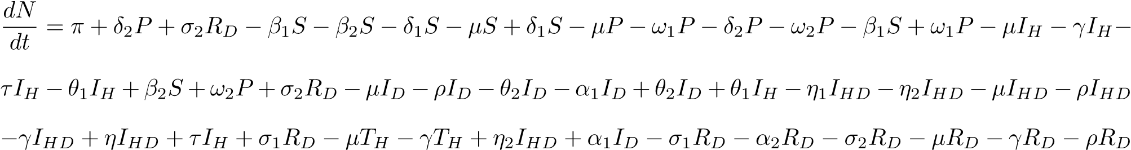
The equation can be simplified as
given that N = S + P + I_{H} + I_{D} + I_{HD} + T_{H} + R_{D} then the equation can be simplified to
(2.2)
In a state of no HIV/AIDS, then there are no HIV/AIDS-induced deaths and therefore γ = 0, which further reduces the equation to
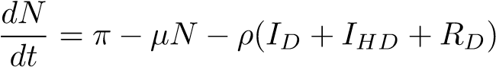
taking a situation where there is no drug abuse in the population, this translates to no drug abuse caused deaths, therefore ρ = 0. This further reduces the equation to
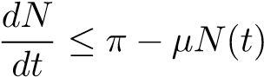 (2.3)
integrating the equation on both sides we have
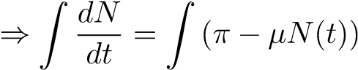 (2.4)
taking v = π − µN(t)
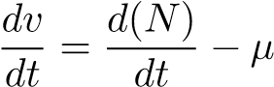
hence 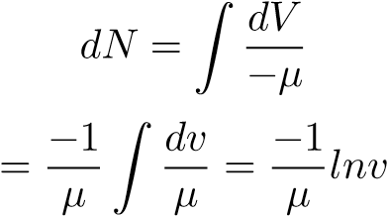
but
V = π − µ(N(t))
therefore
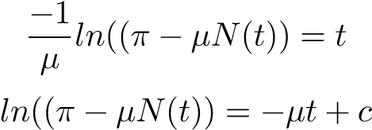
Introducing exponential on both sides, we have
_{e}(ln(π−µN)) = _{Fe}(−µt+c)
This then becomes
π − µ(N(t)) = e(−µt+c)
F = e^{c}
π − µ(N(t) = Fe^{(−µt)} (2.5)
From the equation above, we have
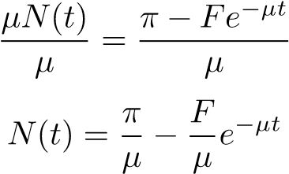
With t = 0 as the initial condition, we have t = 0 we have
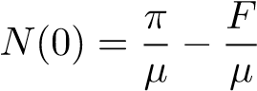
hence
F = π − µN(0)
When substituted, we have
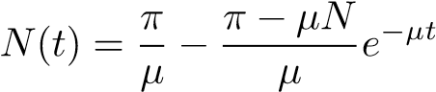
as t goes to ∞ we have t → ∞
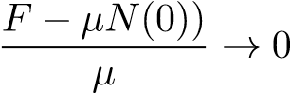
This shows that
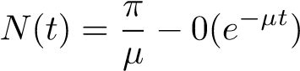
therefore
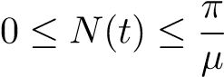 (2.6)
This proves that the model is bounded therefore
(2.7)
therefore X¯ is invariant for all S ≥ 0,P ≥ 0,I_{H} ≥ 0,I_{D} ≥ 0,I_{HD} ≥ 0,T_{H} ≥ 0,R ≥ 0 [12]

Positivity
For a model to be epidemiologically meaningful, it must have non-negative values for all time (t).
Theorem: For all initial conditions S > 0,P > 0,I_{H} > 0,I_{D} > 0,I_{HD} > 0,T_{H} > 0,R_{D} > 0 Then the solution
S,P,I_{H},I_{D},I_{HD},T_{H},R_{D} for all t ≥ 0 are positive.
Considering the equations of the model
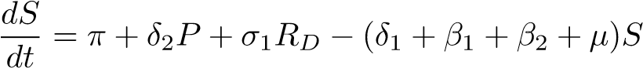
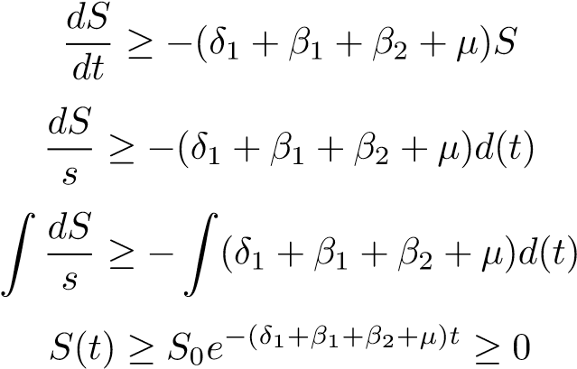 (2.8)
Applying the same method for the other equations, we have
P(t) ≥ P₀e−(δ2+ω1+ω2+µ)t ≥ 0 (2.9)
I_{D}(t) ≥ I_{D}0e−(θ2+α1+µ+ρ)t ≥ 0 (2.10)
I_{H}(t) ≥ I_{H}0e−(τ+θ1+µ+γ)t ≥ 0 (2.11)
I_{HD}(t) ≥ I_{HD}0e−(η1+η2+µ+ρ+γ)t ≥ 0 (2.12)
TH(t) ≥ TH0e−(µ+γ)t ≥ 0 (2.13)
R_{D}(t) ≥ R_{D}0e−(σ1+α2+σ2+µ+γ+ρ)t ≥ 0 (2.14)
From the equation as proven from 2.8, 2.9, 2.11, 2.10, 2.12, 2.13 and 2.14 that given the initial condition that S(T) ≥ 0,P(T) ≥ 0,I_{D}(t) ≥ 0,I_{H}(t) ≥ 0,I_{HD}(t) ≥ 0,T_{H}(t) ≥ 0 and R_{D}(t) ≥ 0 are non-negative at all t > 0 the equations system is positive

Basic Reproduction Number (R₀)
The reproduction number is the number of secondary infections originating from one primary infection. With control measures such as protection, we have control over the reproduction number. In this research, there are two control reproduction numbers for HIV and AIDS, and another for Drug Abuse. Taking the infectious compartments as I_{H}, I_{D} , and I_{HD}

Basic Reproduction Number of HIV&AIDS
Therefore, when considering HIV & AIDS the infectious compartments are I_{H} and I_{HD}
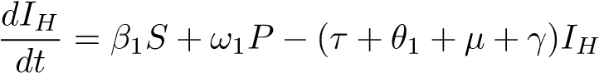
and
Taking Q to represent the new infection and L to represent the transmission of HIV &AIDS in the infectious compartment.
The reproduction number will be given by QL⁻¹ therefore the reproduction is given byQL⁻¹ therefore
= 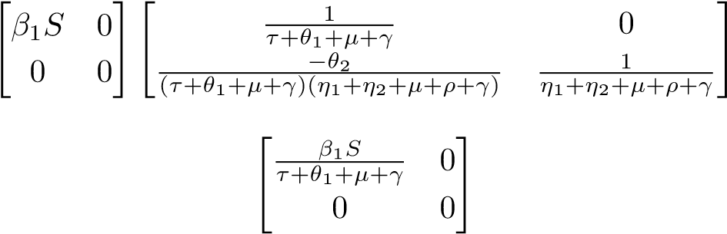
hence, the Reproduction number for HIV& AIDS is
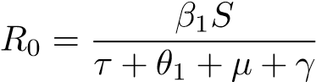 (2.15)
The reproduction is given byQL⁻¹ therefore
= 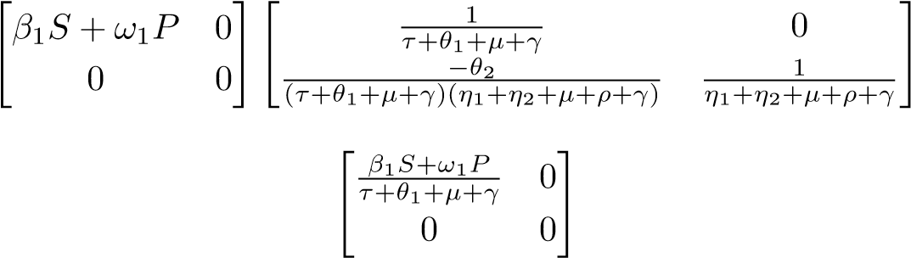
Therefore, the control reproduction number of HIV& AIDS is
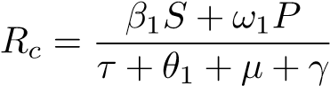 (2.16)

Basic Reproduction Number of Drug Abuse
The reproduction number of Drug abuse is calculated considering the I_{D} and I_{HD}. The equations of the compartments are
Taking Q to represent the new infection and L to represent the transmission of Drug abuse in the infectious compartment.
The reproduction number will be given by QL⁻¹ therefore Taking the inverse of R, we have QL⁻¹ is therefore given by
= 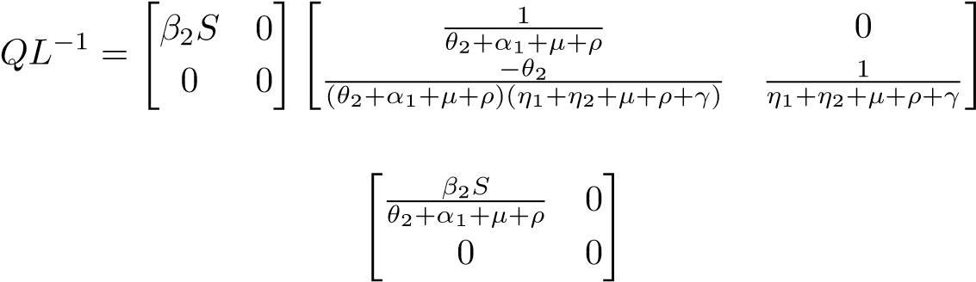
Therefore, the reproduction number of Drug Abuse is
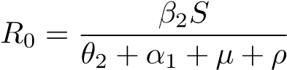 (2.17)
The control reproduction number for Drug Abuse is QL⁻¹, therefore
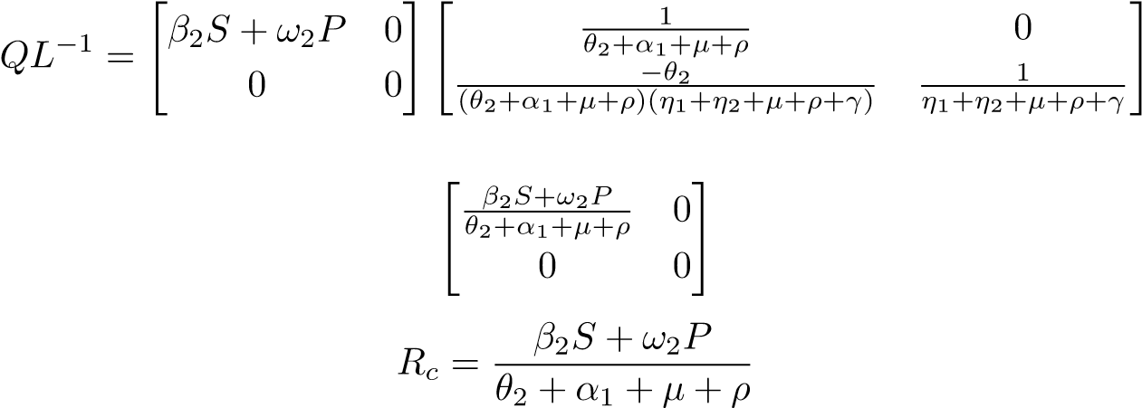
=
(2.18)

Diseases Free Equilibrium (DFE)
In the disease-free equilibrium state, the system of differential equations is evaluated at zero, reflecting a condition in which the population is entirely free from infection. Under this equilibrium, there are no individuals infected with HIV/AIDS, no cases of drug abuse, no co-infections, no individuals undergoing HIV/AIDS treatment, and no individuals recovering from drug addiction. The DFE is given by therefore
At Disease free Equilibrium then I_{H} = 0,I_{D} = 0,I_{HD} = 0,T_{D} = 0,R_{D} Therefore the Disease Free Equilibrium is given by E∗ = (S∗,P∗,IH∗ ,ID∗ ,IHD∗ ,TH∗ ,RD∗ )
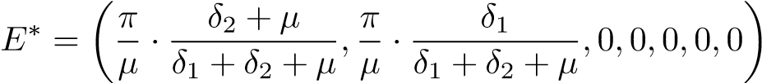

Local Stability of the Disease-Free Equilibrium
This is how the illness acts as it gets closer to the equilibrium point. The disease can be eliminated from the population if the reproduction number is less than one, R₀ < 1, but in a situation where the reproduction number is greater than one, then the disease persist, R₀ > 1. The Jacobian matrix is used to determine the stability of the disease.
At disease-free Equilibrium
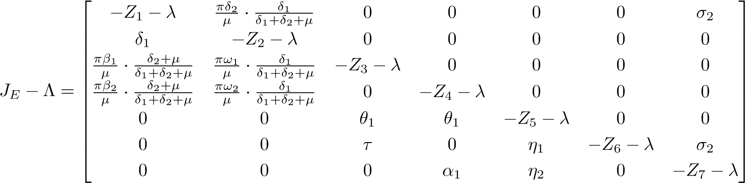
Then
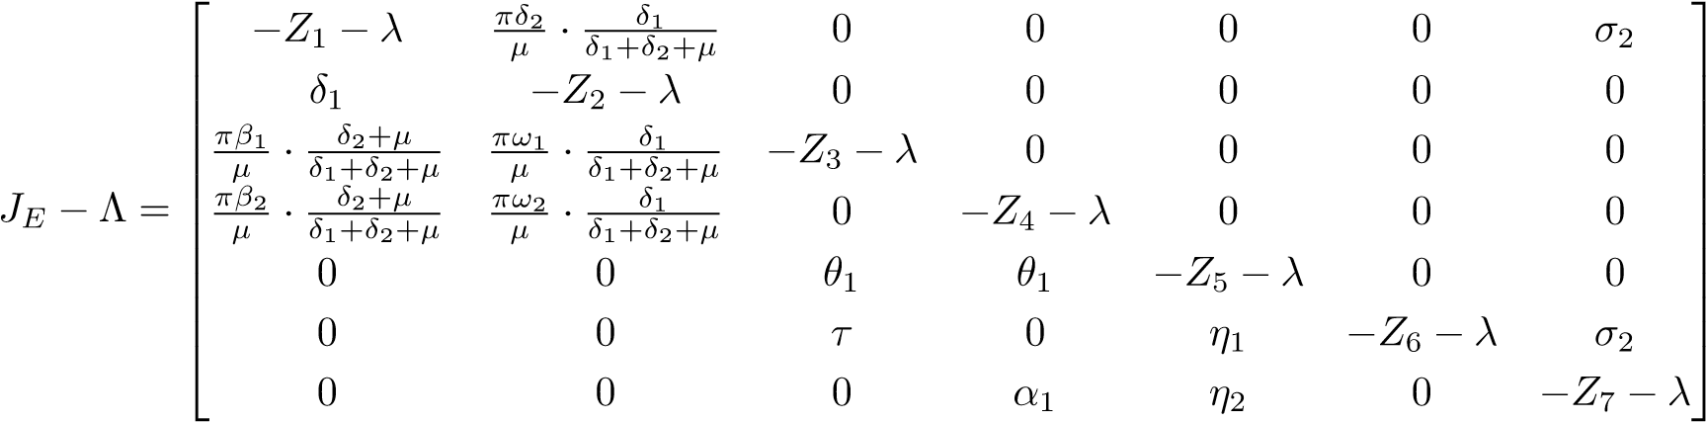
Where Z₁ = δ₁ + β₁ + β₂ + µ,Z₂ = δ₂ + ω₁ + ω₂ + µ,Z₃ = τ + θ₁ + µ + γ,Z₄ = θ₂ + α₁ + µ + ρ,Z₅ = µ + γ + ρ + η₁ + η₂,Z₆ = µ + γ and Z₇ = σ₁ + σ₂ + µ + γ + ρ
The eigenvalues of the matrix are
Λ₁ = −δ₁ − β₁ − β₂ − µ < 0
Λ₂ = −δ₂ − ω₁ − ω₂ − µ < 0
Λ₃ = −τ − θ₁ − µ − γ < 0
Λ₄ = −θ₂ − α₁ − µ − ρ < 0
Λ₅ = −µ − γ − ρ − η₁ − η₂ < 0
Λ₆ = −σ₁ − σ₂ − µ − γ − ρ < 0
Λ₇ = −µ − γ < 0
Following the principle in mathematical epidemiology, ”the disease-free equilibrium is locally asymptotically stable if and only if R₀ < 1, which corresponds to all eigenvalues of the Jacobian evaluated at the DFE have negative real parts.” [13]
The system is asymptotically locally stable since the eigenvalues are negative or smaller than zero.

Global Stability of Disease-Free Equilibrium
Theorem; If the R₀ < 1, then the Disease Free Equilibrium is globally stable asymptotically.
Proof: using the Lyapunov function technique
- Global stability of HIV/AIDS
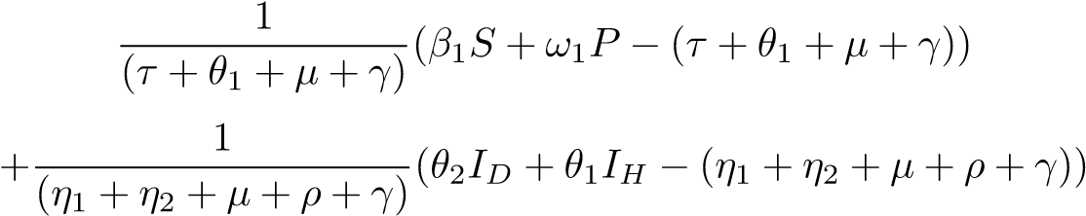
Taking the negatives on one side we have
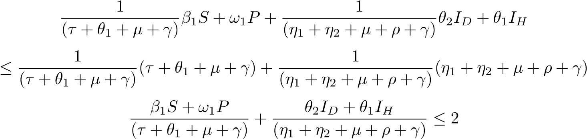
The controlled reproduction number of HIV/AIDS is 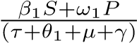 then
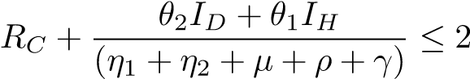
Therefore 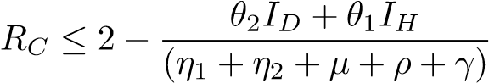
This shows that RC ≤ 1,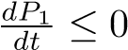 hence the disease-free equilibrium for HIV/AIDS is globally asymptotically stable.
- Global stability for Drug Abuse
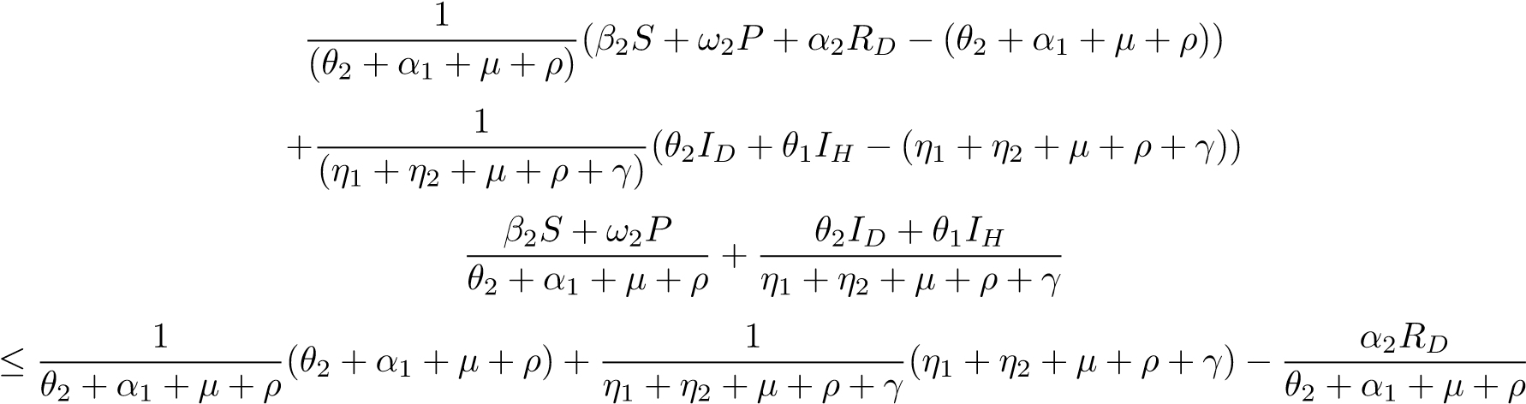
then
since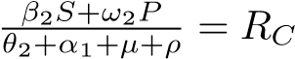 then
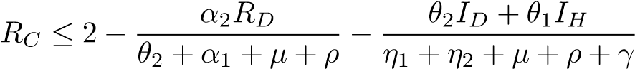
Therefore R_{C} ≤ 1 hence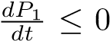 hence the disease-free equilibrium for Drug Abuse is globally asymptotically stable.

Endemic Equilibrium
When at least one of the infectious compartments is not equal to zero, the disease will persist in the population. At equilibrium, the rate of change in the compartments is Zero, and the system is written as follows. Taking the endemic equilibrium point as E₀. Then
E0 = (S0,P0,IH0 ,ID0 ,IHD0 ,TH0 ,RD0 )
0 = π + δ₂P + σ₁R_{D} − (δ₁ + β₁ + β₂ + µ)S
0 = δ₁S − (δ₂ + ω₁ + ω₂ + µ)P
0 = β₁S + ω₁P − (τ + θ₁ + µ + γ)I_{H}
0 = β₂S + ω₂P + α₂R_{D} − (θ₂ + α₁ + µ + ρ)I_{D}
0 = θ₂I_{D} + θ₁I_{H} − (η₁ + η₂ + µ + ρ + γ)I_{HD}
0 = η₁I_{HD} + τI_{H} + σ₁R_{D} − (µ + γ)T_{H}
0 = η₂I_{HD} + α₁I_{D} − (σ₁ + α₂ + σ₂ + µ + γ + ρ)R_{D}
Then the Endemic Equilibrium point is
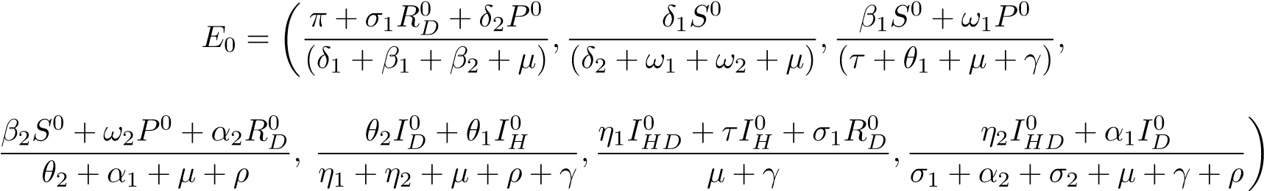

Stability of Endemic Equilibrium Point
The stability of the Endemic Equilibrium is investigated using the Lyapunov function. The function is viewed as
Q = (S∗,P∗,I_{H∗},I_{D∗},I_{HD∗},T_{H∗},R_{D∗}) = (S − S∗ − S∗lnS) + (P − P∗ − P∗lnP)
+(IH − IH∗ − IH∗lnIH) + (ID − ID∗ − ID∗lnID) + (IHD − IHD∗ − IHD∗lnIHD)
+(TH − TH∗ − TH∗lnTH + (RD − RD∗ − RD∗lnRD)
Taking the differentiation of both sides, we have
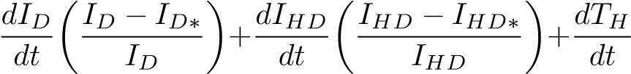
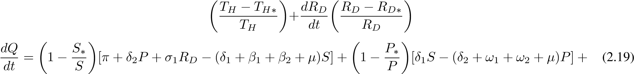
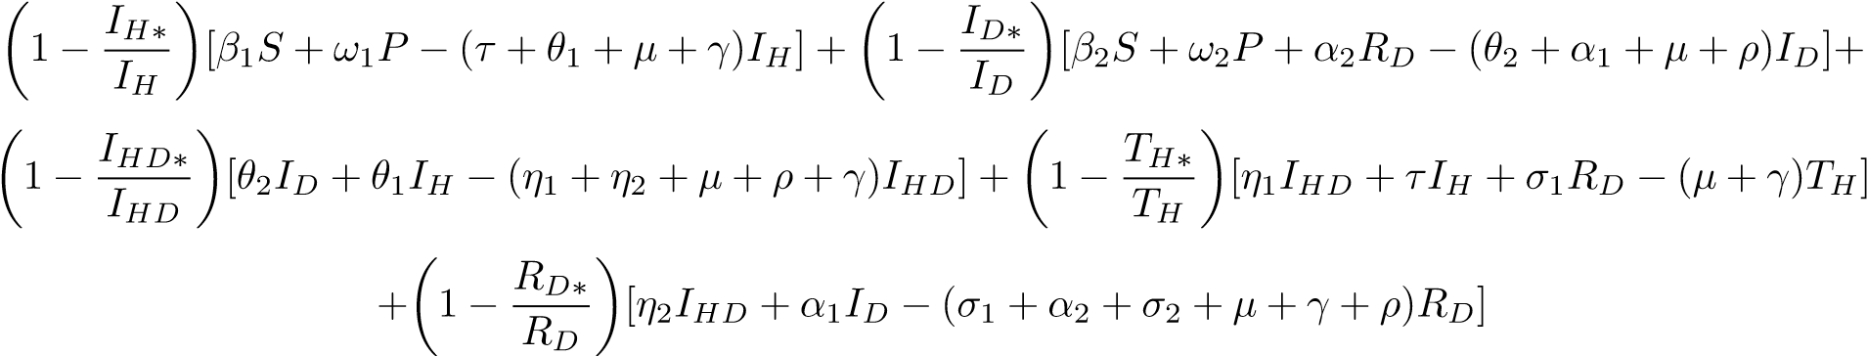
The equation 20 above can be simplified
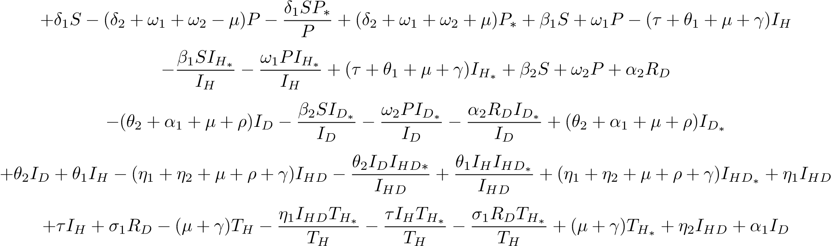
(2.20)
Rearranging the equations, we have
+β₁S + ω₁P(τ + θ₁ + µ + γ)I_{H∗} + β₂S + ω₂P + α₂R_{D}+(θ₂ + α₁ + µ + ρ)I_{D∗} + θ₂I_{D} + θ₁I_{H} + (η₁ + η₂ + µ + ρ
+γ)IHD∗ + η1IHD + τIH + σ1RD + η2IHD + α1ID + (σ1 + α2 + σ2 + µ + γ + ρ)RD∗
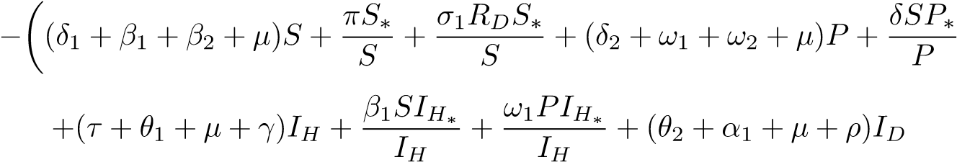
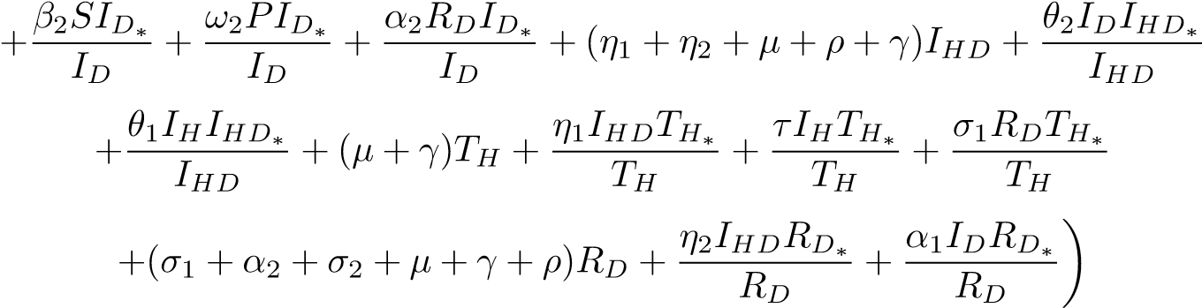 (2.21)
Using W and R to represent the positive and negative terms respectively, we have
(δ₂ + ω₁ + ω₂ + µ)P∗ + β₁S + ω₁P(τ + θ₁ + µ + γ)I_{H∗} + β₂S + ω₂P + α₂R_{D}+
(θ2 + α1 + µ + ρ)ID∗ + θ2ID + θ1IH + (η1 + η2 + µ + ρ + γ)IHD∗ + η1IHD + τIH + σ1RD + η2IHD + α1ID+
(σ₁ + α₂ + σ₂ + µ + γ + ρ)R_{D∗}
And
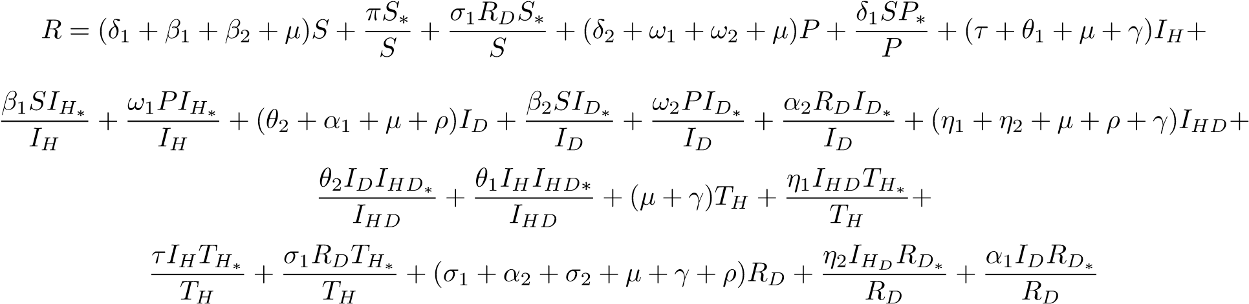
Therefore
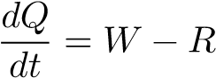
Using the conditions if W < R, then 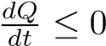 If and only if S = S∗,P = P∗,I_{H} = I_{H∗},I_{D} = I_{D∗},I_{HD} = I_{HD∗}, T_{H=} $T_{H}^{*}, R_{D}=R_{D}^{*}$ then
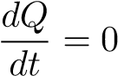
This indicates that the highest invariant set in
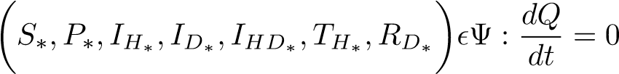
Therefore 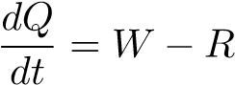
Using the conditions if W < R, then If and only if S = S∗,P = P∗,I_{H} = I_{H∗},I_{D} = I_{D∗},I_{HD} = I_{HD∗},∗, T_{H=} $T_{H}^{*}, R_{D}=R_{D}^{*}$ then
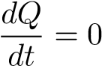
This indicates that the highest invariant set in
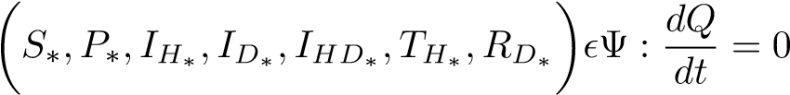
The Endemic Equilibrium Point E₀ is globally asymptotically stable in the invariant set if W < R

Sensitivity Analysis
In this subsection, we focus on the importance of each parameter on HIV/AIDS and drug abuse by looking at the effectiveness of the control reproduction number. We use the variable normalized forward sensitivity, which is differentiable and relies on parameters. The Reproduction number sensitivity analysis index as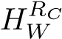, is given by
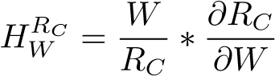 (2.22)
where W is Taking the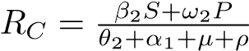 for drug Abuse and
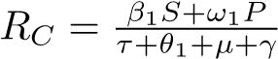 for HIV/AIDS and their respective R_{C} at DFE as
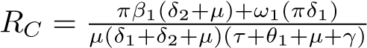 and
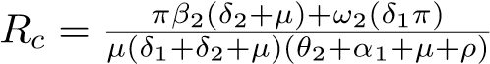
Finding the sensitivity of π we have
(2.23)
But the terms in the brackets are the same as R_{C}, then 2.23 is reduced to
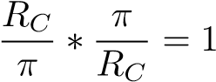
and therefore, the sensitivity of π = 1 when the other parameters are calculated, the following are their respective sensitivities.
PARAMETER | SENSITIVITY
π | + 1.00
µ | -1.145
γ | -0.252
θ₁ | -0.700
θ₂ | -0.729
τ | -0.032
α₁ | -0.1212
α₂ | -0.0285
ρ | -0.0643
ω₁ | +0.899
ω₂ | +0.996
β₁ | +0.0245
β₂ | +0.051
δ1 | +0.179
Table 2: Sensitivity indices of parameters on R_{C}
From Table 2, it can be deduced that when the infectious rate of the susceptible (β₁ and β₂) increases, the HIV/AIDS and drug abuse rates increase while other factors are held constant. When µ.γ,θ₁,θ₂,τ,α₁ α₂ and ρ are increased R_{C} decreases, but when π,ω₁ δ, and ω₂ are increased, the R_{C} also increases; hence they are the most delicate parameters.

Numerical Simulation
The simulations were carried out using Maple software, which numerically solved the system of differential equations and generated the corresponding graphs. The analysis is based on the assumed initial conditions: S(0) = 800000, P(0) = 50000, $I_{D}(0)$= 30000, $I_{H}(0)$= 50000$,I_{HD}(0)$= 30000, $T_{H}(0)$= 20000, and $R_{D}(0)$= 20000. These conditions reflect the population distribution across the seven compartments at time zero and form the basis for exploring disease transmission and control strategies.
PARAMETERS | VALUE | SOURCE
π | 0.0397 | World Bank 2017
β₁ | 0.04 | Kenya HIV estimate 2015
β₂ | 0.06 | NACADA 2017
δ | 0.1200 | Estimated
ω₁ | 1.1100 | Estimated
ω₂ | 0.0800 | Estimated
θ₁ | 0.8333 | [10]
θ₂ | 0.1700 | [10]
τ | 0.0390 | [10]
η₁ | 0.9008 | [10]
η₂ | 0.0962 | [10]
σ₁ | 0.5200 | Estimated
σ₂ | 0.3142 | [14]
α₁ | 0.02827 | [14]
α₂ | 0.0005 | [10]
µ | 0.0200 | WHO 2015
γ | 0.300 | [15]
ρ | 0.015 | [10]
Table 3: Parameters, values and source

HIV/AIDS and Drug Abuse dynamics on the population
Figure 2 presents the interrelationship among the various epidemiological compartments, namely: the susceptible population, protected individuals, those infected with HIV/AIDS (I_{H}), individuals engaged in drug abuse (I_{D}), those co-infected with both HIV/AIDS and drug abuse (I_{HD}), individuals undergoing treatment for HIV/AIDS, and those in rehabilitation for drug abuse. The graphical trends demonstrate that an increase in rehabilitation efforts is associated with a decline in the drug-abusing population. Likewise, enhanced treatment coverage for HIV/AIDS is correlated with a reduction in the HIV-infected cohort. Moreover, the size of the co-infected population (I_{HD}) exhibits a direct dependence on the magnitudes of both I_{H} and I_{D}; as the prevalence of HIV infection and drug abuse declines, the number of individuals simultaneously affected by both conditions also diminishes accordingly.
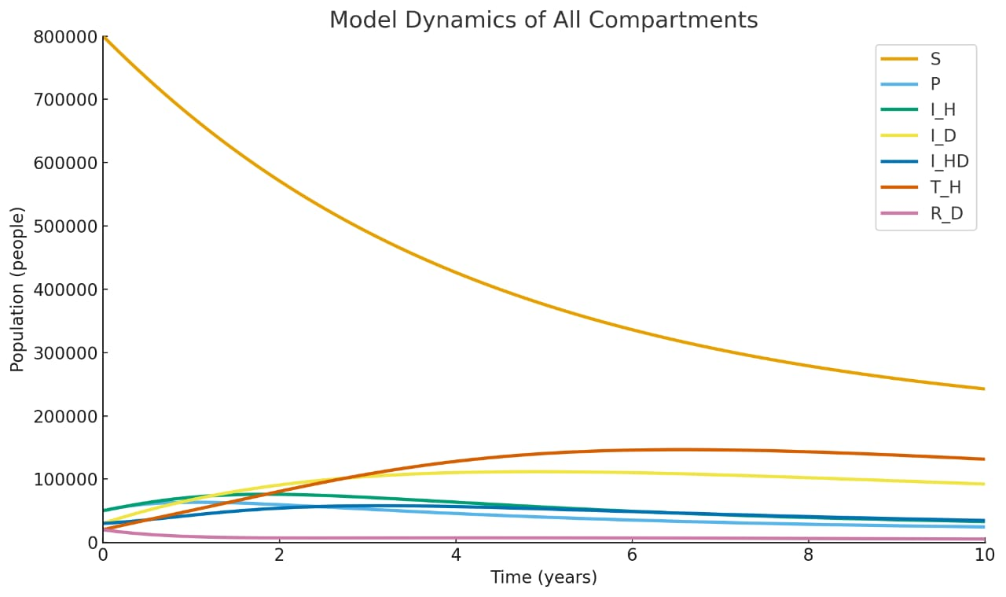
Figure 2: Graph of the model, source: Author's model

Effect of protection on HIV/AIDS and Drug abuse
Figure 3 illustrates how varying the protection rate ω₁ influences the population of HIV-infected individuals (I_{H}). As ω₁ increases from 0.5 to 1.0 and then to 1.5, the number of infected individuals decreases more rapidly over time. A higher protection rate leads to a steeper decline in the I_{H} compartment, demonstrating that effective protective measures, such as condom use and education, significantly reduce HIV/AIDS transmission. This emphasises the importance of strong preventive strategies in slowing the spread of HIV/AIDS and reducing the infected population within a short time.

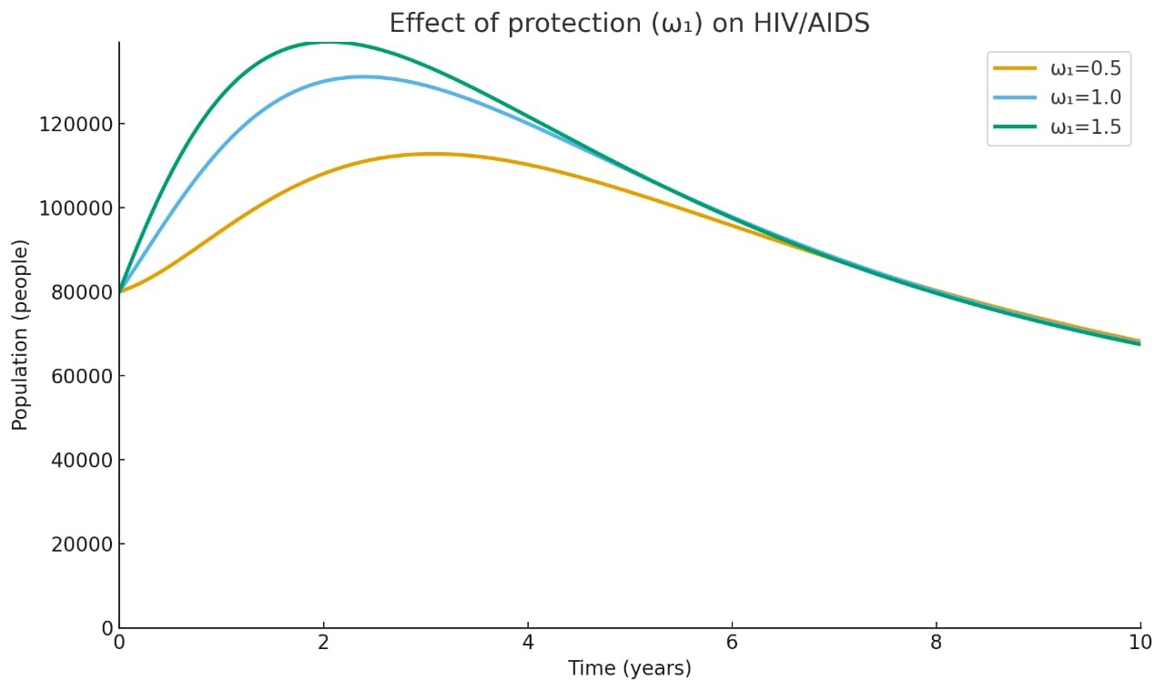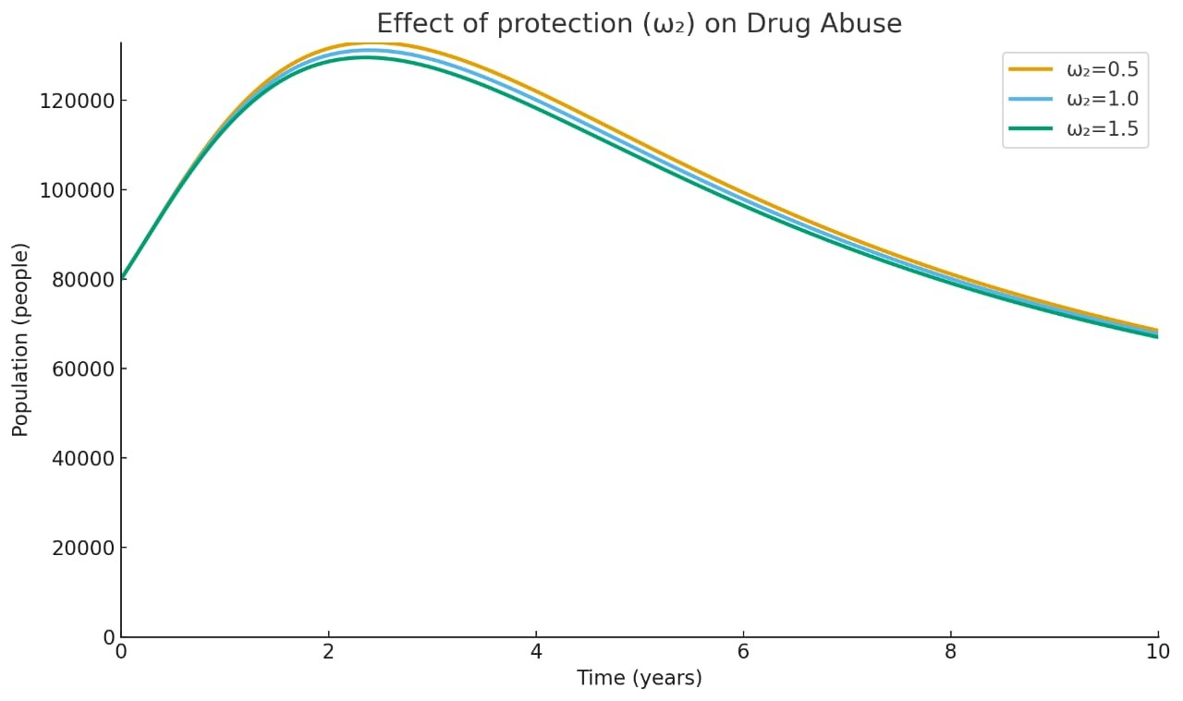
Figure 3: Effect of protection on HIV/AIDS source; Author's model | Figure 4: Effect of Protection on Drug Abuse source; Author's model
frame.
Figure 4 shows the impact of the protection rate ω₂ on the number of drug abusers (ID). As ω₂ increases, the I_{D} population declines more quickly. The curve for ω₂ = 1.0 exhibits the steepest drop, indicating that higher protection results in faster control of drug abuse. Although all curves eventually stabilise, higher protection significantly reduces peak drug abuse levels and shortens the duration of widespread use. This suggests that enhanced protective interventions, like public awareness and policy enforcement, are essential in reducing drug addiction rates and related societal impacts.

Effect of α₁ on Drug Abuse and Rehabilitation Compartments
Figure 5 illustrates the impact of varying the rehabilitation rate α₁ on the number of rehabilitated individuals (RD) over time. With parameters α₁ = 0.01000, 0.02827, and 0.5000, it is evident that higher rehabilitation rates lead to a sharper rise in RD, reaching higher peaks more quickly. The curve for α₁ = 0.5 shows the most significant increase, indicating
that more drug abusers are successfully transitioned into rehabilitation. This demonstrates that increasing α₁, the rate at which drug users receive help, significantly boosts the rehabilitation process and reduces prolonged addiction.
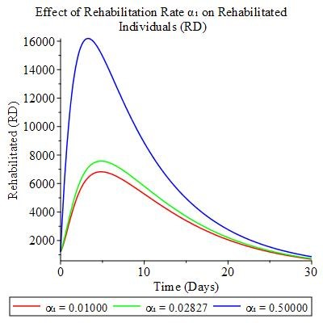
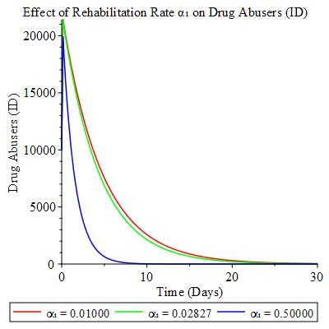
Figure 5: effect of α₁ on drug abuse, source: Author's model.
Figure 6: Effect of α₁ on Rehabilitation, source: Authors' model

Figure 6 illustrates how different rehabilitation rates (α₁ = 0.0100, 0.028270, and 0.50000) influence the decline of drug abusers (ID) over time. Higher values ofα₁ result in a faster and more pronounced reduction in the ID population. The curve for α₁ = 0.50000 shows the sharpest decline, indicating highly effective rehabilitation. This reduction in drug abuse not only curbs addiction but also significantly lowers the risk of HIV transmission via drug-related behaviors. Therefore, enhancing rehabilitation efforts plays a critical dual role in managing drug abuse and preventing HIV/AIDS.

Conclusion
A differential equation model describing the co-dynamics of HIV/AIDS and drug abuse has been formulated and analyzed. The model was shown to be mathematically and epidemiologically well-posed by establishing the positivity and boundedness of its solutions within an invariant region. Equilibrium points were derived, and their local and global stability was examined based on the threshold values for disease transmission.
Biologically, it was confirmed that both HIV/AIDS and drug abuse can be controlled if the respective reproduction numbers remain below one. The model incorporated critical behavioral transitions, including the movement of individuals between susceptible, protected, infected, and rehabilitated states, offering a comprehensive view of disease dynamics.
Sensitivity analysis revealed that an increase in the rates of HIV transmission and drug induction significantly contributes to the persistence of both conditions in the population. However, enhanced protection strategies and increased rehabilitation rates reduce the spread of infection and drug dependency.
The study concludes that a combination of preventive and rehabilitative interventions is vital in mitigating the dual burden of HIV/AIDS and drug abuse. The model offers a useful framework for informing policy decisions and designing targeted strategies to reduce co-infection in affected populations.
- Data Availability
The article has data that were utilized to bolster these conclusions.
- Conflict of interest
The authors affirm that there is no conflict of interest with respect to the article’s publication.

COMPETING INTERESTS DISCLAIMER:
Authors have declared that they have no known competing financial interests OR non-financial interests OR personal relationships that could have appeared to influence the work reported in this paper.

REFERENCES
- A. Verma, S. M. Bhatt, A. Singh, and P. Dwivedi, “Hiv: An introduction,” Text book on molecular biotechnology. Delhi: IK International Publishing House Pvt. Ltd., India, pp. 853–878, 2009.
- E. Bassey, “Dynamic optimal control model for dual-pair treatment functions of dual delayed HIVpathogen infections,” Journal of Mathematical Sciences: Advances and Applications, vol. 51, no. 1, pp. 1–50, 2018.
- World Health Organization, Substance abuse, https://www.afro.who.int/healthtopics/substance-abuse, Accessed: 2025-03-29.
- A. Kapila, S. Chaudhary, R. Sharma, H. Vashist, S. Sisodia, and A. Gupta, “A review on: Hiv aids,” Indian Journal of Pharmaceutical and Biological Research, vol. 4, no. 3, pp. 69–73, 2016.
- A. Odejide, “Status of drug use/abuse in africa: A review,” International journal of mental health and addiction, vol. 4, pp. 87–102, 2006.
- C. C. Espitia Morillo and J. F. d. C. A. Meyer, “Hiv/aids mathematical model of triangle transmission,” Viruses, vol. 14, no. 12, p. 2749, 2022.
- P. Kariuki, M. Omariba, and J. Motari, “Addressing the burden of alcohol and drug abuse,” 2024.
- N. Anggriani, S. Toaha, and K. Kasbawati, “Optimal control of mathematical models on the dynamics spread of drug abuse,” Jurnal Matematika, Statistika dan Komputasi, vol. 17, no. 3, pp. 339–348, 2021.
- World Health Organization, Hiv prevention, https://www.who.int/teams/global-hivhepatitis-and-stis-programmes/hiv/prevention, Accessed: 2025-03-29.
- E. Lokaran, “A mathematical model for the effects of drug abuse in transmission of hiv/aids in turkana county.,” Ph.D. dissertation, University of Nairobi, 2020.
- A. Bloomquist and N. K. Vaidya, “Modelling the risk of hiv infection for drug abusers,” Journal of Biological Dynamics, vol. 15, no. sup1, S81–S104, 2021.
- G. T. Tilahun, W. A. Woldegerima, and A. Wondifraw, “Stochastic and deterministic mathematical model of cholera disease dynamics with direct transmission,” Advances in Difference Equations, vol. 2020, no. 1, p. 670, 2020.
- P. Van den Driessche and J. Watmough, “Reproduction numbers and sub-threshold endemic equilibria for compartmental models of disease transmission,” Mathematical biosciences, vol. 180, no. 1-2, pp. 29– 48, 2002.
- C. Alfiniyah, A. Puspitasari, and F. Fatmawati, “Mathematical modelling of drug abuse reduction strategies taking into account the treatment type and risks level,” Jambura Journal of Biomathematics (JJBM), vol. 4, no. 1, pp. 23–30, 2023.
- B. E. Bassey and A. O. Henry, “Global stability analysis of the role of antiretroviral therapy (art) abuse in hiv/aids treatment dynamics,” Pure Appl. Math. J, vol. 10, pp. 9–31, 2021.

