Toxicity Assessment of Hyptis suaveolens in Albino Rats: Haematological, Biochemical, and Histopathological Investigations

Abstract
The present study assessed the toxicological impact of Hyptis suaveolens leaf extract on liver and kidney functions in albino rats using standardized procedures. Following a two-week acclimatization period, sixteen rats were randomly divided into four groups (n=4 per group). Group 1 served as the control, receiving only the vehicle (normal saline), while Groups 2 to 4 were administered H. suaveolens extract at doses of 400 mg/kg, 600 mg/kg, and 1200 mg/kg body weight respectively for 14 consecutive days. Blood samples were collected via intracardiac puncture for the determination of plasma levels of aspartate aminotransferase (AST), alanine aminotransferase (ALT), alkaline phosphatase (ALP), total protein, urea, creatinine, and proline using commercially available assay kits. Liver and kidney tissue homogenates were also analyzed for biochemical parameters. Histopathological evaluation revealed moderate sinusoidal dilation with normal hepatocytes and mild inflammatory cell infiltration at 400 mg/kg. At 600 mg/kg, mild hepatic architectural distortion with ballooning of hepatocytes, necrosis, and karyolysis was observed. Interestingly, rats treated with 1200 mg/kg exhibited liver morphology similar to that of the control. Kidney histology showed mild tubular injury at 400 mg/kg, increased tubular inflammation and reduced Bowman’s capsules at 600 mg/kg, and severe tubular damage with loss of functional nephrons at 1200 mg/kg. Overall, administration of H. suaveolens leaf extract at the tested doses did not result in severe organ damage.
Keywords: Toxicology, Hyptis suaveolens, Aspartate aminotransferase, Alanine aminotransferase, Alkaline phosphatase

Introduction

The increasing resistance of storage pests to synthetic insecticides and the environmental and health concerns associated with their overuse have stimulated a global search for eco-friendly pest control alternatives. Among these, plant-derived biopesticides have attracted considerable interest due to their biodegradability, low toxicity to non-target organisms, and local availability. One such promising botanical is Hyptis suaveolens, a plant that has shown significant insecticidal activity, especially in managing Sitophilus oryzae, a major pest of stored grains (Oguntola, 2023).
In comparative laboratory trials evaluating the biopesticidal effects of three botanicals—Ageratum conyzoides, Petiveria alliacea, and Hyptis suaveolens—H. suaveolens emerged as the most effective in suppressing adult emergence and reducing grain damage caused by S. oryzae. Its consistent performance led to its recommendation for potential application in grain storage systems, especially in smallholder settings where access to synthetic pesticides may be limited (Oguntola, 2023). However, the deployment of such botanicals in food storage warrants an evaluation of their toxicological safety, particularly for human consumers who may be exposed to residual components through treated products.

Botanical Description and Distribution
Hyptis suaveolens Poit. belongs to the family Lamiaceae. It is an erect, fast-growing, aromatic annual herb that can attain a height of up to two meters. The plant is easily identifiable by its long branching pattern, deeply veined, oval-shaped leaves with serrated margins, and its distinctive purple or white flowers. It typically grows in open spaces such as abandoned farmlands and waste areas, thriving at both low and moderate altitudes, especially in tropical and subtropical climates.
The leaves are opposite and ovate, typically measuring between 4 and 9 centimeters in length. They exhibit a rounded (obtuse) apex and a bilaterally symmetrical base. The venation is alternate and stipulate, and the leaf surface is dorsiventrally curved. The plant's floral structures are axillary and borne on long stalks, with a hairy calyx approximately 4 mm long. The corolla is blue, bilabiate, and zygomorphic. It bears four diclinate stamens, each about 8 mm long. The seeds are flat and coated with a mucilaginous layer (Pankaj, 2005), which may play a role in its dispersal and germination strategy.

Traditional Uses and Ethnomedical Relevance
H. suaveolens holds significant medicinal value in traditional healthcare systems across Africa, Asia, and South America. In Nigeria, particularly in Niger, Nasarawa, and Kaduna States, traditional healers use decoctions of the plant’s leaves for managing diabetes mellitus and fevers, especially those accompanied by cold symptoms (Abdullahi et al., 2003). The herb is also known for its aromatic qualities, which have made it popular as a household remedy and spiritual plant.
In Indian Ayurvedic and folk medicine, the plant is respected for its purported anticancer properties and is used both topically and systemically to treat dermatitis, eczema, and other inflammatory conditions (Pankaj, 2005). These therapeutic applications have been linked to its diverse phytochemical constituents, including essential oils, alkaloids, terpenoids, and flavonoids (Gills, 1992). Nearly every part of the plant—including the roots, stems, leaves, and seeds—have been employed in traditional practices to manage a wide spectrum of ailments.
Previous pharmacological studies have shown that extracts from H. suaveolens can alleviate gastrointestinal disorders such as colic and stomach pain. Research by Mandal et al. (2007) and Verma et al. (2011) confirmed the antispasmodic and analgesic activities of the plant’s crude leaf extract, further supporting its use in traditional medicine.

Toxicological Considerations
Despite its widespread medicinal use and biopesticidal potential, it is essential to assess the safety of H. suaveolens, particularly in the context of its use on consumable products. A toxicological study was thus conducted to evaluate the acute effects of the methanolic extract of H. suaveolens leaves using albino rats as a model organism. This approach provides insight into the potential risks associated with exposure and helps determine a safe dosage threshold.
The acute toxicity assay revealed an LD₅₀ (median lethal dose) value of 2154.1 mg/kg body weight in rats. This suggests that the extract exhibits relatively low toxicity upon short-term exposure, making it a candidate for further safety evaluation in chronic toxicity and histopathological studies. Nonetheless, a cautious approach is warranted before large-scale application, especially in scenarios where the extract might directly or indirectly affect human health.
Materials and Methods
Plant Collection and Preparation
Fresh leaves of Hyptis suaveolens were harvested from an abandoned farmland located near the permanent site of Osun State Polytechnic, Iree, Osun State, Nigeria. The identity of the plant was confirmed at the Department of Pharmacognosy, Obafemi Awolowo University, Ile-Ife, Osun State. After collection, the leaves were rinsed thoroughly with clean water to eliminate debris and dust, then air-dried at room temperature in a well-ventilated laboratory. Once dried, the leaves were ground into a fine powder using a Supermaster® electric blender (Model SMB 2977, Japan). The powder was sieved through a 1 mm mesh to ensure uniform particle size (Ileke and Oni, 2011). The processed powder was then stored in airtight plastic containers and refrigerated at 4°C until use.
Animal Model and Experimental Design
Male albino rats (120–188 g) were obtained from the animal breeding unit of the Department of Biochemistry, Federal University of Technology, Akure. The animals were maintained at a temperature of 25°C, under a 12-hour light/dark cycle, with unrestricted access to standard laboratory chow and water. A two-week acclimatization period was allowed before the initiation of the experiment.The animals were randomly assigned into four groups, each containing four rats. Group 1 served as the control and received normal saline. Groups 2, 3, and 4 received oral doses of Hyptis suaveolens leaf extract at concentrations of 400 mg/kg, 600 mg/kg, and 1200 mg/kg body weight, respectively.

Sample Collection and Processing
At the end of the experiment, animals were fasted overnight and euthanized via cervical dislocation. Blood samples were collected via cardiac puncture into plain tubes for serum separation. The samples were centrifuged at 3000 g for 10 minutes, and the sera were stored for biochemical analysis. Organs such as the heart, liver, and kidneys were excised, rinsed in normal saline, and fixed in 10% formalin for histopathological assessment.
Biochemical Analysis
Serum levels of urea, creatinine, cholesterol, triglycerides, high-density lipoprotein (HDL), low-density lipoprotein (LDL), very-low-density lipoprotein (VLDL), bilirubin, alanine aminotransferase (ALT), aspartate aminotransferase (AST), alkaline phosphatase (ALP), total protein, albumin, and globulins were determined using standard diagnostic kits (Randox Laboratories, UK). Liver and kidney tissues were homogenized in ice-cold phosphate buffer (pH 6.9), and the homogenates were centrifuged to obtain clear supernatants for enzymatic assays (Bello et al., 2004).
Histopathology
Fixed liver and kidney tissues were dehydrated in ascending grades of ethanol (50%, 70%, 80%, and 100%), cleared in xylene, and embedded in paraffin wax. Sections (5 µm thick) were cut using a rotary microtome, mounted on slides, and stained with hematoxylin and eosin following standard procedures (Silver et al., 1990). The slides were examined under a light microscope, and images were digitally captured for analysis.
Hematological Analysis
Whole blood was collected into EDTA tubes for hematological evaluation. Parameters such as hemoglobin concentration (Hb), red blood cell count (RBC), packed cell volume (PCV), mean corpuscular volume (MCV), mean corpuscular hemoglobin (MCH), mean corpuscular hemoglobin concentration (MCHC), total and differential white blood cell counts (WBC, neutrophils, lymphocytes, monocytes, eosinophils), and platelet counts were determined using an automated hematology analyzer.
Statistical Analysis
Data were expressed as mean ± standard error of the mean (SEM). Statistical comparisons among groups were performed using one-way analysis of variance (ANOVA), followed by Duncan’s multiple range test for post hoc analysis. A p-value of ≤ 0.05 was considered statistically significant.

Results
Table 1: Behavioral pattern of the Albino rat in treated with extract of Hyptis suaveolens and the control groups
Parameters | 30minutes |  |  |  | 4hours |  |  |  |  | 24hours |  |  |  |  | 48hours |  |  |  |  | 7days |  |  |  |  | 14days
Parameters | Con | G2 | G3 | G4 | Con | G2 | G3 | G4 | Con |  | G2 | G3 | G4 | Con |  | G2 | G3 | G4 | Con |  | G2 | G3 | G4 | Con |  | G2 | G3 | G4
Fur&Skin | N | N | N | N | N | N | N | N | N |  | N | N | N | N |  | N | N | N | N |  | N | N | N | N |  | N | N | N
Eye | N | N | N | N | N | N | N | N | N |  | N | N | N | N |  | N | N | N | N |  | N | N | N | N |  | N | N | N
Urination (Colour) | N |  |  |  | N |  |  |  | N |  | N | N | N | N |  | N | N | N | N |  | N | N | N | N |  | N | N | N
Faeces consistency | N | N | N | N | N | N | N | N | N |  | N | N | N | N |  | N | N | N | N |  | N | N | N | N |  | N | N | N
Sleep | N |  |  |  | N | N | N | N | N |  | N | N | N | N |  | N | N | N | N |  | N | N | N | N |  | N | N | N
Mucous membrane | N | N | N | N | N | N | N | N | N |  | N | N | N | N |  | N | N | N | N |  | N | N | N | N |  | N | N | N
Convulsion & treamors | N.P | N.P | N.F | N.P | N.P | N.P | N.P | N.P | N.P |  | N.P | N.P | N.P | N.P |  | N.P | N.P | N.P | N.P |  | N.P | N.P | N.P | N.P |  | N.P | N.P | N.P
Itching | N.P | N.P | N.F | N.P | N.P | N.P | N.P | N.P | N.P |  | N.P | N.P | N.P | N.P |  | N.P | N.P | N.P | N.P |  | N.P | N.P | N.P | N.P |  | N.P | N.P | N.P
Coma | N.P | N.P | N.F | N.P | N.P | N.P | N.P | N.P | N.P |  | N.P | N.P | N.P | N.P |  | N.P | N.P | N.P | N.P |  | N.P | N.P | N.P | N.P |  | N.P | N.P | N.P
Mortality | N.P | N.P | N.F | N.P | N.P | N.P | N.P | N.P | N.P |  | N.P | N.P | N.P | N.P |  | N.P | N.P | N.P | N.P |  | N.P | N.P | N.P | N.P |  | N.P | N.P | N.P
Key: Con= Control Group, G2= Group 2, G3=Group 3, G4=Group 4, N= Normal, = Increase
N.F =NOT present, P=Present

Table 1 presents the behavioral observations of albino rats in both the control and treatment groups throughout the experimental period. The animals were monitored at intervals of 30 minutes, 4 hours, 24 hours, 48 hours, and 7 days post-administration. No visible alterations were observed in the fur, skin, or eyes of any of the rats across all groups. A transient change in urine coloration was noted between 30 minutes and 4 hours following extract administration, but this normalized thereafter. Fecal consistency remained unchanged throughout the observation period. A brief episode of drowsiness was recorded approximately 30 minutes post-treatment, which resolved with time. There were no indications of increased mucous membrane secretion, convulsions, tremors, pruritus, coma, or mortality in any of the animals during the study.

Table 2: Effect of Hyptis suaveolens leaf extract on the Haematological parameters of the Albino
Rat
Result are means ± SEM of four replications. Means in a column followed by the same letter are
not significantly different (p>0.05) using New Duncan Multiple Range Test.

Haematological Parameters 2
Animal Group | WBC | GRA | LYMPH% | MON% | EOS%
CONTROL | 4.98±1.31a | 34.25±0.85b | 63.00±1.08a | 1.50±0.29a | 1.25±0.25a
GROUP 2 | 3.25±0.48a | 28.50±0.95a | 68.75±0.75b | 1.50±0.29a | 1.25±0.25a
GROUP 3 | 10.85±1.55a | 37.50±0.50a | 60.00±0.00a | 1.00±0.00a | 1.50±0.50a
GROUP 4 | 5.14±0.65a | 28.00±0.82a | 70.00±0.82a | 1.00±0.00a | 1.00±0.00a

Tables 2 and 3 present the hematological parameters measured in the albino rats used in this study. The parameters assessed include Packed Cell Volume (PCV), Red Blood Cell (RBC) count, Mean Corpuscular Hemoglobin Concentration (MCHC), Mean Corpuscular Hemoglobin (MCH), Hemoglobin concentration (Hb), White Blood Cell (WBC) count, granulocytes (GRA), and the percentages of lymphocytes, monocytes, and eosinophils. Across the treatment and control groups, there were no statistically significant differences (p > 0.05) observed in the mean values of these hematological indices. This suggests that the methanolic extract of Hyptis suaveolens leaves did not exert any adverse effects on the blood profile of the treated rats.
Table 3: Effect of Hyptis suaveolens on the haematological parameters in Albino rat

Haematological Parameters 2
Animal Group | WBC | GRA | LYMPH% | MON% | EOS%
CONTROL | 4.98±1.31a | 34.25±0.85b | 63.00±1.08a | 1.50±0.29a | 1.25±0.25a
GROUP 2 | 3.25±0.48a | 28.50±0.95a | 68.75±0.75b | 1.50±0.29a | 1.25±0.25a
GROUP 3 | 10.85±1.55a | 37.50±0.50a | 60.00±0.00a | 1.00±0.00a | 1.50±0.50a
GROUP 4 | 5.14±0.65a | 28.00±0.82a | 70.00±0.82a | 1.00±0.00a | 1.00±0.00a
Results are means ± SEM of four replications. Means in a column followed by the same letter are not significantly different (p>0.05) using New Duncan Multiple Range Test.
Tables 4 and 5 illustrate the effects of Hyptis suaveolens leaf extract on liver function biomarkers in albino rats. The liver function indicators evaluated include aspartate aminotransferase (AST), alanine aminotransferase (ALT), alkaline phosphatase (ALP), and total protein (TP). The activity of AST was found to be elevated in all treated groups compared to the control group, with a dose-dependent increase observed. Specifically, AST levels were recorded at 6.50 U/L in the control group, while treated groups 2, 3, and 4 showed increasing values of 11.25 U/L, 15.88 U/L, and 17.73 U/L, respectively. This trend suggests a possible hepatocellular response to the administered extract, which warrants further investigation into its biochemical and histological implications.

Table 4: Effect of Hyptis suaveolens leaf extract on the liver function of the Albino rat
Biochemicals Parameters in the Liver
Group of Animals | Aspartate Aminotransferase (U/L) | Alanine Aminotransferase (U/L) | Creatinine  (g/dl) | Urea  (g/dl) | Alkaline Phosphatase  (u/g) | Total  Protein  (g/dl)
Control | 6.50±1.86a | 96.80±11.60a | 196.33±32.48a | 21.73±6.39a | 449±160a | 0.933±0.26a
Group 2 | 11.25±1.75a | 101.30±5.4a | 399.43±82.8ab | 16.51±2.97a | 511.98±74.6a | 1.170±0.63a
Group 3 | 15.88±3.3.9a | 101.75±9.20a | 630.85±19.65b | 17.39±2.13a | 518±126a | 1.41±0.14a
Group 4 | 17.73±2.09a | 111.2±4.0a | 220.78±8.425a | 30.14±2.50a | 648±55.21a | 1.44±0.077a
Result are means ± SEM of four replications. Means in a column followed by the same letter are not significantly different (p>0.05) using New Duncan Multiple Range Test.

Table 5: Effect of Hyptis suaveolens on leaf extract on the Kidney function in Albino rat
Parameters Biochemicals Parameters in the Kidney
Group of Animals | Aspartate Aminotransferase (U/L | Alanine Aminotransferase (U/L) | Creatinine  (g/dl) | Urea  (g/dl) | Alkaline Phosphatase  (u/g) | Total  Protein  (g/dl)
Control | 10.25±4.68a | 27.30±8.7a | 62.68±17.82a | 28.16±2.6b | 198.72±41.6a | 6.8±2.03b
Group 2 | 11.68±2.77a | 52.33±8.6a | 133.7±55.7a | 11.01±1.38a | 301.63±119a | 1.36±0.324ab
Group 3 | 13.00±1.50a | 52.35±4.7a | 114.6±0.00a | 17.39±4.6ab | 501.34±36a | 0.70±0.186a
Group 4 | 21.00±7.14a | 61.50±15.3a | 315.13±199a | 19.04±2.96ab | 514±211a | 0.93±0.18a
Result are means ± SEM of four replications. Means in a column followed by the same letter are not significantly different (p>0.05) using New Duncan Multiple Range Test.

Table 6: Effect of Hyptis suaveolens on leaf extract on serum biochemical parameters in in Albino rat
Biochemical parameters (Serum)
Group of Animals | Aspartate  (U/L) | Alanine Aminotransferase (U/L) | Creatinine  (g/dl) | Urea  (g/dl) | Alkaline  Phosphatase  (u/g) | Total Protein  (g/dl)
Control | 12.6±2.07a | 6.20±5.2a | 1028.10±74.05a | 22.74±1.16a | 71.07±39.10a | 8.05±0.69a
Group 2 | 14.25±0.25a | 14.50±2.9ab | 863.8±14.39a | 26.36±2.30a | 93.84±71.76a | 6.99±0.66a
Group 3 | 15.50±2.5a | 21.10±0.66ab | 933.29±169.29a | 28.26±0.00a | 111.78±9.11a | 6.30±0.49a
Group 4 | 41.37±28.00a | 24.90±2.5b | 933.29±71.81a | 27.39±0.76a | 141.45±69.38a | 5.98±0.31a
Result are means ± SEM of four replications. Means in a column followed by the same letter are not significantly different (P>0.05) using New Duncan Multiple Range Test.

Table 7: Effect of Hyptis suaveolens on leaf extract on serum biochemical parameters in in Albino rat
Biochemical parameters (Serum)
Group of Animals | CHOLESTEROL  (g/dl) | HIGH DENSITY LIPOPROTEIN  (g/dl) | ALBUMIN  (g/dl) | TRIGLYCERIDE  (g/dl) | LOW DENSITY LIPOPROTEIN (g/dl) | GLOBULINS  (g/dl)
Control | 132.15±55.01a | 39.96±14.09a | 3.64±0.26a | 28.47±12.34a | 86.49±56.9a | 4.49±0.87a
Group 2 | 201.19±52.31a | 71.74±14.37a | 3.601±0.31a | 29.59±4.48a | 123.54±54.5a | 3.38±0.35a
Group 3 | 153.54±112.6 | 40.91±17.91a | 3.35±0.07a | 41.47±3.6a | 104.32±93.92a | 2.94±0.56a
Group 4 | 92.054±15.06 | 63.62±16.99a | 3.44±0.39a | 44.7±16.29a | 24.69±9.36a | 2.53±0.65a
Result are means ± SEM of four replications. Means in a column followed by the same letter are not significantly different (P>0.05) using New Duncan Multiple Range Test.
Table 6 shows the effects of Hyptis suaveolens extract on the biochemical serum of the Albino rat. AST, ALT, Creatinine, Urea, ALP and Total protein was analysed. The values of Aspartate aminotransferase, Alanine aminotransferases, Creatinine, Urea, Alkaline Phosphatases and total Protein showed noticeable increases from the control to groups 2, 3 and 4. The values were not statistically different from one another and the control.
The effects of Hyptis suaveolens leaf extract on serum biochemical are presented in Table 7. The cholesterol, High-Density Lipoprotein, Albumin, Triglyceride, Low-Density Lipoprotein and Globulins was assessed in the serum of albino rats. The values were not statistically different when comparing the control with the experimental albino rat. The globulin value decreases from the control animals to the experimental (control 4.49 g/dl, Group 2(3.38 g/dl), Group 3 (2.94 g/dl) and Group 4 (2.53 g/dl), respectively).

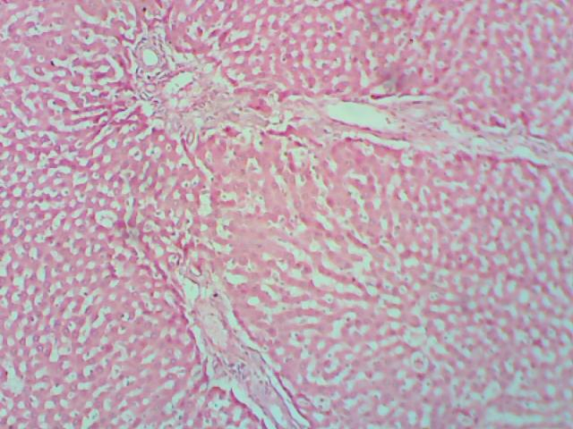
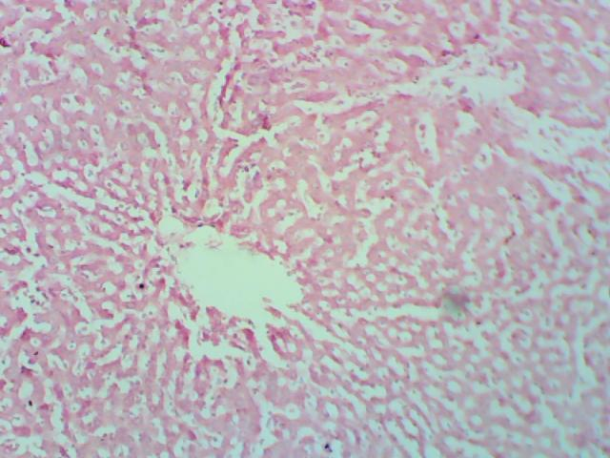
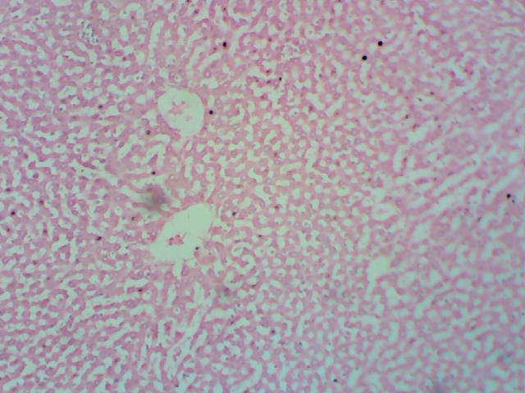
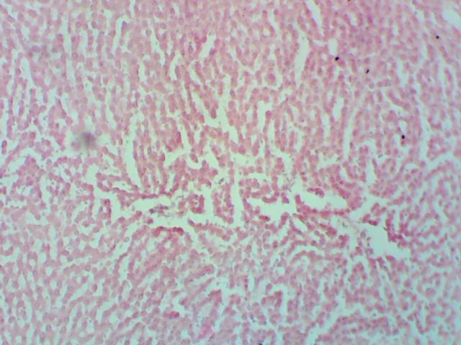
Histopathology Results
c
CV
a
CV
d
b

Plate 1: Representation photomicrographs of liver histopathology (x100):
KEY: CV: central vein, black circle indicate ballooning and necrosis of hepatocytes, blue circle indicate sinusoids dilation.

Histopathological Analysis and Discussion
Histological examination of liver tissues from both control and treated albino rats revealed dose-dependent alterations following oral administration of Hyptis suaveolens leaf extract. The liver of the control group (Plate 1a) displayed normal histological architecture characterized by intact hepatocytes radiating from the central vein, with well-preserved sinusoids and no signs of inflammation, degeneration, or necrosis. In rats administered 400 mg/kg body weight of the extract (Plate 1b), moderate sinusoidal dilation was observed, although hepatocytes remained mostly intact. The presence of mild inflammatory infiltration indicates an early or mild hepatic response to the extract at this concentration, suggesting that the liver may be undergoing adaptive changes. At 600 mg/kg (Plate 1c), more noticeable histological alterations were evident. These included slight disruption of hepatic architecture, ballooning of hepatocytes, sinusoidal dilation, and focal areas of necrosis and karyolysis. These changes suggest hepatocellular stress and potential toxicity at this dosage, pointing to a threshold at which the extract may begin to compromise liver integrity.
Interestingly, at the highest dose of 1200 mg/kg (Plate 1d), the liver architecture was largely preserved, with histological features similar to those of the control group. This could imply either a recovery or tolerance mechanism at this concentration or a possible biphasic dose response. Such findings may reflect the complex interaction between phytochemicals in Hyptis suaveolens and liver metabolic processes, where certain doses trigger adaptive hepatoprotective mechanisms, while others may be hepatotoxic. Overall, while mild to moderate liver alterations were noted at intermediate doses, the absence of significant pathological changes at the highest dose suggests that Hyptis suaveolens leaf extract may not exert severe hepatotoxic effects within the tested dose range. However, further sub-chronic and chronic studies are recommended to fully understand its long-term hepatic safety profile.

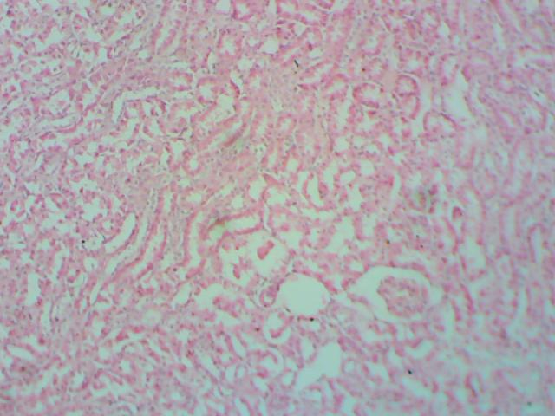
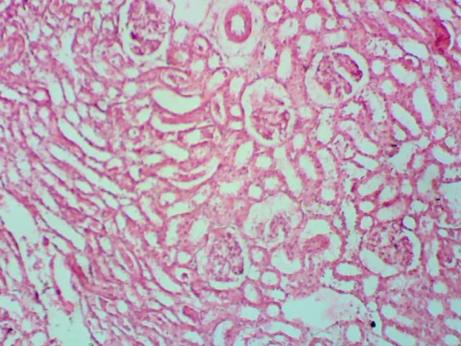
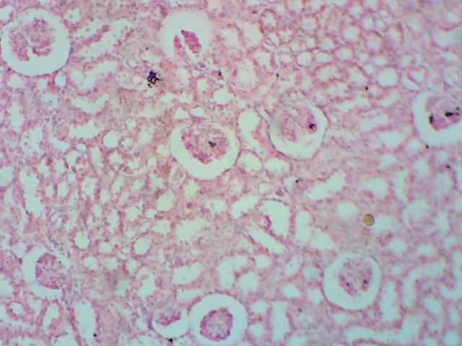
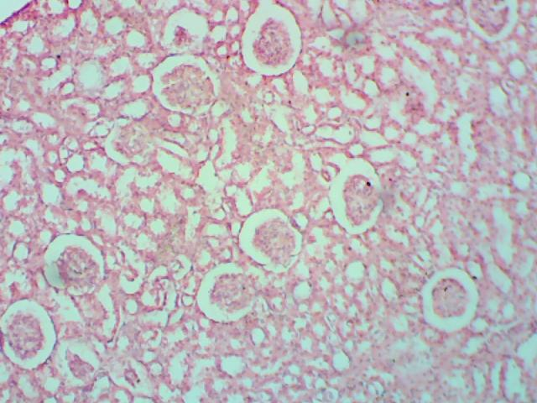
B
G
B
Plate 2: Representation photomicrographs of Kidney histopathology (x100)
Key: B- Bowman capsule; G- Glomerulus; black circle indicates Tubules.
The histopathological evaluation of kidney tissues from albino rats treated with Hyptis suaveolens extract revealed progressive, dose-dependent structural alterations compared to the control group. The control kidney section (Plate 2a) exhibited normal renal architecture, with well-defined glomeruli and intact renal tubules, indicating no evidence of cellular damage or inflammation. This serves as a baseline for assessing renal toxicity in the treatment groups.
At a dose of 400 mg/kg body weight (Plate 2b), the kidney tissues showed signs of mild tubular injury accompanied by vascular congestion. While the glomeruli remained largely unaffected, the onset of tubular alterations suggests an early nephrotoxic response, possibly due to the accumulation or metabolic activity of phytochemicals present in the extract.
Further deterioration was observed in the group administered 600 mg/kg (Plate 2c), where there was a notable reduction in Bowman’s capsules and increased tubular inflammation. These histological changes indicate a progression in nephrotoxicity, affecting both filtration structures (glomeruli) and reabsorptive tubules, thereby threatening normal renal function.
The most severe pathological changes occurred at the highest dose of 1200 mg/kg (Plate 2d). Kidney tissues displayed extensive tubular inflammation, with little or no obvious functional nephrons visible. The widespread damage to both glomerular and tubular regions at this dose points to significant renal impairment, suggesting that the extract, at high concentrations, may compromise renal integrity and function severely.

In summary, the kidney histopathological findings demonstrate a clear dose-related toxic effect of Hyptis suaveolens extract, particularly at higher concentrations. While low doses cause only mild, reversible changes, intermediate to high doses lead to increasingly severe structural damage, culminating in significant loss of nephron function. These results underscore the importance of careful dose regulation and further investigation into the nephrotoxic potential of this plant, especially if it is to be considered for medicinal or pesticidal use.

Discussion
In a previous study, Hyptis suaveolens, among other botanicals such as Ageratum conyzoides and Petiveria alliacea, was reported to be more effective in controlling Sitophilus oryzae (Oguntola, 2023). Given its pesticidal efficacy, evaluating its safety for end-users or consumers of treated commodities becomes imperative. The findings of this research indicate that the leaf extract of Hyptis suaveolens possesses a moderately high safety margin.
This observation aligns with the report of Ikpi and Nku (2008), who similarly concluded that the plant material exhibited a moderately high safety profile. Odeyemi et al. (2008) emphasized that biochemical indices are reliable tools for assessing the potential harmful effects of foreign compounds, including plant-derived substances, on the blood. Yakubu et al. (2007) also highlighted the significance of haematological and biochemical parameters in elucidating the physiological effects of plant materials.
Moreover, studies by Ileke et al. (2014) and Nwosu et al. (2017) have demonstrated a clear relationship between serum biochemical indices and liver and kidney functions in albino rats. Evaluations of such tissue function parameters are, therefore, integral in toxicological assessments, disease investigations, and diagnosis (Yakubu et al., 2003).
Enzymes such as alanine aminotransferase (ALT) and aspartate aminotransferase (AST) serve as critical biomarkers for hepatic and renal damage. Elevation of these enzymes in serum typically signifies injury to hepatic tissues, often resulting from exposure to toxic substances (Oluba et al., 2008). In the present study, a dose-dependent increase in AST and ALT levels was observed in rats administered with Hyptis suaveolens extract, suggesting mild hepatic stress, particularly at higher concentrations. Nonetheless, the changes were not severe, supporting the assertion that the plant extract is only moderately toxic at elevated doses.
Histopathological observations of the liver corroborated these findings, revealing mild architectural alterations such as sinusoidal dilation, hepatocyte ballooning, and necrosis at intermediate doses. Interestingly, near-normal liver architecture was observed at the highest dose, which may be attributed to a potential adaptive response by hepatic detoxification pathways.
Conversely, kidney histology presented more pronounced dose-dependent alterations. From mild tubular injuries at 400 mg/kg to severe tubular inflammation and reduced nephron integrity at 1200 mg/kg, the nephrotoxicity potential of the extract was evident. This suggests that the kidneys are more vulnerable to Hyptis suaveolens toxicity than the liver under the conditions of this study.
Despite these alterations, haematological parameters, including packed cell volume (PCV), red and white blood cell counts, haemoglobin concentration, and differential leukocyte counts, remained largely unaffected across treatment groups. This indicates that the extract may not significantly impair haematopoiesis or induce acute blood toxicity at the tested doses.
Taken together, the findings suggest that Hyptis suaveolens possesses moderate toxicity at high doses but remains relatively safe at lower concentrations, supporting its potential use in stored product protection, provided that exposure to consumers is minimized or appropriately regulated.

Conclusion
The present study assessed the toxicological implications of Hyptis suaveolens leaf extract on albino rats through behavioural observation, haematological and biochemical evaluations, and histopathological examinations of liver and kidney tissues. The results demonstrated that while low to moderate doses of the extract caused minimal behavioural and physiological disturbances, higher doses induced notable alterations, particularly in liver enzyme activities and renal histoarchitecture.
Although haematological parameters remained relatively stable across treatment groups, indicating limited hematopoietic toxicity, significant dose-dependent increases in AST, ALT, and ALP activities suggest hepatic stress or mild liver injury. Histological analysis further confirmed these effects, with moderate to mild liver tissue alterations at intermediate doses, and near-normal liver architecture at the highest dose, possibly due to an adaptive detoxification mechanism.
In contrast, the kidney tissues displayed a clearer trend of dose-dependent damage. From mild tubular injuries at 400 mg/kg to severe tubular inflammation and apparent nephron loss at 1200 mg/kg, the nephrotoxicity potential of Hyptis suaveolens was strongly evident.

Recommendations
• Controlled Dosage Use: Although Hyptis suaveolens demonstrates potential for ethnomedicinal and pesticidal applications, its use should be restricted to low concentrations to reduce the likelihood of organ toxicity.
• Expanded Toxicological Evaluation: It is recommended that further sub-chronic and chronic toxicity studies be conducted to assess long-term effects, with particular emphasis on liver and kidney functions.
• Phytochemical Profiling: Future studies should aim to isolate and identify the bioactive constituents responsible for both the beneficial and adverse effects of H. suaveolens, to enable safer and more precise usage.
• Human Safety Assessment: Comprehensive toxicokinetic and toxicodynamic evaluations are essential prior to any consideration for human use, to establish a thorough understanding of potential health risks.
• Community Education: Awareness campaigns should be implemented to inform traditional users about the potential dangers of high-dose or prolonged use of Hyptis suaveolens, encouraging safer practices.

References
Adebo, C. T., Adeyemi, J. A., & Adedire, C. O. (2018). Biochemical and histopathological effects of a bioinsecticide, Anchomanes difformis (Blume) Engler rhizome powder on Wistar rats. Comparative Clinical Pathology, 27(6), 1545-1550.
Adeyemo-Salami, O. A., & Makinde, J. M. (2013). Acute and sub-acute toxicity studies of the methanol extract of the leaves of Paullinia pinnata (Linn.) in Wistar albino mice and rats. Afr J Med Med Sci, 42(1), 81-90.
Alelign, T., Chalchisa, D., Fekadu, N., Solomon, D., Sisay, T., Debella, A., & Petros, B. (2020). Evaluation of acute and sub-acute toxicity of selected traditional antiurolithiatic medicinal plant extracts in Wistar albino rats. Toxicology Reports, 7, 1356-1365.
Bamisaye, F. A., Odutuga, A. A., Minari, J. B., Dairo, J. O., Oluba, O. M., Babatola, L.J. (2013). Evaluation of hypoglycemic and toxicological effects of leaf extracts of Morinda lucida in hyperglycemic albino rats. International Research Journal of Biochemistry and Bioinformatics, 3: 37–43.
Chinaru Nwosu, L., Olukayode Adedire, C., Oludele Ogunwolu, E., & Olufemi Ashamo, M. (2017). Toxicological and histopathological effects of Dennettia tripetala seed used as grain protectant, food, and medicine. Food Quality and Safety, 1(3), 211-220
Ghosh, D., Mondal, S., & Ramakrishna, K. (2019). Acute and sub-acute (30-day) toxicity studies of Aegialitis rotundifolia Roxb., leaves extract in Wistar rats: safety assessment of a rare mangrove traditionally utilized as pain antidote. Clinical Phytoscience, 5(1), 1-16.
Ikpi, D. E., Nku, O. (2008). Effect of ethanolic extract of Dennettia tripetala fruit on haematological parameters in albino wistar rats. Nigerian Journal of Physiological Sciences, 23: 13–17.
Ileke, K. D., Odeyemi, O. O., Ashamo, M. O., & Oboh, G. (2014). Toxicological and histopathological effects of cheese wood, alstonia boonei de wild stem bark powder used as cowpea protectant against cowpea bruchid, callosobruchus maculate (fab.)[coleoptera: chrysomelidae] on albino rats. Ife Journal of Science, 16(1), 23-33.
Kale, O. E., Awodele, O., & Akindele, A. J. (2019). Subacute and subchronic oral toxicity assessments of Acridocarpus smeathmannii (DC.) Guill. & Perr. root in Wistar rats. Toxicology reports, 6, 161 175.
Mandal S.M., Mondal K.C., Dey S. and Patil B.R., Antimicrobial activity of the leaf extracts of Hyptis suaveolens (L.) poit, Indian Journal of Pharmaceutical Sciences, 69(4), 568-569 (2007) 7.
Odeyemi, O. O., Masika, P. & Afolayan, A. J. (2008). A review of the use of phytochemicals for insect pest control. African Plant Protection, 14: 1–7.
Oguntola, E. A. (2023). Biopesticidal activities of three botanicals (Ageratum conyzoides L., Petiveria alliacea L., and Hyptis suaveolens L. Poit) against Sitophilus oryzae L. Open Access Journal of Science, 6(1), 61–66. https://doi.org/10.15406/oajs.2023.06.00194
Oluba, O. M., Adeyemi, O., Ojeih, G. C., Adebisi, K. E., Isiosio, I. O., Aboluwoye, C. O. (2008). Effect of dietary cholesterol on some serum enzymes. Journal of Medical Sciences, 3: 390–394.
Saleem, U., Amin, S., Ahmad, B., Azeem, H., Anwar, F., & Mary, S. (2017). Acute oral toxicity evaluation of aqueous ethanolic extract of Saccharum munja Roxb. roots in albino mice as per OECD 425 TG. Toxicol Rep Elsevier 4 (October): 580–585.
Vermab Amita, Mukerjeea Alok, Vijayakumarc M. and Mishraa Shanti Bhushan, Anti hyperglycemic activity of leaves extracts of Hyptis suaveolens L. Poit in streptozotocin induced diabetic rats, Asian Pacific Journal of Tropical Medicine, 4(9), 689–693(2011)

