Biodegradation and Detoxification of a Mixture of Synthetic Dyes in Simulated Wastewater by a Newly Isolated Bacillus licheniformis Strain WLS

ABSTRACT
The ability of an isolated microbe from wood-rot soil to degrade a complex mixture of synthetic dyes in simulated wastewater was investigated. The organism was identified as Bacillus licheniformis based on 16S rDNA sequencing. Decolorization was monitored using UV–Vis spectroscopy, and biodegradation was confirmed through FTIR and GC–MS analyses. Detoxification was further established via a phytotoxicity assay. The organism effectively decolorized the simulated waster within 24 h, achieving decolorization efficiencies of 93% and 96% with dye concentration of 50 mg/L and 250 mg/L respectively. FTIR bands in the range of 802–775 cm⁻¹ and the peak at 1753 cm⁻¹, which are in the fingerprint region and characteristic of C–H bending in substituted aromatic rings, were observed in the spectrum of the simulated wastewater but were absent in the spectrum of the metabolites. A similar observation was made for the peak at 1585 cm⁻¹, corresponding to in-ring C=C stretching. Remarkable variations were also noted in the fragmentation patterns of the GC–MS spectra and in the peaks of the GC chromatogram of the metabolites compared to those of the simulated wastewater. The decolorized wastewater supported germination of Zea mays (100%) and Vigna unguiculata (86.67%), but these rates were reduced by 13.3% and 6.67%, respectively, in seeds exposed to the untreated simulated wastewater. The study concludes that Bacillus licheniformis strain WLS demonstrated effective biotransformation of simulated wastewater by degrading the constituent dyes and converting them into less toxic metabolites.
Keywords: Bacillus licheniformis, textile effluent, decolorization, biodegradation, FTIR spectroscopy
- INTRODUCTION
Natural water resources continue to face significant threats due to widespread industrial activities across the globe (Lellis et al., 2019). Staggeringly, approximately 80% of global wastewater is released into the environment without undergoing any form of treatment and this more prevalent in developing economies (UN, 2017). Among industrial sectors, the textile industry is recognized as one of the most polluting, both in terms of wastewater volume and contaminant complexity (Lellis et al., 2019). Textile effluents are typically distinguished by their vivid coloration, elevated biochemical oxygen demand (BOD) and chemical oxygen demand (COD), substantial levels of suspended and dissolved solids (SS and DS), and notably high pH values (Azanaw et al., 2022; Dutta et al., 2022).
The textile industry utilizes a broad spectrum of dyes, which can be categorized based on their origin (natural or synthetic), chemical composition, application technique, and solubility. Chemically, dyes are classified into groups such as azo, diazo, anthraquinone, triphenylmethane, phthalocyanine, and nitro compounds (Singh and Srivastava, 2017; Benkhaya et al., 2020). Globally, over 100,000 synthetic dyes are used, and approximately 280,000 tons of textile dyes are discharged into aquatic ecosystems each year (Singh & Singh, 2017; Kusumlata et al., 2024). Due to the low fixation efficiency of many synthetic dyes, up to 80% of dye-laden wastewater is discharged into the environment without sufficient treatment, which has been linked to has been linked to adverse effects on ecosystems and human health (Wang et al., 2022; Kusumlata et al., 2024). Synthetic dyes discharged into water bodies can significantly disrupt ecological balance by impeding light transmission and impairing photosynthesis, thereby threatening aquatic flora and fauna (Lin et al., 2023 Periyasamy, 2025).
Synthetic dyes can exacerbate the depletion of dissolved oxygen in aquatic systems, leading to oxygen sag. This condition disrupts microbial communities that are essential for the natural breakdown of organic waste, thereby impairing the water body's intrinsic self-purification capacity (Ayub et al., 2025). Many of these dyes or in some instances, their metabolites, are toxic, mutagenic, and carcinogenic posing serious threats to aquatic ecosystems and potentially endangering human health (Sela, et al., 2020; Sudarshan, et al., 2023). From an environmental standpoint, it is essential to treat textile wastewater for dye removal to substantially reduce its toxicity prior to discharge into natural ecosystems or potential reuse.
Conventional physicochemical treatment including flocculation, coagulation, membrane technologies, sorption techniques, photolysis, and biological treatment such as the biological activated sludge systems often result in the generation of substantial amounts of sludge and other hazardous by-products, necessitating complex and costly management procedure particularly for cottage industries, which find these approaches very unsuitable, hence their preference to pay fine rather than comply with extant rules governing wastewater management. These techniques have also been found wanting in terms of supporting wastewater reuse. (UN 2017; Lin et al., 2023; Periyasamy, 2025).
However, biocatalysis—whether employing whole cells or isolated enzymes—has proven to be an effective, eco-friendly, and energy-efficient approach for dye degradation, offering a cost-effective alternative for wastewater treatment. These advantages make biocatalysis a compelling strategy in advancing sustainable technologies for effective wastewater management (Wohlgemuth, 2021; 2024; Tanaya et al., 2024). In this study a newly isolated strain of Bacillus licheniformis was investigated for its capacity to decolorize simulated wastewater composed of a complex mixture of textile dyes. The biodegradation of the dyes was also investigated and the toxicity of both treated and untreated wastewater assessed via phytotoxicity assay.
- MATERIALS AND METHODS
2.1 Dye and Chemicals
Crystal violet and Malachite green (MG) dye was a product of SD-Fine Chemicals Limited, India, navy blue HER and red HE7B were donated by a textile manufacturing company in Lagos, while nutrient broth and nutrient agar were obtained from HiMedia Laboratories, Mumbai, India.

2.2 Isolation, Screening and Identification of Bacteria

The organism was isolated from wood-rot soil and cultured on solid media. Microbes were enriched in nutrient broth in the presence of a mixture of dyes composed of malachite green, crystal violet, navy blue HER, and red HE7B (NBD) (100 mg/L) in static condition at 35ºC and incubated for 48 h. Cell suspension (1 mL) was transferred into fresh NBD to screen strains with colour removal potential. Aliquots of decolorized medium were streaked nutrient agar plates in the presence of the dye mix. Colonies surrounded by decolorized zones were selected and isolated by streaking on fresh nutrient agar plates. Isolates were then screened for their color removal ability in in submerged culture by transferring individual colonies into fresh NBD and the isolate with the best decolorization potential was selected. The organism was subjected to some morphological and biochemical analysis and identified by genetic method. The 16S rRNA gene of the isolate was sequenced at IITA Ibadan, Nigeria. The sequence was subsequently analyzed using BioEdit, FinchTv along with the NCBI server (http://www.ncbi.nlm.nih.gov) and submitted to GenBank. Phylogenetic analysis was performed using MEGA version 7 (Kumar et al, 2016). The organism was maintained on a nutrient agar slant at 4 °C until required for downstream operation in which case it was proliferated in 250 mL Erlenmeyer flask containing 13g/L nutrient broth at room temperature for 24h. The nutrient agar was composed Per litre of beef extract (3 g), peptone (5 g), NaCl and agar No. 2 (12 g), while the composition of the nutrient broth per litre was yeast extract (2 g), peptone 5g, beef extract (1 g), and NaCl (5 g).

2.3 Wastewater Simulation
The simulated wastewater (SW) was prepared by mixing 10 mg/L each azo dyes (navy blue HER and red HE7B), and triphenylmethane dye (malachite green and crystal violet), 1 mg/L starch and 2 mg/L each of Na₂SO₄and Na₂HPO₄ in distilled water. The mixture was placed in a heating mantle until a homogenized mixture was obtained and adjusted to pH 8.
2.4 Decolorization Assay
Decolorization assay was performed in static anoxic batch cultures by modifying the method of Liu et al. (2010). The process was monitored using UV-vis spectrophotometric analysis. Cell suspension (1 mL) of 24 h culture was transferred into fresh NBD for further adaptation of the organism. Cells in the log-phase were harvested after 24 h incubation and 1 ml aliquot was inoculated into 50 mL simulated wastewater (50 mg/L or 250 mg/L) in the presence of nutrient broth (13 g/L) and incubated 37 °C, pH 8. Aliquot of 3 mL was withdrawn at interval of 12 h, and centrifuged at 4000 rpm for 20 min. The cell-free supernatant’s absorbance was measured at 430 nm, which is the predetermined maximum absorbance wavelength of the SE. The decolorization efficiencies (E) was evaluated thus:
E = ((A_{i} - A_{t})/A₀) x 100
Where A_{i} is the absorbance of untreated SW and A_{t} represents the absorbance of the cell-free supernatant of the wastewater after treatment. Experiments were conducted in triplicate, with an abiotic control included.
2.5 Biodegradation Study
The degradation of the dye mixture in SW by Bacillus licheniformis was evaluated using Fourier Transform Infrared (FTIR) spectroscopy and Gas Chromatography (GC-MS). Functional group analysis of dye mix or metabolites was conducted with FTIR in the mid-infrared range (400–4000 cm⁻¹) at a scan speed of 45, utilizing a Shimadzu FTIR-8400S instrument. The cell-free supernatant after 24 h decolorization - metabolites - were extracted using an equal volume of ethyl acetate, and the resulting organic phase was air-dried. The solids recovered were mixed with spectroscopic-grade potassium bromide (KBr) in a 5:95 ratio and mounted in a sample holder for analysis (Olukanni et al., 2019).
Gas chromatography was performed using a QP2010 GC-MS system (Shimadzu). Helium was used as carrier gas at a flow rate of 1.0 ml/min. Biodegradation was analysed by comparison of retention time and fragmentation patterns of the Simulated wastewater and the metabolites.
2.6 Phytotoxicity Assay
Phytotoxicity was assessed using a germination test adapted from the method described by Parshetti et al. (2006). Zea mays and Vigna unguiculata seeds, 10 each, were sown in soil-filled polythene pots and treated with 5 ml of either untreated simulated wastewater (50 mg/L) or treated wastewater, over a period of 7 days. The seeds were sourced from the Federal College of Agriculture, Moor Plantation, Ibadan, Nigeria. Zea mays, a monocot cereal, was chosen for its widespread cultivation and dietary importance in Nigeria, while Vigna unguiculata, a dicot legume, is also commonly consumed. All treatments were conducted in triplicate, including control groups where seeds were exposed to distilled water. The effects of the treatments were evaluated based on percentage germination and measurements of plumule and radicle lengths.
2.7 Statistical Analysis
Results were expressed as mean of triplicate experiments ± standard deviation. Data were expressed as means ± standard deviation and analyzed using IBM Statistical Package for the Social Sciences (SPSS) software 17.0. Phytotoxicity data were analyzed by one-way analysis of variance (ANOVA) with Tukey–Kramer multiple comparisons test.
- RESULTS AND DISCUSSION
3.1 Identity of the Isolate
The bacterium, based on morphology and biochemical analysis, exhibited gram-positive staining, catalase activity, and was oxidase-negative, aerobic, and rod-shaped, forming moderate-sized colonies. Based on analysis of its 16S rRNA gene sequence, it was identified as a strain of Bacillus licheniformis. The sequence has been submitted to the NCBI GenBank under accession number MH760797 (Fig. 1). B. licheniformis is generally considered a non-pathogenic bacterium and rarely harmful with many beneficial uses including biodegradation of environmental pollutants (He et al., 2023).
Fig 1. Phylogenetic relationships of B. licheniformis strain WLS. Distance tree was constructed
by the neighborjoining method using MEGA 7.

3.2 Decolorization Simulated Waster by B. licheniformis WLS
The spectral scan of the SW revealed two peaks of maximum absorbance at wavelengths (λ_{max}) 500 nm and 638 nm, indicating that the SW contains more than one entity capable of absorbing the visible light, each having its unique absorption spectrum or same absorbing species having at least two distinct electronic transitions. These peaks however were observed to have shifted to near 400 nm in the spectrum of the treated SW due to the action of the B. licheniformis WLS (Fig. 2). This shift is the first indication of et al., biotransformation of the dyes to new molecules and has been linked to change in the molecular structure or electronic configuration, hence the SW, after treatment with B. licheniformis WLS, was able absorb higher energy indicated by the shift to new but shorter wavelengths (Pavia et al., 2015). In context of the dye mixture in this study, this observation may be signalling degradation as the organism was able to decolorize the SW achieving an efficiency of 96% within 24 h at 37⁰C, even at a relatively high concentration (250 mg/l) of the complex mixture of dyes (Fig. 3). A strain of B. licheniformis has been shown to decolorize a single dye system-RGY 84 (100 mg/L) by 80% (Narsinge, 2017). Meanwhile an estimate of about 60 mg/L of dyes is reportedly contained in a typical textile effluent (Shen et al, 2002). The ability of B. licheniformis WLS to decolorize simulated textile wastewater with dye concentration up to 250 mg/L is an indication of its potential in dye-laden wastewater remediation. Although the organism attained a complete decolorization of the SW (50 mg/L or 250 mg/L) at 48 h, the rate was, however, higher within 12 h (3.2 - 3.8-fold) to relative to the decolorization rate observed at 48 h, while the rate at 24 h was 1.4 - 1.6-fold higher than at 48 h (Fig. 4). This indicates that the organism was probably in its exponential phase within 24 h when microbial metabolism was at its peak.

Fig. 2. Absorption spectra of simulated wastewater before and after (metabolites) 24 h decolorization by Bacillus licheniformis WLS

Fig. 3. Decolorization of simulated wastewater by B. licheniformis WLS

Fig. 4. Rate of decolorization simulated wastewater by B. licheniformis WLS

3.3 FTIR Analysis
To confirm biodegradation, the SW and its metabolites were investigated for functional group analysis. The loss bands within the region 802-775 cm ⁻¹ (out of plane C–H bending of substituted aromatic rings), is indicative of ring opening. Similar observation has been linked to aromatic ring removal (Olukanni et al, 2019). This is supported by disappearance of the peak at 1753 cm⁻¹ (Fig. 5a&b). The peak evident at 1585 cm ⁻¹ in the SW spectrum indicates in-ring C=C stretching but has disappeared in metabolites’ spectrum suggesting degradation of the aromatic ring system, hence, a plausible secretion of suitable enzymes that ensured ring cleavage. Lu et al. (2012) demonstrated that an alkaline resistant and halotolerant spore laccase from B. licheniformis degraded synthetic dyes.
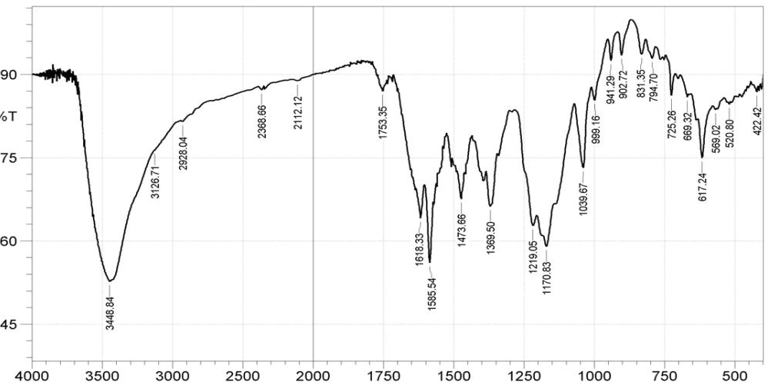
a
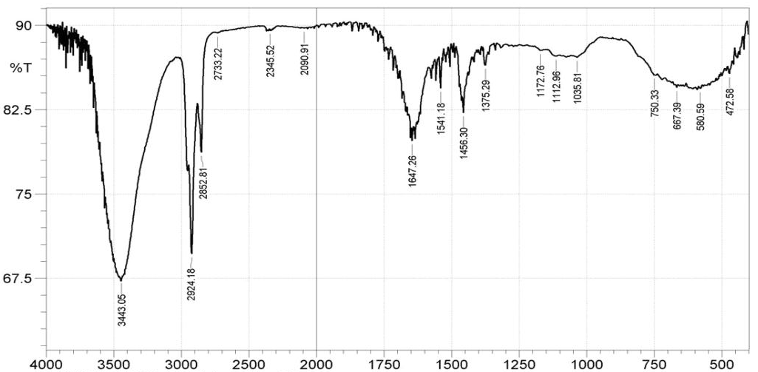
b
Fig. 5. FTIR spectra of simulated wastewater before (a) and after (b) 24 h degradation by Bacillus licheniformis WLS
3.4 GC-MS Analysis
The chromatogram of the untreated SW exhibited several distinct peaks that were absent in the chromatogram of the metabolites (Fig. 6). Conversely, new and well-resolved peaks emerged in the metabolite profile, indicating the formation of new compounds. Barring boiling point and polarity, and with other factors held constant, lower molecular weight compounds generally exhibit shorter retention times in GC analysis. All the peaks but one of the SW were observed in the range 12.9-24.5 min whereas for the metabolites, most of the peaks had retention time in the range 3.6-8.9 min. This shift strongly suggests the formation of new, lower molecular weight products. Furthermore, GC-MS spectra revealed significant changes in fragmentation patterns, with the treated SW displaying predominantly lower m/z values. These findings confirm the biotransformation of synthetic dyes into degradation products.
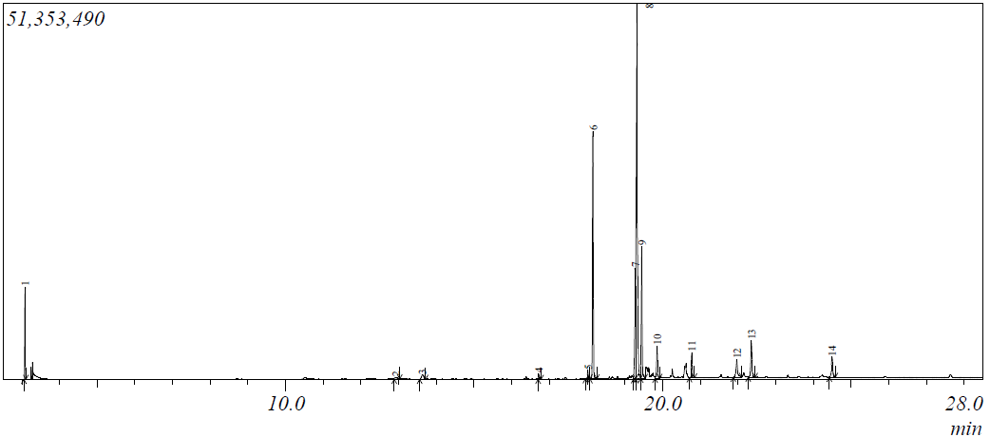
a
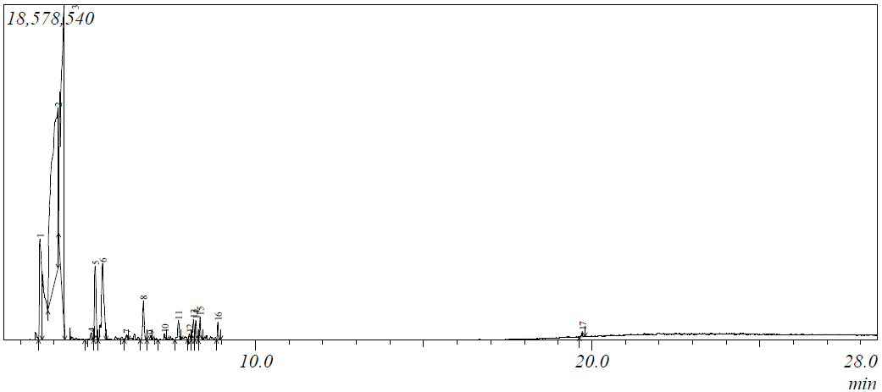
b
Fig. 6. GC Chromatogram of simulated textile wastewater before (a)
and after (b) 24 h degradation by Bacillus licheniformis WLS
3.5 Phytotoxicity
The untreated SW inhibited germination of Zea mays and Vigna unguiculata by 13.33% and 20% respectively whereas the decolorized SW supported germination of Zea mays (100%) and Vigna unguiculata by 86.67%. In both plants, induction of shoot and root length was generally higher in decolorized SW compared than in untreated SW, but similar or higher when compared to the control. These findings showed 24 h-decolorized wastewater contains compounds that are less toxic to the germinating seeds. Zea mays and Vigna unguiculata were selected as test crops for this study due to their relevance as widely consumed staples in Nigeria used both in direct culinary applications and as raw material for processed food products. Phytotoxicity have been used to assess the toxicity of synthetic dyes and their degradation products (Parshetti et al., 2006, Jadhav et al., 2008).
Table 1. Effect of untreated and decolorized simulated wastewater on germination of Zea mays and Vigna unguiculata seeds
 | Zea mays |  |  | Vigna unguiculata
Parameters | Control (Distilled Water) | Simulated Wastewater | Decolorized Wastewater | Distilled Water | Simulated Wastewater | Decolorized Wastewater
Germination (%) | 100.00 | 86.67 | 100.00 | 100.00 | 80.00 | 86.67
Shoot Length (cm) | 6.00 ± 0.02 | 6.70 ± 0.5 | 8.50 ± 0.42* | 7.40 ± 0.2 | 6.70 ± 1.15 | 7.50 ± 0.30
Root Length (cm) | 8.00 ± 0.12 | 7.40 ± 0.42 | 7.70 ± 0.42 | 7.30 ± 0.2 | 5.50 ± 1.07 | - 0.61§
Shoot length of Zea mays seeds grown in decolorized wastewater was significantly different from seeds grown in distilled water *P ≤ 0.05. Root length of Vigna unguiculata seeds grown in was significantly different from those grown in distilled water and simulated wastewater §P ≤ 0.05.
4.0 CONCLUSION
In this study, Bacillus licheniformis strain WLS demonstrated effective biotransformation of simulated wastewater by degrading the constituent synthetic dyes and converting them into non-toxic and less toxic metabolites. This highlights the strain’s potential as a promising candidate for use in environmentally sustainable dye-laden wastewater treatment and bioremediation applications.
DISCLAIMER (ARTIFICIAL INTELLIGENCE)
No artificial intelligence (AI) technologies were used in the process of writing this paper.

COMPETING INTERESTS
No competing interests exist.

REFERENCES

Ayub, A., Wani, A. K., Chopra, C., Sharma, D. K., Amin, O., Wani, A. W., Singh, A., & Singh, R. (2025). Advancing dye degradation: Integrating microbial metabolism, photocatalysis, and nanotechnology for eco-friendly solutions. Bacteria, 4(1), 15. https://doi.org/10.3390/bacteria4010015
Azanaw, A., Birlie, B., Teshome, B., & Jemberie., M. (2022). Textile effluent treatment methods and eco-friendly resolution of textile wastewater. Case Studies in Chemical and Environmental Engineering, 6, 100230. https://doi.org/10.1016/j.cscee.2022.100230
Dutta, S., & Bhattacharjee, J. (2022). A comparative study between physicochemical and biological methods for effective removal of textile dye from wastewater. In M.P Shah, S. Rodriguez-Couto & R.T. Kapoor (Eds.), Development in Wastewater Treatment Research and Processes (pp 1-21). Elsevier. https://doi.org/10.1016/B978-0-323-85657-7.00003-1
He, H., Zhang, Y., Shi, G., & Li, Y. (2023). Recent biotechnological advances and future prospective of Bacillus licheniformis as microbial cell factories. Systems Microbiology and Biomanufacturing, 3, 521–532. https://doi.org/10.1007/s43393-023-00162-7
Jadhav, S. U., Kalme, S. D., & Govindwar, S. P. (2008). Biodegradation of Methyl red by Galactomyces geotrichum MTCC 1360. International Biodeterioration & Biodegradation, 62(2), 135–142. https://doi.org/10.1016/j.ibiod.2007.12.010
Kumar, S., Stecher, G., & Tamura, K. (2016). MEGA7: Molecular Evolutionary Genetics Analysis version 7.0 for bigger datasets. Molecular Biology and Evolution, 33(7), 1870–1874. https://doi.org/10.1093/molbev/msw054
Lellis, B., Fávaro-Polonio, C.Z., Pamphile, J.A., & Polonio, C. (2019). Effects of textile dyes on health and the environment and bioremediation potential of living organisms. Biotechnology Research and Innovation, 3(2), 275-290. https://doi.org/10.1016/j.biori.2019.09.001
Lin, J., Ye, W., Xie, M., Seo, D. H., Luo, J., Wan, Y., & Van der Bruggen, B. (2023). Environmental impacts and remediation of dye-containing wastewater. Nature Reviews Earth & Environment, 4, 785-803. https://doi.org/10.1038/s43017-023-00489-8
Lu, L., Zhao, M., Wang, T. N., Zhao, L. Y., Du, M. H., Li, T. L., & Li, D. B. (2012). Characterization and dye decolorization ability of an alkaline resistant and organic solvents tolerant laccase from Bacillus licheniformis LS04. Bioresource Technology, 115, 35-40.
Narsinge, A. P. (2017). Dye degradation by microorganisms. World Journal of Pharmaceutical Research, 6(15), 636–643. https://doi.org/10.20959/wjpr201715-10052
Olukanni, O., Awotula, A., Osuntoki, A., & Govindwar, S. (2019). Influence of redox mediators and media on methyl red decolorization and its biodegradation by Providencia rettgeri. SN Applied Sciences, 1, 697. https://doi.org/10.1007/s42452-019-0668-0
Parshetti, G., Kalme, S., Saratale, G., & Govindwar, S. (2006). Biodegradation of malachite green by Kocuria rosea MTCC 1532. Acta Chimica Slovenica, 53, 492–498. https://acta-arhiv.chem-soc.si/53/53-4-492.pdf
Pavia, D. L., Lampman, G. M., Kriz, G. S., & Vyvyan, J. R. (2015). Introduction to spectroscopy (5th ed., pp. 404-406). Cengage Learning.
Rani, R., Rathee, J., Kumari, P., Singh, N. P., & Santal, A. R. (2022). Biodegradation and detoxification of low-density polyethylene by an indigenous strain Bacillus licheniformis SARR1. Journal of Applied Biology & Biotechnology, 10(1), 9-21. https://doi.org/10.7324/JABB.2021.100102
Sela, S.K., Nayab-Ul- Hossain, A.K.M., Hussain, S.Z., & Hasan, N. (2020). Utilization of prawn to reduce the value of BOD and COD of textile wastewater. Cleaner Engineering and Technology, 1, 100021. https://doi.org/10.1016/j.clet.2020.100021
Shen, J., Do, T., Carwood, G., & Jenkins, R. (2002). Biotreatment of textile effluent using Pseudomonas spp. immobilized on a polymer support. In I. R. Hardin et al. (Eds.), Advanced biotechnology for textile processes (pp. 35–45). The University of Georgia. http://hdl.handle.net/2086/1777
Singh, P. K., & Singh, R. L. (2017). Bio-removal of Azo Dyes: A Review. International Journal of Applied Sciences and Biotechnology, 5(2), 108–126. https://doi.org/10.3126/ijasbt.v5i2.16881
Sudarshan, S., Harikrishnan, S., RathiBhuvaneswari, G., Alamelu, V., Aanand, S., Rajasekar, A., & Govarthanan, M. (2023). Impact of textile dyes on human health and bioremediation of textile industry effluent using microorganisms: current status and future prospects. Journal of Applied Microbiology, 134(2), lxac064. https://doi.org/10.1093/jambio/lxac064
Tanaya, K., Kumari, A., Singh, A. K., & Singh, D. (2024). Bioremediation: An economical approach for treatment of textile dye effluents. Water, Air, & Soil Pollution, 235(516). https://doi.org/10.1007/s11270-024-07287-y
United Nations (2017). Wastewater: The untapped resources. The United Nations World Water Development Report. http://unesdoc.unesco.org/images/0024/002475/247552e.pdf
Wohlgemuth R. (2021). Biocatalysis – Key enabling tools from biocatalytic one-step and multi-step reactions to biocatalytic total synthesis. New Biotechnology, 60,113-123.

