Synthesis and evaluation of novel synthetic piperazine derivatives with biological and anxiolytic potency: A preliminary report

Abstract
Anxiety is one of the mental conditions that has a substantial impact on individual health and well-being and is a major issue of concern in societies globally. Stress and anxiety are neurological syndromes affecting humans and animals. Current treatment regimens for anxiety disorders include benzodiazepines, antidepressants (like SSRIs and SNRIs), and beta-blockers. Each of these drugs has its advantages and drawbacks. To this end, in recent years, the pharmacological properties of many synthetic heterocyclic compounds have proven to possess higher biological efficacy in the treatment of several CNS (central nervous system) disorders. With this background, the aim of the present research was to design and study cellular and anxiolytic effects of novel synthetic piperazine derivative compounds. We have synthesized 5 novel derivatives of piperazine (PD1-PD5). The results of the cellular assays are as follows: in the microbial assay the compound PD2 demonstrated an inhibition zone of 1.3 cm and MIC value to be 0.2±0.24 mg/ml. Whereas, the antioxidant activity of compounds was as follows: PD5 toxicity had a range of 53.60% - 78.04% (DPPH assay), and compound PD2 had 64.15% - 77.26% (H₂O₂ scavenging) toxicity. In the cytotoxic assays, PD3 compound demonstrated higher viability at 56.81% (trypan blue test) and PD2 64.39% viability (resazurin test). Behavioral assays indicated increased traveled distance and locomotion activity at low (2.5 µg/ml) and high (5.0 µg/ml) doses in comparison to the control group. PD2-treated fish showed anti-anxiety activity and spent more time in the green zone. Finally, caffeine-treated fish spent more time in the dark zone, implying anxiety, whereas piperazine derivative-treated fish spent more time in the light zone, implicating reduced anxiety. In summary, the present study demonstrates the hybrid role of compound PD2 with anti-microbial, cytotoxic, and anti-oxidant properties. Also, it reestablishes zebrafish as a model for behavioral studies.
Key words: Heterocyclic compounds. piperazine derivatives, Benzodiazepines, anxiolytic activity, anti-anxiety, anti-oxidant, cytotoxicity.

- Introduction
The most common mental illness is anxiety, which might raise the chance of developing co-occurring mood and drug use problems. Importantly, it adds to the worldwide burden of illness and is associated with significant health expenses in a number of nations (Javaid et al., 2023). Despite a better understanding of the pathophysiology of anxiety, treatment duration and efficacy have often not increased. Over the past 50 years, pharmacological therapies for anxiety disorders have increased in number, availability, and tolerability (Garakani et al., 2020). Beta-blockers, antidepressants (such as SSRIs and SNRIs), and benzodiazepines are among the medications used to treat anxiety disorders. While antidepressants can take weeks to work, benzodiazepines provide quick relief but are usually only used temporarily due to the possibility of dependence. Physical symptoms such as a fast heartbeat can be alleviated with beta-blockers (Beyer et al., 2024). Clinicians have been compelled to mix medications and alter dosage schedules because in spite of these remarkable advancements, between one-third and half of patients on contemporary antidepressants do not experience long-lasting remission from anxiety (Ormel et al., 2022).
In the area of drug chemistry several new compounds and molecules are being synthesized and tested for their increasing pharmacological and kinetic properties. Several of these are under clinical trials. Many medications are made of piperazines, which are chemical molecules with broad biological action that have two nitrogen atoms positioned opposite each other in a 6-membered heterocyclic ring (Md Faizan et al., 2024). Due to the nature of the molecule, significant derivatives with a variety of applications have been synthesized. Piperazine compounds have been shown in numerous investigations to exhibit antihelmintic, antitubercular, antimalarial, antifungal, antiviral, and anticancer properties (Panda et al., 2024).
It is used to treat anxiety and depression in the context of mental health conditions (Ranjan Kumar et al., 2021). A number of piperazine compounds, including m-chlorophenylpiperazine as an agonist for the 5-HT1A receptor and trifluoromethylphenylpiperazine (TFMMPP), have shown affinity for CNS receptors (Yuan et al., 2021). 1 [2-yl)propyl-3-(6-fluorobiphenyl] (2-(1-isopropylpiperidin-4-yl)ethyl)-4-[2-(4-fluorophenyl)-2-] 3-hydrochloride piperazine with 1-(3-biphenyl-2-yl-propyl) [2-[4-fluorophenyl]] -4- 4-yl)ethyl-2-(1-isopropylpiperidin] hydrochloride of piperazine-3 for the melacortin receptor (MC). Finally, the 1-[1-(4-chlorophenyl)-1H-pyrazol-4ylmethyl] for the dopamine D2 receptor, uses 4-phenyl-piperazine (Yuan and Tao 2022). Researches in the area of drug-chemistry, structure-function and drug- interactions are ways to find new medications for CNS illnesses. Therefore, research on piperazine derivatives has focused on a variety of key therapeutic uses, such as anxiolytic, antipsychotic, and antidepressant uses.
To this end, several lines of research, including synthesis chemistry, structure-function relationships, animal models, and in silico studies, have been pursued by researchers in industry and academic settings (Durand and Michal Szostak 2021; Szczepańska et al.,2021; Zernov et al., 2024; Ikwu et al., 2020).
Previous studies
For the advancement of neuroscience research and drug discovery, precise examination of anxiety behaviors in animal models is essential. A good model organism for research on stress and anxiety as well as pharmaceuticals is the zebrafish (Danio rerio) (Chahardehi et al., 2023). It makes it easier to examine the effects of pharmacological and environmental changes on their physiological and behavioral characteristics (Srivastava et al., 2025). In brain research, zebrafish are a good alternative to the majority of adult rodents (mice and rats) because of their great reproduction capacity and inexpensive maintenance costs. It has been utilized to create a conceptual framework for research on anxiety behavior that has several uses in the lab, such as the investigation of pharmacological and herbal medications (Chakraborty et al., 2025).
With this background, the present study was designed to synthesize chemical piperazine derivatives and screen their microbial and cellular properties and anxiolytic activity in a zebrafish model.

2.0. Materials and methods
All chemicals and reagents were of analytical grade. Experiments were carried out with due care to exclude errors (Human and experimental errors).
Resazurin (Invitrogen), Antibiotic discs PefloxanPF5 – HIMEDIA, streptomycin (Abbot), Trypan blue dye, Giemsa stain, Sodium nitroprusside, Greece reagent, Ascorbic acid, Caffeine (Loba Chemie pvt.ltd). Microorganisms used in the experiments - Saccharomyces cerevisiae (yeast), E. coli, Streptococcus aureus and Zebra fish (Danio rerio).
Chemistry of compounds is summarized in table-2
2.1. Antimicrobial activity
Determination of Minimum Inhibitory Concentration
MIC defines the in vitro levels of susceptibility or resistance of specific bacterial strains to applied antibiotics. MIC measurement was conducted to evaluate antibacterial activities of our test compounds Piperazine derivatives (PD) against E. coli strain.1x10⁵cfu/ml E. coli cells were seeded to a 96 well plate containing growth media. Test compounds were added in the range (0.2mg, 0.4mg, 0.8mg, 1.6mg, 3.2mg, 6.4mg/ml). The plates were then incubated at 37°C for 24 hr. The plates were analyzed with plate reader at 530nm, MIC values were recorded with each compound. Methanol was included as negative control and antibiotic streptomycin was used as positive control (Honnegowdanahalli Shivabasappa Nagendra Prasad 2022).
.
Disc diffusion assay:
Escherichia coli and Staphylococcus aureus cultures were prepared by growing them in a suitable medium under optimal conditions. The bacterial suspensions were evenly spread across the surface of an agar plate to form a uniform layer. On to this agar surface, filter discs were placed which were pre-soaked with 30µg of our test compounds - Piperazine derivatives (PD). Methanol was included as a negative control, and Streptomycin as a positive control. The plates were then incubated at 30°C for 24hr. After incubation, the plates were checked for the inhibition zone. The diameter of the inhibition zone was measured to determine the antimicrobial activity of the test compounds (Espinel-Ingroff, et al., .2007).

2.2. Cytotoxicity
Resazurin assay
Resazurin assay is commonly used to quantify the number of live cells in a sample and to monitor cell viability or cytotoxicity. It is based on the principle that the amount of resorufin produced is directly proportional to the number of living cells. 2×10⁴ yeast cells per well were seeded in final volume of 100µl along with media. Test compounds were dissolved in methanol and treated at the concentration of 0.5mg and 1.0mg/ml. Cells treated with streptomycin were the positive control and cells treated with only methanol were the negative control. Finally, 10µl of Resazurin 0.01% W/v in water was added to each well and the plates were incubated at 37°C for 4hrs. Fluorescence was measured at a wavelength of 570nm. (Jessica Petiti, et al., 2004).
Cell viability
2×10⁶ yeast cells/ml was seeded in 96 well culture plates containing media and 5µg of test compounds each with and without H₂O₂, along with respective controls were incubated for 4h at 37⁰C in a humidified incubator. After incubation cells were harvested by centrifugation at 3000 RPM for 5 min. The cell pellet was then re-suspended in 100 µl of PBS; 10 µl of the cell suspension was stained with an equal volume of 0.4% trypan blue in 980 µl of PBS and incubated for 2 min at 37⁰C. (Sathish Byrappa, et al., 2019). The total number of cells was counted using a Neubauer’s Chamber and the percentage of viability was calculated using the formula;
% viability = No. of viable cells/Total No. of cells (Viable + dead) x 100.

2.3. Antioxidant activity
2,2-diphenyl-1-picrylhydrazyl radical (DPPH) assay:
DPPH free radical scavenging property was assessed according to the protocol described by (Kuntal das, et al., 2017; Nwachukwu, et al., 2021) with minor modifications. The test compounds (10 to 400µg/mL) were taken on a 96-well plate and DPPH at concentration of 300µM was added. 2×10⁴ yeast cells per well were seeded in final volume of 100µl along with media. The plate was incubated in the dark at 37⁰C for 30 minutes and absorbance was measured at 515nm. The half-maximal inhibitory concentration (IC50) value was calculated depicting the concentration of the sample needed to scavenge 50% of DPPH free radicals. Ascorbic acid was used as a standard for the assay. The absorbance was calculated at 515 nm. The inhibitory activity was determined according to the equation.

Scavenging (%) = OC − OS
× 100
OS

where: OC is the absorbance of the control (DPPH+solvent) and OS is the absorbance of the sample (DPPH+compounds).
Hydrogen peroxide scavenging (H₂0₂) assay:
Hydrogen peroxide initiates lipid peroxidation and causes DNA damages in eukaryotic cells. A solution of hydrogen peroxide (40mM) was prepared in a phosphate buffer (pH 7.4). Different concentrations of the test compounds (500, 1000, 1500µg/mL) or ascorbic acid as the standard were added to a hydrogen peroxide. The broth was diluted with fresh medium to get 0.2 of absorbance (A600). After incubating for 10min, absorbance was taken at 230nm. (Kuntal das, et al., 2017).
The hydrogen peroxide percentage scavenging activity was then calculated using the following formula:

H₂O₂ (scavenging effect %) = Aº – A
×100
Aº

where A_{o} is the absorbance of the control and A₁ is the absorbance in the presence of the test samples.
2.4. Behavioral study of zebrafish
Maintenance of zebrafish
A total of 170 Zebrafish (Danio rerio) wild-type strain; 4–6 months old were maintained in glass tanks of 100L capacity. The animals were obtained from a local commercial supplier (Sea World Aquarium, Mysuru, India) and were acclimatized for 2 weeks before the experiments. A tank containing normal water was de-chlorinated and maintained under constant aeration and mechanical, and chemical filtration (25–27°C; pH 7–8 and a 14:10 h light–dark cycle was provided by fluorescent lamp tubes. Only fishes weighing 450 mg and above were used for experiments. All fishes were fed two times a day with Optimum micro pallet fish food. All procedures were performed according to the CPASEA guidelines, India (Committee for the Purpose of Control and Supervision of Experiments on Animals) (Michelle E, et al., 2019, Nityashree, et al., 2024)
Toxicology study
The test compounds (piperazine derivatives) were tested for its toxicity on zebrafish. On the 1stday, healthy zebrafish which weighed above 400mg were chosen, and transferred into 5 separate labeled bowls. Each bowl contained 10 fishes. Different doses of compounds were prepared that were used to determine the toxicity of zebrafish. Each bowl of fish was labeled as control, 2.5µg/ml dose, 5µg/ml dose, 7.5µg/ml dose, and 10µg/ml dose. The fishes were injected intraperitoneally with compounds of their respective doses at an interval of 24hrs, 48hrs, 72hrs, and 96hrs for 4 consecutive days and the fish's death count were documented till 7th day to determine the extract's LD₅₀ value and the adequate dose range for anti-anxiety protocol.
Intraperitoneal injection
The fish were immersed in cold water at 10–15⁰C for 30–60 seconds to anesthetize them, or until there was only gill movement in the fish. When the fish cannot move, a tap on the beaker is made to make sure the fish is anesthetized. Fishes were transferred to a watered sponge holder to inject the fish into its intraperitoneal region. Since this is a time-sensitive procedure, all the steps were completed within 30–40 s after anesthetizing the fish. The fishes were later transferred to a beaker that holds three to four liters of water so that the fish can recover from the cold-water anesthesia (Allan V. Kalueff, et al., 2014, Omar, et al., 2023).

Anxiety protocol
In the anxiety study design the fish were housed for one day wherein caffeine was used as a drug to induce anxiety. The fishes were exposed to caffeine-treated water for about 15 min in a bowl. Later fish were divided into 3 groups: control, low dose and high dose respectively for treatment using the test compounds piperazine derivatives which were dissolved in 5% DMSO. Fish weighing more than 450 mg were chosen so that the fish could sustain the caffeine doses. The concentration of caffeine in the tank water was 100mg/L. Ten fish from each group were anesthetized and intraperitoneally injected with a test compound (PD2). The control group received an injection with 5% DMSO solution, while the low dose and high dose groups received 2.5 µg/ml, and 5 µg/ml of test compound (PD2), respectively (Barbara D. Fontana, et al., 2022). Tax Track software TM was used to record the assays.
Open-field test
The open-field test is a frequently used method of assessing zebrafish behavior and locomotion. This was chosen as an adaptation of the designs which also utilized top-down measurement of horizontal fish movement. After each trial, the water was replaced since substances released by a fish can influence the behavior of the fish used in the next trial, invalidating the result. Water temperature was maintained at between 25 and 28°C for all trials. Zebrafish were assessed across virtual zones in a testing arena in a tank with a height of 15 cm. The tank was filled to a depth of 6 cm with normal water which was changed every trial (Nityashree, et al., 2024).
Light–dark test
The device was a tank that measured 15 × 10 × 45 cm in height, depth, and length. The zebrafish were subjected to light and dark tests for 5 min. It was evenly divided into two separate compartments, one coated in a white material and the other in a black sheet of thick paper, where the light rays could not enter the tank. From one side of the tank, the light was on so that only half of the tank could receive light. This test was conducted in a dark room (Nityashree, et al., 2024). The amount of time spent in each zone (dark and light) and the number of entries to each zone were considered as behavioral parameters. A quick back into the dark container after making a partial entry into the white compartment was the definition of risk assessment behavior.
T-maze experiment
With a few minor adjustments, we employed the previously reported methodology for learning and memory. 3 trials of each experiment were conducted for 6 h, 5 min each with a 2 minute break at each trial. There was one stem and two arms wherein one was colored red and the other was colored green, which made up the T-maze. For four days in a row, the zebrafish were trained with one trial per day. The green-colored arm section held 20 µg of food, which was brine shrimp, throughout the training sessions, and the red-colored arm contained frequent manual chasing behavior (which creates fear in the fish) with a glass rod by the experimenter. Based on these trials the fish tries to assume that the red arm is harmful and the green arm is safe (cognitive map). Following a 4-day training session, memory testing was conducted on all experimental zebrafish treated with test compounds on the fifth day (Yun-Hee Kim, et al., 2019, Nityashree, et al., 2024).

3.0. Results
3.1. Synthesis of compounds
(HSY 36 ) PD1: 4-(2-methoxyphenyl) piperazin-1-ium Penta fluoro benzoate.
Experimental
Synthesis and Crystallisation
The reagents were obtained commercially and were used as received. For the synthesis of the 4-(2-methoxyphenyl) piperazin-1-ium Penta fluoro benzoate salt, equimolar quantities (0.52 mmol of each component) of N-(2-methoxyphenyl)piperazine (100 mg) (from Sigma-Aldrich) and pentafluorobenzoic acid (110 mg) were separately dissolved in methanol (10 ml) and the two solutions were then mixed, and stirred briefly at 333 K and then set aside to crystallize, giving the solid product (I) after a few days. The product were collected by filtration and then dried in air ( I: yield: 85%; m.p.: 396–398 K ) Crystal of compound ( I ) suitable for single-crystal X-ray diffraction were grown by slow evaporation, at ambient temperature and in the presence of air, of solutions in methanol– acetonitrile (initial composition 1:1, v/v) for (I)
Reaction Scheme for Salt I

Scheme 1: High-performance thermoplastic polymer
(HSY 39) PD2: 4-(2-methory phenyl) piperazin-1- ium tartarate
All reagents were obtained commercially and were used as received. For the synthesis of the salts, equimolar quantities (0.52 mmol of each component) of N-(2-methoxyphenyl)piperazine (100 mg) (from Sigma-Aldrich) and tartaric acid (78 mg) were separately dissolved in methanol (10 ml) and the two solutions were then mixed, and stirred briefly at 333 K and then set aside to crystallize, giving the solid products ( II) after a few days. The products were collected by filtration and then dried in air ( II: yield: 75%; m.p.: 386–388 K). Crystals of compound II suitable for single-crystal X-ray diffraction were grown by slow evaporation, at ambient temperature and in the presence of air, of solutions in methanol– acetonitrile (initial composition 1:1, v/v) .
(HSY 4) PD3: 4-(2-methoxyphenyl) piperazin-1- ium Succinate
The reagents were obtained commercially and were used as received. For the synthesis of the salts, equimolar quantities (0.52 mmol of each component) of N-(2-methoxyphenyl)piperazine (100 mg) (from Sigma-Aldrich) and succinic acid (61 mg) were separately dissolved in methanol (10 ml) ) and the two solutions were then mixed, and stirred briefly at 333 K and then set aside to crystallize, giving the solid product III after a few days. The products were collected by filtration and then dried in air III: yield: 80%; m.p.: 377–379 K. Crystals of compound III suitable for single-crystal X-ray diffraction were grown by slow evaporation, at ambient temperature and in the presence of air, of solutions in methanol– acetonitrile (initial composition 1:1, v/v) for ( III ) .
Reaction Scheme for the salt III
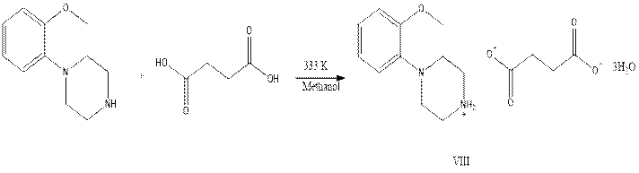

Scheme 2 : PD3: 4-(2-methoxyphenyl) piperazin-1- ium Succinate(HSY 82)

PD4: 4-phenylpiperazin-1-ium 3-Chlorobenzoate
All reagents were obtained commercially and were used as received. For the synthesis of the salts, equimolar quantities (0.62 mmol of each component) of 1-phenylpiperazine (100 mg) (from Sigma-Aldrich) and 3-chlorobenzoic acid (97 mg) were separately dissolved in methanol (10 ml) and the two solutions were then mixed, and stirred briefly at 333 K and then set aside to crystallize, giving the solid products (IV) after a few days. The product were collected by filtration and then dried in air ( IV: yield: 70%; m.p.: 397–399 K; X: yield: 75%; m.p.: 365–367 K. Crystals of compounds (IV) suitable for single-crystal X-ray diffraction were grown by slow evaporation, at ambient temperature and in the presence of air, solutions of methanol-ethylacetate (initial composition 1:1, v/v) for (IV).
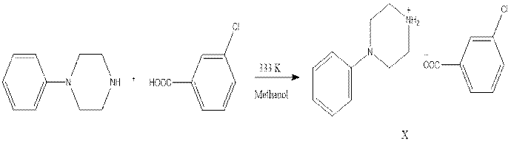

Scheme 3 : PD4: 4-phenylpiperazin-1-ium 3-Chlorobenzoate
(HSY 84) PD5: 4-phenylpiperazin-1-ium 4-Chlorobenzoate
The reagents were obtained commercially and were used as received. For the synthesis of the salts, equimolar quantities (0.62 mmol of each component) of 1-phenylpiperazine (100 mg) (from Sigma-Aldrich) and 4-chlorobenzoic acid (97 mg) were separately dissolved in methanol (10 ml) and the two solutions were then mixed, and stirred briefly at 333 K and then set aside to crystallize, giving the solid products (V) after a few days. The product were collected by filtration and then dried in air IX: yield: 70%; m.p.: 397–399 K . Crystals of compounds (V) suitable for single-crystal X-ray diffraction were grown by slow evaporation, at ambient temperature and in the presence of air, solution of methanol-ethylacetate (initial composition 1:1, v/v) for (V).
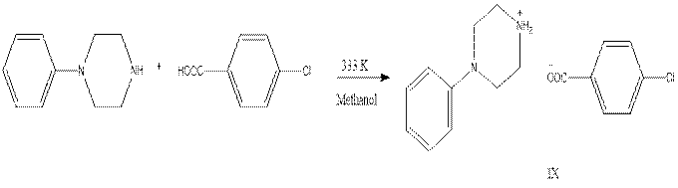

Scheme 4 : 4-phenylpiperazin-1-ium 4-Chlorobenzoate
3.2. Anti - microbial activity
Disc diffusion assay
As evident from table-1 a significant dose-dependent increase in inhibition of bacteria was observed in compounds PD1, PD2 and PD4 respectively. PD2 derivative showed a comparatively better MIC value of 0.2±0.24mg/ml. The results are illustrated in figure-1
MIC assay
As evident from figure-2 a significant dose-dependent increase in inhibition of bacteria was observed in compounds PD1, PD2 and PD4 respectively. There was 75.90% - 112.17% inhibition on compound PD1 treatment, and 106.16% - 172.58% inhibition on PD2 treatment and 107.82% - 159.39% inhibition on PD4 treatment respectively. Hence, the results implicate the anti-microbial effect of compounds PD1, PD2 and PD4.

3.3. Antioxidant activity
DPPH assay
As demonstrated in the bar graphs of figure-3, the results demonstrated that the DPPH free radicals were scavenged by all compounds in a concentration dependent manner: PD1(36.83% - 56.63%), PD2 (32.14% - 45.96%), PD3 (45.60% - 74.40%), PD4 (49.50% - 71.02%), PD5 (53.60% - 78.04%) respectively. Interestingly, the IC₅₀ value of PD3, PD4, and PD5 compounds showed better results compared to other compounds. Taken together, the results suggested that piperazine derivatives are potential antioxidant compounds.

H₂O₂ scavenging activity
The compounds PD1 to PD5 demonstrated a strong scavenging activity against H₂O₂. Higher inhibition percentage was seen in PD1 (64.62% - 76.80%) followed by PD2 (64.15% - 77.26%) and PD4 (62.23% - 75.25%) respectively (Figure-4). These results confirm the antioxidant potential of piperazine derivatives.
Cell viability
In comparison to all derivatives, compound PD3 demonstrated 56.81% viability and 50.61% (with H₂O₂) and PD5 demonstrated 45.78% and 41.01% (with H₂O₂) respectively(Figure-5).
Resazurin assay:
In comparison to all derivatives PD2 showed 64.39% viability and PD4 showed 49.21% viability (Figure-6).
3.4 .in vivo toxicity test on zebrafish
Zebrafish were exposed to various concentrations of piperazine derivatives (2.5, 5.0, 7.5 and 10µg/ml) for 7 days to assess their toxicity. All zebrafishes survived for 7 days in the control group. However, at a higher concentration of 10µg/ml 4 zebrafish perished out of 6, which indicates maximum death as compared to other concentrations (2.5, 5.0 and 7.5µg/ml). Therefore, 2.5 and 5.0µg/ml were considered to be safe doses to treat zebrafish for anti-anxiety tests (Figure-7).
3.5. Anti - anxiety
Open Tank Test
The experimental group subjected to anti - anxiety showed an increase in distance traveled and locomotion activity at low dose (2.5µg/ml) and high dose (5.0µg/ml) compared to the control group. The results are summarized in Figure-8A. The study demonstrates that anxiety manipulations using caffeine in adult zebrafish can significantly impact their anxiety-related behaviors and locomotion. Further, as demonstrated in Figure-8B, piperazine derivatives had a significant impact on anxiety-related behaviors and locomotion in zebrafish. The findings highlight the potential of this assay to uncover the effects of various treatments or conditions on zebrafish behavior.
T Maze test
As evident from the Figure-8 the time spent in the red arm increased in the anxiety-induced groups, indicating a reduction in memory retention. Figure -8 illustrates that the fish in the control group spent more time in the green arm in contrast to piperazine derivatives treated implicating improved cognitive ability, particularly spatial memory and learning. These findings demonstrate piperazine derivatives enable zebrafish to improve their cognitive abilities, notably spatial memory and learning. The compound PD2 showed higher anti – anxiety activity. As evident from graph (figure-9), fishes treated with compound PD2 5µg/ml spent more time in the green zone which signifies the anti-anxiety property. These findings provide useful insights for future research into the effects of natural chemicals on cognitive function, as well as their potential applicability in understanding neurological illnesses and environmental factors influencing cognitive performance.
Light and Dark test
The zebrafish trajectories exhibit anti- anxiety induced movement, with more time spent in the tank’s light side. The graph (Figure-10A) illustrates that all the caffeine-treated group fish spent more time in the dark zone, implying that they liked it owing to anxiety. The zebrafish trajectories reveal the piperazine derivatives reduce anxiety since greater time was spent in the light zone (Figure-10B). Thus, suggesting that these fishes have normal or reduced anxiety. The study examines the behavioral consequences of several experimental circumstances on zebrafish, including changing the levels of exposure to different chemicals. The control group spent more time in the dark zone, which is suggestive of typical behavior of anxiety. The piperazine derivatives treated group preferred higher light zones, indicating reduced anxiety-like behaviour.

4.0. Discussion
Newer medications with established efficacy, safety, and tolerability characteristics are needed for pharmacological treatments of anxiety and related mental illnesses. Novel compounds have been identified as anxiolytics by a number of researchers. N-(3-(4-(piperonyl) piperazin-1-yl) propyl) isonicotinamide and 30 N-(2-(4-(pyrimidin-2-yl)piperazin-1-yl)ethyl) picolinamide compounds are described by Kędzierska et al., 2019 with effects on the GABAergic and 5-HT systems. Using behavioral tests on mice, da Silva et al. (2018) reported a drug called LQFM104 and validated its characteristics. The design, synthesis, molecular docking, and evaluation of six derivatives of 2-(4-phenylpiperazin-1-yl)-1H-benz[d]imidazole and 2-(4-phenylpiperazin-1-methyl)-1H-benz[d]imidazoles are reported by Mahajan et al. (2024). According to Gomtsyan et al. (2012), the 6-member heterocyclic ring moiety is beneficial for a number of reasons, including its influence on the final molecule's physicochemical qualities, structural and conformational features, and ease of handling in synthetic chemistry. The moiety is a fundamental component of bioactive compounds. Because of their capacity to take on particular conformations and participate in a variety of interactions (such as hydrogen bonding and hydrophobic interactions), the compounds have a high affinity for proteins and enzymes (Meanwell 2023). These rings can be readily altered by cyclization, cycloaddition, and oxidative coupling, which makes it possible to incorporate them into molecules and enhance their pharmacokinetic and biological qualities, including solubility, bioavailability, and other drug-like traits (Amin et al., 2022). 2.5 and 5.0 µg/ml were deemed to be safe levels to treat zebrafish for anti-anxiety testing, but 10 µg/ml of the substance was the concentration that caused the greatest death in comparison to other concentrations. Caffeine affects anxiety-related behaviors and locomotion, as evidenced by the anti-anxiety experiment, which showed that fish traveled farther and had greater locomotor activity at low (2.5 µg/ml) and high (5.0 µg/ml) levels as compared to the control group. The trajectory experiments showed that piperazine derivatives significantly affected the locomotion and anxiety-related behaviors of zebrafish. In contrast to piperazine derivative treatment, the T-maze results reveal a decrease in memory retention caused by anxiety, as evidenced by the amount of time spent in the red arm. This suggests that cognitive capacity, namely spatial memory and learning, has improved. Piperazine compound PD2 (5µg/ml) allowed zebrafish to enhance their cognitive capacities, particularly spatial memory and learning through the green zone index, according to light/dark behavioral experiments. These findings provide useful insights for future research into the effects of piperazine derivatives on cognitive function, as well as their potential applicability in understanding neurological illnesses and the role of environmental factors in cognitive performances.
The inhibitory zone investigations showed that PD2 (0.8 mg) had a larger zone of 1.3 cm than PD1 (1.2 cm) suggesting sensitivity. In comparison to other drugs, the MIC assay showed greater suppression on PD2 therapy (106.16% – 172.58%). In comparison to other drugs, the MIC value of PD2 (0.2±0.24 mg/ml) showed comparatively lower inhibitory concentration, suggesting PD2 to have anti-bacterial activity. Another Schiff-based piperazine derivative have shown to possess potent antibacterial effect against Staphylococcus aureus (MRSA). (Honnegowdanahalli Shivabasappa Nagendra Prasad 2022) Also, a few piperazine fluoroquinolone derivatives have showed potent anti-bacterial activity with MIC values to be 16-fold more potent than ciprofloxacin. (Po-Ting Chen 2013)

The outcome collectively illustrates the synthetic compounds' has potent antibacterial properties. The majority of second-generation antibiotic medications contain piperazine, which is also present in sixth-generation antibiotics. One of the materials used to fight harmful microbes and stop infectious diseases is polymeric material. The polymer molecules reduce toxicity and increase the effectiveness of several currently used low-molecular-weight antibacterial medicines (Alkarri et al., 2024). In the past, authors have documented synthesizing second-generation antibiotics by mixing piperazine with antibiotic molecules. Xue et al. 2012 report macromonomer (GCM) synthesized by reacting ciprofloxacin (CPF) with glycidyl methacrylate. Ahmed et al., 2018 designed cationic poly (guanylurea) (PGUs) using piperazine and ethylenediamine for the development of biocompatible, specific, and selective antimicrobial polymers. The derivatives demonstrated antimicrobial activity against E. coli, M. smegmatis, S. aureus, and Candida albicans in comparison with the standard drug ciprofloxacin. The diverse areas of application of the derivatives included wound dressing, the textile industry, the biomedical field, water purification systems, and so forth, demonstrating their strength and physico-chemical properties.
Compound PD3 demonstrated 56.81% viability and 50.61% (with H₂O₂), and PD5 demonstrated 45.78% and 41.01% (with H₂O₂), respectively. The resazurin assay implicates PD2 with 64.39% viability. According to the toxicity experiment, PD5 (400 µg/ml) exhibits the highest concentration-dependent activity (53.60% - 78.04%), followed by PD3 (40 µg/ml) (45.60% - 74.40%). When compared to other drugs, PD3 and PD4 have superior IC50 values. A novel Piperazine benzanilides have also shown to be a promising anti-plasmodial and cytotoxicity activity (Theresa Herman 2025). A few Piperazine derivatives are used as conjugates along with Vinca alkaloids have presented a significant anti-proliferative and cytotoxic effects against some breast and lung cancer cell lines (Bernadett 2024).
Antioxidant treatments and their protective benefits against OS-related pathophysiologies have drawn more interest in the biomedical field in recent years. Neuropsychiatric disorders are frequently linked to oxidative stress, compromised antioxidant defense, and neuroinflammation. The production of molecules having antioxidant qualities derived from piperazine has been documented by researchers. Six novel aryl/aralkyl-substituted piperazine compounds with a methylxanthine moiety are reported by Andonova et al. (2016). LQFM212 by Moreira et al. (2023).

It may be possible to treat brain illnesses, especially those that involve inflammation or oxidative stress, by using hybrid molecules that have both antibacterial and antioxidant properties. According to Chayrov et al. (2019), hybrid compounds have antifungal and antibacterial properties and can be used as Alzheimer disease medications. According to Ostrowska et al. (2020), coumarin-piperazine compounds possess antioxidant, cytotoxic, and bactericidal qualities. The synthesis of medicinally important scaffolds is a major focus in drug development. Piperazine (C4H10N2), a heterocyclic amine, serves as a key building block in pharmaceuticals. Its derivatives show diverse bioactivities, functioning as anthelmintics, antipsychotics, and anxiolytics, while also exhibiting psychoactive properties that sometimes lead to recreational use (Rizwan et al., 2024).
Conclusion
In conclusion, the primary mechanism of central pharmacological activity of piperazine derivatives is the stimulation of CNS receptor pathways. Therefore, research on piperazine derivatives has focused on a variety of key therapeutic uses, such as anxiolytic, antipsychotic, and antidepressant uses. The derivatives PD1, 2, and 4 had anti-microbial properties, where The present study is another addition to the growing list of hybrid compounds with a spectrum of cellular and biological properties. Additional cellular and biolocal assays and characterization of kinetic properties followed by animal and clinical trials will establish the present compounds as potential anxiolytics.

References:
Javaid, S.F., Hashim, I.J., Hashim, M.J. Epidemiology of anxiety disorders: global burden and sociodemographic associations. Middle East Curr Psychiatry 30, 44 (2023). https://doi.org/10.1186/s43045-023-00315-3.

Garakani A Murrough JW, Freire RC, Thom RP , Larkin K, Buono FD , Dan V Iosifescu DV. Pharmacotherapy of Anxiety Disorders: Current and Emerging Treatment Option. Front Psychiatry. 11, 1-21 (2020).
https://doi.org/10.3389/fpsyt.2020.595584

Beyer C, Currin CB , Williams T , Stein D J. Meta-analysis of the Comparative efficacy of benzodiazepines and antidepressants for psychic versus somatic symptoms of generalized anxiety disorder. Comprehensive Psychiatry. 132 (2024).
PMID: 38564872, DOI: 10.1016/j.comppsych.2024.152479

Ormel J, Hollon SD, Kessler RC, Cuijpers P and Scott M. More treatment but no less depression: The treatment-prevalence paradox. Clin Psychol Rev. 91(2022).
https://doi.org/10.1016/j.cpr.2021.102111

Faizan M, Kumar R, Mazumder A, Salahuddin , Kukreti N, Kumar A Chaitanya M V N L. The medicinal chemistry of piperazines: A review. Chem Biol Drug Des. 103 (2024).
https://doi.org/10.1111/cbdd.14537

Panda KC, Devi A M ,Mangala K J, Gupta MK, Kumar PB, Sivasubramanian P. Exploring the Chemistry and Biological Activities of Piperazine Derivatives in Medicinal Chemistry.Naturalista Campano.28, 1 (2024).
Kumar RR, Sahu B, Pathania S , Singh PK , Akhtar MJ , Kumar B. Piperazine, a Key Substructure for Antidepressants: Its Role in Developments and Structure-Activity Relationships. Chem Med Chem. 16 (12):1878-1901. (2021).
https://doi.org/10.1002/cmdc.202100045

Yuan W, Ma Y, Zhang H. Development of heterocyclic-based frameworks as potential scaffold of 5-HT_{1A} receptor agonist and future perspectives: A review. Medicine (Baltimore). 103, 24. (2024).
https://doi.org/10.1097/MD.0000000000038496

Yuan XC, Tao YX. Ligands for Melanocortin Receptors: Beyond Melanocyte-Stimulating Hormones and Adrenocorticotropin. Biomolecules. 12, 10(2022).
https://doi.org/10.3390/biom12101407

Szczepańska K, Podlewska S, Dichiara M, Gentile D, Patamia V, Rosier N, Mönnich D, Ruiz MC, Cantero, Karcz T, Łażewska D, Siwek A, Pockes S, Cobos EJ, Marrazzo A, Stark H, Rescifina A, Bojarski AJ, Amata E, Kononowicz KK. Structural and Molecular Insight into Piperazine and Piperidine Derivatives as Histamine H3 and Sigma-1 Receptor Antagonists with Promising Antinociceptive Properties. ACS Chem Neurosci. 13, 1:1-15 (2022)
https://doi.org/10.1021/acschemneuro.1c00435

Zernov N, Ghamaryan N V, Melenteva D, Makichyan A, Hunanyan L, Popugaeva E. Discovery of a novel piperazine derivative, cmp2: a selective TRPC6 activator suitable for treatment of synaptic deficiency in Alzheimer's disease hippocampal neurons. Sci Rep. 14, 1 (2024).
https://doi.org/10.1038/s41598-024-73849-z

Durand C and Szostak M. Recent Advances in the Synthesis of Piperazines: Focus on C–H Functionalization.Organics, 2(4), 337-347 (2021).
https://doi.org/10.3390/org2040018.

Srivastava, V., Muralidharan, A., Swaminathan, A., Poulose, A. SrivastavaAnxiety in aquatics: Leveraging machine learning models to predict adult zebrafish behavior. Neuroscience. 565: 577-587.(2024).
https://github.com/DiL-Lab-iisertvm/Zebrafish-Behavior
Chahardehi AM, Hosseini Y, Mahdavi SM, Naseh I. Zebrafish, A biological model for pharmaceutical research for the management of anxiety. Mol Biol Rep. 50, 4:3863-3872 (2023). https://doi.org/10.1007/s11033-023-08263-1
Chakraborty P, Pal S, David S. Galstyan, Petersen EV, Amstislavskaya TG, Kolesnikova TO, de Abreu MS, Kalueff AV. Zebrafish models for studying central nervous system effects of Ayurvedic medicinal plants. J Ayurveda Integr Med. 16, 4 (2025).
Balouiri M, Sadiki M, Ibnsouda SK. Methods for in vitro evaluating antimicrobial activity: A review. J Pharm Anal. 6, 2 :71-79 (2016).
https://doi.org/10.1016/j.jpha.2015.11.005

Espinel-Ingroff A, Arthington-Skaggs B, Iqbal N, Ellis D, Pfaller MA, Messer S, Rinaldi M, Fothergill A, Gibbs D L, Wang A. Multicenter evaluation of a new disk agar diffusion method for susceptibility testing of filamentous fungi with voriconazole, posaconazole, itraconazole, amphotericin B, and caspofungin. J Clin Microbiol. 45, 6:1811-20 (2007).
https://doi.org/10.1128/jcm.00134-07

Zhao S, Ye X , Chen D , Zhang Q, Xiao W, Wu S, Hu J, Gao N, Huang M. Multi-Component Passivators Regulate Heavy Metal Accumulation in Paddy Soil and Rice: A Three-Site Field Experiment in South China. Toxics.10, 5:259 (2022).
https://doi.org/10.3390/toxics10050259

Sharma A, Wakode S, Fayaz F, Khasimbi S. An Overview of Piperazine Scaffold as Promising Nucleus for Different Therapeutic Targets. Curr. Pharm. Des. 26, 35 (2020).
http://dx.doi.org/10.2174/1381612826666200417154810
Mahajan BS, Kawale LA, Nade VS. Design, synthesis, and evaluation of anxiolytic activity of 2-(4-phenylpiperazin-1-yl)-1H-benz[d]imidazole and 2-(4-phenylpiperazin-1-methyl)-1H-benz[d]imidazole derivatives. Futur J Pharm Sci 10,50 (2024). https://doi.org/10.1186/s43094-024-00626-0.
Gomtsyan, A. Heterocycles in Drugs and Drug Discovery. Chem. Heterocycl. Comp. 48, 7–10.
https://doi.org/10.1007/s10593-012-0960-z.
Meanwell, N.A. The pyridazine heterocycle in molecular recognition and drug discovery. Med Chem Res 32, 1853–1921 (2023). https://doi.org/10.1007/s00044-023-03035-9.
Amin A, Qadir T, Sharma PK, Jeelaniand I, Abe H. A Review on The Medicinal And Industrial Applications of N-Containing Heterocycles. The Open Medicinal Chemistry Journal. 16 Nov 2022.http://dx.doi.org/10.2174/18741045-v16-e2209010.
Jalageri MD, Nagaraja A, Puttaiahgowda YM. Piperazine based antimicrobial polymers: a review. RSC Advances, 11, 25:15213-15230, (2021).
https://doi.org/10.1039/d1ra00341k
Alkarri S, Saad HB and Soliman M . On Antimicrobial Polymers: Development, Mechanism of Action, International Testing Procedures, and Applications. Polymers. 16, 6:771 (2024). https://doi.org/10.3390/polym16060771.
Xue Y, Guan Y, Zheng A, Wang H and Xiao H. Synthesis and Characterization of Ciprofloxacin Pendant Antibacterial Cationic Polymers, J. Biomater. Sci., Polym. 23, 1115–1128.(2012)
https://doi.org/10.1163/092050611x576639

Ahmed MS, Annamalai T, Li X, Seddek A, Teng P, Dinh T and Moon JH, Synthesis of Antimicrobial Poly(guanylurea)s. Bioconjugate Chem. 29, 1006–1009. (2018).
https://doi.org/10.1021/acs.bioconjchem.8b00057

Teleanu DM, Niculescu AG, Lungu II, Radu CI, Vladâcenco O, Roza E, Costăchescu B, Grumezescu AM, Teleanu RI. An Overview of Oxidative Stress, Neuroinflammation, and Neurodegenerative Diseases. Int J Mol Sci, 23, 11:5938. (2022).
https://doi.org/10.3390/ijms23115938
Andonova L, Dimitrova ZD, Georgieva M, Zlatkov A. Synthesis and antioxidant activity of some 1-aryl/aralkyl piperazine derivatives with xanthine moiety at N4. Biotechnol Biotechnol Equip. 28(6):1165–1171. (2014).
https://doi.org/10.1080/13102818.2014.979978

PMID: 36402170
Moreira LKDS ,Turones LC, Campos HM, Nazareth AM, Thomaz DV, Gil ES, Ghedini PC, Rocha FFD, Menegatti R, Fajemiroye JO, Costa EA. LQFM212, a piperazine derivative, exhibits potential antioxidant effect as well as ameliorates LPS-induced behavioral, inflammatory and oxidative changes. 312:121199. (2022).
https://doi.org/10.1016/j.lfs.2022.121199

Rizwan M, Noreen S, Asim S, Liaqat Z, Shaheen M, Ibrahim H. A comprehensive review on the synthesis of substituted piperazine and its novel bio-medicinal applications. Chem Inorg Mater. 2:100041(2024).
https://doi.org/10.1016/j.cinorg.2024.100041

Chayrov R, Tencheva A, Sbirkova-Dimitrova H, Shivachev B, Kujumdzieva A, Nedeva T and Stankova I. Synthesis, Antibacterial, and Antifungal Activities of Hybrid Molecules Based on Alzheimer Disease Drugs and Bearing an Amino Acid Fragment. Proceedings. 41, 1, 23. (2019).
https://doi.org/10.3390/ecsoc-23-06602.
Ostrowska K.Coumarin-piperazine derivatives as biologically active compounds.Saudi Pharm Jour. 28, 2:220-232(2020).

Table 1: MIC assay result of piperazine derivatives against E. coli strain.
Synthetic compound | MIC mg/mL
PD 1 | 0.4±0.38
PD 2 | 0.2±0.24
PD 3 | 1.6±0.45
PD 4 | 0.4±0.20
PD 5 | 0.8±0.34
Streptomycin | 0.01±0.05

Table-2.Chemistry of compounds
SI NO | Chemical name
1 | PD1:4-(2-methoxyphenyl) piperazin-1-ium Penta fluoro benzoate.
2 | PD2:4-(2-methory phenyl) piperazin-1- ium tartarate
3 | PD3:4-(2-methoxyphenyl) piperazin-1- ium Succinate
4 | PD4:4-phenylpiperazin-1-ium 3-Chlorobenzoate
5 | PD54-phenylpiperazin-1-ium 4-Chlorobenzoate

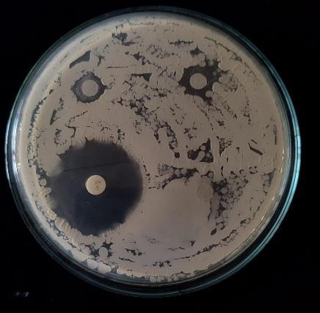
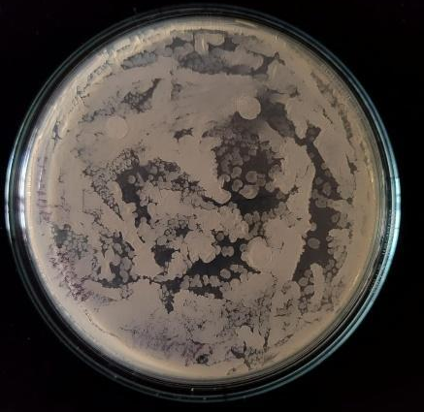

Petri Dish 1
Petri Dish 2

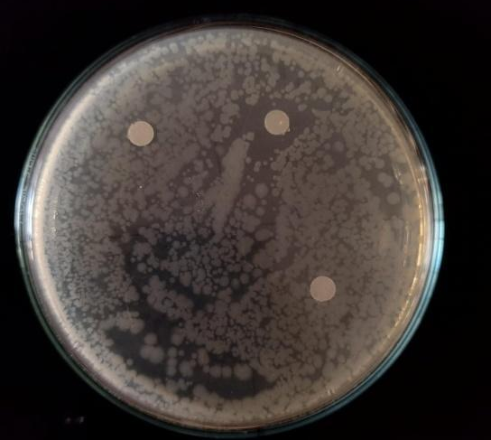
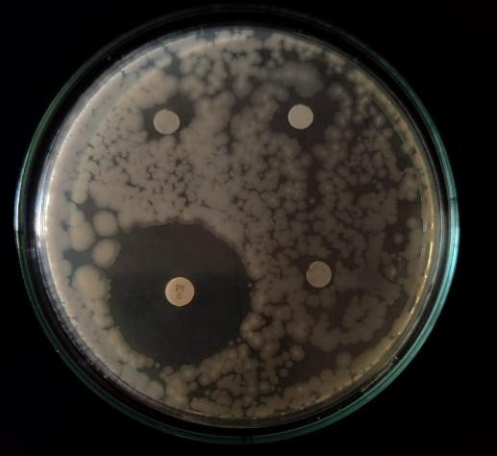
Petri dish 4
Petri dish 3
1
2
3
4
5
6
7
Figure-1: Petri dish 1 and 2: Escherichia coli treated with piperazine derivative. And Petri dish 3 and 4: Staphylococcus aureus treated with piperazine derivatives.

Figure-2: Bargraph representing the minimum inhibition concentration of piperazine derivatives against E. coli bacteria. (MIC) in mg/ml. E. coli cells were treated with piperazine derivatives (PD1, PD2, PD3, PD4 and PD5) at 0.2mg, 0.4mg, 0.8mg, 1.6mg, 3.2mg, 6.4mg concentrations. Streptomycin was used as positive control and methanol as negative control. The data represents the mean ±SEM of three independent experiments; **P < 0.01 and *p˂0.05.

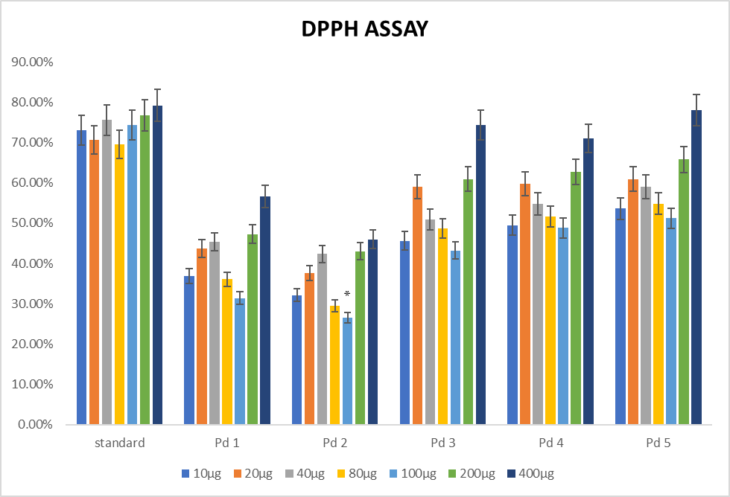
Figure-3: Bargraph representing the 2,2-Diphenyl-1-Picrylhydrazyl (DPPH) assay results for Piperazine derivatives. The inhibition percentage of piperazine derivatives (PD1, PD2, PD3, PD4 and PD5) at different concentrations 10, 20, 40, 80, 100, 200, 400 µg/ml were studied. The data represents the mean ±SEM of three independent experiments; **P < 0.01 and *p˂0.05.

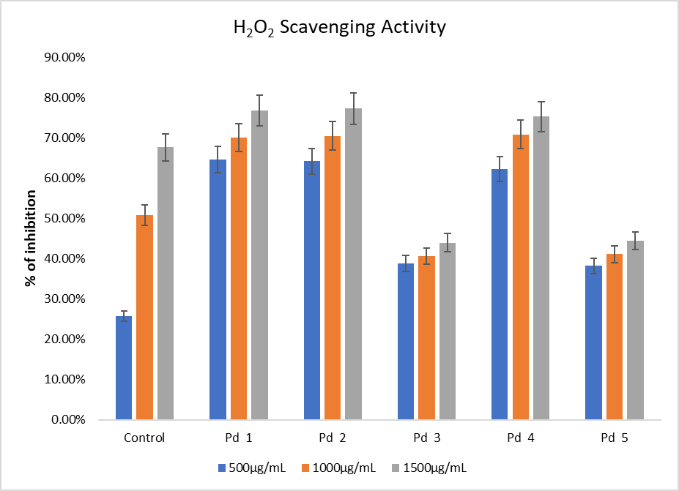

Figure-4: The bargraph representing the percentage of cell viability against the piperazine derivatives (PD1 to PD5) with and without H₂O₂ respectively. The percentage of cell viability after treatment of piperazine derivatives (PD1, PD2, PD3, PD4 and PD5) were studied. The data represents the mean ±SEM of three independent experiments; **P < 0.01 and *p˂0.05.

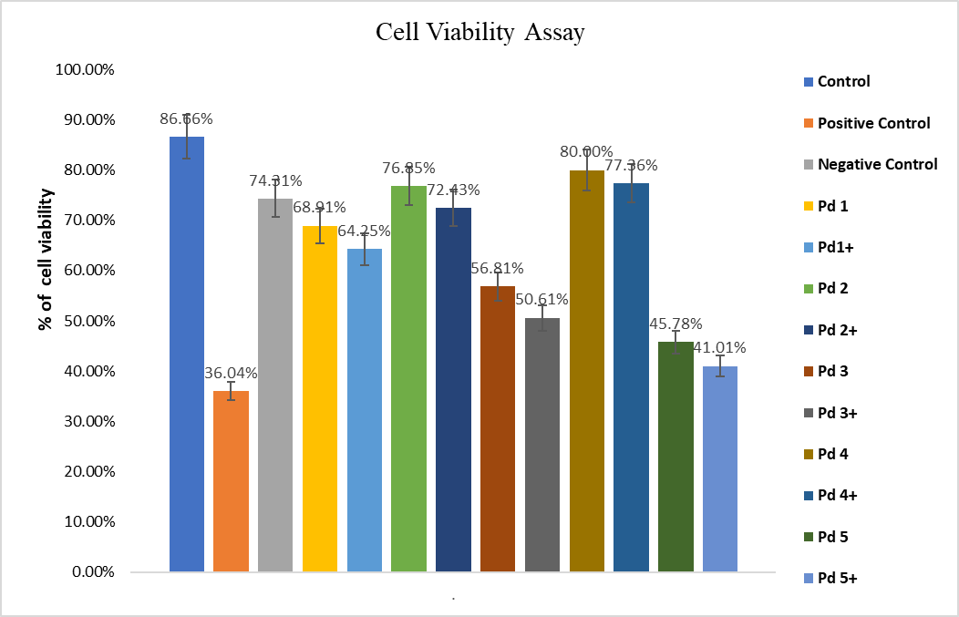

Figure-5: The Bargraph representing the percentage of cell viability against the piperazine derivatives (PD1 to PD5) by Resazurin assay.

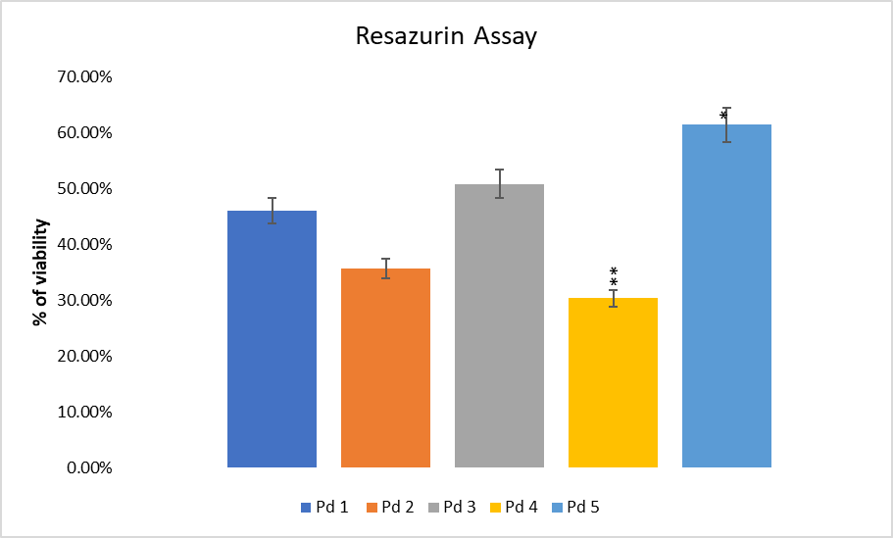
Figure-6. Bar graph of results of Resazurin assay.The percentage of cell viability on treatment of piperazine derivatives (PD1, PD2, PD3, PD4 and PD5) were studied. The data represents the mean ±SEM of three independent experiments; **P < 0.01 and *p˂0.05.

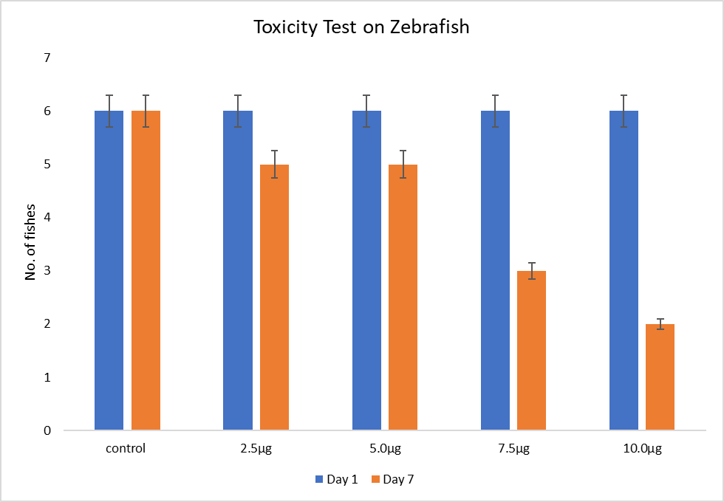
Figure-7: Graph represents the toxicity test on zebrafish at different concentrations for 7 consecutive days. The IC₅₀ value of piperazine derivatives and standard were compared at different concentrations (2.5, 5.0, 7.5, 10.0µg/ml). The data represents the mean ±SEM of three independent experiments; **P < 0.01 and *p˂0.05.


A

LOW 2.5µg/ml HIGH 5.0µg/ml
B
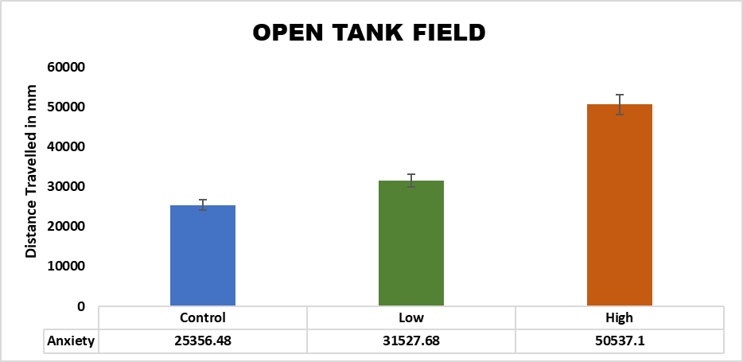

Figure-8.A,B: Zebrafish treated with piperazine derivatives, trajectories in open tank test.The data represents the mean ±SEM of three independent experiments; **P < 0.01 and *p˂0.05.
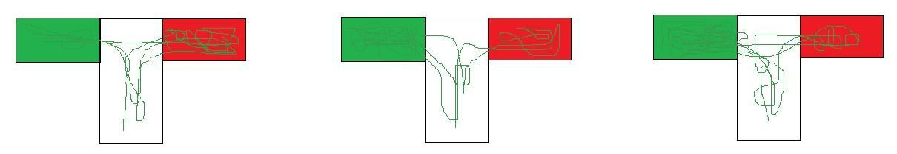
A

LOW 2.5µg
CONTROL
HIGH 5.0µg

B
**
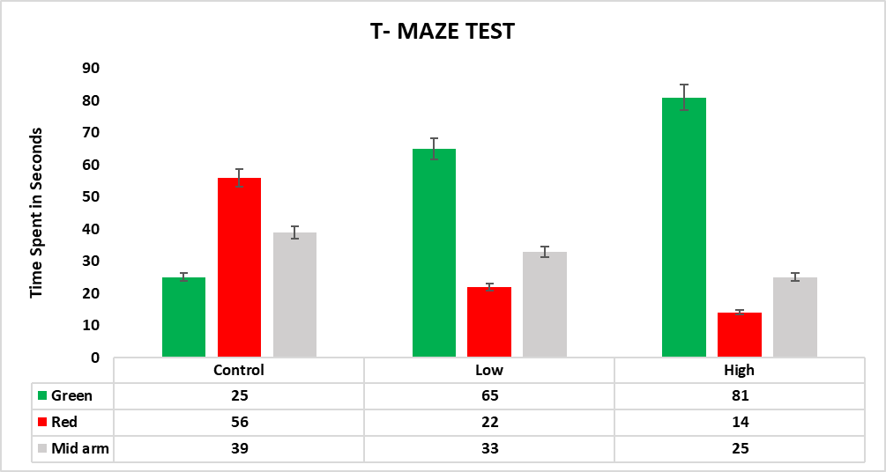
Figure-9 : A. Trajectories of anxiety – induced and treated zebrafish in T - maze.
B. Comparison of time spent in arms of T-maze when Zebrafish were induced with anxiety and treated with synthetic compound. The data represents the mean ±SEM of three independent experiments; **P < 0.01 and *p˂0.05.

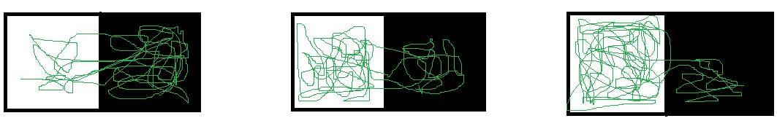
CONTROL
HIGH 5.0µg

A
LOW 2.5µg

B
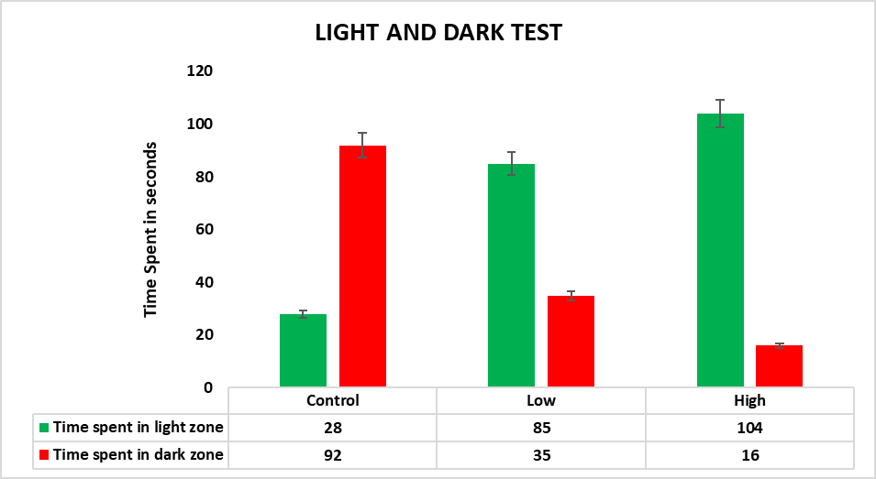

Figure-10: A.B Light and dark test trajectories of anxiety induced zebrafish and treated zebrafish.Comparison of zebrafish time spent in the light zone/ dark zone in anxiety induced group and group treated with synthetic compound (low- 2.5µg, high- 5.0µg). The data represents the mean ±SEM of three independent experiments; **P < 0.01 and *p˂0.05.

