Original Research Article
STANDARDISATION OF 16S rRNA GENE BASED NESTED PCR AS A SENSITIVE TOOL FOR CANINE LEPTOSPIROSIS DIAGNOSIS

.
ABSTRACT

Aim: The present study aimed to standardize a 16S rRNA gene-based nested PCR assay for the sensitive detection of leptospirosis in dogs and to compare its diagnostic performance with PCR targeting lipL32 and microscopic agglutination test (MAT).
Study design: A cross-sectional diagnostic study was conducted on clinically suspected canine cases of leptospirosis.
Place and Duration of Study: The study was carried out at the Department of Veterinary Epidemiology and Preventive Medicine, College of Veterinary and Animal Sciences, Pookode, during November 2024 to August 2025.
Methodology: A total of 53 dogs with clinical signs suggestive of leptospirosis were screened. Serum samples were tested by MAT using 13 serovars of Leptospira interrogans. Whole blood was subjected to conventional PCR targeting the lipL32 gene, and nested PCR targeting the conserved region of the 16S rRNA gene. The sensitivity of different diagnostic tests was compared using kappa statistics.
Results: Of the 53 suspected dogs, 21 (39.6%) were positive by nested PCR, 14 (26.4%) by lipL32 PCR, and 6 (11.3%) by MAT. The predominant serovar detected was Leptospira interrogans Pomona (50%). Nested PCR showed the highest sensitivity (100%), compared to PCR (66.7%) and MAT (28.6%).
Conclusion: The study demonstrates that 16S rRNA gene-based nested PCR is a highly sensitive diagnostic tool for canine leptospirosis, capable of detecting infection even in early stages when antibody response is absent. Integration of molecular techniques with serological assays can provide a more reliable diagnostic strategy and enhance surveillance and control of leptospirosis in endemic regions.
.

Keywords: Leptospirosis, Dogs, Microscopic agglutination test, Nested PCR, 16S rRNA, Kerala.

1. INTRODUCTION

Leptospirosis, a significant re-emerging zoonotic disease affecting a variety of domestic and wild animals as well as humans worldwide. Leptospirosis is caused by spirochete bacteria of the genus Leptospira, which includes 69 recognized species categorized into over 250 serovars across more than 25 serogroups (Antoniolli et al. 2025). The primary mode of leptospirosis transmission is contact with water or soil contaminated by the urine of infected animals. The bacteria enter the body through skin abrasions, cuts, or intact mucous membranes (like the eyes and mouth). It can also be acquired by drinking contaminated water or handling infected animal tissues. Due to diagnostic challenges, leptospirosis is frequently underdiagnosed. Clinical signs in companion animals are highly nonspecific, spanning from subclinical infection to acute multi-organ failure, with the liver and kidneys most severely affected. Infection can be identified through various laboratory techniques, including culture-based methods, serological methods such as microscopic agglutination test (MAT), and molecular techniques like conventional PCR. Because culture and serological methods are more complicated, the requirement for precise, efficient and simple molecular techniques becomes essential. Among molecular techniques, specifically nested PCR that targets the 16S rRNA gene, is recognized as a sensitive test for the quick differentiation of both pathogenic and non-pathogenic Leptospira infection. Considering these points, the current study is primarily aimed at standardizing a nested PCR to enhance the diagnostic sensitivity for leptospirosis.

2. material and methods
The study was conducted at the Department of Veterinary Epidemiology and Preventive Medicine, College of Veterinary and Animal Sciences, Pookode during the period from November 2024 to August 2025. A total of 53 dogs presented to veterinary hospitals under Kerala Veterinary and Animal Sciences University with clinical signs suggestive of leptospirosis viz. pyrexia, anaemia, icterus, vomiting, diarrhoea, loss of appetite, lethargy, depression, dehydration and polyuria/ oliguria/ anuria/ haematuria/ haemoglobinuria formed the materials for study.

2.1 Sample collection
About 3-5 ml of blood was collected aseptically from dogs in sterile heparinized and serum vials for obtaining blood and serum respectively.

2.2 MICROSCOPIC AGGLUTINATION TEST
The serum samples were tested using the MAT. The test employed a panel of 13 serovars of Leptospira interrogans, following the standard method established by Faine (1982). The specific serovars used were: L.interrogans serovar Australis, L.interrogans serovar Autumnalis, L.interrogans serovar Bataviae, L.interrogans serovar Canicola, L.interrogans serovar Grippotyphosa, L.interrogans serovar Hebdomadis, L.interrogans serovar Icterohaemorrhagiae, L.interrogans serovar Javanica, L.interrogans serovar Hardjo, L.interrogans serovar Djasiman, L.interrogans serovar Pomona, L.interrogans serovar Patoc and L.interrogans serovar Pyrogenes.

2.3 PCR TARGETING lipL32 GENE
The DNA was extracted from whole blood using a commercially available Genomic DNA extraction kit (Origin™) following the manufacturer’s instructions and samples were stored at -20°C. The conventional PCR assay was carried with primers targeting lipl32 gene as described by Krishna et al. (2013). Details of the primers used for detection are given in Table1.

Table 1. Details of primers for PCR targeting lipL32 gene
Sl No. | Target gene | Primer sequence 5’-3’ | Product size
1. | lipL32 | F- 5’-CGC GCT GCA GTT ACT TAG TCG CGT CAG AAG-3’  R- 5’-CGC GGT CGA CGC TTT CGG TGG TCT CTG CCA AGC-3’ | 790 bp

2.4 NESTED PCR TARGETING 16S rRNA GENE
Nested PCR was carried out using two pairs of 16S rRNA based primers as described earlier (Natarajaseenivasan et al., 2012). Details of the primers used for amplification are given in Table 2. The nested PCR was standardized using positive DNA isolated from reference cultures.

Table 2. Details of primers used for Nested PCR
Sl no. | Target gene | Primer sequence 5’-3’ | Product size
1 | 16S rRNA | First round primers  F – 5’-GGC GGC GCG TCT TAA ACA TG-3’  R – 5’- GTC CGC CTA CGC ACC CTT TAC G-3’ | 525bp
1 | 16S rRNA | Second round primers  F -5’-CAA GTC AAG CGG AGT AGC AA-3’  R - 5’-TAA CCT GCT GCC TCC CGT A-3’ | 289bp

The initial amplification round was conducted in a 25 μL reaction mixture. This mixture consisted of 12.50 μL of Emerald Amp® GT PCR Master Mix, a pair of primers (1 μL each), 5.50 μL of nuclease-free water, and 5 μL of template DNA. The amplification protocol consisted of an initial denaturation at 95 °C for 5 minutes; this was followed by 30 cycles of denaturation at 95 °C for 1 minute, annealing at 60 °C for 45 seconds, and extension at 72 °C for 1 minute; a final extension was then performed at 72 °C for 7 minutes. For the second round of amplification, 1μL of the product from the first PCR was used as the template. The reaction mixture contained 12.50 μL of Emerald Amp® GT PCR Master Mix, a pair of primers (1 μL each), and 9.50 μL of nuclease-free water. The same thermal conditions and program were used as in the first round, with the exception that the annealing temperature was adjusted to 62 °C for 45 seconds.
The PCR products were identified using a submerged agarose gel electrophoresis system. A one percent agarose gel stained with ethidium bromide was used, with Tris Borate EDTA (TBE) buffer serving as the matrix, and the gel was run at 90V. The gel was then visualized, and the results were documented using a Gel Doc system (Bio-Rad, USA).

3. results and discussion

Out of 53 suspected dogs, 21 showed positive for leptospirosis in any one of the tests. Most of the positive dogs were within the age of one to four years (52.4%). Eight cases (38.10%) belong to the five to nine years of age. One case each (4.8%) belongs to less than one year and above ten years of age. Out of 21 positive animals, fourteen (66.67%) were males and seven (75%) were females. Most of the positive dogs in the present study were labrador retriever (23.8%), followed by non-descriptive (19.0%), dachshund (14.3%), german shepherd and spitz (9.5% each), rottweiler, golden retriever, doberman, lhasa apso and cane corso (4.8% each). The dog cases were presented mostly in june and april: seven cases each (33.34%), followed by five cases (23.80%) in march, and two cases (9.52%) during may. Most predominant clinical sign manifested by dogs positive for leptospirosis was anorexia (100%), followed by lymphadenopathy (66.67%), pyrexia (57.14%), vomiting (43%), dark yellow urine (38.09%), jaundice (33.33%), weakness (23.81%), melena (19.04%), haematuria (14.3%), splenomegaly (9.5%) anuria, halitosis and hepatomegaly (4.7% each).
3.1 MICROSCOPIC AGGLUTINATION TEST

Of the 53 suspected samples examined, six (11.32%) yielded positive results for antibodies against different serovars of Leptospira. Serum samples with a titer of 1:200 and above were considered positive (Fig.1,2,3). The predominant serovar showing agglutination was Leptospira interrogans serovar Pomona (3 cases, 50%), followed by Leptospira interrogans serovar Icterohaemorrhagiae (2 cases, 33.34%) and Leptospira interrogans serovar pyrogens (1 case, 16.67%). A similar observation was made by soman et al. (2014) indicating the predominance of Leptospira interrogans serovar Pomona as most prevalent serovar (38.63 %) followed by serovar Australis (36.36 %) in central and north Kerala.

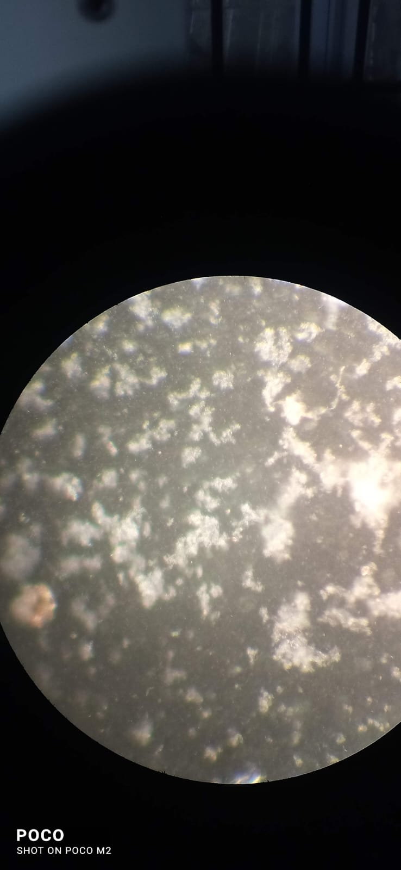 | 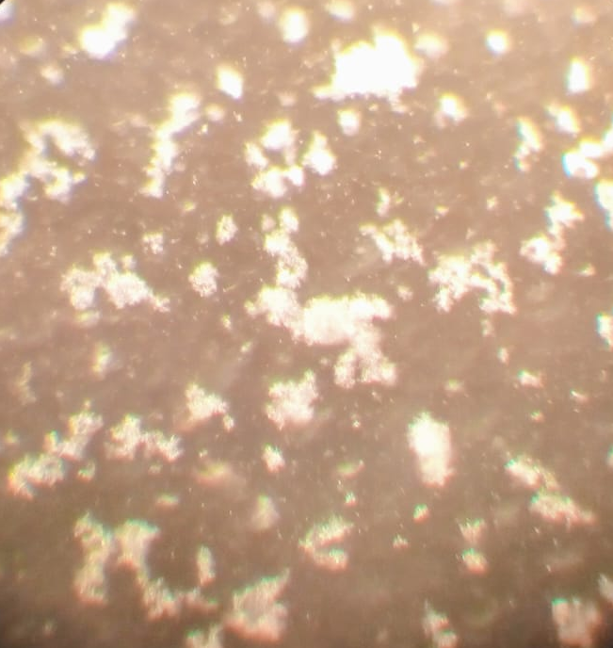 | 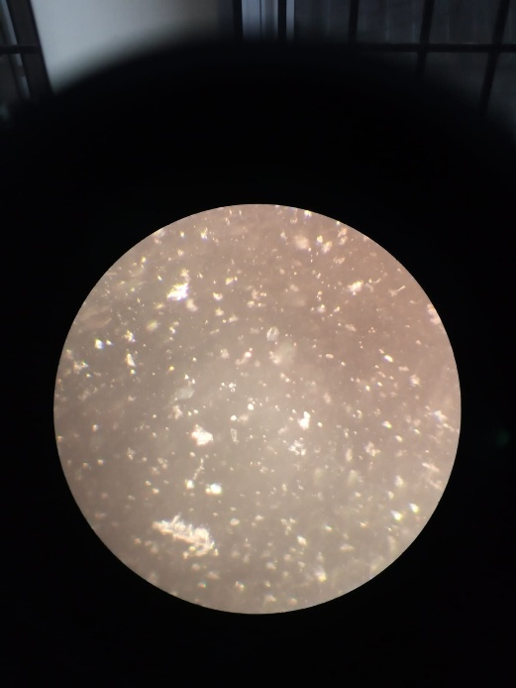

Fig.1.MAT titre of 1/200 in 20X magnification

Fig.2.MAT titre of 1/400 in 20X magnification
Fig.3.MAT titre of 1/600 in 20X magnification

3.2 PCR TARGETING lipL32 GENE

Fifty-three blood samples collected from suspected leptospirosis cases were tested using polymerase chain reaction (PCR) targeting the lipL32 gene. Out of these 14 cases (26.41%) showed positive results producing a 790 bp amplicon specific to pathogenic leptospires (Fig.4). This is in agreement with the observations of Joseph et al. (2018), who reported a 27.29 per cent prevalence in Southern India. Di Azevedo et al. (2021) documented a 45 per cent prevalence in canine clinical samples using conventional PCR targeting lipL32.

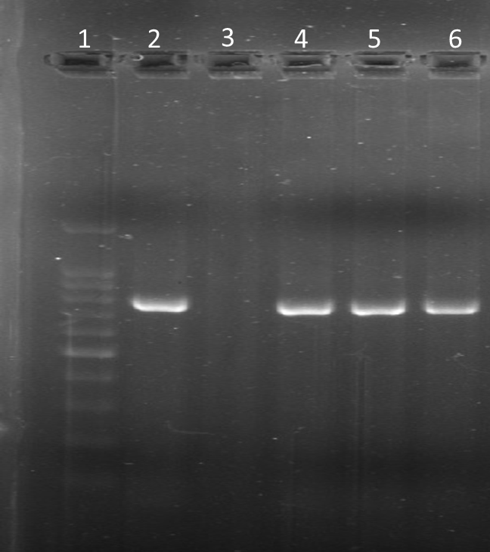
790bp

Fig.4. PCR results of clinical samples-Lane 1: Ladder, Lane 2: Positive control, Lane 3: Negative control, Lane 4,5,6: Clinical samples showing positive result (Amplicon size-790bp)

3.3 NESTED PCR TARGETING 16S rRNA GENE

A nested PCR assay targeting the conserved region of the 16S rRNA gene of pathogenic Leptospira spp. was successfully standardized (Fig.5). Optimization was performed using DNA extracted from the reference culture of Leptospira interrogans serovar Pomona, maintained in our laboratory. Primary amplification consistently yielded the expected 525 bp fragment in positive control reactions, although amplification from several field samples appeared faint. Subsequent nested amplification with internal primers generated distinct 289 bp products in all positive controls, while a subset of test samples also produced sharp 289 bp bands, confirming the presence of leptospiral DNA.
A total of 53 dogs clinically suspected of leptospirosis were screened using nested PCR targeting the 16S rRNA gene. Among them, 21 dogs (39.6%) tested positive, with a characteristic amplicon size of 289 base pairs (Fig.6). Similar findings were reported by Miotto et al. (2018), who found a 42.4 per cent positivity rate in suspected dogs.

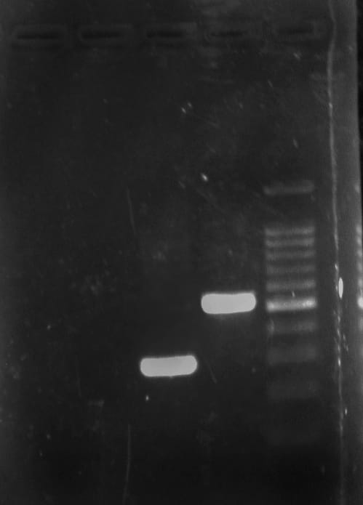  289bp  525bp | 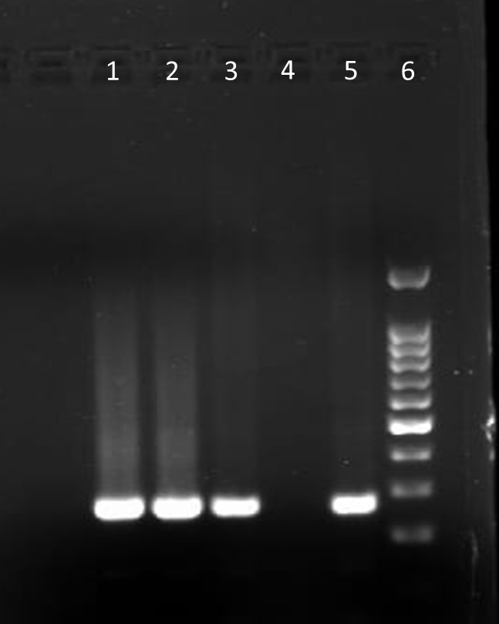  289bp

Fig.5. Validation of primers for 16S rRNA showing amplicons with 525bp in step 1 PCR and 289bp in nested PCR

Fig.6. Nested PCR results of clinical samples- Lane1,2,3: Clinical samples showing positive result (Amplicon size-289bp), Lane 4: Negative control, Lane 5: Positive control, Lane 6: Ladder

3.4 COMPARISON OF DIAGNOSTIC TESTS

Comparison between different diagnostic tests were done using kappa statistics. Nested PCR showed the highest sensitivity, achieving 100 per cent compared to 66.7 per cent for PCR targeting lipl32 and 28.6 per cent of MAT(Table 3) This indicates the superior ability of nested PCR to detect leptospirosis, especially in the early stages of infection. Combining molecular methods like nested PCR with MAT may provide the most robust diagnostic strategy for leptospirosis.

Table 3: Details of diagnostic test results
Tests | Positive | Negative | Sensitivity (%)
MAT | 6 | 52 | 28.6
PCR | 14 | 38 | 66.7
Nested PCR | 21 | 31 | 100

4. Conclusion

The present study successfully standardized a 16S rRNA gene-based nested PCR assay for the diagnosis of leptospirosis in dogs. Among the diagnostic tests employed, nested PCR demonstrated the highest sensitivity (100%), outperforming both lipL32 PCR (66.7%) and MAT (28.6%). This highlights its superior ability to detect leptospiral DNA, particularly in early stages of infection when serological responses may be absent. The predominance of Leptospira interrogans serovar Pomona was evident among MAT-positive cases, reaffirming earlier reports of its prevalence in Kerala. These findings emphasize the need for molecular assays, particularly nested PCR, as a routine diagnostic tool to improve early detection and management of leptospirosis in dogs. Integrating molecular methods with serological assays may provide the most reliable diagnostic strategy, thereby supporting better surveillance and control of this important zoonosis.

References

Antoniolli, A., Guis, H., Picardeau, M., Goarant, C. and Flamand, C. (2025). One Health field approach applied to Leptospirosis: a Systematic review and meta-analysis across humans, animals and the environment. In Open Forum Infectious Diseases,12(1), 757. https://doi.org/10.1093/ofid/ofae757.

Faine, S. (1982). Guidelines for the Control of Leptospirosis (p. 171pp).

Krishna, V., Joseph, S., Ambily, R., Mini, M., Anto, L., And Mohan, S. G. (2013). Cloning And Sequencing of The Virulent Gene Lipl32 of Leptospira Interrogans Serovar Autumnalis. Vet World, 6(4), 193-195.Https://Doi.Org/10.5455/ Vetworld.2013.193-195

Natarajaseenivasan, K., Raja, V., And Narayanan, R. (2012). Rapid Diagnosis of Leptospirosis in Patients with Different Clinical Manifestations By 16s Rrna Gene Based Nested Pcr. Saudi Journal of Biological Sciences, 19(2), 151-155. https://doi.org/10.1016/j.sjbs.2011.11.005

Soman, M., Jayaprakasan, V., And Mini, M. (2014). Epidemiological Study on Human and Canine Leptospirosis in Central and North Kerala. Veterinary World, 7(10). Https://Doi.Org/10.14202/Vetworld.2014.759-764

Joseph, S., Mini, M., Sriram, V. K., Ambily, R., Aravindakshan, T., And Ajithkumar, S. (2018). Evaluation Of Real-Time Pcr, Mat, And Recombinant Lipl32-Based Elisa for The Diagnosis of Canine Leptospirosis in A Disease-Endemic South Indian State, Kerala. Turkish Journal of Veterinary fnd Animal Sciences, 42(3), 191-197. Https://Doi.Org/10.3906/Vet-1711-29
Di Azevedo, M. I. N., And Lilenbaum, W. (2021). An Overview on The Molecular Diagnosis of Animal Leptospirosis. Letters In Applied Microbiology, 72(5), 496-508. Https://Doi.Org/10.1111/Lam.13442

Miotto, B. A., Tozzi, B. F., Penteado, M. D. S., Guilloux, A. G. A., Moreno, L. Z., Heinemann, M. B., Et Al (2018). Diagnosis Of Acute Canine Leptospirosis Using Multiple Laboratory Tests and Characterization of the Isolated Strains. Bmc Veterinary Research, 14(1), 222. Https://Doi.Org/10.1186/S12917-018-1547-4

