Comparative Evaluation of MAT, PCR, and LAMP Assays for the Diagnosis of Canine Leptospirosis

ABSTRACT
Leptospirosis is a globally significant zoonosis in dogs, yet its clinical diagnosis remains challenging due to the heterogeneous performance of available assays. This study evaluated the diagnostic accuracy of the microscopic agglutination test (MAT), polymerase chain reaction (PCR), and loop-mediated isothermal amplification (LAMP) in 52 dogs presenting with clinical signs suggestive of leptospirosis at the Teaching Veterinary Clinical Complex, Pookode. Among the cohort, 26 (50.0%) were confirmed positive by at least one diagnostic assay. Of these, 6 (23.1%) were detected by MAT, 14 (53.9%) by PCR, and 23 (88.5%) by LAMP. MAT demonstrated 100% specificity but low sensitivity (23.1%), identifying Pomona, Icterohaemorrhagiae, and Pyrogenes as predominant serovars. PCR targeting the lipL32 gene achieved moderate sensitivity (53.9%), reflecting its value during the leptospiraemic phase but diminished reliability in later infection. LAMP displayed superior diagnostic performance, with 88.5% sensitivity, substantial agreement with PCR (κ = 0.63), and the highest accuracy on ROC analysis (AUC = 0.94) compared with PCR (AUC = 0.77) and MAT (AUC = 0.62). These findings underscore the limitations of MAT in acute diagnosis, while highlighting LAMP as a rapid, robust, and highly sensitive alternative suitable for clinical and field application. Integration of molecular assays, particularly LAMP, with serology offers a comprehensive diagnostic strategy across different stages of canine leptospirosis, with implications for both veterinary care and zoonotic surveillance.
INTRODUCTION
Leptospirosis is a worldwide zoonosis caused by infection with pathogenic spirochetes that belong to the genus Leptospira. Leptospira spp. colonize the proximal renal tubules of various mammals and are excreted in the urine of carrier animals. Transmission of leptospirosis in humans and animals occurs by exposure to water or soil contaminated by the urine of infected animals or by direct contact with infected animals, as reported by Faine et al., (1999). Leptospirosis was first described as an acute infectious syndrome with spleen tumour, jaundice, and nephritis (Weil, 1886).
The genus Leptospira belongs to the family Leptospiraceae, order Spirochaetales (Adler and De la Peña Moctezuma., 2010). As reported by Barthi et al., (2003), this genus is composed of a varied group of organisms which can live in diverse environments, habitats and life cycles. Within the genus, highly pathogenic host-specific strains can be found, as well as harmless free-living waterborne strains. The genus is divided in about 20 species based on DNA hybridization studies. While based on serological classification, the members belonging to the genus Leptospira are grouped into 24 antigenically related serogroups and classified into more than 250 serovars (Llanes et al., 2016).
Direct detection approaches for Leptospira, like dark-field microscopy and histochemical staining, are seldom recommended for routine clinical diagnosis in animals due to their inherently poor sensitivity and low specificity. Microscopy reliably identifies only samples with organism loads exceeding 104104 cells/mL, and operator experience introduces further variability; culture, while definitive, may require months for organism recovery owing to slow growth rates and fastidious culture requirements, rendering it impractical for timely veterinary intervention (Ciurariu et al., 2025).
Serological tests such as the microscopic agglutination test (MAT) and ELISA remain the most broadly utilized laboratory methods in dogs, yet their accuracy is compromised by confounding factors including previous vaccination and repeated environmental exposure to Leptospira. These factors inflate background antibody titers, which complicates result interpretation. Additionally, MAT is labor-intensive, relies on the continuous maintenance of live Leptospira panel cultures, and is recommended only for use in specialized laboratories, limiting accessibility and reproducibility in general diagnostic settings (Warnasekara et al., 2022).
Molecular diagnostic techniques, especially conventional and quantitative PCR targeting lipL32, lipL21, and lipL41 genes, offer substantially higher specificity and sensitivity for Leptospira detection in blood and urine. Nonetheless, these assays require sophisticated laboratory infrastructure and trained personnel, leading to limited adoption in resource-constrained regions. Furthermore, the optimal window for PCR-based diagnosis is narrow, as leptospiremia may rapidly wane after the acute phase due to immune clearance, resulting in reduced DNA detectability in specimens collected during later stages of illness (Wang et al., 2025).
In this context, loop-mediated isothermal amplification (LAMP) has emerged as a promising alternative nucleic acid amplification method. LAMP can be performed in a simple water bath at a constant temperature, producing results within approximately 60 minutes without the need for thermal cycling. The amplification can be visualised directly by eye, making it highly amenable to resource-limited and field settings (Williams, 2024).
MATERIALS AND METHODS
Patient selection criteria and sample collection
The study was conducted in the Department of Veterinary Epidemiology and Preventive Medicine from November 2024 to August 2025. Clinical samples were collected from animals exhibiting signs of leptospirosis among dogs reported at the Teaching Veterinary Clinical Complex, College of Veterinary and Animal Sciences, Pookode. Clinical samples, such as blood samples for isolation of leptospiral DNA for further downstream detection techniques and serum samples for microscopic agglutination test, were collected from animals exhibiting clinical manifestations suggestive of leptospirosis, including pyrexia, anorexia, vomiting, lethargy, jaundice, oliguria/anuria/haematuria/haemoglobinuria.
Microscopic agglutination test
A microscopic agglutination test was carried out using live Leptospira serovars, as described by Faine (1982). The Leptospira interrogans serovars used in the study were maintained by regular sub-culturing in the liquid Ellinghuasen McCullough Johnson and Harris (EMJH) culture medium at 28-30°C at a 5-day interval. The contaminated cultures were filtered through 0.4 µm membrane filters. The live leptospiral organisms in maintained culture were identified by their typical morphology and motility using a dark-field microscope. Thirteen serovars for Leptospira interrogans were maintained at the Department of Veterinary Epidemiology and Preventive Medicine, College of Veterinary and Animal Sciences, Pookode, during the tenure as reference strains. The serovars used in the study were maintained by regular subculturing in liquid leptospiral culture medium at 28-30°C with a 5-day interval. The reference strains were Leptospira interrogans serovar Icterohaemorrhagiae, Leptospira interrogans serovar Canicola, Leptospira interrogans serovar Grippotyphosa, Leptospira interrogans serovar Pomona, Leptospira interrogans serovar Pyrogenes, Leptospira interrogans serovar Patoc, Leptospira interrogans serovar Australis, Leptospira interrogans serovar Autumnalis, Leptospira interrogans serovar Hardjo, Leptospira interrogans serovar Hebdomadis, Leptospira interrogans serovar Bataviae, Leptospira interrogans serovar Javanica and Leptospira interrogans serovar Djasiman.
In the first step, 1:100 serum dilutions were prepared in PBS; 50 μL of each was taken and mixed with 50 μL of each of the four-to-old live leptospiral serovars separately. Antigen controls were set up with 50 μL of PBS and 50 μL of different live leptospiral serovars, and the plates were incubated at 37°C for 2 hours. After incubation, the results were read by examining a drop of the serum-antigen mixture from each well under a 10x objective of the DFM for the agglutination of leptospires. Samples positive at a 1:100 dilution were again serially diluted up to 1:1200. The dilution at which 50 per cent or more leptospiral organisms were seen agglutinated was taken as positive. In cases where samples showed agglutination against more than one serovar, the reaction at the highest titre was presumed to be the infecting serovar. Sera samples showing the same agglutination titre to more than one serovar were considered as mixed equals.
Plate 1 : The results for MAT are depicted in. a. shows 1:200 dilution. b. shows 1:400 dilution. c. shows 1:600 dilution
a.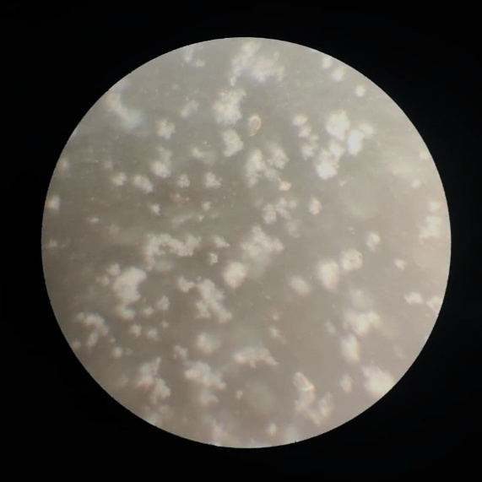 b.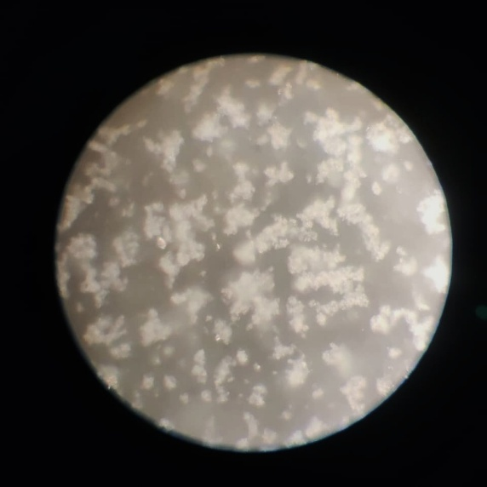
c.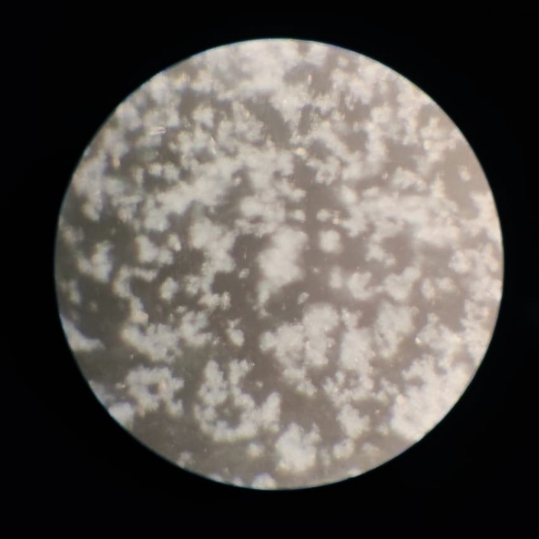
Polymerase Chain Reaction
The DNA was isolated from whole blood using a commercially available Genomic DNA extraction kit (Origin™), according to the procedure described by the manufacturer. Detection of pathogenic Leptospira spp. DNA was amplified using PCR for the detection of LipL32 gene, specific to pathogenic leptospira. The details of primers used are depicted in table 1. The lyophilized primers were reconstituted in the required volume of nuclease-free water to make a stock solution with a concentration of 100 pmol/µL and stored at -20ºC. A working solution with a concentration of 10 pmol/µL was prepared. Components of PCR mixture were 5.00 µL of Template DNA, 12.50 µL Emerald Amp GT PCR Master Mix (Takara), 1.00 µL of forward and reverse primers each were added, and the final volume was adjusted to 25 µL using nuclease free water. A T100 thermal cycler (Biorad, USA), was used for the thermal cycling of polymerase chain reaction. The optimized PCR protocol is depicted in table 2.
Plate 2 : The results for PCR are depicted in. Lane 1 depicts 100 bp ladder. Lane 2 and 3 depict positive and negative control. Lane 4,5 and 6 depict positive samples
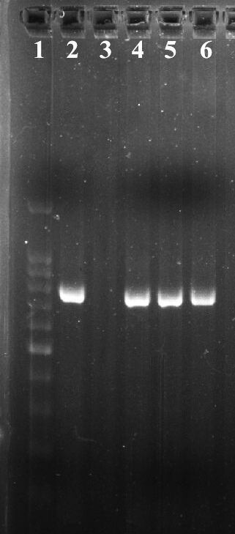
Table 1. PCR primers used for the detection of Leptospira spp.
Serial no: | Target gene | Primer sequence 5’-3’ | Product size | Reference
1. | lipL 32 | Forward- 5’-CGC GCT GCA GTT ACT TAG TCG CGT CAG AAG-3’  Reverse – 5’-CGC GGT CGA CGC TTT CGG TGG TCT CTG CCA AGC-3’ | 790 bp | Krishna et al. (2013)

Table 2. Optimised conditions for PCR for L. interrogans
Sr. No. | Reagents | Quantity
1. | Template DNA | 5.00 µL
2. | Emerald Amp GT PCR Master Mix | 12.50 µL
3. | Forward primer | 1.00 µL
4. | Reverse primer | 1.00 µL
5. | Nuclease-free water | 5.50 µL
Total |  | 25.00 µL

The PCR amplicons were visualised by gel electrophoresis. Gel loading dye (6X) (Thermo-scientific Cat. No. R0611) was used for gel electrophoresis. The results were visualized using electrophoresis system and gel documentation system (Biorad, USA).
Loop-mediated isothermal amplification
Details of the primers for the Loop-Mediated Isothermal Amplification (LAMP) Assay, purchased from Vision Scientific Solutions, Angamali, Kerala, are presented in Table 3. A set of two inner (FIP, BIP), two outer primers (F3, B3), and two loop (LF, LB) primers targeting the conserved sequence of the lipl32 gene of Leptospira spp. as reported by Suwanchareon et al. (2016). The lyophilized primers were reconstituted in the required volume of nuclease-free water to make a stock solution with a concentration of 100 μmol/μL and stored at -20ᵒC. A working solution at a concentration of 40 µM for the inner primer, 10 µM for the outer primer, and 10 µM for the loop primer was prepared using sterile, nuclease-free water.
Plate 3 : The results for LAMP assay are depicted Lane 1-5 depicts positive results. Lane 6 and 7 depict positive and negative controls.
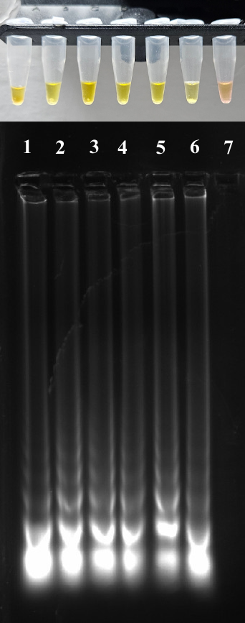
Table 3. LAMP primers used for the detection of Leptospira spp.
Primers | Primer sequence 5’ – 3’
Forward Inner Primer (FIP) | 5’CGCTTACTAAGTCTCCGTCGCGTAATCGCTGAA ATGGGAGT-3’
Backward Inner Primer (BIP) | 5’GCGGCTACCCCAGAAGAAAAGCATAATCGCCG ACATTCT-3’
Forward Outer primer (F3) | 5’-TCTATGTTTGGATTCCTGCC-3’
Backward Outer Primer (B3) | 5’-TGCCACATTGGTTTGATACTTG-3’
Forward loop primer (LF) | 5’-CTCACCGATTTCGCCTGT-3’
Reverse loop primer (LB) | 5’- TGCCACATTGGTTTGATACTTG-3’

For LAMP assay 5.00 µL of Template DNA, 8.50 µL Bst Mix (OriginTM, cat. No. OBD01), 1.00 µL of each primer were added, and the final volume was adjusted to 25 µL using nuclease free water Reagents 1 to 5 (as detailed in Table 5) were combined and incubated at 95 °C for five minutes to achieve denaturation. Following this, Bst Mix was introduced to the reaction mixture, and incubation was performed at 60°C for 60 minutes. The reaction was subsequently inactivated by cooling to room temperature. All incubation steps were conducted using a programmable heat block (Equitron Medica Private Limited, Mumbai, India). The results of the reaction were visualised based on a colour change in the reaction mix from deep pink to salmon pink and yellow. Further confirmation of amplification was achieved through visualisation of DNA by agarose gel electrophoresis, as described above.
Statistical analysis
Statistical analysis was performed to evaluate and compare the diagnostic performance of MAT, PCR, and LAMP assays. Inter-test agreement was assessed using Cohen’s Kappa statistics, with values interpreted according to standard benchmarks. Additionally, Receiver Operating Characteristic (ROC) curve analysis was carried out to determine the overall diagnostic accuracy of each assay, expressed as the area under the curve (AUC).
RESULT AND DISCUSSION
A total of 52 dogs presenting to the Teaching Veterinary Clinical Complex, Pookode, with clinical signs suggestive of leptospirosis were enrolled in the study. Among these, 6 (11.5%) tested positive by MAT, 14 (26.9%) by PCR, and 23 (44.2%) by LAMP. Overall, 26 dogs (50.0%) were confirmed positive for leptospirosis by at least one of the diagnostic assays.
Microscopic agglutination test
Among the 26 confirmed leptospirosis cases, six (23.1%) tested positive by the microscopic agglutination test (MAT). Canine serum samples suspected of leptospirosis were screened against 13 Leptospira serovars, with titres of ≥1:200 considered positive. The sensitivity of MAT was 23.07 per cent, whereas the specificity was 100 per cent.
Antibodies were detected in six samples, with Pomona identified as the predominant serovar (2/6; 33.3%), followed by Icterohaemorrhagiae (1/6; 16.7%) and Pyrogenes (1/6; 16.7%).
Two samples exhibited agglutination with more than one serovar. In such cases, the serovar showing agglutination at the highest dilution was considered the infecting serovar. Mixed infections were detected in two samples: Canicola with Pomona (1/6; 16.7%) and Icterohaemorrhagiae with Pyrogenes (1/6; 16.7%).
The microscopic agglutination test (MAT) identified only 23.1 per cent of confirmed cases in this study, despite demonstrating 100 per cent specificity. This result highlights a recognised limitation of MAT: its poor sensitivity in acute infections, when detectable antibody levels have not yet developed (Levett, 2001; Samrot et al., 2021). Although MAT remains the reference standard for serological confirmation, its primary value lies in epidemiological surveillance and serovar distribution studies rather than in acute clinical diagnosis. In the present investigation, the predominant serovars detected were Pomona (33.3%), Icterohaemorrhagiae (16.7%), and Pyrogenes (16.7%), consistent with reports from canine leptospirosis in India and globally (Ambily et al., 2013; Raj et al., 2021). These findings reaffirm the epidemiological importance of these serovars and support their inclusion in surveillance and vaccine strategies.
Polymerase Chain Reaction
Blood samples from suspected leptospirosis cases were analysed by polymerase chain reaction (PCR) targeting the lipL32 gene. Fourteen of the 26 confirmed cases (53.9%) yielded a 790 bp amplicon specific to pathogenic Leptospira.
The assay targeted the lipL32 gene, a well-established pathogenic marker of Leptospira spp. (Sykes et al., 2011). Despite its recognised diagnostic value, the sensitivity of PCR is influenced by several factors, including bacterial load, the stage of infection at the time of sampling, and the presence of inhibitors in clinical specimens. These limitations may account for the moderate performance observed. Our findings corroborate earlier reports indicating that PCR is particularly valuable during the early leptospiraemic phase, when circulating organisms are detectable, but its diagnostic reliability diminishes in later stages due to bacterial clearance (Levett, 2001; Sykes et al., 2011).

Loop-mediated isothermal amplification
Twenty-three of the 26 confirmed samples (88.5%) tested positive by the LAMP assay. Positive reactions were characterised by a distinct colour change from deep pink to salmon pink or yellow, and the amplification products displayed the typical ladder-like pattern on agarose gel electrophoresis.
The loop-mediated isothermal amplification (LAMP) assay demonstrated superior diagnostic performance compared with both MAT and PCR. The rapid amplification process, straightforward visualisation of results, and methodological robustness highlight its potential as a practical tool for field-level diagnosis of leptospirosis. Comparable findings have been reported by Chen et al. (2015) and Suwanchareon et al. (2016), who similarly observed enhanced sensitivity of LAMP relative to conventional diagnostic assays, thereby reaffirming its diagnostic value.
Cohen’s kappa statistics
A summary of the performance of various diagnostic tests is depicted in table 4. On comparison of PCR with MAT kappa statistics revealed a score of 0.52, indicative of moderate agreement between the tests, while the comparison of LAMP with MAT revealed a score of 0.28, indicative of fair agreement between the tests. The comparison of LAMP with PCR revealed a score of 0.63, indicative of substantial agreement between the tests.
PCR and MAT exhibited moderate agreement (κ = 0.52), while LAMP and MAT showed only fair agreement (κ = 0.28), underscoring the limitations of MAT in acute infections. In contrast, the substantial agreement observed between LAMP and PCR (κ = 0.63) highlights the consistency of molecular methods and confirms that LAMP can reliably complement PCR.
Table 4. Performance of MAT, PCR, and LAMP in the diagnosis of Leptospirosis
MAT (+)  PCR (+)  LAMP (+) | MAT (+)  PCR (-)  LAMP (-) | MAT (-)  PCR (+)  LAMP (+) | MAT (-)  PCR (-)  LAMP (+) | MAT (-)  PCR (-)  LAMP (-) | TOTAL
3 | 3 | 11 | 9 | 26 | 52

ROC analysis
ROC analysis showed the highest accuracy for LAMP (AUC = 0.94), followed by PCR (AUC = 0.77), while MAT had lower accuracy (AUC = 0.62). The results are depicted in Figure 1.
Receiver operating characteristic (ROC) analysis reinforced the observations of kappa statistics. LAMP achieved the highest diagnostic accuracy (AUC = 0.94), followed by PCR (AUC = 0.77), whereas MAT exhibited lower accuracy (AUC = 0.62). Collectively, these findings demonstrate that molecular assays, particularly LAMP, provide superior diagnostic performance over serology and are more dependable for early detection of leptospirosis in dogs.

Figure 1. ROC curve for different diagnostic tests for leptospirosis
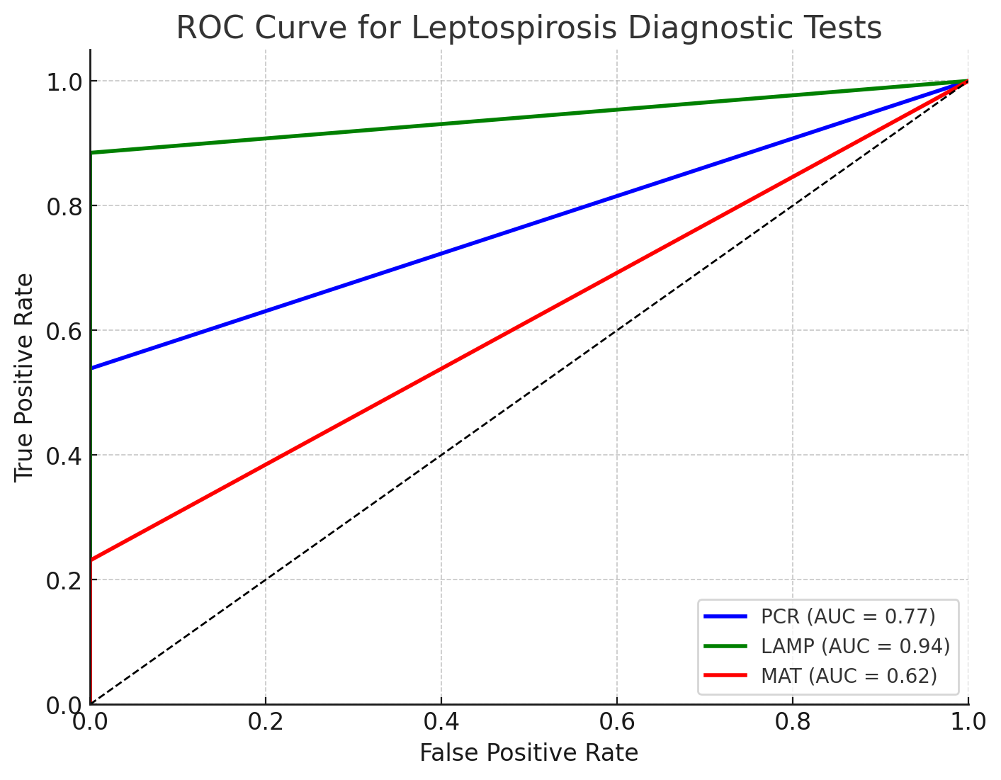

Interpretation of Diagnostic Discordance
The observed discordance underscores the strengths and limitations of each assay type. Molecular assays (PCR and LAMP) target leptospiral DNA, identifying infection at early or acute stages, whereas MAT detects antibodies produced in later stages of infection. LAMP had higher sensitivity than PCR, likely due to its amplification efficiency and tolerance to inhibitors, agreeing with previous reports that favor LAMP for field diagnostics. The presence of MAT-positive but molecular-negative cases reflects the natural decline of leptospiral DNA as immune clearance progresses, with antibodies persisting longer.
Implications for Clinical Diagnostics
The findings advocate combined use of molecular and serological tests to improve case detection throughout the infection timeline. While LAMP offers rapid molecular screening with superior sensitivity, MAT remains essential for sero-epidemiological context and confirmation of exposure especially in convalescent phases. Efforts should focus on integrating test platforms in diagnostic algorithms tailored to clinical presentation and infection stage.
CONCLUSION
This study demonstrates that among dogs suspected of leptospirosis, LAMP assay provides higher detection rates compared to PCR and MAT, but concordant results across all modalities remain limited. The diagnostic discordance highlights distinct infection phases and assay capabilities. Combined molecular and serological testing enhances diagnostic accuracy, guiding timely and appropriate management in veterinary settings.
REFERENCES
Adler B, A De la Peña Moctezuma. 2010. Leptospira and leptospirosis. Vet Microbiol 140, 287-296.
Bharti A, J Nally, J Ricaldi, M Mathias, M Lovett, P Levett, R Gilman, M Willing, E Gotuzzo, J Vinetz. 2003. Leptospirosis: a zoonotic disease of global importance. Lancet Infect Dis 3, 757-772.
Ciurariu, E., Prodan-Barbulescu, C., Mateescu, D. M., Tutac, P., Sorop, V. B., Susan, M., & Varga, N. I. (2025). Diagnostic Advances in Leptospirosis: A Comparative Analysis of Paraclinical Tests with a Focus on PCR. Microorganisms, 13(3), 667. https://doi.org/10.3390/microorganisms13030667
Faine, S., Adler, B., Bolin, C. and Perolat, P. 1999. Leptospira and Leptospirosis, 2nd ed., MediSci, Melbourne.
Llanes, A, Carlos M. R. and Sreekumari R. 2016. "Whole genome sequencing allows better understanding of the evolutionary history of Leptospira interrogans serovar Hardjo." PloS one 11: 0159387.
Warnasekara, J., Srimantha, S., Kappagoda, C., Jayasundara, D., Senevirathna, I., Matthias, M., Agampodi, S., & Vinetz, J. M. (2022). Diagnostic method-based underestimation of leptospirosis in clinical and research settings; an experience from a large prospective study in a high endemic setting. PLoS neglected tropical diseases, 16(4), e0010331. https://doi.org/10.1371/journal.pntd.0010331
Wang, W., Gao, Y., Ji, J., Huang, Z., Xiong, B., & Xiang, S. (2025). Trends and advances in Leptospira, a bibliometric analysis. Frontiers in microbiology, 15, 1514738. https://doi.org/10.3389/fmicb.2024.1514738
Williams C (2025). A Novel Loop-Mediated Isothermal Amplification (LAMP) Assay for the Detection of Leptospira in Febrile Patients. J Infect Dis Diagn. 10:332.
Weil, A. (1886). Ueber eine eigentümliche, mit Milztumor, Icterus und Nephritis einhergehende acute Infektionskrankheit. Deutsches Archiv für klinische Medizin, 39, 209–232.
Suwancharoen, D., Sittiwicheanwong, B., and Wiratsudakul, A. (2016). Evaluation of loop-mediated isothermal amplification method (LAMP) for pathogenic Leptospira spp. detection with leptospires isolation and real-time PCR. The Journal of veterinary medical science, 78(8), 1299–1302. https://doi.org/10.1292/jvms.15-0702
Levett P. N. (2001). Leptospirosis. Clinical microbiology reviews, 14(2), 296–326. https://doi.org/10.1128/CMR.14.2.296-326.2001
Samrot, A. V., Sean, T. C., Bhavya, K. S., Sahithya, C. S., Chan-Drasekaran, S., Palanisamy, R., Robinson, E. R., Subbiah, S. K., and Mok, P. L. (2021). Leptospiral Infection, Pathogenesis and Its Diagnosis-A Review. Pathogens (Basel, Switzerland), 10(2), 145. https://doi.org/10.3390/pathogens10020145
Ambily, R., Mini, M., Joseph, S., Abhinay, G., and Saseendranath, M. R. (2013). Seroprevalence of leptospirosis among dogs in Kerala. Journal of Veterinary and Animal Sciences, 44(1), 47–49.
Raj, J., Campbell, R., and Tappin, S. (2021). Clinical findings in dogs diagnosed with leptospirosis in England. The Veterinary record, 189(7), e452. https://doi.org/10.1002/vetr.452
Sykes, J. E., Hartmann, K., Lunn, K. F., Moore, G. E., Stoddard, R. A., and Goldstein, R. E. (2011). 2010 ACVIM small animal consensus statement on leptospirosis: diagnosis, epidemiology, treatment, and prevention. Journal of veterinary internal medicine, 25(1), 1–13. https://doi.org/10.1111/j.1939-1676.2010.0654.x
Chen, H.-W., Weissenberger, G., and Ching, W.-M. (2015). Development of lyophilized loop-mediated isothermal amplification reagents for the detection of Leptospira. Military Medicine, 181(5 Suppl), 227–231. https://doi.org/10.7205/MILMED-D-15-00149

