Genetic variability and divergence studies on seed traits and L-dopa content of Mucuna pruriens (L.) DC. accessions

ABSTRACT:
Mucuna pruriens (L.) DC. belongs to the Fabaceae family and is widely distributed across tropical and subtropical regions of the world. Seeds of Mucuna are an industrially important source of natural L-dopa. The present study was intended to screen out the superior Mucuna germplasm that can be utilized for commercial cultivation. A total of 59 accessions of M. pruriens (L.) DC. were evaluated for seed-associated agronomic traits and L-dopa content in the seed. Morphological observations of seed samples revealed a wide variation in seed color patterns, including complete white, black, and striped or mottled. Quantitative traits such as 100 seed weight (90.30–150.59 g), seed length (5–19.3 mm), width (2.66–13.00 mm), thickness (0.90–8.67 cm), length width ratio (1.17–2.26), length thickness ratio (1.50–7.40), width thickness ratio (0.89–6.00), seed geometric diameter (2.34–12.60 mm), arithmetic mean diameter (2.88–13.33 mm), seed sphericity (41.89–78.75), seed surface area (17.19–498.51 mm²), and L-dopa content (1.79–6.05%) were evaluated in order to compare the features of the accessions collected from different places. Furthermore, variability studies have shown that seed size may not be a selection criterion for determining a genotype with high L-dopa content, as there was a negative correlation found between 100 seed weight and L-dopa content (-0.614**).
Key words: Mucuna, germplasm, seed and agronomic trait

- INTRODUCTION
Mucuna pruriens (L.) DC. is a legume of high economic importance and a notable underutilized tribal pulse with a diploid chromosome number (2n = 2x = 22). It is a member of the family Fabaceae, subfamily Papilionaceae, with its natural habitats in tropical areas such as the region of Asia, South America, and Africa (Pathania et al., 2020). Szabo and Tebbett, (2002) described the plant as a yearly climbing vegetable that has been widely explored and utilized for nutraceuticals, pharmaceuticals, and food. In India, different parts of the plant have been incorporated into more than 200 locally formulated medications (Sastry & Kavathekar, 1990) and have been found to exhibit various biological activities such as anticarcinogenic, antiviral, antimicrobial, anti-inflammatory, antihypertensive, anti-Parkinson, and antioxidant with action against nervous disorders (Sadh et al., 2018). The seeds of Mucuna are of economic importance because of their valuable phytochemicals and nutritional substances. One of these important phytochemicals is L-3,4-dihydroxyphenyl alanine (L-dopa), a non-protein amino acid that is active against Parkinson disease (Soares et al., 2014). There is high demand for the seeds of M. pruriens, and this has increased many folds in India as well as in the international drug market due to its resourcefulness.
Hadapad et al., (2018) opined that greater emphasis should be given to seed yield per plant and seed test weight to enhance L-dopa yield. Mucuna seeds have been found to be larger and bulkier than the seeds of most common legumes, with variability in kernel size and shape that may be important for domestic processing (Ezeagu et al., 2003) and affect quality attributes. The selection of suitable parents for quality breeding and improvement is premised on the existence of genetic diversity in a crop plant, which involves the evaluation and categorization of genetic differences. Some reports have been documented on genetic diversity assessment of Mucuna plants using molecular approaches (Patil et al., 2016; Chinapolaiah et al., 2020; Lepcha and Sathyanarayana, 2021). Misra et al., (2021) assessed genetic diversity and extent of variability in Mucuna adans (Fabaeceae) in Odisha, Eastern India, using some botanical characters and chemical evaluation of L-dopa, while some qualitative and reproductive traits were employed for the same purpose by Mahesh and Sathyanarayana (2011) and reproductive traits by Hemkumar et al., (2021). There is a dearth of information on the physical dimensions of Mucuna species seeds and their usefulness in the assessment of genetic diversity. As such, the present study was conducted to assess the variability in physical dimensions and L-dopa content of the seeds of M. pruriens germplasm and investigate the degree of association among the traits and their utility in selection.

- MATERIALS AND METHODS
Seeds of fifty-nine (59) M. pruriens accessions (both itching and non-itching types) collected from different parts of India's terrain were evaluated for L-dopa content and seed physical traits. Ten seeds were randomly selected from collections of each accession, and three linear dimensions, such as length (L), width (W), and thickness (T), of the seeds were measured using a Vernier caliper. The hundred seed weight was determined using a weighing balance. The geometric mean diameter of the seeds was determined according to Tarighi et al., (2011). $Dg={(LWT)}^{1/3}$
Where, Dg is the geometric mean diameter, L is the length, W is the width, and T is the thickness.
Arithmetic mean diameter was calculated following the method of Isık & Unal (2007).
$Da=(L+W+T)/3$
Where, Dg is the geometric mean diameter, L is the length, W is the width, and T is the thickness.
The sphericity (Φ) for the Mucuna seeds was calculated as a function of the three principal dimensions (Mohsenin, 1970) and reported as the average of ten determinations.
$Φ={[(LWT)}^{1/3}/L]*100$
The surface area (As) was measured using equation that shows the analogy with a sphere of same geometric mean diameter (Sathe, 1984).
$As=π{Dg}^{2}$
2.1 Extraction and Quantification of L-dopa
L-dopa content was determined and quantified by the reversed-phase high-performance liquid chromatography (RP-HPLC) method described by Hasegawa et al., (2011). HPLC was performed using a PU-2089 apparatus equipped with an ultraviolet (UV) detector (Model LC-2030 PLUS (IND), SHIMADZU, and C18 reverse phase column (250 x 4.6 mm, 5 µm). An ammonium formate buffer of 10mmol/l (pH 3.5)/acetonitrile (3:7) served as the mobile phase. The injection volume was 10µl, and the mobile phase's flow rate was set at 1.0ml/min. The column temperature was maintained at 40°C with the UV detector set at 280nm.
2.2 Data analysis
Data collected on seed physical dimensions were subjected to analysis of variance using SPSS software version 22, while statistically significant means were separated using the Duncan Multiple Range Test (P<0.05).
- RESULT AND DISCUSSION
Seed traits, among other characteristics, are key elements of crop improvement and a promising path for further study into the genetic control of seed development (Maiti et al., 1994; Gonzalez-Andres & Ortiz, 1995). Significant differences were observed among the genotypes for each trait, indicating that all of the character genotypes are variable. According to the descriptive statistics for the L-dopa content in dried seed powder, L-dopa content in M. pruriens seeds ranges from 1.79 to 6.05%. Results from a comparable study were published by Tewari (1999); Singh et al., (2008); Raina et al., (2018) and Chinapolaiah et al., (2019). Significant variation in L-dopa content in Mucuna genotypes could be due to differences between the genetic makeup of genotypes, geographic location, and environmental effects. In the current study, it was found that wild varieties with itching trichomes have a higher level of L-dopa in their seeds than non-itchy types do. These itchy varieties can be utilized in a crop modification program to provide the desired high L-Dopa trait with a non-itchy character for commercial cultivation, meeting the demand for L-Dopa in both regional and global markets (Chinapolaiah et al., 2021).
Fig. 1 Variability in M. pruriens seeds
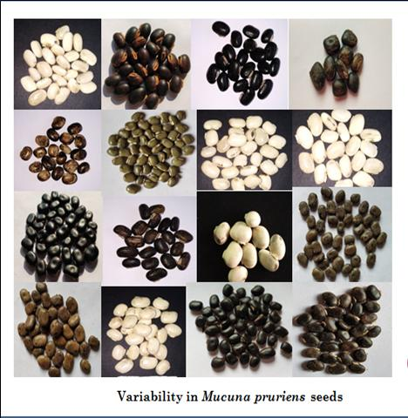
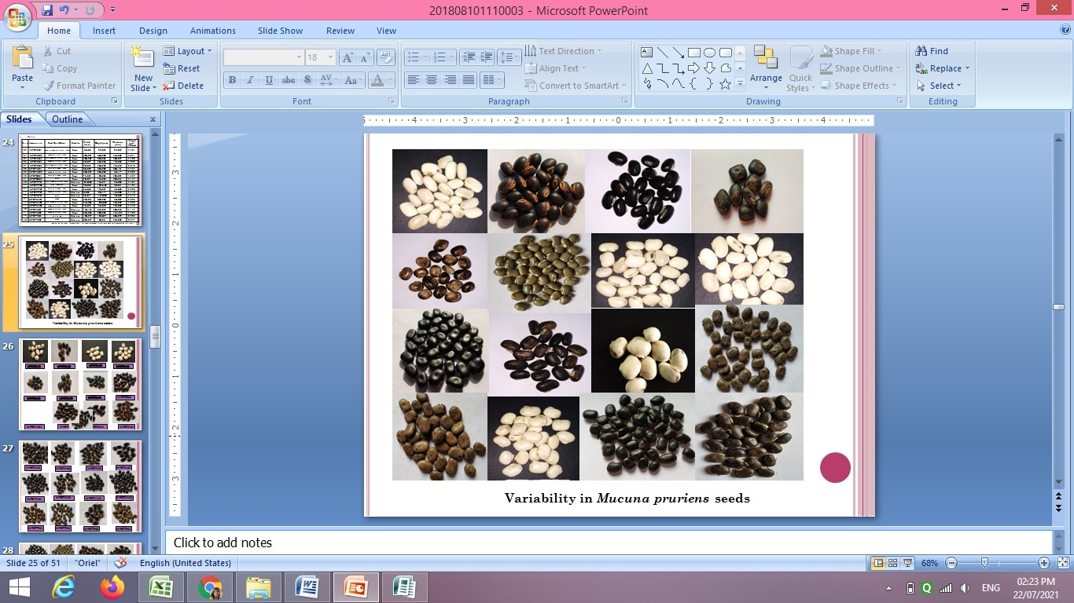
Fig. 2 HPLC chromatogram of L-dopa content (minimum (1.79%), Maximum (6.05%)
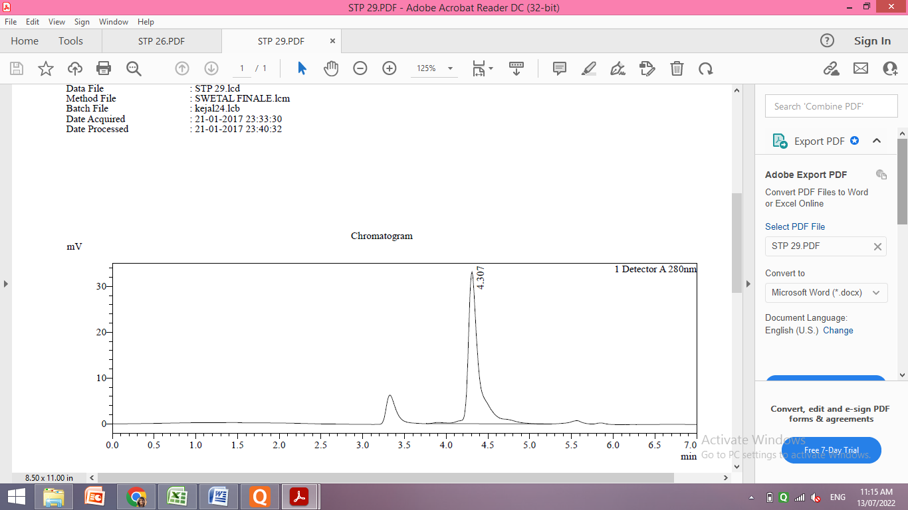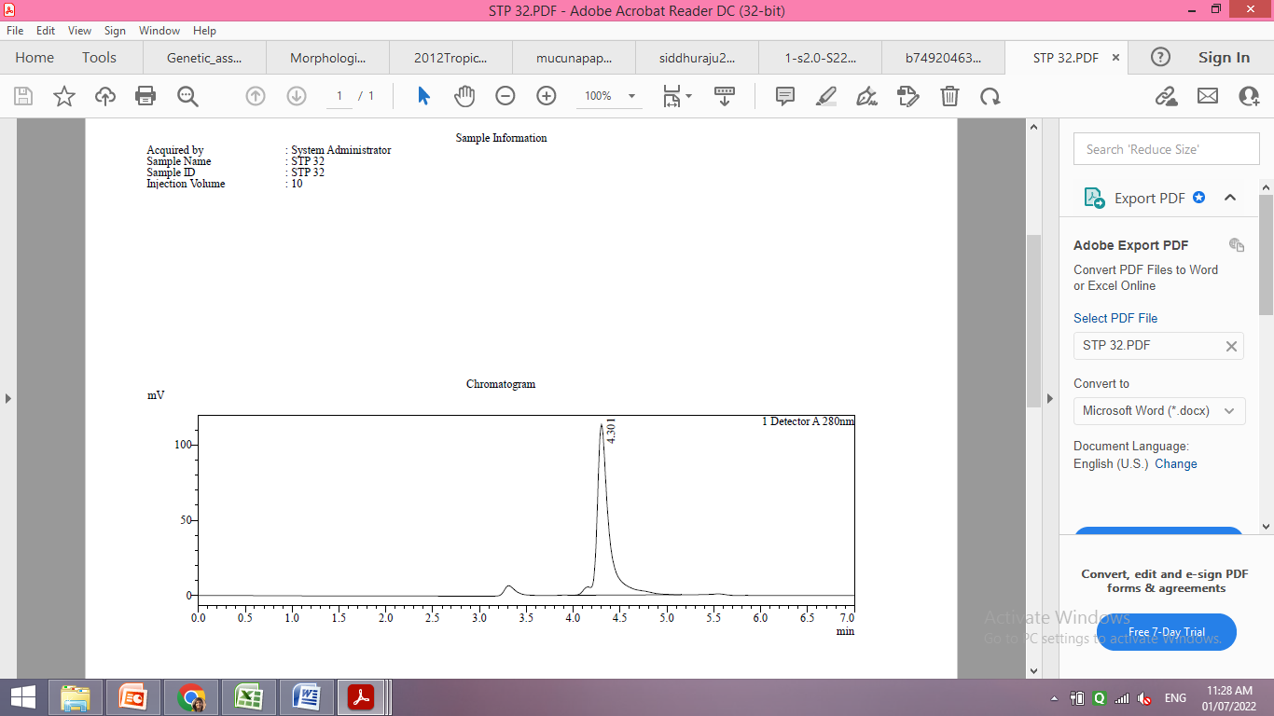

Table 1. Variability for L-dopa content and seed associated characters among M. pruriens accessions
Character | Mean | Range | SD | Std. error | CV% | LSD5%
L-dopa (%) | 3.67 | 1.79-6.05 | 1.06 | 0.14 | 28.83 | 0.28
Seed length (mm) | 11.20 | 5.00-19.33 | 3.94 | 0.52 | 35.11 | 1.03
Seed Width (mm) | 7.88 | 2.66-13.00 | 3.30 | 0.43 | 41.89 | 0.87
Seed Thickness (mm) | 4.69 | 0.90-8.67 | 2.67 | 0.35 | 56.95 | 0.70
Length width ratio | 1.49 | 1.17-2.26 | 0.23 | 0.03 | 15.56 | 0.06
Length thickness ratio | 3.09 | 1.50-7.40 | 1.53 | 0.20 | 49.45 | 0.40
Width thickness ratio | 2.07 | 0.89-6.00 | 0.95 | 0.12 | 45.94 | 0.25
Seed geometric diameter (mm) | 7.36 | 2.34-12.60 | 3.32 | 0.44 | 45.13 | 0.87
Arithmetic mean diameter (mm) | 7.92 | 2.88-13.33 | 3.23 | 0.42 | 40.75 | 0.85
Seed sphericity (Φ) | 63.20 | 41.89-78.75 | 10.23 | 1.34 | 16.18 | 2.69
Seed surface area (mm²) | 204.33 | 17.19-498.51 | 155.54 | 20.42 | 76.12 | 40.90
100 Seed weight(g) | 68.19 | 19.30-150.59 | 40.86 | 5.37 | 59.92 | 10.74
Descriptive statistics for the seed morphological traits (Table 1) showed that the seed length among the accessions varied from 5 to 19.3mm, the seed width ranged from 2.66 to 13.00 mm, and the seed thickness was between 0.90 and 8.67 mm. For all of the accessions examined in this study, it was observed that the seed length was greater than their width and thickness. Length width ratio (1.17-2.26), length thickness ratio (1.50-7.40), width thickness ratio (0.89-6.00), seed geometric diameter (2.34-12.60 mm), arithmetic mean diameter (2.88-13.33 mm), seed sphericity (41.89-78.75), seed surface area (17.19-498.51 mm²), and the hundred seed weight (19.30-150.59 g) among different accessions varied significantly and were also comparable to the previous studies by Sathyanarayana et al., (2012); Lepcha and Sathyanarayana (2021); Raina and Misra (2018).
An important agronomic trait that can be used in breeding efforts to create desirable cultivars is seed weight, since the heavier the seeds, the better the price they command (Alfieri et al., 2017). According to the current study 21.81% of the total collected accessions were having 100 seed weight more than 100 gm considered as bold type. Accessions with bold seeds are desirable for breeding programs to increase yield components (Krishnamurthy et al., 2002). Merely 1.6% of accessions with L-dopa concentration higher than 4% have 100 seeds weighing more than 100 g. Dessalegn et al., (2008) reported a similar finding: coffee beans with a low 100-bean weight contained much more caffeine than heavy beans.
3.1 Principle component analysis
A two-dimensional principal component analysis was performed using the seed morphological traits, and the central variability of all traits was displayed (Table 2). Similar studies on seed traits were reported by Khatun et al., (2022) in country bean, which revealed that the first principle component explained the greater proportion of the total variability (76.119), followed by the second (10.077) and third (6.888). As suggested by Arshad et al., (2010), the characters positively affected by the first three principal components might be taken into account while choosing the best hybrids without losing yield potential. Kaiser (1960) used the eigenvalue criterion to select a statistically significant principal component. The first component contributes the maximum eigenvalue (9.134), followed by second (1.209) and third (0.827), respectively. PCA analysis carried out by Sathyanarayana et al., (2012) for 30 agro- morphological traits of wild and cultivated species of Mucuna revealed that low morphological diversity within cultivated accessions highlights the need for increasing its genetic base in India. Additionally, considering that up until now, improvement efforts have solely focused on cultivated genotypes, it has shown promise for incorporating wild germplasm into the current breeding programs. Because the cultivated gene pool has less variability than previously reported, it is necessary to improve these plants' genetic foundation by extensive hybridization, mutation breeding, and other methods.
Table 2. Principle component analysis
Attributes | Principal Components
Attributes | 1 | 2 | 3
L-dopa % | -0.671 | -0.107 | -0.355
Seed Length (mm) | 0.929 | 0.075 | 0.279
Seed Width (mm) | 0.965 | 0.225 | 0.003
Seed Thickness (mm) | 0.984 | -0.071 | 0.034
Length-Width Ratio | -0.584 | -0.482 | 0.629
Length-Thickness Ratio | -0.817 | 0.514 | 0.224
Width-Thickness Ratio | -0.701 | 0.703 | 0.025
Seed Geometric Diameter (mm) | 0.987 | 0.050 | 0.084
Arithmetic Mean Diameter (mm) | 0.977 | 0.088 | 0.124
Seed Sphericity (%) | 0.902 | -0.179 | -0.370
Seed Surface Area (mm²) | 0.971 | 0.114 | 0.111
100-Seed Weight (g) | 0.857 | 0.302 | 0.065
Eigen Value | 9.134 | 1.209 | 0.827
% Variance Explained | 76.119 | 10.077 | 6.888
Cumulative Variance Explained | 76.119 | 86.196 | 93.085

3.2 Correlation coefficient analysis
For systematic breeding to determine seed yield and shape, the metrics measured on seeds, their correlation, and their relationship are crucial (Mahalingam et al., 2020). Correlation coefficient analysis revealed that LDP content is positively correlated with LWR (0.320**), LTR (0.468**), WTR (0.409**) and negatively correlated with all the other seed characters, indicating that seed size may not be a selection criterion for identifying a genotype with high L-dopa content (Raina et al., 2012). Seed length (SLT) has a significant correlation with SWT (0.940**), which is crucial for farmers as they prefer seeds with a large size. Thus, these two factors are crucial for size improvement (Valombola et al., 2019) (Table 3).
Table 3. Correlation coefficients between L-dopa % and seed physical dimensions
Attributes | SLT | SWT | STH | LWR | LTR | WTR | SGD | AMD | SSC | SSA | HSW
LDP | -0.630** | -0.617** | -0.613** | 0.320** | 0.468** | 0.409** | -0.631** | -0.635** | -0.497** | -0.617** | -0.614**
SLT |  | 0.940** | 0.926** | -0.391** | -0.651** | -0.577** | 0.970** | 0.982** | 0.705** | 0.954** | 0.789**
SWT |  |  | 0.936** | -0.662** | -0.665** | -0.513** | 0.978** | 0.980** | 0.821** | 0.972** | 0.868**
STH |  |  |  | -0.502** | -0.817** | -0.727** | 0.982** | 0.971** | 0.971** | 0.966** | 0.808**
LWR |  |  |  |  | 0.386** | 0.092 | -0.535** | -0.523** | -0.676** | -0.530** | -0.581**
LTR |  |  |  |  |  | 0.943** | -0.752** | -0.716** | -0.910** | -0.695** | -0.537**
WTR |  |  |  |  |  |  | -0.646** | -0.609** | -0.763** | -0.594** | -0.418**
SGD |  |  |  |  |  |  |  | 0.997** | 0.845** | 0.988** | 0.840**
AMD |  |  |  |  |  |  |  |  | 0.812** | 0.985** | 0.839**
SSC |  |  |  |  |  |  |  |  |  | 0.808** | 0.691**
SSA |  |  |  |  |  |  |  |  |  |  | 0.876**
*Represents significant correlation at P <0.05. L-dopa content (LDP), seed length (SLT), Seed width (SWT), thickness (STH), length width ratio (LWR), length thickness ratio (LTR), width thickness ratio (WTR) seed geometric diameter (SGD), arithmetic mean diameter (AMD), seed sphericity (SSC), seed surface area (SSA) and hundred seed weight (HSW).
3.3 Cluster analysis
The degree of genetic variation is revealed through cluster analysis, which is helpful for plant breeding (Sultana et al., 2006). A distribution of 59 M. pruriens accessions was classified into IV clusters (Table 4). Cluster-I consisted of the maximum number of genotypes (14) and represented 50.87% of the total genotypes evaluated. It indicates that the genotypes present in this cluster had narrow genetic diversity among them. The higher number of genotypes (12) next to this cluster was present in cluster II (21.05%), followed by clusters III and IV, each of which had nine accessions (15.78%), respectively. It has been suggested by Abdulkareem et al., (2015) that even though accessions within a cluster has similar genetic traits, environmental influences over time may have caused them to diverge morphologically.

Table 4. Composition of Euclidean clusters for L-dopa and seed traits in Accessions of plants
Cluster Studied | No of Accessions | Accession No
I | 29 | Mp027, Mp037, Mp025, Mp031, Mp029, Mp034, Mp033, Mp038, Mp021, Mp030, Mp022, Mp041, Mp020, Mp024, Mp026, Mp023, Mp028, Mp019, Mp035, Mp036, Mp039, Mp032, Mp048, Mp042, Mp043, Mp053, Mp058, Mp040, Mp049
II | 12 | Mp006, Mp046, Mp044, Mp050,Mp 045, Mp047, Mp015, Mp057, Mp052, Mp007, Mp056, Mp017
III | 09 | Mp001, Mp059, Mp014, Mp011, Mp018, Mp004, Mp013, Mp003, Mp008
IV | 09 | Mp002, Mp009, Mp010, Mp016, Mp051, Mp055, Mp005, Mp054, Mp012

Table 5. Cluster mean values for L-dopa and seed traits in 59 accessions studied
Attributes | Cluster I | Cluster II | Cluster III | Cluster IV
L-dopa % | 3.23 | 4.43 | 3.60 | 2.73
Seed Length (mm) | 14.09 | 6.94 | 11.76 | 16.44
Seed Width (mm) | 10.69 | 4.38 | 7.59 | 12.44
Seed Thickness (mm) | 6.86 | 1.76 | 4.77 | 8.29
Length-Width Ratio | 1.32 | 1.61 | 1.57 | 1.32
Length-Thickness Ratio | 2.06 | 4.52 | 2.56 | 1.99
Width-Thickness Ratio | 1.56 | 2.85 | 1.67 | 1.50
Seed Geometric Diameter (mm) | 10.09 | 3.70 | 7.43 | 11.97
Arithmetic Mean Diameter (mm) | 10.54 | 4.36 | 8.04 | 12.39
Seed Sphericity | 71.80 | 53.17 | 63.74 | 73.07
Seed Surface Area (mm²) | 320.88 | 44.77 | 177.35 | 450.32
100-Seed Weight (g) | 96.76 | 37.08 | 46.32 | 132.63
Table 6. Estimates of between and within cluster Euclidean distances for L-dopa and seed traits in 59 accessions studied
Clusters | I | II | III | IV
I | 51.013 | 134.393 | 283.458 | 152.462
II |  | 51.325 | 417.537 | 286.622
III |  |  | 30.583 | 133.597
IV |  |  |  | 57.933
The cluster mean values recorded in the present study, presented in Table 5, indicated appreciable variation among the clusters. According to the values, cluster IV represents the highest number of accessions with superior characteristics for seed-associated characters, followed by cluster III, cluster I, and cluster II, respectively. In contrast to that, cluster II included the accessions with higher L-dopa content, followed by clusters III, I, and IV. The average intra- and inter-cluster distance (Table 6) revealed that the genetic diversity among the genotypes was generally superior for one or a few characters, which made them divergent from other clusters. The genotypes from distantly related clusters are likely to produce more transgressive segregants through hybridization and selection (Geetha et al., 2011). The maximum distance (417.537) was observed between clusters III and II, giving scope for hybridization between the genotypes of these clusters for improvement of yield and yield-contributing traits, followed by clusters II and IV (286.622) and clusters I and III (283.458), the minimum indicating a close relationship between those clusters. The highest inter cluster distance was observed in cluster IV (57.933) while the minimum distance was found in cluster III (30.583).
Understanding the relationships between different variables at the beginning of any breeding program enhances the likelihood of choosing superior genotypes with a wide range of desirable traits. According to Gizachew and Gebeyaw (2021), the genotypes in the cluster with the greatest intercluster distance are genetically more diverse, and these genotypes might be used in the velvet bean hybridization program to evolve high L-dopa types in order to fulfill the needs of the pharmaceutical business.

Fig. 3 Dendrogram of 59 accessions of plant seeds studied using Ward linkage

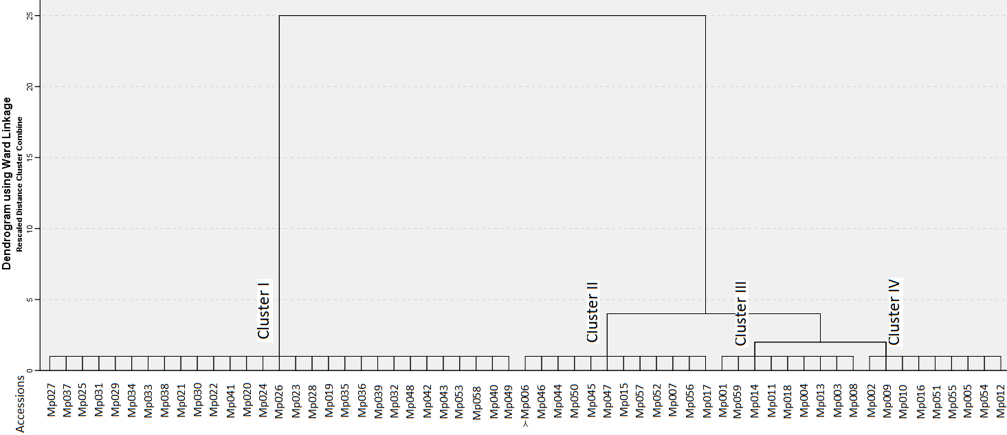
- CONCLUSION
An enormous amount of genetic variability is a prerequisite for establishing a breeding program and the success of breeding relies on the amount of genetic variety present in the crop gene pool. The present investigation found significant differences between L-dopa content and seed-associated traits. The principle, component analysis, and correlation analysis of these attributes in combination with different sets of characters revealed an undesirable negative correlation between 100 seed weight and L-dopa content, a promising antiparkinson drug. As a result, these qualities can be enhanced through hybridization and selection to develop a cultivar with a high yield.

REFERENCES
Abdulkareem, K. A., Animasaun, D. A., Oyedeji, S., & Olabanji, O. M. (2015). Morphological characterization and variability study of African yam beans [Sphenostylis Stenocarpa (Hochst Ex A. Rich)]. Global Journal of Pure and Applied Sciences, 21(1), 21-27. https://doi.org/10.4314/gjpas.v21i1.4
Alfieri, M., Balconi, C., Cabassi, G., Habyarimana, E., & Redaelli, R. (2017). Antioxidant activity in a set of sorghum landraces and breeding lines. M23
Arshad, M., Khan, M. A., Jadoon, S. A., & Mohmand, A. S. (2010). Factor analysis in sunflower (Helianthus annuus L.) to investigate desirable hybrids. Pak. J. Bot, 42(6), 4393-4402.
Basavaraj, H., Ravi, C. S., Shivaprasad, M., Hima bindu, Sadashiv N., & Devaraju (2018). Genetic variability and correlation studies for quantitative and qualitative traits in velvet bean (Mucuna pruriens L.) genotypes in rubber plantation under hill zone of Karnataka. Journal of Pharmacognosy and Phytochemistry 7(3S), 86-90.
Chinapolaiah, A., Bindu, K. H., Khadke, G. N., Manjesh, G. N., Rao, N. H., Kumar, S. S., & Suthar, M. K. (2020). Genetic diversity analysis in underutilized medicinal climber Mucuna pruriens (L.) DC. germplasm revealed by inter simple sequence repeats markers. Legume Research-An International Journal, 43(1), 32-37. https://doi.org/10.18805/LR-3954
Chinapolaiah, A., Bindu, K. H., Thondaiman, V., Manjesh, G. N., Rao, N. H., Kumar, S. S., & Reddy, R. N. (2021). Variability of L-Dopa and its association with morphological growth and yield traits of Mucuna pruriens (L.) germplasm. Legume Research-An International Journal, 44(1), 8-14. https://doi.org/10.18805/LR-4069
Chinapolaiah, A., Manjesh, G. N., Thondaiman, V., & Rao, V. K. (2019). Variability in L-Dopa and other biochemical composition of Mucuna pruriens (L.) an underutilized tropical legume. Industrial Crops and Products, 138, 111447. https://doi.org/10.1016/j.indcrop.2019.06.010
Dessalegn, Y., Labuschagne, M. T., Osthoff, G., & Herselman, L. (2008). Genetic diversity and correlation of bean caffeine content with cup quality and green bean physical characteristics in coffee (Coffea arabica L.). Journal of the Science of Food and Agriculture, 88(10), 1726-1730. https://doi.org/10.1002/jsfa.3271
Dhan Prakash, D. P., & Tewari, S. K. (1999). Variation of smallcap˜ L-dopa contents in Mucuna species. Journal of Medicinal and Aromatic Plant Science, 21, 343–346.
Ezeagu, I. E., Maziya-Dixon, B., & Tarawali, G. (2003). Seed characteristics and nutrient and antinutrient composition of 12 Mucuna accessions from Nigeria. Tropical and subtropical Agroecosystems, 1(2-3), 129-139.
Geetha, K., Mani, A. K., Hepziba, M. J., Latha, R., & Shanthi, P. (2011). Studies on genetic diversity among germplasm accessions of horsegram macrotyloma uniflorum (LAM) verde. Legume Research-An International Journal, 34(1), 14-19.
González-Andrés, F., & Ortiz, J. M. (1995). Seed morphology of Cytisophyllum, Cytisus, Chamaecytisus and Genista (Fabaceae: Genisteae) species for characterization.
Hasegawa T., Takahashi, I., SaijoMassaki, K., Tomohide, F., Tomoko, N., & Yuji, M. (2011). Quantitative determination of l-dopa in dietary supplements containing Mucuna pruriens by high performance liquid chromatography. Chiba Prefecture Wei Yan Annual Report, 60, 53-56.
Ișık, E., & Unal, H. (2007). Moisture-dependent physical properties of white speckled red kidney bean grains. Journal of Food Engineering 82, 209-216. https://doi.org/10.1016/j.jfoodeng.2007.02.012
Joshi, H., Tirkey, P. K., Khokhar, D., Mehta, N. (2021). Study of genetic variability in velvet bean (Mucuna pruriens L.). Journal of Pharmacognosy and Phytochemistry, 10(2), 1443-1445.
Kaiser, H. F. (1960). The application of electronic computers to factor analysis. Educational and psychological measurement, 20(1), 141-151. https://doi.org/10.1177/001316446002000116
Kavitha, C., & Thangamani, C. (2014). Amazing bean" Mucuna pruriens": a comprehensive review. Journal of Medicinal Plants Research 8(2), 138-143. http://dx.doi.org/10.5897/JMPR2013.5036.
Kebede, G. Y., & Haile, G. A. (2021). Genetic Diversity Analysis of Kabuli Chickpea (Cicer arietinum L.) Genotypes at Arsi-Robe, Southeastern Ethiopia. Plant, 9(3), 58-65. https://doi.org/10.11648/j.plant.20210903.13
Khatun, R., Uddin, M. I., Uddin, M. M., Howlader, M. T. H., & Haque, M. S. (2022). Analysis of qualitative and quantitative morphological traits related to yield in country bean (Lablab purpureus L. sweet) genotypes. Heliyon, 8(12). https://doi.org/10.1016/j.heliyon.2022.e11631
Lepcha, P., & Sathyanarayana, N. (2022). Variability for seed-based economic traits and genetic diversity analysis in Mucuna pruriens population of northeast India. Agricultural Research, 11(2), 1-11. https://doi.org/10.1007/s40003-021-00568-6
Mahalingam. A., Manivanan, N., Bharathi, K.K., Ramakrishnan, P., Vadivel, K. (2020). Character association and principal component analysis for seed yield and its contributing characters in greengram (Vigna radiata (L.) Wilczek). Electronic Journal of Plant Breeding. 11(1),259-262
Mahesh, S., & Sathyanarayana, N. (2011). The genotype x environment interaction and stability analysis for L-Dopa trait in Velvetbean (Mucuna pruriens) seeds. Indian Journal of Genetics and Plant Breeding, 71(03), 279-282.
Maiti, R. K., Hernández-Piñero, J. L., & Valdez-Marroquin, M. (1994). Seed ultrastructure and germination of some species of Cactaceae. Fiton, 55, 97-105
Misra, R. C., Raina, A. P., Pani, D. R., Das, G., Mukherjee, A. K., & Ahlawat, S. P. (2021). Genetic diversity, extent of variability and indigenous traditional knowledge of Mucuna Adans.(Fabaceae) in Odisha, Eastern India. Genetic Resources and Crop Evolution, 68, 1243-1268. https://doi.org/10.1007/s10722-020-01093-1
Mohsenin, N. N. (1970). Physical properties of plant and animial materials. Vol. 1. Structure, physical characterisitics and mechanical properties.
Murthy, R. K., Chandorkar, M. S., Palsuledesai, M. R., Pathak, J. M., & Rajendra Gupta, R. G. (2002). Breeding in velvet bean (Mucuna pruriens) for improvement in seed yield and quality traits.Indian Journal of Agricultural Sciences 72 (12), 709-15.
Pathania, R., Chawla, P., Khan, H., Kaushik, R., & Khan, M. A. (2020). An assessment of potential nutritive and medicinal properties of Mucuna pruriens: a natural food legume. 3 Biotech, 10(6), 261. https://doi.org/10.1007/s13205-020-02253-x
Patil, R. R., Pawar, K. D., Rane, M. R., Yadav, S. R., Bapat, V. A., & Jadhav, J. P. (2016). Assessment of genetic diversity in Mucuna species of India using randomly amplified polymorphic DNA and inter simple sequence repeat markers. Physiology and Molecular Biology of Plants, 22, 207-217. https://doi.org/.1007/s12298-016-0361-3
Raina, A. P., & Misra, R. C. (2018). Chemical evaluation of Mucuna species for L-dopa content-an anti-Parkinson’s drug yielding medicinal plant from India.
Raina, A. P., Tomar, J. B., & Dutta, M. (2012). Variability in Mucuna pruriens L. germplasm for L-Dopa, an anti parkinsonian agent. Genetic Resources and Crop Evolution, 59, 1207-1212. https://doi.org/10.1007/s10722-012-9836-4
Sadh, P. K., Chawla, P., & Duhan, J. S. (2018). Fermentation approach on phenolic, antioxidants and functional properties of peanut press cake. Food bioscience, 22, 113-120. https://doi.org/10.1016/j.fbio.2018.01.011
Sastry, T. C., & Kavathekar, K. Y. (Eds.). (1990). Plants for reclamation of wastelands. Pbl CSIR, New Delhi, India, pp 360- 362
Sathe, S. K., Deshpande, S. S., Salunkhe, D. K., & Rackis, J. J. (1984). Dry beans of Phaseolus. A review. Part 2. Chemical composition: carbohydrates, fiber, minerals, vitamins, and lipids. Critical Reviews in Food Science & Nutrition, 21(1), 41-93.
Sathyanarayana, N., Mahesh, S., Jaheer, M., & Leelambika, M. (2012). Genetic diversity of wild and cultivated Mucuna pruriens (L.) DC. accessions analyzed using thirty morpho-agronomical characters. Tropical and Subtropical Agroecosystems, 15(2), 249-259.
Singh, A. K., Malik, S. S., & Tomar, Y. S. (2008). Studies on the Medicinal Compound L-Dopa in Mucuna pruriens Bak. Indian Journal of Plant Genetic Resources, 21(3), 217-220.
Soares, A. R., Marchiosi, R., Siqueira-Soares, R. D. C., Barbosa de Lima, R., Dantas dos Santos, W., & Ferrarese-Filho, O. (2014). The role of L-DOPA in plants. Plant signaling & behavior, 9(4), e28275.
Sultana, Tayyaba, Abdul Ghafoor, and Muhammad Ashraf. "Geographic patterns of diversity of cultivated lentil germplasm collected from Pakistan, as assessed by seed protein assays." Acta Biologica Cracoviensia, Series Botanica, Poland 48, no. 1 (2006): 77-84.
Szabo, N. J., & Tebbett, I. R. (2002). The chemistry and toxicity of Mucuna species. Mucuna as a Food and Feed: Current Uses and the Way Forward, 120-141.
Tarighi, J., Mahmoudi, A., & Alavi, N. (2011). Some mechanical and physical properties of corn seed (Var. DCC 370). African Journal of Agricultural Research, 6(16), 3691-3699. https://doi.org/10.5897/AJAR10.521
Valombola, J. S., Akundabweni, L. M., Awala, S. K., & Hove, K. (2019). Agronomic and morphological diversity of Bambara groundnut (Vigna subterranea (L.) Verdc.) accessions in North-Central Namibia. Welwitschia International Journal of Agricultural Sciences, 1, 88-99. https://doi.org/10.32642/wijas.v1i0.1369

