Evaluation of organic carbon and macronutrient availability in the soils of different litchi (Litchi chinensis Sonn.) cultivars

ABSTRACT
Litchi (Litchi chinensis Sonn.) belongs to the Sapindaceae family and is known as the ‘Queen of Fruits’. It is a subtropical fruit with significant commercial and nutritional value. A range of soil and climate factors affect its production, however there is little scientific information on the quality of the soil for various litchi cultivars. The main purpose of this study was to evaluate the organic carbon and macronutrient availability of rhizosphere soils from nine litchi cultivars: ‘Shahi’, ‘Rose Scented’, ‘Dehradun’, ‘Dehra Rose’, ‘Ajhauli’, ‘China’, ‘Mandraji’, ‘Purbi’, and ‘Bombai’, which were collected from the ICAR-National Research Centre on Litchi, Muzaffarpur, Bihar. The availability of organic carbon, nitrogen, phosphorus, potassium, and sulphur was assessed in soil samples that were collected at a depth of 0–20 cm. All rhizosphere soils exhibited a considerable reduction in organic carbon, nitrogen, phosphorus, and potassium in comparison to the control, with potassium exhibiting the most severe depletion. The available sulphur content was deficient in all the soil samples. The observed reductions in nutrient content, particularly potassium and sulphur, highlight the need for balanced nutrient management and cultivar-specific soil fertility management strategies to sustain litchi productivity.
Keywords: Litchi, Cultivars, Organic carbon, Nitrogen, Phosphorus, Potassium, Sulphur.
- INTRODUCTION
Litchi (Litchi chinensis Sonn.) is a valuable subtropical evergreen fruit tree of the Sapindaceae family. Litchi is known as the “queen of fruits” due to its outstanding quality, exquisite fruit, well-balanced sugar and acid levels, distinctively pleasant flavor, appealing color, and high nutritional value. India is the world’s second-largest producer of litchi, following China. According to Raghavan et al., (2018), the production of litchi is mostly limited to Bihar (40%), West Bengal (16%), Jharkhand (10%), Assam (8.2%), Chhattisgarh (6.4%), Uttarakhand (5.2%), and to a lesser degree, Punjab, Odisha, and Tripura. In terms of land area and litchi production, Bihar is India’s most productive state. Around 40% of India’s total litchi output comes from Bihar, which has an area of roughly 32,000 hectares (2014–15) (Kumar et al., 2018). Litchi farming is a significant source of income for the people of Bihar, as the state produces 73.38 percent of the nation’s litchi. Because it generates work both on and off farms, millions of people depend on it to survive. The majority of litchi is grown in North Bihar districts, including Samastipur, Vaishali, Darbhanga, Sitamarhi, East Champaran, West Champaran, and Muzaffarpur, which is also referred to as India’s Litchi Capital (Kumar et al., 2022).
Litchi comes in thirty-five different varieties that are produced throughout India. These varieties are mostly derived from Chinese cultivars. Just six cultivars Shahi, China, Rose Scented (Dehradun), Seedless, Muzaffarpur, and Bombai provide the majority of the litchi produced. In fact, each district has its own dominant cultivars. Table 1 displays the classification of litchi cultivars according to their maturity period.
Table 1: Litchi cultivars maturity periods
Period | Cultivars
Early | Shahi, Rose Scented, Dehradun, Dehra Rose, Ajhauli, Deshi, Muzaffarpur, Green, Trikolia
Mid | China, Purbi, Bombai, Culcuttia, Bedana, Swarna Roopa, Kasba, Sabour Bedana, Sabour Madhu
Late | Late Bedana, Longia, Kaselia
(Source: The Litchi, FAO, 2012)
Litchi fruit is not widely cultivated due to its short post-harvest life and great susceptibility to soil and climate conditions. Litchi plants need cool, dry winters and warm, lush summers to grow. The primary limiting factor for low yield and quality in practically all litchi-growing nations has been determined to be inadequate and unbalanced nutrition combined with a water deficit (Kumar et al., 2018). The litchi yield in some places of China is low and unstable (Xu et al., 2010), mainly due to inappropriate fertilization (Yao, 2009). Litchi trees with poor K nutrition (Yao et al., 2009), low N and K in the soil (Li et al., 2011), and dynamic variations in nutrition in litchi foliar and the effects of potassium-nitrogen fertilization ratio are some of the most important causes of low yield.
One of the most crucial inputs for raising litchi orchard productivity and production is fertilizer. Inadequate nutrition is often associated with low litchi yields and low-quality litchi fruit (Kumari and Khare, 2020). All aspects of litchi growth, including floral initiation, appear to be stunted by the severe lack of N, P, and K (Mathura et al., 2002). Waseem et al., (2002) reported that undesirable yield losses or a decline in fruit quality can be caused by irrigation (Li et al., 2001), nutrients and both high and low temperatures. In order to maintain the soil’s available nutrient status at the appropriate level and guarantee good economic output, accurate fertilizer and manure dosages must be applied using reliable diagnostic instruments intended to prevent nutrient imbalance (Mathura et al., 2002; Raghavan et al., 2018).
A short shelf life, inadequate fertilizer management, and sensitivity to soil and climate are some of the issues that affect litchi cultivation despite its great demand and economic significance. Reduced productivity and fruit quality are frequently the result of inadequate knowledge of the requirements for nitrogen, phosphorus, and potassium. There is a lack of region-specific research, particularly in critical areas such as Bihar. To raise Indian litchi’s competitiveness internationally and boost production, fruit quality, and soil health, a concentrated study on balanced nutrient management is necessary. Thus, the present study was carried out to investigate the organic carbon and macronutrient availability in the soils of different litchi cultivars in the Muzaffarpur region.
- MATERIALS AND METHODS

  - Site Description
The rhizosphere soil samples of nine different litchi cultivars i.e. ‘Shahi’, ‘Rose Scented’, ‘Dehradun’, ‘Dehra Rose’, ‘Ajhauli’, ‘China’, ‘Mandraji’, ‘Purbi’, and ‘Bombai’, were collected from the litchi orchards of ICAR-National Research Centre on Litchi, Muzaffarpur, Bihar. The centre is located in Muzaffarpur, Bihar, between 26⁰5′87″N latitude and 85⁰26′64″E longitude, with an elevation of 210 meters. The area has a subtropical climate, with an average annual rainfall of 1100-1300 mm. The soil at the location is alluvial, sandy loam in texture, calcareous in nature, and has a pH of 7.5-8.0.

  - Collection of Soil Samples
Soil samples were collected from the rhizospheres of early and mid-season litchi cultivars. Early-maturing litchi cultivars included ‘Shahi’, ‘Rose Scented’, ‘Dehradun’, ‘Dehra Rose’, and ‘Ajhauli’, whilst mid-season-maturing litchi cultivars included ‘China’, ‘Mandraji’, ‘Purbi’, and ‘Bombai’. For each cultivar, rhizosphere soil samples were randomly collected from the root zone at a depth of 0–20 cm after removing surface debris, grasses, and the topsoil layer. From each tree, three replicates were gathered, combined, and thoroughly mixed. For the control, surface soil (0–20 cm) was collected from an adjacent uncultivated area. Approximately 500 g of soil sample was collected and stored in sterile sample bags. In the laboratory, the collected samples were air-dried, ground using a mortar and pestle, passed through a 2 mm sieve, and stored in plastic bags for soil analysis. Soil samples were sent to the Central Soil Testing Laboratory (CSTL), located in Mithapur, Patna, for the purpose of estimating the nutrient content of the soil.

  - Analysis of Soil Parameters
Organic carbon was estimated using 1 N potassium dichromate and back titrated with 0.5 N ferrous ammonium sulphate solutions (Walkley and Black, 1934). Available nitrogen was determined by using alkaline potassium permanganate (Subbaiah and Asija, 1956). Available phosphorus in soil was determined by Olsen’s method (Olsen et al., 1954). Available potassium was determined by the neutral ammonium acetate method using a flame photometer (Toth and Prince, 1949). Available sulphur was determined by turbidimetric method. The methodology described in the methods manual Soil Testing in India (Anonymous, 2011) was followed for laboratory analysis.

  - Statistical Analysis
For all soil parameters, the data was statistically examined using analysis of variance (ANOVA). Several litchi cultivars were compared using a one-way ANOVA in Excel. The experiment was carried out in triplicate, and the mean ± standard deviation (SD) was used to express the data.

- RESULTS

  - Soil organic carbon
The concentration of soil organic carbon in the rhizosphere soil of litchi cultivars that mature early and mid-season is contrasted with the control in Figure 1. The control contained the highest amount of soil organic carbon (0.75%), but the rhizosphere soil's level ranged from 0.49% to 0.60%. Of the early litchi cultivars, Dehra Rose and Shahi had the highest organic carbon content (0.58%), while cultivar Rose Scented had the lowest (0.49%). Among mid-season maturing litchi cultivars, Mandraji and Bombai showed the highest and lowest soil organic carbon concentrations, respectively (0.60% and 0.50%). In comparison to the other samples, which had medium soil organic carbon (0.5–0.75%); the cultivar Rose Scented had low soil organic carbon (less than 0.5%).
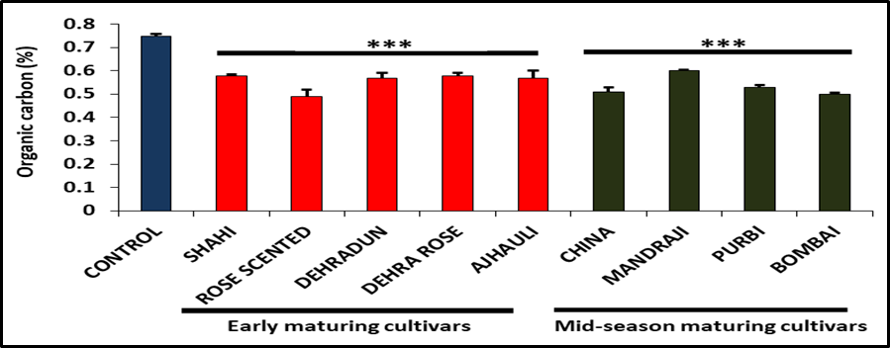Figure 1. The soil organic carbon content in the rhizosphere soil of early and mid-season maturing litchi cultivars was compared to the control. Experiments were performed in triplicate, and data is represented as mean ± SD. The asterisks indicate a significant difference (p < 0.001).

  - Macronutrients availability
Macronutrients are nutrients that are abundantly absorbed by plants. Primary and most important macronutrients are nitrogen, phosphorus, and potassium (Daramola, D.A., and Hatzell, M.C., 2023), while secondary macronutrient includes sulphur (Keita, D. S., et al., 2023).The macronutrient availability in the rhizosphere soil of early and mid-season maturing litchi cultivars showed significant difference when compared to control.

    - Available nitrogen content in the soil:
Figure 2 depicts the available nitrogen content in the rhizosphere soil of early and mid-season maturing litchi cultivars as compared to the control. The available nitrogen content in the rhizosphere soil ranged from 335-401 kg/ha, whereas control had the highest nitrogen content (461 kg/ha). Among the early maturing cultivars, Dehra Rose and Shahi recorded the maximum available nitrogen content (389 kg/ha), while Rose Scented recorded the minimum (335 kg/ha). In the mid-season maturing litchi cultivar, Bombai exhibited the lowest available nitrogen content (341 kg/ha), whereas Mandarji had the highest (401 kg/ha). According to our results, in all soil samples available nitrogen was found in medium range.
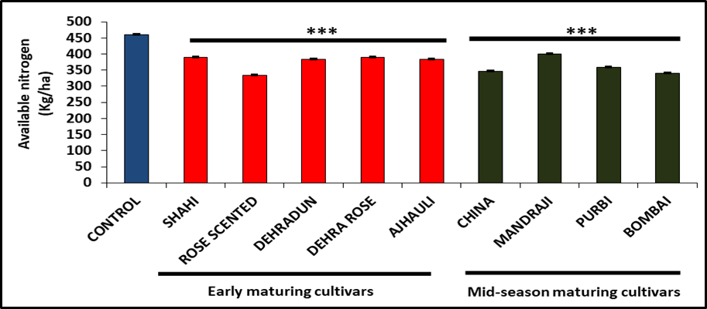
Figure 2. Available nitrogen content in the rhizosphere soil of early and mid-season maturing litchi cultivars was compared to the control. Experiments were performed in triplicate, and data is represented as mean ± SD. The asterisks indicate a significant difference (p < 0.001).

    - Available phosphorus content in the soil:
The accessible phosphorus concentration in the rhizosphere soil of litchi cultivars that mature early and mid-season is displayed in Figure 3 in contrast to the control. The available phosphorus content in the rhizosphere soil ranged from 33 to 57 kg/ha, whereas control had the highest available phosphorus (137 kg/ha). Among the early maturing cultivars, Dehra Rose recorded the minimum available phosphorus content (36 kg/ha), while Rose Scented recorded the maximum (57 kg/ha). In the mid-season maturing litchi cultivar, Mandraji exhibited the lowest available phosphorus content (33 kg/ha), whereas Purbi had the highest (53 kg/ha). According to our findings, the available phosphorus was high in all soil samples.
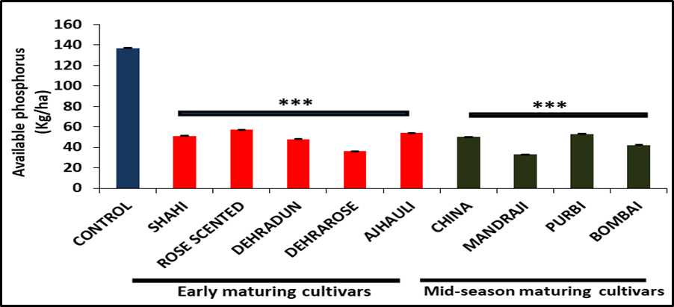
Figure 3. Available phosphorus content in the rhizosphere soil of early and mid-season maturing litchi cultivars was compared to the control. Experiments were performed in triplicate, and data is represented as mean ± SD. The asterisks indicate a significant difference (p < 0.001).

    - Available potassium content in the soil:
Figure 4 shows the available potassium content in the rhizosphere soil of early- and mid-season-maturing litchi cultivars in comparison to the control. It was observed that the available potassium content in the rhizosphere soil ranged from 47 to 102 kg/ha, whereas the control had the highest available potassium (301 kg/ha). Dehra Rose recorded the minimum available potassium content (62 kg/ha) among the early-maturing cultivars, whereas Rose Scented recorded the maximum (94 kg/ha). Among the mid-season maturing litchi cultivars, Bombai recorded the lowest available potassium content (47 kg/ha), whereas Purbi had the highest (102 kg/ha). The rhizosphere soil had a low amount of available potassium, but the control had a high amount, according to our data.
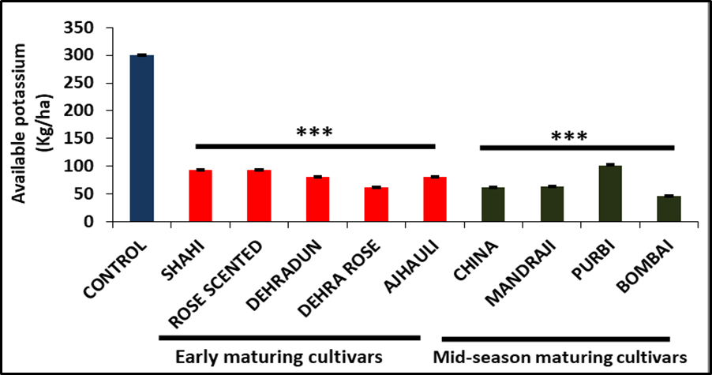
Figure 4. Available potassium content in the rhizosphere soil of early and mid-season maturing litchi cultivars was compared to the control. Experiments were performed in triplicate, and data is represented as mean ± SD. The asterisks indicate a significant difference (p < 0.001).

    - Available sulphur content in the soil:
The available sulphur content in the rhizosphere soil of early- and mid-season-maturing litchi cultivars was measured and compared to the control (Figure 5). It was observed that the available sulphur content in the rhizosphere soil ranged from 3 to 9 ppm, whereas the control had 6 ppm. Shahi recorded the minimum available sulphur content (3 ppm) among the early-maturing litchi cultivars, whereas Dehradun recorded the maximum (8 ppm), followed by Rose Scented (7 ppm), both of which were significantly higher than the control. Among the mid-season maturing litchi cultivars, Bombai recorded the lowest available sulphur content (4 ppm), whereas Purbi had the highest (9 ppm), significantly higher than the control (p < 0.001). According to our results, in all soil samples available sulphur content was below the critical limit.
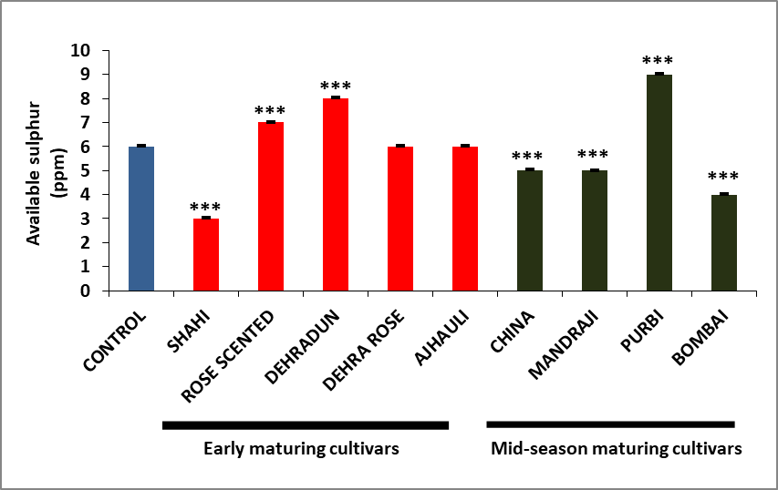
Figure 5. Available sulphur content in the rhizosphere soil of early and mid-season maturing litchi cultivars was measured and compared to the control. Experiments were performed in triplicate, and data is represented as mean ± SD. The asterisks indicate a significant difference (p < 0.001).

- DISCUSSION

  - Soil organic carbon
Soil Organic Carbon (SOC) refers to the amount of carbon found in the organic matter of soil. It plays a vital role in many ecological processes and is essential to healthy soil. Decomposition of plant and animal waste, such as leaves, roots, and dead organisms, is the main sources of SOC. It’s an important measure of soil fertility and health. SOC affects the soil’s ability to retain and release vital nutrients. It promotes microbial activity and controls water-holding capacity. In our study, we measured and compared the rhizosphere soil organic carbon content of early- and mid-season maturing litchi cultivars to the control. We found that the SOC content in the rhizosphere soil ranged from 0.49% to 0.60%, while the control (0.75%) showed the highest SOC content (Figure 1). Our results also revealed that the rhizosphere soil samples from Dehra Rose (0.58%), Shahi (0.58%), and Mandraji (0.60%) had the highest SOC, while cultivars Rose Scented (0.49%) and Bombai (0.50%) had the lowest. According to Kumar et al., (2016) organic carbon content ranged from 0.02% to 1.05%. The soil organic carbon observed in our study falls within this range. Considering the critical range mentioned by Kumar et al., (2016) our data reveal that soil organic carbon was low (<0.5%) in the Rose Scented sample, while in all other samples, it was in the medium range (0.5–0.75%).

  - Macronutrients availability
The nutrients that plants receive in large quantities are known as macronutrients. Nitrogen, phosphorus, and potassium are the primary and most significant macronutrients, but sulphur is a secondary macronutrient.

    - Available nitrogen content in the soil:
The nutrient that has the greatest impact on litchi plant growth and productivity is nitrogen. Like other plants, litchi orchards depend heavily on nitrogen for vegetative growth, which has a significant impact on the tree’s ability to bear fruit. There have also been reports of increased fruit set, retention, and yield when nitrogen is added. Branches develop poorly, blooming and fruit set are inhibited, and plant growth is slowed in N-deficient plants. Since no reliable correlation has been found between blooming time and nitrogen application or soil nitrogen concentrations, nitrogen has no direct effect on floral initiation (Singh et al., 2012). We examined the available nitrogen content in the rhizosphere soil of each litchi cultivar that matures early and mid-season and compared it to the control. We found that the available nitrogen content in the rhizosphere soil ranged from 335 to 401 kg/ha, whereas the control had the highest nitrogen level, at 461 kg/ha (Figure 2). Our results showed that the maximum accessible nitrogen concentration was found in the rhizosphere soil samples of Dehra Rose (389 kg/ha), Shahi (389 kg/ha), and Mandraji (401 kg/ha), while the lowest was found in Rose Scented (335 kg/ha) and Bombai (341 kg/ha). According to Ray, P.K. (2004), the critical limit of nitrogen for orchard soil and healthy, high-yielding litchi trees in North Bihar is 250 kg/ha. A deficit may result from a quantity below this limit. According to Kumar et al., (2016) majority of the samples showed high nitrogen while according to our findings all samples exhibited available nitrogen in the medium range (280–560 kg/ha).

    - Available phosphorus content in the soil:
Phosphorus is a vital plant nutrient that plays a crucial role in various plant functions, including photosynthesis, nutrient movement within the plant, the conversion of sugars and starches, and the transmission of genetic traits across generations (Kumari et al., 2020). In addition to nitrogen and potassium, phosphorus is essential for litchi productivity and fruit quality. It has been determined that phosphorus is one of the most crucial minerals for litchi yield, quality, and growth. In regions where mixed fertilizers are frequently applied, litchi phosphorus shortage is uncommon. A high concentration of phosphorus in the soil does not last for many years because it is fixed in calcareous soil as calcium phosphate and in acidic soil as iron and aluminium phosphate. Regular application of phosphorus has also been observed to cause deficiencies in other nutrients, including zinc and iron (Kumar et al., 2017). We compared the available phosphorus concentration in the rhizosphere soil of early and mid-season maturing litchi cultivars to the control. The rhizosphere soil’s accessible phosphorus concentration varied between 33 and 57 kg/ha, whereas the control had the largest amount (137 kg/ha) (Figure 3). According to our findings, the rhizosphere soil samples of Purbi (53 kg/ha) and Rose Scented (57 kg/ha) had the highest accessible phosphorus concentration, whereas Mandraji (33 kg/ha) and Dehra Rose (36 kg/ha) had the lowest. The necessary limit of accessible phosphorus for healthy, high-yielding litchi trees and orchard soil in North Bihar is 25 kg/ha, according to Ray, P.K. (2004). According to our findings, all samples had high amounts of accessible phosphorus (>25 kg/ha).

    - Available potassium content in the soil:
One of the most important nutrients for fruit quality and fullness (size and weight) is potassium. Potassium also promotes ripening and enhances skin color. Due to its great plant mobility, the peak need for potassium occurs right before harvest. Even in soils that are high in potassium, shortages frequently arise due to inadequate soil uptake, particularly when calcium, magnesium, and nitrogen levels are also high. In our study, we compared the available potassium content in the rhizosphere soil of early and mid-season maturing litchi cultivars to the control. The rhizosphere soil’s available potassium content varied between 47 and 102 kg/ha, whereas the control (301 kg/ha) had the largest amount (Figure 4). According to our findings, the rhizosphere soil samples of Purbi (102 kg/ha) and Rose Scented (94 kg/ha) had the highest accessible potassium concentration, whereas Bombai (47 kg/ha) and Dehra Rose (62 kg/ha) had the lowest. In North Bihar, the critical limit of available potassium for orchard soil and high-yielding litchi trees is 125 kg/ha (Ray, P.K., 2004). According to our data, the control had a significant amount of potassium (>280 kg/ha), whereas the rhizospheric soil of different litchi cultivars had low accessible potassium levels (<112 kg/ha).

    - Available sulphur content in the soil:
The amount of sulphur in the soil has a direct correlation with its organic matter concentration. The impact of sulphur nutritional status on quality and production is well-established for most crops, with the exception of litchi (Kumar et al., 2017). In our study, we compared the available sulphur content in the rhizosphere soil of early and mid-season maturing litchi cultivars to the control. We found that the available sulphur content in the rhizosphere soil ranged from 3 to 9 ppm, whereas the control had 6 ppm (Figure 5). Our study showed that Dehradun (8 ppm) and Purbi (9 ppm) had the highest sulphur content when compared to the control, while Shahi (3 ppm) and Bombai (4 ppm) recorded the lowest. Considering critical limits of 10 ppm for litchi, all soil samples was found to be below critical limit. These findings are similar to the result of Kumar et al., 2016.

- CONCLUSION
The study found that there were notable differences in the availability of soil organic carbon and macronutrients among litchi varieties. Compared to the control soil, we discovered that the rhizosphere soils of litchi cultivars had reduced amounts of organic carbon, accessible nitrogen, phosphorus, potassium, and sulphur. All nutrient levels remained within or above critical limits for optimal litchi growth, despite reduced nutrient availability beneath litchi orchards. The only exceptions were potassium and sulphur, which were below the recommended range in every litchi cultivar. The recorded decreases in nutrient content, particularly in potassium and sulphur, underscore the need for cultivar-specific methods of soil fertility management to sustain litchi productivity. According to these findings, targeted nutrient supplementation and soil management practices are important for reducing nutrient depletion in litchi orchards.

REFERENCES
- Anonymous, 2011. Methods Manual, Soil Testing in India. Department of Agriculture and Cooperation, Ministry of Agriculture, Govt. of India, New Delhi.
- Daramola, D.A., and Hatzell, M.C., 2023. Energy Demand of Nitrogen and Phosphorus Based Fertilizers and Approaches to Circularity. ACS Energy Letters, 8(3), 1493-1501.
- Keita, D. S., Keita, M., Moctar, T., and Patel, H., 2023. Physico-chemical parameters, macronutrients and micronutrients evaluation in the soil of Trenabougou, rural commune of Siby, Mali. African Journal of Agricultural Research, 19(1), 24-32.
- Kumari, N., and Khare, P., 2020. Effect of indigenous beneficial rhizobacterial isolates on growth of Litchi seedlings. FLORA AND FAUNA, 26(2), pp.213-217.
- Kumari, P., Singh, R. R., Rani, R., Singh, M., and Kumar, U., 2020. Influence of Mycorrhiza and Phosphorus on Physiological Parameters of Leaves of Litchi (Litchi chinensis Sonn.) Layers. Current Journal of Applied Science and Technology, 39(10), 92–101.
- Kumar, A., Pandey, S.D., Patel, R.K., Kumar, P., Kumar, G., Pongener, A., Ganeshamurthy, A.N., and Nath, V., 2017. Soil Fertility and Nutrition in Litchi: Delineation, Deficiencies and Management of Nutrients. NRCL-TB-12. ICAR-NRCL, Muzaffarpur. Pp.: 28.
- Kumar, G., Kumar, R., Nath, V., Pande, S.D., Marboh, E.S., and Kumar, P., 2018. Integrated Soil Management Technique for Young Growing Orchards of Litchi (Lychee chinensis). Int. J. Curr. Microbiol. App. Sci, 7(9), pp.710-722.
- Kumar, G., Tewari, G., Kumar, V., Pandey, S.D., and Nath, V., 2018. Climate resilience in litchi (Litchi chinensis) orchards in Bihar through soil manipulations. Indian Journal of Soil Conservation, 46(2), pp.190-198.
- Kumar, J., Roy, A., Kumar, A., and Singh, S.P., 2022. Economic analysis and marketing efficiency of litchi in Muzaffarpur district of Bihar. The Pharma Innovation Journal, 11(4), pp.690-693.
- Kumar, V., Kumar, R. and Anal, A.K.D., 2016. Spore population, colonization, species diversity and factors influencing the association of arbuscular mycorrhizal fungi with litchi tree in India. Online Copy. Journal of Environmental Biology, 37, pp.91-100.
- Li, G.L., Yao, L.X., Zhang, Z.Q., He, Z.H., Zhou, C.M., Huang, L.X., Guo, B., and Tu, S.H., 2011. Temporal and Spatial Variation of Nutrient Fertility on Guangdong Litchi Plantation. Chinese Journal of Soil Science, 42(5), 1081-1086.
- Li, J.G., Huang, H.B., Gao, F.F., Huang, X.M., and Wang, H.C., 2001. An overview of litchi fruit cracking. Acta Hortic. 558:205-208.
- Mathura, R., Dey, P., Gangopadhyay, K.K., Das, B., Nath, V., Reddy, N.N., and Singh, H.P., 2002. Influence of nitrogen, phosphorus and potassium on growth parameters, leaf nutrient composition and yield of litchi (Litchi chinensis). India J. Agril. Sci, 72(5), pp.267-270.
- Olsen, S.R. Cole, Watanable, F.S., and Dean, L.A., 1954. Estimation of available phosphorus in soils by extraction with sodium bicarbonate. Circ. U.S. Dep. Agric. 939.
- Raghavan, M., Hazarika, B.N., Das, S., Ramjan, M., and Langstieh, L.B., 2018. Integrated nutrient management in litchi (Litchi chinensis Sonn.) cv. Muzaffarpur for yield and fruit quality at foothills of Arunachal Pradesh. IJCS, 6(3), pp.2809-2812.
- Ray, P.K., 2004. Litchi: Production Technology and Post-Harvest Handling for Export. Rajendra Agricultural University, Pusa, Samastipur, Bihar, India, 43.
- Singh, G., Nath, V., Pandey, S.D., Ray P.K., and Singh, H.S., 2012. The Litchi. Food and Agriculture Organization of the United Nations (FAO). New Delhi, India.
- Subbiah, B.V., and Asija, G.L., 1956. A rapid procedure for the determination of available nitrogen in soils. Curr. Sci. 25: 259-60.
- Toth, S.J., and Prince, A.L., 1949. Estimation of cation exchange capacity and exchangeable Ca, K and Na contents of soils by flame photometric techniques. Soil Sci., 67: 439–445.
- Walkley, A.J. and Black, I.A., 1934. Estimation of soil organic carbon by the chromic acid titration method. Soil Sci. 37: 29-38.
- Waseem, K., Ghafoor, A., and Rahman, S.U., 2002. Effect of fruit orientation on the quality of litchi (Litchi chinenesis Sonn.) under the agroclimatic conditions of Dera Ismail Khan-Pakistan. Int. J. Agric. Biol. 4:503-505.
- Xu, Y.J., Wen, J., Xiao, G.S., Zhang, M.W., Li, S.F., and Wu, J.J., 2010. Comparative studies of processing characteristics of different litchi varieties. Food Science. 31(1), 33-37.
- Yao, L.X., 2009. Investigation report on the application and demand of national litchi nutrient management technology. Litchi Science Technology Communications. 3, 41 54.
- Yao, L.X., Li, G.L., Yang, B.M., He, Z.H., Zhou, C.M., Huang, L.X., and Guo, B., 2009. Nutrient accumulation properties of Guiwei and Feizixiao litchi. Litchi Science Technology Communications, 2, 52-64.

