Plant-based and biocontrol alternative approaches for managing Fusarium wilt of tomato (Solanum lycopersicum L.) in Burkina Faso.

.
ABSTRACT

Vascular Fusarium wilt, caused by Fusarium sp., is a major constraint to tomato production in Burkina Faso. This study aimed to evaluate the pathogenic variability of local Fusarium strains and the efficacy of plant-based treatments against the pathogen. Eight Fusarium strains were inoculated on the Cobra F1 variety via stem injection and foliar application. The in vitro antifungal activity of aqueous extracts (25–75%) and oils (100-200 ppm) from three local species (Ocimum gratissimum L., Azadirachta indica A. Juss., and Jatropha curcas L.), as well as Trichoderma sp. suspensions (5–15%), was assessed on PDA medium, with Mancozeb (5 g/L) as a positive control. The effectiveness of these treatments on seed contamination and germination was also tested using the blotter paper method. Results showed high virulence of the T2F strain on Cobra F1, with a severity index of 9.37 (75%) 40 days after inoculation. Aqueous extracts of O. gratissimum at 50% and 75% concentrations exhibited strong mycelial inhibition (88.89% and 94.84%), statistically comparable to Mancozeb (>96%). Oils of A. indica (200 ppm) and J. curcas (200 ppm) also demonstrated notable activity (84.64% and 74.69%). Trichoderma sp. conidial suspension at 15% reduced mycelial growth by 66.92% and limited seed contamination to 4%, a level close to that achieved with Mancozeb (3.55%). These results indicate that O. gratissimum extracts and Trichoderma sp. have promising potential for integration into sustainable Fusarium wilt management strategies in tomato, as alternatives or complements to synthetic fungicides.

Keywords: Azadirachta indica A. Juss., Burkina Faso, Fusarium sp., Jatropha curcas L., Ocimum gratissimum L.

1. INTRODUCTION

In Burkina Faso, tomato (Solanum lycopersicum L.) cultivation occupies a strategic position in vegetable farming, both for local market supply and as a source of income for numerous producers. As the country’s second most important vegetable crop in terms of area (10,284 ha) and annual production (167,400 tons) after bulb onion, tomato is mainly grown during the dry season and significantly contributes to farmers’ livelihoods (Son, 2018). However, the sustainability of tomato production is challenged by various phytosanitary constraints, foremost among them being fungal diseases, particularly vascular wilts caused by fungi of the genus Fusarium. This pathogen, transmitted through seeds or persisting in the soil, causes characteristic symptoms such as leaf yellowing, irreversible wilting, and, in severe cases, premature plant death (Edel-Hermann and Lecomte, 2019). In Burkina Faso, species such as Fusarium solani and Fusarium oxysporum have been identified as responsible for devastating outbreaks in various vegetable crops, including tomato, onion, and other solanaceous plants, with losses ranging from 60% to 100% depending on environmental conditions (Kintega et al., 2020; Sogoba et al., 2023; Tiendrebeogo et al., 2023; Zombre et al., 2025). Recent analyses have also revealed the presence of F. oxysporum and Cercospora kikuchii across seed lots sampled nationwide (Tiendrebeogo et al., 2023), highlighting the importance of seed disinfection as a preventive measure against these pathogens. Chemical control, still widely used, shows notable limitations, particularly its low effectiveness in contaminated soils, the genetic diversity of pathogenic isolates, and the emergence of resistance (Bai and Shaner, 2004). In this context, biological solutions such as local plant extracts with antifungal potential or antagonistic microorganisms like Trichoderma spp. represent a promising alternative. These approaches, better adapted to local agroecological conditions, could enhance the resilience of production systems while reducing dependence on chemical inputs. The present study aims to evaluate the virulence of Fusarium strains and the efficacy of various biological seed treatment options for improved management of this tomato-associated pathogen in Burkina Faso. It contributes to the development of alternative, sustainable, and economically accessible strategies for local producers.

2. material and methods

2.1 MATERIAL

2.1.1 Plant material
For the evaluation of the effects of aqueous plant extracts and essential oils, three local plant species were selected: Azadirachta indica, Ocimum gratissimum, and Jatropha curcas (Table 1). The choice of these species was based, on the one hand, on their reported antifungal potential against Fusarium species, as suggested by several studies, particularly for Azadirachta indica (Adeniyi et al., 2010) and Ocimum gratissimum (Akpo et al., 2023). On the other hand, Jatropha curcas L. was selected for its richness in bioactive secondary metabolites (flavonoids, saponins, tannins, terpenes, etc.) known for their antifungal properties (Dolaporn Saetae and Suntornsuk, 2010). The main characteristics of these plant species are presented in Table I. In addition, the tomato variety COBRA F1 was used to assess the severity of fungal strains and their ability to induce wilting and dieback symptoms. This variety, with a growth cycle of 65 days, is widely cultivated and highly valued in Burkina Faso. It was generously provided by the Regional Center of Excellence in Fruits and Vegetables of the Institute of Agricultural and Environmental Research of Burkina Faso.

Table 1. General characteristics of the local plants
Scientific names | Common names
A. indica (A. Juss) | Neem | Meliaceae | Hauts-Bassins | Leaves | March 2025
O. gratissimum L. | African basil | Lamiaceae | Hauts-Bassins | Leaves | March 2025
J. curcas L. | Physic nut | Euphorbiaceae | Hauts-Bassins | Leaves | April 2025

2.1.2 Fungal material
A total of eight Fusarium strains were tested on the tomato variety COBRA F1 to evaluate their pathogenicity. These strains were collected from tomato plants showing symptoms of Fusarium wilt (dieback) in Burkina Faso (Table 2). In addition, an isolate of Trichoderma sp. was used to assess its fungistatic activity against the most virulent Fusarium sp. strain as determined by the pathogenicity test.
Table 2. General characteristics of the Fusarium strains
Codes | Plant organs | Locations | Crop | Species
T1A | Stem branch | Djaradugu | Tomato | Fusarium solani
T2F | Root | Djaradugu | Tomato | Fusarium solani
T2R | Leaf | Bama | Tomato | Fusarium solani
T3F | Leaf | Djaradugu | Tomato | Fusarium solani
T4F | Stem branch | Bama | Tomato | Fusarium solani
T8F | Root | Leguema | Tomato | Fusarium solani
T10F | Stem branch | Bama | Tomato | Fusarium solani
T11F | Leaf | Djaradugu | Tomato | Fusarium solani

2.2 METHODES

2.2.1 Inoculation and evaluation of the pathogenicity of Fusarium sp. Strains
Fusarium strains were cultured on PDA medium at 28 °C for 14 days. A 0.05% Tween 80 solution was used to prepare conidial suspensions. Ten milliliters of this solution were added to each culture plate, then the surface was scraped, vortexed for one minute, and filtered through muslin cloth. The suspension was standardized at 10⁶ conidia/ml using a Malassez counting chamber (Abawi and Corrales, 1990; Klotioloma et al., 2023). Inoculation was performed by stem base injection and foliar application on tomato seedlings (Rodríguez et al., 2017). Control plants received only sterile distilled water. For each strain, 32 two-week-old seedlings grown in cell trays were inoculated. Observations, carried out every 5 days over a period of 40 days, focused on typical Fusarium wilt symptoms (wilting, drying). Strain severity was assessed using a five-class rating scale (Abawi and Corrales, 1990). The incidence of wilt induced by each strain was calculated according to the formula (Cooke et al., 2006) : I = ∑(n/N) × 100, where n is the number of wilted plants and N the total number of observed plants (N = 32).
2.2.2 In vitro evaluation of the antifungal activity of aqueous extracts and essential oils
Aqueous extracts were prepared according to the method of (Dianda et al., 2020). After filtration, extracts were centrifuged at 4,000 rpm for 15 minutes to remove suspended particles. Oils (essential and fixed), obtained by hydrodistillation, were provided by the Laboratory of Natural Substances at IRSAT. Liquid PDA medium (40 g/L) was supplemented with aqueous extracts at concentrations of 25%, 50%, and 75%, and with oils at 100, 150, and 200 ppm. The media were poured into Petri dishes under aseptic conditions, following a completely randomized design with four replicates per treatment. A mycelial explant of Fusarium isolate T2F was placed at the center of each plate, which was then incubated for 8 days at 22 °C under an alternating photoperiod of 12 h near-UV light and 12 h darkness. Mycelial growth was measured on the 4th, 6th, and 8th days. The inhibition percentage (I %) was calculated using the formula (Hamdache, Lamarti and Badoc, 2010): I % = [(X - Xi)/X] × 100, where X is the mean growth diameter in the absence of extracts or antagonists, and Xi is the diameter in the presence of treatment. Mancozeb (MZ) at 5 g/L served as a positive control. The table 3 summarizes all treatments with aqueous extracts and oils.
Table 3. Characteristics of treatments with aqueous extracts and oils

Aqueous extracts |  | Oils |  | Plant species
Code | Dose (%) | Code | Dose (ppm) | Plant species
T1-A | 25 | HN1 | 100 | A. indica
T1-B | 50 | HN2 | 150 | A. indica
T1-C | 75 | HN3 | 200 | A. indica
T2-A | 25 | HO1 | 100 | O.gratissimum
T2-B | 50 | HO2 | 150 | O.gratissimum
T2-C | 75 | HO3 | 200 | O.gratissimum
T3-A | 25 | HJ1 | 100 | J. circas
T3-B | 50 | HJ2 | 150 | J. circas
T3-C | 75 | HJ3 | 200 | J. circas

2.2.3 In vitro evaluation of the antifungal activity of Trichoderma sp.
The direct confrontation method was used to assess the antagonistic effect of Trichoderma sp. on the pathogenic Fusarium sp. isolate T2F (Meraj-Ul and Nandkar, 2012). First, liquid PDA media were inoculated with Trichoderma sp. spore suspensions at 10⁹ spores/mL, at respective concentrations of 5% (T4A), 10% (T4B), and 15% (T4C) v/v. The inoculated medium was poured and cooled in Petri dishes, and a 1 cm mycelial explant of Fusarium sp. was placed at the center of each dish. Second (T4CD), 6 mm diameter mycelial explants of Trichoderma sp. and Fusarium sp. isolates were placed on the same axis, 5 cm apart (Gaston et al., 2023). All plates were sealed and incubated for 8 days at 25 °C under an alternating photoperiod of 12 h near-UV light and 12 h darkness. Pathogen growth in the interaction zone was measured in the presence or absence of Trichoderma sp. The inhibition percentage (I %) was calculated using the following formula (Hamdache et al., 2010) : I % = [(X - Xi)/X] × 100, where X is the mean growth of the pathogen in the control, and Xi is the growth observed in interaction with the antagonist.
2.2.4 Seed disinfection
The direct confrontation method was used to assess the antagonistic effect of Trichoderma sp. on the pathogenic Fusarium sp. isolate T2F (Meraj-Ul and Nandkar, 2012). First, liquid PDA media were inoculated with Trichoderma sp. spore suspensions at 10⁹ spores/mL, at respective concentrations of 5% (T4A), 10% (T4B), and 15% (T4C) v/v. The inoculated medium was poured and cooled in Petri dishes, and a 1 cm mycelial explant of Fusarium sp. was placed at the center of each dish. Second (T4CD), 6 mm diameter mycelial explants of Trichoderma sp. and Fusarium sp. isolates were placed on the same axis, 5 cm apart (Gaston et al., 2023). All plates were sealed and incubated for 8 days at 25 °C under an alternating photoperiod of 12 h near-UV light and 12 h darkness. Pathogen growth in the interaction zone was measured in the presence or absence of Trichoderma sp. The inhibition percentage (I %) was calculated using the following formula (Hamdache et al., 2010) : I % = [(X - Xi)/X] × 100, where X is the mean growth of the pathogen in the control, and Xi is the growth observed in interaction with the antagonist.
2.2.5 Evaluation of treatment efficacy
The efficacy of the treatments was assessed using the blotter paper method (Mathur and Kongsdal, 2003a). For each treatment, 25 seeds were placed equidistantly in Petri dishes containing sterile blotter paper moistened with sterile distilled water, with three replicates per treatment. The dishes were incubated at 25 °C under an alternating photoperiod of 12 h darkness and 12 h near-UV light for 7 days to promote Fusarium sp. germination and sporulation. Observations were made every three days for two weeks, focusing on fungal contamination (by microscopic examination) and seed germination. The contamination rate (C %) by Fusarium sp. was calculated using the formula: C (%) = (ni / N) × 100, where nᵢ is the number of contaminated seeds and N is the total number of seeds observed. The germination rate (G %) was determined as: G (%) = (n / N) × 100, where n is the number of germinated seeds and N is the total number of seeds incubated.
2.2.6 Data analysis
All statistical analyses were performed using Rstudio software (version 2025.05.1.513). Normality and homogeneity of variance were assessed using the Shapiro–Wilk and Levene tests, respectively. When data met parametric assumptions, one-way analysis of variance (ANOVA) was performed to compare treatment effects. For non-parametric data, the Kruskal–Wallis test was applied. Significant differences among treatments were further evaluated using Duncan’s multiple range test (α = 0.05).
3. results and discussion

3.1 Results

3.1.1 Fusarium strains severity and wilt incidence
Analysis of the mean severity of Fusarium solani strains on the Cobra F1 variety revealed a clear differentiation between strain groups. At early stages (T0–T15), symptoms were generally mild for all strains. However, from T20 onwards, a progressive increase in severity was observed for some strains, with a peak recorded between T30 and T40 (Figure 1). Strain T2F stood out for its high aggressiveness, reaching a score above 8. Strains T4F, T2R, and T8F also exhibited significant severity, although slightly lower than T2F.
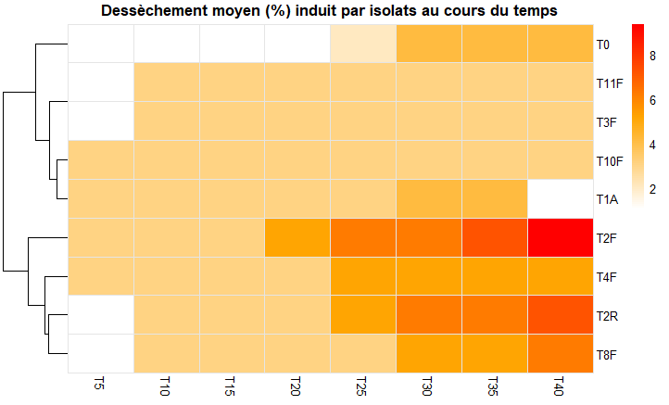

Fig 1. Heatmap showing the mean progression of leaf severity caused by different Fusarium solani strains over time (T5 to T40) according to the 5-class rating scale. Colors indicate the severity intensity, from white (low) to red (high). Strains are grouped based on the similarity of their aggressiveness profiles (row clustering).

In contrast, strains T0, T11F, T3F, and T10F displayed low aggressiveness, with severity remaining below 3 throughout the trial. Moreover, T2F, the most aggressive strain, induced wilting in 36.75% of tomato plants 40 days after inoculation (Figure 2). Strains T3F, T11F, T2R, and T1A caused wilting in 15–19% of plants at the same time point. Conversely, strains T8F, T10F, and T4F induced wilting in less than 10% of the plants.
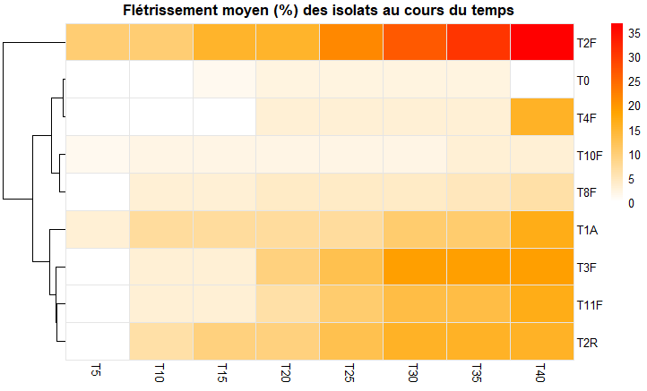

Fig 2. Heatmap showing the average progression of wilting percentage in plants inoculated with different Fusarium solani strains assessed at various times after inoculation (T0 to T40). Colors indicate the intensity of wilting, from white (low) to red (high). Isolates are grouped according to the similarity of their aggressiveness profile (row clustering).

3.1.2 In vitro effect of aqueous extracts and oils
The mean inhibition of Fusarium sp. mycelial growth varied significantly depending on the applied aqueous extract treatment p < 2.2e-16. The synthetic fungicide Mancozeb (MZ), used as a positive control, exhibited the strongest inhibition, with a mean rate exceeding 96.16%, which was statistically higher than most other treatments (Figure 3). Among the tested aqueous extracts, treatments T2B and T2C from Ocimum gratissimum at 50% and 75% concentrations demonstrated high inhibition rates of 88.89% and 94.84%, respectively, comparable to Mancozeb. Treatment T2A at 25% also showed notable activity, although slightly lower. Overall, treatments T2A, T2B, and T2C were among the most effective, with inhibition rates ranging from approximately 75% to 90%. Extracts T1A, T1B, and T1C from Azadirachta indica displayed moderate efficacy, with inhibition rates increasing with concentration. Only the highest dose (T1C) reached an inhibition level of 68.31%, comparable to some O. gratissimum treatments, though not significantly different from the J. curcas extracts. Extracts from J. curcas (T3A, T3B, and T3C) showed the lowest antifungal activity overall, with inhibition rates between 45% and 60%. Oils demonstrated increased efficacy with rising concentrations for all species (Figure 3). The A. indica oil treatment HN3 at 200 ppm achieved the highest mycelial growth inhibition at 84.64%. The J. circas oil treatment HJ3 at 200 ppm also showed notable activity, with an inhibition rate of 74.69%, although not significantly different from HN3. The lowest inhibition rate (25.95%) was observed with the J. circas essential oil at 100 ppm.

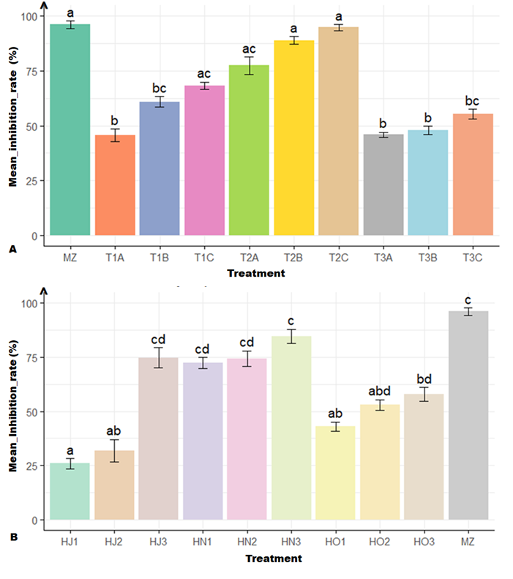

Fig 3. Effect of treatments on the mycelial growth of Fusarium solani: A. Mean mycelial inhibition (%) for the different aqueous extract treatments after 8 days of observation;B. Mean mycelial inhibition (%) for the different oil treatments after 8 days of observation. Error bars represent standard errors. Letters above the bars indicate statistically different groups according to Duncan’s post-hoc test (α = 0.05) following a Kruskal–Wallis test (p < 2.2e-16).

3.1.3 In vitro effect of Trichoderma sp.
The mean mycelial inhibition of Fusarium sp. varied according to the Trichoderma sp. treatment (p = 1.635e-16). The highest mean inhibition rate (66.92%) was observed when the medium was inoculated with a 15% Trichoderma sp. suspension (T4C) (Figure 4). The 10% suspension treatment (T4B) also showed a substantial inhibitory effect (63.37%), being statistically not different from T4C. The synthetic fungicide Mancozeb (MZ) remained the most effective treatment.

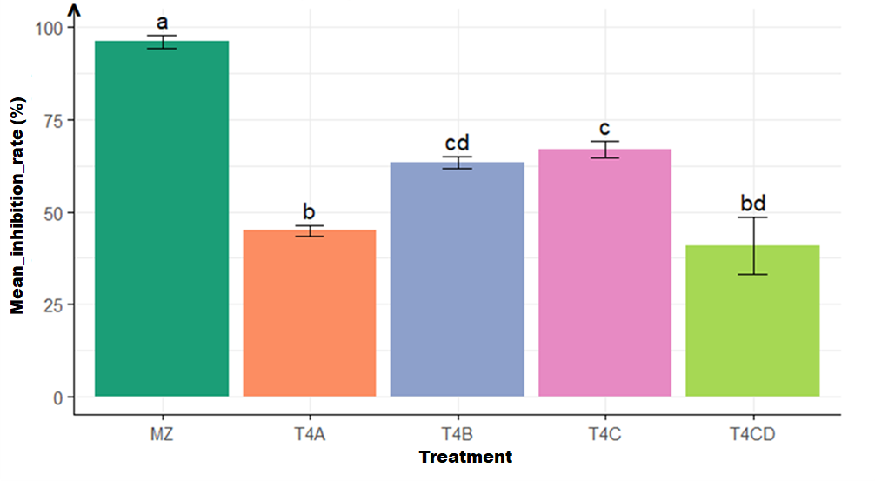

Fig 4. Mean mycelial inhibition (%) of Fusarium solani under different Trichoderma sp. treatments after 8 days of observation. Error bars represent standard error (±SE). Different letters above the bars indicate significant differences among treatments according to Duncan’s post-hoc test (α = 0.05) following a Kruskal–Wallis test (p = 1.635e-16).

3.1.4 Effect of treatments on Fusarium sp. contamination and seed germination
The lowest contamination rate (3.55%) was observed when tomato seeds were treated with Mancozeb (MZ) at 20 g per 5 kg of seeds (Figure 5). The efficacy of this treatment was similar to that of seeds treated with a Trichoderma sp. suspension at 10⁹ spores/mL (Tri), which showed a mean contamination rate of 4%. In contrast, untreated seeds exhibited a high contamination rate of up to 63.55% by Fusarium sp. Treatments with Azadirachta indica oil (HN) and extract (EN) showed comparable efficacy against Fusarium sp., similar to the Trichoderma sp. treatment, with mean contamination rates of 9.77% and 10.22%, respectively. Furthermore, germination rates for the biological treatments were statistically similar to the untreated control (Figure 5).

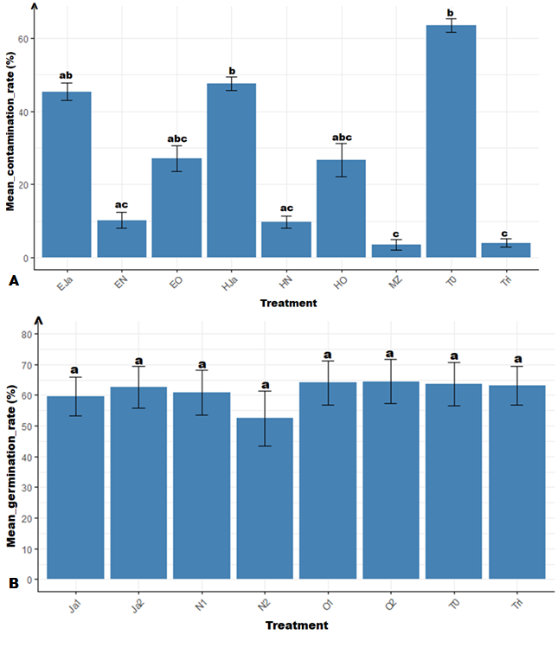

Fig 5. Effect of treatments on Fusarium sp. contamination and seed germination: A. Mean contamination rate (%) of seeds according to the applied treatments; B. Mean germination rate (%) of seeds according to the applied treatments. Vertical bars represent standard error (±SE). Treatments sharing the same letter are not significantly different according to Duncan’s test (α = 0.05).

3.2 Discussion
The pathogenicity assessment revealed marked variability among Fusarium sp. isolates on the tomato variety Cobra F1. Isolate T2F stood out for its high virulence, causing early wilting (from T5) and reaching a maximum incidence of 36.75% at T40. These observations support the existence of differences in pathogenic potential among strains, often linked to their belonging to different physiological races or their adaptation to a specific host (Edel-Hermann and Lecomte, 2019). In contrast, isolates T10F and T8F, which were weakly or non-pathogenic, may correspond to opportunistic or avirulent strains, a phenomenon previously reported by (Leslie and Summerell, 2006). From T20 onwards, a progressive increase in disease severity was observed for certain strains, peaking between T30 and T40, reflecting the typical infection dynamics of F. solani, where fungal multiplication and toxin production lead to rapid tissue deterioration (Mishra et al., 2021). Aqueous extracts of Ocimum gratissimum, particularly at 50% (T2B) and 75% (T2C), exhibited mycelial growth inhibition comparable to Mancozeb (>88%). This efficacy could be attributed to their high content of eugenol and thymol, known to disrupt fungal hyphal membrane integrity (Burt, 2004; Prakash et al., 2015). Azadirachta indica extracts showed moderate efficacy, consistent with the fact that limonoids, although bioactive, generally act more slowly than the phenolic compounds of O. gratissimum (Govindachari et al., 1998). The less effective Jatropha curcas extracts may suffer from limited solubility or restricted diffusion of active compounds in the PDA medium (Donlaporn Saetae and Suntornsuk, 2010). Essential oils confirmed a dose-dependent trend, with HN3 (A. indica, 200 ppm) and HJ3 (J. curcas, 200 ppm) exhibiting the highest inhibition (>74%). This aligns with the understanding that the volatility and lipophilicity of essential oils enhance their interaction with fungal membranes, causing leakage of cellular contents (Bansod and Rai, 2008). Mancozeb and Trichoderma sp. treatments provided the best protection against Fusarium sp. seed contamination (3.55% and 4%, respectively), confirming the effectiveness of both chemical and biological seed disinfection methods (Mathur and Kongsdal, 2003b; Woo et al., 2014). A. indica extracts and oils showed efficacy close to that of Trichoderma, validating their potential as natural alternatives (El-Mougy et al., 2004). Moreover, the biological and plant-based treatments did not compromise germination, which is crucial for practical adoption. This demonstrates that certain plant extracts can protect seeds without affecting their vigor (Bowers and Locke, 2000).

4. Conclusion

This study highlighted the variability of pathogenic potential among local Fusarium sp. strains on the tomato variety Cobra F1, with strain T2F distinguished by its high virulence in terms of both wilting incidence and symptom severity. In vitro evaluation showed that aqueous extracts of Ocimum gratissimum exhibited antifungal activity comparable to the reference chemical fungicide. Essential oils also demonstrated notable efficacy, particularly those from Azadirachta indica and Jatropha curcas. Furthermore, Trichoderma sp. confirmed its potential as a biocontrol agent, with significant mycelial inhibition and a marked reduction in seed contamination, comparable to chemical fungicide. These results suggest that certain combinations of biological treatments, notably O. gratissimum extracts and Trichoderma sp., could serve as viable or complementary alternatives to synthetic fungicides in integrated management strategies for tomato fusariose in Burkina Faso.]

Consent

Not applicable

Ethical approval

Not applicable

Disclaimer (Artificial intelligence)
Author(s) hereby declare that NO generative AI technologies such as Large Language Models (ChatGPT, COPILOT, etc.) and text-to-image generators have been used during the writing or editing of this manuscript.

References

1. Abawi, G.S., Corrales, P. (1990). Seed transmission and effects of fungicide seed treatments against Macrophomina phaseolina in dry edible beans. Turrialba, 40, 334-339.
2. Adeniyi, D.O., Orisajo, S.B., Adejobi, K.B. (2010). Effect of Neem (Azadirachta Indica) Leaf Extracts on the Rot Fungus (Fusarium Spp) Isolated from Kola Nuts. Int. J. Trop. Agric. Food Syst. 4, 83–85.
3. Akpo, A.F., Silué, Y., Nindjin, C., Tano, K., Kouamé, K.A., Tetchi, F.A., Lopez-Lauri, F. (2023). In vitro antifungal activity of aqueous extract and essential oil of African basil (Ocimum gratissimum L.). North Afr. J. Food Nutr. Res. 7, 136–145.
4. Bai, G., Shaner, G. (2004). Management and resistance in wheat and barley to Fusarium head blight. Annu. Rev. Phytopathol. 42, 135–161.
5. Bansod, S., Rai, M. (2008). Antifungal activity of essential oils from Indian medicinal plants against human pathogenic Aspergillus fumigatus and A. niger. World J. Med. Sci. 3, 81–88.
6. Bowers, J.H., Locke, J.C. (2000). Effect of Botanical Extracts on the Population Density of Fusarium oxysporum in Soil and Control of Fusarium Wilt in the Greenhouse. Plant Dis. 84, 300–305.
7. Burt, S. (2004). Essential oils: their antibacterial properties and potential applications in foods. Int. J. Food Microbiol. 94, 223–253.
8. Cooke, B.M., Jones, D.G., Kaye, B. (2006). The Epidemiology of Plant Diseases. Kluwer Academic Publishers, Dordrecht.
9. Dianda, O.Z., Wonni, I., Diana, F., Traoré, O., Zombré, C.T., Borro, F. (2020). In vitro efficacy of some plant aqueous extracts against two species of Lasiodiplodia associated to mango decline in Burkina Faso. Int. J. Biol. Chem. Sci. 14, 2699–2712.
10. Edel-Hermann, V., Lecomte, C. (2019). Current Status of Fusarium oxysporum Formae Speciales and Races. Phytopathology. 109, 512–530.
11. El-Mougy, N.S., Abd-El-Kareem, F., El-Gamal, N.G., Fotouh, Y.O. (2004). Application of fungicides alternatives for controlling cowpea root rot diseases under greenhouse and field conditions. Egypt J Phytopathol 32, 23–35.
12. Dabiré, D.T., Amadou, I.S., Schémaéza, B., Irénée, S. (2023). Effet de l’Еnrobage des Semences de Maïs (Zea mays L.) avec Trichoderma harzianum sur la Levée et la Croissance des Plantules au Burkina Faso. ESJ. 24, 90-110
13. Govindachari, T.R., Suresh, G., Gopalakrishnan, G., Banumathy, B., Masilamani, S. (1998). Identification of antifungal compounds from the seed oil of Azadirachta Indica. Phytoparasitica 26, 109–116.
14. Hamdache, A., Lamarti, A., Badoc, A. (2010). Résistance in vitro de Botrytis cinerea à trois fongicides. Bull Soc Pharm Bordx. 149, 103–114.
15. Kintega, K.R., Zida, P.E., Tarpaga, V.W., Sankara, P., Sereme, P. (2020). Identification of Fusarium species associated with onion (Allium cepa L.) plants in field in Burkina Faso. Adv. Biosci. Biotechnol. 11, 94–110.
16. Klotioloma, C., Jésus, F.I., Françoise, D.-G., Tchéféri, S., Lacina, N., Sahin, G.B., Pierre, N.W., Kotaix, A., Mathias, T., Maryse, A. (2023). Incidence de la pourriture noire des cabosses du cacaoyer (Theobroma cacao L.) et caractérisation de Botryodiplodia theobromae, agent causal en Côte d’Ivoire. J. Appl. Biosci. 184, 19349–19364.
17. Leslie, J.F., Summerell, B.A. (2006). The Fusarium Laboratory Manual, 1st ed. Wiley.
18. Mathur, S.B., Kongsdal, O. (2003a). Common laboratory seed health testing methods for detecting fungi.
19. Mathur, S.B., Kongsdal, O. (2003b). Common laboratory seed health testing methods for detecting fungi.
20. Meraj-Ul, H., Nandkar, P.B. (2012). Antagonistic effect of rhizospheric Trichoderma isolates against tomato damping-off pathogen, Fusarium oxysporum f. sp. lycopersici. Intl J Res BioSci 1, 27–30.
21. Mishra, S., Sahu, P.K., Agarwal, V., Singh, N. (2021). Exploiting endophytic microbes as micro-factories for plant secondary metabolite production. Appl. Microbiol. Biotechnol. 105, 6579–6596.
22. Prakash, B., Kedia, A., Mishra, P.K., Dubey, N.K. (2015). Plant essential oils as food preservatives to control moulds, mycotoxin contamination and oxidative deterioration of agri-food commodities Potentials and challenges. Food Control 47, 381–391.
23. Rodríguez, C.B., Visser, C.W., Schlautmann, S., Rivas, D.F., Ramos-Garcia, R. (2017). Toward jet injection by continuous-wave laser cavitation. J. Biomed. Opt. 22, 105003.
24. Saetae, Dolaporn, Suntornsuk, W. (2010). Antifungal activities of ethanolic extract from Jatropha curcas seed cake. J. Microbiol. Biotechnol. 20, 319–324.
25. Saetae, Donlaporn, Suntornsuk, W. (2010). Antifungal activities of ethanolic extract from Jatropha curcas seed cake. J. Microbiol. Biotechnol. 20, 319–324.
26. Sogoba, K.H., Ouattara, A., Nana, T.A., Nabelo, S., Koïta, K. (2023). Effect of Sorghum bicolor mycorrhizae on development of tomato in nursery. Mycopath 21, 19-24
27. Son, D. (2018). Analyse des risques liés à l’emploi des pesticides et mesure de la performance de la lutte intégrée en culture de tomate au Burkina Faso. Universite de Liege (Belgium) ProQuest Dissertations & Theses. Universite de Liege (Belgium).
28. Tiendrebeogo, A., Bonzi, S., Tobdem Dabiré, G., Son, D., Sanou, A., Sami Kambire, H., Somda, I., Legrève, A. (2023). Identification de mycètes cultivables associés aux maladies de la tomate au Burkina Faso. BASE 27, 255–269.
29. Woo, S.L., Ruocco, M., Vinale, F., Nigro, M., Marra, R., Lombardi, N., Pascale, A., Lanzuise, S., Manganiello, G., Lorito, M. (2014). Trichoderma-based products and their widespread use in agriculture. Open Mycol J 8, 71–126.
30. Zombre, T.C., Dianda, Z.O., Sondo, M., Soumaïla, M.A., Ouattara, B., Ouedraogo, R.S., Koïta, K., Wonni, I. (2025). Morphological and Molecular Characterization of Fusarium spp Associated with Solanaceous Seeds in Burkina Faso. J. Adv. Biol. Biotechnol. 28, 69–81.

