Evaluating Stability of Chickpea (Cicer arietinum L.) Genotypes Across Diverse Agro-climatic Zones in Chhattisgarh Using Different Stability Models.

Abstract: An investigation was conducted to evaluate the productivity of 11 chickpea genotypes alongside three checks, across four distinct locations within Chhattisgarh state i.e. Jagdalpur, Raipur, Kawardha and Ambikapur. Significantly varies responses were observed among the genotypes, environments and their interactions (GxE interaction), highlighting the substantial impact on yield outcomes. Utilizing stability parameters recommended by Eberhart and Russell, AMMI, GGE Biplot and WAASBY analysis, genotypes G11 (RG 2017-106) and G8 (RG 2017-36) were identified as stable performers with high yield potential across all locations. Kawardha location emerged as the most favourable location for these genotypes, followed by Raipur, while Ambikapur was concluded to be unfavourable location for these genotypes.
Keywords: Chickpea, G x E, Stability, Eberhart-Russell, AMMI, GGE Biplot, WAASBY.
Introduction:
Pulses historically have been one of the most important constituent of the Indian cropping and consumption patterns and long considered “the poor man's meat”, as it is one of the less expensive sources of protein (Mohanty and Satyasai, 2015). Among pulses, chickpea (Cicer arietinum) is preferred to food legumes because of its multiple uses, for growing population across the world (Samriti et al., 2020). Chickpea ranks third worldwide and its seeds contain >20% protein that is an important energy source for human beings (Saxena et al., 2021). Also, it is a good source of carbohydrate, dietary fibre, micronutrient like iron and zinc and also, vitamins (Jukanti et al., 2012).
Chickpea is a short-day plant and possess great diversity with respect to growth habit and morphology (Nandedkar et al., 2021) but its production is not consistent and varies widely due to its varied behaviour to photoperiod, temperature, and extended moisture stress (Velu and Shunmugavalli, 2005). The area under chickpea is rainfed, as well as a dearth of high yielding cultivars with a wider tolerance, the crop's production potential has yet to be completely realized when grown as rice fallow, the chickpea crop responds differently depending on the environment (Sharma and Johnson, 2017). Environmental variation causes challenges in breeding programs since, genotypes with improved yield performance, yield stability, grain quality, and other agronomic characteristics are chosen based on data collected over a small number of environments and years, which is not necessarily representative (Bhardwaj et al., 2017). Plant breeders' ultimate goal in a crop improvement program is to generate cultivars that can be adaptable to a wide variety of varying situations. The degree to which a cultivar adapts to diverse habitats is usually measured by how well it interacts with the various environments in which it is grown. When grown in a wide range of conditions, a variety or genotype is regarded more adaptable or stable, if it has a high mean yield but a low degree of variance in yielding capability (Ashraf et al., 2003). Plant breeders and agronomists in Chhattisgarh and across India are grappling with the issue of genotype x environment interaction (GEI). Eberhart and Russell (1966) proposed a methodology for evaluating genotype stability in various contexts. They define, a stable variety with a high mean yield across all locations, a unit regression coefficient (b = 1), and as little variation from regression as possible (S²d_{i} = 0) will be a better choice.
Multi environment yield trails (MET) generally provide yield data that are quite big. It is challenging to comprehend the general pattern of the data without some sort of graphical portrayal. The Biplot method offers a practical approach to this issue (Gabriel, 1971). A biplot is a scatter plot that graphically represents and considers a two-way table's row and column factors, allowing you to simultaneously analyse relationships between the row elements, relationships between the column factors, and the underlying interactions between the row and column factors (Yan and Tinker, 2006). The AMMI and GGE biplot models are thus characterised as potent analytical and remarking tools for multi-environment data structures in breeding operations (Yan et al., 2000; Samonte et al., 2005; Erdemci, 2018). Given that they relate to any two-way data matrices, which can be found in a range of experiments, these two statistical analyses (AMMI and GGE) are particularly interesting to agricultural researchers (Naroui et al., 2013). A two way data matrix is required for both AMMI and GGE biplot analysis. These analyses are combination of 2 statistical procedures i.e. analysis of variance (ANOVA) and principal component analysis PCA (Gauch, 2006). The notions that yield is assessed as the combined effect of G, E, and GE allows GGE biplot analysis to visually examine the G x E interaction pattern of multi environment data. Analysis based on best linear unbiased predictors (BLUPs) offer more predictive accuracy and precision for estimation of G X E interaction (Piepho et al., 2008). Weighted average of absolute scores of BLUPs (WAASB) is a mixed effect model, which calculates the stability and suitability of the genotypes and also the discriminative nature of the environment (Olivoto et al., 2019). Therefore, the current investigation was performed to study the magnitude of environment effect, nature and extend of G X E interaction on yield of desi type chickpea genotypes and also to evaluate the stability of genotypes under different agro-climatic conditions of Chhattisgarh.
Material and Methods:
Chhattisgarh State comprises three distinct agro-climatic zones: the Bastar Plateau Zone, C.G Plains Zone, and Northern Hills Zone. For the experiment, four locations representing these zones were chosen: Jagdalpur (L-1) from the Bastar plateau zone, Raipur (L-2) and Kawardha (L-3) from the CG plains, and Ambikapur (L-4) from the Northern Hills Zone. The experiment was conducted during the Rabi season of 2020-21 at Research Farms, CoA, IGKV, situated at these four diverse locations in Chhattisgarh.
Eleven chickpea genotypes, including three checks (Indira Chana-1, JAKI 9218, and JG-16), were selected for the study (refer to Table 1). Planting of the genotypes followed a randomized complete block design with two replications at each location, under a rice-based cropping system. Each genotype was planted in four rows, each 4 meters in length, maintaining a spacing of 30 cm between rows and 10 cm between plants. Agronomic practices were carried out as per site-specific requirements.
Data collection focused solely on yield (in kg/ha) and was subsequently analyzed using PB Tools software for stability assessment based on the Eberhart and Russell Model, AMMI, and GGE Biplot method. WAASBY analysis was carried out using “metan” package (Olivoto & Lúcio, 2020) using R software version 2024.09.0 (R Core Team, 2023).
Table1: Means of treatment for different Seasons

Code | Treatment | Yield (kg/ha)
Code | Treatment | Raipur | Kawardha | Ambikapur | Grand Mean
G1 | Indira Chana -1 (Ch) | 890.00 | 1462.67 | 541.66 | 964.77
G2 | JAKI 9218 (Ch) | 956.33 | 1535.00 | 625.00 | 1038.78
G3 | JG 16 (Ch) | 923.66 | 332.33 | 798.66 | 684.88
G4 | RG 2016-48 | 533.33 | 311.00 | 354.00 | 399.44
G5 | RG 2016-73 | 868.00 | 277.66 | 292.00 | 479.22
G6 | RG 2016-114 | 830.33 | 1264.67 | 861.33 | 985.44
G7 | RG 2016-115 | 781.66 | 1297.33 | 639.00 | 906.00
G8 | RG 2017-36 | 1379.00 | 1412.33 | 805.33 | 1198.89
G9 | RG 2017-85 | 553.33 | 262.66 | 625.00 | 480.33
G10 | RG 2017-100 | 1,082.00 | 1208.33 | 625.33 | 971.88
G11 | RG 2017-106 | 1526.33 | 1486.00 | 1326.33 | 1446.22
 | Grand Mean | 938.54 | 986.36 | 681.242

Result and Discussion:
Among the 4 different locations selected for the experiment, the first location i.e. Jagdalpur was dropped out from the analysis as the location experienced high rainfall during the initial stages of the crop and resulting in poor germination and inconsistent yield data with very low genotype means. As a result, only three locations i.e. Raipur, Kawardha, and Ambikapur were subjected to analysis.
AMMI Analysis: -
Identifying high yielding stable genotypes:
For investigating the main effects and interactions, a yield-based AMMI 1 biplot was constructed. The additive main effects, or mean yield, are displayed along the abscissa of the AMMI biplot (Fig. 1), whereas the ordinate represents the multiplicative interaction, or 1st PCA. Using either the IPCA axis or the IPCA score the biplot can be interpreted as, if the main effect's IPCA score is near zero it suggests very little interaction. Additionally, a genotype and environment having same sign on the IPCA axis, shows positive interaction; whereas, when the signs disagree, an interaction is considered negative.

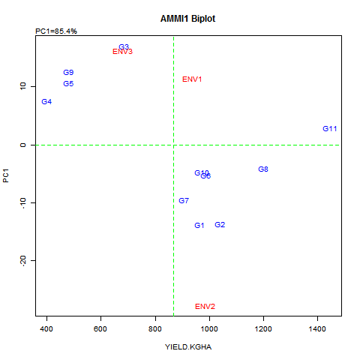
Fig.1 AMMI biplot for yield kg/ha.
The AMMI biplot space (Fig. 1) is divided into 4 sections: two sections on the left represent the low yielding environment, and two sections on the right, which are located on the right side of the grand mean level, represent the high yielding environment. The left side is again separated into two sections: section 1 (up left) has stable but low yielding genotypes, such as G4, G3, G9, and G5, while, section 4 (down left) represents unstable and low yielding genotypes (no genotypes under this section). The right side is divided into two portions as well: section 3 (down right) represents unstable but highly productive genotypes, such as G7, G1, G2, G10, G6, and G8, and section 2 (up right) represents the ideal genotype, G11.
According to AMMI model, the genotypes with means greater than grand mean and IPCA score close to zero are said to possess general adaptability across all environments (Rashidi et al. 2013). Among all genotypes, G11 is the only genotype with a mean surpassing the grand mean and an IPCA score nearly zero, indicating its broad adaptability to all the environments.
As depicted in Fig.1, genotypes G3, G9, G5 and G4 showed specific adaptability for environment 3, exhibiting grain yield lesser than mean, with similar signs on IPCA axis suggests a positive interaction with environment. Conversely, genotype G11 shows general adaptability, characterized by a grain yield exceeding the mean and minimal interaction (close to zero) with environment. Genotypes G10, G6, G8, G7, G1, and G2 exhibit specific adaptability to environment 2, with positive interactions and grain yields surpassing the mean.
Identifying favourable environment for chickpea genotypes:-
To assess the suitability of environments, their positions on the AMMI biplot are compared to each other, and interpretations are derived accordingly. When environments align along a perpendicular line on the biplot, it indicates similarity in their means, whereas environments falling on a horizontal line share similar interaction patterns. Consequently, according to Figure 1, the environment, Raipur and Kawardha emerge as the most productive and highly interactive, thus, most suitable for specifically adapted genotypes.
In Fig.2, the AMMI biplot illustrating yield or PC1 versus PC2 biplot aids in understanding the magnitude of interaction between genotype and environment. Genotypes and environments positioned farthest from the origin are considered more responsive. Additionally, when genotypes and the environments are located within the same sector, they are considered to have a positive interaction, whereas, if they fall into different sector, they interact negatively. The PC1 component accounted for 85.4% of G x E interaction, while PC2 accounted for only 14.6% (Fig.1). Analysis of the distribution of genotype points in the AMMI II biplot revealed that only genotype G11 was closely scattered around the origin, indicating minimal interaction with the environment. Conversely, the remaining ten genotypes were scattered away from the origin, signifying their sensitivity to environmental interactive forces.
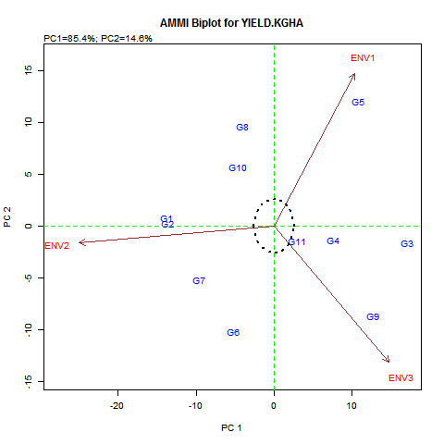
Fig.2 AMMI II biplot, PC1 vs PC2

Table 2: AMMI ANALYSIS
 | percent | acum | Df | Sum.Sq | Mean.Sq | F.value | Pr.F
PC1 | 85.4 | 85.4 | 11 | 4066886.8 | 369716.99 | Inf | 0
PC2 | 14.6 | 100.0 | 9 | 695592.3 | 77288.03 | Inf | 0
PC3 | 0.0 | 100.0 | 7 | 0.0 | 0.00 | Inf | 0

Interaction of genotypes with specific environmental conditions was interpreted by projection of genotypes points on to environment spokes. Consequently, based on this analysis, genotype G5 exhibited positive interaction with the Raipur location, while genotypes G7, G6, G1, G2, G10, and G8 displayed positive interaction with the Kawardha location. Additionally, genotypes G3, G4, and G9 were observed to have positive interaction with the Ambikapur location.
GGE Biplot Analysis:
Relationships among test environments:
To study the pattern of the test environments and the interrelationships among them, the environment vector view of GGE biplot is used (Yan 2000 and Yan and Tinker, 2006, Erdemci et al. 2018, Farshadfar et al. 2011). The biplot explained 95.2% of the total variation, surpassing ≥50% threshold, thereby depicting the correlation coefficient between any two environments reliable (Yan et al., 2000). The interpretation of correlation between the environments is facilitated by environment vectors, which are lines connecting test environment to the biplot origin and the cosine of the angle between these vectors indicates the correlation between environments (Yan and Tinker, 2006). In present study, according to the Fig. 3 all the 3 environments are positively correlated because of presence of an acute angle between them. Furthermore, absence of any wide obtuse angle indicates absence of large GE.
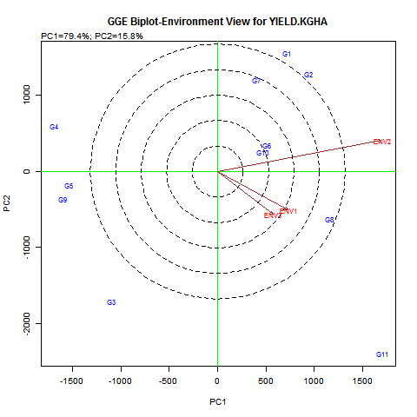
Fig. 3: Biplot representing discriminating ability and relationship among test environment
The distance between the environments measures their dissimilarity in discriminating the genotypes, based on which two groups were formed. Kawardha got categorized in group one, whereas, Ambikapur and Raipur fell under same 2nd group indicating being closely associated and therefore, similar information about the genotypes can be obtained from them and thus, one of them can be dropped to reduce the testing cost without loss of much information about genotypes.
In Fig. 3, the length of environment vectors indicates the discriminating ability of the environments. Among the three environments, Kawardha was found to be most discriminative, followed by Raipur, whereas, Ambikapur was found to be least discriminating or non-informative i.e. provides little information about genotypes. Consequently, it is advisable not to utilize Ambikapur as a test environment further.
According to Fig. 4, Raipur emerged as the most representative environment compared to the other two environments as indicated by the smallest angle formed between its environment vector and the average environment axis (AEA). On the other hand, Kawardha and Ambikapur were found to be least representative. Despite Kawardha being least representative, but discriminative could be advantageous for selecting specifically adapted genotypes; also can be useful for culling unstable genotypes.
Ideal environment:-
According to Yan and Tinker, 2006, the ideal test environment is both highly discriminative and most representatives of all the target environments. An ideal test environment as depicted in Fig. 4 environment is positioned at the center of the concentric circle, on the AEA line (indicating high representativeness), and at a distance from the origin equal to the longest vector (showing high informativeness). Among the three test environments, Kawardha closely aligns with this ideal point. Therefore, Kawardha is considered the best choice for a test environment.
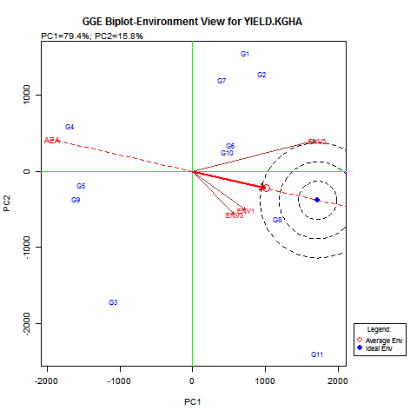
Fig. 4: GGE Biplot showing ideal environment and representativeness of environments
Genotype evaluation based on GGE Biplot:
Performance of genotypes in specific environment was evaluated, genotypes G4, G9, and G5 exhibited below-average performance across all three locations. G3 performed below average in all locations except Ambikapur, where it outperformed the average. G8 and G11 surpassed the average performance in all three locations. G10 also performed above average in all environments except Ambikapur, where its performance was close to average. G6's performance was close to average in Raipur, above average in Kawardha, and below average in Ambikapur. G7, G1, and G2 performed above average in Kawardha but below average in Raipur and Ambikapur (Fig. 5).
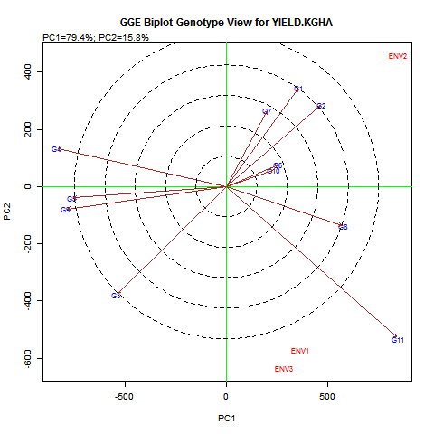
Fig. 5: GGE Biplot showing performance of genotype in each environment
Based on performances of these genotypes, the environments were ranked for their suitability for cultivation of these genotypes. Kawardha which offered maximum 7 genotypes performing better than average was ranked first, followed by Raipur offering 3 genotypes was ranked second and in Ambikapur only 2 genotypes performed better than average therefore, ranked last. (Fig. 6).
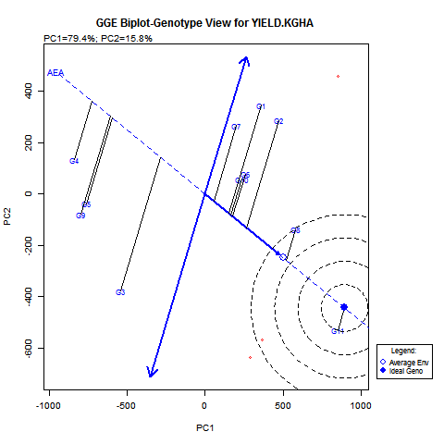
Fig. 6: GGE Biplot showing Ideal genotype and mean performance of all the genotypes
Furthermore, in Figure 6, the single-arrowed line known as the AEC abscissa, points towards higher mean yield of genotypes across environments. Thus, illustrating G11 having the highest mean yield, followed by G8, G2, with G4 exhibiting the lowest yield.
On the other hand, the AEC ordinate, the double-arrowed line, signifies greater variability but poor stability of any genotype in either direction. Based on which, the G3 was identified as highly unstable, whereas G11 was found highly stable (Fig. 6). The instability of G3 results from its above-average yield in Ambikapur, with below-average yields in Raipur and Kawardha.
Ranking genotypes relative to ideal genotype:
A genotype that exhibits both high mean performance and stability across various environments is considered ideal. In Figure 6, the "ideal" genotype is depicted as the central point within concentric circles, positioned on the AEA axis in the positive direction and has a vector length equivalent to the longest vectors of genotypes with the highest mean performance on the positive side of the AEA. Thus, genotypes closer to this "ideal genotype" are preferred over others. Consequently, G11 emerges as the ideal genotype and the most desirable one. Despite G4's consistency, its yield was lower than that of the highly variable (least stable G3), because G3 demonstrated satisfactory performance in at least one environment, specifically E3.
Comparison among all genotypes:
The distance between two genotypes provides an estimate or approximation of the Euclidean distance between them, representing the overall dissimilarity. When the distance between two genotypes is significant, it indicates a high level of dissimilarity, suggesting they are markedly different from each other. In the current experiment, genotype G1 and G11 were observed to be distinctly dissimilar. Similarly, genotypes G4, G3, G5, and G9 also exhibited dissimilarity from G11. Conversely, genotypes G6 and G10, as well as G5 and G9, were found to be similar to each other (Fig. 3).
A virtual genotype, representing an average value across environments, is depicted by the biplot origin, indicating zero contribution to both genetic (G) and genotype-environment interaction (GE). The length of the genotype vector, indicating the distance from a genotype to the biplot origin, signifies the deviation of the genotype from the average. Hence, genotypes positioned close to the biplot origin have minimal contributions to both G and GE, unlike those with longer vectors, which exhibit significant contributions to either G, GE, or both. However, substantial contributions can result in genotypes being the best, poorest, or most unstable. In our experiment, three genotypes were identified with long vectors, among which G11 emerged as the best genotype, G4 as the poorest, and G3 as the most unstable.
What won where: The ‘which-won-where’ biplot visually represents the crossover of genotype-environment interactions and specific adaptations. It is created by connecting the most distant genotypes to form a polygon (Kumar and Kumar, 2021). The genotypes located at the vertices of this polygon represent the best or worst performers in one or more environments, with the vertex genotype representing the highest performance in the respective sector or environment (Yan and Tinker, 2006).
According to Fig. 7, G2 emerged as the top performer in Kawardha, while G11 took the lead in Raipur and Ambikapur, followed by G8.
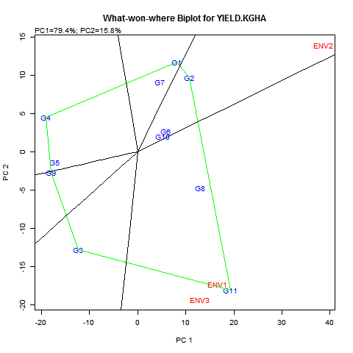
Fig. 8: What-won-where Biplot for yield

Eberhart and Russell Stability Analysis:
Results of analysis of variance for stability of yield of chickpea genotypes over three different locations given in Table 3. revealed that the mean sum of square difference among the genotypes and the environment were highly significant for yield indicating the presence of variability among the genotypes as well as the environment. Variance owing to Genotype x Environment was determined to be highly significant, indicating that further investigation to predict stability parameters can be done. It also suggested that genotypes and environmental conditions in interaction with each other have a significant impact on grain yield. The sum of squares due to Environment + Genotype X Environment was partitioned into environment (Linear), Genotype X Environment (Linear) and the remaining part was distributed to the residue called pooled deviation. The pooled deviation is further portioned into component associated with genotypes. The significant of different effects was tested by variance ratio as per Eberhart and Russell (1966). The linear component of environment was found to be significant for yield whereas the Environment X Genotype (linear) was found to be non-significant which indicated that variation in the performance of varieties is entirely unpredictable and hence, varieties may perform better in the favourable environment for the yield (Sharma and Johnson, 2017).

Table 3: Pooled analysis of Variance for Stability performance (Eberhart and Russel Model) for grain yield

SV | DF | MSS
Variety | 10 | 318867.43**
Environment | 2 | 296249.03*
Var. X Envion. | 20 | 79374.65**
Env+Var X Env | 22 | 99,090.51
Env (Linear) | 1 | 592498.07*
Env X Var (Lin) | 10 | 77,719.86
Pooled Deviation | 11 | 73663.13**
Pooled Error | 60 | 16,970.57
Total | 32
** and *Significant at 1 and 5 % level of probability
Eberhart and Russell (1966) defined a stable genotype as the one which showed high mean yield, regression coefficient (b_{i}) around unity and deviation from regression near to zero. Accordingly, the mean and deviation from regression of each genotype were considered for stability and linear regression was used for testing the varietal response. Further the genotypes were divided into following categories (Ramezanil and Torabil, 2011). Genotypes with high mean, b_{i} = 1 and no significant difference in S²d_{i} are suitable for general adaptation, so that they can be recommended for all environmental conditions and they are considered as stable genotypes. Genotype G11 having highest mean yield, non-significant S²d_{i} and regression coefficient nearly equal to 1 (Table 4) falls under this category have general adaptability and is rewarding for unfavourable conditions too. Genotypes with high mean, b_{i} > 1 with no significant difference in S²d_{i} are considered as genotype with average stability and they can be recommended for favourable environments. Genotypes with low mean, b_{i} < 1 with no significant difference in S²d_{i} are considered as genotype with low stability. Genotypes with a few b_{i} values with significant difference in S²d_{i} are unstable and are considered as genotype with poor stability.
The genotypes, G8, G10, G9 and G4 deviated non-significantly from zero (Table 3). Hence, they are stable. However, among these genotypes, G8 and G10 are found to be highly responsive and also recorded mean values higher than the grand mean. Therefore, these two genotypes can be recommended for favorable environment. Genotypes, G9 and G4 are low responsive and also have mean yield lower than the grand mean. Thus, these genotypes have low stability and cannot be recommended. Similar evaluation of genotypes for stability in different environment was performed by Shivani and Sreelakshmi, 2015; Tilahun et al., 2015a; Tilahun et al., 2015b; Mahmud et al., 2017 and Sharma et al., 2019.
Table 4: Estimate of different stability parameters for grain yield
Treatment | Mean | Stability parameter (S²d_{i}) | Reg. Coefficient (b_{i})
RG 2017-106 | 1446.22 | -3195.92 | 0.81
RG 2017-36 | 1198.89 | -3456.8 | 2.07
JAKI 9218 (Ch) | 1038.78 | 103891.85* | 2.42
RG 2016-114 | 985.44 | 73696.66* | 0.84
RG 2017-100 | 971.89 | -4952.44 | 1.87
Indira Chana - 1 (Ch) | 964.78 | 100045.3* | 2.46
RG 2016-115 | 906.00 | 92374.19* | 1.62
JG 16 (Ch) | 684.88 | 149085.16** | -0.86
RG 2017-85 | 480.33 | 25858.62 | -0.88
RG 2016-73 | 479.22 | 193599.65** | 0.72
RG 2016-48 | 399.44 | 21122.76 | 0.14
Grand mean | 868.71
** and *Significant at 1 and 5 % level of probability
WAASBY analysis:
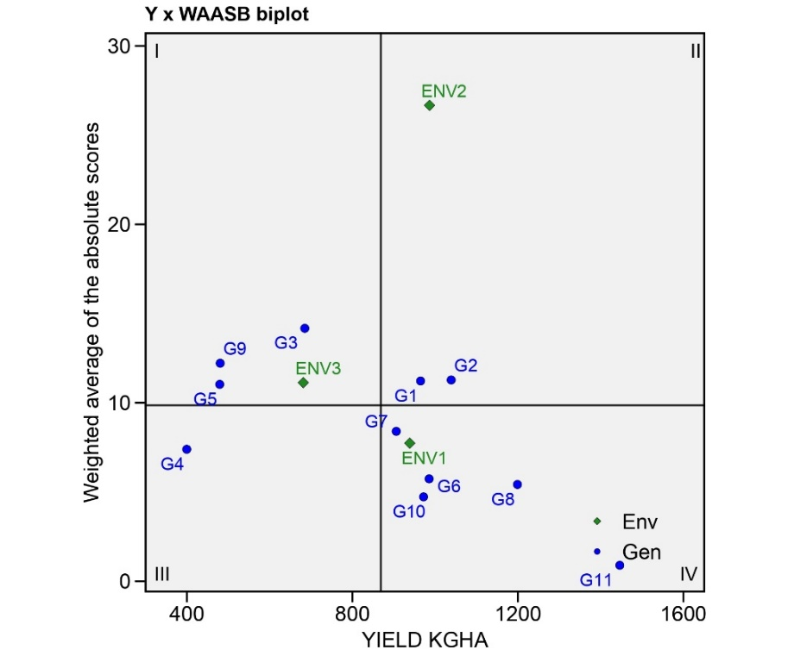
AMMI stability indices and other indices often rank genotypes while giving equal weightage to both yield and stability. But, yield can be given more weightage over stability to select for high yielding and stable genotypes. Hence, in the WAASBY analysis a weight age of 60:40 was given to yield and stability respectively. WAASB scores were plotted against yield (Y) to obtain a WAASBY biplot (Olivoto et al., 2019). The genotypes and environments are then plotted on the biplot based on mean yield and WAASB scores (Fig. 9). The biplot is dived into four quadrants. The first quadrant comprises of low yielding and unstable genotypes (G5, G9 and G3). Environment E3 i.e. Ambikapur also falls under this quadrant indicating its high discriminative ability in selecting genotypes. The second quadrant comprises of unstable but high yielding genotypes (G1, G2) while, the Kawardha (E2) location is considered to be productive and discriminative. The third quadrant comprises of low yielding but stable genotypes (G4). The fourth quadrant comprises of stable and productive genotypes (G7, G10, G6, G8 and G11). The location Raipur (E1) in this quadrant are said to be highly productive but have low discriminating ability.
Fig. 9: WAASBY biplot with Yield KGHA as the response variable (Y)

Chickpeas, as cool-season crop, demands less moisture and thrive in dry conditions, attributed to their deep taproot system. Conversely, heavy rainfall seasons often result in reduced yields due to excessive vegetative growth, leading to lodging issues and increased susceptibility to diseases. Regions known for high chickpea yields and quality seeds typically experience lighter, evenly distributed rainfall. Additionally, chickpeas thrive on well-drained black cotton and red laterite soils, while saline, alkaline, and waterlogged soils are unsuitable for cultivation.
In order to evaluate the suitability of the three different locations for the cultivation of these genotypes and to find out the best favourable location for cultivation of the genotype, environment index was calculated for each location (Table 5). For the Raipur location, the environment index was found 69.83, while for Kawardha it was 117.65. On the other hand, Ambikapur region showed a negative environment index of -187.47. Hence, in the Chhattisgarh plain zone, both Raipur and Kawardha exhibited positive environment index values, indicating favorable conditions for chickpea genotypes. Among these, Kawardha had the highest environment index value, making it the most favorable location among all three, followed by Raipur.
The superior performance of genotypes in Kawardha, yielding higher results, can be attributed to its favorable climatic and soil conditions prevalent in the region. Kawardha experiences lower rainfall compared to other regions, and approximately 70% of its area is covered by black soil, known for its moderate infiltration and water holding capacities, making it suitable for chickpea cultivation.
Conversely, the environment index value for Ambikapur in the Northern Hills Zone was the lowest and negative (-187.47), indicating its unfavorable or least favorable status among all locations. The area received heavy rainfall both during the early and later stages of the crop growth. Additionally, the soil in Ambikapur is characterized by high concentrations of calcium and magnesium salts, resulting in salinity and alkalinity issues, posing challenges for optimal crop performance.
Table 5: Environment index values for different locations
CODE | Location | Environment Index
E1 | Raipur | 69.83
E2 | Kawardha | 117.65
E3 | Ambikapur | -187.47

Examining the performance of genotypes in each specific environment (Table 1), comparisons were made with the check JG-16 (G3). In the Raipur region, it was observed that the genotype G11 outperformed JG-16 (with a yield of 1526.33 Kg/ha), followed by genotypes G8 and G10 with yields of 1379 Kg/ha and 1082 Kg/ha, respectively. Similarly, in the Kawardha region, several genotypes including G11, G8, G7, G6, and G10 exhibited superior performance compared to JG-16 (yielding 332.33 Kg/ha), with recorded yields of 1486, 1412.33, 1297.33, 1264.67, and 1208.33 Kg/ha, respectively. Meanwhile, in Ambikapur, where JG-16 yielded 798.66 Kg/ha, the genotypes outperforming this check included G11, G6, and G8, with respective yields of 1326.33, 861.33, and 805.33 Kg/ha. The grain yield performance and stability status of G11, followed by G8, were consistently higher and superior to that of the chickpea varieties used as checks across all locations, establishing G11 as the ideal genotype. The results obtained from the Eberhart and Russel model, AMMI analysis, GGE Biplot and WAASBY analysis were consistent with each other.
Conclusion:
This investigation into the productivity of chickpea genotypes across various locations in Chhattisgarh has demonstrated significant yield variations due to genotype, environment and their interactions. Utilizing stability parameters and different stability models enabled the identification of genotypes G11 (RG 2017-106) and G8 (RG 2017-36) as high yielding and stable across the tested environments. The Kawardha location was found to be the most favourable for these genotypes. These results highlight the critical role of selecting the right genotypes and environments to improve chickpea productivity, which has the potential to greatly benefit local agricultural practices in Chhattisgarh.
References:
Ashraf, M., Bakhh, A. and Haqqani,A. M. 2003. Genotype – environment interaction for grain yield in Chickpea (Cicer arietinum L.). Pakistan J. Bot., 35(2): 181-186.
Bhardwaj, R.K, Gautam, S.S. and Saxena, R.R. 2017. Assessment of G x E interaction and adaptation of chickpea in Chhattisgarh State using AMMI model. Int.J.Curr.Microbiol.App.Sci. 6(7): 834-844
Eberhart, S.A. and Russell, W.A. 1966. Stability parameters for comparing varieties. Crop Sci., 6:36- 40.
Erdemci, I. 2018. Investigation of Genotype X Environment interaction in chickpea genotypes using AMMI and GGE biplot analysis. Turk J Field Crops. 23(1), 20-26.
Farshadfar, E., Zali, H. and Mohammadi, R. 2011. Evaluation of phenotypic stability in chickpea genotypes using GGE-Biplot. Annals of Biological Research, 2 (6):282-292.
Gabriel, K.R. 1971. The biplot graphical display of matrices with applications to principal component analysis. Biometrika 58, 453–467.
Gauch, H.G. 2006. Statistical analysis of yield trials by AMMI and GCE. Crop science 46: 1488- 1500. http://dx.doi.org/10.1007/BF00021563
Jukanti, A.K, Gaur, P.M, Gowda, C.L.L., Chibbar, R.N. 2012. Nutritional quality and health benefits of chickpea (Cicer arietinum L.): A Review. Br J. Nutr. 108: S11-S26.
Kanouni, H., Farayedi, Y., Saeid, A. and Sabaghpour, S.H. 2015. Stability analyses for seed yield of chickpea (Cicer arietinum L.) genotypes in the western cold zone of Iran. Journal of Agricultural Science; Vol. 7, No. 5.
Kumar, N. and Kumar, V. 2021. GGE biplot and AMMI analysis of advanced breeding lines of linseed. 2021. Electronic Journal of Plant Breeding, 12 (2): 455-463.
Mahmud, F., Ullah, M.Z. and Huda, K.M.K. 2017. Genotype-Environment interaction for seed yield and yield contributing characters in chickpea (Cicer arietinum L.). Bangladesh J. Pl. Breed. Genet., 20(1): 09-12.
Mohanty, S. and Satyasai, K.J. 2015. Feeling the Pulse, Indian Pulses Sector. NABARD Rural Pulse, 10: 1-4.
Nandedkar, N., Saxena, R.R., Dixit, G.P., Rawte, S. and Saxena, R.R. 2021. DUS based Agro-morphological characterization and classification of desi chickpea (Cicer arietinum L.). The Pharma Innovation Journal; 10(11): 716-722
Naroui, M.R.R., M.A. Kadir, M. Y. Rafii, Z. E. HawaJaafar, M. R. Naghavi and F. Ahmadi. 2013. Genotype × environment interaction by AMMI and GGE biplot analysis in three consecutive generations of wheat (Triticum aestivum) under normal and drought stress conditions. AJS 7 (7):956-961.
Olivoto, T., Lúcio, A. D. C., da Silva, J. A. G., Marchioro, V. S., de Souza, V. Q., & Jost, E. (2019). Mean Performance and Stability in Multi-Environment Trials I: Combining Features of AMMI and BLUP Techniques. Agronomy Journal, 111(6), 2949-2960. https://doi.org/https://doi.org/10.2134/agronj2019.03.0220
Olivoto, T., & Lúcio, A. D. C. (2020). metan: An R package for multi‐environment trial analysis. Methods in Ecology and Evolution, 11(6), 783-789.
Piepho, H., Möhring, J., Melchinger, A., & Büchse, A. (2008). BLUP for phenotypic selection in plant breeding and variety testing. Euphytica, 161(1), 209-228.
R Core Team. (2023). R: A Language and Environment for Statistical Computing. https://www.R-project.org/
Ramezanil, A and Torabil, M. 2011. Stability analysis of grain yield and its components of rice (Oryza sativa L.) genotypes. Electronic Journal of Plant Breeding, 2(4):484-487.
Rashidi, M., Farshadfar, E., and Jowkar, M. M. 2013. AMMI Analysis of Phenotypic Stability in Chickpea Genotypes over Stress and Non-stress Environments. Intl. J. Agri. Crop Sci., 5: 253-260.
Samonte, S.O.P.B., L.T. Wilson, A. M. Mc Clung and J. C. Medley. 2005. Targeting cultivars onto rice growing environments using AMMI and SREG GGE biplot analyses. Crop Sci. 45: 2414-2424.
Samriti, Sharma, S., Sharma, R. and Pathania, A. 2020. Trends in area, production, productivity and trade of chickpea in India. Economic Affairs, 65(2): 261-265.
Saxena, R.R., Nandedkar, K., Rawte, S., Porte, S.S., Xalxo, M.S., Parikh, M., Saxena, R.R. 2021. Exploiting Genomic Resources for Efficient Utilization of Chickpea (Cicer arietinum L.) Crop Improvement based on Agro-morphological, Yield and Nutritional Traits. Legume Research. DOI: 10.18805/LR-4696.
Sharma, R.N and Johnson, P.L. 2017. Genotype x environment interaction and stability analysis for yield traits in chickpea (Cicer arietinum L.). Electronic Journal of Plant Breeding, 8(3): 865-869.
Sharma, R.N., Johnson, P.L., Nanda, H.C., Sao, A. and Sarawgi, A.K. 2019. Genetic variability, character association and co-heritability for yield traits over the locations in chickpea (Cicer arietinum L.). Legume Research, 1-5
Shivani D. and Sreelakshmi, Ch. 2015. Stability analysis in chick pea, Cicer arietinum L. Journal of Global Biosciences, 4(7): 2822-2827.
Tilahun, G., Mekbib, F., Fikre, A. and Eshete, M. 2015 a. Genotype x environment interaction and stability analysis for yield and yield related traits of Kabuli-type Chickpea (Cicer arietinum L.) in Ethiopia. African Journal of Biotechnology, 14(18): 1564-1575.
Tilahun, G., Mekbib, F., Fikre, A. and Eshete, M. 2015 b. Genotype x environment interaction and stability analysis for yield and yield related traits of desi-type chickpea (Cicer arietinum L.) in Ethiopia. Current Research in Agricultural Sciences, 2(3):100-113
Velu, G. and Shunmugavalli, N., 2005. Genotype x environment interaction in sesame (Sesamum indicum L.). In: J. Fernandez Martinez (ed.), Sesame and Safflower Newsletter. Institute of Sustainable Agriculture (ISA), Spain. No. 20, pp.1-5.
Yan, W. and N.A. Tinker. 2006. Biplot analysis of multi-environment trial data: Principles and applications. Canadian Journal of Plant Science 86: 623–645.
Yan, W., L.A. Hunt, Q. Sheng and Z. Szlavnics. 2000. Cultivar evaluation and mega-environment investigation based on the GGE biplot. Crop Sci. 40:597–605. ISSN 1435-0653.

