Original Research Article
Validation of Pregnancy Associated Glycoprotein Based Rapid Diagnosis Kit with the Aid of Ultrasonography in Cattle and Buffaloes

ABSTRACT
Early pregnancy diagnosis in the dairy cattle is always challenging, which makes the dairy as profitable by timely conception and timely calving procedures. Various methods are available for diagnosing pregnancy in cows, including estrus observation, rectal palpation, and ultrasonography , which are commonly employed examination techniques. The present study was conducted in the Veterinary College, Shivamogga, Karnataka, by using Pregnancy Associated Glycoprotein (PAG) based test kits as a reliable method and was validated in 141 dairy animals. The results of the present study revealed that, these tests allowed for early detection of pregnancy and could be easily integrated into farm routines, with proven specificity and accuracy and in some tests, there was a chance of false positive and false negative results but, such proportion is less. To optimize herd management and productivity, verifying negative test outcomes, this kit could be used and whenever there was a doubt, ultrasound examination was carried out for accurate diagnosis.
Key words: Pregnancy, Cattle, Buffaloes, Pregnancy Associated Glycoprotein (PAG) Kit.

1. INTRODUCTION
Diagnosis of pregnancy at an early stage is important for profitable dairy enterprise. An early and precise diagnosis of reproductive dysfunctions or anomalies holds paramount importance for enhancing reproductive management in livestock. Achieving high reproductive efficiency is essential for optimizing lifetime production in dairy animals. Timely identification of reproductive issues, particularly through early pregnancy diagnosis, plays a pivotal role in reducing the calving interval by promptly addressing open animals and facilitating their treatment and rebreeding. This approach aims to maintain a postpartum barren interval within optimal parameters, ideally around 60 days.
Pregnancy diagnosis is an important requirement for successful dairying and to enhance the wealth of farmers. Pregnancy diagnosis within 4 to 6 weeks after Artificial insemination (AI) in dairy cows is critical for identifying non-pregnant cows and making them enable for rebreeding so that time from calving to conception (days open) and number of services will be reduced. Rectal palpation is the oldest and most widely used method for pregnancy diagnosis in dairy cattle and it has its own disadvantages of rectal bleeding, early embryonic mortalitydue toto rupture and damage to corpus luteum with extreme stress on the pregnant animal and needs a skilled veterinarian. Further, the pregnancy diagnosis of pregnancy by per rectal palpation can be achieved only after 40-45 days after insemination in cows only by the experienced veterinarians. Advanced methods currently available for pregnancy diagnosis such as ultrasonography and radio immunoassay are developed and most used in developed countries and cannot be easily implemented in the rural areas of developing countries.

A reliable and effective method for early non-pregnancy detection in cattle involves the estimation of progesterone concentrations in plasma, serum, or milk samples. The use of progesterone as a diagnostic marker has been facilitated by advancements in analytical techniques such as radioimmunoassay (RIA) and Enzyme-Linked Immunosorbent Assay (ELISA). Currently, chemiluminescence immunoassay (CLIA) is widely employed to quantify serum progesterone levels in cattle, utilizing species-specific kits and specialized instrumentation. This approach enables early pregnancy diagnosis as soon as 24 days post natural service or artificial insemination (AI), with studies indicating that nearly 95% of cows exhibiting low progesterone levels at this stage are unlikely to be pregnant. However, both RIA and CLIA are costly, require advanced laboratory infrastructure, and involve technical complexities-particularly the use of radioactive materials in RIA-making them impractical and economically unfeasible for routine on-farm application.
Various methods are available for diagnosing pregnancy in cows, including estrus observation, rectal palpation, and ultrasonography (USG), which are commonly employed examination techniques. Additionally, several molecules associated with pregnancy in cows have been identified, including interferon-stimulated gene (ISG), progesterone (P4), and pregnancy-associated glycoproteins (PAGs) (Lucy et al., 2011). Laboratory-based diagnostic tests such as those for milk/blood PAGs, plasma/serum P4 levels, early pregnancy factors, and pregnancy-specific protein B (PSPB) are utilized for clinical pregnancy diagnosis (Balhara et al., 2013).

PAGs are inactive aspartic proteases produced and secreted by placental binuclear cells and detected in maternal circulation on days 24–25 of gestation in cows (Zoli et al., 1992 and Telugu et al., 2009). The biological function of PAGs is not completely clear; however, they are used to determine pregnancies in cows, ewes, and other ruminants because of placental- specific secretions (Gabor et al., 2007). Bovine PAGs are more localized in trophoblast binuclear cells in caruncular epithelial cells (Zoli et al., 1992, Kline et al., 2024 and Safak et al., 2025). PAG and PAG-like proteins are produced from cow placenta on day 25 of gestation. Zoli et al. (1992) have suggested that these proteins can be used to determine pregnancy and embryonic loss. PAG concentrations were determined as 1.5, 1.9, and 2.2 ng/mL on days 33, 34, and 44 after AI, respectively. In cows for which a miscarriage (embryo loss) had been determined, PAG concentration was < 2.5 ng/ml (Piechotta et al., 2011).

Pregnancy Associated Glycoproteins (PAGs) are powerful pregnancy markers in domestic cattle. These proteins are expressed in mono-and binucleate trophoblast cells from the first days of gestation until calving. In maternal blood and milk, PAGs rise to detectable levels from days 22 to 28 after fertilization. Efforts are being put in India and abroad to prepare the rapid diagnostic kits. However, these kits need validation in terms of its sensitivity (correctly identify pregnant animals), specificity (correctly identify non-pregnant animals) under field conditions.
The present study was aimed at determining the efficacy of a visual commercial rapid pregnancy diagnosis test kit Prompt® BovEasy, Pregnancy Rapid Test Kit (Prompt Equipments Pvt. Ltd, Gujarat, India) using PAG in whole blood to determine pregnancy at 28,32,36 and 45 days after AI in cows and buffaloes under field conditions with validation from ultrasound scanning.
In field conditions, it is difficult to get the required number of pregnancies with confirmed insemination history. Certain organized dairy farms with the number of breeding cattle ranging from 50-150 also do not maintain the records as many of the farms are run by the labors with little education. Many times the insemination date etc are either not mentioned or may be skipped. Hence, it is difficult to diagnose the pregnancy on day 28, 30, 32 and subsequently 45 day. Apart from this, there is a chance of false negative and false positive results. Many times, there is a chance of post conceptional delayed death of embryo. These all do require a rapid and accurate diagnostic kit for bovine pregnancy detection.

The present study was conducted in the cattle of Shivamogga, Davanagere and Chitradurga districts near to Veterinary College, Shivamogga, Karnataka. The locality is dominated by the marginal and small farmers and many of their animals were repeat breeding and required the therapeutic intervention.
In view of this, by using different protocols, the animals were subjected to estrous synchronization and were inseminated on the day as per the respective protocols to get the maximum conception rate. Further in animals, which have not came to estrous after 22 days were examined for pregnancy on day 28, 32, 36 and final confirmation by day 45.

The study aimed to evaluate the performance of the rapid pregnancy test kit by comparing its results with gold standard method of confirmation of pregnancy with ultrasonography with following objectives of synchronization of the estrus in cows with hormonal protocols for the uniformity in the cattle and buffaloes with repeat breeding conditions with comparative evaluation of the pregnancy kit with ultrasonographic conformation on day 28, 32, 36 of post artificial insemination.
2. MATERIALS AND METHODS
The synchronization of the estrus was done in 131 cows with different estrous synchronization protocols for the uniformity including 10 buffaloes with repeat breeding conditions was done with subsequent insemination with semen containing viable sperms.
In the present study, mainly multiparous (second and third lactation, days in milk 65–90 days) HF or Jersey cross bred cattle, few indigenous cattle and buffaloes were subjected for pregnancy test after synchronization protocols. The CIDR-Ovsynch protocol was applied to most of the animals unless specified otherwise. In selected cases, the standard Ovsynch protocol was employed based on the reproductive status assessed through ultrasonographic evaluation of the genital tract and ovarian structures. Briefly, on day 0, a Controlled Internal Drug Release (Breedeasy® CIDR, Zoetis,India) or progesterone insert device containing 1.38 g progesterone, which was inserted intra-vaginally with due care and10-20 µg of the Gonadotropin-releasing hormone (GnRH) analogue Buserelin acetate (Gynarich®, Intas, India) was administered intra muscularly. On the day 7, cloprostenolsodium equivalent to PGF2α 263 mcg (Vetmate®, Cargill,India) was administered simultaneously with the removal of the progesterone insert, followed by a second dose of Buserelin acetate on day 9. Fixed time artificial insemination (FTAI) was performed 16-18 h after the second GnRH injection to achieve high conception rate (Carbonari et al., 2024). In some animals with normal estrous cycle, the same protocol followed without the insertion of progesterone insert.
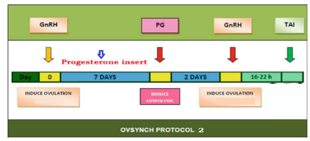
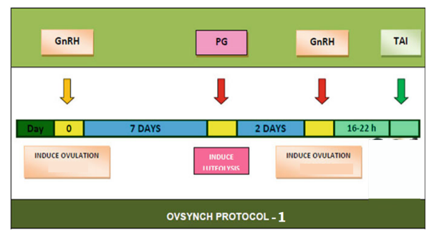
All the animals subjected to estrous synchronization were administered with the 10 ml of injection of the combination of each ml containing butaphosphan 100 mg and cyanocobalamin 50 mcg (Synkomet®, Intas, India) with 5 ml of injection of vitamin A 2,50,000 IU, vitamin D 25,000 IU, vitamin E 100 IU, biotin 12.5 mcg for each ml ( Intavita®, Intas, India) for increasing the fertility rate.

Figure 1:Hormonal protocol used (CIDR-Ovsynch). CIDR, Controlled Internal Drug Release; FTAI, Fixed-Time Artificial Insemination; GnRH, Gonadotropin-Releasing Hormone; PGF₂α, Prostaglandin F2α (Carbonari et al., 2024).
The fecal samples of each animals were collected in a ziplocked cover and was examined for the presence of parasitic egg and animals positive with round worm eggs in dung were dewormed with fenbendazole @ 5 mg/kg orally (Panacure Bolus®, 3 g MSD, India). Further the animals were applied with flumethrin 1% pour on the vertebral column from head to tail @ 1 ml per 10 kg (Bayticol® Pour on Solution, 500 ml bottle, Elanco, India) to get rid of ectoparasites like ticks and biting flies etc. This was an established protocol to increase the fertility rate to get the maximum number of pregnancy to the extent of 80-85%.
All the animals mentioned in the above protocol were synchronized the estrus and were inseminated after confirming the thawed straw do contain a minimum sperm motility of 50% without any deformities of spermatozoa, and was confirmed by the examination under binocular microscope at magnification of 40 X (Olympus, Japan). The study involved both cattle (131) and buffaloes (10) with a total of 141animals including HF or Jersey cross bred cattle with graded buffaloes.
Pregnancy diagnosis was performed on cows that did not return to estrus by 21–22 days post-insemination. Initial screening was conducted on day 28 using ultrasonography and a commercially available pregnancy diagnostic kit. Follow-up examinations were carried out on days 28, 32 and 36, with final confirmation performed on day 45 through a combination of per rectal palpation of the uterus, ultrasonography, and the diagnostic kit. This multi-step approach enabled with accurate determination of the insemination date and facilitated comprehensive assessment of pregnancy status, including ovarian evaluation and confirmation of corpus luteum presence, thereby enhancing the reliability of the study outcomes.
The pregnancy of the inseminated cattle on day 28, 30 and 32 was confirmed with transrectal examination of uterus size and characteristics, with the ultrasound examination with anechoic fluid in any horn with uterine horn diameter of approximately 3 to 4 cm, embryonic vesicle size or conceptus around 1 to 1.5 cm. Every time the gentle and careful per rectal examination of the uterus was done and the the horn carrying the conceptus, which would felt slightly distended compared to the non-pregnant horn with a a small, fluid-filled structure (embryonic vesicle).
This was followed by collection of 1 ml of the blood from jugular or ear vein in the vacutainer provided in the pregnancy kit and putting it in the well provided and reading the result as per the manufacturer's instructions. False positive and false negative results were ruled out by careful collection of the history of animal insemination. In the present study, the false positive and negative cases were very minimal, as sufficient care was taken to counter act the underlying causes.
On day 28 post-insemination, first pregnancy was assessed through transrectal examination by evaluating the size and characteristics of the uterus. Ultrasonographic findings indicative of early pregnancy included the presence of an anechoic (fluid-filled) area in one uterine horn, with the horn measuring approximately 3 to 4 cm in diameter. The embryonic vesicle or conceptus was typically observed to be around 1 to 1.5 cm in size. During per rectal palpation, the pregnant uterine horn consistently appeared slightly more distended compared to the non-pregnant horn. A small, fluid-filled embryonic vesicle could be palpated in the gravid horn and was subsequently confirmed via ultrasonography, thereby strengthening the accuracy of early pregnancy detection.
2.1. RAPID PREGNANCY DIAGNOSIS KIT
In the present study Prompt® BovEasy, Pregnancy Rapid Test Kit (Prompt Equipments Pvt. Ltd, Gujarat, India) was used to detect the early pregnancy in cattle and buffaloes by the Department of Veterinary Pharmacology and Toxicology, Veterinary College, Shivamogga, under the Karnataka Veterinary, Animal and Fisheries Sciences University (KVAFSU), Bidar, during the year 2024-2025. The rapid pregnancy diagnosis kit is a newer, better way for pregnancy detection in cows & buffaloes. The kit was claimed to detect Pregnancy Associated Glycoprotein (PAGs) in the blood and help to optimize reproductive efficiency with reliable results in 10-20 minutes. It was also claimed to be an essential tool for veterinarians, breeders, and livestock owners who want to manage pregnancy of their livestock efficiently. The pregnancy test was conducted as per the instructions in the leaflet insert of the manufacturer.
2.2. PREGNANCY DIAGNOSIS USING TRANSRECTAL ULTRASONOGRAPHY
Permission to examine the animals under field conditions was obtained under PC-PNDT Act, Government of India (Pre-Conception and Pre-Natal Diagnostic Techniques (Prohibition of Sex Selection Act, 1994) under the licence number No.DHO/SMG/PNDT/77|2022-23 Dated: 15-04-2023 valid till 8-2-2027.
Before the synchronization of oestrous in the animals, the genital organs and ovaries of all the animals were examined with the Portable Ultrasound Equipment (Sonoray DS 100 Plus ®,Sonaray) with a transrectal probe offering direct imaging of the reproductive tract with frequency range of 5.0 to 7.5 MHz, image size of 10 to 25 cm resolution and of 128 to 256 lines for accuracy. The images and videos were stored inside the machine after labelling for further use.
A positive pregnancy diagnosis was based on the observation of a fluid-filled uterus containing an embryo with a detectable heartbeat in the ultrasonographic examination. If a uterus without an embryo was observed, the pregnancy was considered negative. In addition, the presence of a fluid- filled uterus containing an embryo without a heartbeat or embryonic membrane integrity damage, was considered evidence of embryonic death, and these cases were included in the pregnancy-negative group.
List 1 : Important events during the early embryonic period (Morris and Diskin, 2008 and Hafez, 1993).
Days of pregnancy | Event
Days 0-1 | Fertilization, single-cell embryo (zygote) in oviduct
Day 2 | Early cleavages in the oviduct (up to 8 cell stages), activation of embryonic genome
Days 3-4 | Embryo enters the uterus
Days 5-6 | 16–32 cell zona-enclosed embryo progressing into compact morula stage
Days 7-8 | Formation of a blastocoele with differentiation of embryonic cells
Days 9-10 | Blastocyst expansion and hatching from the zona pellucid
Days 11–15 | Blastocyst elongation from a tubular to a filamentous structure
Days 14–19 | Maternal recognition of pregnancy
Days 19-20 | Implantation begins
Day 21 | Caruncles-cotyledons appear
Days 22–41 | Implantation progresses
Day 42 | Implantation completed
Around Day 28th of post-insemination, transrectal B-mode ultrasound in cattle typically detects an embryonic vesicle (~15–20 mm) with a heartbeat, along with fluid accumulation in the uterine horn on the corpus luteum (CL) side, enabling reliable early pregnancy diagnosis. At the same time, Color-Doppler assessment of luteal blood flow demonstrates that evaluating the CL’s vascularization by Day 20 achieves nearly 100% sensitivity and 85–100% specificity in distinguishing pregnant from non-pregnant cows. Additionally, measuring CL area on Day 21 provides perfect diagnostic accuracy in some studies. Overall, combining uterine and ovarian ultrasound yields highly accurate pregnancy detection by Day 28 (Dubuc et al., 2020).
2.3. INSTITUTIONAL ANIMAL ETHICAL COMMITTEE CLEARANCE FOR THE STUDY
Prior to the study, the permission of Institutional Animal Ethics Committee (IAEC with number1838/GO/ReRcBiBt/SL/15/CCSEA Valid till: 24-7-2029 ), Veterinary College, Shivamogga was obtained ( No.VCS/IAEC/ LA-112/2024-25 dated 30.08.2024 for 12 months till 30-08-2025) for carrying out the study in the village conditions.

3. RESULTS
The statistical analysis of the data was done to evaluate the effectiveness of the commercially available pregnancy kit for its accuracy, sensitivity and specificity for detection of pregnancy.
The data presented in the table, shows the overall accuracy of the Prompt BovEasy® Pregnancy Rapid Test Kit on day 28,32 and and 36.
Table 1: Summary of the results of Prompt BovEasy® Pregnancy Rapid Test Kit on day 28, 32
and 36.

Sl No | Attributes | Cows (131) |  |  | Buffaloes (10) |  |  | Total (141)
Sl No | Attributes | Day |  |  | Day |  |  | Day
Sl No | Attributes | 28 | 32 | 36 | 28 | 32 | 36 | 28 | 32 | 36
 | True Positive | 99 | 98 | 101 | 6 | 7 | 8 | 105 | 105 | 109
 | True Negative | 25 | 26 | 25 | 3 | 3 | 3 | 28 | 29 | 28
 | False Positive | 4 | 4 | 3 | 1 | 0 | 0 | 5 | 4 | 3
 | False Negative | 3 | 3 | 2 | 0 | 0 | 0 | 3 | 3 | 2
Total |  | 131 | 131 | 131 | 10 | 10 | 10 | 141 | 141 | 142
 | Actual pregnant on  Day 45 | 101/131 |  |  | 8/10 |  |  | 109/141
 | Accuracy (%) | 96.38 | 98.71 | 97.61 | 100 | 100 | 100 | 97.96 | 99.33 | 99.43
 | Sensitivity (%) | 96.65 | 98.62 | 98.73 | 100 | 100 | 100 | 98.09 | 98.03 | 99.02
 | Specificity (%) | 95.80 | 99.00 | 99.50 | 100 | 100 | 100 | 97.00 | 99.00 | 99.00

Figure 2: Results of Prompt BovEasy® Pregnancy Rapid Test Kit on day 28 of pregnancy
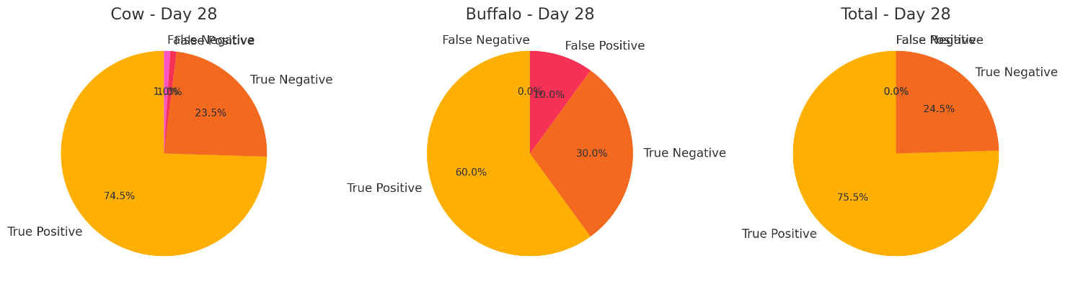
Figure 3: Results of Prompt BovEasy® Pregnancy Rapid Test Kit on day 36 of pregnancy
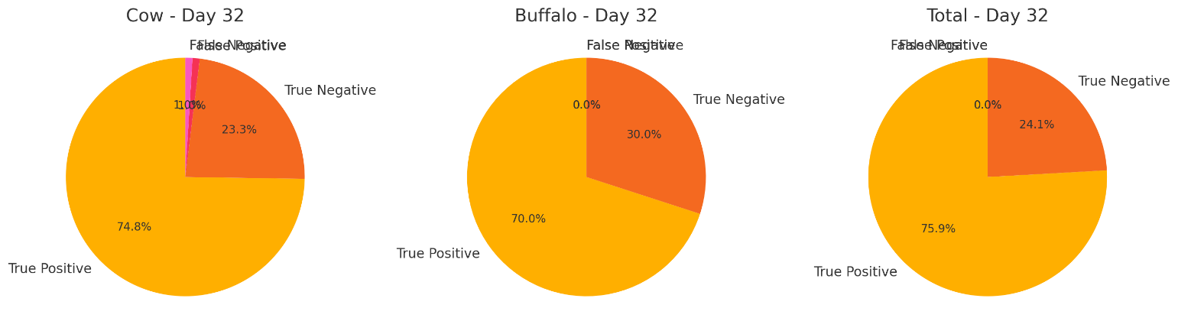
Figure 4: Results of Prompt BovEasy® Pregnancy Rapid Test Kit on day 32 of pregnancy
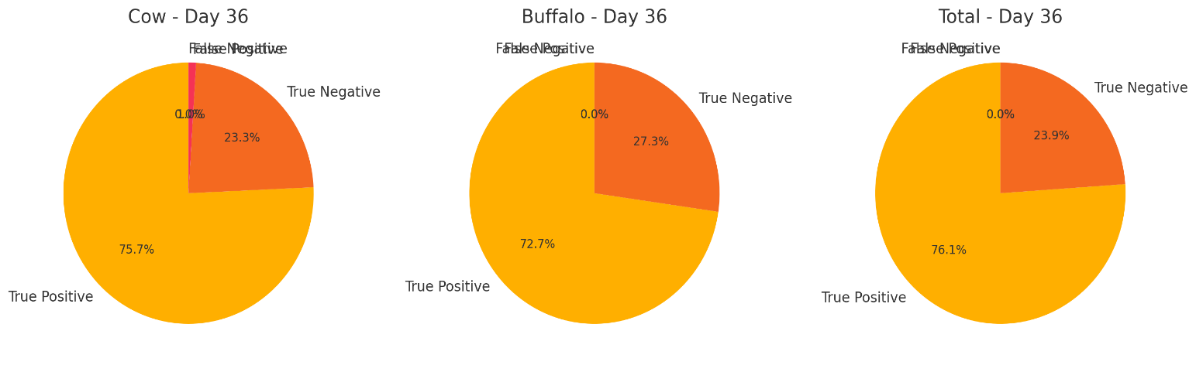

The data presented showed that the overall accuracy of the Prompt BovEasy® Pregnancy Rapid Test Kit was to the extent of 97.96, 99.33 and 99.43 % & on days 28,32, and 36 respectively. The variation in the result based on species was negligible and could be due to inevitable early embryonic mortality in some animals. There was a very close positive association between the kit results and the ultrasound diagnosis results.
From the above results, it can be concluded that the Pregnancy Associated Glycoprotein based Prompt BovEasy™ Pregnancy Rapid Test Kit was an effective, reliable, and easy-to-use tool for early pregnancy detection, offering significant advantages in improving reproductive performance. It was suitable for field use, as it is non-invasive and portable. The kits could be used for the early detection of pregnancy, but recommended for the early pregnancy diagnosis on day 32, which gave accurate results.
4. DISCUSSION
Ultrasound and rectal palpation are primary methods for detecting pregnancy in dairy cows. However, the accuracy of these methods largely depends on the operator’s skill and experience. Inexperienced staff or incorrect pregnancy detection can lead to issues such as pregnancy loss in pregnant cows and an extended empty gestation period. This, in turn, can reduce the lifetime milk production of non-pregnant cows (Yáñez et al., 2023). Various pregnancy markers have been studied for use in different livestock species, including sheep (Ishwar, 1995), buffaloes (Barbato and Barile, 2012) and cows (Balhara et al., 2013). Advancements over the years and scientific research augmentation, numerous private establishments are now successfully developing commercial assays for pregnancy diagnosis across various livestock species, utilizing PAGs in serum, plasma and milk as the basis for these assays (Commun et al., 2016). PAGs-ELISA test had 100% specificity and approximately 100% sensitivity at around 25 days post-AI.

In this study, PAG based pregnancy kit was evaluated using whole blood samples. Consistent with our findings, Akköse (2023), reported the sensitivity, specificity etc on Day 28 post-AI as 100%, 93.1%, 89.1%, 100% and 95.6%, respectively. In the present study also, the kit showed a sensitivity of 98.5% and a specificity of 89.5% between Days 28 and 34 of pregnancy. Sensitivity and specificity of pregnancy tests can vary based on factors such as parity and breed differences. It should also be observed that maternal PAG concentrations differ between heifers with high and low fertility levels (Reese et al., 2019).

Karakuş et al. (2021) achieved high accuracy in diagnosing pregnancy at 30 days post-AI using the commercial visual test kit in serum samples from Simmental and Brown Swiss cows. Sensitivity, specificity, accuracy, for the Rapid Visual Pregnancy Test on Day 28 post-AI in serum samples were reported as 98%, 85%, 92%, 87% and 98%, respectively (Mayo et al., 2016). In another study, Akköse (2023) found that the RVPT had sensitivity, specificity, accuracy, PPV and NPV values of 97.4%, 92.1%, 94%, 98.4% and 94%, respectively.

Ricci et al. (2015) reported that for Holstein cows, 32 days post-AI using the plasma PAG-ELISA based kit, the accuracy was 92%, with sensitivity and specificity of 100% and 87%, respectively. For goats, using the similar kit with ultrasonographic results as the gold standard, the sensitivity was 94.12%, while specificity, PPV, NPV and accuracy were 80.49%, 80%, 94.29% and 86.67%, respectively (Akkaya Doğan and Köse, 2022). Hence, the prevailing literature also supports the findings in the present study which is more confirmative scientifically also.

During the study, pyometra cases were also met and diagnosed only with ultrasound equipment. But all these cases were found negative in the kit method, and many times it is difficult to diagnose the pyometra by per rectal examination. Hence, the PAG Pregnancy Rapid Test Kit(BovEasy®, Prompt Equipments Pvt. Ltd, Gujarat, India) can also be used to differentiate the pregnancy and pyometra in field conditions, as the uterus will be go on filling during the pyometra even from day 30 of insemination, the uterine horn size increases. It is a very tough task to differentiate the same by per rectal examination with skilled veterinarian. Hence, this will be an additional finding for the recommendation of the kit to differentiate between the correct pregnancy and pyometra as the case rate is up to 2-10 % in cattle as per the prevailing literature.

Even for the proper diagnosis of mummified fetus cases the kit can be recommended. In the present study, 2 mummified and 1 macerated fetus conditions were diagnosed with per rectal examination were also tested with the kit. In mummified fetus cases, the pregnancy diagnosis kit showed clear negative but in macerated fetus case, it showed the doubtful result. Hence, with more clinical case study and standardization it may become an effective tool for the diagnosis of both conditions, as it is difficult to diagnose the said conditions unless the veterinarian is very well experienced. In few cases where the animal was tested as positive to pregnancy, but the fetus could not be found by ultrasound examination was considered as late embryonic death.

5. CONCLUSION

The Pregnancy diagnosis tests adopted in this study demonstrated good specificity and good accuracy. These tests allow for early detection of pregnancy and are easily integrated into farm routines, with their specificity and accuracy and in some cases, there was a chance of false positive and false negative results but the percentage is meager. To optimize herd management and productivity, verifying negative test outcomes through this kit was recommended and whenever there is a doubt, ultrasound examination is recommended.

6. REFERENCES
Akkaya Doğan, A., & A. M. Kose, (2022). Evaluation of bovine visual ELISA test for detection of pregnancy-associated glycoproteins in early pregnancy diagnosis in goats. Small Ruminant Research, 212: 106722-10735.
Akköse, M., (2023). Comparative evaluation of two commercial pregnancy-associated glycoproteins tests for early detection of pregnancy in dairy cattle. Theriogenology, 200: 11-17.
Balhara, A.K., Gupta, M., Singh, S., Mohanty, A.K., & Singh, I., (2013). Early pregnancy diagnosis in bovines, current status and future directions. Scientific World Journal, 1: 958540–958550.
Barbato, O., & Barile., V. L., (2012). The pregnancy diagnosis in buffalo species: Laboratory methods. Journal of Buffalo Science , 1(2): 157-162.
Carbonari, A., Burgio, M., Frattina, L., Cicirelli, V., & Rizzo, A., (2024). Repeat breeder syndrome therapies in dairy cows: A review. Reproduction in Domestic Animals, 59(10):14732-14743.
Commun, L., Velek, K., & Barbry, J. B., (2016). Detection of pregnancy-associated glycoproteins in milk and blood as a test for early pregnancy in dairy cows. Journal of Veterinary Diagnostic Investigation, 28(3): 207-213.

Dubuc, J., Houle, J., Rousseau, M., Roy, J.P., & Buczinski, S., (2020). Accuracy of corpus luteum color flow Doppler ultrasonography to diagnose nonpregnancy in dairy cows on day 21 after insemination. Journal of Dairy Science, 103(2): 2019-2023.
Gabor, G., Toth, F., Ozsvari, L., Abonyi-Toth, Z., & Sasser, R.G., (2007). Early detection of pregnancy and embryonic loss in dairy cattle by ELISA tests. Reproduction in Domestic Animals, 42(6): 633–636.
Hafez, E.S.E., & Hafez, E.S.E., (1993). Reproduction in Farm Animals 2nd Edition. Lea and Febiger, Philadelphia, PA, USA,
Ishwar, A. K., (1995). Pregnancy diagnosis in sheep and goats: A review. Small Ruminant Research,17(1): 37-44.
Karakuş, O., Kaçar, C., Kuru, M., Kaya, S., Demir, M.C., Arı, U.Ç., Zonturlu, A.K., & Öztürkler, (2021). Efficacy of a commercial test kit to determine early pregnancy in cows using whole blood and blood serum. Tropical Animal Health and Production, 53(1): 28-35.
Kline, A.C., MenegattiZoca, S., Epperson, K.M., Quail, L.K., Ketchum, J.N., Andrews, T.N., Rich, J.J., Rhoades, J.R., Walker, J.A., & Perry, G.A., (2024). Evaluation of pregnancy associated glycoproteins assays for on farm determination of pregnancy status in beef cattle. Plos One, 19(7): 306325-306333.
Lucy, M., Green, J., & Poock, S., (2011). Pregnancy determination in cattle: A review of available alternatives. Proceedings, Applied Reproductive Strategies in Beef Cattle, 1: 367-376.
Mayo, L.M., Moore, S.G., Poock, S.E., Silvia, W.J., & Lucy, M.C., (2016). Validation of a chemical pregnancy test in dairy cows that uses whole blood, shortened incubation times, and visual readout. Journal of Dairy Science, 99(9): 7634-7641.
Morris, D., & Diskin, M., (2008). Effect of progesterone on embryo survival. Animal. 2(8):1112-1119.
Piechotta, M., Bollwein, J., Friedrich, M., Heilkenbrinker, T., Passavant, C., Branen, J., Sasser, G., Hoedemaker, M., & Bollwein, H., (2011). Comparison of commercial ELISA blood tests for early pregnancy detection in dairy cows. Journal of Reproduction and Development, 57(1): 72-75.
Reese, S.T., Geary, T.W., Franco, G.A., Moraes, J.G.N., Spencer, T.E., & Pohler, K.G., (2019). Pregnancy associated glycoproteins (PAGs) and pregnancy loss in high vs sub fertility heifers. Theriogenology, 135: 7-12.
Ricci, A., Carvalho, P.D., Amundson, M.C., Fourdraine, R.H., Vincenti, L., & Fricke, P.M., (2015). Factors associated with pregnancy-associated glycoprotein (PAG) levels in plasma and milk of Holstein cows during early pregnancy and their effect on the accuracy of pregnancy diagnosis. Journal of Dairy Science, 98(4): 2502-2514.
Safak, T., Tümer, K.Ç., Alp, Y.İ., Özen, T.Y., & Yilmaz‐Koc, O., (2025). Evaluation of the accuracy and performance of two commercial pregnancy‐associated glycoprotein tests for early pregnancy detection in cows. Veterinary Medicine and Science, 11(2): 70226-70233.
Telugu, B.P., Walker, A.M., & Green, J.A., (2009). Characterization of the bovine pregnancy-associated glycoprotein gene family-Analysis of gene sequences, regulatory regions within the promoter and expression of selected genes. BMC Genomics, 10: 185-195.
Yáñez, U., Murillo, A.V., Becerra, J.J., Herradón, P.G., Peña, A.I., & Quintela, L.A., (2023). Comparison between transrectal palpation, B-Mode and Doppler ultrasonography to assess luteal function in Holstein cattle. Frontiers in Veterinary Science,10: 1162589-1162596.
Zoli, A.P., Guilbault, L.A., Delahaut, P., Ortiz, W.B., & Beckers, J.F., (1992). Radioimmunoassay of a bovine pregnancy-associated glycoprotein in serum: Its application for pregnancy diagnosis. Biology of Reproduction, 46(1):83-92.

