EXPERIMENTAL ASSESSMENT OF ANTI-ARTHRITIC AND ANTI-DIABETIC EFFECTS OF ANTIDESMA MADAGASCARIENSE LAM.

ABSTRACT
Systematic evaluation of plants used in the traditional medicines was considered as an approach that was able to provide more promising information regarding their therapeutic value and was beneficial in addressing the increasing demand for newer agents to fight infections and diseases. With this view, the plant Antidesma madagascariense Lam. was selected for our research. As the continuation of our previous effort, the present study was focused on the in vivo evaluation of anti-arthritic and anti-diabetic activity of methanol extract of A. madagascariense. Initially, acute toxicity of the extracts was evaluated and the effective dose (ED50) was fixed ^{[1]}. Anti-arthritic activity of the extract was evaluated by Complete Freund’s adjuvant (CFA) induced arthritic animal models. Anti-diabetic activity of the extract was evaluated by streptozotocin-induced diabetes mellitus animal models. Two doses of test extract, low dose and high dose (250 and 500mg.kg-1), were subjected to the evaluation. In these evaluations, methanol extract in the dose of 500mg.kg-1 was found to show a significant result. Further studies of this extract in future were suggested as they might yield significant results that would be useful for the development of new chemotherapeutic agents.

KEYWORDS: Antidesma madagascariense extracts, in vivo anti-arthritic activity, Anti-diabetic activity, Traditional medicine, streptozotocin

1-INTRODUCTION
Since ancient times, herbal remedies have been extensively applied worldwide to treat a wide range of ailments and disorders. The use of plant-based therapies in different traditional healing practices has continually inspired and guided researchers toward discovering new therapeutic possibilities. ^{[2-3]} Recent studies have shown that nearly two-thirds of the medicines approved worldwide are obtained from plants.^{[4]} The organic compounds known as secondary metabolites in plants are responsible for their physiological functions. Alkaloids, glycosides, flavonoids, essential oils, saponins, resins, and phenols are among them, distributed in plant parts such as the root, stem, flower, fruit, seed, and exudates. These compounds can be applied in the treatment of several chronic and infectious diseases. ^{[5,6]}

A detailed evaluation of herbal remedies used in traditional healing systems is required, as this may provide valuable information about their therapeutic potential and could help meet the rising need for new agents against infections and diseases. ^{[7–9]} With this aim, Antidesma madagascariense, a plant with ethnomedicinal importance, was selected for our investigation. In our earlier study, the anti-inflammatory and anti-diabetic effects of various extracts of A. madagascariense were successfully evaluated in vitro. As a continuation, the present study was focused on the in vivo evaluation of the anti-arthritic and anti-diabetic activities of the selected extract of A. madagascariense, in an attempt to provide a basis for future research.

2-MATERIALS AND METHODS

2-1-Plant Material and Traditional Use

The aerial parts of Antidesma madagascariense, a plant belonging to the Phyllanthaceae family, were collected in Vohipeno, located in the Vatovavy Fitovinany region. ^{[10]} In Madagascar, this plant is traditionally used for its medicinal properties, including the treatment of diabetes, inflammation, and certain infections. Locally, in Vohipeno, it is known as "Hazomalama"^{[11 ,12].}

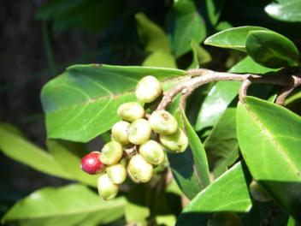
Fig1: Antidesma madagascariense Lam.

This species was identified at the Department of Botany of Botanical and Zoological Park of Tsimbazaza (Antananarivo). The experimental evaluation of the anti-arthritic and anti-diabetic effects of Antidesma madagascariense Lam. was carried out at the Medizinische Hochschule Hannover (MHH), Institute for Clinical Pharmacology, while the extraction and identification were performed at the Analytical Chemistry and Formulation Laboratory, Faculty of Sciences, University of Antananarivo. A voucher specimen has been deposited at both institutions for future reference.

2-2-Extraction and Preliminary Evaluation

Following proper identification and authentication, the collected plant material was dried, powdered, and subjected to a Soxhlet extraction using solvents of increasing polarity: petroleum ether, chloroform, ethyl acetate, and methanol. Preliminary studies had previously evaluated the in vitro antioxidant and anti-inflammatory activities of the plant, suggesting its promising biological potential.
The dried extracts were then evaluated for preliminary phytochemical analysis and in vitro anti-inflammatory and anti-diabetic activity. The methanol extract demonstrated the presence of the majority of phytochemicals and showed significant in vitro activity. Based on these results, the methanol extract was selected for the present study ^{[13]}.

2-3-Animals and approval of the study

Healthy male Wistar albino rats, 7 weeks old and weighing between 150–170 g, were used for the experiments.

2-4-Acute Toxicity Study

The LD50 of the selected extract was determined in accordance with OECD guideline 423 and established procedures found in scientific literature. Animals were randomly selected, marked for identification, and acclimatized to laboratory conditions for five days before dosing. They were housed in a controlled environment with an ambient temperature of 25±1°C, relative humidity of 55±5%, and a 12-hour light/dark cycle, with access to standard food pellets and water ad libitum.
Following an overnight fast (with free access to water), a single dose of the test extract was administered to the animals via gavage. An initial dose of 50 mg/kg was given to three animals. After a 24-hour observation period, the number of deaths was recorded. This process was then repeated for subsequent doses of 300 mg/kg and 2000 mg/kg.

2-5-In vivo anti-arthritic activity

The selected extract was subjected to in vivo evaluation in reference with standard procedure ^{[3,13]} with slight modification.

2-5-1-Treatment protocol

For this study, the selected Wistar albino rats were separated into five groups, each containing six animals:
Group 1 served as the normal control. These rats were given only a standard diet and water.
Group 2 acted as the arthritic control. To induce arthritis, these rats received an injection of Complete Freund’s Adjuvant (CFA).
Group 3 was the standard control group, treated with prednisolone at a dose of 10mg/kg.
Group 4 was the first experimental group, which received 250mg/kg of the selected Antidesma madagascariense Lam. extract.
Group 5 was the second experimental group, treated with a higher dose of the same extract, at 500 mg/kg.

2-5-2-Treatment and Evaluation
Arthritis was induced in all animals except for Group 1 through a single intradermal injection of Complete Freund’s Adjuvant (CFA). The CFA, containing 1.0 mg of heat-killed M. tuberculosis in sterile paraffin oil, was administered in a 0.1 ml volume into the footpad of the left hind paw. For the injection, a glass syringe with a 25G needle was used, and the rats were anesthetized with ether beforehand.
The standard drug and the test extracts were administered orally every day for 20 days, starting from the third day after the CFA injection. The swelling of the paws was regularly measured using a Digital Plethysmometer and the changes in paw volume (in ml) were calculated.
At the end of the study, blood samples were taken sublingually. The serum and plasma were separated by centrifugation at 3000 rpm for 10 minutes and stored at –20°C for later analysis. Various biochemical parameters, including Alkaline Phosphatase (ALP), Acid Phosphatase (ACP), Serum Glutamate Oxaloacetate Transaminase (SGOT), and Serum Glutamate Pyruvate Transaminase (SGPT), were measured using an auto-analyzer with specific kits. The total WBC count was also determined by mixing blood samples with a diluting fluid and counting the cells with a Neubauer's chamber.
2-6-In vivo anti-diabetic activity

The study was designed in reference with the standard procedure in published literature. ^{[14-17]}

2-6-1-Treatment protocol

For this study, the selected Wistar albino rats were divided into five groups of six animals each.
- Group 1 served as the normal control, receiving only a standard diet and water.
- Group 2 was the diabetic control group, in which diabetes was induced using Streptozotocin (STZ).
- Group 3 acted as the standard control, and these rats were treated with Glibenclamide at a dose of 0.5 mg/kg.
- Group 4 was the first experimental group, which received a dose of 250 mg/kg of the selected Antidesma madagascariense Lam. extract.
- Group 5 was the second experimental group, treated with a higher dose of the same extract, at 500 mg/kg.

2-6-2-Treatment and evaluation
Before the experiment, all animals in groups 2 through 5 were fasted for 12 hours. Diabetes mellitus was then induced in these groups by a single intraperitoneal injection of 60 mg/kg of Streptozotocin (STZ). The normal control group (Group 1) received only a saline injection.
After 72 hours, an electronic glucometer was used to measure the blood glucose levels of the treated rats. Only those with a blood sugar level of 180 mg/dL or higher were considered diabetic and included in the study. The standard drug and the test extracts were then administered orally, once daily, for 30 consecutive days, starting from the third day after the STZ injection. Blood glucose was monitored weekly with the same glucometer.
At the conclusion of the fourth week, all the rats were euthanized via cervical dislocation. Blood samples were collected through direct cardiac puncture, and the serum and plasma were separated by centrifuging at 3000 rpm for 10 minutes, then stored at -20°C for later analysis of various hematological and biochemical markers. To prepare for histopathological evaluation, organs like the liver and pancreas were immediately removed and preserved in a 10% formalin solution.
The blood samples were analyzed for hematological parameters such as hemoglobin and glycosylated hemoglobin using a COBAS MICROS OT 18, Roche analyzer. Biochemical parameters, including total cholesterol, triglycerides, HDL, LDL, SGOT, SGPT, and ALP, were measured with a COBAS MIRA PLUS – S, Roche analyzer.
3-RESULTS AND DISCUSSION

3-1-In Vivo Anti-Arthritic Evaluation
Based on the promising results of the in vitro tests, the methanol extract was chosen for further in vivo anti-arthritic evaluation.
During the acute toxicity study, no animal deaths were observed after the first two doses of the extract were administered. However, two out of the three animals died within 24 hours of receiving the third dose of 2000 mg/kg. This led to the conclusion that the LD50 (lethal dose 50%) was 2000 mg/kg, and consequently, the ED50 (effective dose 50%) was established as 250 mg/kg for the selected methanol extract of Antidesma madagascariense.
Overall, the findings from the in vivo evaluation strongly support the anti-arthritic properties of the Antidesma madagascariense Lam. methanol extract. Notably, the high dose of 500 mg/kg demonstrated a significant effect comparable to the standard control drug, prednisolone. The detailed results of this evaluation are presented in Tables 1-3 and Figures 2-4.

Table 1: Effect of Antidesma madagascariense Methanol Extract on Paw Volume in Experimental Animals
Days control | Normal control | Arthritic control | Standard control (250mg/kg) | Test extract (500mg/kg) | Test extract control
00 | 0.19±0.02 | 0.60± 0.05 | 0.57 ± 0.04 | 0.59±0.02 | 0.56 ± 0.02
03 | 0.21±0.04 | 0.75 ± 0.01 | 0.65 ± 0.05
  0.67 ± 0.03
  0.67 ± 0.03
05 | 0.20±0.01 | 0.84 ± 0.02 | 0.64 ± 0.07 | 0.70 ± 0.02 | 0.62 ± 0.03
07 | 0.22±0.03 | 0.95 ± 0.04 | 0.60 ± 0.03
  0.66 ± 0.02
  0.66 ± 0.02
09 | 0.24±0.02 | 1.04 ± 0.05 | 0.59 ± 0.03
  0.62 ± 0.04
  0.62 ± 0.04
11 | 0.20±0.01 | 1.07 ± 0.06 | 0.54 ± 0.05
  0.58 ± 0.01
  0.58 ± 0.01
13 | 0.19±0.02 | 1.10 ± 0.03 | 0.41 ± 0.04
  0.54 ± 0.03
  0.54 ± 0.03
15 | 0.22±0.01 | 1.13 ± 0.05 | 0.38 ± 0.05
  0.49 ± 0.02
  0.49 ± 0.02
17 | 0.20±0.02 | 1.16 ± 0.07 | 0.34 ± 0.06
  0.45 ± 0.01
  0.45 ± 0.01
19 | 0.21±0.01 | 1.19 ± 0.04 | 0.24 ± 0.07
  0.36 ± 0.04
  0.36 ± 0.04
21 | 0.19±0.02 | 1.21 ± 0.05 | 0.20 ± 0.02**
  0.32 ± 0.03
    - 0.03
All values are presented as the mean ± standard error of the mean (SEM) for six determinations. P < 0.01 when compared to the arthritic control group.
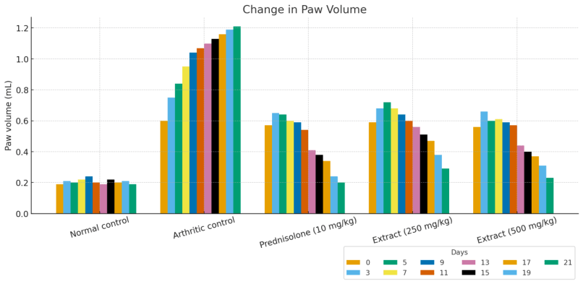
Figure 2: Effect of the Methanol Extract on Paw Volume Changes in Experimental Animals.

Table 2: Effect of Antidesma madagascariense Methanol Extract on Biochemical Parameters in Experimental Animals
Groups | ACP (U/L) | SGPT (U/L) | ALP (U/L) | SGOT (U/L)
Normal control | 5.80±0.03 | 35.70±0.34 | 71.60±1.70 | 35.40±0.93
Arthritic control | 23.51±1.24 | 164.20±0.50 | 439.3±2.35 | 108.2±2.04
Standard control | 6.24±0.53 | 42.60±2.35 | 152.1±1.08 | 47.51±1.31
Test extract (Low dose) | 14.34±0.40 | 66.40±1.31 | 219.2±0.58 | 64.22±2.01
Test extract (High dose) | 7.34±0.24 | 54.71±0.81 | 178.5±0.22 | 49.60±0.48

Data are expressed as the mean ± the standard error of the mean (SEM) for six independent determinations. Statistical significance was defined as P < 0.05 relative to the normal control and P < 0.01 relative to the arthritic control.
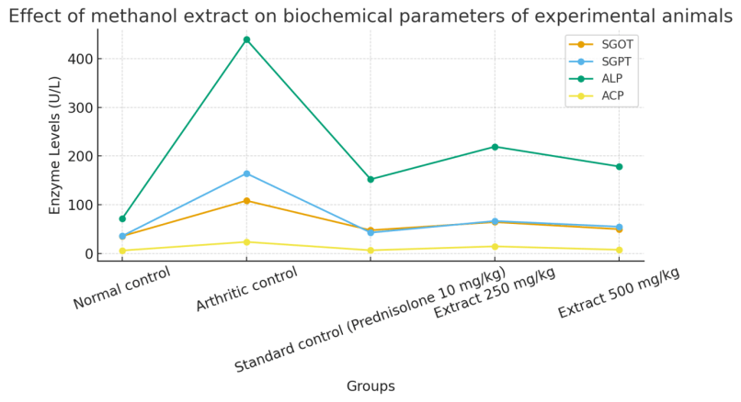
Figure 3: Effect of Methanol Extract on Biochemical Parameters in Experimental Animals
Table 3: Effect of Antidesma madagascariense Methanol Extract on Hematological Parameters in Experimental Animals
Groups | WBC (Cells/ml×10³)
Normal control | 10.48 ± 1.32
Arthritic control | 14.72 ± 2.11ᵃ
Standard control (Prednisolone 10 mg/kg) | 11.05 ± 1.54ᵇ
Test extract (250 mg/kg | 12.38 ± 1.72ᵇ
Test extract (500 mg/kg) | 11.92 ± 1.43ᵇ
Each value represents the mean ± SEM from six separate measurements.
- a - Indicates a statistically significant difference compared to the normal control (P < 0.01).
- b - Indicates a statistically significant difference compared to the arthritic control (P < 0.01).

3-2-In Vivo Anti-Diabetic Evaluation
Following the promising results of the in vitro evaluation, the methanol extract was chosen for an in vivo anti-diabetic study using diabetes-induced Wistar albino rats. Two doses of the extract, 250 mg/kg and 500 mg/kg, were tested.
In this study, researchers analyzed several factors, including the rats' blood glucose levels, various hematological and biochemical parameters, as well as the histopathology of their liver and pancreas. The findings from the blood glucose analysis are detailed in Table 4 and Figure 4.
Table 4: Effect of selected extracts on blood glucose level of experimental animals.
Animal Group | Day 0 | Day 7 | Day 14 | Day 21 | Day 30
G1 – Normal control | 102.12 ± 6.45 | 113.85 ± 1.88 | 109.74 ± 1.26 | 111.42 ± 1.49 | 107.35 ± 1.58
G2 – Diabetic control | 246.58 ± 6.14 | 260.32 ± 2.74 | 274.86 ± 2.12 | 295.21 ± 1.31 | 319.74 ± 1.71
G3 – Standard (Glibenclamide 0.5 mg/kg) | 344.62 ± 10.75 | 118.92 ± 1.30 | 174.86 ± 3.27 | 113.72 ± 1.22 | 112.45 ± 1.86
G4 – Extract (250 mg/kg) | 350.45 ± 5.64 | 138.54 ± 1.19 | 170.65 ± 2.21 | 137.42 ± 1.59 | 126.88 ± 1.82
G5 – Extract (500 mg/kg) | 321.75 ± 6.11 | 136.52 ± 2.76 | 135.84 ± 2.12 | 127.14 ± 1.69 | 121.96 ± 1.79

All values are expressed as the mean ± standard error of the mean (SEM) for six animals per group. The p-value of < 0.001 indicates a significant difference between the normal control, the diabetic control, and the treated groups.
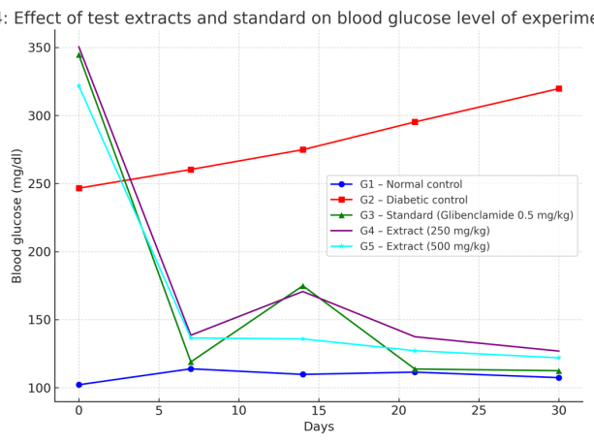
Figure 4: The Effect of Test Extracts and a Standard Drug on Blood Glucose Levels in Experimental Animals.

Table 5: Effect of Selected Extracts on Hemoglobin and Liver Enzymes in Experimental Animals
Animal Group | Haemoglobin | Glycosylated haemoglobin | SGOT | SGPT | ALP
G1 | 12.65±1.50 | 4.75±0.36 | 25.98±3.17 | 51.49±8.25 | 130.82±7.05
G2 | 10.85±0.21 | 12.72±0.81 | 60.12±6.54 | 63.59±5.81 | 204.10±9.42
G3 | 12.68±0.41 | 5.35±0.38 | 34.84±2.09 | 57.12±3.72 | 137.64±5.11
G4 | 11.77±0.45ns | 6.58±0.39 | 41.32±2.35 | 60.59±2.41 | 144.85±2.25
G5 | 12.68±0.29 | 6.12±0.65 | 37.85±3.42 | 59.49±2.56 | 141.07±2.04
G6 | 12.92±0.47 | 5.74±0.37 | 37.24±1.24 | 62.10±3.42 | 143.05±3.12
G7 | 13.42±0.44 | 3.67±0.41 | 34.92±2.41 | 58.49±2.41 | 138.22±2.09

G₁–Normal control; G₂–Diabetic control; G₃–Standard control; G₄–Group (Methanol extract 200mg.kg⁻¹); G₅–Group (Methanol extract 500mg.kg⁻¹); All values are expressed as mean ± SEM for 6 animals in each group; ns–not significance; p<0.01, p<0.001significance between normal control Vs diabetic control and treated groups
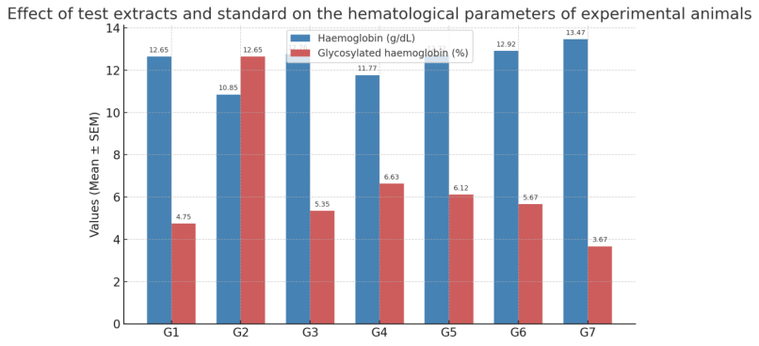

Figure 5: Influence of Test Extracts and Standard on Hematological Profiles in Experimental Animals.

3-1-1Hemoglobin and Glycosylated Hemoglobin

The Hemoglobin (g/dL) level (blue bar) is around 12–13 in most groups, but it is lower in Group 2 (Diabetic control).
The Glycosylated hemoglobin (%) level (red bar) is very high in Group 2 and appropriately lower in Groups 1 and 7.

3-1-2-Hemoglobin and Glycosylated Hemoglobin Results
In the diabetic control group (Group 2), hemoglobin levels showed a marked reduction compared to the normal control group (Group 1). However, levels were restored in Group 3, which received the standard drug Glibenclamide. Both the low (250 mg/kg) and high (500 mg/kg) doses of the tested extract significantly raised hemoglobin levels in the experimental animals. Notably, the most significant increase was seen in Group 5, which received the 500 mg/kg methanol extract.
Glycosylated hemoglobin levels were significantly elevated in the diabetic control group (Group 2) compared to the normal control group (Group 1). However, no significant changes in glycosylated hemoglobin were observed in the treatment groups (Groups 3-5) when compared to the normal control animals. The group treated with the 500 mg/kg methanol extract (Group 5) showed a very significant score compared to the other treatment groups (Figure 6).
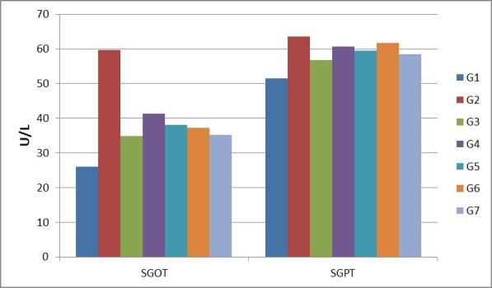
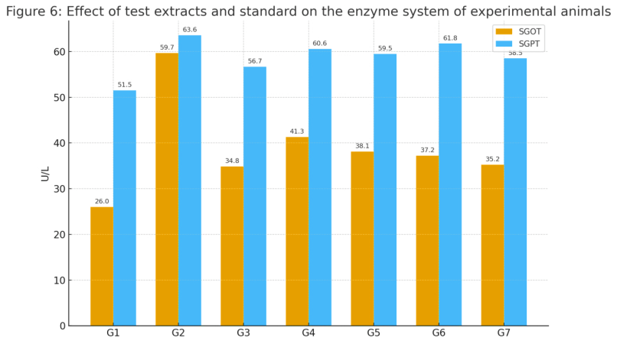 Figure 6: Effect of Test Extracts and Standard Drug on the Enzyme System of Experimental Animals.
ALP (IU/L) Total cholesterol(mg/dL)
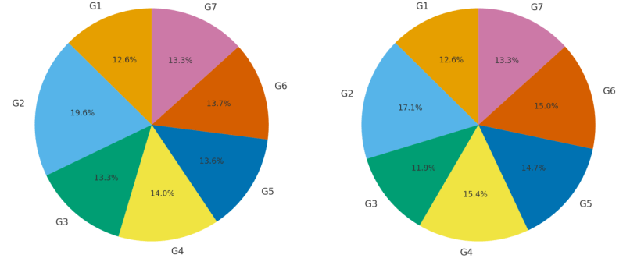
Figure 7: Effect of test extracts and standard on the enzyme ALP and total cholesterol in experimental animals.

3-2-Enzyme and Lipid Profile Results
Enzyme levels like SGOT, SGPT, and ALP were elevated in the diabetic control group. However, treatment with the standard drug, Glibenclamide, reversed these levels, bringing them back to a normal range. The tested methanol extract also had a positive effect, with both the low and high doses significantly reversing the enzyme levels toward normal. The high dose of the methanol extract was particularly effective.
Similarly, the diabetic control group showed abnormal levels in their lipid profiles (total cholesterol, triglycerides, HDL, and LDL). In the treated groups, these scores returned to normal. The methanol extract-treated animals showed a more significant improvement in their lipid profiles compared to the animals treated with the ethyl acetate extract.
Table 6: Effect of Selected Extracts on the Lipid Profile of Experimental Animals
Group | ALP (IU/L) | Total Cholesterol (mg/dL)
G1 (Normal control) | 135.20 ± 3.90 | 168.80 ± 4.55
G2 (Diabetic control) | 215.45 ± 5.40 | 238.95 ± 4.64
G3 (Standard control) | 142.33 ± 4.25 | 160.44 ± 4.18
G4 (Methanol 250 mg/kg) | 165.78 ± 4.70 | 218.87 ± 4.85
G5 (Methanol 500 mg/kg) | 158.90 ± 3.85 | 205.97 ± 5.55
G6 (Ethyl acetate 250 mg/kg) | 162.41 ± 4.05 | 210.06 ± 5.74
G7 (Ethyl acetate 500 mg/kg) | 150.12 ± 3.60 | 185.31 ± 2.78

As shown in Table 6 and the accompanying descriptive text, both ALP and Total Cholesterol levels were higher in the diabetic control group (G2).
The standard control group (G3) had levels similar to the normal control (G1).
Both the methanol extract (G4 and G5) and the ethyl acetate extract (G6 and G7) gradually reduced and restored these levels to near-normal ranges.
Among all treatments, the high dose methanol extract (G5) provided the best results in reducing both ALP and cholesterol.
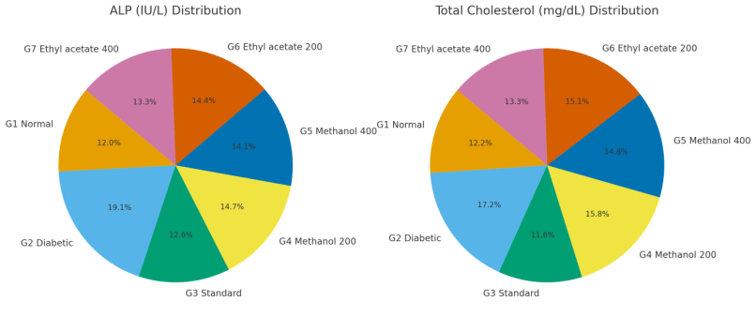
Figure 8: Effect of test extracts and standard on different biochemical parameters of experimental animals.
Left Figure: Distribution of ALP (IU/L) among all groups (G1–G7).
Right Figure: Distribution of Total Cholesterol (mg/dL) in the same groups.

3-3-Enzyme and Cholesterol Levels
The figures show the distribution of ALP and Total Cholesterol across the experimental groups. As expected, both ALP and Total Cholesterol were significantly elevated in the diabetic control group (G2). In contrast, the standard control (G3) had levels similar to the normal control (G1). Treatment with both low- and high-dose methanol and ethyl acetate extracts (G4-G7) gradually lowered these levels, bringing them closer to normal.

3-4-Liver Histopathology
The histopathological analysis of the liver revealed clear differences between the groups. Normal control animals had a healthy liver with normal hepatocyte morphology. The diabetic control group, however, showed significant issues, including hepatic congestion, micro-steatosis, and hepatocyte necrosis caused by high blood glucose levels.
The standard control group showed only mild congestion and micro-steatosis, indicating a positive effect. Both the low- and high-dose test extract groups also showed a moderate improvement, with less inflammation and necrosis compared to the diabetic control. The reduction in hepatic congestion and micro-steatosis suggests that the extracts helped to normalize lipid metabolism. Additionally, the proliferation of Kupffer cells (scavenger cells), which was high in the diabetic control due to inflammation, was reduced in the treated groups. This indicates that the treatments, including the standard drug and the extracts, improved insulin sensitivity and reduced overall inflammation.

3-5-Pancreas Histopathology
The pancreas of the normal control group had a healthy, normal structure. In contrast, the diabetic control group showed pancreatic β-cell degeneration, which was likely caused by the STZ injection. Importantly, the extract-treated groups showed significant regeneration of these pancreatic β-cells. This finding, along with the results from the liver analysis, strongly supports the anti-diabetic properties of the tested extract.
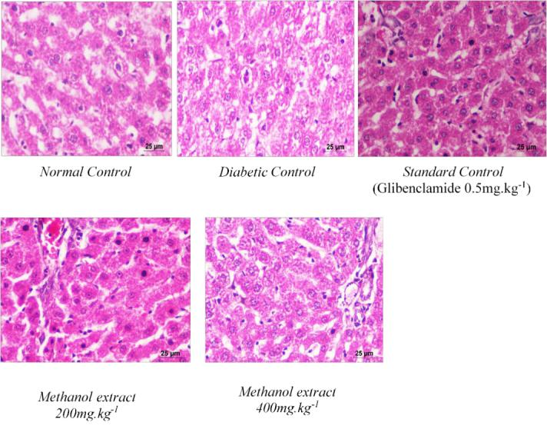
Methanol extract 500mg/kg Methanol extract 250 mg/kg
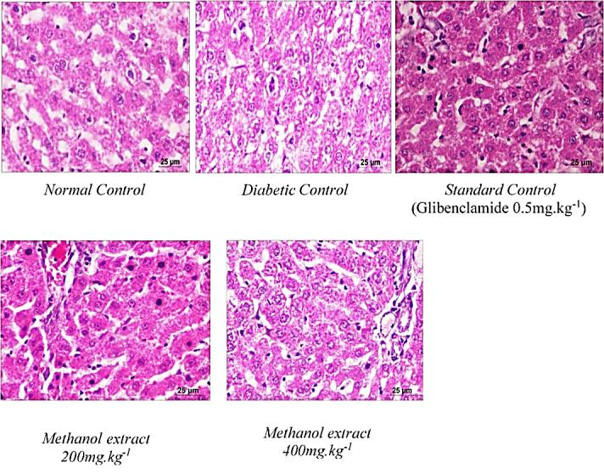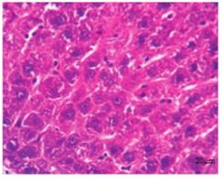
Standard control Normal Baseline Pathological contol
Figure 9: Effect of Standard Drug and Selected Extract on Liver Histopathology

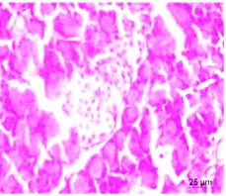. 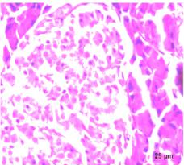 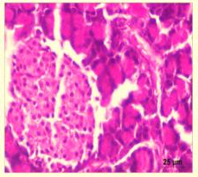
Glibenclamide-treated group (0.5 mg/kg) Baseline control Pathological control
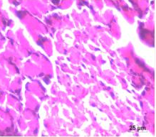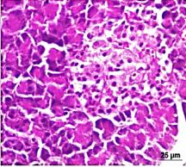
Methanol extract 250mg/kg Methanol extract 500mg/kg
Figure 10: Effect of Standard and Selected Extract on Pancreas Histopathology

4-Conclusion:

In this study, the methanolic extract of Antidesma madagascariense was evaluated in vivo for its anti-arthritic and anti-diabetic activities. The results demonstrated significant effects, particularly at the higher dose (500 mg/kg), which exhibited the strongest activity. Our previous investigations had already emphasized the relevance of this extract through its extraction yield, phytochemical analysis, and in vitro assessment of anti-inflammatory and anti-diabetic properties. The polarity of the solvent may explain these consistent findings. Future research may provide further insights, supporting the potential of this extract in the development of novel chemotherapeutic agents.

REFERENCES:
[1] : Patel, SS, et Goyal, RK (2012). Évaluation de l'activité antiarthritique et antidiabétique in vivo de Cissus quadrangularis Linn. Ancient Science of Life, 32 (2), 71–77.
[2] : Gul R., Jan S.U., Faridullah S., Sherani S., Jahan N. Phytochemical screening and quantification of alkaloids along with antioxidant evaluation of crude extracts from Ephedra intermedia native to Balochistan. Sci World J., 2017; Article ID 5873648. https://doi.org/10.1155/2017/5873648, PMID: 28386582.
[3] : Auwal M.S., Saka S., Mairiga I.A., Sanda K.A., Shuaibu A., Ibrahim A. Phytochemical and elemental profiling of aqueous and fractionated pod extracts of Acacia nilotica (Thorn mimosa). Vet Res Forum, 2014; 5(2): 95–100. PMID: 25568701.
[4] : Leslie V., Mahajan A., Aron S., Harikumar S.L. Evaluation of anti-arthritic effects of Sesbania procumbens extracts in vivo. J Chem Health Risks, 2024; 14(1): 1179–1182.
[5] : Banothu V., Neelagiri C., Adepally U., Lingam J., Bommareddy K. Phytochemical assessment and in vitro antioxidant and antimicrobial activities of the medicinal plant Albizia odoratissima. Pharm Biol., 2017; 55(1): 1155–1161. https://doi.org/10.1080/13880209.2017.1291694, PMID: 28219296.
[6] : Suryawanshi P., Vidyasagar G.M. Phytochemical screening of secondary metabolites in Opuntia dillenii Haw. J Med Plants Stud, 2016; 4(5): 39–43. Arun T.S., Rakesh K.J., Jaslin E.J. Preliminary phytochemical profiling and in vitro antimicrobial testing of Kedrostis rostrata plant extracts. World J Pharm Med Res., 2021; 7(6): 250–255.
[7] :Anoob Kumar K.I., Swamivel Manickam M., Sreejith M., Sebastin V. Preliminary phytochemical evaluation, isolation, and spectroscopic characterization of compounds from dried whole-plant extracts of Crotalaria biflora (L). Int J Life Sci Pharma Res., 2020; 10(5): 124–133.
[8] : Duraipandiyan V., Ayyanar M., Ignacimuthu S. Antimicrobial investigation of ethnomedicinal plants used by the Paliyar tribe in Tamil Nadu, India. BMC Complement Altern Med., 2006; 6: 35. https://doi.org/10.1186/1472-6882-6-35, PMID: 17042964.
[9] : Tasnuva S., Sukla S. Evaluation of biological activities of Cucumis sativus leaves grown in Bangladesh. J Pharmacogn Phytochem, 2017; 6: 254–257.
[10] : Hoffmann, P., & McPherson, G. (2007). The New World species of Antidesma (Phyllanthaceae). Kew Bulletin, 62(1), 1-24.
[11] : Rasoanaivo, P., Ratsimamanga-Urverg, S., Frappier, F., & Bezard, J. A. (2003). Plant-derived antimalarial agents. In Phytochemistry of Medicinal Plants (pp. 209-232). Humana Press.
[12] : Gautier, L., & Rabehevitra, V. (2016). Ethnobotanical uses of the Malagasy flora: a review. Journal of Ethnopharmacology, 187, 120-135.
[13] : Alamgeer, Uttra, AM, Hasan UH. Anti-arthritic activity of aqueous-methanolic extract and various fractions of Berberis orthobotrys Bien ex Aitch. BMC Complement Med Ther., 2017; 17: 371. 16 Pages. Doi: 10.1186/s12906-017-1879-9
[14] : Sebastin V, Gopalakrishnan G, Sreejith M, Anoob Kumar KI. In vitro and in vivo anti-diabetic evaluation of whole plant extracts of Argyreia imbricata (Roth) Sant. & Patel. Pharmacogn J., 2021; 13(1): 30-36. Doi: 10.5530/pj.2021.13.5
[15] : Cetto AA, Wiedenfeld H, Revilla MC, Sergio IA. Hypoglycemic effect of Equisetum myriochaetum aerial parts on streptozotocin diabetic rats. J Ethnopharmacol, 2000; 72(1-2): 129-133. Doi: 10.1016/S0378-8741(00)00218-X
[16] : Murali B, Upadhyaya UM, Goyal RK. Effect of chronic treatment with Enicostemma littorale in noninsulin dependent diabetic (NIDDM) rats, J Ethnopharmacol, 2002; 81(2): 199-204. Doi: 10.1016/S0378-8741(02)00077-6.
[17] : Murali B, Upadhyaya UM, Goyal RK. Effect of chronic treatment with Enicostemma littorale in noninsulin dependent diabetic (NIDDM) rats, J Ethnopharmacol, 2002; 81(2): 199-204. Doi: 10.1016/S0378-8741(02)00077-6.

