Original Research Article
Diversity and seasonal occurrence of insect pest complex in litchi ecosystem from two different agro-climatic sub-regions of Eastern Himalayan Zone of India

ABSTRACT
A study was conducted to find out the diversity and seasonal occurrence of different insect pests in litchi orchards of two different agro-climatic sub-regions, i.e., sub-region II and sub-region V of Agro-Climatic Zone II (Eastern Himalayan Region) of the country during March, 2022 to February 2024. The study has documented a total of 16 species of insect pests under 16 different families infesting litchi plants from these two sub-regions of Zone II. Among them, six were Coleopteran pests, two were Hemipteran, and six were Lepidopteran pests, and one pest from each of the Diptera and Sarcoptiformes orders was in the species assemblage. The cumulative population of different leaf- and stem-infesting insect pests was 1763 individuals/120 sweeps in sub-region II, which was drastically higher than that of sub-region V (i.e., total population of 581 individuals/120 sweeps). However, the sub-region V was characterized by a greater diversity and richness in the species community than the sub-region II. Furthermore, in sub-region V, the species are more evenly distributed in the community, with less dominance by a single or few species as compared to sub-region II. The incidence pattern of different insect pests suggested higher insect pest incidence from the 1st fortnight of March to the 1st fortnight of June in sub-region V and from the 1st fortnight of May to the 1st fortnight of June in sub-region II. These outcomes provide valuable insights in order to adopt appropriate pest management schedules, typically during the most critical period of pest incidence.
Keywords: Diversity, incidence, Litchi chinensis, population
1. INTRODUCTION
Originating in the mountainous areas of central and western China, litchi (Litchi chinensisSonn.), a perennial fruit crop belonging to the Sapindaceae family, was brought to India by the end of the 17th century (Dalui and Sarkar, 2021). From an Indian perspective, this crop is of enormous importance, as the country holds 2nd position in litchi production after China (Rangare et al., 2022). Although India and China contribute 91% of the world’s litchi production (Rangare et al., 2022), this crop is also grown in countries like Australia, Hong Kong, Indonesia, Mauritius,Malaysia, South Africa, Thailand, and Taiwan (Kumar et al., 2014a; Dalui and Sarkar, 2021).In India, litchi is the sixth most valuable fruit crop, yet it ranks seventh in terms of area and ninth in terms of production (Rangare et al., 2022). Litchi has a growing popularity because of its unique flavor, deliciousness, higher nutritional content, and juicy aril that provides a cooling effect in the sweltering summer months (Chauhan et al., 2008) and hence is considered as the 'Queen of the Fruits' (Regmi, 2022). Such growing demand, high economic return, and export potential make the cultivation of litchi a gaining traction (Regmi, 2022).
However, the enormous contribution of litchi towards the horticultural sector of the country is highly threatened due to a number of biotic and abiotic stressors that affect its production (Srivastava et al., 2015;Malik and Deveshwar, 2022). Among them, the occurrence of different insect pests can cause significant yield loss in litchi orchards. Litchi plants used to face a variety of insect attacks throughout their growth period. Usually, the plant starts blooming in February, and fruits get mature during April-May (Yadav et al., 2011). At that time, the crop becomes more susceptible to the attack of different fruit-feeding insects, including fruit borer, fruit fly, nut borer, etc. (Kumar et al., 2024). In addition to that, litchi plants used to face infestation by a wide range of leaf- and stem-feeding insects, including stem borer, leaf folder, bark eating caterpillar, grey weevil, red weevil, litchi mite, phytophagous beetles, bagworm, etc., almost throughout the season (Srivastava et al., 2016). Infestation by these insect pests can cause severe yield loss and also reduce the quality and marketability of the fruits.
Litchi is also considered an important fruit crop in eastern and northeastern parts of the country, including states like Bihar, West Bengal, Assam, Arunachal Pradesh, Tripura, Meghalaya, etc. In these states, this crop plays a very crucial role for the socio-economic upliftment of the rural people. Despite the importance of litchi in the country's economic growth and the fact that a large area of litchi is under cultivation in India, research literature on insect pest complexes on litchi plants from the country is limited. That’s why the present study was conducted in order to determine the diversity and seasonal occurrence of different insect pests of litchi in two different agro-climatic sub-regions of Agro-Climatic Zone II (Eastern Himalayan Region) of the country.
2. MATERIALS AND METHODS
2.1 Study area
The study was conducted in sub-region II and sub-region V of the Agro-Climatic Zone II (Eastern Himalayan Region) of India. Sub-region II includes parts of the Arunachal Pradesh and Bhutan Himalayas, which are distinguished by their rich biodiversity, deep forests, and abundant rainfall. This sub-region has an annual temperature of 25.5ºC and receives about 119.04 millimeters of precipitation annually. In sub-region II, the study was conducted at the Instructional Farm of the College of Horticulture and Forestry, Central Agricultural University (CAU), Pasighat, Arunachal Pradesh.
In contrast, the sub-Himalayan tract of West Bengal, which comes under sub-region V, has a perhumid climate with temperatures ranging between 10°C and 38°C with an average of around 3000 mm of rainfall annually, which usually falls between June and September as a result of the southwest monsoon. After that, there is a brief winter with little to no rainfall and reduced sunlight from December to February. In the sub-region V, the study was conducted at the Horticultural Instructional Farm of Uttar Banga Krishi Viswavidyalaya (UBKV), Pundibari, West Bengal, India.
2.2 Collection, preservation and identification of insect pests
The adults of different insect pests were collected through aerial sweeping. The captured insects were collected in vials and brought back to the laboratory for identification. The larvae of different internal feeders, like stem borers, fruit borers, nut borers, fruit fly, bark eating caterpillar, etc., were collected and reared in the laboratory for adult emergence. In the laboratory, the specimens were pinned, dried, and identified under a stereo-zoom microscope by using proper taxonomic literatures. The specimens were also sent to the Zoological Survey of India, Kolkata, for confirmation of their identity.
2.3 Field study and observation recording
The experiment was conducted in a fixed plot during March, 2022 to February, 2024 with a randomly selected 10 number of litchi trees of 8–12 years old. The experimental trees were maintained completely under natural conditions and kept free from insecticidal applications. Four twigs (from 30 to 50 cm from the shoot tip) from each direction in an individual tree at a height of 1.5 to 2 m above ground level were tagged for observation. The observations were taken at fortnightly intervals for major pests on each tree’s leaf, stem, and fruit during the period of investigation.
To record the leaf infestation, sampling was done in the morning or evening with a sweep net depending on the activity of the pests by sweeping and hand picking. Ten sweeps were randomly made from all four directions of the tree, and their population was recorded as the number of individuals/10 sweeps. For fruit-infesting insects, 100 fruits from each tree were randomly collected at the time of harvest from all directions (East, West, North, and South) and different elevations of the tree. Each fruit was cut open to check for the presence of larvae, and their population was recorded as the number of individuals/100 fruits.
2.4 Diversity indices
Based on the cumulative population of different insect pests in litchi, the following ecological indices (Table 1) for species diversity, evenness, richness, and dominance were computed for each sub-region.
Table 1. Different ecological indices for species diversity, richness, evenness, and dominance used in the study
Indices |  | Equation | Reference
Diversity indices | Shannon index | $$-\sum_{i}^{n}{}p_{i}lnln p_{i}$$ | Shannon, 1948
Diversity indices | Brillouin index | $$\frac{lnln N!-\sum_{i=1}^{s}{}lnln n_{i}! }{N}$$ | Peet, 1975
Richness indices | Margalef index | $$\frac{S-1}{lnln N }$$ | Margalef, 1958
Richness indices | Menhinick index | $$\frac{S}{\sqrt{N}}$$ | Menhinick, 1964
Evenness indices | Sheldon index | $$\frac{{e^{H}}^{'}}{S}$$ | Sheldon, 1969
Evenness indices | Heip index | $$\frac{{e^{H}}^{'}-1}{S-1}$$ | Heip, 1974
Evenness indices | Pielou index | $$\frac{H^{'}}{lnln S }$$ | Pielou, 1966
Dominance Indices | Berger-Parker index | $$\frac{N_{max}}{N}$$ | Berger and Parker, 1970
Dominance Indices | Simpson index | $$\sum{}{p_{i}}^{2}$$ | Simpson, 1949
Dominance Indices | McIntosh index | $$\frac{N-√\sum_{i=1}^{S}{}{n_{i}}^{2}}{(N-\sqrt{N})}$$ | McIntosh, 1967
Note: N = total no. of individuals; n_{i} = no. of individuals of i^{th} species; S = total no. of species; N_{max} = no. of individuals of most abundant species; p_{i} = proportion of species in a community (n_{i}/N)
3. RESULTS AND DISCUSSION
3.1 Diversity of insect pest complex
The study has documented a total of 16 species of insect pests under 16 different families infesting litchi plants from these two sub-regions of Zone II. This insect pest complex included six Coleopteran, two Hemipteran, and six Lepidopteran pests, and one pest from each of the Diptera and Sarcoptiformes (Acari) orders (Table 2). Furthermore, there was also little variation in qualitative species composition between sub-region II and sub-region V. The occurrence of these insect pests in litchi orchards has also been reported from different parts of India, causing mild to serious damage to the plants (Hameed et al., 1992, 2001; Singh et al., 2001; Kumar et al., 2011; Choudhary et al., 2013; Kumar et al., 2013; Kar et al., 2023).
Table 2. Diversity of insect pests observed during the period of study (2022-24)
Order | Family | Common name | Scientific name
Coleoptera | Curculionidae | Grey weevil | Myllocerus sp.
Coleoptera | Attelabidae | Red weevil | Apoderus sp.
Coleoptera | Chrysomelidae | Flea beetles | Altica sp.
Coleoptera | Scarabaeidae | Metallic Beetle | Popillia sp.
Coleoptera | Tenebrionidae | Shoulder beetle | Lagria sp.
Coleoptera | Cerambycidae | Litchi stem borer | Aristobiareticulator(Fabricius)
Hemiptera | Alydidae | Gundhi bug | Leptocorisaoratoria(Fabricius)
Hemiptera | Tessaratomidae | Litchi stink bug | Tessaratomapapillosa(Drury)
Lepidoptera | Tortricidae | Leaf folder/ roller | DuduaaprobolaMeyrick
Lepidoptera | Cossidae | Bark-eating caterpillar | Indarbela sp.
Lepidoptera | Psychidae | Bagworm | EumetacrameriWestwood
Lepidoptera | Geometridae | Semilooper | Perixeraillepidaria(Guenee)
Lepidoptera | Gracillariidae | Fruit borer | Conopomorphasinensis Bradley
Lepidoptera | Blastobasidae | Litchi nut borer | Blastobasissp.
Diptera | Tephritidae | Fruit fly | Bactroceratau Walker
Sarcoptiformes | Eriophyidae | Mite | Aceria litchi(Keifer)

3.2 Seasonal occurrence of leaf- and stem-infesting insect pests in litchi
Our study suggests a great variation in the occurrence of different insect pests in two sub-regions. Sub-region II was characterized by a very high incidence of different leaf- and stem-infesting insect pests, with a total population of 1763 individuals/120 sweeps, which was drastically higher than that of sub-region V (i.e., total population of 581 individuals/120 sweeps).
3.2.1 Seasonal occurrence of leaf- and stem-infesting insect pests in sub-region V
In sub-region V, the incidence of different leaf- and stem-infesting insect pests was much higher from the 1st fortnight of March to the 1st fortnight of June, with the population peaking in the 1st fortnight of March. This period is characterized by the flowering and fruiting season of litchi in this region, making these crop growth stages highly susceptible to the insect pest attack in this sub-region. Thereafter, there was a steady decline, as a very small population of insect pests was noted from the in-between 2nd fortnight of July to the 1st fortnight of February. Furthermore, the occurrence of different insect pests also greatly varies throughout the season. During the 1st fortnight of March, the flea beetle used to dominate the insect pest complex (with a population of 33 individuals/10 sweeps), and its population started declining with the passing date, with no individuals recorded from the 2nd fortnight of June onwards. In contrast, the population of grey weevil followed an opposite trend, as its population was very low in the 1st fortnight of March (with a population of 4 individuals/10 sweeps) but gradually increased with time and peaked in the 1st fortnight of June (with a population of 55 individuals/10 sweeps), and again the population declined thereafter. Considering the other insect pests of sub-region V, their population used to follow a declining trend from the 1stfortnight of March onwards, whereas the occurrence of leaf rollers followed a trend similar to the grey weevil, with a peak population in the 2nd fortnight of April (with a population of 22 individuals/10 sweeps) (Fig.1).
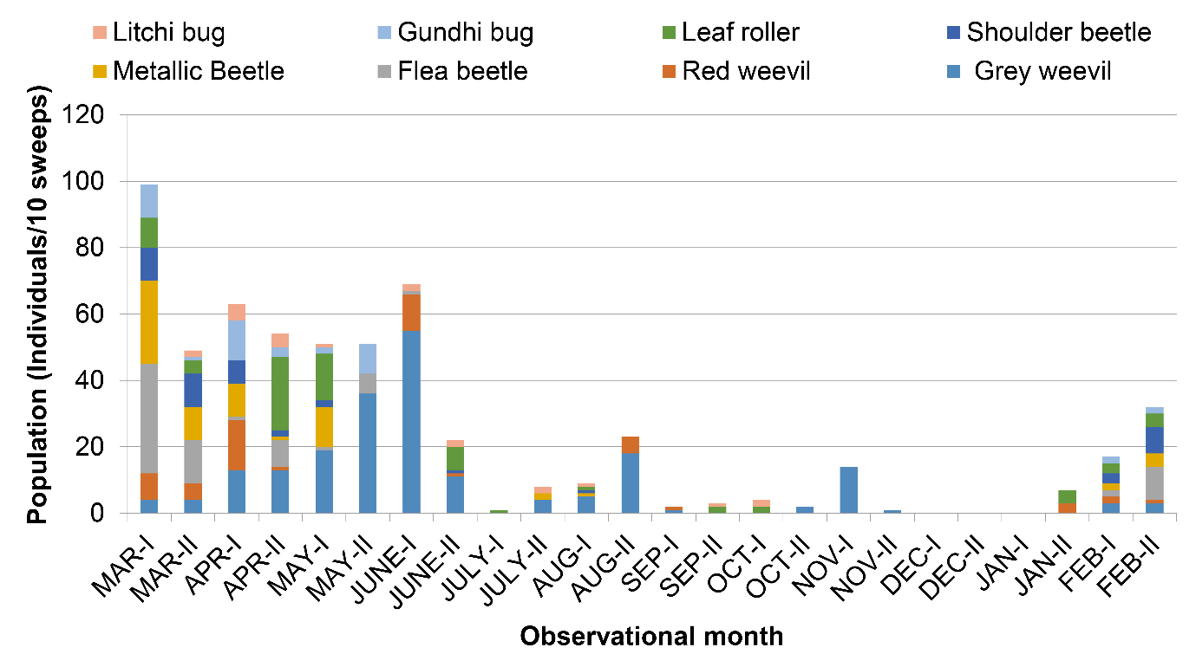
Fig. 1. Insect-pest populations of litchi leaf and stem in sub-region V 2022-24
3.2.2 Seasonal occurrence of leaf- and stem-infesting insect pests in sub-region II
Unlike sub-region V, in sub-region II, the highest population of different insect pests was recorded from the 1st fortnight of May to the 1st fortnight of June. Thereafter, the population started declining and became almost negligible in winter months (i.e., during January-February). However, there was a small peak in the 1st fortnight of October, which was due to a sudden increase in the grey weevil population. Like sub-region V, in sub-region II, the grey weevil was also the most dominant pest in the species assemblage. The grey weevil population was highest in the 1st fortnight of May (with a population of 382 individuals/10 sweeps) and declined thereafter. In contrast, the second most abundant insect of this sub-region, i.e., the litchi bug, had an increment in population from the 1st fortnight of May onwards and had the peak population in the 2nd fortnight of June (with a population of 97 individuals/10 sweeps). Furthermore, the litchi stem borer was found to be present in the field for a very short period, from the 2nd fortnight of July to the 2nd fortnight of September. In sub-region II, two pests, i.e., leaf roller and litchi bug, were found in litchi plants almost throughout the season (Figure 2).
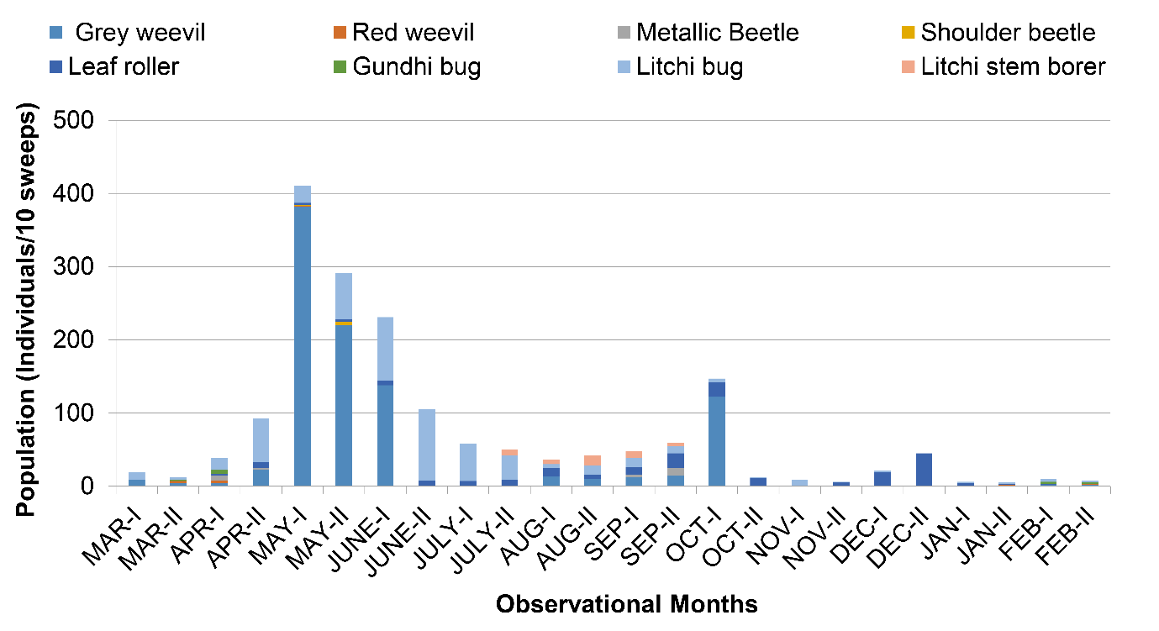
Fig. 2. Insect-pest populations of Litchi leaf and stem in Sub-region II 2022-24
3.3 Seasonal occurrence of fruit-infesting insect pests in litchi
Our study has documented only three insect pests that used to infest litchi fruits. These fruit-infesting pest complexes were first observed during March, with fruit initiation. Unlike the population of leaf- and stem-infesting insects, the cumulative population of fruit-infesting insects was a bit higher in sub-region V than sub-region II. Among them, the population was highest for the litchi fruit borer in both sub-regions. Furthermore, its population was quite higher in sub-region II than sub-region V, whereas fruit fly and nut borer had a greater population in sub-region V than sub-region II (Fig.3).
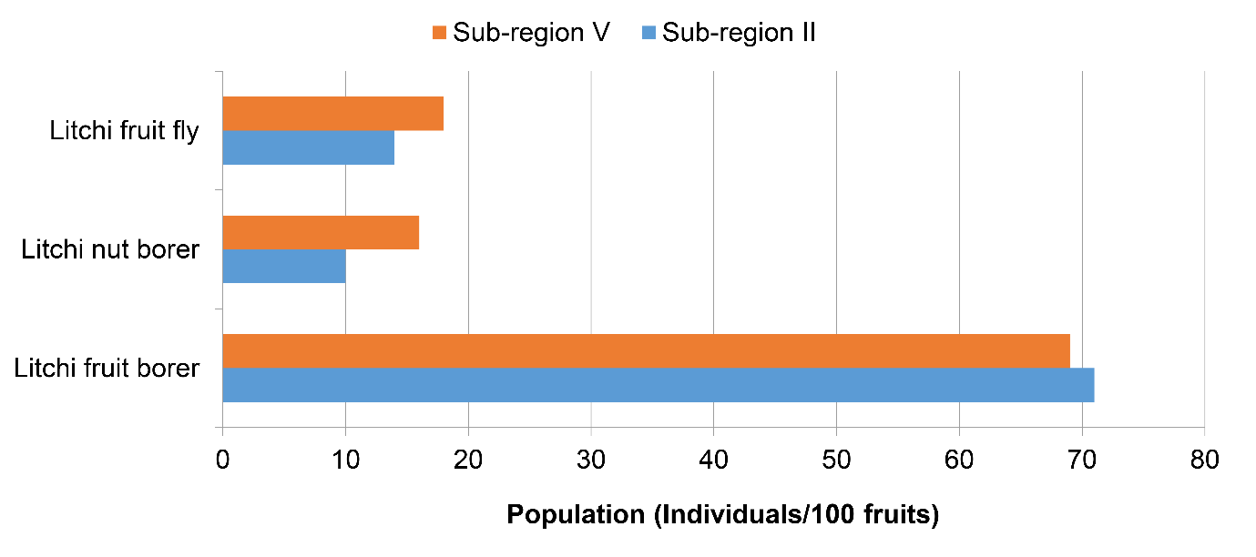
Fig. 3. Insect-pest populations of Litchi fruit
From flowering to fruiting, this is the typical time period when the crop is highly vulnerable to different insect pest attacks. Our study showed variation in the seasonal occurrence of different insect pests, which was sometimes in corroboration with or sometimes a bit different from previously published literatures. The pattern of grey weevil population fluctuation, with a greater population from April‒July, was also reported by other researchers (Atwal, 1976; Mazumder et al., 2014). Furthermore the complete absence of this weevil during December‒January was also recorded by Srivastava et al. (2015). Kumar et al. (2014b) have noticed a low red weevil population during December-January, when the temperature was low, and a high population during May-June, when the temperature was high enough in Bihar, which was pretty similar to our outcomes. Although three species of litchi leaf roller have been reported from West Bengal, among them, Duduaaprobola was the predominant one (Kar et al., 2023). According to Kar et al. (2023), this pest started infesting the plant from the 26th standard week (i.e., the 1st week of July) and remained active up to the 41st standard week (i.e., the 2nd week of October), which was almost similar to its seasonal incidence pattern in our sub-region II. Further, our finding on litchi leaf roller incidence is also in line with the findings of Chakraborty and Samanta (2005).
The litchi stem borer, Aristobiareticulator, is an invasive pest of litchi and usually found in the north-eastern part of India, including Assam, Manipur, Meghalaya, Sikkim, Tripura (Firake et al., 2013; Agarwala and Bhattacharjee, 2015), Arunachal Pradesh (Kumawat et al., 2017; Kumawat and Wangchu, 2021), Mizoram, and Nagaland (Mozhui et al., 2020) and Nagaland (Reddy et al., 2025). In our study also, this pest was found only in sub-region II of Zone II at the north-eastern part of the country. According to different studies, this pest used to attack the plants from mid-June to August, causing damage to young as well as old litchi trees (Kumawat et al., 2017; Reddy et al., 2025), which was also observed in the pest population pattern of sub-region II. In the case of the litchi bug, the adults used to hibernate during extreme winter (Kumar et al., 2008), which might be the reason for the low population of this pest during October‒February in our sub-region II. Then a greater population was noticed during March‒September, which was in agreement with the findings of Deng et al.(1999) and Kumar et al. (2008).
Usually, three species of litchi fruit borers, viz., Conopomorphasinensis, C. cramerella, and C. litchiensis, are found in India (Reddy et al., 2016). However, we have found only one of them from our studied regions. According to a previous study from West Bengal (Dalui and Sarkar, 2021),the infestation of C. sinensis used to begin at the last week of March, and infestation gradually increased and reached its peak during the first week of May, which was in line with our outcomes.The higher incidence of litchi fruit and shoot borer from the 11th to 22nd standard week (i.e., March‒June) was also reported by Kumar et al. (2024).
3.3 Comparative ecological indices of insect pests in sub-region II and sub-region V
In this study (Table 3), we have observed greater values for Shannon and Brillouin diversity indices in sub-region V (i.e., 2.139 and 1.835, respectively) than sub-region II (i.e., 1.348 and 1.525, respectively), indicating a greater species diversity in sub-region V. Likewise, the Margalef and Menhinick richness indices were also depicted as greater values in sub-region V (1.532 and 0.421, respectively) than sub-region II (i.e., 1.329 and 0.255, respectively), suggesting a rich insect pest composition in the litchi ecosystem in sub-region V. In addition to that, the insect pest assemblage of sub-region V is not only diverse and rich, but the higher values (tending to 1) of different evenness indices (Sheldon, Heip, and Pielou index) suggested an evenly distributed species composition in sub-region V. Whereas, in the sub-region II, the values are tending towards 0, suggesting a less evenly distributed species composition. This is also justified by the dominance indices (Simpson, Berger-Parker, and McIntosh index). The greater values of the Simpson and Berger-Parker dominance indices and lower value of the McIntosh index in sub-region II are a clear indication that the region had a greater dominance by a single or few species in the species assemblage (Heip, 1974; Kanieski et al., 2018). This can be further justified by the individual population of different insect pests in both sub-regions, as stated above. Although, the species composition of the sub-region V has a bit greater population of grey weevils, but in comparison to sub-region II, this variation is low enough. Moreover, in sub-region II, the greater dominance by the grey weevil and litchi bug in the species composition is mainly responsible for obtaining lower evenness and higher dominance in its species composition.
Table 3. Different indices of insect-pests of the Litchi ecosystem in 2022-24
Indices |  | Sub-region |  | Indices |  | Sub-region
 |  | II | V |  |  | II | V
Diversity | Shannon index | 1.348 | 2.139 | Richness | Margalef index | 1.329 | 1.532
Diversity | Brillouin index | 1.525 | 1.835 | Richness | Menhinick index | 0.255 | 0.421
Dominance | Berger-Parker index | 0.515 | 0.301 | Evenness | Sheldon index | 0.350 | 0.772
Dominance | Simpson index | 0.355 | 0.150 | Evenness | Heip index | 0.285 | 0.749
Dominance | McIntosh index | 0.414 | 0.637 | Evenness | Pielou index | 0.562 | 0.892
4. CONCLUSION
Our study on the diversity and seasonal occurrence of different insect pests in the litchi ecosystem has provided valuable insights, particularly with regard to the implementation of incidence-based management strategies. As per our study, a wide range of insect pests are available in these regions that can cause serious damage to the litchi production. Furthermore, the insect pest population was drastically higher in sub-region II, requiring a comparatively greater management effort in the litchi orchards of this sub-region than sub-region V. The higher population of different insect pests at the flowering-to-fruiting stage of the crop makes the crop more vulnerable during these particular growth stages. This suggests that appropriate and judicious insect pest management strategies need to be implemented at this typical timeframe in order to safeguard the orchards from facing a heavy yield loss.
DISCLAIMER (ARTIFICIAL INTELLIGENCE)
Authors hereby declare that NO generative AI technologies such as Large Language Models (ChatGPT, COPILOT, etc.) and text-to-image generators have been used during the writing or editing of this manuscript.

REFERENCES
Agarwala B K, Bhattacharjee P P. 2015. Redescription of Aristobiareticulator (F., 1781) (Coleoptera: Cerambycidae: Lamiinae), with a taxonomic note and record of a new food plant for adults in Northeastern India. The Coleopterists Bulletin, 69(2), 205-212.
Atwal, A. S. (1976). Agricultural Pests of India and Southeast Asia. Delhi:Kalyani Publishers.
Berger, W. H., & Parker, F. L. (1970). Diversity of planktonic foraminifera in deep-sea sediments. Science, 168(3937), 1345-1347. https://10.1126/science.168.3937.134
Chauhan, V. S., Ahlawat, V. P., &Joon, M. S. (2008). Evaluation of different cultivars of litchi (Litchi chinesissonn.) under northern region of Haryana state of India. Agricultural Science Digest, 28(2), 155-156.

Chakraborty, K., & Samanta, A. (2005). Evaluation of litchi germplasms based on biochemical parameters along with incidence of leaf roller (Platypepla aprobola Meyer.) and fruit borer (Conopomorpha cramerella Snellen). Annals of Plant Protection Sciences; 13(2), 338-342.
Choudhary, J. S., Prabhakar S. C., Moanaro, Das, B. & Kumar, S. (2013). Litchi stink bug (Tessaratomajavanica) outbreak in Jharkhand, India, on litchi. Phytoparasitica, 41, 73- 77.https://doi.org/10.1007/s12600-012-0265-x
Dalui, T., & Sarkar, S. K. (2021). Seasonal incidence and damage potentiality of Litchi fruit Borer (Conopomorphasinensis Bradley, 1986) in relation to major abiotic environmental factors. Ecology Environment and Conservation, 27, S302-307.
Deng, G.R., Yang, H.H., Huang, D.X., Zeng, D.Q., Chen, D.Y., &Huang, S.S. (1999). List of the insect pests and diseases of longan in nanning. Guangxi Plant Protection, 12, 12-16.
Firake, D. M., Behere, G. T., Deshmukh, N. A., Firake, P. D., &Thakur, N. S. A. (2013). Recent scenario of insect-pests of guava in North East India and their eco-friendly management. Indian Journal of Hill Farming, 26(1), 55-57.
Hameed, S. F., Singh, P. P., & Singh, S. P. 2001. Pests. In: K. S. Chauhan(Ed), Litchi: Botany, Production, Utilization(pp. 228). Ludhiana:Kalyani Publishers.
Hameed, S.F., Sharma, D.D.,& Agarwal, M.L. (1992). Integrated Pest management in litchi. In Proceedings of National Seminar on Recent Developments in Litchi Production held at R.A.U., Pusa. pp. 38.
Heip, C. (1974). A new index measuring evenness. Journal of the Marine Biological Association of the United Kingdom, 54(3), 555-557. https://doi.org/10.1017/S0025315400022736
Kanieski, M. R., Longhi, S. J., &Soares, P. R. C. (2018). Methods for biodiversity assessment: Case study in an area of Atlantic forest in southern Brazil. In: B.Şen, &O. Grillo(Eds), Selected studies in biodiversity (pp. 45-58). IntechOpen,.https://dx.doi.org/10.5772/intechopen.71824
Kar, A., Majhi, D., Chakarborti K., & Mishra, D. (2023). Species complex of leaf roller infesting litchi (Litchi Chinensis) in West Bengal with their seasonal incidence. Indian Journal of Entomology, 85(4), 959-962.
Kumar, A., Srivastava, K., Patel, R. K., &Nath, V. (2014a). Management of litchi fruit borer and litchi mite using bio-rational approaches under subtropics of Bihar. The Ecoscan, Special (6), 285-289.
Kumar, S., Srivastava, K., Patel,R. K., Pratap A. D. & Singh, S. K. (2024).Seasonal occurrence and management of litchi fruit and shoot borer, Conopomorphasinensis (Bradley). Pest Management in Horticultural Ecosystem, 18, 210-212.
Kumar, V., Dubedi, A. K.&Nath, V. (2014b). Prevalence of some threatening pests and disease of litchi (Litchi chinensisSonn.) in Bihar state of India. Journal of Applied Horticulture, (16),11-13.
Kumar, V., Kumar, A., &Nath, V. (2011). Emerging pests and diseases of litchi (LitchichinensisSonn.). Pest Management in Horticultural Ecosystem, 17, 11-13.
Kumar, V., Reddy, P. V., &Anal, A. K. D. (2013). Report on the occurrence and biology of ThalassodespilariaGuenee (Lepidoptera: Geometridae) on litchi (LitchichinensisSonn.) in Bihar, India. Pest Management in Horticultural Ecosystems, 19(2), 245-247.
Kumawat, M. M., Singh, K. M.,&Wangchu, L. (2017). First report of an invasive longhorn beetle, Aristobiareticulator (Voet) (Coleoptera: Cerambycidae) in Litchi, Litchi chinensisSonn. (Sapindaceae) in India. The Coleopterists Bulletin, 71(1), 131-136.
Kumawat, M. M., &Wangchu, L. (2021). First record of Aristobiareticulator (Voet) on aonlaEmblica officinalis Gaertn. Indian Journal of Entomology 83(1), 25-29.
Malik, G., &Deveshwar, P. (2017). Abiotic stress management in fruit crop Litchi chinensis. In: M. Kumar, V. Kumar, R. Prasad, & A. Varma (Eds.), The lychee biotechnology (pp. 243-263). Singapore: Springer.https://doi.org/10.1007/978-981-10-3644-6_8
Margalef, R. (1958). Temporal succession and spatial heterogeneity in phytoplankton. In: A.A. Buzzati-Traverso (Ed), Perspectives in marine biology (pp. 323-349). USA: University of California Press. https://doi.org/10.1525/9780520350281-024
Mazumder, N., Dutta, S. K., Bora, P., Gogoi, S. & Purnima, D. (2014). Record of litchi weevil, Myllocerusdiscolor (Coleoptera: Curculionidae) on litchi (Litchi chinensisSonn. (Sapindaceae) from Assam. Insect Environment. 20, 29-31.
McIntosh, R. P. (1967). An index of diversity and the relation of certain concepts to diversity. Ecology, 48(3), 392-404. https://doi.org/10.2307/1932674
Menhinick, E. F. (1964). A comparison of some species‐individuals diversity indices applied to samples of field insects. Ecology, 45(4), 859-861.https://doi.org/10.2307/1934933
Mozhui L, Rana A, Neikha K, Kakati L N. 2020. A checklist of long horn beetles (Coleoptera: Cerambycidae) of Lumami, Zuhenboto District, Nagaland with 23 new records. Halteres, 11, 118-128.
Peet, R. K. (1975). Relative diversity indices. Ecology, 56(2), 496-498.https://doi.org/10.2307/1934984
Pielou, E. C. (1966). The measurement of diversity in different types of biological collections. Journal of Theoretical Biology, 13, 131-144. https://doi.org/10.1016/0022-5193(66)90013-0
Rangare, N. R., Lal, N., &Sahu, N. (2022). Litchi-an emerging potential fruit crop in India. In: S. Singh, & N. R. Rangare (Eds.), Research Management in Horticultural Crops (pp. 97-109). New Delhi: Scripown Publications.
Reddy,P. M., Choudhary, J. S., Limtinaro, &Maiti, C. S. (2025). Invasive longhorn beetle, Aristobiareticulator (Voet) (Coleoptera: Cerambycidae): A major threat to litchi trees in Nagaland. Indian Journal of Entomology, Online published Ref. No. e25746, https://doi.org/10.55446/IJE.2025.1746.
Reddy, P. V. R., Srivastava, K.,&Nath, V. (2016). Litchi fruit borers. Current Science, 10, 758-759.
Regmi, N. R. (2022). A review on management options for litchi fruit and shoot borer, Conopomorphasinensis. Big Data in Agriculture (BDA), 4(2), 58-61.
Shannon, C. E. (1948). A mathematical theory of communication. The Bell System Technical Journal, 27(3), 379-423. https://doi.org/10.1002/j.1538-7305.1948.tb01338.x
Sheldon, A. L. (1969). Equitability indices: dependence on the species count. Ecology, 50(3), 466-467. https://doi.org/10.2307/1933900
Simpson, E. H. (1949). Measurement of diversity. Nature, 163(4148), 688-688. https://doi.org/10.1038/163688a0
Singh, H. S., Rai, M.&Nath V. (2001). Status and Management of Insect Pests and Mites. In: M. Rai, V.Nath, & P,Dey (Eds.), Litchi, Genetic Resources, Production, Protection and Post-harvest management (pp.73–80).
Srivastava, K., Pandey, S. D., Patel, R. K., Sharma, D., &Nath, V. (2016). Insect pest management practices in litchi. In: A. Kumar & P. M. Pandey (Eds.), Insect Pests Management of Fruit Crops (pp. 127-149). India: Bio-Green.
Srivastava, K., Patel, R. K., Kumar, A., Rai, R. R., &Nath, V. (2015). Seasonal incidence and management of ash weevil (Myllocerusundecimpustulatus) population on litchi. The Ecoscan, 8, 161-165.
Yadav, P., Lal, R. L., & Pandey, C. (2011). Effect of different levels of fertigation on yield, quality and leaf nutrient status of litchi (Litchi chinensisSonn.) cv. Rose Scented. Progressive Horticulture, 43(2), 276-280.

