Molecular Docking and Simulation Analysis: Assessing Phytochemical Interactions with COVID-19 Main Protease

Abstract
The global outbreak of severe acute respiratory syndrome coronavirus 2 (SARS-CoV-2) in 2020 has had a profound worldwide impact, with over 773 million confirmed cases reported across multiple countries. To mitigate this crisis, several vaccines and repurposed drugs have been deployed under emergency use authorization. However, concerns remain regarding the side effects and limited efficacy of some repositioned therapeutics. In the search for alternative strategies, computational approaches have identified numerous potential inhibitors of the viral main protease (Mpro), a key enzyme in viral replication. In this study, we compiled a phytochemical library of 2,453 compounds with reported antiviral properties, curated through an extensive literature review. Virtual molecular docking analysis identified five bioactive compounds-theaflavate C, theaflavin-3,3′-O-digallate, amentoflavone, hinokiflavone, and theaflavin-3-gallate-that displayed notably high binding affinities toward SARS-CoV-2 Mpro, with docking scores ranging from –10.1 to –9.7 kcal/mol. These top candidates were subsequently subjected to 20-nanosecond molecular dynamics (MD) simulations using the GROMACS package. The MD trajectories were analyzed for structural stability and interaction dynamics using parameters such as root mean square deviation (RMSD), root mean square fluctuation (RMSF), radius of gyration (Rg), solvent-accessible surface area (SASA), hydrogen bond formation, and principal component analysis (PCA). Converged trajectories were further employed in MM-PB/GBSA calculations to estimate the binding free energies with greater accuracy.
Keywords: Phytochemicals, SARS-CoV-2, main protease, molecular docking, MD simulation, MM-P/G/BSA calculations

Introduction
Coronavirus disease (COVID-19) is a respiratory infectious disease caused by a novel virus strain, Severe Acute Respiratory Syndrome Coronavirus-2 (SARS-CoV-2). The first reported case emerged on December 31, 2019, in Wuhan, China, after which the infection rapidly spread to over 212 countries, affecting millions of people worldwide. On January 30, 2020, the World Health Organization (WHO) declared COVID-19 a Public Health Emergency of International Concern. The virus is believed to have originally been hosted by bats and subsequently transmitted to humans, with further spread occurring primarily via human-to-human transmission (Patel et al., 2021; Pushkaran et al., 2021; Rajagopal et al., 2020). SARS-CoV-2 transmission occurs through multiple routes, including contact, respiratory droplets, airborne particles, fomites, fecal–oral, bloodborne, mother-to-child, and animal-to-human pathways. Common clinical manifestations of COVID-19 include fever, dry cough, shortness of breath, fatigue, muscle pain, headache, runny nose, sneezing, sore throat, loss of smell, and pneumonia. Gastrointestinal symptoms such as diarrhea, nausea, vomiting, and abdominal pain have also been reported. The infection can lead to respiratory, gastrointestinal, and neurological complications ranging from mild illness to severe disease or death. Notably, some individuals remain asymptomatic despite infection (Parihar et al., 2022; Shereen et al., 2020).
SARS-CoV-2 is a single-stranded, positive-sense RNA virus with a genome size of 26–32 kb (approximately 29,903 nucleotides). The genome is organized into a 5′ cap, a 5′ untranslated region (UTR), open reading frames (ORFs), a 3′ UTR, and a 3′ poly-A tail. The 5′ region encodes two large polyproteins, pp1a (486 kDa) and pp1ab (790 kDa), which occupy about two-thirds of the genome and are processed into 16 non-structural proteins. The 3′ end encodes four structural proteins: Spike (S), Envelope (E), Membrane (M), and Nucleocapsid (N) (Islam et al., 2021; Muhseen et al., 2021). These structural proteins are essential for viral recognition, receptor binding, and membrane fusion, facilitating infection and viral transmission. SARS-CoV-2 primarily infects alveolar type II epithelial cells through the interaction of its Spike protein with the host receptor angiotensin-converting enzyme 2 (ACE2), leading to acute alveolar damage (Jannat et al., 2020; Joshi et al., 2020). After entry, the viral RNA genome associates with host ribosomes to initiate translation of large polyproteins, which are subsequently processed by proteolysis into functional proteins required for viral replication (Nallusamy et al., 2021; Yadav et al., 2021).
The viral main protease (Mpro), also known as 3-chymotrypsin-like protease (3CLpro), is a cysteine protease featuring a catalytic dyad composed of cysteine (C145) and histidine (H41). Mpro plays a pivotal role in viral replication and maturation (Neupane et al., 2020; Wang et al., 2020; Abouelela et al., 2021). During translation, viral polyproteins undergo autocleavage mediated by Mpro, producing the mature protease. This active form processes the polyproteins into 11 non-structural proteins (nsps) essential for replication and transcription. As such, Mpro activity is indispensable for viral polyprotein processing, genome replication, and overall maturation. Inhibiting Mpro can therefore effectively disrupt viral replication and transmission (Das et al., 2021; Fiorucci et al., 2020). Because no human proteases share the same substrate recognition sequences as Mpro, it represents an attractive and highly specific antiviral drug target. Importantly, potential inhibitors must also be non-toxic to ensure therapeutic safety (Halder et al., 2022; Rutwick & Praveen, 2021).
After the COVID 19 outbreak, a diverse array of drugs, either singularly or in combination, has been extensively utilized worldwide. However, the significant adverse effects associated with repurposed drugs have raised concerns, and their effectiveness is currently undergoing evaluation. There is urgency for safe and effective treatment options. Natural product with anti-viral property can be used because of their low toxicity profile in comparison to synthetic compounds, as they have been already used in the past for treatment of other viruses such as influenza, MERS-CoV, and HIV (Hasan et al., 2020 and Mahmud et al., 2021). Phytochemicals are chemical compounds derived from plants, generally help them to resist against fungi, bacteria, and virus infections (Mostafa et al., 2022 and Murugesan et al., 2021). Many potential phytochemicals have been found with anti-inflammatory, anti-allergic, COVID-19 main protease (Mpro) inhibitory activities and diverse therapeutic potentials that could be considered as a valuable resource for the discovery of novel drug leads (Ebada et al., 2020, Mpiana et al., 2020 and Zang et al., 2020). The interaction between active phytochemicals and Mpro reduces viral transcription and replication by inhibiting the cleavage of polyproteins into non-structural proteins (nsps) (Mitra et al., 2021).
Important way of identifying potential phytocompounds that can bind to and block the main protease of COVID-19 can be done through computational screening methods. Computational screening reveals promising prospects for preclinical compound discovery targeting SARS-CoV-2 viral infection (Sawant et al., 2021). Here, a deep literature survey is conducting to prepare phytochemicals library for identifying effective candidates against the main protease of SARS-CoV-2. Molecular Docking was then used for determining binding affinity of the target with compounds of an in-silico library. By using molecular docking technique best bioactive phytochemicals are identifying and further assessed through molecular dynamics simulations to address issues such as suboptimal binding efficacy, motion impact, and solvation effects observed in the molecular docking pipelines. Molecular dynamic simulation is used to understand the time dependent interactions that are responsible for biological activity of a molecule (Khan et al., 2021 and Kumar et al., 2020). Computer-aided drug design encompasses the creation of a simulated environment mirroring the conditions within the human body (Alamri et al., 2020). This simulation facilitates the study of receptor-ligand interactions under controlled conditions, offering advantages in terms of both time and cost savings. Hence, computational technology has become a vital tool in drug candidate identification (Gowrishankar et al., 2021).
MATERIALS AND METHODS
Construction of Phytochemical Library: Library of 2453 phytochemicals were prepared after a profound literature search. The tertiary structures of these phytochemicals were extracted from the PubChem database which is available at NCBI (http://www.pubchem.ncbi.nlm.nih.gov). For the ligands whose structures were not available, the 3D structures were obtained using open babel tool (O'Boyle et al., 2011) by using their SMILES (Simplified Molecular Input Line Entry System).
Target Preparation: The three-dimensional crystal structure of SARS-CoV-2 main protease (Mpro) with PDB ID 7BQY, resolved at 1.70 Å, was obtained from the RCSB Protein Data Bank.This crystal structure consists one chain of 306 amino acids and one fragment of N3 compound. The pre-processing of Mpro protein structure was accomplished by the removing water molecules, ions, and bound ligands from the protein crystal structure; hydrogen atoms and kollman charges were added in protein through the Autodock tool.
Ligand Preparation: The ligand library was prepared for docking by atom-typing and by adding hydrogen through AutoDock Vina command line. The ligands were initially obtained in sdf format and subsequently converted to pdbqt format, ensuring their compatibility for docking in AutoDock Vina.
Molecular Docking: Molecular docking was carried out using AutoDock Vina (Eberhardt et al., 2021) to evaluate the orientations, conformations, and binding affinities of ligands within the active site of Mpro. In this setup, the protein was treated as rigid, while the ligands were modeled as flexible, allowing rotation of all rotatable bonds. Binding site of the main protease was analysed by using the information about the amino acid residues interacting with the known, co-crystallized inhibitor. A grid box was generated specifically targeting the active site of the main protease, set at X: 10.614, Y: -1.936, Z: 23.513, encompassing the binding region using the AutoDock Vina grid program.
PyMol were used to visualize the non-bonding interactions within the docked protein–ligand complex, and to analyze the docking pose. The molecular interactions, such as hydrogen bonds and their respective bond lengths within the protein-ligand complexes, were analyzed and presented using the LigPlot+ v.1.4.5 program (Laskowski & Swindells 2011).
Molecular dynamics (MD) simulations: A 20-nanosecond molecular dynamics (MD) simulation of the protein–ligand complex was performed using GROMACS 2020.3 (Bekker et al., 1993) with the CHARMM36 all-atom force field. Protein topology files were generated using the pdb2gmx module in GROMACS, while ligand topologies were prepared through the CGenFF server. The complexes were solvated in a dodecahedron box with TIP3P explicit water molecules, and the system was neutralized by adding four sodium ions at random positions using the gmx solvate tool. Energy minimization was conducted using the steepest descent method with a cutoff of 1000 kJ·mol⁻¹ for up to 50,000 steps, reducing steric clashes. Equilibration was carried out in two phases: (i) NVT ensemble, where the system was gradually heated from 0 to 300 K and equilibrated for 200 ps, and (ii) NPT ensemble, where the system was equilibrated at 300 K and 1 bar for 500 ps using the Berendsen coupling scheme for both temperature and pressure.
Finally, a 20 ns production run was performed to assess the stability of the protein–ligand complex. Trajectories were analyzed for structural and dynamic properties, including root mean square deviation (RMSD), root mean square fluctuation (RMSF), radius of gyration (Rg), hydrogen bond interactions, principal component analysis (PCA), and solvent-accessible surface area (SASA). These analyses were conducted using built-in GROMACS modules (rms, rmsf, gyrate, sasa, hbond, covar, and anaeig), and graphical representations were generated using XMGrace.
MM/G/P/BSA binding free energy calculations: Binding free energy was estimated using the Molecular Mechanics–Generalized Born/Poisson–Boltzmann Surface Area (MM-GB/PBSA) method. For each system, MMPBSA analysis was performed over the final 2 nanoseconds of the combined MD trajectories. This approach provides a reliable balance between computational efficiency and accuracy in predicting binding affinities. The gmx_MMPBSA tool (Valdés-Tresanco et al., 2021) was used to independently minimize the receptor, ligand, and receptor–ligand complex, and the total binding free energy was then calculated using the standard MMPBSA energy equation.

ΔG_{(bind)} = G_{complex} – (G_{ligand} + G_{receptor})
ΔG = ΔG_{gas} + ΔG_{sol} - TΔS
ΔG_{gas} = ΔE_{electrostatic} + ΔE_{vdW}
ΔG_{solv} = ΔG_{GB} + ΔG_{SA}

where, ΔG(_{bind}) = Binding free energy
G = Free energy of complex, protein and ligand
T = Temperature
ΔS = Entropy
ΔG_{gas}= Gas phase molecule free energy
ΔG_{solv} = Solvation free energy
ΔG_{GB} = Polar solvation free energy
ΔG_{SA} = Non polar solvation free energy

RESULTS AND DISCUSSION
Molecular Docking: Before performing whole docking procedure, re-docking of the N3 compound (native co-crystal ligand) has been done. The redocking results shown that it binds to the same site as the co-crystal ligand bind on of the Mpro. The major amino acid interaction includes: Thr25, Leu27, His41, Met49, Tyr54, Phe140, Leu141, Asn142, Cys145, His163, His164, Met165, Glu166, Asp187, Arg188, Gln189, Thr190 (Fig.1). N3 inhibitor binds with the His41- Cys145 dyad of Mpro.
Fig.1: 3D and 2D top docking interaction of inhibitor N3 with COVID-19 Mpro (7BQY)
The optimized structures of all phytochemicals were docked into the Mpro binding site using the same docking protocol employed for the N3 inhibitor's redocking process. Out of 2453 ligands screened against SARS-CoV Mpro, top five potential candidates (theaflavate C, theaflavin-3,3-O-digallate, amentoflavone, hinokiflavone and theaflavin3-gallate) were selected for further analysis (Table1), which had binding affinities of −10.1, −9.9, −9.7, −9.7, and −9.7 kcal/mol, respectively.
Table 1: Top five best docked phytochemicals with COVID-19 Mpro
Rank | Phytochemical Name | Pubchem Id | Binding Energy | Structure
1 | Theaflavate C | 101446897 | -10.1 | 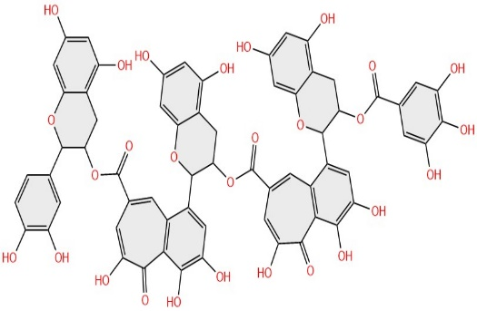
2 | Theaflavin-3,3-O-digallate | 13543795 | -9.9 | 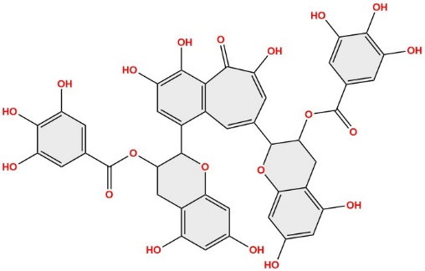
3 | Amentoflavone | 5281600 | -9.7 | 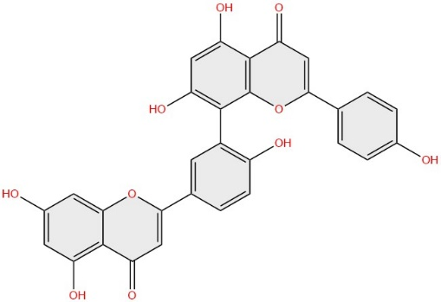
4 | Hinokiflavone | 5281627 | -9.7 | 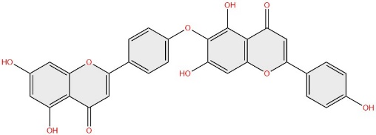
5 | Theaflavin3-gallate | 136825044 | -9.7 | 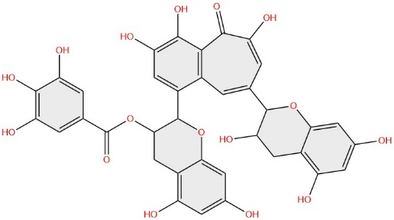

Theaflavate C has displayed the highest binding affinity with the receptor, as demonstrated in Fig. 2a. Docking study has revealed that theaflavate C interacts with 20 amino acid residues- Thr25, Thr26, His41, Ser46, Glu47, Met49, Leu141, Asn142, Gly143, Ser144, Cys145, His163, Met165, Glu166, Leu167, Pro168, Asp187, Arg188, Gln189, Thr190 (Fig.2a).
Theaflavin-3,3-O-digallate, another important phytochemical, demonstrated a binding energy of -9.9 kcal/mol. It engaged with a total of 17 amino acid residues, among which 14 residues (Thr25, Leu27, His41, Met49, Phe140, Leu141, Cys145, His163, Met165, Glu166, Asp187, Arg188, Gln189) in common with those interacting with the N3 inhibitor, as depicted in Fig. 2b. Therefore, it can be concluded that theaflavin-3,3-O-digallate binding to all major amino acid residues contributes significantly to inhibiting the receptor protein. Amentoflavone, a biflavonoid, has demonstrated notable binding affinity, displaying a binding energy of -9.7 kcal/mol (Fig.2c).The docking study has revealed that amentoflavone interacted with 15 amino acid residues among which 11 (Thr25, His41, Leu141, Asn142, Cys145, His164, Met165, Glu166, Asp187, Arg188, Gln189) coincides with that of the native co-crystal ligand which suggests that amentoflavone is responsible for inhibition of COVID-19 Mpro. Yet another flavonoid, hinokiflavone has interacted with 14 major amino acid residues among which 10 amino acids (Thr25, His41, Met49, Cys145, His164, Met165, Glu166, Arg188, Gln189, Thr190) are same as of the native ligand (Fig.2d). Theaflavin3-gallate exhibit a considerably good binding affinity towards the target with a binding energy of -9.7 Kcal/mol. This phytochemical interacts with 17 amino acid residues and among them, 14 amino acid residues interaction (Thr25, His41, Met49, Tyr54, Phe140, Leu141, Asn142, Cys145, His163, Met165, Glu166, Asp187, Arg188, Gln189) are like that of the native ligand (Fig.2e).

Fig. 2. Binding site interactions of SARS-CoV-2 Mpro with selected ligands. Amino acid residues forming polar hydrogen bonds with the ligands are highlighted in green using LigPlot. (a) Theaflavate C, (b) Theaflavin-3,3′-O-digallate, (c) Amentoflavone, (d) Hinokiflavone, and (e) Theaflavin-3-gallate.

Hydrogen bonds are critical in defining the binding affinity of protein–ligand complexes. In general, a higher number of hydrogen bonds correlates with stronger binding interactions. To assess the binding affinity of phytochemicals with Mpro, we analyzed the protease residues involved in both hydrogen bonding and hydrophobic interactions. These molecular interactions play a key role in stabilizing the docking complexes and shaping their overall conformational stability.
Table2: Docking results of selected top five phytochemicals and list of residues involving in hydrophobic and hydrogen bonding interactions in docked complex.
Rank | Binding Energy | Phytochemical Name | Amino acid interactions
Rank | Binding Energy | Phytochemical Name | Hydrogen Bonds | Hydrophobic interactions
1 | -10.1 | Theaflavate C | Thr25, Ser46, Ser144, Cys145, Glu166, | Thr26, His41, Glu47, Met49, Leu141, Asn142, Gly143, His163, Met165, Leu167, Pro168, Asp187, Arg188, Gln189, Thr190
2 | -9.9 | Theaflavin 3,3'-di-O gallate | His41, Ser144, Leu141, His163, Glu166, Leu167, Arg188 | Thr25, Thr26, Leu27, Ser46, Met49, Phe140, Asn142, Cys145, Met165, Pro168, Asp187, Gln189
3 | -9.7 | Amentoflavone | Thr26, Ser46, Asn142 | Thr25, His41, Cys145, Leu141, Gly143, Met149, His164, Met165, Glu166, Asp187, Arg188, Gln189,
4 | -9.7 | Hinokiflavone | Thr24, Thr45, Ser46, Cys145 | Thr25, His41, Met49, His164, Met165, Glu166, Pro168, Arg188, Gln189, Thr190
5 | -9.7 | Theaflavin3-gallate | Ser46, Tyr54, Leu141, Gly143, Ser144, His163 | Thr24, Met49, His41, Phe140, Asn142, Cys145, Met165, Glu166, Asp187, Arg188, Gln189,

Molecular Dynamic Simulation
Stability Analysis: RMSD and RMSF in Mpro-Ligand Complexes: RMSD analysis performed to know the conformational changes occur in protein backbone throughout the molecular dynamic simulation. TAs the simulations progressed, protein RMSD values were expected to stabilize which indicated a steady state within the binding pocket.. Theaflavate C shows higher rmsd value than other protein-ligand complexes throughout the simulation (Fig.3). Protein in complex with amentoflavone and theaflavin3-gallate show rise and fall for rmsd value below 0.3nm. Complex theaflavin-3,3-O-digallate and hinokiflavone were found to be more stable than other ligands as these ligands maintained low rmsd throughout the simulation time scale.

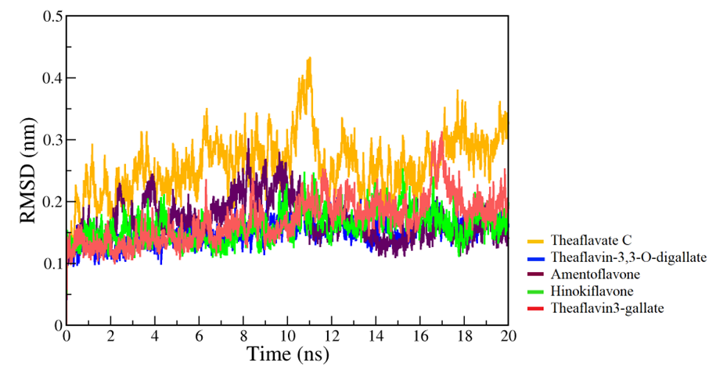
Fig.3: RMSD of the C-α backbone atoms of Mpro with phytochemicals: theaflavate C, theaflavin-3,3-O-digallate, amentoflavone, hinokiflavone and theaflavin3-gallate

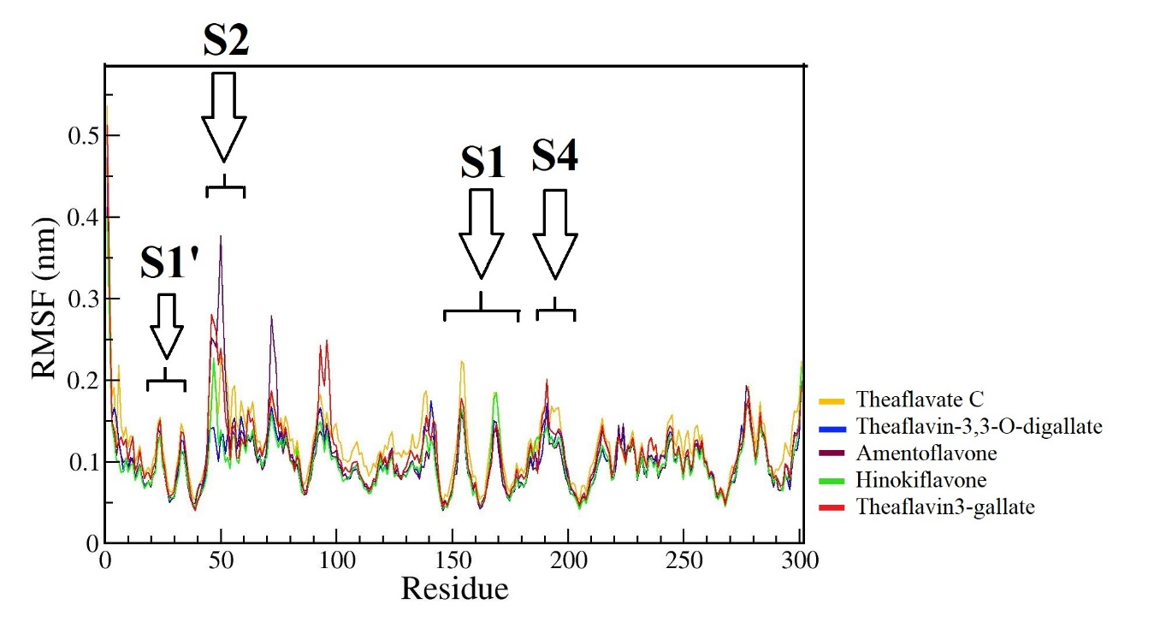
Fig.4 Residue-wise RMSF deviations (nm) of Mpro with top five docked phytochemicals: theaflavate C, theaflavin-3,3-O-digallate, amentoflavone, hinokiflavone and theaflavin3-gallate.
The root mean square fluctuation (RMSF) value is calculated to know at what extent the ligand binding to protein affects its flexibility. Through RMSF analysis, it has been observed that theaflavin-3,3--digallate and hinokiflavone structure have low RMSF value. Whereas Theaflavate C show little higher RMSF value in all areas as compared to others. Phytochemical amentoflavone found to have local flexibility at residue Met49, LEU50 and Asn51 (S2 pocket). Theaflavin 3-gallate shows local fluctuation between residue 90 to100 which are not part of binding site of Mpro (Fig.4). RMSF analysis of docked complexes showed less conformational changes during binding and can act as a stable complex.
There are noticeable fluctuations within specific residue ranges, namely residues 20–30, 40–60, 70-80, 140–170, and 175–200. The groupings of residues within 20–30 and 40–60 belong to the binding site, forming the S1’ and S2 pockets respectively. Meanwhile, the larger cluster spanning residues 175–200 represents the S1 and S4 pockets of the binding site. Residues outside of these ranges are not involved in the protein's binding site. Significant fluctuations, reaching up to 0.5 nm in magnitude, were observed specifically within the residues comprising the S2 binding pocket.
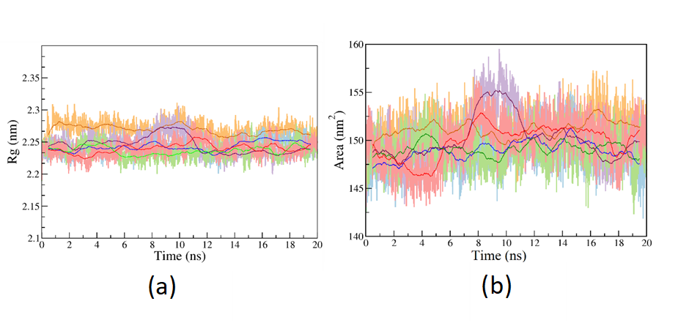
Radius of gyration (Rg) and Surface accessible solvent area (SASA) analysis: The radius of gyration (Rg) reflects the structural compactness throughout molecular dynamic simulation. A lower Rg value indicates a higher level of compactness and rigidity within the system. Theaflavate C show comparatively higher Rg value than other systems. Theaflavin-3,3-O-digallate, amentoflavone, hinokiflavone and theaflavin3-gallate show the almost same Rg value during simulation except for region between 8-10ns where amentoflavone increase its Rg value and after that again decreased (Fig.5a). This rise shows that protein structure expands between region 8-10ns and then again compact itself.
Fig.5: (a) Radius of Gyration and (b) SASA analysis of protein for complex with theaflavate C, theaflavin-3,3-O-digallate, amentoflavone, hinokiflavone and theaflavin3-gallate
Moreover, we performed SASA analysis across all complexes to assess the receptor's exposure to the solvent throughout the MD simulation. The interaction of phytochemicals could potentially alter SASA, impacting the protein structure significantly. When observing SASA values between 145-155 nm², it was evident that the binding of ligands did not induce notable alterations in the protein folding, as depicted in Fig. 5b.

Hydrogen bond interactions of Mpro and phytochemicals: H-bond helps to determine the binding strength between the ligands and protein.More the number of hydrogen bonds formed, stronger the binding affinity.Theaflavin-3-gallate formed a maximum of nine hydrogen bonds, consistently maintaining at least five hydrogen bonds throughout the entire simulation.. In case of theaflavate C, theaflavin-3,3-O-digallate, amentoflavone, hinokiflavone, maximum 7, 8, 8 and 9 hydrogen bonds were formed respectively (Fig.6).
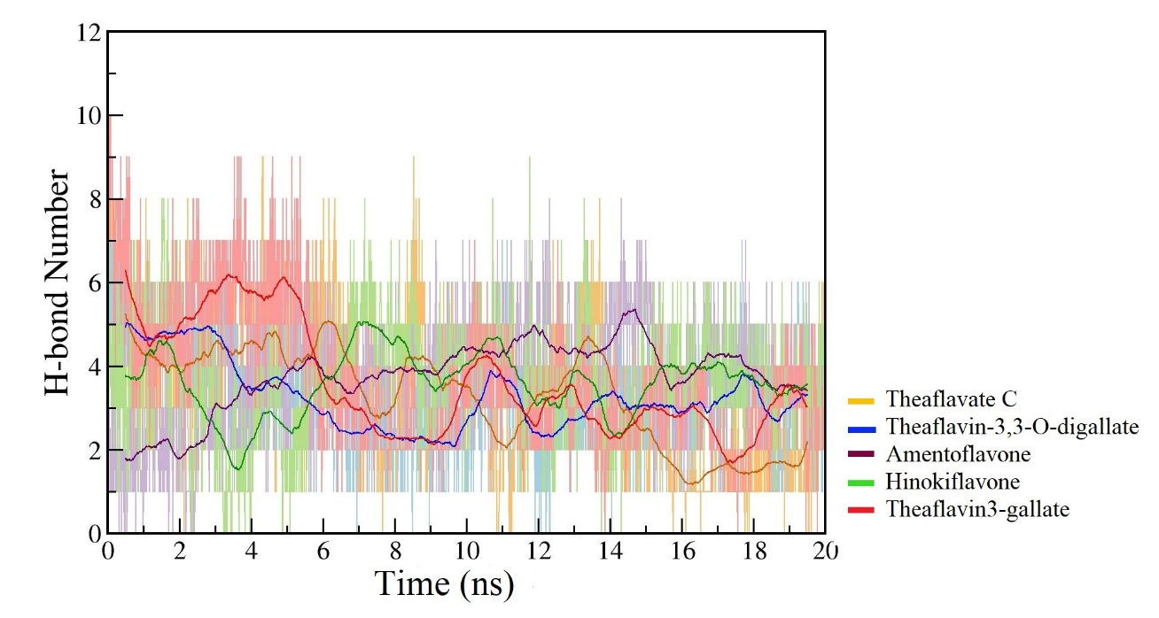
Fig.6: Inter H-bond formation between Mpro and phytochemicals: theaflavate C, theaflavin-3,3-O-digallate, amentoflavone, hinokiflavone and theaflavin3-gallate.

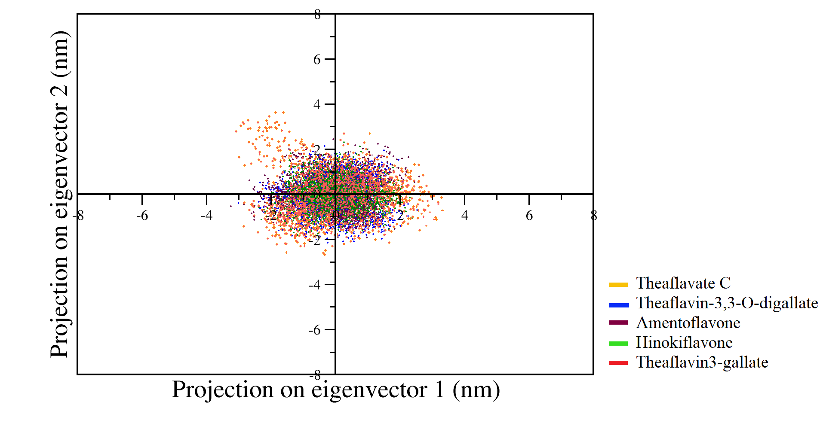
Principal component analysis (PCA): To study the coordinated movements within protein-ligand complexes, we conducted PCA analysis focusing on C-α atoms. Plotting the first two eigenvectors against each other allowed us to visualize correlated motions, where clustered dots signify greater structural stability and dispersed dots indicate lower stability. From PCA, we observed that except theaflavte C all complexes displayed well-clustered and thus very stable dots.

Fig.7: 2D Scatter Plot: Principal component Analysis (PC1 & PC2) for theaflavate C, theaflavin-3,3-O-digallate, amentoflavone, hinokiflavone and theaflavin3-gallate.

Binding Energy Calculation: The ligand's affinity for the receptor is quantitatively evaluated through binding free energy calculation using gmx_MMPBSA. This energy comprises various non-bonded interactions, encompassing van der Waals energy, electrostatic energy, polar solvation energy, and SASA energy. The binding free energy analysis reveals that polar solvation energy consistently contributes positively to the total binding free energy. Conversely, among negative contributors, van der Waals interactions dominate over electrostatic interactions across all cases. SASA energy makes a relatively minor contribution compared to the overall binding energy. Analysis of all ligands bound to COVID-19 Mpro indicates the major role of hydrophobic interactions in stabilizing the protein-ligand complex, evidenced by the notably high negative values of van der Waals energy (Table 3). Among top docked phytochemicals complex amentoflavone and hinokiflavone shows highest binding free energy.

Table 3: Van der Waals, electrostatic, polar solvation, SASA and binding energy (kcal/mol) for the docked compounds into Mpro inhibition site

Ligand | Van der Waals Energy | Electrostatic Energy | Polar Solvation Energy | SASA Energy | Binding Free Energy
Theaflavate C | -33.31 ± 3.16 | -32.08 ± 10.83 | 50.57 ± 8.56 | -4.72 ± 0.39 | -19.54 ± 3.96
Theaflavin 3,3'-di-O gallate | -33.16 ± 2.65 | -19.31 ± 7.33 | 34.99 ± 5.32 | -4.10 ± 0.32 | -21.59 ± 3.11
Amentoflavone | -44.25 ± 2.88 | -23.98 ± 4.45 | 44.03 ± 3.28 | -5.96 ± 0.23 | -30.16 ± 2.62
Hinokiflavone | -54.53 ± 3.52 | -30.43 ± 8.79 | 60.63 ± 6.88 | -7.52 ± 0.34 | -31.85 ± 3.53
Theaflavin3-gallate | -38.04 ± 3.13 | -35.70 ± 8.33 | 53.56 ± 6.74 | -5.46 ± 0.38 | -25.65 ± 3.52

Conclusion
In this study, computational analysis was conducted to carry out in-silico screening of phytochemicals obtained from deep literature study against the COVID-19 Mpro to check the binding affinity of the ligands with the protein and performed molecular dynamic simulations of selected phytochemicals. The virtual molecular docking results reveals that among the docked 2453 phytochemicals, 404 bioactive compounds have higher binding affinity towards Mpro as compared to co-crystal ligand inhibitor N3. The results of docking studies indicated that theaflavate C, theaflavin-3,3-O-digallate, amentoflavone, hinokiflavone, theaflavin3-gallate have the lowest binding energy against SARS-COV-2 Mpro. The molecular dynamics simulations (20 nanoseconds) indicate that four out of the top five docked compounds exhibit significant stability, flexibility, and favorable binding affinity towards the COVID-19 Mpro (Mpro). It has been demonstrated that theaflavate C, theaflavin-3,3-O-digallate, amentoflavone, hinokiflavon, and theaflavin3-gallate hold promise for further optimization as inhibitors of the Mpro. Subsequent in vitro and in vivo evaluations of these compounds can confirm their antiviral activity and, consequently, their potential as drug candidates.
Reference
Abouelela, M. E., Assaf, H. K., Abdelhamid, R. A., Elkhyat, E. S., Sayed, A. M., Oszako, T., Belbahri, L., El Zowalaty, A. E., & Abdelkader, M. S. A. (2021). Identification of Potential SARS-CoV-2 Main Protease and Spike Protein Inhibitors from the Genus Aloe: An In Silico Study for Drug Development. Molecules 2021, Vol. 26, Page 1767, 26(6), 1767.
Bekker, H., Berendsen, HJC., Dijkstra, EJ., Acheterop, S., Vondrumen, R., Vanderspoel, D., Sijbers, A., Keegstra, H., & Renardus, MKR. (1993). GROMACS - A PARALLEL COMPUTER FOR MOLECULAR-DYNAMICS SIMULATIONS. In RA. DeGroot, & J. Nadrchal (Eds.), PHYSICS COMPUTING '92 (pp. 252-256).
Das, P., Majumder, R., Mandal, M., & Basak, P. (2021). In-Silico approach for identification of effective and stable inhibitors for COVID-19 main protease (Mpro) from flavonoid based phytochemical constituents of Calendula officinalis. Journal of Biomolecular Structure and Dynamics, 39(16), 6265–6280.
Ebada, S. S., Al-Jawabri, N. A., Youssef, F. S., El-Kashef, D. H., Knedel, T. O., Albohy, A., Korinek, M., Hwang, T. L., Chen, B. H., Lin, G. H., Lin, C. Y., Aldalaien, S. M., Disi, A. M., Janiak, C., & Proksch, P. (2020). Anti-inflammatory, antiallergic and COVID-19 protease inhibitory activities of phytochemicals from the Jordanian hawksbeard: identification, structure–activity relationships, molecular modeling and impact on its folk medicinal uses. RSC Advances, 10(62), 38128–38141.
Eberhardt, J., Santos-Martins, D., Tillack, A.F., Forli, S. (2021). AutoDock Vina 1.2.0: New Docking Methods, Expanded Force Field, and Python Bindings. Journal of Chemical Information and Modeling.
Fiorucci, D., Milletti, E., Orofino, F., Brizzi, A., Mugnaini, C., & Corelli, F. (2020). Computational drug repurposing for the identification of SARS-CoV-2 main protease inhibitors. Https://Doi.Org/10.1080/07391102.2020.1796805, 39(16), 6242–6248.
Gowrishankar, S., Muthumanickam, S., Kamaladevi, A., Karthika, C., Jothi, R., Boomi, P., Maniazhagu, D., & Pandian, S. K. (2021). Promising phytochemicals of traditional Indian herbal steam inhalation therapy to combat COVID-19 – An in silico study. Food and Chemical Toxicology, 148, 111966.
Halder, P., Pal, U., Paladhi, P., Dutta, S., Paul, P., Pal, S., Das, D., Ganguly, A., Dutta, I., Mandal, S., Ray, A., & Ghosh, S. (2022). Evaluation of potency of the selected bioactive molecules from Indian medicinal plants with MPro of SARS-CoV-2 through in silico analysis. Journal of Ayurveda and Integrative Medicine, 13(2), 100449.
Hasan, A., Al Mahamud, R., Jannat, K., Fariba, M. H., Jahan, R., Rahmatullah, M., Bondhon, T. A., Farzana, B.-N., & Fariba, H. (2020). Phytochemicals from Solanum surattense Burm.f. have high binding affinities for C-3 like main protease of COVID-19 (SARS-CoV-2). Journal of Medicinal Plants Studies, 8(4), 20–26.
Islam, R., Parves, M. R., Paul, A. S., Uddin, N., Rahman, M. S., Mamun, A. Al, Hossain, M. N., Ali, M. A., & Halim, M. A. (2021). A molecular modeling approach to identify effective antiviral phytochemicals against the main protease of SARS-CoV-2. Journal of Biomolecular Structure and Dynamics, 39(9), 3213–3224.
Jannat, K., Hasan, A., Al Mahamud, R., Jahan, R., Bondhon, T. A., Rahmatullah, M., & Farzana, B.-N. (2020). In silico screening of Vigna radiata and Vigna mungo phytochemicals for their binding affinity to SARS-CoV-2 (COVID-19) main protease (3CL pro). ~ 89 ~ Journal of Medicinal Plants Studies, 8(4), 89–95.
Joshi, T., Joshi, T., Sharma, P., Mathpal, S., Pundir, H., Bhatt, V., & Chandra, S. (2020). In silico screening of natural compounds against COVID-19 by targeting Mpro and ACE2 using molecular docking. European Review for Medical and Pharmacological Sciences, 24(8), 4529–4536.
Khan, J., Sakib, S. A., Mahmud, S., Khan, Z., Islam, M. N., Sakib, M. A., Emran, T. Bin, & Simal-Gandara, J. (2021). Identification of potential phytochemicals from Citrus Limon against main protease of SARS-CoV-2: molecular docking, molecular dynamic simulations and quantum computations.
Kumar, A., Choudhir, G., Shukla, S. K., Sharma, M., Tyagi, P., Bhushan, A., & Rathore, M. (2020). Identification of phytochemical inhibitors against main protease of COVID-19 using molecular modeling approaches. Journal of Biomolecular Structure & Dynamics, 39(10), 1.
Laskowski R A, Swindells M B (2011). LigPlot+: multiple ligand-protein interaction diagrams for drug discovery. J. Chem. Inf. Model., 51, 2778-2786.
Mahmud, S., Biswas, S., Paul, G. K., Mita, M. A., Promi, M. M., Afrose, S., Hasan, M. R., Zaman, S., Uddin, M. S., Dhama, K., Emran, T. Bin, Saleh, M. A., & Simal-Gandara, J. (2021). Plant-based phytochemical screening by targeting main protease of sars-cov-2 to design effective potent inhibitors. Biology, 10(7).
Majumder, R., & Mandal, M. (2020). Screening of plant-based natural compounds as a potential COVID-19 main protease inhibitor: an in silico docking and molecular dynamics simulation approach.
Mitra, D., Verma, D., Mahakur, B., Kamboj, A., Srivastava, R., Gupta, S., Pandey, A., Arora, B., Pant, K., Panneerselvam, P., Ghosh, A., Barik, D. P., & Mohapatra, P. K. D. (2021). Molecular docking and simulation studies of natural compounds of Vitex negundo L. against papain-like protease (PLpro) of SARS CoV-2 (coronavirus) to conquer the pandemic situation in the world. Journal of Biomolecular Structure and Dynamics.
Mostafa, I., Mohamed, N. H., Mohamed, B., Almeer, R., Abulmeaty, M. M. A., Bungau, S. G., El-Shazly, A. M., & Yahya, G. (2022). In - silico screening of naturally derived phytochemicals against SARS-CoV Main protease. Environmental Science and Pollution Research, 29(18), 26775–26791.
Mpiana, P. T., Ngbolua, K. te N., Tshibangu, D. S. T., Kilembe, J. T., Gbolo, B. Z., Mwanangombo, D. T., Inkoto, C. L., Lengbiye, E. M., Mbadiko, C. M., Matondo, A., Bongo, G. N., & Tshilanda, D. D. (2020). Identification of potential inhibitors of SARS-CoV-2 main protease from Aloe vera compounds: A molecular docking study. Chemical Physics Letters, 754, 137751.
Muhseen, Z. T., Hameed, A. R., Al-Hasani, H. M. H., Ahmad, S., & Li, G. (2021). Computational Determination of Potential Multiprotein Targeting Natural Compounds for Rational Drug Design Against SARS-COV-2. Molecules 2021, Vol. 26, Page 674, 26(3), 674.
Murugesan S, Kottekad S, Crasta I, Sreevathsan S, Usharani D, Perumal MK & Mudliar SN (2021) . Targeting COVID-19 (SARS-CoV-2) main protease through active phytocompounds of ayurvedic medicinal plants - Emblica officinalis (Amla), Phyllanthus niruri Linn. (Bhumi Amla) and Tinospora cordifolia (Giloy) - A molecular docking and simulation study. Comput Biol Med. 2021 Sep;136:104683. .
Nallusamy, S., Mannu, J., Ravikumar, C., Angamuthu, K., Nathan, B., Nachimuthu, K., Ramasamy, G., Muthurajan, R., Subbarayalu, M., & Neelakandan, K. (2021). Exploring Phytochemicals of Traditional Medicinal Plants Exhibiting Inhibitory Activity Against Main Protease, Spike Glycoprotein, RNA-dependent RNA Polymerase and Non-Structural Proteins of SARS-CoV-2 Through Virtual Screening. Frontiers in Pharmacology, 0, 1704.
Neupane, N. P., Karn, A. K., Mukeri, I. H., Pathak, P., Kumar, P., Singh, S., Qureshi, I. A., Jha, T., & Verma, A. (2021). Molecular dynamics analysis of phytochemicals from Ageratina adenophora against COVID-19 main protease (Mpro) and human angiotensin-converting enzyme 2 (ACE2). Biocatalysis and Agricultural Biotechnology, 32, 101924.
O'Boyle, N.M., Banck, M., James, C.A., Morley, C., Vandermeersch, Tim., and Hutchison G. R. (2011) Open Babel: An open chemical toolbox. J Cheminform 3, 33 (2011).
Parihar, A., Sonia, Z. F., Akter, F., Ali, M. A., Hakim, F. T., & Hossain, M. S. (2022). Phytochemicals-based targeting RdRp and main protease of SARS-CoV-2 using docking and steered molecular dynamic simulation: A promising therapeutic approach for Tackling COVID-19. Computers in Biology and Medicine, 145, 105468.
Patel, C. N., Jani, S. P., Jaiswal, D. G., Kumar, S. P., Mangukia, N., Parmar, R. M., Rawal, R. M., & Pandya, H. A. (2021). Identification of antiviral phytochemicals as a potential SARS-CoV-2 main protease (Mpro) inhibitor using docking and molecular dynamics simulations. Scientific Reports 2021 11:1, 11(1), 1–13.
Pushkaran, A. C., Nath EN, P., Melge, A. R., Puthiyedath, R., & Mohan, C. G. (2021). A phytochemical-based medication search for the SARS-CoV-2 infection by molecular docking models towards spike glycoproteins and main proteases. RSC Advances, 11(20), 12003–12014.
Rajagopal, K., Varakumar, P., Baliwada, A., & Byran, G. (2020). Activity of phytochemical constituents of Curcuma longa (turmeric) and Andrographis paniculata against coronavirus (COVID-19): an in silico approach. Future Journal of Pharmaceutical Sciences 2020 6:1, 6(1), 1–10.
Rutwick Surya, U., & Praveen, N. (2021). A molecular docking study of SARS-CoV-2 main protease against phytochemicals of Boerhavia diffusa Linn. for novel COVID-19 drug discovery. VirusDisease, 32(1), 46–54.
Sawant, S., Patil, R., Khawate, M., Zambre, V., Shilimkar, V., & Jagtap, S. (2021). Computational assessment of select antiviral phytochemicals as potential SARS-Cov-2 main protease inhibitors: molecular dynamics guided ensemble docking and extended molecular dynamics. In Silico Pharmacology, 9(1).
Shereen, M. A., Khan, S., Kazmi, A., Bashir, N., & Siddique, R. (2020). COVID-19 infection: Origin, transmission, and characteristics of human coronaviruses. Journal of Advanced Research, 24, 91.
Shree, P., Mishra, P., Selvaraj, C., Singh, S. K., Chaube, R., Garg, N., & Tripathi, Y. B. (2020). Targeting COVID-19 (SARS-CoV-2) main protease through active phytochemicals of ayurvedic medicinal plants – Withania somnifera (Ashwagandha), Tinospora cordifolia (Giloy) and Ocimum sanctum (Tulsi) – a molecular docking study. Journal of Biomolecular Structure & Dynamics, 1.
Sk, M. F., Roy, R., Jonniya, N. A., Poddar, S., & Kar, P. (2021). Elucidating biophysical basis of binding of inhibitors to SARS-CoV-2 main protease by using molecular dynamics simulations and free energy calculations. Journal of Biomolecular Structure and Dynamics, 39(10), 3649–3661.
Umadevi, P., Manivannan, S., Fayad, A. M., & Shelvy, S. (2020). In silico analysis of phytochemicals as potential inhibitors of proteases involved in SARS-CoV-2 infection. Journal of Biomolecular Structure and Dynamics.
Valdés-Tresanco, M. S., Valdés-Tresanco, M. E., Valiente, P. A., & Moreno, E. (2021). Gmx_MMPBSA: A New Tool to Perform End-State Free Energy Calculations with GROMACS. Journal of Chemical Theory and Computation, 17(10), 6281–6291.
Wang, M. Y., Zhao, R., Gao, L. J., Gao, X. F., Wang, D. P., & Cao, J. M. (2020). SARS-CoV-2: Structure, Biology, and Structure-Based Therapeutics Development. Frontiers in Cellular and Infection Microbiology, 10, 724.
Yadav, R., Chaudhary, J. K., Jain, N., Chaudhary, P. K., Khanra, S., Dhamija, P., Sharma, A., Kumar, A., & Handu, S. (2021). Role of Structural and Non-Structural Proteins and Therapeutic Targets of SARS-CoV-2 for COVID-19. Cells, 10(4), 821.
Zhang, D. hai, Wu, K. lun, Zhang, X., Deng, S. qiong, & Peng, B. (2020). In silico screening of Chinese herbal medicines with the potential to directly inhibit 2019 novel coronavirus. Journal of Integrative Medicine, 18(2), 152.

