Original Research Article
EFFECTS OF CHITOSAN TREATMENT ON DAILY FLUCTUATIONS IN CARBOHYDRATE AND AMYLASE ACTIVITY IN SILKWORM HAEMOLYMPH DURING BACTERIAL INFECTION

ABSTRACT
Silkworm (Bombyx mori L.) rearing is a cornerstone of India's rural economy but is frequently hampered by infections such as flacherie, caused by Staphylococcus aureus and Bacillus thuringiensis. This study evaluated the influence of silkworm pupal chitosan extracted via deproteinization, demineralization, deacetylation and decolorization from commercial pupae and exuviae, on haemolymph carbohydrate content and amylase activity during infection. Fifth-instar larvae were orally inoculated with 10⁸ CFU/mL of either bacterial strain, followed by feed treatments of chitosan at 3500–5000 ppm, commercial chitosan at 1000 ppm, and ampicillin at 1000 ppm, administered at intervals of 6, 12, 18, 24 and 30 hours after bacterial inoculation. Haemolymph sampling from days 2 through 8 revealed that early chitosan applications (within 6-18 hours) significantly enhanced carbohydrate reserves and amylase enzyme activity compared to controls, with higher responses seen during S. aureus infection. Delayed treatment showed attenuated effects. These results suggest that pupal chitosan augments nutrient utilization and enzymatic mobilization, mitigating the metabolic stress induced by bacterial pathogens. Timely administration of silkworm-derived chitosan therefore represents a promising, sustainable and cost-effective bioagent for improving disease resilience and productivity in sericulture.
Keywords: Bombyx mori, flacherie, chitosan, carbohydrate, amylase activity, sericulture
INTRODUCTION
The sericulture industry is crucial for rural India's economic growth, but silkworms are vulnerable to diseases like pebrine, muscardine, flacherie and grasserie, which significantly affect productivity. Flacherie is a highly infectious disease that endangers silkworm health. Pathogen infections initiate intricate biochemical and physiological changes in silkworms, leading to distinct changes in their physiology and characteristics. The interplay between pathogens and host cells is complex.
Biomolecules like proteins, carbohydrates, lipids and enzymes are vital for silkworm cellular functions. Carbohydrates are a key energy source and play a critical role in various physiological processes. Enzymes such as amylase catalyze metabolic reactions, allowing cells to function efficiently. Amylase breaks down complex carbohydrates into simpler sugars, supplying energy for growth, development and metabolic processes.
The silkworm pupae, a byproduct of sericulture, is rich in nutrients and energy. A significant amount of dry pupae is produced annually in India, which can be harnessed for its nutritional and biochemical value. Silkworm pupae-derived chitosan exhibits biocompatibility and antibacterial properties, making it a promising compound for medical, agricultural and food preservation applications. Additionally, chitosan may serve as a natural growth enhancer and antimicrobial agent in sericulture (Priyadarshini et al., 2016).
This research examines the correlation between carbohydrates and amylase activity in silkworm haemolymph during infections caused by Staphylococcus aureus and Bacillus thuringiensis. It also investigates the potential advantages of utilizing silkworm pupal chitosan as a disease control strategy.
MATERIALS AND METHOD
The extraction of chitin and chitosan involved a three-step process, specifically deproteinization, demineralization and deacetylation. The methodology developed by Suresh et al. (2012) was adopted for chitosan extraction.
For the experiment, twenty-five Disease Free Layings (DFLs) of the third instar FC1×FC2 silkworm hybrid were obtained from the Registered Chawki Rearing Centre. The silkworms were reared until the fourth moult on untreated mulberry leaves, following standard practices outlined by Dandin and Giridhar (2014). After the fourth moult, the silkworms were orally inoculated with pathogens by feeding them mulberry leaves smeared with bacterial suspensions.
The mulberry leaves used for inoculation were prepared by washing them in running water, sterilizing them with 70 per cent alcohol and shade-drying them. The leaves were then evenly smeared with a bacterial suspension of 10⁸ CFU/mL (0.27 mL/replication of 50 worms) using non-absorbent cotton. Control batches of silkworms were fed only with non-inoculated, surface-sterilized mulberry leaves, as per the method described by Manjunath Gowda (2009).

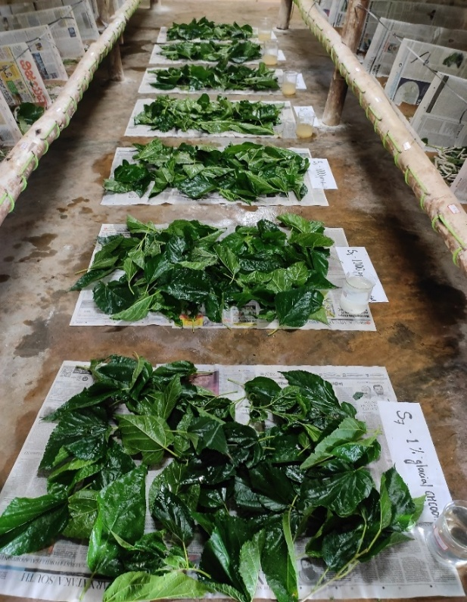
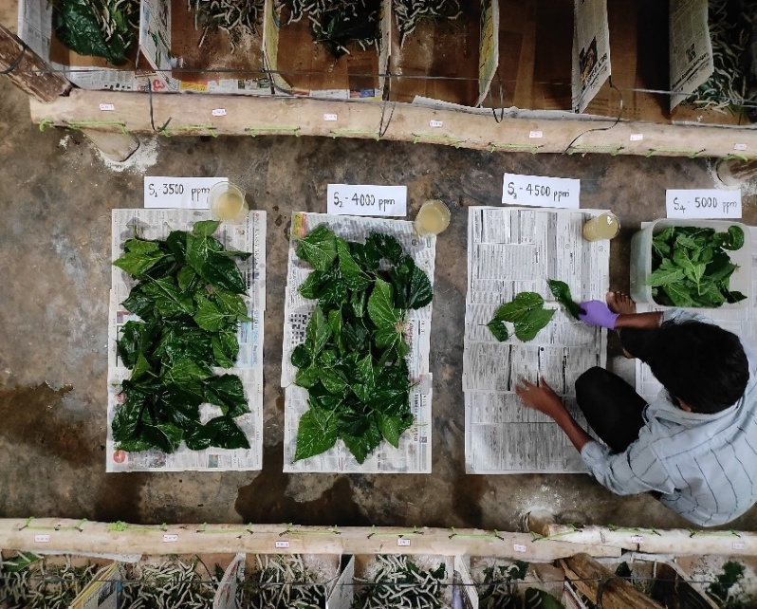
B
A

Fig. 1: Application of the chitosan to the silkworms by leaf dip method; A - dipping of mulberry leaves in chitosan solution; B - Shade drying of treated mulberry leaves
The experiment was designed as a completely randomized design with nine treatments, each replicated thrice. The treatments consisted of chitosan at concentrations of 3500 ppm, 4000 ppm, 4500 ppm and 5000 ppm, along with standard ampicillin at 1000 ppm, commercial chitosan at 1000 ppm, solvent control, absolute control and bacteria-uninoculated silkworms. The sterilized mulberry leaves were dipped in the respective treatments for ten minutes and shade-dried. The treated leaves were fed to the silkworms at 6 hours post-inoculation (hpi), 12 hpi, 18 hpi, 24 hpi and 30 hpi of bacterial suspension. For subsequent feedings, inoculum-free leaves suitable for the age were provided to both treated and untreated batches.
Haemolymph samples were collected daily from both normal and treated larvae during the fifth instar stage, following treatment. To obtain haemolymph, one of the pro-legs of anesthetized larvae was severed and the haemolymph that emerged was promptly gathered in pre-chilled vials containing a few crystals of phenyl thiourea (Fig. 2). The collected haemolymph was analyzed for biochemical and physiological parameters, including protein levels and protease activity.
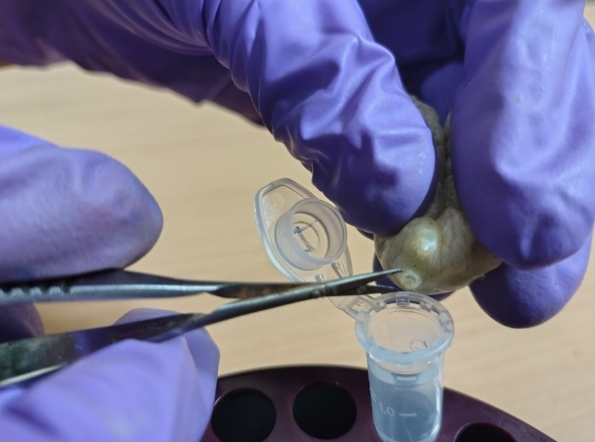

Fig. 2: Collection of the silkworm haemolymph

The quantitative estimation of total carbohydrate in the haemolymph of silkworm was done by Anthrone method (Dubois et al., 1956) using glucose as standard and the quantitative estimation of amylase activity in the haemolymph of silkworm was done as per the procedure given by Tanaka and Kusano (1980). In this assay, starch was the substrate and maltose was the end product.
Further, the data was analysed statistically for the test of significance using Fisher’s method of analysis of variance as outlined by Sundarraj et al. (1972). The level of significance of F-test was at 5 per cent. The interpretation of data was done using critical difference (CD) values.
RESULTS AND DISCUSSION
1. Carbohydrate content (mg/mL)
Total carbohydrate content varied significantly among bacterial strains (A), treatments (B), time of chitosan application after bacterial inoculation (C) and their interactions (A×B, B×C, A×C and A×B×C), from the second to the eighth day, except on the first day, where no significant difference was observed. The treatments with chitosan at 3500 ppm, 4000 ppm, 4500 ppm and 5000 ppm, as well as ampicillin at 1000 ppm and commercial chitosan at 1000 ppm, resulted in a significant increase in total carbohydrate content from the first to the eighth day of the fifth instar among bacteria inoculated batches. Moreover, the total carbohydrate content increased substantially in bacterial un-inoculated groups from day to day. In contrast, the total carbohydrate content in the absolute control decreased on the second day, followed by a slow increase from the third day onwards until pupation in silkworms infected with both pathogens. Carbohydrate content levels were significantly higher in S. aureus inoculated silkworms compared to B. thuringiensis inoculated silkworms across all treatments. However, carbohydrate content levels varied significantly in batches of silkworms fed with chitosan at different timings after bacterial inoculation. A decreasing trend in carbohydrate levels was observed in batches where chitosan application was delayed (Fig. 3 and 4).
The notable increase in carbohydrate content in treatments with chitosan and ampicillin likely reflects enhanced nutrient absorption and utilization. These compounds may boost feed efficiency by suppressing pathogen growth, reducing energy expenditure on immune responses and consequently augmenting the availability of nutrients for carbohydrate production and synthesis. Moreover, the elevated carbohydrate content in S. aureus inoculated silkworms compared to B. thuringiensis inoculated silkworms may be attributed to differences in the severity of infection and the associated metabolic requirements and demands. S. aureus infections may trigger more robust immune reactions and higher energy necessities in silkworms, leading to increased carbohydrate utilization and consumption to fuel these physiological processes. Adequate leaf consumption provides the necessary raw materials and building blocks for carbohydrate synthesis and improved feed utilization, as observed in some chitosan treatments, likely translates to increased leaf intake and consumption, resulting in higher carbohydrate levels in silkworms. The downward trend in carbohydrate levels with delayed chitosan application underscores the importance of timely intervention and prompt chitosan treatment. Early application of chitosan treatment likely mitigates the impact of infections on host metabolism, enabling more efficient nutrient absorption and utilization and maintaining sufficient carbohydrate reserves for growth, development and overall well-being.
The results are consistent with the findings of Etebari and Matindoost (2004), who reported that various stresses can diminish the amount of total carbohydrates in silkworm haemolymph, where bacterial infection served as the stressor in the present study. Mishra et al. (2010) observed that a high concentration of carbohydrates in haemolymph is maintained during larval development as an energy reserve to be utilized later during metamorphosis, pupal and adult stages. Furthermore, Simex and Kodrik (1986) reported that haemolymph carbohydrates increased with the advancement of larval age, reaching a peak on the last day of the fifth instar. Prashanth Kumar and Umakanth (2017) revealed that the lowest carbohydrate level (6.39 mg/g) occurred on the first day, while the highest level (7.91 mg/g) was recorded on the sixth day of the fifth instar. Mamatha and Balavenkatasubbaiah (2014) observed that as larval age increased, there was a consistent and progressive increase in the level of total carbohydrates in both control and the batches treated with BmIFV, which aligns with the present findings.


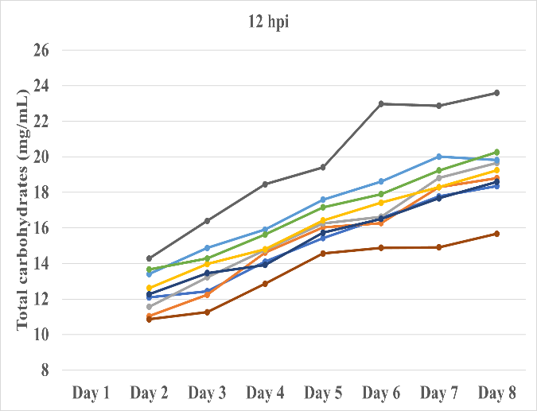
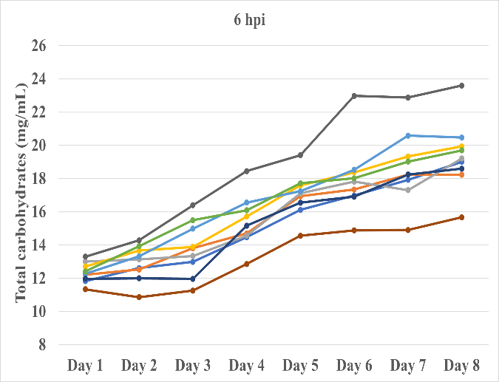

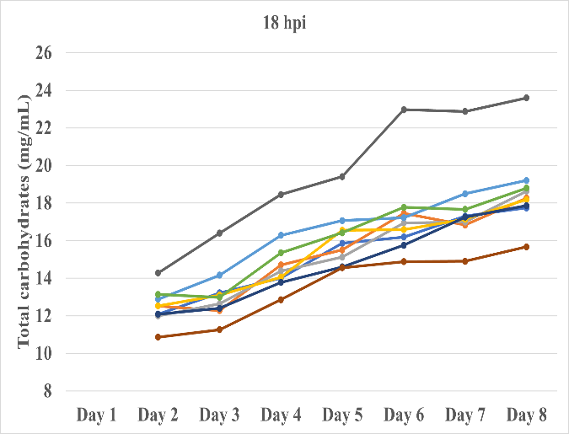
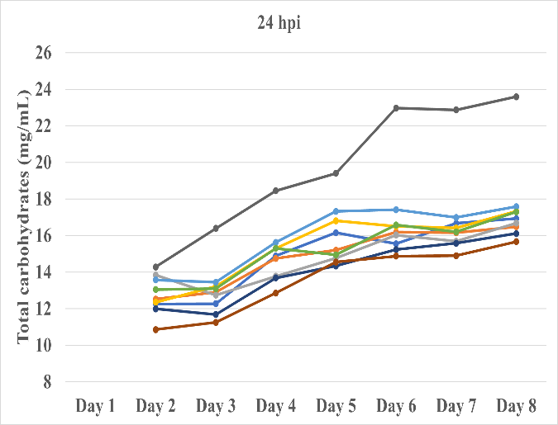

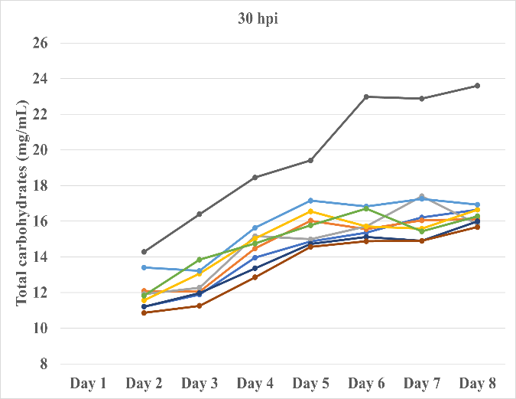

Fig 3: Effect of chitosan on carbohydrate content (mg/mL) in haemolymph of fifth instar silkworm inoculated with Staphylococcus aureus

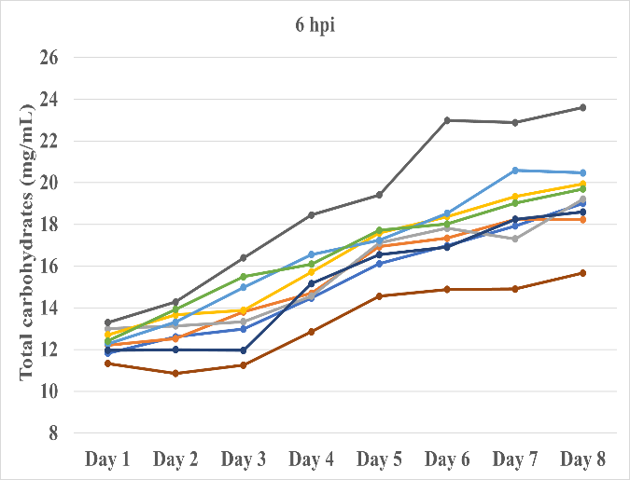
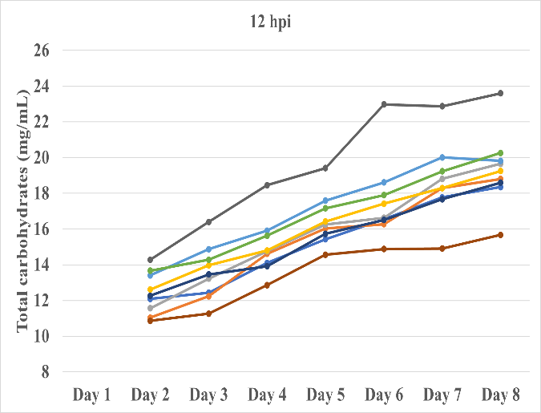

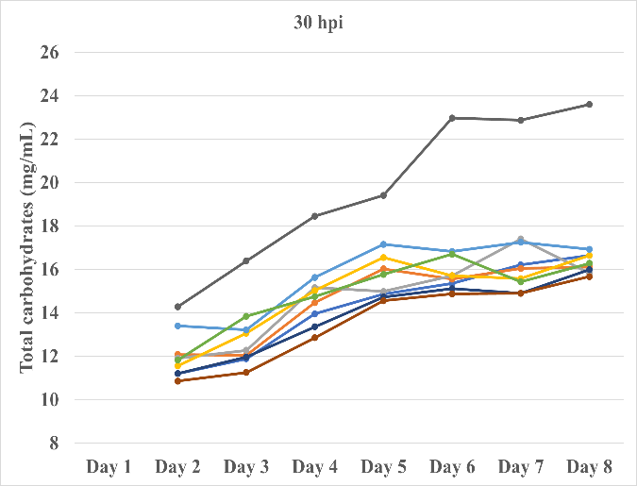

Fig 4: Effect of chitosan on carbohydrate content (mg/mL) in haemolymph of fifth instar silkworm inoculated with Bacillus thuringiensis

2. Amylase activity (mg/mL/h)
The amylase activity (mg/mL/h) differed significantly among all factors, including bacterial strains (A), treatments (B), time of chitosan application after bacterial inoculation (C) and their interactions (A×B, A×C, B×C and A×B×C) from the second to the eighth day of the fifth instar silkworms infected with S. aureus and B. thuringiensis, except on the first day, where no significant difference was observed. The amylase activity increased significantly in all treatments of S. aureus inoculated groups from the second to the fifth day of the fifth instar and then decreased day by day until pupation. Similarly, the amylase activity increased significantly in all treatments of B. thuringiensis inoculated groups from the second to the fourth day of the fifth instar and then decreased day by day until pupation. But in case of bacterial un-inoculated groups, the amylase activity increased until the sixth day and then decreased till the pupation. Among all the treatments, the least activity was observed in the absolute control on all days. Amylase activities were significantly higher in S. aureus inoculated silkworms compared to B. thuringiensis inoculated silkworms across all treatments. However, amylase activities varied significantly in batches of silkworms fed with chitosan at different time timings after bacterial inoculation. A decreasing trend in amylase activity was observed in batches where treatment application was delayed (Fig. 5 and 6).
Treatment with chitosan at various concentrations, ampicillin and commercial chitosan exerted a profound impact on amylase activity in silkworms, significantly influencing its levels. These treatments may have modulated carbohydrate metabolism by affecting enzyme activity, nutrient absorption, or immune responses, potentially altering the intricate regulatory mechanisms governing energy production and utilization. The elevated amylase activity in S. aureus infected silkworms compared to B. thuringiensis infected silkworms likely reflects a more vigorous and intense metabolic response to infection, potentially involving increased energy requirements for immune defence mechanisms and tissue repair processes. Chitosan treatments, while exhibiting some influence on amylase activity, did not consistently lead to significant enhancements or augmentations. The observed decrease in amylase activity with delayed treatment application suggests a potential disruption of metabolic pathways, a reduced capacity to efficiently utilize carbohydrates, or an impairment of enzymatic function. Increased carbohydrate availability may stimulate amylase production to facilitate carbohydrate breakdown, degradation and energy generation. These findings underscore the importance of understanding the intricate, complex and multifaceted regulatory mechanisms governing carbohydrate metabolism and amylase activity in silkworms, particularly in the context of bacterial infections, immune responses and disease resilience.
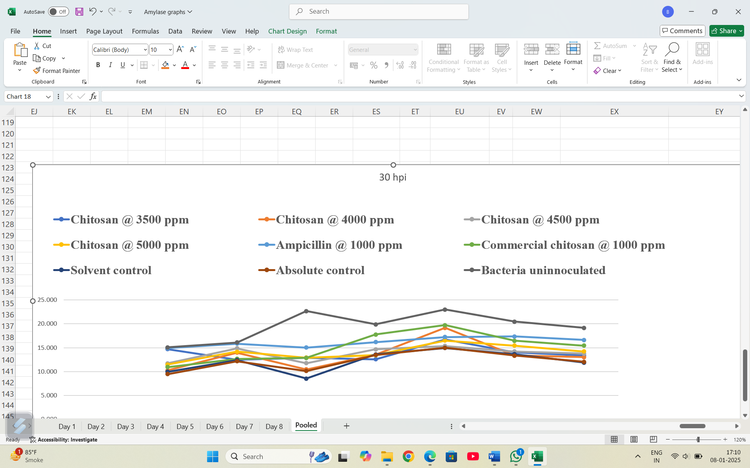

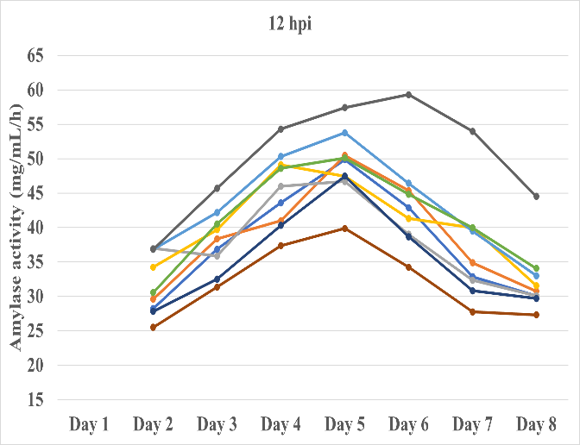
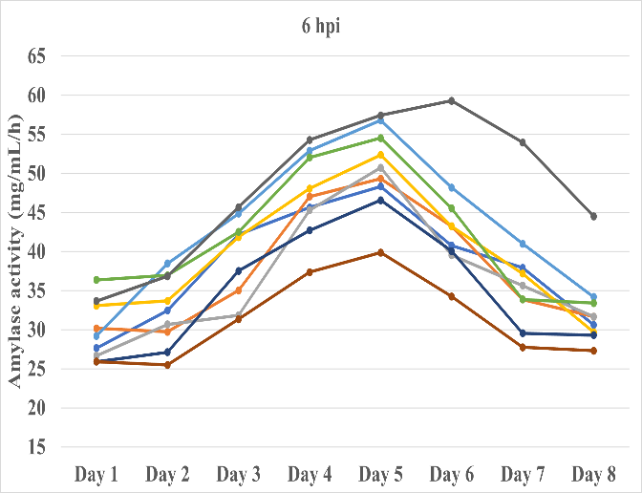

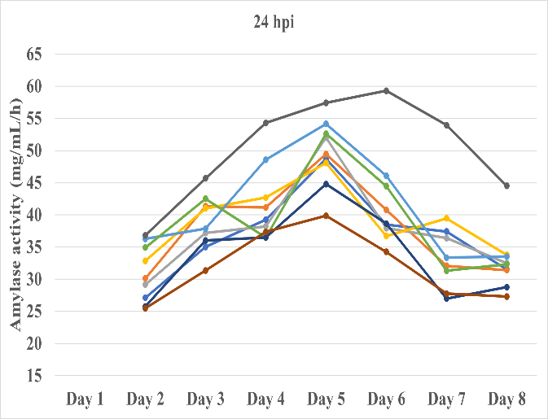
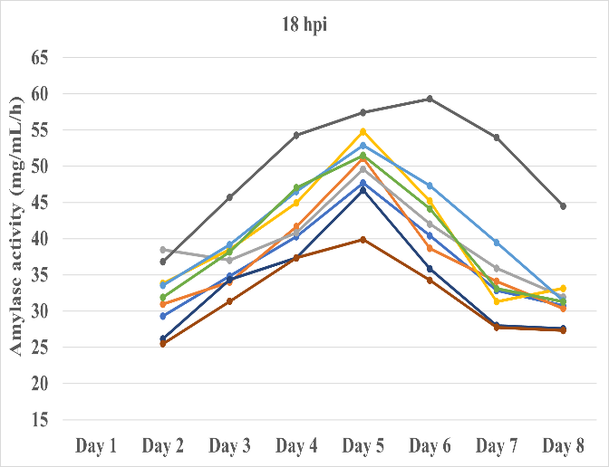

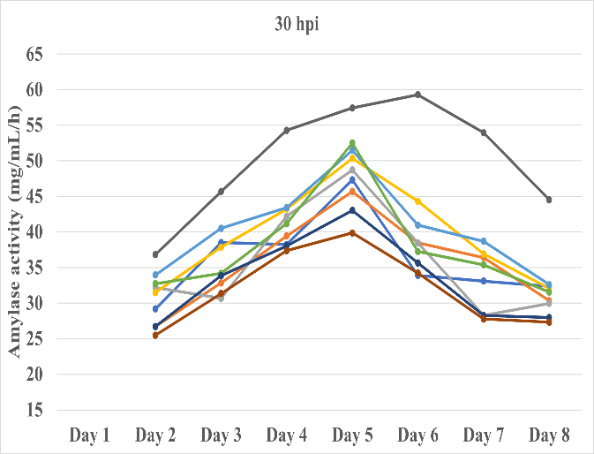

Fig 5: Effect of chitosan on amylase activity (mg/mL/h) in haemolymph of fifth instar silkworm inoculated with Staphylococcus aureus

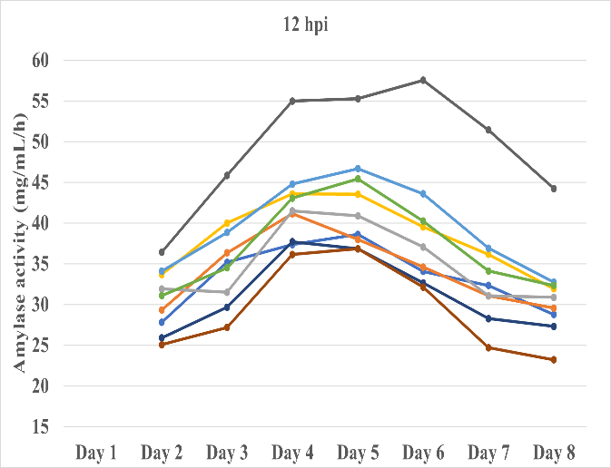
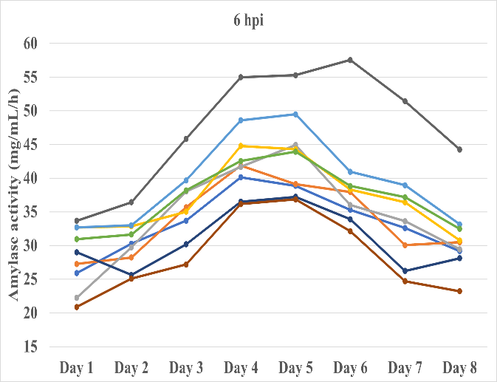

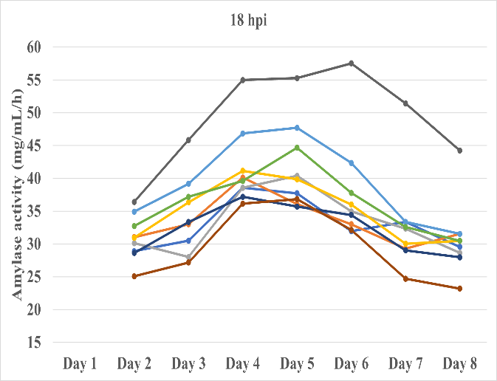
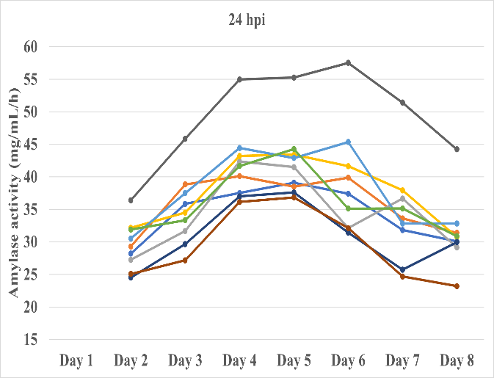
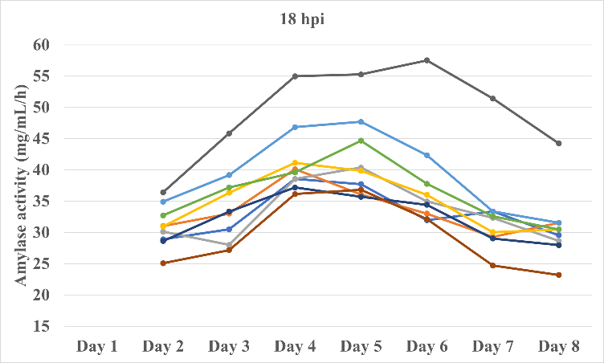
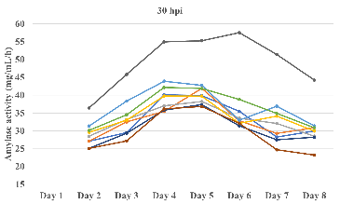

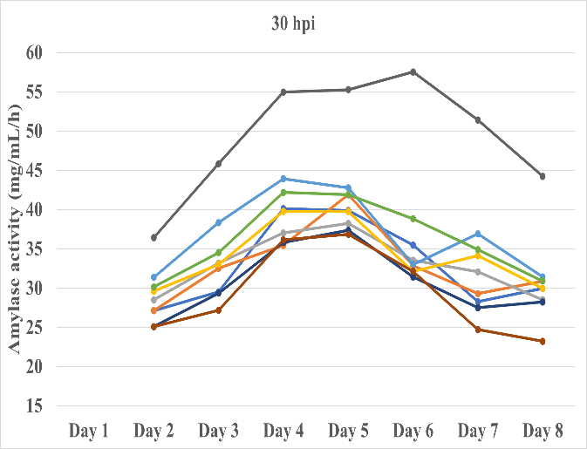

Fig 6: Effect of chitosan on amylase activity (mg/mL/h) in haemolymph of fifth instar silkworm inoculated with Bacillus thuringiensis

The results are corroborated by the findings of Amarnatha (2004), who noted that haemolymph amylase activity escalated from the first day to the fifth day of the fifth instar in all breeds and thereafter fluctuated, exhibiting diminished activity on the sixth day. Similarly, Sandhya (2023) reported that the highest peak of haemolymph amylase activity, 41.42 mg/mL/h, occurred in the water spray treatment, followed by 40.75 mg/mL/h in the absolute control treatment on the fifth day of the fifth instar, surpassing the levels recorded on other days. These findings align with the present study, where the highest peak of haemolymph amylase activity, 59.29 mg/mL/h, was detected on the sixth day of the fifth instar in bacterial un-inoculated treatment. Conversely, the lowest peak of amylase activity, 20.87 mg/mL/h, occurred on the first day of the fifth instar in the absolute control treatment among B. thuringiensis infected groups. The results are further supported by the findings of Rajitha and Savithri (2014), who observed an increasing trend in amylase activity in the haemolymph of healthy larvae up to the fifth day (0.475 mg/mL to 0.667 mg/mL) of the fifth instar, followed by a decline on the sixth day (0.626 mg/mL). In contrast, Gururaj et al. (1999) found that amylase activity in BmNPV infected larvae increased significantly in the haemolymph from 48 h to 144 h, but decreased substantially as the disease progressed.
CONCLUSION
The present investigation compellingly demonstrates that oral administration of silkworm pupal-derived chitosan significantly modulates carbohydrate metabolism and amylase activity in Bombyx mori larvae during infections caused by Staphylococcus aureus and Bacillus thuringiensis. Treatment with chitosan (3500-5000 ppm), as well as commercial chitosan and ampicillin, led to substantial increases in haemolymph carbohydrate levels and stimulated amylase activity compared to controls. These effects were most pronounced when chitosan was applied early within 6 to 18 hours post-infection, while delayed treatment resulted in diminished biochemical benefits. The differential responses between S. aureus and B. thuringiensis infections highlight that S. aureus triggered higher carbohydrate utilization and amylase activation, consistent with a more aggressive immune-metabolic engagement. Elevated energy reserves and enzymatic mobilization in chitosan and ampicillin treated groups suggest that these agents enhance host nutritional status, suppress pathogen proliferation and reduce metabolic costs associated with immune upregulation. In contrast, untreated or late-treated groups exhibited lower carbohydrate retention and enzyme activity. Our findings align with prior studies showing chitosan's antibacterial efficacy in silkworms, significantly reducing larval mortality and enhancing growth parameters during bacterial septicemia caused by S. aureus and B. thuringiensis. Moreover, broader research on insect-derived chitosan emphasizes its potent antimicrobial properties and structural similarity to commercial chitosan. In summary, silkworm pupal chitosan is effective in mitigating bacterial challenge through enhanced carbohydrate availability and metabolic enzyme activity when applied promptly post-infection. These outcomes underscore its promise as a natural, resource-efficient and sustainable bioagent in sericulture disease management, offering both economic and ecological advantages.
Conflict of interest:
I confirm that, I or my relative have a financial or other interest in the subject / matter of the work in which I will be involved, which may be considered as constituting a real, potential or apparent conflict of interest.

REFERENCES
- Amarnatha, N., Studies on the amylase activity in some bivoltine breeds of Bombyx mori L. M.Sc. (Seri.) Thesis, UAS, Bangalore, 2004; p.71.
- Dandin, S. B. and Giridhar, K., Handbook of Sericulture Technologies, CSB, Madivala, Bangalore, 2014; p. 335-385.
- Dubois, M., Gilles, K. A. Hamilton, J. K., Rebers, P. A. and Smith, F., Colorimetric method for determination of sugars and related substances. Anal. Chem., 1956; 28: 350-356.
- Etebari, K. and Matindoost, L., The study on effects of larval age and starvation stress on biochemical macromolecules abundance of haemolymph in silkworm, Bombyx mori. In: Proceedings of the sixteenth Iranian plant protection congress, General Entomology Symposium, University of Tabriz, Iran, 2004; p. 435.
- Gururaj, C. S., Sekharappa, B. M. and Sarangi, S. K., Effect of BmNPV infection on the digestive enzyme activity in the silkworm, Bombyx mori L. Indian J. Seric., 1999; 38(2): 102-106.
- Mamatha, M. and Balavenkatasubbaiah, M., Biochemical changes during the progressive infection of Bm IFV in the silkworm, Bombyx mori L. Intl. J. Pl. Ani. Envi. Sci., 2014; 4(2): 372-378.
- Manjunath Gowda, Inheritance of tolerance to BmNPV among popular breeds of silkworm, Bombyx mori L. Ph. D. Thesis, UAS, Bangalore, 2009; p.182.
- Mishra, P. K., Kumar, D., Jaiswal, L., Kumar, A., Singh, B. M. K., Sharan, S. K., Pandey, J. P. and Prasad, B. C., Biochemical aspects of diapause preparation in ultimate instar of tropical tasar silkworm, Antheraea mylitta Drury. J. Ecophysiol. Occ. Heal., 2010; 9: 253-260.
- Prashanth Kumar, B. N. and Umakanth, R. S., Estimation of carbohydrates in selected breeds of silkworm, Bombyx mori L. using two mulberry varieties. Intl. J. Appl. Res., 2017; 3(10): 156-161.
- Priyadharshini, P., Mohanraj, P., Mahalingam, C. A., Manimegalai, S. G., Swatigal, G. and Thangmalar, A., In-vitro evaluation of antioxidant activity of bioproducts extracted from silkworm pupae. Environ. We Int. J. Sci. Tech., 2016; 11: 33-39.
- Rajitha, K. and Savithri, G., Day to day analysis of amylase and trehalase activity in the haemolymph of silkworm, Bombyx mori L. infected with fungal pathogen Beauveria bassiana (Bals.) Vuill. Intl. J. Life Sci. Biotech. Pharma. Res., 2014; 3(1): 225-230.
- Sandhya, N., Studies on residual effect of pesticides on biochemical and physiological parameters in haemolymph of the silkworm, Bombyx mori L. M.Sc. (Seri.) Thesis, UAS, Bangalore, 2023; p. 87.
- Simex, V. and Kodrik, D., Changes in the tissue glycogen and free carbohydrates of haemolymph during the last larval instar and metamorphosis of silkworm, Bombyx mori L., Acta. Entomol. Bohemoslov, 1986; 83(2): 92-100.
- Sundarraj, N., Nagaraju, S., Ventataramu, M. N. and Jagannath, M. K., Design and analysis of field experiments. Directorate of Research, UAS, Bangalore, 1972; p. 139.
- Suresh, H. N., Mahalingam, C. A. and Pallavi, Amount of chitin, chitosan and chitosan based on chitin weight in pure races of multivoltine and bivoltine silkworm pupae Bombyx mori L. Int. J. Sci. Nature, 2012; 3: 214.
- Tanaka, Y. and Kusano, T., The haemolymph amylase activity during development of the silkworm, Bombyx mori L. J. Seric. Sci. Japan, 1980; 49: 95-99.

