Original Research Article
Investigation on effect of Ustilaginoidea virens infection on seed quality parameters of false smut tolerant and susceptible rice genotypes

.
ABSTRACT
Aims: To evaluate the seed infection of U. virens and its relationship to seed germination and vigour quality of false smut tolerant and susceptible rice genotypes
Study design: CRD.
Place and Duration of Study: Indian Institute of Rice Research, Hyderabad and Seed Research and Technology Centre, PJTAU, Hyderabad.
Methodology: The moderately tolerant lines identified at ICAR- IIRR, viz., RL-479 (DL-27), RL-1516 (DL-28), RL-2453 (DL-29), RL-4609 (DL-31) and Vary Lava IRGC 386-1 (PAU2) under artificial screening were selected for the current studies. The susceptible genotype includes RL-263 (DL-25), CO51, BPT-5204, and GSR123 (PAU3).
U. virens chlamydospores and conidia were used for infection and seed quality parameters were recorded.
Results: Upon chlamydospore treatment, the tolerant genotypes, recorded mean reduction of 0.53% of germination percentage as against 5.83% in the susceptible genotypes. Similarly, the germination percentage of conidia treated susceptible genotypes recorded reduction of 9.5% as against 1.6% in tolerant genotypes. The mean Vigor Index 1 across the tolerant genotypes upon chlamydospore treatment was reduced by 230 units and in case of conidial treatment it was 359. However, in the seeds of susceptible genotypes, the reduction of mean Vigor Index was 829 in the chlamydospore treatment and 595 in the conidial treatment.

Conclusion: The identified tolerant genotypes maintained significantly better seed quality traits (germination %, root/shoot length, vigour indices, and biomass) against U. virens chlamydospore and conidial infection compared to the susceptible genotypes.

Keywords: Rice - False smut – Tolerant genotypes- Seed Quality Parameters

1. INTRODUCTION

Rice is the most important cereal crop being staple food for more than half of the global population and in India, the area, production and productivity of rice is 46.38 Mha, 130.29 MT and 2,809 kg/ha respectively (Arunprakash et al., 2023). The grain yield of the rice crop is affected by both biotic and abiotic stress factors. Among them, Ustilaginoidea virens [Cooke] Takahashi gaining importance wherein the pathogen causes false smut disease of rice and the disease was first reported by Cooke in 1878 from Tirunelveli district of Tamil Nadu. In India, almost all the rice growing states reported the false smut incidence (Leharwan and Arunkumar, 2023). The rice false smut disease (RFSD) incidence was reported between 2 to 80% in Tamil Nadu and Uttar Pradesh (Ladhalakshmi et al., 2012; Singh et al., 2014) and significant reduction in yield reported up to 75% (Upadhyay et al., 2013). Under favourable climatic conditions, the virulent pathogen on a susceptible host can infect and produce a very high number of smut balls (> 80 numbers) and the infected field produces black color smoky appearance during the harvesting period (Ladhalakshmi et al., 2012). Under such circumstances there are higher chances for dispersal of pathogen inoculum from the smut balls to the healthy seed and soil on which, the pathogen may survive.
The infected seeds may carry U. virens pathogen externally or internally, causing reduced seed germination, poor seedling vigour, and potential early-season disease outbreaks under favourable environmental conditions. U. virens not only infects rice grains but can also asymptomatically colonize young roots and the coleoptile, as an epiphyte (Fan et al., 2014; Preeti Kumari et al., 2025). Furthermore, U. virens produces two types of toxins known as usitiloxins and ustilaginoidins. Ustiloxins is known to obstruct the microtubule assembly and diminish cell division and there by affects the seed germination (Koiso et al., 1998). Ustilaginoidins are a class of bis-naphtho-γ-pyrones, which have cytotoxic activities and inhibitory effects on the radicle elongation of rice seeds (Wang et al., 2016). In this study, we evaluated the effect of Ustilaginoidea virens chlamydospores and conidia on seed quality parameters, in tolerant and susceptible rice genotypes.

2. material and methods

2.1. Seed and Fungal Material
The false smut tolerant and susceptible landraces identified under the DBT Project ‘Mainstreaming rice landraces diversity in varietal development through genome-wide association studies: A model for large-scale utilization of gene bank collections of rice” were used in the present study. The tolerant genotypes were RL-479 (DL-27), RL-1516 (DL-28), RL-2453 (DL-29), RL-4609 (DL-31) and Vary Lava IRGC 386-1 (PAU2) and the susceptible genotype includes RL-263 (DL-25), CO51, BPT-5204, and GSR123 (PAU3). The genotypes PAU2 and PAU3 were obtained from Punjab Agricultural University, Ludhiana. Investigation was performed by treating the seeds of tolerant and susceptible rice genotypes with two kinds of false smut pathogen propagules i.e. conidia (asexual spores) and chlamydospores (thick-walled resting spores). The fungal isolate used in this study was the Kandhukur isolate (KDK) of Ustilaginoidea virens.
2.2. Screening of False Smut Tolerant and Susceptible Genotypes
The genotypes were screened under artificial inoculation conditions at the screening facility established at ICAR–Indian Institute of Rice Research (IIRR), Hyderabad, during 2022–2024. Seeds were dried to desirable moisture content before use in the experiment. Artificial inoculation was carried out at the booting stage following standard protocols, and disease reaction was assessed by recording the number of smut balls per panicle for each genotype (Ladhalakshmi et al., 2012).
2.3. Preparation of inoculum
2.3.1 Chlamydospore suspension
False smut pathogen U. virens was cultured on Potato Sucrose Agar (PSA) and incubated for 15 - 20 days at 28ºC ±2°C to produce yellow coloured chlamydospores. The spore masses were harvested, suspended in sterile distilled water containing a drop of Tween-20, and vortexed to achieve a uniform spore suspension. The suspension was adjusted to a final concentration of 2.5 × 10⁶ spores/ml using a haemocytometer and used for inoculation.
2.3.2. Conidial suspension
For conidia production, U. virens was inoculated into Potato Sucrose Broth (PSB) and incubated in a rotary shaker at 25 °C, 125 rpm for 5–6 days. The culture was filtered through muslin cloth, and the filtrate was centrifuged at 6000 rpm for 6 min at 4 °C. The resulting pellet was suspended in sterile distilled water, and the concentration was adjusted to 2.5 × 10⁶ spores/ml using a haemocytometer.
2.4. Surface sterilization of seed material
Healthy seeds from the fore mentioned genotypes were initially washed in sterile distilled water for 2 to 3 minutes. The washed seeds were sterilized by incubating for five minutes in 70% ethanol. Then the seeds were incubated in 2% sodium hypochlorite for two minutes before being washed three times with sterile distilled water to eliminate any sterilizing agents (Abdul-Baki et al., 1973).
2.5. Seed treatment
For each genotype, 50 surface-sterilized seeds were soaked in 30–40 mL of chlamydospore and conidial suspension (2.5 × 10⁶ spores/mL) in sterile falcon tubes. Healthy control was maintained by soaking the seeds in the sterile distilled water. The tubes were incubated in rotary shaker at 125rpm, 25ºC for 24 hrs to favour pathogen propagule attachment or establishment. The seeds were placed between two layers of germination paper moistened with distilled sterile water, gently rolled and incubated it in the incubator (Walk-in Germinator, Dept. of Seed Science and Technology, PJTAU) for 14 days. Each treatment was replicated three times. The seed quality parameters were recorded as per the standard protocol of International Seed Testing Association (ISTA, 2022). About ten germinated seedlings were collected at random from each treatment, parameters viz., germination percentage, root length, shoot length, dry weight were recorded. From the recorded observations seedling length, Seedling Vigour Index 1 (SVI 1), Seedling Vigour Index 2 (SVI 2) were calculated as below:
Seedling length = root length + shoot length
Seedling Vigour Index 1 = Germination percentage × Seedling length
Seedling Vigour Index 2 = Germination percentage × Dry weight
2.6. Statistical Analysis:
Data on seed quality parameters (germination percentage, root length, shoot length, seedling length, seedling vigour indices, and dry weight) were subjected to statistical analysis using R software (version 4.4.2). Within each tolerance group (tolerant and susceptible), an independent two-sample t-test was performed to compare each genotype under chlamydospore treatment vs conidial treatment. Differences were considered statistically significant at p ≤ 0.05 and highly significant at p ≤ 0.01. Graphs were generated using the ggplot2 package in R.

3. results and discussion

3.1. Disease reaction of false smut tolerant and susceptible genotypes
Under artificial inoculation, tolerant genotypes (DL-27, DL-28, DL-29, DL-31, and PAU2) produced 2–4 smut balls per panicle, whereas susceptible genotypes (DL-25, CO-51, PAU3, and BPT-5204) produced 15–40 smut balls per panicle. This confirmed the differential reaction of tolerant and susceptible lines under uniform screening conditions.
3.2. Effect of chlamydospore treatment on seed quality parameters
3.2.1. Seed Germination percentage: The seeds were artificially inoculated with chlamydospores and incubated for 24 hours. In healthy control, the germination percentage varied from 95.33% to 98.00%. and in the treated tolerant genotypes it varied from 92.67% to 98.00%. With respect to susceptible genotypes, healthy seeds recorded 92.67% to 98.00% germination, whereas chlamydospore treated seeds of susceptible genotypes recorded the germination percentage as 82.67 % to 96.67% (Table 1).
3.2.2. Root Length: The healthy seeds of the tolerant genotypes recorded the root length of 14.25 to 17.08 cm. After treating the seeds with chlamydospore, the root length was reduced and it varied from 13.14 to 16.11 cm. Similarly, the healthy seeds of the susceptible genotypes varied from 11.44 to 14.53 cm (Table 1) and the chlamydospore treated susceptible genotype seeds recorded reduced root length of 8.78 to 12.30 cm.
3.2.3. Shoot Length: Similar results were replicated in shoot length also wherein tolerant genotypes retained shoot length in response to pathogen, and the value was ranged from 7.39 to 14.45 cm, but in susceptible genotypes it recorded in the range of 5.84 to 11.36 cm (Table 1).
3.2.4. Seedling Length: The seedling length of the healthy tolerant genotypes recorded between 23.35 to 31.99 cm, while the treated tolerant genotypes recorded from 21.73 to 30.56 cm. Seedling length of healthy susceptible genotypes ranged from 17.34 to 28.79 cm and that of treated genotypes ranged between 11.10 to 18.74 cm (Table 1). Seedling length was highest in control tolerant genotypes, followed by infected tolerant genotypes, healthy susceptible genotypes and treated susceptible genotypes.
3.2.5. Seedling Vigor Indices 1 & 2: SVI 1 of healthy tolerant genotypes ranged between 2272 to 3134 and chlamydospore treated tolerant genotypes ranged from 2017 to 2996. With respect to healthy susceptible genotypes, the values recorded between 1628 to 2764 and in the treated genotypes the value was significantly reduced between 918 to 1812. SVI 2 of healthy tolerant ranged between 12.72 to 23.20 units, treated tolerant genotypes ranged between 10.47 to 19.67, healthy susceptible genotypes ranged between 9.57 to 16.33 and finally treated susceptible genotypes recorded between 7.41 to 13.55 (Table 1 & Fig 1).

Table 1: Seed quality parameters of false smut tolerant and susceptible genotypes treated artificially with U. virens Chlamydospore
Treatments | Treatment  details | Germina-  tion (%) | Root  Length | Shoot  Length | Seedling  Length | SVI 1 | Dry  Weight | SVI 2
T1 | DL 27+CH | 98.00 | 16.11 | 14.45 | 30.56 | 2996 | 0.16 | 15.69
T2 | DL 27+H | 98.00 | 17.08 | 14.46 | 31.99 | 3134 | 0.18 | 17.95
T3 | DL28+CH | 97.33 | 14.80 | 7.39 | 22.20 | 2160 | 0.12 | 11.35
T4 | DL28+H | 97.33 | 14.95 | 8.39 | 23.35 | 2272 | 0.14 | 13.95
T5 | DL29+CH | 92.67 | 13.14 | 8.59 | 21.73 | 2017 | 0.11 | 10.47
T6 | DL29+H | 95.33 | 14.25 | 10.25 | 24.51 | 2337 | 0.13 | 12.72
T7 | DL31+CH | 95.33 | 13.93 | 13.40 | 27.32 | 2605 | 0.15 | 14.30
T8 | DL31+H | 95.33 | 15.49 | 14.72 | 30.21 | 2880 | 0.16 | 15.89
T9 | PAU2+CH | 96.67 | 15.06 | 12.75 | 27.81 | 2690 | 0.20 | 19.67
T10 | PAU2+H | 96.67 | 16.96 | 14.06 | 31.02 | 2999 | 0.24 | 23.20
T11 | DL 25+CH | 82.67 | 12.30 | 11.36 | 11.10 | 918 | 0.14 | 11.84
T12 | DL 25+H | 96.00 | 14.53 | 13.95 | 28.79 | 2764 | 0.17 | 16.33
T13 | CO51+CH | 96.67 | 10.86 | 7.88 | 18.74 | 1812 | 0.14 | 13.55
T14 | CO51+H | 97.33 | 13.71 | 9.40 | 22.97 | 2235 | 0.14 | 13.63
T15 | BPT 5204+CH | 92.67 | 8.81 | 5.84 | 14.65 | 1360 | 0.08 | 7.41
T16 | BPT 5204 +H | 92.67 | 11.44 | 6.45 | 17.89 | 1628 | 0.10 | 9.57
T17 | PAU 3+CH | 88.67 | 8.78 | 8.56 | 17.34 | 1539 | 0.14 | 12.17
T18 | PAU3+H | 98.00 | 12.89 | 10.75 | 23.64 | 2318 | 0.15 | 14.57
S. E (M) |  | 2.29 | 0.81 | 0.38 | 0.83 | 92 | 0.007 | 0.65
C.V (%) |  | 5.09 | 10.41 | 6.23 | 6.11 | 7.09 | 8.36 | 8.05
Note: DL-27, DL-28, DL-29, DL-31, PAU-2 - false smut tolerant genotypes (T1 – T10); DL-25, CO-51, BPT 5204, PAU-3 are false smut susceptible genotypes (T11-T18); CH – Chlamydospore treatment; H- Healthy control treatment; SVI 1 - Seedling Vigour Index 1 = Seedling length*Germination percentage; SVI 2- Seedling Vigour Index 2 = Dry weight*Germination percentage

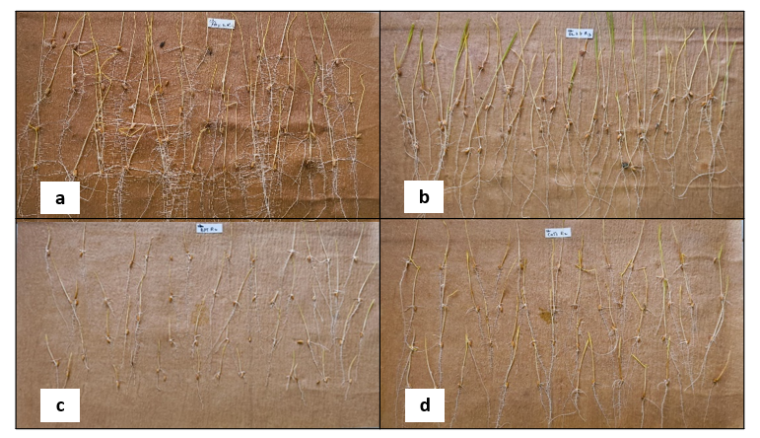
Fig 1: Effect of U. virens chlamydospore treatment on the seeds of tolerant and susceptible genotypes; a) PAU-2 b) DL-27 – Tolerant genotypes; c) BPT 5204 & d) CO-51 - Susceptible genotypes

3.3. Effect of Conidial treatment on seed quality parameters
3.3.1. Germination percentage: With respect to conidial treatment, the tolerant healthy controls displayed highest germination percentage ranged between 95.33% to 98% followed by tolerant treated seeds (92.67% to 98%) and healthy susceptible genotypes (92.67% to 98%). Conidia treated susceptible genotypes displayed lower germination percentages ranged between 74.67% to 95.33% (Table 2).
3.3.2. Root Length: Tolerant genotypes displayed greater root lengths, in comparison to susceptible ones, ranged between 14.25 to 17.08 cm (Table 2) for healthy controls followed by treated tolerant genotypes ranged between 14.12 to 15.61 cm. Root length of healthy controls of susceptible genotypes recorded from 11.44 to 14.53 cm and in treated genotypes it was ranged from 9.73 to 14.51 cm.
3.3.3. Shoot Length: Shoot length of tolerant healthy controls displayed highest range i.e., 8.39 to 14.72 cm, followed by tolerant treated seeds with range of 7.04 to 12.75 cm. Healthy controls of susceptible genotypes displayed a shoot length of 6.45 to 13.95 cm and treated seeds recorded a range between 5.45 to 10.21 cm (Table 2).
3.3.4. Seedling Length: Seedling length of control tolerant genotypes ranged between 23.35 to 31.99 cm, while treated tolerant genotypes ranged between 21.16 to 27.96. Seedling length of susceptible controls ranged between 17.89 to 28.79 and that of susceptible treated ranged between 16.33 to 24.72cm (Table 2)
3.3.5. Seedling Vigor Indices 1 & 2: SVI 1 of tolerant control genotypes ranged between 2272 to 3134, tolerant treatments ranged between 1982 to 2736, susceptible controls ranged between 1628 to 2764 and finally susceptible treatments recorded between 1226 to 2157. SVI2 of tolerant control ranged between 12.72 to 23.20 units, tolerant treatments ranged between 10.51 to 20.70, susceptible controls ranged between 9.57 to 16.32 and finally susceptible treatments ranged between 6.49 to 14.84 units (Table 2).
Table 2: Seed quality parameters of false smut tolerant and susceptible genotypes treated artificially with U. virens Conidia

Treatments | Treatment  details | Germina-  tion (%) | Root  Length | Shoot  Length | Seedling  Length | SVI 1 | Dry  Weight | SVI 2
T1 | DL 27+CO | 98 | 15.61 | 12.34 | 27.96 | 2736 | 0.17 | 16.65
T2 | DL 27+H | 98 | 17.08 | 14.46 | 31.99 | 3134 | 0.18 | 17.95
T3 | DL28+CO | 96.67 | 14.12 | 7.04 | 21.16 | 2049 | 0.13 | 12.57
T4 | DL28+H | 97.33 | 14.95 | 8.39 | 23.35 | 2272 | 0.14 | 13.95
T5 | DL29+CO | 92.67 | 14.21 | 7.14 | 21.35 | 1982 | 0.11 | 10.51
T6 | DL29+H | 95.33 | 14.25 | 10.25 | 24.51 | 2337 | 0.13 | 12.72
T7 | DL31+CO | 94.67 | 15.48 | 11.97 | 27.45 | 2600 | 0.15 | 14.21
T8 | DL31+H | 95.33 | 15.49 | 14.72 | 30.21 | 2880 | 0.16 | 15.89
T9 | PAU2+CO | 92.67 | 15.06 | 12.75 | 27.81 | 2461 | 0.22 | 20.70
T10 | PAU2+H | 96.67 | 16.96 | 14.06 | 31.02 | 2999 | 0.24 | 23.20
T11 | DL 25+CO | 87.33 | 14.51 | 10.21 | 24.72 | 2157 | 0.17 | 14.84
T12 | DL 25+H | 96.00 | 14.53 | 13.95 | 28.79 | 2764 | 0.17 | 16.32
T13 | CO51+CO | 88.67 | 11.10 | 5.45 | 16.55 | 1472 | 0.13 | 11.79
T14 | CO51+H | 97.33 | 13.71 | 9.40 | 22.97 | 2235 | 0.14 | 13.29
T15 | BPT 5204+CO | 74.67 | 10.87 | 5.46 | 16.33 | 1226 | 0.09 | 6.49
T16 | BPT 5204+H | 92.67 | 11.44 | 6.45 | 17.89 | 1628 | 0.10 | 9.57
T17 | PAU3+CO | 95.33 | 9.73 | 8.22 | 17.95 | 1712 | 0.13 | 12.20
T18 | PAU3+H | 98.00 | 12.89 | 10.75 | 23.64 | 2318 | 0.15 | 14.57
S. E (M) |  | 2.28 | 0.73 | 0.52 | 0.95 | 108 | 0.03 | 0.51
C.V |  | 5.14 | 9.78 | 8.91 | 6.81 | 8.25 | 2.96 | 6.24
Note: DL-27, DL-28, DL-29, DL-31, PAU-2 - false smut tolerant genotypes (T1 – T10); DL-25, CO-51, BPT 5204, PAU-3 are false smut susceptible genotypes (T11-T18); CO – Conidial treatment;
H- healthy control treatment; SVI 1- Seedling Vigour Index 1 = Seedling length*Germination percentage, SVI 2- Seedling Vigour Index 2 = Dry weight*Germination percentage

3.4. Comparison between U. virens Chlamydospore and Conidial infection in the tolerant and susceptible genotypes
Among the tolerant genotypes both chlamydospore and conidial treatments showed no significant impact in terms of seed quality parameters between each other, which delivers a fact that both the propagules have lower effect in tolerant genotypes (Fig 2a). Compared to tolerant genotypes, the susceptible genotypes, showed significant effect on seed quality traits due to chlamydospore and conidial treatments and the impact of infection varied with the genotypes. For example, in BPT 5204, germination percentage highly reduced by conidial infection. Root length of susceptible genotypes showed drastic reduction upon chlamydospore treatment. Shoot lengths of all susceptible genotypes have shown greater effect upon conidial treatment. Vigor indices of DL-25 have shown greater effect upon chlamydospore treatment, while BPT 5204 and CO-51 have shown more effect upon conidial treatment (Fig 2b).
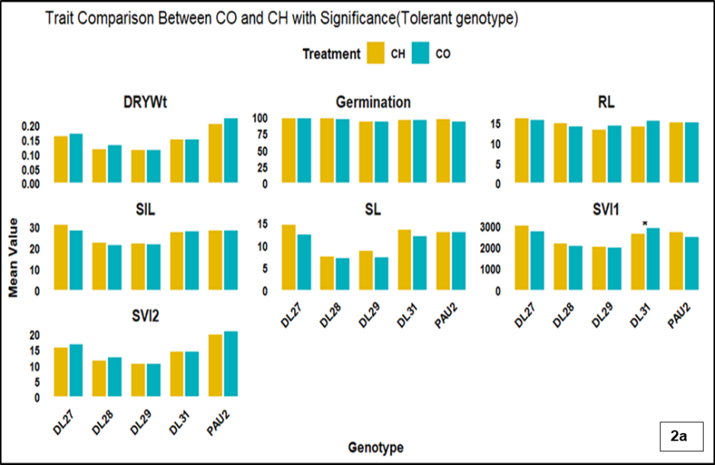

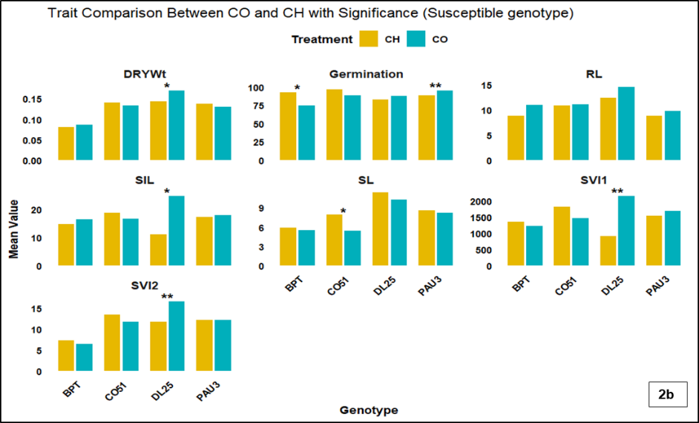
Figure 2a & 2b: Performance of tolerant & susceptible genotypes with respect to U. virens chlamydospore and conidial infection (*=p≤0.05, **=p≤0.01)
Research with respect to effect of U. virens chlamydospore and conidia on seeds through artificial inoculation is very limited. However, studies were conducted about the U. virens infection on seeds under natural conditions. In the present study, the obtained results appear in parity, which declared decrease in seed germination with chlamydospore contamination and on seed quality attributes such as reduction in seed germination, grain weight (Srivastava et al., 2014; Bag et al., 2016). The germination of the naturally U. virens infected seeds varied from 67% to 89% (Neesa et al., 2018). Andargie et al. (2015) reported that U. virens infected the coleoptiles and roots of rice seedlings during germination. Sanghera et al. (2012) reported 22-25% reduction in seed germination ability upon false smut infection. Hedge and Anahosur et al. (2000) concluded from their experiments about the poor seedling vigour and reduced root and shoot length of seedlings emerged from false smut infected seeds. The results of the present study revealed that artificial inoculation of U. virens chlamydospore and conidia was able to infect the seeds and reduce the seed vigour. In our study, though the tolerant genotypes recorded reduced percentage of germination and other parameters such as root and shoot length, seedling vigour index 1 due to chlamydospore and conidial infection, the susceptible genotypes recorded significant difference.

3.6 Effect of U. virens chlamydospore and conidia across the tolerant and susceptible genotypes with respect infected and Healthy Seed

Upon, both chlamydospore and conidial treatment, there was reduction in seed quality parameters of all tolerant and susceptible genotypes, compared to their respective healthy controls. However, reduction was more pronounced in susceptible genotypes than tolerant genotypes. In chlamydospore treatment, the reduction in mean germination percentage of tolerant genotypes was only 0.53%, conversely in susceptible genotypes it was greater i.e., 5.83%. Likewise, the mean reduction in seedling length of all the tolerant genotypes was 2.29 cm as against 7.87cm in susceptible genotypes (Table 3). Further, the mean vigour Index 1 across the tolerant genotypes upon chlamydospore treatment reduced by 230 units, while in susceptible genotypes, it was reduced drastically by 829 units in comparison to their healthy control.
Upon conidial treatment, in the tolerant genotypes the mean germination percentage was reduced up to 1.6% as against 9.5% in the susceptible genotypes. The reduction in seedling length of tolerant genotypes was 3.07 cm, and it was recorded as 4.44 cm in the susceptible genotypes. Both the mean vigour indices 1 & 2 showed greater reduction in susceptible genotypes as 595 units and 2.11 units as compared to the tolerant genotypes which recorded 359 and 1.81 units respectively (Table 3).
Table 3: Mean reduction percentage across the tolerant and susceptible genotypes with respect to U. virens chlamydospore and conidia infection on seeds
 | Germination (%) | Root  Length | Shoot  Length | Seedling  Length | SVI 1 | Dry  Weight | SVI 2
Chlamydospore treated Seeds
TG + H | 96.53 | 15.75 | 12.38 | 28.22 | 2724 | 0.17 | 16.74
TG + CH | 96.00 | 14.61 | 11.32 | 25.92 | 2494 | 0.15 | 14.30
Mean Difference | 0.53 | 1.14 | 1.06 | 2.29 | 230 | 0.02 | 2.45
SG + H | 96.00 | 13.14 | 10.14 | 23.32 | 2236 | 0.14 | 13.53
SG + CH | 90.17 | 10.19 | 8.41 | 15.46 | 1407 | 0.13 | 11.24
Mean Difference | 5.83 | 2.96 | 1.73 | 7.87 | 829 | 0.02 | 2.28
Conidia treated seeds
TG + H | 96.53 | 15.75 | 12.38 | 28.22 | 2724 | 0.17 | 16.74
TG + CO | 94.94 | 14.90 | 10.25 | 25.15 | 2366 | 0.16 | 14.93
Mean Difference | 1.60 | 0.85 | 2.13 | 3.07 | 359 | 0.01 | 1.81
SG + H | 96.00 | 13.14 | 10.14 | 23.32 | 2236 | 0.14 | 13.44
SG + CO | 86.50 | 11.55 | 7.34 | 18.89 | 1642 | 0.13 | 11.33
Mean Difference | 9.50 | 1.59 | 2.80 | 4.44 | 595 | 0.01 | 2.11
Note: TG+H: Tolerant Healthy control; TG+CH: Tolerant Chlamydospore treatment; TG+CO: Tolerant Conidial treatment; SG+H: Susceptible Healthy control; SG+CH: Susceptible Chlamydospore treatment; SG+ CO: Susceptible Conidial treatment. Mean Difference was calculated between the healthy and its respective treatment

4. Conclusion:
Though, the exact mechanism of the infection of false smut pathogen is not yet revealed under natural conditions, understanding about the false smut pathogen propagules viz., chlamydospores and conidia is crucial for developing integrated disease management strategies. In addition, the results will give a clue about the U. virens survival during the infection cycle. The identified false smut disease tolerant lines exhibited better seed quality parameters viz., germination %, root/shoot length, higher vigour indices compared to the susceptible genotypes, exhibiting lower seedling infection and increased vigour in early plant life effectively combating pathogenesis. In the tolerant genotypes, the resistant mechanism combating the pathogen during booting/flowering stage might have been activated in the early stages itself and provided physiological resilience against pathogen infection.

References

Arunprakash, S. & Paranidharan, V. (2023). Survey and Isolation of Rice False Smut Pathogen Ustilaginoidea virens (Cooke) Takahashi. International Journal of Plant & Soil Science, 35, 277-283.
Leharwan, M., and Arunkumar, T. V. (2023). Advances in False Smut of Rice and its Integrated Diseases Management: A Review. Agricultural Reviews, 44, 78-83.
Ladhalakshmi, D., Laha, G. S., Singh, R., Karthikeyan, A., Mangrauthia, S. K., Sundaram, R. M., Thukkaiyannan, P. and Viraktamath, C. (2012). Isolation and characterization of U. virens and survey of false smut disease of rice in India. Phytoparasitica, 40, 171-176.
Singh, S., Lal, A. A., Simon, S., Singh, A., Taduman, R., Kamaluddeen, D. A. A., David, A. A. (2014). Survey of false smut (Ustilaginoidea virens) of rice (Oryza sativa L.) in selected districts of Uttar Pradesh, India. The Bioscan, 9, 389-392.
Upadhyay, A. L., Singh, R. V. (2013). Yield loss assessment in rice due to false smut. Annuals of Plant and Soil Research, 15(2), 173-174.
Fan, R. H., Wang, Y. Q., Liu, B., Zhang, J. Z., Hu, D. W. (2014). Epiphytic colonization of Ustilaginoidea virens on biotic and abiotic surfaces implies the widespread presence of primary inoculum for rice false smut disease. Plant Pathology, 63, 937–945.
Preeti Kumari V., Manonmani Swaminathan, Ramalingam Suresh, Chellappan Gopalakrishnan, Muthurajan Raveendran, Mannu Jayakanthan. (2025). From infection to resistance: A comprehensive review on false smut (Ustilaginoidea virens) and its impact on rice. Physiological and Molecular Plant Pathology, 139.
Koiso, Y., Morisaki, N., Yamashita, Y., Mitsui, Y., Shirai, R., Hashimoto, Y., Iwasaki, S. (1998). Isolation and structure of an antimitotic cyclic peptide, ustiloxin F: Chemical interrelation with a homologous peptide, ustiloxins. B.J Antibiot, 51(4), 418-422.
Wang, X. H., Fu, X. X., Lin, F. K., Sun, W. B., Meng, J. J., Wang, A. L., et al. (2016). The contents of ustiloxins A and B along with their distribution in rice false smut balls. Toxins, 8(9), 262.
Abdul‐Baki, A. A., Anderson, J. D. (1973). Vigor determination in soybean seed by multiple criteria. Crop science, 13, 630-633.
Srivastava, J. P., Maurya, D. K., Kushwaha, G. D. (2014). Effect of false smut (Ustilaginoidea virens) on seed yield and quality attributes in rice varieties. Agricultural and Biological Research, 30, 196-200.
Bag, M. K., Mukherjee, A. K., Sahoo, R. K. and Jena, M. (2016). Impact of false smut (Ustilaginoidea virens (Cooke.) Tak.) disease on rice seed health. Indian Phytopathology, 69(4s), 284-285.
Nessa, B., Dipti, S. S, Salam, M. U., Haque, A. H. M. M., Biswas, J. K., Kashem M. A. and Kabir M. S. (2018). Seed Germination and Grain Quality of Rice as Affected by False Smut Disease. Bangladesh Rice J, 22(1), 1-7.
Andargie, M., Li, L.Y., Feng, A. Q., Li, J. X. (2015). Colonization of rice roots by a green fluorescent protein-tagged isolate of Ustilaginoidea virens. Am J Plant Sci, 6(14), 2272-2279.
Sanghera, G. S., Ahanger, M. A., Kashyap, S. C., Bhat, Z. A., Rather, A. G. and Parray, G. A. (2012). False smut of rice (Ustilaginoidea virens) under temperate agroclimatic conditions of Kashmir, India. Elixir Biotechnology Journal, 49, 9827-9830.
Hegde, Y. R. and Anahosur K. H. (2000). Effect of false smut of rice on yield components and growth parameters. Indian Phytopathology, 53, 181-184.

