Development of millet milk-based ready-to-drink beverage

ABSTRACT:
Aim: This study focused on developing a nutritionally rich, ready-to-drink functional beverage from germinated little millet (Panicum sumatrense) and sapota (Manilkara zapota) as a sustainable non-dairy alternative.
Methodology: Standard AOAC methods were followed for physicochemical, proximate, and nutritional evaluation, while enzyme hydrolysis of millet milk was optimized using Response Surface Methodology with a Central Composite Design analysed through Design Expert software. Formulation and thermal processing treatments were standardized using a Completely Randomized Design. The beverage was prepared in bulk, bottled, thermally processed, and stored under ambient and refrigerated conditions with quality assessments conducted at 5-day intervals.
Results: Optimization identified hydrolysis at an enzyme concentration of 1194.56 IU, incubation done at 54 °C for 102 min as ideal, yielding desirable viscosity (4.9 mPa.s) and TSS (4.3°Brix). The enzyme-treated millet milk had a good amount of bioactive compounds, i.e., 122.38 mg GAE of total phenols and 154.13mg QE flavonoids, along with essential minerals. Sapota juice, naturally rich in sugars and antioxidants, was blended with millet milk in varying proportions to enhance nutritional and sensory qualities, with the 2:1 ratio (millet milk: sapota juice) processed at 90 °C for 15 min, achieving the best sensory acceptance and meeting microbiological safety standards. Nutritional analysis confirmed appreciable levels of protein, crude fiber, antioxidants, bioactive compounds, and essential minerals, validating the beverage’s functional benefits. Storage studies revealed that while ambient conditions limited stability, refrigerated storage effectively preserved quality for up to 35 days.
Conclusion: The present study successfully developed a safe, nutrient-dense millet-sapota beverage offering an innovative, health-oriented, non-dairy alternative for consumers.

Keywords: Plant-based beverage, ready-to-drink, little millet, millet milk, sapota juice, enzyme hydrolysis, thermal processing, storage study

1. INTRODUCTION:
Ready-to-drink (RTD) beverages have gained global popularity due to their convenience, portability, and alignment with fast-paced lifestyles. As consumers increasingly prioritize health and functionality, there has been a shift from sugary sodas to healthier beverage alternatives, and modern customers seek out specific applications that align with their lifestyles (Kalpana & Rajeswari, 2019; Sethi et al., 2016). The demand is also driven by growing awareness of dietary restrictions such as lactose intolerance, which affects up to 70% of the global population, and by the rising number of vegetarians, vegans, and flexitarians (Li et al., 2023). This has fuelled the growth of the plant-based beverage market, projected to exceed US$12.1 billion by 2024, with an annual growth rate of 4.91% (Penha et al., 2021). Environmental concerns have also contributed to the rise of green consumerism, promoting plant-based alternatives (Yu et al., 2023).
Plant-based milk beverages are aqueous extracts derived from nuts, legumes, oilseeds, cereals, and pseudocereals that offer dairy-free options that emulate the sensory characteristics of cow’s milk (Sethi et al., 2016; Reyes-Jurado et al., 2023). While soy, almond, and oat dominate the market, research is exploring novel sources like pulses, quinoa, amaranth, flax, and hemp etc. (Henchion et al., 2017; Tachie et al., 2023).
Among cereals, millet stands out for its nutritional richness, affordability, and adaptability to arid regions. As the sixth most produced cereal globally and a staple in India, millet offers significant potential for the development of cost-effective, health-oriented plant-based beverages (Yousaf et al., 2021).Being members of the same family (Poaceae) as the main cereals, small millets are superior to big cereals in terms of agroecological characteristics, nutritional value, and capacity to meet short-term food security needs (Muthamilarasan & Prasad, 2021).
Little millet (Panicum sumatrense) is popularly known by the names samalu, samai, gajro, kutki, sama, etc. It is naturally gluten-free, nutrient-dense grain with a rich profile of bioactive compounds and essential nutrients, which makes it a valuable component of a health-conscious diet (Dayakar Rao et al., 2017). Despite having a high nutritional profile, the raw flavour and taste of millet milk make it unappealing. It can therefore be combined with fruit juices to enhance its sensory profile (Kasapoğlu et al., 2019). Millet starch content varies between 56.07 to 62.13%, and its gelatinization temperature ranges between 64 to 75 °C. This presents a challenge when millet milk is heated to a high temperature because the liquid milk forms gels. The product's in vitro protein and starch digestibility was improved by an enzymatic process (Shunmugapriya et al., 2020). Thus, millet milk can be stabilized at high-temperature processing using enzymatic hydrolysis.
Sapota (Manilkara zapota L.) is one of the delicious fruits found in humid tropical and subtropical regions and a great source of minerals, such as vitamin C, calcium, phosphorus, iron, and carotene. Sapota juice is rejuvenating and holds their distinct flavour and fragrance for several months after being blended into a beverage (Hiremath et al., 2012).
Beverages and juices are most commonly processed using HTLT (temperature > 80 °C and holding periods > 30 s). Preserving food's organoleptic properties intact is one of the main objectives of the food industry. Thus, heat treatment optimization is one of the most crucial steps to maintain a balance between microbial safety and nutritional content (Petruzzi et al., 2017). Though some of the plant-based milk beverages are available in the local market, there is less research done on the development of millet milk-based fruit juice blended beverages. Keeping these points in mind, this research was carried out to optimize and standardize the enzyme hydrolysis and thermal processing.

2. MATERIALS AND METHODS:
The present study was conducted at the College of Food Processing Technology and Bio-Energy, Anand Agricultural University, Anand, Gujarat, India.
2.1. Materials
The Little millet (OLM 203 variety) was procured from College of Agriculture, Navsari, and Sapota of Kallipatti variety was procured from the College of Horticulture, Anand, Gujarat. Other ingredients like α-amylase enzyme having 2000 IU/gm enzyme activity from Hi-Media, whereas xanthan gum and cardamom powder were purchased from the local market. All analytical grade chemicals were procured and solutions required for chemical analysis were freshly prepared as per the standard procedure.
2.1.1 Preparation of millet milk
The millets were soaked for 8 h and then germinated for 18 h. Later blended with water in a 1:2 (millet: water) ratio for millet milk extraction (Sheela et al., 2018). Millet milk was extracted from the slurry using a muslin cloth with gentle pressure and further filtered again using a double-layered muslin cloth to filter out the residue.
2.1.2 Preparation of sapota juice
The fruits were cleaned, sliced, peeled, and deseeded and a laboratory mixer grinder was then used to blend these slices into a uniform pulp. The juice was extracted from pulp using a double-layer muslin cloth with gentle pressure, separating the pomace (Baskar & Padmini, 2015).
2.1.3 Preparation of millet milk-based ready-to-drink beverage
The enzyme-treated millet milk was blended with sapota juice in different formulations and 0.2% of cardamom and 0.2% of xanthan gum was added to increase the sensory attributes of beverage and thermally processed.
2.2 Methods
2.2.1 Total soluble solids, pH ,and viscosity
The total soluble solids were measured by a portable refractometer, and values were expressed in °Brix and pH was measured by a digital pH meter model 102.
Viscosity was measured using rheometer which is a sophisticated instrument used to measure the viscosity and other rheological properties of a sample. According to Liu et al. (2013), rheological measurements were carried out using a physical rheometer (MCR302, Anton Paar, Germany) and parallel plates (50 mm diameter) with a 1 mm gap size. A Peltier device was used to maintain the temperature at 25°C. 3 mL of enzyme-treated millet milk was added between each plate for the steady flow experiments. At 25 ± 1 °C, shear stress and viscosity were measured for shear rates between 0.1 and 100 s.

2.2.3 Titratable acidity
A sample weighing between 5 to 10 grams was mixed with 200 mL of distilled water and transferred to a 250 mL volumetric flask. From this, a 100 mL aliquot was taken into a conical flask and titrated against 0.1 N sodium hydroxide (NaOH) using phenolphthalein as an indicator. To determine the percentage of titratable acidity, the following formula was used (Ranganna, 1986).
$$Titratable acidity \left(\% citric acid\right) \frac{T×N×V×E×100}{Aliquot volume×Weight of sample×1000}$$
Where:
T = titration volume (mL), N = normality of NaOH, V = total volume (mL), E = equivalent weight of citric acid, W = sample weight (g), V1 = aliquot volume (mL).
2.2.4 Colour value
The colour characteristics of samples were evaluated using a Lovibond colorimeter, Model RT 850i ,which measures L* (lightness), a* (red-green), and b* (yellow-blue) values. Before each use, the instrument was calibrated using black and white standards. The juice sample was placed in a cuvette and positioned against the light source. The ΔE* value here was between the thermally treated sample and the untreated sample.
ΔΕ*= [(L1* - L0*)² + (b1* - b0*)² + (a1* - a0*)²]^{1/2}
Subscripts '1' and '0' represent the colour values of the treated and untreated samples, respectively. The classification suggested by Cserhalmi et al. (2006) was used for the interpretation of ΔE* values, i.e., 0-0.05 (unnoticeable), 0.5-1.5 (somewhat noticeable), 1.5-3.0 (noticeable), 3.0-6.0 (clearly observable), and > 6.0 (big difference).
2.2.5 Proximate and mineral analysis
The proximate composition of moisture, fat, protein, crude fiber, ash, carbohydrate (by difference method), energy value was analysed using standard procedure (AOAC, 2010, 2019). Mineral analysis of samples was done by Inductively coupled plasma-optical emission spectrometry (ICP-OES) (Model: Optima 700DV) as per Sharma et al. (2020).
2.2.6 Antioxidant activity
The antioxidant activity of the sample was estimated using the DPPH scavenging effect method as described by Brand-Williams et al. (1995). To prepare the sample extract, 1 g of the sample was mixed with 10 mL of methanol. From this extract, an aliquot equivalent to 100 mg was transferred into a test tube. Subsequently, 2.9 mL of a 0.1 mM DPPH solution was added. The mixture was vortexed thoroughly and then kept in the dark for 30 min to allow the reaction to occur. The absorbance of the resulting solution was measured at 517 nm using a UV-Visible Spectrophotometer, with methanol serving as reference. DPPH solution was used as a blank (control). The antioxidant activity of the sample was calculated by the following formula:

$$Antioxidant activity \left(\%\right)=\frac{AB-AA}{AB}×100$$
Where,
AB = Absorbance of blank
AA = Absorbance of sample

2.2.7 Total phenolic compounds
The total phenolic compounds of samples were estimated using the Folin-Ciocalteu (FC) reagent as per method given by Kunnika & Pranee, (2011) with slight modification. The procedure involved adding 150 µl of extracts to 3 mL of distilled water, and then oxidizing the mixture for 8 min at room temperature using 500 µl of FC reagent. After that, 700 µL of 15% sodium carbonate (Na₂CO₃) was mixed in with the solution to neutralize it. After 60 min of incubation at 30 °C, the absorbance at 750 nm was measured with a UV-Vis Spectrophotometer All the tests were performed in triplicate. The results were expressed as mg GAE (Gallic acid equivalent) mg per 100ml.
2.2.8 Total flavonoid content
The total flavonoid content of the millet extracts was determined according to the method given by Pradeep and Guha (2011) with slight modification. A mixture of 4.9 mL of distilled water and 0.1 mL of acidified methanolic extract was made. At zero min, 0.3 mL of (5% w/ v) NaNO₂ was added. 5 min later, 0.3 mL of (10% w/v) AlCl₃ was added, and at 6 min, 2 mL of 1 M NaOH was added, and the volume was made up to 10 mL with distilled water immediately. The mixture was shaken vigorously, and the absorbance was read at 510 nm. The result was expressed as Quercetin equivalent (QEE) mg/100ml of sample.
2.2.9 Microbial evaluation
Pour plate method was used for assessing the microbial quality of the sample as per procedure described by Ranganna (2008). Aerobic plate count was assessed using nutrient agar after incubation at 37°C for 24–48 hours. Potato Dextrose Agar PDA incubated at 25°C for 48–72 hours for enumeration of yeast and mold counts . Coliforms were analysed on MacConkey agar plates incubated at 37°C for 24–48 hours.
2.2.10 Sensory evaluation
The sensory evaluation of the beverage was measured using a 9-point hedonic scale by 10 semi-trained panellists. It was carried out in terms of colour and appearance, body and texture, taste and aroma, and the overall acceptability score was taken into consideration for statistical analysis.
2.2.11 Experimental design and Statistical design
The Central composite design of response surface methodology was utilized to optimize the enzyme hydrolysis of millet milk. Incubation time, enzyme concentration, and incubation temperature were considered as independent variables, and viscosity and TSS were taken as dependent variables. The runs were analysed by using Design Expert software.
The standardization of the thermal processing of beverage was carried out using a Completely Randomized Design and was analysed using KAU Grapes software. The independent variables considered were processing time, temperature, and formulation composition, while the dependent variables were microbial quality parameters and sensory attributes
The beverage was processed in bulk, filled into glass bottles (200 mL), capped, thermally processed, and placed under both ambient (35 ± 2 ℃) and refrigerated (4± 2 ℃) conditions. Storage study was done at an interval of 5 days till sensory quality and microbial quality remained acceptable for human consumption. The statistical analysis of storage study of the beverage was done by Completely Randomized Design and was analysed using KAU Grapes software.
3 RESULTS AND DISCUSSION:
3.1 Optimization of enzyme hydrolysis of millet milk
Enzyme hydrolysis is an essential step in enhancing the quality and processability of plant-based milk, especially when it comes to starch-induced gelatinization during heat treatment. α-amylase improves flow characteristics, increases total soluble solids, and decreases viscosity, thereby avoiding gel formation at high-temperature processing.
3.1.1 Analysis of responses
The dependent variables viscosity and TSS were measured as per the methods mentioned above. The obtained results are presented in Table 1 below.

Table 1. Variables and responses of experiments for the enzyme hydrolysis of extracted millet milk
Run | Variables |  |  | Responses
Run | A: Time  (min) | B: Concentration  (IU) | C: Temperature  (°C) | Viscosity  (mPa.s) | TSS  (⁰Brix)
1 | 75 | 1200 | 50 | 5.19 | 3.90
2 | 75 | 400 | 50 | 7.46 | 2.80
3 | 75 | 2000 | 50 | 5.08 | 4.00
4 | 75 | 1200 | 60 | 6.18 | 3.76
5 | 48.25 | 1675.68 | 44.05 | 6.43 | 3.70
6 | 101.76 | 724.32 | 55.95 | 6.10 | 3.76
7 | 75 | 1200 | 50 | 5.42 | 3.85
8 | 75 | 1200 | 40 | 6.71 | 3.30
9 | 101.76 | 724.32 | 44.05 | 6.58 | 3.20
10 | 30 | 1200 | 50 | 6.33 | 3.60
11 | 48.25 | 1675.68 | 55.95 | 5.98 | 4.02
12 | 75 | 1200 | 50 | 5.24 | 3.92
13 | 75 | 1200 | 50 | 5.40 | 4.00
14 | 120 | 1200 | 50 | 4.82 | 4.20
15 | 75 | 1200 | 50 | 5.30 | 4.02
16 | 48.25 | 724.32 | 44.05 | 7.02 | 3.34
17 | 101.76 | 1675.68 | 55.95 | 4.50 | 4.70
18 | 48.25 | 724.32 | 55.95 | 6.94 | 3.10
19 | 101.76 | 1675.68 | 44.05 | 5.19 | 3.90
20 | 75 | 1200 | 50 | 5.18 | 4.01

3.1.1.1 Viscosity
The ANOVA model fit is presented in Table 4.8, which illustrates the significance of the developed quadratic model used to evaluate the effect of process variables on a response parameter (viscosity). The F, adjusted R², and predicted R² values were 96.03, 0.978, and 0.938, indicating the overall model was highly significant (p < 0.0001). The coefficient of determination (R²) was 0.9886 with a Coefficient of variance (CV) of 2.09% indicating high precision and low variability in the experimental data. The viscosity values varied from 4.5 to 7.46.The graphical representation of the effect of variables on viscosity response is presented in Fig.1.
The following quadratic model can be utilized for presenting the variation in viscosity:

Viscosity = 5.29-0.4789A-0.6255B-0.1909AB-0.1800AB-0.0800AC-0.0725BC+0.0897A²+0.3354B²+0.3990C²

Where A, B, and C are coded variables for incubation time, enzyme concentration, and temperature. The reduction in viscosity is due to the liquefaction effect of alpha amylase as reported by Słominska et al. (2003). During the processing, a similar reduction in viscosity through alpha amylase hydrolysis was observed in oat milk by Deswal et al. (2014), in faba bean milk by Akintayo et al. (2025), and in an oat-chickpea-based beverage by Carbajal-Padilla et al. (2025).

Table 2. ANOVA table for the effect of enzyme hydrolysis on Viscosity

Source | Sum of Squares | df | Mean Square | F-value | p-value
Model | 12.90 | 9 | 1.43 | 96.03 | < 0.0001 | Significant
A-Time | 3.13 | 1 | 3.13 | 209.76 | < 0.0001
B-Concentration | 5.34 | 1 | 5.34 | 357.90 | < 0.0001
C-Temperature | 0.4981 | 1 | 0.4981 | 33.36 | 0.0002
AB | 0.2592 | 1 | 0.2592 | 17.36 | 0.0019
AC | 0.0512 | 1 | 0.0512 | 3.43 | 0.0937
BC | 0.0421 | 1 | 0.0421 | 2.82 | 0.1242
A² | 0.1158 | 1 | 0.1158 | 7.76 | 0.0193
B² | 1.62 | 1 | 1.62 | 108.58 | < 0.0001
C² | 2.30 | 1 | 2.30 | 153.76 | < 0.0001
Residual | 0.1493 | 10 | 0.0149
Lack of Fit | 0.0956 | 5 | 0.0191 | 1.78 | 0.2709 | Not significant
Pure Error | 0.0537 | 5 | 0.0107
Cor Total | 13.05 | 19
Std. Dev. |  | 0.1222 |  | R² |  | 0.9886
Mean |  | 5.85 |  | Adjusted R² |  | 0.9783
C.V. (%) |  | 2.09 |  | Predicted R² |  | 0.9381
 |  |  |  | Adeq Precision |  | 32.4539
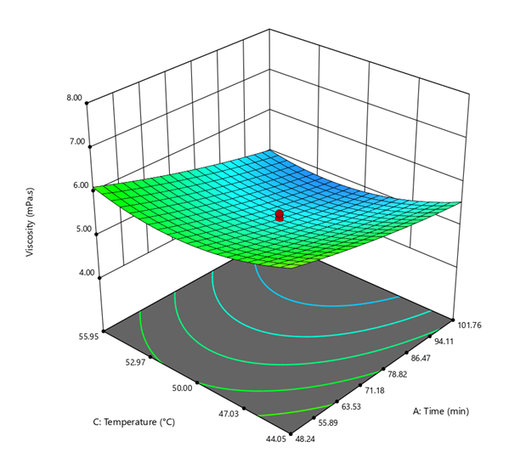
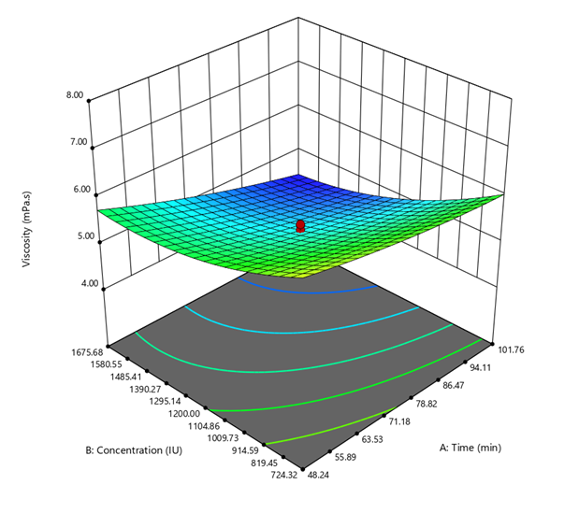

- (b)
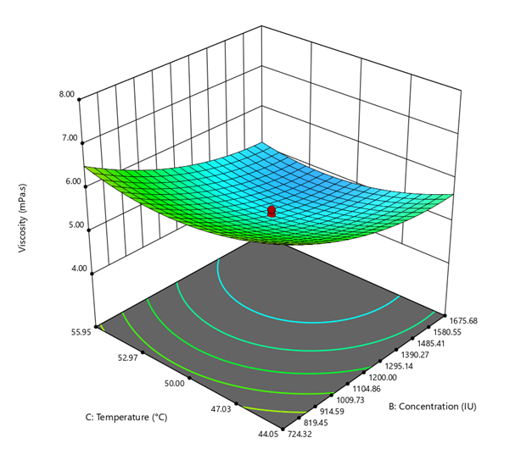

(c)
Fig. 1. Effect of independent variables on Viscosity (a) Interaction effect of concentration and time (b) Interaction effect of temperature and time and (c) Interaction effect of concentration and temperature
3.1.1.2 Total soluble solids
The concentration of soluble sugars in the medium rises as the starch is digested by enzymes, raising the TSS levels due saccharification. The extent of saccharification depends on factors such as enzyme concentration, incubation time, and temperature (Cahya, 2025). The analysis of variance (ANOVA) in Table 3 assesses the significance of the regression model that was developed for the response variable. The F, adjusted R², and predicted R² values were 40.83, 0.945, and 0.836, indicating the model accurately represents the experimental data. The graphical representation of the effect of variables on viscosity response is presented in Fig.2.
The F-value of 40.83 and a corresponding p-value < 0.0001, indicating that the model accurately represents the experimental data. The model's adequacy was confirmed by the high coefficient of determination (R²), the coefficient of variance (CV) was 2.58% indicating low variability in the experimental data. A similar rise in the TSS content by enzyme hydrolysis by alpha amylase was seen in the processing of rice milk (Padma et al., 2018), oat milk (Zhang et al., 2024), and apple juice processing (Dey et al., 2014).
The following quadratic model can be utilized for presenting the variation in TSS:
TSS = 3.95+0.1764A+0.3616B+0.0450AB+0.1600AC+0.1000BC+0.0088A²-0.1679B²-0.1220C²
Where A, B, and C are coded variables for incubation time, enzyme concentration, and temperature.

Table 3. ANOVA table for the effect of enzyme hydrolysis on Viscosity
Source | Sum of Squares | df | Mean Square | F-value | p-value
Model | 3.46 | 9 | 0.3840 | 40.83 | < 0.0001 | Significant
A-Time | 0.4250 | 1 | 0.4250 | 45.18 | < 0.0001
B-Concentration | 1.79 | 1 | 1.79 | 189.83 | < 0.0001
C-Temperature | 0.3588 | 1 | 0.3588 | 38.15 | 0.0001
AB | 0.0162 | 1 | 0.0162 | 1.72 | 0.2187
AC | 0.2048 | 1 | 0.2048 | 21.77 | 0.0009
BC | 0.0800 | 1 | 0.0800 | 8.51 | 0.0154
A² | 0.0011 | 1 | 0.0011 | 0.1195 | 0.7367
B² | 0.4065 | 1 | 0.4065 | 43.21 | < 0.0001
C² | 0.2144 | 1 | 0.2144 | 22.80 | 0.0008
Residual | 0.0941 | 10 | 0.0094
Lack of Fit | 0.0697 | 5 | 0.0139 | 2.85 | 0.1372 | Not significant
Pure Error | 0.0244 | 5 | 0.0049
Cor Total | 3.55 | 19
Std. Dev. |  |  | 0.0970 | R² |  | 0.9735
Mean |  |  | 3.75 | Adjusted R² |  | 0.9497
C.V. (%) |  |  | 2.58 | Predicted R² |  | 0.8361
 |  |  |  | Adeq Precision |  | 26.3510
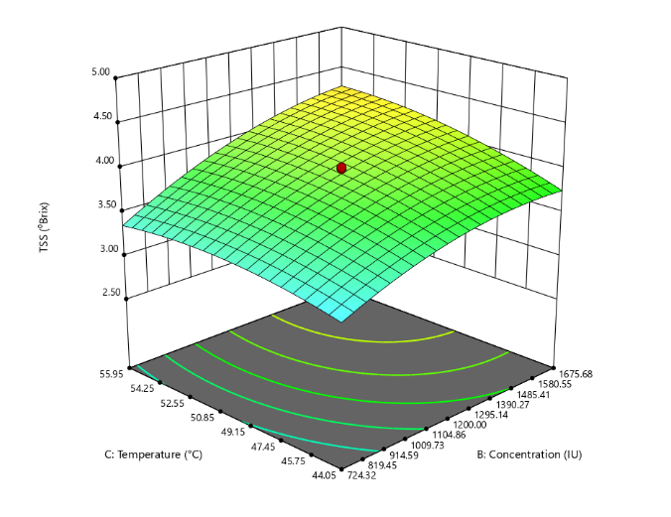

(a)

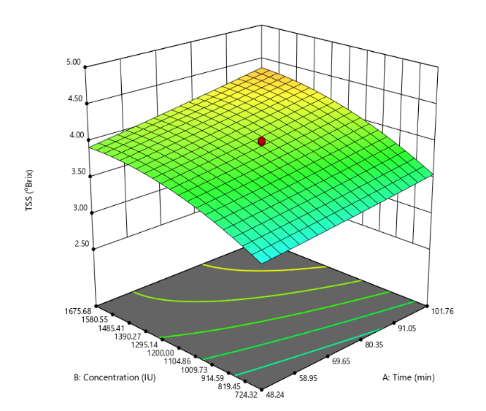
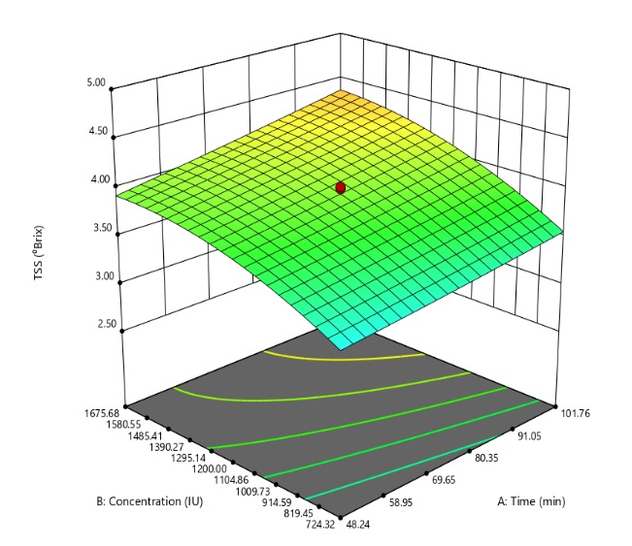
(b) (c)
Fig. 2. Effect of independent variables on TSS (a) Interaction effect of concentration and temperature (b) Interaction effect of concentration and time and (c) Interaction effect of concentration and temperature

3.1.1.3 Optimized parameters for enzyme hydrolysis process of millet milk
Achieving the maximum TSS and minimum viscosity while utilizing the minimum enzyme concentration to guarantee cost effectiveness was the aim to avoid the gelation at high temperature processing. The control sample had high viscosity (23mPa.s) suggesting gel formation due to gelatinisation on thermal processing whereas enzyme treated samples had less viscosity (below 10 mPa.s) indicating that there was no clotting or gelation even after thermal processing (Sharma et al., 2018).
The expected results under these circumstances were a TSS of 4.3 °Brix and a viscosity of 4.90 mPa.s, with a 72.8% overall model desirability. Based on the RSM experimental design, it was anticipated that the enzyme hydrolysis of extracted millet milk using 1194.46 IU, 54 °C incubation, and 102 min would result in a viscosity of 4.90 mPa.s and a TSS of 4.28 °Brix. Four replications of the optimized formulation were created under optimal circumstances in order to verify the optimized responses.
Table 4. Constraints set for the optimization and validation of the optimization of enzyme hydrolysis process
Parameter | Goal | Lower Limit | Upper Limit | Importance | Predicted value | Actual value
A: Time (min) | is in range | 48.25 | 101.76 | 3 | 102 | 102
B: Concentration (IU) | minimize | 724.32 | 1675.68 | 2 | 1194.46 | 1194.46
C: Temperature (°C) | is in range | 44.05 | 55.95 | 3 | 54 | 54
Viscosity (mPa.s) | minimize | 4.50 | 7.46 | 3 | 4.91 | 4.93 ± 0.03
TSS (°Brix) | maximize | 2.80 | 4.70 | 3 | 4.29 | 4.30 ± 0.02
Values are reported as mean ± standard error; (n≥3)
The goals/criteria that were set for optimization and validation of the optimized RSM model for enzyme hydrolysis of extracted millet milk is presented in the table (Table 4). The actual values were in agreement with the predicted values of model in 95% level of confidence. The nutritional analysis of enzyme treated millet milk was carried out and represented in Table 5.
Table 5. The nutritional attributes of enzyme treated millet milk

Parameter | Composition (per 100ml)
Moisture content (%) | 85.21 ± 0.23
Protein (%) | 2.45 ± 0.08
Crude fiber (%) | 0.92 ± 0.02
Fat (%) | 1.02 ± 0.04
Ash (%) | 0.71 ± 0.01
Carbohydrates (%) | 9.69 ± 0.13
Total phenol content (mg GAE) | 122.38 ± 0.76
Total flavonoid content (mg QE) | 154.13 ± 0.51
Antioxidant activity (%) | 58.47 ± 0.16
Calcium (mg/100 mL) | 23.04 ± 0.21
Iron (mg/100 mL) | 1.30 ± 0.01
Potassium (mg/100 mL) | 25.08 ± 0.18
Phosphorus (mg/100 mL) | 98.24 ± 0.46
Magnesium (mg/100 mL) | 71.80 ± 0.17
Copper (mg/100 mL) | 8.3 ± 0.06
Values are reported as mean ± standard error; (n≥3)

3.2 Standardization of thermal treatment for millet milk based ready-to-drink beverage
In the food and beverage sector, thermal processing is a commonly used preservation method that is mainly employed to prolong the shelf life of liquid food products, guarantee microbial safety, and deactivate spoilage enzymes. Maintaining the nutritional integrity and sensory acceptability of plant-based functional beverages, during processing is crucial and thus standardization of thermal processing is important. The treatments and responses are reported in Table 6.

Table 6. Treatments and responses of experiments for the standardization of thermal processing parameters
Run  Run | Treatments |  |  | Responses
Run  Run | Temperature  (°C) | Time  (min) | Formulation  (millet milk: sapota juice) | APC  (log CFU/mL) | Overall acceptability  score
1 | 80 | 10 | 4:1 | 4.50ª±0.01 | 5.72^{n}±0.36
2 | 80 | 10 | 3:1 | 4.48ª±0.02 | 6.72^{jk}±0.61
3 | 80 | 10 | 2:1 | 4.40^{b}±0.02 | 7.30^{fgh}±0.34
4 | 80 | 15 | 4:1 | 4.38^{b}±0.02 | 6.15^{m}±0.21
5 | 80 | 15 | 3:1 | 4.34^{bc}±0.02 | 7.09^{hi}±0.10
6 | 80 | 15 | 2:1 | 4.25^{cd}±0.03 | 7.15^{i}±0.11
7 | 80 | 20 | 4:1 | 4.28de±0.02 | 6.16^{m}±0.12
8 | 80 | 20 | 3:1 | 4.22de±0.02 | 7.23^{ghi}±0.19
9 | 80 | 20 | 2:1 | 4.19e±0.01 | 7.66^{cde}±0.22
10 | 85 | 10 | 4:1 | 3.68^{f}±0.04 | 6.23^{lm}±0.11
11 | 85 | 10 | 3:1 | 3.58^{g}±0.03 | 7.59^{def}±0.12
12 | 85 | 10 | 2:1 | 3.49^{g}±0.04 | 7.72^{bcde}±0.17
13 | 85 | 15 | 4:1 | 3.61^{h}±0.02 | 6.51^{kl}±0.14
14 | 85 | 15 | 3:1 | 3.43^{hi}±0.04 | 7.45^{efg}±0.51
15 | 85 | 15 | 2:1 | 3.37^{i}±0.02 | 7.82^{bcd}±0.13
16 | 85 | 20 | 4:1 | 2.67^{j}±0.01 | 7.00^{ij}±0.10
17 | 85 | 20 | 3:1 | 2.40^{k}±0.09 | 7.65^{cde}±0.24
18 | 85 | 20 | 2:1 | 2.29^{l}±0.07 | 7.81^{bcd}±0.12
19 | 90 | 10 | 4:1 | 2.33^{lm}±0.01 | 6.75^{jk}±0.24
20 | 90 | 10 | 3:1 | 2.26^{m}±0.01 | 7.87^{abcd}±0.18
21 | 90 | 10 | 2:1 | 2.25^{m}±0.02 | 7.96^{ab}±0.08
22 | 90 | 15 | 4:1 | 1.63^{n}±0.04 | 6.78^{jk}±0.09
23 | 90 | 15 | 3:1 | 1.46º±0.02 | 7.89^{abc}±0.16
24 | 90 | 15 | 2:1 | 1.35^{p}±0.06 | 8.23ª±0.15
25 | 90 | 20 | 4:1 | 1.33^{pq}±0.06 | 6.72^{jk}±0.12
26 | 90 | 20 | 3:1 | 1.27^{qr}±0.03 | 7.78^{bcd}±0.14
27 | 90 | 20 | 2:1 | 1.24^{r}±0.04 | 7.95^{ab}±0.11
Values are represented as mean ± SD (n=3). Here APC = Aerobic plate count.

3.2.1 Microbial quality
Thermal processing significantly reduced the microbial count to a safer level (APC < 3 log CFU/mL for thermally processed beverages other than pasteurisation, FSSAI, 2022) making the product suitable for human consumption. The data suggested that higher temperatures (90 °C), longer holding times (15–20 min), and lower formulation ratios (2:1) result in the best microbial reduction. Notably, coliform count and yeast & mold (Y&M) count were not detected (ND) in any of the treatment combinations.
The Analysis of Variance (ANOVA) was used to ascertain if the means of several treatment groups differ significantly (5% level of significance), as shown in Table 7. Duncan's Multiple Range Test (DMRT) indicates that treatment means that share a same letter in a column are not significant. Treatment differences are statistically significant at a very high degree of confidence, as indicated by the computed F-value of 264.973, the low coefficient of variation (1.295%). The similar results were reported in a soya-tiger nut milk-based beverage by Okorie et al. (2014).

Table 7. ANOVA table for microbial quality
SoV | df | Sum Sq | Mean Sq | F value | Pr(>F) | SE(d) | SE(m) | CV (%)
Treatment | 26 | 108.443 | 4.171 | 264.973 | 0 | 0.032 | 0.023 | 1.295
Error | 54 | 0.085 | 0.002 | NA | NA | - | - | -

3.2.2 Sensory quality
The treatments had a statistically significant impact on the sensory quality, according to the ANOVA table 8. The calculated F-value of 58.497 shows that there is a high level of significance in the treatment differences. The standard error of the mean (SEm) and standard error of the difference (SEd) were found to be 0.104 and 0.147, and the coefficient of variation (CV) was 3.213% respectively.
Table 8. ANOVA table for sensory quality
SoV | df | Sum Sq | Mean Sq | F value | Pr(>F) | SE(d) | SE(m) | CV (%)
Treatment | 26 | 58.960 | 2.268 | 58.497 | 0 | 0.147 | 0.104 | 3.213
Error | 108 | 5.809 | 0.054 | NA | NA | - | - | -

Regarding overall acceptability, an improvement in sensory scores was noticed with increasing temperature and high concentration of sapota juice blending (i.e., 2:1). The highest overall acceptability score (8.23) was recorded at 90 °C, 15 min, and 2:1 ratio, indicating the panel's preference for this treatment as further increase in time resulted in slight overcooked flavour. So, the treatment at 90°C, 15 min, and 2:1 formulation was selected due to the superior sensory quality, and compliance of microbial counts with the FSSAI regulations. The similar results were reported by Verma et al. (2019), Kumara et al. (2019), and Punoo et al. (2023).
3.3 Characterization of developed beverage
The characterization of beverage involved physiochemical properties, proximate and nutritional analysis and values are represented in the Table 9.
The proximate composition of the beverage revealed that it had 84.03% moisture, 2.42% protein, 0.88% crude fiber, 0.67% ash, 11% carbohydrate, and 1.01% fat, which aligns with consumer preferences for low-fat beverages, and its total energy value was 62.73 kcal. The results obtained align with the findings of Wickramaarachchi et al. (2024). According to data obtained for physio-chemical properties analysis, the beverage's pH was 6.47 and its titratable acidity was 0.10% of citric acid, indicating a nearly neutral to slightly acidic environment. Total soluble solids (TSS) was 12.04 °Brix. Viscosity, measured at 36.81mPa.s, demonstrated a relatively fluid consistency and led to an appealing mouthfeel because of the stabilizing impact of xanthan gum. Similar results were reported by Sanjana et al. (2025) in a coconut-cashew beverage.
The sample's colour values were observed to be L* = 58.29, a* = 0.85, and b* = 12.64. It indicates moderate brightness and a slight yellow tone due to the addition of sapota juice and thermal processing of the beverage as typically seen in other grain beverages. Punoo et al. (2023) reported that similar phenomenon in soy whey and orange juice blended beverage.
Parameter | Developed beverage
Moisture content (%) | 84.03 ±0.41
Protein (%) | 2.42 ± 0.02
Crude fiber (%) | 0.88 ± 0.01
Fat (%) | 1.01 ± 0.02
Ash (%) | 0.67 ± 0.01
Carbohydrates (% by difference) | 11.00 ± 0.11
Energy value (kcal/100 mL) | 62.73
Titratable acidity (%) | 0.10 ± 0.01
Total soluble solids (°Brix) | 12.02 ± 0.06
pH | 6.47 ± 0.13
Viscosity (mPa.s) | 36.81 ± 0.52
Colour value (L*, a*, b*) | L*(58.29 ± 0.62),
Colour value (L*, a*, b*) | a*(0.85 ± 0.03)
Colour value (L*, a*, b*) | b*(12.64 ± 0.14)
Calcium (mg/100 mL) | 21.43 ± 0.14
Iron (mg/100 mL) | 1.08 ± 0.05
Magnesium (mg/100 mL) | 65.90 ± 0.11
Potassium (mg/100 mL) | 60.68 ± 0.29
Phosphorus (mg/100 g) | 98.63 ± 0.73
Zinc (mg/100 g) | 0.50 ± 0.01
Total phenols (mg GAE/100 mL) | 116.36 ± 1.04
Antioxidant activity (%) | 50.90 ± 0.48
Total flavonoids (mg QE/100 mL) | 150.41 ± 1.03
Table 9. Physiochemical properties, proximate and nutritional composition of developed beverage

Values are reported as mean ± standard error; (n≥3)
The mineral profile of the beverage revealed that the calcium content was 21.43 mg/100 mL, iron was 1.08 mg/100 mL, magnesium was 65.90 mg/100 mL, potassium was 60.68 mg/100 mL, while the phosphorus content and zinc content were recorded as 98.63 mg/100 g, 0.60 mg/100 g respectively. According to nutritional analysis data, the amount of functional bioactive components was 116.36 mg GAE/100 mL for total phenols and 150.41 mg QE/100 mL for total flavonoids, and antioxidant activity of 50.90% suggesting that it potentially has health-promoting qualities.
3.4 Storage study
The shelf-life analysis is essential and offers important information about how long a food will retain the appropriate level of safety, nutritional value, and sensory appeal under particular storage situations. The samples were analysed for physio-chemical properties (colour, pH, TSS, and titratable acidity), sensory analysis (overall acceptability score), and microbial analysis (aerobic plate count, yeast and mold count, and coliform count).
3.4.1 Quality Characteristics of Beverage Stored Under Refrigerated Conditions
The processed samples stored at ambient temperature spoiled within 5 days at ambient temperature. By the fourth day, the processed samples kept at room temperature exhibited visible signs of spoilage, such as the formation of gas bubbles and the curdling of the beverage indicating the low shelf-life product at ambient storage condition.
3.4.2 Quality Characteristics of Beverage Stored Under Refrigerated Conditions
A significant decline in pH was observed during the storage period, decreasing from 6.47 to 6.07. This reduction in pH may be attributed to chemical reactions occurring over time and the increasing acidity during storage. Similar findings have been reported by Mishra et al. (2017) and Sanjana et al. (2025).The variation in pH values during storage is shown graphically in Fig.3.

Fig. 3. Effect of refrigerated storage on pH of beverage sample

The significant increase in ΔE* value of the beverage from 1.72 to 2.19 was observed during 35 days of storage period, and the values are presented in Table 10 and in Fig. 4. The similar increase in ΔE*
values were reported by Tsai et al. (2018) in thermally processed hazelnut milk beverage. During the storage study, there was slight increase in TSS from 12.04 to 12.22 ⁰Brix under refrigerated conditions and is presented graphically in Fig. 5. This increase can be correlated with the decreased pH values on storage, which caused the solubilisation and hydrolysis of polymeric components in beverages (Dhiman et al., 2017). The similar observations were reported by Rather et al. (2024) in soya-whey and pineapple beverage.

Fig. 4. Effect of refrigerated storage on colour value (ΔE*) of beverage sample

Fig. 5. Effect of refrigerated storage on TSS of beverage sample

Fig. 6. Effect of refrigerated storage on titratable acidity of beverage sample
Titratable acidity (% of citric acid) increased significantly from 0.10 to 0.21 during storage, which may be attributed to the production of organic acids due to biochemical reactions occurring over the storage period. Wickramaarachchi et al. (2025) reported a similar increase in acidity in a thermally processed grain beverage. The TSS and titratable acidity values were found to be within the permissible limits prescribed by the FSSAI standards for ready-to-serve (RTS) beverages, i.e., TSS ≥ 10 ⁰Brix, TA ≤ 0.3% (FSSAI, 2020). The variation in titratable acidity values during storage is shown in Table 10 and graphically in Fig. 6.
The Aerobic Plate Count (APC) was determined during the entire storage period and results are presented in Table 10 and graphically in Fig. 7. It was observed that the APC was increased during storage period from 1.35 log CFU /mL on 0 day to 2.82 log CFU /mL on 35th day. Yeast and mold count and coliform count were not detected in any sample during the storage period. On 40th day, the beverage sample was observed to have gas formation and the aerobic plate count (3.28 log CFU/mL) was above the permissible limits (>3 log CFU/mL) of FSSAI regulations. The similar findings were observed by Okorie et al. (2014) in soy-tiger nut milk beverage and Gorachiya et al. (2018) in watermelon-based whey beverage.

Fig. 7. Effect of refrigerated storage on aerobic plate count of beverage sample

Fig. 8. Effect of refrigerated storage on sensory quality (overall acceptability score) of beverage sample

The overall acceptability score of beverage sample reduced significantly from 8.23 to 6.67 during 35 days of storage period. The variation in overall acceptability score is presented graphically in Fig. 8. The physicochemical changes and other auto-oxidative deteriorative reactions that occur during the storage result in a decline in sensory attributes of the product (Mu et al., 2022). Similar reduction in sensory score during storage was reported in a mango-based whey beverage by Pandey & Ojha, (2020).
The antioxidant activity of the beverage significantly reduced from 51.25 % to 36.10% and changes in its value is shown graphically in Fig. 9. The reduction in antioxidant activity may be correlated to the reduction in total phenolic and flavonoid content (Ali et al., 2020). Sanjana et al. (2025) reported a similar reduction in antioxidant activity during storage in coconut-cashew nut milk beverage.

Fig. 9. Effect of refrigerated storage on antioxidant activity of beverage sample

The bioactive compounds, namely total phenol content and total flavonoid content, were analysed during storage study. The changes in total phenol content and total flavonoid content values during storage are represented in Table 10 and shown graphically in Fig. 10 and Fig. 11. Total phenol content (mg GAE/100mL) decreased from 116.21 to 82.92 on 35 days of storage. Manzoor et al. (2020) reported a similar reduction in TPC on storage in a thermally processed almond milk beverage. Whereas, total flavonoid content (mg QE /100 mL) decreased from 150.06 to 128.85 during storage. The similar findings were reported by Tsai et al. (2018) in in thermally processed hazelnut milk beverage.
Hence, refrigerated storage proved effective in extending the shelf life of the thermally processed beverage, as it helped preserve the product's physicochemical properties, delayed microbial growth, retained bioactive compounds to some extent, and maintained overall quality throughout the storage period.

Fig. 10. Effect of refrigerated storage on total phenol content of beverage sample

Storage days | pH | Colour value (ΔE*) | TSS (⁰Brix) | Titratable acidity  (% citric acid) | Aerobic plate count  (log  CFU/mL) | Overall acceptability score | Antioxidant activity (%) | Total phenolic content  (mg GAE/mL) | Total flavonoid content  (mg QE /mL)
0th day | 6.47ª± 0.01 | 1.72ª± 0.01 | 12.04^{f} ± 0.02 | 0.10e ± 0.02 | 1.35^{h} ± 0.01 | 8.21ª ± 0.06 | 50.73ª ± 0.98 | 116.21ª ± 0.17 | 150.06ª ± 1.72
5th day | 6.44ª ± 0.04 | 1.73^{ab} ± 0.01 | 12.04^{ef}± 0.09 | 0.10e± 0.01 | 1.43^{g} ± 0.03 | 8.02^{ab} ± 0.09 | 49.45^{ab} ± 0.47 | 113.72^{b} ± 2.32 | 149.46^{ab} ± 1.90
10th day | 6.36^{b} ± 0.05 | 1.80^{b} ± 0.02 | 12.07e ± 0.32 | 0.12^{d} ± 0.02 | 1.75^{f}± 0.61 | 7.83^{bc} ± 0.31 | 48.87^{ab} ± 1.19 | 110.15^{c} ± 1.52 | 147.80^{bc} ± 0.76
15th day | 6.31^{bc} ± 0.07 | 1.85^{c} ± 0.01 | 12.10^{d} ± 0.01 | 0.13^{d} ± 0.08 | 1.83e ± 0.01 | 7.70^{cd} ± 0.23 | 48.09^{b} ± 1.70 | 97.80^{d} ± 1.01 | 145.30^{c} ± 1.26
20th day | 6.25^{cd} ± 0.06 | 2.08^{d}± 0.01 | 12.14^{c} ± 0.15 | 0.15^{c} ± 0.11 | 2.02^{d} ± 0.23 | 7.56de ± 0.17 | 45.78^{c} ± 1.47 | 95.05e ± 0.99 | 142.03^{d} ± 0.70
25th day | 6.23de ± 0.06 | 2.13e ± 0.05 | 12.16^{bc} ± 0.06 | 0.16^{c} ± 0.07 | 2.34^{c} ± 0.15 | 7.40^{ef} ± 0.13 | 41.80^{d} ± 1.96 | 92.41^{f}± 1.36 | 139.33e ± 0.68
30th day | 6.17e ± 0.06 | 2.14^{f} ± 0.02 | 12.18^{b}± 0.01 | 0.18^{b} ± 0.64 | 2.59^{b} ± 0.21 | 7.20^{f} ± 0.15 | 39.07e ± 0.24 | 87.74^{g} ± 0.81 | 135.82^{f} ± 0.90
35th day | 6.07^{f} ± 0.01 | 2.19^{g} ± 0.03 | 12.22ª ± 0.08 | 0.21ª ± 0.81 | 2.82ª ± 0.72 | 6.66^{g} ± 0.07 | 36.10^{f} ± 0.42 | 82.92^{h} ± 1.67 | 128.52^{g} ± 2.00
SEm± | 0.02 | 0.21 | 0.09 | 0.07 | 0.12 | 0.07 | 0.743 | 0.792 | 0.84
CD (0.05) | 0.01 | 0.05 | 0.02 | 0.19 | 0.36 | 0.05 | 0.48 | 0.52 | 0.56
CV (%) | 0.82 | 1.34 | 0.13 | 7.87 | 1.02 | 2.30 | 2.85 | 1.38 | 1.01
Table 10: Changes in quality characteristics of beverage under refrigerated conditions during storage study
Values are expressed as mean ± standard deviation (n=3). Values followed by different letters in the same column are significantly different according to Duncan’s Multiple Range (DMR) test at a 5% significance level.

Fig. 11. Effect of refrigerated storage on total flavonoid content of beverage sample

4. CONCLUSION
The current study effectively illustrated the potential of little millet (Panicum sumatrense) and sapota (Manilkara zapota) for the formulation of a nutritionally dense, functional beverage.The optimized condition for enzyme hydrolysis was 102 min of incubation time at 54 ⁰C incubation temperature, with minimum enzyme concentration of 1194.56 IU resulting in 4.9 mPa.s of viscosity and 4.3 ⁰Brix of TSS was suggested by RSM with desirability of 72.8%.The standardized treatment was 90 ⁰C, 15 min and 2:1 formulation with highest sensory score and microbial count within the permissible limits of regulation. The developed beverage exhibited considerable functional potential by its 50.90% antioxidant activity and rich profile of bioactive components, which included 150.41 mg QE/100 mL flavonoids and 116.36 mg GAE/100 mL phenolics. With 21.43 mg/100 mL calcium, 1.08 mg/100 mL iron, 65.90 mg/100 mL magnesium, 60.68 mg/100 mL potassium, 98.63 mg/100 mL phosphorus, and 0.50 mg/100 mL zinc, mineral analysis also showed significant levels of important micronutrients, suggesting that the beverage can serve as a functional drink that promotes health while also making a significant contribution to daily mineral requirements. In the storage study, the samples at ambient temperature spoiled within 5 days, indicating the low shelf-life of the product in ambient conditions (35 ± 2 °C).Under refrigerated conditions (5 ± 2 °C), the samples showed an increase in titratable acidity, TSS, colour difference, microbial count and a decreasing trend in pH, overall acceptability, antioxidant activity, total phenolic content and flavonoid content. Samples stored at refrigerated conditions had no yeast or mould growth, and no coliform growth, whereas the aerobic plate count exceeded the permissible microbial limit (FSSAI standards for thermally processed beverages other than pasteurization (<100 °C) APC < 3logCFU/ml) after 35 days of storage.
Plant-based milk beverages have emerged as a dynamic and rapidly growing segment of the functional beverage market, driven by growing consumer awareness of health, sustainability, and ethical concerns. Thus, the current study concludes that a novel plant-based milk beverage can be developed by blending millet milk with sapota juice, followed by thermal processing. The combination of nutrient-dense little millet and naturally sweet, antioxidant-rich sapota resulted in a beverage with enhanced nutritional and sensory properties. This formulation supports the sustainable use of underutilised grains like millet and adds value to indigenous fruits like sapota.Further research on large-scale processing, packaging, and fortification can aid in its commercialization, and even the use of non-thermal technologies may help retain more bioactive compounds.

REFERENCES
Akintayo, O. A., Falconer, R. J., Lauer, J. C., Cowley, J. M., & Bozkurt, H. (2025). The effect of gelatinisation and enzymatic hydrolysis methods on the starch, sugar and physicochemical profiles of faba bean milk. International Journal of Biological Macromolecules, 304 (2), 140898.
Ali, N., Popović, V., Koutchma, T., Warriner, K., & Zhu, Y. (2020). Effect of thermal, high hydrostatic pressure, and ultraviolet‐C processing on the microbial inactivation, vitamins, chlorophyll, antioxidants, enzyme activity, and color of wheatgrass juice. Journal of Food Process Engineering, 43 (1), e13036.
Baskar, M., & Padmini, T. (2015). Optimization of Enzymatic Extraction and Clarification of Sapota (Manilkhara achras) Juice. Trends in Biosciences, 8 (16), 4189-4195.
Brand-Williams, W., Cuvelier, M. E., & Berset, C. L. W. T. (1995). Use of a free radical method to evaluate antioxidant activity. LWT-Food Science and Technology, 28 (1), 25-30.
Cahya, O. E. (2025). Optimisation of α-Amylase and Amyloglucosidase Enzyme Concentration on Glucose Syrup Characteristics from Purple Sweet Potato (Ipomoea batatas L var. Antin 2). European Journal of Agriculture and Food Sciences, 7 (1), 1-8.
Carbajal-Padilla, D., Sosa-Morales, M. E., Cerón-García, A., Morales-De la Peña, M., & Gómez-Salazar, J. A. (2025). Effect of Oat and Chickpea Content on the Physicochemical, Bioactive, and Sensory Properties of a Plant-Based Beverage during Chilled Storage. American Chemical Society Food Science & Technology, 5 (3), 942-952.
Cserhalmi, Z., Sass-Kiss, A., Tóth-Markus, M., & Lechner, N. (2006). Study of pulsed electric field treated citrus juices. Innovative Food Science & Emerging Technologies, 7 (1), 49-54.
Dayakar Rao, B., Bhaskarachary, K., Arlene Christina, G. D., Sudha Devi, G., Vilas, A. T., & Tonapi, A. (2017). Nutritional and health benefits of millets. ICAR_Indian Institute of Millets Research (IIMR) Rajendranagar, Hyderabad, 2, 38-57.
Deswal, A., Deora, N. S., & Mishra, H. N. (2014). Optimization of enzymatic production process of oat milk using response surface methodology. Food and Bioprocess Technology, 7 (1), 610-618.
Dey, T. B., & Banerjee, R. (2014). Application of decolourized and partially purified polygalacturonase and α-amylase in apple juice clarification. Brazilian Journal of Microbiology, 45 (1), 97-104.
Dhiman, A. K., Babu, G. N., Attri, S., & Ramachandran, P. (2017). Development and storage development and storage stability of pumpkin-based ability of pumpkin based ready- to- serve (RTS) beverages. Development, 12 (3), 1481–1486.
FSSAI (2020). 2.3.9. Thermally Processed Fruit Ready to Serve, Compendium Food Additives Regulations, Version-XII, 153-154, New Delhi, India.
FSSAI (2022). Manual of Method of Analysis of Foods (Microbiological Testing), Food Safety and Standard Authority of India, New Delhi.
Gorachiya, P. R., Bais, B., Kumar, D., & Devi, D. (2018). Study of formulation, sensory evaluation, antioxidant potential and storage study of watermelon-based whey beverage from camel and buffalo milk. Journal of Animal Research, 8 (6), 1075-1079.
Henchion, M., Hayes, M., Mullen, A. M., Fenelon, M., & Tiwari, B. (2017). Future protein supply and demand: Strategies and factors influencing a sustainable equilibrium. Foods, 6 (7), 53. https://doi.org/10.3390/foods6070053.
Hiremath, J. B., Rokhade, A. K., Hegde, N. K., & Patil, C. P. (2012). Preparation and preservation of sapota juice. International Journal of Food, Agriculture and Veterinary Sciences, 2 (1), 87-91.
Kalpana, V. N., & Rajeswari, V. D. (2019). Preservatives in beverages: perception and needs. In A. M. Grumez & A. M. Holban (Eds.), Preservatives and preservation approaches in beverages (1st ed., pp. 1-30). Academic Press. https://doi.org/10.1016/B978-0-12- 816685-7.00001-X
Kasapoğlu, K. N., Daşkaya-Dikmen, C., Yavuz-Düzgün, M., Karaça, A. C., & Özçelik, B. (2019). Enrichment of beverages with health beneficial ingredients. In A. M. Grumezescu & A. M. Holban (Eds.), Value-added ingredients and enrichments of beverages (1st ed., pp. 63–99). Academic Press. https://doi.org/10.1016/B978-0-12-816687-1.00003-5.
Kumara, A., Mahagamage, M. G. Y. L., & Arampath, P. C. (2019). Development of ready-to-serve pineapple juice with coconut milk. The North African Journal of Food and Nutrition Research, 3 (6), 214-218.
Kunnika, S., & Pranee, A. (2011). Influence of enzyme treatment on bioactive compounds and colour stability of betacyanin in flesh and peel of red dragon fruit Hylocereus polyrhizus (Weber) Britton and Rose. International Food Research Journal, 18 (4), 1437-1448.
Li, A., Zheng, J., Han, X., Jiang, Z., Yang, B., Yang, S., Zhou, W., Li, C., & Sun, M. (2023). Health implication of lactose intolerance and updates on its dietary management. International Dairy Journal, 140, 105608. https://doi.org/10.1016/j.idairyj.2023.105608.
Manzoor, M. F., Zeng, X. A., Ahmad, N., Ahmed, Z., Rehman, A., Aadil, R. M., Siddique, R., & Rahaman, A. (2020). Effect of pulsed electric field and thermal treatments on the bioactive compounds, enzymes, microbial, and physical stability of almond milk during storage. Journal of Food Processing and Preservation, 44 (7), e14541.
Mishra, L. K., & Sangma, D. (2017). Quality attributes, phytochemical profile and storage stability studies of functional ready to serve (RTS) drink made from blend of Aloe vera, sweet lime, amla and ginger. Journal of Food Science and Technology, 54 (3), 761-769.
Mu, Q., Su, H., Zhou, Q., Xiao, S., Zhu, L., Xu, X., ... & Hu, H. (2022). Effect of ultrasound on functional properties, flavor characteristics, and storage stability of soybean milk. Food Chemistry, 381, 132158.
Muthamilarasan, M., & Prasad, M. (2021). Small millets for enduring food security amidst pandemics. Trends in Plant Science, 26 (1), 33–40. https://doi.org/10.1016/j.tplants.2020.08.008.
Okorie, S. U., Adedokun, I. I., & Duru, N. (2014). Effect of blending and storage conditions on the microbial quality and sensory characteristics of soy-tiger nut milk beverage. Food Science and Quality Management, 31 (1), 96-103.
Pandey, S., & Ojha, P. (2020). Preparation and quality evaluation of mango based whey beverage. Journal of Food Science and Technology, Nepal, 12 (12), 59-61.
Penha, C. B., Santos, V. D. P., Speranza, P., & Kurozawa, L. E. (2021). Plant-based beverages: Ecofriendly technologies in the production process. Innovative Food Science & Emerging Technologies, 72, 102760.
Petruzzi, L., Campaniello, D., Speranza, B., Corbo, M. R., Sinigaglia, M., & Bevilacqua, A. (2017). Thermal treatments for fruit and vegetable juices and beverages: A literature overview. Comprehensive Reviews in Food Science and Food Safety, 16 (4), 668–691. https://doi.org/10.1111/1541-4337.12270.
Punoo, H. A., Rather, J. A., & Muzaffar, A. (2023). Development of soy whey fortified orange juice beverages: Their physicochemical, rheological, antioxidant, and sensory properties. Exploration of Foods and Foodomics, 1 (4), 206-220.
Ranganna, S. (1986). Handbook of analysis and quality control for fruit and vegetable products (2nd ed.). Tata McGraw-Hill Publishing Ltd., New Delhi, India.
Ranganna, S. (2008). Handbook of analysis and quality control for fruit and vegetable products. (2nd ed.). Tata McGraw-Hill Publishing Ltd., New Delhi, India.
Rather, J. A., Punoo, H. A., Akhter, N., Muzzaffar, S., Khanday, F. A., & Goksen, G. (2024). Effect of storage on the physicochemical, rheological, antioxidant activity, and sensory properties of soy whey‐fortified pineapple juice beverages. Food Science & Nutrition, 12 (8), 5858-5871.
Reyes-Jurado, F., Soto-Reyes, N., Dávila-Rodríguez, M., Lorenzo-Leal, A. C., Jiménez-Munguía, M. T., Mani-López, E., & López-Malo, A. (2023). Plant-based milk alternatives: Types, processes, benefits, and characteristics. Food Reviews International, 39 (4), 2320-2351.
Sanjana, K., Buvaneswaran, M., Moses, J. A., Hema, V., & Sinija, V. R. (2025). Effect of thermal and high-pressure processing on the quality and shelf life of coconut-cashew nut milk beverage. Journal of Food Measurement and Characterization, 19 (2), 1469-1481.
Sethi, S., Tyagi, S. K., & Anurag, R. K. (2016). Plant-based milk alternatives an emerging segment of functional beverages: A review. Journal of Food Science and Technology, 53 (9), 3408-3423.
Sharma, N., Alam, T., Goyal, S. K., Fatma, S., Pathania, S., & Niranajan, K. (2018). Effect of different storage conditions on analytical and sensory quality of thermally processed, milk‐based germinated foxtail millet porridge. Journal of Food Science, 83 (12), 3076-3084.
Sharma, N., Singh, V. K., Lee, Y., Kumar, S., Rai, P. K., Pathak, A. K., & Singh, V. K. (2020). Analysis of mineral elements in medicinal plant samples using LIBS and ICP-OES. Atomic Spectroscopy, 41(6), 234-241.
Sheela, P., Kanchana, S., Maheswari, T. U., & Hemalatha, G. (2018). Optimization of parameters for the extraction of millet milk for product development. Research Journal of Agricultural Sciences, 9 (6), 1345-1349.
Shunmugapriya, K., Kanchana, S., Maheswari, T. U., Kumar, R. S., & Vanniarajan, C. (2020). Standardization and stabilization of millet milk by enzyme and its physicochemical evaluation. European Journal of Nutrition & Food Safety, 12 (1), 30–38. https://doi.org/10.9734/ejnfs/2020/v12i130181.
Słominska, L., Wiśniewska, D., & Grześkowiak, A. (2003). Liquefaction of starch by thermostable alpha-amylase. ACTA Scientiarum Polonorum Technologia Alimentaria, 2 (2), 17-26.
Tsai, M. J., Cheng, M. C., Chen, B. Y., & Wang, C. Y. (2018). Effect of high-pressure processing on immunoreactivity, microbial and physicochemical properties of hazelnut milk. International Journal of Food Science and Technology, 53 (7), 1672-1680.
Verma, V., Chauhan, O. P., & Nanjappa, C. (2019). Optimization process for the development of soymilk-based strawberry RTS beverages. Plant Archives, 19 (1), 599-607.
Wickramaarachchi, L. A., Rajawardana, D. U., Gunasekara, M. M. N. P., Herath, H. M. T., & Jayasinghe, M. A. (2024). Development and evaluation of physico-chemical, sensorial, and shelf-life of grain-milk beverages. Journal Of Cereal Science, 116, 103875.
Yousaf, L., Hou, D., Liaqat, H., & Shen, Q. (2021). Millet: A review of its nutritional and functional changes during processing. Food Research International, 142, 110197. https://doi.org/10.1016/j.foodres.2021.110197.
Yu, Y., Li, X., Zhang, J., Li, X., Wang, J., & Sun, B. (2023). Oat milk analogue versus traditional milk: Comprehensive evaluation of scientific evidence for processing techniques and health effects. Food Chemistry: X, 19,100859,1-10.
Zhang, M., Huang, K., Lu, J., Lu, A., Guan, X., Zhang, Y., Sen Li, Song, H., Cao, H., & Yu, Z. (2024). Enzymatic hydrolysis of oat core flour improves physicochemical and sensory behaviours for oat milk. Journal of Cereal Science, 116, 103841.

