Original Research Article
CHITOSAN-MEDIATED RESILIENCE IN BACTERIAL INFECTED SILKWORMS: A STUDY ON GRAINAGE PARAMETERS

ABSTRACT
A biological assay was conducted to evaluate the efficacy of chitosan extracted from silkworm (Bombyx mori) pupae in mitigating bacterial infections and improving key grainage parameters in infected silkworms. Silkworm larvae (third instar, FC1×FC2 hybrid) were orally inoculated with Staphylococcus aureus and Bacillus thuringiensis, then treated with leaf-coated chitosan at 3500, 4000, 4500 and 5000 ppm; commercial chitosan and ampicillin at 1000 ppm served as controls, along with solvent, absolute and bacteria-free groups. Treatments were applied at five time intervals (6, 12, 18, 24 and 30 hours post-inoculation). The endpoints included moth emergence rate, deformed moth rate, fecundity (eggs/worm) and egg-hatching rate. Uninfected controls achieved approximately 95.9 per cent emergence and 3.8 per cent deformed moths. Ampicillin treatment at 6 hpi resulted in 85.1 per cent emergence, 10.6 per cent deformity, 612 eggs fecundity and 95 per cent hatching in infected groups. Among chitosan treatments, 5000 ppm dose applied at 6 hpi delivered the best performance, with approximately 82.0 per cent emergence, 13.9 per cent deformity, 582 eggs and 94.6 per cent hatching.
Keywords: Bombyx mori, flacherie, chitosan, moth emergence, deformed moths, fecundity, hatching, S. aureus, B. thuringiensis

1. INTRODUCTION
India is a prominent player in the global silk production landscape, accounting for a substantial share of the world's output, with mulberry silk constituting roughly 70 per cent of its total production. The southern states, particularly Karnataka, Tamil Nadu, Telangana and Andhra Pradesh, drive this industry, with Karnataka taking the lead. Despite the challenges posed by the COVID-19 pandemic, India's raw silk production saw an uptick, reaching 38,913 metric tons in 2023-24 from 36,582 metric tons in the previous year. However, China remains the largest producer, consistently generating over 50,000 metric tons during the same period. India's silk exports also witnessed a rise, fetching ₹2,027.56 crores in 2023-24, up from ₹1,848.96 crores in 2022-23 (Anon., 2024).
The sericulture industry generates a substantial amount of silkworm pupae, approximately 60 per cent of the dry weight of cocoons, which translates to around 2 kg of dry pupae for every kilogram of raw silk harvested. India alone produces about 40,000 metric tons of dry pupae annually, presenting a vast opportunity for their utilization. Global silk production of 1.6 million tons results in the generation of nearly 3 million tons of pupae, underscoring the potential for their reuse and valorization (Mahesh et al., 2015).
Silkworm pupae are a nutrient-rich resource, containing high levels of protein, lipids and energy, along with essential minerals and vitamins (Longvah et al., 2011). Once defatted, the remaining pupal biomass can serve as a viable alternative source of chitin, which can be converted into chitosan through deacetylation (Suresh et al., 2012). Chitosan, known for its biocompatibility, non-toxicity and antimicrobial properties, has garnered significant attention for its applications in various fields (Priyadarshini et al., 2018).
Research has shown that chitosan-enriched feed can enhance silkworm growth and exhibit bactericidal effects, offering a natural alternative to synthetic bactericides (Priyadarshini et al., 2018). However, silkworm diseases, particularly bacterial infections, pose a significant threat to the sericulture industry, causing substantial crop losses. Bivoltine silkworm varieties are more susceptible to diseases than multivoltine types, with septicemia being a major concern (Tayal & Chauhan, 2017). Present studies have explored the antimicrobial efficacy of chitosan derived from silkworm pupae against harmful bacterial pathogens, including Staphylococcus aureus and Bacillus thuringiensis.

2. METHODOLOGY
Chitin and chitosan extraction involved a three-step process: deproteinization, demineralization and deacetylation, following the protocol outlined by Suresh et al. (2012) with modifications. The extraction process involved treating silkworm pupal powder with 4 per cent NaOH at 70°C for 4 hours for deproteinization, followed by washing and rinsing. Demineralization was then performed using 3 per cent HCl at room temperature for 2 hours. Subsequently, chitin was converted to chitosan through deacetylation with 45 per cent NaOH at 95°C for 4 hours. The resulting chitosan was washed, rinsed and dried in a hot air oven at 50°C for 10 hours. Finally, chitosan was purified through decolorization with 6 per cent H₂O₂ at 50°C for 4 hours, yielding pure chitosan.
Twenty-five DFL’s of third instar FC1×FC2 silkworm hybrid, were procured from the Registered Chawki Rearing Centre, for further rearing and experimentation. Silkworms were reared until the fourth moult by feeding with untreated mulberry leaves by following the standard recommended practices outlined by Dandin and Giridhar (2014). The pathogens were inoculated orally by feeding mulberry leaves to the silkworms smeared with bacterial suspensions, soon after fourth moult. The mulberry leaf bits of 100 cm² size was prepared and washed in running water and sterilized by using 70 per cent alcohol (by cotton swab). The sterilized leaves were shade dried and such leaves were smeared evenly with bacterial suspension of 10⁸ CFU/mL (i.e., 0.27 mL/ replication of 50 worms) using non-absorbent cotton. The leaves were shade dried and fed to the silkworms and control batches of silkworms were fed only with non-inoculated surface sterilized mulberry leaves (Manjunath Gowda, 2009) (Fig. 1).
The experiment was carried out in a completely randomized design with nine treatments which were replicated thrice. The treatments are chitosan @ 3500 ppm, 4000 ppm, 4500 ppm and 5000 ppm along with standard ampicillin @ 1000 ppm, commercial chitosan @ 1000 ppm, solvent control, absolute control and bacteria un-inoculated silkworms. The sterilized mulberry leaves were dipped in the above treatments for ten minutes and shade dried. The treated dried leaves were fed to the silkworms after 6 hours post inoculation (hpi), 12 hpi, 18 hpi, 24 hpi and 30 hpi of bacterial suspension. For subsequent feedings, inoculum free leaves suitable for the age was provided for both treated and untreated batches. Further, the ripe worms were hand-picked from each replication and were mounted separately on the mountages for cocoon spinning. The mountages were kept in the mounting hall to provide optimum environmental conditions for spinning. Later on, the cocoons were harvested manually on the sixth day of mounting and economic traits such as moth emergence (%), deformed moth (%), fecundity and hatching (%) were recorded.
Further, the data was analysed statistically for the test of significance using Fisher’s method of analysis of variance as outlined by Sundarraj et al. (1972). The level of significance of F-test was at 5 per cent. The interpretation of data was done using critical difference (CD) values.
3. RESULTS AND DISCUSSION
3.1. Moth emergence (%)
The table 1 depicts that the treatments (B), time of chitosan application after bacterial inoculation (C) and the interaction of the treatments with bacterial strains and the time of application had showed the significant difference in the moth emergence of silkworms infected with S. aureus and B. thuringiensis. Individual bacterial strains (A) and their interaction with time of chitosan application after bacterial inoculation (A×C) have no significant difference over the moth emergence (%).
Among the treatments (B), bacteria un-inoculated control showed the highest moth emergence (95.86%), confirming no bacterial interference. Among infected silkworms, ampicillin at 1000 ppm recorded the highest mean emergence (85.07%), followed by commercial chitosan at 1000 ppm and chitosan at 5000 ppm with moth emergence rates of 83.34 per cent and 81.98 per cent, respectively. Chitosan treatments demonstrated dose-dependent efficacy, with higher concentrations (4500-5000 ppm) performing better, likely due to improved antimicrobial activity. The solvent control and absolute control had the lowest emergence rates, highlighting the adverse effects of untreated infection. The data supports the use of ampicillin or higher concentrations of chitosan as promising options for managing bacterial infections in silkworms.
Moth emergence percentages decreased with the time of chitosan application after bacterial inoculation (C) in most treatments, indicating the progressive impact of bacterial inoculation and chitosan efficacy. Emergence was highest in the early-treated silkworm batches at 6 hours post-inoculation (hpi) with 82.19 per cent and then followed a decreasing trend as chitosan treatment was delayed, recording 80.19 per cent, 79.36 per cent, 78.55 per cent and 77.77 per cent at 12 hpi, 18 hpi, 24 hpi and 30 hpi, respectively.
The interactions between bacterial strains, treatments and time were complex and multifaceted. The interaction between bacterial strains and treatments (A×B) was significant, reflecting differential treatment responses across bacterial strains. In contrast, the interaction between bacterial strains and time of chitosan application after bacterial inoculation (A×C) was non-significant, suggesting similar trends for both strains over time. However, the interaction between treatments and time of chitosan application after bacterial inoculation (B×C) was significant, highlighting the importance of timing for specific chitosan treatments. Notably, the three-way interaction (A×B×C) was significant, indicating complex interactions among all factors and underscoring the need for tailored treatment approaches that account for bacterial strain, treatment type and chitosan application time after bacterial inoculation.

Table 1: Effect of chitosan application on moth emergence (%) in silkworm infected with Staphylococcus aureus and Bacillus thuringiensis
Treatments (B) | Time of chitosan application following bacterial inoculation (hpi) (C) |  |  |  |  |  |  |  |  |  | Bacterial strains (A) mean |  | Treatments (B) mean
Treatments (B) | 6 hpi |  | 12 hpi |  | 18 hpi |  | 24 hpi |  | 30 hpi
Treatments (B) | Sa | Bt | Sa | Bt | Sa | Bt | Sa | Bt | Sa | Bt | Sa | Bt
S₁: Chitosan @ 3500 ppm | 81.83 | 78.35 | 77.70 | 75.09 | 78.16 | 77.35 | 79.25 | 74.56 | 73.53 | 74.07 | 78.09 | 75.88 | 76.99
S₂: Chitosan @ 4000 ppm | 83.57 | 81.64 | 78.29 | 79.70 | 79.28 | 80.56 | 71.74 | 79.85 | 78.84 | 76.20 | 78.34 | 79.59 | 78.97
S₃: Chitosan @ 4500 ppm | 84.06 | 80.95 | 79.08 | 83.39 | 78.13 | 80.43 | 83.69 | 75.65 | 76.57 | 75.65 | 80.31 | 79.22 | 79.76
S₄: Chitosan @ 5000 ppm | 86.29 | 84.80 | 82.15 | 82.37 | 82.14 | 80.67 | 79.37 | 81.85 | 80.63 | 79.50 | 82.12 | 81.84 | 81.98
S₅: Ampicillin @ 1000 ppm | 89.60 | 88.31 | 87.23 | 86.09 | 83.20 | 83.29 | 86.41 | 80.55 | 84.45 | 81.60 | 86.18 | 83.97 | 85.07
S₆: Com. chitosan @ 1000 ppm | 87.57 | 86.39 | 82.40 | 84.13 | 85.51 | 81.96 | 81.05 | 82.54 | 82.22 | 79.63 | 83.75 | 82.93 | 83.34
S₇: Solvent control | 72.84 | 75.71 | 70.33 | 78.00 | 66.01 | 73.66 | 66.02 | 73.88 | 67.83 | 71.57 | 68.61 | 74.56 | 71.58
S₈: Absolute control | 63.06 | 62.78 | 63.06 | 62.78 | 63.61 | 62.78 | 63.06 | 62.78 | 63.06 | 62.78 | 63.17 | 62.78 | 62.97
S₉: Bacteria un-inoculated | 95.86 | 95.86 | 95.86 | 95.86 | 95.86 | 95.86 | 95.86 | 95.86 | 95.86 | 95.86 | 95.86 | 95.86 | 95.86
Mean | 82.19 |  | 80.19 |  | 79.36 |  | 78.55 |  | 77.77 |  | 79.60 | 79.62
Mean A, B, C | 79.61 |  |  |  |  |  |  |  |  |  | 79.61 |  | 79.61
 | A | B | AB | C | AC | BC | ABC
F-Test | NS | * | * | * | NS | * | *
SEm ± | - | 0.611 | 0.864 | 0.455 | - | 1.366 | 1.933
CD @ 5% | - | 1.206 | 1.705 | 0.899 | - | 2.697 | 3.814
Note: * Significant; NS - Non-significant; A- Bacterial strains; B- Treatments; C- Hours of post inoculation (hpi); Sa- Staphylococcus aureus; Bt- Bacillus thuringiensis; Com.- Commercial chitosan

Among the infected silkworms, highest moth emergence (89.60%) was observed in the treatment of ampicillin @ 1000 ppm applied 6 hours after the S. aureus inoculation. Among the chitosan concentrations, highest moth emergence (86.29%) was observed in the treatment of chitosan @ 5000 ppm applied 6 hours after the S. aureus inoculation followed by 84.80 percentage of moth emergence was observed in the treatment of chitosan @ 5000 ppm applied 6 hours after the B. thuringiensis inoculation and 84.06 percentage of moth emergence was observed in the treatment of chitosan @ 4500 ppm applied 6 hours after the S. aureus inoculation. Similarly, bacteria un-inoculated silkworms found with the highest moth emergence of 95.86 percentage. Contrary, the least moth emergence (62.78%) was observed in the treatment of absolute control with B. thuringiensis inoculation.
Chitosan's positively charged molecular structure enables it to readily interact with negatively charged bacterial cells, thereby inhibiting their proliferation. According to Helander et al. (2001), surface interference is a considerable mechanism underlying the bactericidal properties of chitosan. The bactericidal effects of chitosan and antibiotic treatments in silkworms effectively eliminate bacterial infections, which in turn helps maintain the immune homeostasis of infected silkworms. Consequently, this leads to optimal outcomes for moth emergence percentages in chitosan and antibiotic treated groups, surpassing those of the control groups for infected silkworms.
3.2. Deformed moth (%)
The analysis of table 2 revealed significant effects of treatments (B), time of chitosan application after bacterial inoculation (C) and their interactions (A×B, A×C and B×C) on deformed moth percentages in silkworms infected with S. aureus and B. thuringiensis. Individual bacterial strains (A) and the three-way interaction (A×B×C) have no significant difference on the moth emergence percentage.
The treatments (B) had a significant impact on the deformed moth percentages. Bacteria un-inoculated silkworms had the lowest deformation rate (3.84%), confirming the absence of pathogenic stress. Among the bacterial infected silkworms, ampicillin at 1000 ppm and commercial chitosan at 1000 ppm showed the least deformed moth percentages, at 10.56 per cent and 13.01 per cent, respectively. These were followed by chitosan at 5000 ppm, chitosan at 4500 ppm, chitosan at 4000 ppm and chitosan at 3500 ppm, which recorded deformed moth percentages of 13.90 per cent, 17.06 per cent, 18.38 per cent and 22.89 per cent, respectively. Chitosan treatments exhibited dose-dependent efficacy. Higher doses reduced deformation, likely due to enhanced antimicrobial activity. The solvent control and absolute control had the highest deformation rates, at 30.17 per cent and 42.22 per cent, respectively, indicating severe effects of untreated bacterial infection.
Time of chitosan application after bacterial inoculation (C) significantly affected deformed moth percentages. The earliest application time, 6 hours post-inoculation (hpi), recorded the lowest mean deformity (15.98%), suggesting that early intervention is most effective in reducing deformities. In contrast, delayed application resulted in reduced chitosan treatment efficacy, as evidenced by the gradual increase in deformity percentages from 24 to 30 hpi, with the highest deformity percentage observed at 30 hpi (21.52%).
The interaction between bacterial strains and treatments (A×B) was significant, reflecting the varied response of treatments across bacterial strains. Similarly, the interaction between bacterial strains and time of chitosan application after bacterial inoculation (A×C) was significant, highlighting the influence of time on deformity percentage for each strain. The interaction between treatments and time of chitosan application after bacterial inoculation (B×C) was also significant, indicating the importance of timing for specific chitosan treatments. However, the interaction of all the factors (A×B×C) was non-significant, showing that the combined effects did not vary substantially across all factors.
Among the interactions, least deformed moth percentage (89.60%) was observed in the treatment of ampicillin @ 1000 ppm applied 6 hours after the S. aureus inoculation. Among the chitosan concentrations, lower deformed moth percentage (86.29%) was observed in the treatment of chitosan @ 5000 ppm applied 6 hours after the S. aureus inoculation followed by 84.80 percentage of deformed moth was observed in the treatment of chitosan @ 5000 ppm applied 6 hours after the B. thuringiensis inoculation and 84.06 percentage of deformed moth was observed in the treatment of chitosan @ 4500 ppm applied 6 hours after the S. aureus inoculation. Similarly, bacteria un-inoculated silkworms found with the minimum deformed moth percentage (95.86%). Contrary, the highest deformed moth percentage (62.78%) was observed in the treatment of absolute control with B. thuringiensis inoculation.

Table 2: Effect of chitosan application on deformed moth (%) in silkworm infected with Staphylococcus aureus and Bacillus thuringiensis
 | Treatments (B) | Time of chitosan application following bacterial inoculation (hpi) (C) |  |  |  |  |  |  |  |  |  |  |  | Bacterial strains (A) mean |  | Treatments (B) mean
 | Treatments (B) | 6 hpi |  |  | 12 hpi |  | 18 hpi |  |  | 24 hpi |  | 30 hpi
 | Treatments (B) | Sa | Bt |  | Sa | Bt | Sa | Bt |  | Sa | Bt | Sa | Bt | Sa | Bt
 | S₁: Chitosan @ 3500 ppm | 16.93 | 20.45 |  | 21.05 | 23.33 | 27.40 | 18.89 |  | 22.69 | 23.65 | 29.94 | 24.54 | 23.60 | 22.17 | 22.89
 | S₂: Chitosan @ 4000 ppm | 15.07 | 17.10 |  | 19.89 | 19.10 | 18.70 | 15.26 |  | 18.97 | 16.03 | 21.94 | 21.74 | 18.91 | 17.85 | 18.38
 | S₃: Chitosan @ 4500 ppm | 11.29 | 11.75 |  | 14.93 | 14.55 | 20.93 | 15.87 |  | 24.86 | 16.96 | 19.72 | 19.70 | 18.35 | 15.77 | 17.06
 | S₄: Chitosan @ 5000 ppm | 9.42 | 10.58 |  | 12.38 | 15.30 | 17.69 | 12.49 |  | 15.32 | 13.69 | 16.93 | 15.24 | 14.35 | 13.46 | 13.90
 | S₅: Ampicillin @ 1000 ppm | 6.60 | 7.85 |  | 9.65 | 9.48 | 11.63 | 10.04 |  | 12.01 | 10.87 | 13.49 | 13.97 | 10.68 | 10.44 | 10.56
 | S₆: Com. chitosan @ 1000 ppm | 8.34 | 10.21 |  | 10.94 | 10.51 | 14.54 | 13.53 |  | 15.97 | 14.28 | 16.72 | 15.02 | 13.30 | 12.71 | 13.01
 | S₇: Solvent control | 24.60 | 25.00 |  | 29.77 | 26.75 | 36.31 | 31.27 |  | 30.91 | 31.15 | 33.23 | 32.74 | 30.96 | 29.38 | 30.17
 | S₈: Absolute control | 37.50 | 47.22 |  | 37.50 | 47.22 | 36.11 | 47.22 |  | 37.50 | 47.22 | 37.50 | 47.22 | 37.22 | 47.22 | 42.22
 | S₉: Bacteria un-inoculated | 3.84 | 3.84 |  | 3.84 | 3.84 | 3.84 | 3.84 |  | 3.84 | 3.84 | 3.84 | 3.84 | 3.84 | 3.84 | 3.84
 | Mean | 15.98 |  |  | 18.34 |  | 19.75 |  |  | 19.99 |  | 21.52 |  | 19.02 | 19.21
 | Mean A, B, C | 19.11 |  |  |  |  |  |  |  |  |  |  |  | 19.11 |  | 19.11
 | A | B |  | AB |  | C | AC |  | BC |  | ABC
F-Test | NS | * |  | * |  | * | * |  | * |  | NS
SEm ± | - | 0.710 |  | 1.005 |  | 0.529 | 0.749 |  | 1.588 |  | -
CD @ 5% | - | 1.402 |  | 1.983 |  | 1.045 | 1.478 |  | 3.135 |  | -
Note: * Significant; NS - Non-significant; A- Bacterial strains; B- Treatments; C- Hours of post inoculation (hpi); Sa- Staphylococcus aureus; Bt- Bacillus thuringiensis; Com.- Commercial chitosan

3.3. Fecundity
The bacterial strains (A), treatments (B), time of chitosan application after bacterial inoculation (C) and their interaction (BC) significantly affected the fecundity of silkworms infected with S. aureus and B. thuringiensis (Table 3; Fig. 2). Interactions A×B, A×C and A×B×C have no significant differences.
The bacterial strains (A) significantly influenced fecundity. The mean fecundity was slightly higher for Sa, with 558.47 eggs, compared to B. thuringiensis with 529.44 eggs, indicating varying impacts on silkworm reproduction depending on the bacterial infection.
Treatments (B) had a significant impact on the fecundity of infected silkworms. Among infected silkworms, ampicillin at 1000 ppm recorded the highest fecundity among treatments, with 612.63 eggs, followed by commercial chitosan at 1000 ppm with 585.72 eggs and chitosan at 5000 ppm with 582.43 eggs. Chitosan treatments displayed dose-dependent improvement in fecundity, with the highest dose (5000 ppm) being the most effective. Bacteria un-inoculated silkworms showed the highest fecundity (648.93 eggs), confirming the negative impact of bacterial infection on egg-laying. The absolute control and solvent control exhibited the lowest fecundity, with 384.70 and 457.32 eggs, respectively, underscoring the detrimental effects of untreated infection.
Time of chitosan application after bacterial inoculation (C) significantly influenced fecundity. The timing of chitosan application had a profound impact on fecundity, with the earliest application time, 6 hours post-inoculation (hpi), recording the highest mean fecundity (574.62 eggs). This emphasizes the critical importance of early intervention in reducing bacterial damage. In contrast, delayed application resulted in reduced chitosan efficacy, with the lowest fecundity (518.19 eggs) observed at 30 hpi, suggesting that chitosan effectiveness decreases with time.
The interactions between bacterial strains, treatments and time were analysed for their impact on fecundity. Notably, the interactions between bacterial strains and treatments (A×B) and between bacterial strains and time of chitosan application after bacterial inoculation (A×C) were non-significant, indicating that the effect of treatments on fecundity was consistent across bacterial strains and that time-based effects on fecundity did not vary significantly between bacterial strains. In contrast, the interaction between treatments and time of chitosan application after bacterial inoculation (B×C) was significant, highlighting the critical role of time of chitosan application after bacterial inoculation in the efficacy of specific treatments. Furthermore, the three-way interaction (A×B×C) was non-significant, showing no substantial combined variation across all factors.

Table 3: Effect of chitosan application on fecundity in silkworm infected with Staphylococcus aureus and Bacillus thuringiensis
Treatments (B) | Time of chitosan application following bacterial inoculation (hpi) (C) |  |  |  |  |  |  |  |  |  | Bacterial strains (A) mean |  | Treatments (B) mean
Treatments (B) | 6 hpi |  | 12 hpi |  | 18 hpi |  | 24 hpi |  | 30 hpi
Treatments (B) | Sa | Bt | Sa | Bt | Sa | Bt | Sa | Bt | Sa | Bt | Sa | Bt
S₁: Chitosan @ 3500 ppm | 574.00 | 534.67 | 577.67 | 541.50 | 533.50 | 510.50 | 517.83 | 484.83 | 538.17 | 438.33 | 548.23 | 501.97 | 525.10
S₂: Chitosan @ 4000 ppm | 604.83 | 584.83 | 582.50 | 555.33 | 568.00 | 499.83 | 498.00 | 510.17 | 534.33 | 508.00 | 557.53 | 531.63 | 544.58
S₃: Chitosan @ 4500 ppm | 594.33 | 569.00 | 599.00 | 530.83 | 560.00 | 542.33 | 575.67 | 519.50 | 536.50 | 514.67 | 573.10 | 535.27 | 554.18
S₄: Chitosan @ 5000 ppm | 632.33 | 615.50 | 611.17 | 576.67 | 563.67 | 564.50 | 567.50 | 532.50 | 585.50 | 575.00 | 592.03 | 572.83 | 582.43
S₅: Ampicillin @ 1000 ppm | 662.17 | 625.00 | 624.50 | 645.50 | 607.50 | 601.00 | 606.50 | 578.00 | 602.50 | 573.67 | 620.63 | 604.63 | 612.63
S₆: Com. chitosan @ 1000 ppm | 636.17 | 611.67 | 620.67 | 596.83 | 597.00 | 594.00 | 600.50 | 519.33 | 542.33 | 538.67 | 599.33 | 572.10 | 585.72
S₇: Solvent control | 510.00 | 465.00 | 495.33 | 473.67 | 466.17 | 444.67 | 489.83 | 424.50 | 421.33 | 382.67 | 476.53 | 438.10 | 457.32
S₈: Absolute control | 418.50 | 365.67 | 405.67 | 369.83 | 404.17 | 369.17 | 414.50 | 356.17 | 384.67 | 358.67 | 405.50 | 363.90 | 384.70
S₉: Bacteria un-inoculated | 679.83 | 659.67 | 660.33 | 658.67 | 634.50 | 629.33 | 642.83 | 631.67 | 649.17 | 643.33 | 653.33 | 644.53 | 648.93
Mean | 574.62 |  | 562.54 |  | 538.32 |  | 526.10 |  | 518.19 |  | 558.47 | 529.44
Mean A, B, C | 543.96 |  |  |  |  |  |  |  |  |  | 543.96 |  | 543.96

 | A | B | AB | C | AC | BC | ABC
F-Test | * | * | NS | * | NS | * | NS
SEm ± | 3.276 | 6.949 | - | 5.179 | - | 15.538 | -
CD @ 5% | 6.464 | 13.713 | - | 10.221 | - | 30.663 | -
Note: * Significant; NS - Non-significant; A- Bacterial strains; B- Treatments; C- Hours of post inoculation (hpi); Sa- Staphylococcus aureus; Bt- Bacillus thuringiensis; Com.- Commercial chitosan

Bacterial infection appears to adversely impact the ovarioles, resulting in a reduced number of eggs in the absolute control and solvent control. The findings of the present study was corroborated by those of Priyadharshini et al. (2018), who concluded that chitosan extracted from silkworm pupae possesses not only antibacterial properties against bacterial pathogens in silkworms but also enhances economic parameters. However, the improvement observed in other treatments may be attributed to the bactericidal effect of chitosan, which is facilitated by the positively charged amino groups of chitosan binding to the teichoic acids of the peptidoglycan layer. This binding leads to cell wall distortion, disruption and the leakage of cytoplasmic contents and death of bacteria (Vishu Kumar et al., 2005). This mechanism likely underlies the improvement in fecundity observed among the chitosan and antibiotic treated groups. Chitosan treatment at higher concentrations has yielded superior control over bacterial pathogens, similar to antibiotic treatment, resulting in significantly higher fecundity compared to the control groups.
3.4. Hatching (%)
The analysis of variance (Table 4; Fig. 2) revealed significant effects of bacterial strains (A), treatments (B) and time of chitosan application after bacterial inoculation (C) on hatching percentage, while interactions (A×B, A×C, B×C and A×B×C) have no significant effect on hatching percentage of the eggs laid by the silkworms infected with S. aureus and B. thuringiensis. Among the bacterial strains (A), slightly higher hatching percentages were observed with S. aureus (94.39%) compared to B. thuringiensis (94.18%), indicating lower virulence of the S. aureus compared to B. thuringiensis.
Hatching percentages were also influenced by the treatments (B), with bacteria un-inoculated silkworms exhibiting the highest hatching percentage (96.25%), confirming optimal conditions in the absence of infection. Among pathogen-inoculated treatments, ampicillin at 1000 ppm recorded the best hatching percentage (94.97%), followed by chitosan at 5000 ppm with 94.63 per cent. In the chitosan treatments, chitosan at 5000 ppm recorded the highest hatching percentage (94.63%), followed by chitosan at 4000 ppm, chitosan at 4500 ppm and chitosan at 3500 ppm with hatching percentages of 94.08 per cent, 94.05 per cent and 93.87 per cent, respectively. The solvent control and absolute control had the lowest hatching rates, at 93.29 per cent and 92.83 per cent, respectively, demonstrating the adverse impact of untreated bacterial infections.
Time of chitosan application after bacterial inoculation (C) significantly influenced hatching percentages. The time of chitosan application after bacterial inoculation had a notable impact on hatching viability, with the earliest application time, 6 hours post-inoculation (hpi), recording the highest mean hatching percentage (94.49%). This highlights the crucial importance of early intervention in maintaining hatching viability. In contrast, delayed application resulted in diminished chitosan efficacy, with the lowest hatching percentage observed at 30 hpi (93.89%).
Treatment with higher concentration of chitosan and ampicillin proved efficacious in eliminating bacterial infections in silkworms, leveraging their antibacterial properties to boost the immune system of the infected silkworms. This, in turn, facilitated the laying of healthy eggs and significantly improved hatching percentages, which were notably higher in these treatment groups compared to the absolute control and solvent control, where hatching percentages were recorded at a minimum. These findings align with the research conducted by Sandhya (2023), who reported that silkworms fed on normal mulberry leaves laid a relatively higher average number of eggs compared to those fed on pesticide-sprayed leaves, where the hatching percentage was significantly lower. This disparity suggests that exposure to pesticides induces stress in silkworms, where the bacterial infection is the stressor in the present study, ultimately resulting in reduced hatching percentages.

Table 4: Effect of chitosan application on hatching (%) in silkworm infected with Staphylococcus aureus and Bacillus thuringiensis
Treatments (B) | Time of chitosan application following bacterial inoculation (hpi) (C) |  |  |  |  |  |  |  |  |  | Bacterial strains (A) mean |  | Treatments (B) mean
Treatments (B) | 6 hpi |  | 12 hpi |  | 18 hpi |  | 24 hpi |  | 30 hpi |  |  |  | Treatments (B) mean
Treatments (B) | Sa | Bt | Sa | Bt | Sa | Bt | Sa | Bt | Sa | Bt | Sa | Bt | Treatments (B) mean
S₁: Chitosan @ 3500 ppm | 93.77 | 94.18 | 93.94 | 93.45 | 94.00 | 94.09 | 93.74 | 93.83 | 94.04 | 93.63 | 93.90 | 93.84 | 93.87
S₂: Chitosan @ 4000 ppm | 94.58 | 94.23 | 94.18 | 93.98 | 94.28 | 93.81 | 94.39 | 94.38 | 93.69 | 93.30 | 94.22 | 93.94 | 94.08
S₃: Chitosan @ 4500 ppm | 94.39 | 94.29 | 94.05 | 93.35 | 94.60 | 94.84 | 94.47 | 93.95 | 93.30 | 93.29 | 94.16 | 93.94 | 94.05
S₄: Chitosan @ 5000 ppm | 94.28 | 95.39 | 93.81 | 95.33 | 94.29 | 94.70 | 95.51 | 93.92 | 94.43 | 94.62 | 94.46 | 94.79 | 94.63
S₅: Ampicillin @ 1000 ppm | 95.28 | 95.37 | 94.67 | 95.25 | 94.61 | 95.41 | 95.90 | 94.88 | 94.36 | 93.98 | 94.96 | 94.98 | 94.97
S₆: Com. chitosan @ 1000 ppm | 94.95 | 95.06 | 94.62 | 94.76 | 94.44 | 94.61 | 95.61 | 93.44 | 94.46 | 94.00 | 94.81 | 94.37 | 94.59
S₇: Solvent control | 93.56 | 93.28 | 94.03 | 93.36 | 93.64 | 93.50 | 93.15 | 93.15 | 93.00 | 92.21 | 93.47 | 93.10 | 93.29
S₈: Absolute control | 93.03 | 92.84 | 93.17 | 93.49 | 93.84 | 92.30 | 93.62 | 91.86 | 92.21 | 91.96 | 93.17 | 92.49 | 92.83
S₉: Bacteria un-inoculated | 96.49 | 95.81 | 95.58 | 95.73 | 96.32 | 96.14 | 96.35 | 96.52 | 96.94 | 96.67 | 96.34 | 96.17 | 96.25
Mean | 94.49 |  | 94.26 |  | 94.41 |  | 94.37 |  | 93.89 |  | 94.39 | 94.18
Mean A, B, C | 94.29 |  |  |  |  |  |  |  |  |  | 94.29 |  | 94.29

 | A | B | AB | C | AC | BC | ABC
F-Test | * | * | * | * | NS | * | *
SEm ± | 0.238 | 0.504 | 0.713 | 0.376 | - | 1.128 | 1.595
CD @ 5% | 0.469 | 0.995 | 1.407 | 0.742 | - | 2.225 | 3.147
Note: * Significant; NS - Non-significant; A- Bacterial strains; B- Treatments; C- Hours of post inoculation (hpi); Sa- Staphylococcus aureus; Bt- Bacillus thuringiensis; Com.- Commercial chitosan

4. CONCLUSION
This study demonstrates that chitosan derived from silkworm pupae can significantly ameliorate the effects of S. aureus and B. thuringiensis infections in Bombyx mori, particularly when delivered at higher dosages (4500-5000 ppm) and within 6 hours of bacterial exposure. At this optimal treatment schedule, moth emergence rates (approximately 82%) and fecundity (approximately 582 eggs per female) approached those achieved with conventional antibiotic therapy (ampicillin at 1000 ppm). Silkworms treated with chitosan at 5000 ppm exhibited only a modest increase in malformation (around 14 %) and achieved a high hatch rate of 94.63 per cent, slightly below the 94.97 per cent seen with ampicillin at 1000 ppm. Moreover, applications administered at 6 hpi consistently enhanced emergence, fecundity and hatching across all treatment groups highlighting the critical importance of early intervention in suppressing bacterial impact.
The underlying mode of action likely involves electrostatic interaction between positively charged chitosan amino groups and the negatively charged bacterial cell wall, causing cell wall disruption and cytoplasmic leakage. These findings carry important implications for sustainable sericulture in India, where pupal waste is generated in large volumes. Converting this biomass into functional chitosan not only adds economic value to a by-product but also reduces reliance on antibiotics, thereby mitigating risks of resistance and residue buildup in cocoons or the environment.
While laboratory results are robust, validation under field conditions is essential. Subsequent research should assess the formulation of chitosan, optimize dosage upscaling, evaluate shelf-stability and test across various hybrid lines and bacterial varieties endemic to different sericulture regions. Investigations into host immune modulation, antioxidant status, gut microbiome stability and silkworm growth kinetics alongside cocoon quality will provide further insight.
Ultimately, chitosan from silkworm waste holds promises as an eco-friendly bio-agent to manage flacherie and other bacterial threats, enhance grainage outcomes and promote circular bio-economy in sericulture. Further research and development are necessary to fully realize the potential of this approach.

Conflict of interest:
I confirm that, I or my relative have a financial or other interest in the subject / matter of the work in which I will be involved, which may be considered as constituting a real, potential or apparent conflict of interest.

5. REFERENCES
ANONYMOUS, 2024, Performance of Indian silk industry. Ann. Rep., CSB, Bangalore, p.19.
DANDIN, S. B. AND GIRIDHAR, K., 2014, Handbook of Sericulture Technologies, CSB, Madivala, Bangalore, pp. 335-385.
HELANDER, I. M., NURMIAHO-LASSILA, E. L., AHVENAINEN, R., RHOADES, J. AND ROLLER, S., 2001, Chitosan disrupts the barrier properties of the outer membrane of gram-negative bacteria. Int. J. Food Microbiol. 71: 235-244.
LONGVAH, T., MANGTHYA, K. AND RAMULUN, P., 2011, Nutrient composition and protein quality evaluation of eri silkworm (Samia cynthia ricini) prepupae and pupae. Food Chem., 128: 400-403.
MAHESH, D. S., VIDHATHRI, B. S., NARAYANASWAMY, T. K., SUBBARAYAPPA, C. T., MUTHURAJU, R. AND SHRUTHI, P., 2015, Bio-nutritional science of silkworm pupal residue to many new ways for utilization. Int. J. Adv. Res. Biol. Sci., 2 (9): 35-40.
MANJUNATH GOWDA, 2009, Inheritance of tolerance to BmNPV among popular breeds of silkworm, Bombyx mori L. Ph. D. Thesis, UAS, Bangalore, P.182.
PRIYADHARSHINI, P., MAHALINGAM, C. A., PRABHU, S., THANGAMALAR, A. AND UMAPATHY, G., 2018, In-vivo antibacterial effect of chitosan against Staphylococcus aureus and Bacillus thuringiensis and its impact on economic parameters of silkworm, Bombyx mori. L. J. Pharmacognosy Phytochem., 7 (2): 2448-2451.
SANDHYA, N., 2023, Studies on residual effect of pesticides on biochemical and physiological parameters in haemolymph of the silkworm, Bombyx mori L. M.Sc. (Seri.) Thesis, UAS, Bangalore, P. 87.
SUNDARRAJ, N., NAGARAJU, S., VENTATARAMU, M. N. AND JAGANNATH, M. K., 1972, Design and analysis of field experiments. Directorate of Research, UAS, Bangalore, 139.
SURESH, H. N., MAHALINGAM, C. A. AND PALLAVI, 2012, Amount of chitin, chitosan and chitosan based on chitin weight in pure races of multivoltine and bivoltine silkworm pupae Bombyx mori L. Int. J. Sci. Nature, 3: 214.
TAYAL, M.K. AND CHAUHAN, T.P., 2017, Silkworm Diseases and Pests. Ind. Entomol. Springer, pp 10: 265-289.
VISHU KUMAR, A. B., VARADARAJ, M. C., GOWDA, L. R. AND THARANATHAN, R. N., 2005, Characterization of chito-oligosaccharides prepared by chito-sanolysis with the aid of papain and pronase and their bacterial action against Bacillus cereus and Escherichia coli. Biochem. J., 391: 167-175.

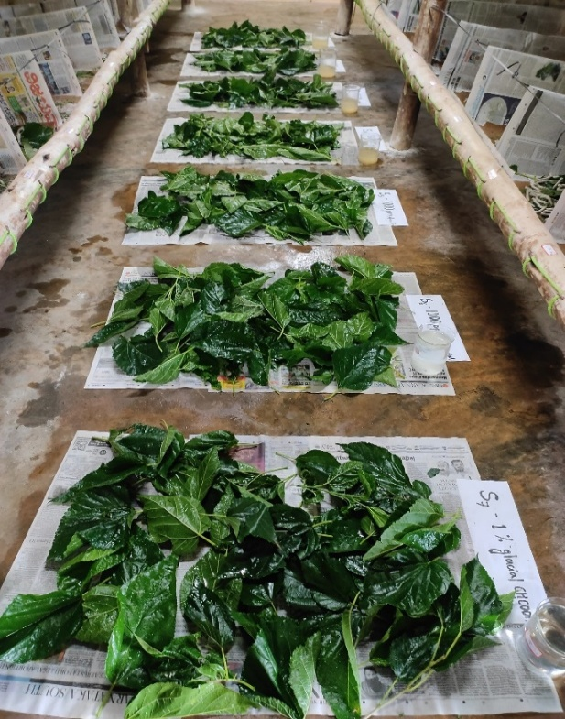
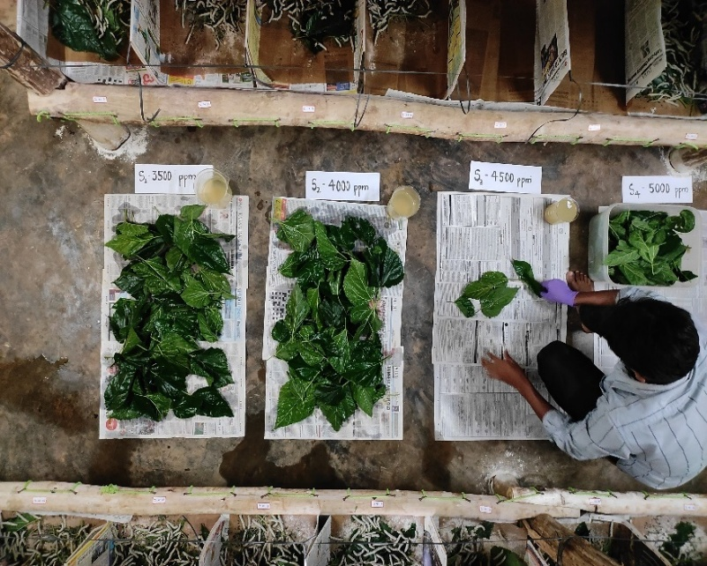
B
A

Fig. 1: Application of the chitosan to the silkworms by leaf dip method; A - dipping of mulberry leaves in chitosan solution; B - Shade drying of treated mulberry leaves

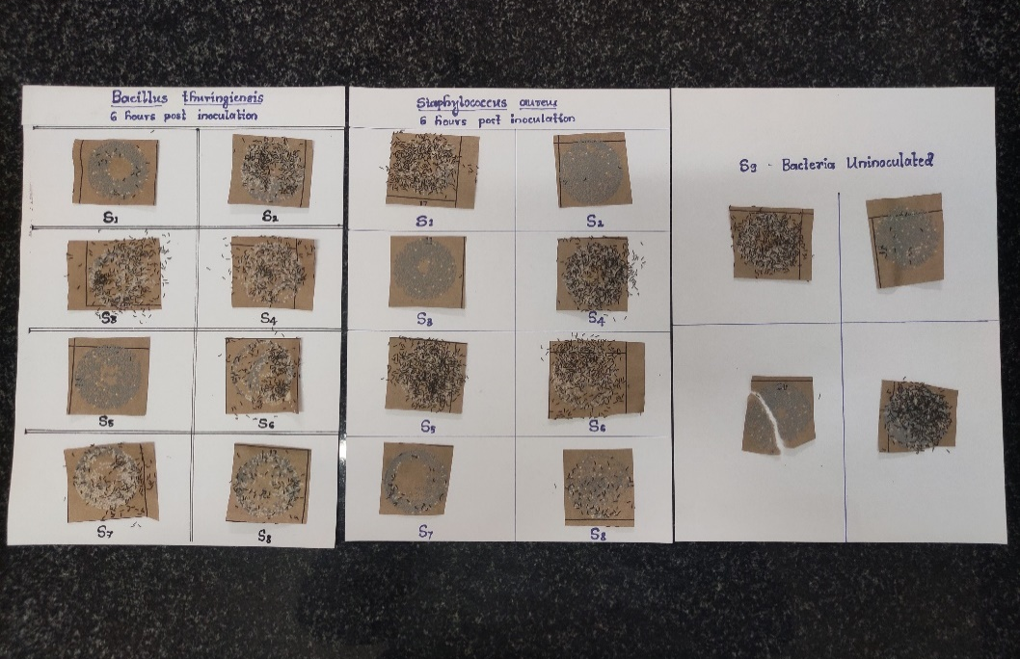

Fig. 2: Hatching of eggs laid by the infected silkworms treated with chitosan concentrations

